Transforming Aged Care for Aboriginal and Torres Strait Islander people
  - Community Booklet

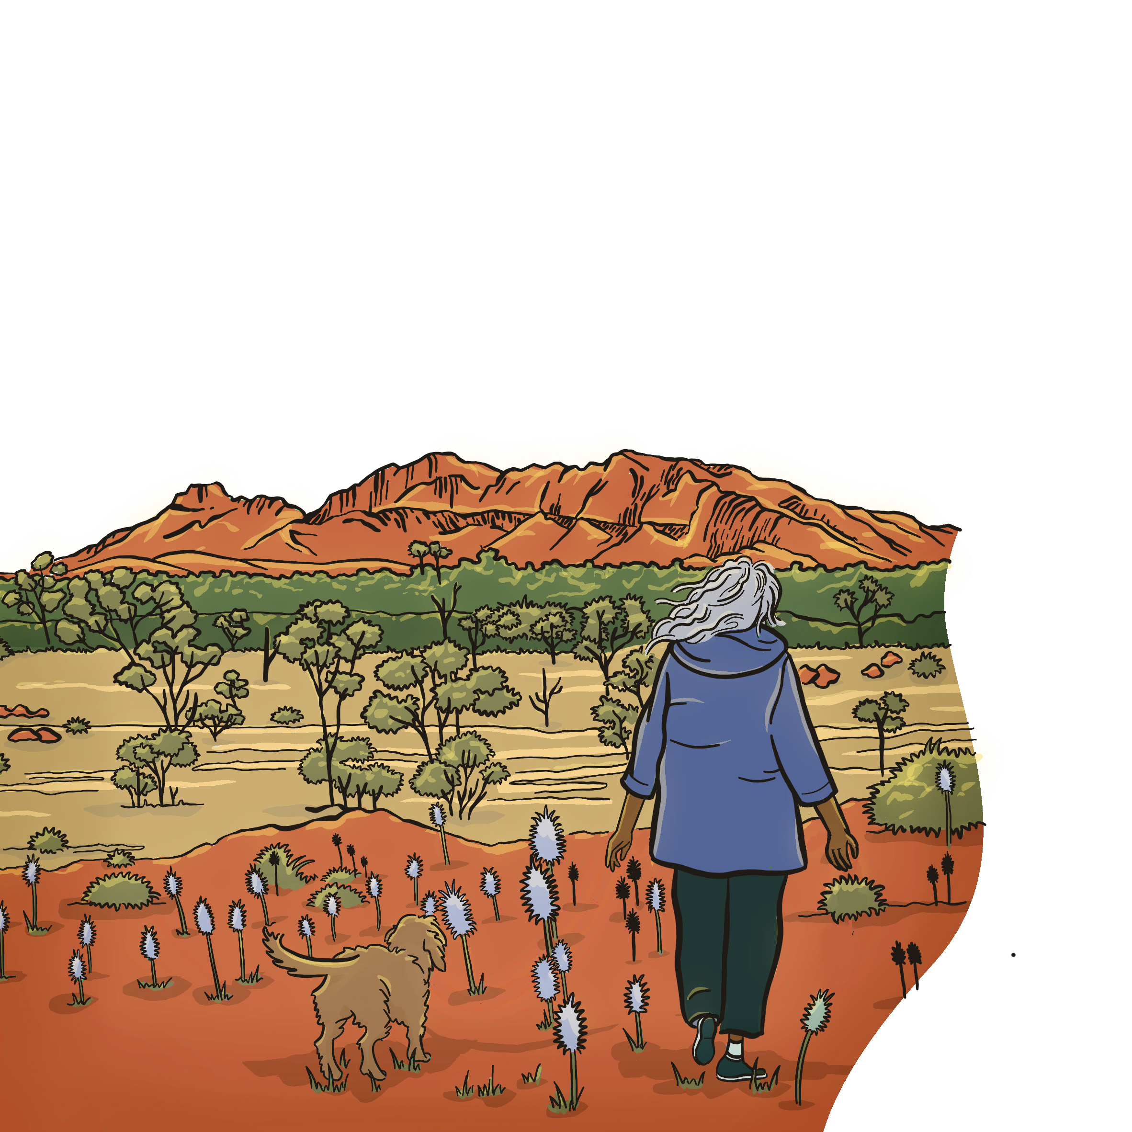


© 2024 Commonwealth of Australia as represented by the Department of Health and Aged Care.
This work is copyright. You may copy, print, download, display and reproduce the whole or part of this work in unaltered form for your own personal use or, if you are part of an organisation, for internal use within your organisation, but only if you or your organisation:
Do not use the copy or reproduction for any commercial purpose; and retain this copyright notice and all disclaimer notices as part of that copy or reproduction.
Apart from rights as permitted by the Copyright Act 1968 (Cth) or allowed by this copyright notice, all other rights are reserved, including (but not limited to) all commercial rights.
Requests and inquiries concerning reproduction and other rights to use are to be sent to the Communication Branch, Department of Health and Aged Care, GPO Box 9848, Canberra ACT 2601, or via e-mail to copyright@health.gov.au.
Artwork and graphic design by Peta Roebuck from Tuna Blue.

Artwork title: “Koorliny on Boodja” meaning “Walking on Country”
Artist: Miranda Davis (Aunty Mandy)
Aunty Mandy is a Noonga Yorga woman from the Western Australia Wheatbelt region with family connection to Whadjuk, Wilman, Ballardong, Yued and Wardandi countries.
Aunty Mandy was born in Pingelly on Ballardong Country and has lived in Mandurah on Binjareb Country for the past 25 years. She lives with her husband and has 4 children and 7 grandchildren.
Aunty Mandy has worked extensively in the Mandurah area with local agencies to complete commissioned pieces and projects, including the Noongar Six Seasons signage for the local park in Cunderdin.
Aunty Mandy painted and gifted “Koorliny on Boodja” to the Interim First Nations Aged Care Commissioner in recognition of her visit to Mandurah as part of her nationwide consultations.
I acknowledge Aboriginal and Torres Strait Islander peoples as the Traditional Owners of Country throughout what is now known as Australia, and recognise their continuing connection to land, sea, waters, and culture. I pay my respects to their Elders past and present and acknowledge sovereignty was never ceded.
I particularly acknowledge the generous contributions of Aboriginal and Torres Strait Islander peoples who shared their lived experiences of the aged care system. By sharing their experiences, they have provided the voice and foundation for this report. Their contributions are the evidence and momentum for change.

Purpose of this Community Report
Many of you told me about sharing your stories and experiences, but never hear anything back about how your feedback is used.
I made a promise to everybody I met with that I would come back with what I heard and not in hard-to-understand Government speak. I hope everybody who reads this Community Report connects with what is inside and that it speaks to the many different communities I met with.
Between 5 February 2024 and 21 June 2024, I travelled across the country to listen to older Aboriginal and Torres Strait Islander people, their families and communities, service providers and peak bodies about the aged care system and what we can do to make it better for our mob.
It was important to do this Community Report so I could share what I heard back to all of you who were so generous to meet and share your stories with me. We will only see the changes you asked for if the Government listens and understands us – so it’s my hope that you see yourself in this report.

I travelled around the country to yarn with you about your experiences with aged care...
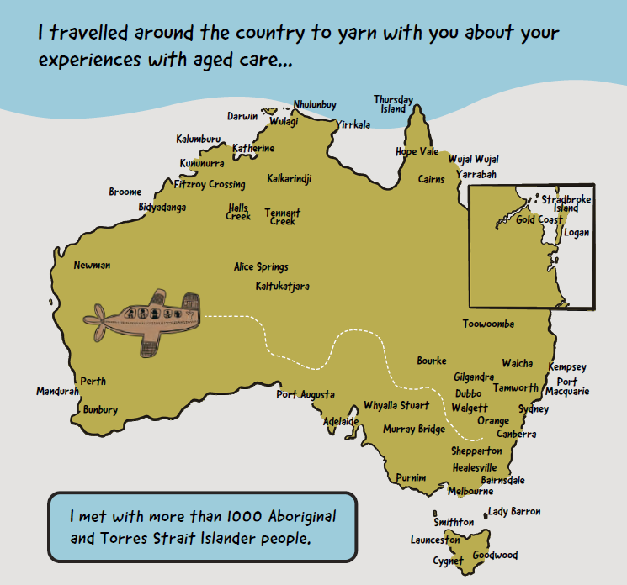
I met with more than 1000 Aboriginal and Torres Strait Islander people.
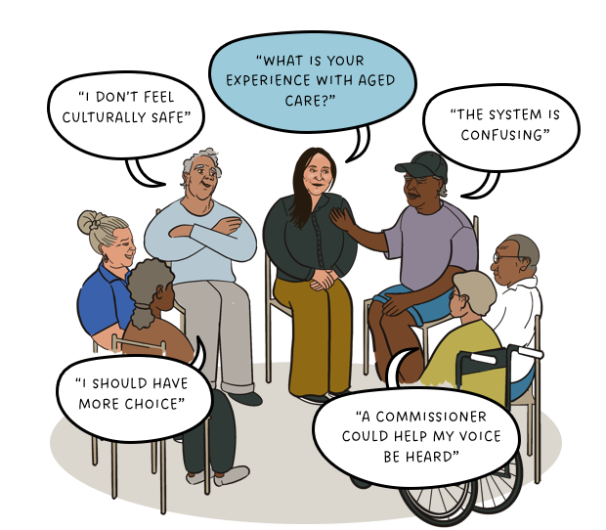
“What is your experience with aged care?”
“I should have more choice.”
“I don’t feel culturally safe.”
“The system is confusing.”
“A commissioner could help my voice be heard.”

You shared what matters most to you...
- Face to face support is better for me.
- At my ACCO I get all the services I need. I only have to organise appointments and travel once.
- We want to be cared for by our mob. They are deeply connected to our Country, communities, and culture.
- Our connection to Country is so important and needs to be supported.

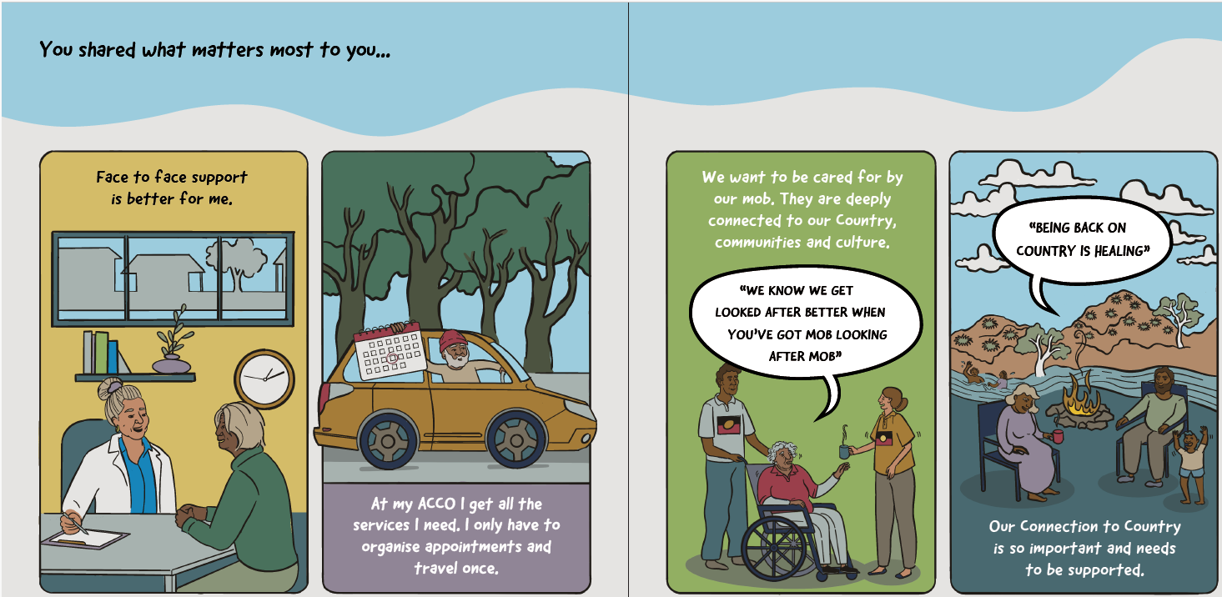
- I can continue to live independently, stay connected to Country, community and Culture and access services that I need.
- Being active is important for my spirit to stay strong and healthy.
- If we have to go into residential care, they must be designed with us in mind - to honour our ancestors and our Country.
- Sitting around the fire, yarning, and connecting with family is good for our spirit and healing.
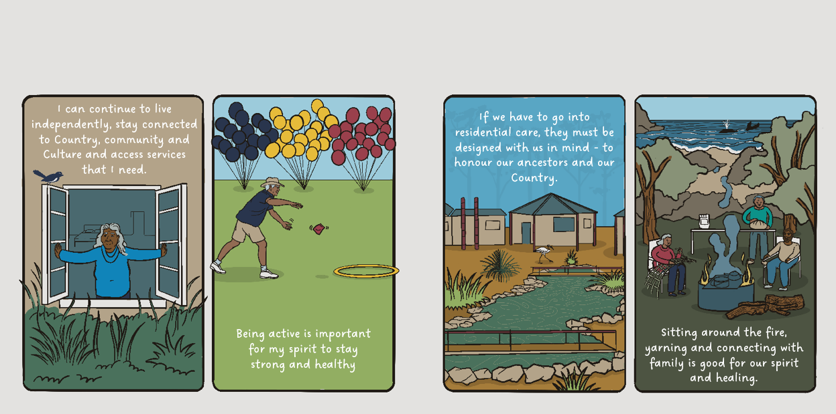

I also heard some of the troubles you have with aged care…
- The thought of returning to an institution can be traumatizing
“I spent too much of my life in an institution. I’m not going back”.
“At the age of 70, I just received my birth certificate”.
- The impacts are ongoing.
- The intergenerational trauma impacts on dependents of Stolen Generations survivors.
“Stolen Generations survivors have unique needs and the people who are helping them need to be trained properly.”

Culturally unsafe
- Assessments are culturally unsafe – they are rushed and invasive.
“Racism has always been there, but it’s like the referendum gave them permission.”
- Racism exists – institutional and interpersonal.
- Connection to Country is not understood or catered for.
“Andrea, I want you to tell the Prime Minister that we want to die on country.”
- We need a cultural safety definition and training.
“My culture is me. It’s who I am, and no one can take that away from me”

Confusing and overwhelming
- “My Aged Care” is complex, confusing, and overwhelming.
- Wait times for an assessment are too long, and then I have to wait even longer for a package.
“We are jumping through many hoops to access a simple aged care package.”

Not flexible for mob
- Fees and contributions make it hard for us to choose aged care services that we need, because we can’t afford it.
“Our elders have no choice but to continue going without the help they need to stay independent at home.”
- Funding needs to be flexible so that we can have the services and supports we need.
“I was told I need to pick from a list of services to spend my packages on. But it’s not what I need.”

Lack of choice
- We want more Aboriginal and Torres Strait Islander staff working in aged care.
“We need to grow the ACCO sector.”
“Government needs to have better pathways for our mob to get these jobs.”
- There is not enough culturally safe, trauma-aware and healing informed services for mob to choose.
“Aboriginal and Torres Strait Islander people need to choose between services that are not culturally safe or not accessing care and support at all.”
- We need the services where we live. We shouldn’t have to travel for hours just to access aged care services.
“We can’t get workers out here or can’t get them to stay.”

You told me that we need to make sure the aged care system is culturally safe, trauma-aware and healing informed.
“The system wasn’t designed with us in mind, Government need to sit down with us and design a system that works for us, and we know this will take time “
“What about a plan? It’s going to take time, but we need to get it right!”

The plan needs to be transformative and based on 3 things...
- Feedback given to the Interim Commissioner through consultations.
- The 4 Priority Reforms under the National Agreement on Closing the Gap.
- The recommendations from the Royal Commission.

From our yarns, you told me that having an Aboriginal and Torres Strait Islander Commissioner was really important to you.
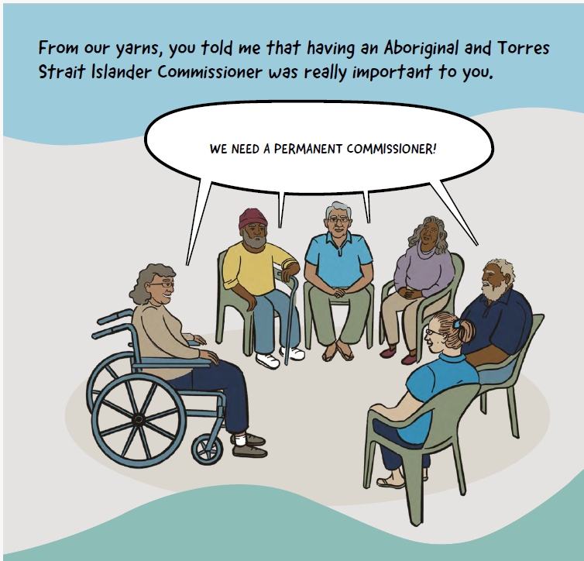

You told me that the permanent Commissioner should...
- keep meeting with us, not just one off
- be chosen with the help of our mob
- make a bridge between mainstream system and us mob
- be independent of Government and statutory
- be sharing our voices with Government
- be holding government accountable
- make positive change for Aboriginal and Torres strait Islander people.
Community told me they want the permanent Commissioner to have “teeth.” The Commissioner should be able to...
- undertake formal inquiries
- hold the aged care system to account
- make recommendations to Government
- make recommendations and report to Parliament.

The Commissioner could focus on...
- a strong and expanded Aboriginal and Torres strait Islander Aged care workforce and community-controlled aged care sector
- the aged care system being culturally safe and meeting the needs of Aboriginal and Torres strait Islander people
- equitable access and outcomes for older Aboriginal and Torres Strait Islander people in the aged care system
- the 4 Closing the Gap priority reforms are implemented as they relate to aged care.

I wrote a report to Government about everything you told me. I made some recommendations, and I will let you know when I hear back from the Minister...
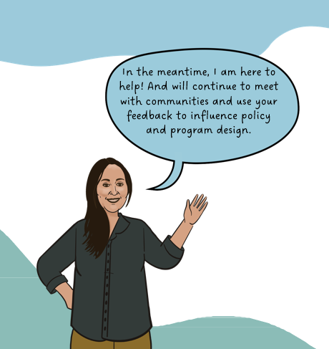

In the meantime, I am here to help and will continue to meet with communities and use your feedback to influence policy and program design.
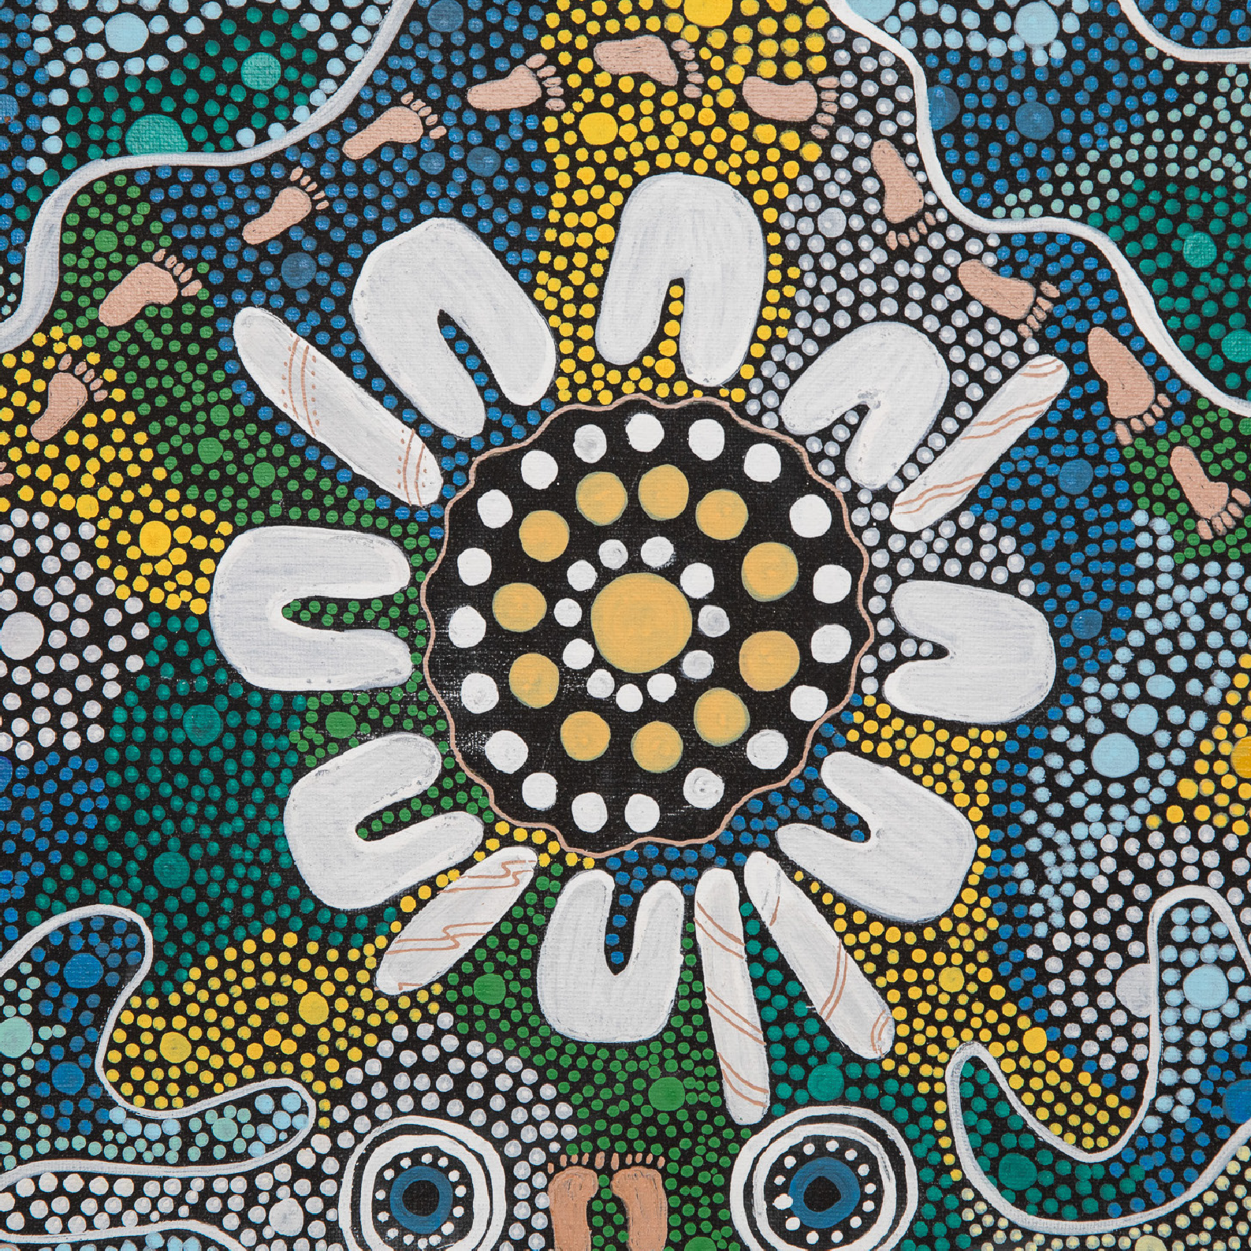
Health.gov.au
All information in this publication is correct as of January 2025.

