Strengthened
Aged Care
Quality Standards
  - February 2025

Below are the strengthened Aged Care Quality Standards (February 2025), including the expectation statements for older people, intent of each standard, and a number of outcomes, each supported by an outcome statement (which is what providers would be assessed against) and a number of actions (which are how providers might demonstrate achievement of the outcome).
Further information about how these strengthened Quality Standards have been developed can be found through the Department of Health and Aged Care’s website.
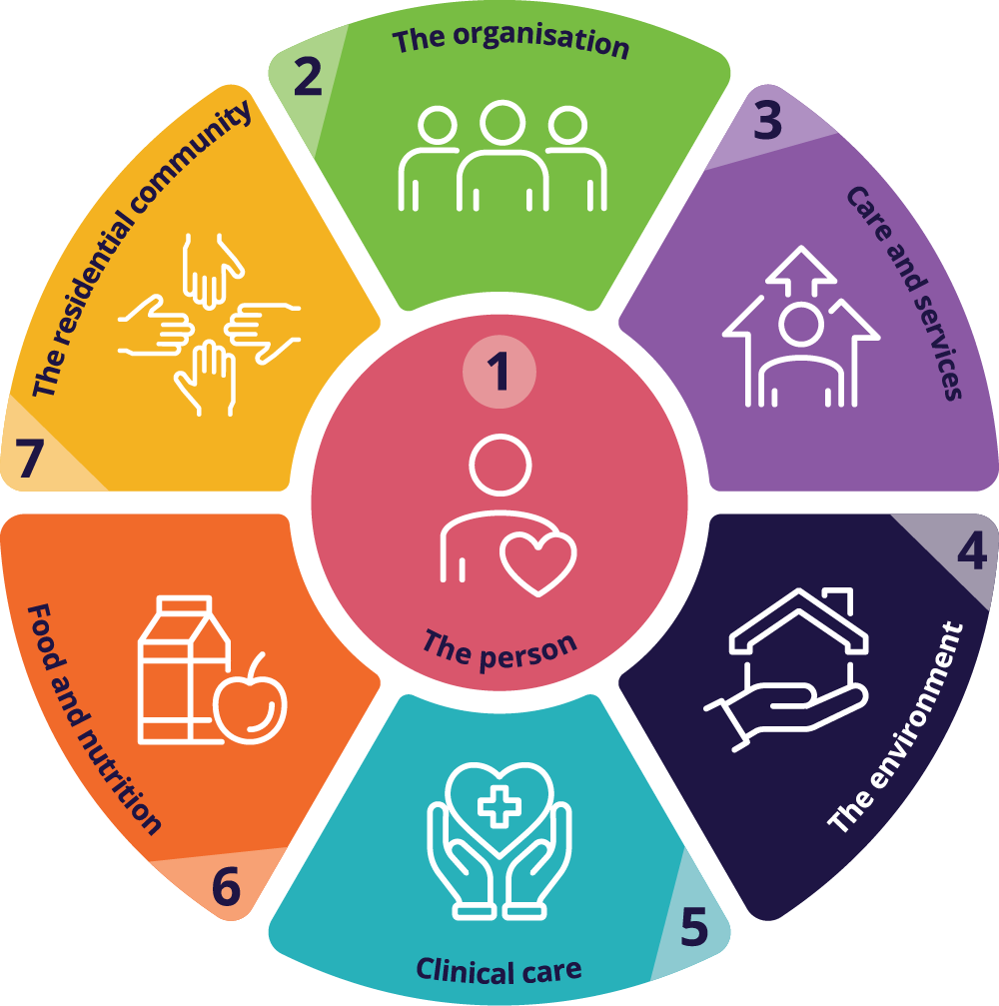
Please note the draft strengthened Quality Standards in this document are not yet in operation. This document has been updated to support the public consultation of the Stage 3 release of the Rules for the new Aged Care Act. While there may be further changes following the consultation process, the intent and purpose of the strengthened Quality Standards will not change. The strengthened Quality Standards will come into effect from 1 July 2025 in line with the new Aged Care Act and the new regulatory model.

Contents
Contents 5
Standard 1: The Individual 8
Intent of Standard 1 8
Standard 1 expectation statement for older people: 9
Outcome 1.1: Person-centred care 9
Outcome 1.2: Dignity, respect and privacy 10
Outcome 1.3: Choice, independence and quality of life 11
Outcome 1.4: Transparency and agreements 12
Standard 2: The Organisation 13
Intent of Standard 2 13
Standard 2 expectation statement for older people: 13
Outcome 2.1: Partnering with individuals 14
Outcome 2.2a: Quality, safety and inclusion culture to support aged care workers to deliver quality care 14
Outcome 2.2b: Quality, safety and inclusion culture to support individuals 15
Outcome 2.3: Accountability, quality system and policies and procedures 15
Outcome 2.4: Risk management 17
Outcome 2.5: Incident management 17
Outcome 2.6a: Complaints and feedback management for aged care workers 18
Outcome 2.6b: Complaints and feedback management for individuals 19
Outcome 2.7: Information management 19
Outcome 2.8: Workforce planning 20
Outcome 2.9: Human resource management 21
Outcome 2.10: Emergency and disaster management 22
Standard 3: The Care and Services 23
Intent of Standard 3 23
Standard 3 expectation statement for older people: 23
Outcome 3.1: Assessment and planning 24
Outcome 3.2: Delivery of funded aged care services 25
Outcome 3.3: Communicating for safety and quality 27
Outcome 3.4: Planning and coordination of funded aged care services 28
Standard 4: The Environment 29
Intent of Standard 4 29
Standard 4 expectation statement for older people: 29
Outcome 4.1a: Environment – services delivered in the individual’s home 30
Outcome 4.1b: Environment – services delivered other than in the individual’s home 30
Outcome 4.2: Infection prevention and control 31
Standard 5: Clinical Care 33
Intent of Standard 5 33
Standard 5 expectation statement for older people: 34
Outcome 5.1: Clinical governance 34
Outcome 5.2: Preventing and controlling infections in delivering clinical care services 35
Outcome 5.3: Safe and quality use of medicines 35
Outcome 5.4: Comprehensive care 37
Outcome 5.5: Safety of clinical care services 38
Outcome 5.6: Cognitive impairment 40
Outcome 5.7: Palliative care and end-of-life care 41
Standard 6: Food and Nutrition 43
Intent of Standard 6 43
Standard 6 expectation statement for older people: 44
Outcome 6.1: Partnering with individuals on food and drinks 44
Outcome 6.2: Assessment of nutritional needs and preferences 44
Outcome 6.3: Provision of food and drinks 45
Outcome 6.4: Dining experience 46
Standard 7: The Residential Community 47
Intent of Standard 7 47
Standard 7 expectation statement for older people: 48
Outcome 7.1: Daily living 48
Outcome 7.2: Transitions 49

Standard 1: The Individual

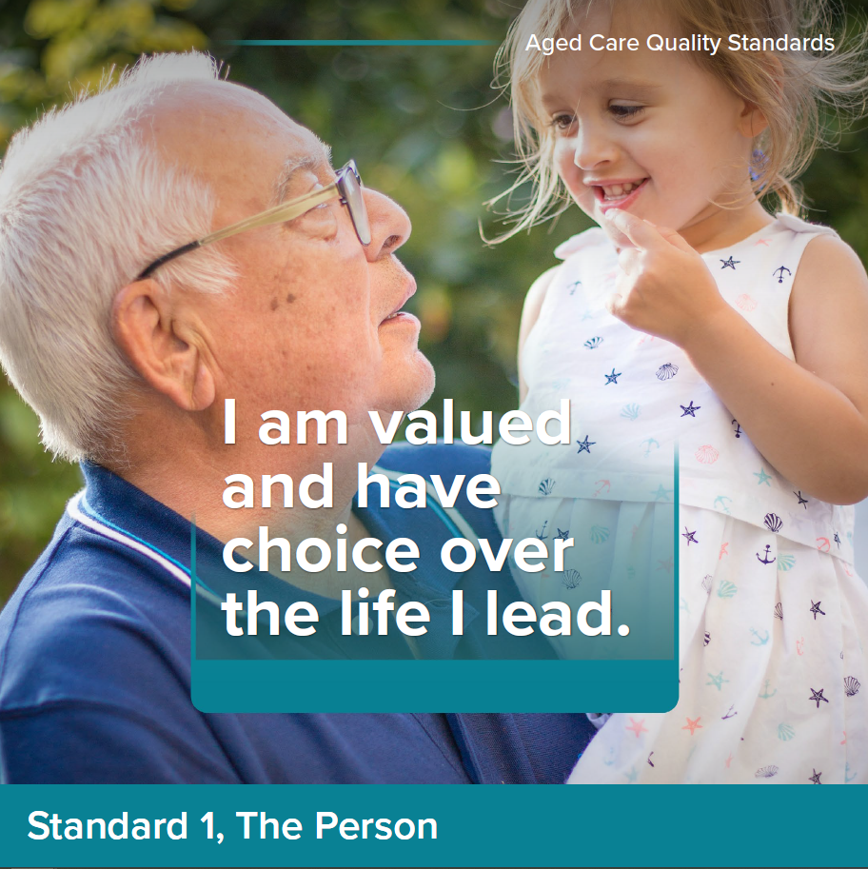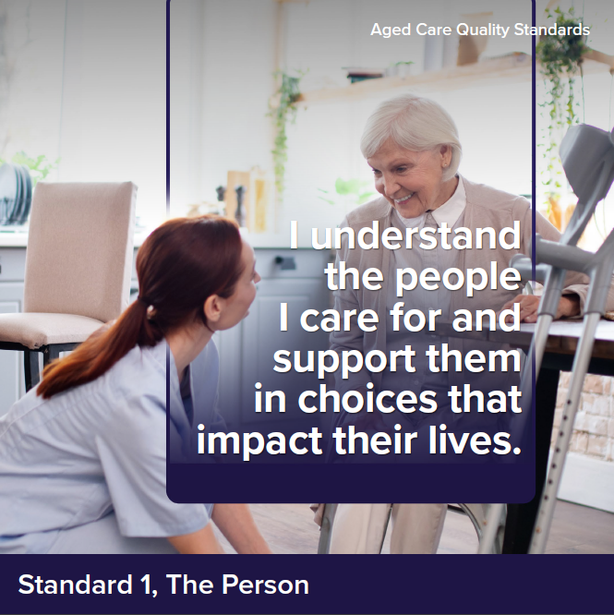

Intent of Standard 1
Standard 1 underpins the way that providers and aged care workers are expected to treat older people and is relevant to all standards. Standard 1 reflects important concepts about dignity and respect, older person individuality and diversity, independence, choice and control, culturally safe care and dignity of risk. These are all important in fostering a sense of safety, autonomy, inclusion and quality of life for older people.
Older people are valuable members of society, with rich and varied histories, characteristics, identities, interests and life experiences.
Older people can come from a diverse range of backgrounds and groups, including, but not limited to, Aboriginal or Torres Strait Islander persons, people from culturally and linguistically diverse backgrounds, people living in rural or remote areas, people who are financially or socially disadvantaged, people who are veterans, people experiencing homelessness or at risk of becoming homeless, people who are care leavers (i.e. a who spent time in care as a child), parents separated from their children by forced adoption or removal, people who are lesbian, gay, bisexual, transgender or intersex, people of various religions, people experiencing mental health problems and mental illness, people living with cognitive impairment including dementia, people living with disability.
A person’s diversity does not define who they are, but it is critical that providers recognise and embrace each person’s diversity and who they are holistically as a person, and that this drives how providers and aged care workers engage with older people and deliver their funded aged care services.

Standard 1 expectation statement for older people:
I have the right to be treated with dignity and respect and to live free from any form of discrimination. I make decisions about my funded aged care services, with support when I want or need it. My identity, culture and diversity are valued and supported, and I have the right to live the life I choose. My provider understands who I am and what is important to me, and this determines the way my funded aged care services are delivered.

Outcome 1.1: Person-centred care
Outcome statement:
The provider demonstrates that the provider understands that the safety, health, wellbeing and quality of life of individuals is the primary consideration in the delivery of funded aged care services.
The provider demonstrates that the provider understands and values individuals, including their identity, culture, ability, diversity, beliefs and life experiences.
The provider demonstrates that the provider develops funded aged care service with, and tailored to, individuals, taking into account their needs, goals and preferences.
Actions:
- The way the provider and aged care workers engage with individuals supports them to feel safe, welcome, included and understood.
- The provider implements strategies to:
  - identify the individual background, culture, diversity, beliefs and life experiences as part of assessment and planning and uses this to direct the way their funded aged care services are delivered
  - identify and understand the particular communication needs and preferences of the individual
  - ask and record if an individual identifies as an Aboriginal or Torres Strait Islander person
  - deliver funded aged care services that meet the needs of individuals with specific needs and diverse backgrounds, including Aboriginal or Torres Strait Islander persons and individuals living with dementia
  - deliver funded aged care services that are culturally safe, trauma aware and healing informed, in accordance with contemporary, evidence-based practice
  - support individuals to cultivate relationships and social connections, including for individuals who identify as Aboriginal or Torres Strait Islander persons, connection to community, culture, and Country and Island Home
  - continuously improve its approach to inclusion and diversity.
- The provider and aged care workers recognise the rights, and respect the autonomy, of individuals, including their right to intimacy and sexual and gender expression.
- Aged care workers have professional and trusting relationships with individuals and work in partnership with them to deliver funded aged care services.

Outcome 1.2: Dignity, respect and privacy
Outcome statement:
The provider must deliver funded aged care services to individuals in a way that is free from all forms of discrimination, abuse and neglect, treats individuals with dignity and respect, and respects the personal privacy of individuals.
The provider demonstrates that the provider understands the rights of individuals under the Statement of Rights. The provider must have practices in place to ensure that the provider acts compatibly with the Statement of Rights, in accordance with subsection 24(2) of the Act (acting compatibly with the Statement of Rights).
Actions:
- The provider implements a system to recognise, prevent and respond to violence, abuse, racism, neglect, exploitation and discrimination.
- Individuals are treated with kindness, dignity and respect.
- The relationship between individuals and the supporters of individuals is recognised and respected.
- The personal privacy of individuals is respected, individuals have choice about how and when they receive intimate personal care or treatment, and this is carried out sensitively and in private.

Outcome 1.3: Choice, independence and quality of life
Outcome statement:
The provider must support individuals to exercise choice and make decisions about their funded aged care services, and provide them with support to exercise choice and make decisions when they want or need it.
The provider must provide individuals with timely, accurate, tailored and sufficient information about their funded aged care services, in a way they understand.
The provider must support individuals to exercise dignity of risk to achieve their goals and maintain independence and quality of life.
Actions:
- The provider implements a system to ensure information given to individuals to enable them to make informed decisions about their funded aged care and services:
  - is current, accurate and timely
  - is plainly expressed and presented in a way the individual understands.
- The provider implements a system to ensure that individuals give their informed consent where this is required for a treatment, procedure or other intervention.
- The provider implements a system:
  - to ensure individuals who require support with decision-making are identified and provided access to the support necessary to make, communicate and participate in decisions that affect their lives
  - that involves supporters of individuals where possible, for individuals who require support with decision-making
  - that uses substitute decision-makers only after all options to support an individual to make decisions are exhausted.
- The provider supports individuals to access advocates of their choosing.
- The provider supports individuals to live the best life they can, including by understanding the individual’s goals and preferences and enabling positive risk-taking that promotes the individual’s autonomy and quality of life.
- The provider records, monitors and responds to changes to the individual’s quality of life.

Outcome 1.4: Transparency and agreements
Outcome statement:
Before entering into any agreements with individuals about the delivery of funded aged care services, the provider must provide individuals with the opportunity to exercise autonomy, the time they need to consider the agreement and an opportunity to seek advice.
The provider must support individuals to understand and make informed decisions about their agreements, fees and invoices.
Actions:
- Prior to entering into any agreement or commencing funded aged care services (whichever comes first), the provider gives individuals information to enable them to make informed decisions about their funded aged care services.
- The provider supports individuals to understand information provided to them, including any agreement they will be required to enter into, the terms relating to their rights and responsibilities, the funded aged care services to be provided and the fees and other charges to be paid.
- The provider allows individuals the time they need to consider and review their options and seek external advice before making decisions.
- The provider informs the individual of any changes to previously agreed fees and charges and seeks their informed consent to implement these changes before they are made.
- The provider implements a system to ensure prices, fees and payments are accurate and transparent for individuals.
- The provider ensures invoices are timely, accurate, clear and presented in a way the individual understands.
- The provider promptly addresses any overcharging and provides refunds to individuals.

Standard 2: The Organisation

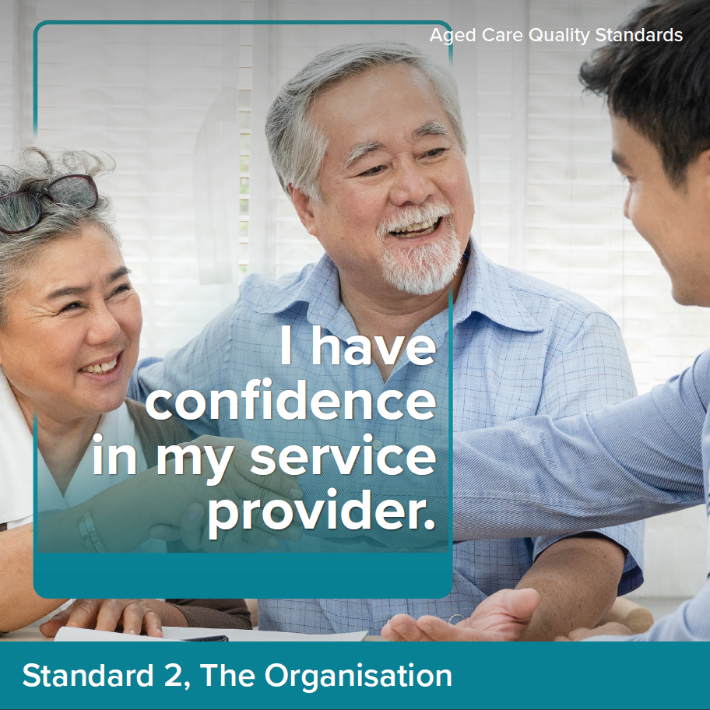

Intent of Standard 2
The intent of Standard 2 is to set out the expectations of the governing body to meet the requirements of the Quality Standards and deliver quality funded aged care services.
The governing body sets the strategic priorities for the organisation and promotes a culture of safety and quality. The governing body is also responsible for driving and monitoring improvements to funded aged care services, informed by engagement with older people, their supporters and aged care workers, and data and information on care quality.
A provider’s governance systems and workforce are critical to the delivery of safe, quality, effective and person-centred care for every older person, and continuous care and services improvement. Aged care workers are empowered to do their jobs well.

Standard 2 expectation statement for older people:
The organisation is well run. I can contribute to improvements to care and services. My provider and aged care workers listen and respond to my feedback and concerns. I receive funded aged care services from aged care workers who are knowledgeable, competent, capable and caring.

Outcome 2.1: Partnering with individuals
Outcome statement:
The provider must engage in meaningful and active partnerships with individuals to inform organisational priorities and continuous improvement.
Actions:
- The governing body partners with individuals to set priorities and strategic directions for the way their funded aged care services are provided.
- The provider supports individuals to participate in partnerships and partners with individuals:
  - who reflect the diversity of those who use their funded aged care services
  - who identify as Aboriginal or Torres Strait Islander to ensure funded aged care services are accessible to, and culturally safe for, Aboriginal and Torres Strait Islander persons.
- The provider partners with individuals in the design, delivery, evaluation and improvement of quality funded aged care services.

Outcome 2.2a: Quality, safety and inclusion culture to support aged care workers to deliver quality care
Outcome statement:
The governing body must lead a culture of quality, safety and inclusion that supports aged care workers to provide quality funded aged care services by focussing on continuous improvement, embracing diversity and prioritising the safety, health and wellbeing of aged care workers.
Actions:
- The governing body leads a positive culture of quality funded aged care services and continuous improvement and demonstrates that this culture exists within the organisation.
- In strategic and business planning, the governing body:
  - prioritises the safety, health and wellbeing of aged care workers
  - proactively engages, listens, consults with aged care workers to leverage their expertise in delivering quality funded aged care services to individuals
  - communicates information to aged care workers that is relevant to aged care workers’ safety to support their delivery of quality funded aged care services
  - adheres to legislative requirements, and active consideration is given to organisational and operational risks, workforce needs and the wider organisational environment.

Outcome 2.2b: Quality, safety and inclusion culture to support individuals
Outcome statement:
The governing body must lead a culture of quality, safety and inclusion that supports individuals receiving quality funded aged care services by focussing on continuous improvement, embracing diversity and prioritising the safety, health and wellbeing of individuals.
Actions:
- The governing body leads a positive culture of quality funded aged care services and continuous improvement and demonstrates that this culture exists within the organisation.
- In strategic and business planning, the governing body:
  - prioritises the physical and psychological safety, health and wellbeing of individuals
  - ensures that funded aged care services are accessible to, and appropriate for, individuals with specific needs and diverse backgrounds, Aboriginal or Torres Strait Islander persons and individuals living with dementia
  - adheres to legislative requirements, and active consideration is given to organisational and operational risks, and the wider organisational environment.

Outcome 2.3: Accountability, quality system and policies and procedures
Outcome statement:
The governing body is accountable for the delivery of quality funded aged care services and must maintain oversight of all aspects of the provider’s operations.
The provider must use a quality system to enable and drive continuous improvement of the provider’s delivery of funded aged care services.
The provider must maintain current policies and procedures that guide the way aged care workers undertake their roles and require aged care workers to follow the policies and the procedures.
Actions:
- The provider engages with aged care workers on the planning and design of systems they are required to engage with, to improve the delivery of quality funded aged care services.
- The provider implements a quality system that:
  - supports quality funded aged care services for all individuals
  - sets out accountabilities and responsibilities for supporting quality funded aged care services, specific to different roles
  - sets strategic and operational expectations for the delivery of quality funded aged care services
  - enables the governing body to monitor the organisation’s performance in delivering quality funded aged care services, informed by:
    - feedback from individuals, supporters of individuals and aged care workers delivering the funded aged care services
    - analysis of risks, complaints and incidents (and their underlying causes)
    - Quality Indicator data
    - contemporary, evidence-based practice
  - supports the provider to meet strategic and operational expectations and identify opportunities for improvement.
- The governing body monitors investment in priority areas to deliver quality funded aged care services.
- The provider regularly reviews and improves the effectiveness of the quality system.
- The provider regularly reports on its quality system and performance to individuals, supporters of individuals and aged care workers.
- The provider practices open disclosure and communicates with individuals, supporters of individuals and aged care workers when things go wrong.
- The provider maintains and implements policies and procedures that are current, regularly reviewed, informed by contemporary, evidence-based practice, and are understood and accessible by aged care workers and relevant parties.

Outcome 2.4: Risk management
Outcome statement:
The provider must use a risk management system to identify, manage and continuously review risks to individuals, aged care workers and the provider’s operations.
Actions:
- The provider implements a risk management system to identify, assess, document, manage and regularly review risks to individuals, aged care workers and the organisation.
- The provider puts strategies in place and undertakes actions to prevent, control, minimise or eliminate identified risks.
- The provider collects and analyses data and engages with individuals and aged care workers to inform risk assessment and management. This feeds into the provider’s quality system to improve funded aged care services.
- The provider regularly reviews and improves the effectiveness of the risk management system.

Outcome 2.5: Incident management
Outcome statement:
The provider must use an incident management system to safeguard individuals and acknowledge, respond to, effectively manage and learn from incidents.
Actions:
- The provider implements an incident management system to record, investigate, respond to and manage incidents and near misses that occur in connection with the delivery of funded aged care services and reduces or prevents incidents from recurring.
- The provider takes timely action to respond to and manage incidents.
- The provider supports individuals and supporters of individuals to report incidents and encourages their involvement in identifying ways to reduce incidents from occurring.
- The provider supports the workforce including through provision of tools, training and clear policies to prevent, recognise, respond to and report incidents.
- The provider collects and analyses incident data and reports to the relevant regulator as required. All outcomes are reported to individuals and aged care workers and feed into the provider’s quality system to improve the quality of funded aged care services.
- The provider regularly reviews and improves the effectiveness of the incident management system and communicates changes to aged care workers and individuals.

Outcome 2.6a: Complaints and feedback management for aged care workers
Outcome statement:
The provider must encourage and support aged care workers to make complaints and give feedback about the provider’s delivery of funded aged care services, without reprisal.
The provider must acknowledge and transparently manage all complaints and feedback and use complaints and feedback to contribute to the continuous improvement of funded aged care services.
Actions:
- The provider implements a complaints and feedback management system to receive, record, respond to and report on complaints and feedback.
- The provider encourages and supports aged care workers to make complaints and give feedback including supporting access to advocates and services to support raising and resolving complaints and feedback.
- The provider takes timely action to resolve complaints and uses an open disclosure process when things go wrong.
- The provider collects and analyses complaints and feedback data. Outcomes are reported to the governing body and aged care workers and inform the provider’s quality system to improve the quality of funded aged care services.
- The provider regularly reviews and improves the effectiveness of how complaints and feedback from aged care workers on delivery of funded aged care services are managed through the complaints and feedback management system.

Outcome 2.6b: Complaints and feedback management for individuals
Outcome statement:
The provider must encourage and support individuals and others to make complaints and give feedback about the provider’s delivery of funded aged care services, without reprisal.
The provider must acknowledge and transparently manage all complaints and feedback and use complaints and feedback to contribute to the continuous improvement of funded aged care services.
Actions:
- The provider implements a complaints and feedback management system to receive, record, respond to and report on complaints and feedback.
- The provider encourages and supports individuals, supporters of individuals and others to make complaints and give feedback.
- Individuals are empowered to access advocates, language services and other ways of raising and resolving complaints and feedback.
- The provider takes timely action to resolve complaints and uses an open disclosure process when things go wrong.
- The provider collects and analyses complaints and feedback data. Outcomes are reported to the governing body and individuals and inform the provider’s quality system to improve the quality of funded aged care services.
- The provider regularly reviews and improves the effectiveness of the complaints management system.

Outcome 2.7: Information management
Outcome statement:
The provider must ensure that information recorded about an individual is accurate and current, is able to be accessed and understood by the individual, supporters of the individual, aged care workers and health professionals involved in the individual’s care.
The provider must ensure that the information of individuals is kept confidential and managed appropriately, in line with their informed consent.
Actions:
- The provider implements an information management system to securely manage records.
- The provider’s information management system ensures that:
  - aged care workers and individuals, supporters of the individual, and health professionals involved in the individuals care have access to the right information at the right time to deliver and receive quality funded aged care services
  - the accuracy and completeness of information collected and stored is maintained
  - informed consent is sought to collect, use and store the information of individuals or to disclose their information (including assessments) to other parties
  - individuals understand their right to access or correct their information or withdraw their consent to share information
  - information from different sources is integrated.
- The provider regularly reviews and improves the effectiveness of the information management system.

Outcome 2.8: Workforce planning
Outcome statement:
The provider must demonstrate that the provider understands and manages their workforce needs and plans for the future.
Actions:
- The provider implements a workforce strategy to:
  - identify, record and monitor the number and mix of aged care workers required and engaged to manage and deliver safe, quality funded aged care services
  - meet minimum care requirements including legislative obligations such as delivering a minimum average minutes of direct care and have a registered nurse on-site and on duty at all times, and engage with, and provide information to, aged care workers on how planning and rostering will achieve or exceed these minimum requirements
  - identify the skills, qualifications and competencies required for each role
  - engage sufficient numbers of suitably qualified and competent aged care workers
  - use direct employment to engage aged care workers whenever possible, and minimise the use of independent contractors and agencies providing contractors
  - mitigate the risk and impact of workforce shortages and aged care worker absences or vacancies.
- The provider implements strategies for supporting and maintaining a satisfied and psychologically safe aged care workforce.

Outcome 2.9: Human resource management
Outcome statement:
The provider must deliver funded aged care services to individuals by aged care workers who are skilled and competent in their roles, hold relevant qualifications for their roles and have expertise and experience relevant to delivering quality funded aged care services.
The provider must provide aged care workers with training and supervision to enable them to effectively perform their roles.
Actions:
- The provider maintains records of aged care worker pre-employment checks, contact details, qualifications and experience.
- The provider deploys the number and mix of aged care workers to enable the delivery and management of safe and quality funded aged care services.
- Aged care workers have access to appropriate supervision, escalation, support and resources. This should be accessible for aged care workers with English as a second language, and be culturally sensitive.
- The provider maintains and implements a training system that:
  - includes training strategies to ensure that aged care workers have the necessary skills, qualifications and competencies to effectively perform their roles
  - draws on the experience of individuals to inform training strategies
  - is responsive to feedback, complaints, incidents, identified risks and the outcomes of regular aged care worker performance reviews.
- The provider regularly reviews and improves the effectiveness of the
training system.
- All aged care workers regularly receive competency-based training in relation to core matters, at a minimum:
  - the delivery of person-centred, rights-based care
  - culturally safe, trauma aware and healing informed care
  - caring for individuals living with dementia
  - responding to medical emergencies
  - the requirements of the Code of Conduct, the Serious Incident Response Scheme, the Quality Standards and other requirements relevant to the aged care worker’s role.
- The provider undertakes regular assessment, monitoring and review of the performance of aged care workers.

Outcome 2.10: Emergency and disaster management
Outcome statement:
The provider must demonstrate that emergency and disaster management planning considers and manages the risks to the health, safety and wellbeing of individuals and aged care workers.
Actions:
- The provider develops emergency and disaster management plans that describe how the provider and aged care workers will respond to an emergency or disaster and to manage risks to the health, safety and wellbeing of individuals and aged care workers.
- The provider implements strategies to prepare for, and respond to, an emergency or disaster.
- The provider engages with individuals, supporters of individuals and aged care workers about the emergency and disaster management plans.
- The provider regularly tests and reviews the emergency and disaster management plans in partnership with individuals, supporters of individuals, aged care workers and other response partners.

Standard 3: The Care and Services
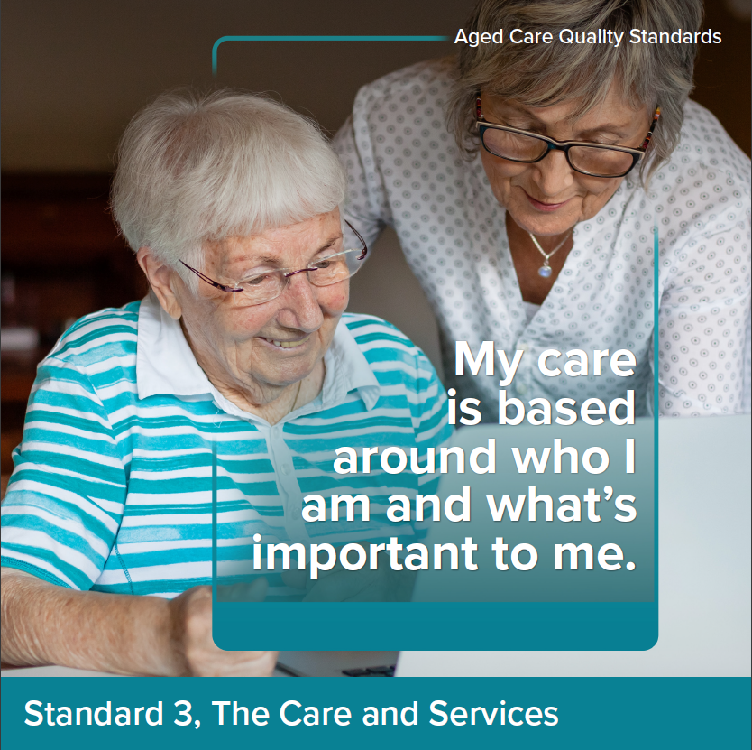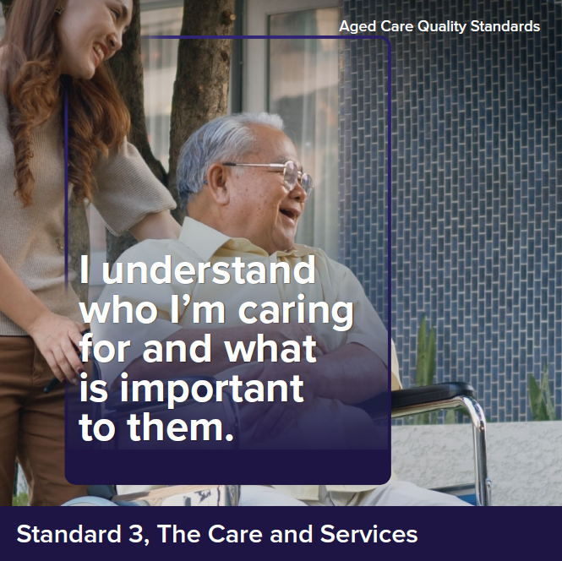

Intent of Standard 3
Standard 3 describes the way providers must deliver funded aged care services for all types of services being delivered (noting that other standards describe requirements relevant to specific service types). Effective assessment and planning, communication and coordination relies on a strong and supported workforce as described in Standard 2 and is critical to the delivery of quality funded aged care services that meet the older person’s needs, are tailored to their preferences and support them to live their best lives.
In delivering funded aged care services, providers and aged care workers must draw on all relevant standards, with particular reference to Standard 1, including to ensure care is tailored to the individual and what’s important to them. Older people’s supporters are recognised as having an important role in assisting or providing funded aged care services.

Standard 3 expectation statement for older people:
The funded aged care services I receive:
- are safe and effective
- optimise my quality of life, including through maximising independence and reablement
- meet my current needs, goals and preferences
- are well planned and coordinated
- respect my right to take risks.

Outcome 3.1: Assessment and planning
Outcome statement:
The provider must actively engage with individuals to whom the provider delivers funded aged care services, supporters of individuals (if any) and any other persons involved in the care of individuals in developing and reviewing the individual’s care and services plans through ongoing communication.
Care and services plans must describe the current needs, goals and preferences of individuals and include strategies for risk management and preventative care.
The provider must ensure that care and services plans are regularly reviewed and are used by aged care workers to guide the delivery of funded aged care services.
Actions:
- The provider implements a system for assessment and planning that:
  - identifies and records the needs, goals and preferences of the individual
  - identifies risks to the individual’s health, safety and wellbeing and, with the individual, identifies strategies for managing these risks
  - supports preventative care and optimises quality of life, reablement and maintenance of function
  - involves relevant health professionals where required
  - directs the delivery of quality funded aged care services.
- Assessment and planning is based on ongoing communication and partnership with the individual and others that the individual wishes to involve.
- The outcomes of assessment and planning are effectively communicated to:
  - the individual, in a way they understand
  - the individual’s supporters and others involved in their care, with the individual’s informed consent.
- Care and services plans are individualised and:
  - describe the individual’s needs, goals and preferences
  - are current and reflect the outcomes of assessments
  - include information about the risks associated with the delivery of funded aged care services and how aged care workers can support individuals to manage these risks
  - are offered to, and able to be accessed by, the individual
  - are used and understood by aged care workers to guide the delivery of funded aged care services.
- Care and services plans are reviewed regularly, including when:
  - the individual’s needs, goals or preferences change, or the care and services plan is not effective
  - the individual’s ability to perform activities of daily living, mental health, cognitive or physical function, capacity or condition deteriorates or changes
  - the care that can be provided by an individual’s family or carer changes
  - transition occurs
  - risks emerge or there are changes or an incident that impacts the individual
  - care responsibility changes between others involved in the individual’s care.
- The provider has processes for advance care planning that:
  - support the individual to discuss future medical treatment and care needs, in line with their needs, goals and preferences, including beliefs, cultural and religious practices and traditions
  - support the individual to complete and review advance care planning documents, if and when they choose
  - support the individual to nominate and involve a substitute decision maker for health and care decisions, if and when they choose
  - ensure that advance care planning documents are stored, managed, used and shared with relevant parties, including at transitions of care.

Outcome 3.2: Delivery of funded aged care services
Outcome statement:
The provider must ensure that individuals receive quality funded aged care services that meet their needs, goals and preferences and optimise their quality of life, reablement and maintenance of function.
The provider must ensure that funded aged care services are delivered in a way that is culturally safe and culturally appropriate for individuals with specific needs and diverse backgrounds.
Actions:
- Individuals receive culturally safe, trauma aware and healing informed funded aged care services that:
  - are provided in accordance with contemporary, evidence-based practices
  - meet their current needs, goals and preferences
  - optimise their quality of life.
- The provider delivers funded aged care services in a way that optimises the individual’s quality of life, reablement and maintenance of function, where this is consistent with their preferences.
- Individuals are supported to use equipment, aids, devices and products safely and effectively.
- The provider ensures individuals receive timely and appropriate referrals to support early identification and intervention, reablement, maintenance of function and quality of life, including to:
  - health professionals
  - My Aged Care for re-assessment as required.
- The provider implements strategies for supporting aged care workers to:
  - recognise risks or concerns related to an individual’s health, safety and wellbeing
  - identify deterioration or changes to an individual’s ability to perform activities of daily living, mental health, cognitive or physical function, capacity or condition
  - respond to, and escalate, risks in a timely manner.
- The provider implements a system for caring for individuals living with dementia that:
  - incorporates contemporary, evidence-based strategies for the timely recognition of dementia and the delivery of care that best supports individuals living with dementia
  - enables the identification and regular review of the strengths and skills of individuals living with dementia and encourages use of these in day-to-day activities
  - enables supporters of individuals and health professionals involved in the individual’s care to act as partners in planning and delivering the individual’s funded aged care services (in line with the individual’s wishes).
- The provider minimises the use of restrictive practices and, where restrictive practices are used, these are:
  - used as a last resort
  - used in the least restrictive form and for the shortest time needed
  - used with the informed consent of the individual
  - monitored and regularly reviewed.
- The provider makes reasonable efforts to involve the individual in selecting their aged care workers (including the gender of, and language spoken by, aged care workers providing funded aged care services) and maximise aged care worker continuity.
- The provider supports aged care workers to:
  - understand the way different individuals communicate, including individuals living with dementia or have difficulty communicating
  - communicate effectively with different individuals, both verbally and non-verbally.

Outcome 3.3: Communicating for safety and quality
Outcome statement:
The provider must ensure that critical information relevant to the delivery of funded aged care services to individuals is communicated effectively to the individuals, between aged care workers delivering the services, with supporters of the individuals and other persons supporting the individuals and with health professionals involved in the individual’s care.
The provider must ensure that risks to individuals, and changes and deterioration in the condition of individuals are escalated and communicated as appropriate.
Actions:
- The provider implements a system for communicating structured information about individuals and their funded aged care services that ensures critical information is effectively communicated in a timely way to aged care workers, supporters of the individual, other persons supporting the individuals and health professionals involved in the individual’s care.
- The provider’s communication system is used when:
  - the individual commences receiving funded aged care services
  - the individual’s needs, goals or preferences change
  - risks emerge, there is a change, deterioration or an incident that impacts the individual
  - handover or transitions of care occur between aged care workers or others involved in the individual’s care.
- The provider implements processes for individuals, supporters of individuals and health professionals involved in the individual’s care to escalate concerns about the individual’s health, safety or wellbeing.
- The provider implements processes to:
  - correctly identify and match individuals to their funded aged care services
  - provide Care Statements to individuals in residential aged care.

Outcome 3.4: Planning and coordination of funded aged care services
Outcome statement:
The provider must ensure that individuals receive funded aged care services that are planned and coordinated, including where multiple health providers and registered providers, supporters of individuals and other persons supporting individuals are involved.
Actions:
- The provider, in partnership with the individual, identifies others involved in the individual’s funded aged care services and ensures coordination and continuity of care.
- Supporters of individuals and other persons supporting the individuals are recognised as partners in the individual’s care and involved in the coordination of funded aged care services.
- The provider facilitates a planned and coordinated transition to or from the provider in collaboration with the individual and other providers of funded aged care services, and this is documented, communicated and effectively managed.

Standard 4: The Environment

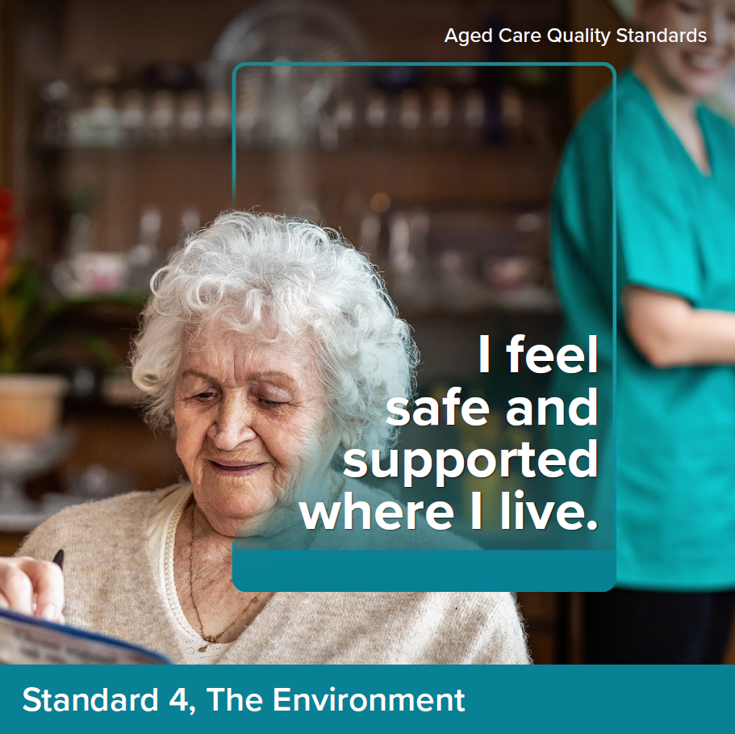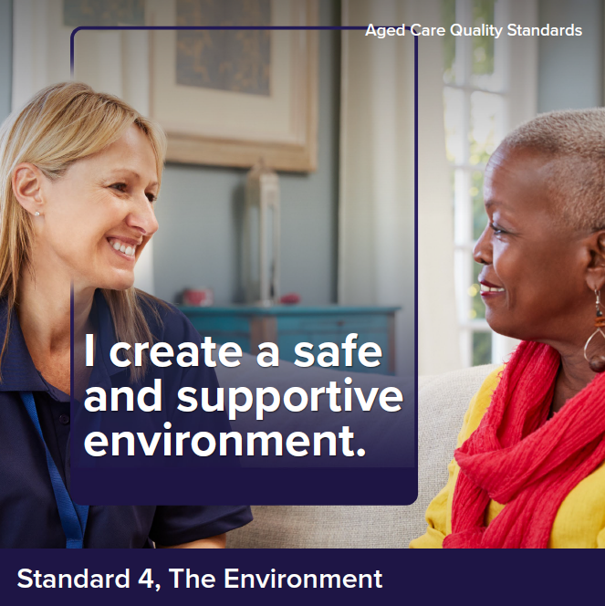

Intent of Standard 4
The intent of Standard 4 is to ensure that older people receive funded aged care services in a physical environment that is safe, supportive and meets their needs. Effective infection prevention and control measures are a core component of service delivery to protect older people, their supporters and aged care workers.

Standard 4 expectation statement for older people:
I feel safe when receiving funded aged care services. Where I receive funded aged care services through a service environment, the environment is clean, safe and comfortable and enables me to move around freely. Equipment is safe, appropriate and well-maintained and precautions are taken to prevent the spread of infections.

Outcome 4.1a: Environment – services delivered in the individual’s home
Outcome statement:
When delivering funded aged care services to individuals in their homes, the provider must support the individuals to mitigate environmental risks relevant to the services.
Where the provider uses equipment in the delivery of any funded aged care services to individuals, or provides equipment to individuals, the equipment must be safe and must meet the needs of the individuals.
Actions:
- Where funded aged care services are delivered in the individual’s home, as relevant to the services being delivered, the provider:
  - identifies any environmental risks to the safety of the individual
  - discusses with the individual any environmental risks and options to mitigate these.
- Equipment and aids provided by the provider are safe, clean, well-maintained and meets the needs of individuals.

Outcome 4.1b: Environment – services delivered other than in the individual’s home
Outcome statement:
Where the provider delivers funded aged care services to individuals other than in their homes, the provider must ensure that individuals are able to access funded aged care services in a clean, safe and comfortable environment that optimises their sense of belonging, interaction and function.
Where the provider uses equipment in the delivery of any funded aged care services to individuals, or provides equipment to individuals, the equipment must be safe and must meet the needs of the individuals.
Actions:
- The provider ensures the service environment is:
  - routinely cleaned and well-maintained
  - safe, welcoming and comfortable
  - fit-for-purpose.
- The provider ensures the service environment:
  - is accessible, including for individuals with a disability
  - promotes movement, engagement and inclusion through design
  - enables individuals to move freely both indoors and outdoors
  - unobtrusively reduces safety risks, optimises useful stimulation and is easy to navigate.
- Equipment used in the delivery of funded aged care services is safe, clean, well-maintained and meets the needs of individuals.

Outcome 4.2: Infection prevention and control
Outcome statement:
The provider must have an appropriate infection prevention and control system.
The provider must ensure that aged care workers use hygienic practices and take appropriate infection prevention and control precautions when delivering funded aged care services.
Actions:
- The provider implements a system for infection prevention and control that is used where funded aged care services are delivered, which:
  - identifies an appropriately qualified and trained infection prevention and control lead
  - prioritises the rights, safety, health and wellbeing of individuals
  - complies with contemporary, evidence-based practice
  - describes standard and transmission-based precautions appropriate for the setting, including cleaning practices, hand hygiene practices, respiratory hygiene, cough etiquette and waste management and disposal
  - ensures personal protective equipment is available to aged care workers, individuals and others who may need it
  - supports aged care workers, individuals and others who need to use personal protective equipment to correctly use personal protective equipment
  - includes additional precautions to respond promptly to novel viruses and outbreaks of infectious diseases (suspected or confirmed)
  - communicates and manages infection risks to individuals, supporters of individuals and aged care workers
  - is informed by aged care workers and individual immunisation and infection rates
  - undertakes risk-based vaccine-preventable diseases screening and immunisation for individuals and aged care workers
  - implements disease screening and immunisation requirements for visitors.

Standard 5: Clinical Care
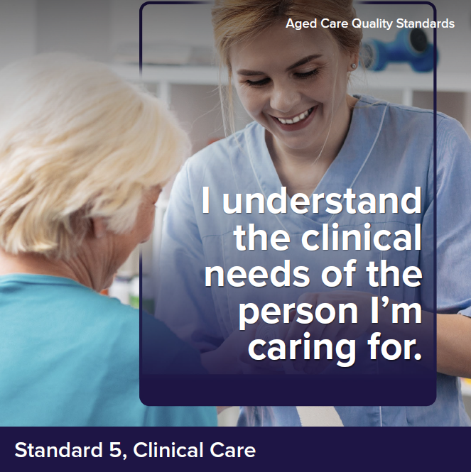

Intent of Standard 5
The Clinical Care Standard describes the responsibilities of providers to deliver safe and quality clinical care services to older people. The governing body has overall responsibility to ensure a clinical governance framework is implemented and to monitor its effectiveness in supporting aged care workers to deliver quality clinical care services. Providers operationalise the clinical governance framework and report on its performance.
Many older people who require clinical care services have multiple chronic co-morbidities and complex care needs. These people may be experiencing sickness, frailty, disability, cognitive impairment or be nearing the end of their life. Access to a range of health professionals is crucial to address these complex needs. Quality clinical care services can optimise an older person’s quality of life, reablement and maintenance of function. Improved health and wellbeing supports continued participation in activities that are enjoyable and give life meaning.
At all times, clinical care services provided should be person-centred, inclusive, safe, effective and coordinated. It should be planned and delivered in partnership with the older person, involving their supporters and others in line with the older person’s needs and preferences. Delivering safe, quality clinical care services requires a multidisciplinary approach with a skilled workforce with clear accountabilities that are supported to deliver contemporary, evidence-based care. Allied health professionals have distinct roles in reablement and maintenance of an older person’s functional capabilities.
Effective implementation of Standard 5 is reliant on the systems and processes from Standards 1–7. Standard 5 does not seek to replicate the base expectation of understanding the person in Standard 1 or the base planning, assessment and delivery expectation of Standard 3. For example, implementation of processes for advance care planning in action 3.1.6 is critical to quality clinical care, including at the end of life (action 5.7.2). These systems and processes establish a baseline expectation which supports the delivery of person-centred and safe clinical care services, ensuring that risks of harm to older people from clinical care services are minimised and support continuous quality improvement.

Standard 5 expectation statement for older people:
I receive person-centred, evidence-based, safe, effective, and coordinated clinical care services by health professionals and competent aged care workers that meets my changing clinical needs and is in line with my goals and preferences.

Outcome 5.1: Clinical governance
Outcome statement:
The governing body must meet its duty to individuals and continuously improve the safety and quality of clinical care services delivered to individuals.
The provider must integrate clinical governance into corporate governance to actively manage and improve the safety and quality of clinical care services delivered to individuals.
Actions:
- The governing body:
  - sets priorities and strategic directions for safe and quality clinical care services and ensures that these are communicated to aged care workers and individuals
  - endorses the clinical governance framework
  - monitors the safety and quality of clinical systems and performance.
- The provider implements the clinical governance framework as part of corporate governance to drive safety and quality improvement.
- The provider implements processes to ensure aged care workers providing clinical care services are qualified, competent and work within their defined scope of practice or role.
- The provider and health professionals agree on their respective roles, responsibilities and protocols for providing quality clinical care services.
- The provider works towards implementing a digital clinical information system that:
  - integrates clinical information into nationally agreed digital health and aged care records
  - supports interoperability using established national Healthcare Identifiers, terminology and digital health standards
  - has processes for aged care workers and others to access information in compliance with legislative requirements.

Outcome 5.2: Preventing and controlling infections in delivering clinical care services
Outcome statement:
The provider must ensure that individuals, aged care workers, health professionals and others are encouraged and supported to use antimicrobials appropriately to reduce risks of increasing resistance.
The provider must ensure that infection risks are minimised and, if they occur, are controlled effectively.
Actions:
- The provider implements an antimicrobial stewardship system that complies with contemporary, evidence-based practice and is relevant to the service context.
- The provider implements processes to minimise and manage infection when providing clinical care services that include, but are not limited to:
  - performing clean procedures and aseptic techniques
  - using, managing and reviewing invasive devices including urinary catheters
  - minimising the transmission of infections and complications from infections.

Outcome 5.3: Safe and quality use of medicines
Outcome statement:
The provider must encourage and support individuals, aged care workers and health professionals to use medicines in a way that maximises benefits and minimises the risks of harm.
The provider must ensure that before administering medicine to an individual, the medicine has been prescribed for the individual and medicines are appropriately and safely administered, monitored and reviewed by health professionals, considering the clinical needs and informed decisions of the individual.
The provider must ensure that medicines-related adverse events are monitored and reported and are used to inform safety and quality improvement.
Actions:
- The provider implements a system for the safe and quality use of medicines, including processes to ensure:
  - access to medicines-related information for individuals, aged care workers and health professionals
  - health professionals and others caring for an individual can access the individual’s up-to-date medicines list and other supporting information at transitions of care
  - safe administration including assessing the individual’s swallowing ability, determining suitability of crushing medicines and providing alternative safe formulations when required
  - minimal interruptions to the administration of prescribed medicines including supporting access to medicines when an individual is prescribed a new medicine or an urgent change to their medicine
  - documentation of a current, accurate and reliable record of all medicines and the clinical reasons for the treatment, including pro re nata (PRN) medicines
  - support remote access for prescribing.
- The provider has processes to ensure medication reviews are conducted including:
  - at the commencement of care, at transitions of care and annually when care is ongoing
  - when there is a change in diagnosis or deterioration in behaviour, cognition or mental or physical condition or when a person is acutely unwell
  - when there is polypharmacy and the potential to deprescribe
  - when a new medicine is commenced, or a change is made to an existing medicine or medication management plan
  - when there is an adverse event potentially related to medicines.
- The provider documents existing or known allergies or side effects to medicines, vaccines or other substances at the commencement of care and monitors and updates documentation when new allergies or side effects occur.
- The provider implements processes to identify, monitor and mitigate risks to individuals associated with the use of high-risk medicines, including reducing the inappropriate use of psychotropic medicines.
- The provider has processes to report adverse medicine and vaccine events to the Therapeutic Goods Administration.
- The provider regularly reviews and improves the effectiveness of the system for the safe and quality use of medicines.

Outcome 5.4: Comprehensive care
Outcome statement:
The provider must ensure that individuals receive comprehensive, safe and quality clinical care services that are evidence-based, person-centred and delivered by health professionals.
Clinical care delivered by the provider must encompass clinical assessment, prevention, planning, treatment, management and review to minimise harm and optimise quality of life, reablement and maintenance of function.
The provider must have systems and processes that support coordinated, multidisciplinary clinical care services that are delivered to individuals, in partnership with individuals, supporters of individuals and other persons supporting individuals, and that are aligned with the individual’s needs, goals and preferences.
The provider must support early identification of, and response to changing clinical needs.
Actions:
- The provider implements an assessment and planning system that supports partnering with the individual, supporters of the individual and other persons supporting the individual to set goals of clinical care services and support decision making.
- The provider conducts a comprehensive clinical assessment on commencement of clinical care services, at regular intervals and when needs change, that includes:
  - facilitating access to a comprehensive medical assessment with a general practitioner
  - identifying, documenting and planning for clinical risks, acute conditions and exacerbations of chronic conditions
  - identifying an individual’s level of clinical frailty and communication barriers and planning clinical care services to optimise the individual’s quality of life, independence, reablement and maintenance of function
  - identifying and providing access to the equipment, aids, devices and products required by the individual.
- The provider refers and facilitates access to relevant health professionals and medical, rehabilitation, allied health, oral health, specialist nursing and behavioural advisory services to address the individual’s clinical needs.
- The provider implements processes to:
- deliver coordinated, multidisciplinary and holistic comprehensive care in line with the care and services plan
- communicate and collaborate with others involved in the individual’s clinical care services, in line with the individual’s needs and preferences
- facilitate access to after-hours and urgent clinical care services
- provide timely notification to the individual’s general practitioner, the individual’s supporters, other persons supporting the individual and health professionals involved in the individual’s care when clinical incidents or changes occur.
- The provider implements processes to monitor clinical conditions and reassess when there is a change in diagnosis or deterioration in behaviour, cognition, mental, physical or oral health, and at transitions of care.

Outcome 5.5: Safety of clinical care services
Outcome statement:
The provider must identify, monitor and manage high impact and high prevalence risks in the delivery of clinical care services to ensure the delivery of safe, quality clinical care services and to reduce the risk of harm to individuals.
Actions:
    - The provider implements a system that supports the identification, monitoring and management of high impact and high prevalence clinical care risks, including but not limited to Actions 5.5.2 to 5.5.10.
Choking and swallowing
    - The provider implements processes to support safe chewing and swallowing when the individual is eating, drinking, taking oral medicines and during oral care.
Continence
    - The provider implements processes for continence care by:
  - optimising the individual’s dignity, comfort, function and mobility
  - ensuring safe and responsive assistance with toileting
  - managing incontinence
  - protecting the individual’s skin integrity and minimising incontinence associated dermatitis.
Falls and mobility
    - The provider implements processes to minimise falls and harm from falls by:
  - maximising mobility to prevent functional decline
  - delivering effective and timely post falls care
  - monitoring falls and injuries and reviewing the reasons for and consequences from falls.
Nutrition and hydration
    - The provider implements processes to maintain an individual’s nutrition and hydration by:
  - conducting regular malnutrition screening
  - minimising the impact of chronic conditions
  - responding to the risk of malnutrition and when an individual is malnourished or has unplanned weight loss or gain.
Mental health
    - The provider implements processes to optimise mental health by:
- actively promoting an individual’s mental health and wellbeing
- responding to signs of deterioration in an individual’s mental health
- responding supportively to distress and symptoms of mental illness including self-harm and suicidal thoughts minimising risks to the psychological and physical safety of each individual.
Oral health
    - The provider implements processes to maintain oral health and prevent decline by:
  - facilitating access to a dentist or other oral health practitioner for oral health assessments at the commencement of care, regularly and when required
  - monitoring and responding to deterioration in oral health
  - assisting with daily oral hygiene needs.
Pain
    - The provider implements processes to manage pain by:
  - assessing the individual’s pain including where the individual experiences challenges in communicating their pain
  - planning for, monitoring and responding to the individual’s need for pain relief
  - ensuring pain management is available 24-hours a day.
Pressure injury and wounds
    - The provider implements processes to prevent and manage pressure injuries and wounds by:
  - conducting routine comprehensive skin inspections
  - monitoring and responding to pressure injuries and wounds when they occur.
Sensory Impairment
    - The provider implements processes to minimise and manage sensory impairment from hearing loss, vision loss and balance disorders by providing access to and supporting the use of assistive devices and aids to maximise the individual’s independence, function and quality of life.

Outcome 5.6: Cognitive impairment
Outcome statement:
The provider must ensure that individuals who experience cognitive impairment (whether acute, chronic or transitory) receive comprehensive clinical care services that optimise clinical outcomes and are aligned with their clinical needs, goals and preferences.
The provider identifies situations and events that may lead to changes in behaviours.
Actions:
    - The provider identifies and responds to the complex clinical care needs of people with delirium, dementia and other forms of cognitive impairment by:
  - identifying and mitigating clinical risks
  - delivering increased care requirements
  - being alert to deterioration and underlying contributing clinical factors.
    - The provider collaborates with individuals with cognitive impairment and supporters of individuals to understand the individual and to optimise clinical care outcomes.
    - The provider implements processes to:
  - identify and minimise situations that may precipitate changes in behaviour
  - identify and respond to clinical and other identified causes of changes in behaviour.

Outcome 5.7: Palliative care and end-of-life care
Outcome statement:
The provider must recognise and address the needs, goals and preferences of individuals for palliative care and end-of-life care, and must preserve the dignity of individuals in those circumstances.
The provider ensures that the pain and symptoms of individuals are actively managed, with access to specialist palliative and end-of-life care when required.
The provider must ensure that supporters of individuals and other persons supporting individuals are informed and supported, including during the last days of life.
Actions:
    - The provider has processes to recognise when the individual requires palliative care or is approaching the end of their life, supports them to prepare for the end-of-life and responds to their changing needs and preferences.
    - The provider supports the individual, supporters of the individual and other persons supporting the individuals and substitute decision maker, to:
  - continue end-of-life planning conversations
  - discuss requesting or declining aspects of personal care, life-prolonging treatment and responding to reversible acute conditions
  - review advance care planning documents to align with their current needs, goals and preferences.
    - The provider uses its processes from comprehensive care to plan and deliver palliative care that:
- prioritises the comfort and dignity of the individual
- supports the individual’s spiritual, cultural and psychosocial needs
- identifies and manages changes in pain and symptoms
- provides timely access to specialist equipment and medicines for pain and symptom management
- communicates information about the individual’s preferences for palliative care and the place where they wish to receive this care to aged care workers, supporters of individuals and other persons supporting individuals
- facilitates access to specialist palliative care and end-of-life health professionals when required
- provides a suitable environment for palliative care
- provides information about the process when an individual is dying and about loss and bereavement to supporters of individuals and other persons supporting individuals.
    - The provider implements processes in the last days of life to:
  - recognise that the individual is in the last days of life and respond to rapidly changing needs
  - ensure medicines to manage pain and symptoms, including anticipatory medicines, are prescribed, administered, reviewed and available
24-hours a day
  - provide pressure care, oral care, eye care and bowel and bladder care
  - recognise and respond to delirium
  - minimise unnecessary transfer to hospital, where this is in line with the individual’s preferences.

Standard 6: Food and Nutrition

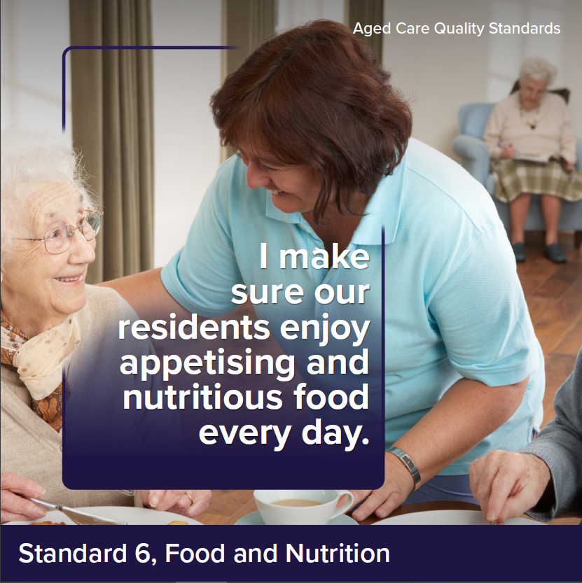

Intent of Standard 6
Access to nutritionally adequate food is a fundamental human right. Food, drink and the dining experience can have a huge impact on a person’s quality of life. As people age, they may lose their appetite or experience conditions that impact on their ability to eat and drink. As such, it is particularly important that providers engage with older people about what and how they like to eat and drink, deliver choice and meals that are full of flavour, appetising and nutritious (including for older people with texture modified diets), and support older people to consume as much as they want and exercise dignity of risk.
In many cultures, food also plays a large role in fostering feelings of inclusion and belonging. The experience of sharing food and drink with other older people and their supporters is important for many older people.
Providers must draw on Standard 3 in delivering food services to ensure this is informed by robust assessment and planning and funded aged care services are delivered in line with the needs, goals and preferences of older people. It is also critical for providers to monitor older people for malnutrition and dehydration and respond appropriately where concerns are identified – this is addressed as part of Standard 5.
Standard 6 is intended to apply only to residential care homes.

Standard 6 expectation statement for older people:
I receive plenty of food and drinks that I enjoy. Food and drinks are nutritious, appetising and safe, and meet my needs and preferences. The dining experience is enjoyable, includes variety and supports a sense of belonging.

Outcome 6.1: Partnering with individuals on food and drinks
Outcome statement:
The provider must partner with individuals to deliver a quality meal and refreshment service that includes appealing and varied food and drinks and an enjoyable dining experience.
Actions:
- The provider must partner with individuals on how to create enjoyable food, drinks and dining experiences at the service.
- The provider implements a system to monitor and continuously improve the food service in response to:
  - the satisfaction of individuals with the food, drink and the dining experience
  - individuals’ intake of food and drink to ensure it meets their nutritional needs (including review of identified unplanned weight loss and malnutrition identified in Standard 5)
  - the impact of food and drink on the health outcomes of individuals
  - contemporary, evidence-based practice regarding food and drink.

Outcome 6.2: Assessment of nutritional needs and preferences
Outcome statement:
The provider must demonstrate that the provider understands the specific nutritional needs of individuals and assesses the current needs, abilities and preferences of individuals in relation to what and how they eat and drink.
Actions:
- As part of assessment and planning, the provider assesses and regularly reassesses each individual’s nutrition, hydration and dining needs and preferences. The assessment considers:
  - the specific nutritional needs of individuals, including a focus on protein and calcium rich foods
  - the individual’s dining needs
  - what the individual likes to eat and drink
  - when the individual likes to eat and drink
  - what makes a positive dining experience for the individual
  - clinical and other physical issues identified that impact the individual’s ability to eat and drink.

Outcome 6.3: Provision of food and drinks
Outcome statement:
The provider must provide individuals with food and drinks that meet their nutritional needs and are appetising and flavoursome, have variation and choice about what they eat and drink and choice about how much they eat and drink.
Actions:
- Menus (including for texture modified diets):
  - are designed in partnership with individuals
  - are developed with the input of chefs, cooks and an Accredited Practising Dietitian, including for individuals with specialised dietary needs
  - are regularly changed, include variety and enable individuals to make choices about what they eat and drink
  - enable individuals to meet their nutritional needs
  - are reviewed at least annually through a menu and mealtime assessment by an Accredited Practising Dietitian.
- For each meal, individuals can exercise choice about what, when, where and how they eat and drink.
- Meals, drinks and snacks provided to individuals (including where individuals have specialised dietary needs or need support to eat):
  - are appetising and flavourful
  - are served at the correct temperature and in an appealing way, including the presentation of texture modified foods using tools such as moulds
  - are prepared and served safely
  - meet each individual’s assessed needs
  - are in accordance with each individual’s choice
  - reflect the menu.
- Individuals are offered and able to access nutritious snacks and drinks (including water) at all times.

Outcome 6.4: Dining experience
Outcome statement:
The provider must support individuals to eat and drink.
The provider must ensure that the dining experience meets the needs and preferences of individuals to support social engagement, function and quality of life.
Actions:
- The provider supports individuals to eat and drink, including by:
  - making sufficient aged care workers available to support individuals to eat and drink
  - prompting and encouraging individuals to eat and drink
  - identifying individuals who require support to safely eat or drink
  - physically supporting individuals who require support to safely eat and drink as much as they want, at their preferred pace.
- The dining environment supports reablement, social engagement and a sense of belonging and enjoyment.
- There are opportunities for individuals to share food and drinks with their visitors.

Standard 7: The Residential Community
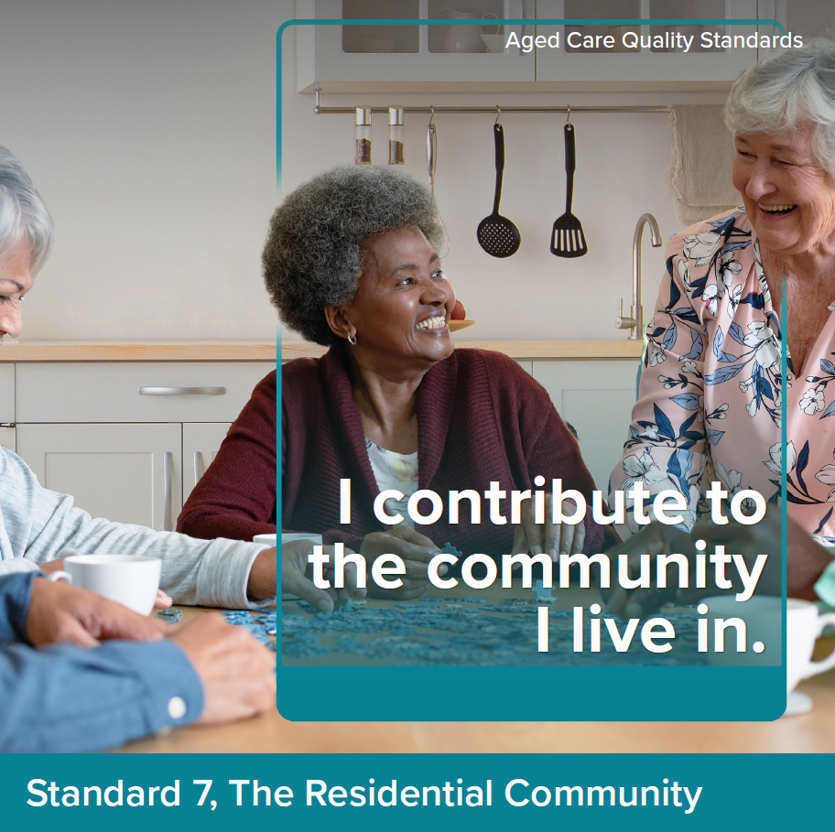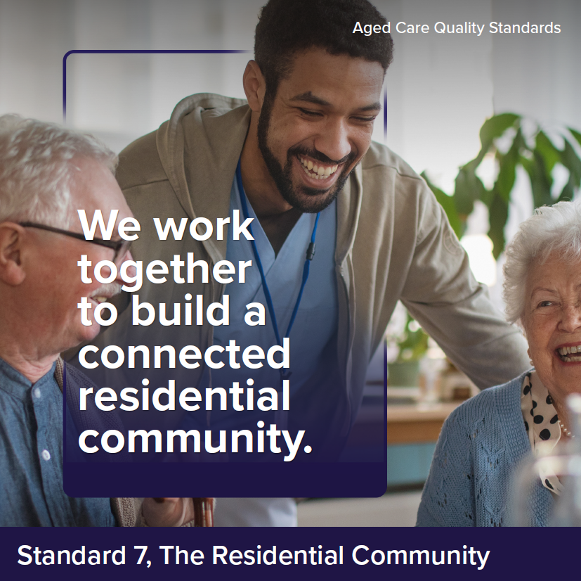

Intent of Standard 7
When people move into a residential care home, the residential community becomes a central feature of their lives. It is critical that older people feel safe and at home in the residential community, have opportunities to do things that are meaningful to them and are supported to maintain connections with people important to them. Meaningful activities can include participating in hobbies or community groups, seeing friends and family or activities that contribute to the residential community such as gardening, cooking and setting tables.
A residential community can involve diverse members from different cultures and backgrounds. It is important that each older person's culture is respected, and their diversity valued so they feel included, safe and at home in the service.
Given the scope of responsibility in residential care, providers also have increased requirements to ensure that older people have access to other services and to coordinate a planned transition to or from the service to maximise continuity of care for older people.
Standard 7 is intended to apply only to residential care homes.

Standard 7 expectation statement for older people:
I am supported to do the things I want and to maintain my relationships and connections with my community. I am confident in the continuity of my care and security of my accommodation.

Outcome 7.1: Daily living
Outcome statement:
The provider must ensure that individuals receive funded aged care services that optimise their quality of life, promote use of their skills and strengths and enable them to do the things they want to do.
The provider must ensure that individuals feel safe in their residential care home.
Actions:
- The provider supports and enables individuals to do the things they want to do, including to:
  - participate in lifestyle activities that reflect the diverse nature of the residential community
  - promote their quality of life
  - minimise boredom and loneliness
  - maintain connections and participate in activities that occur outside the residential community
  - have social and personal relationships
  - contribute to their community through participating in meaningful activities that engage the individual in normal life.
- The provider has processes to identify, monitor and record individuals function in relation to activities of daily living.
- The provider implements strategies to protect the physical and psychological safety of individuals.
- Individuals have control over who goes into their room and when this happens.
- Individuals can entertain their visitors in private.
- Individuals can maintain relationships of choice free from judgement, including intimate relationships, and engage in sexual activity.

Outcome 7.2: Transitions
Outcome statement:
The provider must ensure that individuals experience a well-coordinated transition, whether planned or unplanned, to or from a provider.
The provider must set out clear responsibility and accountability for the delivery of funded aged care services between aged care workers, health professionals and across organisations.
Actions:
- The provider has processes for transitioning individuals to and from hospital, other care services and stays in the community, and ensures that:
  - use of hospitals or emergency departments are recorded and monitored
  - there is continuity of care for the individual
  - individuals and supporters of individuals as appropriate, are engaged in decisions regarding transfers
  - supporters of individuals, health professionals or organisations are given timely, current and complete information about the individual as required
  - when the individual transitions back to the service, their funded aged care services are reviewed and adjusted as needed.
- The provider facilitates access to services offered by health professionals, other individuals or organisations when it is unable to meet the individual’s needs.
- The provider maintains connections with specialist health services, including specialist dementia care services, and accesses these services as required.

 | Phone 1800 200 422  (My Aged Care’s freecall phone line)
 | Visit agedcareengagement.health.gov.au
For translating and interpreting services, call 131 450 and
ask for My Aged Care on 1800 200 422.
To use the National Relay Service, visit nrschat.nrscall.gov.au/nrs
or call 1800 555 660.

