# **Closing the Gap Social and Emotional Wellbeing Policy Partnership – Meeting #6 Communique**

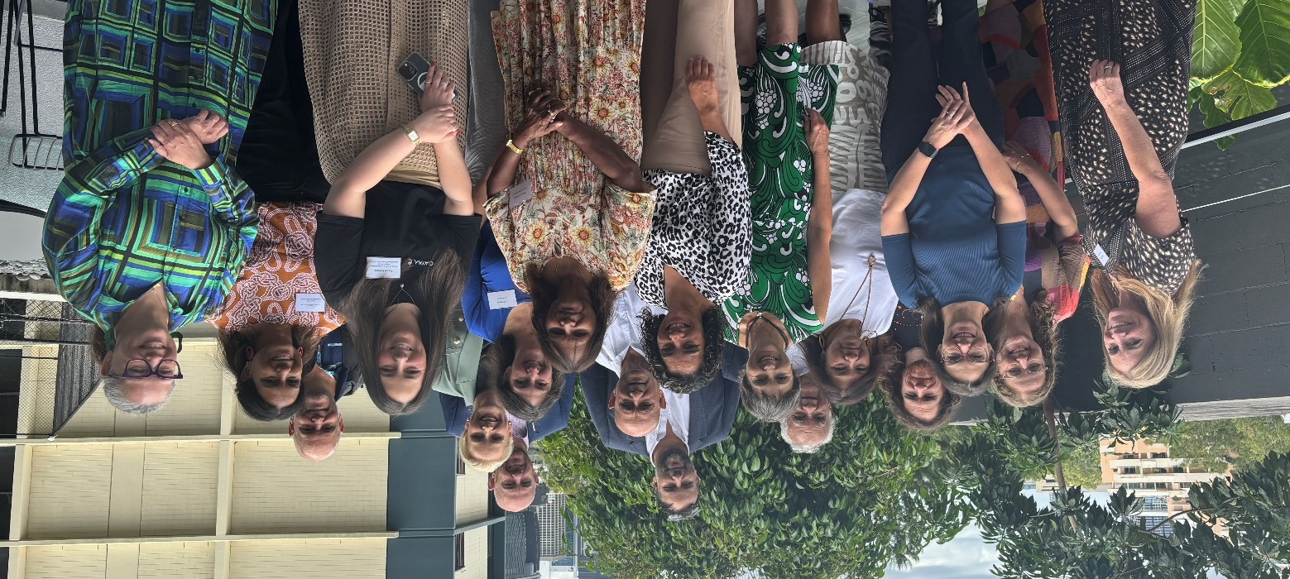

Back row: Matthew Trindall, Kurt Towers

Middle row: Dr Paul Gray, Prof Tom Calma AO, Michael Mitchell, Dr Liz Develin, Zaccariah Cox,

Front row: Sandra Eyre, Kristen Price, Emma Gleeson, Monica Barolits-McCabe, Kate Garvey, Danielle Dyall, Deborah Woods, Liz Prouse, Rachel Fishlock, Leonie Williamson, Julie-Ann Guivarra

The Social and Emotional Wellbeing Policy Partnership (SEWB Policy Partnership) held its sixth meeting on 18 and 19 February 2025, on the lands of the Turrbal and Jagera (Yuggera) people in Meanjin (Brisbane). It was co-chaired by Professor Pat Dudgeon AM, Board member, Gayaa Dhuwi (Proud Spirit) Australia (Gayaa Dhuwi) (out-going Aboriginal and Torres Strait Islander Co-Chair), Dr Clinton Schultz, Board member, Gayaa Dhuwi (Proud Spirit) Australia (in-coming Aboriginal and Torres Strait Islander Co-Chair) and Dr Liz Develin, Deputy Secretary, Department of Health and Aged Care (Government Co-Chair).

Members welcomed Professor Tom Calma AO, Patron of Gayaa Dhuwi, to set the scene for the two-day event and the forward work of the policy partnership.

Day 1 of the meeting was followed by the launch of the [*Gayaa Dhuwi Declaration Framework and Implementation Plan*](https://www.gayaadhuwi.org.au/wp-content/uploads/2025/02/GDPSA-Implementation-Plan_WEB.pdf)*.* The document was launched by Professor Tom Calma AO, Professor Helen Milroy AM, Dr Liz Develin and Dr Sophie Davison, and emceed by Dr Clinton Schultz.

## **Member updates**

* Government members reported on progress against the Priority Reforms of the National Agreement on Closing the Gap.
* Aboriginal and Torres Strait Islander members brought forward progress and concerns about constraints with respect to contributing to Target 14 of the National Agreement on Closing the Gap.
* Members noted the recent launch of the *National Aboriginal and Torres Strait Islander Suicide Prevention Strategy.*
* These updates provided members the opportunity to share key initiatives and identify linkages to the *National Agreement on Closing the Gap*, highlighting ways in which Aboriginal and Torres Strait Islander peoples’ wellbeing is being improved through their work.

**Workshops**Members:

* participated in a strengths-based activity that delivered insights into the ways in which the SEWB Policy Partnership members work together to effectively improve wellbeing for Aboriginal and Torres Strait Islander peoples,
* members reflected on system changes and were challenged to consider the dominant ways of thinking to ensure the Policy Partnership is positioned to provide strong policy advice and recommendations.
* reflected on interlinkages and reaffirmed a commitment to ensuring Aboriginal and Torres Strait Islander voices are heard in the implementation and monitoring of the National Mental Health and Suicide Prevention Agreement,
* discussed interdisciplinary responses across government at all levels – ensuring services are treating the person, not just the illness / symptoms, and
* consolidated their understanding of the differences and intersections between social and emotional wellbeing and mental health.

**Presentations**The SEWB Policy Partnership welcomed presentations from:

* Leonie Williamson, Deputy CEO of the Healing Foundation, sharing feedback from Stolen Generations organisations,
* Associate Professor Graham Gee on measuring Social and Emotional Wellbeing (SEWB),
* Karly Warner and Tamsyn Harvey, Co-Chairs of the Justice Policy Partnership on work and key priorities, including better integrated policy making with the SEWB Policy Partnership,
* Dr Sandra Diminic (The University of Queensland) and Ruth Davy (Australian Institute of Health and Welfare) on the National Mental Health Service Planning Framework, and
* Department of Health and Aged Care on progress towards the establishment of the National Early Intervention Service (NEIS).

These workshops and presentations provided opportunities for collaboration with other policy partnerships and provided members with insights from jurisdictions and other sectors to enhance their knowledge and understanding.

## **Key decisions made by the Partnership**

1. Endorsed the final draft of the refreshed **National Strategic Framework for Aboriginal and Torres Strait Islander Peoples’ Mental Health and Social and Emotional Wellbeing 2025-2035** (the SEWB Framework) and agreed for this to progress to Joint Council following jurisdictional endorsement. Members agreed to review the accompanying **Implementation Plan** with a view to incorporate a more refined accountability mechanism.
2. Endorsed key enablers and next steps towards a **Commissioning Framework**, which, amongst other things, will ensure that when services are commissioned, they are done in keeping with the Priority Reforms within the *National Agreement on Closing the Gap.* 
   1. These key enablers are: Aboriginal and Torres Strait Islander governance and leadership, holistic approach and application of social and emotional wellbeing, and culturally safe and
   2. responsive framework and system.
3. Agreed that as part of the priorities of the SEWB Policy Partnership going forward, the **needs of youth will be a much greater focus**.
4. Discussed the **Small Initiatives Funding Workplan**, to support a range of enabling activities to be agreed by the SEWB Policy Partnership and managed by Gayaa Dhuwi. This includes a greater focus on youth, consistent with the priorities of the SEWB Policy Partnership.
5. Endorsed updates to the **Agreement to Implement the Social and Emotional Wellbeing Policy Partnership**, including reflecting new chairing arrangements appointing the new Aboriginal and Torres Strait Islander Co-Chair, Dr Clinton Schultz and Rachel Fishlock, CEO of Gayaa Dhuwi as Deputy Co-Chair, and noting other recent changes to the Government and Peaks membership.

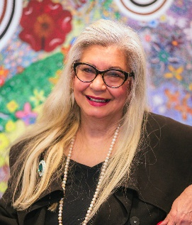

The SEWB Policy Partnership noted their deep appreciation and thanks to the out-going Co-Chair, Professor Pat Dudgeon AM.

Under Professor Dudgeon’s leadership, the SEWB Policy Partnership was established and undertook a range of high-profile activities. She played a key role in developing the partnership’s Strategic Plan, progressing the refresh of the *National Strategic Framework for Aboriginal and Torres Strait Islander Peoples’ Mental Health and Social and Emotional Wellbeing*, and developing and endorsing the *National Aboriginal and Torres Strait Islander Suicide Prevention Strategy*.

The SEWB Policy Partnership will meet again in Hobart in May 2025, and looks forward to hearing local stories and ways of knowing, being, and doing.