Review of the National Strategic Framework for Chronic Conditions

Australian Government Department of Health and Aged Care

Final Report (Summary)

Submitted to the Department of Health and Aged Care on 15 December 2023

Table of contents

1

Executive Summary 2

Background 2

Aims of the Review 3

Review Approach 4

Key findings 4

Recommendations to inform the refresh of the NSFCC 7

Conclusion 10

Executive Summary

In September 2023, the Australian Government Department of Health and Aged Care (the ‘Department’) engaged Ernst & Young (‘EY’) to conduct a review (the ‘Review’) of the National Strategic Framework for Chronic Conditions (the ‘NSFCC’), its related Action Plans (of which there are 11) and the National Asthma Strategy 2018 (the ‘Strategy’).

Findings from the Review will inform future work by the Department to refresh the NSFCC to provide greater impact at a national, state / territory, consumer and community level.

Background

The increasing burden of chronic conditions is recognised as a global health issue that requires targeted action. Chronic conditions are currently the leading cause of illness and disability in Australia; and they have significant health, social, and broader economic impacts. In 2022, 49.9% of Australians had one or more chronic conditions, and 21.9% had two or more chronic conditions (Australian Bureau of Statistics, 2022)[1]. Individuals with chronic conditions often require frequent use of health services and medicines which strains the health system budget as well as service and workforce capacity (Department of Health and Aged Care, 2021).[2]

A range of factors influence the health and wellbeing of the Australian population, and the likelihood of having one or more chronic conditions; these factors are categorised as behavioural risk factors (e.g. smoking, diet), biomedical risk factors (e.g. high blood pressure, obesity), non-modifiable risk factors (e.g. age, genetics), physical environmental determinants (e.g. air pollution, geographic location), and social and economic determinants (e.g. education, employment status) (Department of Health and Aged Care, 2021).[3]

Priority populations include several different groups within society who experience a disproportionate burden of disease, leading to differences in health outcomes and life expectancy. These include, but are not limited to: Aboriginal and Torres Strait Islander people; people from culturally and linguistically diverse backgrounds; older Australians; carers of people with chronic conditions; people experiencing socio-economic disadvantage, people living in remote, or rural and regional locations; people with disability; people with mental illness; and people who are, or who have been, incarcerated (Department of Health and Aged Care, 2021).[4]

This inequitable burden of disease is not due to personal fault or responsibility. The World Health Organisation recognises that the main causes are a result of social inequality and social disadvantage. While individuals from these groups may not be physically ill, they are often unable to fully participate in their health and may be resisting or recovering from a crisis or illness.

In 2017, the NSFCC was developed and launched by the Council of Australian Government (COAG) Health Council to provide high-level guidance to work towards a national response to chronic conditions that is effective and coordinated. The NSFCC recognises that many chronic conditions share similar principles for prevention and management, and thus is designed to:

* Move away from a disease-specific approach to prevent and manage chronic conditions.
* Enable greater coordinated management of care that embeds preventive actions throughout the health system.
* Address the underlying social determinants of health that impact priority populations, including Aboriginal and / or Torres Strait Islander people, people experiencing socio-economic disadvantage, and people living in regional, rural or remote locations.

The NSFCC is supported by a wider set of policies and strategies focused on chronic conditions and broader health outcomes – including *Australia’s Long Term National Health Plan,* the *National Preventive Health Strategy 2021-2030,* the *Strengthening Medicare Taskforce Report* and *Australia’s Primary Health Care 10 Year Plan 2022-2032*. The NSFCC provides high level guidance to facilitate an effective and coordinated national response to chronic conditions by aiming to achieve three objectives:

* A focus on prevention for a healthier Australia.
* Provide efficient, effective and appropriate care to support people with chronic conditions to optimise quality of life.
* Target priority populations (as described above).

Since the implementation of the NSFCC, 11 chronic condition-specific Action Plans and two strategies have been finalised; these align with and complement the NSFCC and its objectives and were authored by peak bodies representing the specific condition / disease groups, in consultation with stakeholders. They are intended for collective ownership, direction and action amongst all stakeholders, with implementation being a shared responsibility between the Commonwealth and chronic condition stakeholders.

The Australian Institute of Health and Welfare (AIHW) was engaged by the Department in 2018 to develop a reporting framework to assist in monitoring the impact of the NSFCC[5] (Australian Institute of Health and Welfare, 2022).[6] It contains 45 indicators to monitor collective, national progress against the three objectives of the NSFCC (as described above) using largely publicly available data. A report was released in 2022, which provided results for each of the indicators (Australian Institute of Health and Welfare, 2022)[7]. While it provides a baseline for a range of measures relating to chronic conditions in Australia, a follow-up report would be needed to examine the impact of the NSFCC on chronic conditions over time[8].

Aims of the Review

EY was engaged by the Department to undertake a review (the ‘Review’) of the achievements and lessons learnt against the NSFCC, and complementary Action Plans and Strategies[9]. The findings of the Review will inform future work by the Department to refresh the NSFCC (scheduled for 2025) to provide greater impact at a national, state / territory, consumer and community level. The Review answered the questions below:

1. What difference is the NSFCC (focusing on objectives and Strategic Priority Areas) making?
2. How effective has the implementation of the NSFCC been to date and what can we learn from it?
3. What difference are the Action Plans and Strategy making?

Review Approach

A rigorous and systematic approach, guided by a Review Framework was taken to conduct the Review. It included a desktop review and consultations with stakeholders. A highly structured approach was used to enable the large amount of relevant documentation to be coded to answer Review questions. All identified information was reviewed and collated in Microsoft Excel. Data were analysed according to the process outlined in Figure 1, according to Review questions and sub-questions.

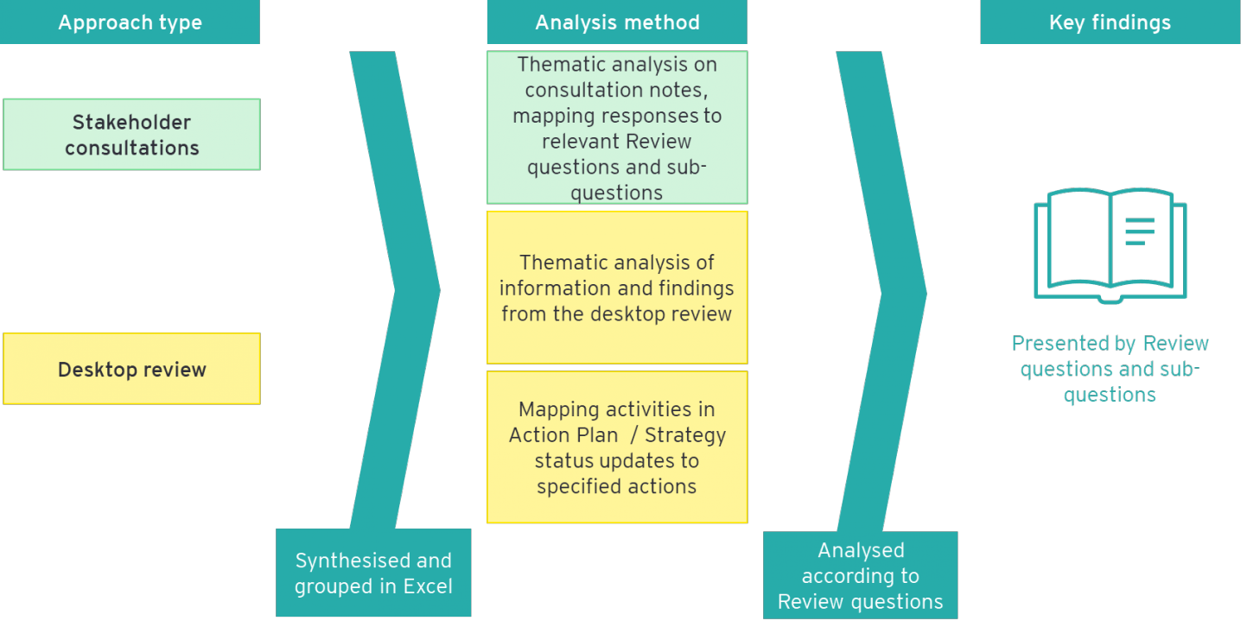Figure 1: Approach to data analysis

Key findings

This section presents a summary of findings against each of the overarching Review questions.

Q1: What difference is the NSFCC making?

The NSFCC was found to enable activities related to its objectives and Strategic Priority Areas to varying degrees. Despite a high level of awareness of the NSFCC from policy stakeholders, this did not correspond with actual use of the NSFCC. There was concern that the NSFCC may fuel the unintended outcomes of more siloed disease-specific activity and wariness of collaboration due to funding competition.

Although there were no comprehensive outcomes available to contribute to this Review[10], the NSFCC was found to enable activities related to its objectives and Strategic Priority Areas (SPAs). The *extent* to which it enabled these activities, and the *impact* of those activities is not yet clear. Activities that appeared to be enabled by the NSFCC[11] were mostly those aligned to Objective 1 (which focuses on prevention) and Objective 3 (which focuses on targeting priority populations). Whereas providing appropriate care appeared to be more enabled by broader initiatives. A summary of findings, with some high-level examples, are provided in Table 1.

Table 1: Summary of progress of the chronic conditions sector relative to the NSFCC’s Strategic Priority Areas [12]

|  |  |
| --- | --- |
| **Objective 1: Focus on prevention for a healthier Australia** | **Objective 3: Target priority populations** |
| * SPA 1.1 Promote health and reduce risk: Progressed through increased availability of evidence-based resources and awareness activities. * SPA 1.2 Partnerships for health: The creation of the NSFCC has resulted in stronger partnerships within disease sectors, inviting collaborative approaches to common goals. * SPA 1.3 Critical life stages: Activities focused on education programs for young people as a critical life stage, with progress seen in prevention for this group. * SPA 1.4 Timely and appropriate detection and intervention: Progressed through programs that seek to increase risk-assessment and evidence-based screening for timely detection of chronic conditions. | * SPA 3.1 Aboriginal and Torres Strait Islander health: Progress towards developing more culturally safe information / treatment for Aboriginal and Torres Strait Islander people, developing a more culturally safe workforce and, to some extent, tailoring service models. * SPA 3.2 Action and empowerment: There are tailored resources for culturally and linguistically diverse communities – in particular translated education and awareness materials. |
| **Objective 2: Provide efficient, effective and appropriate care to support people with chronic conditions to optimise quality of life** |
| * SPA 2.1 Active engagement: Development and improvement of resources to educate and inform individuals about their condition, and programs delivered to individuals to enhance their ability to self-manage their condition. * SPA 2.2 Continuity of care: Multiple Action Plans identified the need to develop innovative models of care to enable the continuity of care, with evidence of this occurring. * SPA 2.3 Accessible health services: Progress has been achieved across multiple conditions and sections of the health system. * SPA 2.4 Information sharing: Gradual progress related to information sharing continues to be made – e.g. My Health Record, Epilepsy Action Australia partnering with Healthshare. * SPA 2.5 Supportive systems: Investment seen in alternative funding models and innovative models of care such as collaborative commissioning in New South Wales and the Australian Capital Territory. MyMedicare may set the foundations to introduce blended funding models and more supportive systems in primary care and the Medicare Benefits Schedule has continued to be refined. |

Representatives from each Australian state and territory health department were consulted to explore this question further. Key findings include:

* While there was high awareness of the NSFCC across most of the Australian jurisdictional health departments, this did not correspond with high use in most cases. In an instance where a jurisdiction had awareness and implemented the Framework within their own jurisdiction, the NSFCC helped shape holistic approaches focused on, or impacting on, chronic conditions.
* Some jurisdictions noted that the NSFCC was a useful lever to support investment under state and territory-level chronic condition policies, being used as evidence in funding proposals that the actions of states and territories align with federal priorities.
* In the cases where it was not used, the reasons included being overshadowed by more recent or existing national[13] and / or local policies, lack of funding incentives to use it and the absence of a national collaborative response (which in turn, reduced the scope for shared learnings).

Key barriers to leveraging the NSFCC and / or achieving its intended outcomes are provided in Figure 2. While these are similar to the barriers and enablers of implementing the Action Plans and Strategy, they have a system level impact, and are not confined to any specific condition.

Figure 2: Enablers and barriers to leveraging the NSFCC and / or achieving its intended outcomes

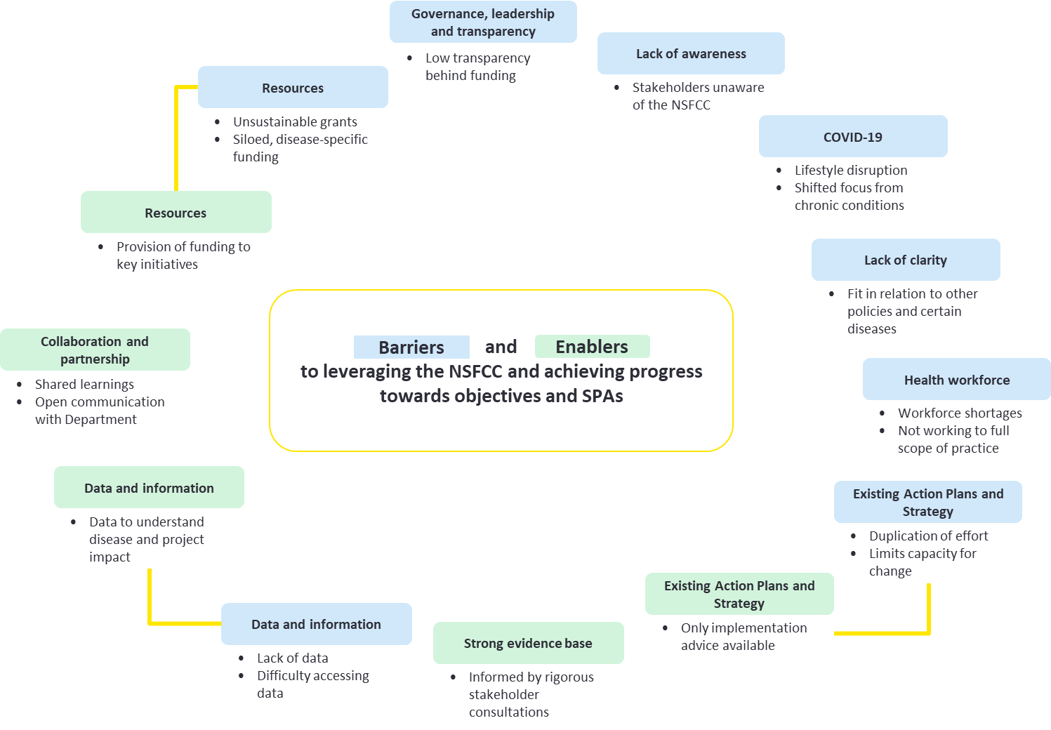

Finally, unintended outcomes that were reported from the development and implementation of the NSFCC include:

* **Siloed activity** because of multiple disease-specific Action Plans and Strategies – leading to duplication of effort and missed opportunities to have a wider impact.
* **Competition across the sector for funding** leading to wariness of forming partnerships with other organisations vying for the same funding pool.
* **Feelings of exclusion** from certain peak bodies and chronic condition-focused stakeholders who reported that the NSFCC did not represent their condition. This may be a product of the non-disease specific intent of the NSFCC with limited detail included applicable to conditions with unique characteristics, such as neurological conditions.

Q2: How effective has implementation of the NSFCC been to date and what can we learn from it?

**The duality of the NSFCC as a guiding policy document and an actionable framework limits the extent to which the NSFCC has been implemented as intended. The absence of measurable actions in the NSFCC has made it challenging to implement and measure progress. Actions and interventions to support achievement of the phase 1, 2 and aspirational outcomes are implied within the NSFCC, however these are not linked to Framework-exclusive measures and therefore impossible to confirm if the outcome is driven under the NSFCC or through other drivers. Related, but distinct, actions are detailed in disease-specific Action Plans / Strategies, which appears to have contributed towards a fragmented implementation at a disease-specific level. Despite this, the NSFCC has helped the sector prioritise investment and support for chronic conditions.**

To a large extent, the NSFCC and associated Action Plans / Strategy have enabled the sector to prioritise investment and support for chronic conditions in alignment with the NSFCC. The Action Plans and Strategy have also guided peak bodies to identify evidence-based priority areas relevant to their chronic condition, which has led to prioritised investment into certain actions.

While the NSFCC seeks to move away from a disease-specific approach, funding has been provided in such a way that activities have been separated by disease, reinforcing a disease-specific approach to prevention and management. This is evident in grants provided by the Department, which have predominantly supported initiatives related to specific conditions rather than targeting shared risk factors or multi-disease approaches. Other key points include:

* The NSFCC identifies key principles for effective prevention and management, however, there are opportunities for further promotion and awareness of the NSFCC by both Government and non-government organisations. This is likely to have limited its ability to shape actions in the chronic condition sector.
* The NSFCC supports stronger emphasis on coordinated care, however the area of the Department with responsibility for Chronic Conditions policy is not principally responsible for care coordination. A small number of contracts and funding agreements have supported projects that aim to improve care coordination, but these are in the minority.
* Consultations with state and territory stakeholders revealed that it was challenging to implement the NSFCC at a state and territory level, despite desire to be in alignment with the NSFCC, as there was not funding directly tied to it. As such, much of the funding at a federal and state level is directed towards traditional awareness and education activities, with few innovative coordinated care approaches.

Q3: What difference are the Action Plans and Strategy making?

**Overall, there is evidence of progress towards completing the activities which have been designed to achieve the intended outcomes of the Action Plans and Strategy. Greater progress was associated with the size of the author organisation, with most of the Action Plans and Strategy of larger and more highly resourced organisations progressing with more activities. The main enabler of progress was cross-organisation collaboration, while the main barriers to progress were the COVID-19 pandemic and issues related to the health workforce (such as training, turnover and engagement of General Practitioners (GPs)).**

The Action Plans and Strategy were intended to complement the NSFCC by guiding and prioritising work related to specific conditions by partner organisations. Their goals align with the objectives of the NSFCC and aim to improve the health outcomes and quality of life for Australians with chronic conditions and their families and carers, including a focus on priority populations.

The activities, actions, and intended outcomes vary considerably between each of the Action Plans / Strategy. Of the 11 Action Plans and the Strategy, four were associated with strong progress towards completing activities designed to achieve their intended outcomes; the others showed some progress. Three of the four Action Plans / Strategy associated with strong progress were generally authored by large organisations and were based on chronic conditions with an existing high public profile.

Those identified as having made ‘some’ progress appear to be driven by common barriers, such as resourcing and infrastructure and limited internal capacity and capability to implement programs / activities relating to clinical models, digital solutions and support for recovery. Collaborative partnerships within the sector, including with consumers to understand needs and co-design solutions, was an important enabler to implementing the Action Plans and Strategies.

Recommendations to inform the refresh of the NSFCC

Using the information gathered and analysed for this Review, seven key recommendations have been developed to inform the future refresh of the NSFCC. A snapshot of these is provided in Figure 3, and described in more detail below.

Figure 3: Timeline of Recommendations to inform the refresh of the NSFCC

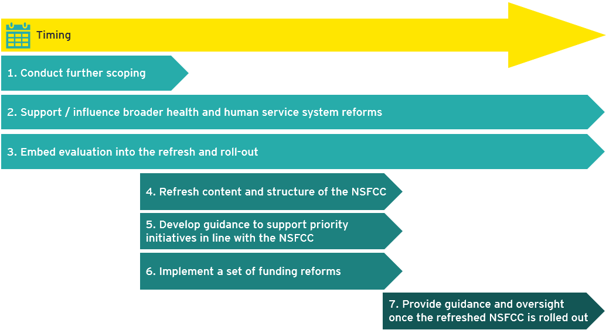

**Recommendation 1: Conduct further scoping.** This includes:

* Pursuing a public open consultation process to gather the diverse perspectives, experiences and knowledge of stakeholders and interested members of the community to inform the future refresh of the NSFCC. Open consultation could involve developing Objective 3 (priority populations) by gaining a greater understanding from those with lived experience.
* Engaging broadly across the Department of Health and Aged Care to consider common goals and areas of overlap with work supporting chronic conditions prevention and management. Engagement across the Department will strengthen the cohesion and consistency of federal responses to chronic conditions.

**Recommendation 2: Support / influence broader health and human service system reforms**, including:

* Data reforms to improve the maturity and breadth of data collection to adequately capture information on chronic conditions, the social determinants of health and health behaviours.
* Reforms to support the health workforce. This could include supporting existing Medicare reforms to harness the full strength and skills of the diverse workforce, including GPs, nurses, nurse practitioners and allied health professionals, supporting them to work collaboratively across their full scope of practice (Strengthening Medicare Taskforce Report, 2022)[14].
* Efforts to increase the role of the Private Health Insurance (PHI) sector in prevention and management of chronic conditions.

**Recommendation 3: Embed evaluation** **into the refresh and roll-out** by:

* Building upon the Program Logic and Theory of Change developed in the early stages of this Review to clearly define the intended outcomes of the NSFCC, and the pathways anticipated to achieve them. This will help inform investment decisions by identifying gaps in activity and will also guide activity around Recommendation 1. A Program Logic and / or Theory of Change should be developed for / by each grant recipient / initiative, so that their likely contribution to the vision of the NSFCC can be mapped and cross checked against other programs to inform funding decisions.
* Implementing a developmental evaluation approach to collect and analyse information in real-time to improve and inform the design, development and implementation of the refreshed NSFCC. This should include embedding Specific, Measurable, Actionable, Realistic and Timely (SMART) intended outcomes in the NSFCC and / or associated documents as well as into an Evaluation Framework to guide evaluation activities.
* Designing an evaluation rubric to complement the Evaluation Framework and measure the extent to which each objective has been achieved by individual funded organisations. Then data from each organisation could be combined using the rubric to measure the total achievements of the NSFCC. This would build upon the evaluation rubric designed to determine the extent to which the Action Plans and Strategy have achieved their intended outcomes.

**Recommendation 4: Refresh the content and structure of the NSFCC.** This includes:

* Positioning the NSFCC relative to other relevant policies and strategies, using similar language while differentiating areas of focus relevant to chronic conditions.
* Ensuring that language in the NSFCC is reflected in the supporting guidelines and grant reporting requirements, with strong consistency to avoid confusion for all organisations.
* Ensure that outcomes of the objectives can be measured using SMART goals that can be applied / measured by any organisation implementing the NSFCC.
* Developing a plain language summary embedded in the NSFCC, or as a supplementary ‘Information Sheet’ tailored for consumers and other target groups which may include health professionals, non-health sector stakeholders or specific chronic condition groups (example: ‘What does this Framework mean for me – a guide for consumers’).
* Incorporate a robust process to update content in the new framework. This should be adaptive based on changes in Government direction, evidence and / or process by regularly reviewing the framework.
* Amending content to reflect current evidence and stakeholder input, including[15]:
  + - Embedding social, environmental, and commercial determinants of health together with the impact of health behaviours and health risk factors in the NSFCC.
    - Strengthening the focus on lived experience.
    - A more targeted focus on assessment of risks across conditions.
    - Increased focus on the nuanced differences between managing single chronic conditions and multiple comorbidities.

**Recommendation 5: Develop guidance to support priority initiatives in line with the NSFCC.** This should be informed by the principles outlined in Recommendation 4. In addition:

* Guidance may include (but not be limited to) areas of focus as well as statements of intent for guiding actions, interventions and activities. It may also include development of additional collateral which will support organisations, community and consumers in understanding and implementing the NSFCC.
* The responsibilities of the federal government, state and territory governments and non-government organisations in the implementation of the NSFCC should be clearly outlined to create greater accountability and an avenue for reporting against allocated actions.

**Recommendation 6: Implement a set of funding reforms.** This includes:

* Embedding principles of sustainable funding in the NSFCC to focus on strategic long-term change and embedding the requirement for multisectoral collaboration.
* Increasing transparency surrounding funding processes.
* Ensuring that sustained / continued funding is tied to evidence of achieving agreed outcomes.

**Recommendation 7: Provide guidance and oversight once the refreshed NSFCC is rolled out**. It is suggested this be carried out by the Department, and should include:

* Increasing engagement with, and support for, key stakeholders to drive a nationally consistent approach to prevent and manage chronic conditions, including providing leadership and governance advice.
* Creating and supporting a forum where states and territories can share their learnings with each other and discuss progress towards prevention and management of chronic conditions.

Conclusion

The NSFCC has an important role in guiding the prevention and management of chronic conditions in Australia. It presents a vision for chronic condition prevention and management which moves away from exclusively disease-specific initiatives to a more holistic approach that addresses the shared health determinants, risk factors and multimorbidity. There has been strong progress towards carrying out activities to achieve its intended outcomes – however, the reliance on disease-specific Action Plans / Strategies to guide activities has led to disease-siloed approaches. The recommendations to inform the refresh of the NSFCC, including developing a non-disease specific support guide, will help address these challenges and initiate more action around the holistic management of chronic conditions and strategies to target priority populations.

References:

Australian Bureau of Statistics (2022) *Health Conditions Prevalence*, Canberra: ABS Website

Australian Institute of Health and Welfare. (2022). *Australian Burden of Disease Study 2022.* Canberra: AIHW.

Australian Institute of Health and Welfare (2022*) National Strategic Framework for Chronic Conditions, Reporting framework: Indicator Results*, Canberra: AIHW

Australian Health Ministers' Advisory Council. (2017). *National Strategic Framework for Chronic Conditions.* Canberra: Australian Government

Department of Health and Aged Care. (2021). *National Preventative Health Strategy 2021-2030.* Canberra: Australian Government

Department of Health and Aged Care. (2022). *Strengthening Medicare Taskforce Report.* Canberra: Australian Government.

1. Australian Bureau of Statistics (2022) *Health Conditions Prevalence*, Canberra: ABS
2. Australian Health Ministers’ Advisory Council. (2017). *National Strategic Framework for Chronic Conditions*. Canberra: Australian Government.
3. Australian Health Ministers' Advisory Council. (2017). *National Strategic Framework for Chronic Conditions.* Canberra: Australian Government.
4. Department of Health and Aged Care. (2021). *National Preventative Health Strategy 2021-2030.* Canberra: Australian Government
5. This occurred in partnership with states and territories under the auspice of the Australian Health Ministers’ Advisory Council.
6. Australian Institute of Health and Welfare. (2022). *Australian Burden of Disease Study 2022.* Canberra: AIHW
7. Australian Institute of Health and Welfare (2022) *National Strategic Framework for Chronic Conditions, Reporting framework: Indicator Results*. Canberra: AIHW
8. Note that, when additional reports are released, the specific impact of the NSFCC will be difficult to determine due to the presence of other related policies and strategies.
9. Note that, given a recent review, the National Diabetes Strategy was not included within the scope of this Review.
10. The AIHW indicator report (Australian Institute of Health and Welfare, 2022) could not be used to explore improvements in relevant indicators since the introduction of the NSFCC. Most of the contributing data sources were collected prior to 2017 or were not longitudinal data sources with the ability to show a difference in outcomes before and after introducing the NSFCC. The indicator report does provide an important benchmark to measure improvements in chronic conditions over time.
11. As they were funded by the Chronic Conditions Strategic Policy Section in the Department, under the remit of the NSFCC, or were detailed to be driven by NSFCC / Action Plan / Strategy by stakeholders in consultation.
12. The table shows activities that *appear to be enabled by the NSFCC as identified in status updates and stakeholder consultations (green)* and *activities that appear to be enabled by other strategies as identified in additional research (blue).*
13. Such as the *National Preventive Health Strategy 2021–2030, Strengthening Medicare Taskforce Report* and *National Obesity Strategy 2022–2032*
14. Department of Health and Aged Care. (2022). *Strengthening Medicare Taskforce Report.* Canberra: Australian Government.
15. If covered comprehensively in other policies, a brief summary should be included to acknowledge the relationship between various policy documents and evidence.