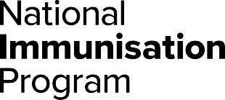**National Immunisation Program**

**Respiratory syncytial virus (RSV) vaccine consumer fact sheet**

## About Respiratory syncytial virus (RSV)

Respiratory syncytial virus (RSV) is a common virus that can cause a range of severe respiratory illnesses such as bronchiolitis in children and pneumonia.

RSV is spread through droplets from an infected person’s cough or sneeze. The droplets can be inhaled by others or land on surfaces where the virus can live for several hours.

Symptoms of RSV disease include:

* runny nose
* cough
* fever
* wheezing or difficulty breathing.

It may be a mild disease for some, but it can cause serious illness and hospitalisation in otherwise healthy children and adults.

RSV vaccination in pregnancy protects your newborn baby against RSV from birth and in their vulnerable first few months of life.

## Who is recommended an RSV vaccine

Women at 28 to 36 weeks pregnancy are recommended to receive the maternal RSV vaccine (Abrysvo®) to protect their baby against serious illness from RSV. The vaccine is available to eligible women for free through the National Immunisation Program (NIP).

## Who is recommended an RSV immunisation product

Infants up to 8 months and children up to 2 years may be recommended to receive the infant RSV immunisation product Beyfortus™ (nirsevimab). This is available for free through state and territory RSV infant protection programs. If you have questions about these programs, speak with your health professional or state or territory health department.

Aboriginal and Torres Strait Islander people aged 60 and over, people aged 60 and over with medical risk conditions, and adults aged 75 and over are recommended to receive RSV vaccines. People 60 to 74 years can consider RSV vaccination.

RSV vaccines for these groups are not funded through the NIP or state and territory programs. They can be purchased through the private market, but the cost cannot be claimed or reimbursed through the NIP or state or territory programs.

|  |
| --- |
| **RSV vaccination is especially important in pregnancy** |
| The maternal RSV vaccine helps to protect your newborn baby against RSV.  RSV is a leading cause of hospitalisation in children aged less than 6 months. Even healthy infants and children can get very sick from RSV.  Research shows that maternal vaccination reduces the risk of severe RSV illness in infants under 6 months of age by around 70%.  Vaccination in pregnancy enables you to transfer antibodies to your baby through the placenta. This protects your baby from birth and in their vulnerable early months of life against RSV. |

## Pregnant women

A single dose of the maternal RSV vaccine is recommended and free through the NIP for eligible women at 28 to 36 weeks pregnancy.

You can safely receive the RSV vaccine at the same visit as the NIP maternal influenza and whooping cough vaccines or COVID-19 vaccines if recommended by your trusted health professional.

## Infants and children

Infants up to 8 months and children up to 2 years may be recommended to receive single dose of the RSV immunisation product if:

* their mother did not receive the RSV vaccine during pregnancy, or
* they were born within 2 weeks after the mother receiving an RSV vaccine, or
* they have a condition or circumstance that increases their risk of severe RSV disease.

Young children 8 months to 2 years who have certain risk conditions for severe RSV disease are recommended to receive the RSV immunisation product before their second RSV season.

|  |
| --- |
| **Where to get RSV vaccines or immunisation products** |
| Appointments for NIP maternal vaccines can be booked at a range of health services including:   * maternal health specialists or general practices * local council immunisation clinics   (available in some states and territories)   * community health centers * Aboriginal health services * participating pharmacies.   Not all of these health services will have free NIP maternal vaccines. Check with your preferred health service to find out if they are available and when you can book your vaccination appointment.  The infant RSV immunisation product will be available through your state or territory RSV infant protection programs. Check with your health department to find out where and how to book an appointment. |

It is safe for your child to get an RSV immunisation product either on its own or at the same appointment as their other routine childhood vaccinations.

The infant and child RSV immunisation product is available for free through state and territory RSV infant protection programs.

## Aboriginal and Torres Strait Islander people, older people, and medically at risk

Currently, no RSV vaccines for Aboriginal and Torres Strait Islander adults, people with medical risk conditions, or older people are funded through the NIP or state or territory vaccination programs.

While you can purchase RSV vaccines through the private market, you cannot be reimbursed for these through the NIP.

You can safely receive an RSV vaccine at the same visit as other recommended vaccines such as influenza and COVID-19.

## RSV vaccine and immunisation product safety

The RSV vaccine and immunisation product are both safe and effective. The Therapeutic Goods Administration tests all vaccines, products and medicines before they are approved for use in Australia.

Side effects from RSV vaccines and immunisation products include mild pain, redness or swelling where the injection was given, tiredness and headaches. These usually last for a few days and go away without any treatment. Serious side effects, such as a severe allergic reaction, are rare.

## Australian Immunisation Register

## **Your health professional should always check the Australian Immunisation Register (AIR) before giving you or your baby a vaccine or immunisation product. They should also report to the AIR all immunisations they give to ensure you and your baby’s immunisation history is complete and accurate.**

## More information

**To find out more about RSV and vaccination, go to:**

* **the Department of Health and Aged Care at**health.gov.au/immunisation
* **your state or territory health department website or trusted health professional**
* **National Centre for Immunisation Research and Surveillance at** ncirs.org.au**.**

|  |  |
| --- | --- |
| **State and territory health department contact numbers:** | |
| **ACT** 02 5124 9800 | **SA**  1300 232 272 |
| **NSW** 1300 066 055 | **TAS** 1800 671 738 |
| **NT**  08 8922 8044 | **VIC**  immunisation@health.vic.gov.au |
| **WA**  08 9321 1312 | **QLD**  Contact your local Public Health Unit |

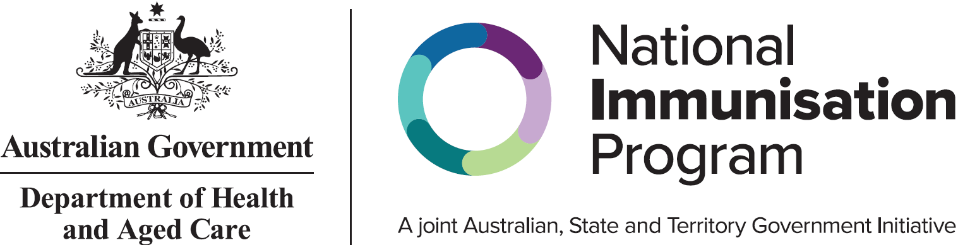

This information is current as of 5 February 2025