**National Immunisation Program**

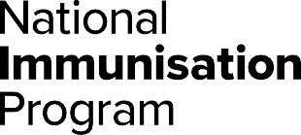

**Respiratory syncytial virus (RSV) products  
Program advice for health professionals **

|  |
| --- |
| Key points |
| * The National Immunisation Program (NIP) provides the free maternal RSV vaccine Abrysvo® to eligible women at 28 to 36 weeks of pregnancy. * States and territories are offering the infant Beyfortus™ (nirsevimab) RSV monoclonal antibody product. This product will be covered through state and territory RSV infant protection programs. Questions about access should be directed to state and territory health departments. * People aged 60 and over, Aboriginal and Torres Strait Islander people aged 60 and over, and people with medical risk conditions may consider purchasing RSV vaccines through the private market. However, these cannot be reimbursed through the NIP or state and territory programs. * RSV vaccines and immunisation products can be safely administered with other recommended vaccines or COVID-19 vaccines based on an individual risk-benefit assessment. |

## About Respiratory syncytial virus (RSV)

Respiratory syncytial virus (RSV) is a common virus that causes upper and lower respiratory tract infection.

While it may be a mild disease for some, it can cause serious illness and hospitalisation in otherwise healthy children and adults. Effects can range from colds to severe conditions such as bronchiolitis in children and pneumonia.

RSV is spread through droplets from an infected person’s cough or sneeze. The droplets can be inhaled by others or land on surfaces where the virus can live for several hours.

## Who should receive an RSV vaccine or immunisation product

## Pregnant women

A single dose of Abrysvo® is recommended and funded through the NIP for eligible women at 28 to 36 weeks of pregnancy. Abrysvo® canbe administered at any time of year provided it is at an appropriate point in the pregnancy.

Arexvy® **must** **not** be administered to pregnant women. Abrysvo® is the only RSV vaccine approved for use in pregnant women.

Abrysvo® can be safely co-administered with other recommended maternal vaccines or COVID-19 vaccines based on an individual risk-benefit assessment.

The maternal RSV vaccine given during pregnancy is primarily to protect infants. Women who are breastfeeding but not pregnant are not recommended to receive RSV vaccination. While there are no safety concerns, there is no evidence that protection is passed to the infant through breastfeeding.

Advice on repeat vaccination during subsequent pregnancies will be provided in future as more data becomes available.

## Infants and children

Abrysvo® **must** **not** be administered to infants and children.

Infants <8 months and children ≥8 to 24 months are recommended to receive a single dose of Beyfortus™ (nirsevimab) monoclonal antibody if:

* the mother did not receive an RSV vaccine during pregnancy, or
* they were born within 2 weeks after the mother receiving an RSV vaccine, or
* they have a condition or circumstance that increases their risk of severe RSV disease.

Administration of nirsevimab is likely to be most effective when given shortly after birth for infants born just before or during the RSV season.

Children ≥8 to 24 months who have certain risk conditions for severe RSV disease are recommended to receive nirsevimab before their second RSV season.

At this time, nirsevimab is not recommended for infants during the first 6 months of life if:

* the infant’s mother received an RSV vaccine at an appropriate time during pregnancy, and
* the infant does not have a risk condition for severe RSV disease.

Questions about the RSV immunisation product and RSV infant protection program eligibility should be directed to state and territory health departments.

Infants and children can safely receive nirsevimab on its own or at the same appointment as other routine childhood vaccinations.

## Aboriginal and Torres Strait Islander people, older people, and medically at-risk people

RSV vaccines for Aboriginal and Torres Strait Islander adults, older people, or those with medical risk factors are not funded through the NIP or state or territory vaccination programs.

RSV vaccines can be purchased through the private market but cannot be claimed or reimbursed through the NIP.

## RSV vaccine and immunisation product safety

Clinical trials of RSV vaccines and immunisation products have found them to be both safe and effective.

Common side effects include mild pain, redness or swelling where the injection was given, fatigue and headaches. These side effects usually last for a few days and go away without any treatment. Serious side effects, such as a severe allergic reaction, are rare.

## Contraindications

The only contraindications to RSV vaccines and immunisation products are anaphylaxis after:

* a previous dose of the same vaccine or monoclonal antibody
* any component of an RSV vaccine or monoclonal antibody.

## Adverse events or administration errors

You must notify all adverse events and vaccine or immunisation product administration errors through the reporting mechanisms in your state or territory.

|  |
| --- |
| RSV vaccines and products by cohort |
| | **Cohort** | **Vaccines and monoclonal antibodies** | | | | --- | --- | --- | --- | | Abrysvo®  0.5mL  (Pfizer) | Arexvy®  0.5mL  (GSK ) | Beyfortus™ (nirsevimab)  50/100mg  (Sanofi) | | Women at 28 to 36 wks pregnancy | NIP | DO NOT  USE | DO NOT  USE | | Infants & children ≤24 months | DO NOT  USE | DO NOT  USE | State & Territory | | People 60 to 74 years | Not funded | Not funded | DO NOT  USE | | People ≥75 years | Not funded | Not funded | DO NOT  USE | | First Nations ≥60 years | Not funded | Not funded | DO NOT  USE | | Medically  at risk  ≥60 years | Not funded | Not funded | DO NOT  USE | |

Ensure you are administering the correct vaccine or immunisation product for your patient. Private stock incorrectly given instead of NIP or state or territory stock cannot be claimed or reimbursed. Consider storing vaccines for different cohorts on separate shelves to prevent errors.

## Australian Immunisation Register

**Check the Australian Immunisation Register (AIR) before administering an RSV vaccine or immunisation product. You should report all RSV maternal and infant immunisations to the AIR to ensure complete and accurate records. For more information, go to** [servicesaustralia.gov.au/hpair](https://servicesaustralia.gov.au/hpair)**.**

## Keep up to date

Read the advice in this factsheet in conjunction with the Australian Immunisation Handbook at immunisationhandbook.health.gov.au

Subscribe to the NIP update email update service. Search ‘NIP updates’ on health.gov.au.

|  |  |
| --- | --- |
| **State and territory health department contact numbers:** | |
| **ACT** 02 5124 9800 | **SA**  1300 232 272 |
| **NSW** 1300 066 055 | **TAS** 1800 671 738 |
| **NT**  08 8922 8044 | **VIC**  immunisation@health.vic.gov.au |
| **WA**  08 9321 1312 | **QLD**  Contact your local Public Health Unit |

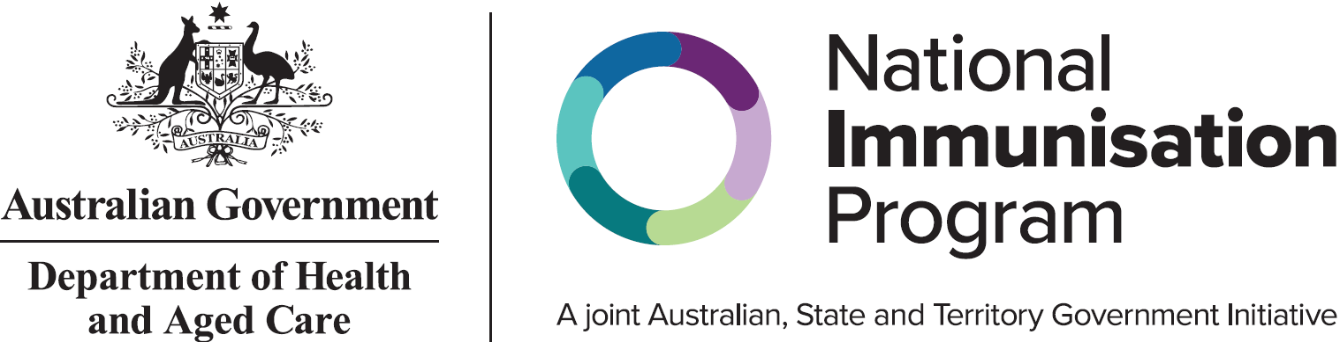

This information is current as of 5 February 2025