Communication toolkit

Provider finance and operation information for older people, their families and their carers

This communication toolkit provides information and materials to help you communicate with older people, their families and carers about updated provider finance and operations information on the My Aged Care website, Find a Provider tool.

# About this toolkit

This communication toolkit provides information and materials to aged care providers to help you talk to and promote the finance and operations information on the My Aged Care website Find a Provider tool. Please share this information with your workers, boards, people receiving aged care, older people, their families and carers and community networks through your communication channels.

## What’s in this toolkit

* Key messages
* Discussion guide
* Editorial content for newsletters and website/intranet news resources
* Social media posts and tiles
* Links to key resources.

Call to action

We recommend including the following calls to action in communication materials:

* Finance and operations information enables older people, their families and carers to compare their residential or home care provider with the sector on wage rates, income, expenses and food. This will help older people to make informed decisions about their aged care.
* Finance and operations information is available on the My Aged Care Website, [Find a Provider tool](https://www.myagedcare.gov.au/find-a-provider/).

## Key messages

* Residential and home care provider finance and operations information is up-to-date and on the My Aged Care website, [‘Find a Provider’ tool](https://www.myagedcare.gov.au/find-a-provider/). You can use this information to see what providers spend on care, staffing, food and other expenses.
* Knowing how aged care providers operate and manage their finances can help you compare and choose the right provider for you.
* This information has been updated with the most recent annual and quarterly finance and operations reports from providers.
* In addition to provider income and expenses, wages and food preparation, you can find provider information on:
  + activities to support a diverse and inclusive environment
  + diversity of a provider’s governing body
  + feedback, complaints and improvements
  + information about whether the provider meets requirements and responsibilities under aged care legislation, as well as details of any non-compliance
  + service provision and use.
* Finance and operations information, along with Star Ratings, helps you to explore your care options or learn about the providers delivering your care.
* Read how you can use and [understand the information on provider finances and operations](https://www.myagedcare.gov.au/find-provider/understanding-costs/understanding-financial-information-find-provider) to help you make an informed choice.

## Discussion guide

Where does the finance and operation information come from?

Providers submit data through annual and quarterly financial reports and the Provider Operations Collection Form.

The information is then reviewed and prepared for publication.

Before the information is published on the My Aged Care website, providers can check their information is correct during a preview period.

Is the information on the My Aged Care website correct?

Providers are legally responsible for reporting correct and factual financial data to the Department of Health and Aged Care, as per the *Accountability Principles 2014* and the *Aged Care Act 1997*.

The department works with providers to identify incorrect data and supports providers to resubmit data to ensure the accuracy of information published on the My Aged Care website.

Editorial content

Use this editorial content in your newsletter to older people, aged care workers or community network.

## Understand how aged care providers operate and manage their finances

Are you exploring your aged care options or wanting to learn more about the provider delivering your care?

You can find information on aged care providers on the My Aged Care website, [Find a Provider tool](https://www.myagedcare.gov.au/find-a-provider/).

Compare and choose the right provider for you

Knowing how aged care providers operate and manage their finances can help you compare and choose the right provider for you.

Information on the finances and operation of aged care providers helps you to understand:

* providers’ spend on care and staffing
* food preparation and cost
* staff minimum and average hourly wage rates
* service diversity activities, including the provider’s governing body
* feedback and complaints processes.

This information is updated regularly with annual and quarterly finance and operations reports from providers.

Make an informed choice

Finance and operations information, along with Star Ratings, helps you to explore your care options or learn about the providers delivering your care.

Read how you can use and [understand the information on provider finances and operations](https://www.myagedcare.gov.au/find-provider/understanding-costs/understanding-financial-information-find-provider) to help you make an informed choice.

## Social media content

Use this content on your social media channels.

Facebook

Compare and choose the right aged care provider for you.

Finance and operations information on My Aged Care, Find a Provider tool shows you:

👩‍⚕️ what providers are spending on care and nursing

🗃️ the average wages paid to workers

🥗 how food is prepared and its cost.

Find which provider best suits your needs at 💻<https://www.myagedcare.gov.au/find-a-provider/>

**First comment (to be published with post):**

To help you understand provider finance information, visit <https://www.myagedcare.gov.au/find-provider/understanding-costs/understanding-financial-information-find-provider>

Instagram

Compare and choose between aged care providers.

Finance and operations information on My Aged Care, Find a Provider tool shows you:

👩‍⚕️ what providers are spending on care and nursing

🗃️ the average wages paid to workers

🥗 how food is prepared and its cost.

Check it out at the link in our bio to understand the provider finance information.

#AgedCare

**Bio link:**

<https://www.myagedcare.gov.au/find-provider/understanding-costs/understanding-financial-information-find-provider>

Twitter

Aged care provider finance & operations info makes it easier for older people to make informed decisions about their care.

Understand how you can use this information to compare and choose: <https://www.myagedcare.gov.au/find-provider/understanding-costs/understanding-financial-information-find-provider> #AgedCare

Tile

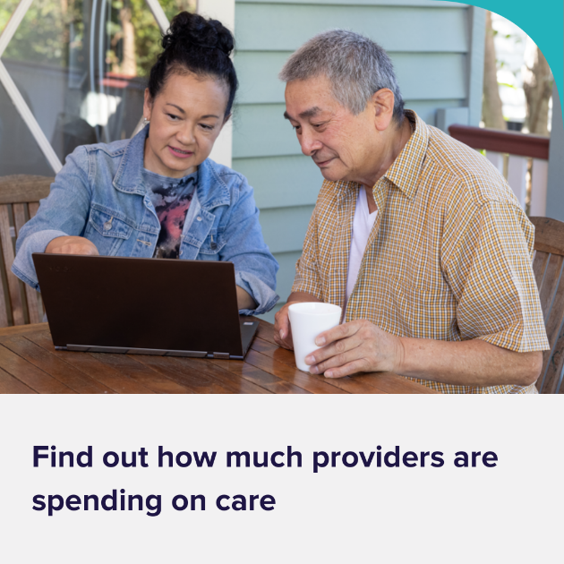

## Resources

You can refer to these resources for further information.

* [My Aged Care](https://www.myagedcare.gov.au/)

If you need some help around the house or think it’s time to look into aged care homes, My Aged Care is here to help.

* [My Aged Care, Find a Provider tool](https://www.myagedcare.gov.au/find-a-provider)

Find an organisation in your area to meet your needs or compare providers.

* [Understanding financial information in Find a provider](https://www.myagedcare.gov.au/find-provider/understanding-costs/understanding-financial-information-find-provider)

Direction on what information is available, what do with the information and information accuracy.

* [Publishing of aged care provider finance and operations information](https://www.health.gov.au/topics/aged-care/providing-aged-care-services/reporting/publishing-of-finance-and-operations-information)

Why we publish the information and latest updates for aged care providers.

* [Aged care provider reporting](https://www.health.gov.au/topics/aged-care/providing-aged-care-services/reporting)

Approved providers must submit regular reports to the Australian Government to ensure the sector is transparent and accountable.