# National Immunisation Strategy for Australia 2025–2030

**Summary of public consultation submissions**

**Prepared by the   
National Centre for Immunisation Research and Surveillance (NCIRS)**

## Contents

List of figures 3

Overview 4

Methods 4

Results 5

Six proposed Priority Areas 6

1. Priority Area One: Improve immunisation coverage through universal and equitable access to vaccination, with a focus on First Nations people 8

2. Priority Area 2: Strengthen community engagement, acceptance and understanding of immunisation 10

3. Priority Area 3: Strengthen program governance and how we manage programs and account to the public 12

4. Priority Area 4: Use data and evidence to target interventions, build confidence and improve outcomes 13

5. Priority Area 5: Strengthen the immunisation workforce to work with Australia’s diverse population 15

6. Priority Area 6: Prepare for emerging infectious diseases and emergencies requiring rapid and/or targeted vaccination 16

Evidence-informed targets 17

Key areas of importance for the NIS 2025–2030 17

Summary of free text data 19

Summary of public consultation submissions 21

## List of figures

Figure 1. Breakdown of stakeholder groups among within scope submissions 5

Figure 2. Overall extent of agreement to the proposed vision and mission of the new NIS 2025–2030 6

Figure 3. Degree to which submissions agreed with the six proposed Priority Areas for the NIS 2025–2030 7

Figure 4. Degree to which submissions agreed with the six Opportunities for Action under Priority Area 1 9

Figure 5. Degree to which submissions agreed with the five Opportunities for Action under Priority Area 2 11

Figure 6. Degree to which submissions agreed with the four Opportunities for Action under Priority Area 3 12

Figure 7. Degree to which submissions agreed with the five Opportunities for Action under Priority Area 4 14

Figure 8. Degree to which submissions agreed with the five Opportunities for Action under Priority Area 5 15

Figure 9. Degree to which submissions agreed with the five Opportunities for Action under Priority Area 6 16

Figure 10. Responses to whether the NIS 2025–2030 should have additional evidence-informed targets for vaccination coverage 17

Figure 11. Key areas of the NIS 2025–2030 most important to responders 18

## Overview

The Australian Government is currently developing the National Immunisation Strategy (NIS)   
2025–2030, with the vision of ‘A healthier Australia through immunisation’. The NIS 2025–2030 builds upon previous National Immunisation Strategies, and is being developed through consultations with the Australian Government, state and territory governments, experts, key stakeholders and the Australian public.

The NIS 2025–2030 has received input from an iterative process of stakeholder and expert engagement, including a public consultation, the establishment of an Expert Advisory Group, and consultation with the Australian Health Protection Committee.

The Australian Government Department of Health and Aged Care invited the Australian community and key stakeholders to partake in a public consultation on a discussion paper draft for a new NIS   
2025–2030. The public consultation was open from May to June 2024 and received 2,729 submissions from a range of stakeholders. The data from the public consultation are analysed and synthesised into this report by the National Centre for Immunisation Research and Surveillance. with the results informing development of the Priority Areas and Strategic Goals for the NIS 2025–2030. Overall, the results predominantly demonstrated support for the proposed vision, mission and Priority Areas in the NIS 2025-2030, noting that the relative level of importance varied.

### Methods

#### Consultation process and participants’ responses

Between 22 May and 19 June 2024, a four-week public consultation was undertaken via an online survey on the government Citizen Space platform (Appendix A), asking for stakeholder views and responses to the ideas put forward in the document ‘Towards a National Immunisation Strategy 2025–2030'. The online portal provided options for a scaled response to the questions posed, as well as free text options.

The public consultation received a total of 2,729 submissions from various stakeholders. These stakeholder groups represented a large variety of experiences and opinions on vaccines and immunisation programs. Stakeholder groups included health and clinical professionals, private and public health providers, national peak bodies, not-for-profit organisations, First Nations organisations, academia, government agencies, community groups and interested members of the public.

The responses from the public consultation were analysed and sorted into those that aligned with the stated aims of the Strategy (n=352) and those that ran counter to the stated aims of the Strategy (n=2377) . Responses that ran counter to the stated aims of the Strategy did not support the premise of immunisation programs. These responses did not undergo substantive additional analyses.

#### Survey analysis methodologies

Scaled-response survey data were quantitatively analysed and graphs were constructed using Microsoft Excel. The free text data were initially qualitatively analysed using the generative artificial intelligence program Microsoft Copilot, to extract key themes based on the most frequently emerging patterns. Copilot uses Large Language Models, AI tools in which the same prompt used multiple times can result in different responses. To ensure analysis was reliable, it was run multiple times with the same prompts, and common themes were then examined among the various outputs. This was followed by manual review of the submissions to ensure alignment with the extracted key themes from Copilot. Data were synthesised into this report, with the results informing the development and drafting of the Priority Areas and Strategic Goals for the NIS 2025–2030.

### Results

#### Summary of quantitative responses

Of the 2,729 submissions, 352 were deemed within-scope of the stated aims of the Strategy, of which 335 had quantitative responses. Survey responders were required to select the stakeholder group with which they most identified, as displayed in Figure 1. Health professionals/clinicians involved in immunisation service delivery were the most represented stakeholder group (28%), followed by respondents who selected more than one stakeholder group (19%) and interested members of the public (13%).

Figure 1. Breakdown of stakeholder groups among within scope submissions

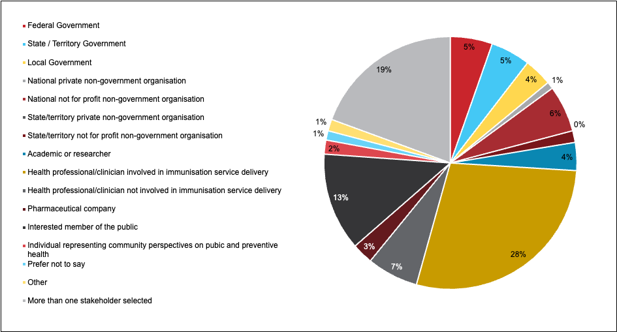

Survey responses to the following sections are described below.

#### Vision and mission

Among the submissions, responders were asked to what extent they agreed with the proposed vision and mission of the NIS 2025–2030:

* *Vision:* To protect individuals and communities from the harms of vaccine-preventable diseases
* *Mission:* Improve vaccine uptake and reduce the impact of vaccine-preventable diseases in Australia

The results are summarised in Figure 2.

Figure 2. Overall extent of agreement to the proposed vision and mission of the new NIS 2025–2030

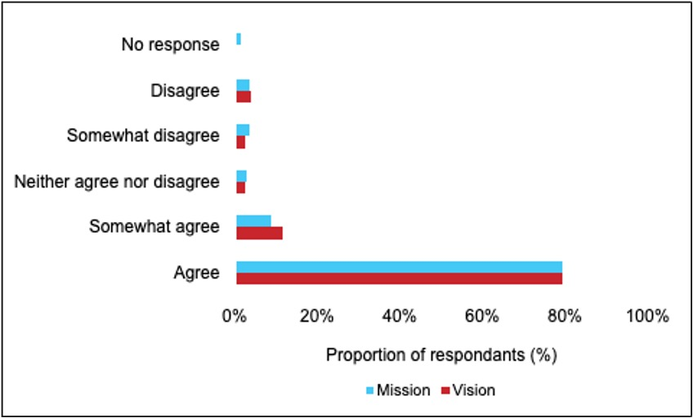

Of the responses, 79.4% agreed with the vision. This was followed by ‘somewhat agree’ (11.6%) and ‘disagree’ (3.9%). For the mission, 79.4% of submissions also agreed. This was followed by somewhat agree (9%) and somewhat disagree and disagree, both with 3.6% of responses.

### Six proposed Priority Areas

Respondents were asked to submit the degree to which they agreed with each of the six proposed Priority Areas for the NIS:

1. Improve immunisation coverage through universal and equitable access to vaccination, with a focus on First Nations people.
2. Strengthen community engagement, acceptance and understanding of immunisation.
3. Strengthen program governance and how we manage programs and account to the public.
4. Use data and evidence to target interventions, build confidence and improve outcomes.
5. Strengthen the immunisation workforce to work with Australia’s diverse population.
6. Prepare for emerging infectious diseases and emergencies requiring rapid and/or targeted vaccination.

*Note:* Submissions were permitted to select the same response for more than one priority group.   
Figure 3 displays the responses submitted for this question.

Figure 3. Degree to which submissions agreed with the six proposed Priority Areas for the NIS 2025–2030

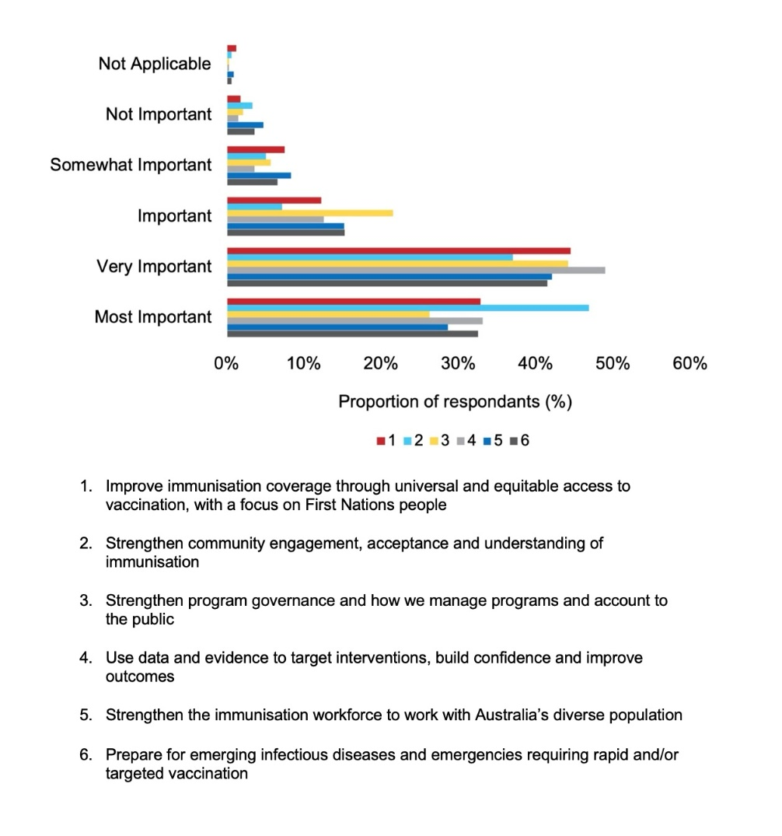

For the different Priority Areas, the proportion of respondents who ranked the outcomes as ‘most important’, ‘very important’ and ‘important’ were as follows:

* *Priority Area 1 –* ‘most important’: 32.8%; ‘very important’: 44.5%; ‘important’: 12.2%
* *Priority Area 2 –* ‘most important’: 46.9% (highest among all Priority Areas categorised as ‘most important’); ‘very important’: 37.0%; ‘important’: 7.2%
* *Priority Area 3 –* ‘most important’: 26.3%; ‘very important’: 44.2%; ‘important’: 21.5%
* *Priority Area 4 –* ‘most important’: 33.1%; ‘very important’: 49.0%; ‘important’: 12.5%
* *Priority Area 5 –* ‘most important’: 28.7%; ‘very important’: 42.1%; ‘important’: 15.2%
* *Priority Area 6 –* ‘most important’: 32.5%; ‘very important’: 41.5%; ‘important’: 15.2%.

#### Priority Area 1: Improve immunisation coverage through universal and equitable access to vaccination, with a focus on First Nations people

Under Priority Area 1, six Opportunities for Action were proposed, and respondents were asked to indicate their view of the importance of each. The Opportunities for Action were as follows:

1. Improve monitoring of vaccine coverage across all age cohorts, priority populations and at-risk groups. Use these data to drive performance and accountability.
2. Prioritise partnership and shared decision making with First Nations communities and the Aboriginal Community Controlled Health Sector in delivering immunisation services.
3. Build collaborative partnerships with communities with low immunisation rates, drawing on successful models from COVID-19 programs, particularly those designed for disability, First Nations, and Culturally and Linguistically Diverse communities.
4. Continue to develop and adjust vaccination strategies to protect people in aged care, and residential care for people with disability.
5. Make vaccines easier to access through immunisation programs and wider health system, especially primary care.
6. Consider evidence-informed targets for specific vaccines or groups of people to focus national efforts during the implementation of the next National Immunisation Strategy.

*Note:* Submissions were permitted to select the same response for more than one priority group.   
Figure 4 displays the responses submitted for this question.

Figure 4. Degree to which submissions agreed with the six Opportunities for Action under Priority Area 1

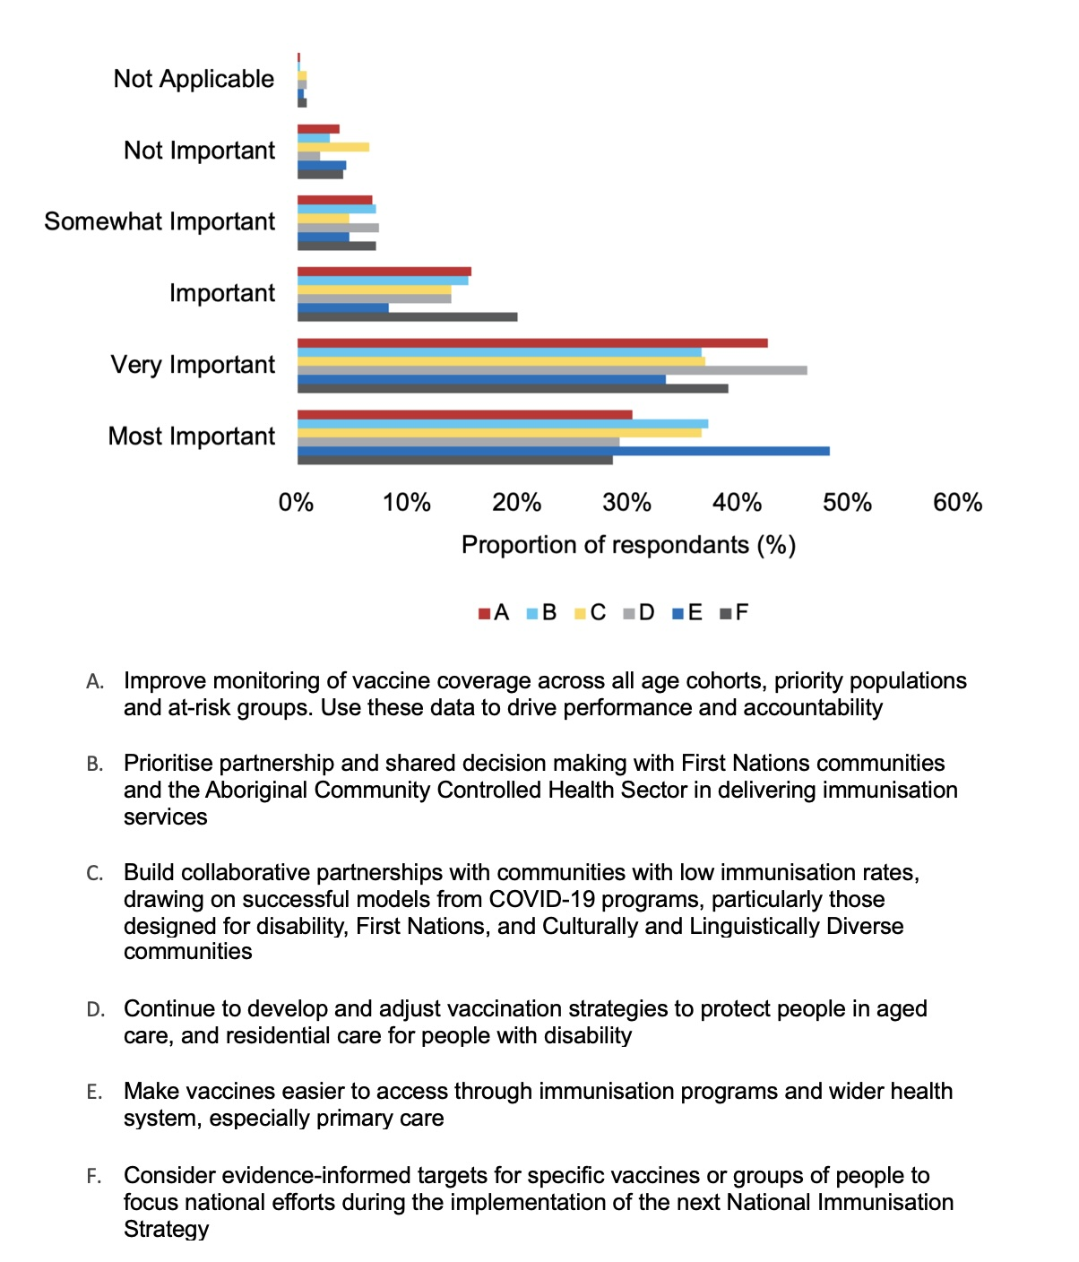

Under Opportunity for Action E, ‘most important’ was the most frequently selected option (48.4%). ‘Most important’ was also the most frequently selected option for Opportunity for Action B (37.3%), followed by ‘very important’ (36.7%).

Under the other Opportunities for Action, ‘very important’ was the predominant answer selected: Opportunities for Action A (42.7%), C (37.0%), D (46.3%), F (39.1%).

#### Priority Area 2: Strengthen community engagement, acceptance and understanding of immunisation

Under Priority Area 2, five Opportunities for Action were proposed, and respondents were asked to indicate their view of the importance of each. The Opportunities for Action were as follows:

1. Prioritise community partnerships and engagement design, delivery and evaluation of communication campaigns and information resource, using appropriate national, state in and local mechanisms.
2. Track community sentiment using behavioural insights among groups eligible for National Immunisation Program vaccines to inform communications and strategies and use this evidence to tailor policy and practice.
3. Evaluate and report against the performance of vaccine awareness campaigns and other resources including performance in First Nations communities, priority populations and most remote/rural populations.
4. Provide quality resources for a health workforce to respectfully engage with diverse individuals and communities on understanding and enabling vaccination.
5. Consider the feasibility of a no-fault compensation scheme for Commonwealth-funded vaccines.

*Note:* Submissions were permitted to select the same response for more than one priority group.   
Figure 5 displays the responses submitted for this question.

Figure 5. Degree to which submissions agreed with the five Opportunities for Action under Priority Area 2

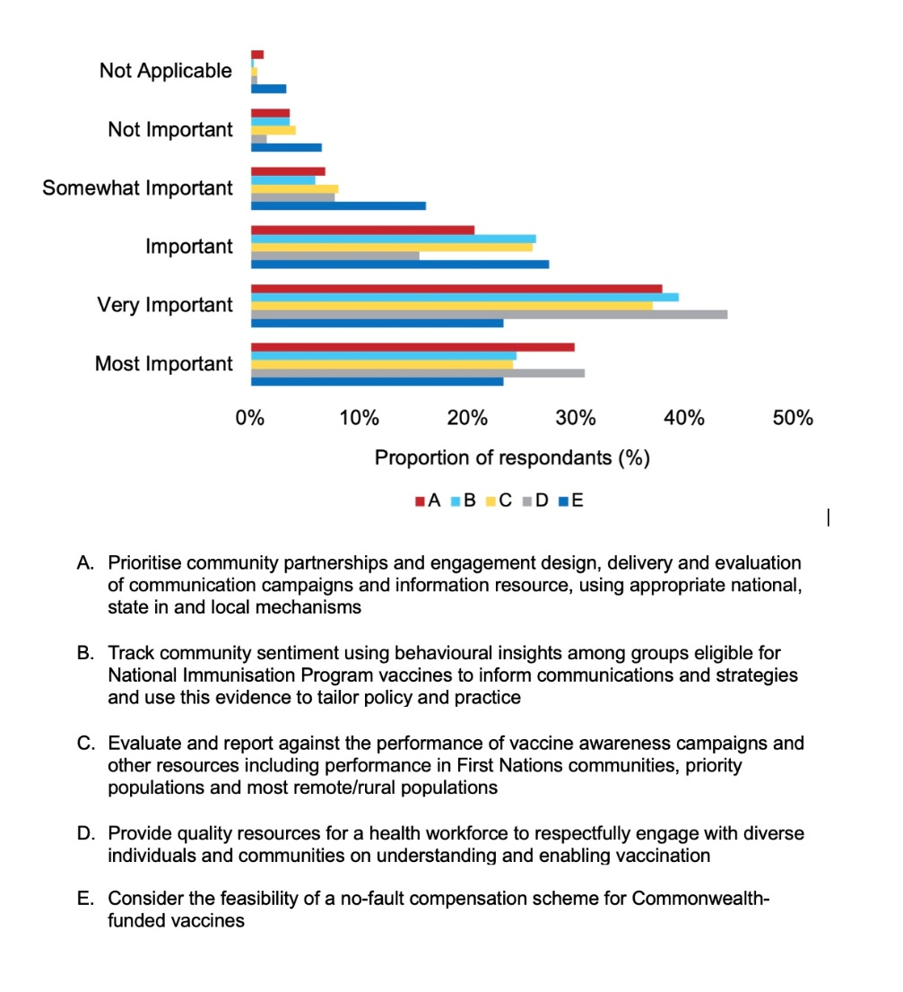

Among the Opportunities for Action under Priority Area 2, ‘very important’ was the dominant answer submitted by respondents for Opportunities for Action A (37.9%), B (39.4%), C (37.0%) and D (43.9%). However, for Opportunity for Action E, ‘important’ was the most selected answer (27.5%).

#### Priority Area 3: Strengthen program governance and how we manage programs and account to the public

Under Priority Area 3, four Opportunities for Action were proposed, and respondents were asked to indicate their view of the importance of each. The Opportunities for Action were as follows:

1. Shape the next intergovernmental agreement on essential vaccines to reflect shared vision of the National Immunisation Strategy.
2. Continue to deliver the national COVID-19 vaccine response while working with stakeholders to transition the COVID-19 vaccination program to a sustainable operating model.
3. Strengthen accountability and generate evidence to inform improvement to programs and policy through transparent reporting against a monitoring and evaluation framework.
4. Prepare for assessment of emerging vaccine technology and for the opportunities and challenges that adopting new technologies may present to existing immunisation programs and delivery.

*Note:* Submissions were permitted to select the same response for more than one priority group.   
Figure 6 displays the responses submitted for this question.

Figure 6. Degree to which submissions agreed with the four Opportunities for Action under Priority Area 3

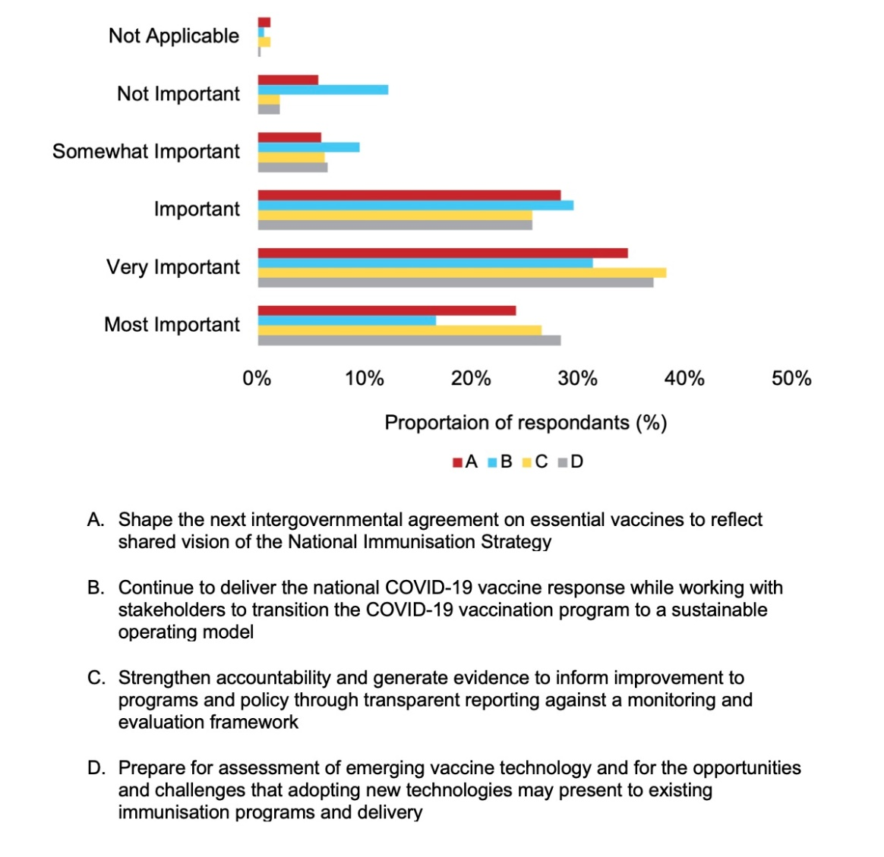

For each Opportunity for Action under Priority Area 3, ‘very important’ was the most frequently selected option by responders: Opportunities for Action A (34.6%), B (31.3%), C (38.2%), D (37.0%). Opportunity for Action C had the greatest number of respondents ranking it as ‘Very important’.

#### Priority Area 4: Use data and evidence to target interventions, build confidence and improve outcomes

Under Priority Area 4, five Opportunities for Action were proposed, and respondents were asked to indicate their view of the importance of each. The Opportunities for Action were as follows:

1. Boost compliance with mandatory reporting to the Australian Immunisation Register (AIR), while improving the quality and accuracy of AIR data.
2. Expand the use of high-quality data linkage to inform specific policy or programmatic questions
3. Explore options to increase availability and accessibility of a range of timely population level vaccine coverage data from the AIR.
4. Improve use of disease surveillance data with vaccine coverage data to better understand, respond to and mitigate risks of spread of vaccine-preventable diseases.
5. Sustain robust vaccine safety systems including enhanced vaccine safety surveillance for new vaccine introductions.

*Note:* Submissions were permitted to select the same response for more than one priority group.   
Figure 7 displays the responses submitted for this question.

Figure 7. Degree to which submissions agreed with the five Opportunities for Action under Priority Area 4

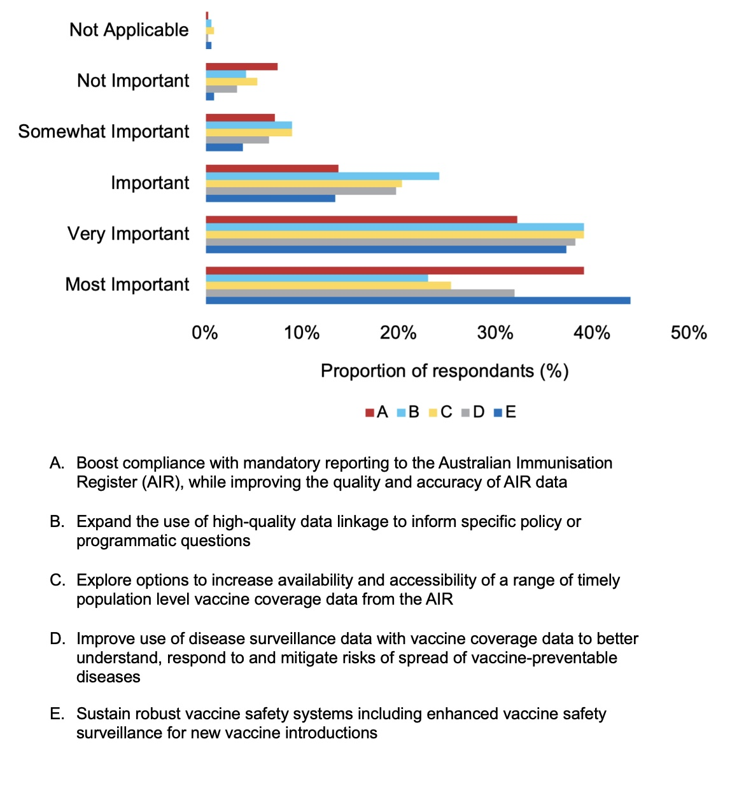

Under Priority Area 4, for Opportunities for Action A and E, majority of responses chose ‘most important’ (39.1% and 43.9%, respectively). The predominant response selected for the other Opportunities for Action was ‘very important’, with this option picked for Opportunities for Action B and C (by 39.1% of respondents each) and D by 38.2% of respondents.

#### Priority Area 5: Strengthen the immunisation workforce to work with Australia’s diverse population

Under Priority Area 5, three Opportunities for Action were proposed, and respondents were asked to indicate their view of the importance of each. The Opportunities for Action were as follows:

1. Continue to improve availability and distribution of health professionals who are immunisation providers or who can support delivery immunisation programs.
2. Improve cultural competence in professions and settings where vaccinations are delivered through awareness, training and appropriate resources.
3. Build a more diverse immunisation workforce through support specific cadres of health professionals, including First Nations health practitioners, to work across a scope of practice that includes immunisation.

*Note:* Submissions were permitted to select the same response for more than one priority group.   
Figure 8 displays the responses submitted for this question.

Figure 8. Degree to which submissions agreed with the five Opportunities for Action under Priority Area 5

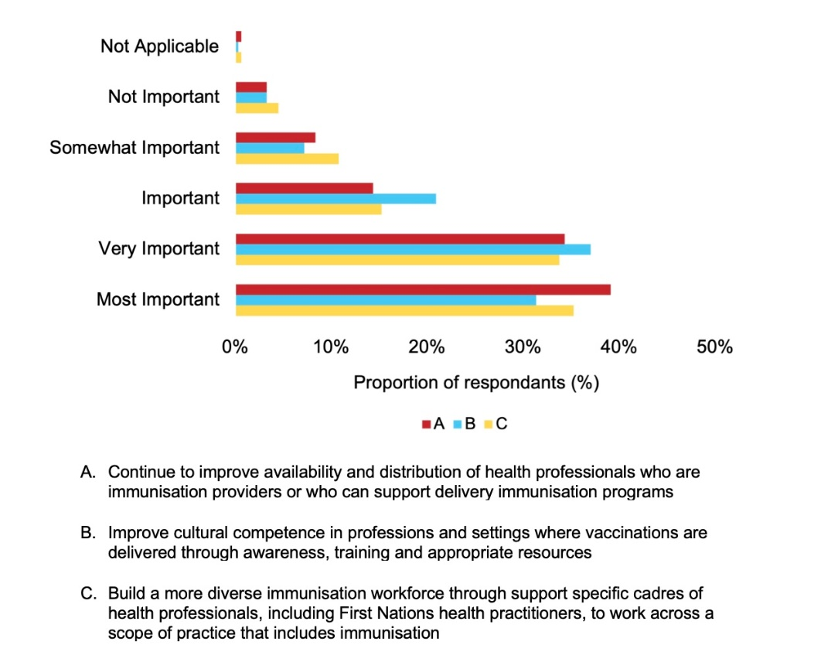

Under Priority Area 5, most respondents opted for ‘most important’ for Opportunities for Action A and C (39.1% and 35.2%, respectively). ‘Very important’ was the most frequently selected option for Opportunity for Action B (37.0%).

#### Priority Area 6: Prepare for emerging infectious diseases and emergencies requiring rapid and/or targeted vaccination

Under Priority Area 6, four Opportunities for Action were proposed, and respondents were asked to indicate their view of the importance of each. The Opportunities for Action were as follows:

1. Continue to plan for emergency vaccine rollouts.
2. Strengthen immunisation research capabilities through domestic and international partnerships and funding.
3. Maintain onshore manufacturing capacity for critical vaccines.
4. Continue Australia’s contribution to strengthening immunisation in the Indo-Pacific and globally.

*Note:* Submissions were permitted to select the same response for more than one priority group. Figure 9 displays the responses submitted for this question.

Figure 9. Degree to which submissions agreed with the five Opportunities for Action under Priority Area 6

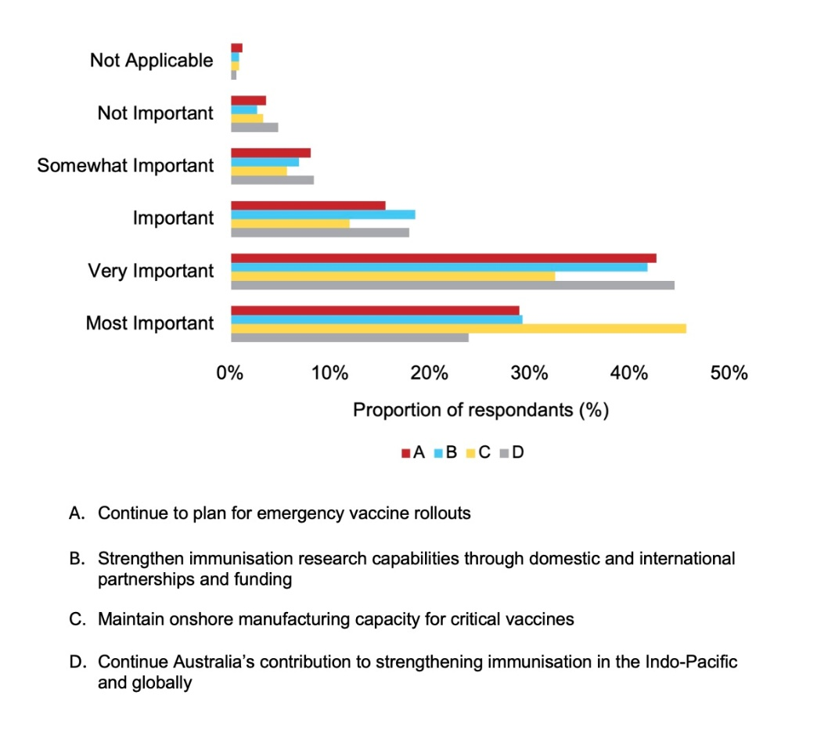

Across the Opportunities for Action for Priority Area 6, the ‘most important’ category was selected by the majority of respondents for Opportunity for Action C (45.7%). ‘Very important’ was the most frequently selected category for Opportunities for Action A (42.7%), B (41.8%) and D (44.5%).

### Evidence-informed targets

Respondents were asked whether the proposed NIS 2025–2030 should have additional evidence-informed targets for vaccination coverage. Figure 10 showcases the responses to this question.

Figure 10. Responses to whether the NIS 2025–2030 should have additional evidence-informed targets for vaccination coverage

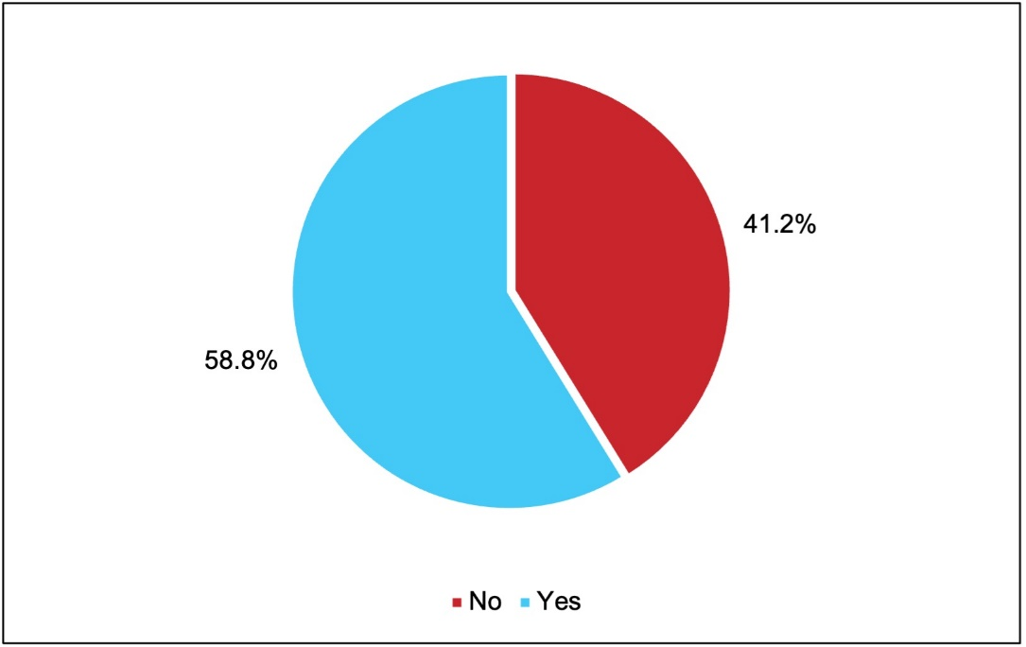

Of all responses, the majority selected ‘Yes’ (58.8%), while 41.2% of respondents chose ‘No’. In contrast, amongst those who identified as the ‘health professional/clinician involved in immunisation service delivery’ stakeholder group, a majority responded with ‘No’ (55.8%) compared to ‘Yes’ responses (44.2%)

### Key areas of importance for the NIS 2025–2030

Respondents were asked which key areas of the NIS 2025–2030 were the most important to them out of the following statements:

1. Be promoted to reach health professionals, peak bodies, and/or researchers to increase awareness.
2. Be promoted to consumers and the general public to increase awareness.
3. Increase the focus on how organisations can work together to improve the effectiveness of immunisation-related activities in Australia.
4. Improve the collaboration between state and territory governments and the federal government.
5. Be more aligned with other state and territory, national and international policies, strategies and plans.
6. Focus on emerging risks and issues (e.g. ensuring preparedness for infectious disease outbreaks).
7. Provide a greater emphasis on the needs of priority populations.
8. Drive immunisation reform at national level to improve health outcomes.
9. Ensure greater transparency of national and State and Territory actions to deliver priorities.

Respondents were allowed to select up to five options. The responses to this question are summarised in Figure 11.

Figure 11. Key areas of the NIS 2025–2030 most important to responders

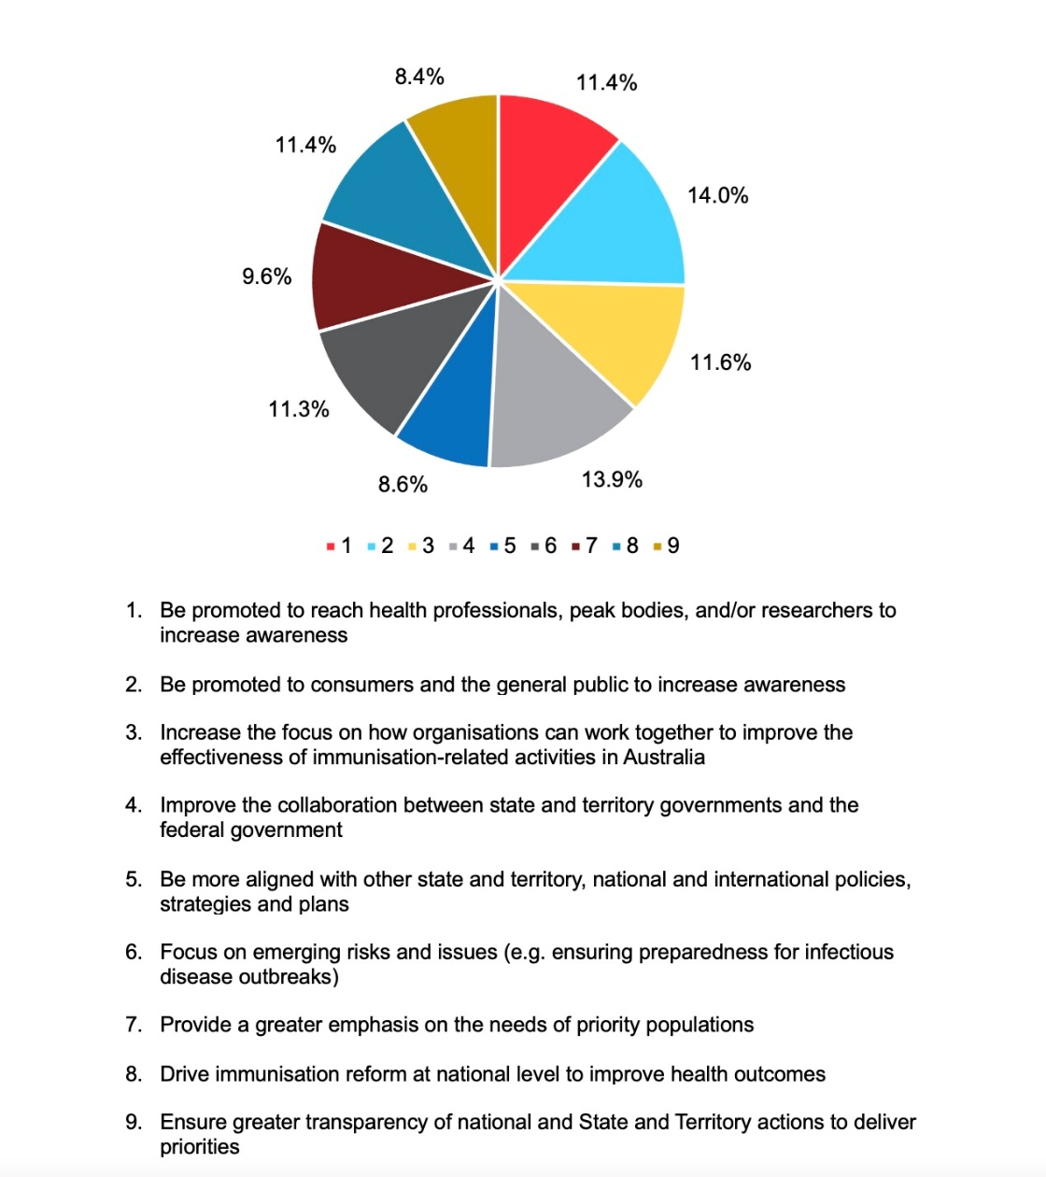

In terms of relative importance, respondents chose a fairly even distribution across the nine key areas of the NIS 2025–2030. Of the nine areas, key area 2, ‘Be promoted to consumers and the general public to increase awareness’, was deemed most important by respondents (14.0%). This was closely followed by key area 4, ‘Improve the collaboration between state and territory governments and the federal government’ (13.9%). A similar weighting of importance was given to key areas 1 (‘Be promoted to reach health professionals, peak bodies, and/or researchers to increase awareness’: 11.4%), 3 (‘Increase the focus on how organisations can work together to improve the effectiveness of immunisation-related activities in Australia: 11.6%), 6 (‘Focus on emerging risks and issues [e.g. ensuring preparedness for infectious disease outbreaks]’: 11.3%) and 8 (‘Drive immunisation reform at national level to improve health outcomes’: 11.4%).

Survey responses provided by different stakeholder groups are shown in Appendix B for all sections.

### Summary of free text data

#### Key themes raised

The key themes raised from the free text submission in the survey are described below. These themes largely reflect and, in some cases, expand upon the Priority Areas stated in the discussion paper. No substantive new themes or topics were raised.

#### Vaccine education and information transparency

Increased vaccine education and information transparency to members of the community was described by respondents as critical to enhancing engagement with vaccination programs. Submissions raised the need to focus on educating the public about immunisation, with a particular focus on the transparency of vaccination, benefits and risks, as well as safety and adverse outcome data. This was viewed as beneficial in addressing vaccine hesitancy, countering misinformation and boosting trust – concerns that these submissions noted have proliferated since the COVID-19 pandemic. Social media was identified as a crucial medium in spreading vaccine misinformation, and submissions emphasised the importance of better use of social media for disseminating educational information on vaccination. Respondents also encouraged investing in research to better understand vaccine hesitancy in various communities. Responses heavily emphasised the importance of adopting culturally sensitive methods and involving community stakeholders when disseminating vaccine educational information among diverse populations.

#### Access and delivery of vaccines

Submissions strongly supported the need to improve access to, and delivery of, vaccinations to reduce the impact of vaccine-preventable diseases. Greater access to vaccines involved expanding the number of free vaccines to the public, addressing vaccine shortages and ensuring timely and consistent implementation, particularly during main or peak vaccination program periods.

To improve the delivery of vaccination, submissions stressed the crucial role primary healthcare. . Bolstering general practices, nurse-delivered immunisation and community pharmacies were described as essential in achieving greater outreach and engagement. Submissions viewed that greater funding for primary healthcare would ensure a more appropriately distributed workforce that allows more timely delivery of vaccines.

Achieving equitable outcomes was also largely tied to the theme of access and delivery. Respondents noted a limited variety of approaches have previously been used to address inequitable access to, and delivery of, vaccinations for vulnerable populations. Submissions identified the need to provide greater support to high-risk groups and vulnerable populations, including First Nations people, people who are immunocompromised or with comorbidities, elderly people, infants, children, pregnant women, people with disabilities, culturally and linguistically diverse communities, people with low incomes, and populations in rural and remote regions. Submissions also emphasised a call for addressing contextual barriers to vaccine access and delivery, such as geographical location, socioeconomic background, limited provision of culturally safe services for some populations, physical accessibility and inability to take leave from work. An emphasis was also placed on the need to tackle historical injustices and exclusions to healthcare to address existing inequities, particularly among First Nations people.

#### Community-centred approaches

A number of submissions demonstrated the role of adopting community-centred approaches in engaging communities in immunisation. Community-centred approaches involve consulting community members and community-based stakeholders in decision-making processes related to immunisation, which can improve the understanding of barriers to immunisation and ways to best support communities. Respondents noted that understanding these barriers and enablers allows for more tailored responses to reduce the impact of vaccine-preventable diseases.

Submissions stressed the importance of community-centred approaches among First Nations people, calling for consultations with First Nations communities, Aboriginal Health Practitioners, Aboriginal Nurse Immunisers and Practitioner Immunisers, and Aboriginal Community Controlled Health Organisations. These collaborations ensure that culturally safe immunisation approaches and resources are delivered to First Nations people to match community needs. Responses also identified the need for community-centred approaches to be incorporated when working with culturally and linguistically diverse communities. This allows for meaningful and appropriate engagement, and the adaptability of communication strategies.

#### Expanding the no-fault compensation scheme

In contrast to the quantitative survey responses, responses to the qualitative part of the survey demonstrated strong support for the development of a no-fault compensation scheme for vaccine-related injuries from publicly funded vaccines. Responses argued that the development of a strategy for such a scheme should firstly acknowledge any injuries caused by vaccines, and secondly provide compensation to those affected. A call for an expansion of the scheme beyond the existing COVID-19 no-fault vaccination scheme was raised, with responses emphasising Australia’s shortcomings compared to 25 other countries that have already adopted vaccine no-fault compensation schemes, including New Zealand, the United States, the United Kingdom, European countries and South Korea.

#### Evidence-based vaccination uptake and coverage targets

The submissions focused on the need for more specific evidence-based targets to track progress towards strategic priorities and improve vaccination coverage. Targets were encouraged to be shared with jurisdictions to promote greater transparency and understanding of vaccine uptake among different groups, and to foster evidence-based policymaking.

Submissions underlined the importance of evidence-based targets for the population overall as well as for high-risk/vulnerable populations, including elderly people, First Nations people, pregnant women, adolescents, rural and regional communities, those who are immunocompromised or with comorbidities, populations in rural and remote areas, and those living in residential aged care facilities.

Respondents also drew attention to specific diseases needing evidence-based targets, such as influenza, pneumococcal, shingles, respiratory syncytial virus (RSV), meningococcal, human papillomavirus (HPV), COVID-19 and Q-fever, and to the need to ensure the targets are specific to communities with low uptake of vaccines.

#### Improving data quality, collection and linkage

Submissions emphasised the need to improve data collection and quality, as well as data linkage, to enable better tracking and monitoring systems for improved immunisation outcomes. High-quality immunisation data are required to capture vaccination coverage, and immunisation data linked to disease outcomes enable assessment of vaccine effectiveness and safety, supporting confidence in immunisation. Such data are also valuable in identifying high-risk populations to develop targeted strategies to improve vaccine coverage.

Respondents suggested that current data tracking systems significantly underreport immunisation uptake and that there are a range of insufficiencies in near-time reporting and timely data linkage.

#### Out-of-scope responses

Of the out-of-scope responses, the majority of responders identified as ‘interested member of public’ or ‘Individual representing community perspectives on public and preventive health’. The main themes arising from these responses were informed consent and freedom of choice regarding vaccinations without mandates; greater transparency from the government, vaccine manufacturers and pharmaceutical companies; and the need for more independent and rigorous safety and efficacy testing of vaccines.

### Summary of public consultation submissions

In summary, public consultation on the NIS 2025-2030, engaged a diverse range of stakeholders. The responses predominantly supported the proposed Vision, Mission, Priority Areas and Opportunities for Action outlined in the Discussion Paper *Towards a National Immunisation Strategy 2025-2030*. . No substantive new priorities were raised through responses. While there was some variation by responder type, this was expected to vary based on the diversity, experience and interests of the many stakeholders in immunisation. A high number of out-of-scope responses were received, but these were not further analysed, as they were not supportive of the premise of vaccine use or immunisation programs, a view that is not consistent with the majority of the Australian population.[1]

Overall, the body of responses provides important inputs in the further development for the NIS  
2025–2030.

1. The Royal Children’s Hospital Melbourne. RCH National Child Health Poll: Vaccination: perspectives of Australian parents. March 2017. Available from <https://rchpoll.org.au/wp-content/uploads/2015/10/ACHP-Poll6_Detailed-report_FINAL.pdf>. Accessed 25 July 2024