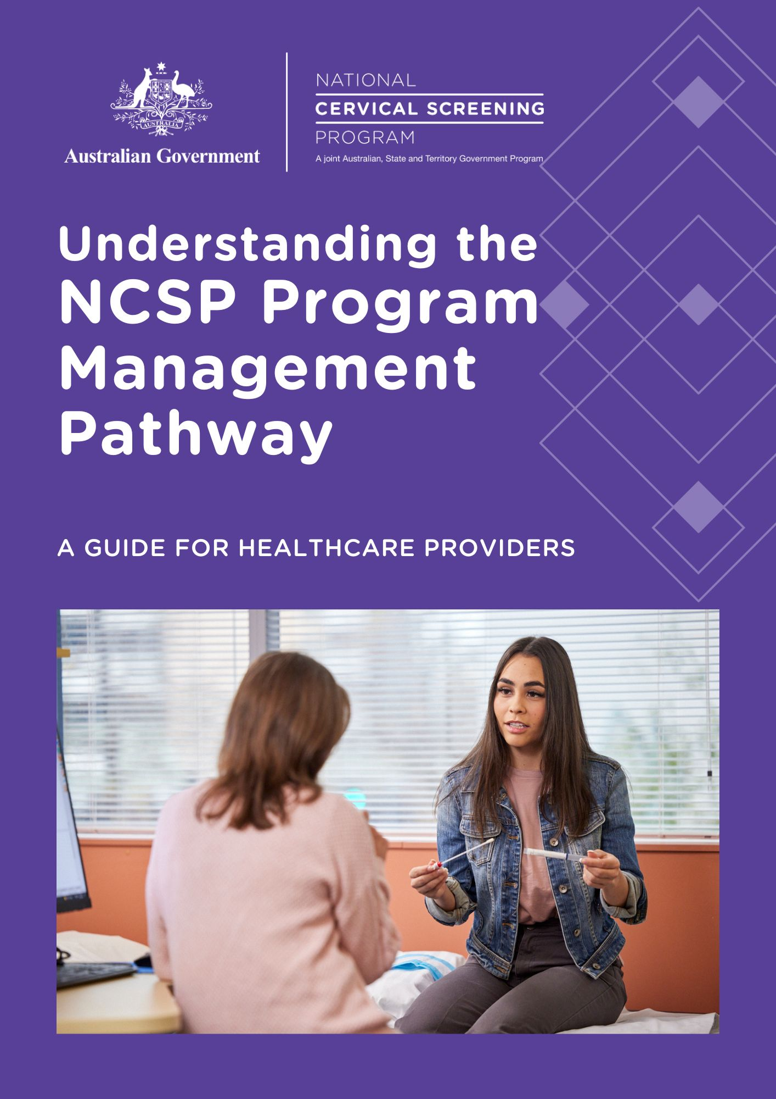
Contents
1. About cervical cancer 4
Human papillomavirus (HPV): the most common cause of cervical cancer 4
Cervical cancers and HPV 4
2. Cervical screening 5
Checking screening participants histories 5
Talking with patients about cervical screening 6
Addressing cervical screening in under-screened and never-screened patients 7
Tips and resources for communicating results 8
Resources for general audiences 9
Easy read and translated resources 9
Resources for Aboriginal and/or Torres Strait Islander peoples 9
Resources for Healthcare providers 10
3. The Cervical Screening test and pathway – a risk-based approach 10
The screening pathway 11
4. Understanding the risk categories 13
Understanding low risk 13
Is rescreening at 5 years safe? 13
Understanding intermediate risk 14
Understanding higher risk 16
5. Collecting a Cervical Screening Test sample 19
Symptomatic patients 19
Asymptomatic screening participants 21
Clinician-collected Cervical Screening Test – step-by-step instructions 21
Self-collected Cervical Screening Test – step-by-step instructions 23
Self-collection swab 24
Self-collection instructions 24
Co-tests 26
Testing during pregnancy 26
6. Screening in people attending for an exit test (aged 70-74) 27
Testing after total hysterectomy 28
7. When test results are unsatisfactory 30
8. Further testing and treatment 30
9. What is a colposcopic assessment? 31
10. Treatment for abnormalities 32
Loop excision 32
Laser 32
Cone biopsy 32
Care after treatment 32
11. Management after treatment for high–grade abnormalities 33
HSIL (CIN2/3) 33
Adenocarcinoma in situ (AIS) 33
12. Pathology tests for cervical and vaginal testing 35
What do I write on the pathology request form? 35
How will the pathology laboratory manage my request? 35
Are the MBS items for pathology tests gender specific? 36
How is a self-collect HPV test request handled differently at the laboratory? 36
What if the pathology laboratory my clinic uses cannot process self-collected samples? 36
13. National Cancer Screening Register 40
Privacy in the NCSR 40
Program correspondence 40
Supporting your patients through the NCSR 42
Contacting the NCSR 43
14. More information and online training 44
Online training with CPD points 44
Resources to support you with under-screened and never-screened people 44
15. Contacts 45
16. Glossary 45

Figures
Figure 1 - Cervical Screening pathway for primary oncogenic HPV screening (HPV tests on clinician-collected or self-collected samples) in participants aged 25-69 years 12
Figure 2: Self-collection instructions 25
Figure 3: Vaginal screening after hysterectomy 29
Figure 4: Test of Cure following treatment for high grade squamous abnormalities 34



About cervical cancer

Human papillomavirus (HPV): the most common cause of cervical cancer
Cervical cancer is a rare outcome of persistent infection with oncogenic human papillomavirus (HPV) types. Infection with an oncogenic HPV type is necessary, although not sufficient, for the development of cervical cancer. HPV types 16, 18 and 45 are most predominantly associated with cervical cancer, with types 16 and 18 detected in 70%–80% of cases in Australia.

Cervical cancers and HPV

What is HPV?
HPV is a virus, which is easily transmitted via genital-skin-to-skin contact during sexual activity. It is common for anyone who has ever had any type of sexual contact. This includes sexual intercourse, penetrative sex, oral sex, intimate genital skin contact (for example as part of foreplay) and anal sex. Most people have been infected with at least one type of HPV at some point in their life without ever knowing it.

What is the link between HPV and cervical cancer?
While HPV infections are normally cleared naturally by the immune system, sometimes they persist and cause cervical cells to become abnormal. The body is usually able to rid itself of HPV and the abnormal cells, but in some cases, this does not happen, and the abnormal cells develop into cervical cancer.

Most cervical cancers are caused by HPV, including squamous cell carcinoma and adenocarcinoma and most neuroendocrine cancers. The time from HPV infection to cervical cancer is usually 10–15 years or more.

There are other very rare types of cervical cancer including clear cell cancers that account for a very small percentage of all cervical cancers, that the Cervical Screening Test does not effectively detect.

Why HPV-vaccinated patients still need to participate in cervical screening
The HPV vaccine protects against most but not all types of HPV that can cause cervical cancer. Therefore, vaccinated patients are still at some risk of significant cervical abnormalities from these other oncogenic HPV types and need to participate in regular cervical screening.


Cervical screening
The National Cervical Screening Program (NCSP) invites participants to attend routine cervical screening every 5 years. Participants should include women and people with a cervix who:
- are aged between 25-74
- report no symptoms of cervical cancer
- have ever had any type of sexual contact

Checking screening participants histories
Medicare items for routine cervical screening can only be claimed once in a 57-month (4 years, 9 months) period.

Different item numbers apply for follow-up tests or for screening in specific populations with different recommendations (see the section titled Pathology tests for cervical and vaginal testing section and, for further details, the NCSP Pathology Guide and MBS online).

Check when your patient last had a Cervical Screening Test and what sort of test, they are due for by accessing the Healthcare Provider Portal via PRODA. Practices using Best Practice, MedicalDirector and Communicare can integrate their practice systems with the NCSR to view their patient’s cervical screening record directly within a patient record. Visit NCSR.gov.au for more information, including walkthrough videos.

Talking with patients about cervical screening
The aim of the NCSP is to reduce the incidence, morbidity and mortality rates of cervical cancer by encouraging women and people with a cervix to have regular cervical screening and attend all follow up recommendations/treatment. Patients have the choice of a clinician-collected cervical sample or self-collected vaginal sample for their Cervical Screening Test.

If an HPV infection is going to develop into cervical cancer, it will take around 10-15 years or more. Most cervical cancers occur in people who have never screened or do not screen regularly. Having regular screening tests is an important way to protect against cervical cancer.

A person’s willingness to undertake screening can be impacted by their level of knowledge about cervical screening, as well as social, personal, and structural factors. Providing accurate and clear information about the Cervical Screening Test. Using safe, accessible, inclusive, and respectful language is one of the best ways to help people make an informed choice.

Key information to mention includes:
- The link between persistent HPV infection and cervical cancer, noting:
  - HPV infections are usually cleared by the immune system in 1–2 years
  - if HPV infection persists, in rare cases it can lead to development of cervical cancer after about 10–15 years
  - if HPV is not detected, cancer is extremely unlikely to develop in the near future
  - Cervical screening is based on HPV testing, and cells in the sample will only be studied for changes if HPV is detected.
- Screening participants have the choice to either have a cervical sample collected by a healthcare provider or to collect their own vaginal sample (this visual guide may assist).
- When deciding whether to choose clinician-collection or self-collection, screening participants must be given clear information about the pros and cons of each method including what follow-up will be required if HPV 16/18 or HPV (not 16/18) is detected.
- Screening is only required once every 5 years for those who do not have HPV detected.
- Specific guidelines apply for people who are immune-deficient.
- It should be explained to screening participants that the Cervical Screening Test does not test for all gynaecological cancers and any unusual signs or symptoms should be investigated regardless of the findings of the Cervical Screening Test. It only tests for cervical cancer.

Addressing cervical screening in under-screened and never-screened patients
Around 70% of Australian patients who develop cervical cancer are under-screened or have never been screened.

Being under-screened or never screened is more common among those:
- who identify as Aboriginal and/or Torres Strait Islander
- from culturally and linguistically diverse backgrounds
- with disability
- who have experienced sexual trauma and/or domestic violence
- who identify as lesbian, gay, bisexual, trans/transgender, intersex or queer
- from lower socio-economic groups
- from rural and remote areas

It is of utmost importance to support engagement and participation in the program among these groups, remembering that they are not homogeneous and may intersect. Each person’s individual circumstances will influence their participation in cervical screening.

When discussing cervical screening with your patients, particularly those who may be under screened or never screened, it is important to be mindful of these considerations:
- Building trust and rapport is vital. Creating a sense of safety and security will go a long way towards allaying concerns or fears.
- Demonstrating respect and inclusivity through the language you use and by creating an inclusive atmosphere in your health service, e.g., waiting room displays and consumer resources in various languages.
- Enquiring about past screening experiences, and identifying the barriers (e.g. shame, past trauma, discomfort, body image embarrassment). Take the time to help your patient feel supported, comfortable, and clear on the benefits of screening.
- Ensuring people understand that their Cervical Screening Test results will remain confidential.
- Offering a choice for their Cervical Screening Test, of either a clinician-collected cervical sample or self-collected vaginal sample. Guides using simple language are available to help explain the choice.
- Providing reassurance that the test will be undertaken carefully and respectfully, and that they will be able to undress in private and given a sheet to cover their lower body, if clinician-collected sample, or be provided a private place to self-collect their own sample.
- Helping with self-collection for those who have difficulty collecting a vaginal sample by themselves, including by collecting the sample on their behalf using a self-collection swab without using a speculum.
- Using visual aids (diagrams and anatomical models) where appropriate, particularly with patients with low literacy levels or those who may be embarrassed discussing sexual activity or their genitalia.
- Giving sufficient time to feel comfortable with new information, to ask questions and make informed decisions.
- Not making assumptions about cultural background, sexual history, sexual preferences, literacy levels or an individual’s knowledge of their bodies. Asking questions and showing interest.
- Using a face-to-face or telephone interpreter if language is a barrier or allowing a chaperone, if desired by the patient.
- Some patients may prefer to insert their own speculum, and it can be helpful to offer this option.
- Asking transgender and non-binary people with a cervix what language they are comfortable using for their body parts.

Where HPV (any type) is detected in a self-collected sample and the person was overdue for screening, they may require additional and individualised support to progress along the clinical pathway and access to follow-up services where they will receive sensitive treatment. This additional support may involve reassurance and explanation of the screening pathway and follow-up procedures, longer appointments or additional follow-up contact.

Tips and resources for communicating results
- Explain Cervical Screening Test results in a compassionate, open, non- judgmental manner and use plain language.
- When a relative or carer is present, it is important to check whether the person would prefer to be alone during the appointment.
- When abnormal Cervical Screening Test results occur, it is important to explain that this does not necessarily mean the patient has cancer.
- Screening participants may feel anxious or worried if they are told they have HPV and need further investigation following their Cervical Screening Test.
- It can be helpful to explain that:
  - HPV is a very common infection that is spread by genital skin-to-skin contact.
  - Condoms do not completely prevent HPV infections.
  - Most people have HPV at some point in their lives but never know they have it as there are usually no symptoms.
  - HPV is very common and more than 80% of people contract HPV sometime in their life.
  - A new positive HPV screening test result does not necessarily indicate recent sexual transmission because previous HPV infections can be latent in the body and reactivated years (or even decades) later, as the immune response changes over time.
- In most cases, the HPV infection will be cleared by the immune system in 1-2 years.
- Explain the difference between a clinician-collected cervical sample and a self-collected vaginal sample, and that both sampling methods are equivalent in terms of test accuracy.
- When describing LBC results, avoid using terminology such as 'pre-cancerous' as it can cause anxiety and may be inaccurate.
- Reassure patients that cervical cancer is a rare outcome, and that low-grade changes are common, usually transient and can safely be monitored.
- Provide opportunities for patients to ask questions.

The following resources are available on the National Cervical Screening Program website to support conversations with patients about the Cervical Screening Test.

Resources for general audiences
Available on the NCSP website (www.health.gov.au/ncsp)
- Promotional poster
- Cervical Screening Test – your choices explained visual guide
- Cervical screening explainer video
- Self-collection instructional video
- Self-collection instructional visual guide
- What happens when my healthcare provider collects my sample visual guide
- Understanding results booklet

Easy read and translated resources
Available on the NCSP website:
- About the Cervical Screening Test (Easy Read)
- Understanding choice visual guide
- Self-collection visual guide
- Understanding choice explainer video
- Self-collection instructional video
- Understanding results visual guide

Resources for Aboriginal and/or Torres Strait Islander peoples
Available on the NCSP website:
- Promotional poster
- Cervical screening information sheet
- Self-collection instructional video
- Self-collection instructional visual guide
- Case study
- Understanding results visual guide

Resources for Healthcare providers
Available at on the NCSP website:
- Cervical screening quick reference guide
- Cervical Screening Guidelines – A summary for healthcare providers
- Cervical screening communication toolkit
- Pathology Test Guide for Cervical and Vaginal Testing
- Healthcare provider toolkit to engage under- and never-screened people

The Cervical Screening test and pathway – a risk-based approach
Note: Important changes were made to the NCSP Guidelines in 2024/25 regarding:
- Test of Cure after treatment for HSIL (CIN2/3)
- Surveillance after treatment for AIS for those with complete excision and clear margins

The Cervical Screening Test detects infection with HPV.

The Cervical Screening Test and pathway is a risk-based approach to the management of those participating in the NCSP. Screening participants are managed according to their risk of developing significant cervical abnormalities. A person’s overall risk assignment is determined by their Cervical Screening Test result, their prior screening history, and clinical findings.
All women and people with a cervix eligible for a Cervical Screening Test have the choice to screen using either a clinician collected sample from the cervix or a self-collected vaginal sample, accessed through a healthcare provider in both cases. HPV testing using self-collected vaginal samples is as accurate as using a clinician-collected sample from the cervix.

Clinician-collected cervical samples can be tested for HPV and cervical cell abnormalities. A self- collected sample is taken from the vagina (not the cervix) and can only be tested for HPV.

HPV testing for cervical screening is more sensitive than cytology and detects the potential for progression to high-grade lesions much earlier, thus preventing more cervical cancers. Screening using HPV testing also can improve detection of adenocarcinoma and its precursors.

Partial genotyping is used to classify the oncogenic type of HPV into one of two groups: HPV 16/18 or HPV (not 16/18) as a pooled result.

Patients are managed according to their risk of developing significant cervical abnormalities, which is determined by their HPV test result and LBC result, if indicated. If both tests are performed, the pathology report will include the combined result as a risk category and the recommended clinical management.

If glandular abnormalities are detected on a screening test, you should follow up in accordance with the NCSP Guidelines.

The screening pathway
The screening pathway below (Figure 1) and the results matrix (Table 1) outline how the risk categories and management strategies are determined based on HPV and LBC (if performed) results.

Figure 1 - Cervical Screening pathway for primary oncogenic HPV screening (HPV tests on clinician-collected or self-collected samples) in participants aged 25-69 years
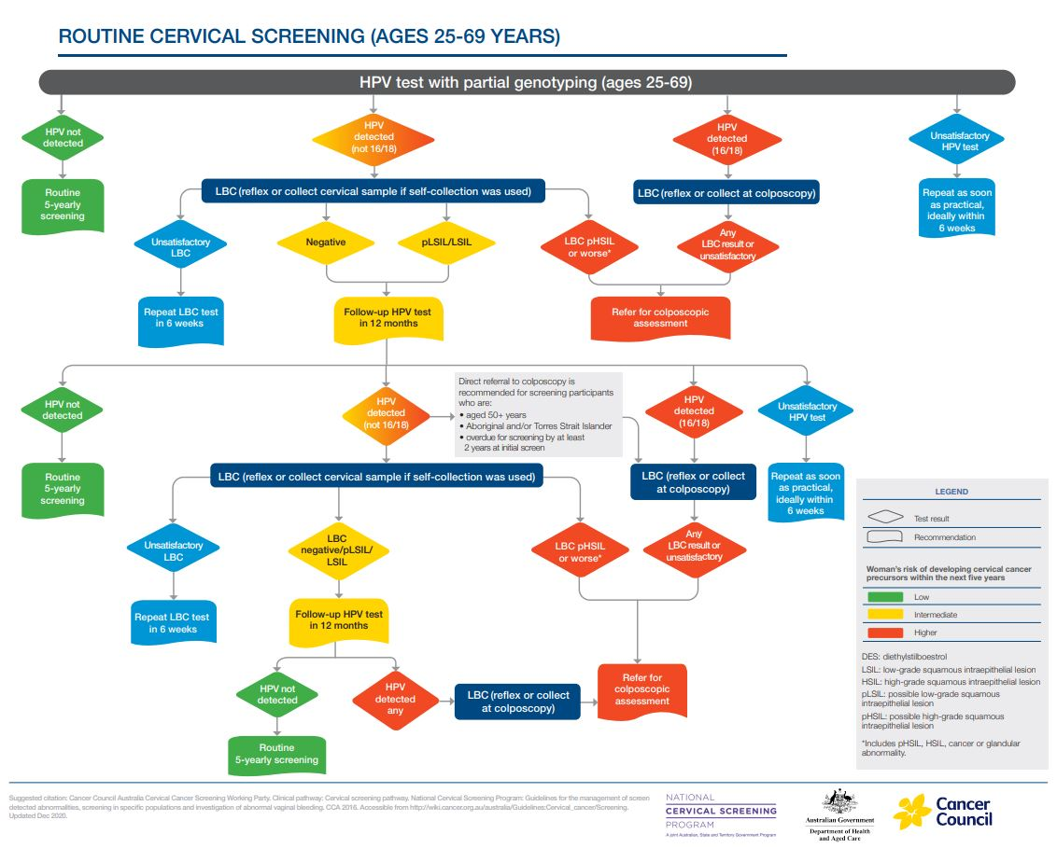



Understanding the risk categories

Understanding low risk

What does a low-risk result mean?
A low-risk result means HPV was not detected. HPV is required for the development of most cases of cervical cancer. Screening participants at a low risk of developing cervical cancer can safely return for their next Cervical Screening Test in 5 years.

We cannot tell people that they are at ‘no risk’ because they may subsequently acquire an HPV infection or have a latent infection that becomes active and may develop into cervical cancer over time, usually 10–15 years. Screening participants with a low-risk result will be invited to screen again in 5 years.

NCSP guidelines outline separate guidance for people with severe immune deficiency, those who have been exposed to diethylstilbestrol (DES), those undergoing test of cure after treatment of HSIL and those aged 70+ attending for an exit test.

Is rescreening at 5 years safe?
It is safe for those with a low-risk result to wait for 5 years before their next Cervical Screening Test. Evidence about the natural history of cervical cancer has shown that the average time taken for a persistent HPV infection to cause cervical abnormalities and then progress to cervical cancer is usually 10–15 years.

No screening test is 100% effective, however because the HPV test has a high negative predictive value, screening participants who have not had HPV detected are at low risk of developing significant cervical abnormalities or cervical cancer within 5 years. Because of this, they will only need to have a Cervical Screening Test every 5 years. The 5-year period between screening tests is the same regardless of HPV vaccination status.

Understanding intermediate risk

What does an intermediate risk result mean?
An intermediate risk result means that the screening participant should return for a follow-up test in 12 months.

This result is given where HPV (not 16/18) was detected as part of a routine screening in a participant aged 25-69 years (not as a follow-up, test of cure, investigation of symptoms, or an exit test in someone aged 70 years or older) and a reflex LBC was performed with a report of negative or possible low-grade squamous intraepithelial lesion (pLSIL), or LSIL abnormal cervical cells.

When oncogenic HPV (not 16/18) is detected on a Cervical Screening Test in a participant aged 25-69 years, LBC must be performed to determine the final risk category (higher risk or intermediate risk).
- If the sample was collected by a healthcare provider, then the laboratory will perform reflex LBC.
- If the sample was self-collected, the screening participant should return to their healthcare provider as soon as practical, ideally within 6 weeks, to have a cervical sample collected for LBC. If the person does not return until 9 months or more after the HPV test, a follow-up self-collected HPV test can be offered, rather than LBC, because this will determine if the HPV infection has now been cleared and the person can then return to routine screening.
- If LBC result is unsatisfactory the patient should repeat LBC only in 6 weeks.

An intermediate risk result is not associated with high-grade cell changes that require treatment.

Screening participants with an intermediate risk result will be invited to return for a follow-up HPV test in 12 months. This is to check if their body has cleared the HPV infection.

What happens 12 months after an intermediate risk result?
The screening participant should have a follow-up HPV test, and will receive one of the following possible results:
- HPV not detected: The immune system has cleared the HPV infection. This places the person in the low-risk category and they can now safely return to routine screening.
- HPV (16/18) detected: This places the person in the higher risk category. If the sample was clinician-collected, then they are referred for colposcopy regardless of the reflex LBC result. If the sample was self-collected, the person is referred directly for colposcopy and the LBC will be performed during the colposcopy consultation.
- HPV detected (not 16/18): In most (but not all) cases, LBC must be performed to stratify the risk (see Exceptions to a second follow-up HPV test below). If the sample was clinician-collected, then the laboratory will perform reflex LBC. If the sample was self-collected, the screening participant should return to their healthcare provider as soon as practical, ideally within 6 weeks to have a cervical sample collected for LBC.
  - If the person does not return until 9 months or more after the HPV test, a follow-up self-collected HPV test can be offered. Rather than an LBC, because this will determine if the HPV infection has now been cleared and the person can then return to routine screening (low risk).
  - If the LBC is negative pLSIL or LSIL the screening participant is classified as intermediate risk and recommended to return for a further follow-up HPV test in another 12 months' time (i.e., 24 months from the initial cervical screening test).
  - If the LBC report predicts invasive cancer (squamous, glandular, or other), then the person is classified as higher risk and should be referred to a gynaecological oncologist or gynaecological cancer centre for urgent evaluation, ideally within 2 weeks.
  - If the LBC report predicts pHSIL, HSIL or any glandular abnormality, then the person is classified as higher risk and should be referred for colposcopic assessment at the earliest opportunity, ideally within 8 weeks.

Exceptions to a second follow-up HPV test
Some groups of people may be at higher risk of harbouring a high-grade abnormality despite a negative pLSIL or LSIL LBC result, and so are classified as higher risk and should be referred to colposcopy if HPV (any type) is detected at the 12-month follow-up test (regardless of the reflex LBC result). In these groups, if the sample was self-collected, a sample for LBC should be collected at the time of colposcopy. They do not need to return to their healthcare provider for a cervical sample. These include people who:
- were overdue for screening by at least 2 years, at the time of their initial positive HPV (not 16/18) test result
- identify as Aboriginal and/or Torres Strait Islander
- are aged 50 years or older.

What happens 24 months after an intermediate risk result?
The screening participant should have a follow-up HPV test, and will receive one of two results:
- HPV not detected: Lower risk The immune system has cleared the HPV infection. The person can now safely return to routine screening.
- HPV detected (any type): Higher risk This result means that there is a persistent HPV infection (any type), which could be HPV (16/18) and/or HPV (not 16/18). The person should be referred for colposcopic assessment. If the follow-up sample was clinician-collected, then the laboratory will perform reflex LBC. If the follow-up sample was self-collected, then a sample should be collected for LBC at the time of colposcopy.
There are also other groups of people who fall outside these recommendations, who require separate guidance, including people who:
- are immune-deficient – see section 7.2 of the NCSP Guidelines
- were exposed to DES in utero – see section 7.3 of the NCSP Guidelines
- are currently undergoing Test of Cure following treatment of histological HSIL – see section 9.2.2 of the NCSP Guidelines
- are aged 70-74 (attending for an exit test) - see section 5.8 of the NCSP Guidelines
- are aged 75 or older – see section 5.9 of the NCSP guidelines

Understanding higher risk

What does a higher risk result mean?
A higher risk result means that colposcopy is recommended.

Several possible results can result in a higher risk result. At a primary screening test, the following results will result in a higher risk classification:
- HPV (16/18) detected: HPV types 16 and 18 are associated with approximately 70-80% of cervical cancers. These HPV types are also more likely to progress to cervical cancer than other oncogenic HPV types. Patients with an HPV (16/18) test result should be referred directly for colposcopic assessment because they are at higher risk of cervical cancer. If the sample was collected by a healthcare provider, then reflex LBC will be performed by the laboratory. If the sample was self-collected, then a sample for LBC should be collected at the time of colposcopy. A colposcopy will determine if a biopsy is needed, and this will determine if treatment is required. Investigations and management at colposcopy should follow NCSP guidelines.
- HPV (not 16/18) detected, and LBC result predictive of pHSIL/HSIL, any glandular abnormality or invasive cancer: If HPV (not 16/18) was detected, LBC is needed to assign the risk result.
  - If the LBC showed invasive cancer (squamous, glandular or other) the patient should be referred to a gynaecological oncologist or gynaecological cancer centre for urgent evaluation, ideally within 2 weeks.
  - If the LBC showed pHSIL/HSIL or any glandular abnormality, the patient should be referred for colposcopic assessment at their earliest opportunity, ideally within 8 weeks.
- HPV (any type) detected in a participant aged 70 years or older: Participants attending for an exit test when aged 70 years or older who have oncogenic HPV (any type) detected should be referred for colposcopy. If their test sample was collected by a healthcare provider, then reflex LBC will be performed by the laboratory. If the sample was self-collected, then a sample for LBC should be collected at the time of colposcopy.
For more information on managing HPV test results, see section 6 of the NCSP Guidelines.

Table 1: Cervical Screening Test results and LBC guidance – clinician-collected and self-collected samples
HPV test result | LBC | LBC result | Risk Level | Recommended management
HPV not detected (anywhere in screening pathway) | Not required | – | Low risk | Return to screening in 5 years
HPV (16/18) detected  (anywhere in screening pathway) | Yes. If clinician-collected, laboratory will do reflex LBC. If self-collected, LBC collected at colposcopy, not required prior to referral. | Any result: If reflex LBC is unsatisfactory, it could be repeated at time of colposcopy | Higher risk | Refer to specialist (colposcopy)
HPV  (not 16/18) detected:  routine screening test in participant aged 25-69 years | Yes. If clinician-collect, laboratory will do reflex LBC.  If self-collected, screening participants should return to their healthcare provider as soon as practical, ideally within 6 weeks, to have a cervical sample collected for LBC. | Negative, pLSIL or LSIL | Intermediate risk | Repeat HPV test in 12 months
HPV  (not 16/18) detected:  routine screening test in participant aged 25-69 years | Yes. If clinician-collect, laboratory will do reflex LBC.  If self-collected, screening participants should return to their healthcare provider as soon as practical, ideally within 6 weeks, to have a cervical sample collected for LBC. | pHSIL, HSIL or any glandular | Higher risk | Refer to specialist (colposcopy)
HPV  (not 16/18) detected:  routine screening test in participant aged 25-69 years | Yes. If clinician-collect, laboratory will do reflex LBC.  If self-collected, screening participants should return to their healthcare provider as soon as practical, ideally within 6 weeks, to have a cervical sample collected for LBC. | Unsatisfactory | - | Return for a repeat LBC in 6 weeks.
HPV (not 16/18) detected:  12-month follow-up test in a participant in an exception category | Yes. If clinician-collected, laboratory will do reflex LBC. If self-collected, LBC collected at colposcopy, not required prior to referral. | Any result: If reflex LBC is unsatisfactory, it could be repeated at time of colposcopy | Higher risk | Refer to specialist (colposcopy)
HPV (not 16/18) detected:  12-month follow-up test; not in exception category | Yes. If clinician-collect, laboratory will do reflex LBC. If self-collected, screening participants should return to their healthcare provider as soon as practical, ideally within 6 weeks, to have a cervical sample collected for LBC. | Negative, pLSIL or LSIL | Intermediate risk | Repeat HPV test in 12 months
HPV (not 16/18) detected:  12-month follow-up test; not in exception category | Yes. If clinician-collect, laboratory will do reflex LBC. If self-collected, screening participants should return to their healthcare provider as soon as practical, ideally within 6 weeks, to have a cervical sample collected for LBC. | pHSIL, HSIL or any glandular | Higher risk | Refer to specialist (colposcopy)
HPV (not 16/18) detected:  12-month follow-up test; not in exception category | Yes. If clinician-collect, laboratory will do reflex LBC. If self-collected, screening participants should return to their healthcare provider as soon as practical, ideally within 6 weeks, to have a cervical sample collected for LBC. | Unsatisfactory | - | Return for a repeat LBC test in 6 weeks.
HPV (any type) detected:  24- month repeat | Yes. Yes. If clinician-collected, laboratory will do reflex LBC. If self-collected, LBC collected at colposcopy, not required prior to referral. | Any result  If reflex LBC is unsatisfactory, it could be repeated at time of colposcopy | Higher risk | Refer to specialist (colposcopy)
Unsatisfactory | - | - | - | Return for a repeat HPV test (self-collected or a clinician-collected sample) as soon as practical, ideally within 6 weeks.



Collecting a Cervical Screening Test sample
Anyone who is eligible for a Cervical Screening Test (asymptomatic women and people with a cervix aged 25- 74 years) has the choice to screen using either a clinician-collected sample from the cervix or a self-collected vaginal sample.
When discussing Cervical Screening Test options, explain the pros and cons of both cervical screening options – a clinician–collected and a self–collected sample – to ensure that the participant can make an informed decision. Explain also that both sampling methods are equivalent in terms of test accuracy.
For information about how to fill in the pathology form, see the NCSP Pathology Guide or see Pathology Test Guide (Table 2).

Symptomatic patients
Participants who have signs or symptoms suggestive of cervical cancer are tested and managed on a different clinical pathway from those who are asymptomatic. They are not eligible for screening, but rather for investigation and diagnosis.

Abnormal vaginal bleeding
Abnormal vaginal bleeding can occur at any age. It is rarely caused by cervical cancer and is most commonly associated with other conditions, such as:
- polyps  - adenomyosis  - leiomyomas (fibroids)  - hormonal contraception  - iatrogenic causes | - coagulopathies  - ovulatory disorders  - endometrial disorders  - sexually transmitted infections

The following types of abnormal vaginal bleeding can be suggestive of cervical cancer:
- unexplained intermenstrual vaginal bleeding
- persistent post-coital bleeding
- any post-menopausal bleeding

When to test: Patients at any age with these types of vaginal bleeding should have a co-test. They should also be referred for specialist investigation to exclude genital tract malignancy, regardless of the result of the co-test.

A self-collected test is not appropriate in this situation as it is a HPV test only and cannot detect further advanced cancerous cells.

Note: False negative test results are more common for both the HPV test and LBC in the setting of vaginal bleeding.

If the participant returns a negative co-test but still presents recurrent or persistent postcoital bleeding, they should be referred for investigations to exclude genital tract malignancy. This includes if they have persistent unexplained inter-menstrual bleeding or post-menopausal bleeding.

Co-testing or referral for colposcopy is not required for irregular bleeding due to:
- hormonal contraception
- contact while obtaining a routine CST sample
- heavy regular periods (heavy menstrual bleeding)
- irregular bleeding due to a sexually transmitted infection

For more information on management of participants with abnormal vaginal bleeding, see Chapter 18: Signs and symptoms of cervical cancer of the NCSP Guidelines.

Abnormal vaginal discharge
Unexplained, persistent, unusual vaginal discharge may also be associated with later stage cervical cancer diagnoses. Accordingly, these symptoms should lead to co-test and specialist referral, regardless of the result of the co-test.

Dyspareunia
Pain during sex (dyspareunia) is most commonly due to benign gynaecological conditions. A patient presenting with dyspareunia should be appropriately investigated and, if necessary, referred for gynaecologic assessment.

A routine CST can be performed, but only if the person is due or overdue. Dyspareunia, in the absence of abnormal bleeding, is not a sufficient indication for a co-test outside of NCSP protocols.

Asymptomatic screening participants
Most patients presenting for their Cervical Screening Test will be asymptomatic and be within the eligible age range of 25 to 74 years of age. People presenting with signs or symptoms suggestive of cervical cancer are not eligible for screening and should instead follow a diagnostic pathway (see Symptomatic people below).

Clinician-collected Cervical Screening Test – step-by-step instructions
A vaginal speculum examination is required to obtain a clinician-collected cervical sample and visualise the cervix.
- Before performing any procedure, clearly explain what will happen and ensure the person fully understands this. A visual guide can be used to talk them through each step (NCSP – What happens when my healthcare provider collects my sample). Healthcare providers must be aware and sensitive to the multiple impacts of trauma and the potential of re-traumatisation during the cervical screening process and follow a trauma-informed care approach.
- After the person is prepared and comfortable, begin the speculum examination by examining the external genitalia for any abnormalities, then:
- warm the speculum, and apply a small amount of water-based lubricant,
- hold the speculum in your hand with the handle facing down, and the blades closed,
- gently part the labia and encourage the patient to breathe out while you slowly insert the closed speculum into the vagina using slight downward pressure, keeping the lower blade against the posterior wall of the vagina,
- open the blades slightly, then tilt the speculum forward a little to allow maximum visualisation of the external orifice of the cervix uteri (external os),
- throughout the procedure ask the patient if they are in any discomfort and encourage feedback; if the patient asks to ‘stop’ the procedure at any time this must be followed.
- Once the cervix is visualised, inspect for the following features:
- colour, size, shape
- position
- abnormal areas (lesions)
- surface characteristics
- the transformation zone (squamocolumnar junction; where the endocervical canal lining meets the squamous epithelium), which may or may not be visible
- discharge
- The objective of cervical screening is to sample cells from the transformation zone of the cervix, where HPV and cell abnormalities that precede the development of squamous cell carcinoma are usually found.
When choosing a device(s), consider prior treatment and prior cytology results. Collect a sample of cells from the cervix using a spatula, brush or broom sampling device, following the manufacturer’s instructions. The choice of device depends on the location of the transformation zone, which is influenced by the patient’s age and menopausal status.
- It is optimal for the cervical sample to contain both ectocervical and endocervical cells. However, the sample will not be deemed as unsatisfactory if there is no endocervical component.
Record the person's name, date of birth and ID number on the specimen vial and any other identifiers required by the laboratory.
- Ask the person if they identify as Aboriginal and/or Torres Strait Islander, in accordance with the Australia Bureau of Statistics classification and standards. Aboriginal and/or Torres Strait Islander status may influence clinical management (e.g. in the intermediate risk pathway).
- On the pathology request form, note the following:
- Patient information
- Cervical screening history and other relevant medical history (including gynaecological history)
- Any cervical abnormalities visualised during the cervical examination
- That the sample was clinician-collected
- If the person identifies as Aboriginal and/or Torres Strait Islander
- Place the vial and pathology request form in a specimen bag for transport to the laboratory.
- Ask the person how they would like to be advised of the results and document their preference; use medical software or other systems to ensure they are notified of their results.
- Ensure the details of the consultation and procedure are accurately documented in the clinical record.

Online Education Modules are available with information on how to take a sample for a Cervical Screening Test on the ACPCC website.

Self-collected Cervical Screening Test – step-by-step instructions
A Cervical Screening Test using a self-collected vaginal sample should be routinely offered as a choice to all women and people with a cervix eligible for screening, except where a co-test is indicated.

Cervical screening on a self-collected vaginal sample needs to be ordered by a healthcare provider. The healthcare provider is not required to observe the patient collecting their sample unless this is the person’s preference.

For asymptomatic people, there is robust evidence that HPV tests on self-collected vaginal samples and clinician-collected cervical samples have equivalent sensitivity when using a PCR (Polymerase Chain Reaction) based HPV test.

Self-collection is not appropriate if the person requires a co-test which includes (but is not limited to):
- those with signs or symptoms suggestive of cervical cancer (e.g., present with an abnormal cervix suspicious of cancer, have unexplained postcoital bleeding or persistent intermenstrual bleeding, postmenopausal bleeding, or unexplained persistent unusual vaginal discharge)
- those who have been treated for adenocarcinoma in situ (AIS)
- those who were exposed to diethylstilbestrol (DES) in utero.

Note: Co-testing is not required for breakthrough or irregular bleeding due to hormonal contraception or a sexually transmitted infection, heavy menstrual bleeding, or contact bleeding at the time of obtaining a routine cervical screening test (CST).

Anyone due for cervical screening during pregnancy can be offered the option of self-collection of a vaginal sample for HPV testing.

Patients attending an in-person consultation should be encouraged to collect a sample while they are still at the clinic, as sample collection is more likely in this context.

However, with the aim of maximising participation in cervical screening, collection of the sample can occur in any setting that the healthcare provider ordering the test believes is appropriate, including in the context of a telehealth consultation.

Healthcare providers may assist those who have difficulty collecting a vaginal sample by themselves or can collect the sample on the person’s behalf using a self-collection swab without using a speculum, if requested. A sample collected in this way is still classified as a self-collected sample on the pathology request form.

Self-collection swab
There is a range of collection devices and methods available to use for self-collection of a vaginal sample for cervical screening. As a result, different laboratories may have varying collection and handling instructions and requirements. Healthcare providers should contact their local pathology laboratory to confirm the type of self-collection swab used by that laboratory and any handling and processing requirements.

Self-collection instructions
- During a consultation with a patient explain the following:
- A self-collected sample is from the vagina (not the cervix) and can only be tested for HPV. Any cell changes cannot be seen in this sample and the cervix will not be viewed.
- If HPV is detected in a self-collected vaginal sample, the patient will need to return for a clinician-collected sample for LBC (if HPV (not 16/18) is detected) or will need to be referred to a specialised service for a colposcopy (if HPV (16/18) is detected).
- Among those attending for routine screening:
  - around 2% are expected to have HPV (16/18) detected (and recommended to attend colposcopy), and
  - around 6% will have HPV (not 16/18) detected (and recommended to return for a clinician-collected cervical sample for LBC), although this varies with age and is more common in younger people.
  - in around 90% of people, HPV would not be detected (although this varies with age)
- Provide the screening participant with the self-collection instruction sheet and talk them through each step (as also outlined in Figure 2: Self-collection instructions).
- It is suggested that you print out and talk through these instructions. Make them familiar with the self-collect swab your healthcare facility uses before giving them a copy of the instructions to use while taking their sample.
- This and other resources – including an instructional video can be viewed by the screening participant on their electronic device or mobile phone – available from www.health.gov.au/ncsp
- Engage an interpreter if needed and consider using pictorial, easy read and translated resources with patients to explain the process.
- Provide the person with a private space to collect their sample (e.g., behind a curtain or in the bathroom).
- Record the person's name, date of birth and ID number on the specimen vial and any other identifiers required by the laboratory.
- Ask the person if they identify as Aboriginal and/or Torres Strait Islander, in accordance with the Australia Bureau of Statistics classification and standards. Aboriginal and/or Torres Strait Islander status may influence clinical management (e.g., in the intermediate risk pathway).
- On the pathology request form, note the following:
- Patient information
- Cervical screening history and other relevant medical history (including gynaecological history)
- That the sample was self-collected
- If the person identifies as Aboriginal and/or Torres Strait Islander
- Place the self-collected sample and pathology request form in a specimen bag for transport to the laboratory.
- Ask how they would like to be advised of the results and document their preference, to ensure they are notified of their results; use medical software or other systems to ensure they are notified of their results.
- Ensure the details of the consultation and procedure are accurately documented in the clinical record.

Figure 2: Self-collection instructions
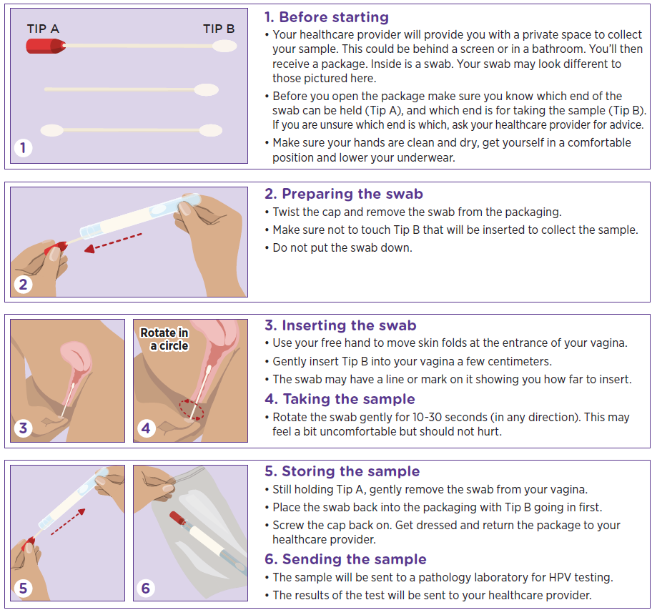

Co-tests

What is a co-test?
Co-testing involves the pathology laboratory performing the HPV and LBC tests concurrently on the same specimen. This means that LBC is performed irrespective of the HPV test result, without requiring an additional request. In instances where a self-collected sample was collected, an HPV test should be performed, and the participant will be asked to return for a clinician-collected sample for LBC testing to complete the co-test.

When is a co-test required?
Co-testing is recommended for:
- those with signs or symptoms suggestive of cervical cancer (e.g. presentation with an abnormal cervix suspicious of cancer; have unexplained postcoital bleeding or persistent intermenstrual bleeding, postmenopausal bleeding, or unexplained persistent unusual vaginal discharge)
- those who have been treated for adenocarcinoma in situ (AIS)
- those who were exposed to diethylstilbestrol (DES) in utero.

Note: Co-testing is not required for breakthrough or irregular bleeding due to hormonal contraception or a sexually transmitted infection, heavy menstrual bleeding, or contact bleeding at the time of obtaining a routine cervical screening test (CST).

If required, ‘co-test’ must be specifically noted on the pathology request form as well as the reason for the co-test (i.e. symptomatic).

Further information on ‘appropriate use’ is outlined in the NCSP Guidelines, and MBS item frequency and descriptors at MBS online (www.medicareonline.gov.au > NCSP Factsheet).

Testing during pregnancy
Routine antenatal and postpartum care should include a review of the patient’s cervical screening history. Those due or overdue for a Cervical Screening Test should be offered screening, which can be done safely during pregnancy if the correct sampling equipment is used. An endocervical brush should not be inserted into the cervical canal because of the risk of associated bleeding.

All people due for a Cervical Screening Test during pregnancy may be offered self-collection of a vaginal swab for HPV testing. Patients with HPV (not 16/18) detected on a self-collected vaginal sample should be advised to return so that a cervical sample for LBC can be collected by the healthcare provider.

If a patient receives a result of HPV (any type) detected or abnormal LBC during pregnancy, the following recommendations apply:
Table 2: Recommendations for follow-up in pregnancy
Result | Management
HPV (16/18) detected | Early* referral for colposcopy regardless of LBC result
HPV (not 16/18) detected and LBC predictive of pHSIL, HSIL or glandular abnormality | Early* referral for colposcopy
HPV (not 16/18) detected and LBC predictive of invasive disease | Referral to a gynaecological oncologist/gynaecological cancer centre, and be seen within 2 weeks
HPV (not 16/18) detected and LBC negative, pLSIL or LSIL | Repeat HPV test in 12 months
*As soon as practical and not deferred until postpartum period.

For more information on performing a cervical screening test during pregnancy, see Section 7.1 of the NCSP Guidelines.


Screening in people attending for an exit test (aged 70-74)
An exit test can be clinician-collected or self-collected depending on the person’s choice. Management is simplified for an exit test, as follows:
- HPV not detected: The person can now safely exit screening.
- HPV (any type) detected (i.e. HPV (not 16/18) or HPV (16/18): This places the person in the higher risk category which requires referral for colposcopy. If the sample was clinician-collected referral for colposcopy should occur regardless of the reflex LBC result. If the sample was self-collected the sample for LBC will be collected during the colposcopy consultation.
Further investigation with colposcopy will help identify abnormal cells that require treatment to prevent cervical cancer progression.

Testing after total hysterectomy
People who have had a total hysterectomy for documented benign reasons (e.g. heavy menstrual bleeding, fibroids) and who have no evidence of cervical pathology detected on the hysterectomy specimen do not require further testing if either of the following conditions apply:
- Normal screening history prior to their hysterectomy
- The person has been treated for histologically-confirmed HSIL and has completed Test of Cure in accordance with NCSP guidelines.

People who have had a total hysterectomy who meet any of the following conditions should have an HPV test taken from the vaginal vault 12 months after hysterectomy and annually thereafter until the person has tested negative on 2 consecutive occasions, after which they do not need further testing:
- Hysterectomy was performed for treatment of HSIL (with or without the presence of benign gynaecological disease)
- Unexpected LSIL or HSIL was identified in the hysterectomy specimen
- The person has previously undergone treatment for histologically confirmed HSIL without completing Test of Cure
- Their screening history is unknown, or they have never been screened.

People who have had a hysterectomy for adenocarcinoma in situ (AIS) or have ever been treated for AIS or with AIS pathology in their cervix are recommended to have annual co-testing (HPV test and LBC) on a vaginal vault specimen, commencing 12 months after treatment. Annual testing is recommended until the person has tested negative on both tests (HPV and LBC) on 2 consecutive occasions, after which they do not need further testing. Follow-up management is summarised below in Figure 2: Vaginal screening after hysterectomy.

People who have had a subtotal hysterectomy (cervix remains in situ) should have routine 5-yearly Cervical Screening Tests. Any abnormalities should be managed according to the relevant recommendations in these guidelines.

Further information is outlined in section 7.4 of the NCSP Guidelines.

Figure 3: Vaginal screening after hysterectomy
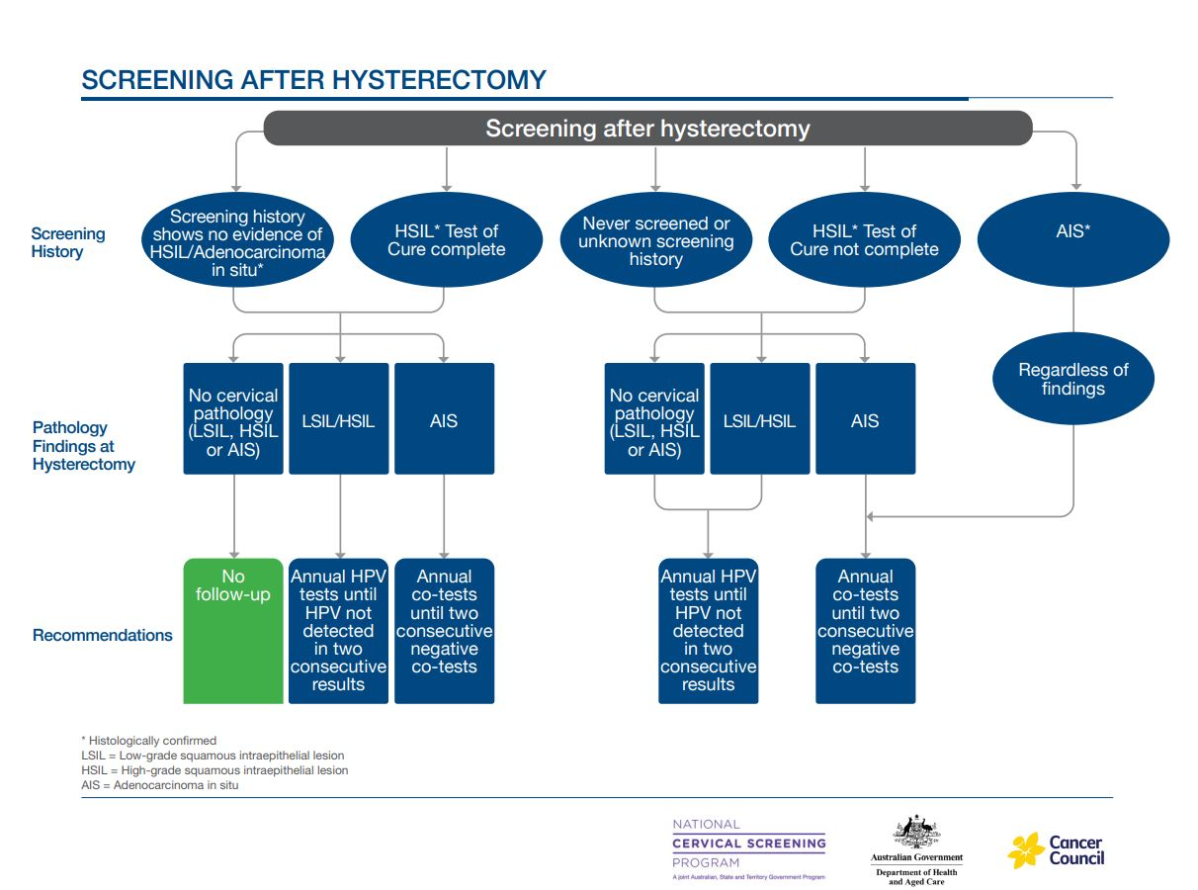

When test results are unsatisfactory
Occasionally the primary test results may be unsatisfactory, and the pathology laboratory will request that the test be repeated.

Where the primary test result is unsatisfactory, the following information should be used on the pathology request form when requesting another test:

Table 3: Recommendations following unsatisfactory primary test
Patient  presents as | Context* | Age | Sample  type | Test type | What to write on the pathology request form
Repeat test following an unsatisfactory test | Following an unsatisfactory test  - Only claimable when preceded by another cervical or vaginal MBS Item | Any | Cervical | HPV test | HPV test, previous result unsatisfactory
Repeat test following an unsatisfactory test | Following an unsatisfactory test  Only claimable when preceded by another cervical or vaginal MBS Item | Any | Vaginal | HPV test | HPV test, previous result unsatisfactory
Repeat test following an unsatisfactory test | Following an unsatisfactory test  Only claimable when preceded by another cervical or vaginal MBS Item | Any | Cervical | LBC | LBC, previous result unsatisfactory

Further information is outlined in:
- NCSP Pathology Guide (Table 2)
- NCSP Guidelines
- MBS item frequency and descriptors (www.mbsonline.gov.au > NCSP Fact Sheet)

Further testing and treatment
Screening participants with a higher risk test result requires further testing and will be referred to a specialised service for assessment and possibly treatment. Primary healthcare providers will need to be prepared to answer some general questions.


What is a colposcopic assessment?
If a higher risk result is given a colposcopic assessment will be needed. During this procedure, the trained healthcare provider inserts a speculum into the vagina (like during a clinician-collected sample for a Cervical Screening Test) and uses an instrument called a colposcope, which looks like a pair of binoculars on a stand. The colposcope allows the clinician to have a magnified view of the cervix to check the extent and nature of any problem. The colposcope stays outside of the body.
During the colposcopy a small sample of tissue (a biopsy) may be taken from any abnormal looking areas of the cervix, the sample will be sent to a laboratory for testing. It will take up to two weeks for the result to come back to the doctor. Arrangements should be made for the patient to discuss the results when they are available and to find out if treatment is required.
If a biopsy is taken the person may have some discomfort for a short time. They should be advised to avoid vigorous physical exercise for 24 hours and avoid sexual intercourse for two days. They may shower, but should avoid swimming, bathing, and spas for one to two days. These precautions are to reduce the risk of bleeding and/or infection. There may be some brown discharge and ‘spotting’ for a few hours afterwards, it is a good idea to take a thin sanitary pad or panty liner to the appointment.

Treatment for abnormalities
Most women and people with a cervix with HPV will not develop high-grade cervical abnormalities. However, some high-risk types of HPV may be more difficult for the body to clear naturally. Long-term infection with oncogenic HPV can increase the risk of high-grade cervical abnormalities, which may lead to cervical cancer. Treatment for high-grade abnormalities caused by HPV infection may be required.

Loop excision
This procedure uses a wire loop to remove abnormal cells from the cervix and takes 15–30 minutes. The technical term is large loop excision of the transformation zone (LLETZ) or loop electrosurgical excision procedure (LEEP).
Most patients can have treatment using a local anaesthetic, which is usually more convenient, but some may require a general anaesthetic and a short hospital stay. Most patients can return to normal activities within two to three days.

Laser
This method uses a laser beam to destroy the abnormal cells from the cervix and takes 15–30 minutes. Most patients can have treatment using a local anaesthetic which is usually more convenient, some may require a general anaesthetic and a short hospital stay. Most patients can return to normal activities within two or three days.

Cone biopsy
In this minor operation, a cone-shaped section of the cervix containing the abnormal cells is removed. This usually requires a general anaesthetic and a day, or rarely an overnight hospital stay.
Only a small number of patients will need a cone biopsy. It is the recommended treatment when the abnormal cells are higher in the cervical canal and/or affect the glandular cells. It may also be recommended to remove potentially cancerous cells.

Care after treatment
After any form of treatment, the patient should not swim, use tampons or have vaginal intercourse for three to four weeks until the cervix has healed. Strenuous exercise should be avoided for seven to ten days following treatment as this increases the risk of bleeding and infection.

Management after treatment for high–grade abnormalities

HSIL (CIN2/3)
It is recommended that patients who have received treatment for a high-grade abnormality should complete Test of Cure surveillance to confirm their treatment has been successful. Test of Cure surveillance involves an HPV test performed 12 months after treatment, and annually thereafter, until they have two consecutive tests with HPV not detected. They should then return to routine screening.

HPV testing can be performed by the person’s usual healthcare provider, on either a self-collected or a clinician-collected sample, depending on the preference of the patient.

Note: People undergoing Test of Cure who had a first follow-up negative co-test before 1 July 2024 can have an HPV test 12 months later, rather than a co-test. The Test of Cure will be considered complete if HPV is not detected on that HPV test.

Adenocarcinoma in situ (AIS)
Histological confirmation of AIS lesions often occurs as the result of a diagnostic excisional biopsy, usually a cold knife cone biopsy, which may or may not have completely excised the lesion. If AIS is incompletely excised or if the margins cannot be assessed, further excision to obtain clear margins should be performed.

People treated for AIS with complete excision and clear margins are recommended to undergo annual co-testing for 5 years at which point, if all co-tests have been negative (HPV not detected and LBC negative), surveillance testing can be extended from annually to every 3 years. If surveillance tests have been performed for 25 years or more since the time of treatment and all tests are negative, the recommendation depends on the screening participant's age.
- Those aged less than 70 years can return to routine screening.
- Those aged 70 years or older can exit screening if they have had at least one co-test when aged 70 years or older, with no oncogenic HPV detected and an LBC report of negative.

For information about how to fill in the pathology form, see the Pathology Test Guide (Table 2). For more information on Test of Cure, see Figure 4: Test of Cure following treatment for high grade squamous abnormalities or section 9.2.1 of the NCSP Guidelines.

Figure 4: Test of Cure following treatment for high grade squamous abnormalities
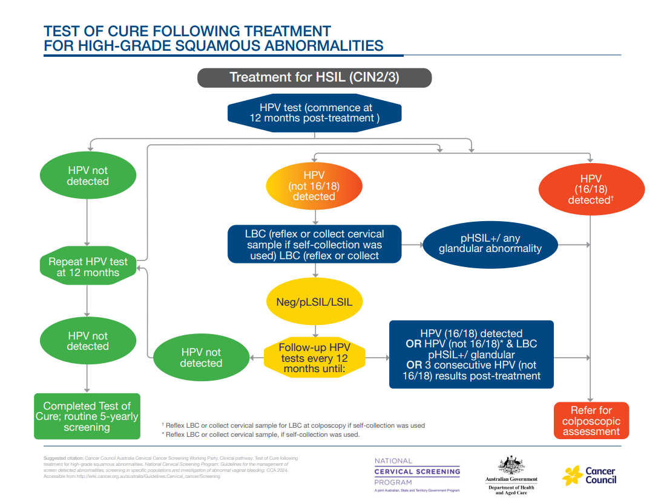



Pathology tests for cervical and vaginal testing

What do I write on the pathology request form?
Clinical information on pathology request forms assists pathology laboratories to perform the right tests, match the right clinical recommendations and select the right MBS item(s). Practitioners will need to specify on the pathology request form:
- whether the collection is for routine screening or clinical management or investigation of symptoms
- the tests required (refer to the tables below)
- whether the sample was clinician-collected or self-collected
- other relevant clinical information (e.g. screening history, DES exposed)
- whether the person identifies as Aboriginal and/or Torres Strait Islander.

This information will help the laboratory identify which pathology MBS item number to use and help them direct any queries back to you.

Ensure you order the correct test for your patient to avoid ordering Medicare ineligible tests or having the test rejected by the pathology laboratory. For further details on pathology tests, refer to the NCSP Pathology Guide MBS item descriptors and details available from MBS Online (www.mbsonline.gov.au – NCSP Factsheet).

How will the pathology laboratory manage my request?
Upon receipt of a sample the pathology laboratory will:
- perform requested tests
- access the person’s screening history from the NCSR to confirm appropriate testing protocol, and contact the requestor if there is a discrepancy from the requested tests, and inform the clinical recommendation
- Issuing a combined report containing the results of the HPV test and (if performed) LBC test, and the management recommendation (considering all test results and screening history).
- If your local pathology is not yet accredited to process self-collected vaginal samples the laboratory is required to refer self-collected samples to another accredited laboratory

Are the MBS items for pathology tests gender specific?
No, the pathology MBS items for cervical screening are not gender specific. Any person with a cervix is eligible for an MBS rebate if the eligibility criteria prescribed in the requested item is met. In addition to women this includes transgender men and may include intersex or gender fluid people.

How is a self-collect HPV test request handled differently at the laboratory?
A self-collected sample can only be tested for HPV.
- If HPV (16/18) is detected, the screening participant should be referred directly to colposcopy (LBC will be collected at the time of colposcopy)
- If HPV (not 16/18) is detected, the screening participant should be advised to return to their healthcare provider as soon as practical for collection of a cervical sample for LBC, preferably within 6 weeks.

What if the pathology laboratory my clinic uses cannot process self-collected samples?
If your local pathology laboratory is not yet able to process self-collected samples themselves, they have an obligation to refer those samples to another laboratory for processing.

Talk to your local pathology provider to:
- confirm you have the correct collection device for self-collected vaginal samples
- confirm handling and processing arrangements for self-collected vaginal samples, including arrangements to refer samples to another lab, where necessary
- order self-collection devices, pathology request forms and patient information sheets.

Table 4: Pathology Test Guide for Cervical and Vaginal Testing^
Patient presents as | Context* | Age | Sample type | Test type | What to write on the pathology request form
Asymptomatic | NCSP routine 5-yearly screening  - Only 1 of these MBS items is claimable in a 57-month period | > 24yrs &  9 mths | Cervical | HPV test | Cervical Screening Test (CST) – clinician collected
Asymptomatic | Patient opts to self-collect  - Only 1 of these MBS items is claimable in a 57 month) period | > 24yrs &  9mths | Vaginal | HPV test | Cervical Screening Test (CST) - self-collected
Asymptomatic | Patient opts to self-collect  - Following a self-collect test result of HPV (not 16/18) detected anywhere in the screening pathway or Test of Cure pathway | > 24yrs &  9 mths | Cervical | Standalone LBC | - LBC  - As part of a CST  - First or Second Follow-up test in the intermediate risk pathway (note if Aboriginal or Torres Strait Islander status as this impacts clinical recommendations)  - As part of Test of Cure
Asymptomatic | Screening in specific populations, example:  - Immune-deficient – (people with severe acquired or congenital immune deficiency, who are deemed to have, or be at substantially higher risk of cervical precancer and cancer, see Table 7.1 of the guidelines)  - Early sexual contact, prior to 14 years and not vaccinated prior to sexual debut (only one claimable between 20 to 24 years of age) | Any age | Cervical | HPV test | - HPV test, Immune-deficient  - HPV test, early sexual contact
Asymptomatic | Follow-up test claimable after previous screening test with HPV detected) | Any age | Cervical | HPV test | Follow-up HPV test – clinician-collected
Asymptomatic | Patient opts to self-collect for follow-up test after previous screening test with HPV detected | Any age | Vaginal | HPV test | Follow-up HPV test – self-collected
Asymptomatic | Follow-up for clinical management  - Following treatment of AIS  - DES exposed in utero | Any age | Cervical | Co-test  (HPV and  LBC) | - “Co-test” or “HPV and LBC” Post-AIS-treatment  - “Co-test” or “HPV and LBC”, DES
Asymptomatic | Following treatment of HSIL (Test of Cure) | Any age | Cervical | HPV test | Test of Cure HPV test – clinician-collected
Asymptomatic | Patient opts to self-collect  Following treatment of HSIL (Test of Cure) | Any age | Vaginal | HPV test | Test of Cure HPV test – self-collected
Symptomatic | For investigation of symptoms e.g. abnormal bleeding (see notes†) | Any age | Cervical | Co-test  (HPV and  LBC) | “Co-test” or “HPV and LBC”, Symptomatic
HPV test after total hysterectomy | Unexpected LSIL or HSIL identified in hysterectomy specimen;  - No evidence of cervical pathology on hysterectomy specimen and:  - following previous treatment for histologically confirmed HSIL without Test of Cure, or  - patient screening history not available  - Hysterectomy for treatment of HSIL (with or without the presence of benign gynaecological disease) | Any age | Vaginal | HPV test | Vaginal vault HPV test
HPV test after total hysterectomy | - Previously treated AIS by excision with negative margins  - AIS pathology in cervix, regardless of screening history | Any age | Vaginal vault | Co-test  (HPV and  LBC) | Vaginal vault “Co-test” or “HPV and LBC”
Repeat test following an unsatisfactory HPV test | Following an unsatisfactory test  - Only claimable when preceded by another cervical or vaginal MBS Item | Any age | Cervical | HPV test | HPV test, previous result unsatisfactory
Repeat test following an unsatisfactory HPV test | Following an unsatisfactory test  - Only claimable when preceded by another cervical or vaginal MBS Item | Any age | Vaginal | HPV test | HPV test, previous result unsatisfactory
Repeat test following an unsatisfactory LBC test | Following an unsatisfactory test  - Only claimable when preceded by another cervical MBS Item | Any age | Cervical | LBC | LBC, previous result unsatisfactory

^ For more information see the booklet, Understanding the National Cervical Screening Program Management Pathway – a Guide for Healthcare Providers
* Further appropriate use scenarios are outlined in the 2025 Guidelines, accessible from www.cancer.org.au/clinical-guidelines/cervical-cancer/cervical-cancer-screening
Persistence of any unexplained gynaecological symptoms should always warrant further investigation and referral as appropriate.



National Cancer Screening Register
The National Cancer Screening Register (NCSR) supports the NCSP by providing a safety net to screening participants and healthcare providers to support usual care.

The NCSR will support you to manage your patient’s personal information and participation in the NCSR for cervical screening.

Privacy in the NCSR
Your patient’s personal details and screening history are securely stored in the NCSR. The NCSR is protected by the latest state-of-the-art-data security measures, in accordance with strict Australian Government information security requirements and legislation. All information in the NCSR is stored, on shore, in Australia.

As the data custodian, the Australian Government Department of Health has control over the information in the NCSR, especially with respect to use and disclosure of this protected information.

Program correspondence
The NCSR provides an invitation and reminder service to people who are due for cervical screening or other follow-up tests, encouraging them to make an appointment with their healthcare provider.

The NCSR may also send you notifications to indicate that your patient has not attended important clinical follow-up tests or examinations.

Table 5: NCSR Correspondence
NCSP Correspondence |  | Recipient
Risk category | Timing/Details | Screening participant | Healthcare provider
Low-risk | Screening invitations sent 3 months prior to their due date. | ✓ | ✗
 | Screening reminders sent at:  - 3 months after their due date.  - 2 years post their due date. | ✓ | ✗
Intermediate risk | Invitation sent 3 months prior to their due date. | ✓ | ✗
Intermediate risk | If no further test results are received by the NCSR, reminders will be sent to the healthcare provider and the individual after the due date. Reminders will be sent in the following order:  - To the screening participant  - To the healthcare provider  - To the screening participant | ✓ | ✓
Higher risk | If no follow up is received by the NCSR – reminders will be sent to the individual if contact from the NCSR with the healthcare provider has not resolved the individual’s clinical management status. Reminders will be sent in the following order:  - To the healthcare provider  - To the screening participant | ✓ | ✓

If there has been no response at 4 years and 9 months after the due date, a new screening round will commence with an invitation to screen.

Supporting your patients through the NCSR
Eligible individuals or personal representatives on their behalf, can manage their personal information including contact information and make the following requests to the NCSR. With consent, you can also perform these functions on behalf of your patients.

Table 6: Supporting patients through the NCSR
Request to the NCSR | Effect on screening participant | Effect on healthcare provider
Cease contact and correspondence | - The person will no longer receive correspondence or contact from the NCSR.  - Clinical information, including test results, will continue to be stored on the NCSR. | You can continue to access your patient’s clinical information or screening history through the NCSR.
Defer Screening | - The person can temporarily defer correspondence from the NCSR for any period of time.  - Clinical information, including test results, will continue to be stored on the NCSR during this time. | You can continue to access your patient’s clinical information or screening history through the NCSR.
Opt out | - The person can opt out of the NCSR and will no longer receive contact or correspondence from the NCSR.  - Any clinical information, including test results, will not be stored on the NCSR from the time of opting out. | - You can still provide cervical screening services for your patient without the safety net of the NCSR.  - You will not be able to request screening histories for this patient.
Pseudonym | - Protects a person’s identity.  - All contact or correspondence sent by the NCSR on behalf of the NCSP will be directed to the pseudonym rather than the legal name. | - Search for the person in the NCSR using their pseudonym.  - The person’s legal name should be written on the pathology request form for Medicare payments.
Nominate a Healthcare Provider | Screening participants can nominate a healthcare provider for the NCSP. | Both the nominated and treating healthcare providers will receive correspondence from the NCSP.
Withdraw a Request | With consent, you can also withdraw the above NCSR requests at any time. | With consent, you can also withdraw the above NCSR requests at any time.

Contacting the NCSR
When contacting the NCSR you will need to provide your:
- First Name
- Last Name
- Medicare Provider Number
- HPI-I (if not known, another identifier will be required).

Find out your patient’s screening history by accessing the Healthcare Provider Portal via PRODA. This provides a self-service alternative to access and submit cervical screening data electronically in the NCSR. Practices using Best Practice, MedicalDirector and Communicare can integrate their practice systems with the NCSR to view their patient’s cervical screening record directly within a patient record. Visit NCSR.gov.au for more information.

If your practice requires support using the NCSR Healthcare Provider Portal or integrating your clinical information system with the NCSR, information, user guides, walkthrough video guides, and technical support are available on the NCSR website NCSR.gov.au. You can also book a time with an NCSR specialist.

NCSR screening participant ‘opt out’ option
Pathology laboratories can no longer act on NFR (not for Register) instructions on the pathology request form. If a person chooses to ‘opt out’ of the NCSR, healthcare providers can manage this through the Healthcare Provider Portal. Screening participants, or their personal representative, can also arrange this by accessing the NCSR Participant Portal via myGov or by calling the NCSR on 1800 627 701.

Opting a person out of the NCSR for cervical screening will not opt this person out of other screening programs (i.e. bowel screening), and they can re-join the NCSR any time.



More information and online training

Online training with CPD points
To assist you to understand the NCSP and the important role of self-collection, the Department of Health and Aged Care has funded ACPCC and GPex to develop online training modules.

These online training modules cover information about cervical screening and screening options available to patients (i.e. clinician-collection or self-collection), and the clinical management recommendations that support the Cervical Screening Test

You can enrol in as many of the following eLearning modules as you wish:
- Cervical cancer causes, prevention and elimination
- The National Cervical Screening Program
- Communicating the importance of cervical screening
- Screening in practice
- Cervical screening follow-up

These modules are accredited for CPD points with RACGP and ACRRM.

NCSP training is available at www.gpex.com.au/course/national-cervical-screening-program-bundle/

Resources to support you with under-screened and never-screened people
Further education and resources are available for providers who would like to learn more about engaging under-screened and never-screened eligible people in cervical screening. These can be found at www.health.gov.au/NCSP-Toolkit

Contacts
Table 7: Contacts and Links
Organisation | Resource | Location
National Cervical Screening Program | For information on the National Cervical Screening Program | health.gov.au/ncsp  Phone: 1800 627 701
Cancer Council Australia | National Cervical Screening Program Guidelines | www.cancer.org.au/clinical-guidelines/cervical-cancer/cervical-cancer-screening
National Cancer Screening Register | If you need to check if a patient has previously had a Cervical Screening Test and when they last had this test | ncsr.gov.au  Phone: 1800 627 701
Australian Immunisation Register | If you need to check if a patient has already had the HPV vaccine, and how many doses they have received | www.servicesaustralia.gov.au/australian- immunisation-register-for-health- professionals  Phone: 1800 653 809
Cancer Council (State and Territory) | For information on cervical cancer prevention, treatment and support | www.cancer.org.au  Phone: 13 11 20
Translating and Interpreting Service | If your patient has difficulty communicating in English | Phone: 13 14 50  (same cost as a local call)
National Relay Service | If your patient is hearing or speech impaired | www.relayservice.gov.au  Phone: 1800 555 660 (TTY) or 1800 555 630 (AccessHub) (free call)

State and Territory Cervical Screening Programs
ACT: www.act.gov.au/cervicalscreening
NSW: www.cancerinstitute.org.au/cervical
NT: www.nt.gov.au/wellbeing/health-conditions-treatments/womens-health/ cervical-screening
QLD: www.qld.gov.au/health/conditions/ screening/cancer/cervical
SA: www.sahealth.sa.gov.au/cervicalscreening
TAS: www.health.tas.gov.au/health-topics/ cancer-screening/cervical-screening
VIC: www.health.vic.gov.au/population- screening/cancer-screening
WA: www.kemh.health.wa.gov.au/For-Health-Professionals/Cancer/Cervical-screening

Glossary
Table 8: Glossary
Term | Definition
Co-testing | Co-testing involves the pathology laboratory performing both the HPV test and Liquid Based Cytology (LBC) test concurrently, on the same specimen. This means the LBC test is performed regardless of the HPV test result, without requiring an additional request. There are different pathology MBS item numbers depending on the purpose of the test.  In instances where a self-collected sample was taken, an HPV test should be performed. The participant will be asked to return for a clinician-collected sample for LBC testing to complete the co-test.
CST | Cervical Screening Test performed on either a clinician-collected cervical sample or a self-collected vaginal sample.
DES | Diethylstilbestrol (DES) is a synthetic estrogen, transplacental carcinogen and an endocrine disrupting compound. DES is no longer registered for human use in Australia. It was prescribed from the 1940s until the early 1970s, to pregnant women during the first trimester to prevent miscarriages.
HPI-I | Healthcare Provider Identifier – Individual
HPV | Human papillomavirus
HSIL | High-grade squamous intraepithelial lesion
LBC | Liquid-based cytology. This cytology test is prepared by placing the cervical sample in liquid suspension, rather than directly applying the sample on a microscope slide like the old Pap test.
LSIL | Low-grade squamous intraepithelial lesion
MBS | Medicare Benefits Schedule is the schedule of fees for medical services set by the Australian Government covering a wide range of consultations, procedures and tests, and the Schedule fee for each of these items. There are different pathology MBS items numbers depending on the purpose of the test.
NCSP | National Cervical Screening Program
NCSR | National Cancer Screening Register
Oncogenic | Potential to cause cancer
pHSIL | Possible high-grade squamous intraepithelial lesion
pLSIL | Possible low-grade squamous intraepithelial lesion
Self-collection | Self-collection is when a screening participant collects their own vaginal sample using a swab. A self-collected sample is from the vagina (not the cervix) and can only be tested for HPV. If HPV is detected on a self-collected vaginal sample, the participant will need to return for a clinician-collected sample for LBC (most situations when HPV (not 16/18) is detected) or will be referred to colposcopy (if HPV 16/18 was detected) and the sample for LBC will be collected at the time of colposcopy.
Test of cure | It is recommended that those who have received treatment for a high-grade abnormality – HSIL (CIN2/3) should complete Test of Cure surveillance to confirm their treatment has been successful. Test of Cure surveillance is now an HPV test, instead of a co-test (HPV and LBC test). Performed 12 months after treatment, and annually thereafter, until they have two consecutive tests with HPV not detected.  HPV testing can be performed by the participants' usual healthcare provider on either a self-collected or a clinician-collected sample, depending on the preference of the patient. After two consecutive negative tests, people can return to routine 5 yearly screening.  In the case of positive margins, the treating clinician may elect to perform annual co-testing rather than HPV alone, on a case-by-case basis.  People undergoing Test of Cure who had a first follow-up negative co-test before 1 July 2024, can have an HPV test 12 months later rather than a co-test. The Test of Cure will be considered complete if HPV is not detected on that HPV test.

