Cover page -
Australian Government Crest 
National Cervical Screening Program Logo

Text: National Cervical Screening Program - a summary guide for healthcare providers

Image of a healthcare professional handing a medical swab to an older lady in a yellow dress.

Contents

1. Guideline Updates 3

2. Cervical Screening 3

Who is eligible for cervical screening? 3

The Cervical Screening Test (CST) 4

HPV testing (self-collection) or co-testing (clinician-collected) 4

Requesting pathology tests for clinician-collected and self-collected samples 4

3. Self-collected HPV tests 5

Who is NOT eligible for self-collection in the NCSP? 5

Supporting informed choice between clinician-collection and self-collection 5

If HPV is detected in the participant’s results 6

Supporting participants who have chosen self-collection 7

Assisted self-collection 8

Self-collection swabs 8

4. Specific groups who fall outside routine recommendations 9

Screening of participants with immune deficiency 9

Symptomatic patients 10

Screening during pregnancy 11

Screening after total hysterectomy 11

Screening in participants attending for an exit test (aged 70-74) 12

Screening in people aged 75+ 12

5. Overview of results management – clinician-collected and self-collected samples 13

Management of unsatisfactory results 14

Low-risk result – HPV not detected – return to screen in 5 years 14

Higher risk result – refer to a specialised service for colposcopy 14

Intermediate risk result –follow-up HPV test in 12 months 14

Follow-up HPV test at 12 months 15

Exceptions to a second follow-up HPV test 15

Follow-up HPV test at 24 months 15

6. Test of Cure: management after treatment for HSIL (CIN2/3) 16

7. Surveillance after treatment for Adenocarcinoma in situ (AIS) 17

8. National Cancer Screening Register 18

NCSR participant ‘opt out’ option 18

9. Links and more information 19

Clinical pathway flowcharts:

Figure 1: Screening Pathways (clinician-collected and self-collected) 20

Figure 2: Vaginal screening after hysterectomy 21

Figure 3: Test of Cure following treatment for high grade squamous abnormalities 22

A woman doctor or nurse with blonde hair wears purple scrubs and is smiling at her dark haired patient (off screen)


# Guideline Updates

Important changes were made to the NCSP Guidelines in 2024 regarding:

* Test of Cure after treatment for HSIL (CIN2/3)
* Surveillance after treatment for AIS for those with complete excision and clear margins

# Cervical Screening

The [National Cervical Screening Program Guidelines (NCSP Guidelines)](https://www.cancer.org.au/clinical-guidelines/cervical-cancer/cervical-cancer-screening) outline the National Cervical Screening Program’s (NCSP) risk-based approach to clinical pathway management of cervical screening participants.

## Who is eligible for cervical screening?

Women and people with a cervix[1] aged 25 to 74 who have ever had any type of sexual contact are eligible for cervical screening.

Sexual contact may include sexual intercourse, penetrative sex, oral sex, intimate genital skin contact (for example as part of foreplay) and anal sex.

It is also important to note:

* not all sexual contact is consensual[2] or comprehended[3]
* the human papillomavirus (HPV) can be contracted even while using a condom, as HPV spreads through skin-to-skin contact in areas the condom may not cover.

Patients should be encouraged to screen regardless of whether they:

* are gay, lesbian, bisexual, transgender or straight
* have had the HPV vaccination or not
* are no longer sexually active
* have been through menopause
* have been with only one sexual partner
* have experienced traditional cutting or circumcision
* have had a baby
* are pregnant

## The Cervical Screening Test (CST)

The CST detects infection with Human Papillomavirus (HPV) – a common infection and the cause of almost all cervical cancer.

If HPV is found, partial genotyping is used to classify the type of HPV into 1 of 2 groups:

* oncogenic[4] HPV (types 16/18)
* non-oncogenic HPV (not types 16/18) as a combined result

Anyone who is eligible for cervical screening should be offered the choice of either:

* a self-collected vaginal sample (except where a co-test is recommended)

or

* a clinician-collected sample from the cervix

## HPV testing (self-collection) or co-testing (clinician-collected)

There are 2 options for collecting a CST sample (noting that both methods are tested for HPV only in the first instance):

* A HPV only test – taken using a swab, usually via self-collection
* A co-test – combination HPV test and Liquid Based Cytology (LBC) taken from the cervix by a clinician

Participants requiring a co-test may include:

* those with signs or symptoms suggestive of cervical cancer such as participants who
  + present with an abnormal looking cervix suspicious of cancer
  + have unexplained postcoital bleeding
  + are experiencing persistent intermenstrual or postmenopausal bleeding
  + have unexplained persistent unusual vaginal discharge)
* those who have been treated for adenocarcinoma in situ (AIS)
* those who were exposed to diethylstilbestrol (DES) in utero

## Requesting pathology tests for clinician-collected and self-collected samples

When sending a clinician-collected or self-collected CST sample to a laboratory, include all relevant clinical details on the pathology request form.

Clinical information on pathology request forms assists laboratories in performing the right tests, matching the right clinical recommendations and selecting the right MBS item/s.

On the pathology request form, make sure you:

* clearly indicate if the sample has been self-collected or clinician-collected
* record whether the participant identifies as Aboriginal and/or Torres Strait Islander (this is for data collection purposes).

See the [NCSP Pathology Test Guide](https://www.health.gov.au/resources/publications/national-cervical-screening-program-pathology-test-guide?language=en) for more information and to avoid ordering Medicare ineligible tests or having the test rejected by the laboratory.



# Self-collected HPV tests

Anyone in the cervical screening pathway can be offered the option to collect their own CST sample, unless they require a [co-test](#_HPV_testing_(self-collection)).

The self-collected sample is taken from a few centimeters inside the vagina using a flocked swab.

## Who is NOT eligible for self-collection in the NCSP?

Any screening participant requiring a co-test is not eligible for self-collection. This is because a self-collected sample can only be tested for HPV, not for cytology.

Participants requiring a co-test are mentioned above.

Co-testing or referral for colposcopy is not required for irregular bleeding due to:

* hormonal contraception
* contact while obtaining a routine CST sample
* heavy regular periods (heavy menstrual bleeding)
* irregular bleeding due to a sexually transmitted infection

## Supporting informed choice between clinician-collection and self-collection

Eligible screening participants must be given clear evidence-based information when deciding between the choice of self-collection or clinician-collection. This includes:

* evidence that a self-collected sample is as accurate at detecting of HPV and cervical intraepithelial neoplasia (CIN) 2+ as a clinician-collected sample
* information about how the 2 different test samples are taken
* the likelihood that HPV may be detected on a self-collected test sample (and therefore the likelihood they will have to return for a clinician collected sample)
* what follow-up will be required

NCSP visual guides are available to explain:

* [screening choice](https://www.health.gov.au/resources/publications/national-cervical-screening-program-cervical-screening-test-your-choices-explained-easy-read?language=en)s
* [steps involved in self-collecting a vaginal sample](https://www.health.gov.au/resources/publications/national-cervical-screening-program-how-to-collect-your-own-sample?language=en)
* [how clinician-collected tests are done](https://www.health.gov.au/resources/publications/national-cervical-screening-program-what-happens-when-my-healthcare-provider-collects-my-sample?language=en)

Healthcare providers should advise participants of follow-up recommendations if HPV is detected. Explain that a self-collected test only tests for HPV, where as a clinician-collected sample allows the laboratory to investigate cell changes on the same sample.

Doing a clinician-collected test in the first instance could potentially save the participant the need for an additional visit to have a clinician-collected LBC test.

## If HPV is detected in the participant’s results

Over 90% of participants who do a routine CST[5] will have no oncogenic HPV detected and can be advised to return for routine screening in 5 years. However, this rate is typically lower in under or never screened people.

Ensure participants are aware of the screening pathway for participants who have HPV (any type) detected (approximately 8%) differs slightly.

### HPV 16/18 detected

Approximately 2% of participants will have HPV (16/18) detected. It is recommended these participants attend a colposcopic assessment.

**If the sample was clinician-collected,** then the laboratory will have performed reflex LBC to inform the colposcopic assessment.

**If the sample was self-collected,** the participant does not need to return for a clinician-collected test; a sample for LBC will be taken at the time of the colposcopy.

### HPV (not 16/18) detected

Approximately 6% of participants will have HPV (not 16/18) detected (this rate varies with age and is higher among younger screening participants).

**If the sample was clinician-collected,** the laboratory will perform reflex LBC to determine the risk associated with the type of HPV found. HPV testing is not repeated on the clinician-collected sample in this circumstance.

**If the sample was self-collected**, the person must be recalled for a clinician-collected test as soon as practical, ideally within 6 weeks. This will inform the risk rating and next steps.

## Supporting participants who have chosen self-collection

Cervical screening done by self-collection of a vaginal sample must be ordered by a healthcare provider with systems in place to ensure follow-up management of results.

A participant should be encouraged to self-collect their test in a private space in a healthcare practice or clinic, as test completion is more likely in this context. Note there is no requirement to observe the person collecting their sample unless this is their preference.

Healthcare providers who offer self-collection must have clear follow-up processes in place to ensure that participants with screen-detected HPV can promptly do a clinician-collected test if required.

Note: The person who provided the self-collection test to the participant is not required to do the clinician-collected sample themselves (e.g. for follow-up testing). Clinician-collected tests can be provided by another healthcare provider.

During an initial consultation with an eligible participant who has chosen to collect their own CST:

* use the [self-collect instruction sheet](https://www.health.gov.au/resources/publications/national-cervical-screening-program-how-to-collect-your-own-vaginal-sample-for-a-cervical-screening-test?language=en) and talk them through each step
* use [translated resources](https://www.health.gov.au/resources/translated?f%5b0%5d=h_translations_our_work:7421) or engage an interpreter if needed
* consider using [easy-read pictorial](https://www.health.gov.au/resources/collections/easy-read-resources-national-cervical-screening-program) resources to explain the process
* use tailored [Aboriginal and Torres Strait Islander focused resources](https://www.health.gov.au/our-work/ncsp-healthcare-provider-toolkit/working-with-patients/aboriginal-and-torres-strait-islander-people) if appropriate

These and other resources and videos for the participant to view on their device are available from <https://www.health.gov.au/our-work/national-cervical-screening-program/cervical-screening-resources> (also from the bottom ‘resources’ section on [www.health.gov.au/ncsp](http://www.health.gov.au/ncsp))

When discussing self-collection, explain the following:

* A self-collected sample is taken from the vagina – the participant does not need to reach the cervix
* A self-collected sample can only be tested for HPV – any cervical cell changes cannot be detected from this sample and the cervix will not be viewed
* how the participant will receive their test results
* the likelihood that HPV will not be detected
* if HPV is detected, what follow-up will be required

### Self-collection outside of a clinical setting

There is flexibility for self-collection to occur in any setting the facilitating healthcare provider[6] believes is appropriate to encourage screening. This can include telehealth models of care, if the healthcare provider thinks it is clinically safe to do so.

For all collections occurring in non-clinic-based settings, clear and documented lines of responsibility (with a systems-based approach) are required.

The healthcare provider ordering the screening test has full responsibility for ensuring the participant has access to:

* the correct device/s for administering the test themselves (i.e. a self-collect swab used by the receiving laboratory)
* clear instructions and information on how to take the test
* a point of contact for questions or issues that may arise
* an agreed clear process delivering the test sample to the laboratory

The healthcare provider ordering the self-collected test also needs to ensure there are arrangements in place with the receiving laboratory for receipt and processing self-collected samples, and for distributing the participant’s results back to the healthcare provider.

The healthcare provider is also responsible for ensuring participants understand their results and any required follow-up.

## Assisted self-collection

If requested, a healthcare provider may assist a participant who is not confident or has trouble collecting a CST vaginal sample by themselves (e.g. for a participant with limited mobility, tremor or poor vision).

In the same manner the participant would do it themselves, a healthcare provider can collect the participant’s HPV sample from the vagina using a self-collection swab. This can be done without using a speculum.

A sample collected in this way is still classified as a self-collect sample on the pathology request form.

## Self-collection swabs

There is a range of pathology devices available for self-collected vaginal CSTs.

Self-collection devices will vary by laboratory and may also have differing requirements as well as processing and handling instructions.

Talk to your local pathology provider to confirm:

* they can process self-collected vaginal CST samples, or
* they have arrangements in place to send on self-collected vaginal samples to another laboratory that can process them, and
* you can order the correct swabs and other consumables for offering cervical screening self-collection
* the correct processing method for the type of swab they supply.



# Specific groups who fall outside routine recommendations

There are specific groups of participants who fall outside the general recommendations and require separate guidance. This includes participants who:

* are immune-deficient
* have symptoms suggestive of cervical cancer
* are pregnant
* have had a total hysterectomy
* are aged 70-74 (attending for an exit test)
* are aged 75+
* were exposed to diethylstilbestrol (DES) in utero
* are currently undergoing Test of Cure following treatment of histological HSIL (CIN2/3)
* are undergoing surveillance after treatment for adenocarcinoma in situ (AIS)

## Screening of participants with immune deficiency

In the NCSP Guidelines, the category ‘immune-deficient screening participants’ refers to participants with severe acquired or congenital immune deficiency. These participants are deemed to have a substantially higher risk of cervical precancer and cancer.

Three-yearly, rather than 5-yearly screening is recommended for these specific groups. If HPV (any type) is detected, the participant should be referred to colposcopy.

If the screening sample was clinician-collected, then reflex LBC will be performed by the laboratory. If the screening sample was self-collected, then a sample for LBC will be undertaken at colposcopy.

Although most evidence related to high-risk participants refers to transplant patients and those living with HIV, it is now recommended to consider expanding the recommendations to other participant groups.

Some of the main conditions and therapies that may require a 3-yearly screening interval are listed in [Section 16: Screening in Immune-deficient women](https://www.cancer.org.au/clinical-guidelines/cervical-cancer/cervical-cancer-screening/screening-in-immune-deficient-women) of the NCSP Guidelines. The list is not exhaustive, and some cases may need to be considered individually. The specialist responsible for managing the immunosuppressant medications or condition may be of assistance in supporting decision-making.

## Symptomatic patients

Participants who have signs or symptoms suggestive of cervical cancer are tested and managed on a different clinical pathway from those who are asymptomatic. They are not eligible for screening, but rather for investigation and diagnosis.

### Abnormal Vaginal Bleeding

Abnormal vaginal bleeding can occur at any age. It is rarely caused by cervical and is most commonly associated with other conditions, such as:

* polyps
* adenomyosis
* leiomyomas (fibroids)
* hormonal contraception
* iatrogenic causes
* coagulopathies
* ovulatory disorders
* endometrial disorders
* sexually transmitted infections

The following types of abnormal vaginal bleeding can be suggestive of cervical cancer:

* unexplained intermenstrual vaginal bleeding
* persistent post-coital bleeding
* any post-menopausal bleeding

**When to test:** Patients at any age with these types of vaginal bleeding should have [a co-test](#_HPV_testing_(self-collection)). They should also be referred for specialist investigation to exclude genital tract malignancy, regardless of the result of the co-test.

A self-collected test is not appropriate in this situation as it is a HPV test only and cannot detect further advanced cancerous cells.

Note: False negative test results are more common for both the HPV test and LBC in the setting of vaginal bleeding.

If the participant returns a negative co-test but still presents recurrent or persistent postcoital bleeding, they should be referred for investigations to exclude genital tract malignancy. This includes if they have persistent unexplained inter-menstrual bleeding or post-menopausal bleeding.

**Co-testing or referral for colposcopy is not required** for irregular bleeding due to:

* hormonal contraception
* contact while obtaining a routine CST sample
* heavy regular periods (heavy menstrual bleeding)
* irregular bleeding due to a sexually transmitted infection

For more information on management of participants with abnormal vaginal bleeding, see [Chapter 18: Signs and symptoms of cervical cancer](https://www.cancer.org.au/clinical-guidelines/cervical-cancer/cervical-cancer-screening/signs-and-symptoms) of the NCSP Guidelines.

### Abnormal vaginal discharge

Unexplained, persistent, unusual vaginal discharge may also be associated with later stage cervical cancer diagnoses. Accordingly, these symptoms should lead to co-test and specialist referral, regardless of the result of the co-test.

### Dyspareunia

Pain during sex (dyspareunia) is most commonly due to benign gynaecological conditions. A patient presenting with dyspareunia should be appropriately investigated and, if necessary, referred for gynaecologic assessment.

A [routine CST](https://urldefense.proofpoint.com/v2/url?u=https-3A__healthgov.sharepoint.com_sites_CHPSDEngagementParticipationandEducationteam_Shared-2520Documents_09.-2520Cervical_Resources_Guideline-2520Refresh_Summary-2520Guide-2520Resource_NCSP-2520-2D-2520A-2520summary-2520guide-2520for-2520healthcare-2520providers-2520-2D-2520January-25202025.docx-23-5FHPV-5Ftesting-5F-28self-2Dcollection-29&d=DwMFAg&c=euGZstcaTDllvimEN8b7jXrwqOf-v5A_CdpgnVfiiMM&r=mzw1DGgwIMUW6tW9wRtDfM0haeUvdWCBfFyt2MR6Vl0&m=5VVTkbkNEKIzbi-KqgT9txAZAj5eGdr2FONn-stBz0mTi3kNhyY05Uax6u8f-K9c&s=H-JkyNNaVwY46zT9QpPzDao10LDAZMgwUpiYY8tHJdU&e=) can be performed, but only if the person is due or overdue. Dyspareunia, in the absence of abnormal bleeding, is not a sufficient indication for a co-test outside of NCSP protocols.

## Screening during pregnancy

Antenatal and postpartum visits can be an ideal and opportune time to offer cervical screening. Routine care should include a review of the person’s cervical screening history.

If a person is due for screening this can be done safely at any time during pregnancy, provided that the correct equipment is used.

If a clinician-collected sample is taken, a cytobrush or combi-brush should not be inserted into the cervical canal because of the risk of bleeding. Use a broom-type brush instead.

Self-collection using a swab can be offered at any time during pregnancy.

Check with your laboratory that the swabs provided to you are validated for self-collection in pregnancy.

For more information on screening during pregnancy, see [Section 14: Screening in pregnancy](https://www.cancer.org.au/clinical-guidelines/cervical-cancer/cervical-cancer-screening/screening-in-pregnancy) of the NCSP Guidelines.

## Screening after total hysterectomy

Patients who have had a total hysterectomy do not need further cervical cancer surveillance if:

* the participant has a normal prior screening history

or

* has been treated for histologically confirmed HSIL and has a cleared test of Cure in accordance with NCSP Guidelines

and

* there was no evidence of cervical abnormalities detected on their hysterectomy specimen

Patients who have had a total hysterectomy and meet any of the below conditions should have an HPV test on a vaginal vault sample 12 months after hysterectomy.

* Hysterectomy was performed for treatment of HSIL (with or without the presence of benign gynaecological disease)
* Unexpected LSIL or HSIL was identified in the hysterectomy specimen
* The person has previously undergone treatment for histologically confirmed HSIL without completing Test of Cure
* Their screening history is unknown, or they have never been screened.

HPV tests should continue annually until the person has tested negative on 2 consecutive occasions, after which they do not need further testing.

People who have had a hysterectomy and have ever been treated for adenocarcinoma in situ (AIS) or with AIS pathology in their cervix are recommended to have annual co-testing on a vaginal vault sample.

This should occur from 12 months after hysterectomy, until the person has tested negative on both tests (HPV and LBC) on 2 consecutive occasions, after which they do not need further testing.

Follow-up management is summarized below. See also Figure 2: Vaginal screening after hysterectomy (Page 21).

### Screen after subtotal hysterectomy

People who have had **subtotal hysterectomy** (cervix remains in situ) should be screened every 5 years with an HPV test. Any abnormalities should be managed according to the relevant recommendations in the Guidelines.

## Screening in participants attending for an exit test (aged 70-74)

An exit test is performed on participants aged 70-74 to ensure they can safely leave the NCSP.

An exit test can be clinician-collected or self-collected depending on the person’s choice.

The screening participant will receive one of the following possible results:

* **HPV not detected:** The participant can now safely exit screening.
* HPV (any type) detected (i.e. HPV (not 16/18) or HPV (16/18)): This places the participant in the higher risk category.
  + **If the sample was clinician-collected,** refer for colposcopy regardless of the reflex LBC result.
  + **If the sample is self-collected,** the sample for LBC will be taken during the colposcopy consultation.

Further investigation with colposcopy will identify abnormal cells requiring treatment to prevent the progression to cervical cancer.

## Screening in people aged 75+

Routine cervical screening is not recommended for people 75 years or older.

If a patient aged 75 years or older request to screen, they can do so if they:

* have never had a CST or
* have not had one in the past 5 years

Results of HPV tests for cervical screening in participants aged 75 or older should be managed in the same way as those doing a 70–74 years exit test.

* **HPV not detected:** no further screening is required.
* **HPV (any type) detected:** referral for colposcopy.
  + **If the sample was clinician-collected,** refer for colposcopy regardless of the reflex LBC result.
  + **If the sample is self-collected,** the sample for LBC will be taken during the colposcopy consultation.



# Overview of results management – clinician-collected and self-collected samples

Familiarise yourself with the NCSP clinic-pathway flowcharts (from Page 19) to support discussion of CST results with participants.

**For a clinician-collected sample,** the pathology report will include the HPV result and (if HPV was detected) the reflex LBC results.

**For a self-collected sample,** the report will include the HPV result.

For clinician-collected and self-collected samples, if HPV is not detected the person will be recalled in 5 years for their next routine CST.

If HPV was detected, the clinical management depends on the HPV type/s detected:

**If HPV (16/18) is detected,** the person should be referred directly for colposcopy.

* **If the sample was clinician-collected,** refer for colposcopy regardless of the reflex LBC result.
* **If the sample is self-collected,** the sample for LBC will be taken during the colposcopy consultation.

**If HPV (not 16/18) is detected and the person is aged 25-69 years,** the participant should return for a clinician-collected cervical sample for LBC. Request a LBC test only on the pathology request form. The results of the LBC will determine the risk rating and clinical management.

**If HPV (not 16/18) is detected and the person is aged 70 years or more (exit test),** the participant should be referred directly for colposcopy.

* **If the sample was clinician-collected,** refer for colposcopy regardless of the reflex LBC result.
* **If the sample is self-collected,** the sample for LBC will be taken during the colposcopy consultation.

The overall screening result will identify the participant’s risk category and the recommended clinical management pathway in accordance with the NCSP Guidelines.

## Management of unsatisfactory results

**If the HPV result is unsatisfactory,** the participant should do a repeat HPV test as soon as practical (ideally within 6 weeks).

**If the LBC result is unsatisfactory,** the participant should do a repeat LBC after 6 weeks (this provides sufficient time for regeneration of cells on the cervix).

## Low-risk result – HPV not detected – return to screen in 5 years

HPV is required for the development of most cases of cervical cancer. A low-risk result means oncogenic HPV was not detected and a LBC is not required.

Patients at low risk of developing cervical cancer can safely return for a CST in 5 years.

It is not guaranteed low-risk participants are at ‘no risk’ of developing a HPV infection. This is because the participant may:

* acquire an HPV infection between screenings
* have a latent infection that becomes active between screenings

HPV can take time (10-15 years) to develop into cervical cancer.

## Higher risk result – refer to a specialised service for colposcopy

A higher risk result means the person has received 1 of 2 possible screening test results:

**HPV detected (16/18):** HPV types 16 and 18 are associated with approximately 70-80% of cervical cancers. These HPV types are also more likely to progress to cervical cancer than other oncogenic HPV types.

* Regardless of the reflex LBC test result, the participant should be managed as indicated by the higher risk pathway and referred for colposcopic assessment.
* A colposcopy will determine if a biopsy is needed, and this will determine if treatment is required.

**HPV detected (not 16/18):** the participant had a LBC test to determine their risk level, and the result was high-risk predictive of pHSIL or HSIL, cancer or a glandular abnormality.

## Intermediate risk result –follow-up HPV test in 12 months

An intermediate risk result means HPV (not 16/18) was detected as part of a routine screening (not as a follow-up, exit test, Test of Cure, or investigation of symptoms) and the LBC (conducted either on the same sample or at a follow-up test if self-collected) showed that the participant had negative cytology, or pLSIL, or LSIL.

An intermediate risk result is not associated with high-grade cell changes requiring treatment.

Patients with an intermediate risk result should return for a follow-up HPV test 12 months after their initial CST to check if the body has cleared the HPV infection.

## Follow-up HPV test at 12 months

The 12-month follow-up HPV test can be clinician-collected or self-collected depending on the person’s choice. The screening participant will receive 1 of 3 possible results.

**HPV not detected:** The immune system has cleared the HPV infection. The person can now safely return to routine screening.

**HPV (16/18) detected:** This places the person in the **higher risk** category.

**HPV detected (not 16/18):** In most cases, a LBC must be done to identify the participant’s risk (see **Exceptions to a second follow-up HPV test** below).

If the sample was clinician-collected, the laboratory will automatically perform reflex LBC.

If the sample was self-collected, the participant should return as soon as practical, ideally within 6 weeks, to obtain a clinician-collected cervical sample for LBC.

Notes:

* If the person does not return for their first follow-up clinician collected test until **9 months or more** from their original HPV test, they can do a self-collected HPV test (rather than a LBC). Due to the large time gap, the HPV infection is likely to have been cleared and the person can return to routine screening.
* If the LBC is negative, pLSIL or LSIL, the screening participant is recommended to return for a further follow-up HPV test in another 12 months’ time (i.e. 24 months from the initial CST).
* If the LBC report predicts invasive cancer (squamous, glandular, or other) then the participant should immediately be referred to a gynaecological oncologist or gynaecological cancer centre for urgent evaluation, ideally within 2 weeks.
* If the LBC report predicts pHSIL, HSIL or any glandular abnormality, the participant should be referred for colposcopic assessment at the earliest opportunity, ideally within 8 weeks.

## Exceptions to a second follow-up HPV test

Some groups of participants may be at higher risk of underlying high-grade abnormality, despite a negative pLSIL or LSIL LBC result. As a result, they should be referred for colposcopy if HPV (any type) is detected at the 12-month follow-up test, regardless of the reflex LBC result.

If a participant falls within one of the below groups and their CST sample was self-collected, a sample for LBC will be collected at the time of colposcopy. They do not need to return for a clinician-collected cervical sample. These include participants who:

* were overdue for screening by at least 2 years at the time of their initial positive HPV (not 16/18) screening test result
* identify as Aboriginal and/or Torres Strait Islander
* are aged 50 years or older.

## Follow-up HPV test at 24 months

The 24-month follow-up CST can be clinician-collected or self-collected, depending on the person’s preference. The participant will receive one of the following possible results:

**HPV not detected:** The immune system has cleared the HPV infection. The person can now safely return to routine screening.

**HPV (any type) detected (i.e. HPV (not 16/18) or HPV (16/18)):** This places the person in the higher risk category which requires referral for colposcopy.

* **If the sample was clinician-collected,** refer for colposcopy regardless of the reflex LBC result.
* **If the sample is self-collected,** the sample for LBC will be taken during the colposcopy consultation.

Further investigation with colposcopy will identify any abnormal cells requiring treatment to prevent progression to cervical cancer.



# Test of Cure: management after treatment for HSIL (CIN2/3)

Patients who receive treatment for a high-grade abnormality should complete Test of Cure surveillance to confirm their treatment has been successful.

Note: Important changes regarding Test of Cure after treatment for HSIL (CIN2/3) were made to the NCSP Guidelines in 2025.

A review of new evidence recommended participants 12-months post-treatment for HSIL (CIN2/3), may have annual HPV tests instead of [co-tests](#_HPV_testing_(self-collection)), commencing 12 months after treatment.

HPV testing can be performed by the participant’s usual healthcare provider. This can be done by a self-collected or clinician-collected sample, depending on the participant’s preference.

After 2 consecutive annual ‘HPV not detected’ tests, the participant can return to routine screening.

In the case of positive margins, the treating healthcare provider may elect to perform annual co-testing, rather than HPV alone. This should be decided on a case-by-case basis.

Note: participants undergoing Test of Cure who had a negative first follow-up co-test before 1st July 2024, can have a HPV test for their second 12 month follow-up test. Test of Cure will be considered ‘complete’ if HPV is not detected on this second 12-month follow-up HPV test.

See Figure 3: Test of Cure following treatment for high grade squamous abnormalities (Page 22).

Three older women laughing and smiling while playing lawn bowls


# Surveillance after treatment for Adenocarcinoma in situ (AIS)

Histological confirmation of AIS lesions often occurs as the result of a diagnostic excisional biopsy, usually a cold knife cone biopsy, which may or may not have completely excised the lesion.

If AIS is incompletely excised or if the margins cannot be assessed, further excision to obtain clear margins should be performed.

Note: Important changes were made to the NCSP Guidelines in 2025 regarding surveillance after treatment for AIS for those with complete excision and clear margins.

Instead of indefinite annual co-testing, these participants should undergo annual co-testing for 5 years. After 5-years, if all co-tests have been negative (oncogenic HPV not detected and LBC negative), surveillance testing can be extended from annually to every 3 years.

If surveillance tests have been performed for 25 years or more since the time of treatment, and all tests are negative, the recommended pathway depends on the screening participant's age.

* Patients aged less than 70 years can return to routine screening.
* Patients aged 70 years or older can safely exit routine screening if they have had at least 1 co-test with no oncogenic HPV detected and negative LBC test since turning 70.

A younger Asian woman holding a vegetable at the kitchen sink. She is dressed in a light purple cardigan and is smiling to someone behind her.


# National Cancer Screening Register

The National Cancer Screening Register (NCSR) supports the NCSP by recording participant screening information and sending eligible participants invitations to screen and reminders when due.

The NCSR assists healthcare provider to manage participants throughout the clinical management pathways.

You can find out a participants’ screening history by accessing the Healthcare Provider Portal via PRODA. This provides a self-service alternative to accessing and submitting cervical screening data electronically in the NCSR. Practices and clinics using Best Practice, MedicalDirector, and Communicare clinical software can integrate their practice systems with the NCSR to view their participant’s cervical screening record directly.

Visit [NCSR.gov.au](https://ncsr.gov.au/) for more information.

## NCSR participant ‘opt out’ option

Laboratories can no longer act on ‘Not for Register’ instructions on pathology request forms. If a participant chooses to ‘opt out’ of the NCSR, healthcare providers can arrange this through the Healthcare Provider Portal. Participants or their personal representatives can ‘opt-out’ by accessing the [NCSR Participant Portal](https://ncsr.gov.au/information-for-participants/participant-portal.html) via myGov or by calling the NCSR on **1800 627 701.**

Opting out of the NCSR for cervical screening will not opt this person out of other screening programs (i.e. bowel screening). The person can re-join the NCSP at any time.



# Links and more information

For the full National Cervical Screening Program Guidelines visit

[www.cancer.org.au/clinical-guidelines/cervical-cancer-screening](http://www.cancer.org.au/clinical-guidelines/cervical-cancer-screening)

Details on MBS item frequency and descriptors can be found at [www.mbsonline.gov.au](http://www.mbsonline.gov.au)

For information on the NCSR visit [www.ncsr.gov.au](http://www.ncsr.gov.au)



Figure 1: Screening Pathways (clinician-collected and self-collected)

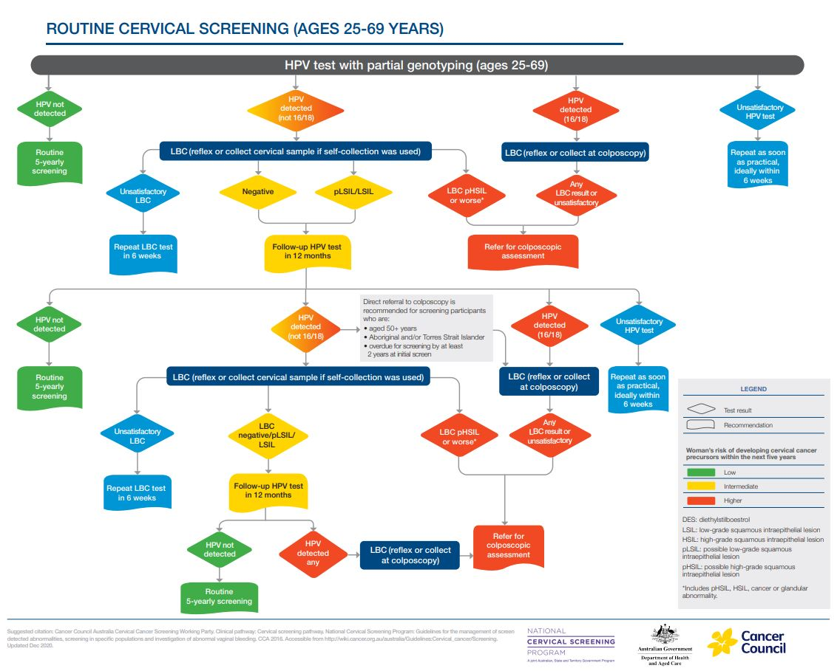

Figure 2: Vaginal screening after hysterectomy

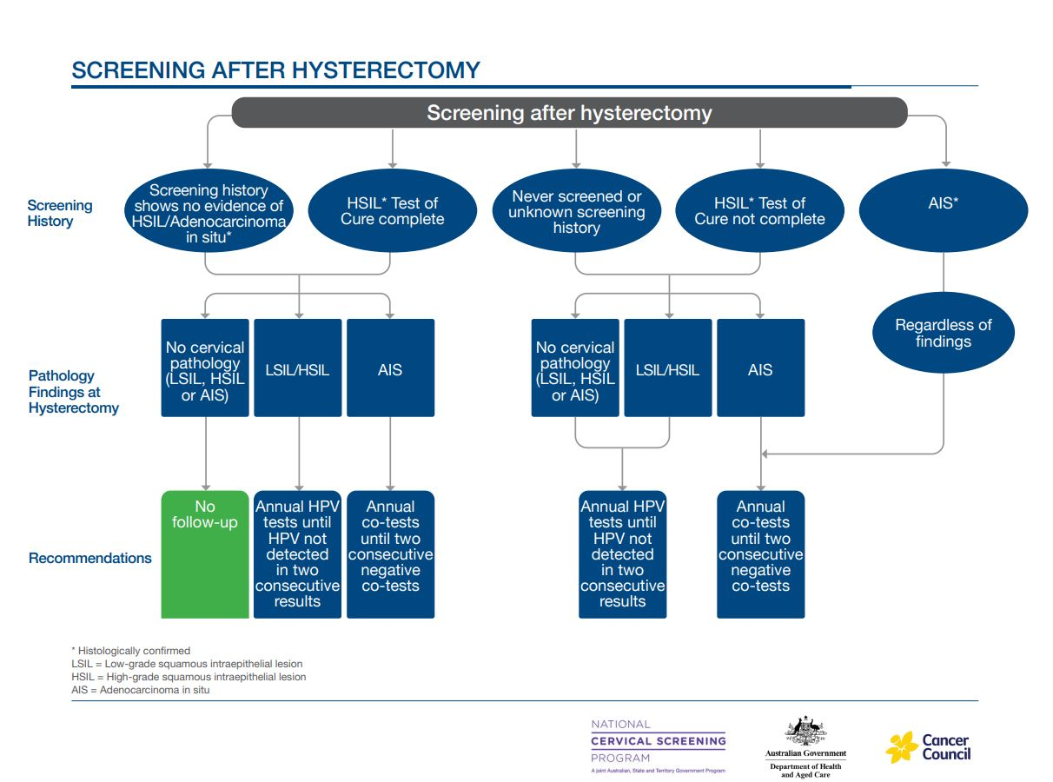

Figure 3: Test of Cure following treatment for high grade squamous abnormalities

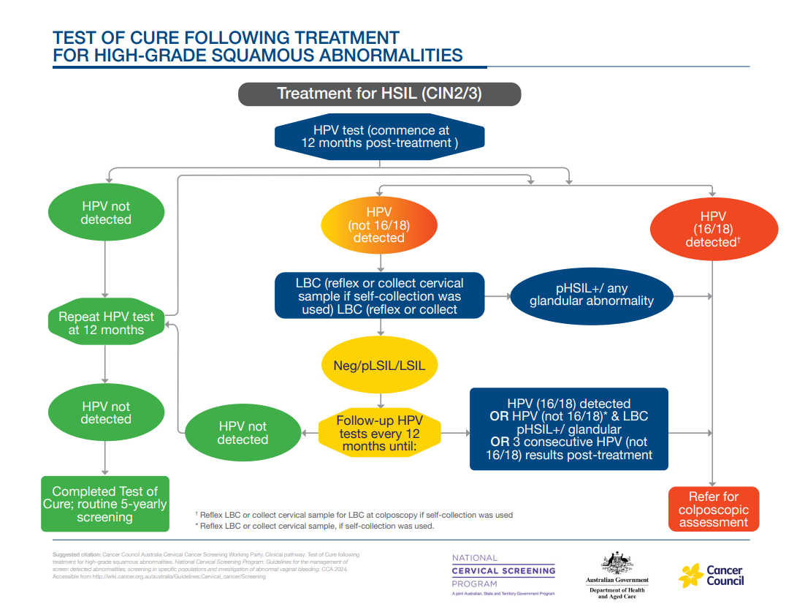

1. 1 The term ‘women and people’ is used when describing NCSP eligibility, as this incorporates gender-diverse people with a cervix
2. According to [the AIHW](https://www.aihw.gov.au/family-domestic-and-sexual-violence/types-of-violence/sexual-violence), 14% of Australian women have reported experiencing sexual violence
3. The [Disability Royal Commission](https://disability.royalcommission.gov.au/news-and-media/media-releases/alarming-rates-family-domestic-and-sexual-violence-women-and-girls-disability-be-examined-hearing) noted 46% of women with cognitive disability and 50% of women with psychological disability have experienced sexual violence, compared to 16% of the general population.
4. Oncogenic refers to a gene that has the potential to cause cancer.
5. A routine CST is one done by an asymptomatic participant every 5 years and not as a follow-up test, exit test, Test of Cure, or investigation of symptoms.
6. Under current MBS rules only doctors and nurse practitioners can sign the pathology request for tests.