**Assessor Portal User Guide 9 – Tasks and Notifications**

A **task** is an activity that an aged care needs assessor (assessor) needs to action (finalise/close).

A **notification** is an activity that informs the assessor of an event. The assessor may need to complete an action as a result of the notification.

The My Aged Care assessor portal (assessor portal) contains notifications and prompts users to action tasks. Preferences can also be configured by your outlet’s Administrator to enable an email alert to be sent for tasks and notifications. You can also manage your task and notification preferences.

All staff with access to the assessor portal will have access to view tasks and notifications.

You will receive a notification when a client’s status has changed to ‘Deceased'. You should review the client record to see if further action is required, for example you may need to close any active referrals or assessment records for the client.

This user guide contains the following topics:

Viewing and actioning tasks 2

Viewing notifications 7

Viewing and reassigning Home Care Package (HCP) notifications 12

Managing task and notification preferences 14

## Viewing and actioning tasks

Assessors will be able to see all tasks and notifications for clients in the tasks and notifications tab, however service providers will only be able to see tasks and notifications that are associated to their outlet and for clients they are providing services to.

1. From the assessor portal homepage select **Tasks and notifications**.

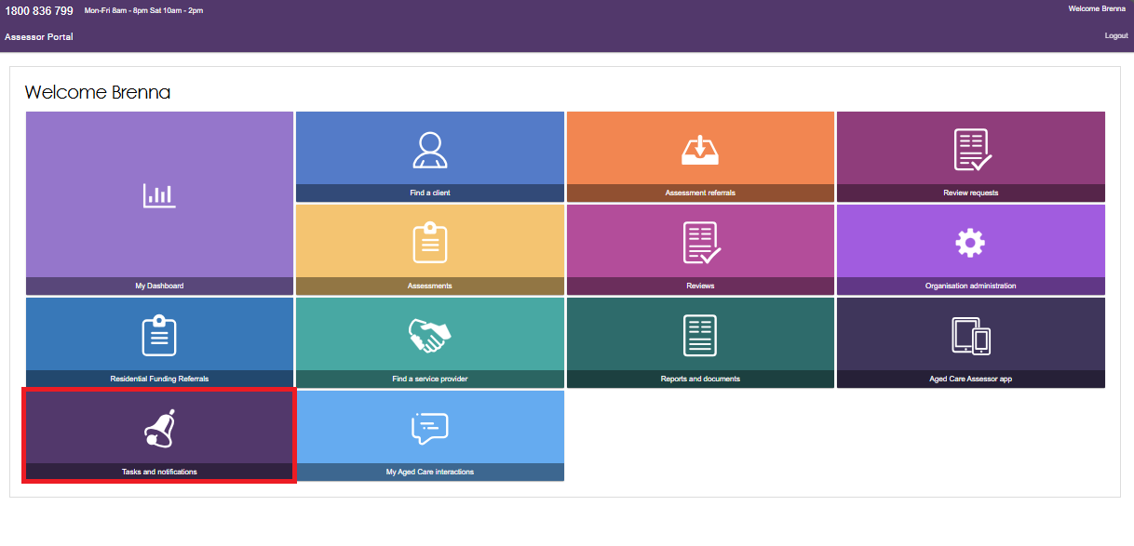

1. The **Tasks** tab will open by default.

If you are accessing the assessor portal as clinical aged care needs assessor (clinical assessor) your Tasks and Notifications tab will appear like this, with tabs labelled as Tasks, Notifications, and Maximum HCP wait times:

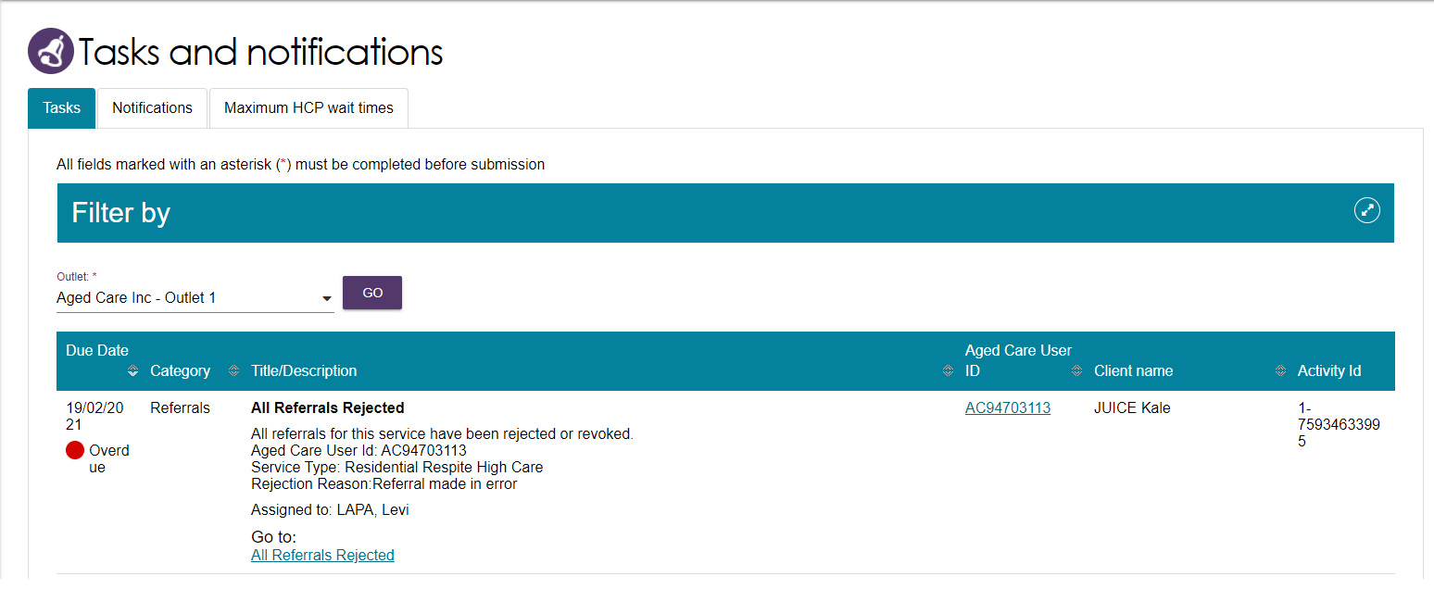

If you are accessing the assessor portal as a clinical assessor team lead, your Tasks and Notifications tab will appear like this, with tabs labelled as Tasks, Notifications, HCP Notifications, and Maximum HCP wait times:

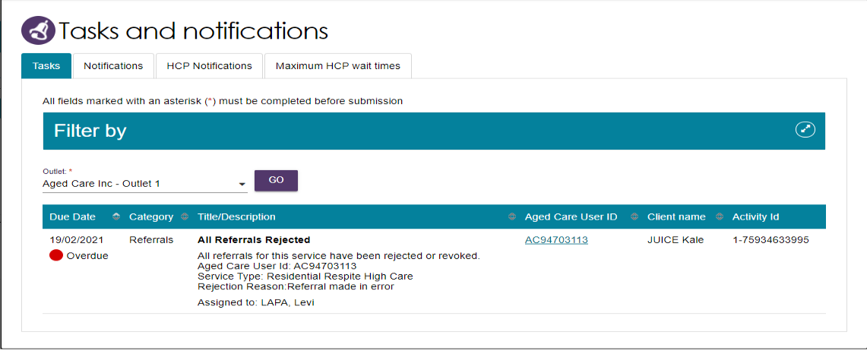

In the Tasks tab, you will be able to view all tasks that are relevant to your role.

You can sort tasks by:

* Due date
* Category
* Title/Description
* Aged Care User ID
* Client name
* Activity ID

|  |  |
| --- | --- |
| ! | Certain types of tasks can be marked as important for your outlet by your outlet administrator.  When these tasks are created, they will be displayed with a visual indicator. The Managing task and notification preferences section in this guide explains how to set tasks as important.  Image shows a task that has been set to 'important', this shows a yellow circle under the due date with the word 'important' next to the yellow circle.  The circle and Important are highlighted. |

Alternatively, if you want to see all tasks and notifications for a single client, navigate to the **Tasks and Notifications** tab in the client’s record to see all relevant tasks and notifications for that client.

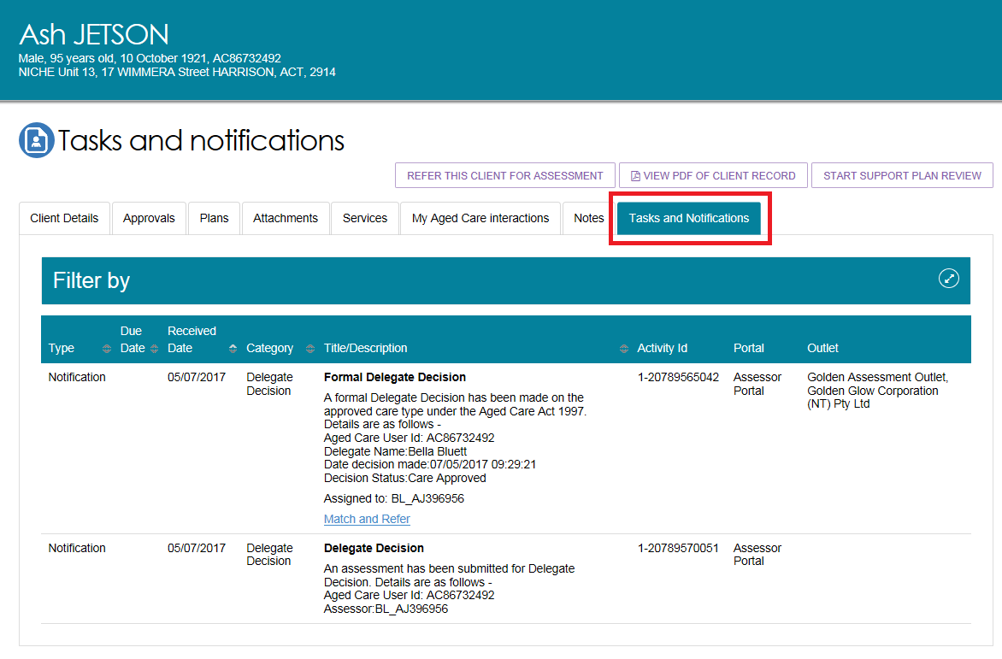

1. You can search for specific tasks using the filter options or using custom filters in **Advanced Search**. Select the arrows to the right to expand or collapse the filter options.

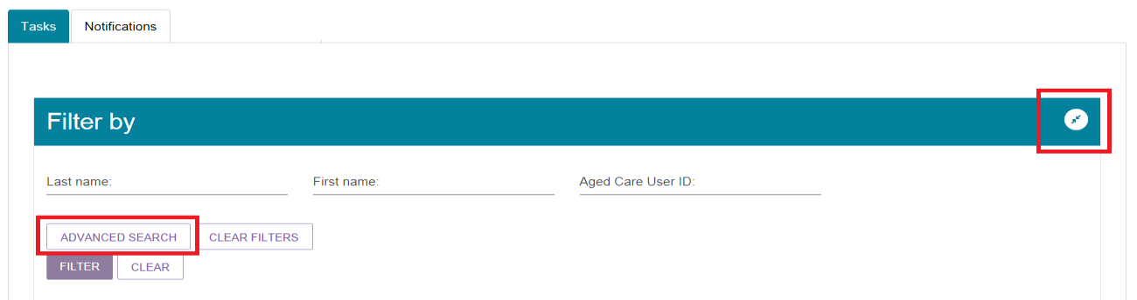

To apply custom filters, select **ADVANCED SEARCH** and choose filters from the drop-down menu and select **ADD FILTER** for each filter you want to apply.

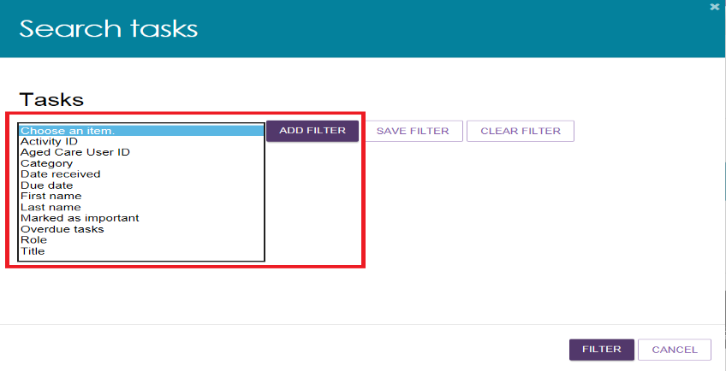

1. The hyperlink under the task description will take you directly to the individual record and the section of the portal where you can action the task. Alternatively, you can navigate to the client’s record by selecting the client’s Aged Care ID from the tasks list.

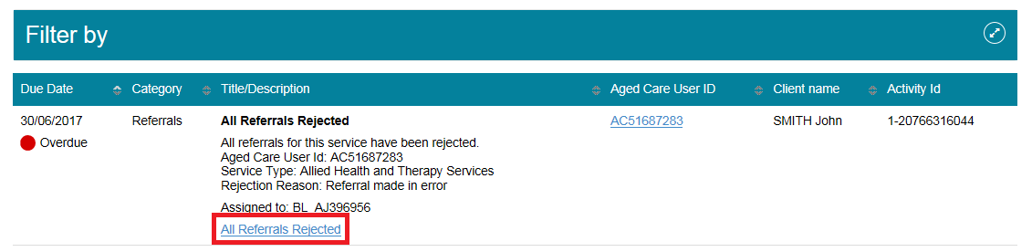

For example, selecting the link in an **All Referrals Rejected** task will take you directly to the client’s support plan where you can review the rejected referral and issue any referrals required.

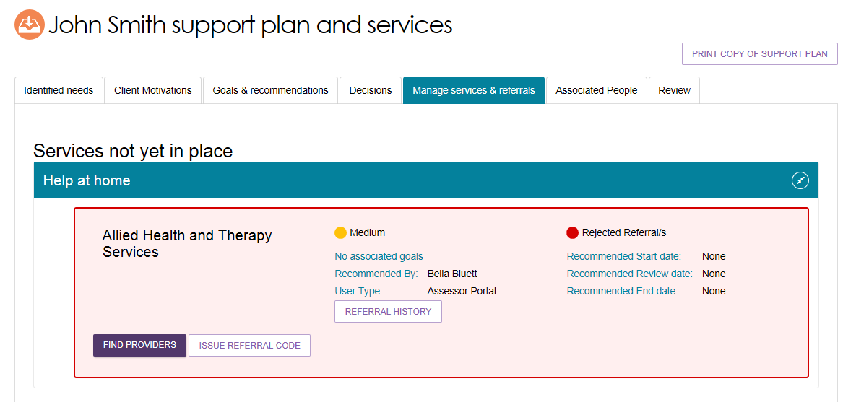

Once the action required from the task has been completed, the task will be removed from your task list.

Certain tasks may close automatically once an action has been taken by another My Aged Care user (e.g. when a service provider accepts a referral that has triggered a task for assessor to follow up, the task is automatically closed in the assessor portal).

|  |  |
| --- | --- |
| ! | If you believe you have completed a task and it has not been removed from your portal, please call the My Aged Care Service Provider and assessor helpline on 1800 836 799 who will be able to assist in completing the task. |

1. Assessors can also change the client’s status to deceased by opening the **Client details** tab and selecting **NOTIFY MY AGED CARE OF A DEATH**.

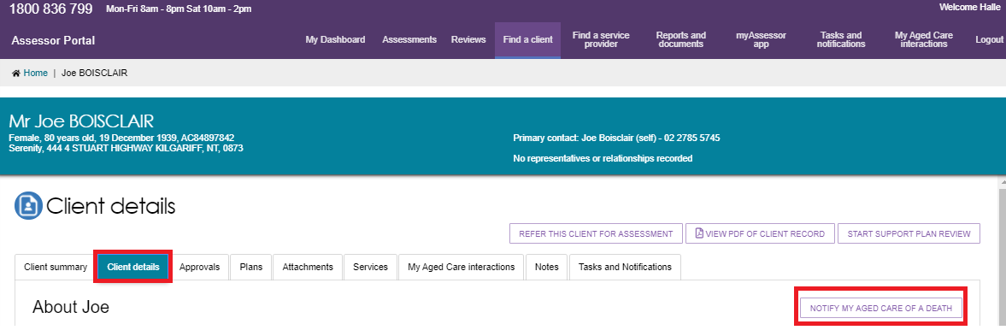

When **NOTIFY MY AGED CARE OF A DEATH** is selected you will be taken to **Notify My Aged Care that person is deceased** screen where you will have to add the following details:

* Who, when and how you were informed that this person is deceased? E.g. “Mrs. Smith rang to inform us that Mr. Smith has passed away on Saturday”
* Date of death (if known)
* Add Attachments, as available (e.g. Death Certificate, Hospital Discharge documents).

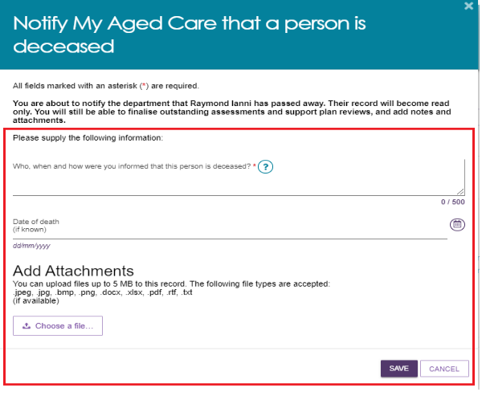

When the client status is changed to deceased, if they have an in-progress assessment, a notification will be sent to the associated assessor and provider advising them to close or finalise the in-progress tasks.

## Viewing notifications

Assessors will be able to see all tasks and notifications for clients, however service providers will only be able to see tasks and notifications that are associated to their outlet and for clients they are providing services to.

1. From the assessor portal homepage select **Tasks and notifications** and select the **Notifications** tab.



1. In the **Notifications** tab, you will be able to view notifications from the last 30 days that are relevant to your role. The earliest date that the notifications are displayed from is visible under the filter options. Any notifications older than 30 days will be removed and will no longer be visible in the portal.

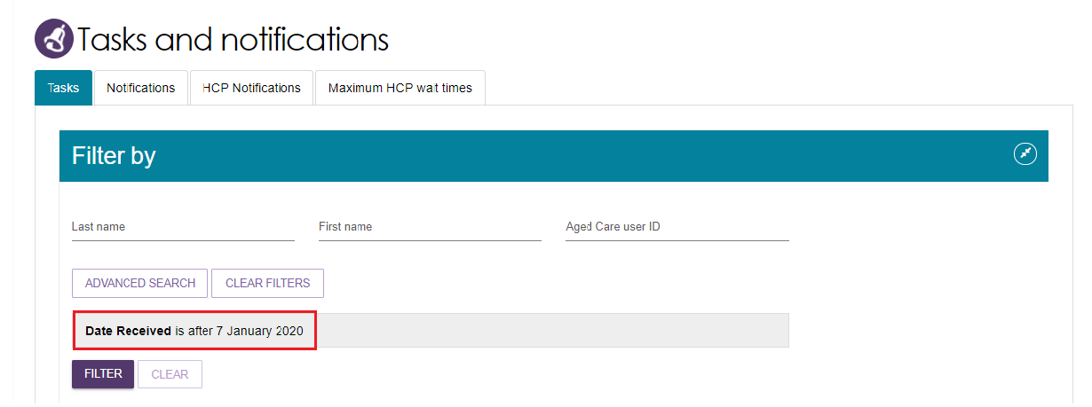

Alternatively, if you want to see all tasks and notifications for a single client, navigate to the **Tasks and Notifications** tab in the client’s record to see all relevant tasks and notifications for that client.



1. In the **Notifications** tab, you can sort notifications by:

* Received Date
* Category
* Title/Description
* Aged Care User ID
* Client name
* Client Correspondence

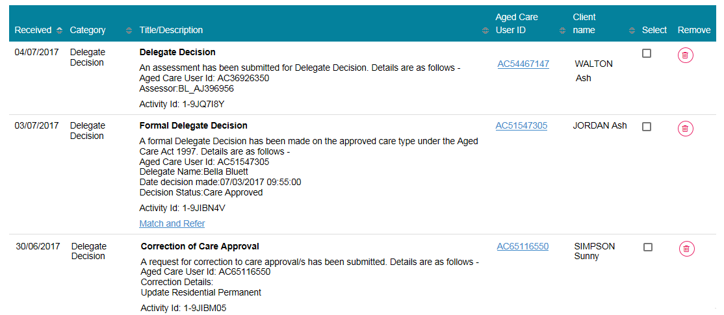

Home Care notifications will display in the **Notifications** tab if enabled in the client’s support plan or on the **Approvals** tab in the client record.

Further information on selecting to receive this notification can be found in the [My Aged Care – Assessor Portal User Guide 13 – Management of Home Care Packages](https://www.health.gov.au/resources/publications/my-aged-care-assessor-portal-user-guide-13-management-of-home-care-packages).

|  |  |
| --- | --- |
| ! | As with tasks, certain types of notifications can be marked as important for your outlet by your outlet administrator.  When these notifications are created, they will be displayed with a visual indicator.  The Managing task and notification preferences section in this guide explains how to set notifications as important.  Image shows how Users are able to select notifications they can mark as 'important'. This screenshot shows a notification that has been marked as important as indicated by a yellow circle under the received date column and the word 'important' next to the yellow circle, these are both highlighted. |

1. You can also remove individual or bulk notifications from your portal by selecting the Remove icon or **Select all** checkbox.

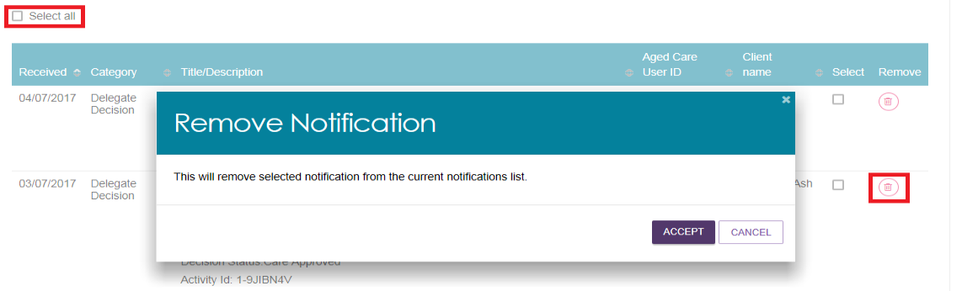

1. You can search for specific notifications using the filter options or using custom filters in Advanced Search. Select the arrows to the right to expand or collapse the filter options.

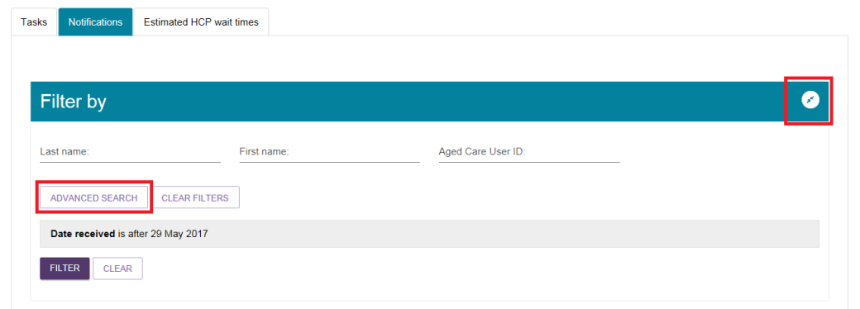

To apply custom filters, select **ADVANCED SEARCH** and choose filters from the drop-down menu and select **ADD FILTER** for each filter you want to apply.

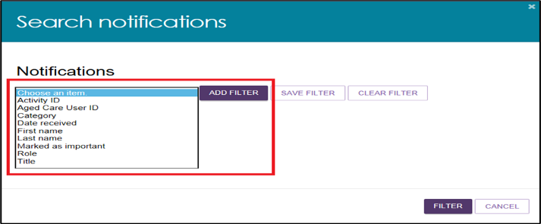

1. The hyperlink under the notification description will take you directly to the individual record and the section of the portal where you can view more information about the notification or complete any action that may be required.

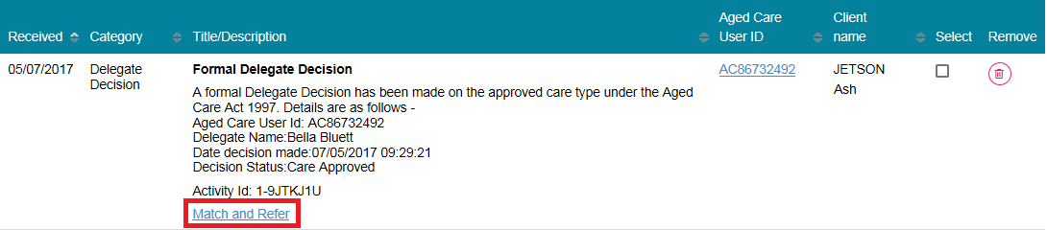

For example, selecting the link in a **Formal Delegate Decision** notification will take you directly to the client’s support plan where you can match and refer for the recently approved care type.

This image shows users the screen they view once selecting the 'match and refer' option from the previous screen. 
This screenshot shows the 'manage service and referrals' tab selected from the top tabs available and then shows the 'services not yet in place' section. This is the divided in to two sections: help at home and aged care homes. 

## Viewing and reassigning Home Care Package (HCP) notifications

You must be assigned in the team leader role to view which assessor or delegate is currently receiving the client’s Home Care Package correspondence notifications.

You will also have the ability to reassign a client or an individual or make bulk reassignment changes to a different assessor or delegate within an outlet.

1. In the **Tasks and Notifications** tab select **HCP Notifications** tab. If you manage more than one outlet you may choose which outlet to view from the dropdown.

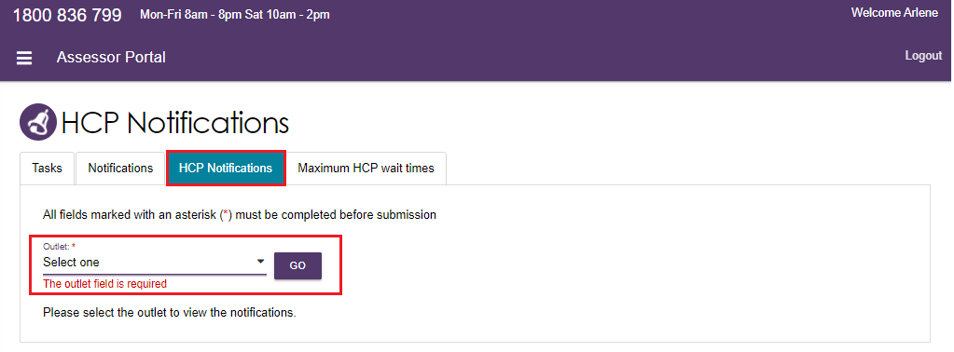

Once you have chosen the outlet to view you will see the following details:

* Last Name
* First Name
* Aged Care User ID
* Locality
* Who receives the notification (First name, Last name)

The last column is a select tick box which allows the team lead to complete individual or bulk reassignments:

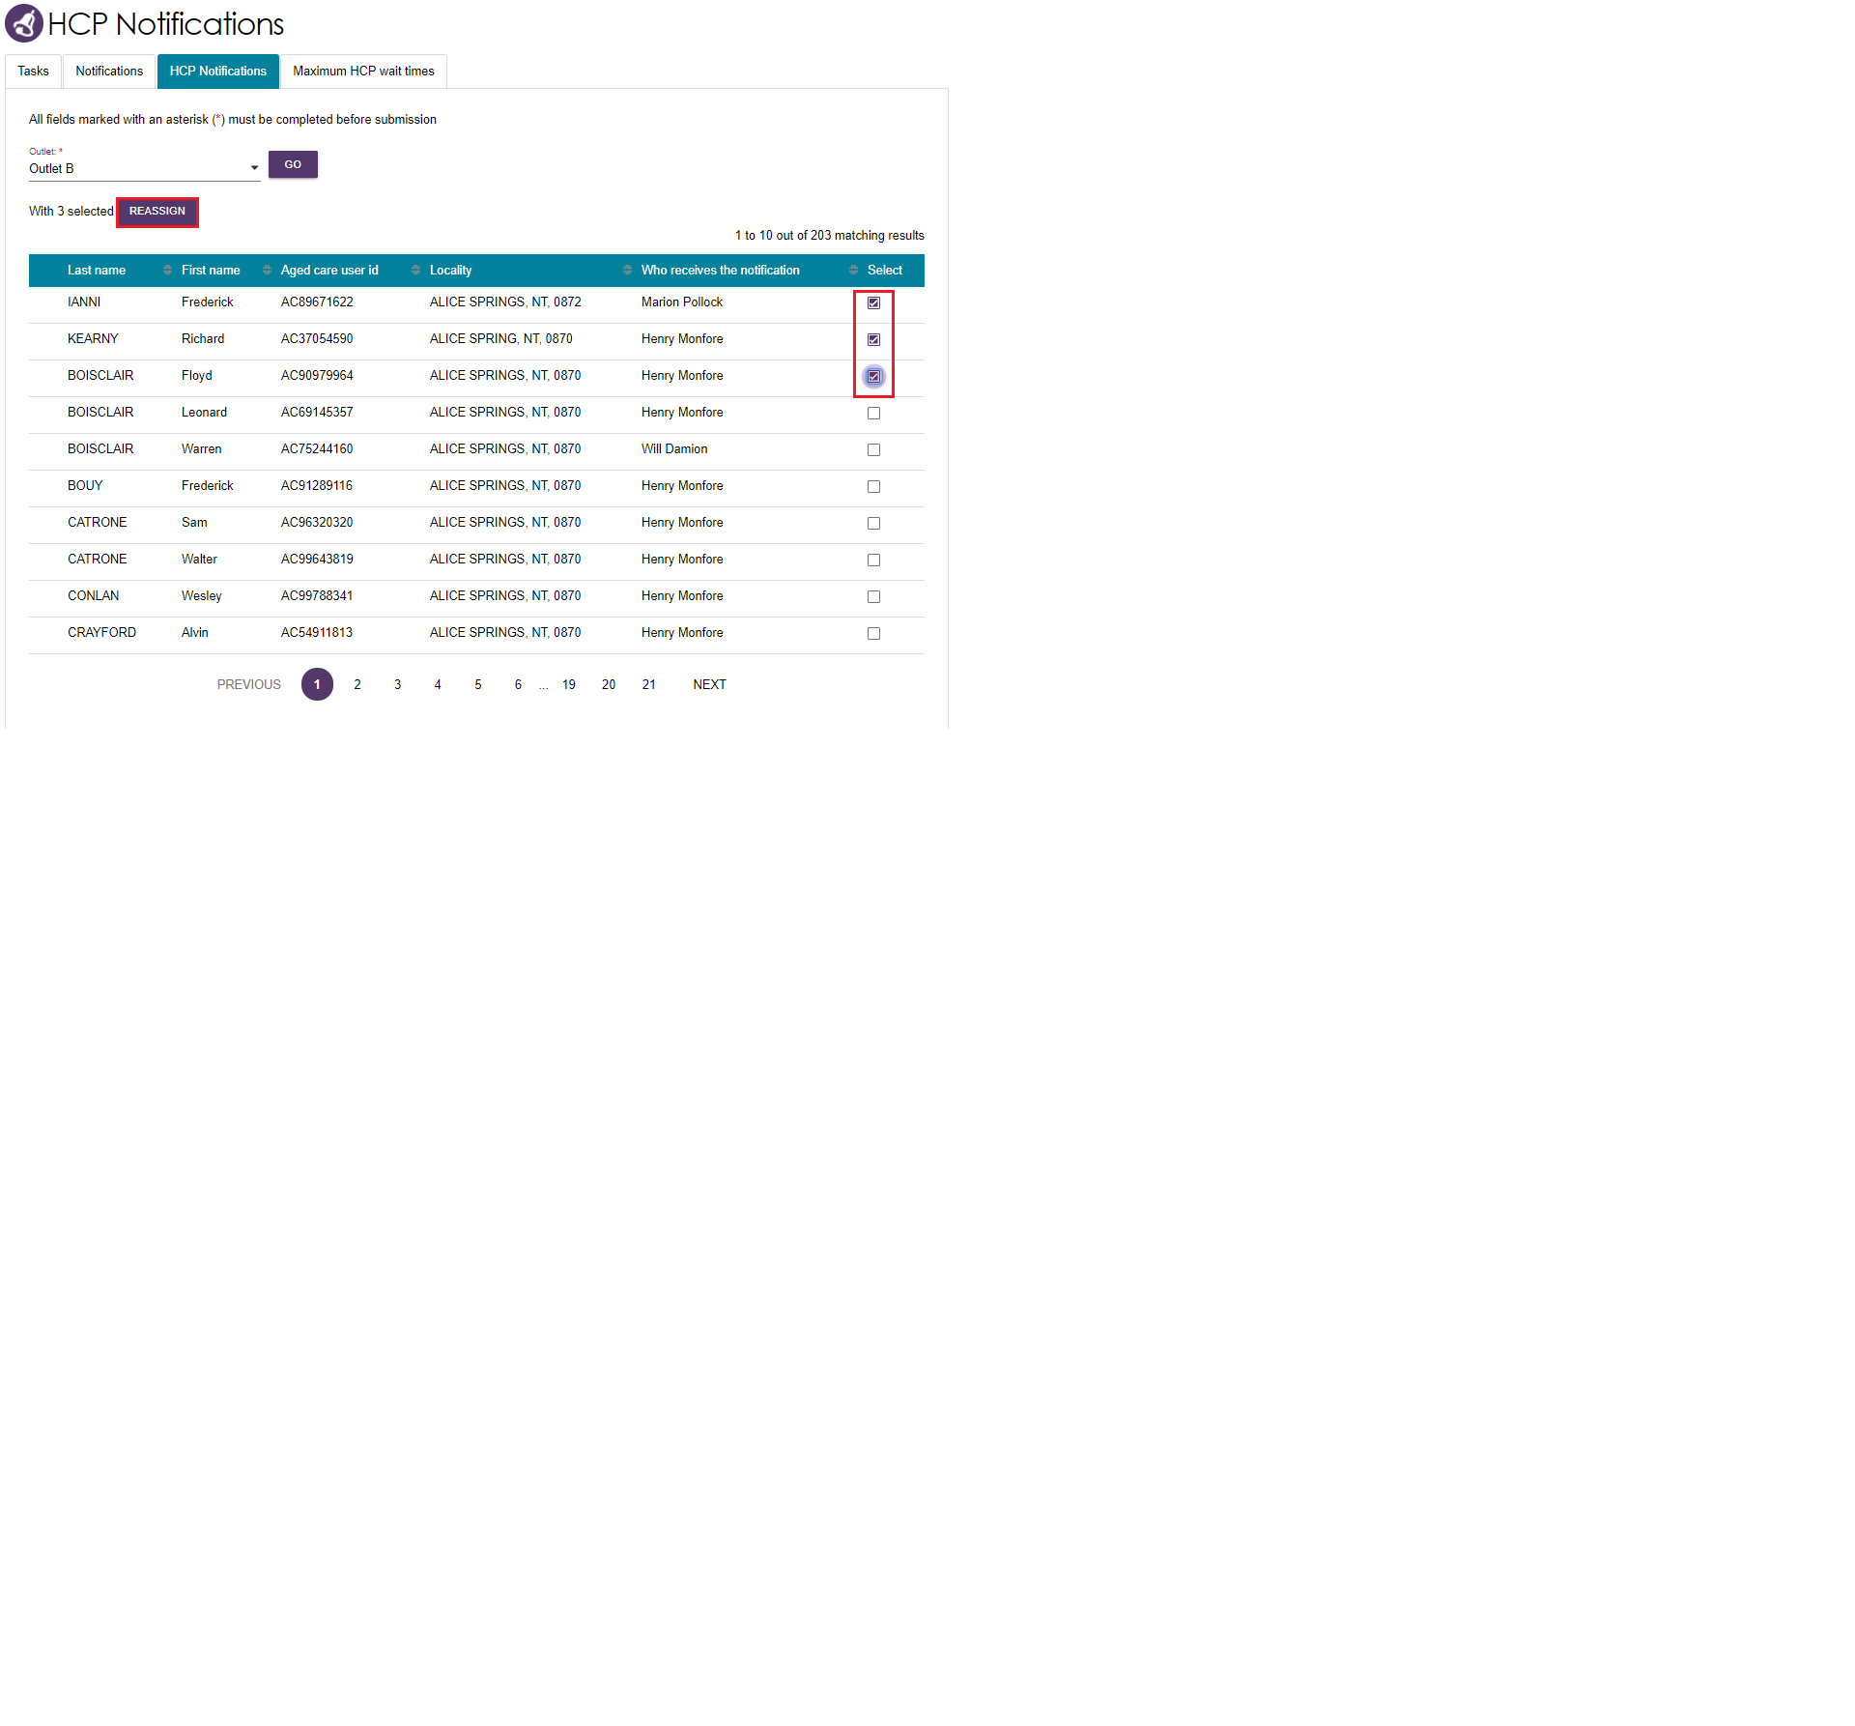

1. By Clicking the **REASSIGN** button, the **Re-assign Home Care correspondence notifications** pop up will be displayed where you can select the new recipient and finalise by clicking the **SAVE** button.

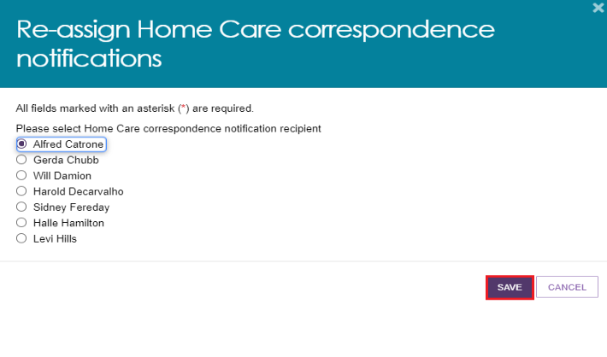

## Managing task and notification preferences

You must be assigned an administrator role to manage task and notification preferences for your organisation or outlet.

If you need to add this role to your user account, please see your organisation administrator.

As an administrator, you will be able to:

* edit email address and email frequency for new task and notifications
* turn off visibility of notifications in the assessor portal
* view description of each task and notification, including which user types will be able to see them
* edit individual task and notification preferences
* mark a task or notification as important to your outlet.

These settings will affect all staff assigned to your outlet, so please ensure all staff are made aware of any changes you make.

1. From the assessor portal homepage select **Tasks and notifications**.



1. Select the **Manage Preferences** tab.

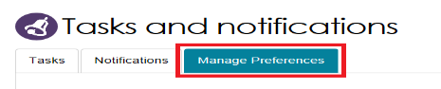

1. If you are the administrator for your organisation, you will be able to select which outlet you want to configure task and notification preferences for. Select **CHANGE PREFERENCES**. If you are the administrator for your outlet, you will only be able to see your outlet’s preferences.

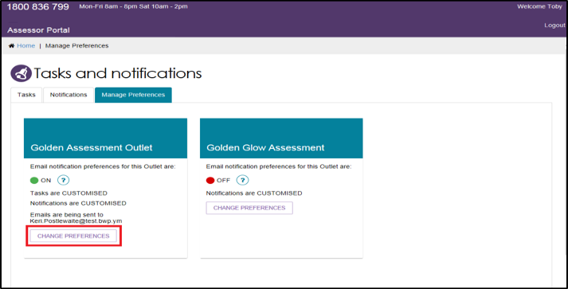

1. The preferences page for the outlet will open. At the top of the page, you can configure the overall preferences for email preference, email address, email frequency and notification visibility in the portal.

You can choose to hide all notifications, or hide individual notification types for the outlet. Selecting **No** to hide all means that no notifications for the outlet will be visible to staff associated with the outlet.

Selecting **No** for an individual notification type means that only notifications of that type will be hidden for staff associated with the outlet.

This image shows the Change preferences pop out box with Received emails for new tasks and notifications and show notifications in the portal highlighted.

The options available to user who have selected to change their outlet preferences. These options include receiving emails for new tasks and notifications with a yes or no box followed by a section that allows the user to write their email to send this information to. Underneath this is a 'show notifications in the portal' question also with a yes or no box to select. 

1. Tasks and notifications are sorted by category. Select the Expand (double arrow) icon to expand/collapse each category.

This image shows the Change preferences pop out box with Client services selected. The task in this section has been highlighted.

It shows tasks and notifications that have been sorted by category. Each category is able to be expanded by clicking on the arrow to the right of the screen. This screenshot shows an expanded view of the category 'client services'. 

For each task or notification you will be able to view:

* Type (e.g. task or notification)
* Title and brief description of the why the task or notification has triggered
* User type who can view or action the task or notification.

For each task or notification you will be able to individually configure:

* Whether to send an email when a task or notification generates
* Frequency of email notification, if enabled
* Whether to display a task or notification as important in the portal.

|  |  |
| --- | --- |
| ! | If you choose to mark a task or notification as important, staff within your outlet who can view that particular task/notification will see a visual indicator in their portal.  This screenshot shows a notification that has been marked as 'important', this is indicated by a yellow circle under the received date column and the word 'important' next to the yellow circle. |

1. Select **SAVE** when all changes have been made. You can reset the preferences by selecting **RESET PREFERENCES** at the top of the page.

Selecting the arrow in the bottom right of the screen will automatically take you to the top of the page.

This image shows the preference screen with the SAVE button and upward arrow highlighted.

Select ‘Save’ when all changes have been made. You can reset the preferences by selecting ‘Reset preferences’ at the top of the page.