**Assessor Portal User Guide 8 – Referring for services**

A client may require services to support their needs as a result of an assessment.

Aged care needs assessors (assessors) may refer the client (with consent) for service recommendations made in the client’s support plan, based on the client’s preferred service provider (or prioritised list of service providers) and location preferences.

They can then send electronic referrals for services, or provide the client with a referral code that allows them to visit providers prior to selecting their preferred provider.

This User Guide contains the following topics:

Referral Types 2

Sequential Mode 2

Broadcast Mode 2

Referral Codes 2

No Care Approval 3

Issuing a referral for service 3

Recalling a referral 12

Issuing a referral code 13

Viewing Delegate decisions 14

Referring for Home Care Package services 16

Managing rejected service referrals 18

## Referral Types

For service recommendations made in the client’s support plan, you can search for and match a client to a preferred service provider (or prioritised list of service providers) based on the client’s preferred location and/or preferences.

|  |  |
| --- | --- |
| ! | You must obtain consent from the client and/or their authorised representative prior to issuing a referral. This is complete by using the referral for services components of the My Aged Care Assessment Consent Form, which is available for download in the Documents & Reports tile in the My Aged Care assessor portal (assessor portal). |

There are three types (modes) of referrals. You can:

* send a Sequential referral for service
* send a Broadcast referral for service or
* provide the client with a referral code that allows them to visit providers prior to selecting their preferred provider.

You can also decline to refer, by issuing a “No Care Approval”.

### Sequential Mode

The assessor will send the client’s referral to their chosen provider/s in the order of their preference. The client can limit their preference to one or more providers. If their first preference is not available, the referral is automatically sent to next preference.

### Broadcast Mode

The assessor will send the client’s referral to all available providers. In agreeing to a broadcast referral, multiple providers could contact the client to see if they can provide them with the service/s. If a provider accepts their referral, the other provider/s will no longer see their information.

### Referral Codes

For **residential aged care services**, assessors will normally generate a referral code for the client rather than issuing an electronic referral (Sequential or Broadcast referral) to service through the assessor portal. Electronic referrals for residential aged care service providers would only be expected where the client has indicated a preferred residential provider or has already discussed care options with a provider.

For **Home Care Package services**, once a client is assigned a package from the National Priority System, they will also be assigned a referral code. This code will be mailed to the client with their package assignment/upgrade letter. Alternatively, assessors can provide this code (available in the client’s support plan) to the client to allow them to visit home care providers prior to selecting their preferred provider. In addition, where the client has indicated a preference or discussed options with a home care provider, assessors can issue an electronic referral.

### No Care Approval

If you have recommended ‘No Care Approval’ due to the client withdrawing their application for care or not wishing to apply for care under the Act, you can select **COMPLETE SUPPORT PLAN AND CONTINUE TO MATCH AND REFER** from any tab in the client’s support plan.



## Issuing a referral for service

|  |  |
| --- | --- |
| ! | **Prior consent required**  You must obtain consent from the client or their representative in their support network prior to issuing a referral. You should use the My Aged Care Assessment Consent Form. The Consent Form includes the consent scripts and fields to record the consent for service referrals. It is located via the Reports and documents tile within the assessor portal. |

1. When you have finished developing the support plan with the client, select **COMPLETE SUPPORT PLAN AND CONTINUE TO MATCH AND REFER**.

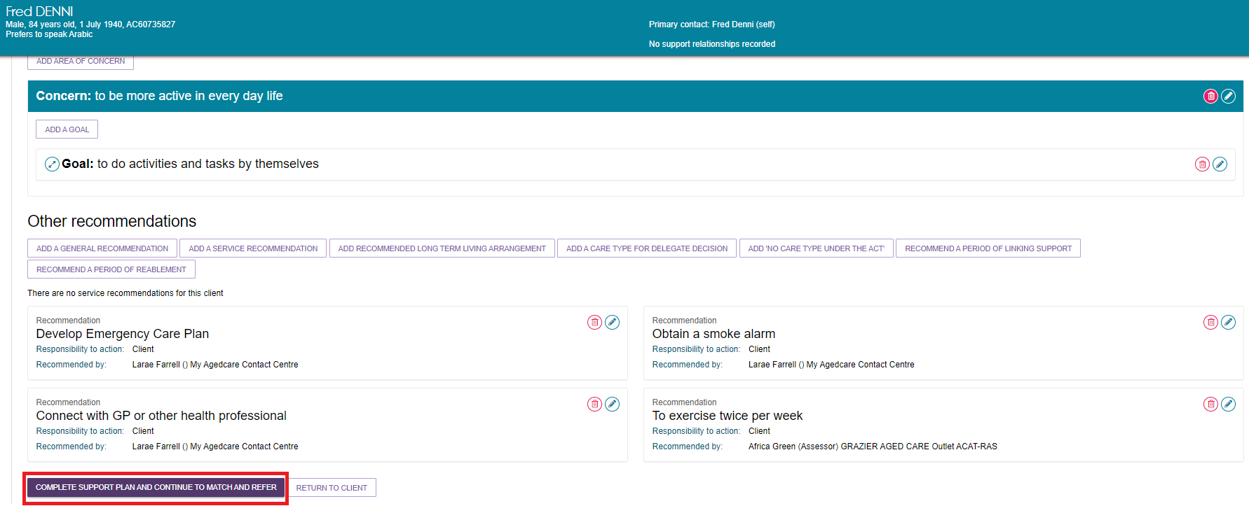

1. You will be taken to the **Manage services & referrals** tab. The services added in the **Goals and recommendations** tab of the support plan will be displayed under **Services not yet in place**.

Select **FIND PROVIDERS** to search and create electronic referrals for services.

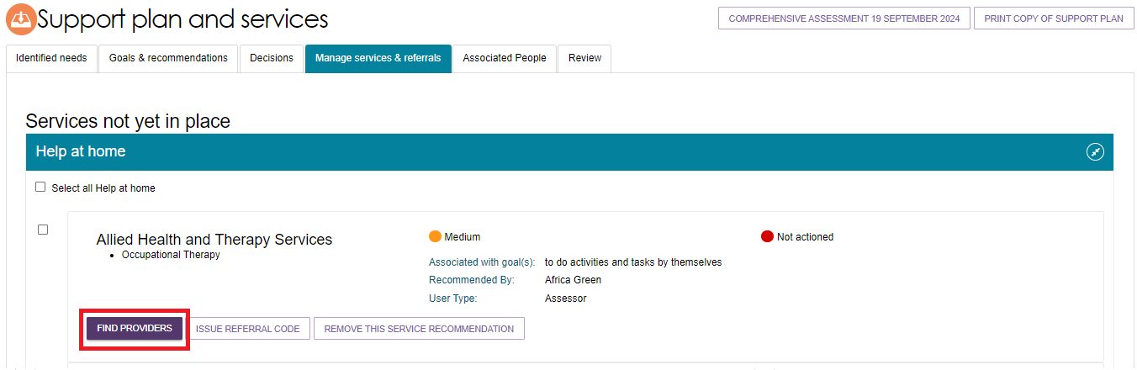

To search for multiple services at the same time, select the services you wish to search for and click **FIND HELP AT HOME PROVIDERS**.

Image of Help at home screen.

With tick boxes for providers circled.

With FIND HELP AT HOME PROVIDERS circled.

1. A page will be displayed that displays the services you ticked in the previous step. It allows you to enter the search criteria for the service. Depending on the service type you are searching for, the search criteria may include, but not necessarily be limited to, the following:

* The list of ‘service sub types’ that are available for the service selected, to further refine the search for a specific client need
* The client’s service delivery address for location-based searches
* Preferred service delivery setting: client location or service provider location
* Direct search for service providers by name or by proximity on a map.

Depending on the service selected, a location search may either be region/area based (e.g. domestic assistance services delivered to the client’s home) or proximity based (e.g. a centre or facility).

Detailed search options are available, including whether the client has previously received services with the service provider, or any specialisations required to cater for a client’s diverse or specialised needs.

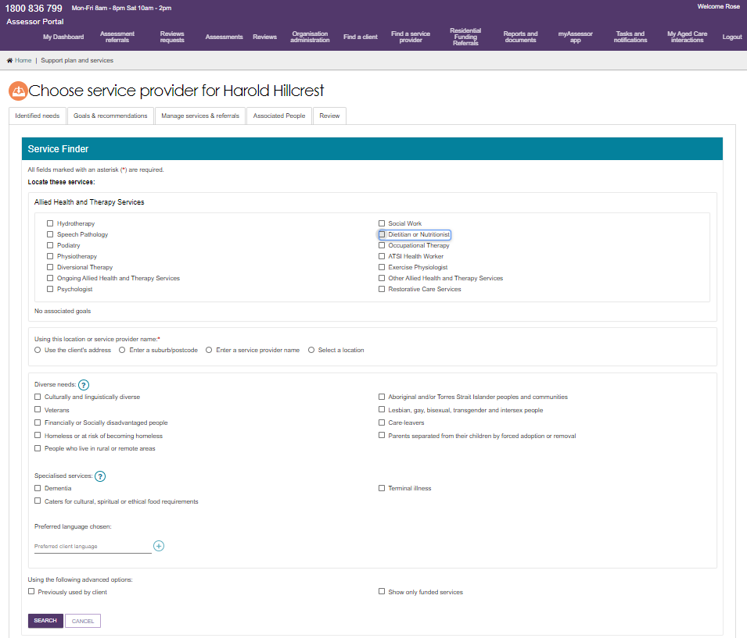

For Home Care Packages, you are able to search for service providers by specific home care service attributes including: Diverse needs, Specialised services, Language, Culture, Religion, Out of Hours service and Case management availability. This can be done by selecting **Advanced search** when choosing a service provider.

Image of Service Folder screen with Advanced search highlighted.

For Home care packages, you are able to search for service provoders by specific home care service attributes including: Special needs group, Specialised services, language, cultural and religion, Out of Hours services and case management availability. This can be done by selecting 'Advanced search' when choosing a service provider.

1. Enter the search criteria. Some further criteria displays depending on previous selections, such as how a service is delivered. Then, select the **SEARCH** button.

Screenshot of the service finder that appears after the user select a service type and select "Find Providers". The Locate three services, Using this location or service providers name section, Diversity needs and Specialised services, Using the following advanced options and SEARCH button are highlighted.


You can enter search criteria such as service name, service location, diverse needs, specialised services, advanced options.

When searching for services provided at a centre/facility, assessors are also able to select a location on a detailed visual map when matching and referring a client for service.

Select a location on the map by placing a pin, this pin may be moved to select a different location, and assessors can navigate around the map to view areas adjacent to the one currently displayed.

When searching by using the map functionality, the search results displayed will contain a list of service providers who provided services at a service delivery address within the search radius entered.

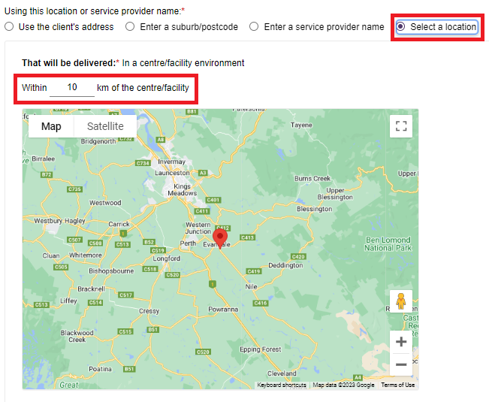

1. View the search results. The search results will be sorted to display the most relevant service providers first or randomised in the case of equal relevance.

By default, you will be able to view the search results of service providers plotted on a detailed, interactive map. You can click **Hide Map** to switch to the list view and click **Show Map** when in the list view to revert to the map view.

The search results will display search results in the following configuration depending on the criteria used when searching for services.

|  |  |  |  |
| --- | --- | --- | --- |
| Search method | Service delivery location | Map View | List View |
| Client Address; or  Suburb/Postcode | At Client Location | Outlet Address | Outlet Address |
| Client Address; or  Suburb/Postcode; or  Select A Location | At Provider Location | Address where services will be delivered | Outlet Address and service delivery address (under the individual service) |
| Service provider name | N/A | Map will be hidden for all services except Residential Care services | Outlet Address and service delivery address (under the individual service) |

As services can be offered at both provider and client location in a service delivery outlet (with the exception of residential care services) the map will be hidden when searching by service provider name, as these results will not display consistently on the map.

The availability of services, service sub-types and waitlist options are displayed for each service provider.

Map View

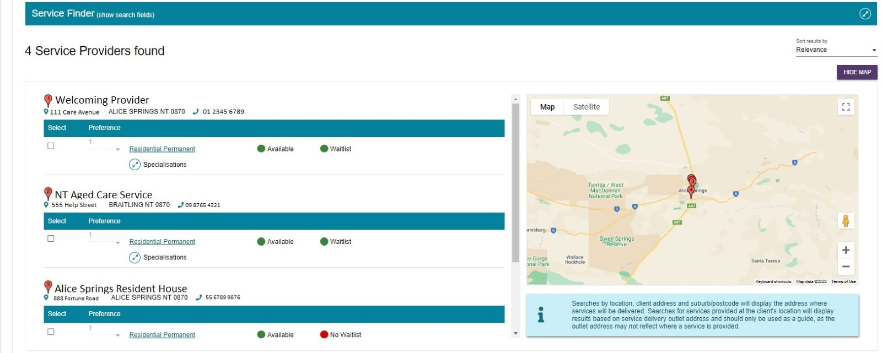

List View

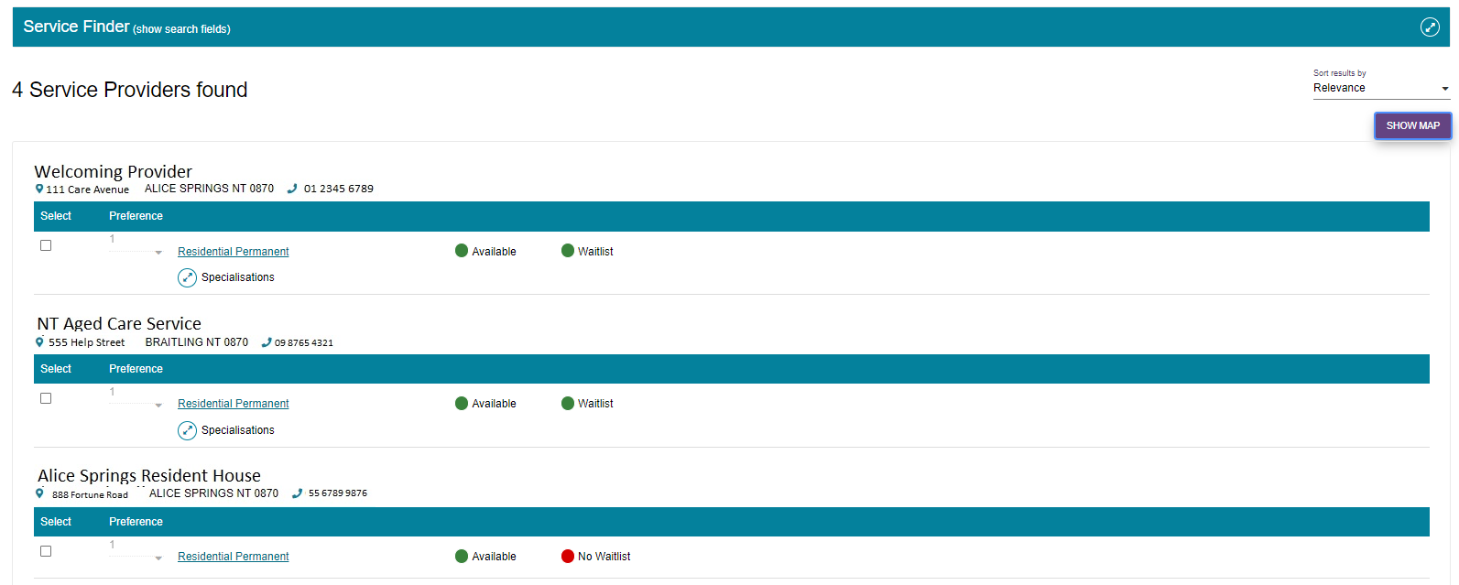

Sub-type availability or specialisations can be accessed as illustrated below.

Select the arrows next to **Sub-type availability** or **Specialisations** to view more detailed information about the service sub-types (including availability and wait list availability) and specialised service offerings of each service provider. For Diverse Needs, only verified diverse needs specialisations will be shown.

Image shows example provider screen with sub-type and specialisations circled.

Select the arrows next to ‘Sub-type availability’ or ‘Specialisations’ to view more detailed information about the service sub-types (including availability and wait list availability) and specialised service offerings of each service provider

Assessors are able to access a detailed page that replicates the information on the My Aged Care service finder by selecting the service name hyperlink under the service provider’s name.

Assessors can view any regulatory decisions made against the provider by selecting the **Regulatory decisions are available here** hyperlink under the provider’s contact details. For care types under the Act, this page will also include information around the status of the service, costs of service etc. For example, Residential Permanent services outline information around the facility’s accreditation and costs for different room types.

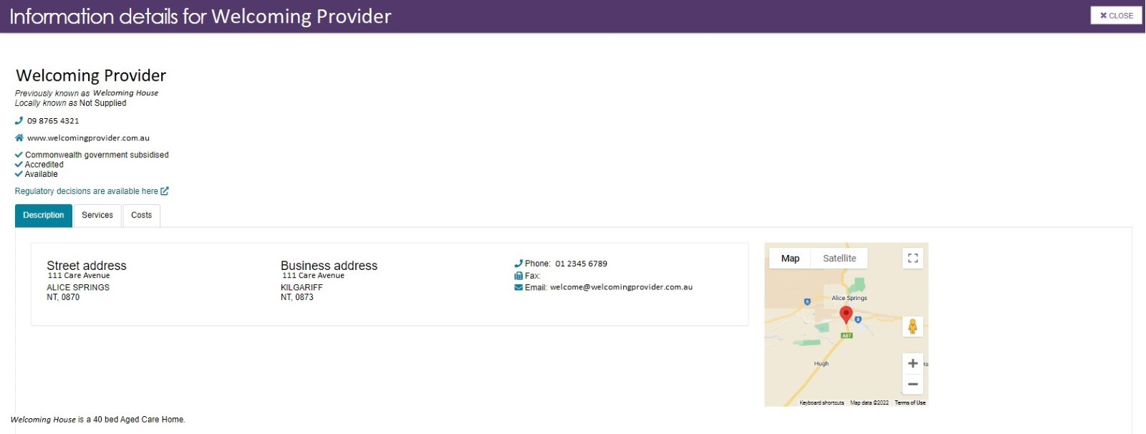

1. The following message will be displayed if an appropriate service provider is not found:



1. Select the client's preferred service provider(s), ensure that you have the client’s consent to send the referrals, and select **SAVE SELECTION AND CONSENT**.

* For broadcast referrals, set preferences for all service providers to **1st**. In agreeing to a broadcast referral, the client needs to be aware that multiple providers could contact them about their service referral.
* For sequential referrals, set preferences for service providers in order of the client’s preference.

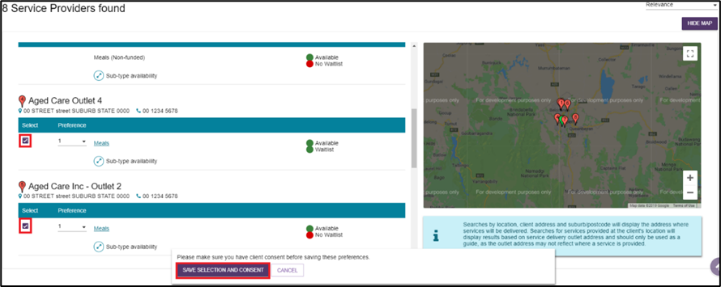

|  |  |
| --- | --- |
| ! | **Waitlisting**  If none of the client’s preferred service providers are available, they may wish to be placed on a waitlist. The search results will indicate whether a service provider has a waitlist available.  When referrals are sent sequentially and a provider accepts a client on to a waitlist, this will automatically trigger a referral to be issued to the next preference.  Clients may choose to be on multiple waitlists at the same time.  Clients will remain on a provider’s waitlist until the provider indicates services are available and accepts the client referral.  Image shows a client on multiple waitlists as shown next to each outlet. Green dot + available, or Red dot + not available, or Red dot + no waitlist. |

1. The selected service provider(s) will now display as saved against the recommended service.

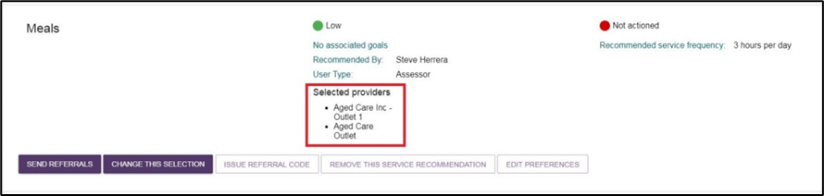

1. To edit or remove existing provider preferences, select **EDIT PREFERENCES**.

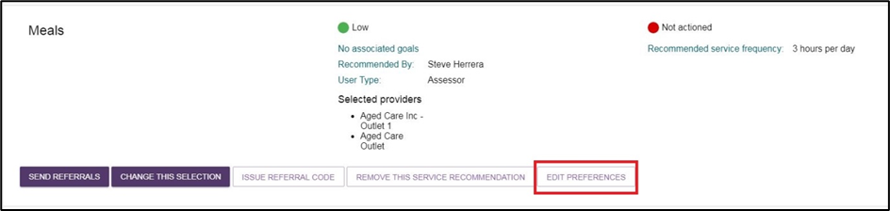

1. To issue electronic referrals, select **SEND REFERRALS**.

Image shows how to issue electronic referrals, select ‘Send referrals’. The SEND REERRALS button is highlighted.

Select **CHANGE THIS SELECTION** to choose additional provider preferences.

1. A screen will be displayed for you to review preferences and capture any other information relevant to the service provider prior to issuing the referrals. Once all information has been reviewed, click **SEND REFERRALS**.

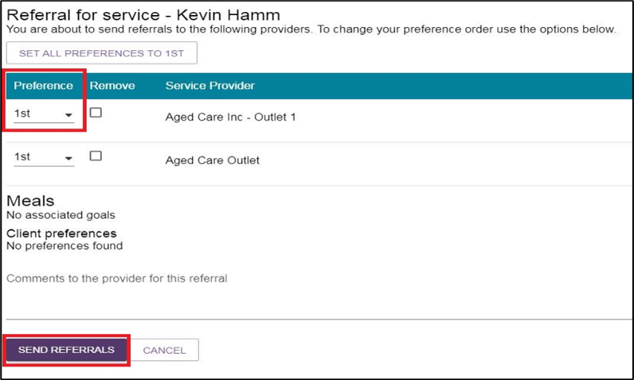

1. You will receive a confirmation message that referrals have been sent. You will also be able to see a visual indicator of the status of the referrals.

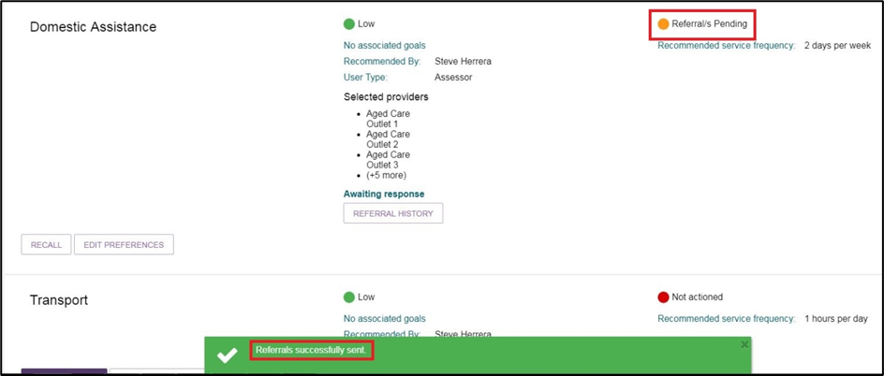

Once the referral has been accepted, the service will be displayed under 'Services in place'.

The referral statuses that will display are:

|  |  |
| --- | --- |
| Category | Status |
| Service not yet in place | Not actioned, Rejected referral, Recalled referral, Referral/s pending, Accepted to waitlist |
| Services pending | Referral code generated, Referral accepted but services have not commenced |
| Service in place | Services are being provided |
| Home Care | Package Unassigned, Package Assigned, Package Committed, Package Withdrawn, Package Declined. |

## Recalling a referral

When a referral for service is issued, it is expected that the service provider will action the referral by accepting or rejecting it. You can recall the referral before the service provider actions it.

1. On the **Manage services & referrals** tab, select the **RECALL** button to recall the referral.

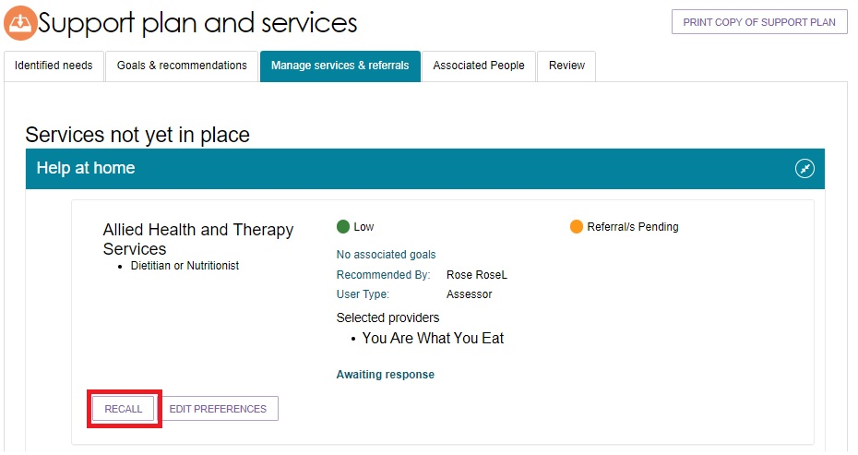

1. A pop up box will be displayed. Select which provider to recall the referral from and select **RECALL REFERRALS**.

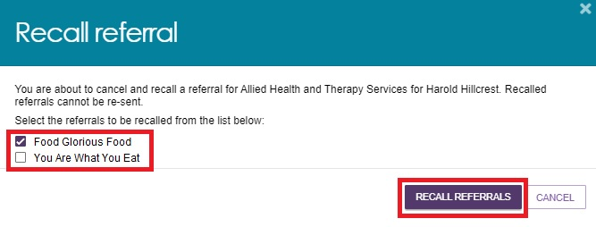

1. You will receive a banner confirming that the referral/s are successfully recalled.

Image of the blue banner confirming that the referrals have been successfully recalled. 

The referral status will be updated to **Recalled Referrals**. In the case of sequential preference referrals, the status of the referral will not change to **Recalled Referrals** until the final preference has been recalled. If you recall a referral, you cannot send it to the same provider again. You are able to send referrals to different providers for that service.

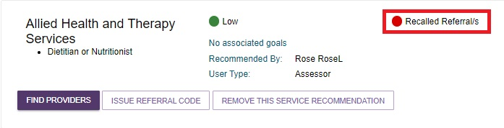

## Issuing a referral code

1. Select the **Manage services & referrals** tab from the client’s Support Plan and select **ISSUE REFERRAL CODE** for the service.

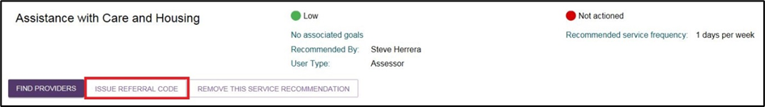

1. A confirmation message will be displayed. Select **ISSUE REFERRAL CODE**.

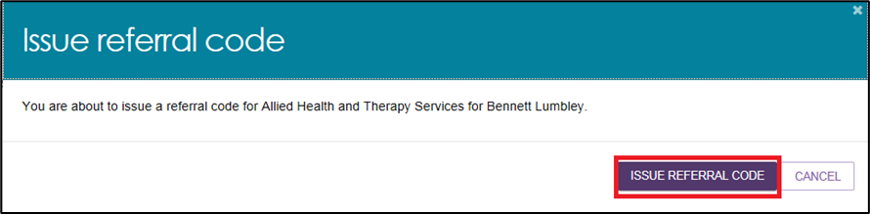

1. You will receive a confirmation message that the referral code has been generated, and the details of the referral will appear under **the Services pending** section.

The referral code will be displayed on the referral list, and the referral code letter should be printed and provided to the client.

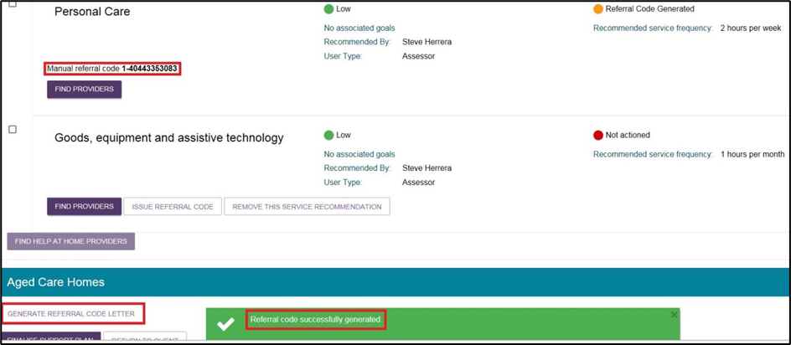

Select **GENERATE REFERRAL CODE LETTER** to print the referral code letter.

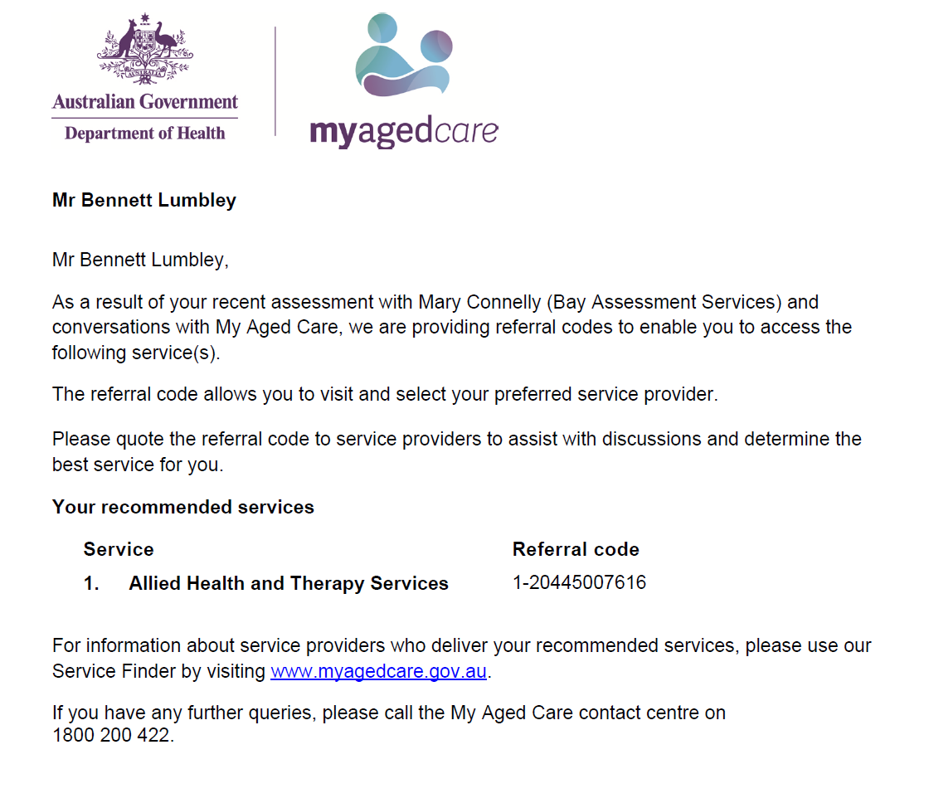

## Viewing Delegate decisions

1. Go to the **Tasks and notifications** tile in the assessor portal.

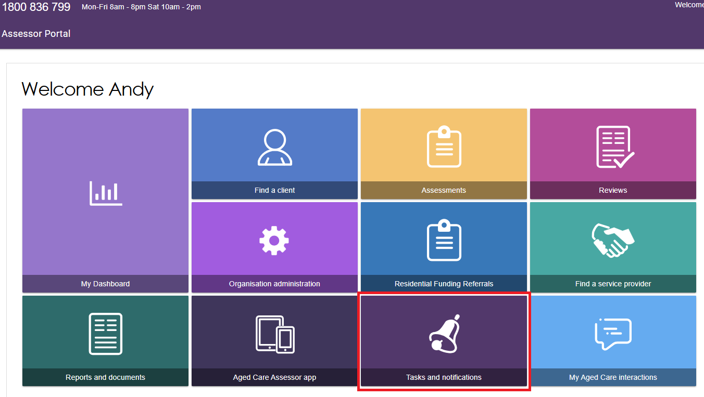

1. Go to the **Notifications** tab, and filter for your client if necessary. A Formal Delegate Decision notification will look like this:

Image of Tasks and notifications page with example Title/Description highlighted.

You will also be able to see that the Delegate has made a decision in your 'Current Work'page. The client's assessment will appear under 'Delegate Decision Complete' section card view, or with a status of 'Delegate Decision Complete' in list view.

1. Alternatively, go to the Assessments tile of the assessor portal home page. You will be able to see that the Delegate has made a decision in the **Current assessments** tab. The client’s assessment will appear under **Delegate decision complete** section in card view, or with a status of **Delegate Decision Complete** in list view.

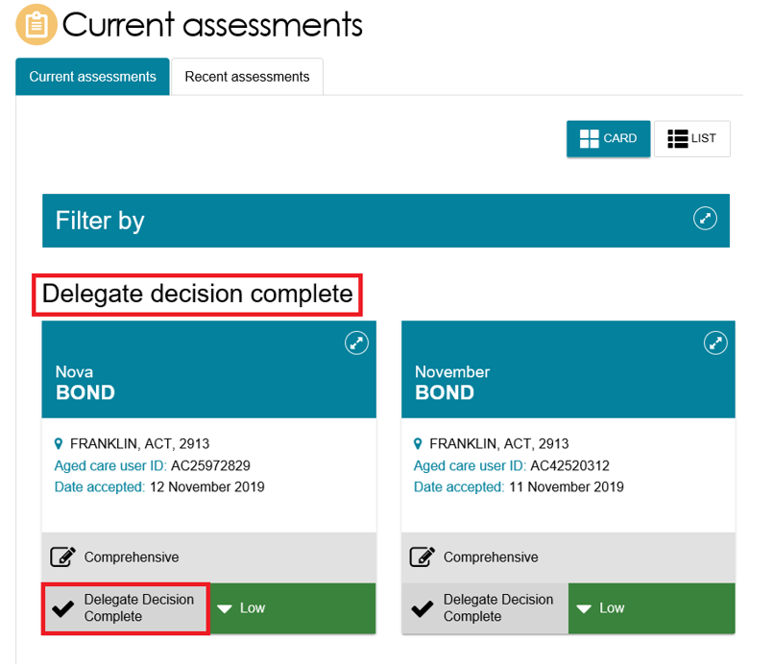

## Referring for Home Care Package services

1. Select the **Assessments** tile from the assessor portal home screen.

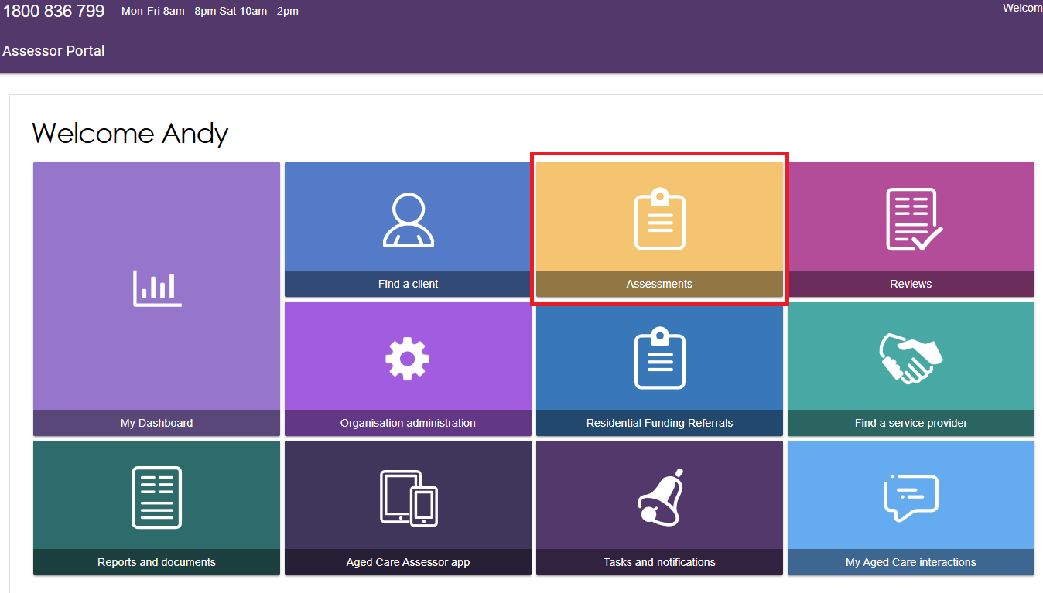

1. Select a client within your **Current assessments** tab and then go to the client’s support plan.

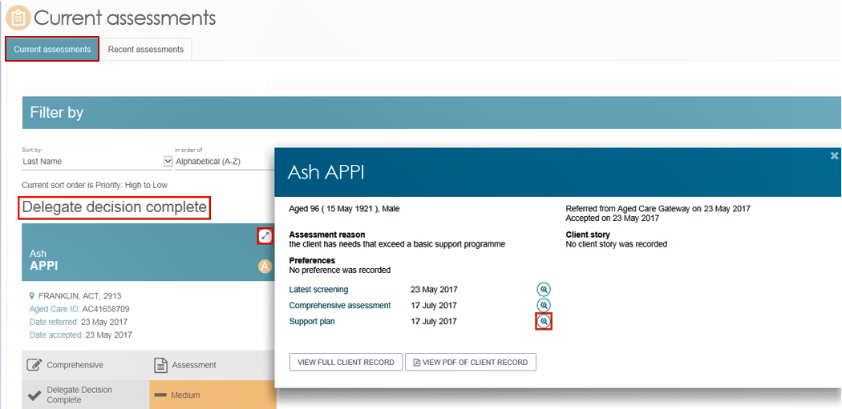

Alternatively, you can also go directly to the client’s support plan from the **Notifications** tab by selecting on the **Match and Refer** link.

Image of the Tasks and notifications page with the Go to: Match and Refer link highlighted.

Alternatively, you can also navigate directly to teh cleint's support plan from the 'Notifications' tab by cliecking on the 'Match and Refer' link.

1. Select the **Manage services & referrals** tab. The services added in the **Goals and recommendations** tab of the support plan will be displayed under **Services not yet in place**. Select **FIND PROVIDERS** to search and create electronic referrals for services.

Image of the Manage Service and referrals tab selected with the  Manage Service and referrals and FIND PROVIDERS button highlighted.

This button is highlighted suggesting to assessors to select this button in order to find providers. 

For Home Care Package recommendations, you will be able to send electronic referrals for service when the client has been assigned a package from the national priority system and the status is **Package Assigned**.

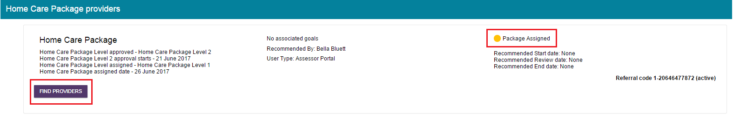

## Managing rejected service referrals

To connect clients to appropriate service providers and ensure consistency for clients, any referrals sent by you will be returned to you for actioning if they are rejected and there are no referral preferences for the client remaining.

Where a referral for service is rejected, and it is the client’s final preference, assessors will:

* Receive a notification that the referral was rejected (an All Referrals Rejected task); and
* Be able to reissue referrals to different providers or accept a provider’s offer to waitlist, based on discussion with the client.

To follow up a rejected referral, follow the steps below.

1. Navigate to the **Tasks** tab in the **Tasks and notifications** section and select the **All Referrals Rejected** link to navigate directly to the client’s support plan or the Aged Care User ID link to navigate to the client record.

Navigate to the ‘Tasks’ tab in the 
Image of the Tasks and notifications page with example Title/Description highlighted. 

‘Tasks and notifications’ section and select the ‘All Referrals Rejected’ link to navigate directly to the client’s support plan or the Aged Care User ID link to navigate to the client record

Alternatively, if you know the client’s name you can view all tasks and notifications for an individual client in the **Tasks and Notifications** tab in the client record.

Image of the tasks and notifications tab selected with the tab highlighted.

if you know the client’s name you can view all tasks and notifications for an individual client in the ‘Tasks and Notifications’ tab in the client record. 

1. If navigating directly from the notification, the **Manage services & referrals** tab in the client’s support plan will open, where the rejected service type will be displayed with **Rejected Referral/s** on the recommendation.

Image of Services not in place yet section with example organisation circled.

the ‘Manage services & referrals’ tab in the client’s support plan will open, where the rejected service type will be displayed with ‘Rejected Referral/s’ on the recommendation.

You will also be able to see the status of any other of the client’s referrals.

1. Navigate to the **Manage services & referrals** tab to see the status of the client’s referrals.

Image of Services not in place section with Manage services and Referrals selected and Rejected Referrals status highlighted.

Navigate to the ‘Manage services & referrals’ tab to see the status of the client’s referrals

For Rejected Referrals, select **Referral history** to see the further detail about the reason the referral was rejected.

1. You can now send referrals to new providers or generate a referral code for the client, following the steps described earlier in this guide. Based on the referral rejection reason, you may be required to add further information to a client’s referral, or need to discuss alternative options with the client prior to issuing another referral.