Assessor Portal – User Guide 7 – Completing a Support Plan and Support Plan Review

This user guide is intended for aged care needs assessors (assessor) who complete support plan and/or a Support Plan Review, using the My Aged Care assessor portal (assessor portal).

It covers the following topics:

What is a support plan? 2

Entering information into the support plan 3

Identified needs 3

Goals and recommendations 7

Adding recommendations 11

Care type for Delegate decision 16

Home Care Packages – Priority and Levels 18

Short-Term Restorative Care (STRC) 20

No Care Type Under the Act 21

Convert to Comprehensive Assessment 22

Manage services and referrals 23

Associated People 24

Review 25

Completing the support plan 26

Completing the support plan for a Comprehensive assessment. 27

Finalising the support plan 28

Ending a period of reablement or linking support 30

Printing a copy of the support plan 33

Receiving and starting Support Plan Reviews 35

How to view Support Plan Reviews 35

Starting a Support Plan Review 35

Transferring a Support Plan Review 41

Issuing an assessment referral as a result of a Support Plan Review 42

## What is a support plan?

The aged care client’s support plan records and identifies the client’s:

* areas of concern regarding care
* goals to address these concerns
* any recommendations for services or actions to achieve the identified goals.

The client develops their own support plan with an assessor during the face-to-face assessment.

1. After completing an aged care needs assessment (assessment) in the assessor portal, assessor will be directed to continue to the client’s support plan by clicking **FINALISE IAT AND GO TO SUPPORT PLAN**.

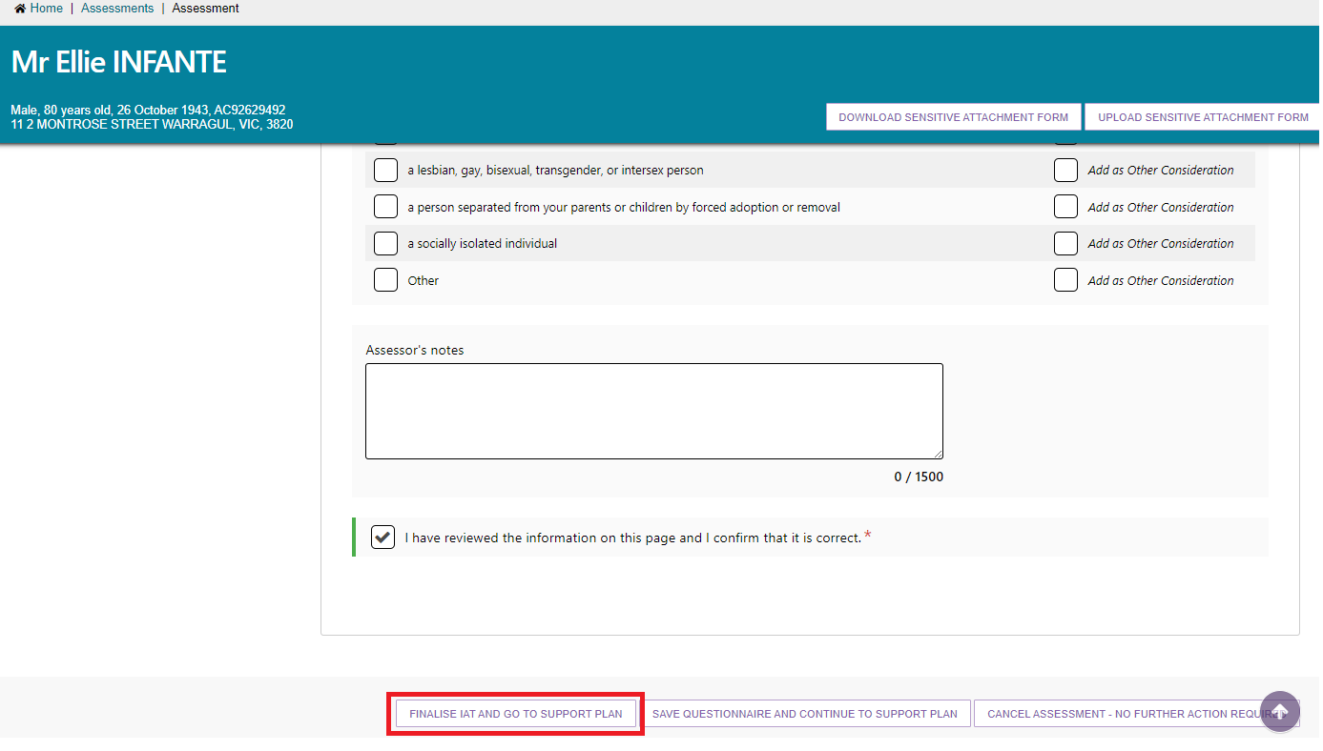

1. Once you have selected **FINALISE IAT AND GO TO SUPPORT PLAN** a pop-up box will appear. To continue select **FINALISE IAT**.

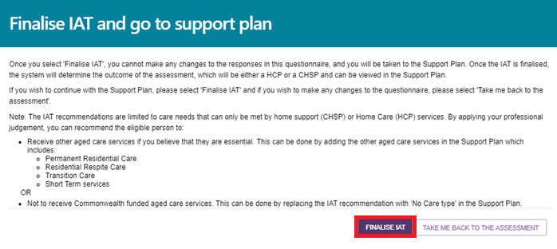

1. The support plan is also displayed in the **Client Record** in the **Plans** tab or the Assessments section in the assessor portal.

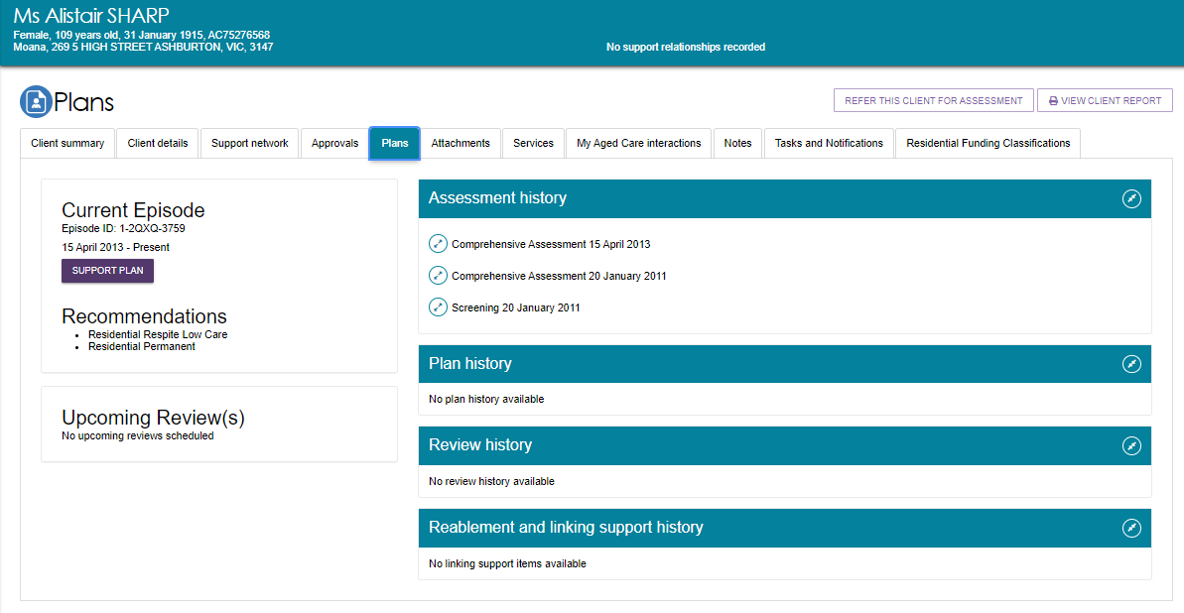

1. To add or edit a support plan, the client must have undergone at least one assessment. The following screenshot shows an example of a client’s **Support plan and services page**.

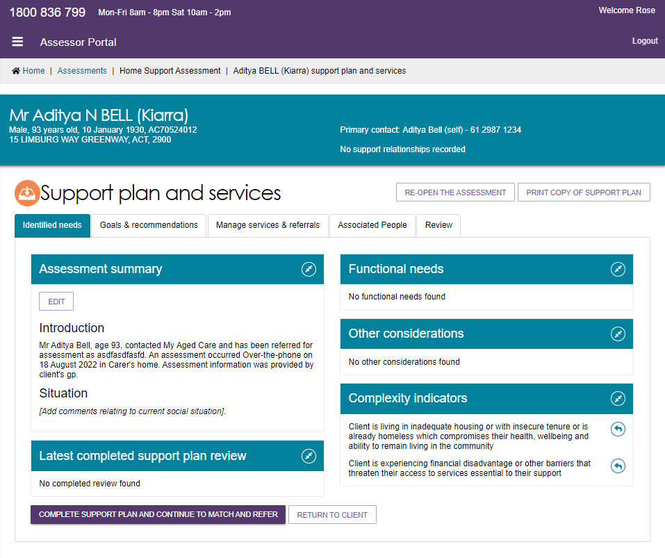

## Entering information into the support plan

The support plan is made up of a number of tabs discussed below.

### Identified needs

Screenshot of the support plan tabs with 'Identified needs' selected.

The **Identified needs** tab contains a summary of the needs identified as part of the assessment that require addressing in the support plan. This also includes information of the client’s latest completed Support Plan Review if applicable.

#### Adding an assessment summary

When completing a support plan, assessors can add an **Assessment summary** within the **Identified needs** tab.

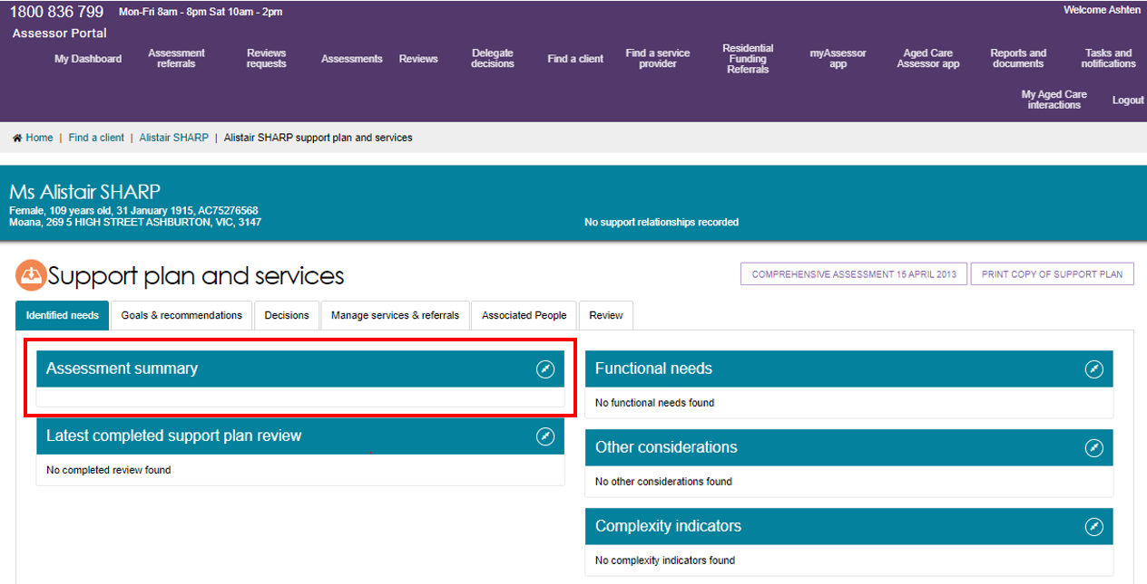

This summary appears on the printed support plan provided to the client. It can help conduct further assessments if required. It is visible to service providers who have received a referral for that client.

The assessment summary can be pre-filled based on the information an assessor records in the assessment. An icon (arrow leaving a square pointing right) will display on the fields which automatically pre-fill into the assessment summary.

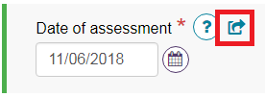

1. To add an assessment summary based on the information captured from the assessment, select **PRE-POPULATE FROM ASSESSMENT**.

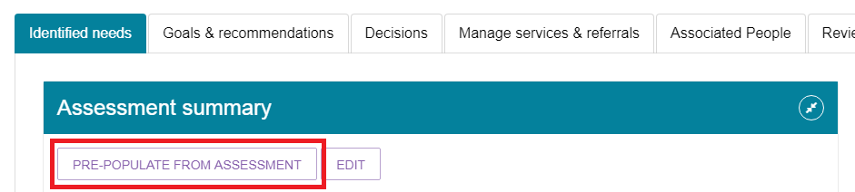

Alternatively, select **EDIT** to edit the assessment summary without any pre-filling. This will open a blank assessment summary. Proceed to Step 4, if you are manually editing the assessment summary without pre-filling.

1. A read-only view of the assessment summary will display.

The system will populate information where it exists. If information does not exist in a field, the system will advise which field has not been populated. This will display as *[field name].*

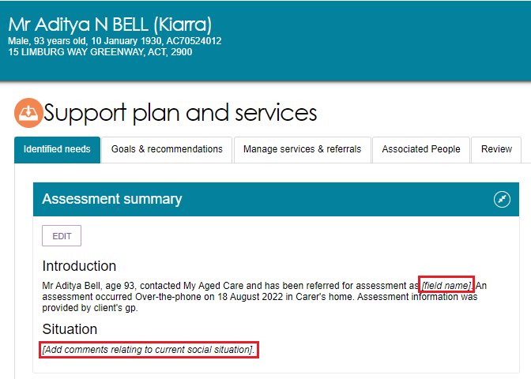

Assessors can choose to enter information in the field in the assessment; add relevant information in the assessment summary; or remove the instruction from the assessment summary.

Assessors will be prompted to enter additional information that could not be populated from the assessment. This will display as *[example instruction].*

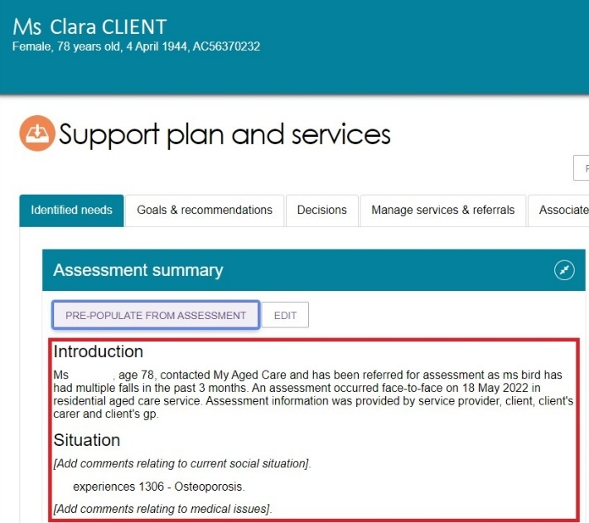

1. Select **EDIT** to start editing information in the assessment summary.

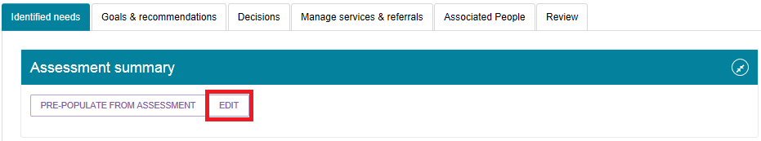

1. Select **CONFIRM EDIT** to open the editable assessment summary.

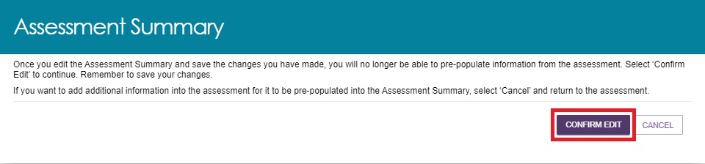

Once **CONFIRM EDIT** has been selected and the changes have been saved, the select **Pre-populate from assessment** option will no longer be available to be selected.

1. Once the assessment summary has been edited/updated, select **SAVE** to save changes.

Based on the information pre-populated from the assessment, the assessment summary may exceed the 5,000 character limit. Assessors should reduce the assessment summary by removing or summarise old content.

Assessors can continue to edit the assessment summary after they have saved their changes.

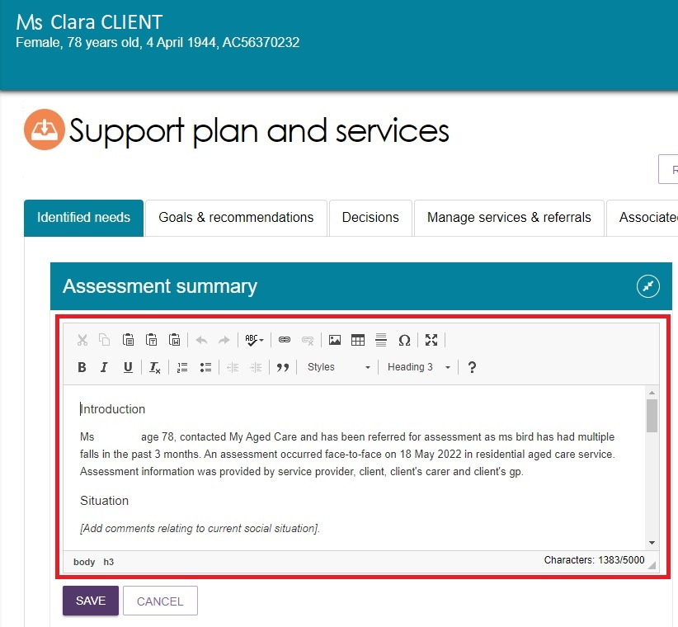

|  |  |
| --- | --- |
| ! | Ensure changes to the assessment summary are regularly saved, as auto-save does not apply to the assessment summary. |

### Goals and recommendations

Screenshot of the 'Goals and recommendations tab' selected.

The **Goals & recommendations** tab is where you will record the client’s areas of concerns, goals to address their concerns, and any services or general recommendations.

Within the **Goals & recommendations** tab you will also be able to view the IAT outcome recommendation. This recommendation is based on inputs from the assessor on the IAT assessment and the client’s current care approvals.

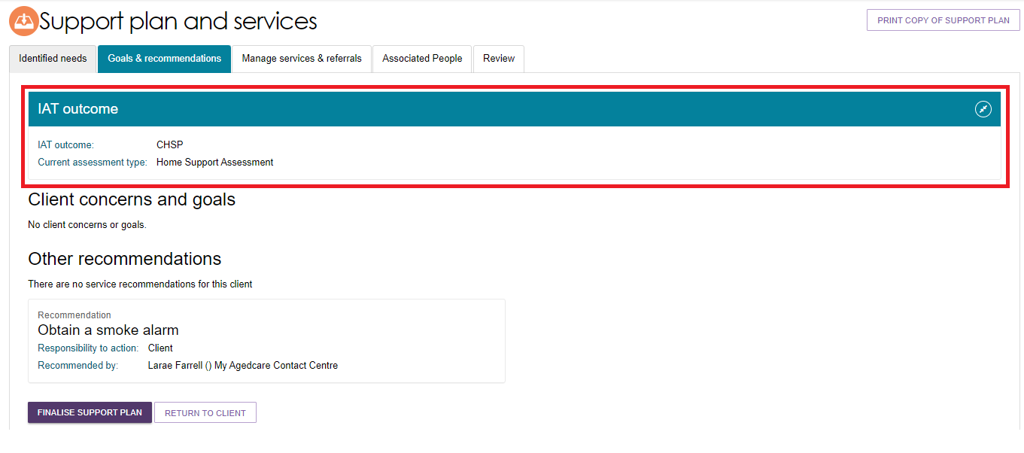

The recommendation displays for guidance only. Assessors will still need to select the service the client requires.

For clinical aged care needs assessors (clinical assessors), this means they should follow current processes for both CHSP and HCP recommendations:

* For a CHSP recommendation – you should consider recommending the client to CHSP services as per current process.
* For an HCP recommendation – you should consider recommending the client for an HCP as per current process.

For non-clinical aged care needs assessors (non-clinical assessors), this means they should consider the following based on the IAT outcome:

* For a CHSP recommendation – you can refer to CHSP services as per current process and continue to finalise the support plan.
* For an HCP recommendation – you should consider converting the assessment to a comprehensive assessment under the supervision of a staff member who holds a clinical assessor role (further information is at Convert to Comprehensive Assessment).

#### Adding an area of concern and goals

1. From the support plan and services page select the **Goals & recommendations** tab.

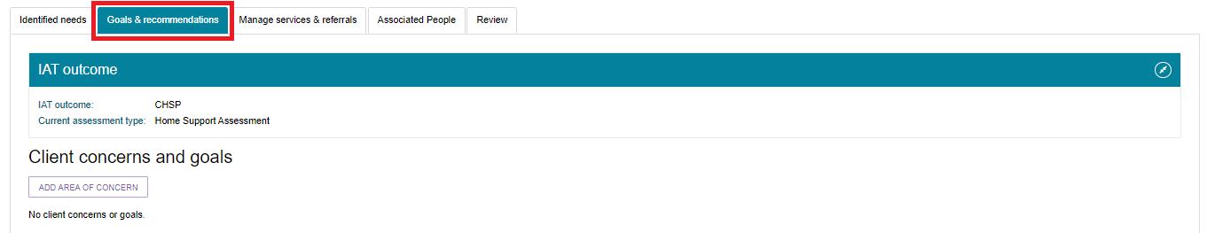

|  |  |
| --- | --- |
| ! | You can also navigate to a client’s support plan via their **Client Summary**. From here you can select the **Plans** tab and then clicking **SUPPORT PLAN.**  **Screenshot of ''Plans" selected.** |

1. Under the Client concerns and goals section, select **ADD AREA OF CONCERN**.

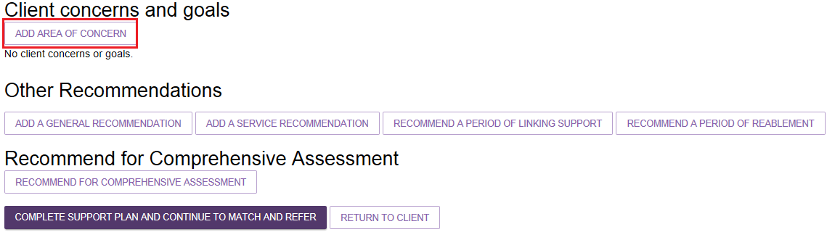

1. In the pop-up box, record the area of concern, and select **SAVE TO PLAN**. The area of concern will appear under the **Client concerns and goals** section.

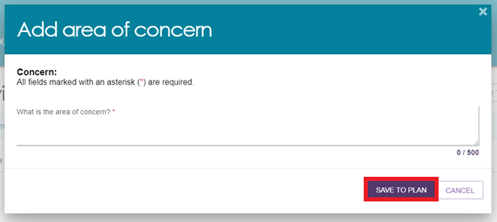

1. To add a goal to the concern, select **ADD A GOAL**.

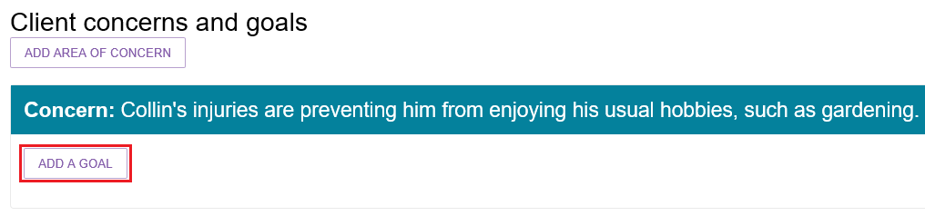

1. In the pop-up box, enter the goal, record the client’s motivation to achieve the goal (with 1 being least motivated to 10 being highly motivated), and the status of the goal, and select **SAVE TO PLAN.**

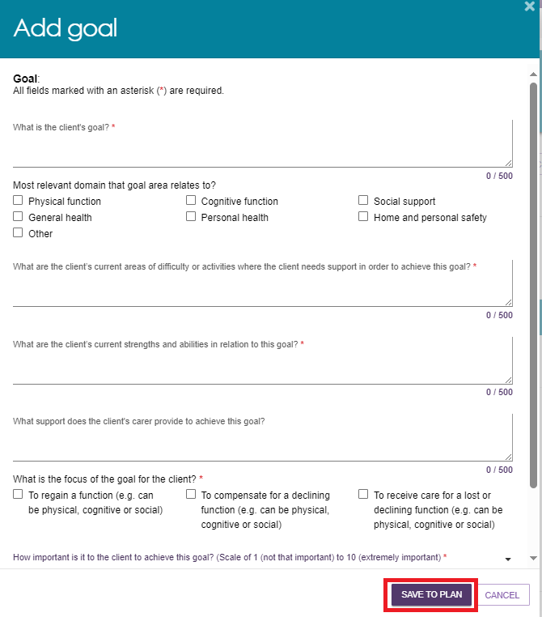

1. This information will appear under the associated area of concern. You can edit or remove goals and concerns that may no longer be relevant to the client’s situation here, by selecting the **Pencil icon** or **Rubbish bin** icon respectively.

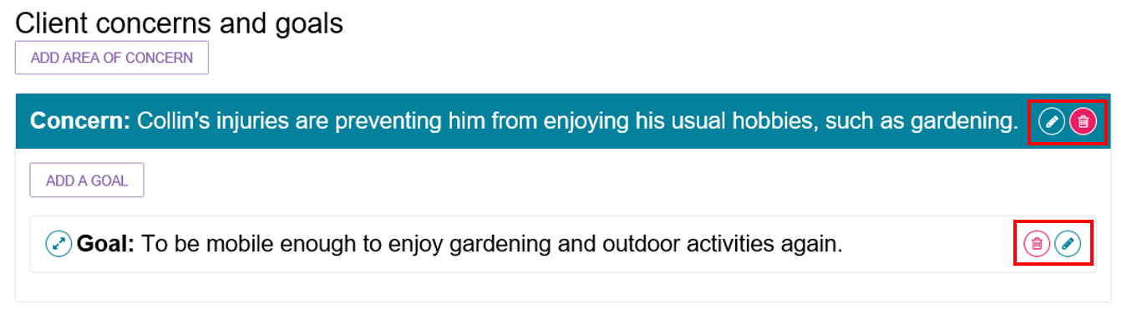

1. Continue to add concerns and goals by repeating steps 2-5.

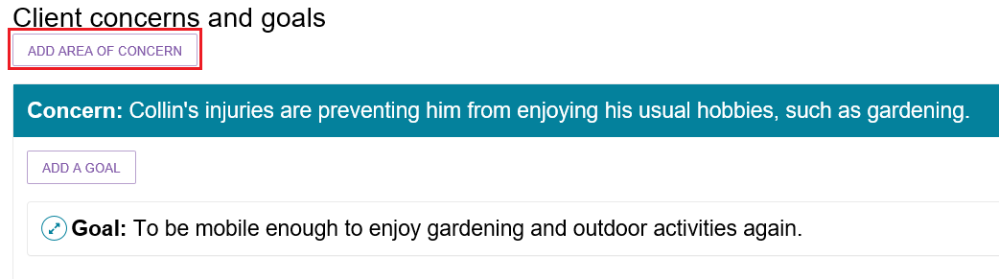

|  |  |
| --- | --- |
| ! | **Display order of multiple concerns of goals**  When multiple concerns or goals have been added, you are able to change the display order by using the drop-down box at the right-hand side of the record.  Screenshot of Client concerns and goals with the pencil icon. rubbish bin icon and drop-down box circled. |

### 

### Adding recommendations

You may choose to link recommended services to the client’s area of concern and goals, or you can recommend services that are not linked to concerns and goals.

There are seven types of recommendations that can be added to a support plan following an assessment:

* **General recommendations** are non-Commonwealth funded supports that are identified by the assessor and the client and will be actioned by the client or the assessor rather than a service provider, for example: that the client sees a health practitioner, or that they join a local support group.
* **Service recommendations** are for adding recommendations for services to a clients support plan, such as Commonwealth Home Support Programme (CHSP) services.
* **Recommended long-term living arrangement** is only applicable to comprehensive assessments. It is the most appropriate long-term living situation identified during a comprehensive assessment that can be selected from a list of accommodation settings after discussing the goals with the client and/or their representative. This can only be recommended after a comprehensive assessment has been completed.
* **Care type for Delegate decision recommendations** are applicable only to comprehensive assessments. These recommendations relate to care types under the *Aged Care Act 1997* (the Act) which require approval by a Delegate. This can only be recommended after a comprehensive assessment has been completed.
* **No Care Type Under the Act** is only applicable to circumstances where a client withdraws their application for care or is not applying for care under the Act, and still requires CHSP services and/or general recommendations. This can only be recommended after a comprehensive assessment has been completed.
* **Recommendations for a period of linking support** are for where a client’s complex circumstances may be a barrier to accessing aged care services, and providing linking support can assist the client to access various services they require.
* **Recommendations for a period of reablement** are for time-limited interventions that are targeted towards a client’s specific goal(s) or desired outcome to adapt to some function loss, or regain confidence and capacity to resume their activities, for example: training in a new skill, modification to a client’s home environment or having access to equipment or assistive technology.

Recommendations can be linked to concerns and goals, or they can be added as an **Other Recommendation**.

Further information on linking support and reablement is available in the *My Aged Care Assessment Manual* on the [department’s website](https://www.health.gov.au/resources/publications/my-aged-care-assessment-manual).

Recommendations can be associated to more than one goal. When adding your recommendations you can:

* Select one or more goals to associate a recommendation
* Unlink the recommendation from all goals.

You canselect the appropriate recommendation from the **Other Recommendations** section of the **Goals & Recommendations** tab. You can then choose to link this recommendation to a relevant goal. If you add a recommendation from the **Other Recommendations** section recommendation will be displayed underneath that heading.

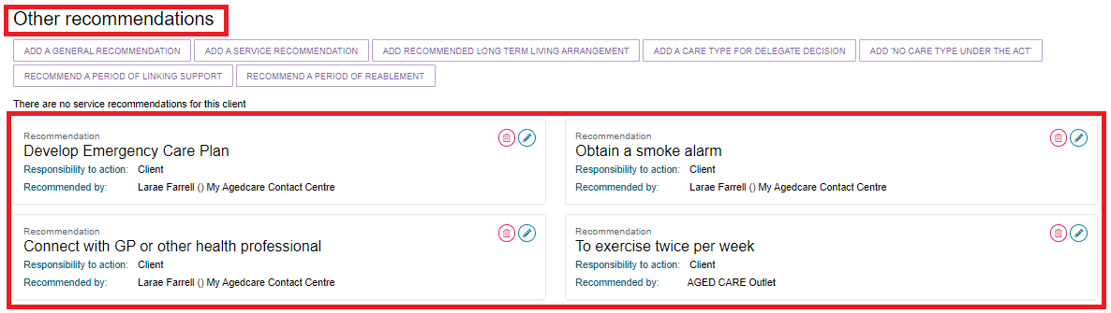

Alternatively, you can add a recommendation directly to an area of concern and goal by selecting the arrow next to **Goal** and below **Add to this goal** on the right-hand side of the panel. If you add a recommendation from the **Add to this goal** section, the recommendation will be displayed underneath the goal. Select the arrow to the left of the goal to display the recommendation details.

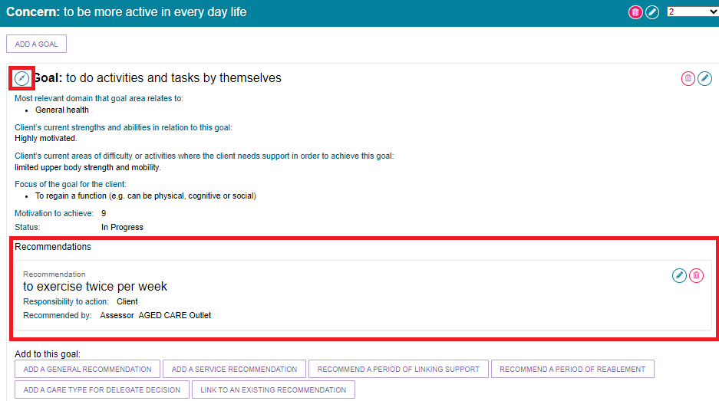

To add a general recommendation, go to **General Recommendation**.

To add a service recommendation, go to **Service Recommendation**.

To add a recommendation for a period of linking support, go to **Period of** **Linking Support**.

To add a recommendation for a period of reablement, go to **Period of Reablement**.

To add a recommendation for a Care type for Delegate decision, go to **Care type for Delegate decision****.**

To add a recommendation of No Care Type Under the Act, go to **No Care Type Under the Act.**

#### General Recommendation

Select **Add a general recommendation**.

Examples of general recommendations include:

* Develop Emergency Care Plan
* Connect with GP or other health professional
* Gain assistance with decision making
* Obtain a smoke alarm
* Develop a Personal Emergency Plan
* Investigate getting a Personal Alarm.

When a pop-up box is displayed, enter information about the general recommendation, check the box if you are linking it to a goal and select **SAVE TO PLAN**.

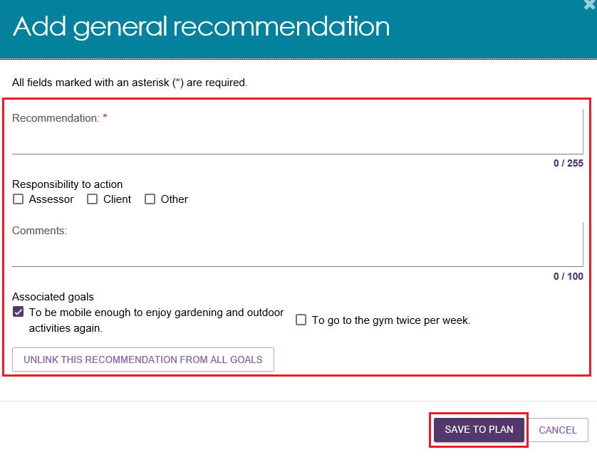

As assessors are completing the assessment, they will be able to add general recommendations to the support plan from the assessment.

In the assessment, the assessor can select to **Add as Recommendation** and this will populate in the **Identified needs** and **Goals & recommendations** tabs in the support plan.

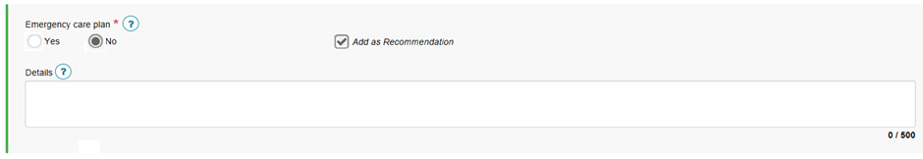

#### Service Recommendation

Select **Add a service recommendation**. When a pop-up box is displayed, select the recommended service, complete all mandatory fields and select **SAVE TO PLAN**.

The priority for CHSP service recommendations will default to Low. Assessors should use the comments field to clarify the specific scope of the services that are recommended to be delivered within the CHSP service type. The scope of services should be linked to the identified needs from the assessment and goals referred to in the support plan, for example: unable to get to places beyond walking distance; requires transport to health clinic.

**Recording Service Frequency and Intensity:**

Assessors can record the recommended service frequency and intensity for each service they recommend. This is **not mandatory**. An assessor can record information that has been discussed with the client or information relating to a client’s preference for the intensity of service delivery. This will be provided as a guide to the service provider who will agree the frequency and intensity of services with the client.

Where a client does not wish to access a particular service at that point in time, or only requires infrequent services, you should still create the service recommendation. The client will be able to access these services at a later date by calling the My Aged Care contact centre to facilitate the sending of electronic referrals from recommendations created in their support plan.

Entering specific information about the services required allows the provider and the contact centre to know whether a service is for a specific purpose only or for an ongoing need. The information allows the contact centre to make a decision regarding whether they can make the referral or need to request a Support Plan Review from the assessment organisation.

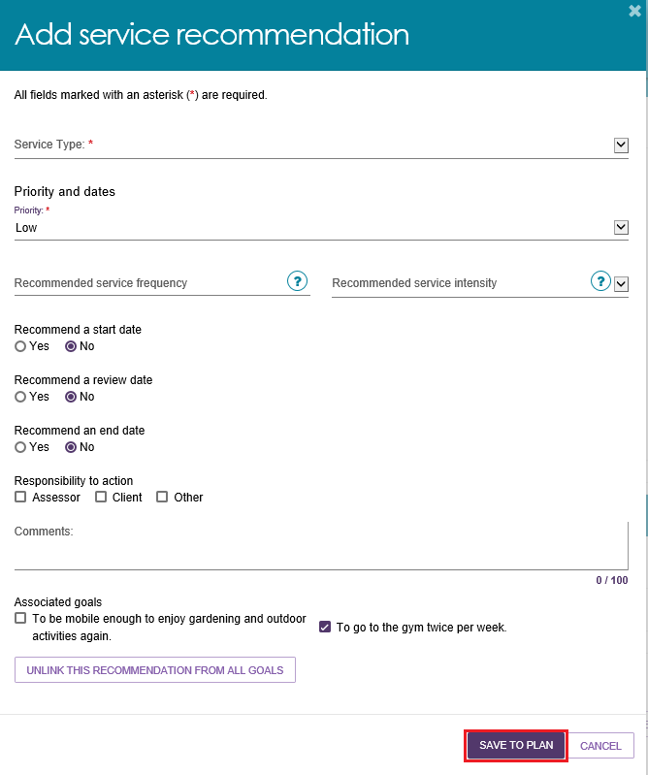

#### Period of Linking Support

Select **RECOMMEND A PERIOD OF LINKING SUPPORT**. In the pop-up box that will display, enter the start date for the period of linking support and the recommended end date, and select the reason for recommending linking support from the drop-down menu. Include any relevant comments and linking to any goals where applicable. Select **RECOMMEND** to save to the client's support plan.

Please note that during a period of linking support, extensions requests for Transition Care and Residential Respite Care services can be requested and granted.

Further information regarding linking support is available in the [My Aged Care Assessment Manual](https://www.health.gov.au/resources/publications/my-aged-care-assessment-manual-effective-1-july-2024).

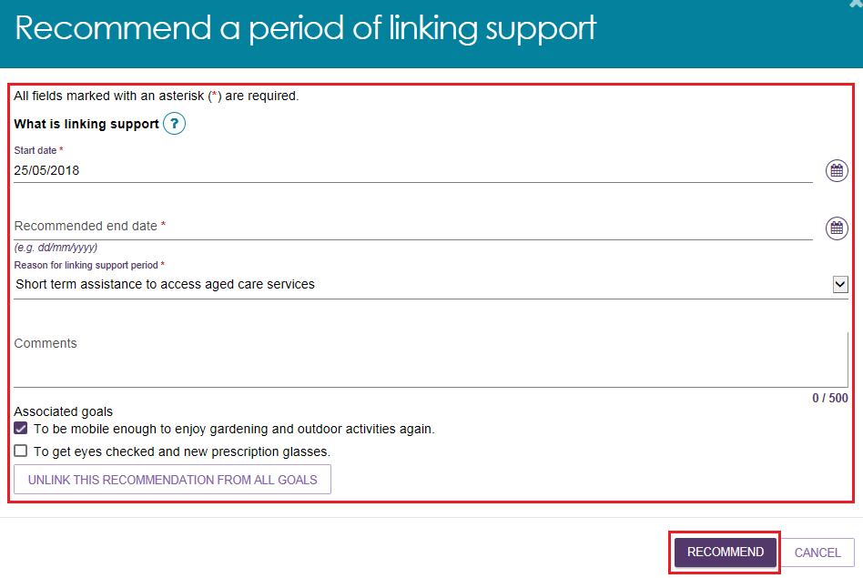

#### Period of Reablement

Select **RECOMMEND A PERIOD OF REABLEMENT**. When a pop-up box is displayed, enter the start date for the period of reablement and the recommended end date, and select the reason for recommending reablement from the drop-down menu. Enter any relevant comments and linking to any goals where applicable. Select **RECOMMEND** to save to the clients support plan.

Please note that during a period of reablement, extensions requests for Transition Care and Residential Respite Care services can be requested and granted.

Further information regarding reablement is available in the [My Aged Care Assessment Manual](https://www.health.gov.au/resources/publications/my-aged-care-assessment-manual-effective-1-july-2024).

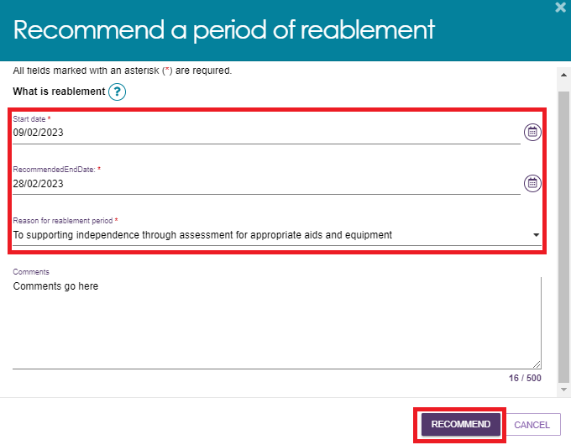

### Care type for Delegate decision

1. Select **ADD A CARE TYPE FOR DELEGATE DECISION**. This can be done either as part of a goal, or separately.

**Adding A Care Type as Part of a Goal**

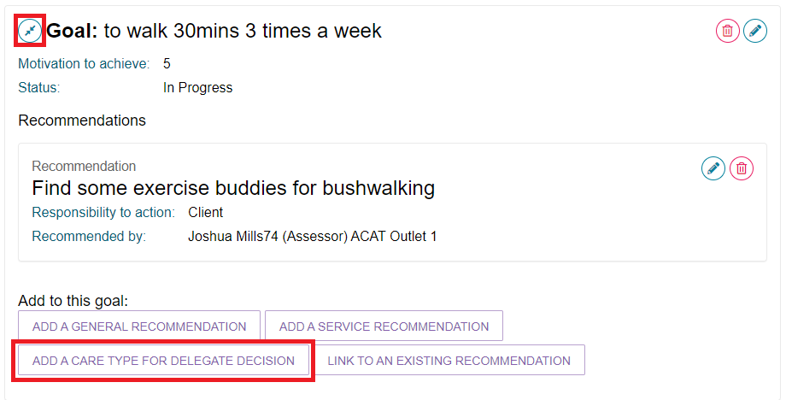

**Adding A Care Type Separately**

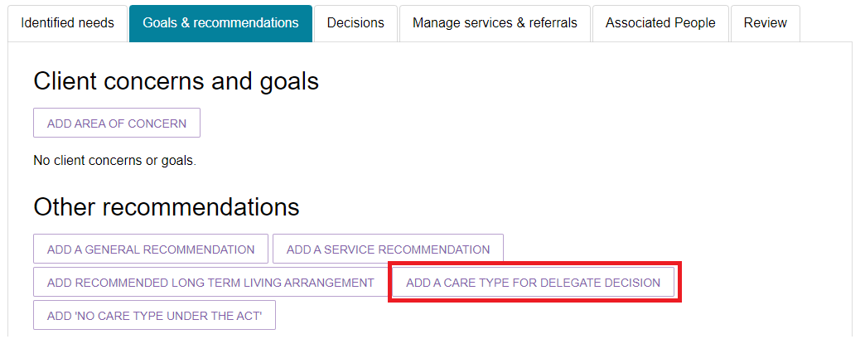

1. At the pop-up, select which care type applies, enter a reason and comments if necessary, then select **SAVE TO PLAN**. The Care types available are:

* Home Care Package Level 1
* Home Care Package Level 2
* Home Care Package Level 3
* Home Care Package Level 4
* No change to existing care approvals
* Residential permanent
* Residential respite care
* Short-term restorative care
* Transition Care.

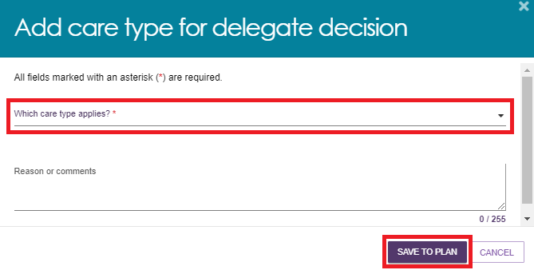

1. Fill out the next pop-up including all mandatory fields, and then select **SAVE TO PLAN**. The information asked will be different depending on the care type chosen.

The following screenshot is an example of the pop-up for Residential Respite Care.

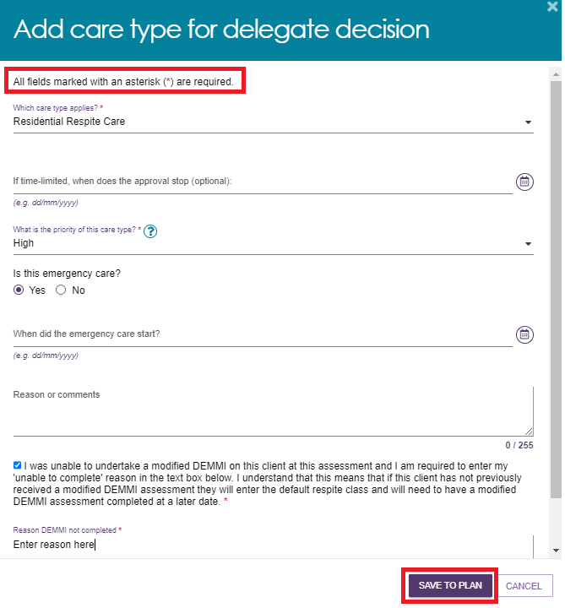

|  |  |
| --- | --- |
| **!** | If a client is under the aged of 65, several additional entry fields will appear to document their exceptional circumstances. |

## Home Care Packages – Priority and Levels

For Home Care Packages, the Priority of this care type determines the Priority for home care service for the purposes of assigning a place in the national priority system.

If it is determined that a client has a high priority for a home care package, you are required to answer all mandatory questions and provide your reason or comments using the available comment field.

|  |  |
| --- | --- |
| ! | **Please note that interim packages are not being released at this time**. Any decision to reinstate interim packages will be communicated to assessors through the regular bulletins. |

Select **SAVE TO PLAN**.

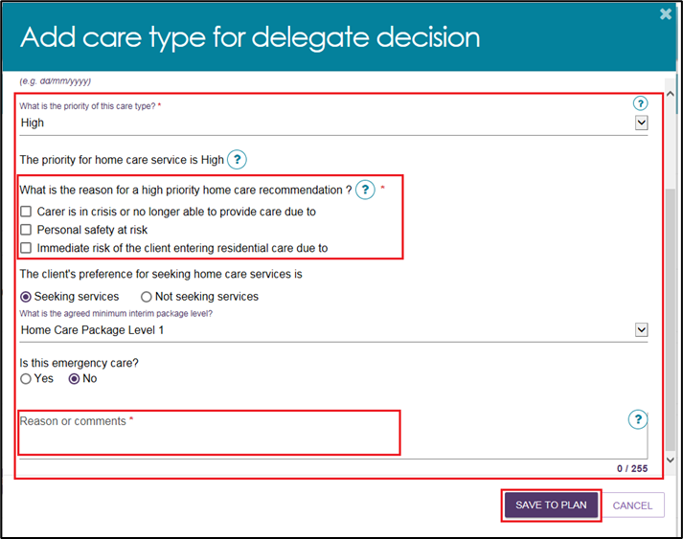

If the client has been marked as Seeking services and/or a Home Care Package has been recommended, assessors will be able to change notifications regarding home care correspondence. To do this, select **REQUEST/CHANGE NOTIFICATION OF HOME CARE CORRESPONDENCE** which will be located at the bottom of the screen.

Screenshot of "REQUEST/CHANGE NOTIFICATION OF HOME CARE CORRESPONDENCE" tab circled.

A pop-up will then display. Select the appropriate option and click **SAVE**.

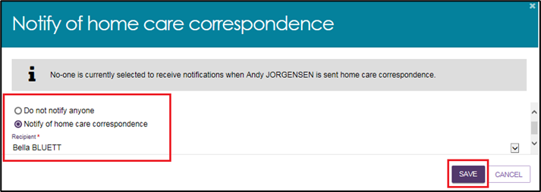

## Short-Term Restorative Care (STRC)

|  |  |
| --- | --- |
| ! | A client is only eligible to receive Short-Term Restorative Care (STRC) under certain conditions. When approving STRC for a client who does not meet the eligibility criteria a warning message will appear asking if you wish to proceed with the approval.  Screenshot of the warning message. |
| ! | Clinical assessors should not recommend a client for approval of STRC where the care recipient has an episode of Transition Care Programme (TCP) within the previous 6 months.  A complete list of the STRC eligibility criteria can be found in the [Short-Term Restorative Care Programme Manual](https://www.health.gov.au/resources/publications/short-term-restorative-care-programme-manual). |

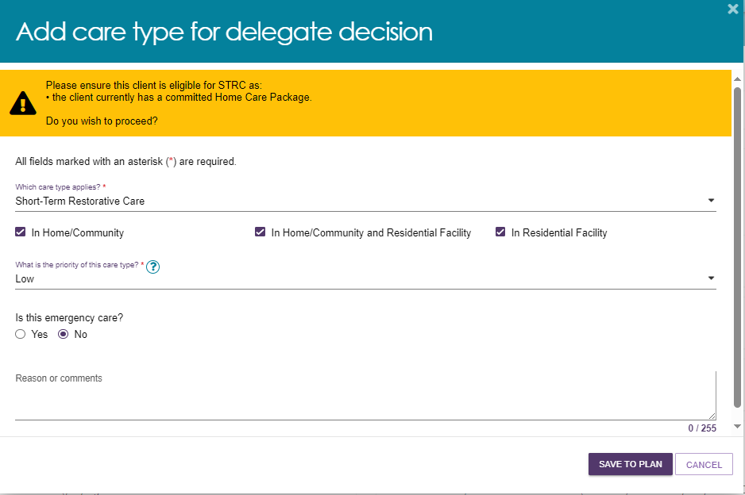

### No Care Type Under the Act

Where a person is determined as not meeting the eligibility requirements of any care program under the Act, the assessment will result in **No Care Approved** and the client receives a Non-Approval letter. For assessments where no care under the Act is approved, clinical assessors may recommend other forms of care and support on the support plan, for example CHSP if available and suitable, or local/state-based services.

1. Select **No Care Type Under The Act**. When a pop-up box is displayed, select the reason for the recommendation that the client receives No Care Type Under the Act, enter a comment or reason if appropriate and select **SAVE TO PLAN**.

If you recommend **No Care Type Under the Act**, you will be able to match and refer for CHSP services without needing to submit to the Delegate for approval.

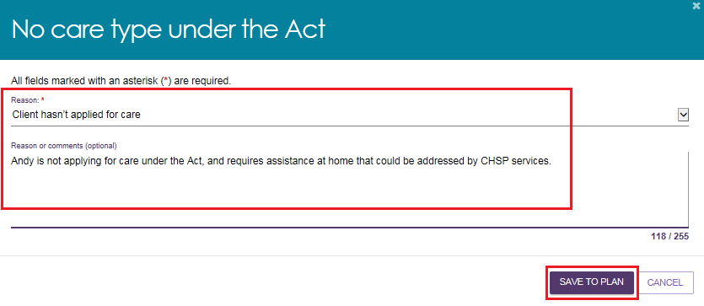

1. Alternatively, if you add a recommendation from the **Other recommendations** section or are adding a **No Care Type Under the Act** recommendation, the recommendation will be displayed underneath that heading. The recommendation will not be linked to a goal.

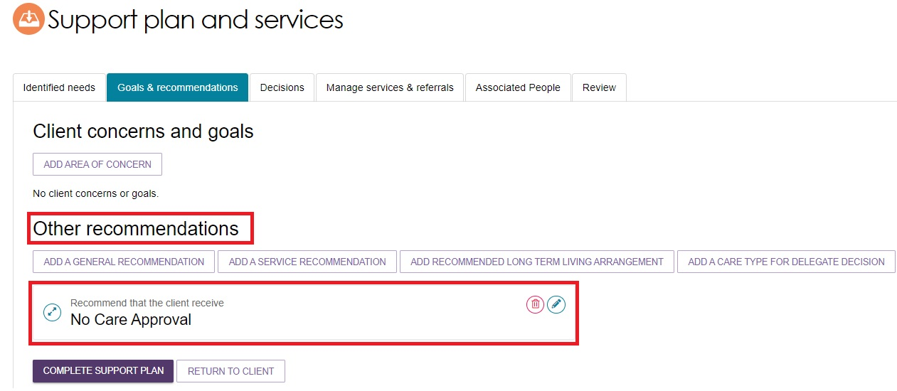

### Convert to Comprehensive Assessment

Non-clinical assessors will have the option to change the assessment from Home Support to Comprehensive once the IAT has been finalised and the algorithm has determined an outcome recommendation. This can only be done if the outlet supports both types of assessments.

1. From the **Goals & recommendations** tab select **CONVERT TO COMPREHENSIVE ASSESSMENT** from the top right-hand side.

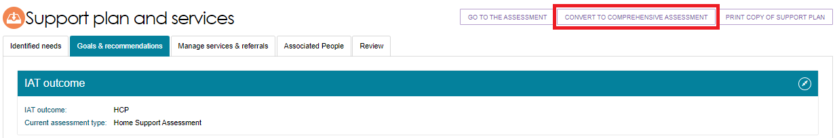

1. The reason for change will be pre-selected to **High level care needs**. Enter in the reason or comments for converting the assessment and then select **YES, CONVERT ASSESSMENT.**

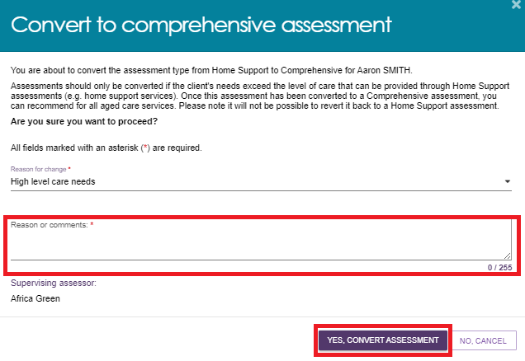

1. A green banner will then display at the bottom of the screen confirming the assessment has been successfully changed. The IAT outcome will now also reflect that a Comprehensive Assessment has been completed.

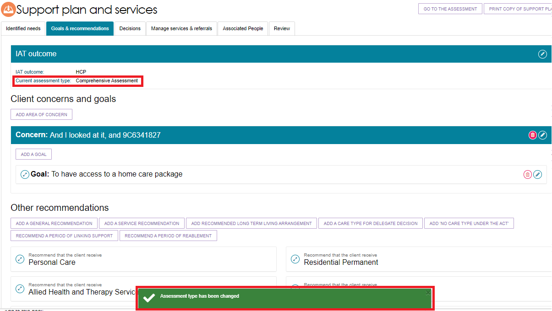

### Manage services and referrals

Screenshot of "Manage services & referrals" tab selected.

The **Manage services & referrals** tab enables assessors to issue referrals for any recommended CHSP services. It also enables the assessors to actively manage service and waitlist referrals for clients, including reissuing all referrals rejected.

The [My Aged Care – Assessor Portal User Guide 8 – Referring for services](https://www.health.gov.au/resources/publications/my-aged-care-assessor-portal-user-guide-8-referring-for-services) contains detailed information on this process.

The below screenshot gives an example of what can appear beneath the Manage Services & Referrals tab.

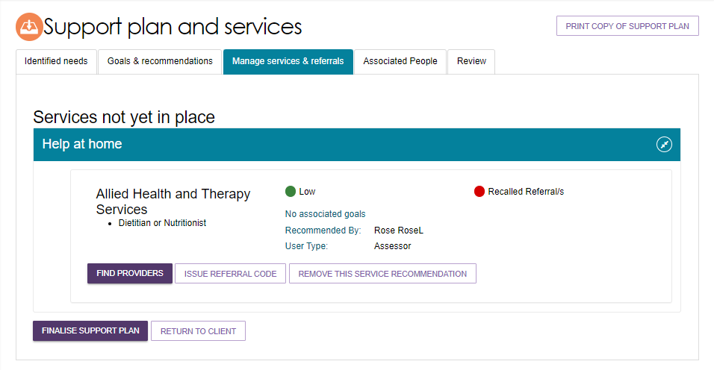

### Associated People

Screenshot of tabs with "Associated People" selected.

The **Associated People** tab allows non-clinical assessors to record any people that were involved in the development of the support plan, or will assist the client (with the client’s consent) with actions within the support plan.

1. Select **ADD PEOPLE**.

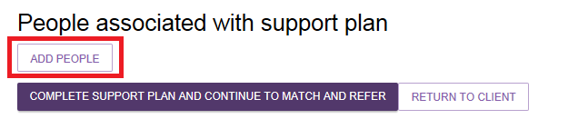

1. Select **ADD A PERSON**.

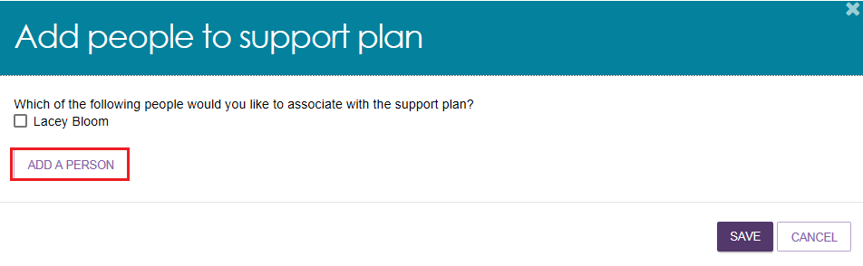

1. Enter required information and select **SAVE** to add the associated person to the clients support plan. You can capture their mailing address in case they wish (with client consent) to receive a copy of the clients support plan.

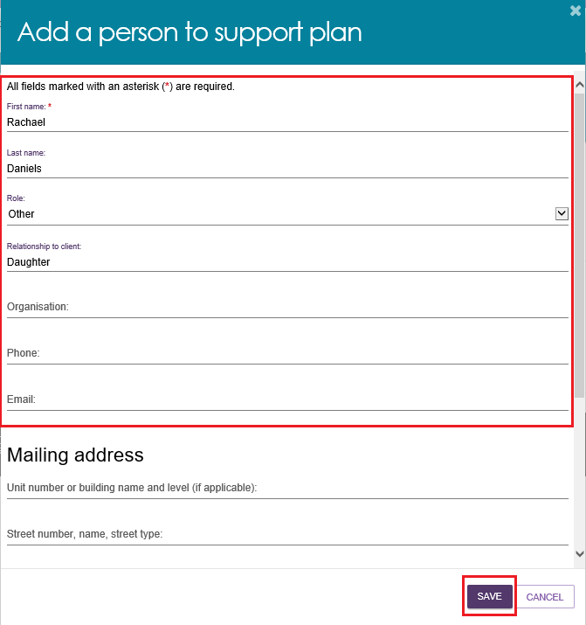

1. Select the person you want to associate to the clients support plan and select **SAVE**.

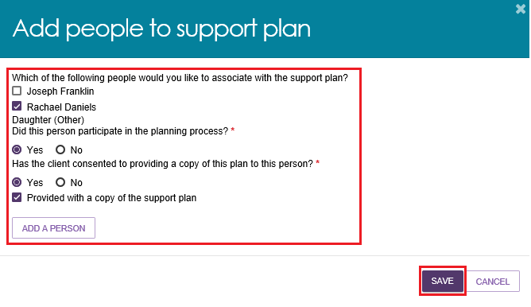

1. The person will now display in the **Associated People** tab in the clients support plan.

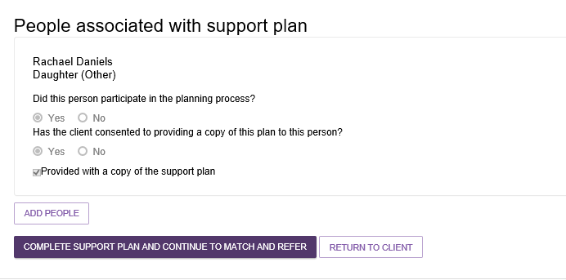

### Review

Screenshot of all support plan tabs showing with 'Review' selected. 

The **Review** tab enables assessors to schedule a date for review of a clients support plan. During a review, assessors can review and, where appropriate, amend a client’s support plan. If necessary, a new assessment can be initiated for a client following the review.

1. To schedule a review of a clients support plan, select the **calendar icon** to choose a review date.

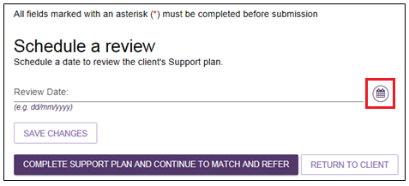

1. Once a date has been selected from the drop-down calendar and a reason for review has been entered, select **SAVE CHANGES** to set the review date.

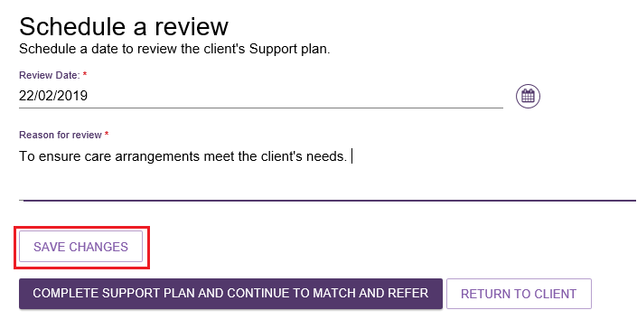

1. The review date will be displayed in the **support plan**. Once a review date has been added to the **support plan**, the referral will display in the team lead’s **Upcoming reviews** tab. A new ad hoc review request is able to override the scheduled review.

## Completing the support plan

A client’s support plan must be completed in order to be able to send referrals for any recommended services.

To complete the support plan for a Home Support assessment, follow the steps below.

1. Confirm that you have made all service or general recommendations, and are satisfied with the client’s goals and concerns, as the support plan cannot be edited after it has been completed.
2. Select, **COMPLETE SUPPORT PLAN AND CONTINUE TO MATCH AND REFER** from any tab in the clients support plan.

Screenshot of "COPMLETE SUPPORT PLAN AND CONTINUE TO MATCH AND REFER" button. 

Review the assessment summary and support plan carefully for consistency and accuracy before completing the support plan. Once you select **COMPLETE SUPPORT PLAN AND CONTINUE TO MATCH AND REFER**, you will not be able to make any changes to the assessment or support plan.

However, you will still be able to issue referrals, generate referral codes and action rejected referrals, for recommendations after you have finalised support plan, where appropriate.

1. If you have not answered all the mandatory questions in the assessment, a pop-up box will be displayed. You will be required to provide a reason for not completing all the mandatory questions before you can **Complete assessment**.

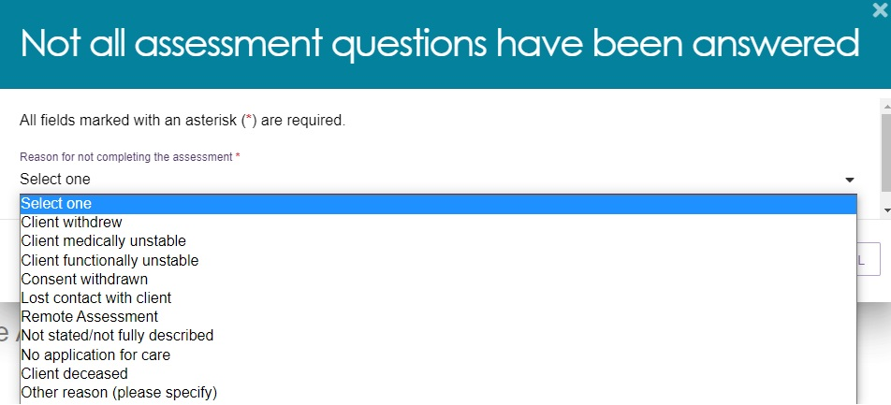

|  |  |
| --- | --- |
| ! | If your reason for ending an assessment without answering all mandatory questions is **Client deceased**, this will change the client’s status to **Deceased** and make the client record read only. Any unaccepted service referrals will be recalled, services in place will be ceased, assessments will be cancelled and the client’s access to the client portal will be revoked. My Aged Care will not send correspondence to the client or their support network after the status is changed to **Deceased**. |

1. You will be taken to the **Manage services & referrals** tab to match and refer for services.

## Completing the support plan for a Comprehensive assessment.

To complete the support plan for a Comprehensive assessment, follow the steps below.

1. Confirm that you have made all service or general recommendations, and are satisfied with the client’s goals and concerns, as the support plan cannot be edited after it has been completed.
2. Select, **COMPLETE SUPPORT** from any tab in the clients support plan.

Screenshot of "COMPLETE SUPPORT PLAN" button. 

1. You will be taken to the **Decisions** tab to submit for Delegate decision. Scroll to the bottom of the page and select **SAVE AND SUBMIT FOR DELEGATE DECISION.**

Screenshot of "SAVE AND SUBMIT FOR DELEGATE DECISION" button circled.

1. From the pop-up tick the appropriate box and select **SUBMIT**.

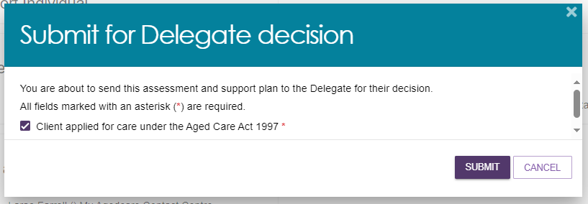

A green banner will then display confirming the assessment and support plan has been sent to the Delegate for their decision.



## Finalising the support plan

When you have completed the assessment and the support plan, you will need to arrange referrals for the recommended service(s), before finalising the support plan.

Refer to the [My Aged Care – Assessor Portal User Guide 8 – Referring for services](https://www.health.gov.au/resources/publications/my-aged-care-assessor-portal-user-guide-8-referring-for-services) for detailed information on this process.

|  |  |
| --- | --- |
| ! | The client’s support plan should be finalised once an effective referral(s) has been made or where the client chose not to proceed with aged care services or to manage their own referrals. An effective referral is where:   * A referral is accepted by a service provider * The client has accepted responsibility for managing their own referral * The outcome of the assessment is that no further action is required by the assessor. |

To finalise the support plan, follow the steps below.

1. From any tab in the clients support plan you will have the option to **FINALISE SUPPORT PLAN** at the bottom of the page.

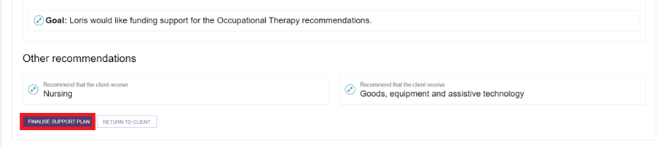

1. A pop-up box will display, and the referral status for each recommended service type will be pre-populated. Where a referral is **Not Actioned** you will need to record a reason.

If the face-to-face assessment was conducted in a remote location, you should ensure that the Remote Assessment indicator is selected before the support plan is finalised.

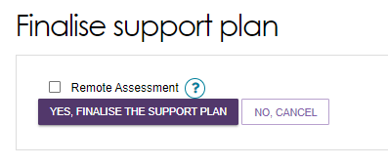

1. Once you have confirmed these outcomes, select **YES, FINALISE THE SUPPORT PLAN**.

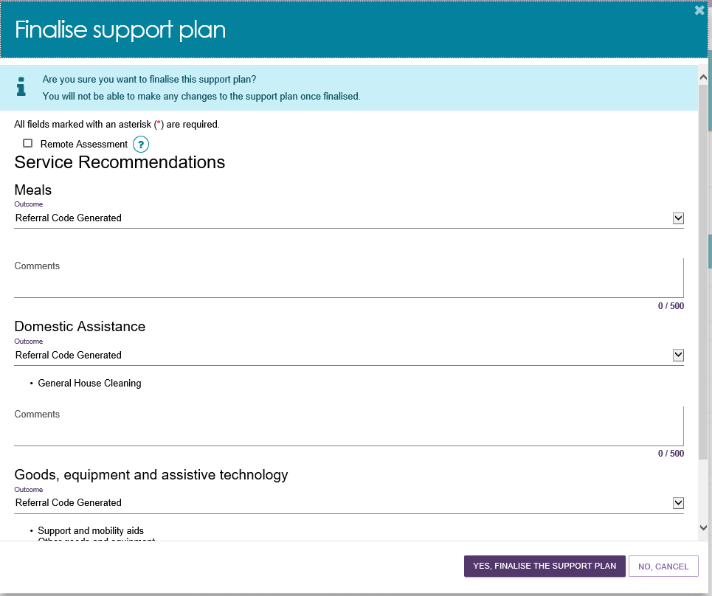

|  |  |
| --- | --- |
| ! | If you are choosing outcomes to support a client located remotely, Community-based care can be selected as an outcome.  Outcome comments are required where not actioned or Community-based care is selected following a remote assessment. Please provide detailed comments to support your outcome reasons.  Screenshot of Finalise support plan with warning message and "Community-based care" option circled. |

1. You will receive a confirmation message that the support plan has been finalised.

Screenshot of finalised support plan message. 

## Ending a period of reablement or linking support

Assessors are able to end the period of support, in either one of two ways.

1. End each linking support and/or reablement period individually, by selecting **END LINKING SUPPORT PERIOD** or **END REABLEMENT PERIOD** on the **Goals & recommendations** tab of the clients Support Plan. Assessors are required to enter the end date for the support period and the outcome.

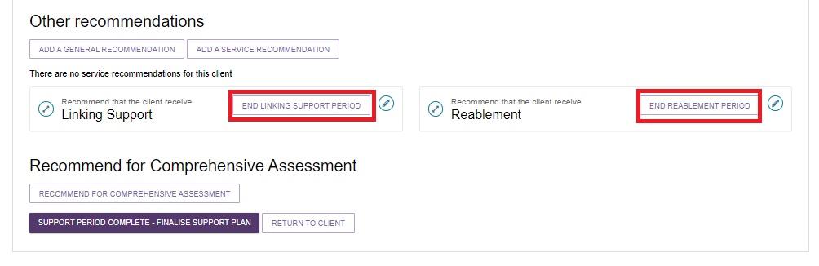

1. To finalise the support plan, but keep the support period open, select **FINALISE SUPPORT PLAN & KEEP OPEN FOR SUPPORT PERIOD**.

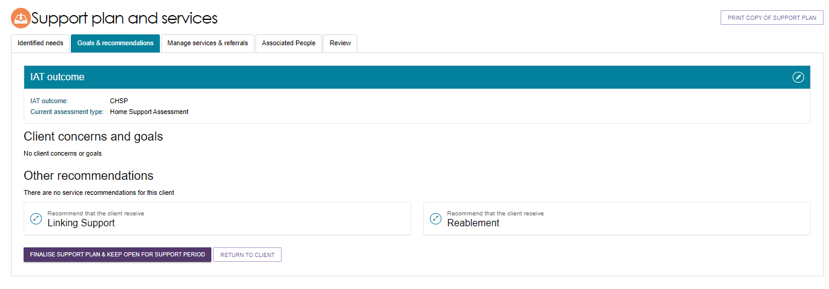

1. A pop-up box will appear and ask you to finalise the support plan and keep open the support period. To finalise select **YES, FINALISE THE SUPPORT PLAN**.

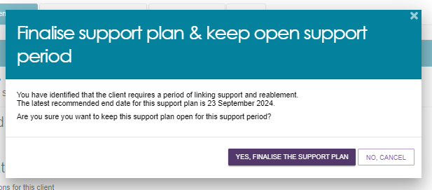

1. End all linking support and/or reablement periods at the same time by selecting **SUPPORT PERIOD COMPLETE – FINALISE SUPPORT PLAN** on the **Goals & Recommendations** tab of the clients support plan.

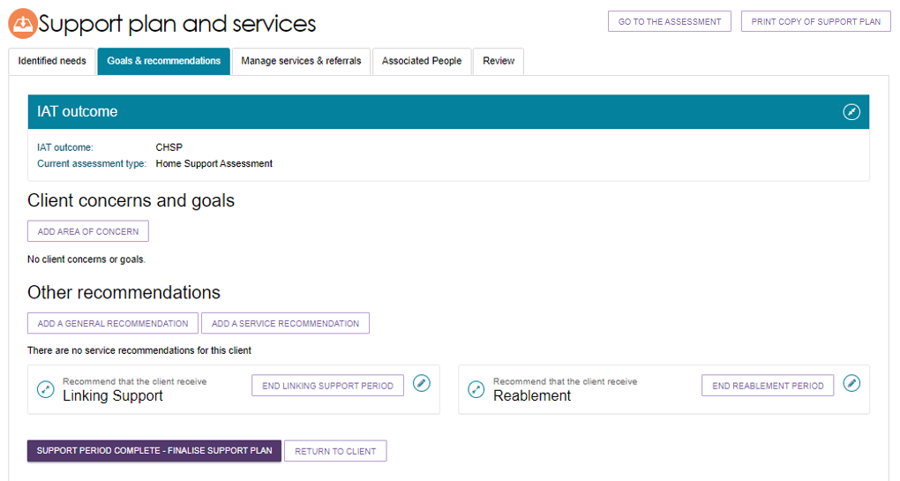

1. All periods of linking support and/or reablement that have not ended will be displayed. Assessors are required to enter the end date for each support period and the outcome.

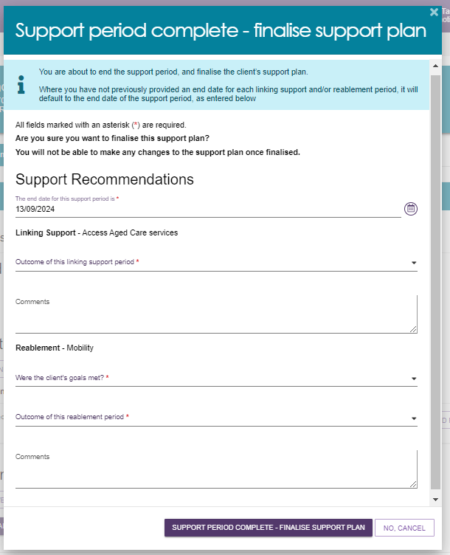

1. When assessors need to end the period of reablement for client they will be able to access it from the **END REABLEMENT PERIOD** button beside the **Reablement** tile under **Other recommendations**.

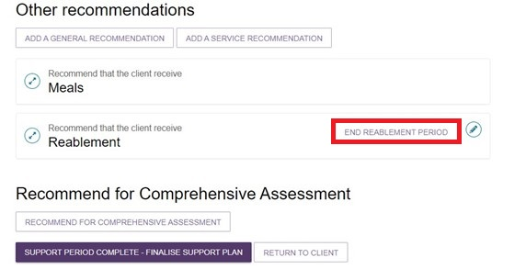

1. A pop-up will appear with the title End period of reablement. Assessors will need to answer two mandatory questions in the **End period of reablement** section in the assessor portal. The first question asks whether the client’s reablement goals were met. The second question prompts the assessor to detail outcomes by selecting from a drop-down menu. Mandatory questions will be marked with an asterisk. Assessors should provide further information about the end of period of reablement in the comments box.

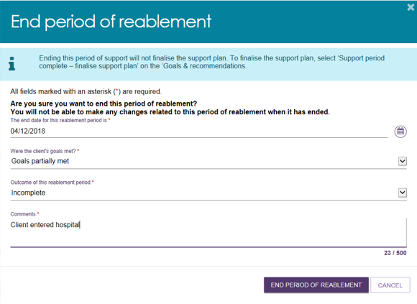

|  |  |
| --- | --- |
| ! | If a client is undergoing a period of support (linking support and/or reablement), the team leader may contact the assessor asking them to end the period of support in order to assign a Support Plan Review. Alternatively, the assessor can request that the team leader cancel the review so the assessor can continue the period of support. |

## Printing a copy of the support plan

A PDF version of a clients support plan is available to print from the assessor portal. The printed version includes the clients: Last completed Support Plan Review (if applicable), Assessment Summary, Goals & Recommendations (including areas of concern), recommended services and strategies and any current care approvals.

To print a copy of the clients support plan, select the **PRINT COPY OF SUPPORT PLAN** link from the client record or support plan.

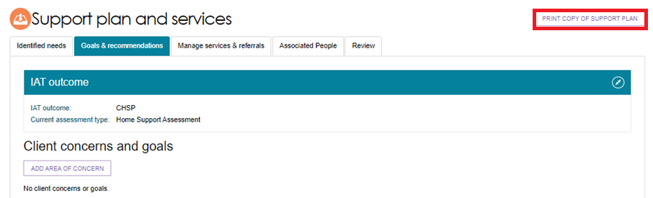

A blue banner will appear at the bottom of the screen whilst the report is in progress. Select **Reports page** to navigate to the Reports and documents page.



From the **Report and documents** page select **View.**

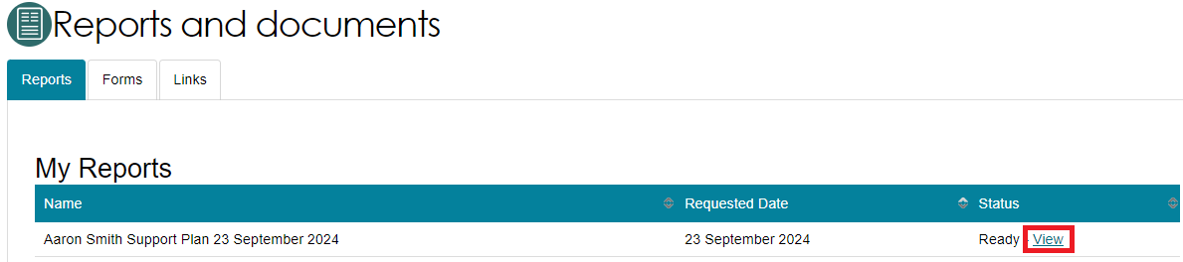

The printer friendly version of the support plan will download. Select your printer options and select **Print**.

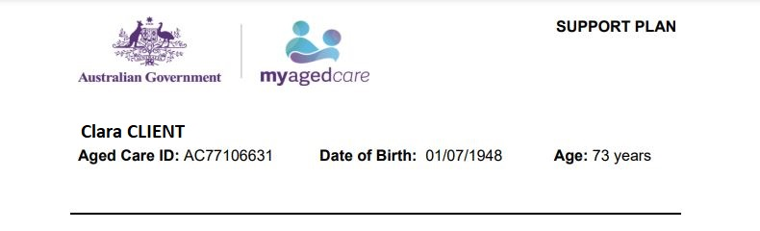

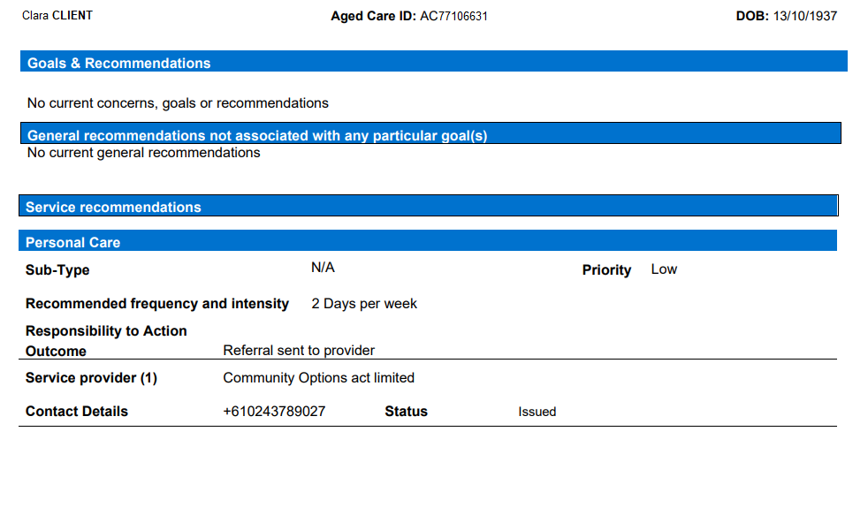

If a client already has a previous Support Plan Review completed the following section named **Support Plan Review (first completed)** would be displayed before the Goals and Recommendations section.

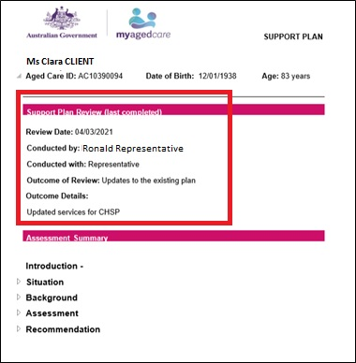

## Receiving and starting Support Plan Reviews

### How to view Support Plan Reviews

1. An assessor can view all Support Plan Reviews assigned to them by selecting the **Reviews** tile from the homepage.

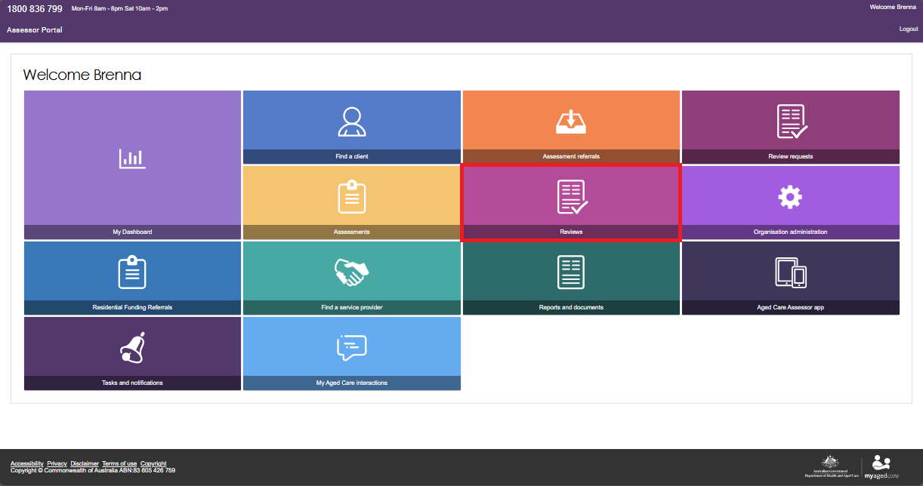

1. All Support Plan Reviews that have been assigned to them are listed under the **Current reviews** tab. To view assigned Support Plan Reviews, assessors will find their assigned work in the **Current review** section.

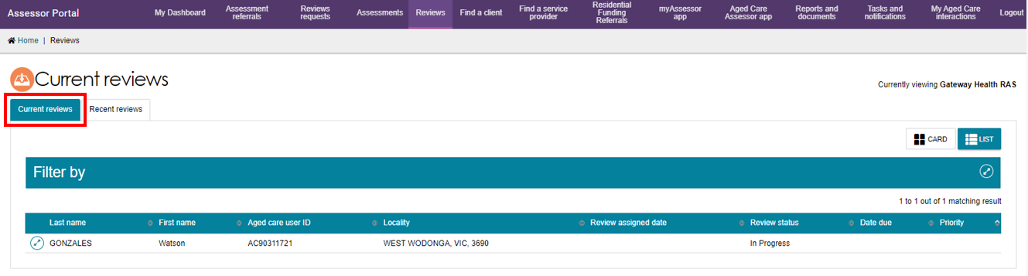

### Starting a Support Plan Review

You are able to start an ad hoc Support Plan Review for any client who has been assessed by your assessment outlet, without requiring a Support Plan Review to be assigned to you. This can be done from any tab within the client record by selecting **START SUPPORT PLAN REVIEW** or via selecting the client card from the **Current review** page.

An ad hoc review will override a scheduled review. In this instance the team leader should cancel the scheduled review in their upcoming review tab if it is no longer required.

1. To start a Support Plan Review that has been assigned to you, expand the client card in either card or list view. The Client Summary page displays. Select **START SUPPORT PLAN REVIEW**.

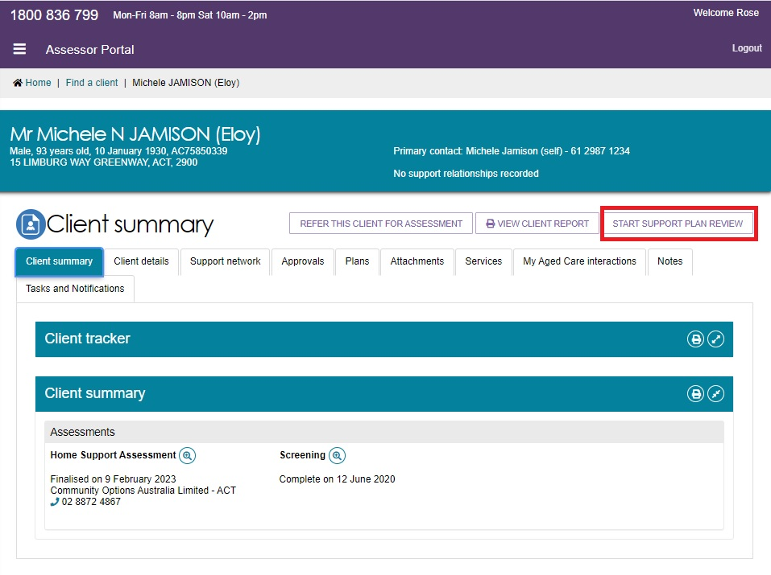

Alternatively, from the **Current reviews** page you can also expand the client card and select **START SUPPORT PLAN REVIEW.**

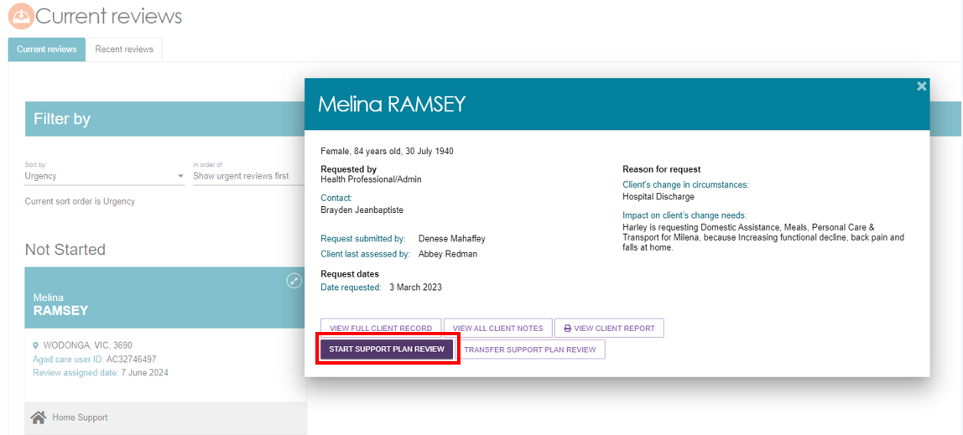

A banner will be displayed on the request if additional attachments have been added to the clients record as part of the Support Plan Review request.

1. From the **Before you start the Support Plan Review** pop-up select either **CONTINUE TO SUPPORT PLAN REVIEW** or **RECOMMEND A NEW ASSESSMENT**.

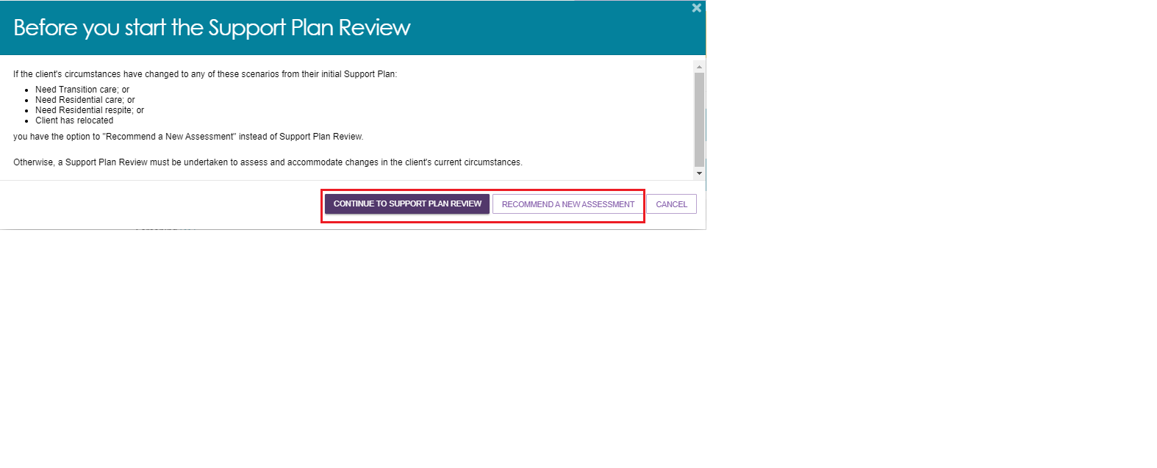

Select **CONTINUE TO SUPPORT PLAN REVIEW** to start the Support Plan Review for the client.

If the client’s circumstances have changed and it is more appropriate to issue a referral directly for a new assessment rather than completing a Support Plan Review, select **RECOMMEND A NEW ASSESSMENT**.

You will be prompted to enter the outcome of the review and reason for the new assessment referral, then select an organisation of which to issue the referral. This can only be done in circumstances where a client requires Transition Care, Residential Care, Residential Respite or has relocated.

1. A pop-up will display asking if the client consents to share their information with My Health Record. Select **No** or **Yes** based on the client’s response and select who this decision was made by from the drop-down menu.

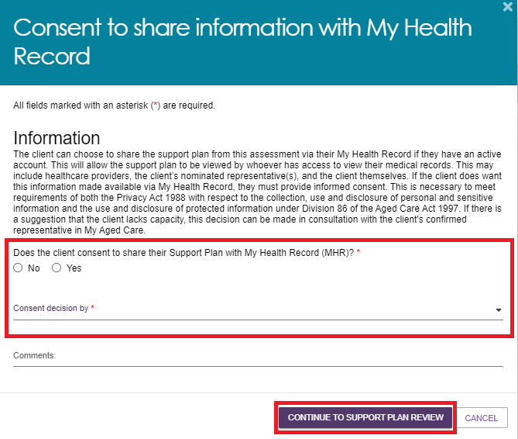

Please note if consent is provided by a Representative then their first name must be entered before proceeding.

If the client does not consent to share their support plan with My Health Record you will also be required to enter a consent denial reason before selecting **CONTINUE TO SUPPORT PLAN REVIEW**.

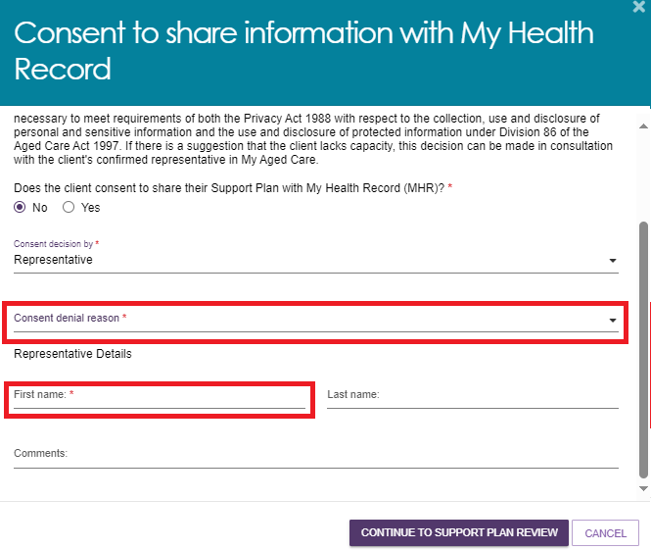

1. Enter the reason for the Support Plan Review before starting the review.

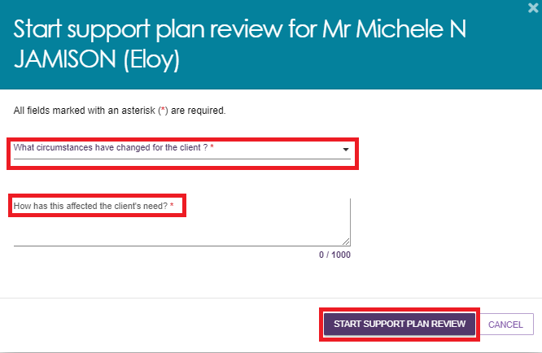

1. Once a Support Plan Review has been started, an assessor will be able to make changes to information in the following sections of the clients support plan:

* Assessment summary
* Client motivations
* Goals & recommendations (including recommendations for linking support & reablement)
* Manage services & referrals
* Associated People
* Review

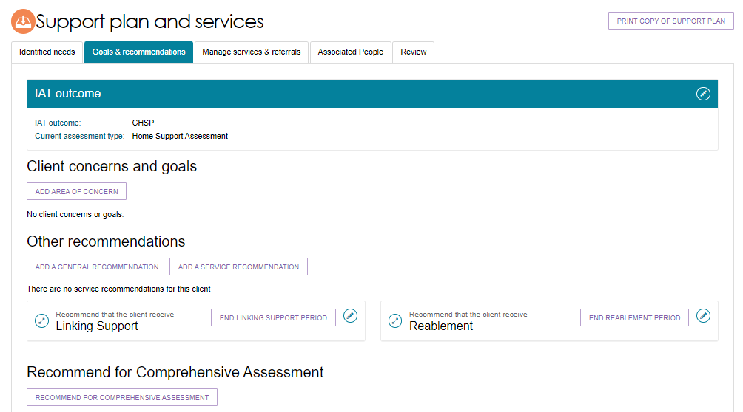

1. Once the Support Plan Review has been completed, select **COMPLETE AND FINALISE SUPPORT PLAN REVIEW** to finalise the Support Plan Review. Please be aware that the outcome details entered above cannot be edited once the Support Plan Review is complete and will appear on the clients support plan.

|  |  |
| --- | --- |
| ! | If a period of reablement or linking support is added to the clients support plan during a Support Plan Review, the outcome of the review will be automatically set to **Updates to the existing plan**. Once the review is complete, the client’s assessment will be open for the assessor to start the support period. |

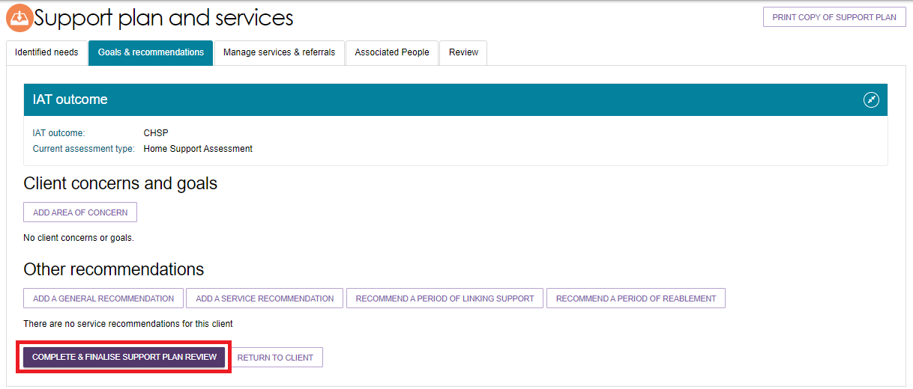

1. Enter the outcome of the Support Plan Review from the drop-down menu selection alongside who the plan was conducted with. Select **COMPLETE AND FINALISE SUPPORT PLAN REVIEW** to finalise the Support Plan Review.

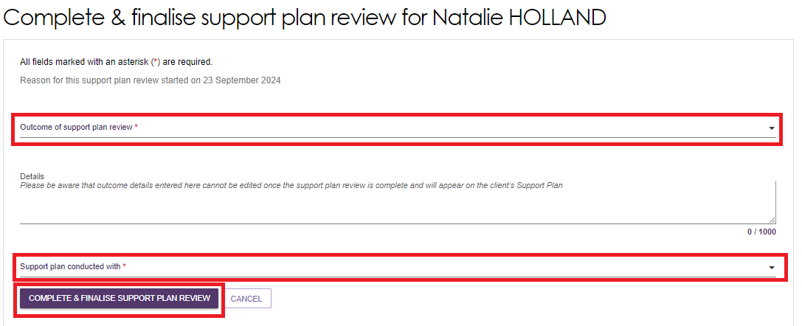

If the outcome of the Support Plan Review is that a new assessment is required, please refer to Issuing an assessment referral as a result of a Support Plan Review.

1. The Support Plan Review will be visible under the **Plans** tab in the client record.

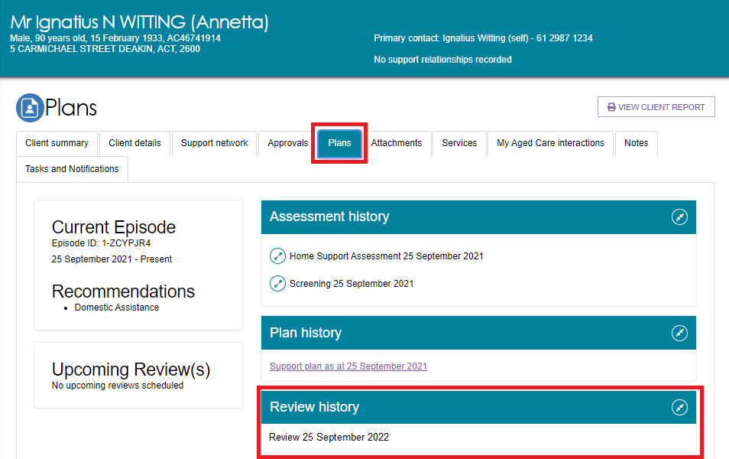

### Transferring a Support Plan Review

Both assessors and team leaders are able to transfer Support Plan Reviews to other assessment organisations.

1. To begin transferring a Support Plan Review, go to **Current reviews** and select the client card you wish to transfer for the Support Plan Review. Select **TRANSFER SUPPORT PLAN REVIEW**.

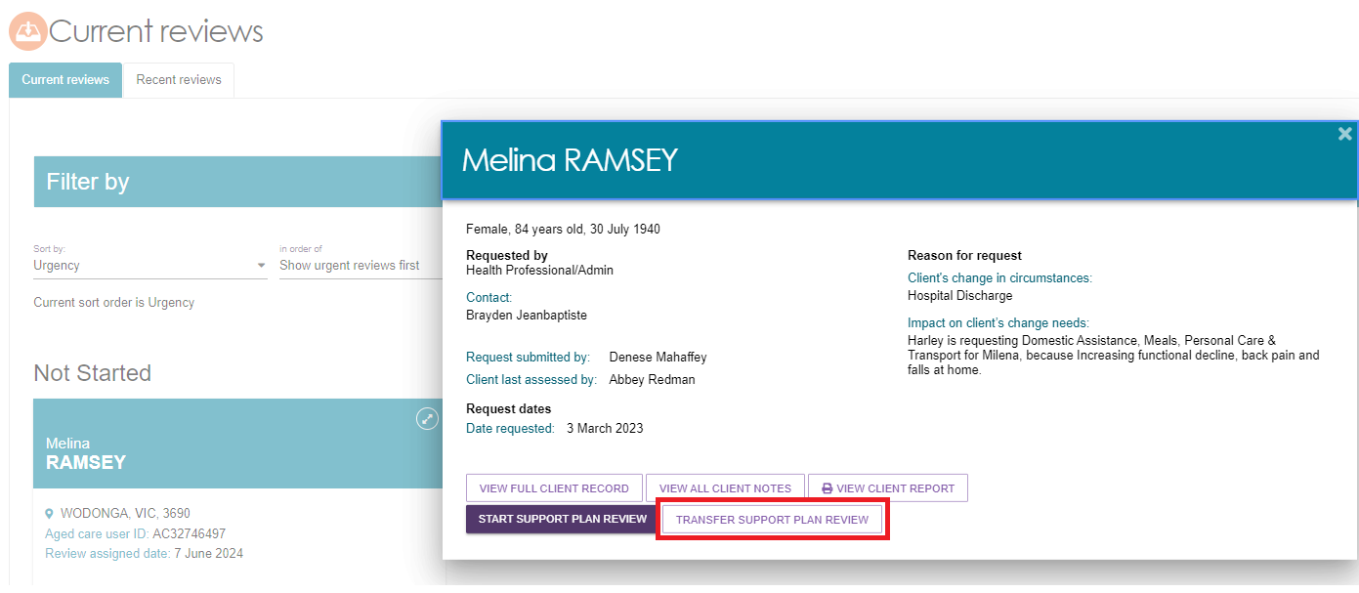

1. You will need to enter **What is the reason for the transfer** and search and select the Assessment Organisation which the Support Plan Review will be transferred to. Once the reason for transfer and organisation have been selected, click **TRANSFER** to finalise.

Please note, a banner will display at the bottom advising you to call the assessment organisation you are referring the client to. This banner also highlights the need for client consent prior to transferring.

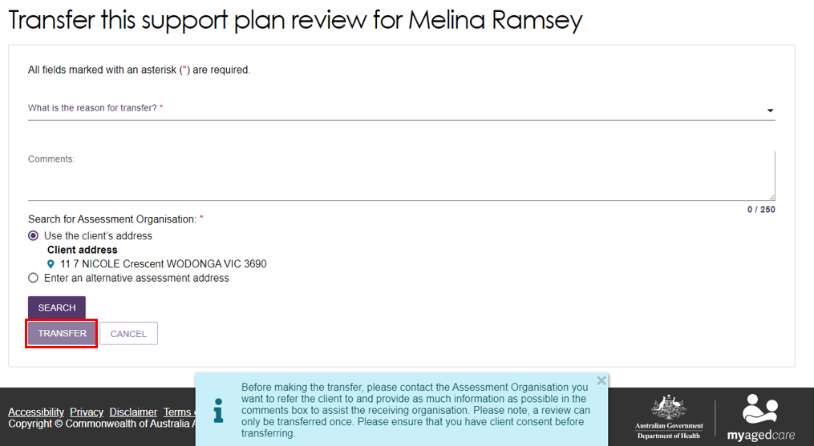

|  |  |
| --- | --- |
| ! | Support Plan Reviews can only be transferred once. |

### Issuing an assessment referral as a result of a Support Plan Review

When completing a Support Plan Review, an assessor is able to refer the client for a new assessment. This is completed during the **Complete & finalise Support Plan Review** page.

1. In the **Complete and Finalise Support Plan Review** section of the client’s support plan, select **A new assessment required.**

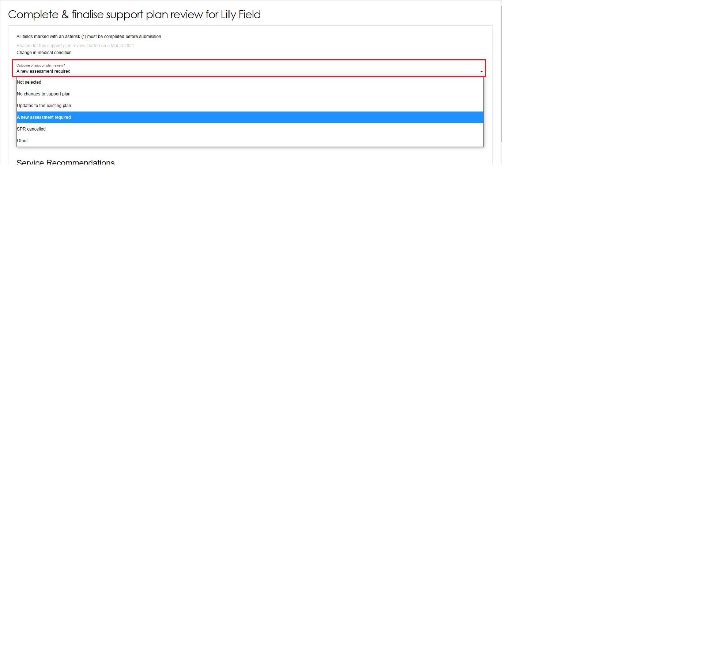

1. You will be required to issue a new assessment referral before completing the review. You are able to send the assessment referral to yourself, your organisation or to another organisation. Select the appropriate option.



If you choose **Myself** or **My Organisation**, you will be prompted to select the assessment type, outlet for referral, assessment setting (if you’ve selected a Comprehensive Assessment) and indicate the priority of the referral.

Screenshot of referral assignment, assessment type selection, outlet selection for referral, assessment setting and Priority section circled.

Screenshot also shows "COMPLETE & FINALISE SUPPORT PLAN REVIEW & REFER ASSESSMENT" button circled. 

If you choose **Another Organisation**, you will be required to indicate the type of assessment required and the assessment setting (if Comprehensive Assessment has been selected) .

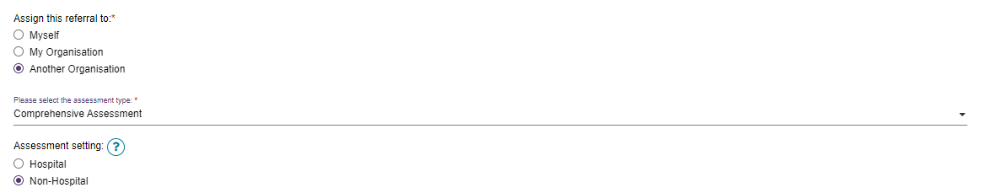

You can then search for the organisation to which the referral will be sent by client address or alternative assessment address. Once you have selected an assessment organisation you will be asked to enter the priority of the assessment. Click **COMPLETE AND FINALISE SUPPORT PLAN AND REFER FOR ASSESSMENT**.

Screenshot of 'Search for Assessment Organisation', 'Select Assessment Organisation and Priority field circled. 

Screenshot also shows "COMPLETE & FINALISE SUPPORT PLAN REVIEW & REFER ASSESSMENT" button circled. 

1. Upon completing the Support Plan Review, a green banner will display to confirm the referral has been issues.



The new assessment will appear under the Current assessments tab if you have assigned it to yourself or appear in the Incoming referrals queue for a team leader if assigned to My Organisation or Another Organisation.

|  |  |
| --- | --- |
| ! | All assessments, including those generated from Support Plan Reviews are required to undergo triage. |