**Assessor Portal User Guide 6 – Completing an Assessment**

Aged care needs assessors (assessor) can conduct assessments using the Integrated Assessment Tool (IAT) via:

* The assessor portal (this guide), the Aged Care Assessor app and uploading information onto the assessor portal when the assessor next has internet connectivity, a printed or blank copy of the IAT and entering information onto the assessor portal after the assessment has been undertaken.
* This user guide outlines the different assessors role for non-clinical (who are able to complete home support assessments) and clinical (who are able to complete comprehensive assessments) assessor role in the system.
* If you have only been assigned an organisation or outlet administrator role, you will not be able to view or complete assessments in the assessor portal.
* For more information about completing an assessment see the [Integrated Assessment Tool (IAT) User Guide](https://www.health.gov.au/resources/publications/integrated-assessment-tool-iat-user-guide).

This guide is divided into sections as follows:

Viewing assessments 2

Starting an assessment 4

Completing an assessment 14

Assessment features 14

Clinical attendance (non-clinical assessor) 16

Viewing and adding carers in the assessment 20

Adding a Sensitive Attachment in the assessment 23

Navigating the Validated Assessment Tools 27

Modified De Morton Mobility Index (DEMMI) and Residential Respite Care (Clinical assessor) 29

Saving an assessment 31

Finalising an assessment 33

Cancelling an assessment 37

## Viewing assessments

To view an assessment, follow the steps below.

1. Select **Assessments** on the homepage.

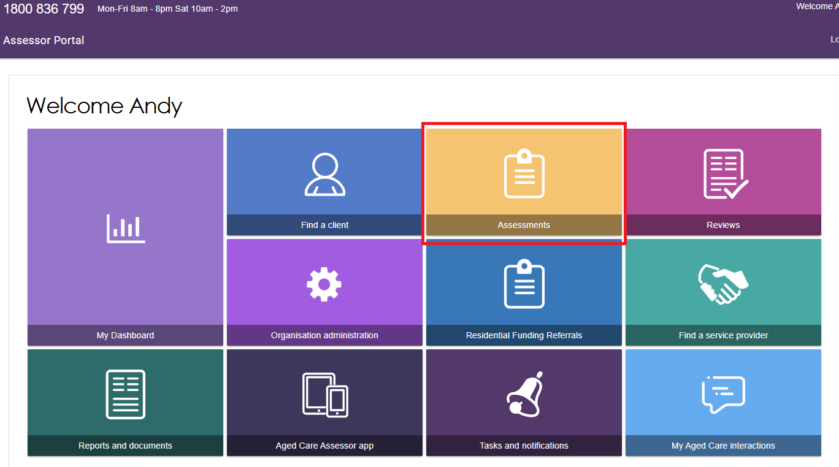

1. From the Assessments page, Needs assessors will be able to see the assessments assigned to them in **Current assessments**.

The **Current assessments** tab contains assessments that may have the following statuses:

* Triage not started
* Assessment not started
* Assessment in progress
* Assessment completed but not yet finalised
* Assessment awaiting delegate decision (not applicable for reviews); and
* Have had a Delegate decision completed, but not finalised (not applicable for reviews).

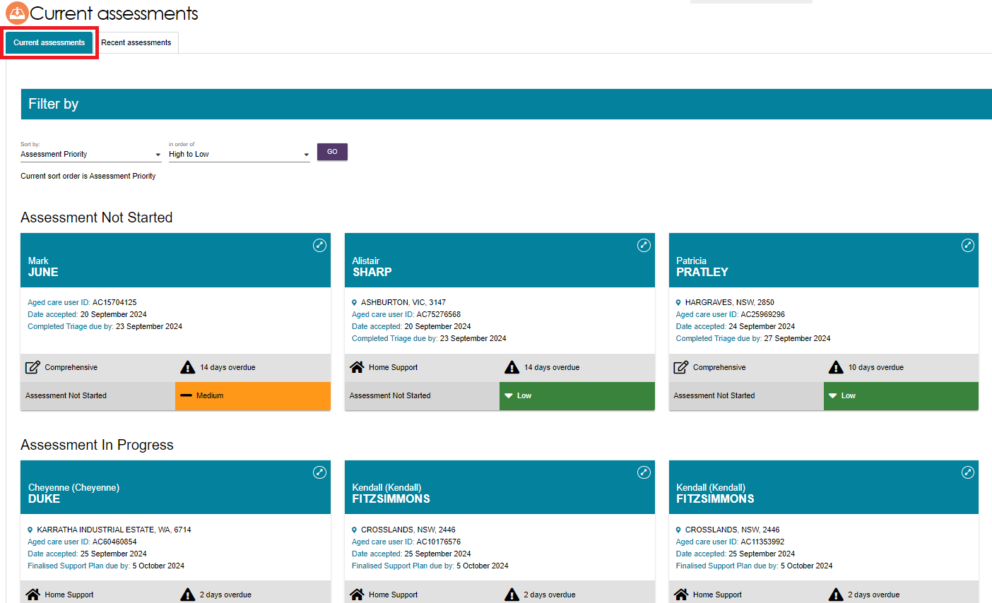

|  |  |
| --- | --- |
| ! | To view the next Key Performance Indicator milestone (for example, Finalised Support plan) and due date for an assessment, go to the client’s referral card. |

The **Recent assessments** tab contains finalised, cancelled and/or closed assessments. It also contains completed and cancelled Support Plan Reviews.

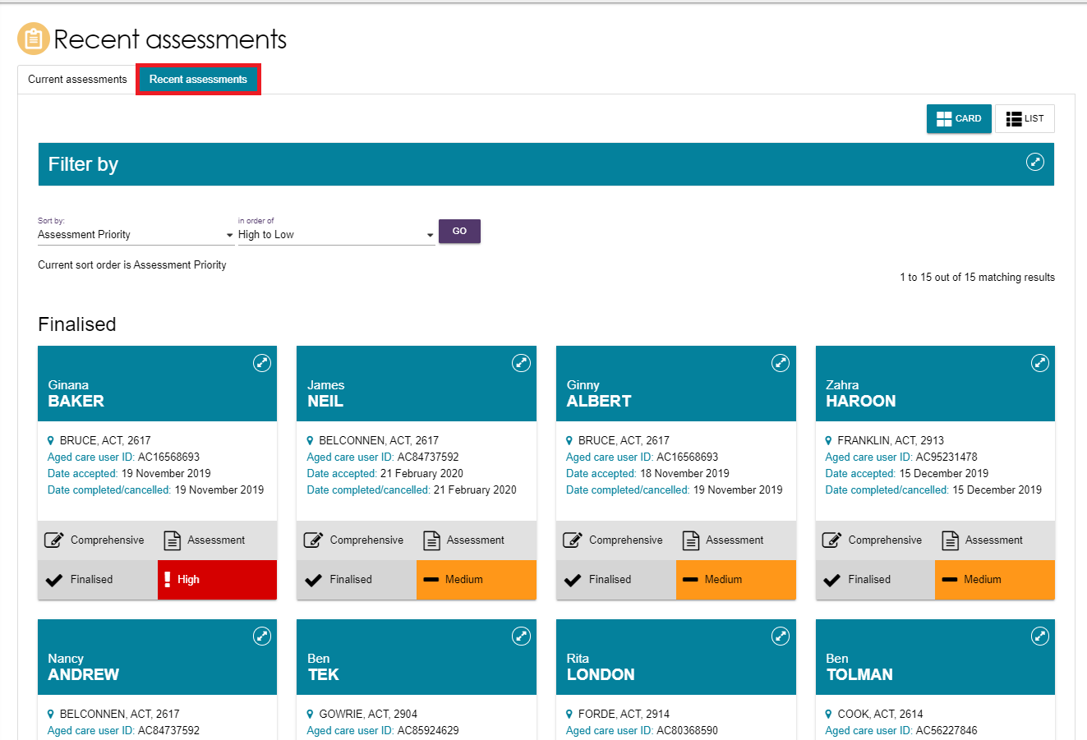

|  |  |
| --- | --- |
| ! | Further information about using the sort and advanced filter functions can be found in the [My Aged Care – Assessor Portal User Guide 3 – Managing Referrals for Assessment and Support Plan Reviews](https://www.health.gov.au/resources/publications/my-aged-care-assessor-portal-user-guide-3-managing-referrals-for-assessment-and-support-plan-reviews). |

## Starting an assessment

1. To start an assessment, select a client from the **Assessment Not Started** heading, and then click the double arrow icon on the top right-hand corner of the **Client card**.

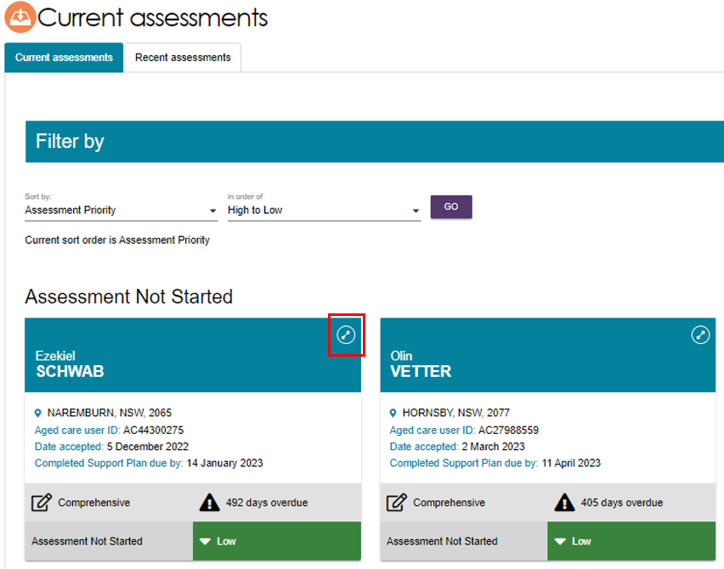

A summary of client information will be displayed. Assessors can access read-only versions of previous screening, triage and assessments, attachments relevant to the client’s referral, and the client’s support plan, if available.

|  |  |
| --- | --- |
| ! | When opening the client card, the Support plan status will be marked as **Triage Completed**. Assessors will also be able to view relevant details of both triage and screening by selecting the magnifying glass icon.  Image of a client card with the  magnifying glass icon highlighted. |

1. For comprehensive assessments, clinical assessors are able to indicate the assessment setting before starting the assessment.

To change the assessment setting, select the **Edit** (pencil) icon next to **Assessment Setting** when the client information is expanded.

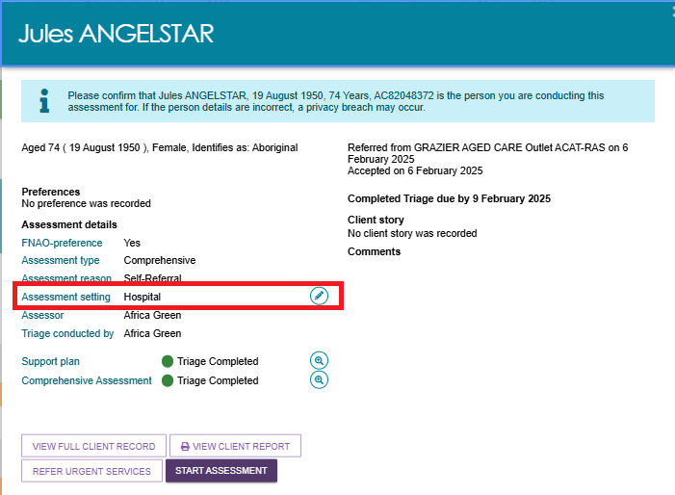

The **Assessment setting** pop up will appear. Select **Hospital** or **Non-Hospital** and select **Save**.

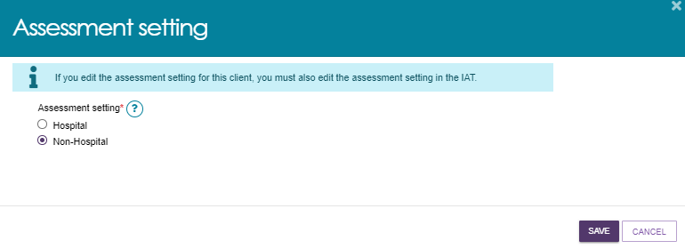

The **Assessment setting** that is filled out here must match the value recorded in the [IAT](https://www.health.gov.au/resources/publications/integrated-assessment-tool-iat-user-guide). Clinical assessors must ensure that both fields are manually updated to reflect the same value if one is changed.

1. Please note, clinical assessors will have the ability to convert Home Support Assessments to Comprehensive Assessments prior to commencing an assessment. To change the assessment type select **CONVERT TO COMPREHENSIVE ASSESSMENT**.

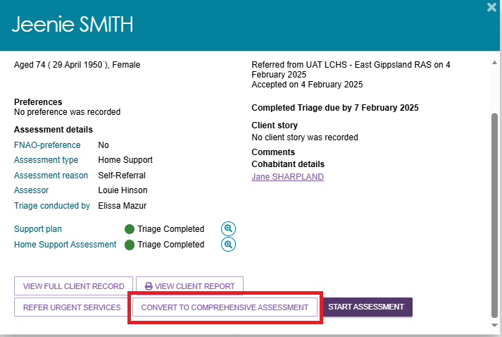

The reason for the change will be auto-filled. Enter in addition context for the reason or comments about converting the assessment.

Non-clinical assessors who wish to convert the home support assessment to a comprehensive assessment will also be required to enter who the supervising clinical assessor is.

1. Once completed, select **YES, CONVERT ASSESSMENT** to continue.

Please note, once you convert to a comprehensive assessment you cannot change is back to a home support assessment.

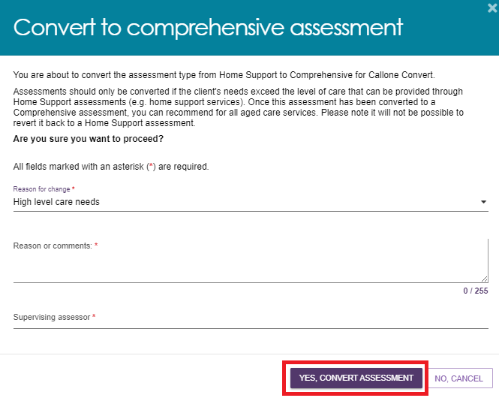

The assessment type will now reflect a Comprehensive Assessment.

1. The assessment type will now reflect a Comprehensive Assessment. When you are ready to start the assessment, select **START ASSESSMENT**.

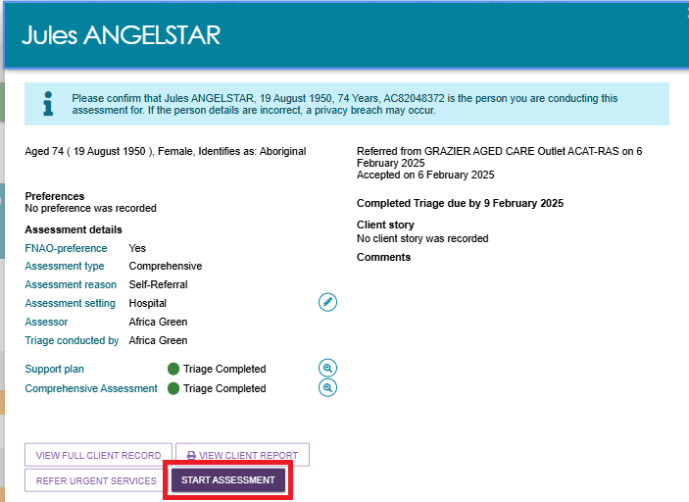

1. You will then be asked to record client consent.To do this, you will be required to read the relevant consent script, which is in the **My Aged Care Assessment Consent Form**, to the individual and record their response. If there is a suggestion that the client lacks capacity for consent, complete this form with the client’s confirmed authorised representative in My Aged Care. The **My Aged Care Assessment Consent Form** is available for download from the **Reports & Documents** tile of the assessor portal.

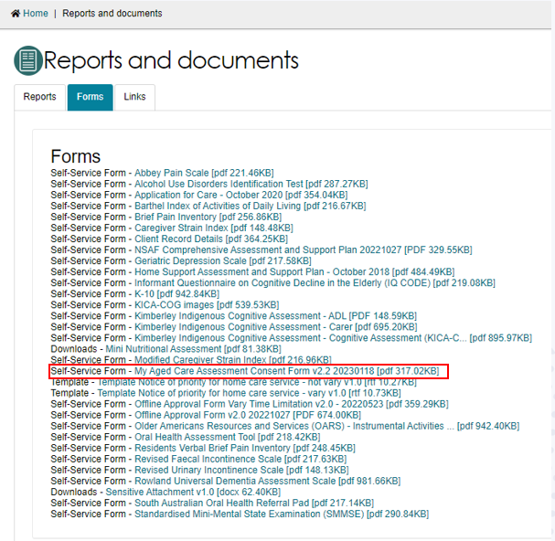

If consent is given, select the applicable consent options and then click **CONTINUE**. A signed copy of the Aged Care Assessment Consent form should be obtained during this step.

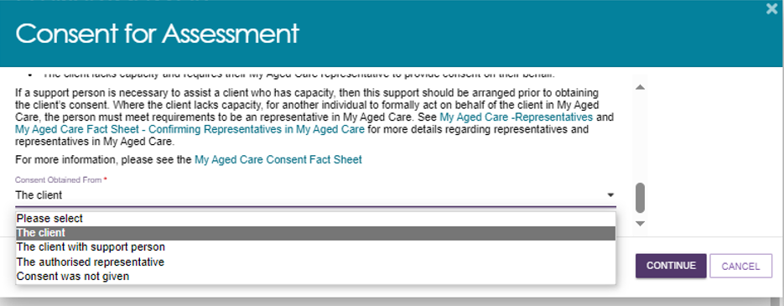

|  |  |
| --- | --- |
| ! | If a client does not provide consent, a warning message will display advising assessors that the assessment cannot proceed. If this is the case, you must enter a reason as to why the assessment could not be completed. If the response is ‘**Other, please specify** you will be required to enter free text. Selecting **SAVE AND CLOSE** will then cancel the assessment.  Image of the consent for assessment pop-up. |

1. Before you start the assessment, you will be given the option to pre-populate the IAT.

For new clients who have not undertaken screening or have a previous assessment, you will have the option to pre-populate the IAT with their information from triage only. If the client has undergone screening, you can also select to pre-populate the IAT with their previous screening. Similarly, if the client has had a previous assessment you can select to pre-populate the IAT using that information.

Once you have selected the relevant pre-population options, select **CONFIRM SELECTION**.

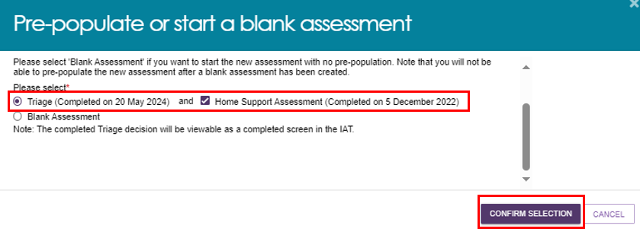

If you do not wish to pre-populate the IAT select **Blank Assessment**.

|  |  |
| --- | --- |
| ! | Please note, if you select **Blank Assessment**, you cannot reverse this decision during the assessment. |

1. You will then be prompted to review and update information regarding the client’s **Demographic details**, including whether this is a remote assessment, the client’s personal details and background, if the client would prefer a First Nations Assessment Organisation for their assessment (if available) and any Government ID references such as the client’s Medicare card number.

These details will be pre-populated from triage but can be edited if required. After confirming the correct details are entered, select **SAVE AND CONTINUE TO ASSESSMENT**.

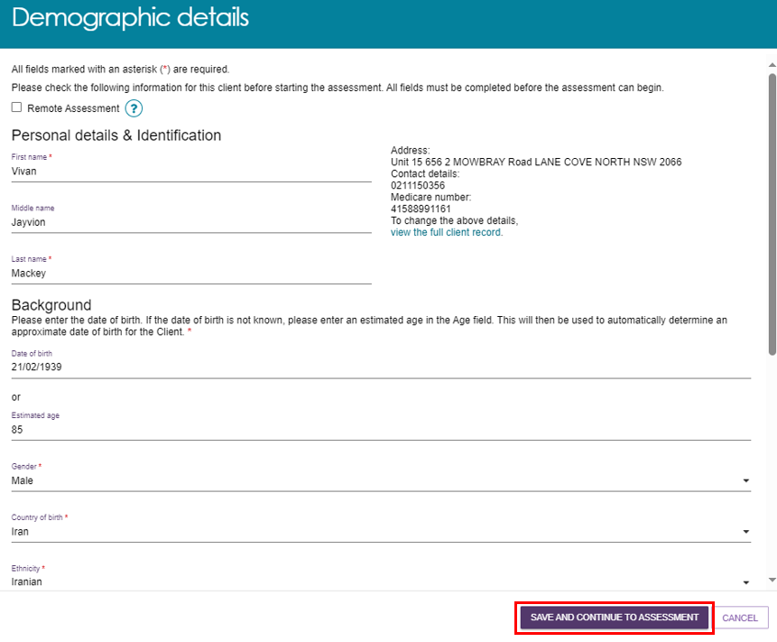

|  |  |
| --- | --- |
| ! | It is important to ensure that the client’s Aboriginal or Torres Strait Islander identity is accurately captured, as this will trigger the system to display Validated Assessment Tools that are appropriate to use with First Nations people if required.  Image of the Aboriginal or Torres Strait Islander identity question. |

|  |  |
| --- | --- |
| ! | A client’s Medicare card number must be correctly entered to ensure that their My Health Record can be successfully linked if they consent to do so.  Image of the demographic details pop-up with the Medicare card number section highlighted. |

|  |  |
| --- | --- |
| ! | Remote assessment should be selected when an assessment is conducted in a remote area. This is to help improve reporting and inform future decision making in consideration of this client demographic.  Geographical remoteness is defined using the Modified Monash Model (MMM). Based on this, remote assessments should only be selected where a face-to-face assessment is undertaken in a remote (MM6) or very remote (MM7) area.  You can check the MMM classification of a client’s address on the [Health Workforce Locator](https://www.health.gov.au/resources/apps-and-tools/health-workforce-locator). From the homepage select **Start the locator now** and enter the client’s address. The MM will then be displayed in the **Summary** section.  Image of the Summary section which highlights the MM. |

If an assessor needs to update a client’s demographic details after they have commenced the assessment, they can do so from the **Client Details** tab of the Client Record.

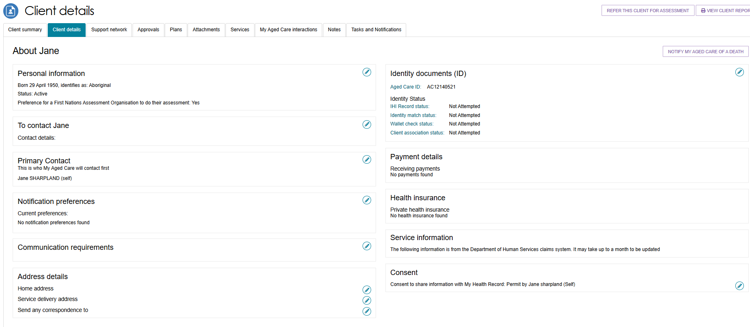

A record of any previous screenings or assessments will be accessible through the **Plans** tab of the client record under **Assessment history**.

## Completing an assessment

|  |  |
| --- | --- |
| ! | An algorithm is integrated into the IAT to ensure consistent client outcomes based on their needs. The algorithm will draw on assessment responses and the client's current care approvals, and recommend either the Commonwealth Home Support Programme (CHSP) or a Home Care Package (HCP). This will display in the **Support plan and services page** under the **Goals and Recommendations** tab after an assessor finalises the IAT. |

Once you have commenced an assessment, the **Assessment Details** page will display. Key client information will be displayed at the top of each page of the assessment.

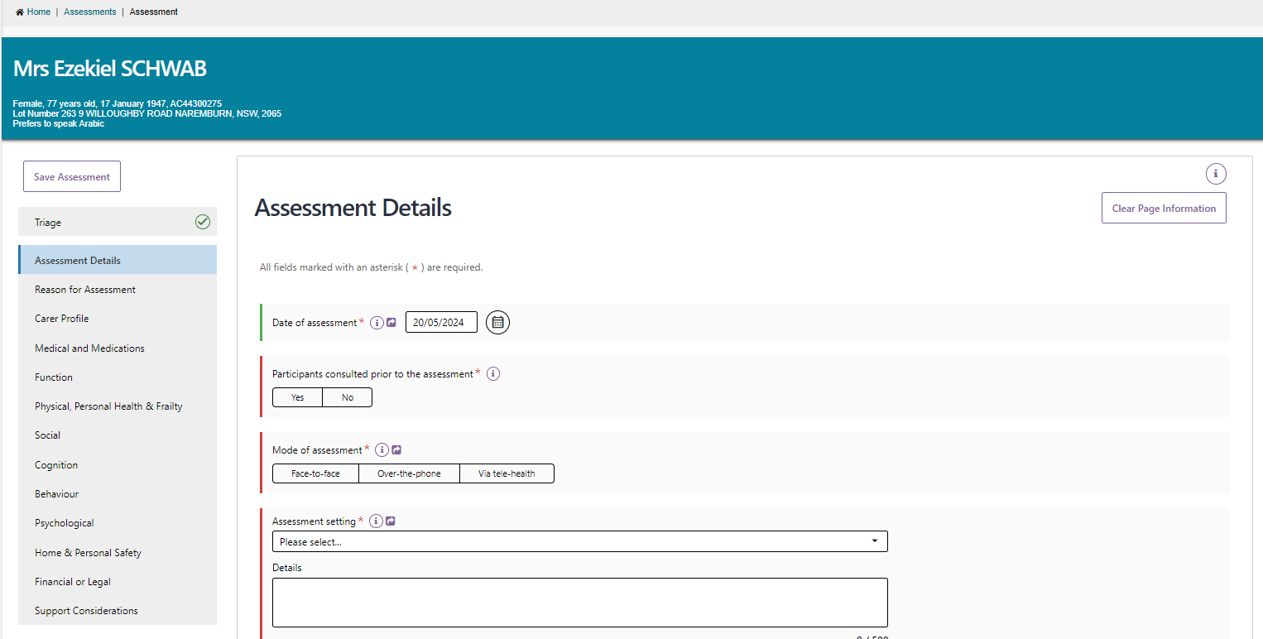

To view information that was collected during triage, you can select **Triage** from the navigation bar. This will open a read-only screen for viewing.

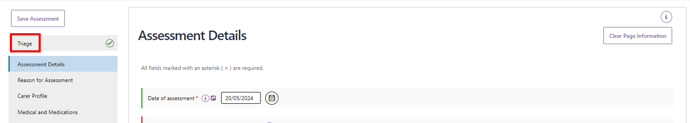

The navigation bar will move up and down the page as you scroll. A tick will display in the navigation bar to confirm completion.

|  |  |
| --- | --- |
| ! | The system will time out due to inactivity if unused for a period of time to maintain the privacy of the information in the system. A warning banner will display if the session has been left unattended for 25 minutes. If the system remains inactive for a following 5 minutes you will automatically be logged out and will need to log in again to restart the assessment. |

## Assessment features

1. On each page of the assessment, you can clear entered information. This can be done by selecting the **Clear Page Information** on the top left-hand side.

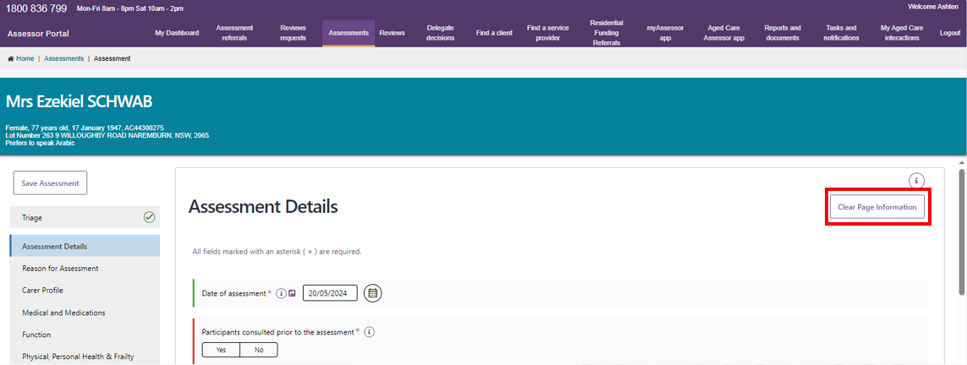

A pop-up will then display. Select **Yes, clear page information**.

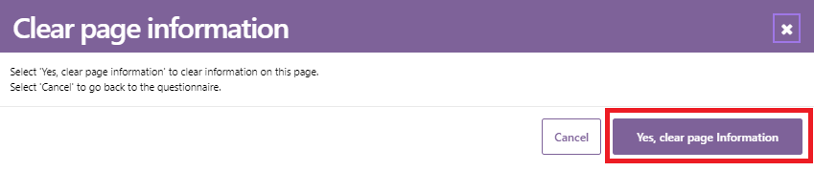

Please note, pages that do not contain Validated Assessment Tool triggering questions will only have the option to **Yes, clear page** and **cancel**. Whereas pages with Validated Assessment Tools trigger questions, will have a third option to **Clear all**. Clicking **Clear page** will trigger an in-action symbol which demonstrates that the clearing is in progress.

|  |  |
| --- | --- |
| ! | Selecting **Clear page information** will also remove the check box that triggers the display of Validated Assessment Tools, but not the information entered into the tool.  If an assessor wants to clear the information relating to the Validated Assessment Tools, they can select **Clear all** or navigate to the page the Tool is on and select **Clear page information**. |

1. There are visual cues to assist with completing the form. When mandatory questions have not been answered, a red line is displayed on the left of the field. When the mandatory questions are answered, this line turns green.

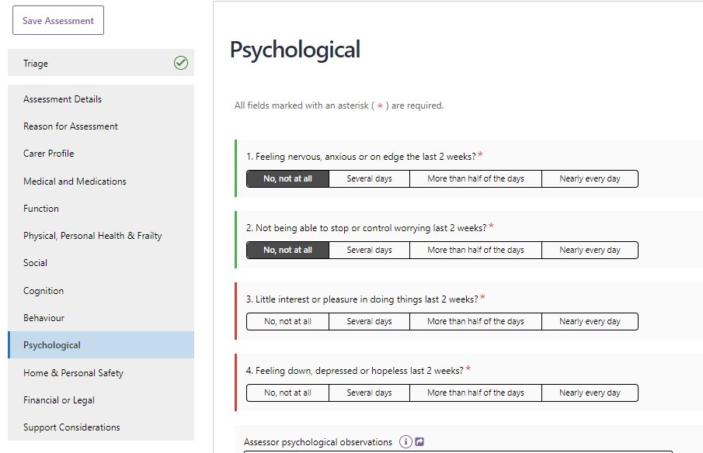

Some questions will require additional mandatory details depending on the answer. In these cases, an asterisk will appear next to the details section to indicate that it is now mandatory to complete.

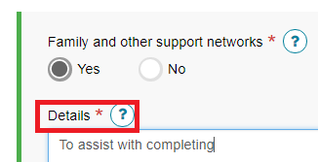

Additional questions may also display if triggered by an answer given to a base IAT question. These questions are used to capture additional information about the client’s needs as indicated by the answer given within the base questions.

## Clinical attendance (non-clinical assessor)

Threshold questions are also used throughout IAT to trigger moving the assessment into clinical/comprehensive areas. These questions are identified by a blue banner.

For example, if you answer **No** to the question “*is the client managing urinary incontinence issue?*’ then additional questions will be displayed that require clinical attendance to complete.

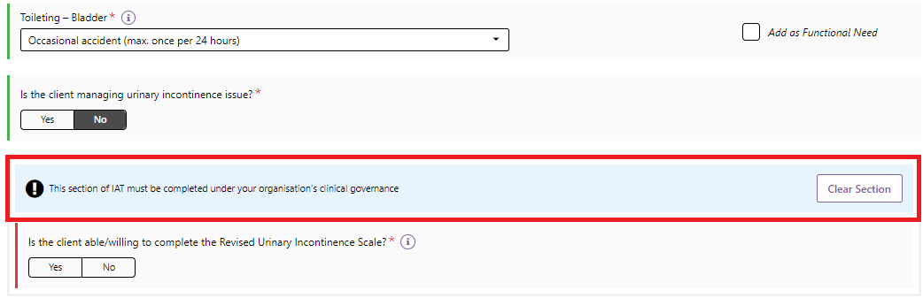

For non-clinical assessors, these questions can only be completed under the clinical attendance process which is supported by an assessment organisation’s clinical governance framework.

To proceed in answering these questions, the clinical supervisors (clinical assessor) details, who has provided clinical attendance, must be selected from the drop-down menu and **Save Details** selected.

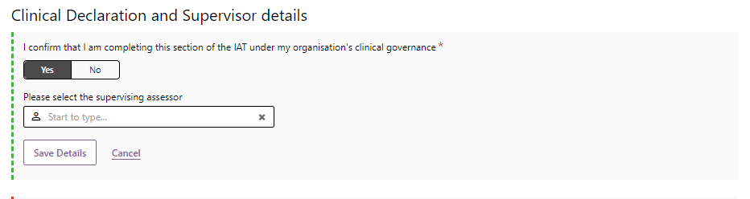

Once the details have been saved, they will display in the IAT and the non-clinical assessor can proceed with clinical supervision.

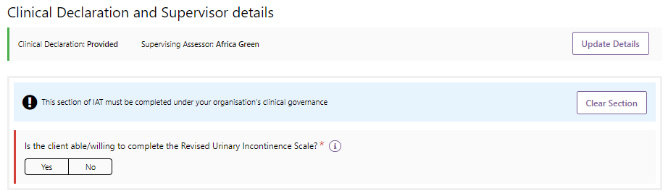

1. View on-screen help text for each question by selecting either the **i** icon next to the question. Help text can be moved around the screen by dragging the text with the cursor and will remain visible until the **X** is selected, or a new help text box is opened.

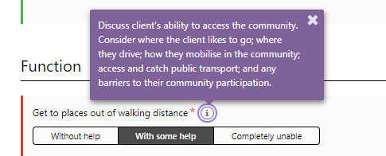

1. A mandatory confirmation box must be completed at the bottom of each section, then you can navigate to the next assessment page by selecting the **Next** button at the bottom right-hand corner or by selecting the relevant section from the navigation bar. Assessment information will also be saved.

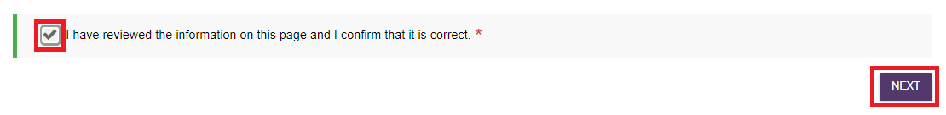

When all mandatory questions (marked with an asterisk and red line) on a page have been completed, a green tick will appear on the navigation bar.

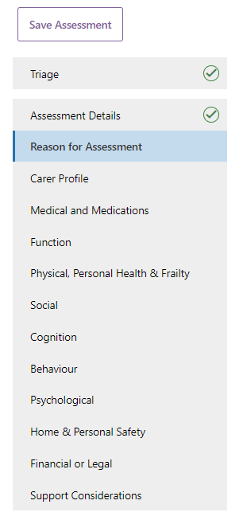

1. From the **Medical and Medications** section you can enter health conditions into the assessment by name or code.

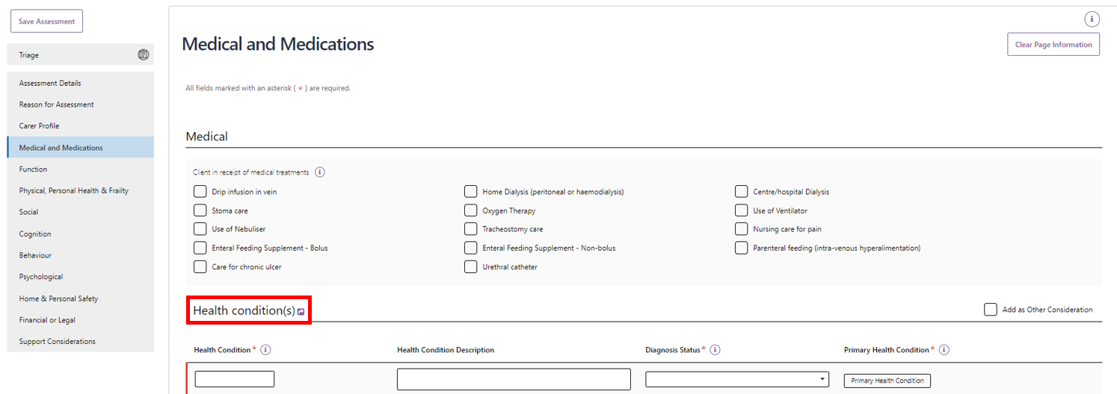

A maximum of ten health conditions can be added for each assessment. Start typing into the free text field to display health condition options.

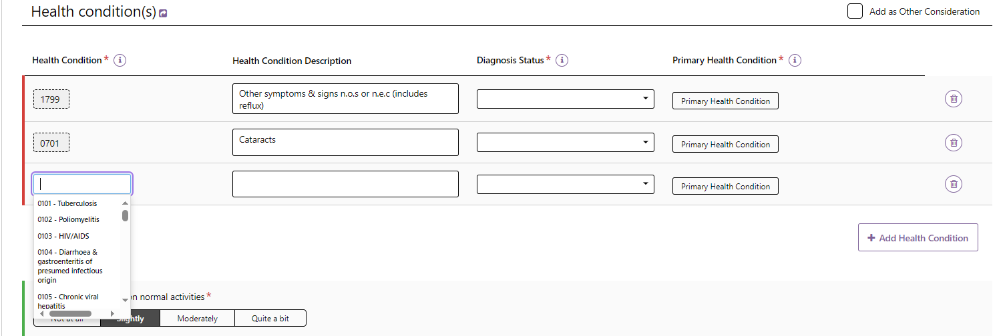

Once you select a health condition, you are able to edit the description to be specific to the client’s health condition and select the appropriate **Diagnosis Status** option.

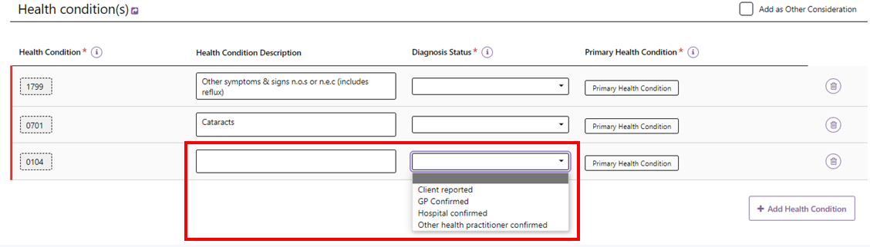

Additional health conditions can be added by selecting + **Add Health Condition** or removed by selecting the bin icon. Assessors can also indicate whether the health condition is the **Primary Health Condition**, or whether to as an **Other Consideration** in the client’s Support Plan.

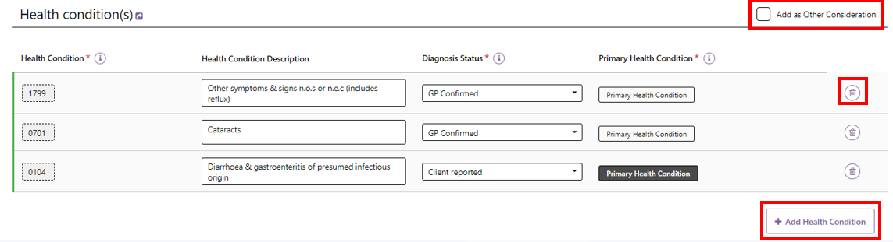

1. When completing the assessment, assessors will be able to select to **Add as Functional Need**, **Add as Complexity Indicator**, **Add as Other Considerations** and **Add as recommendation**.

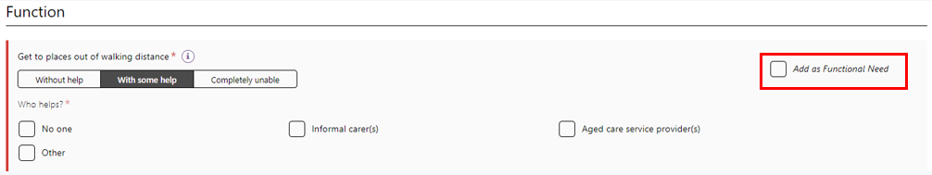

Upon selecting the checkbox, the Needs will appear on the **Identified needs** tab of the **Support Plan**. Recommendations will appear in the **Goals &recommendations** tab.

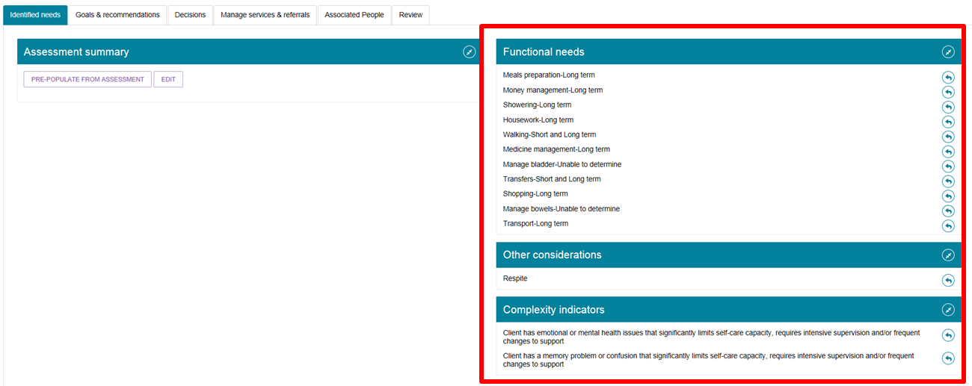

## Viewing and adding carers in the assessment

You can view and add information about carers from the assessment, without having to navigate back to the client record.

1. Select the **Carer Profile** section of the assessment from the navigation menu and then select **View/add carers**.

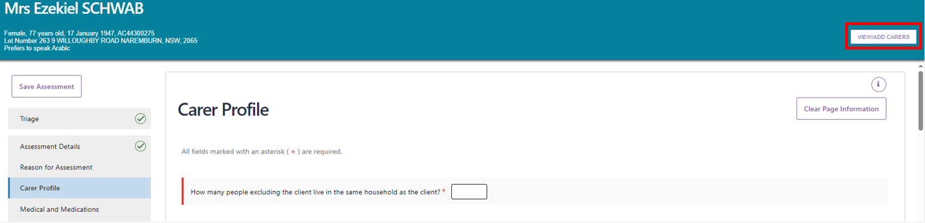

1. A pop-up box will display. Any carers that are already associated with the client will be displayed. If you want to add a new carer select **Add a carer**.

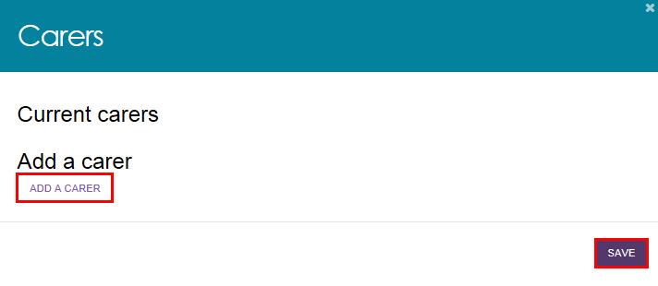

1. Enter the first and last name of the person and select **Search**. You can search with more details by selecting **Show more search fields** and populating the appropriate fields.

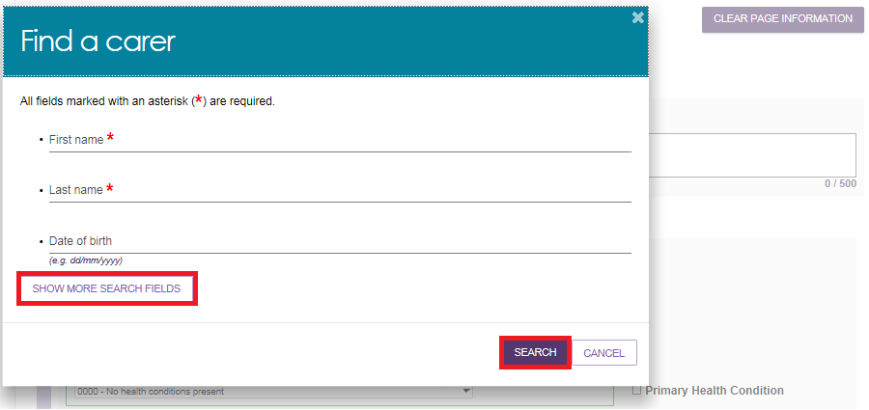

If there is already a record for the person, they will be displayed in matching results. By selecting the radio button next to the person, it will open up further fields including both client and carer consent to the relationship, and the relationship of the user to the client. Select **Add**.

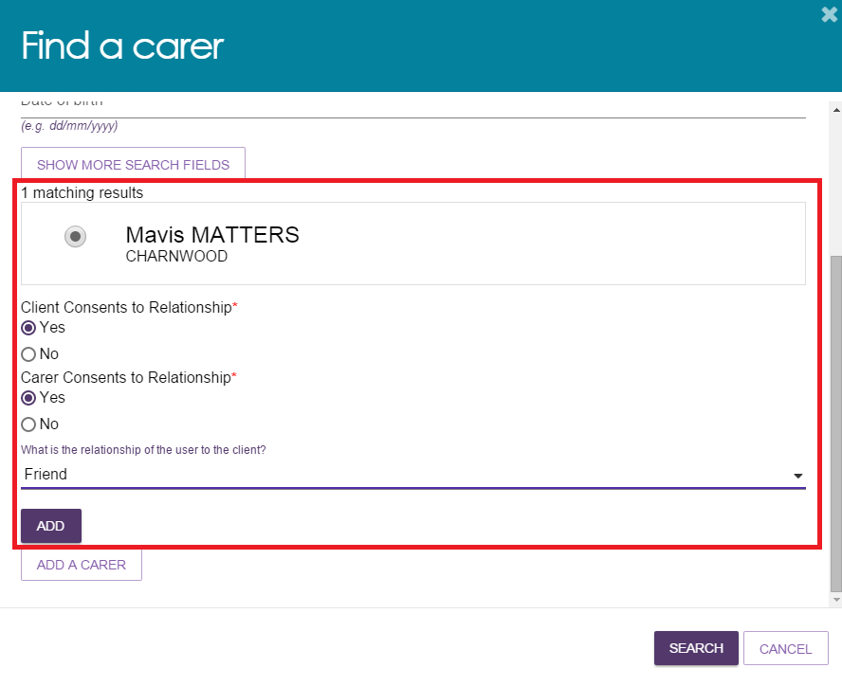

1. You will receive a confirmation message on screen, notifying that **You have successfully added a carer**. Select **Save** to save changes.

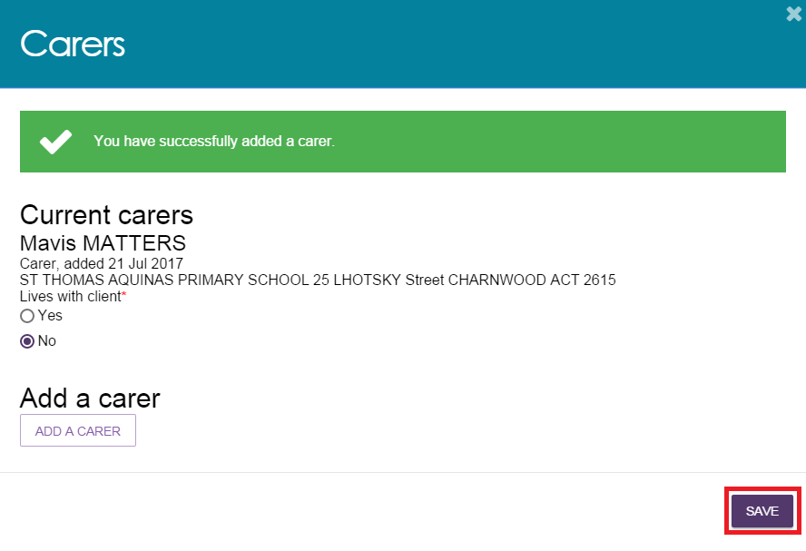

1. If there are no results, or you want to add a different carer, select **Add a carer**.

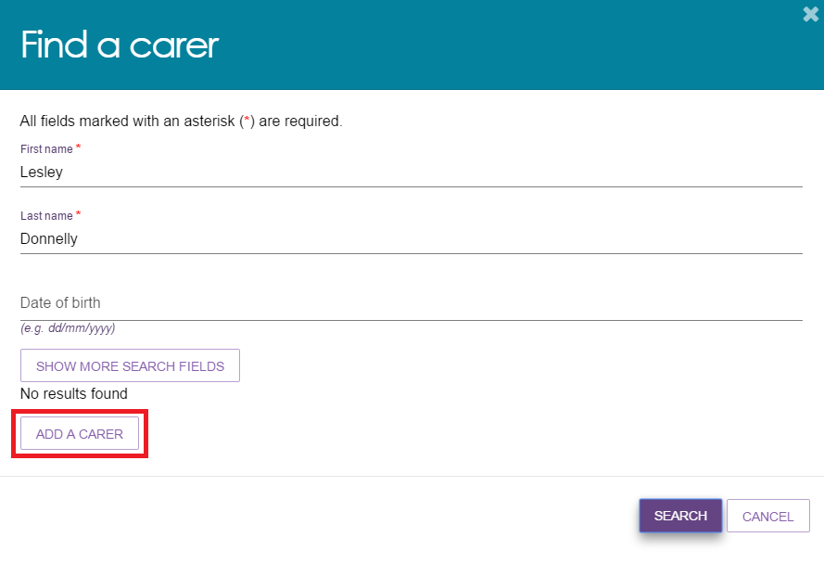

Enter mandatory information about the person, including consent for the relationship from both the client and the carer. Select **Save**.

|  |  |
| --- | --- |
| ! | The consent for registration during this stage is solely to create the client-carer relationship within the My Aged Care system. By creating this relationship, the carer will display in the client’s support network and also appear as an option be added to the client’s support plan at a later stage. Consent will be sought for any changes to this carer relationship throughout the process.  For information on how to capture a client and carer’s consent for call-backs from the [Carer Gateway](http://www.carergateway.gov.au) and/or National Dementia Helpline, go to [Assessor Portal User Guide 2 – Registering support people and adding relationships](https://www.health.gov.au/resources/publications/my-aged-care-assessor-portal-user-guide-2-registering-support-people-and-adding-relationships). |

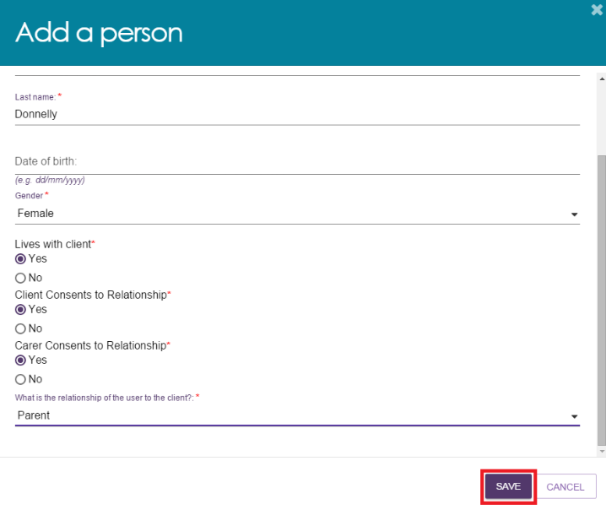

1. You will receive a confirmation message on the screen, notifying that **You have successfully added a care**r. Select **Save** to save changes.

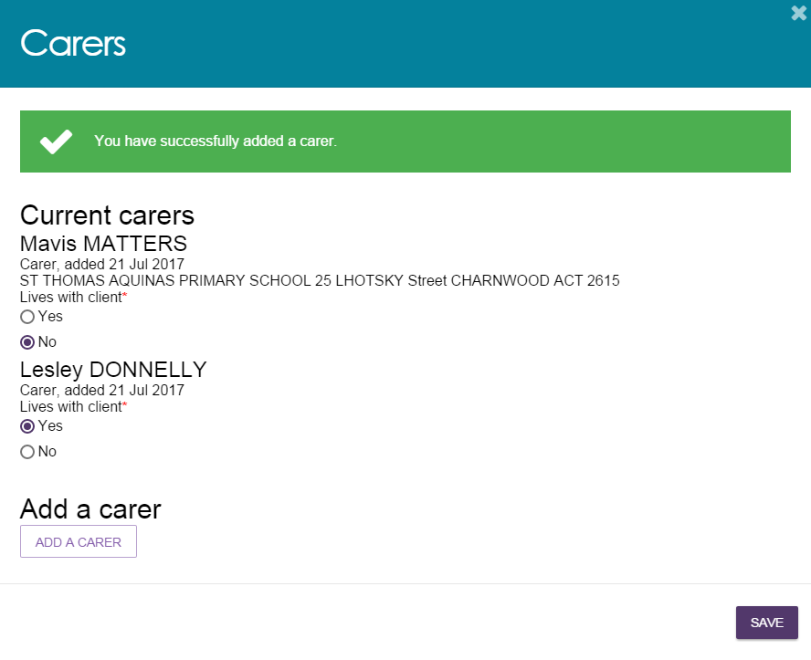

## Adding a Sensitive Attachment in the assessment

Assessors can add attachments for client information of a sensitive nature as part of the assessment.

1. To download the Sensitive Attachment form from the assessment, select **Download Sensitive Attachment Form** on the **Support Considerations** page.

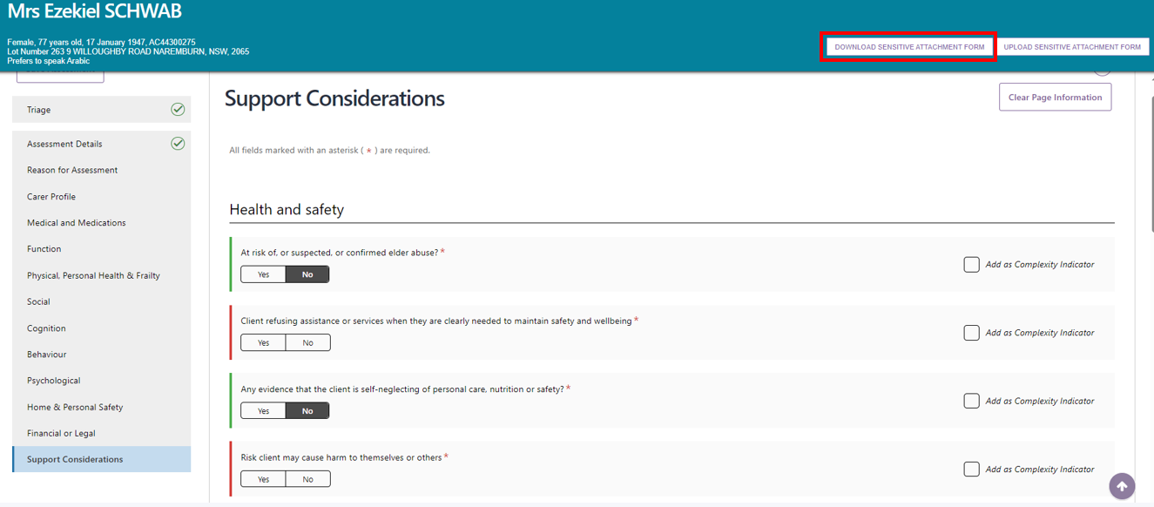

1. The **Sensitive Attachment** form can also be downloaded from the **Forms** tab in the **Reports and documents** section of the portal.

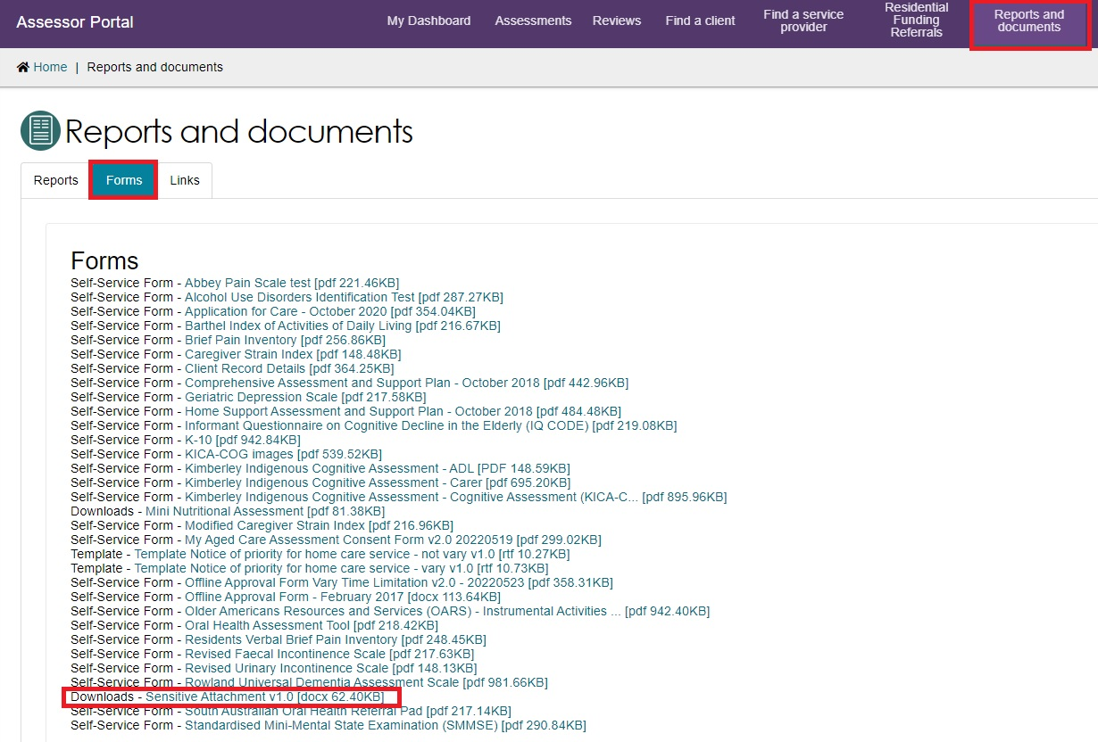

These can then be uploaded to the client record in the **Attachments** tab by clicking **ADD AN ATTACHMENT**.

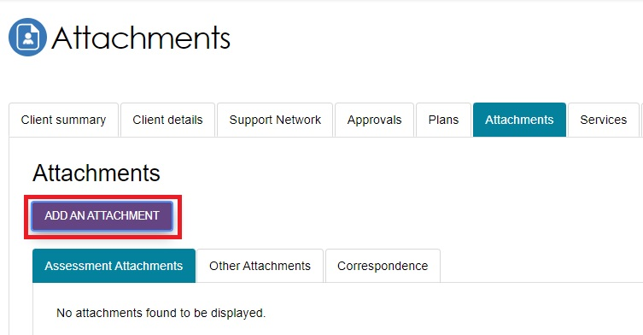

1. Once downloaded, the **Sensitive Attachment** form will display.

 
Image of Sensitive Attachment Form 

1. When you have completed the form, select **Upload Sensitive Attachment Form** from the **Support Considerations** page.

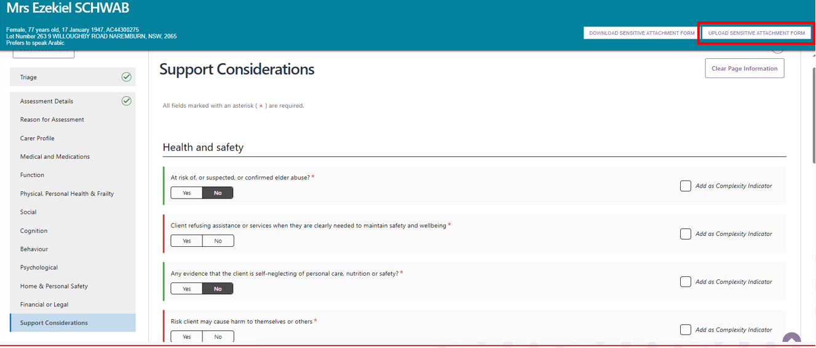

1. You will be prompted to enter information relating to the Sensitive Attachment. Once you have entered this information select **Upload**.

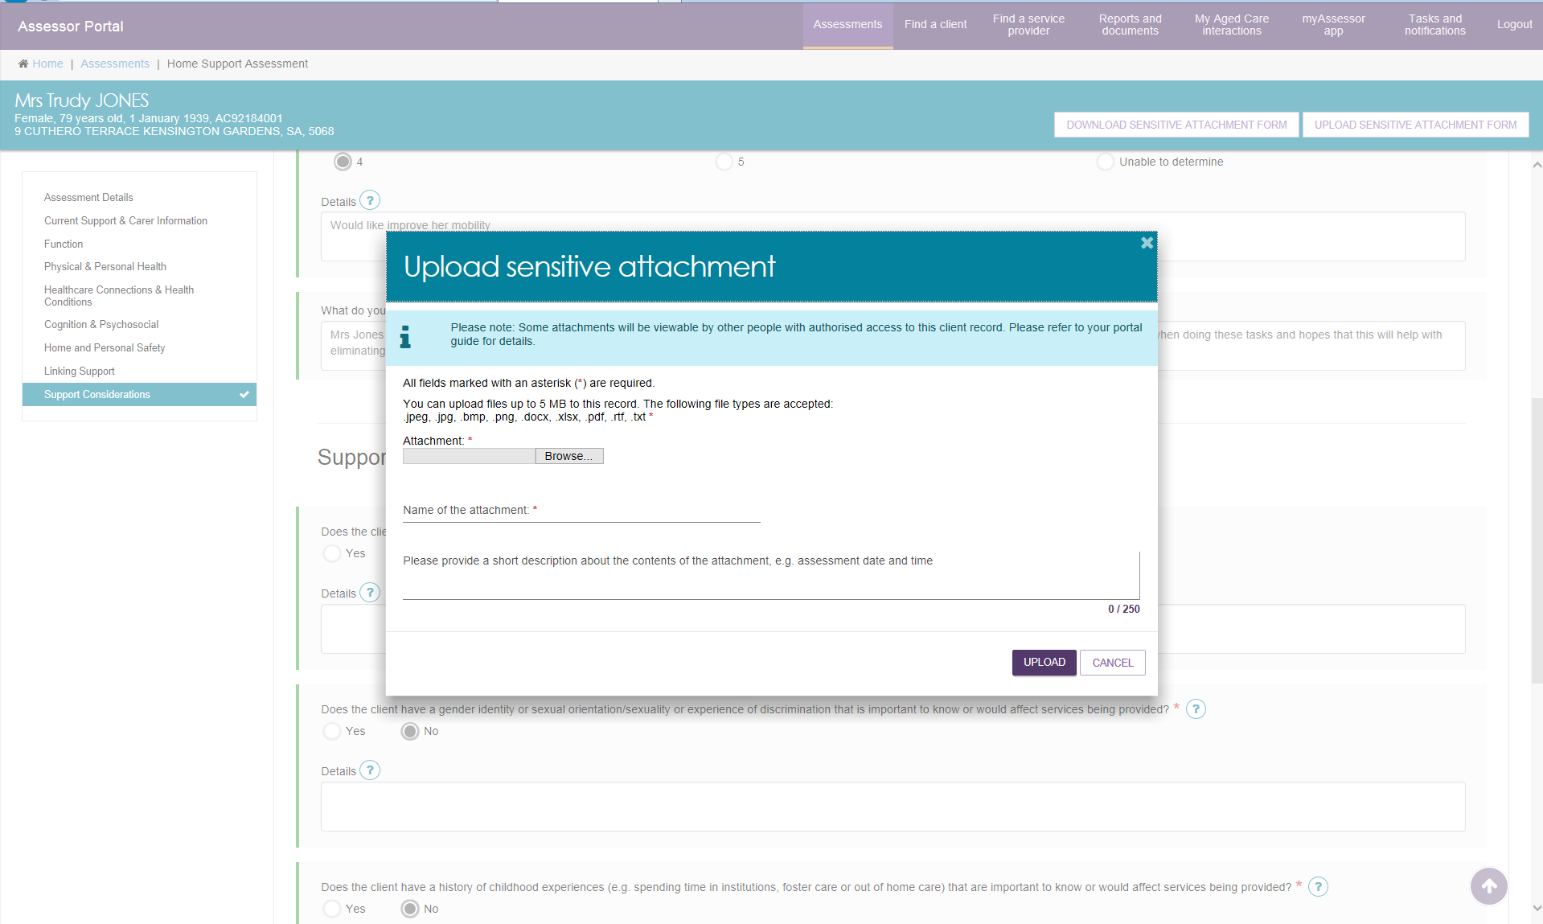

1. Once successfully uploaded, a green banner will display at the bottom of the screen.

Image of the green banner showing that the sensitive attachment has successfully been uploaded. 

The Sensitive Attachment will then appear in **Other Attachments** on the **Attachments** tab of the Client record.

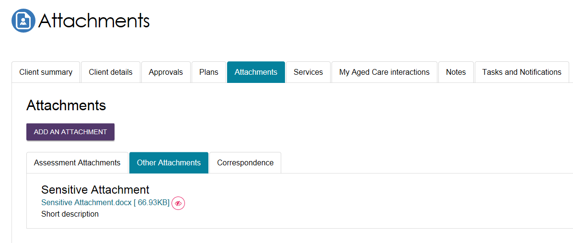

|  |  |
| --- | --- |
| ! | If you have added a Sensitive Attachment as part of the assessment, you should record this in the **Support Considerations** page.  Sensitive attachments will not display to providers or to clients viewing their information through the My Aged Care online account. The My Aged Care contact centre and assessors will be able to view this attachment.  Service providers who have accepted a client’s referral will receive an alert notifying them that sensitive information is available and are advised to contact the client’s assessor or My Aged Care contact centre to access this information.  Image of Attachment radio button on Support Considerations page that is highlighted. |

## Navigating the Validated Assessment Tools

There are a range of Validated Assessment Tools (VATs) available for assessors to help support a client assessment. A number of these are either embedded within the IAT itself or are available as prompts to be utilised as needed.

For example, the Duke Social Support Index is incorporated in the IAT under the **Social section.**

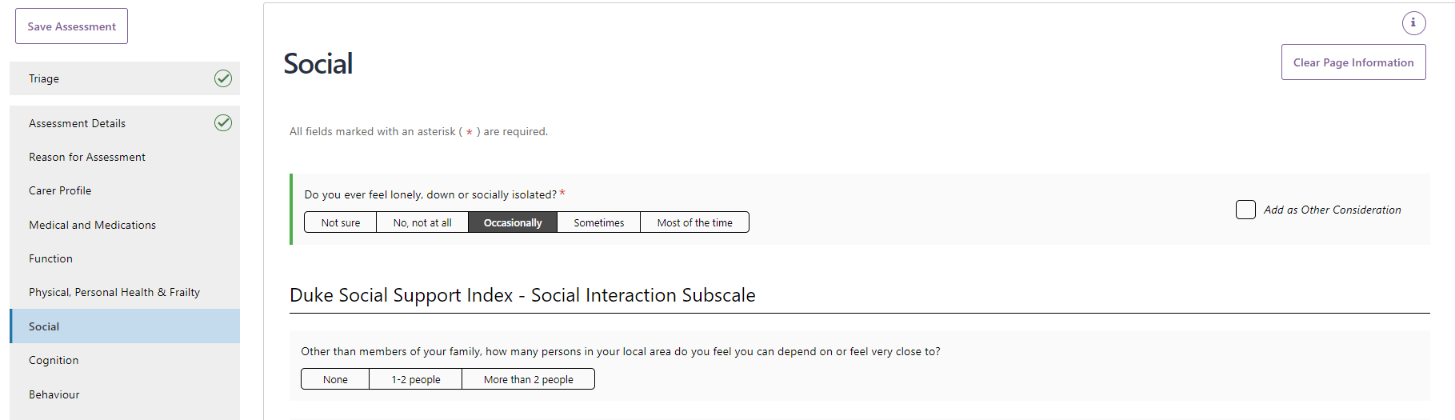

Other Validated Assessment Tools within the IAT will only display if required and agreed to by the client. For example, the **Step 1 GP Cog** tool is available under the **Cognition** section of IAT assessment. 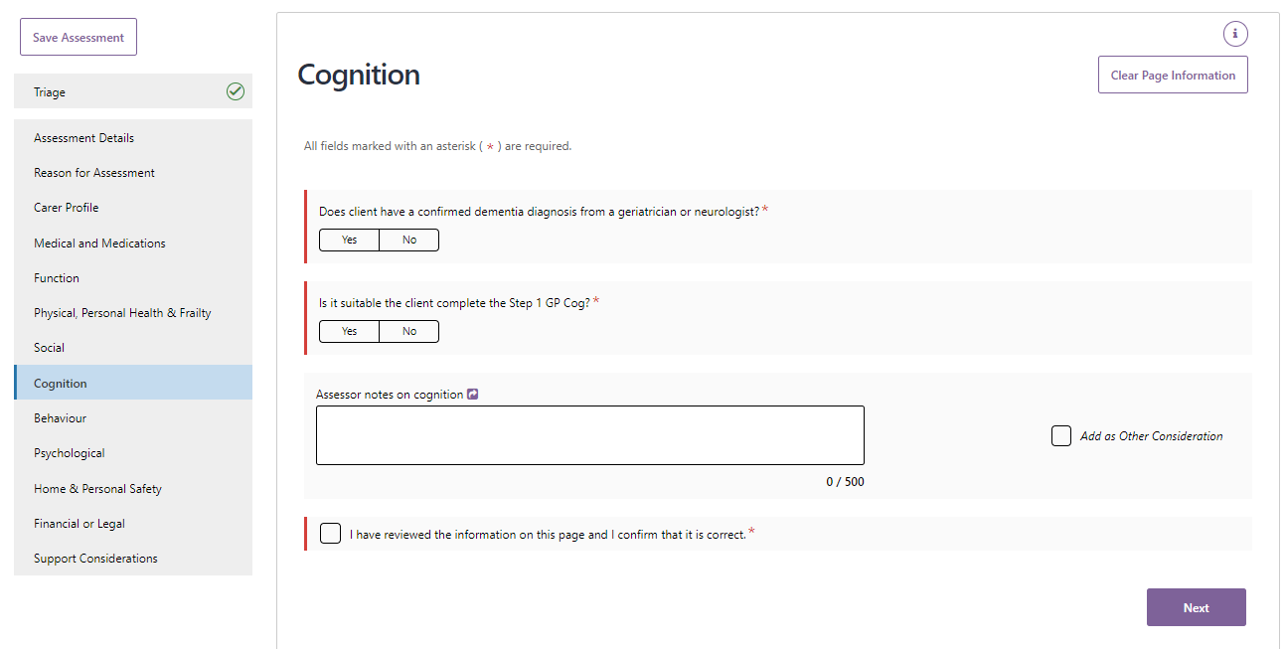

If you answer yes to the client being suitable to complete this, the **GP Cog – Step 1** questions will then display below.

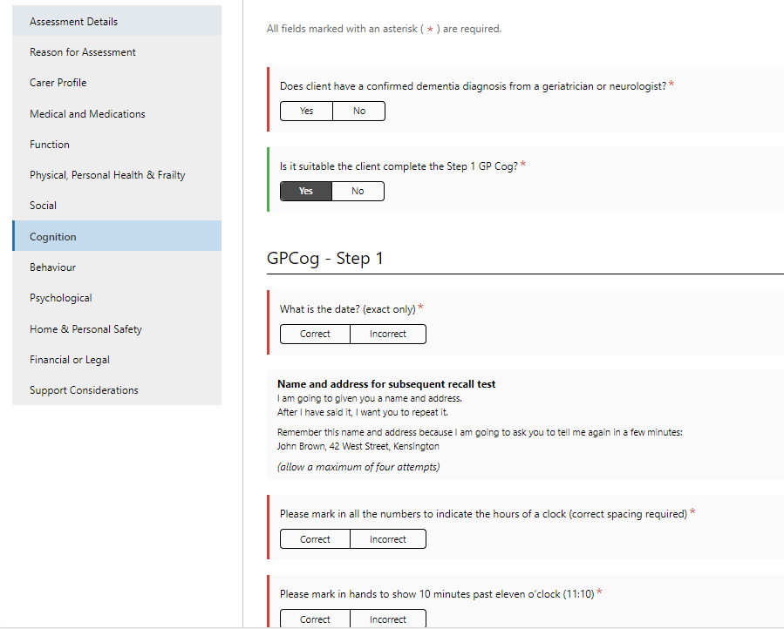

Please note, the total score for these validated assessment tools will be auto generated based on the client’s answers.

Use of validated assessment tools that are not included in IAT is at the discretion of the assessment organisation. If used, you can upload the completed tools as attachments to the client record. Blank versions of these tools are available in the **Reports and Documents** section in the assessor portal.

The eraser button can be used to clear the responses of Validated Assessment Tools if required.



## Modified De Morton Mobility Index (DEMMI) and Residential Respite Care (Clinical assessor)

The IAT includes a validated assessment tool called the DEMMI, that may only be used by clinical assessors in a face-to-face setting when assessing individuals’ care needs for residential respite services. Non-clinical assessors should **not** complete the DEMMI-Modified tool even with clinical attendance.

The responses captured as part of the Modified de Morton Mobility Index (DEMMI) tool becomes part of the Australian National Aged Care Classification (AN-ACC) initiative.

1. Under the Function section of the IAT, clinical assessors will be asked **Are you likely to recommend residential respite care?**

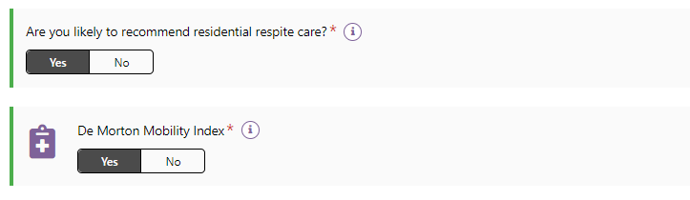

1. If you answer **Yes** to this question, you will be prompted with a new question: **De Morton Mobility Index?** If you are a clinical assessor and answer **Yes** to this question, you must complete the DEMMI assessment tool. The **De Morton Mobility Index (DEMMI) Modified** will appear in the navigation bar below the **Function** section.

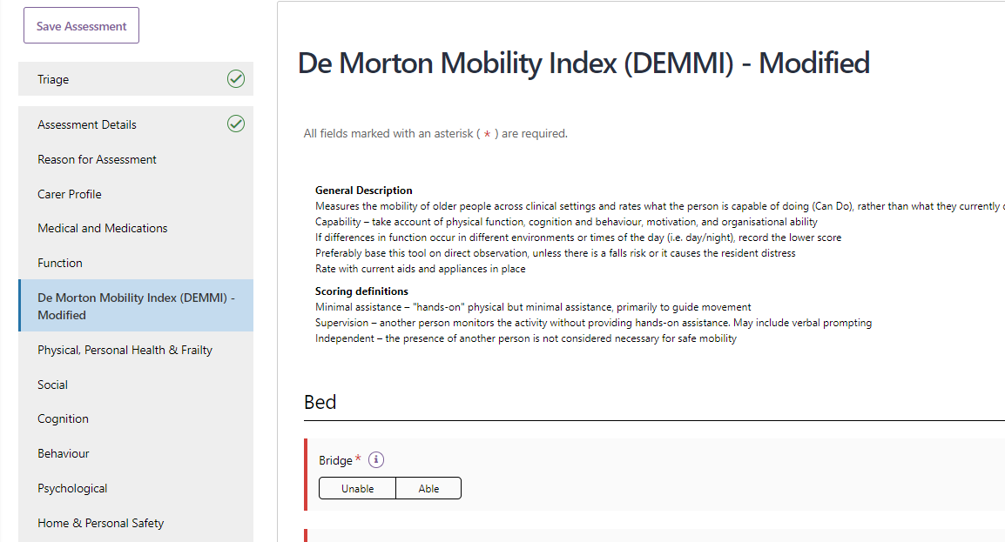

1. Work through the questions associated with the 4 sections of the DEMMI as listed below by selecting the radio box that most reflects the client's mobility:

* Bed;
* Chair;
* Static balance – no gait aid; and
* Walking.

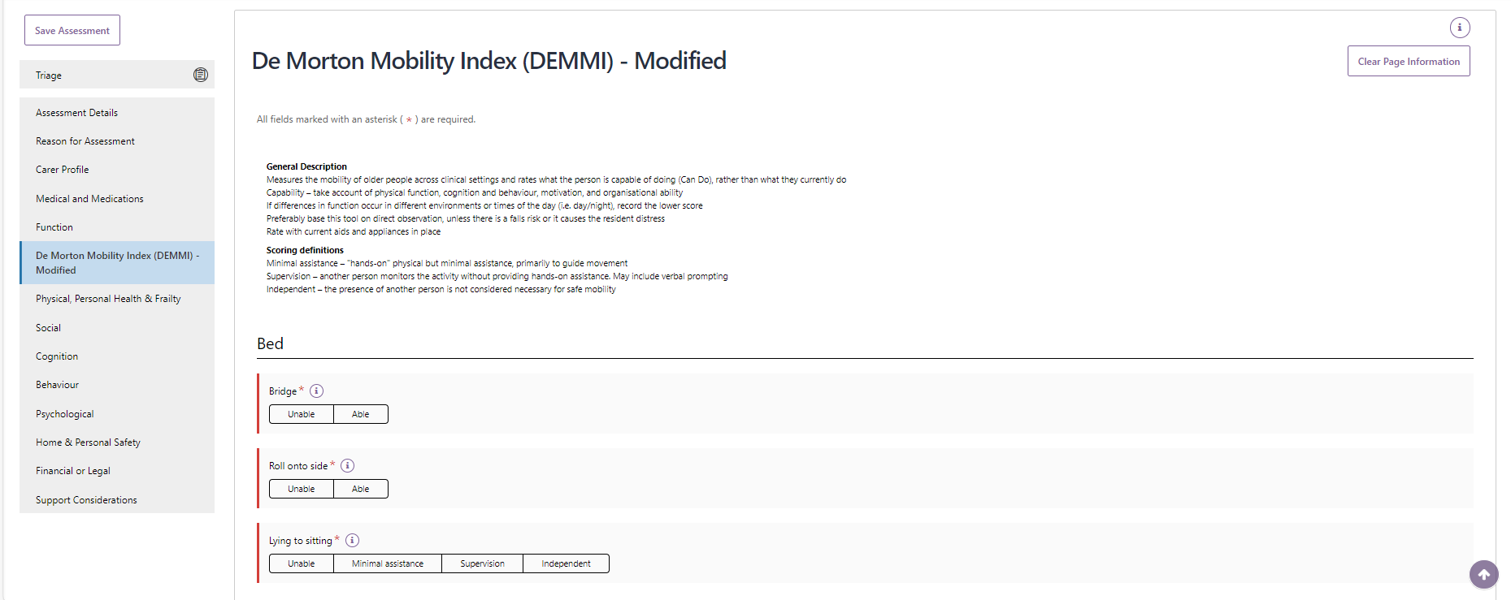

1. Once you have completed the required sections press **Next**.

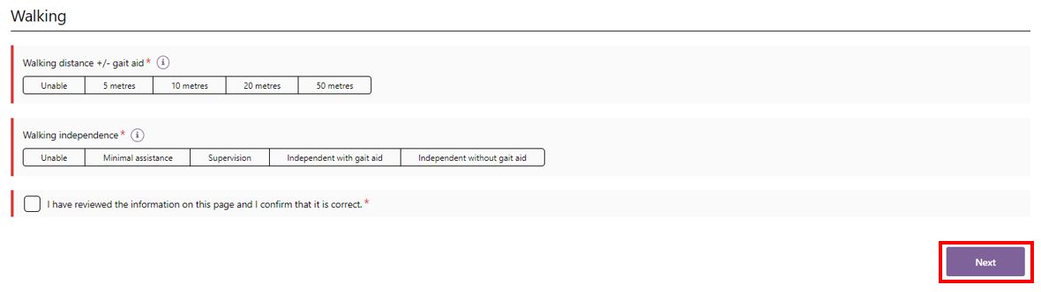

1. You should then progress with completing the assessment and submitting your recommendation for residential respite care for Delegate approval.

In the event that the Modified DEMMI has not been completed and Residential Respite Care is recommended, you will be prompted that you will need to tick a declaration and to add a reason for not completing the Modified DEMMI.

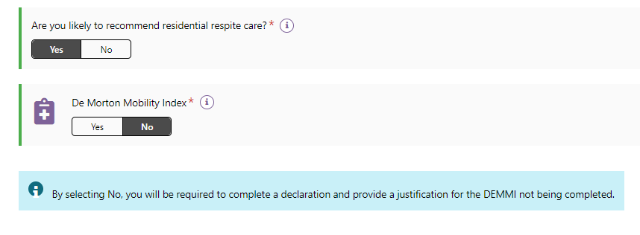

This screenshot shows the declaration and the text field for not completing the DEMMI in the **Add care type for Delegate decision** pop up

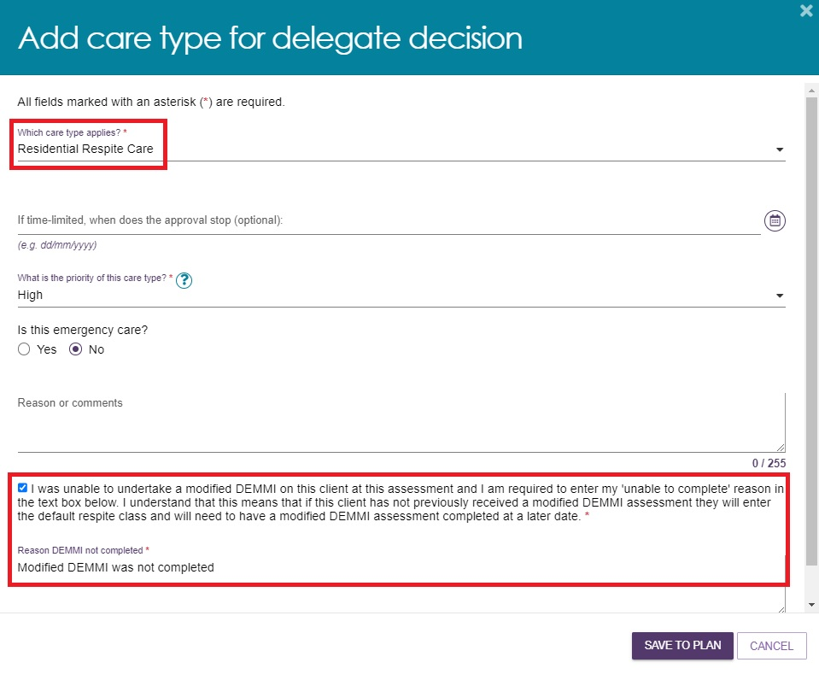

## Saving an assessment

If you have not finished completing the assessment and want to complete it at a later time, you can select **Save Assessment**.

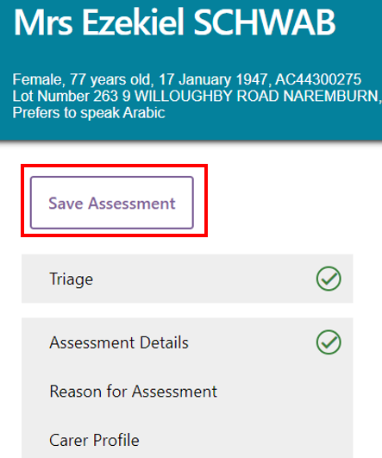

A green banner will then display at the bottom of your screen advising of the successful save.

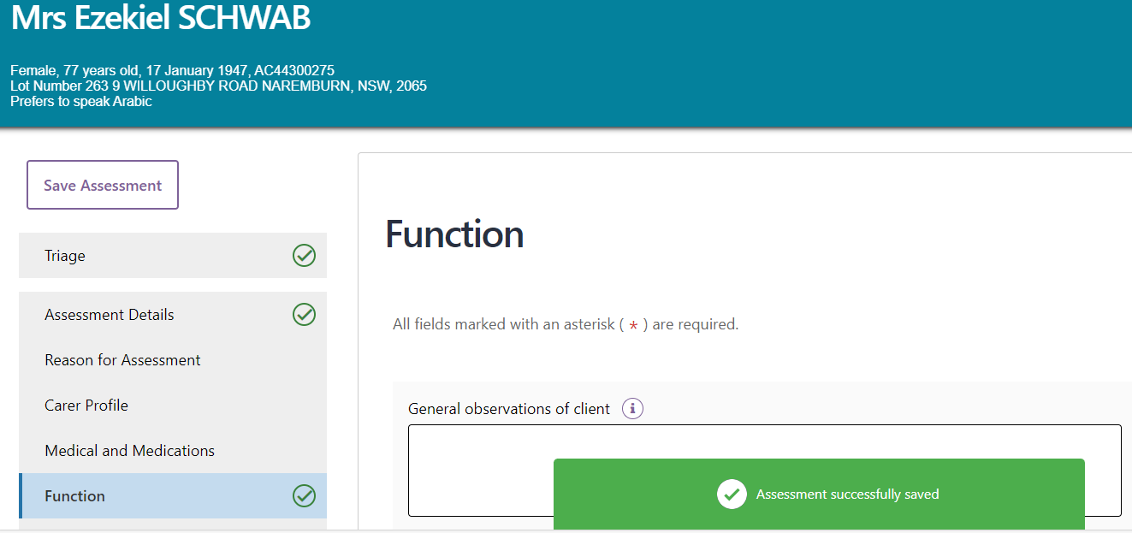

You can then continue completing the assessment with the client at another time.

You can also select **SAVE QUESTIONNAIRE AND CONTINUE TO SUPPORT PLAN** down the bottom of the assessment if you wish to navigate to the support plan but are not yet finished with the assessment.

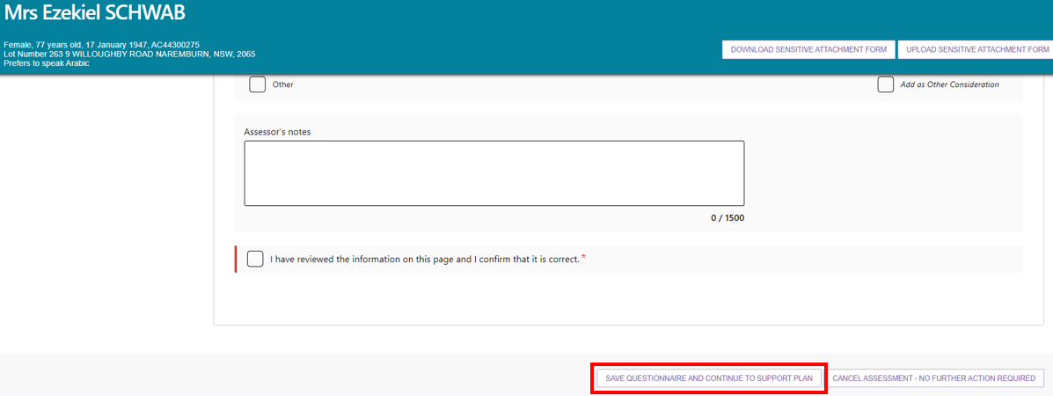

The record will appear under **Assessment In progress** in your **Current assessments** tab.

To prevent any potential loss of information captured during the assessment, or when the portal is idle, the assessment will auto-save regularly.

## Finalising an assessment

1. Once you have completed the assessment, select **FINALISE IAT AND GO TO SUPPORT PLAN**.

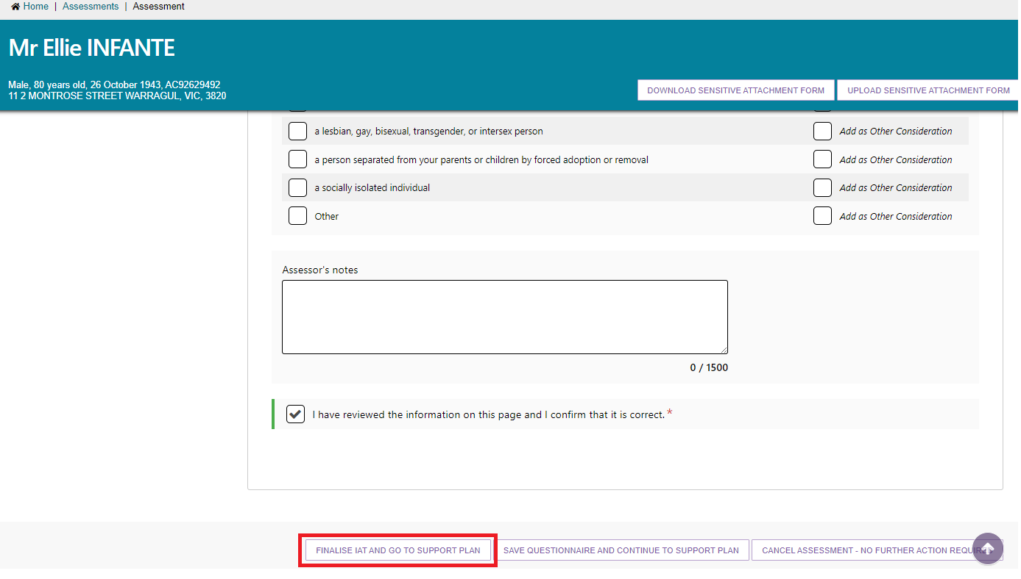

1. A pop-up will then display asking for consent to share their support plan via their My Health Record. After reading the consent information to the client or their representative, select the applicable consent option based on their consent decision.

|  |  |
| --- | --- |
| ! | A client can withdraw their consent at any time by calling the My Aged Care Contact Centre on 1800 200 422. A client’s consent can also be updated by an assessor via the Client details tab in the client record. For more information regarding this please refer to the [My Aged Care – Assessor Portal User Guide 4 – Navigating and updating the client](https://www.health.gov.au/resources/publications/my-aged-care-assessor-portal-user-guide-4-navigating-and-updating-the-client-record). |

If consent is provided select **Yes** and then click **CONTINUE.**

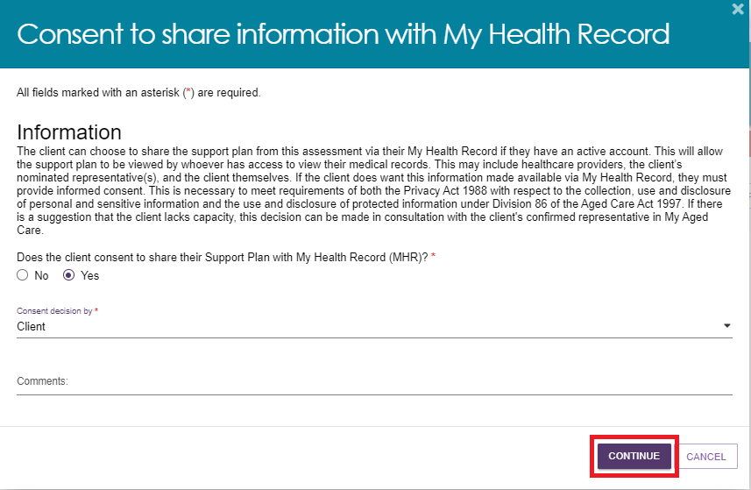

If consent has not been provided, select **No**.You will then be required to select a reason for the decision not to provide consent from the drop-down menu. Next click **CONTINUE**.

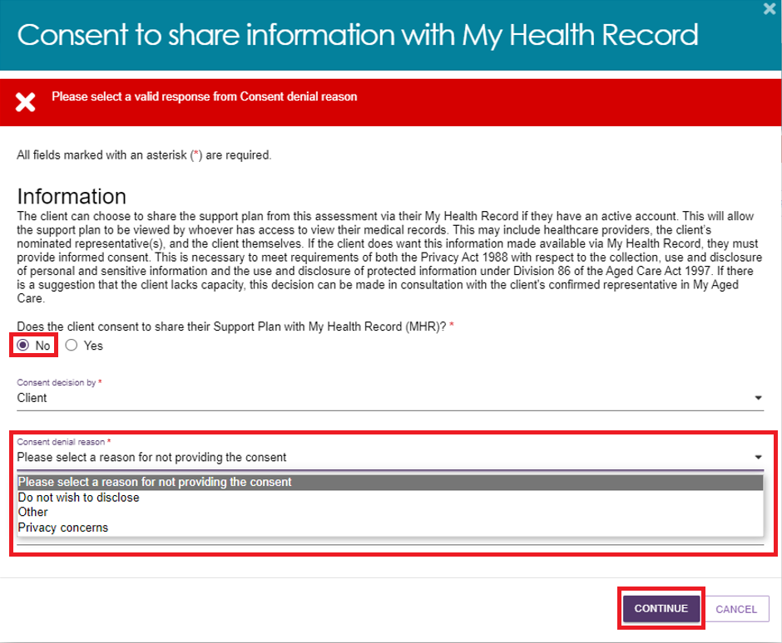

Please note if the consent decision has been made by a Representative then the Representative’s first name must be entered before clicking **CONTINUE**.

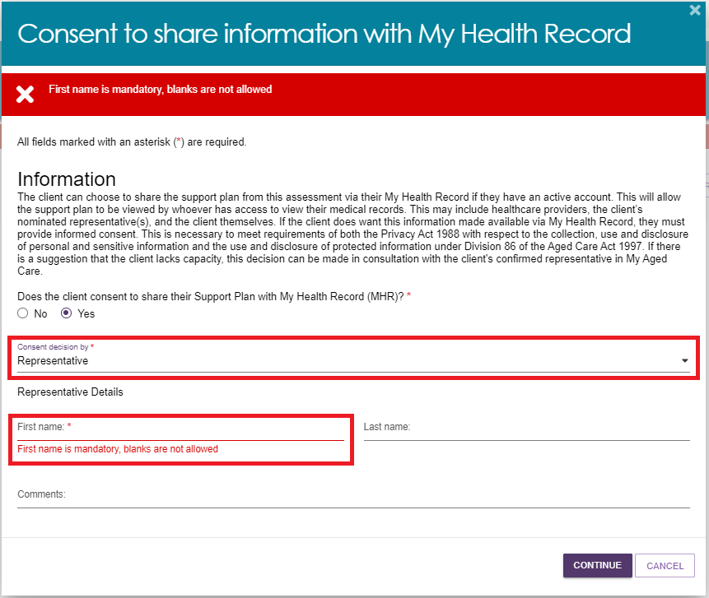

1. Another pop-up will then display. Select **FINALISE IAT** to complete the assessment.

|  |  |
| --- | --- |
| ! | Once the IAT has been finalised it cannot be edited. Therefore, it is important to ensure all information has been correctly captured before selecting **FINALISE IAT**. |

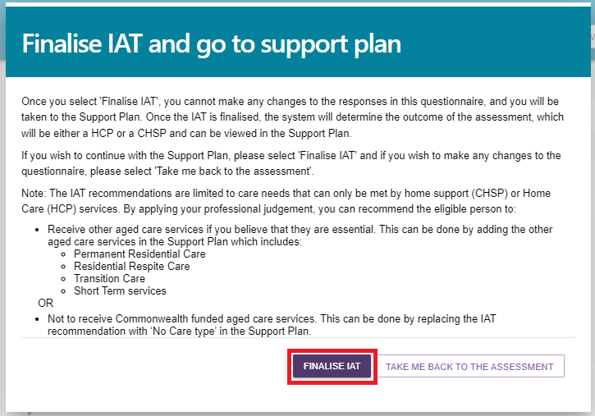

A banner will appear at the bottom of the screen confirming that the save was successful and you will then be re-directed to the client’s **Support plan and services** page to complete the client’s support plan.

If the client consented to sharing their support plan via their My Health Record, a green banner will display at the bottom of the **Support plan and services** page if this was successfully linked.

Image of the green banner notifying a user that the clients My Health Record consent was updated successfully.

|  |  |
| --- | --- |
| ! | If the client’s My Health Record is not successfully linked an amber error banner will display in place of the green banner.  If the ‘Unable to share data as the system could not find an active My Health Record’ error message displays the assessor should inform the client that their support plan will not be uploaded to their My Health Record and that they should contact the **My Health Record helpline on 1800 723 471** for assistance if required.  Image of an error message banner.  If the ‘Unable to retrieve the client's Healthcare Identifier, so we cannot match them with their My Health Record. Their Support Plan cannot be made available in their My Health Record’ error message displays the assessor should call the **My Aged Care service provider and assessor helpline on 1800 836 799**.  Image of an error message banner.  In both instances, you will still be able to proceed with the development of the Support Plan, but it will not be uploaded to My Health Record upon finalisation. |

From the **Support plan and services** page you can reopen the assessment by selecting **Go to question** (arrow icon) on the **Identified needs** tab.

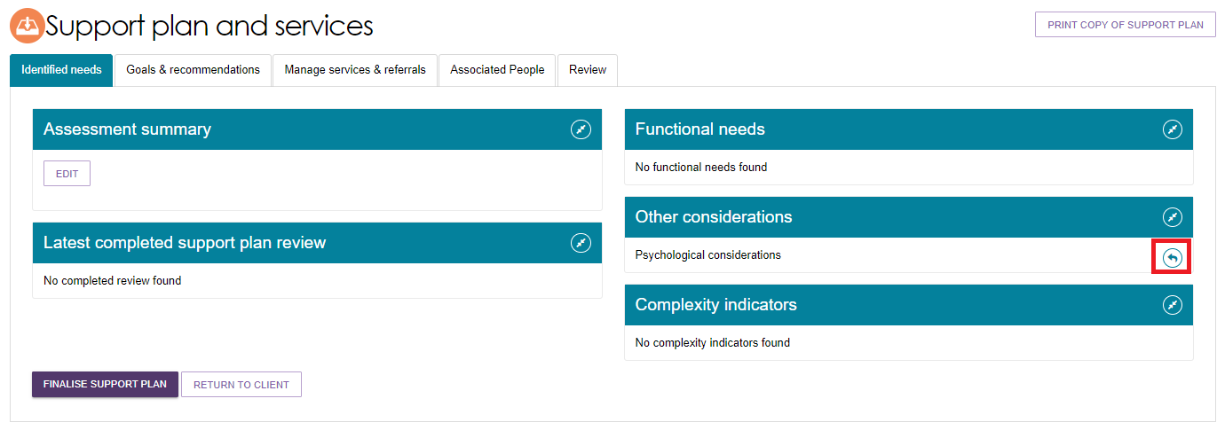

The IAT outcome will be displayed in the Goals & recommendations tab.

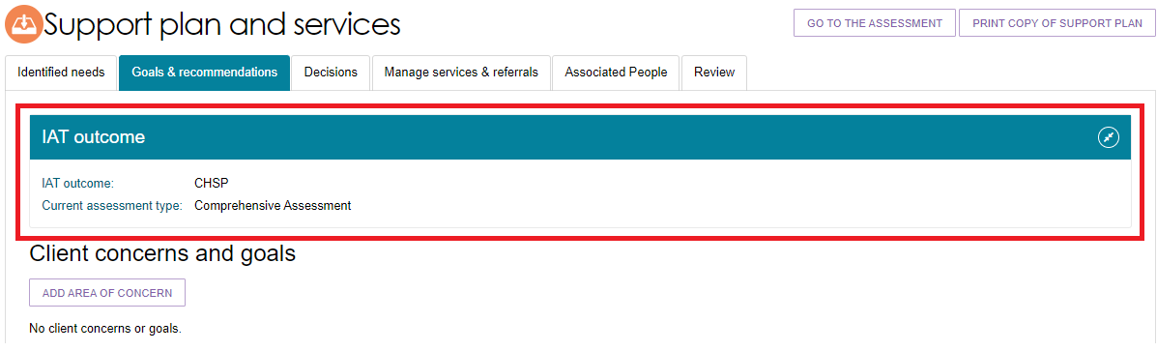

## Cancelling an assessment

If you need to cancel an assessment for a client, you can do so within the assessment. Assessors should add a note or an interaction to the client record explaining the reason for cancelling the assessment.

In order to cancel an assessment, follow the steps outlined below.

1. Select **CANCEL ASSESSMENT- NO FURTHER ACTION REQUIRED** in the assessment.

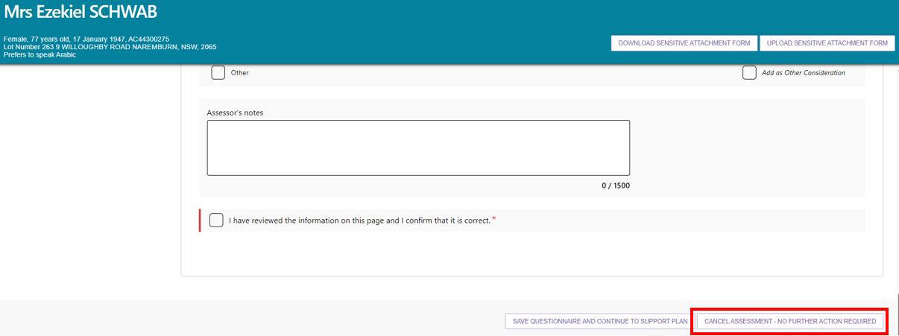

1. Record the reason for cancelling the assessment. If you cancel an assessment because a client is deceased, you will need to supply the following:

* Who, when and how you were informed that this person is deceased. For example, “Mrs. Smith rang to inform us that Mr. Smith has passed away on Saturday.”
* Date of Death (if known)
* Any Attachments such as Death Certificate, Hospital Discharge documents.

Image of Cancel assessment - no further action required pop-up box.
With the following highlighted:
Record the reason for cancelling the assessment, and then supply the following:
• Who, when and how you were informed that this person is deceased.
e.g. “Mrs. Smith rang to inform us that Mr. Smith has passed away on Saturday”
• Date of Death (if known)
• Add Attachments 
e.g. Death Certificate, Hospital Discharge documents 


|  |  |
| --- | --- |
| ! | Cancelling an assessment with the reason of **Client deceased** will change the client’s status to **Deceased** and make the client record read-only. Any unaccepted service referrals will be recalled, services in place will be ceased and the client’s access to the client portal will be revoked. My Aged Care will not send correspondence to the client or their representatives after the status is changed to **Deceased**.  Where a client is active in the National Priority System or has been assigned a Home Care Package, this will remove the client from the National Priority System and withdraw any assigned Home Care Packages. |

1. A confirmation message will be displayed on screen that the assessment has been cancelled. You will then be taken to the Client summary page which will confirm the cancelled status.

Image of Confirmation message - assessment cancelled.

After cancelling an assessment, the client information will appear in the assessor’s recent assessments tab. Assessors will still be able to search for the client using the **Find a client** functionality.