**Assessor Portal User Guide 14 – Short-Term Restorative Care**

This user guide provides guidance on how clinical aged care needs assessors (clinical assessors) and assessment delegates from should use the My Aged Care system for short term restorative care (STRC).

STRC is a form of flexible care. The STRC Programme was established to increase the care options available to older people, through a time-limited, goal-oriented, multi-disciplinary and coordinated package of services.

Further information about STRC can be found on the [department’s website](https://www.health.gov.au/our-work/short-term-restorative-care-strc-programme?language=en).

This guide is divided into the following topics:

STRC Functionality for clinical assessors 2

STRC Functionality for Delegates 2

Completing a Support Plan – Add STRC as Care Type for Delegate Decision 2

Manage services and referrals 5

STRC referral process 5

Lapsing of STRC referrals 5

Finding a STRC Service Provider 6

Delegate decisions 9

For more information or support 9

## STRC Functionality for clinical assessors

* Identify STC as a current support during the client assessment
* recommend STRC, including ability to select a particular care setting
* Search for STRC providers
* Issue STRC referral codes for approved clients.

## STRC Functionality for assessment delegates

* Approve or reject STRC for a client
* Send an approval letter or a non-approval letter.

## Completing a support plan – Add STRC as a Care Type for Assessment Delegate Decision

STRC is a care type delivered under the *Aged Care Act 1997* and requires an Assessment Delegate decision.

1. It can be selected from the **Goals & recommendations** tab of the assessment process, and added using **Add a care type for delegate decision**.

Image of the Goals and Recommendations tab selected.

1. When you select **ADD A CARE TYPE FOR DELEGATE DECISION**, you will be able to add STRC as a care type for Assessment Delegate decision.

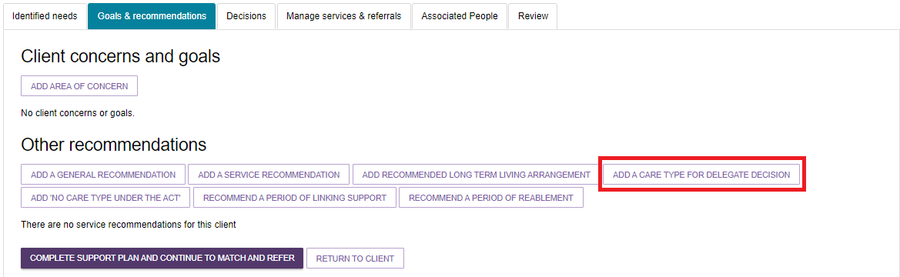

1. When STRC is selected, the STRC service subtypes **In Home/Community**, **In Home/Community and Residential Facility** and **In Residential Facility** are displayed.

Choose the appropriate subtypes, the priority of this care type and if it is for emergency care, then select **SAVE TO PLAN**. Please note if you select **Yes** to **Is this emergency care** you will also be required to enter in when the emergency care started.

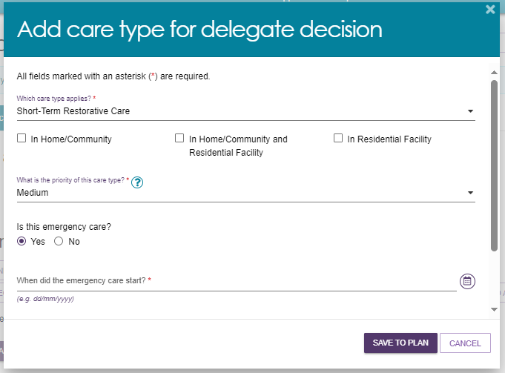

|  |  |
| --- | --- |
| ! | A client is only eligible to receive STRC under certain conditions. When reviewing an STRC approval for a client who does not meet the eligibility criteria, a warning message will appear asking if you wish to agree with the recommendation.  Image of Agree with recommendation pop out box.   When reviewing an STRC approval for a client who does not meet the eligibility criteria a warning message will appear asking if you wish to agree with the recommendation |

A complete list of the STRC eligibility criteria can be found in the [Short-Term Restorative Care Programme Manual](https://www.health.gov.au/resources/publications/short-term-restorative-care-programme-manual?language=en).

1. Once saved to the support plan, STRC will display alongside other recommendations.

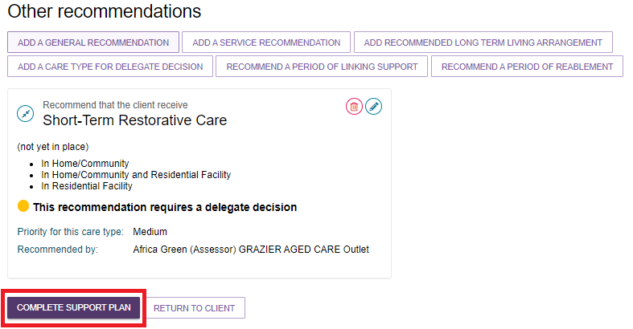

1. As with other recommendations, you may edit the recommendation by selecting the **Edit** button or remove it via the **Remove** button. Once complete, you are able to save and submit for Assessment Delegate decision.

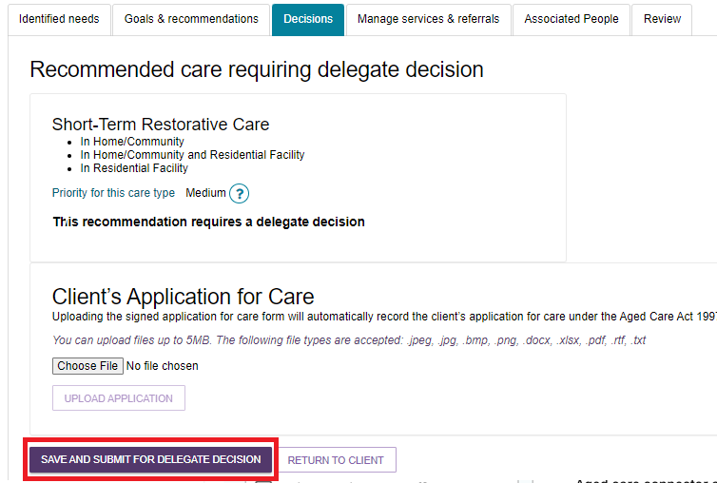

1. A pop-up will display asking you submit for delegate decision. Select **Client applied for care under the Aged Care Act 1997** and then select **SUBMIT**.

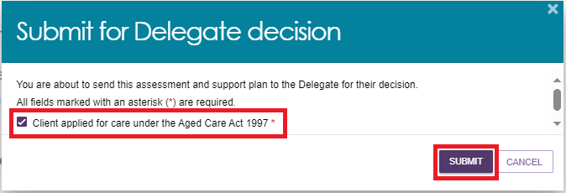

1. You will be notified that the assessment is complete and awaiting delegate action.

Screenshot of the Recommended care requiring delegate decision with banner confirming the assessment and support plan has been sent to the delegate highlighted.

 STRC recommendation and the text "this recommendation is awaiting delegate decision"

For additional support and information about the support plan process, please refer to [My Aged Care - Assessor Portal User Guide 7 - Completing a support plan and support plan review](https://www.health.gov.au/resources/publications/my-aged-care-assessor-portal-user-guide-7-completing-a-support-plan-and-support-plan-review).

## Manage services and referrals

### STRC referral process

The process for issuing referrals and generating referral codes for STRC through   
My Aged Care work in the same way as other care types under the Act (aside from home care – refer to [My Aged Care - Assessor Portal User Guide 13 - Management of Home Care Packages](https://www.health.gov.au/resources/publications/my-aged-care-assessor-portal-user-guide-13-management-of-home-care-packages)).

For additional support and information about the referral process, please refer to [My Aged Care - Assessor Portal User Guide 8 - Referring for Services](https://www.health.gov.au/resources/publications/my-aged-care-assessor-portal-user-guide-8-referring-for-services).

### Lapsing of STRC referrals

STRC referrals are automatically recalled when the client commences receiving another type of care and, as a result, they are no longer eligible to enter into an episode of STRC.

STRC referrals are also automatically recalled when the STRC eligibility end date is reached if the client has not commenced their STRC service episode.

All STRC approvals lapse six months from the day after the Assessment Delegate decision unless the client commences care before then. You can view the end date on the **Manage services & referrals** tab. It is referred to as the **Entry period end date**.

.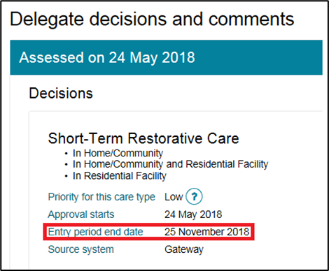

### Finding a STRC Service Provider

1. As a clinical assessor, you can find a STRC service provider in two ways:

* Going to the Home Page and then select Find a service provider;

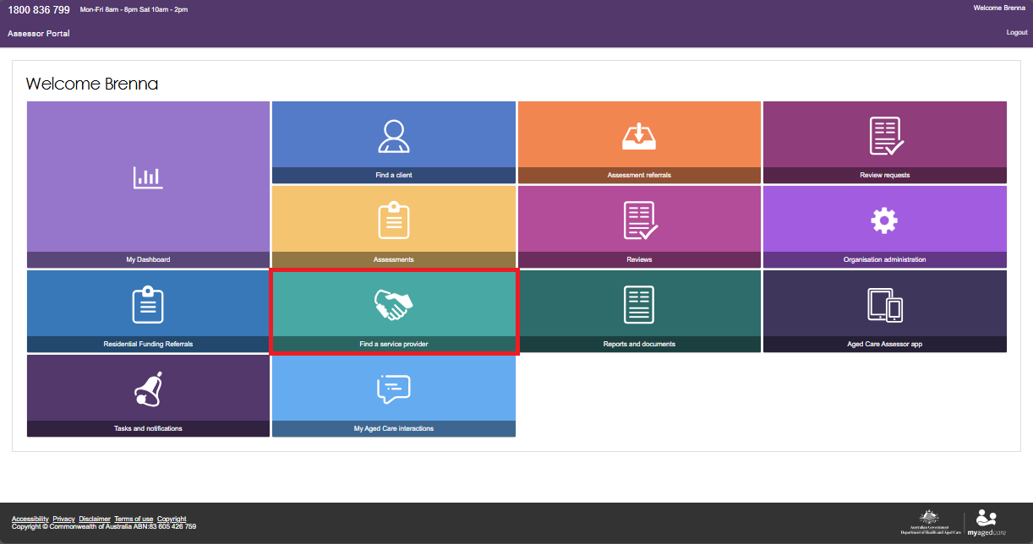

* Or, during the assessment or support plan, select Find a service provider at the top menu.

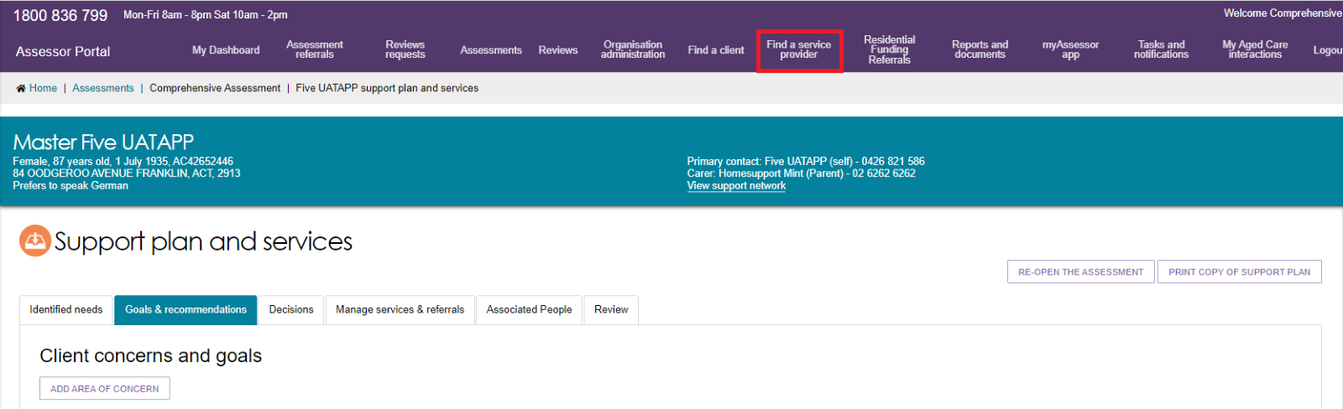

1. Select **Help at Home**, then select **Short-Term Restorative Care**.

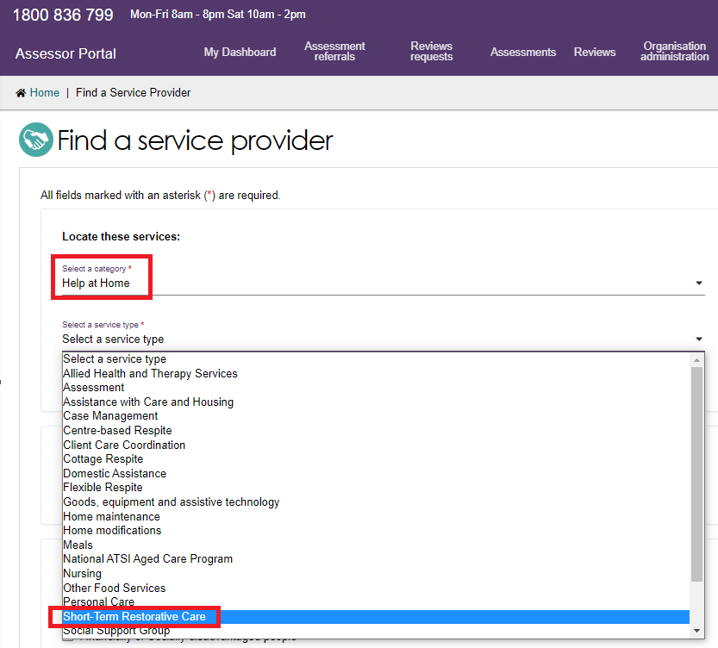

1. You will be directed to choose a service sub-type:

* In home/community
* In residential facility
* In home/community and residential facility.

Then either enter a suburb or postcode, or enter a service provider name.

Optionally you can also choose service providers that will cater for diverse needs and/or specialised services, including preferred language. Select **SEARCH**.

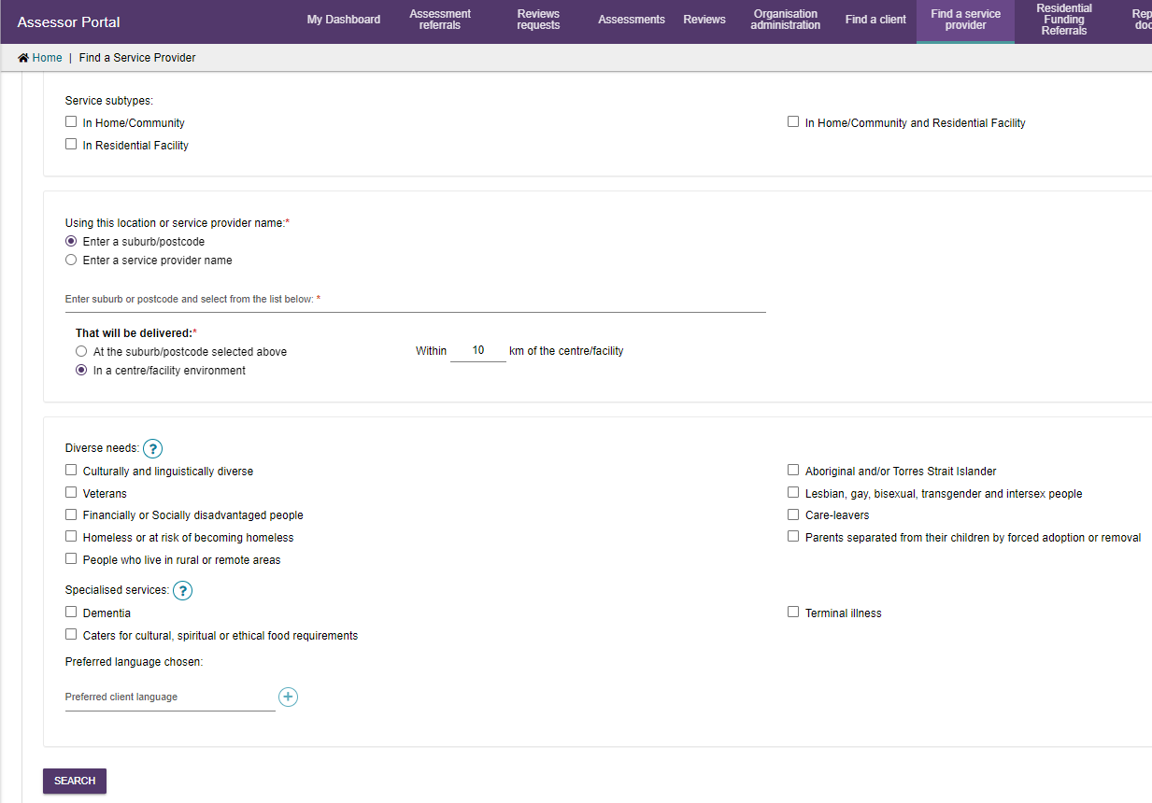

1. It will then tell you how many providers matched your criteria. Those providers will be displayed in service cards along with their location, phone number, whether services are available, whether waitlists are available, and a link to show any regulatory decisions that are made against the provider.

You can also select the double arrow icon on the top right corner to expand the service card. It will then display more information about this provider.

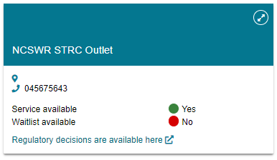

## Assessment Delegate decisions

The process for assessment delegates to make decisions about client eligibility for STRC is the same as the decision process for other care types, including if the delegate wants to add STRC as a care type. For additional support and information about the Assessment Delegate decision process, please refer to [My Aged Care - Assessor Portal User Guide 10 - Delegate processes](https://www.health.gov.au/resources/publications/my-aged-care-assessor-portal-user-guide-10-assessment-delegate-processes).

Note that when agreeing with a decision, the STRC service subtypes that have been associated with the decision are listed as a bullet point list.

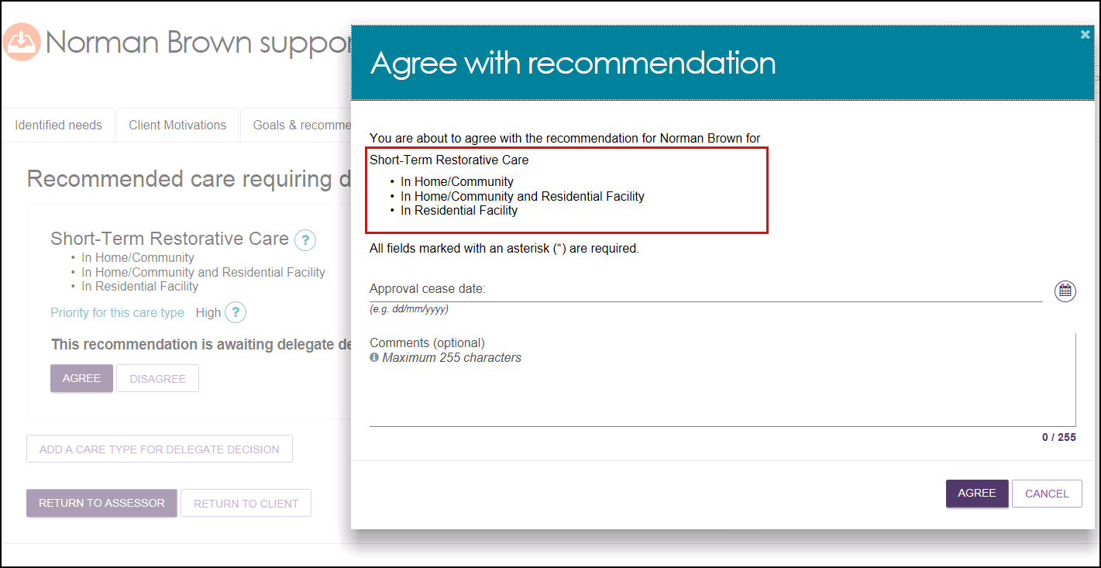

## For more information or support

Further information is available in the [My Aged Care – Assessor Portal Resources](https://www.health.gov.au/resources/collections/my-aged-care-assessor-portal-resources) and the [Information for Assessors](https://agedcare.health.gov.au/programs-services/my-aged-care/information-for-assessors) page on the department’s website.

The My Aged Care service provider and clinical assessor helpline is available by calling 1800 836 799.