# Assessor Portal User Guide 13 – Management of Home Care Packages

This user guide provides an overview of the system functionalities for assessment delegates and clinical aged care needs assessors (clinical assessors) in My Aged Care assessor portal (assessor portal).

This guide contains the following topics:

Assessor portal functions 2

For clinical assessors 2

For assessment delegates 2

For both clinical assessors and assessment delegates 2

Completing a Support Plan 2

Add a care type for delegate decision 3

Seeking Home Care services 5

Setting preference to not seeking Home Care services 6

Setting preference to seeking services 7

Notification of Home Care Package correspondence 8

Home Care Package correspondence sent to clients 10

Confirming client contact information is accurate 12

Notifications – Reporting 13

Adding a Post Office Box address 14

Package Assignment and take-up deadline extension 15

Referral for Services 16

Referral codes 17

## Assessor portal functions

### **For clinical assessors**

* Recommend Home Care at a specific package level (1, 2, 3, 4).
* Recommend priority for service.
* View system generated priority for Home Care service.
* Search for an Approved Provider using Home Care parameters (language, culture, religion, specialised services, etc.).
* Send a referral for the client.

### **For assessment delegates**

* Approve or not approve Home Care Packages at a specific level and priority for Home Care services.
* Issue an Approval or Non-Approval Letter to the client.

### **For both clinical assessors and assessment delegates**

* Capture whether or not a client is currently seeking a Home Care Package (seeking services).
* Receive notifications of Home Care correspondence as issued to clients through My Aged Care.
* Search for, and filter, notifications of Home Care correspondence.
* Generate a report at the outlet level that will display all the clients for whom the clinical assessors and Assessment Delegates have nominated to receive notifications.
* Extend response times for clients beyond the 56-day entry period by an extra 28 days.

## Completing a Support Plan

Image of the Goals and Recommendations tab highlighted in the list of tabs available in a Client Record.

The **Goals & recommendations** tab is where you will record the clients:

* areas of concerns,
* goals to address their concerns,
* any services or general recommendations, and
* any care type recommendations.

Home Care Packages are care types delivered under the Aged Care Act 1997 (the Act). If they need a delegate decision, this can be done at Add a care type for delegate decision.

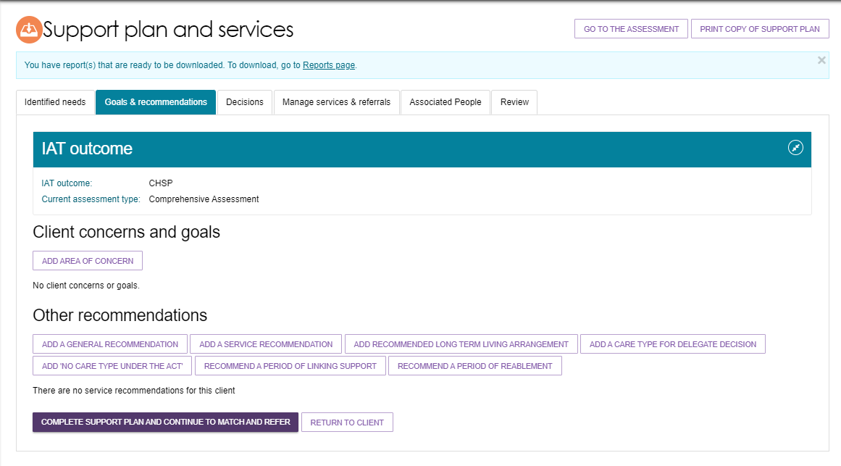

## Add a care type for delegate decision

For Home Care Packages, the **Priority of this care type** decides the **Priority for home care service**. Priority for Home Care, along with the approval date, will decide the client’s place in the National Priority System for Home Care Packages.

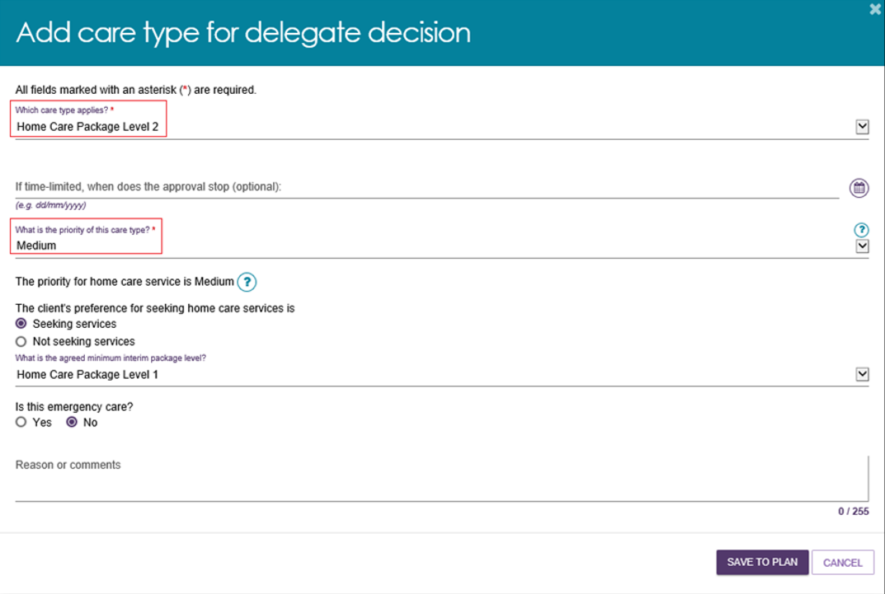

|  |  |
| --- | --- |
| **!** | If a client is under the aged of 65, several additional entry fields will appear to document their exceptional circumstances. |

The priority will default to **Medium** for Home Care Packages. For other care types needing an Assessment Delegate decision will default to the latest Priority for Assessment. Clinical assessors should continue to make change to the priority for service, as appropriate. Assessment delegates can change this priority during delegation or set a priority where a Home Care Package recommendation has been added.

The client’s preference for seeking Home Care services determines whether the client is place on the queue for a Home Care Package. This should be discussed with the client and then the appropriate answer selected from the **Add care type for delegate decision** page.

Please note, the system will default to **Seeking services**.

If a client opts to not seek services and they change their mind in the future, they will not be disadvantaged as their position in the queue will be determines by the date of their original Home Care Package approval.

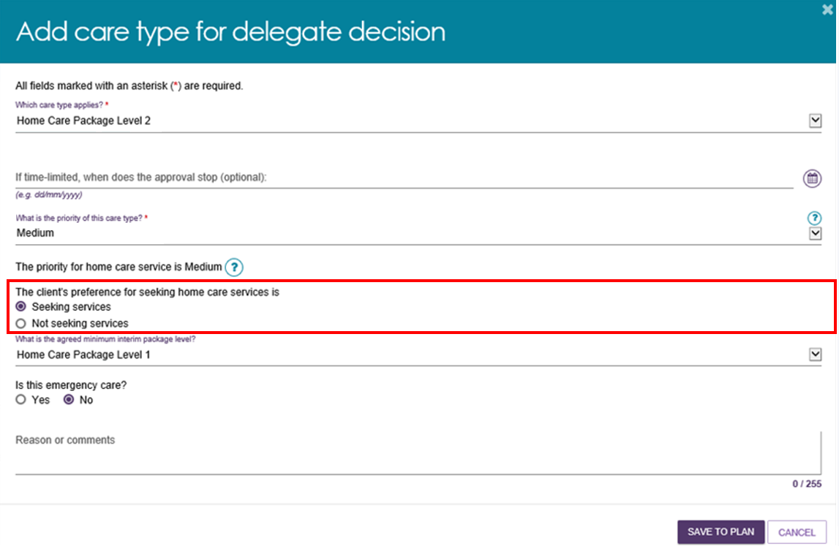

|  |  |
| --- | --- |
| ! | **Please note that interim packages are not being released at this time**. Any decision to reinstate interim packages will be communicated to clinical assessors through the regular bulletins. |

If it is determined that a client has a high priority for a Home Care Package, a reason must be selected from the reasons provided. The clinical assessor must also give further reason/comments in the comments field to further describe the reason for recommending a high priority Home Care Package.

Image of the  Add care type for delegate decision pop-out box with The client's preference for seeking home care services is highlighted.

The 'what is the priority of this care type?' is changed to 'high' it shows the additional fields that are required. These are highlighted in red. 

## Seeking Home Care services

Upon the Assessment Delegate’s approval of a Home Care Package, the client will be placed on the National Priority System for Home Care Packages. Their position in the National Priority System is determined by the approval date and priority for home care. However, they will not be assigned a package until they have indicated that they are currently seeking services.

This can be set when adding a care type for delegate decision in the support plan, and/ or modified after an approval is granted.

Home Care Package approval details and the seeking services status are shown in the client record under the **Approvals** tab.

This image shows the tab 'Approvals' it is highlighted in red.

## Setting preference to not seeking Home Care services

1. If a client is waiting for their approved Home Care Package on the National Priority System and does not wish to seek Home Care services, you can record their preference by selecting **NOT SEEKING SERVICES**.

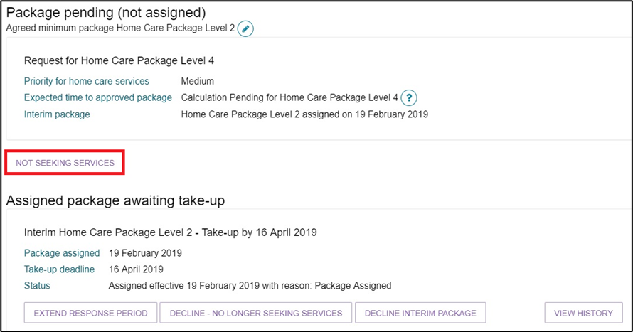

1. If selecting **NOT SEEKING SERVICES** for a package that has not yet been assigned, the following message will display.

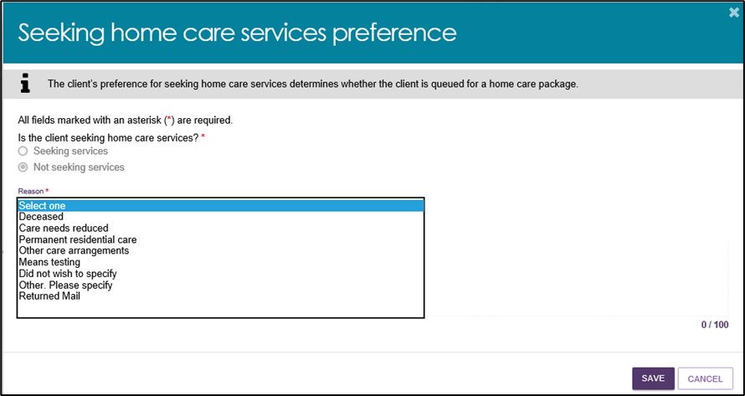

1. If a package has been assigned and the client wishes to decline, go to the **Approvals** tab and choose **DECLINE – NO LONGER SEEKING SERVICES**.

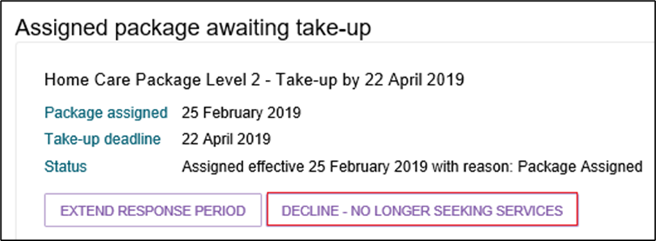

## Setting preference to seeking services

Selecting the edit button next to the current seeking service preference will bring up the following message.

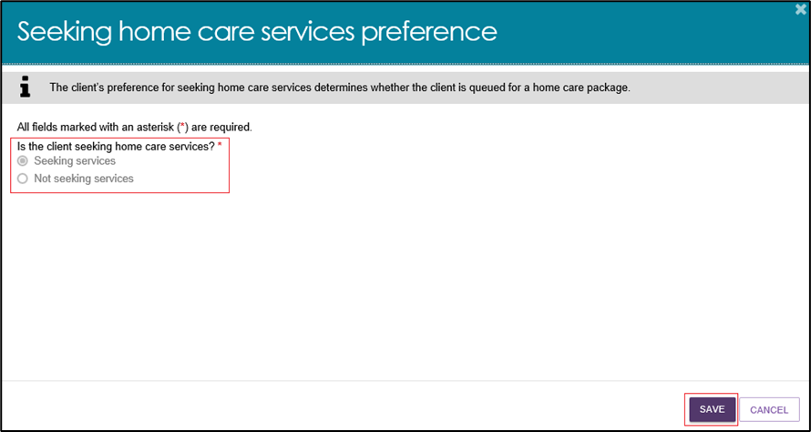

If the client has an approval for a Home Care Package, and their preference was set to **not seeking** the following message will display.

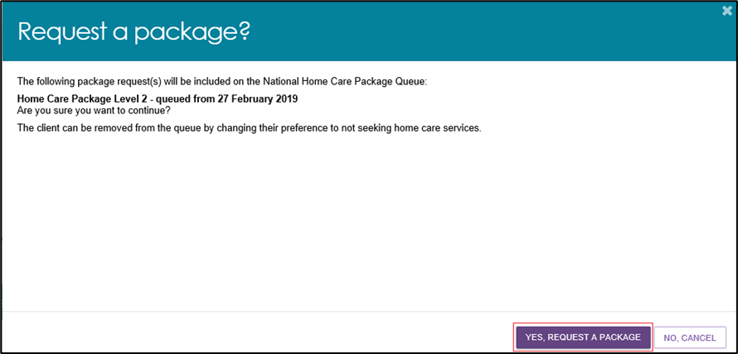

## Notification of Home Care Package correspondence

For those clients that a clinical assessor wishes to monitor more closely, clinical assessors can elect to be notified of Home Care correspondence sent to the client. This notification can be enabled from any tab in the clients support plan or on the **Approvals** tab in the client record. This option is only visible if there is a recommendation for home care.

The tab 'Request/change notification of home care correspondence' is highlighted in red. 

The notification link will only be enabled if the client has been marked as **Seeking services** or a Home Care Package recommendation has been made. This is also available when viewing Home Care Approvals in the client record, as shown below.

Image of the Home care section with Notify of home care correspondence highlighted.

For those clients that an assessor wishes to monitor more closey, assessors can elect to be notifies of home care correspondence sent to the client. 

Only one person from an outlet can be selected to receive this notification. The preference is shown below. All clinical assessors and assessment delegates from the assessment outlet will be displayed in a drop-down menu.

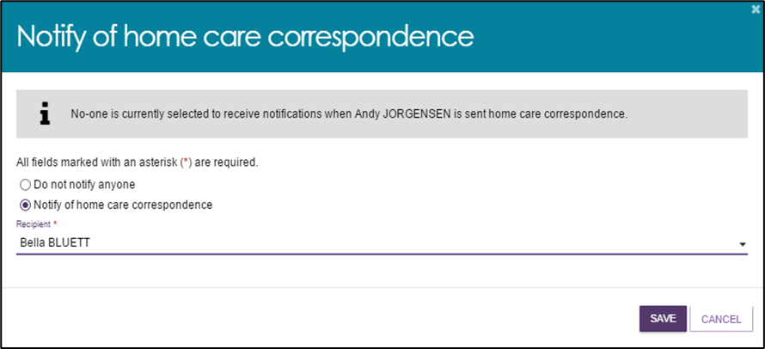

*Team Leader role*

In the team leader role, you can view which clinical assessor or Assessment Delegate is currently receiving the client’s Home Care Package correspondence notifications. You will also have the ability to reassign a client or an individual or make bulk reassignment changes to a different clinical assessor or Assessment Delegate in an outlet.

1. In the **Tasks and Notifications** tab select **HCP Notifications** tab. If you manage more than one outlet you may choose which outlet to view from the dropdown.

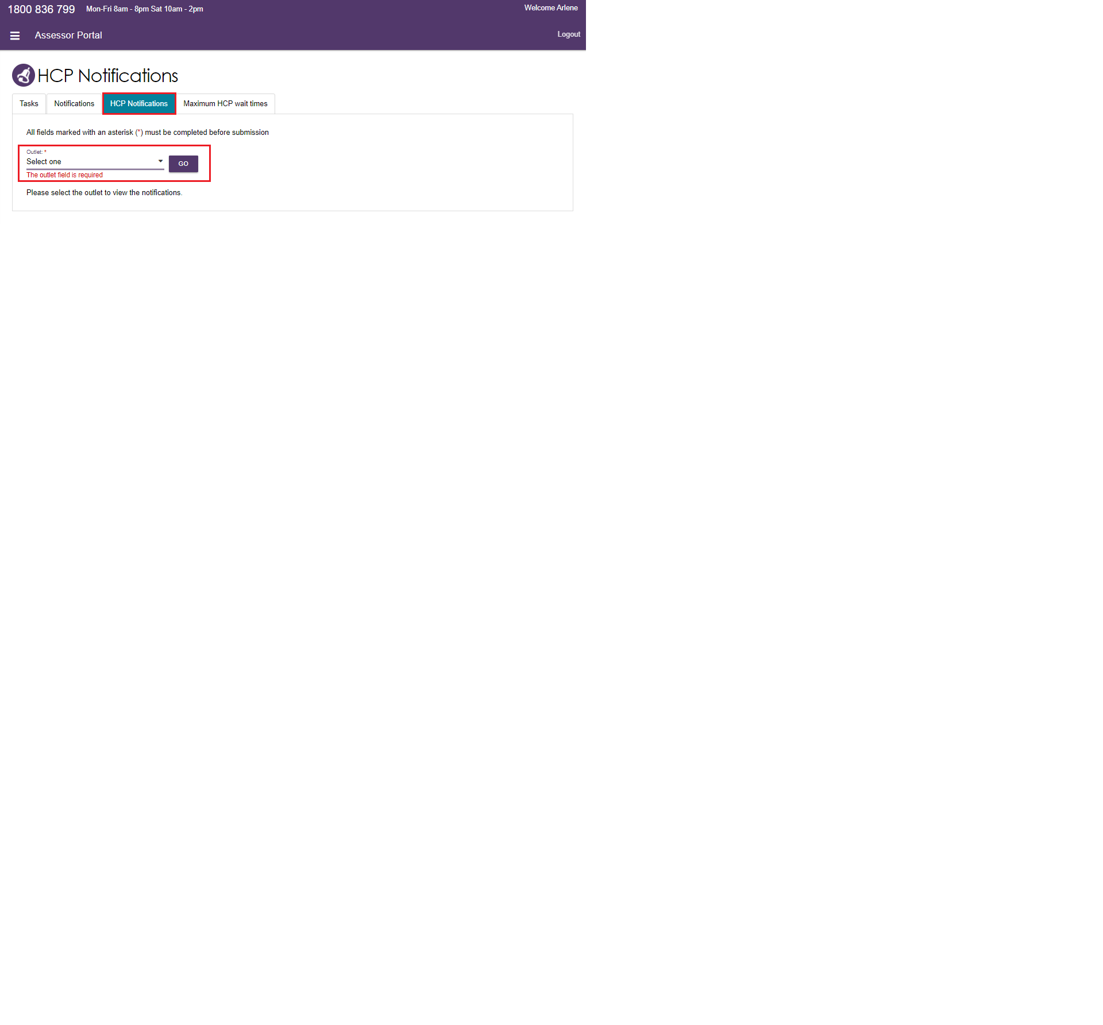

1. Once you have chosen the outlet to view you will see the following details:

* Last Name
* First Name
* Aged Care User ID
* Locality
* Who receives the notification (First name, Last name)
* The last column is a select tick box which allows the team lead to complete individual or bulk reassignments.

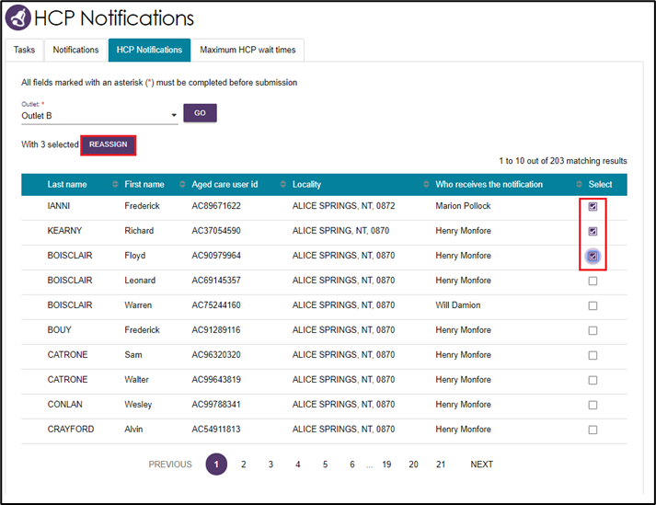

1. By clicking the **REASSIGN** button, the **Re-assign Home Care correspondence notifications** pop-up will be displayed where you can select the new recipient and finalise by clicking the **SAVE** button.

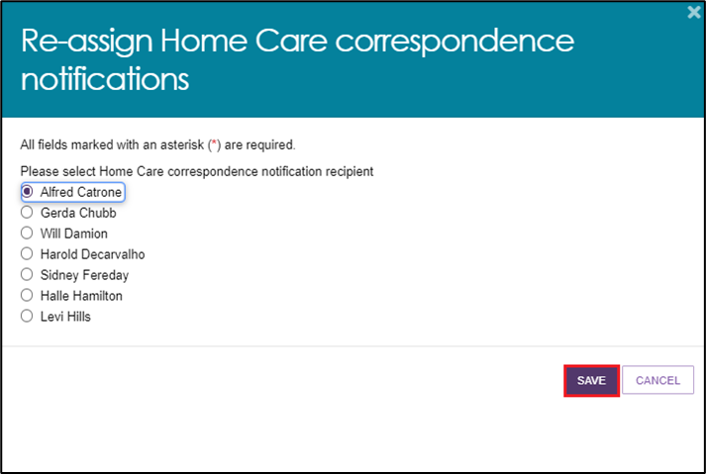

## Home Care Package correspondence sent to clients

There are a number of letters sent to clients related to their Home Care Package at different stages. Copies of these letters will also be sent to their representative/s.

Types of HCP correspondence and content

| Correspondence | Content |
| --- | --- |
| Package Assignment Notice | Client assigned a Home Care Package.  Your client (Aged Care User ID), has been assigned a Home Care Package by My Aged Care.  Package assignment – You’ve been assigned a level Home Care Package. |
| Extend Response Confirmation | Client has been granted a 28-day extension to enter a Home Care Agreement.  Your client (Aged Care User ID), has been granted an extension and now has until <Package Expiry Date + 28 days> to enter into a Home Care Agreement.  You recently asked for more time to find a home care provider and enter into a Home Care Agreement. I am pleased to advise that you have been given an extension and now have until XX XX 202X to enter into a Home Care Agreement. |
| Seeking Service Confirmation | Client is now seeking home care services.  Your client (Aged Care User ID), is now seeking Home Care services.  Thank you for advising My Aged Care that you need a Home Care Package.  I am pleased to tell you that you have now been placed in the National Priority System and will be sent a letter when a package is assigned to you. Your place in the National Priority System is based on when you were approved for home care and the priority you have been assigned. |
| Package Reinstatement | Your client (Aged Care User ID), has had their assigned Home Care Package reinstated by My Aged Care.  We recently wrote to you about your Home Care Package being withdrawn.  I am pleased to advise that your home care provider told us that you entered into a Home Care Agreement by the required date so your Home Care Package is still in place. |
| Upgrade Notice or Upgrade Notice (consecutive) | Client assigned a higher level home care package.  Your client (Aged Care User ID), has been assigned a higher level Home Care Package by My Aged Care.  You are receiving a level <Previous Assigned Package Level> Home Care Package, but I am happy to advise you that a higher level Home Care Package is now available, to offer you more support to remain living at home.  You have now been assigned a Level X Home Care Package allowing you to receive additional services.  **Upgrade Notice (consecutive)** –  I am happy to tell you that a higher Level Home Care Package is now available to offer you more support to remain living at home.  You have now been assigned a Level X Home Care Package. If you have not already done so, you now have until XX XX 202X to enter into a Home Care Agreement.  Less than approved level - Your Home Care Package level has increased. You have now been assigned a level <Assigned Package Level> Home Care Package. This package lets you receive additional services while you stay on the national priority system for a level <Approved Package Level> package. |
| Withdrawal Notice | Client’s Home Care Package withdrawn.  Your client (Aged Care User ID), has had their Home Care Package withdrawn by My Aged Care.  You were assigned a level <Withdrawn Package Level> Home Care Package on <Withdrawn Package Assignment Date>.  Residential care - Your package was withdrawn because you are receiving residential care.  Lapsed approval - Your package was withdrawn because your approval for a Home Care Package was only valid until <Home Care Expiry Date>.  Services not commenced - You needed to have chosen a home care provider and entered into a Home Care Agreement by <Withdrawn Package Expiry Date>.  Services not recommenced - You recently stopped your Home Care Package with <provider name> on <date>.  You needed to have chosen a home care provider and entered into a Home Care Agreement by <Withdrawn Package Expiry Date>.  Assignment declined - You recently told My Aged Care that you no longer want a level <Withdrawn Package Level> Home Care Package. As a result:   * Your level <Withdrawn Package Level> package has now been withdrawn * your client record has been changed to show that you are not seeking services * you have been removed from the Home Care Package national priority system. |
| Referral code reactivation | Client’s referral code has been reactivated.  You recently asked for your referral code to be reactivated. I am pleased to advise that your referral code has now been reactivated and can be used to change your home care provider. |
| All | Full details are contained in the client letter which will typically be available within 24 hours. The letter can be accessed from the Attachments tab in their client record. |

## Confirming client contact information is accurate

To ensure correspondence is received, the client’s address details need to be correct. This is particularly important for Home Care Package clients as they have 56 days in which to enter a Home Care Agreements, with an additional 28 days if required. To view and edit client’s contact details within the assessor portal follow the below instructions.

1. From the client card, select **Client Details**.



1. At the bottom of the client details page, select the **pencil (edit) icon** to then edit the client’s home and/or correspondence address.

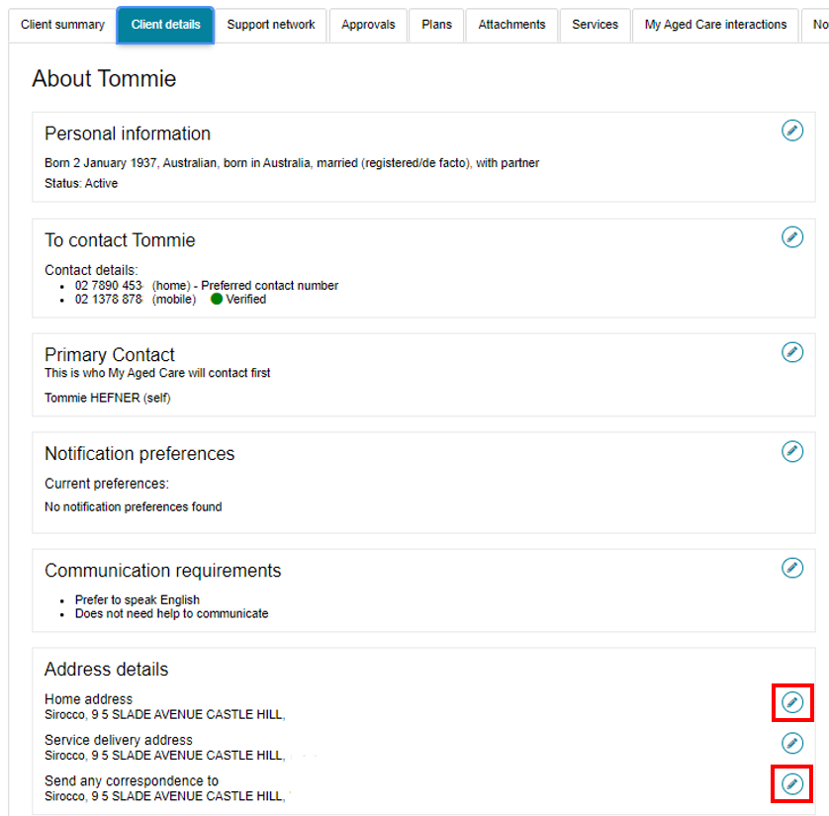

For more information on the processes for viewing, actioning and managing your tasks and notification preferences, refer to the [My Aged Care - Assessor Portal User Guide 9 - Tasks and Notifications](https://www.health.gov.au/resources/publications/my-aged-care-assessor-portal-user-guide-9-tasks-and-notifications).

## Notifications – Reporting

Clinical assessors and assessment delegates and are able to create a report at the outlet level. The report will display the list of clients who have been nominated either by clinical assessors or assessment delegates and wish to receive notifications related to Home Care.

1. This report is accessed in **Reports and documents** tab.

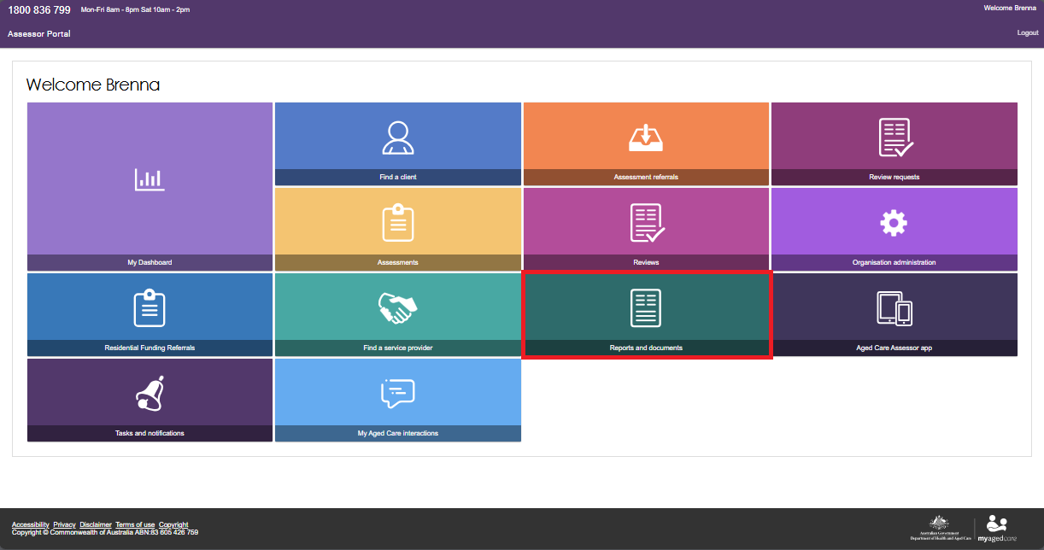

1. Select the **BIP Home Care Correspondence Notifications Report**.

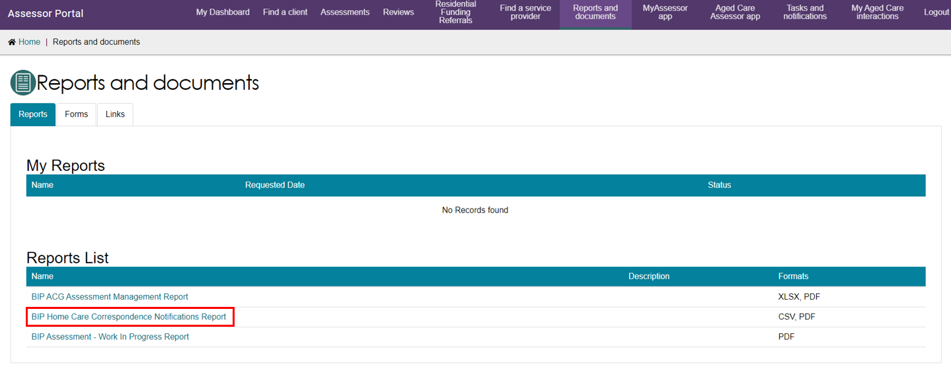

1. Select the **Outlet**, **Recipient** and **Output Type** being either CSV file (comma separate values) or PDF (portable document format).

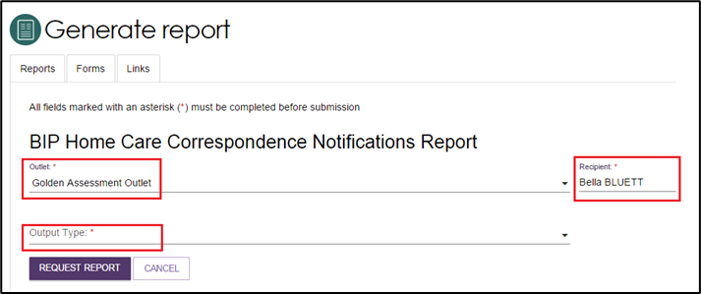

## Adding a Post Office Box address

Clinical assessors and assessment delegates and have the ability to add a Post Office Box address to a client record as the preferred address for all correspondence.

1. This is completed on the **Client details** tab in the client record.



1. Select the edit icon next to **Send any correspondence to**.

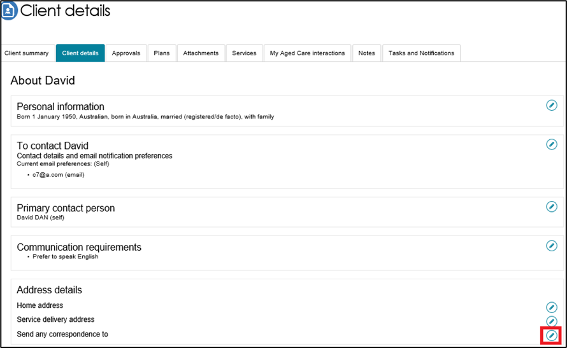

1. Select **Postal address**.

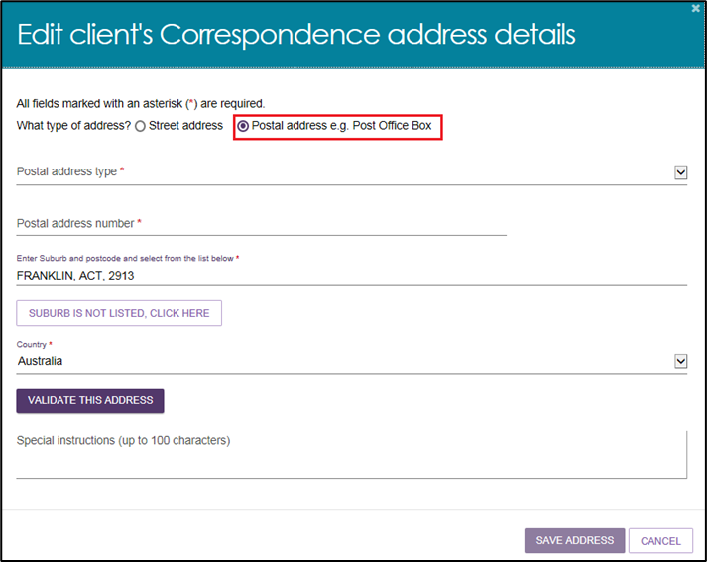

## Package Assignment and take-up deadline extension

A client has 56 days from the package assignment date in which to enter care before their package is withdrawn. For clients that have not yet entered into care, a clinical assessor or Assessment Delegate may extend the response period by selecting the **EXTEND RESPONSE PERIOD** button in the **Approvals** tab of the client record. This will give the client an additional 28 days to enter care before the package is withdrawn. This option cannot be selected if a package has already been withdrawn.

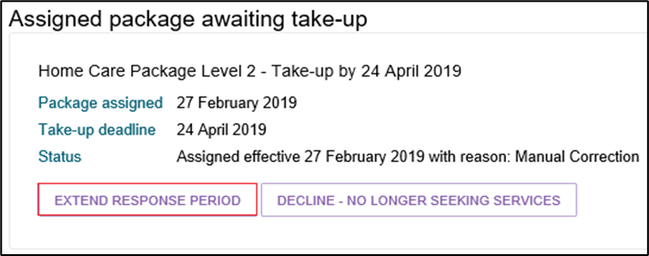

## Referral for Services

For Home Care Package recommendations, you will be able to match and refer for service when the client has been assigned a package from the National Priority System. On assignment of a package, a referral code is generated, and a letter is sent to the client, with a copy to their representative/s, instructing them that they can use the referral code to seek services prior to the take-up deadline.

If the client and/or their representative has elected to receive email notifications, they will also receive an email notification on assignment of a package.

For more information about setting up and configuring email notifications for clients and/or their representatives, refer to [My Aged Care - Assessor Portal User Guide 2 - Registering support people and adding relationships](https://www.health.gov.au/resources/publications/my-aged-care-assessor-portal-user-guide-2-registering-support-people-and-adding-relationships).

1. If you have elected to receive notification of home care correspondence for the client, you will receive a notification of this and you can proceed to matching and referral if you wish. All electronic referrals should be issued in the client’s support plan under **Manage services & referrals**.

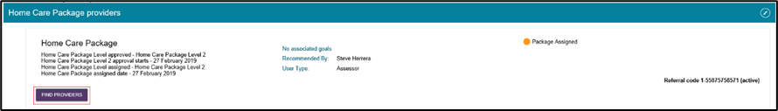

1. Select the **FIND PROVIDERS** button to search for Home Care providers. For Home Care Packages, you are able to search for service providers by specific Home Care service attributes including Diverse needs, Specialised services, Languages, and Cultural and Religion. This can be done by selecting Advanced search when selecting a service provider.

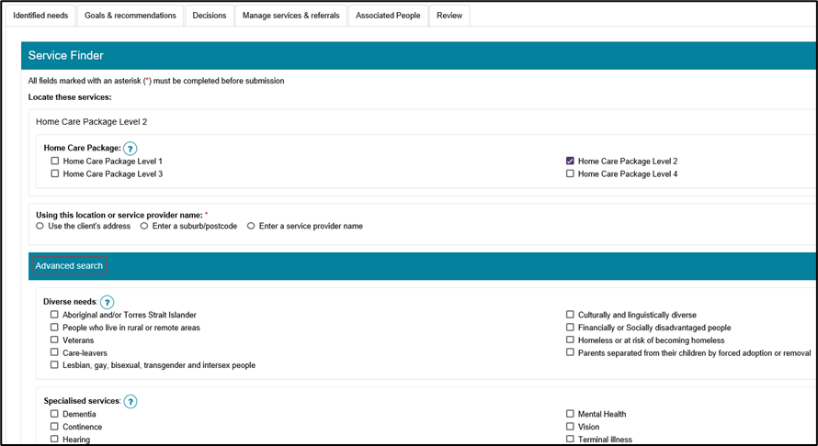

1. Any providers that offer verified Diverse Needs specialisations, as well as any cultural specialisations and specialised services, will be shown under the Specialisations section of the Service Finder listing.

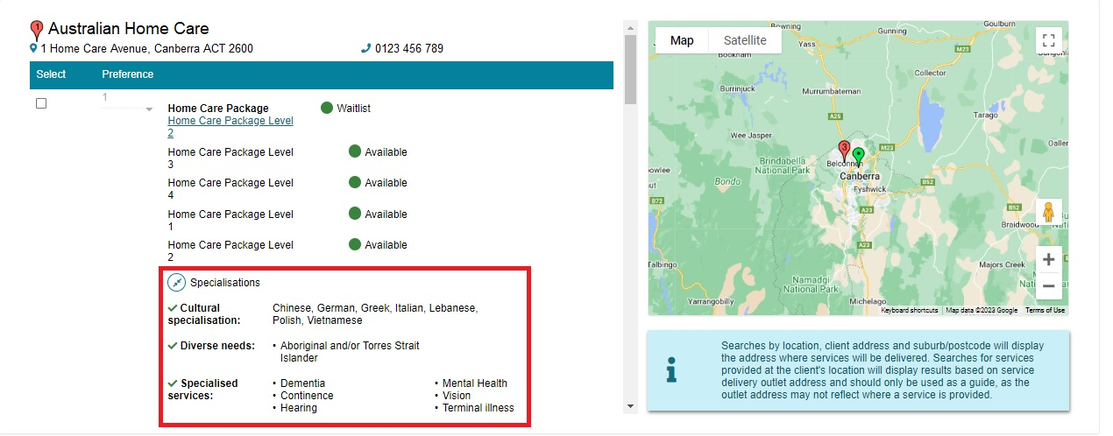

For more information on sending referrals, see [My Aged Care - Assessor Portal User Guide 8 - Referring for services](https://www.health.gov.au/resources/publications/my-aged-care-assessor-portal-user-guide-8-referring-for-services), available on the departments website.

### Referral codes

A client can change providers without changing their referral code.

Against a Home Care Package in **Manage Services & Referrals** you will see a status displayed next to the referral code. This could be one of the following:

* **Active** – a client is assigned a Home Care Package and the referral code is able to be used.
* **Used** – an old referral code for a previous approval that can no longer be used by the client or the service provider for referrals.
* **Inactive** – this status will display if a client has notified that they are not seeking services and/or has had an assigned Home Care Package withdrawn and not replaced or upgraded.
* **Disabled** – this status will display once a service referral is accepted. The referral code is disabled and unable to be used by other providers until it is reactivated.

If a client wishes to reactivate their referral code, for example they might be changing providers, a client or representative can do this via the My Aged Care online account or by contacting the My Aged Care contact centre. Clinical assessors can also perform this function in the **Manage Services & Referrals** tab of the support plan. The following screenshots demonstrate the reactivation of the referral code.

