# Assessor Portal User Guide 10 – Clinical Assessment Delegate Processes

This user guide is to assist Clinical Assessment Delegates in performing and range of functions in the My Aged Care assessor portal (assessor portal) that relate to delegate decisions. This includes viewing and actioning delegate decisions, as well as requesting corrections to care approval decisions and care extensions.

Clinical Assessment Delegates have been introduced ahead of the changes under 1 July 2025, where Non-Clinical Assessment Delegates will be required to approve the provision of entry-level aged care services under the Aged Care Act 2024. Note that Non-Clinical Assessment Delegates do not have any system functionality prior to 1 July 2025.

This user guide contains the following topics:

The Clinical Assessment Delegate home screen 2

Assessment history 2

Viewing an item for decision 3

Assigning an item for decision 6

Reassigning an item for decision 8

Recording a delegate decision 9

Return to a clinical assessor 10

No Decision 11

Agreeing with recommendations 11

Disagreeing with recommendations 13

Editing a recommendation 16

Adding a care type 18

Changing a decision 19

Finalising your decision 20

Printing the approval/non-approval letter 23

Requesting correction to care approval decision 25

Requesting and Approving Care Extensions 33

## The Clinical Assessment Delegate home screen

If you are both a clinical aged care needs assessor (clinical assessor) and a Clinical Assessment Delegate in the Assessor portal, your home screen will look like the following.

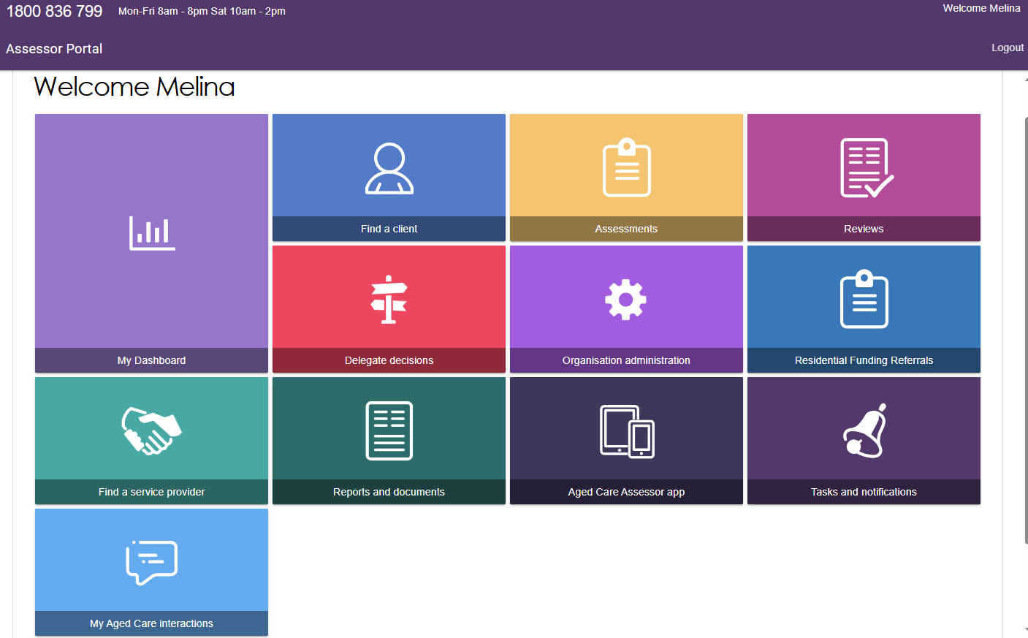

For more information regarding applying to be a Clinical Assessment Delegate please refer to the [My Aged Care Assessor Portal User Guide 12 – Managing Delegate Roles](health.gov.au/resources/publications/my-aged-care-assessor-portal-user-guide-12-managing-delegate-roles).

## Assessment history

To assist Clinical Assessment Delegates with understanding and actioning delegate approvals, Clinical Assessment Delegates can view a client’s assessment history via the **Plan** tab of the client record. Within the **Assessment history** section it will outline key information such as if the assessment has been completed by a non-clinical needs assessor who then converted the assessment from a home support assessment to a comprehensive assessment, as well as the details of the clinical supervising assessor.

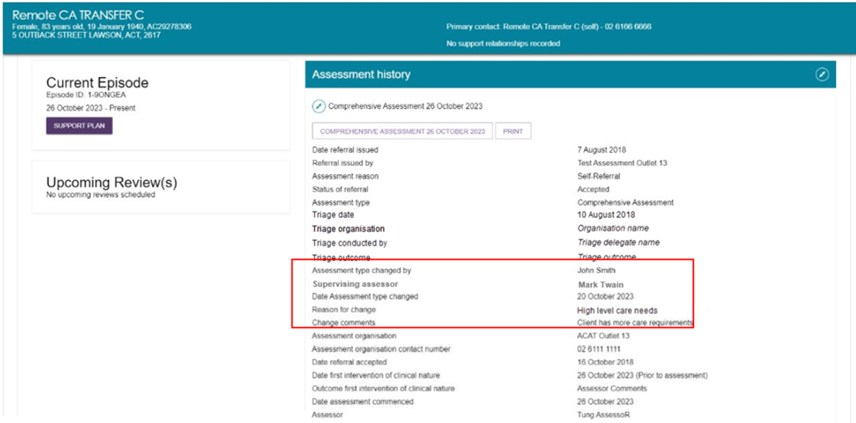

## Viewing an item for decision

As a Clinical Assessment Delegate, , follow the steps below to assign items for decision.

1. Select **Delegate decisions** from the homepage.

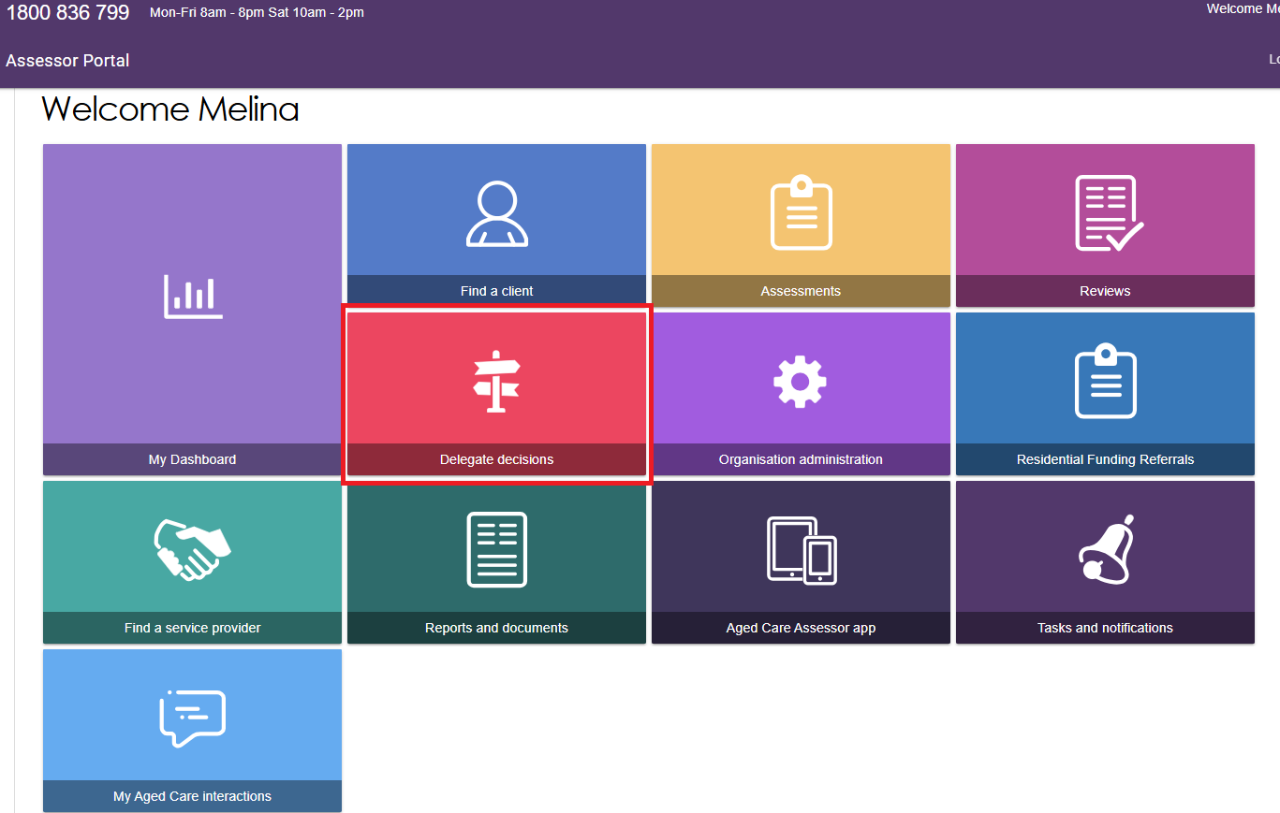

1. The queue containing assessments awaiting Clinical Assessment Delegate decision will be displayed in the **Decision pending** tab.

You can use the filter options (First Name, Last Name, and Aged Care User ID) to refine your results. To show additional filter options select **Advanced Search**.

You can also use the sort function to sort by assessment status, as well as other categories such as last name, first name, Aged Care ID, date submitted, priority, assessor and delegate names and due date. The order in which the results are displayed can also be set.

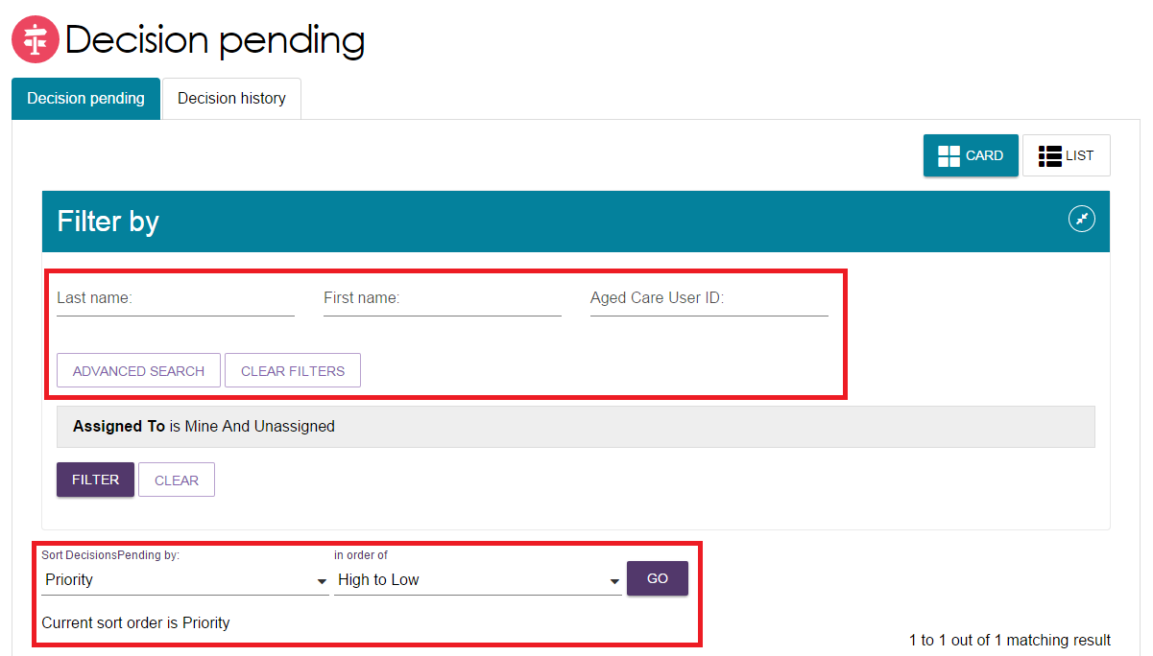

1. The due date against each assessment waiting for delegate decision will be visible to the Clinical Assessment Delegate in both the Card and List View. The pending decisions can be sorted and filtered by date due.

Image shows the Decision pending tab with the Date due column highlighted.

The due date against each assessment waiting for delegate decision will be visible to the delegate in both the Card and List View. The pending decisions can be sorted and filtered by date due.

1. On this page is also the **Decision history** tab, which will display decisions that you have made previously.

**Image shows the Decision history tab.

On the Delegate decisions tab (also the ‘Decision history’),it displays the decisions that has been made previously. **

1. For both the **Decision Pending** and the **Decision History** tabs, you are able to toggle between the card view and the list view (shown below) to display the clients.

Image shows the Decision pending tab with Card and list view buttons highlighted.

For both the ‘Decision Pending’ and the ‘Decision History’ tabs, you are able to toggle between the card view and the list view (shown below) to display the clients. 

## Assigning an item for decision

To assign a client to yourself:

1. If using the card view, select the expand arrows on the Client card to display a summary of the client’s information in a pop-up. Select **ASSIGN** to allocate that item to yourself or to another Clinical Assessment Delegate within the team.

Image shows how the a client card
can be selected by selecting the expand arrows on the Client card.  Th client’s information will appear in a pop-up. Select ‘Assign’ to allocate that item to yourself or to another Delegate within the team.


1. If using the list view, select the expand arrows for the client to display a summary of the client’s information in an expanded view. Select **ASSIGN** to allocate that item to yourself or to another Clinical Assessment Delegate within the team.

Image shows Decision pending tab with edit button highlighted.

If using the list view, select the expand arrows for the client to display a summary of the client’s information in an expanded view. Select ‘Assign’ to allocate that item to yourself or to another Delegate within the team. 

Image shows ASSIGN button highlighted.

If using the list view, select the expand arrows for the client to display a summary of the client's information in an expanded view. Select 'Assign' to allocate that item to yourself or to another Delegate within the team.

1. In the pop-up box, select an Clinical Assessment Delegate, and select **ASSIGN**.

Image shows Assign delegate decision for client with Assign to Me and ASSIGN button highlighted.

When a pop-up box appears, select a Delegate, and select ‘Assign’. 

1. A confirmation message will appear. The client will appear in the queue of the Clinical Assessment Delegate they were assigned to.

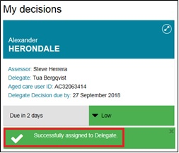

## Reassigning an item for decision

To reassign an item for decision, follow the steps below.

1. Select the expand arrow on the **Client card** to display a summary of the client’s information. Select **REASSIGN**.

Image shows client card with REASSIGN button highlighted.

To reassign an item for decision, follow the steps:  1. Select the expand arrow on the ‘Client card’ to display a summary of the client’s information. Select ‘Reassign’


If using the list view, select the expand arrow next to the client’s name to see more information, and select **REASSIGN**.

Image shows REASSIGN button highligted

If Using the list view, select the expand arrow next to the client’s name to see more information, and select ‘Reassign’. 

1. Nominate another Clinical Assessment Delegate to assign the item to, or select the option **Place back in delegate queue** if you want to un-assign it. Select **REASSIGN**.

Image shows Re-assign delegate decision for client pop up box with options to re-assign and RE-ASSIGN button highlighted.

Nominate another Delegate to assign the item to, or select the option ‘Place back in delegate queue’ if you want to un-assign it. Select ‘Re-assign’.

You will receive a confirmation message that you have either re-assigned or un-assigned the queue item.

Image shows green banner with tick and text 'Delegate successfully unassigned."

You will receive a confirmation message that you have either re-assignedassigned or un-assignedassigned the queue item. 

## Recording a delegate decision

Prior to making any delegate decisions you must view the entire client record, assessment and support plan and attached information to ensure you have all the necessary evidence to support your decisions. The assessment summary prepared by the clinical assessor can be accessed through the **Identified needs** tab of the support plan.

To record your delegate decision, follow the steps below.

1. From the **Decision pending** tab, select the expand arrow on the Client card to display a summary of the client’s information. Select **START DECISION PROCESS**. If using list view, this option is available from the expanded client information section. Select **START DECISION PROCESS** in the pop-up box.

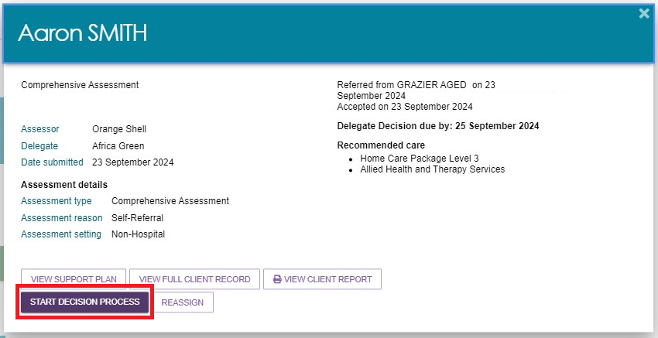

1. You will be taken to the **Decisions** tab on the client’s support plan. The recommendations made by the clinical assessor will be displayed for your review.

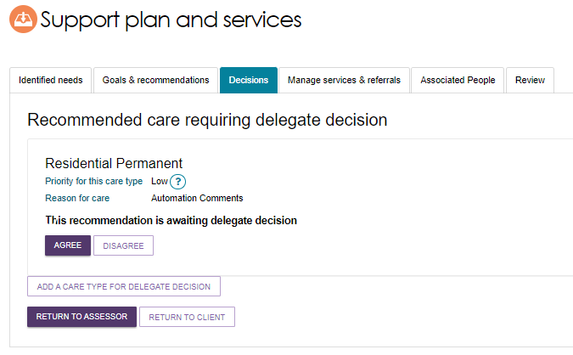

For **High** priority Home Care Package recommendations, you should review the reasoning provided by the clinical assessor and make an independent determination as to whether the priority given for the recommendation is appropriate.

As an Clinical Assessment Delegate, you can:

* Agree with a recommendation
* Disagree with a recommendation
* Edit a recommendation (edit and/or add Emergency Care Indicator and dates, priority and time-limitation of approval etc)
* Add a care type for Delegate decision (these will be automatically agreed to)
* Remove a care type
* Change your decision prior to finalisation (if you need to change from agree to disagreed, or disagreed to agreed)
* Select to be notified of any home care correspondence for a client that you have approved for home care and may need monitoring going forward (note that only one person from your outlet can receive these notifications).

## Return to a clinical assessor

There are circumstances in which you may wish to send the client back to the clinical assessor . For example:

* more evidence is required,
* the care level is not appropriate or sufficient,
* and/or amendments (e.g. to correct spelling errors) need to be made.

By selecting **RETURN TO ASSESSOR**, the original clinical assessor is able to make necessary changes before re-submitting for decision.

Note that you only have the option to return the assessment to the clinical assessor prior to agreeing or disagreeing to any recommendations. If you select **RETURN TO CLIENT** you will navigate back to the client’s record.

Image of buttons on the page with RETURN TO ASSESSOR button highlighted.

There are circumstances in which you may wish to send the client back to the assessor. For example, you need more evidence, the care level is not appropriate or sufficient, and/or amendments (e.g. to correct spelling errors) need to be made. By selecting ‘Return to Assessor’, the original assessor isis able to make necessary changes before re-submitting for decision. Note that you only have the option to return the assessment to the assessor prior to agreeing or disagreeing to any recommendations.

## No Decision

For the following scenario, Clinical Assessment Delegates will not need to make decisions for clients where **No Care Approval** is recommended.

An clinical assessor can recommend and match and refer a client for Commonwealth Home Support Programme (CHSP) services and finalise the support plan without needing to submit to the Delegate for decision if the client:

* Withdraws their application for care but is eligible for CHSP services; or
* Does not wish to apply for care under the Act but would like to receive CHSP services.

## Agreeing with recommendations

1. To agree with the clinical assessor’s recommendation, select **AGREE** below the recommended care type. You will need to repeat this process for each care type where multiple care types recommended.

Image of Decision tab with Recommended care requiring delegate decision and the AGREE button highlighted.

To agree with the assessor’s recommendation, select ‘Agree’ below the recommended care type. 

1. You will be asked to confirm that you agree with the recommendation in a pop-up box. If required, you can enter an approval cease date, and add comments. Select **AGREE**’.

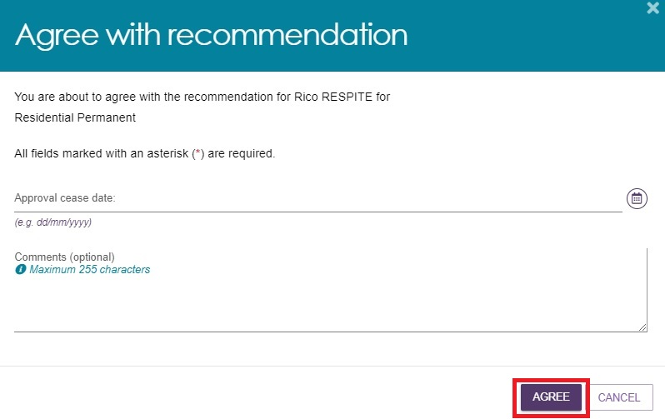

1. If required, you are now able to set an **approval cease date for Permanent Residential Care** through the assessor portal.

A confirmation message will display, and the status of the recommendation will display as **Agreed**.

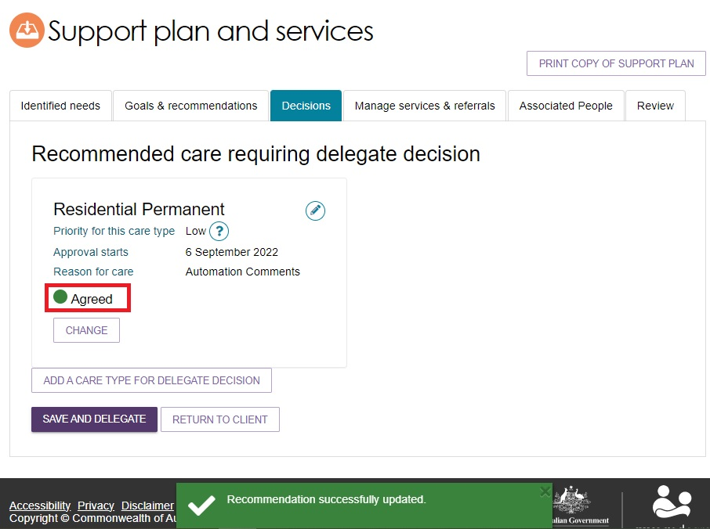

1. A client is only eligible to receive **Short-Term Restorative Care (STRC)** under certain conditions. When reviewing an STRC approval for a client who does not meet the eligibility criteria a warning message will appear asking if you wish to agree with the recommendation.

Image of the Agree with recommendation pop up.

Pop up that appears to allow the delegate to agree with the recommendation made by the assessor. 

For more information about STRC, refer to the [Short-Term Restorative Care Programme Manual](https://www.health.gov.au/resources/publications/short-term-restorative-care-programme-manual) and the [My Aged Care – Assessor Portal User Guide 14 – Short-Term Restorative Care](https://www.health.gov.au/resources/publications/my-aged-care-assessor-portal-user-guide-14-short-term-restorative-care).

## Disagreeing with recommendations

Disagreeing with a recommendation will result in a non-approval of that recommended care type.

If a recommendation is mistakenly added by the clinical assessor, the Clinical Assessment Delegate can:

1) disagree with the clinical assessor’s recommendation, then

2) add their own recommendation.

The disagreed recommendation remains visible at the client’s **Decisions** tab. It can be edited but not deleted.

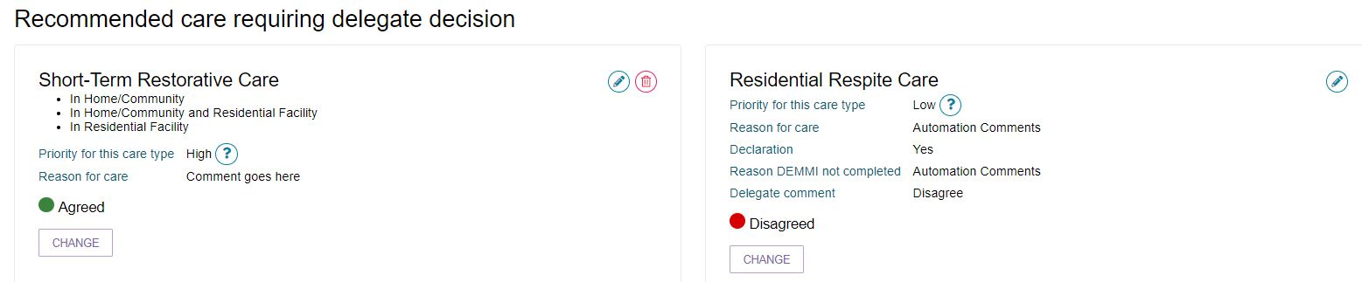

Follow the steps below to disagree with a recommendation.

1. Select **DISAGREE** below the recommended care type. You will need to repeat this process for each care type that you disagree with.

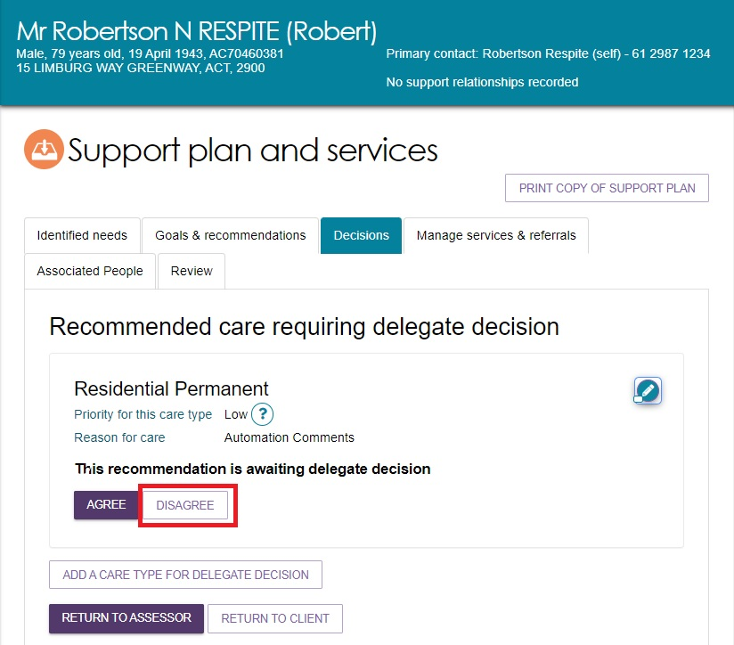

1. You will need to provide a comment about your reason for disagreeing with the recommendation, then select **DISAGREE**.

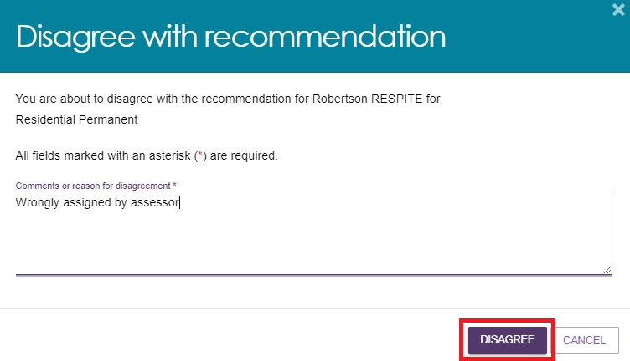

1. A confirmation message will display, and the status of the recommendation will change to **Disagreed**.

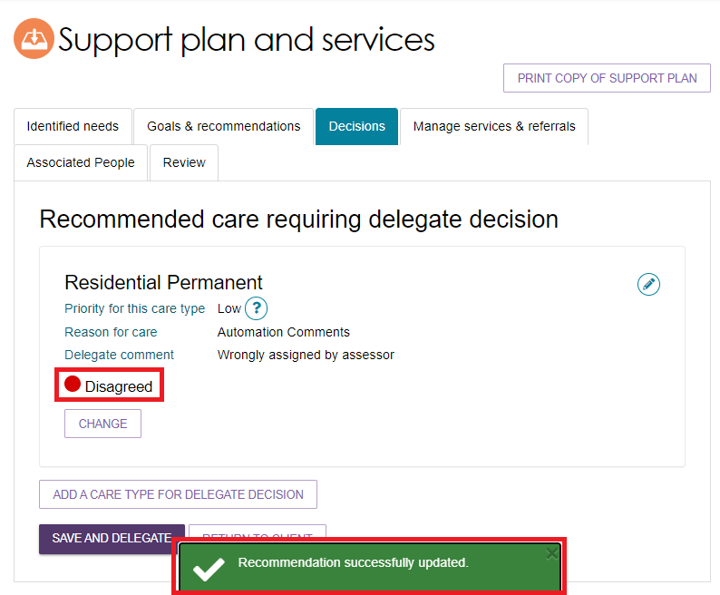

1. If you need to change your decision, you can select **CHANGE**. This option will only be available prior to saving and completing the approval process by selecting **Save and Delegate**. See the Changing a Decision section for more details.

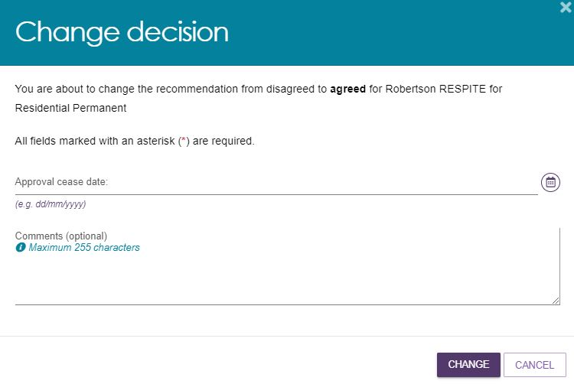

1. If you disagree with all recommendations and you do not add any new approval decisions, you may be prompted to select “No Care Approval” as a service type during the **Save Decision and Delegate** pop-up in order to complete the delegate decision.

Go to Adding a Care Type for more information.

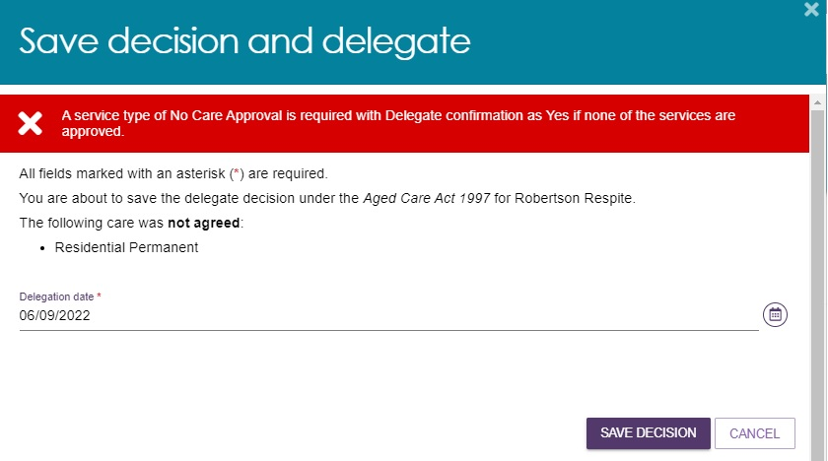

## Editing a recommendation

1. To edit a care type or level of care recommended by a clinical assessor, select the **Edit** icon.

Image of a recommendation with the edit button highlighted.

To edit a care type or level of care recommended by an assessor, select ‘Edit’. 

1. The care type information will be displayed and you will be able to make any changes required. Select **SAVE TO PLAN** to save the changes.

Image of the Edit a care type pop up box with SAVE TO PLAN highlighted.

The care type information will be displayed and you will be able to make any changes required. Select ‘Save to plan’plan’p to save the changes. 

1. You can also change the care type/ level through the edit functionality.

To change a Home Care Package level, you will need to choose a reason for the change. When changing the priority to **High**, you will also need to choose a reason from the options that appear on why the client requires a high priority for home care and provide comments below.

Image shows Edit a care type pop up box with priority level options highlighted.

You can also change the care type/ level through the edit functionality. Please note that to change a Home Care Package level, you will need to choose a reason for the change. When changing the priority to High, you will also need to choose a reason from the options that appear on why the client requires a high priority for home care and provide comments below.

## Adding a care type

Clinical Assessment Delegates can add another care type for delegate decision for the client, if required.

1. Select **ADD A CARE TYPE FOR DELEGATE DECISION**.

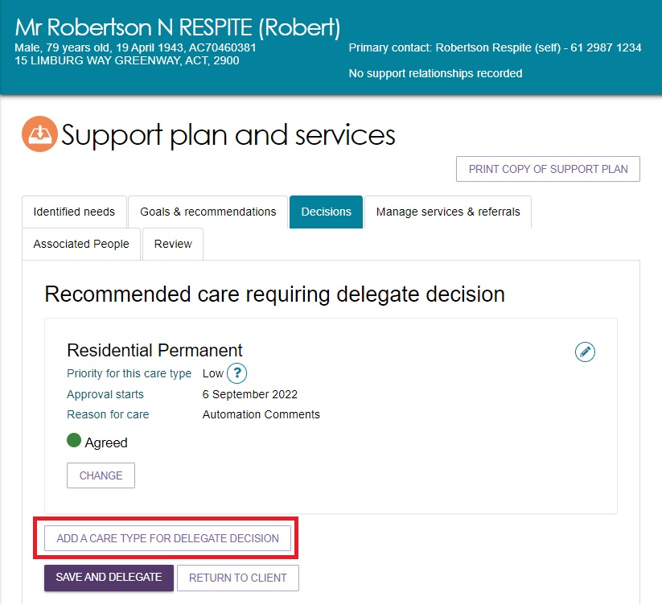

1. In the pop-up box, select the care type that applies from the drop down box. You will need to select the priority for the care type.

Image of the Add care type for delegate decision pop up box with priority and reason for priority options highlighted.

In the pop-up box, select the care type that applies from the drop down box. You will need to select the priority for the care type. 

|  |  |
| --- | --- |
| **!** | If a client is under the aged of 65, several additional entry fields will appear to document their exceptional circumstances. |

1. When setting or changing the priority level to **High** for a Home Care Package recommendation, reason(s) must be selected from the answers provided. The Clinical Assessment Delegate must also provide reasons for changing the initial priority that was recommended by the clinical assessor in the comments field.

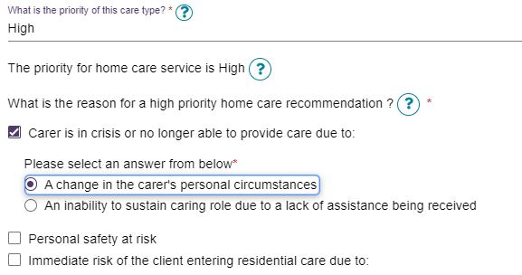

1. The care type will be added to the **Recommended care requiring delegate decision** list with a decision of **Agreed**.

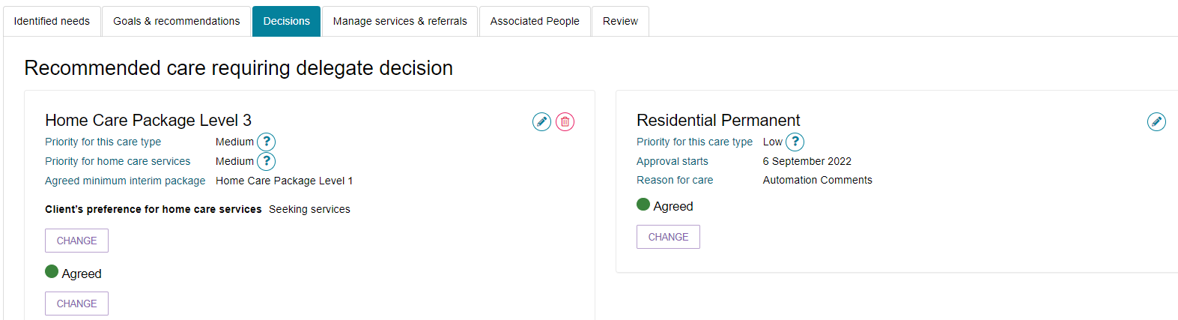

## Changing a decision

1. If you need to change your decision from Agreed to Disagreed, or Disagreed to Agreed, you can select the **CHANGE** button.

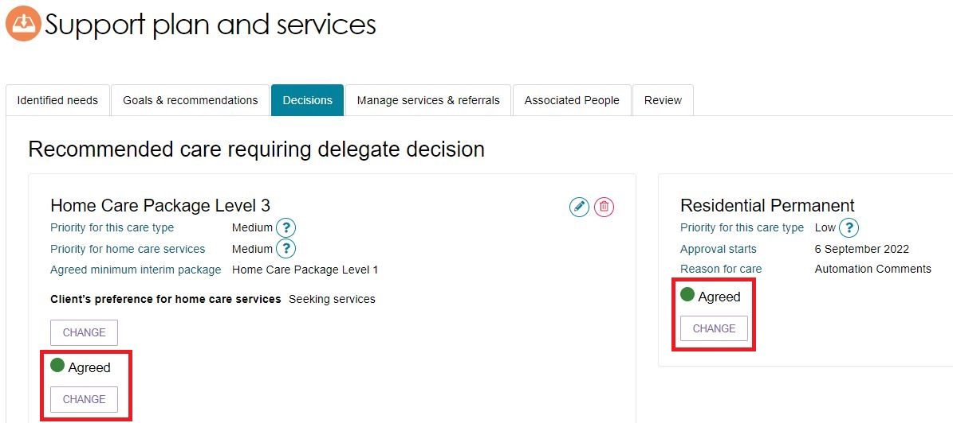

1. You will be able to add approval cease dates and comments where appropriate in the pop-up.

Image of Change decision pop up box with CHANGE button highlighted,

You will be able to add in cease dates and comments where appropriate in the pop-up modal.

1. If you are changing the decision from **Agreed** to **Disagreed**, you will need to provide a reason for the change. Please note, this option will only be available prior to saving and completing the approval process.

A confirmation message will display.

Image of green Recommendation successfully updated banner.

If you are changing the decision from Agreed to Disagreed, you will need to provide a reason for the change. A confirmation message will display.

## Finalising your decision

1. Once the decision has been made, select **SAVE AND DELEGATE**.

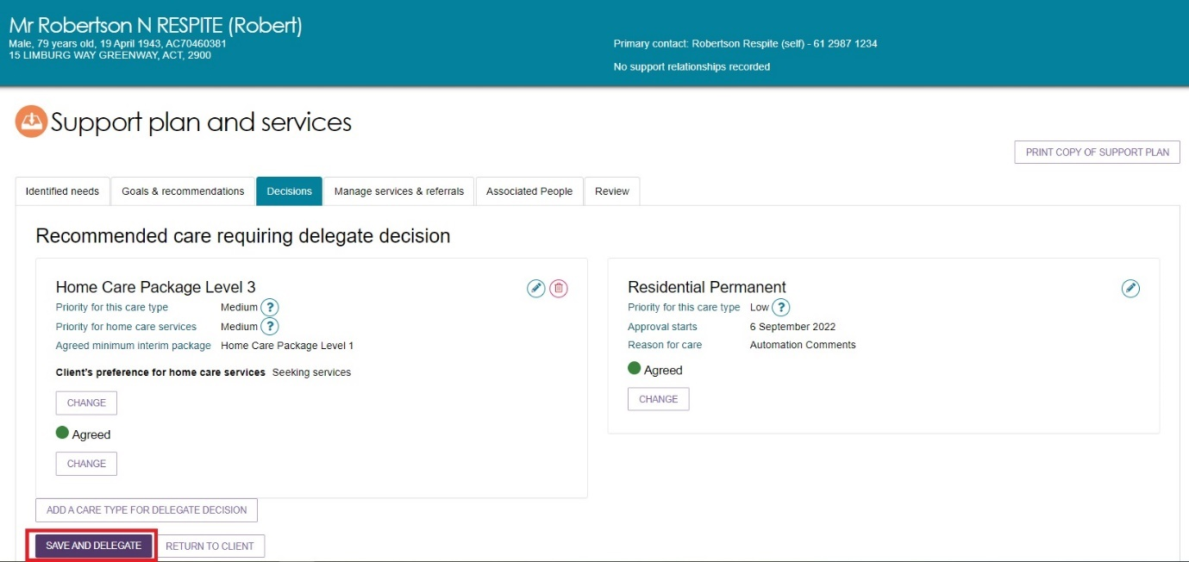

1. A pop-up will display, confirming any care types that were agreed and not agreed. If you need to make any changes to your decision, select **CANCEL**. You need to ensure the date of the delegation is correct. If you are satisfied with the decision and the date, select **SAVE DECISION**.

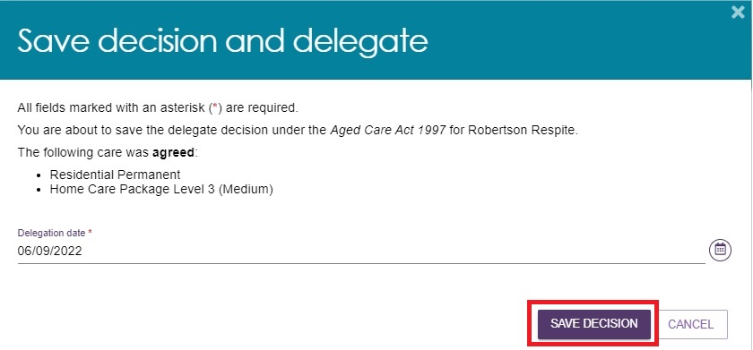

|  |  |
| --- | --- |
| ! | If the approval was actioned off-system earlier than the day that the delegation is completed via the portal, you are able to set the date of delegation to the earlier date as reflected on the Offline Approval Form. It is available for download from the Reports and Documents tile of the assessor portal. This form is evidence that you made the approval decisions prior to the date you are making the entry on the system. You must attach the Offline Approval Form to the **Attachments** tab.  Image of the Save decision and delegate pop up box with tick box and SAVE DECISION highlighted.  If the approval was actioned off-system earlier than today, you are able to set the date of delegation to the earlier date as reflected on the Offline Approval Form. You will need to confirm that you made the decision through other means before today and attach the Offline Approval Form to the client record in the ‘Attachments’ tab. |

1. A confirmation message will display stating that the approvals have been submitted to Services Australia to process and that the decision has been recorded and sent to the clinical assessor to finalise the client’s support plan and match and refer for service.

Image of confirmation message in green banner.

A confirmation message will display, stating that the approvals have been submitted to DHS to process, and that the decision has been recorded and sent to the Assessor to finalise the client’s support plan and match and refer for service.

1. If you have approved a Home Care Package, you can request to receive notifications of any home care correspondence received by that client from the department. This may be required in circumstances where the client is considered to be a vulnerable client that may require assistance from a clinical assessor to link to home care services. To receive notifications, go to the **Approvals** tab in the client record under the Home Care section by selecting the ‘edit’ button. Only one person from an outlet may receive this notification.

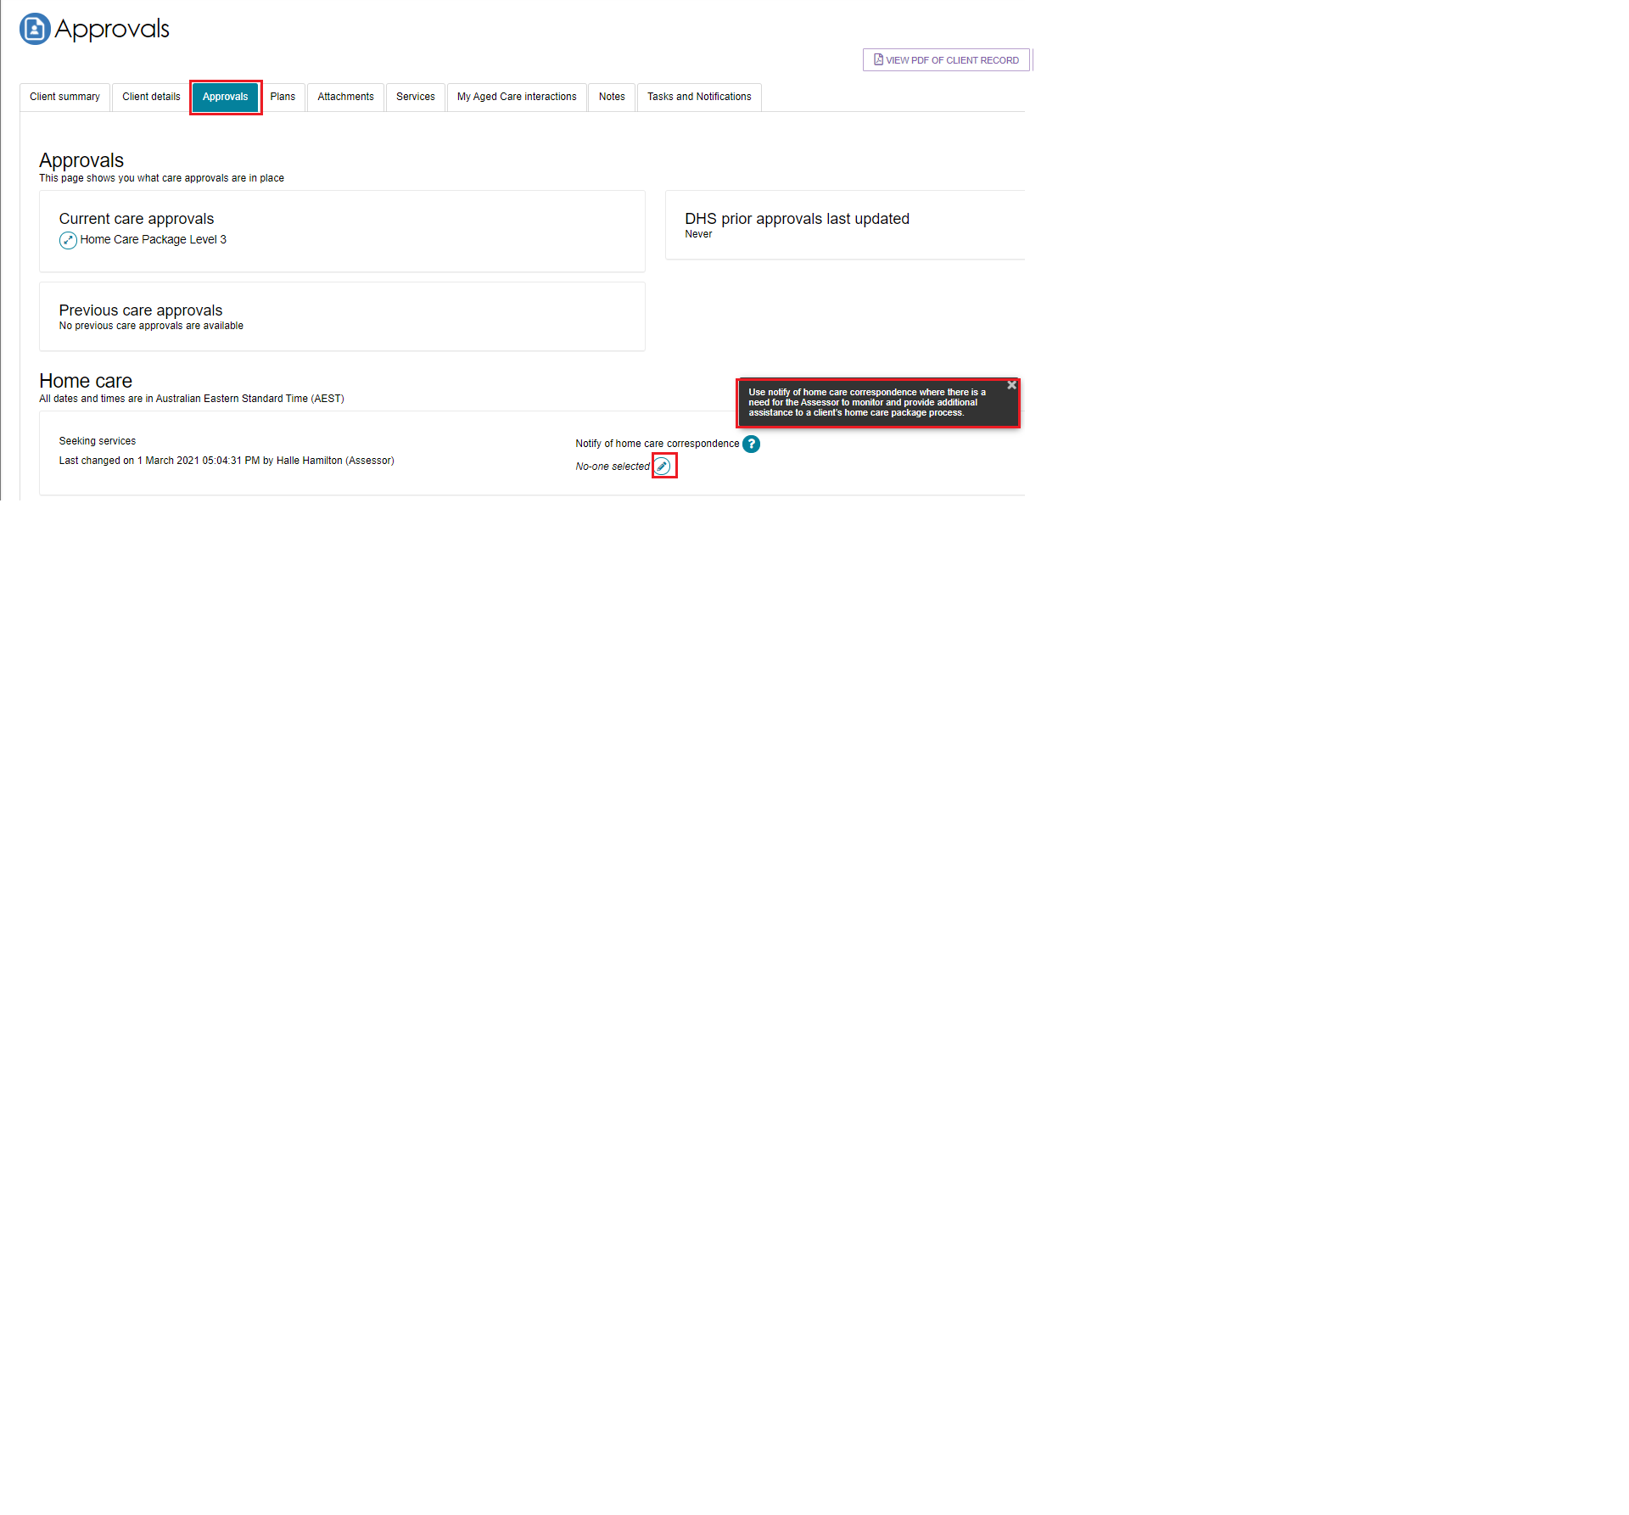

Refer to the help text for guidance.

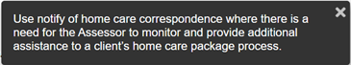

1. The clinical assessor will be able to see the client under the **Delegate decision complete** section of their **Current assessments** tab. The clinical assessor will then need to match and refer for services, and finalise the support plan.

Image of Current assessments page with Current assessments tab and delegate decisions highlighted.

The assessor will be able to see the client under the ‘Delegate decision complete’ section of their ‘Current assessments’ tab. The assessor will then need to match and refer for services, and finalise the support plan.

1. The clinical assessor will receive a notification in the **Task and notifications** page that the delegate has completed their decision, and they will be able to navigate to the client record and directly to match and refer for services from this page.

Image of Task and notifications tab with a delegates decision highlighted.

The assessor will receive a notification in the ‘Task and notifications’ page that the delegate has completed their decision, and they will be able to navigate to the client record and directly to match and refer for services from this page. 

## Printing the approval/non-approval letter

1. To generate, print and upload approval or non-approval letters, navigate to the **Decisions** tab of the support plan. At the bottom of the page, you will be able to select **GENERATE APPROVAL LETTER** or **GENERATE NON-APPROVAL LETTER**. A person assigned the Delegate Support role will also be able to generate, print, and upload these letters.

Image of Decisions tab with GENERATE APPROVAL LETTER button highlighted.

To generate, print and upload approval or non-approval letters, navigate to the ‘Decisions’ tab of the support plan. At the bottom of the page, you will be able to select ‘Generate Approval letter’ or ‘Generate Non-Approval letter’. A person assigned the Delegate Support role will also be able to generate, print and upload these letters.

1. If you have agreed to more than one care type recommendation for the client, you only need to generate and print one approval letter to send to the client. The information about all agreed care types will appear on this letter.

When you select **GENERATE APPROVAL LETTER**, you will be asked to enter information in a pop-up regarding the assessment. This information, for example the client’s doctor’s name, will display on the Approval letter.

Image of Generate approval letter pop up box with GENERAL APPROVAL LETTER button highlighted.

When you select ‘Generate Approval Letter’, you will be asked to enter information in a pop-up modal regarding the assessment. This information, for example the client’s doctor’s name, will display on the Approval letter. 

|  |  |
| --- | --- |
| ! | Any reviewable decision completed by a Clinical Assessment Delegate must contain the following in the decision letter (Approval or Non-Approval letter):   * The Clinical Assessment Delegate’s decision/s, as to whether to approve a person as a care recipient   under section 22-1 of the Act and any limitations or variations to the approval  decision/s;   * The reason/s for the decision/s; * The supporting evidence to justify the decision/s; and * The right of review.   This is to ensure high quality and consistency in letters that clients receive. |

1. If the Approval letter takes too long to generate, you will be re-directed to the **Reports** tab where you will be able to select **View** to open a copy of the letter.

Certain user generated documents, including Approval/Non Approval letters and Referral Code letters, will be retained in **Recently Requested Reports** for seven days, after which they will be cleared from this screen. They can be regenerated as per the original process.

Image of Reports tab with status highlighted

Reports and Documents tab of Assessor Portal, ‘Reports’ tab where you will be able to select ‘View’ to open a copy of the approval letter that you generated

1. When you have signed the letter, you can use the **UPLOAD APPROVAL LETTER** button in the **Decisions** tab of the support plan to upload the letter to the client’s record. Alternatively, you can upload this through the **Attachments** tab on the client record.

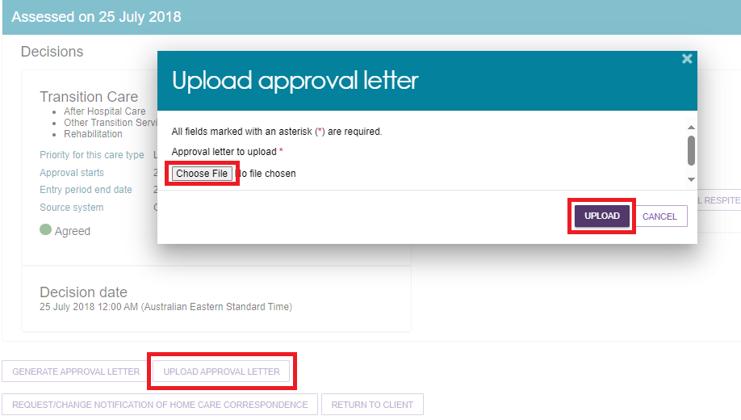

## Requesting correction to care approval decision

A corrections process is available where you have made an error in recording a decision.

Correction requests are able to be submitted up to 42 days after initial delegation, where there are no active or commenced service referrals.

To request a correction to care approval decisions follow the steps below.

1. In the Delegate Decisions tab of the portal, navigate to the **Decision history** tab. Select the expand arrow on the client card to display a summary of the client’s information in the pop-up. Select **REQUEST CHANGES TO CARE APPROVAL DECISION**. If you are using list view, this option will be available from the expanded client information section.

**Card View**

Image of Client card pop up with REQUEST CHANGES TO APPROVAL DECSIONS highlighted.

To request a correction to care approval decisions follow the steps below.

1. Navigate to your ‘Decision history’ tab. Select the expand arrow on the client card to display a summary of the client’s information in the pop-up modal. Select ‘Request changes to care approval decision’. If you are using list view, this option will be available from the expanded client information section. 


**List View**

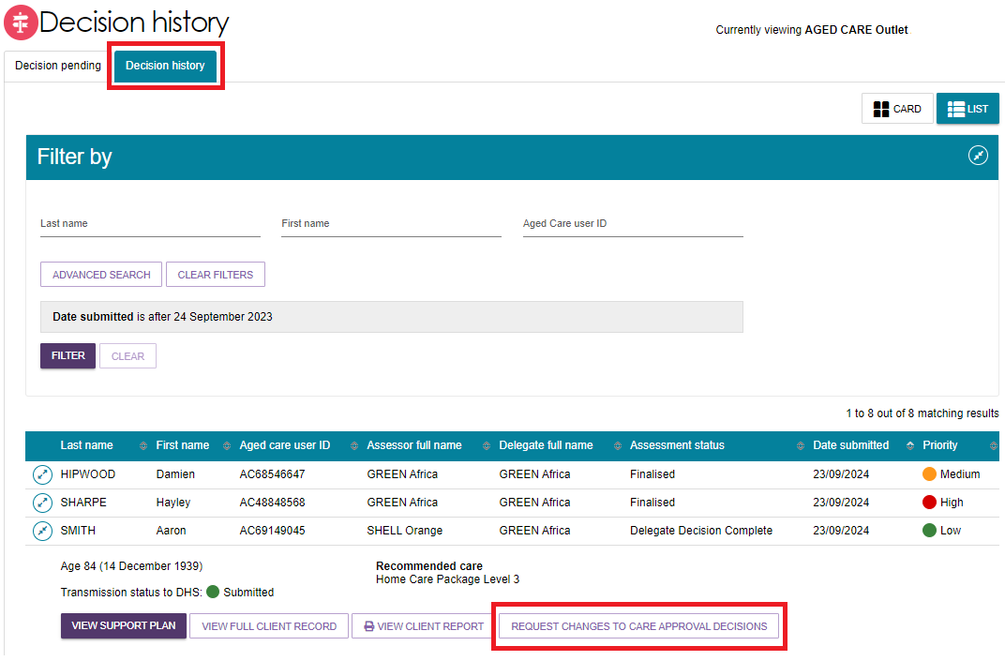

1. Record a reason for the change and provide appropriate reasons for the request, then select **OK, START CHANGES**. Your reasons need to be consistent with the assessment information on the client record.

Image of Request changes to care approval decisions pop up box with Please provide a comment for these changes? and OK, START CHANGES button highlighted

Record a reason for the change and provide appropriate reasons for the request, then select ‘Ok, start changes’. 

1. You will be redirected to the client’s support plan and services page, where you will receive a confirmation message of your change request, and that the correction is in progress.

Image of 2 banners, notification advising you have successfully requested to begin making correction to care approvals. Information banner 
in blue advises Care approval correction in progress.
Correction request notifications

1. Whilst on the same screen, you will be able to make edits to, remove, and/or add care types, including:

* making changes to the commencement date of the delegate decision (provided that the declaration is ticked and the Offline Approval form is attached).
* requesting the removal and addition of different care levels within a care type within the same correction request.

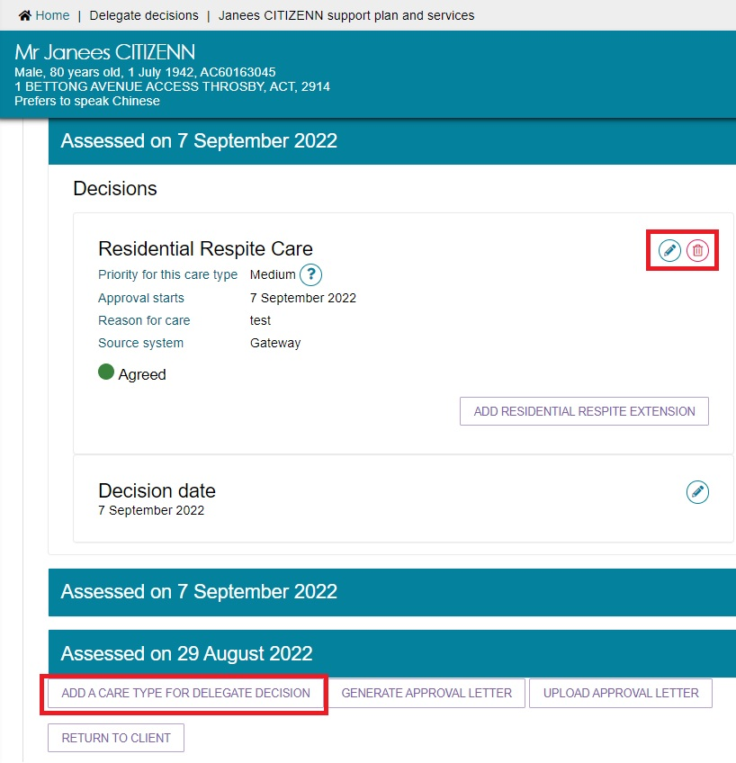

1. To request to remove a Home Care Package approval that you have entered incorrectly, select the remove (bin) button next to the Home Care Package decision.

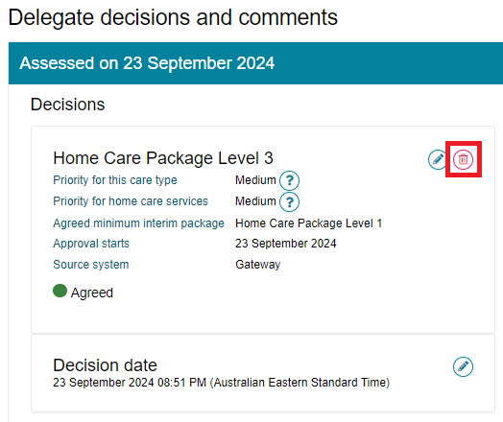

A pop-up will display. Confirm your request to remove the incorrect record by selecting **REMOVE RECOMMENDATION**.

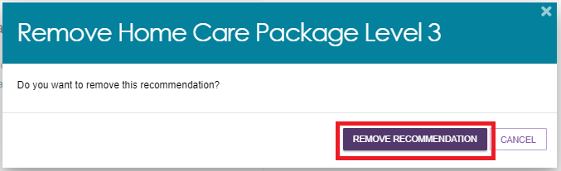

A green banner will then display to confirm that the care approval has been successfully removed.

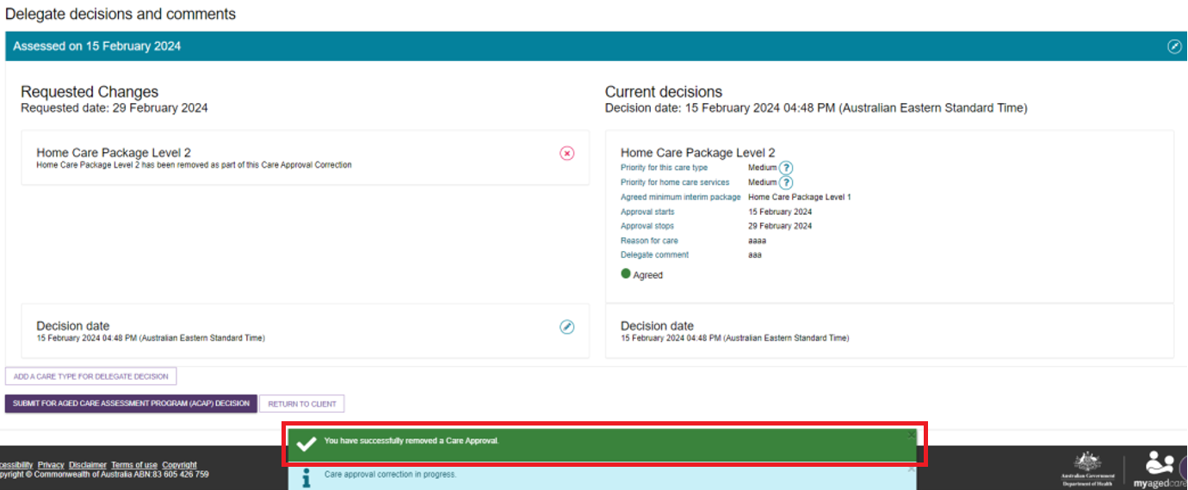

1. To then add the correct Home Care Package approval as intended by the clinical assessor and the Clinical Assessment Delegate, select **ADD A CARE TYPE FOR DELEGATE DECISION**.

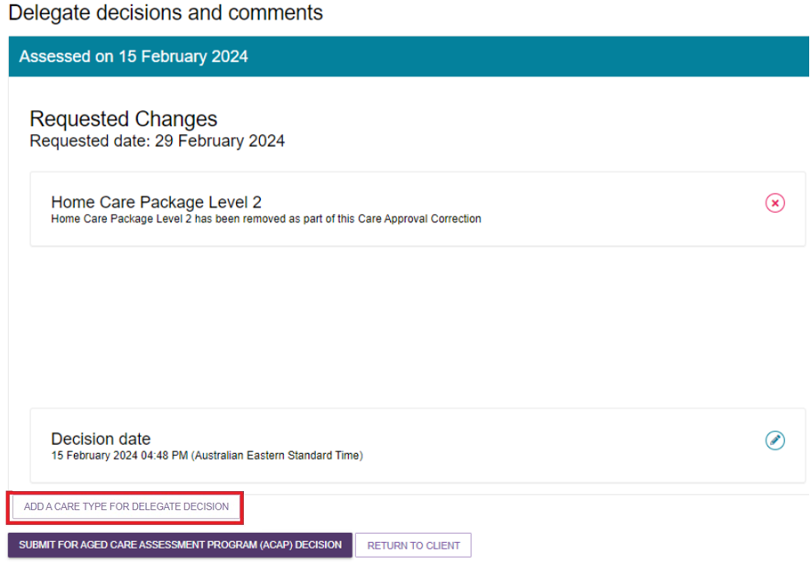

In the pop-up, add the care type, including the correct Home Care Package level and priority for the Clinical Assessment Delegate decision. Once you have successfully completed the required fields (marked by an *) select **SAVE TO PLAN**.

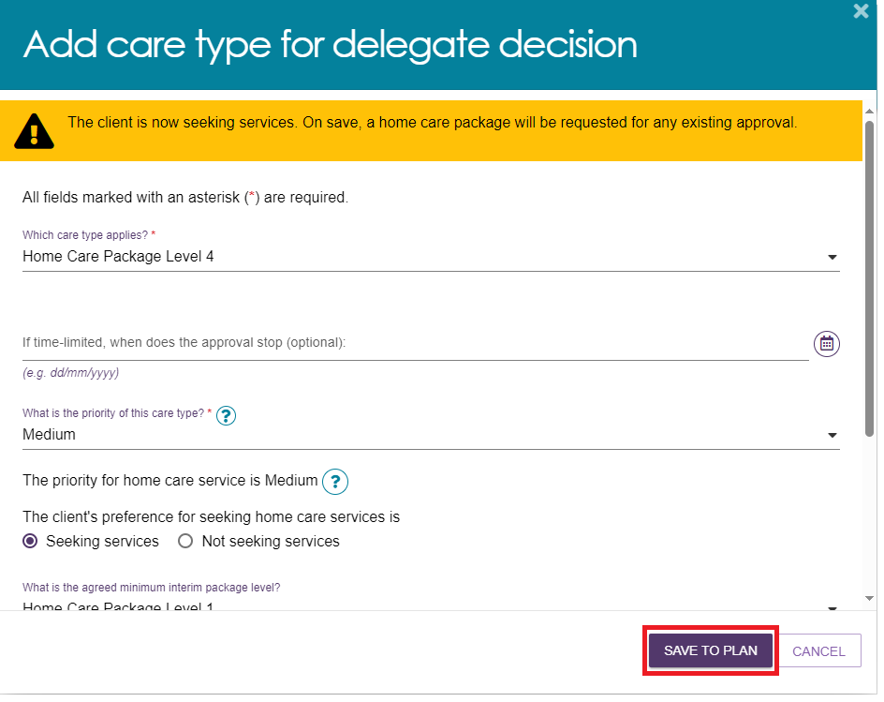

After successfully saving the changes to the Home Care approval, a blue banner will apply outlining that the care approval correction is in progress.



1. If you exit the correction screen, you can navigate back to it by selecting **CONTINUE MAKING CHANGES TO CARE APPROVAL DECISIONS** in the expanded client card on the **Decision history** page.

Image of client card with Continue making changes to care approval decisions button highlighted.

If you exit the correction screen, you can navigate back to it by selecting ‘Continue making changes to care approval decisions’ in the expanded client card on the ‘Decision history’ page.

1. You will be able to see the requested changes displayed against the current decisions. When you have made the required changes to the care approval decisions, select **SUBMIT FOR AGED CARE ASSESSMENT PROGRAMME (ACAP) DECISION**.

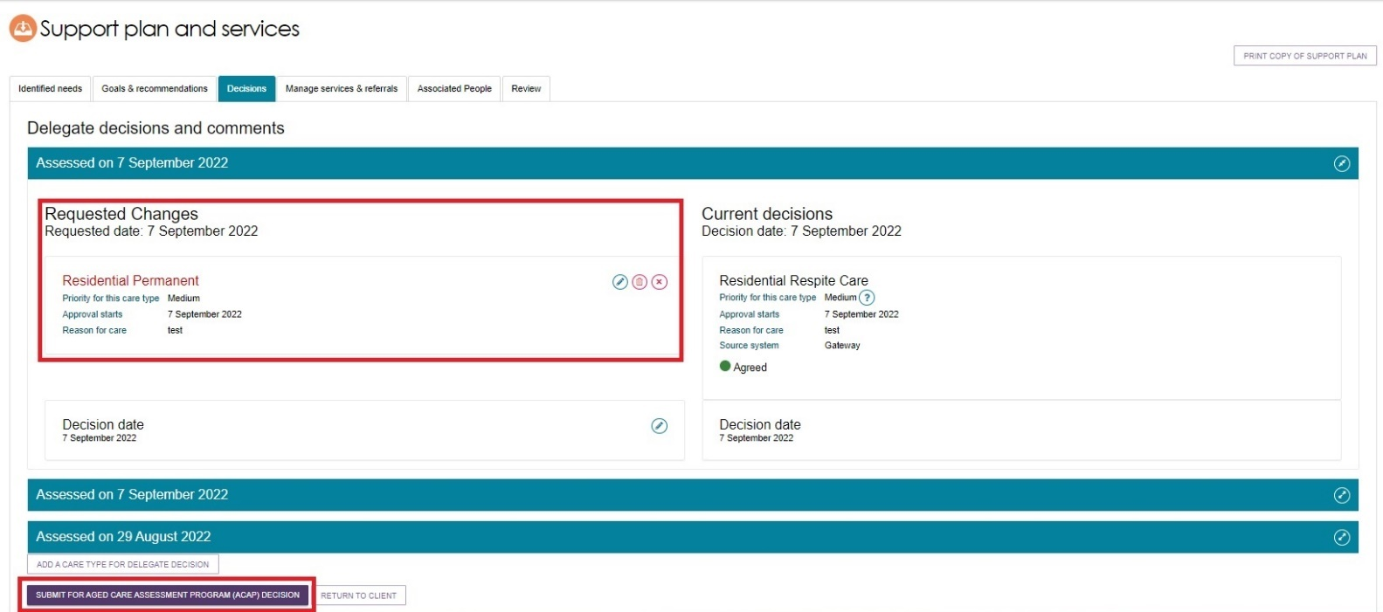

1. A pop-up message will display requesting confirmation to proceed. Select **SUBMIT**.

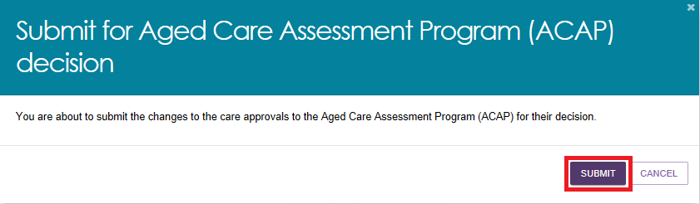

1. You will receive a confirmation message that the correction of the request will be received by the Department’s Aged Care Assessment Program (ACAP) delegate.

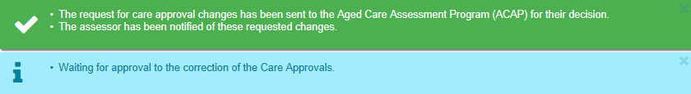

1. The client will be displayed in the **Decision history** tab with a status of **Acceptance Pending**. Once the department has made a decision on the correction request, this status will change to **Delegate Decision Complete**.

Image of Decision history tab with acceptance pending with Acceptance Pending highlighted.


The client will be displayed in the ‘Decision History’ tab with a status of ‘Acceptance Pending’. Once the department has made a decision on the correction request, this status will change to ‘Delegate decision complete’. 

1. There will also be a notification advising of the decision in your **Tasks and notifications** page. You will be able to filter by last name, first name and Aged Care User ID as well as use **Advanced Search** functionality to help you find notifications for certain clients.

The notification itself will contain links back to the client record and the correction request. It will also allow you to remove the notification from the page.

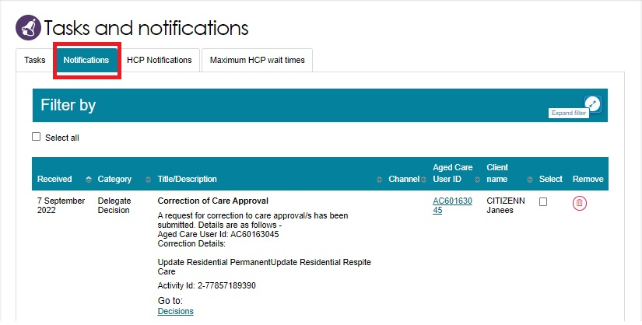

1. Once the Clinical Assessment Delegate has made their decision on the correction, you will receive another notification advising that the correction has been completed.

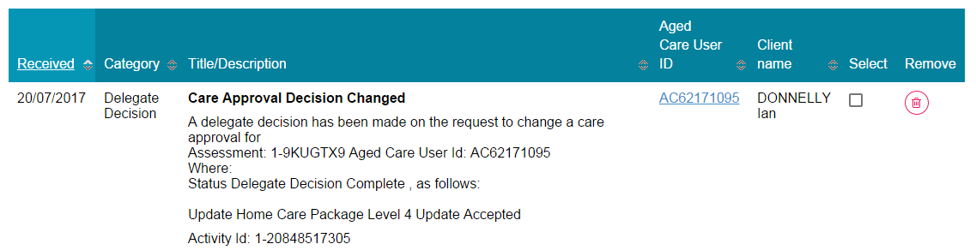

1. You will also be able to see the assessment status reflect this when it changes to **ACAP Decision Complete** in your **Decision history** tab. Additional information regarding the correction decision will be visible by selecting the expand arrow, including the date and details of the correction.

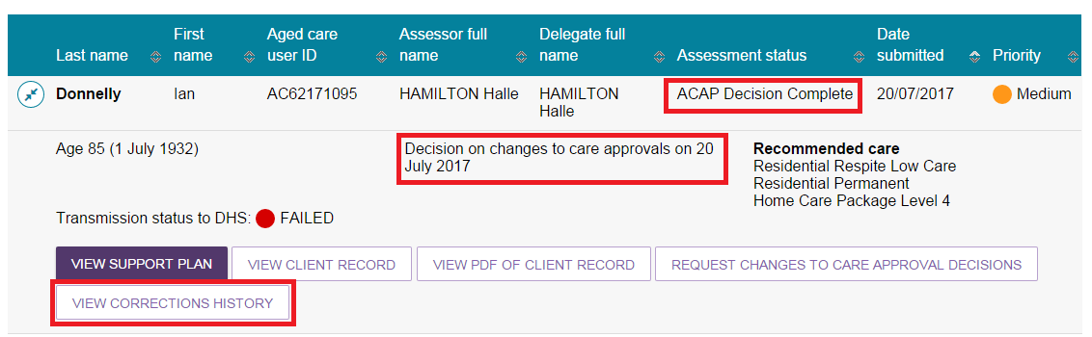

1. A record of the corrections history for the client can be viewed by selecting **VIEW CORRECTIONS HISTORY**.

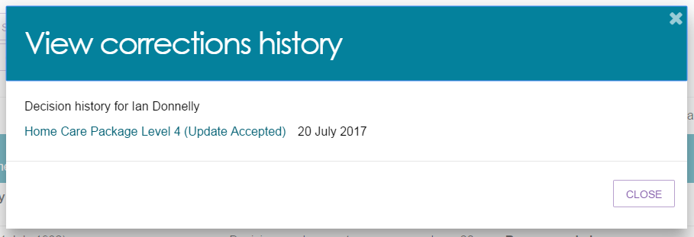

## Requesting and Approving Care Extensions

Care extensions can be requested by clinical assessors or service providers as follows:

* For Residential Respite Care and Transition Care approvals, service providers can request care extensions on behalf of the client through the My Aged Care Services and Support Portal.
* For Residential Respite Care, clinical assessors can also generate a care extension for a person living in the community who requires additional respite through the assessor portal.

In cases where a client has a valid Residential Respite Care approval and requires additional Residential Respite days, but is currently living at home and not currently receiving residential aged care services, a service provider will not be able to request an extension on behalf of the client. The Clinical Assessment Delegate will instead be able to initiate the care extension on behalf of the client.

If you are unable to complete a care extension request for a client via the assessor portal, you should call the Aged Care Service Provider and assessor Helpline on 1800 836 799.

To make a decision about care extensions, follow the steps below.

1. The extension request will appear in the **Decision pending** tab under **unassigned**. It will have a status of **Acceptance Pending**. Open the client’s card in card or list view by selecting the Expand icon.

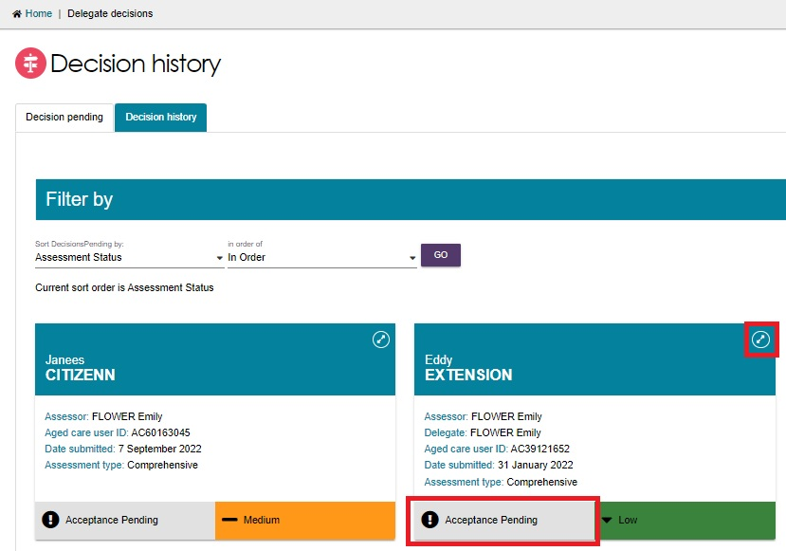

1. Assign the client to yourself if not already done, then the client will now appear under **My Decisions**. Select **START DECISION PROCESS**.

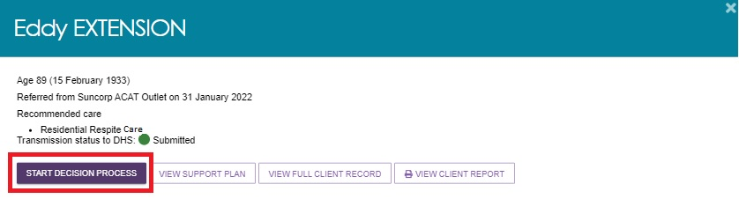

1. You will see the care extension request. Review the information and select **MAKE EXTENSION DECISION**.

Image of Decisions tab selected with MAKE EXTENSION DECISION button highlighted.

Care extension request from a client's Support plan and services tab. The Delegate can select the Make Extension Decision button

1. In the pop-up, select **Yes** or **No** with regards to granting the extension, and fill out the other fields.

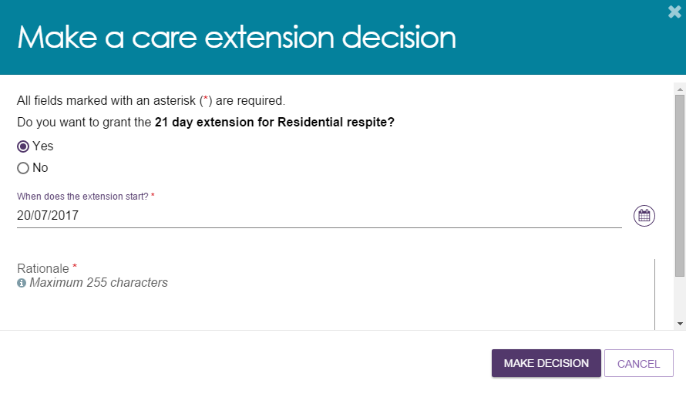

1. A notification will be displayed and the extension request will show with a status of **Granted** or **Not Granted**.

Image of Decisions tab selected with decision status highlighted.

example of when a care extension is granted, and the status showing in the Decisions tab in the client's Support Plan and Services

1. If the service provider requested the extension, they will receive a notification advising them of the decision in their **Tasks and Notifications** in the Services and Support Portal.

