**Assessor Portal User Guide – Residential Respite Classification Referrals (for assessment organisation Team Leaders)**

This user guide outlines how assessment organisation team leaders interact with the My Aged Care assessor portal (assessor portal) to manage Residential Respite Classification referrals (referrals).

This user guide does not contain detailed instructions on functions that assessment organisations perform. Those activities are described in the [Aged Care App User Guide.](https://www.health.gov.au/resources/publications/aged-care-assessor-application-user-guide)

This user guide contains the following topics:

Privacy requirements 2

Assessment organisation team leader view for Residential Respite Classification referrals 2

Accepting Referrals 4

Assigning Referrals 6

Rejecting Referrals 8

Transferring Referrals 10

Clients who are in Hospital or in the community/home 11

Clients who are in a Residential Service Facility 13

Reassigning Referrals 15

Viewing Historical Residential Funding Referrals 17

Viewing Progress of Respite Classification Assessments 19

## Privacy requirements

Assessment organisations are required to comply with the legislative requirements under the *Privacy Act 1988* (Privacy Act), including the Australian Privacy Principles when using the assessor portal. The Privacy Act regulates personal information about individuals, including the collection, use, storage and disclosure of personal information, and access to and correction of that information.

For aged care needs assessors (assessors), information collected on My Aged Care for purposes of assessment is also subject to the *Aged Care Act 1997* (Aged Care Act) which they operate under while carrying out their assessment functions.

For more information refer to the [My Aged Care Assessment Manual](https://www.health.gov.au/resources/publications/my-aged-care-assessment-manual?language=en).

## Assessment organisation team leader view for Residential Respite Classification referrals

1. Select the **Residential Funding Referrals** tile from the assessor portal home page.

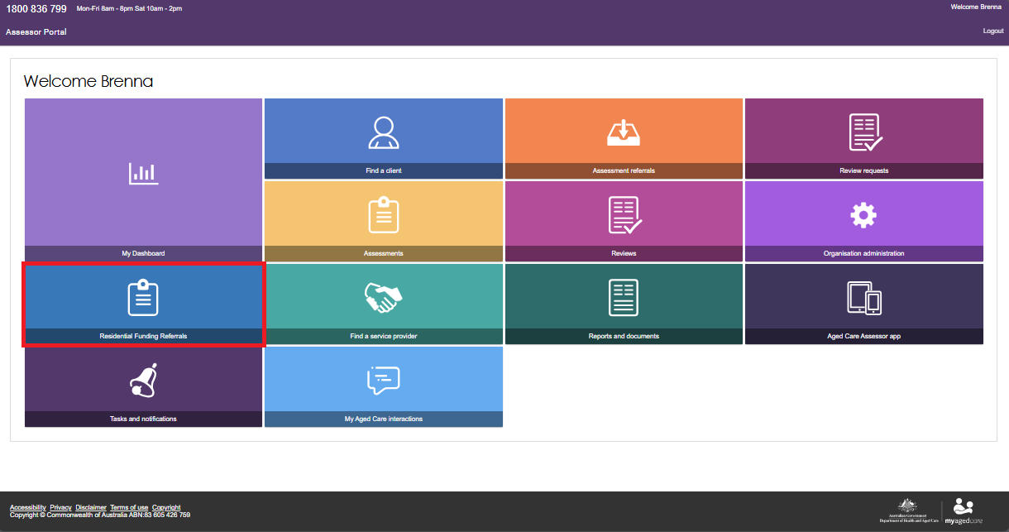

If you are a team lead of both a Residential Funding and assessment organisation outlet, you will be asked to select which outlets referrals you would like to view.

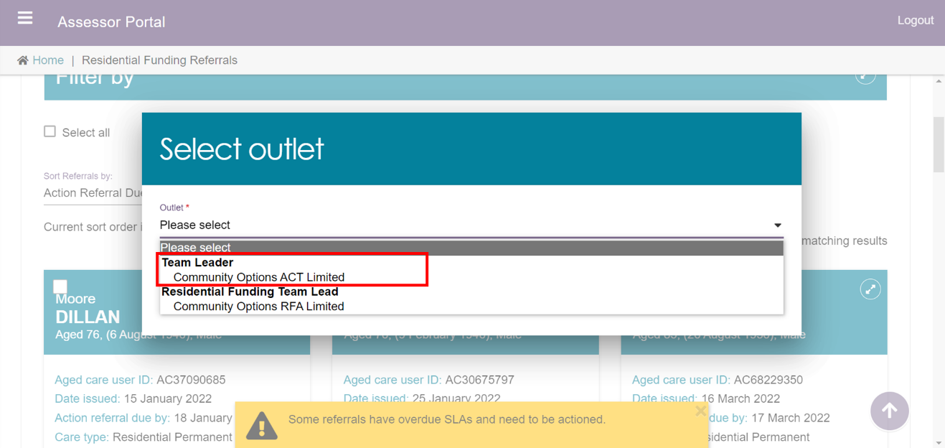

1. The **Incoming referrals** tab will be displayed. By scrolling down the page you will be able to view all the Incoming referrals for the organisation/outlet.

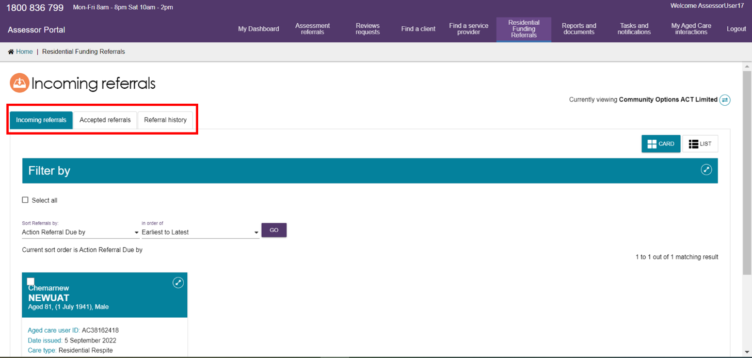

1. Advanced searches can also be conducted to refine the list of referrals by selecting the **Advanced Search** button.

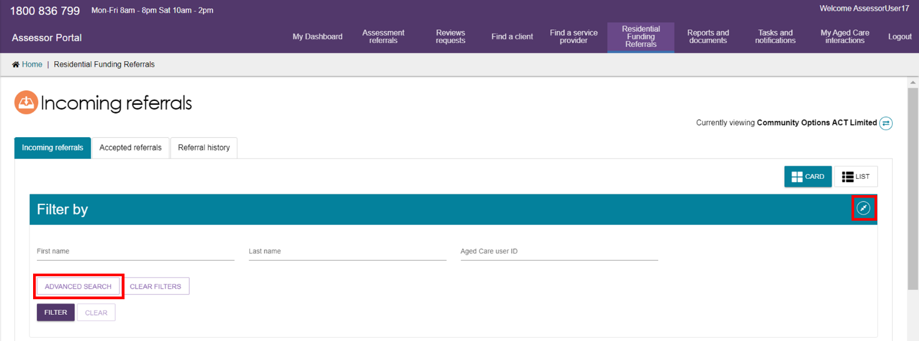

A pop-up will open which will allow you to select from a drop-down list of filters for the list of incoming referrals. To further refine the results, multiple filters can be applied.

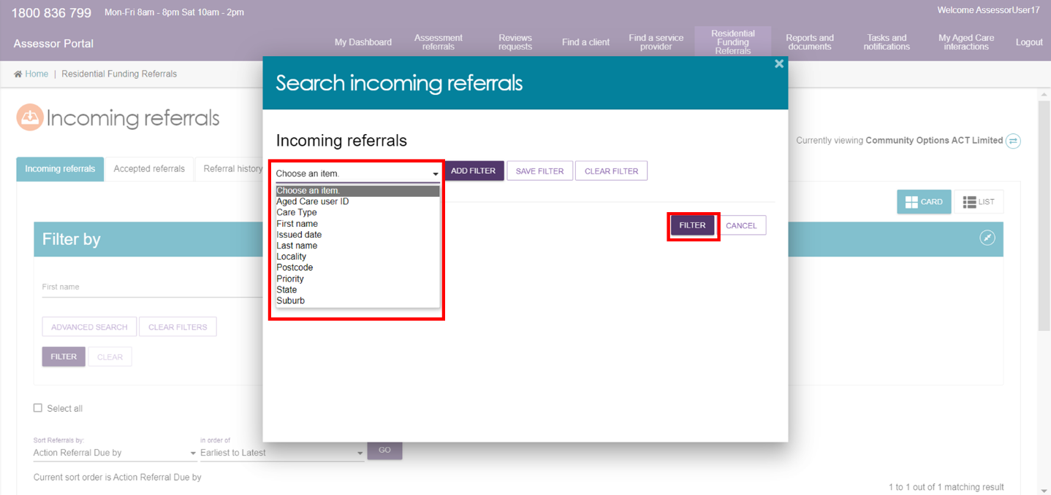

## Accepting Referrals

1. Select the **Residential Funding Referrals** tile from the assessor portal home page.



1. Navigate to the **Incoming Referrals** tab. You can conduct a basic search or an advanced search to refine the list of incoming referrals.

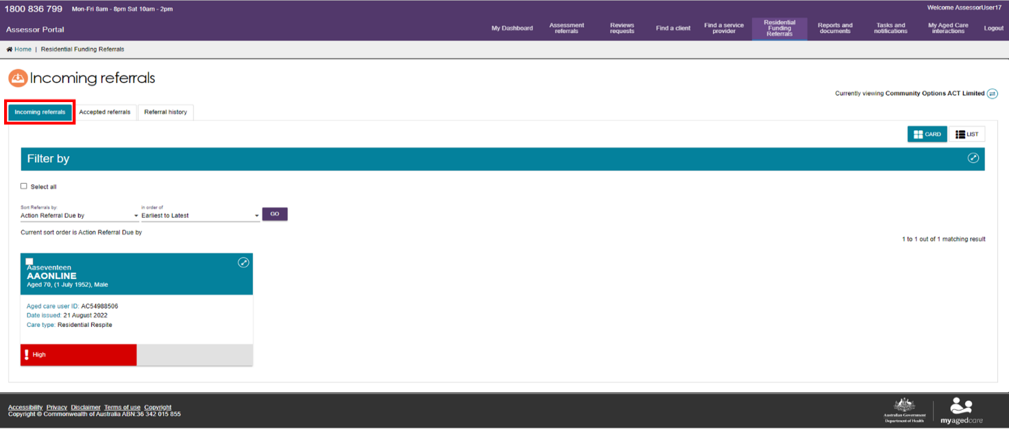

1. To bulk accept referrals, select the tick box on the upper left-hand side of the client tile for the clients whose referrals you wish to accept and select the **Accept** button. You can also accept a referral for only one client. Referrals selected in bulk will need to be assigned to assessors from the **Accepted referrals** tab.

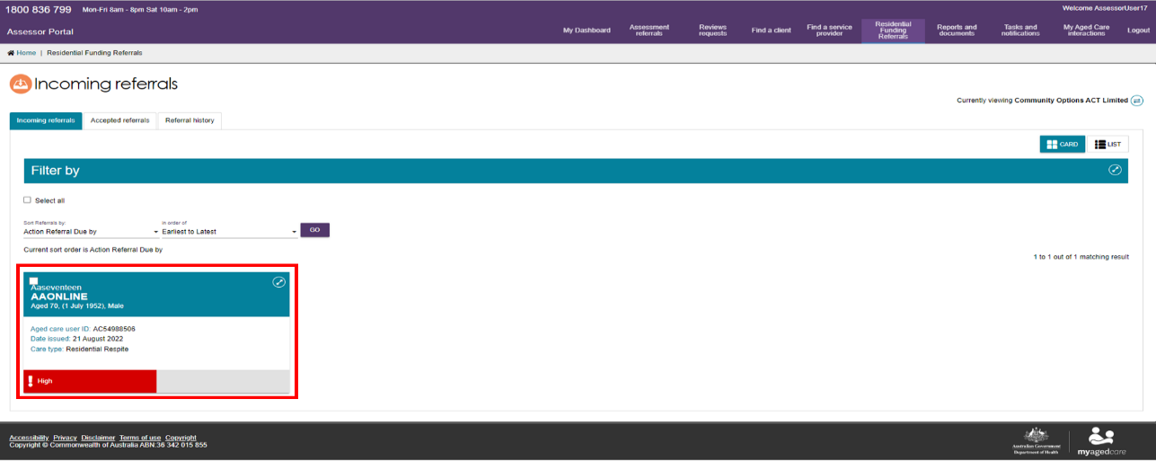

1. When accepting a referral for a single client, a pop-up box will appear confirming the client whose referral you wish to accept. Once you have confirmed, select the **Accept** button.

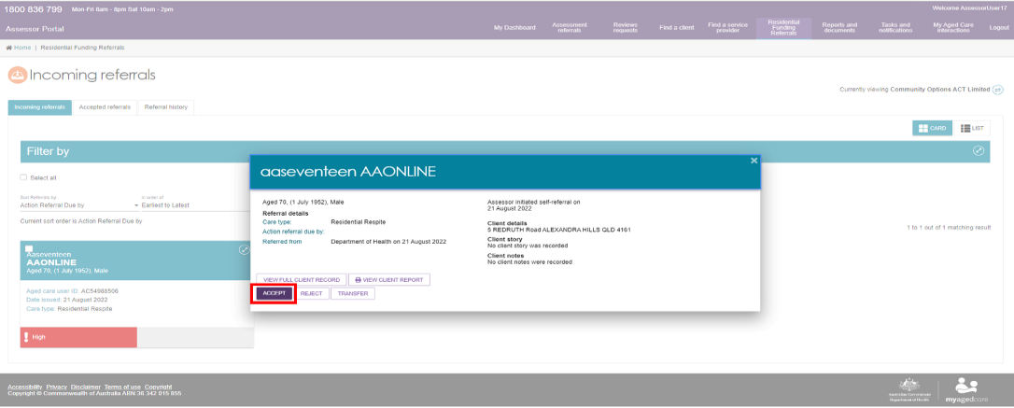

The referral will now be in an Accepted or Assigned state and will be visible on the **Accepted Referrals** tab.

## Assigning Referrals

Assessment organisation team leads can assign referrals to assessors.

1. From the assessor portal home page, select the **Residential Funding Referrals** tile.



1. Navigate to the **Accepted Referrals** tab. You can filter the list of referrals or conduct an advanced search to refine the list of unassigned referrals.

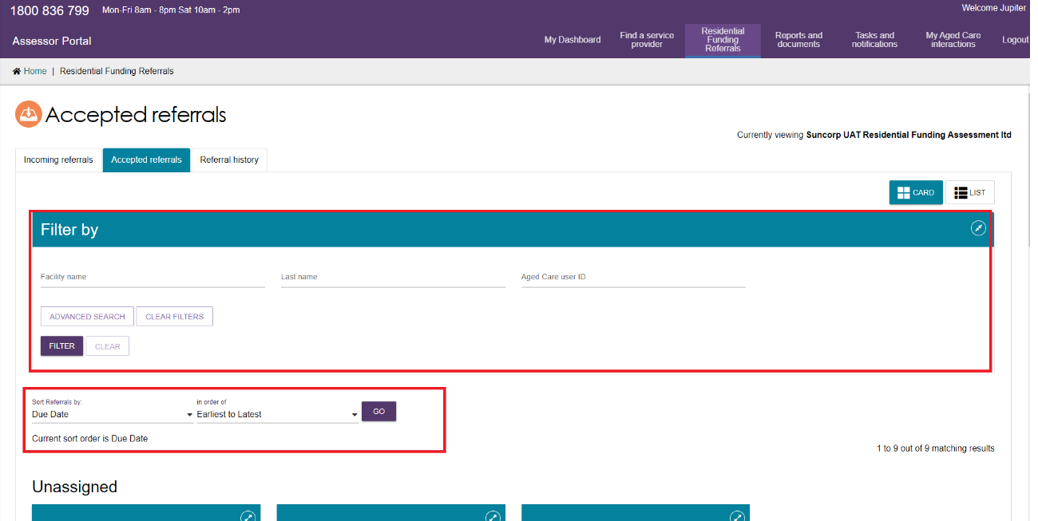

1. Select the referral you wish to assign from the **unassigned** list of referrals.

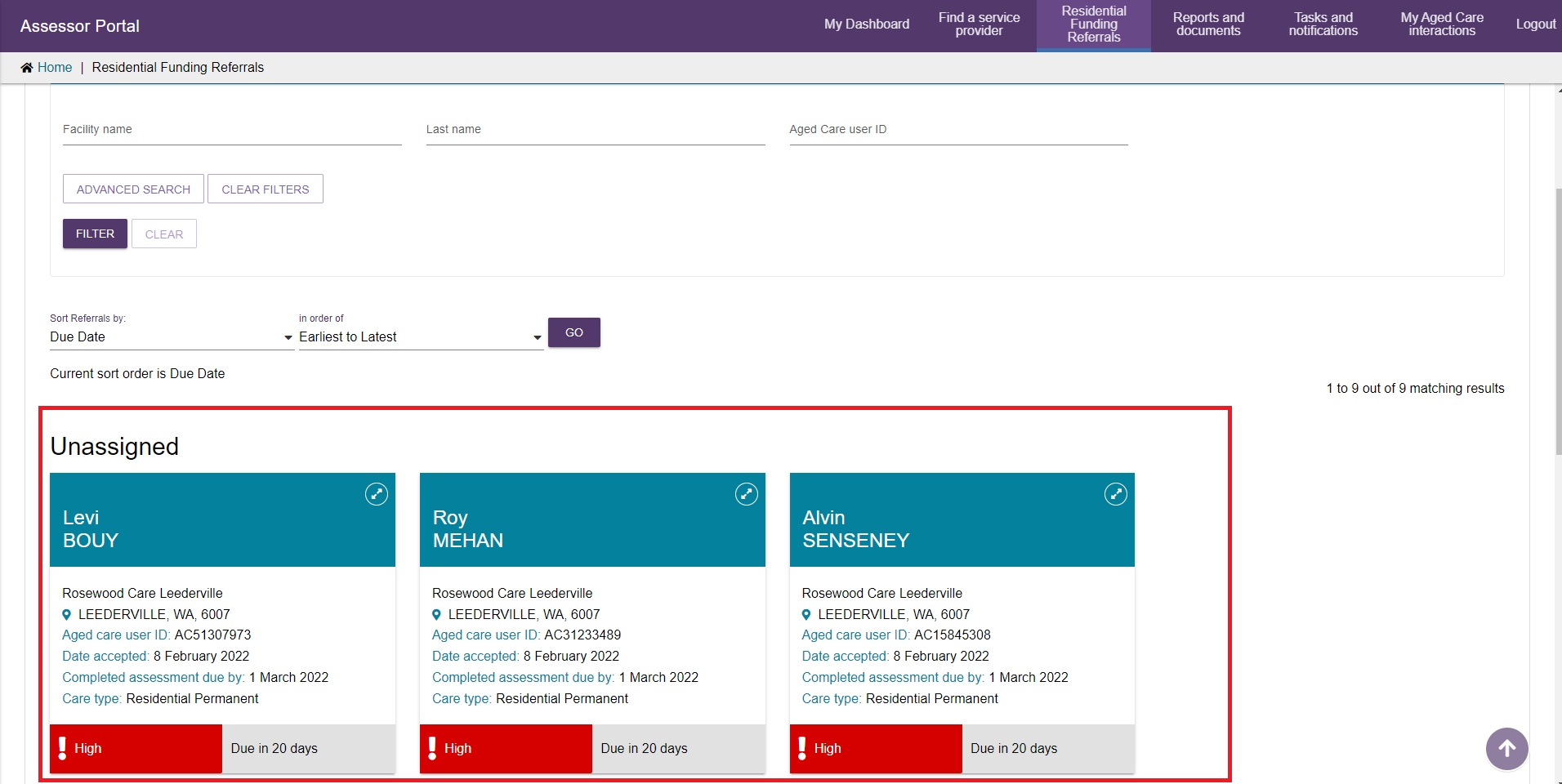

1. A pop-up will appear, select the **assign** button.

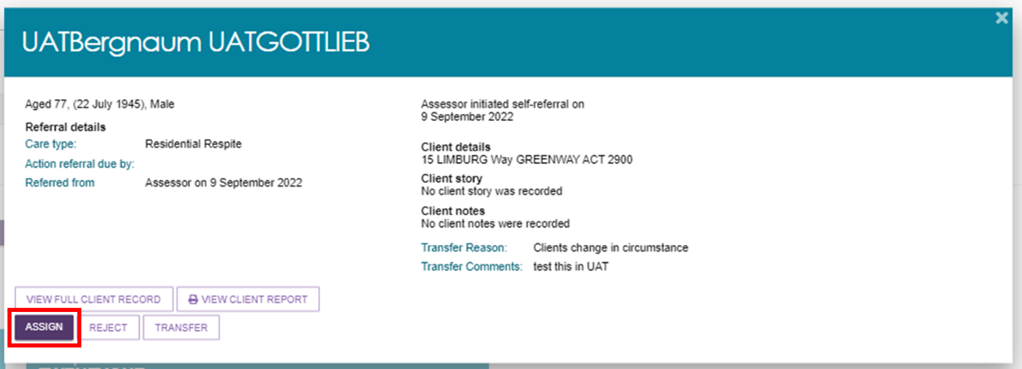

A pop-up will appear, select the assessor that the referral will be assigned to and select the **assign** button.

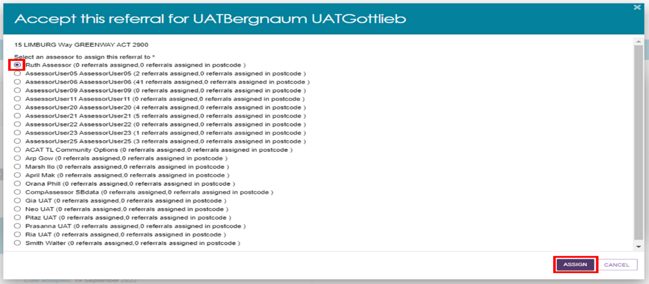

The referral will now be assigned to the assessor selected.

## Rejecting Referrals

Assessment organisation team leaders are able to reject referrals that are both incoming and assigned.

1. From the assessor portal home page, select the **Residential Funding Referrals** tile.



1. Select the referral you wish to reject.

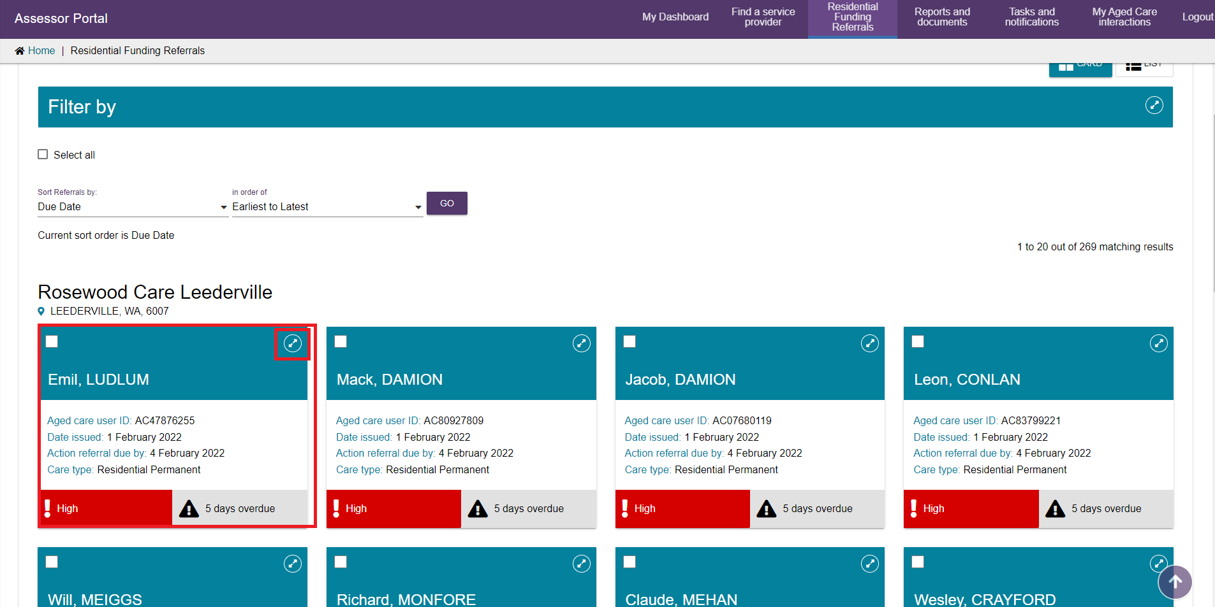

1. A pop-up will appear. Confirm this is the referral you wish to reject and select the **reject** button.

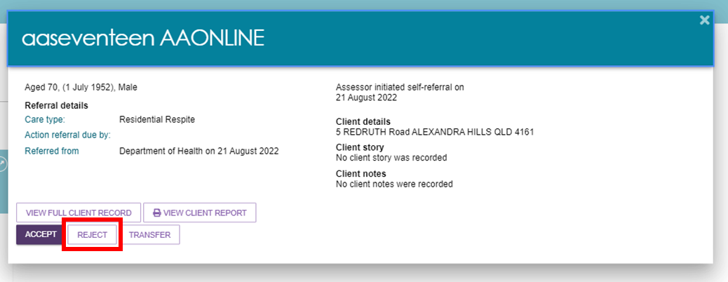

1. A pop-up will appear, select the reason for the referral rejection and provide details in the free text field. Referrals can be rejected for the following reasons:

* **Client Deceased:** You will be required to provide additional information in regards to the circumstances that surround the client.
* **Entered a Residential Facility:** This will transfer the referral to a residential aged care funding assessor, please refer to Transferring Referrals for guidance.
* **Outlet Insufficient Capacity:** This will transfer the referral back to the department to assign to another outlet.
* **Other:** Additional details will be required.

Additional details can be provided in the **Details** text box.

Once complete, select the **reject** button.

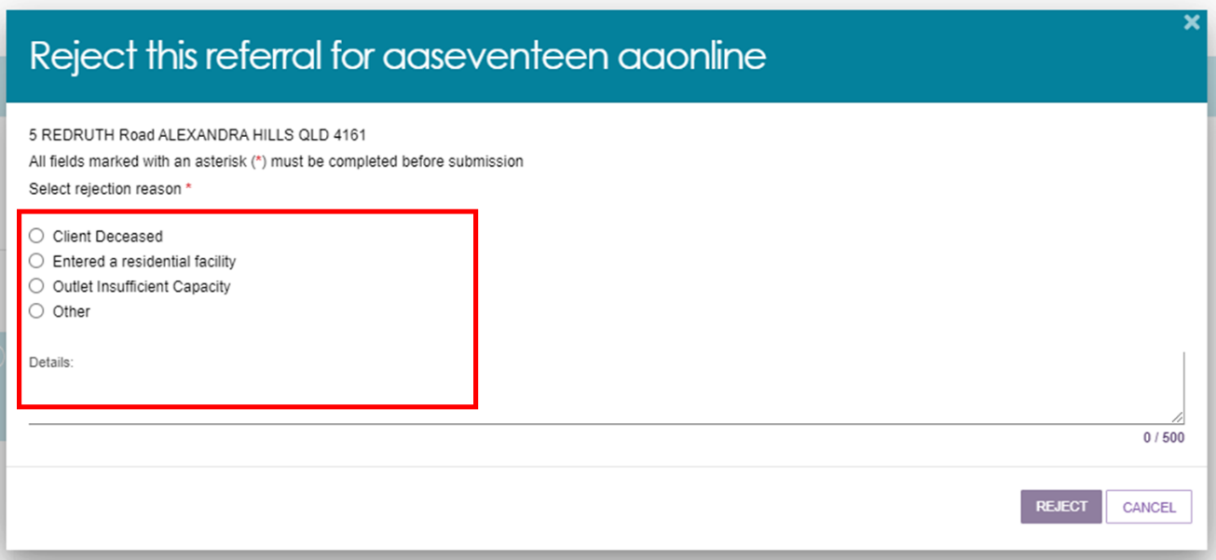

## Transferring Referrals

Assessment organisation team leaders are able to transfer referrals that are both incoming and assigned.

1. From the assessor portal home page, select the **Residential Funding Referrals** tile.



1. Select the referral you wish to transfer.



1. A pop-up will appear. Confirm this is the referral you wish to transfer and select the **Transfer** button.

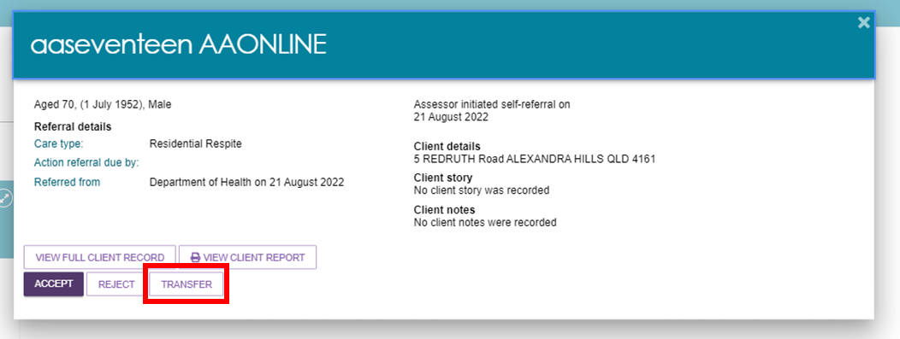

Referrals can be transferred to another assessment organisation outlet or to an RFA outlet where the client has entered a Residential Service facility.

### Clients who are in Hospital or in the community/home

1. Select assessment setting as either **Home** or **Hospital** and select **Transfer**.

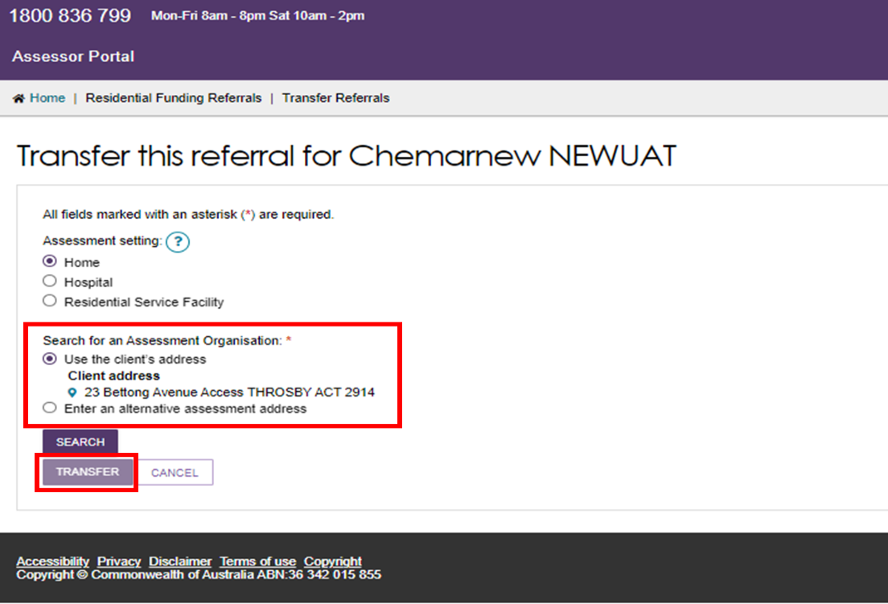

1. Search for an assessment organisation based on either the client’s address or the alternative assessment address and select **Search**.

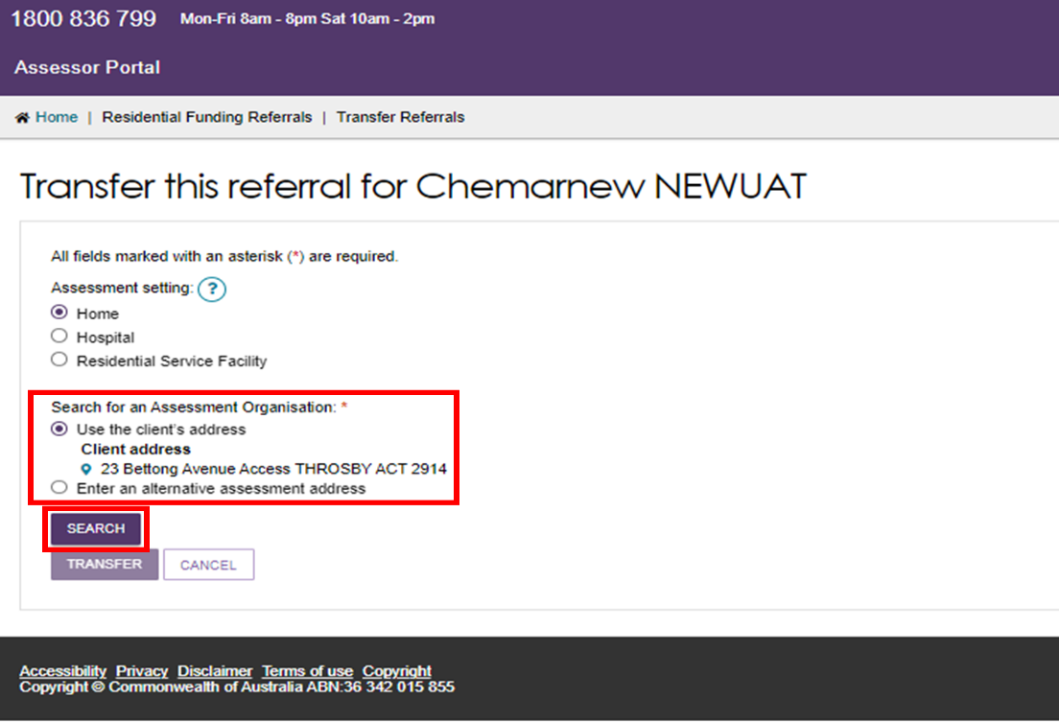

A list of assessment organisations will be displayed, select the appropriate assessment organisation and select **Transfer**.

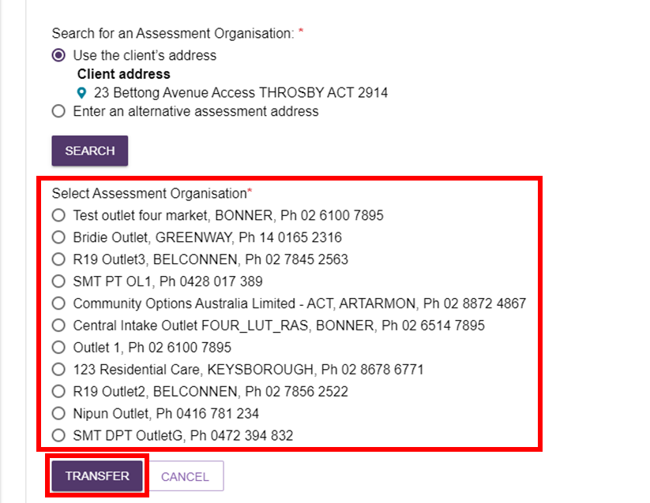

### Clients who are in a Residential Service Facility

1. Select Residential Service Facility.

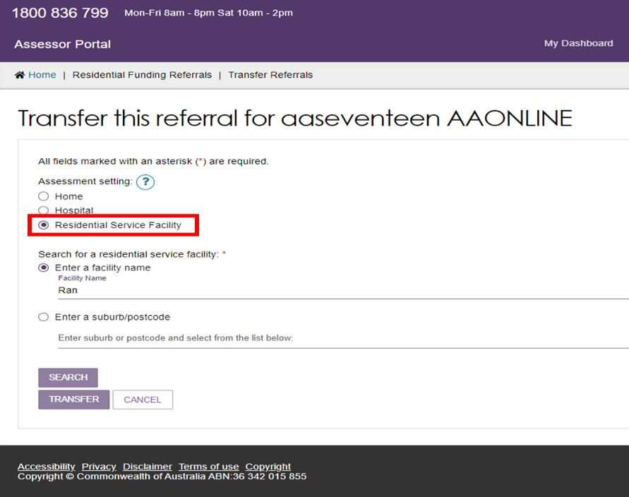

1. Search using either the service facilities name or based on the suburb/postcode.

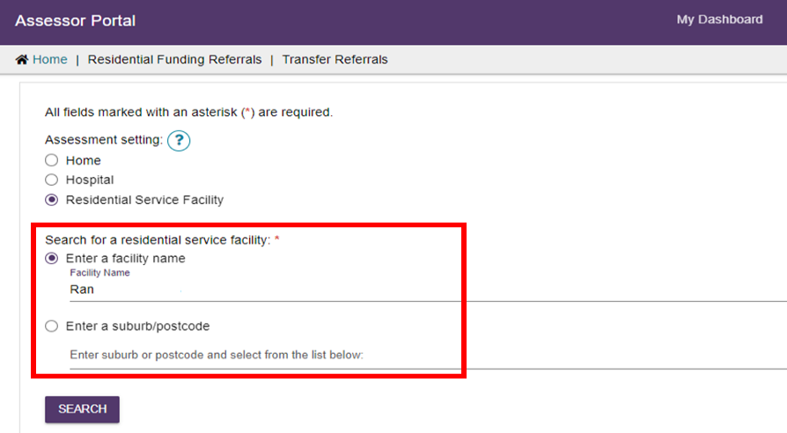

1. Select search and a list of services will appear, select the correct service and enter a reason for transferring the client. For Referrals transferred to RFA Outlets this should be **Other**.

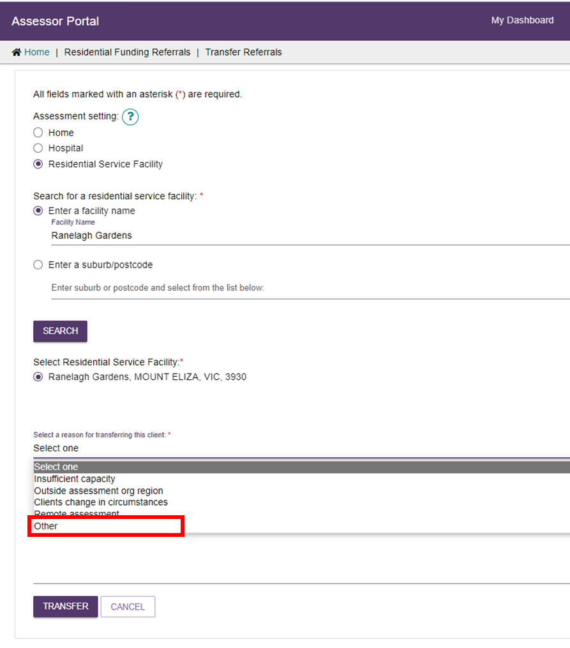

1. Provide comments on why the referral is being transferred and select **Transfer**.

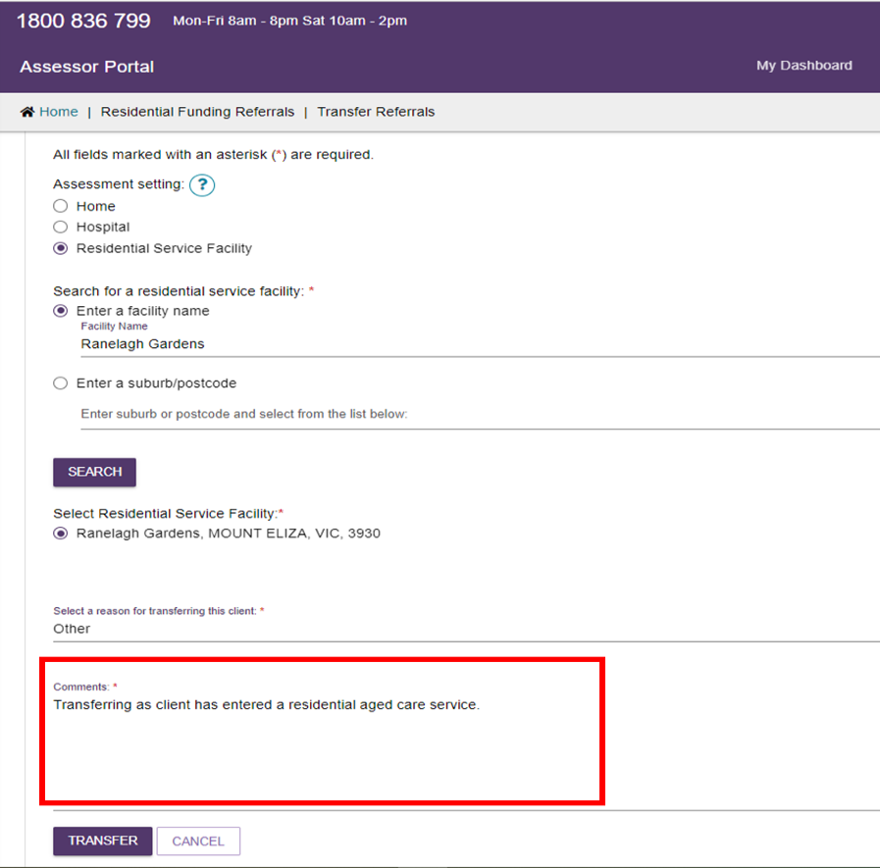

1. When a referral has been successfully transferred, you will be navigated back to the **referrals** tab and a green success message will appear.

banner "referral transferred successfully"

## Reassigning Referrals

Assessment organisation team leaders can re-assign referrals that have been assigned to assessors.

1. From the assessor portal home page, select the **Residential Funding Referrals** tile.



1. Navigate to the **Accepted Referrals** tab. You can search for the referral you wish to re-assign or scroll to the assessors referrals that you wish to re-assign.

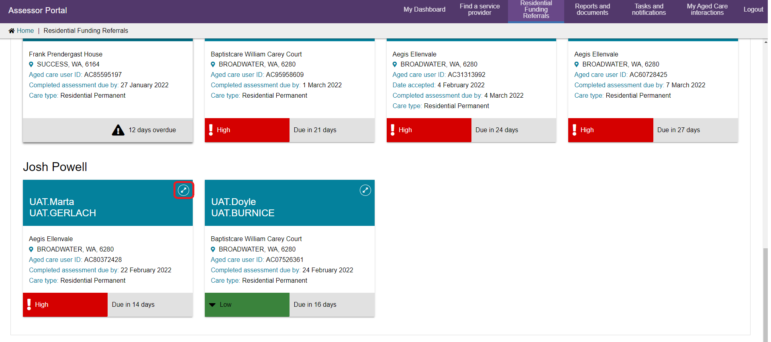

1. A pop-up will appear, select the **Reassign** button.

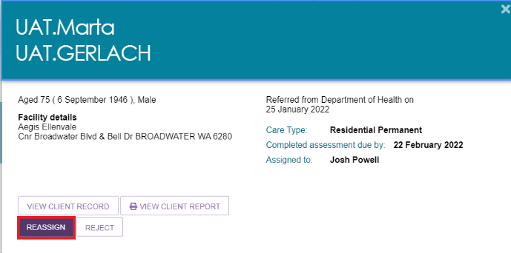

1. A pop-up will appear. Select the assessor you wish to re-assign the referral to and select the **Reassign** button.

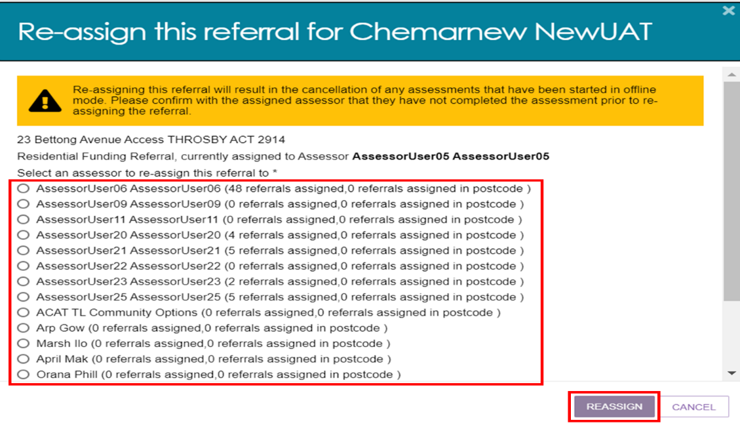

The referral will now be reassigned to the assessor selected to action.

## Viewing Historical Residential Funding Referrals

Assessment organisation team leaders can view historical Residential Funding Referrals for their organisation/outlet. Referral history will display all completed and rejected referrals.

1. From the assessor portal home page, select the **Residential Funding Referrals** tile.



1. Navigate to the **Referral History** tab. You can search or filter the list of referrals or scroll down to see the finalised referrals for your outlet/organisation.

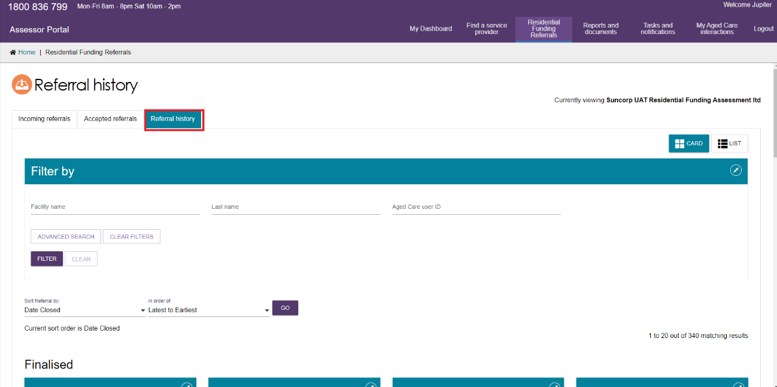

## Viewing Progress of Respite Classification Assessments

Assessment organisation team leaders are able to view the progress of Residential Funding Assessments for their outlet/organisation.

1. From the assessor portal home page, select the **My Dashboard** tile.

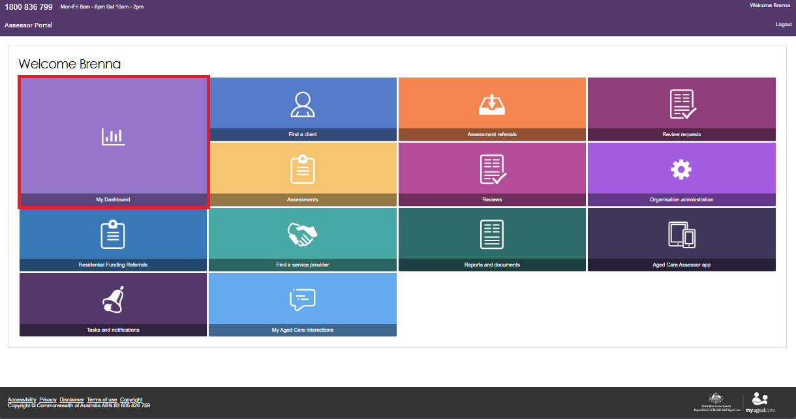

1. Select the blue **Residential funding referrals** tile.

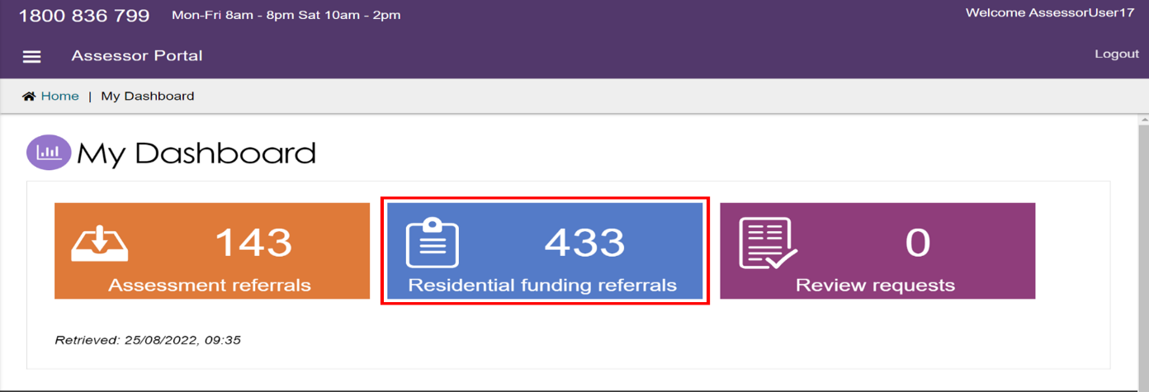

1. You will now be able to see an overview of the Residential Funding Referrals for your assigned outlets.

To see a detailed breakdown select the referral highlighted count next to the desired outlet.

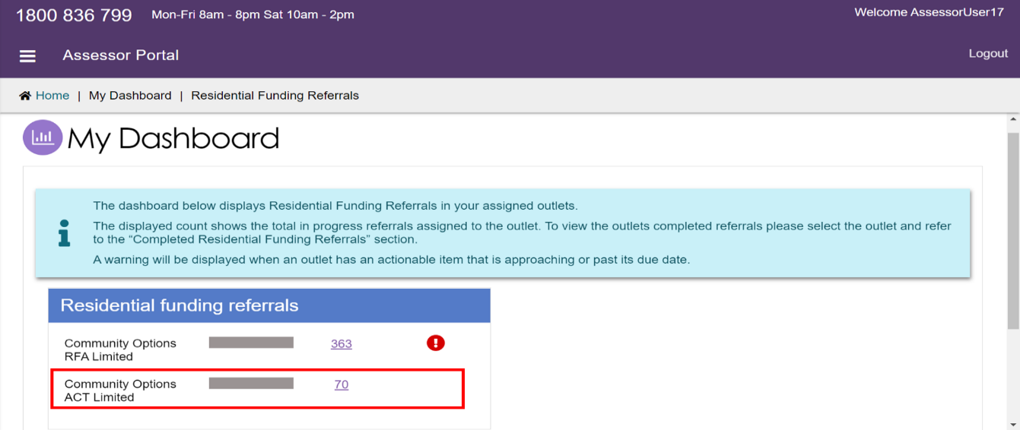

1. The top section will display the breakdown of all in progress assessments, these are the referrals that your outlet has been assigned.

The bottom section will show a count of referrals completed in the current calendar month and the previous calendar month.

Each count is a link that will take you to the list of referrals with the corresponding filter applied.

