Medicare Benefits Campaign
Stakeholder information kit
  - February 2025
Contents
About this kit 2
Background 3
Key messages 3
Frequently Asked Questions 4
Social media content 5
Resources 6

About this kit
This stakeholder kit contains information and resources from the Department of Health and Aged Care (the Department) designed to help you promote greater community awareness on the range of benefits available under Medicare including bulk billing, urgent care, mental health services, and dental services for eligible children.

This kit includes:
- Background
- Key messages
- Frequently Asked Questions
- Social media posts
- Resources

Useful links
- Media release: Supporting Australians to know how to access affordable health care
- Medicare Benefits Campaign website: medicare.gov.au/stronger

Background
Medicare is Australia’s health care system, giving all Australians access to a wide range of health services at low or no cost since 1984.
In 2024 Australia celebrated 40 years of Medicare – a cornerstone of everyday life that ensures people can access health care when they need it, regardless of their income or where they live.
According to the Australian Bureau of Statistics, 3 in 10 Australians delayed or did not go to their GP when they needed to during the 2022-23 financial year.
Twice as many Australians delayed or deferred seeing a GP because of cost in 2022-23, with 7 per cent of people doing so, compared to 3.5 per cent in 2021-22.
This kit highlights a range of benefits available through Medicare that are already helping support access to affordable care, including bulk billed services and free walk-in health care available every day across growing national networks of Medicare Urgent Care Clinics and Medicare Mental Health Centres.

Key messages
- Medicare gives you access to a wide range of health and hospital services at low or no cost, so you can get care when you need it, regardless of your income or where you live.
- Medicare is being strengthened so it can meet the changing health care needs of Australians.
- More than 11 million Australians now have access to free GP services through new bulk billing incentives.
- The growing networks of Medicare Urgent Care Clinics and Medicare Mental Health Centres provide free walk-in services for urgent medical care and mental health support, reducing the pressure on emergency departments. These facilities make healthcare more accessible to all, no matter your situation.
- Medicare means you can access:
- free or lower cost services from doctors and other health professionals who offer bulk billing
- free, walk-in mental health care through a growing network of Medicare Mental Health Centres
- free, walk-in urgent care through a growing network of Medicare Urgent Care Clinics
- part or all the cost of basic dental services for eligible children, under the Child Dental Benefits Schedule.
There are also many other Medicare benefits, to learn more about these visit the Services Australia website.

Frequently Asked Questions

Who can access Medicare?
You’re eligible for Medicare if you live in Australia and you are:
- an Australian or New Zealand citizen
- an Australian permanent resident
- applying for permanent residency (conditions apply)
- a temporary resident covered by a ministerial order
- a citizen or permanent resident of Norfolk Island, Cocos (Keeling) Islands, Christmas Island, or Lord Howe Island.
You’re also eligible for Medicare if you’re visiting Australia from a country with a Reciprocal Health Care Agreement (conditions apply).

How can I enrol in Medicare?
There are three ways you can enrol in Medicare:
- online through the myGov website
- complete a Medicare enrolment form and submit your form including supporting documents by mail or email, or
- visit a Services Australia service centre.

What are Medicare Urgent Care Clinics and what do they offer?
Medicare Urgent Care Clinics offer free, walk-in health care for urgent but not life-threatening injuries and illnesses across Australia. They are open early and late every day and you don’t need a referral – just walk in and wait to be seen.

What are Medicare Mental Health Centres and what do they offer?
Medicare Mental Health Centres offer free, walk-in support for mental health and well-being across Australia. No appointment, referral, Medicare enrolment or Medicare card is needed, and you don’t need to be an Australian citizen to access support.

Social media content
The hashtags #Medicare, #MedicareUrgentCareClinic, #MedicareMentalHealthCentre are associated with this topic.
Channel | Content | Image
Facebook & Instagram | A stronger Medicare means access to health care when you need it  Medicare helps more people access health care when they need it, regardless of their income or where they live.  Medicare means you can access:  - free or lower cost services from doctors and other health professionals  - free, walk-in mental health care through a growing network of Medicare Mental Health Centres  - free, walk-in urgent care through a growing network of Medicare Urgent Care Clinics  - part or all the cost covered of basic dental services for eligible children, under the Child Dental Benefits Schedule.  To find out more about how Medicare can help you, visit medicare.gov.au/stronger | 
X | Medicare means you can access:  - free or lower cost health care  - free, walk-in mental health care at Medicare Mental Health Centres  - free, walk-in urgent care at Medicare Urgent Care Clinics  To find out more about how Medicare can help you, visit medicare.gov.au/stronger | 

Resources
You can download and share these resources with your community through communications channels, such as social media, newsletters, and your website.
All resources are available to download from www.health.gov.au/stronger-medicare/resources. Download links for individual resources are included below.
Resource | Title | Preview
DL brochure | There’s more to Medicare | 
Factsheet | There’s more to Medicare | 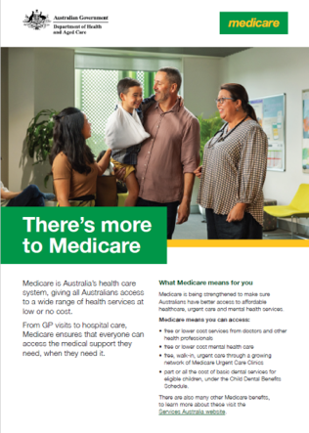
Poster | There’s more to Medicare | 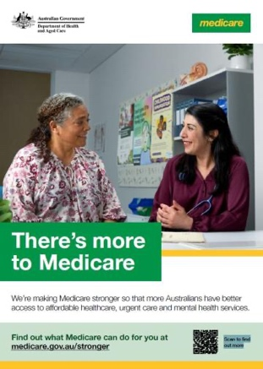
Factsheet | Medicare Urgent Care Clinics – there when you need them | 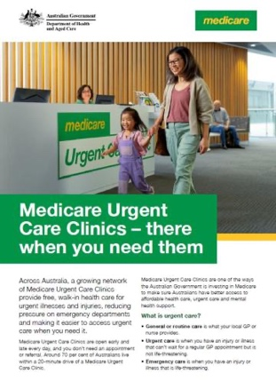
Factsheet | Medicare support for mental health | 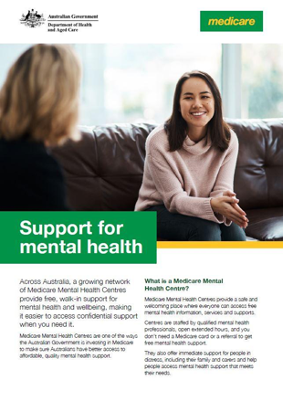
Factsheet | About bulk billing and Medicare | 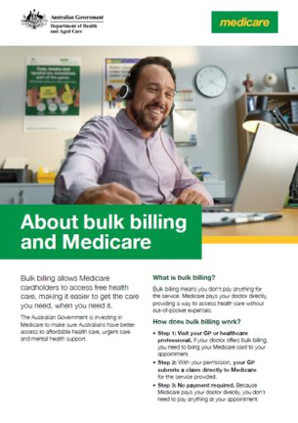
Factsheet | About the Child Dental Benefits Schedule | 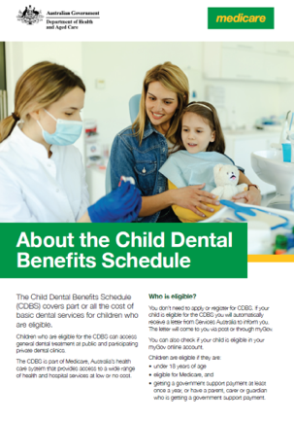
Easy read factsheet | What is Medicare | 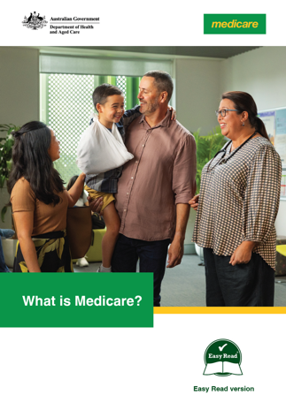
Easy read factsheet | About bulk billing | 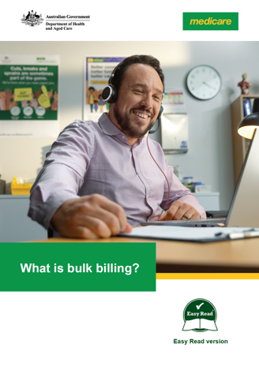
Easy read factsheet | Child Dental Benefits Schedule | 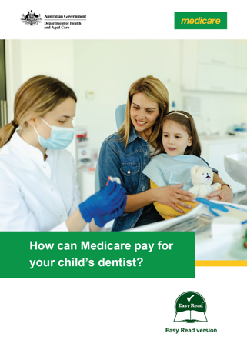
Poster | Your child could be eligible for dental benefits | 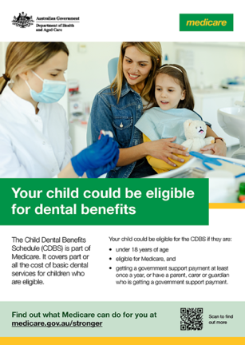
Animation | Understanding Medicare bulk billing | 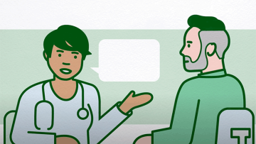
Animation | How Medicare can help you | 
Animation | What is the Child Dental Benefits Schedule | 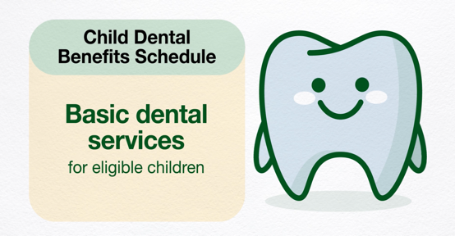
First Nations Factsheet | There’s more to Medicare | 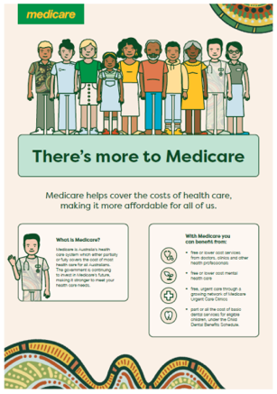
First Nations poster | There’s more to Medicare | 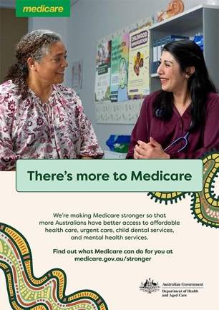
First Nations animation | There’s more to Medicare | 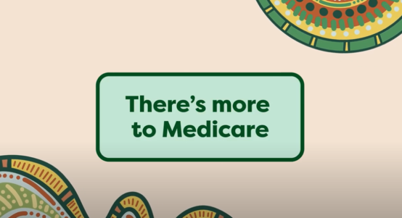
First Nations social messaging guide | First Nations social messaging guide | 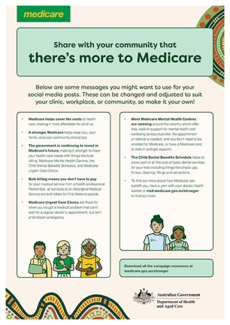
First Nations social tiles | Child Dental Benefits Schedule social tile  Medicare Urgent Care Clinics social tile  Bulk billing social tile  Medicare Mental Health Centres social tile | 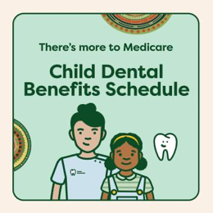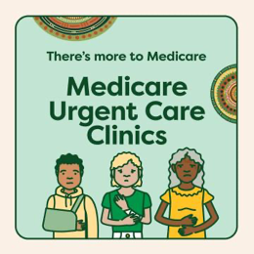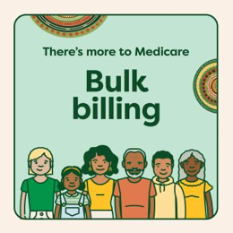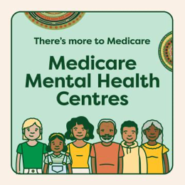
Translated materials | A range of translated resources are available here. | Languages include:  - العربية (Arabic)  - 简体中文 (Simplified Chinese)  - 繁體中文 (Traditional Chinese)  - Ελληνικά (Greek)  - Italiano (Italian)  - 한국어 (Korean)  - Tiếng Việt (Vietnamese)  - Русский (Russian)  - Српски (Serbian)  - Español (Spanish)  - Khmer  - Hrvatski (Croatian)  - Македонски (Macedonian)  - ਪੰਜਾਬੀ (Punjabi)  - Türkçe (Turkish)

