**Hospital Portal User Guide –** **Navigating the client record**

This guide provides an overview of the hospital portal and how authorised hospital staff can use the portal to view patient information in My Aged Care client records. This streamlines the discharge planning process for older people from hospital and safely back into their homes.

The hospital portal enables users to:

* search for a client registered in My Aged Care
* view the client record information in summary about a client’s current aged care services, aged care approvals, most recent assessment service and latest assessment date
* add notes to a client record
* add attachments to a client record such as a hospital discharge summary
* update a client’s status to deceased.

This guide contains the following topics:

Accessing the client record 2

Basic Search 2

Advanced Search 3

What information is in the client record? 4

The Client summary tab 4

The Client details tab 5

Notifying My Aged Care that a client is deceased 6

The Support Network tab 8

Consent 10

Attachments 11

Notes 12

|  |  |
| --- | --- |
| **!** | Privacy requirements  Hospital Organisations are required to comply with the legislative requirements under the *Privacy Act 1988* (Cth) (Privacy Act), including the Australian Privacy Principles when using the My Aged Care hospital portal.  The Privacy Act regulates the handling of personal information about individuals, including the collection, use, storage and disclosure of personal information, and access to and correction of that information.  Hospital staff are also required to comply with the *Aged Care Act 1997* (Cth) when using the My Aged Care hospital portal. |

# Accessing the client record

A client record in My Aged Care reduces the number of times a person has to repeat their story to many hospital staff, assessors, and service providers to be assessed for access to aged care services.

Clients will be asked to give their **consent** to allow their client record to be accessed by authorised staff and shared with all My Aged Care users, such as hospital staff, assessors and service providers.

To access the client record, follow the steps below:

**1.** Log in to the My Aged Care Hospital Portal using this link:

<https://myagedcare-hospitalportal.health.gov.au>

**2.** Access the client record from the ‘Find my client’ landing page.

## Basic Search

You can do a **basic search** by entering the Last Name, First Name or Aged Care User ID into the fields, and then selecting the ‘SEARCH’ button.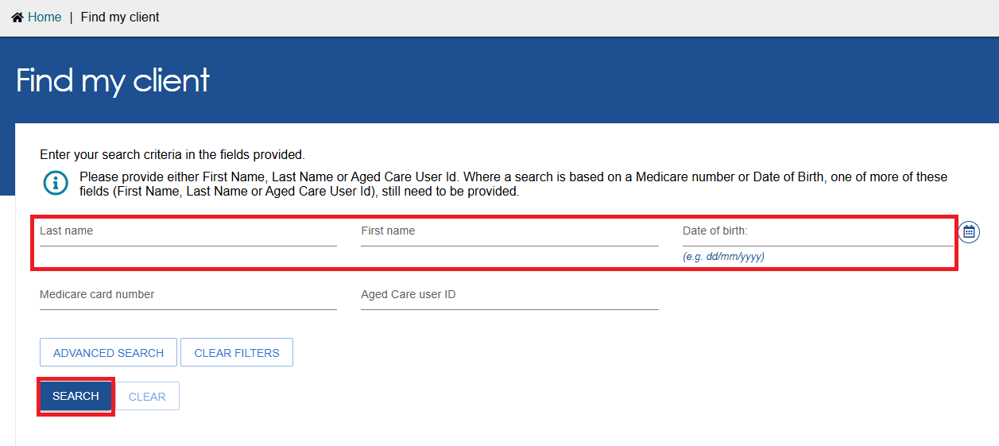

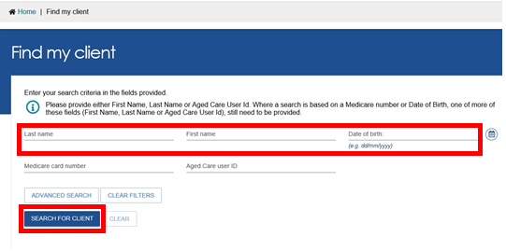

## Advanced Search

* You can also do an advanced search. Advanced search can find an exact match of a client record by also entering a ‘Medicare number’ or ‘Date of Birth’ in the search with one or more of the other fields included.
* To display more search fields, select ‘Advanced Search’.
* To go directly to a recently viewed client, use the links under ‘Recently Viewed Persons’ heading displayed on the right of the ‘Find my client’ page. Selecting a client’s name from the list will take you directly to the client record (Client Summary or Client Details).
* You can also switch how the results display between ‘CARD’ view and ‘LIST’ view by selecting the CARD or LIST button at the right.

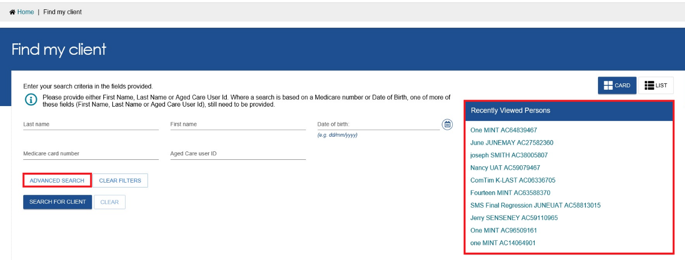

|  |  |
| --- | --- |
| **!** | Advanced Search Functions  Advanced Search options available for ‘Find my Client’ include the following fields:   * Aged Care Payment Management System (ACMPS) number * Aged Care User ID * Centrelink Customer Reference number (CRN) * Client Status * Date of Birth * Department of Veterans’ Affairs (DVA) card number * First name * Home contact number * Last name * Locality * Medicare Number * Postcode * Preferred name * State * Suburb * System for the Payment of Aged Residential Care (SPARC) number |

# What information is in the client record?

The client record contains client information displayed across five tabs described in more detail below:

* Client Summary
* Client details
* Support Network
* Attachments
* Notes

# The Client summary tab

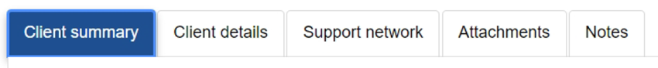

The ‘Client summary’ tab displays a dashboard of key information about the client’s interactions with My Aged Care including:

* Assessments
* Service recommendations and approvals
* Service delivery status
* Client Concerns
* Client Goals

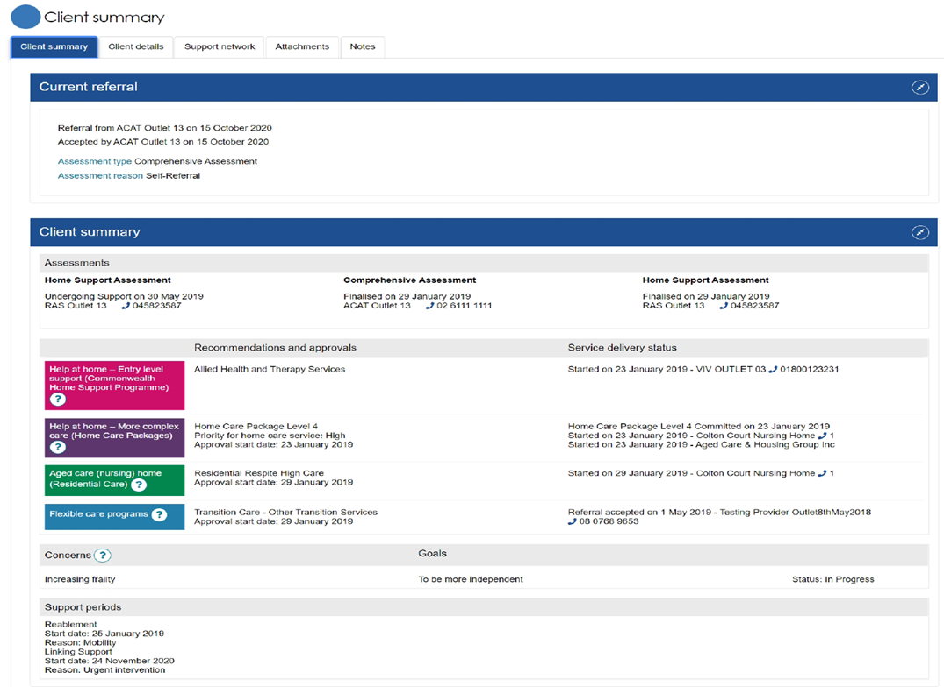

# The Client details tab

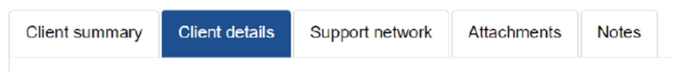

Select the ‘Client details tab to navigate to the client details page of the client record.

The ‘Client details’ tab contains basic demographic and contact information about the client. It is where you can view high level details about any active support plans, services, and the client’s primary contact details.

In this section the client’s nominated ‘primary contact’ person is displayed. The primary contact person can be a representative, support person or the client themselves. This information allows hospital staff, assessors, My Aged Care contact centre staff and service providers to identify the key contact details for a client. This field does not impact on any system generated mail correspondence that the client may receive in relation to their care.

My Aged Care clients and their support network are automatically opted in to receive copies of Home Care Package (HCP) letters.

My Aged Care clients and their support network can also receive email and/or SMS notifications when a client reaches the following key stages of their My Aged Care journey:

* Client registration is complete
* The client’s assessment is finalised
* The client is approved for care after a comprehensive assessment
* A client is assigned a Home Care Package
* A Support Plan Review request has been submitted

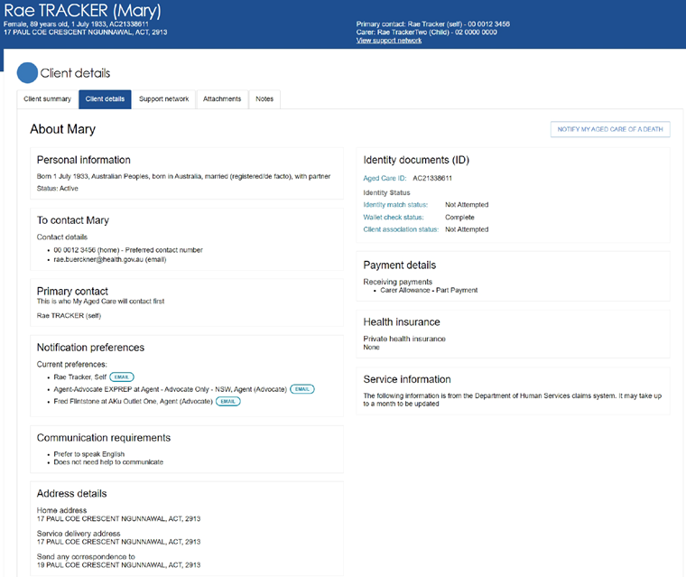

# Notifying My Aged Care that a client is deceased

If a client’s status is Deceased, you will be able to add attachments for up to 30 days from the date the status was updated as ‘deceased’. After this, the client’s record will be read-only, and you will not be able to edit any client information.

A banner will be displayed on all tabs of the client record. If the client’s status is incorrect, please contact the Service Provider and Assessor Helpline on 1800 836 799.

Banner "the Department has been notified that this client is deceased. Please contact us on 1800-836-799 if this is incorrect"

**1:** Select the ‘Notify My Aged Care of a Death’ button in the ‘Client Details’ page of the record.

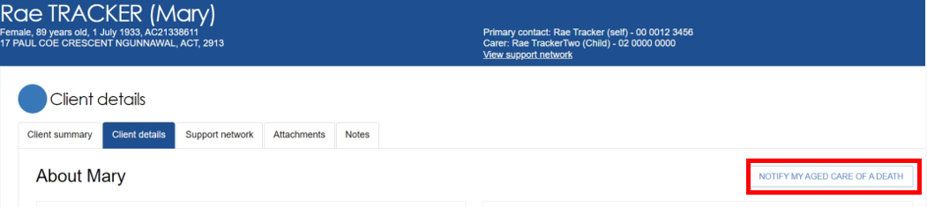

**2:** When ‘Notify My Aged Care of a Death’ is selected, a pop-up box will prompt you to enter the following information:

* Date of Death (if known)
* Add Attachments if available (Death certificate, hospital discharge documents etc)

**3:** After entering details and attachments, select the ‘save’ button to submit your notification.

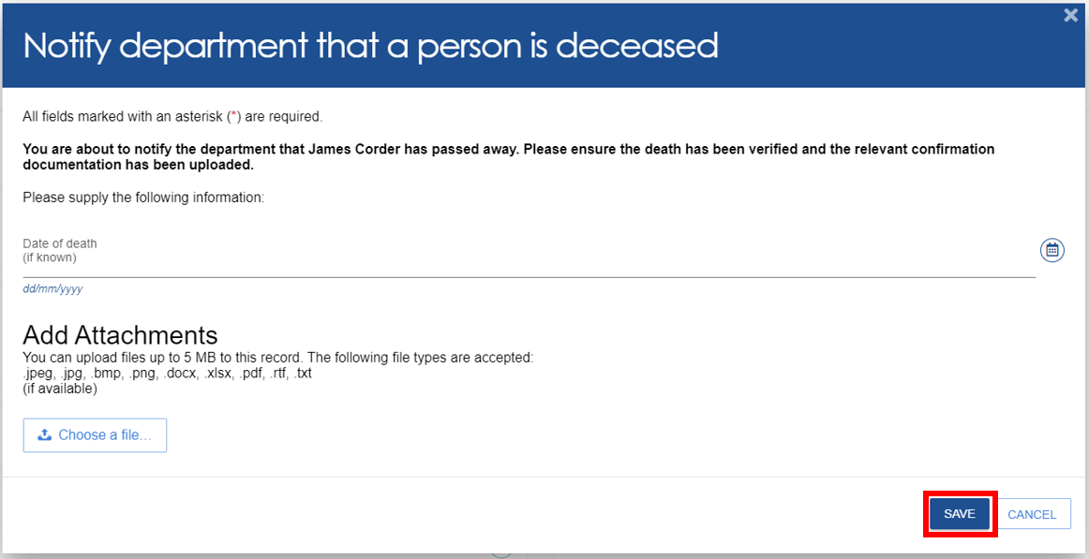

**4:** Updating a client status to deceased cannot be reverted. An additional confirmation box will appear. Once confirmed, click ‘OK’.

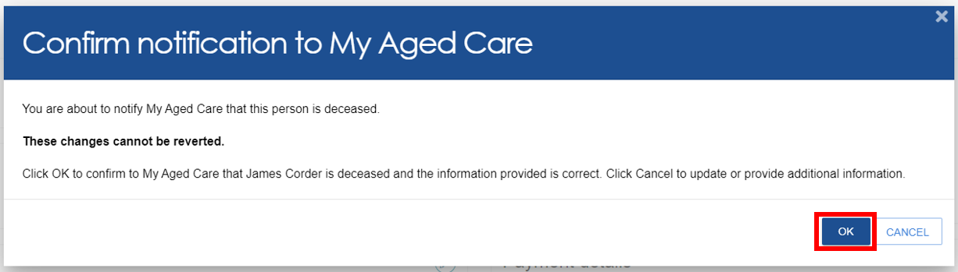

The following banners will then be displayed at the bottom of the page.

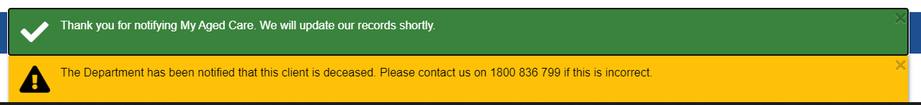

|  |  |
| --- | --- |
| **!** | Primary Contact Person  The ‘Primary contact person’ can be nominated by the client or the client’s representative. This information allows hospital staff, assessors, My Aged Care contact centre staff, and service providers to identify the key contact person for a client.  This field does not have any impact on the system generated mail correspondence the client may receive in relation to their care. |

# The Support Network tab

The ‘Support Network’ tab contains three sub-tabs:

* Client’s Support Network
* People the client supports
* Declined and ended relationships

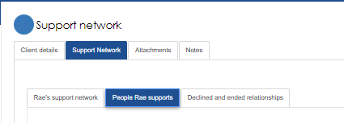

The **‘Client’s Support Network’** sub-tab shows people, organisations, GP’s, and other relationships who provide support to the client.

* The **‘People’** section includes contacts for care and financial matters and must be approved by the client before being approved as a contact.
* The **‘Organisations’** section shows organisations that are approved by the Department to support older Australians and have been selected by the client to be an organisation in their support network.
* The **‘Other Relationships’** section can include family, carers, neighbours and any other contacts the client would like listed.

Images of the **‘Client’s Support Network’** are below:

***People:***

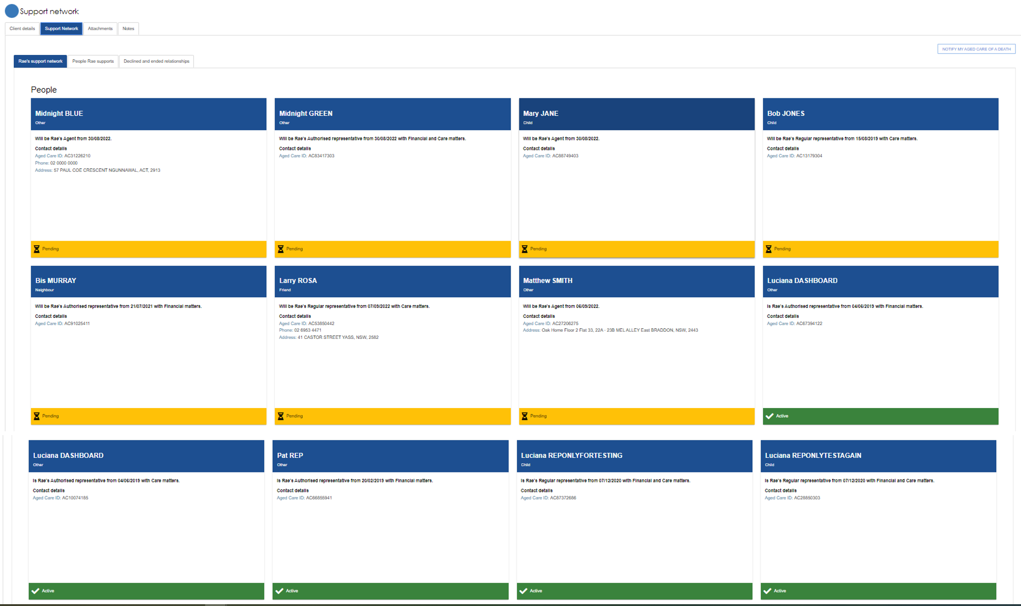

***Organisations:***

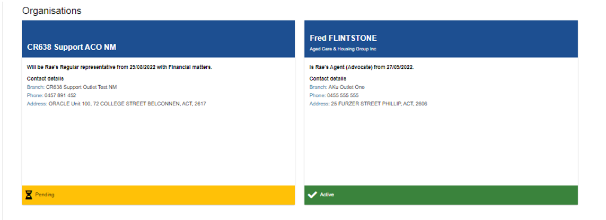

***Other Relationships:***

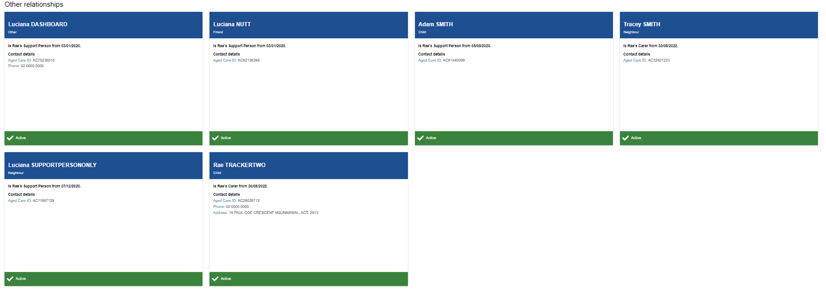

The **‘People Client Supports’** sub-tab shows any people or other relationships which the client directly supports. This could be their partner, neighbour, or other contacts in their network.

The **‘Declined and Ended Relationships’** sub-tab will list any relationships which no longer exist. This could be due to either person no longer requiring care, moving location, being incapable of providing assistance, or becoming deceased. It also includes any organisation connections which no longer exist.

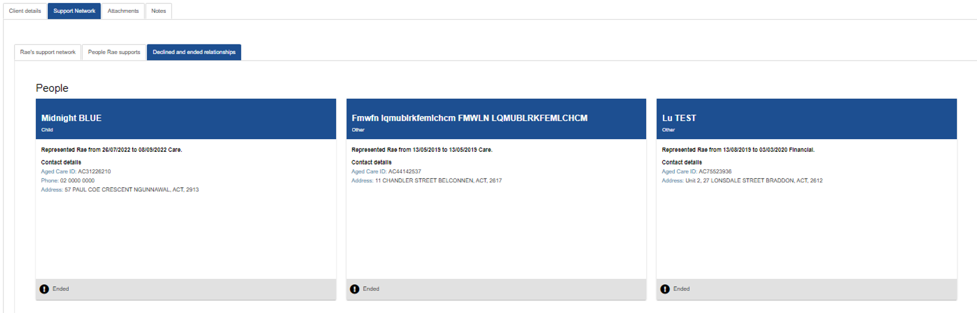

# Consent

For all first-time update actions on a client record a message in a pop-up window will display asking ‘have you obtained consent from the client to collect/edit their information?

You **must** obtain consent before selecting ‘I have consent’.

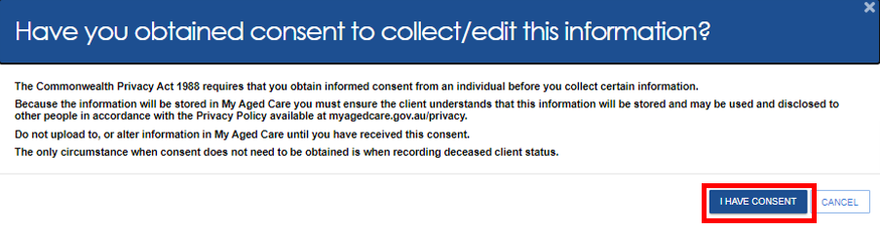

# Attachments

the Attachments tab

The ‘Attachments’ tab contains documents that have been attached to the client record by an authorised hospital staff member (using the hospital portal). To add an attachment to a client record follow the steps below:

**1:** Select ‘Add an attachment’

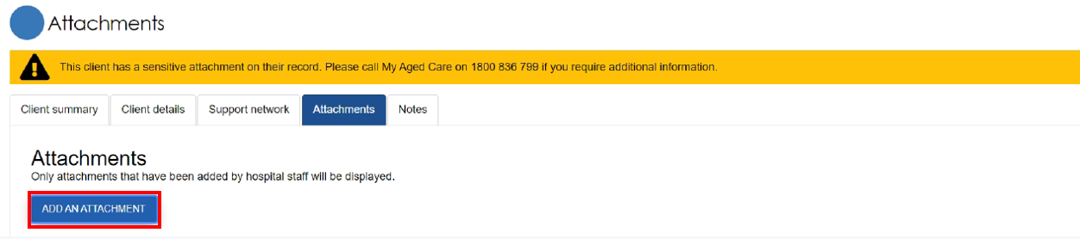

**2:** A pop-up window will display asking ‘have you obtained consent from the client to collect/edit their information?

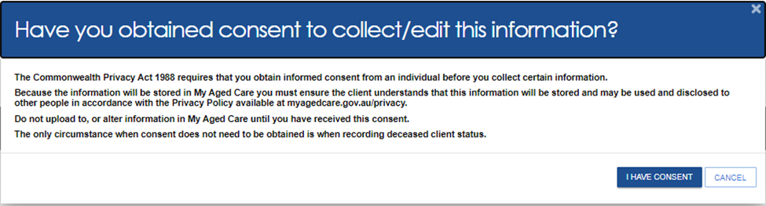

**3:** Add the attachment by selecting ‘Choose file’ then enter the required information in the display fields including ‘Name of the attachment’ and ‘Type of attachment’ and a short description about the contents of the attachment. Select ‘Upload’ to add document to the client record.

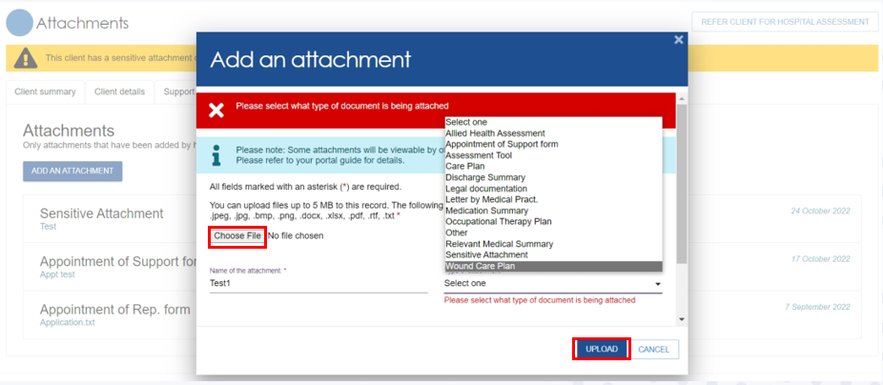

**4:** The document will now display in the ‘Attachments’ tab.

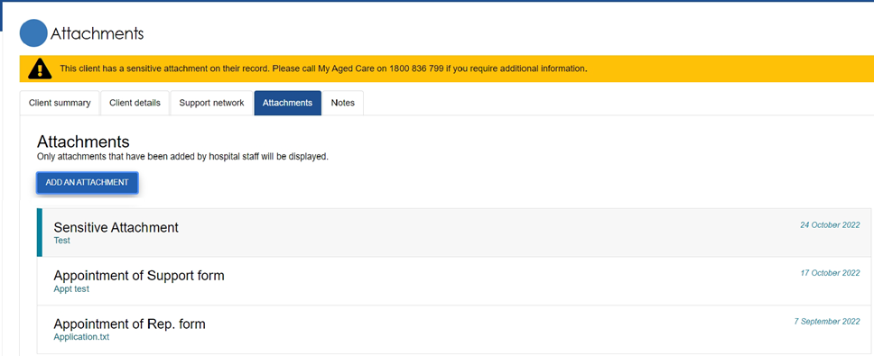

|  |  |
| --- | --- |
| **!** | Sensitive Information  When uploading information against a client record that is deemed sensitive you must select ‘Sensitive Attachment’ as the ‘Type of attachment’ from the drop-down list. The client record will display a message ’The client has a sensitive attachment on their record’.  Anyone accessing the client record will be alerted that a ‘Sensitive Attachment’ exists for the client. They will be directed to contact the assessor who conducted the last assessment, or the My Aged Care provider and assessor helpline to access information within the sensitive attachment. |

# Notes

the Notes tab

The ‘Notes’ tab contains notes that have been created about the client by the hospital staff.

**1:** Hospital staff can add new notes about the client from this tab by selecting ‘Add a Note’.

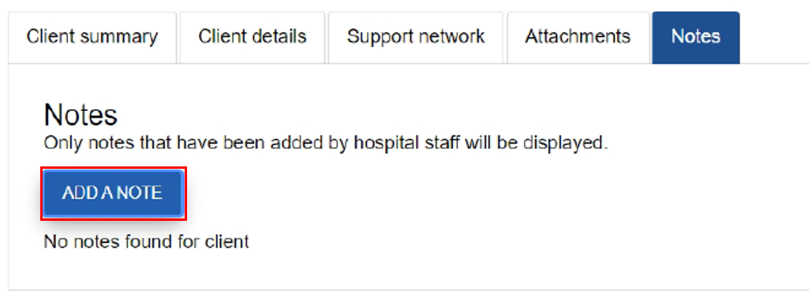

**2:** A popup window will appear. Enter the relevant display fields and select ‘Save’.

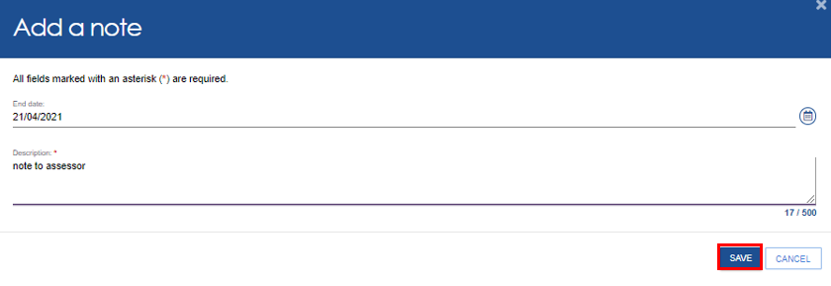

**3:** The note will be added as a row with note type as ‘Hospital Note’ and status set to active. You can edit a note and change the status or ‘end date’.

The ‘Description’ field cannot be changed.

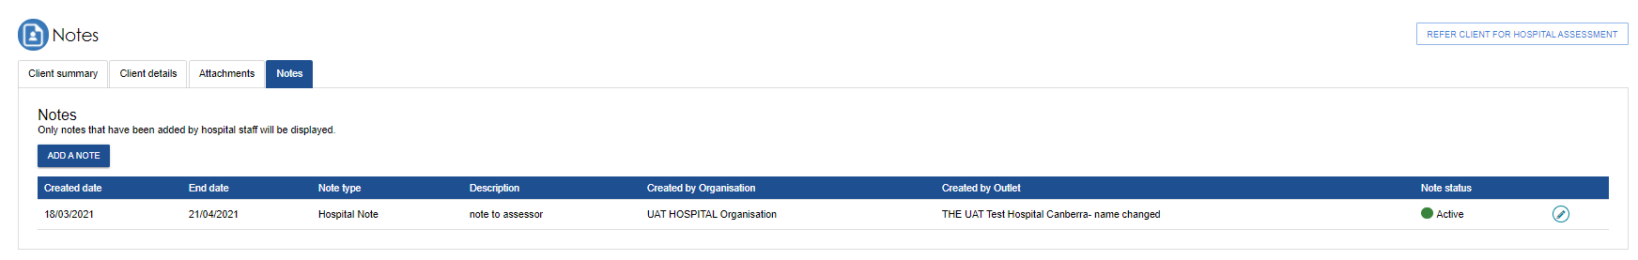

|  |  |
| --- | --- |
| **!** | Sensitive Notes  Anyone accessing the client record will be alerted that a ‘Sensitive Note’ exists for the client. They will be directed to contact the assessor who conducted the last assessment, or the My Aged Care provider and assessor helpline to access information within the sensitive note. |

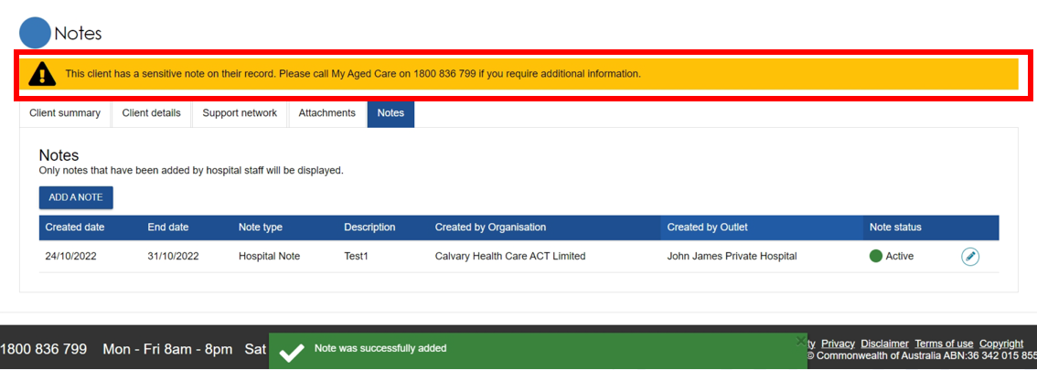

|  |  |
| --- | --- |
| **!** | Deletion of Notes  You cannot delete a note that has been saved. You can only change status to ‘Inactive’. |