Government Provider Management System

User Guide: Star Ratings

February 2025

Version 1.6

This Government Provider Management System (GPMS) User Guide   
provides Star Ratings reviewers, at both the organisation and service level, with guidance when accessing and viewing Star Ratings.

Contents

1. Introduction 3

1.1 Purpose 3

1.2 Before proceeding 3

1.3 Login to the GPMS portal 4

2. Further information and support 4

3. Accessing Star Ratings 4

4. Viewing Star Ratings 5

5. Star Ratings status types 13

6. Downloading PDF Report of Provider Preview 14

# Introduction

Star Ratings has been introduced for residential aged care homes across Australia to provide transparent and nationally consistent measurement of aged care quality, supporting:

* older people and their representatives to make more informed choices about their aged care
* provider engagement in improving the quality of services delivered to older people and their representatives
* government transparency and improvement of aged care at a system level.

## Purpose

This User Guide has been designed to support Star Ratings reviewers (both at the organisational and service level) to:

* access the Star Ratings application
* view their relevant Star Rating/s.

## Before proceeding

Please be advised of the following:

The Department of Health and Aged Care (the Department) will retain records of your access to GPMS and when prompted, you must accept the *GPMS Terms of Use* to be able to access the system.

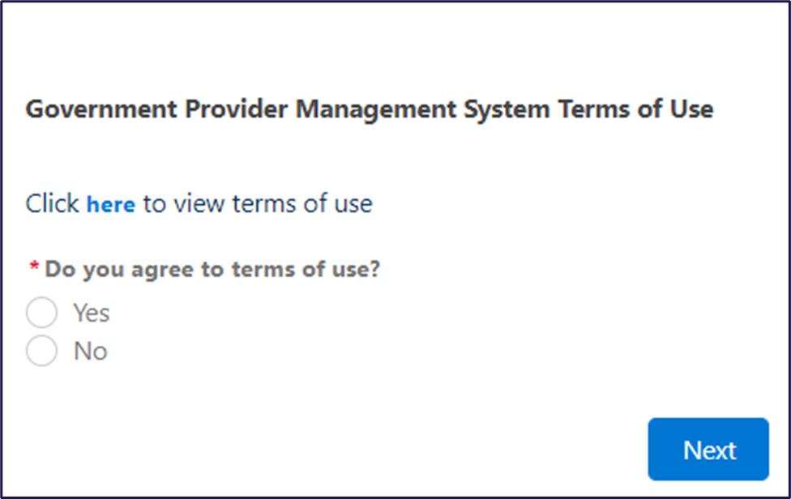

## Login to the GPMS portal

To log into the GPMS portal please visit [Log In Using | Service Provider Portal](https://provider.health.gov.au/serviceproviderportal/login?ec=302&startURL=%2Fserviceproviderportal%2Fs%2F).

Please refer to the [Logging in to the Aged Care Systems](https://www.health.gov.au/resources/publications/logging-in-to-the-aged-care-systems) for information about Accessing the GPMS portal.

# Further information and support

Visit [Star Ratings for residential aged care | Australian Government Department of Health and Aged Care](https://www.health.gov.au/our-work/star-ratings-for-residential-aged-care).

For more information on GPMS please refer to the [Government Provider Management System](https://www.health.gov.au/our-work/government-provider-management-system) webpage.

If you require further assistance to login to GPMS please contact the My Aged Care service provider and assessor helpline on **1800 836 799**, Monday to Friday (8am to 8pm) and Saturday (10am to 2pm) local time across Australia.

For translating and interpreting services, call **131 450** and ask for My Aged Care service provider and assessor helpline on **1800 836 799**.

To use the National Relay Service, visit [About the National Relay Service (NRS) | Access Hub](https://www.accesshub.gov.au/about-the-nrs) or call **1800 555 660**.

To access sign language interpreting and captioning services through Deaf Connect, call [**1300 773 803**](tel:1300%20773%20803) or email [interpreting@deafconnect.org.au](mailto:interpreting@deafconnect.org.au).

# Accessing Star Ratings

Star Ratings is accessed through the GPMS portal. The primary purpose of the Star Ratings application is to allow you to preview new ratings.

To access the Star Ratings application you will need to have either the Star Ratings reviewer (organisation level) or Star Ratings reviewer (service level) access role.

If you do not have this role you will need to discuss your need with your Organisation Administrator.

If you are an Organisation Administrator, you can assign yourself Star Ratings reviewer access.

For more information on how Organisation Adminstrators can assign themselves, or a team member access to the Star Ratings application refer to the [Government Provider Management System – User guide](https://www.health.gov.au/resources/publications/government-provider-management-system-user-guide?language=en).

If you are not an Organisation Administrator at the time of being given Star Ratings reviewer access, you will receive a welcome email with the details of the GPMS portal URL and next steps.

Refer to the [Logging in to the Aged Care Systems](https://www.health.gov.au/resources/publications/logging-in-to-the-aged-care-systems) for information about accessing the GPMS portal.

# Viewing Star Ratings

Once you are in the GPMS portal, you can access the Star Ratings application, by completing the following actions:

1. In the **GPMS portal** landing page, select the **Star Ratings** tile.

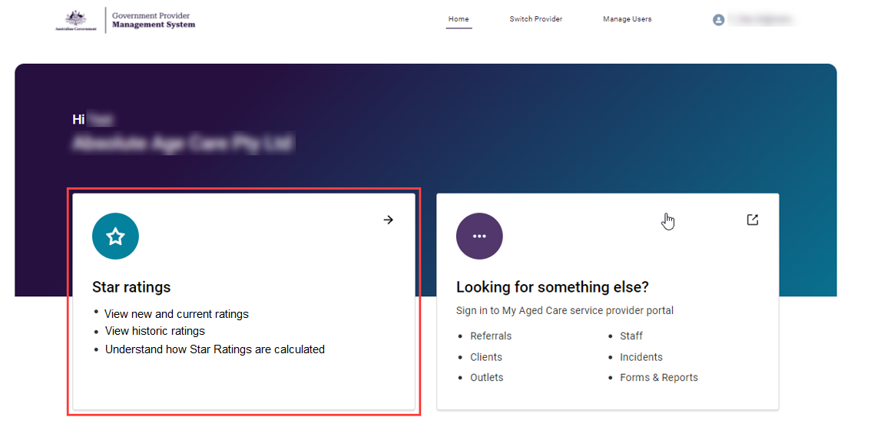

**Please note:**

**Star Ratings reviewers require either the Star Ratings reviewer (organisation) or Star Ratings reviewer (service) access role.**

**If you cannot see the Star Ratings tile on the GPMS portal landing page, notify your Organisation Administrator for the matter to be resolved.**

The Star Ratings screen will display the list of all services currently associated with your provider.

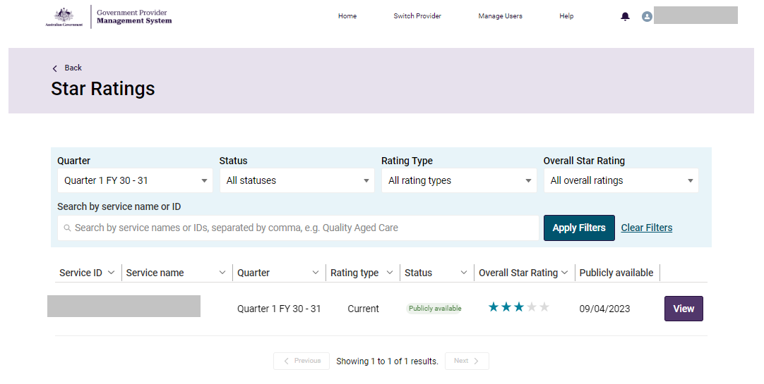

1. You can find the summary of the Star Ratings of each service on this page, or select **View** to find the breakdown of each sub-category of the rating.

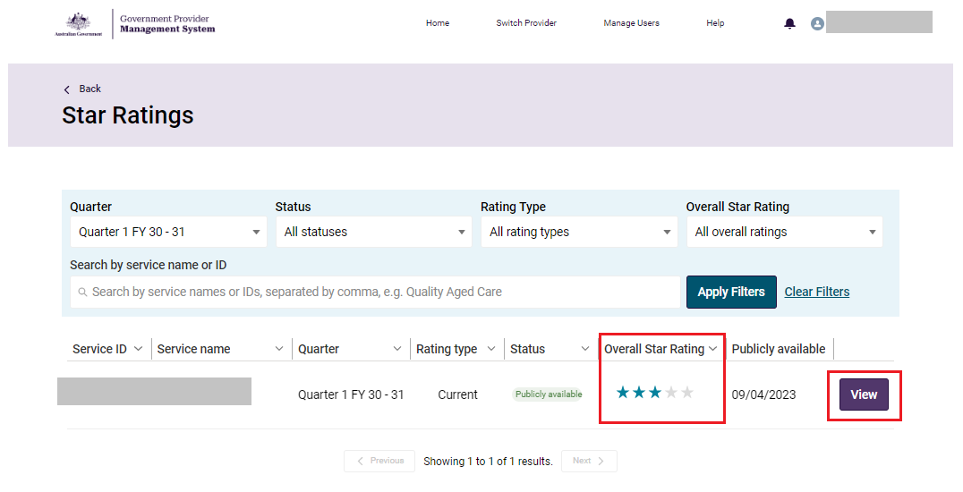

You will be able to preview new ratings and see current and previous Star Ratings your service has received, including the Overall Star Rating and each sub-category rating.

**Example of the Overall Star Rating.**

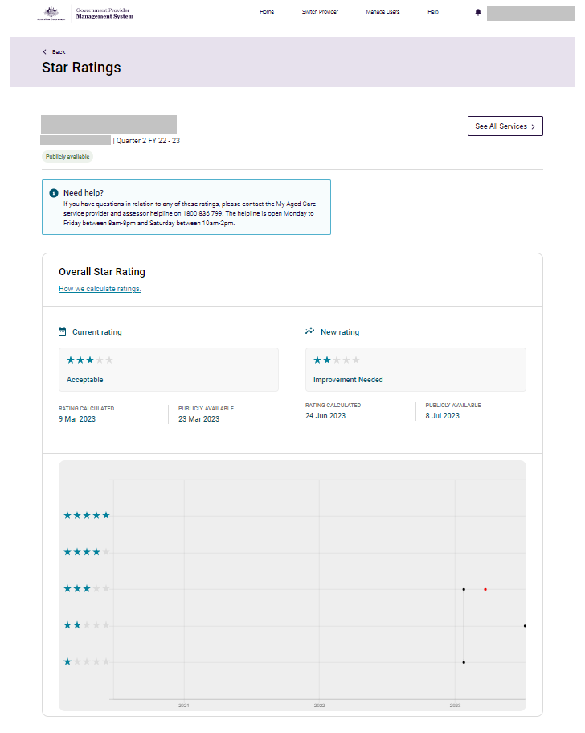

**Example of the Compliance rating.**

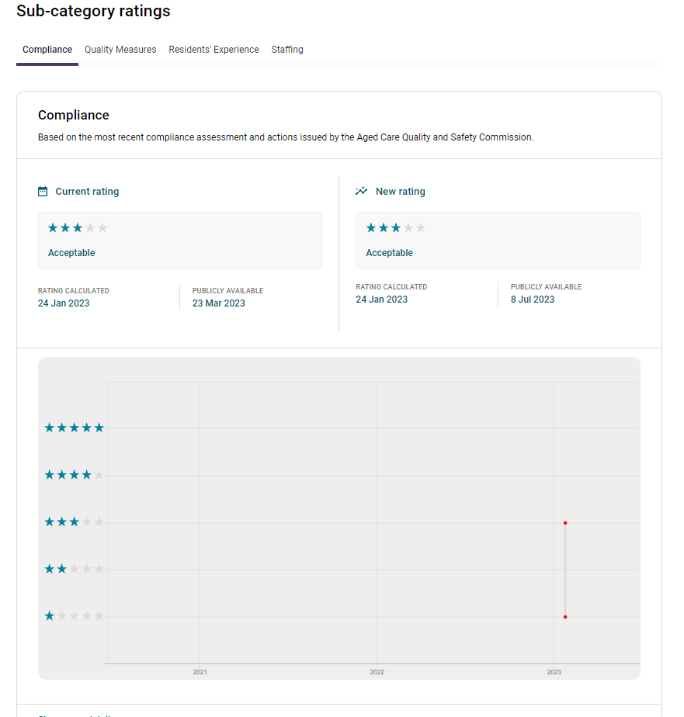

**Example of the Quality Measures rating.**

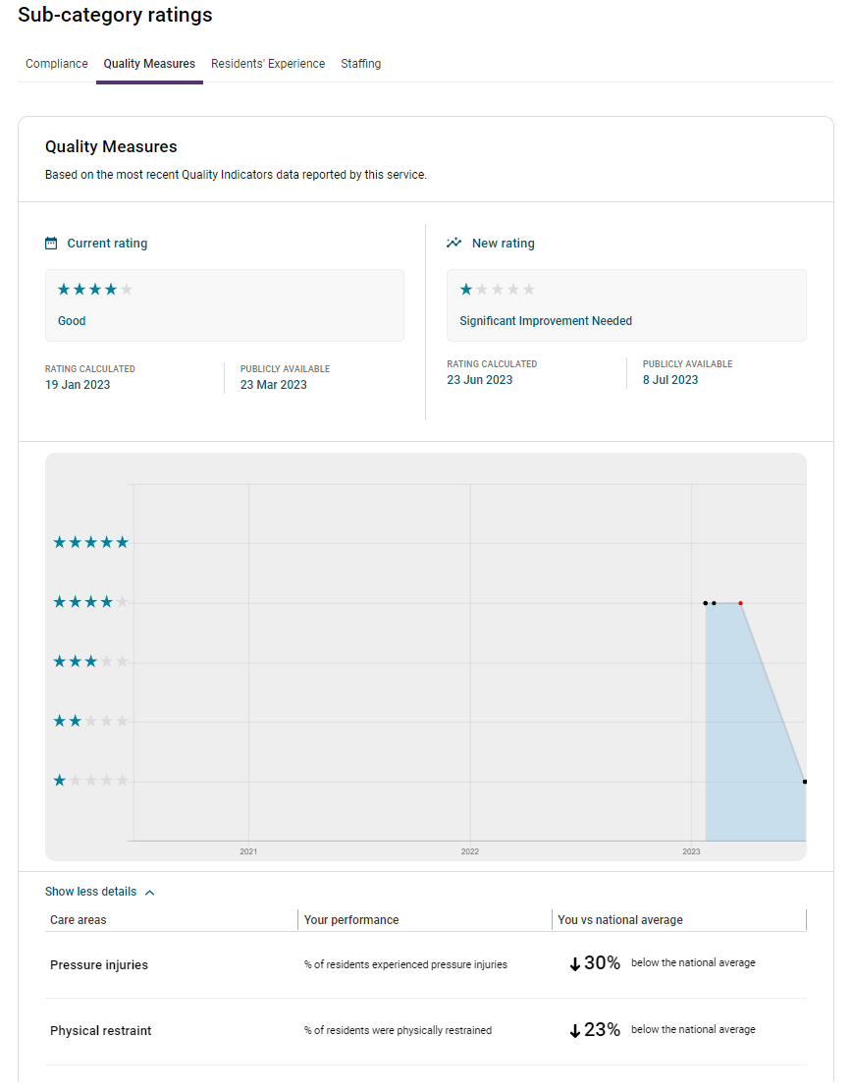

**Please note:**

A service will not receive a Quality Measures rating due to failure to report, or late reporting of the Quality Indicator Program data.

**Example of the Residents’ Experience rating.**

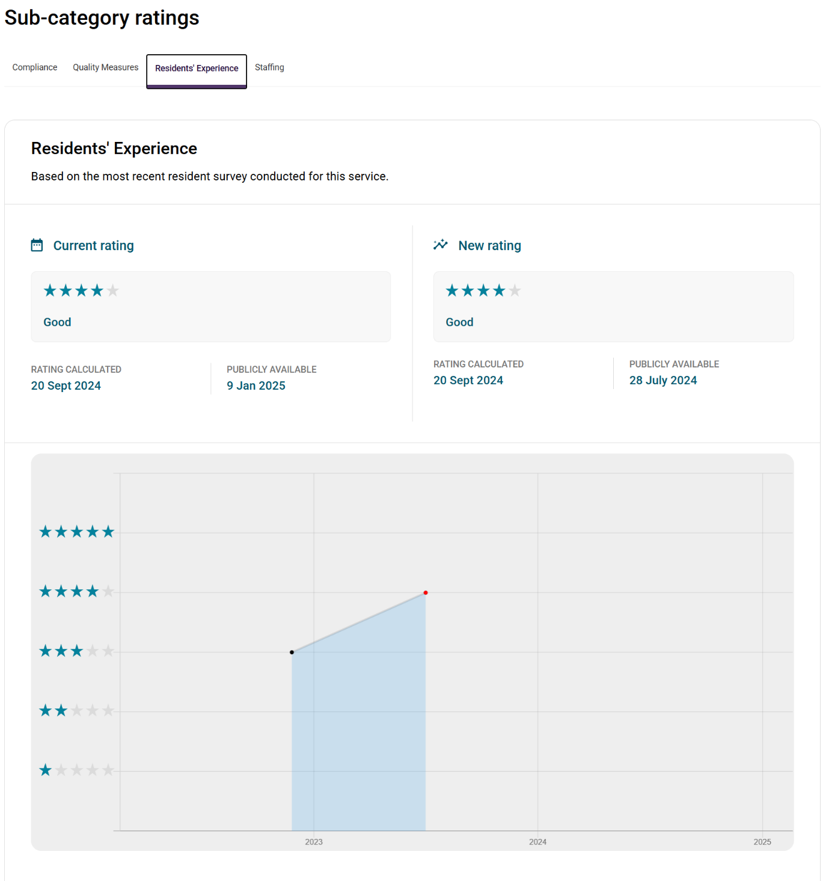

**Example of the Staffing rating.**

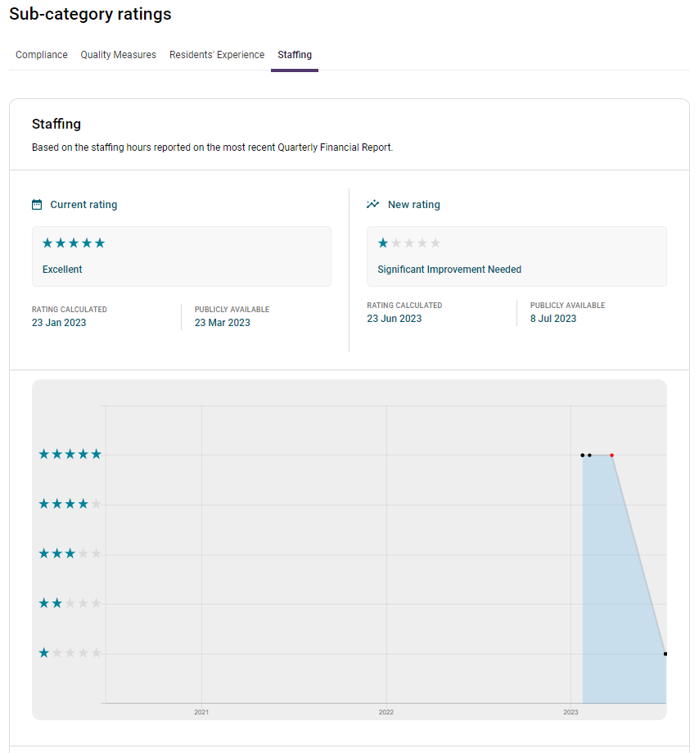

The Staffing page includes additional staffing information on the enrolled nurse care time that contributed to the care time delivered by a registered nurse, up to 10% of the home’s care minute target, that came into effect from 1 October 2024.

For more information on care minutes requirements visit [Care minutes in residential aged care | Australian Government Department of Health and Aged Care](https://www.health.gov.au/our-work/care-minutes-registered-nurses-aged-care/care-minutes).

**Please note:**

A service will not receive a Staffing rating due to failure to report their care minute data on time.

**Please note:**

A rating may not be calculated due to an exemption being granted by the Department of Health and Aged Care.

If this occurs, the warning below will be visible on the rating page.

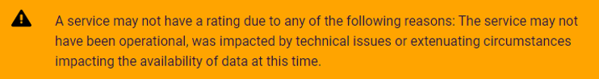

**Please note:**

If you encounter technical errors, please report them to the My Aged Care service provider and assessor helpline on ****1800 836 799****.

The helpline is open Monday to Friday between 8am-8pm and Saturday between 10am-2pm.

# Star Ratings status types

Each Star Ratings entry has a status informing how the rating is being displayed.

The Star Rating status is viewable on the main Star Ratings screen.

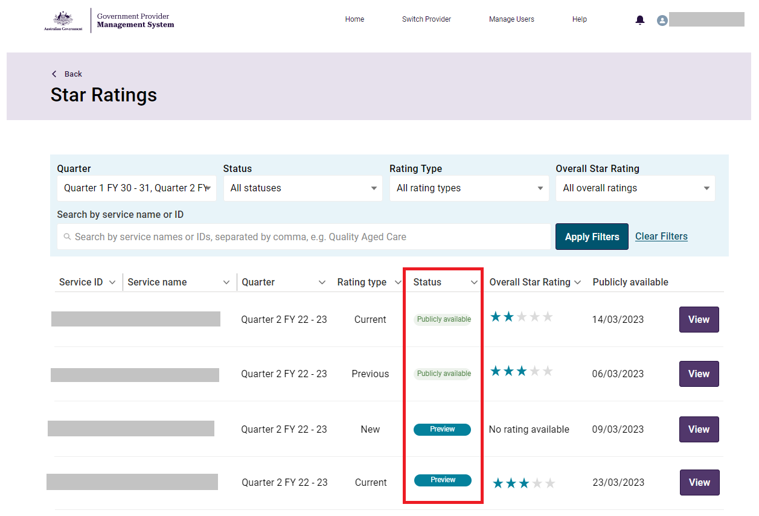

There are three possible status types:

|  |  |
| --- | --- |
| **Status type** | **Meaning** |
| **Preview** | The Star Rating has been published to the GPMS portal to be previewed ahead of being made publicly available. |
| **Publicly available** | The Star Ratings is publicly available on the My Aged Care website. |
| **Under review** | The Star Rating is under review and under investigation by the Department. |

# 

# Downloading a PDF Report of Provider Preview

A PDF Report of your Star Ratings will be available to download in GPMS during the provider preview period.

The provider preview period occurs before each quarterly update. Providers will receive correspondence alerting them to preview dates before each update.

Please note: your report will only be available during the provider preview period. If you would like to print a live rating, you can do this through the My Aged Care website on the Find a Provider tool.

Once you are in the GPMS portal, you can download your PDF report of your Star Ratings provider preview by completing the following actions:

1. In the **GPMS portal** landing page, select the **Star Ratings** tile.

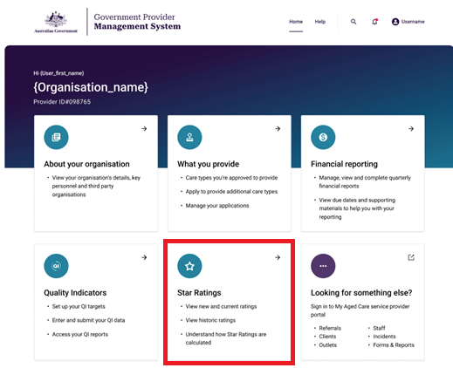

1. The Star Ratings screen will display the list of all services currently associated with your provider.

Select **Generate Report**.

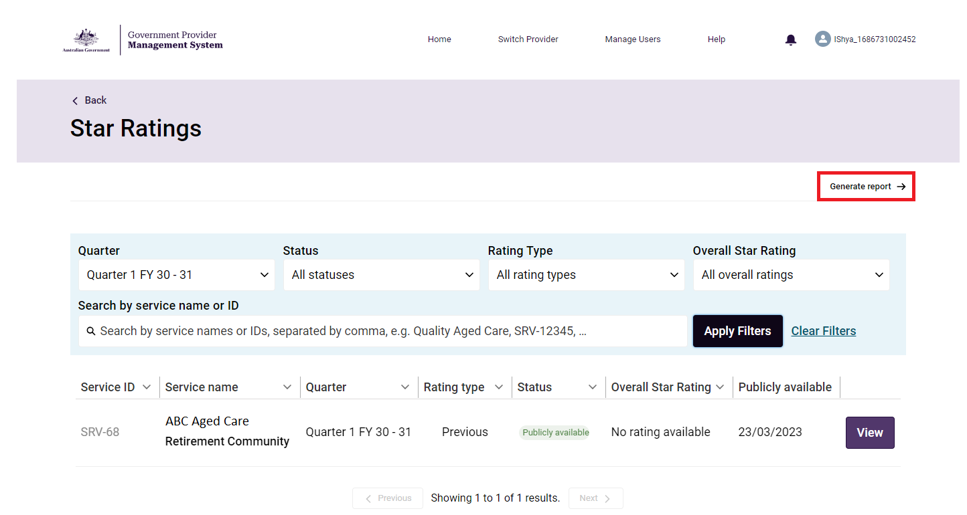

1. Select the **bar chart icon (**A logo depicting a bar chart.**)** to launch Analytical Studio in a new tab.

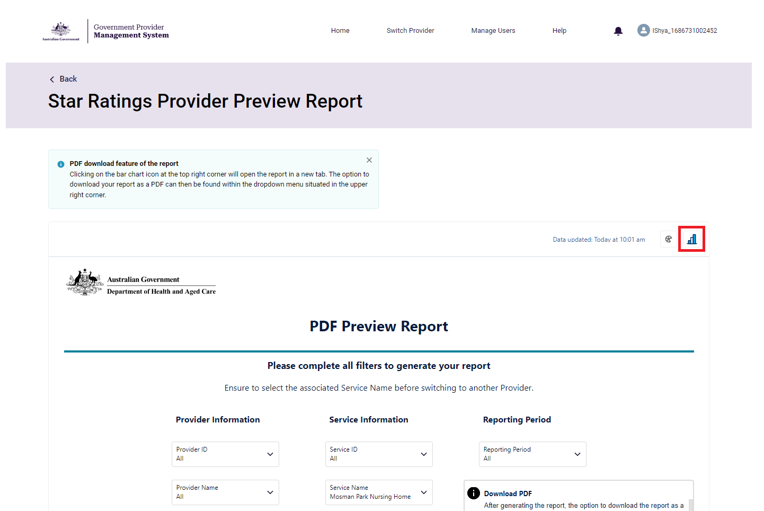

1. A browser page named ‘CRM Analytics | Salesforce’ will load. Select the **Service Name** for the Service you want to view. You can adjust this filter to see services linked to your user profile. You do not need to select any other filters.

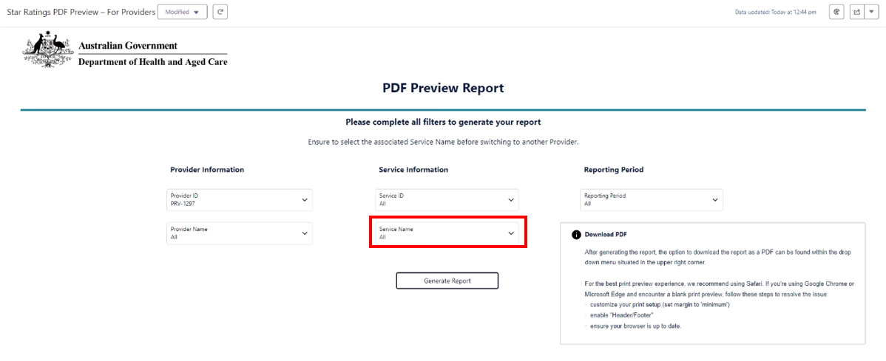

1. Select **Generate Report.**

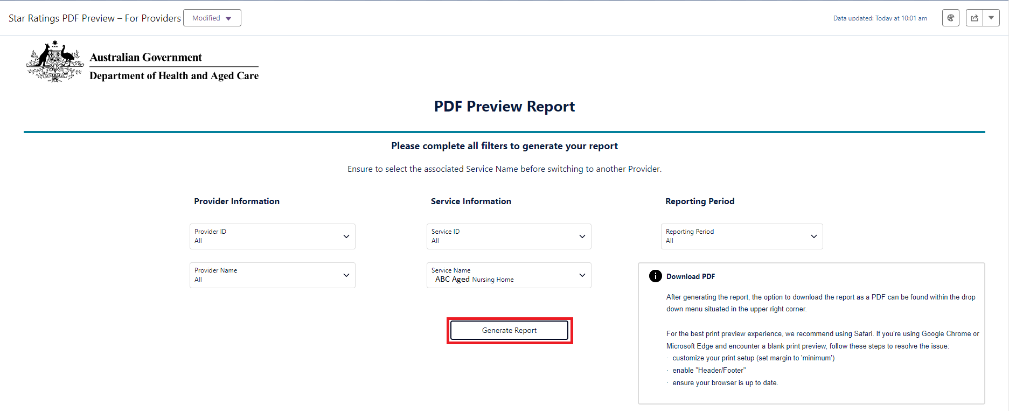

1. The Preview Report page appears. You can scroll down to see the rest of the report, or select **Return to Filters** to return to the filters page.

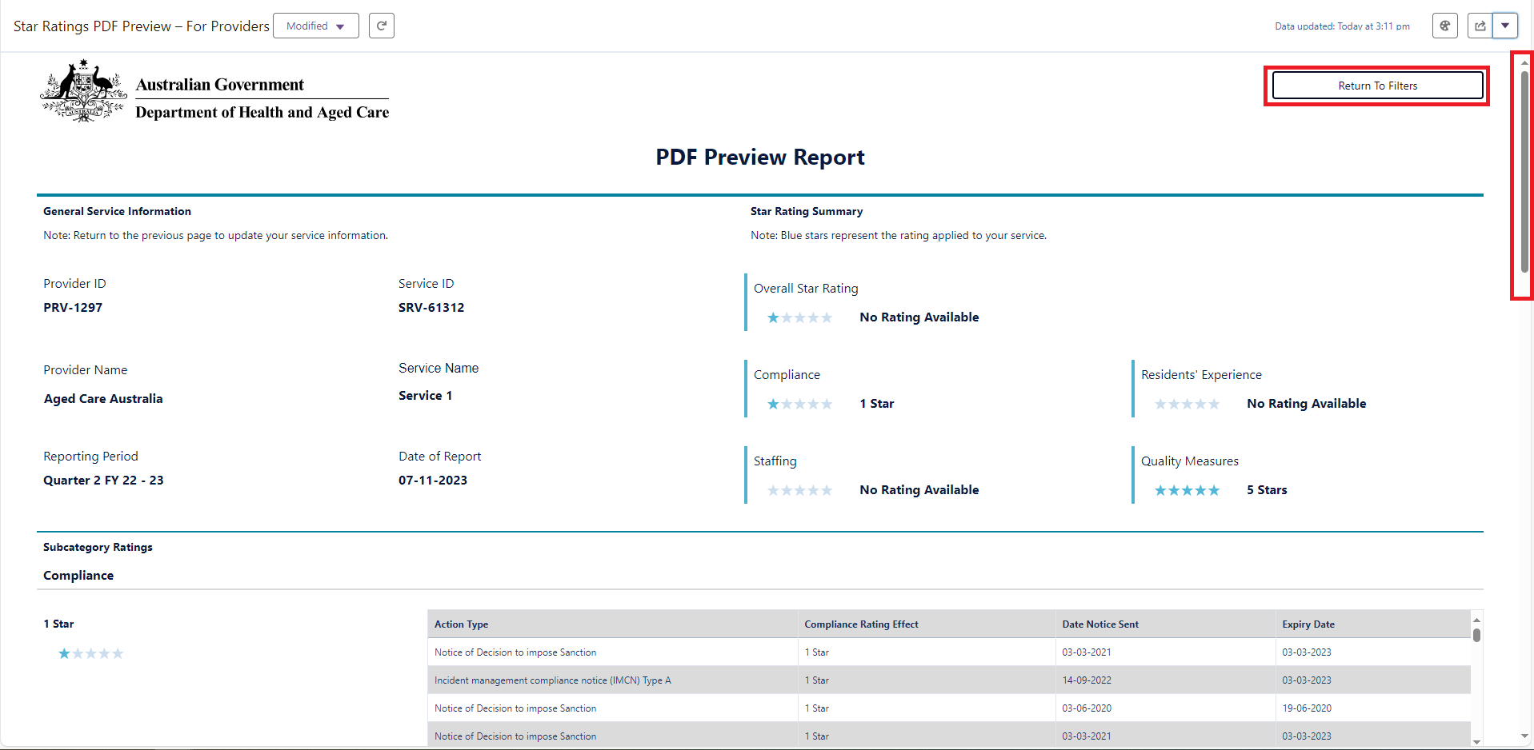

1. To save the report as a PDF, select the dropdown menu in the upper right corner, then select **Print Preview**.

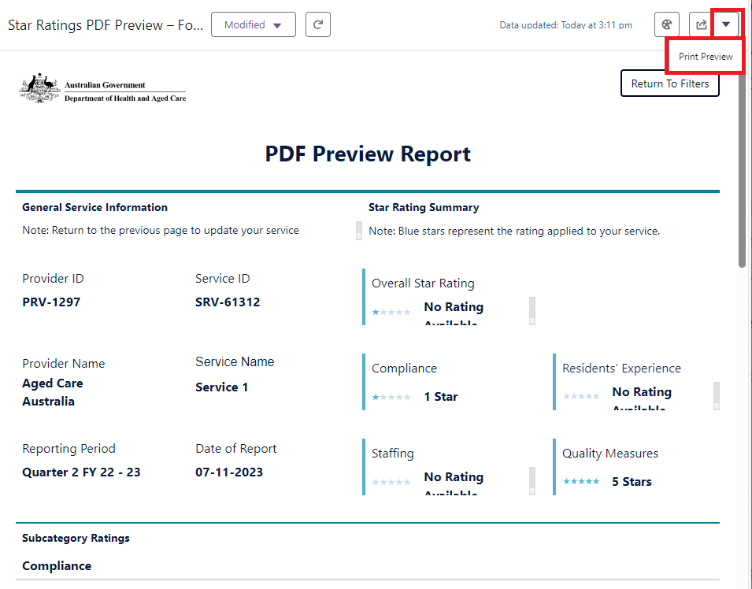

1. Select the **Print** button.

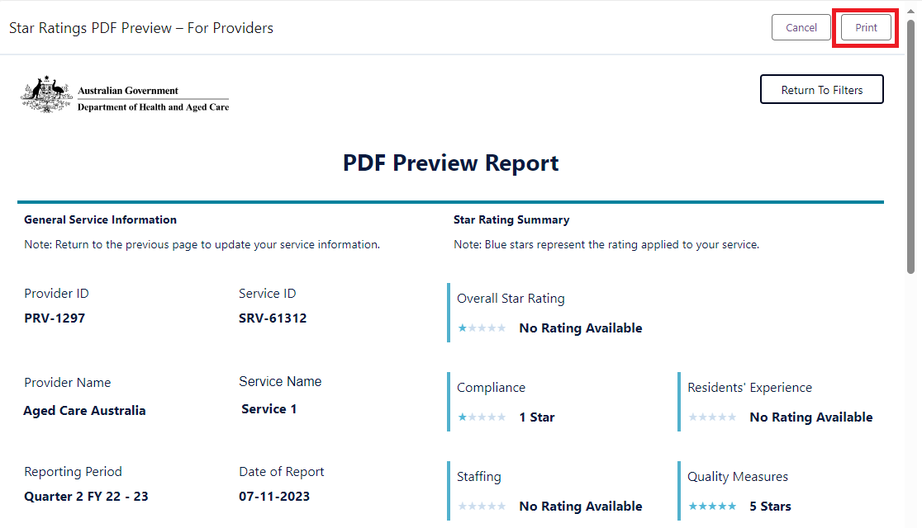

1. The Print pop-up appears.

For the best user experience, we recommend using the Safari browser, otherwise:

* If you are using the Microsoft Edge browser proceed to step 10.
* If you are using Google Chrome browser proceed to step 11.

1. Microsoft Edge browser: select **Save as PDF**.

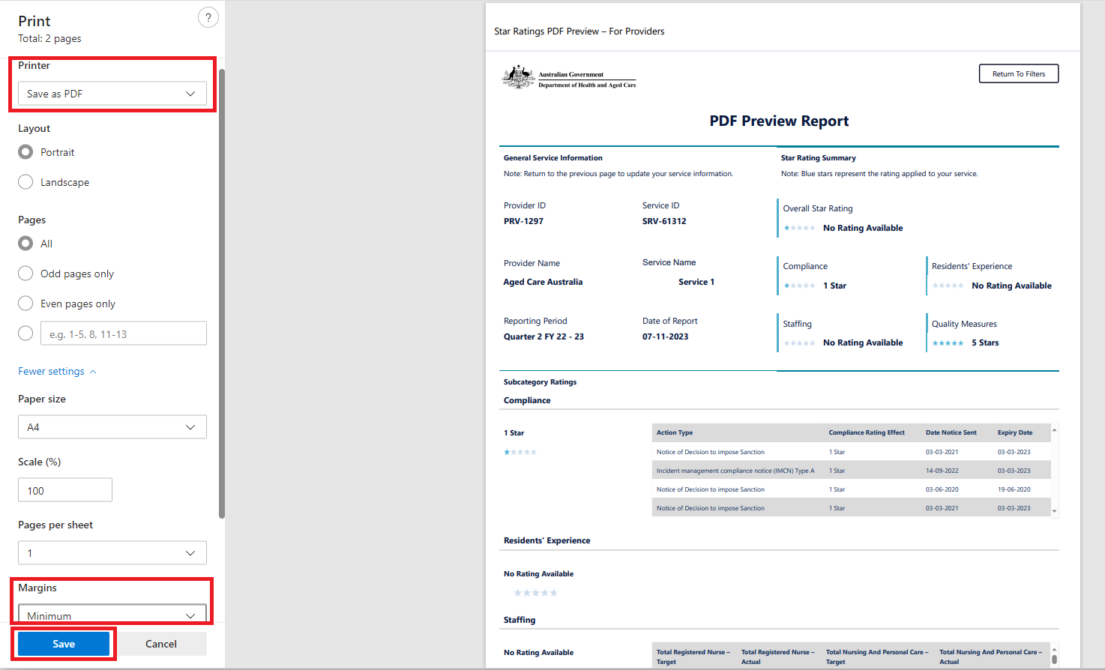

Then, select **More Settings** and select **Minimum** in the Margins drop-down menu. This will ensure that the entire report will be displayed in the PDF preview. Tick **Headers and Footers**.

Finally, select **Save**.

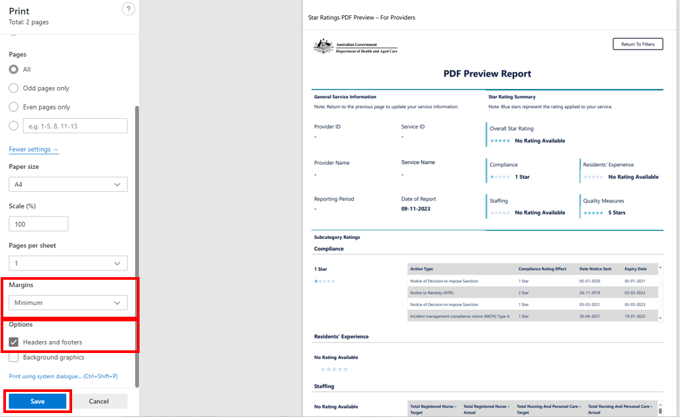

1. Google Chrome browser: select **Save as PDF**.

Then, select **More Settings** and select **Minimum** in the Margins drop-down menu. This will ensure that the entire report will be displayed in the PDF preview. Tick **Headers and Footers**.

Finally, select **Save**.

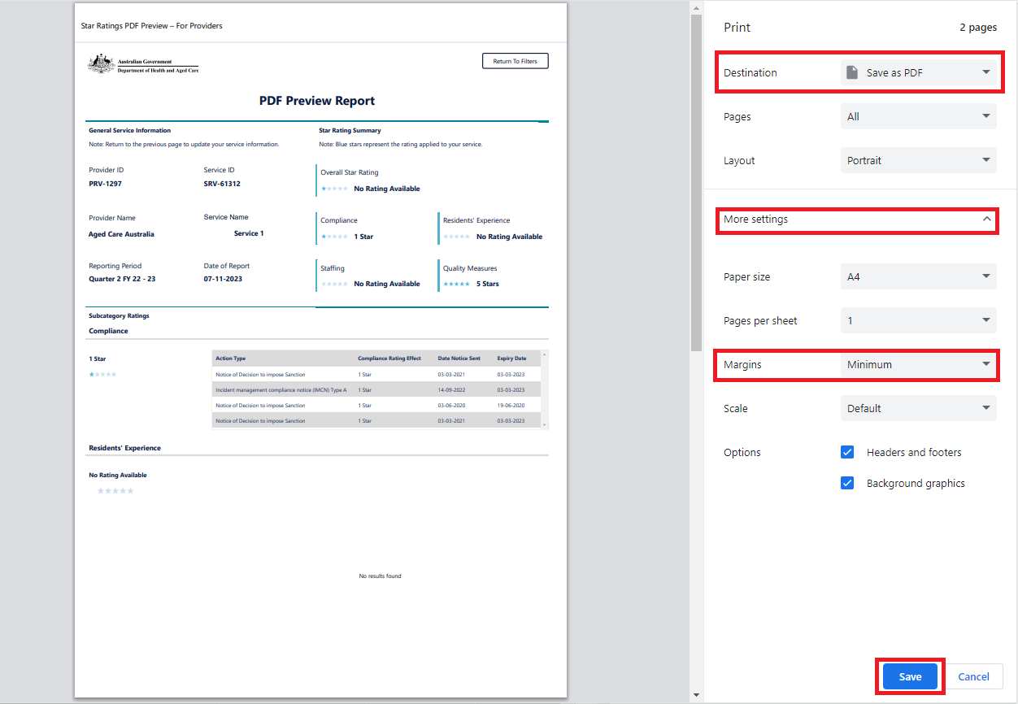

**Please note:**

These printer settings are also displayed in the PDF Preview Report page for your convenience.Screenshot snippet of teh 'Download PDF' information box. 
'After generating the report, the option to download the report as a PDF can be found within the drop down menu situated in the upper right corner. For the best print preview experience, we recommend using Safari. If you are using Google Chrome or Microsoft Edge and encounter a blank print preview, follow these steps to resolve the issue: * customise your print set up (set margin to minimum) * enable 'header/footer' * ensure your browser is up to date.