Strengthening Medicare Monitoring and Evaluation Framework

December 2024

Contents ii

Acknowledgement of Country iii

1 Background 1

1.1 Primary Care 1

1.2 Reform of primary care 2

2 Strengthening Medicare Monitoring and Evaluation Framework 4

2.1 Overview 4

2.2 Methodology 5

Monitoring 5

Evaluation 6

2.3 Program logic and data matrix 7

Program logic 7

Data matrix 9

2.4 Roles and responsibilities 17

2.5 Indicate timelines 17

2.6 Limitations and considerations 18

Appendices 19

Appendix 1: Strengthening Medicare Implementation Oversight Committee Terms of Reference 19

Appendix 2: Strengthening Medicare Budget fact sheets 23

# Acknowledgement of Country

We, the Department of Health and Aged Care, acknowledge the Traditional Owners and Custodians of Country throughout Australia. We recognise the strength and resilience of Aboriginal and Torres Strait Islander people and acknowledge and respect their continuing connections and relationships to country, rivers, land and sea.

We acknowledge the ongoing contribution Aboriginal and Torres Strait Islander people make across the health and aged care systems and wider community. We also pay our respects to Elders past, present and future and extend that respect to all Traditional Custodians of this land.

We acknowledge and respect the Traditional Custodians whose ancestral lands are where our Health and Aged Care offices are located.

# 1 Background

## 1.1 Primary Care

Primary care provides the foundation for universal health care, working hard to keep all Australians healthy and well in the community, and to deliver care that meets the needs of people and communities at all stages of life, no matter where they live and when they need care.

Generally, primary care is the first service people access for health care. Primary care can be informed by a relationship built over time in the context of a person’s family, carers and cultural background. Primary care providers can play a critical function in connecting patients to other services including community-based services, hospitals and specialist providers.

Primary care includes diagnosis and treatment of health conditions and long-term care, health promotion and prevention services. Types of primary care in Australia include, but are not limited to:

* general practice (GP)
* Aboriginal Community Controlled Health Services
* community health centres and walk-in clinics
* community pharmacies
* community nursing services
* oral health and dental services
* mental health services
* drug and alcohol treatment services
* sexual and reproductive health services
* maternal and child health services
* allied health services including care provided by psychologists, physiotherapists, occupational therapists, chiropractors.

Effective primary care benefits patients, their carers, families and the broader health system, and leads to lower costs, improved health outcomes and reduced pressure on hospital emergency departments Reform in primary health care can involve complex changes to systems over time. It is therefore important to understand what is “effective” primary health care and which areas of the system to prioritise in policy reforms.

The quadruple aim outlines four core health targets for optimising health systems and health for individuals and populations. Advancing health equity was added as an additional aim to highlight its importance in health systems, providing the quintuple aims:[1]

* enhancing people’s experience of health care
* improving the health of populations
* improving the cost-efficiency of health systems
* improving healthcare provider experience
* advancing health equity.1,[2]

## 1.2 Reform of primary care

In Australia, primary care operates within a complex ecosystem, and reform occurs in the context of broader health system changes. In 2022, as the country emerged from the COVID-19 pandemic, the Australian Government (the government) established the [Strengthening Medicare Taskforce](https://www.health.gov.au/committees-and-groups/strengthening-medicare-taskforce) (the taskforce) to identify the highest priority areas of reform for the primary care sector and initiatives to be implemented. Building on the quadruple aim of the [Future focused primary health care: Australia’s Primary Health Care 10 Year Plan 2022-203](https://www.health.gov.au/resources/publications/australias-primary-health-care-10-year-plan-2022-2032?language=en)2(10 year plan), the [*Strengthening Medicare Taskforce Report*](https://www.health.gov.au/sites/default/files/2023-02/strengthening-medicare-taskforce-report_0.pdf) (taskforce report) recommended meeting the quintuple aim through four areas for reform in the vision for investment to rebuild primary care:

* increasing access to primary care
* encouraging multidisciplinary team-based care
* modernising primary care
* supporting change management and cultural change.[3]

The taskforce intends the reforms to enable transition of the primary care system from episodic care to a model of care that is high quality, individualised, person centred, team based and is enabled by data and technology.

The government has invested significantly in strengthening Medicare measures to realise the vision set out in the taskforce report to deliver critical funding to meet the urgent healthcare needs of today, while starting reforms to build a stronger Medicare for future generations. To date these have included:

* $2.9 billion in the 2022-23 Budget in October 2022
* $6.1 billion in the 2023-24 Budget
* $2.8 billion in the 2024-25 Budget.

Further detail on these investments is available at Appendix 2.

We expect the implementation of these numerous and interrelated strengthening Medicare measures to be complex and occur over a staggered period. For this reason, consistent monitoring over time is needed to provide an overview of how current and prospective developments work together and shape the implementation of strengthening Medicare measures in primary care going forward.

Strengthening Medicare measures are being undertaken in the context of a broader set of reforms. In this document we refer to these as ‘related initiatives’, which include other related health and aged care system reforms, agreements, plans and strategies external to strengthening Medicare.

The relationships and anticipated linkages between key documents, frameworks, assurance and oversight mechanisms and other groundwork surrounding the implementation of strengthening Medicare is depicted in Figure 1. It highlights how the implementation of strengthening Medicare was underpinned by the taskforce report guided by the 10-year plan. It is also informed by external sector and stakeholder knowledge and national data on the primary health care system.

**Figure 1**: Strengthening Medicare activities interrelationship mapping

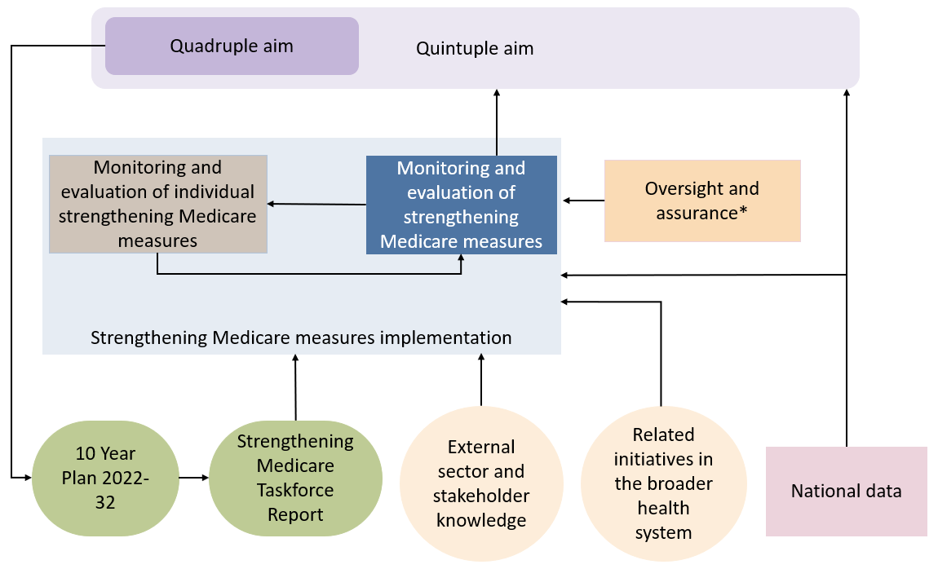

*Note: Relevant Department of Health and Aged Care structures for oversight and assurance include the Implementation Steering Committee (ISC), Health Economics and Research Division (HERD), Digital, Data and Implementation Board (DDIB) and Program Assurance Committee (PAC).

# 2 Strengthening Medicare Monitoring and Evaluation Framework

## 2.1 Overview

The development of this Strengthening Medicare Monitoring and Evaluation Framework (the framework) addresses the taskforce’s recommendation that reforms are supported by an evaluation framework to monitor progress and measure impact.[4]

The framework outlines how strengthening Medicare measures will be monitored and evaluated over time, providing cohesion to a large set of complex and interrelated measures. This includes tracking the implementation and delivery of strengthening Medicare measures and reporting on indicators to provide information on the overall impact.

Monitoring will occur over the next five years. An impact evaluation will be conducted by an independent contractor in consultation with the Department of Health and Aged Care (the department) and governance stakeholders after the five-year mark.

The framework acknowledges primary care reforms are implemented in a highly complex environment with gaps in primary care information and data collection by taking a flexible and strategic approach to:

* provide a cohesive framework for the monitoring of strengthening Medicare measures implementation
* guide the development of a longer-term evaluation focusing on the impact of the measures
* understand the implementation and effect(s) of strengthening Medicare measures through the lens of consumers, providers and patients
* be a communication and accountability tool in an accessible and comprehensive format
* recognise and draw on existing and emerging primary care data and information sources, including stakeholder knowledge
* enable new evidence to be synthesised and communicated in line with strengthening Medicare measures implementation, in turn supporting updates to this framework
* support complementary monitoring and evaluation activities for strengthening Medicare measures within other established and emerging primary care frameworks.[5]

## 2.2 Methodology

The framework includes monitoring and evaluationof strengthening Medicare measures.

Large, foundational strengthening Medicare measures receive a larger focus given their greater capacity to elicit measurable outcomes and contribute to the quintuple aims. This is reflected in the program logic (Figure 3), data matrix (Table 1), and the monitoring and evaluation approach for strengthening Medicare measures.

The approach to monitoring and evaluation is guided by the following key evaluation questions:

1. To what extent have strengthening Medicare measures been implemented as intended?
2. Could insights, learnings and contextual factors from strengthening Medicare measures implementation inform future health reform?
3. To what extent have strengthening Medicare measures contributed to intended outcomes?
4. What additional changes in primary care would help to achieve further long-term outcomes?

Note. Strengthening Medicare monitoring and evaluation is complemented by assurance mechanisms undertaken by the department:

* The Strengthening Medicare Program Management Office supports the monitoring and reporting of progress of certain strengthening Medicare measures. This provides a view of progress as a whole, to inform executive oversight through the department’s Strengthening Medicare Implementation Steering Committee (ISC).
* Health Economics and Research Division (HERD) provides guidance on the monitoring of strengthening Medicare and individual measures.
* The Digital, Data and Implementation Board (DDIB) provides oversight, advice and assurance on the effective implementation of the department’s high risk change projects (Tier 1) and portfolios of work.
* The Program Assurance Committee (PAC) drives excellence in the delivery of programs by conducting reviews to provide strategic advice, and providing program guidance and assurance to the department’s Executive Committee on the effectiveness of program management.

### Monitoring

The purpose of monitoring is to track progress on the implementation of strengthening Medicare measures and determine whether measures are delivered as planned. Collecting and reporting on indicators will help to monitor if there is alignment between the measured and intended outcomes of the strengthening Medicare measures.

Monitoring of strengthening Medicare measures will be reported on an annual basis, and will include:

* progress of implementation of strengthening Medicare measures (see Appendix B)
* environmental scan of the broader health system to understand the context in which strengthening Medicare measures are being implemented
* reportable data and outcomes on the uptake of foundational strengthening Medicare measures, for example uptake of MyMedicare linked programs and changes in bulk billing practices after the introduction of changes to bulk billing incentives
* sentiment of patients and consumers toward primary care
* findings from evaluations conducted on individual measures, for example, evaluation of Urgent Care Clinics and MyMedicare
* any lessons learned that may inform broader health system policy decisions.

### Evaluation

Theeffectivenessof strengthening Medicare measures will be reviewed through a summative evaluation on the longer-term impact of the reforms focused on the four vision areas of the taskforce report.

The summative evaluation will be conducted at least five years from the announcement of the strengthening Medicare package of reforms. It will draw on findings and data collected from the monitoring phase of strengthening Medicare, an environmental scan of other health system changes that may have complemented, enhanced or detracted from the outcomes of Strengthening Medicare measures, and evaluations of key strengthening Medicare measures (for example, the General Practice in Aged Care Incentive). The scope and scale of the summative evaluation will be designed in consultation with key stakeholders.

The complex landscape of the Australian health system and evolving primary care data landscape make it difficult to attribute outcomes to specific initiatives. Therefore the summative evaluation will focus on the collective contribution of reforms towards achieving the outcomes and recommendations of strengthening Medicare measures. An independent evaluator will be contracted to complete the summative evaluation, providing an independent perspective on the cumulative impact of strengthening Medicare measures.

Strengthening Medicare measures encompass a range of investments with varying roles in the reform of primary care. As such, summative evaluation of strengthening Medicare reforms is complementary to but distinct from evaluations of individual measures. Figure 2 indicates relationships and linkages between the summative evaluation of strengthening Medicare measures and evaluations of individual measures. To the extent possible, this framework may be used to guide the development of evaluation plans for individual measures.

The strengthening Medicare summative evaluation will be informed by the outcomes of individual evaluations, supporting an enriched understanding of the overall impact of strengthening Medicare reforms over time. Evaluation of individual reform measures may include more detailed analyses of individual reform measure objectives and indicators. However, these evaluation activities should be aligned with this framework.

The department’s [Evaluation Strategy 2023-26](https://www.health.gov.au/resources/publications/department-of-health-and-aged-care-evaluation-strategy-2023-2026) (the strategy) sets out the evaluation principles that apply to evaluations conducted by the department, including prioritising evaluation efforts based on factors such as the significance, funding level, risk, impact profile and current evidence of likely effectiveness of a given program. Evaluators of individual reform measures should use the strategy and consult the department’s [Evaluation Centre](https://healthgov.sharepoint.com/sites/about-surveys/SitePages/Evaluation.aspx#evaluation-centre) to clarify evaluation requirements.

Figure 2: Strengthening Medicare monitoring and evaluation interrelationship mapping

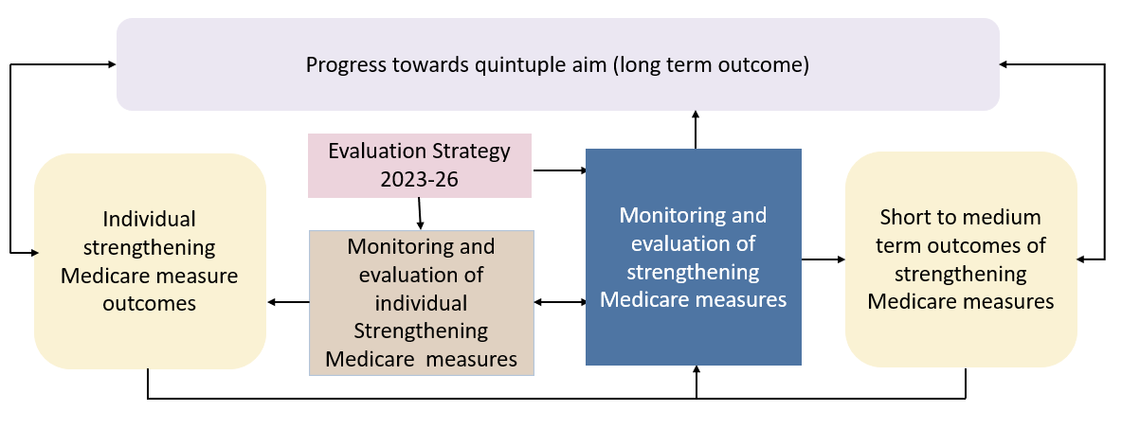

## 2.3 Program logic and data matrix

The framework is underpinned by an overarching program logic and data matrix to provide structure to what is intended to be measured and how.

### Program logic

A program logic provides a visual overview of the inputs, participants, activities, outputs, and outcomes of a program. It represents the logic behind a program’s development, its policy and program intentions, and how it contributes to producing desired results. A program logic can be used to guide evaluation planning, implementation and reporting by providing a universal schema for understanding the relationships between different components of the program logic model. The program logic for the framework is depicted in Figure 3. It provides a high-level, theoretical overview of strengthening Medicare and articulates how it will contribute to the four vision areas of strengthening Medicare and the quintuple aims.

It is important to note that this program logic is not intended to fully capture the details of individual Strengthening Medicare measures. Rather, it is focused on the overall outcomes that can be observed at population level as a result of strengthening Medicare reforms being implemented, and how they contribute to the quintuple aims. The program logic provides structure and guidance for developing the framework.

**Strengthening Medicare Monitoring and Evaluation Program Logic**

**Figure 3: Program logic**

**External Factors:**

* Engagement of sector and levels of government in the reforms
* Related initiatives including other related health and aged care system reforms, agreements, plans and strategies external to strengthening Medicare.
* Government fiscal position
* Emerging research and evidence
* Economic conditions affecting both health care users and health care providers may affect health care affordability, accessibility, and uptake

**Situation:** The Australian health care system faces multiple challenges including rising costs, inequitable access to services in certain areas, and the need for government support to meet the evolving health care needs of the population. The Australian Government has invested significantly to realise the vision set out in the [Strengthening Medicare Taskforce](https://www.health.gov.au/sites/default/files/2023-02/strengthening-medicare-taskforce-report_0.pdf) Report.

|  |
| --- |
| **INPUTS**  *What we invest* |
| Advice   * Primary Health Care 10 Year Plan * Strengthening Medicare Taskforce Report and recommendations * Knowledge, expertise, and consultations from the sector, consumers, and other key stakeholders |
| Governance   * Strengthening Medicare governance committees, including the Implementation Oversight Committee |
| Infrastructure   * Health system infrastructure |
| Financial   * Government investment in strengthening Medicare initiatives that address the recommendations of the Strengthening Medicare Taskforce Report * Departmental resourcing and personnel to implement measures |
| Operational   * Strengthening Medicare measures |

|  |
| --- |
| **ACTIVITIES**  *What we do* |
| Implementation of strengthening Medicare measures |
| Implementation of strengthening Medicare funding reforms |
| Implementation of new, and improvement of existing, digital health tools, platforms and infrastructure for access and sharing of health information |
| Implementation of strengthening Medicare workforce initiatives |
| Involvement of consumers in reform |
| Completion of strengthening Medicare reviews |
| Monitoring and evaluation of strengthening Medicare measures |
| Ongoing engagement and consultation with stakeholders via strengthening Medicare governance mechanisms |

|  |  |
| --- | --- |
| **OUTPUTS**  **Assumptions**   * Continued implementation and delivery of strengthening Medicare measures * Implementation of strengthening Medicare measures occur in a highly complex health system environment * An evaluation to measure the impact of reforms will be undertaken five years from the commencement of the implementation of strengthening Medicare measures * Communication with internal and external stakeholders throughout the staged implementation of strengthening Medicare measures * Governance and reporting (including collaboration between government and stakeholders) throughout implementation of strengthening Medicare measures * Strengthening Medicare reforms * Ongoing governance and reporting (including collaboration with all levels of government and stakeholders) throughout implementation of Strengthening Medicare   *Aligned to strengthening Medicare priority areas* |  |
| Access to primary care   * Primary care providers deliver services to meet the needs of the population * Primary care services receive funding to deliver services the community needs | Access to safe, high quality health care that meets all people’s needs |
| Multidisciplinary care   * Primary care providers are incentivised to work as part of coordinated, multidisciplinary teams * Primary care providers deliver services to meet the changing needs of the Australian population |
| Modern primary care   * Health data providers and individuals are connected securely and can access and share data across the health system * Digital health infrastructure and tools facilitate adoption and navigation by people and primary care providers |
| Effective change management   * People and communities are at the centre of primary care policy design * Primary care sector is supported to effectively adopt and embrace change |

|  |
| --- |
| **SHORT TERM OUTCOMES** |
| Australians increasingly access appropriate, comprehensive, affordable, high quality primary care services when and where they need them |
| Primary care services and providers are more sustainably funded |
| Increased delivery of coordinated care from multidisciplinary teams, including via blended funding models |
| Increased collaboration between primary care providers supports optimal outcomes for their patients |
| Australians and primary care providers increasingly use health data and digital technology to inform decision making |
| Modernised primary care data, infrastructure and digital approaches |
| Consumer input and advice informs development, design and delivery of policy, programs and services |
| Primary care providers uptake and adopt foundational strengthening Medicare measures |

|  |
| --- |
| **MEDIUM TERM OUTCOMES** |
| An accessible primary care system takes pressure off hospitals |
| Primary care services experience reduced challenges of financial viability |
| Enhanced working conditions lead to increased job satisfaction among primary care providers |
| Australians, including those from priority populations and/or with complex needs, receive holistic, person centred care |
| Primary care sector provides a rewarding career path for primary care providers |
| Health data and digital technology is integrated into care delivery and planning to support improved continuity and efficiency of care |
| Primary care system is fit for purpose and meets the needs of Australian people and communities |

|  |
| --- |
| **LONG TERM OUTCOMES** |
| Strengthening Medicare reforms contribute cumulatively towards the quintuple aims to optimise health system performance |
| Australians have improved health outcomes |
| Australians have better health equity |
| Australians have improved experience of care |
| The Australian health system is more cost efficient |
| Australian primary care providers have improved experience of work |

### Data matrix

The data matrix (table 1) summarises the scope of data to be collected and used for monitoring and evaluation. The structure of the data matrix is guided by key evaluation questions 1-3 (refer to 2.2 Methodology).

Indicators are used to investigate whether a program is implemented and performing as planned and can help to answer evaluation questions. To compile the matrix, the department considered existing relevant primary care indicators sourced from national data sets, existing internal departmental data, and publicly available research. All data reported as part of the monitoring and evaluation of strengthening Medicare measures will be aggregated and de-identified.

Table 1a provides an overview of process and implementation metrics. Selected indicators investigate whether strengthening Medicare measures and monitoring and evaluation activities have been implemented in accordance with expected timelines, and insights and learnings from this implementation. Table 1b provides key indicators matched to short term outcomes to track the impact of strengthening Medicare measures at a population level.

The department developed the data matrix through consultation with data experts, sector stakeholders and data custodians to ensure that the data is appropriate. The matrix may be adapted over time to use emerging data and information sources as they become available and to reflect changes and additions to strengthening Medicare measures over time.

Table 1: Data matrix

Table 1a: Data matrix for monitoring implementation progress of strengthening Medicare measures

|  |  |  |  |
| --- | --- | --- | --- |
| **Questions** | **Indicator** | **Data Source** | **Analysis** |
| To what extent have strengthening Medicare measures been implemented as intended? | Number and proportion of measures which have and have not progressed in line with the specified timeline | Strengthening Medicare Program Management Office | Descriptive statistics |
| Number and proportion of measures which have and have not been completed within the specified timeline | Strengthening Medicare Program Management Office | Descriptive statistics |
| What challenges, insights and learnings from the implementation of strengthening Medicare measures could inform future health reform? | Challenges regarding the implementation of strengthening Medicare measures which have not progressed or been completed within the specified timeline | Feedback from departmental staff working on strengthening Medicare measures | Thematic and content analysis |
| Insights and learnings regarding the implementation of strengthening Medicare measures which have not progressed or been completed within the specific timeline | Feedback from departmental staff working on strengthening Medicare reform measures | Thematic and content analysis |
| Number and proportion of measures which are planning or undertaking evaluation activities | Measure owners | Descriptive statistics |
| Number and proportion of measures which have completed evaluation activities | Strengthening Medicare Program Management Office | Descriptive statistics |

Table 1b: Data matrix for impact of strengthening Medicare measures on intended short term outcomes

Data sources included within Table 1b represent data available at the time of publication. Emerging primary care data sources and improved data availability and linkages will be added as they become available. Relevant updates will be made during the implementation of the framework to ensure the most current and complete data sources are used for reporting.

| **Outcome** | **Indicator** | **Data source** | **Analysis** |
| --- | --- | --- | --- |
| **Australians increasingly access appropriate, comprehensive, affordable, high quality primary care services when and where they need them** | Number and proportion of services that are bulk billed (disaggregated geographically by state/territory, primary health network, Modified Monash Model) | Services Australia - Medical Benefits Schedule (MBS) Item Reports-[6] | Descriptive statistics - compared to pre-implementation baseline |
|  | Proportion of general practitioners who bulk bill all, majority, minority, and none of their patients | Services Australia - MBS Item Reports-9  Royal Australian College of General Practitioners (RACGP) Health of the Nation report | Descriptive statistics - compared to pre-implementation baseline |
|  | Proportion of allied health services for chronic disease management that are bulk billed, by profession | Services Australia - MBS Item Reports-9 | Descriptive statistics - compared to pre-implementation baseline |
|  | Out of pocket costs for general practitioner attendances | Services Australia - MBS Item Reports-9 | Descriptive statistics - compared to pre-implementation baseline |
|  | Out of pocket costs for allied health services for chronic disease management, by profession | Services Australia - MBS Item Reports-9 | Descriptive statistics - compared to pre-implementation baseline |
|  | Proportion of people who did not access the care they needed in the past 12 months due to cost | Consumer Health Forum (CHF) National Consumer Sentiment Survey  Australian Bureau of Statistics (ABS) Patient Experience Survey | Descriptive statistics - compared to pre-implementation baseline |
|  | Proportion of people who state that cost is *often* or *always* a serious barrier to them accessing healthcare | CHF National Consumer Sentiment Survey | Descriptive statistics - compared to pre-implementation baseline |
|  | Proportion of people who were unable to see their preferred general practitioner in the past 12 months because they couldn’t get an appointment | ABS Patient Experience Survey | Descriptive statistics - compared to pre-implementation baseline |
|  | Proportion of people who could *often* or *always* access the health care they needed in a time and place that suited them in the past 12 months | CHF Consumer Sentiment Survey | Descriptive statistics - compared to pre-implementation baseline |
|  | Number of people who require after hours care but are unable to access it via a general practitioner | Departmental data - Healthdirect | Descriptive statistics - compared to pre-implementation baseline |
|  | Total number of people who attend an urgent care clinic and proportion who state they would have otherwise attended an emergency department | Services Australia - MBS Item Reports-9  Departmental data – Reform measure owner | Descriptive statistics - analysis may be conducted by measure owners for individual measure monitoring and evaluation (M&E) |
|  | Number of patients successfully diverted from the Emergency Department to an Urgent Care Clinic | Departmental data – Reform measure owner | Descriptive statistics - analysis may be conducted by measure owners for individual measure M&E |
|  | Number of people who use telehealth (phone and video) (including level C and D consultations) | Services Australia - MBS Item Reports-9  CHF National Consumer Sentiment Survey  ABS Patient Experience Survey | Descriptive statistics - compared to pre-implementation baseline |
|  | Number of people receiving care through the General Practice Aged Care Incentive | Services Australia9 - MBS Item Reports | Descriptive statistics |
|  | Proportion of people who have a general practitioner that they consistently see or a general practitioner practice that they consistently attend | CHF National Consumer Sentiment Survey | Descriptive statistics - compared to pre-implementation baseline |
|  | Proportion of people who find it *somewhat easy* or *very easy* to receive after hours care | CHF National Consumer Sentiment Survey | Descriptive statistics - compared to pre-implementation baseline |
|  | Number of First Nations people undertaking cancer screening at an Aboriginal Community Controlled Health Organisation | Reform measure owner - Clinical data | Descriptive statistics – compared to pre-implementation baseline |
| **Primary care services are more sustainably funded** | Proportion of practice owners reporting business profitability as a main business challenge | RACGP Health of the Nation report | Descriptive statistics - compared to pre-implementation baseline |
|  | Proportion of practice owners concerned about financial viability | RACGP Health of the Nation report | Descriptive statistics - Compared to pre-implementation baseline |
|  | Distribution of general practitioners by region, defined as number of FTE GPs per 100,000 people, by region | Productivity Commission Report on Government Services | Descriptive statistics - compared to pre-implementation baseline |
|  | Proportion of GPs who state that they would be willing to work outside of a Monash Medical category 1 (MM1) region | RACGP Health of the Nation report | Descriptive statistics - compared to pre-implementation baseline |
|  | Proportion of general practitioners *moderately satisfied* or *very satisfied* with their job | RACGP Health of the Nation report | Descriptive statistics - compared to pre-implementation baseline |
|  | Proportion of early career doctors choosing general practice | RACGP Health of the Nation report | Descriptive statistics - compared to pre-implementation baseline |
|  | Proportion of general practitioners who are considering stopping practicing or reducing their hours as a general practitioner | RACGP Health of the Nation report | Descriptive statistics - compared to pre-implementation baseline |
| **Increased delivery of coordinated care from multidisciplinary teams, including via blended funding models** | Uptake of Wraparound Care for Frequent Hospital Users program | Departmental data - Reform measure owner | Descriptive statistics |
|  | Uptake of new level E MBS item for consultations over 60 minutes | Services Australia - MBS Item Reports-9 | Descriptive statistics |
|  | Uptake of chronic disease management MBS item numbers by general practitioners | Services Australia - MBS Item Reports-9 | Descriptive statistics - compared to pre-implementation baseline |
|  | Uptake of chronic disease management MBS item numbers for allied health services, by profession | Services Australia - MBS Item Reports-9 | Descriptive statistics - compared to pre-implementation baseline |
|  | Uptake of Workforce Incentive Program | Services Australia - MBS Item Reports-9 | Descriptive statistics - compared to pre-implementation baseline |
|  | Uptake of nurse practitioner services MBS item numbers | Services Australia - MBS Item Reports-9 | Descriptive statistics - compared to pre-implementation baseline |
|  | Uptake of primary health network commissioning of multidisciplinary teams | Departmental data - Reform measure owner | Descriptive statistics |
|  | Proportion of people who saw three or more health professionals for the same condition, as well as the proportion for whom:   * At least one health professional helped coordinate their care * No health professionals helped coordinate their care * Issues were caused by a lack of communication between health professionals | ABS Patient Experience Survey | Descriptive statistics - compared to pre-implementation baseline |
|  | Proportion of primary care practices who employ other health professionals | RACGP Health of the Nation Report | Descriptive statistics - compared to pre-implementation baseline |
|  | Number and proportion of ACCHOs who employ health professionals in cancer prevention | Departmental data – Reform measure owner | Descriptive statistics - compared to pre-implementation baseline |
| **Increased collaboration between primary care providers supports optimal outcomes for their patients** | Patient Reported Experience Measures and Patient Reported Outcome Measures from PHN commissioning of multidisciplinary teams | Departmental data - Reform measure owner | Descriptive statistics |
|  | Patient Reported Experience Measures and Patient Reported Outcome Measures from frequent hospital users | Departmental data - Reform measure owner | Descriptive statistics |
|  | Proportion of people who felt that they were *often* or *always*:   * Involved in decision-making by health care providers * Respected by health care providers | CHF Consumer Sentiment Survey | Descriptive statistics - compared to pre-implementation baseline |
|  | Proportion of people who report that health care providers *often* or *always*:   * Valued their opinion about health and treatment * Considered their individual needs and priorities | CHF Consumer Sentiment Survey | Descriptive statistics - compared to pre-implementation baseline |
| **Australians and primary care providers increasingly use health data and digital technology to inform decision-making** | Number and proportion of eligible individuals in Australia that have a My Health Record | The Australian Digital Health Agency | Descriptive statistics - compared to pre-implementation baseline |
| Number and proportion of eligible individuals in Australia that have a My Health Recordwhich has been used in the last 12 months | The Australian Digital Health Agency | Descriptive statistics - compared to pre-implementation baseline |
| Number and proportion of people who have an active My Health Record but who previously opted out or deleted their record | The Australian Digital Health Agency | Descriptive statistics - compared to pre-implementation baseline |
|  | Number of patient downloads and active users of health-related mobile applications | Australian Government, state and territories, health professional peak bodies – covering the My Health App and relevant apps that interface with My Health Record | Descriptive statistics - compared to pre-implementation baseline |
|  | Number and proportion of MyMedicareeligible patient, practice and provider registrations | Services Australia | Descriptive statistics - compared to pre-implementation baseline |
|  | Number of key documents uploaded to My Health Record:   * discharge summaries, * prescription and dispense records, * pathology reports, * diagnostic imaging reports, * specialist letters, * shared health summaries * event summaries and * pharmacy shared medicine lists. | The Australian Digital Health Agency | Descriptive statistics - compared to pre-implementation baseline |
| Number and proportion of eligible individuals in Australia with key documents (listed above) uploaded which were viewed by a health care provider in the last 12 months | The Australian Digital Health Agency | Descriptive statistics - compared to pre-implementation baseline |
| The level of digital literacy among the population (total index, accessibility, digital ability and affordability) | The Australian Digital Inclusion Index - Australian Internet Usage Survey | Descriptive statistics - compared to pre-implementation baseline |
| Number of Active Script List patient registrations | Departmental data - national Prescription Delivery Service | Descriptive statistics - compared to pre-implementation baseline |
| Number of advance care directives uploaded to My Health Record | Australian Digital Health Agency | Descriptive statistics - compared to pre-implementation baseline |
| **Modernised primary care data, infrastructure and digital approaches** | Healthcare identifiers:   * Number or proportion of eligible consumers registered with an Individual Healthcare Identifier (IHI) * Number or proportion of eligible providers registered with a Healthcare Provider Identifier – Individuals (HPI-I) * Number or proportion of eligible practices registered with a Healthcare Provider Identifier – Organisations (HPI-O) * Number or proportion of individuals ineligible for a Medicare card who are assigned an Individual Healthcare Identifier, who receive care in a primary care setting * Number or proportion of times an Individual Healthcare Identifier is disclosed for primary care purposes other than to connect to or upload to My Health Record or receive an eScript / be dispensed from an eScript | Services Australia - Healthcare Identifier Service | Descriptive statistics - compared to pre-implementation baseline |
| Proportion of primary care clinicians who view content in My Health Record at least weekly (broken down by profession) | Australian Digital Health Agency | Descriptive statistics - compared to pre-implementation baseline |
| Proportion of primary care clinicians who upload content to My Health Record (broken down by profession) | Australian Digital Health Agency | Descriptive statistics - compared to pre-implementation baseline |
|  | Number of electronic prescriptions that are written and dispensed | Departmental data - national Prescription Delivery Service | Descriptive statistics - compared to pre-implementation baseline |
|  | Rate of eRequests actioned/completed | Australian Digital Health Agency - eRequesting Repository (future metric) | Descriptive statistics - compared to pre-implementation baseline |
| **Consumer input and advice informs development, design and delivery of policy, programs, and services** | Number and type of consumer engagement activities conducted with the department to influence policy, program, service development and consumer engagement capability | Departmental data | Descriptive statistics |
| The extent to which consumer engagement activities and consumer input have informed department policies, programs, service development and consumer engagement capability | Feedback from departmental staff working on strengthening Medicare reform measures Feedback from departmental staff who have attended departmental consumer engagement activities | Thematic and content analysis |
|  | How consumers perceived their inclusion in engagement activities | CHF - Feedback from consumers participating in engagement activities - | Thematic and content analysis |
| **Primary care providers uptake and adopt foundational strengthening Medicare measures** | Primary care provider uptake of key strengthening Medicare measures, including:   * General Practice in Aged Care Incentive * frequent hospital users * MyMedicare * My Health Record * Workforce Incentive Program – increased payments to support multidisciplinary team care * General Practice Grants Program | Strengthening Medicare measure owners | Descriptive statistics |

## 2.4 Roles and responsibilities

The department is responsible for design and implementation of the framework, including collection, analysis and reporting of data, and preparation of annual monitoring reports. The department will work with other government agencies, relevant stakeholders, and external parties to seek access to agreed data and information sources where required.

In implementing the framework, the department will be guided by the strengthening Medicare Implementation Oversight Committee (IOC). This external group of stakeholders comprising peak bodies, industry leaders, experts from across the sector, and state and territory representatives, will provide strategic advice and direction in the monitoring and evaluation of strengthening Medicare reform measures. The strengthening Medicare IOC Terms of Reference is at Appendix 1.

The summative evaluation will be conducted by an independent evaluator to ensure an impartial review of the impact of Strengthening Medicare reform measures. The IOC will inform the design of summative evaluation.

Data, information and evaluation activities conducted within the parameters of this Framework will adhere to ethical research considerations as articulated in the [National Medical Research Council’s National Statement on Ethical Conduct in Human Research (2023)](https://www.nhmrc.gov.au/about-us/publications/national-statement-ethical-conduct-human-research-2023) and the Australian Evaluation Society’s Guidelines for the Ethical Conduct of Evaluations (2013).

## 2.5 Indicate timelines

Milestones for Strengthening Medicare Monitoring and Evaluation are set out in table 2.

Table 2: Indicative Strengthening Medicare monitoring and evaluation milestones

|  |  |
| --- | --- |
| Monitoring and Evaluation Framework agreed | September 2024 |
| Strengthening Medicare – Year in Review – Year 1 | April-June, 2025 |
| Progress update to IOC | March 2025 |
| Progress update to IOC | September 2025 |
| Strengthening Medicare – Year in Review – Year 2 | April-June, 2026 |
| Progress update to IOC | March 2026 |
| Progress update to IOC | September 2026 |
| Strengthening Medicare – Year in Review – Year 3 | April-June, 2027 |
| Progress update to IOC | March 2027 |
| Progress update to IOC | September 2027 |
| Strengthening Medicare – Year in Review – Year 4 | April-June, 2028 |
| Progress update to IOC | March 2028 |
| Progress update to IOC | September 2028 |
| Strengthening Medicare – Year in Review – Year 5 | April-June, 2029 |
| Progress update to IOC | March 2029 |
| Progress update to IOC | September 2029 |
| Strengthening Medicare – Summative Evaluation | 2029 or 2030 |

## 2.6 Limitations and considerations

The monitoring and evaluation of strengthening Medicare measures will be constrained by relevant and reliable data sources and relevant indicators available on a national scale. It is anticipated that as the availability of primary care data matures, additional data sources may be incorporated into the framework to develop a more comprehensive understanding of primary care.

There may also be challenges and limitations attributing outcomes of strengthening Medicare measures to the goals of the Strengthening Medicare Taskforce Report and the quintuple aims due to the broad array of factors that can affect these outcomes. It is intended that targeted evaluations of individual measures will be aligned to supplement the summative evaluation where possible and provide more specific information on the outcomes of individual measures.

# Appendices

## Appendix 1: Strengthening Medicare Implementation Oversight Committee Terms of Reference

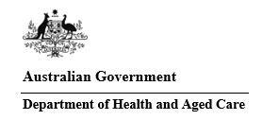

**Strengthening Medicare Implementation Oversight Committee**

**Terms of Reference**

**Purpose**

The Strengthening Medicare Implementation Oversight Committee (the IOC) is established to oversee and advise on the implementation of all Strengthening Medicare reform measures in response to the [Strengthening Medicare Taskforce](https://www.health.gov.au/resources/publications/strengthening-medicare-taskforce-report?language=en) (the Taskforce) Report and against the [Primary Health Care 10 Year Plan](https://www.health.gov.au/resources/publications/australias-primary-health-care-10-year-plan-2022-2032?language=en) (the 10 Year Plan).

**Context**  
In 2022, the Government asked the Taskforce to identify the highest priority areas of reform for the primary care sector, building on the direction outlined in Australia’s 10 Year Plan. In response to recommendations of the Taskforce, the Government made a $6.1 billion investment in measures to strengthen Medicare through the [2023-24 Budget](https://www.health.gov.au/resources/publications/building-a-stronger-medicare-budget-2023-24?language=en). Strengthening Medicare delivers critical funding to meet the urgent healthcare needs of today, while starting reforms to build a stronger Medicare for future generations.

**Role and function**

The IOC is an overarching advisory body comprising of senior leaders and representatives from across the sector. It considers and provides strategic advice to the Department of Health and Aged Care (the Department) on the implementation, monitoring and evaluation of Strengthening Medicare reform measures.

A range of existing and newly established committees and reviews will report to and/or inform the work of the IOC. The following stakeholder and advisory committees will be forums for information sharing, advice and input on the implementation of Strengthening Medicare reform measures:

* Jurisdictional Strengthening Medicare Primary Care Planning Forum;
* Expert Panel for the Review of General Practice Incentives and After Hours;
* National Scope of Practice Review;
* Review of Distribution Levers;
* General Practice Reference Group;
* Nursing and Midwifery Strategic Reference Group;
* Allied Health Industry Reference Group;
* Advisory Network of the National Rural Health Commissioner;
* Health Consumer Roundtables;
* Strengthening Medicare Primary Health Network Working Group; and
* Medical Benefits Schedule Review Advisory Committee.

Members of the IOC will ensure advice provided to the Department is:

* Evidence-based;
* Reflects the views and opinions of the organisations they are representing;
* Is in the best interests of the health of Australians and the Australian Health system;
* Considers equity of access to primary health care services for all Australians; and
* Considers the aims and objectives of the Strengthening Medicare reforms.

**Composition**

The IOC will be co-chaired by the Deputy Secretary, Primary and Community Care Group and the Deputy Secretary, Health Resourcing Group in the Department of Health and Aged Care.

The IOC members are appointed as expert executive and representative leaders within the sector, with the ability to provide advice consistent with their representative organisation.

Membership will include representatives from providers, states and territories, consumers and health leaders and experts from the academic sector. A full list of members and observers is at **Appendix 1**.

The Co-chairs may invite additional members to the IOC at their discretion. Proxies will not be accepted except under exceptional circumstances, and at the sole discretion of the Co-chairs.

The IOC is a departmental non-statutory committee, managed in accordance with the Department’s External Committee Framework.

The Co-chairs may approve ad hoc participation of additional experts or observers in meetings as required.

**Confidentiality and Conflict of Interest**

Members will be required to sign a confidentiality agreement and declare any real or perceived conflicts of interest before the first meeting. Members will advise of any changes in their real or potential conflicts of interest at the commencement of each meeting. A member who has declared a real or potential conflict of interest may participate in the discussion on that matter, subject to the approval of the Co-chairs.

All discussions undertaken by the IOC are in strict confidence and without prejudice, to ensure members can genuinely engage in meaningful discussion on matters presented. Discussions should not be considered as agreement or commitment by Government.

All documents prepared by or presented to the IOC are assumed to be confidential unless identified otherwise by the Co-chairs. Members shall not report or attribute comments of individuals nor their affiliations outside of meetings.

**Authority**

The *Establishing Authority* is the First Assistant Secretary, Primary Care Division in the Department of Health and Aged Care.

**Deliverables**

Timely, targeted and expert advice provided in confidence and as requested by the Co-chairs, in accordance with these Terms of Reference.

**Meeting administration**

The Co-chairs will lead meetings and guide the work of the IOC.

Quorum for meetings is half the number of members plus one.

The Primary Care Reform Branch, Department of Health and Aged Care will provide Secretariat support. An agenda and papers will be distributed at least 5 days prior to meetings.

A communique of meeting outcomes will be produced within 5 days of each meeting that can be used for broader communication by organisations.

The IOC will be governed by the Remuneration Policy Framework for Non-Statutory Committees.

**Timeframes**

It is intended that the initial term of the IOC will be until 30 June 2027. Members are appointed for two-year terms. Reappointment for additional terms is at the discretion of the Co-chairs. The IOC can be dissolved at any time, at the discretion of the Co-chairs.

Meetings will take place as requested by the Co-chairs. There are expected to be two meetings annually, for a duration of three hours, either in-person or via videoconference.

**Reporting and evaluation**

Throughout the term of appointment, the IOC members will report to the Co-chairs.

On completion of the specified term of appointment, the IOC will be reviewed against the objectives outlined in these Terms of Reference. At this time, a review of the Terms of Reference will occur to ensure the objectives of the IOC remain current.

**Strengthening Medicare Implementation Oversight Committee**

Membership:

|  |  |
| --- | --- |
| The Department of Health and Aged Care | Deputy Secretary, Primary and Community Care Group (Co-chair)  Deputy Secretary, Health Resourcing Group (Co-chair) |
| National Rural Health Commissioner | Adjunct Professor Ruth Stewart |
| Australian Medical Association (AMA) | Organisational representative |
| Royal Australian College of General Practitioners (RACGP) | Organisational representative |
| Australian College of Rural and Remote Medicine (ACRRM) | Organisational representative |
| Australian Indigenous Doctors’ Association (AIDA) | Organisational representative |
| Rural Doctors Association of Australia (RDAA) | Organisational representative |
| Allied Health Professions Australia (AHPA) | Organisational representative |
| Australian Physiotherapy Association (APA) | Organisational representative |
| Pharmaceutical Society of Australia (PSA) | Organisational representative |
| Australian College of Nurse Practitioners (ACNP) | Organisational representative |
| Australian Primary Healthcare Nurses Association (APNA) | Organisational representative |
| Australian Nursing and Midwifery Federation (ANMF) | Organisational representative |
| Australian College of Midwives (ACM) | Organisational representative |
| Congress of Aboriginal and Torres Strait Islander Nurses and Midwives (CATSINaM) | Organisational representative |
| National Aboriginal Community Controlled Health Organisation (NACCHO) | Organisational representative |
| Australian Association of Practice Management (AAPM) | Organisational representative |
| Healthdirect Australia | Chief Executive Officer |
| Primary Health Network (PHN) | 1 PHN CEO representative |
| State and territory representatives | 1 representative from small state/territory  1 representative from large state/territory |
| Independent academic economist | Prof. Anthony Scott |
| Independent Advisor | Dr Walid Jammal |
| Independent Advisor | Dr Steve Hambleton |
| Consumers Health Forum of Australia (CHF) | Consumer representative |
| Australian Multicultural Health Collaborative | Consumer representative |
| LGBTQI+ Health Australia | Consumer representative |
| People with Disability Australia | Consumer representative |
| First Nations Health consumer representative, Health Consumers Queensland | Consumer representative |
| COTA Australia | Consumer representative |

Observers:

|  |  |
| --- | --- |
| Department of Health and Aged Care | First Assistant Secretary, Primary Care Division; First Assistant Secretary, Health Workforce Division; First Assistant Secretary, First Nations Health Division; First Assistant Secretary, Medical Benefits and Digital Health Division; Chief Nursing and Midwifery Officer; Chief Allied Health Officer |
| Primary Health Network (PHN) | 1 PHN CEO representative |
| Prof Anne Duggan | Chief Executive Officer, Australian Commission on Safety and Quality in Health Care (ACSQHC)  Chair, Medical Benefits Schedule Review Advisory Committee (MRAC) |
| Prof Ian Frazer AC | Chair, Australian Medical Research Advisory Board (AMRAB) |

## Appendix 2: Strengthening Medicare Budget fact sheets

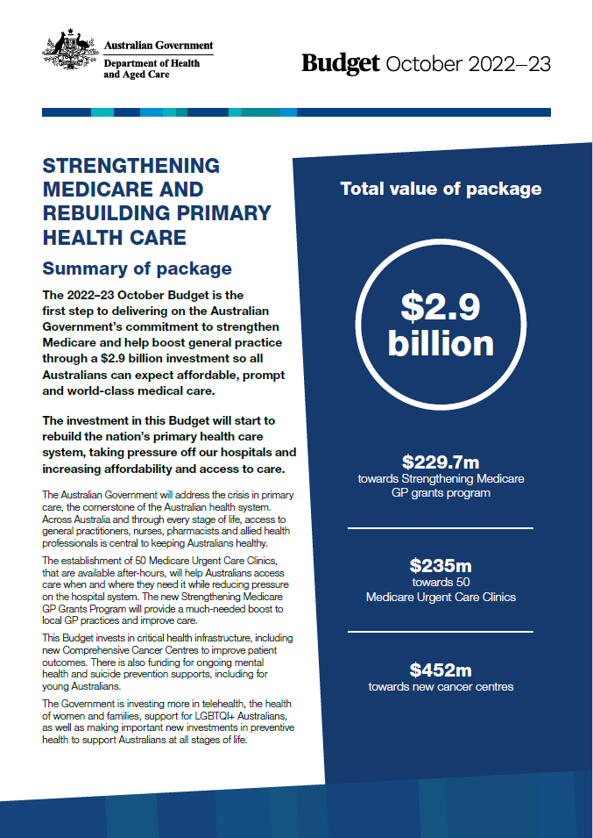

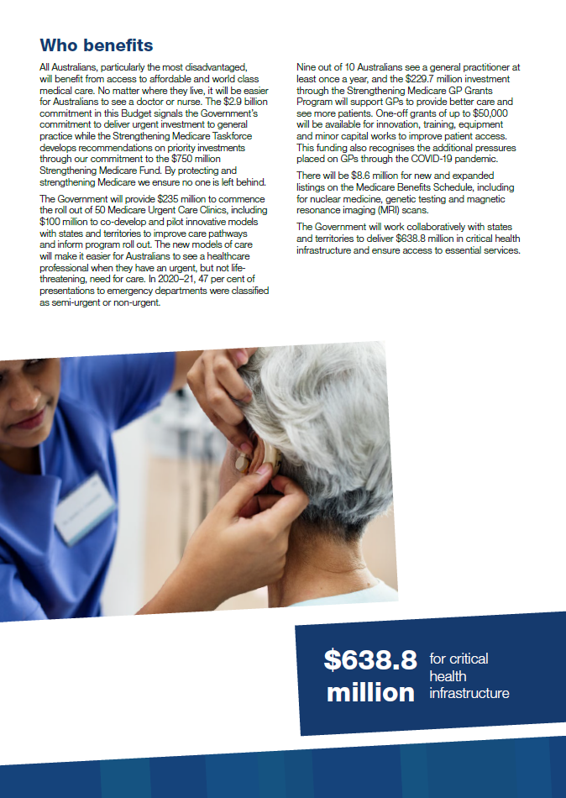

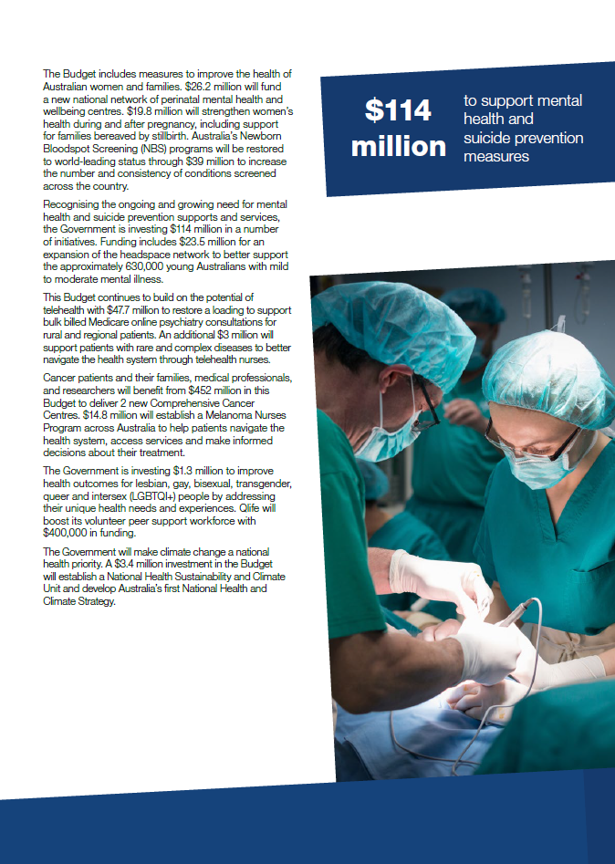

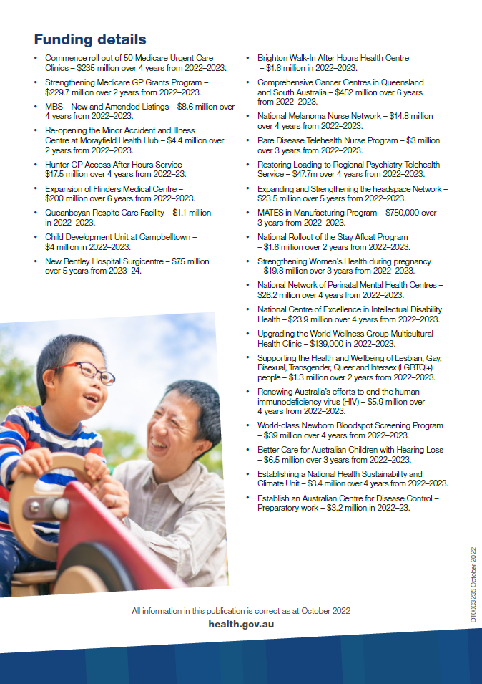

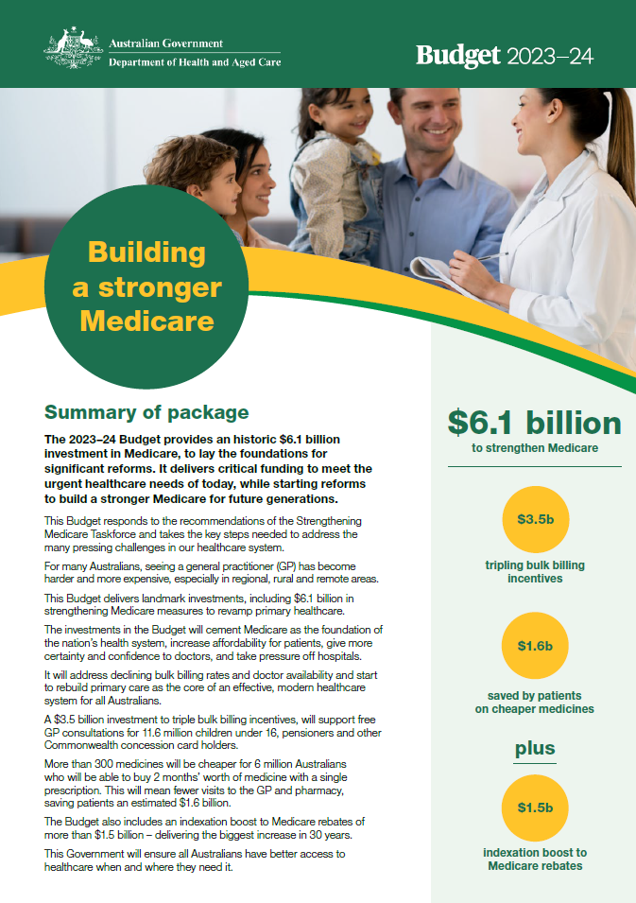

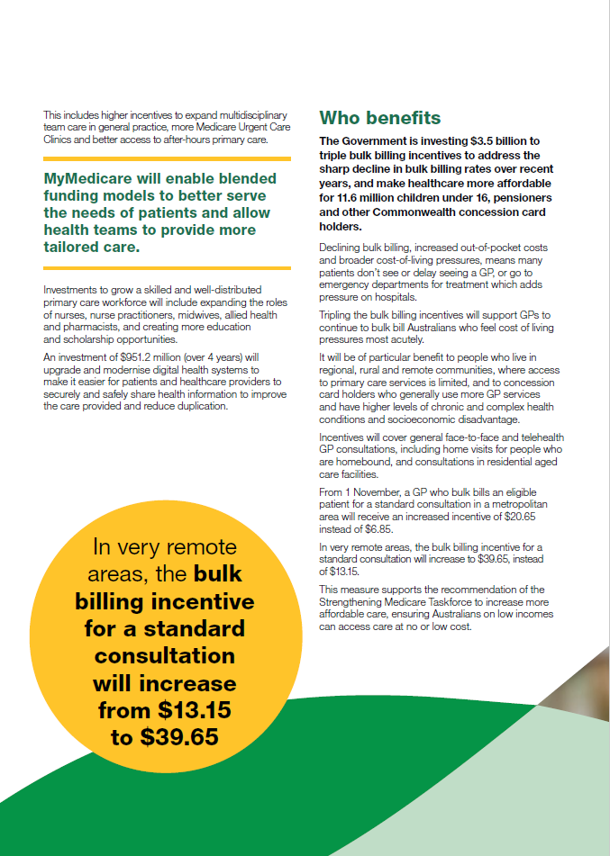





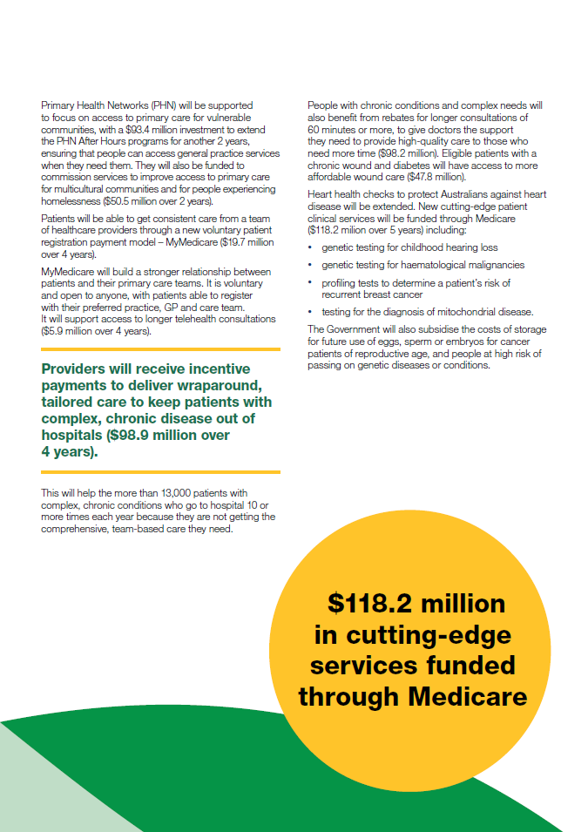



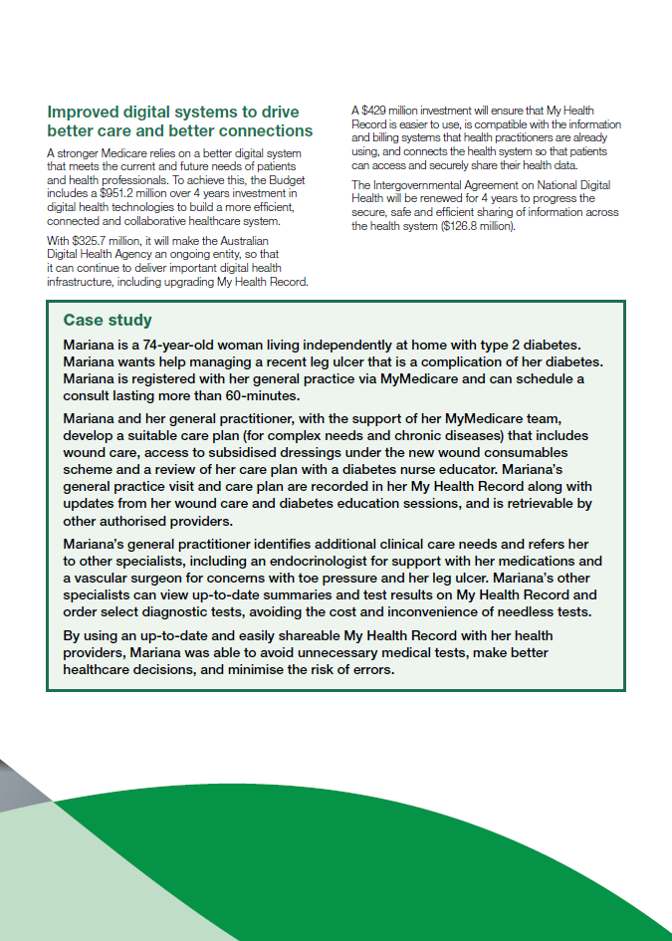

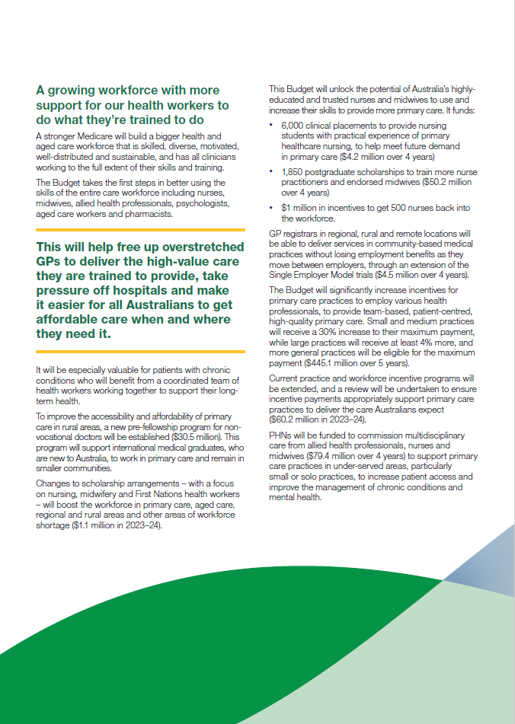



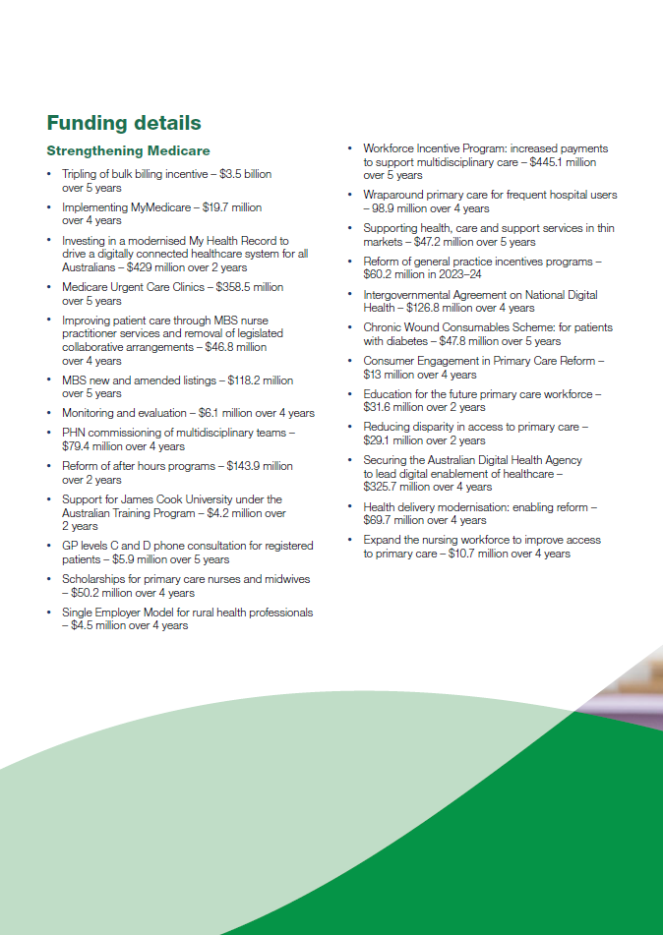



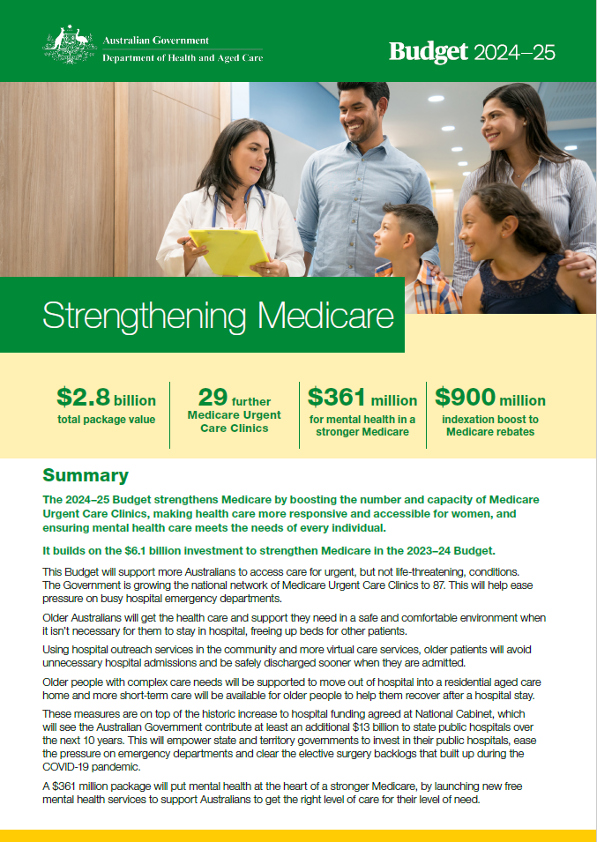

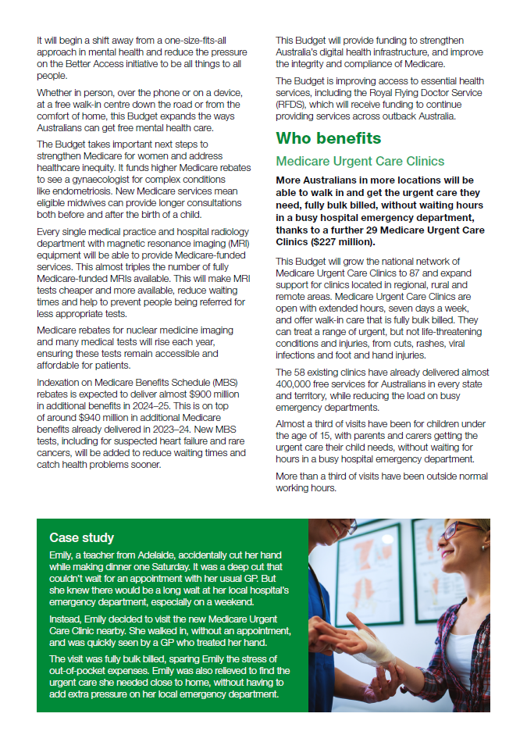

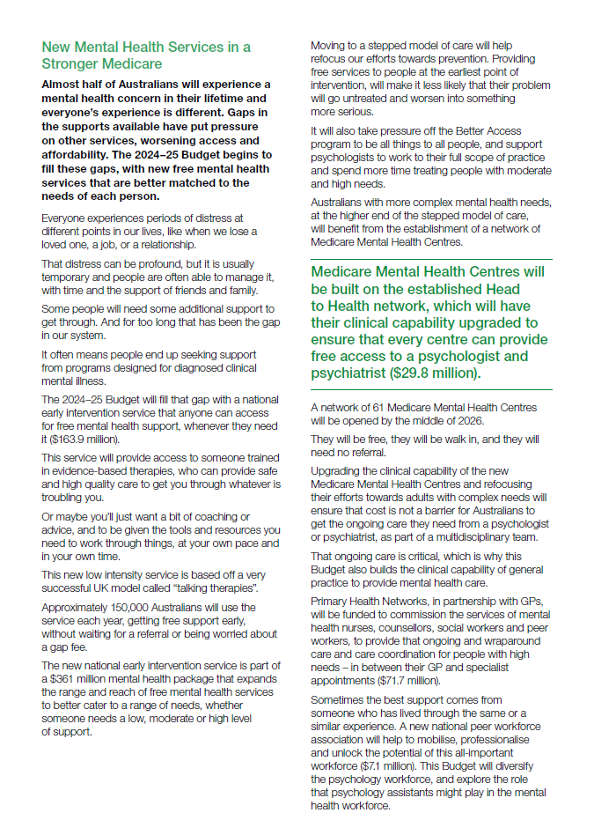

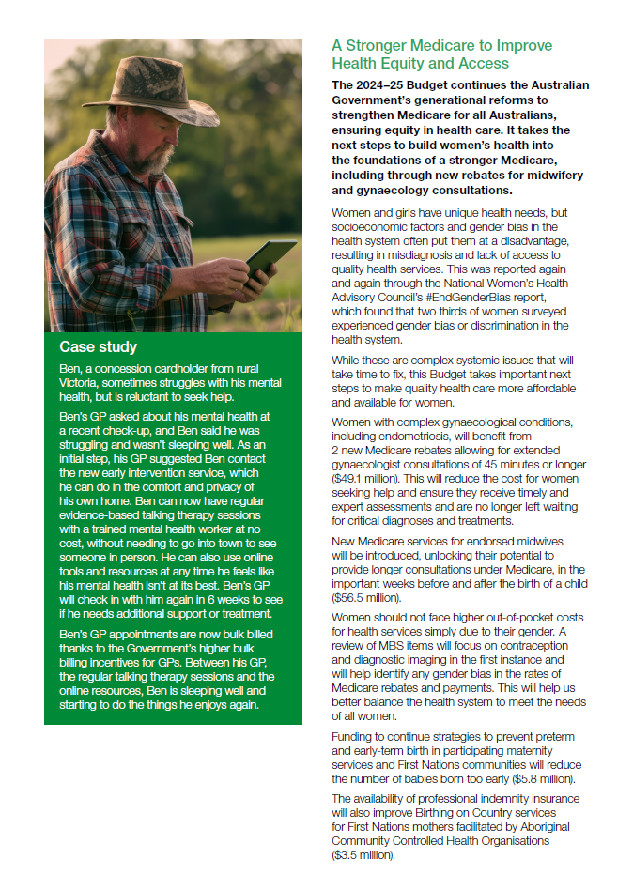

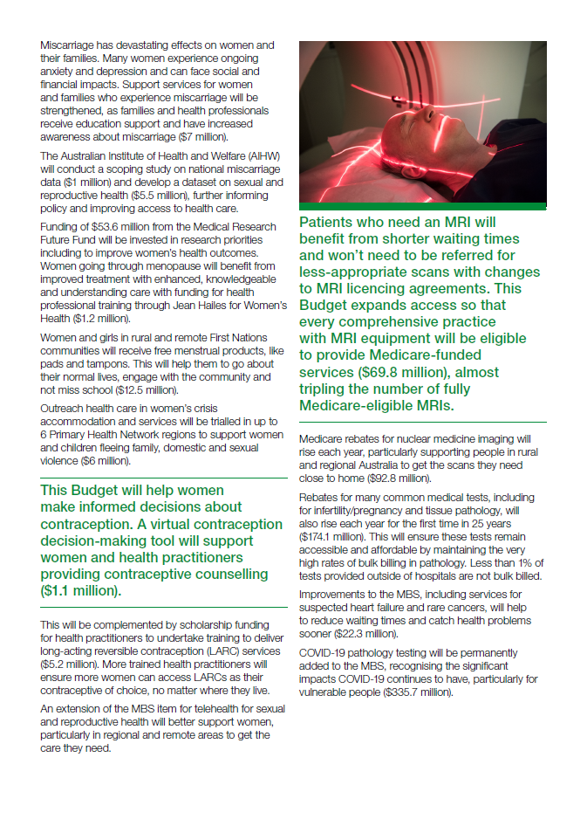



Health.gov.au

All information in this publication is correct as at December 2024.

1. Nundy S, Cooper LA, Mate KS. ‘The Quintuple Aim for Health Care Improvement: A New Imperative to Advance Health Equity’. *JAMA*. 2022: 327(6), pp.521–522. doi:10.1001/jama.2021.25181
2. Bodenheimer T, Sinsky C. ‘From triple to quadruple aim: care of patient requires care of the provider’. *Ann Fam Med.* 2014, Nov-Dec:12(6) pp.573-6. doi:10.1370/afm.1713
3. Australian Government Department of Health, *Strengthening Medicare Taskforce Report,* December 2022.<https://www.health.gov.au/resources/publications/strengthening-medicare-taskforce-report?language=en>
4. Australian Government, *Taskforce Report*, p. 19..
5. For example, [Australia’s Health Performance Framework](https://www.aihw.gov.au/reports-data/australias-health-performance/australias-health-performance-framework) (August 2023), and [*Primary health care measurement framework and indicators: monitoring health systems through a primary health care lens*](https://www.who.int/publications/i/item/9789240044210). Geneva, World Health Organisation and the United Nations Children’s Fund (UNICEF), 2022.
6. MBS data is transactional rather than a direct measure of outcome, with a substantial amount of health care delivered outside of the MBS and should therefore be interpreted with caution.