Closing the Gap Social and Emotional Wellbeing Policy Partnership – Meeting #5 Communique
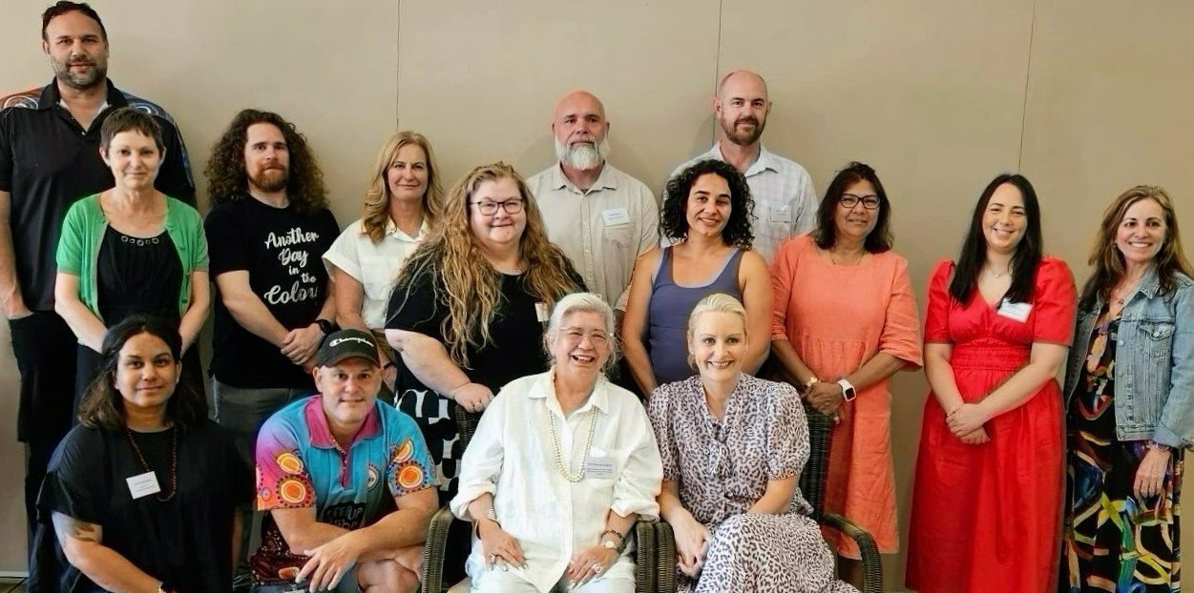
Back row: Matthew Trindall, Dr Paul Gray, Julia Knapton, Dean Bayliss, Kurt Towers
Middle row: Kate Garvey, Monica Kelly, Danielle Dyall, Monica Barolits-McCabe, Rachel Fishlock, Sandra Eyre
Front row: Leonie Williamson, Zaccariah Cox, Prof. Pat Dudgeon, Dr Liz Develin
The Social and Emotional Wellbeing Policy Partnership (SEWB PP) held its fifth meeting on 29 August 2024, on Yawuru Country in Broome. It was co-chaired by Professor Pat Dudgeon (Aboriginal and Torres Strait Islander Co-Chair) and Dr Liz Develin, Deputy Secretary, Department of Health and Aged Care (Government Co-Chair).

Member Updates
- Updates demonstrating the hard work and dedication of the SEWB PP members were shared by both parties.
- The SEWB initiatives occurring across States and Territories included opportunities for co-design, consultation and long-term investment.
- Aboriginal and Torres Strait Islander members called for action to ensure programs have ongoing funding and to address emerging policy shifts in their jurisdictions, particularly in remote areas.

Strategic Direction
The following strategic directions for the SEWB PP were discussed:
- The importance of connecting all SEWB policy, program, and reporting work undertaken in jurisdictions across Australia to the priority reforms under the National Agreement on Closing the Gap.
- The opportunity to embed the Gayaa Dhuwi Declaration in all services relating to mental health and SEWB.
- Establishment of a commissioning framework by the SEWB PP.
- SEWB PP Members can strengthen nation-building activities for Aboriginal and Torres Strait Islander communities.
- The challenges of planning long-term programs in short-term funding cycles to address SEWB in Aboriginal and Torres Strait Islander communities.
- Workforce was highlighted as a key issue as well as cultural safety and belonging for Aboriginal and Torres Strait Islander workers. Additional care is needed to develop resources and facilities to provide additional care for Stolen Generations survivors.
- The SEWB PP Strategic Plan will establish collective approaches to ensure Aboriginal and Torres Strait Islander peoples enjoy high levels of SEWB, strengthen cultural continuity, and increase government accountability. Changes from the recent Aboriginal and Torres Strait Islander members’ meeting were discussed and endorsed, with emphasis on key points including the SEWB Refresh, Commissioning Framework, and SEWB research and development.

Presentations
- Emma Carlin from the Kimberley Aboriginal Medical Service (KAMS) and the University of Western Australia presented her research on trauma-informed care and its impact on SEWB outcomes in the Kimberley.
- Monica Barolits-McCabe from the National Aboriginal Community Controlled Health Organisation (NACCHO) presented on referendum supports, including the development of Culture Care Connect and flexible funding for specific measures tailored to community.
- The National Indigenous Australians Agency (NIAA) presented their national investment mapping exercise, targeted towards SEWB services.
- Andrea Kelly, the Interim First Nations Aged Care Commissioner spoke about her work leading public consultations with First Nations stakeholders and communities on the design and functions of the permanent Commissioner.
- Impact Co. presented their work refreshing the National Strategic Framework for Aboriginal and Torres Strait Islander Peoples’ Mental Health and Social and Emotional Wellbeing 2017-2023.
- This activity, also known as the SEWB Framework Refresh, will guide investment and design of SEWB programs with a dedicated focus on Aboriginal and Torres Strait Islander social and emotional wellbeing and mental health.

Key decisions made by the Partnership
- Changes to the SEWB PP Strategic Plan were discussed and endorsed, with emphasis on key points including the SEWB Framework Refresh and the Commissioning Framework.
- The CEO of Gayaa Dhuwi was endorsed as the Aboriginal and Torres Strait Islander Deputy Co-Chair of the SEWB PP. Updates to the Agreement to Implement the Social and Emotional Wellbeing Policy Partnership will reflect this decision.
- It was agreed to hold future meetings across two days, with Meeting #6 to focus on building relationships between the members.
- SEWB PP members agreed to an alternative governance structure and endorsement process that emphasises shared decision-making. Future reporting will see the SEWB PP seeking endorsement from Health Chief Executives Forum (HCEF) directly before seeking Health Ministers’ Meeting (HMM) endorsement.
The SEWB PP will meet again in early 2025.

