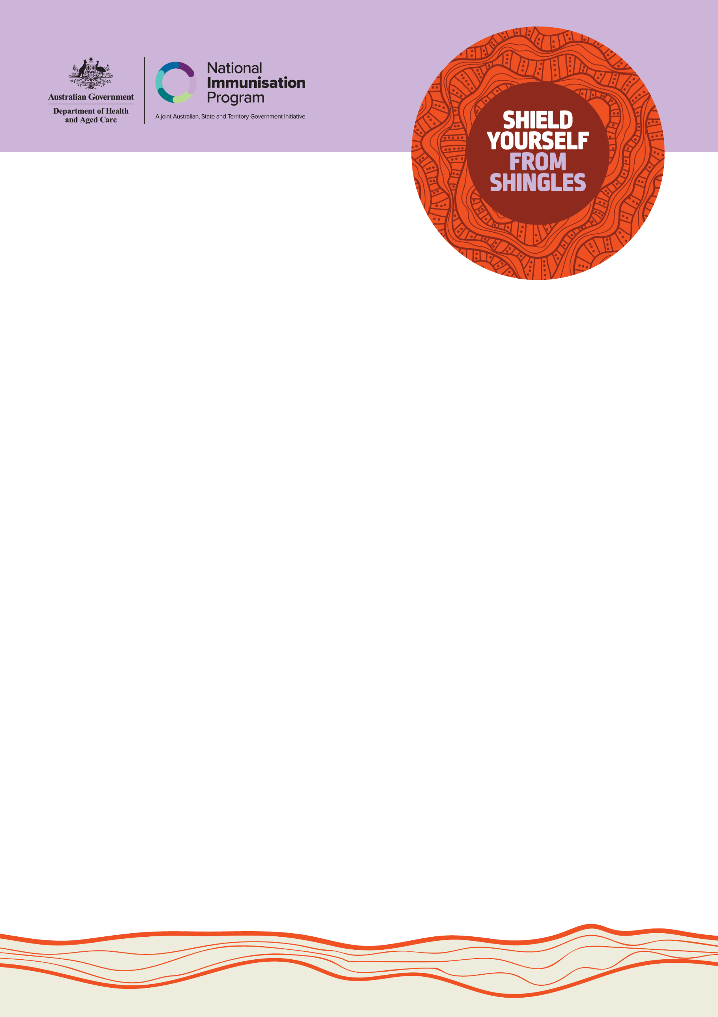TALK TO YOUR HEALTH PROFESSIONAL ABOUT YOUR ELIGIBILITY FOR A FREE SHINGLES VACCINE TODAY.

## THE FREE SHINGLES VACCINE: YOUR QUESTIONS ANSWERED

The shingles vaccine, Shingrix®, is now available free through the National Immunisation Program (NIP), replacing Zostavax®.

## WHAT IS SHINGLES?

If you’ve had chickenpox as a kid, you can get shingles as an adult.

Shingles is a viral infection that can

be really nasty; especially if you are 50 or over, or if your immune system is weak.

Shingles can cause:

* a painful, blistering rash
* sudden and intense pain that can last for months
* serious illness in some cases.

While most symptoms usually last 2 to 3 weeks, shingles can become serious. It can lead to nerve pain that can last for months and can also cause:

* pneumonia (problems with your lungs and breathing)
* hearing problems
* blindness
* swelling of your brain.

## WHO CAN GET THE FREE VACCINE?

Shingles vaccination is free for

Aboriginal and Torres Strait Islander people 50 years and over.

Immunocompromised people (people with weak immune systems) aged 18 years and over with specific medical conditions can also get a free shingles vaccine.

These conditions are:

* haematopoietic stem cell transplant
* solid organ transplant
* haematological malignancy (blood cancer)
* advanced or untreated HIV.

**Note:** Non-Indigenous people aged 65 years and over can receive the free shingles vaccine.

## CAN I GET THE FREE SHINGLES VACCINE IF I’VE ALREADY HAD ONE?

Yes, but it depends on a few factors.

If you’ve already had a free Zostavax® shingles vaccine, you can get the free Shingrix® vaccine 5 years after your Zostavax® dose.

If you purchased the Zostavax® vaccine privately you can receive Shingrix® free under the program if you’re eligible.

You should wait at least 12 months between receiving Zostavax® and getting the Shingrix® vaccine.

## HOW MANY VACCINE DOSES DO I NEED?

You should get 2 doses of the Shingrix® vaccine for the best protection, given a few months apart. Both doses are free through the National Immunisation Program.

## HOW AND WHERE CAN I GET THE FREE SHINGLES VACCINE?

To get the free shingles vaccine, check with your health professional.

Although the vaccine is free, some health professionals may charge a consultation fee for the visit. You can check if there are any fees when making your appointment.

You can book a vaccine appointment at a range of health services including:

* Aboriginal health services
* general practices
* local council immunisation clinics (available in some states and territories)
* community health centres (available in some states and territories)
* participating pharmacies.

Not all health professionals will have the free vaccines so it’s best to call ahead and check.

If you’re under 50, you can talk to your health professional about your needs and if you can buy it privately. You may need a script. Talk to your health professional to find out how much it will cost.

## DO I STILL NEED TO GET VACCINATED IF I’VE ALREADY HAD SHINGLES?

Yes, it is important to get vaccinated even if you have had shingles. You can get shingles again.

Having a shingles vaccine is the best way to protect yourself.

You should wait at least 12 months between getting shingles and getting the vaccine.

You can yarn with your health professional about when you should get it.

## IS THE SHINGLES VACCINE SAFE AND DOES IT WORK?

Yes. The shingles vaccine is safe and very good at preventing shingles and stopping bad side effects from the virus that causes shingles.

The shingles vaccine doesn’t contain any live virus and is safe for adults with weakened immune systems.

## ARE THERE ANY SIDE EFFECTS FROM THE VACCINE?

Most people get only mild side effects such as:

* pain where they had their needle
* redness
* swelling
* tiredness
* headaches
* fever.

These usually go away within a couple of days. Other side effects are very rare.

You should have a yarn to your health professional if you are worried about any side effects.

## I’VE ALREADY PAID FOR A SHINGRIX® VACCINE. CAN I GET MY MONEY BACK?

No, you can’t be reimbursed if you have paid for the Shingrix® vaccine and are now eligible to receive it for free.

However, if you’re eligible and have already paid for the first dose, you can get the second for free.

## WHERE CAN I GET MORE INFORMATION?

Visit [health.gov.au/shield-yourself-from-shingles](https://www.health.gov.au/shield-yourself-from-shingles) or contact your local state or territory health department.

## DO YOU HAVE ANOTHER QUESTION YOU NEED ANSWERED?

Email [enquiries@health.gov.au](mailto:enquiries@health.gov.au) with your questions.