# Service and Support Portal User Guide – Viewing Wait Time Information for Home Care Packages

This user guide is designed for Staff Members or Team Leaders within the My Aged Care Service and Support Portal. It explains how to interpret wait time information for Home Care Packages (HCP).

Once a care recipient is approved for home care by an aged care assessor (assessor), they will automatically be placed on the National Priority System (NPS) to await the assignment of a package.

You can view estimated wait times for each HCP level, as well as wait time information for care recipients including:

* their approved HCP level
* priority for service, and
* time waited for care.

|  |  |
| --- | --- |
| ! | The Service and Support Portal and this user guide refers to the term ‘Maximum HCP wait times’, these times provided are estimations. To view the most up to date information about HCP wait times visit [Home Care Packages](https://www.myagedcare.gov.au/help-at-home/home-care-packages). |

This guide contains the following topics:

Finding general wait time information 2

Finding wait time information for an existing care recipient 4

Finding when my care recipient is assigned a higher-level HCP 5

For more information or support 6

## Finding general wait time information

To view general information about expected wait times for each package level, follow the procedure below.

1. Select the **Tasks and notifications** tile from the Service and Support Portal home page (or from the side menu or toolbar within the portal).

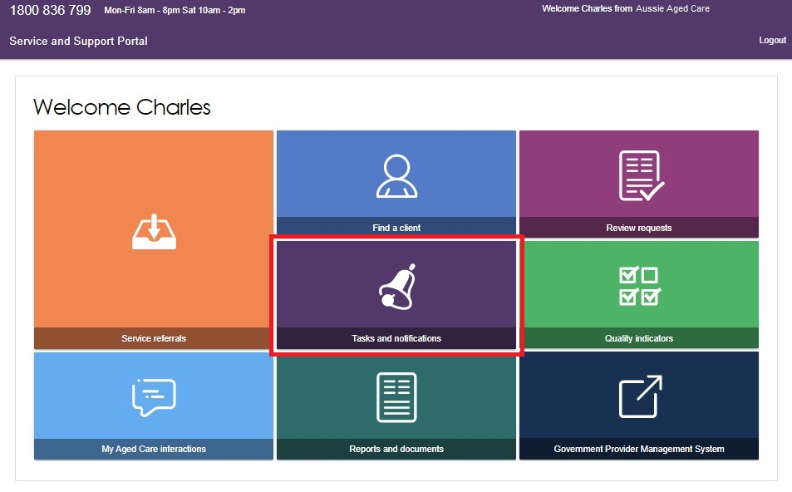

1. On the Tasks and notifications page, select the **Maximum HCP wait times** tab.

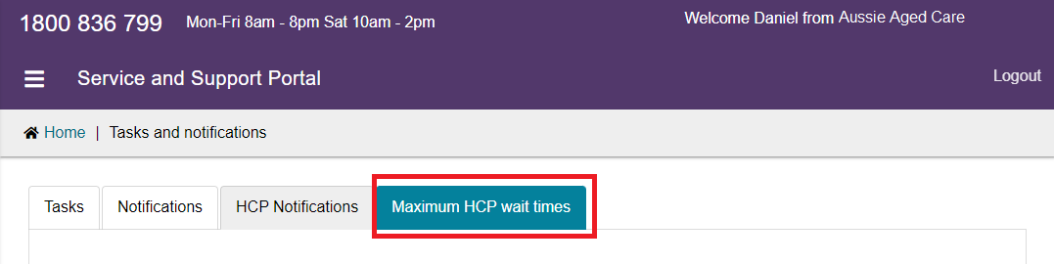

Maximum wait time information is displayed as a time-banded figure (less than 1 month, 1-3 months, 3-6 months, 6-12 months, or 12+ months) for each HCP level and is described in more detail below in the HCP Maximum Wait Times table.

The table contains three columns:

**Approved package level** – an assessor will determine the HCP that best meets an older person’s needs. There are four levels which cater to older people with basic care needs (Level 1) to people with high-level care needs (Level 4).

**Maximum time to first package** – this is the estimated time an older person at a specific approved package level can expect to wait to receive care. For a limited time in the HCP Program, care recipients were able to access ‘interim packages’ while they waited for a package at their approved level. Interim packages ceased in May 2022, however the system still prompts assessors to enter a minimum interim package level. Assessors are asked to enter the approved package level as the minimum interim package level to avoid confusion.

**Maximum time to approved package** – this is the estimated time an older person at a specific approved package level can expect to wait to receive care at their approved level.

For the latest timeframes please refer to [Home Care Packages | My Aged Care](https://www.myagedcare.gov.au/help-at-home/home-care-packages).

! The general wait time information displayed is based on the expected data for an older person who joins the end of the NPS today and is approved for a HCP at a ‘medium’ priority for service.

Wait time information is subject to change as other people enter and exit the NPS.

## Finding wait time information for an existing care recipient

To view expected wait times for a HCP for a care recipient you are currently in a Home Care Agreement with, follow the procedure below.

1. Locate the client record by conducting a basic search from the **Find a client** tile from the Service and Support Portal home page (or from the side menu or toolbar within the portal).

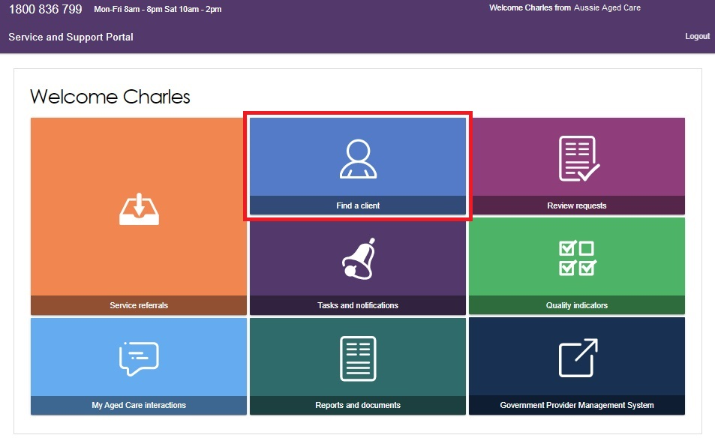

1. Select the care recipient’s name from the list of search results.

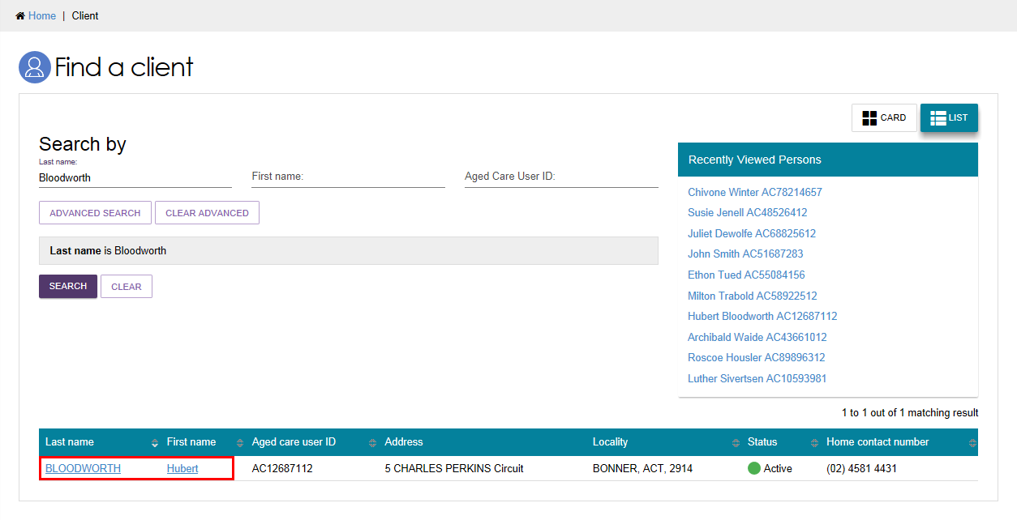

The **Client details** page will be displayed. Select the **Approvals** tab to view the care recipient’s expected wait time information.

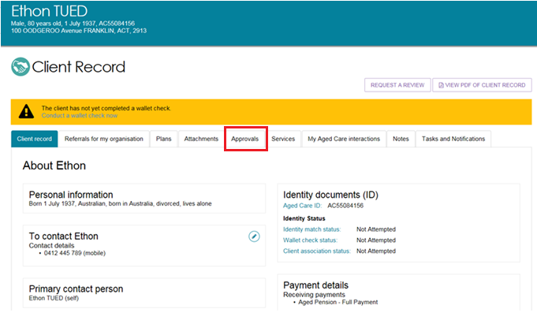

The **Approvals** tab will provide a summary of the care recipient’s:

* current approvals for all care types
* priority for home care service
* time waited to date, which is calculated from the care recipient’s approval date
* expected time to approved package displayed as a time-banded figure
* details of their current HCP.

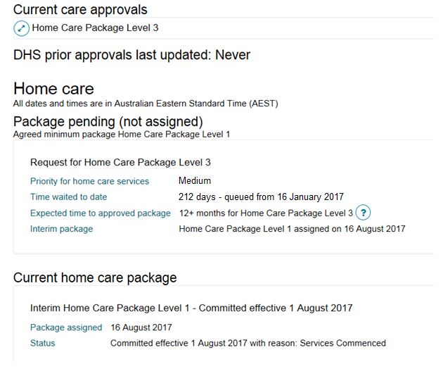

! Details displayed about a care recipient’s wait time and package information will be correct at the time of calculation. However, this may not be reflective of changes made to a care recipient’s record during the day. If the **Expected time to first package** shows **Calculation Pending**, it means that wait time information has not yet been calculated or updated. The My Aged Care system calculates wait times at regular intervals.

## Finding when my care recipient is assigned a higher-level HCP

When a client is assigned a higher-level package from the NPS, a notification will be generated in the Service and Support Portal, both at the outlet level, and within the client record.

This notification will only be generated where a provider is already in a Home Care Agreement with a care recipient.

The care recipient will also receive a letter from My Aged Care to notify them that they have been assigned a higher-level package.

This notification should prompt providers to have a discussion with their care recipient to identify additional care or services that can be provided.

## For more information or support

Further information is available from the [Service and Support Portal Resources page](https://www.health.gov.au/resources/collections/my-aged-care-service-and-support-portal-resources) on the Department’s website.

The My Aged Care Service Provider and Assessor helpline is available by calling 1800 836 799.