Results of the 2024 Medical Research Future Fund performance indicator survey

**December 2024**

Contents

1. Executive summary 3

2. Introduction 4

2.1 Approach 4

2.2 Limitations 5

3. Survey Results 5

3.1 Characteristics of survey respondents and key areas of research focus 5

3.2 Clinical trials 8

3.3 Research capacity and capability building 14

3.4 Co-contributions to MRFF-funded projects 17

3.5 Knowledge gain and dissemination 20

3.6 Consumer involvement 22

3.7 Health and healthcare change 23

3.8 Commercialisation 27

4. Overall and relative indicators of performance 30

5. Conclusions 31

Appendix 1: Survey instrument 32

Appendix 2: Additional figures and tables 34

# Executive summary

The 2024 Medical Research Future Fund (MRFF) performance indicator survey has yielded rich information on the areas of focus, methods, team composition and outcomes achieved by the current cohort of MRFF grantees. Though most projects are yet to conclude, the results of this survey confirm a strong emphasis on translating research outcomes to benefit the health and wellbeing of Australians, strengthen the health system and foster economic growth. They also show that the MRFF is achieving its objectives to address unmet needs in historically underserved and under-researched groups of people (Figure 1).

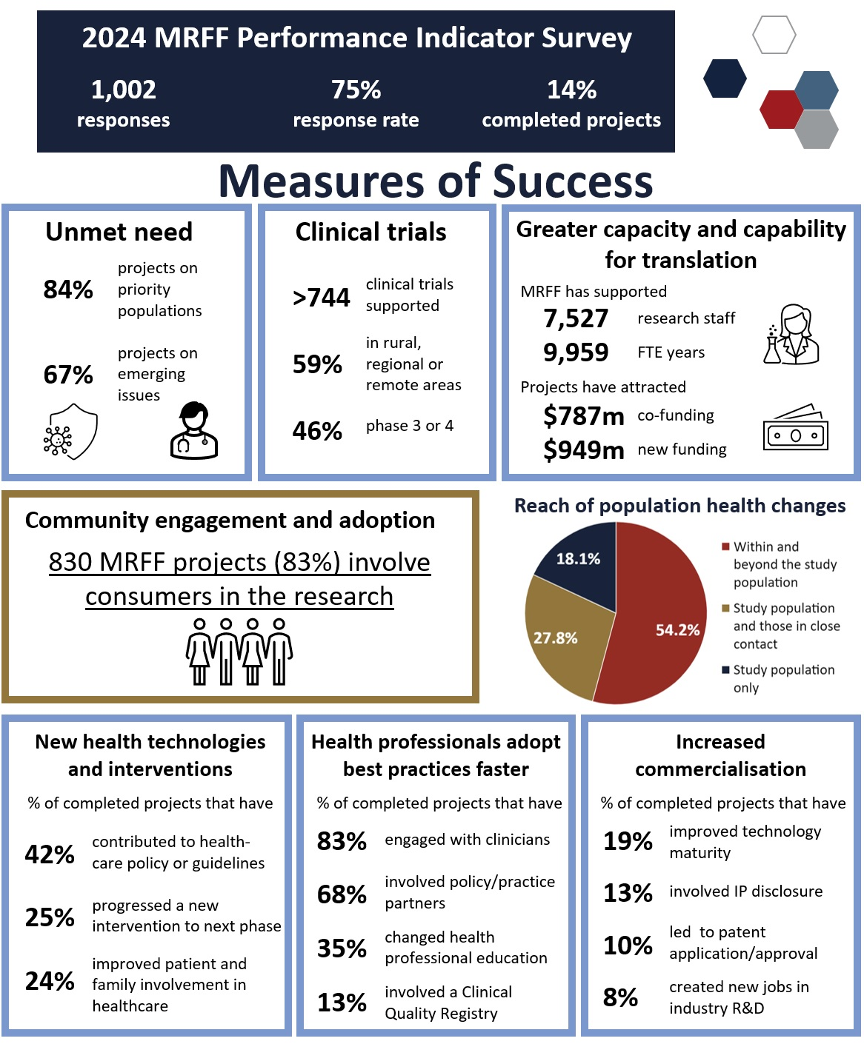

Figure 1. Infographic highlighting key metrics related to the MRFF Measures of Success.

# Introduction

The Medical Research Future Fund (MRFF) is a $22 billion (as at 31 December 2023) long-term investment in Australian health and medical research. The MRFF aims to transform health and medical research and innovation to improve lives, build the economy and contribute to health system sustainability. Under the MRFF 3rd [10-year MRFF Investment Plan](https://www.health.gov.au/our-work/mrff/about/10-year-investment-plan), up to $650 million has been allocated to health and medical research funding annually from 2024-25 to 2033-34.

Measuring the impact of the MRFF is critical to understanding whether it is meeting its stated objective. To support the assessment of MRFF impact, the [MRFF Monitoring, evaluation and learning strategy](https://www.health.gov.au/our-work/mrff/about/monitoring-evaluation-learning) (MEL Strategy) was developed to provide an overarching framework for assessing the MRFF’s performance against eight Measures of Success and ultimately the five Impact Measures (see Figure 2, from the MEL Strategy). This framework is complemented by the [MRFF performance indicators](https://www.health.gov.au/resources/publications/performance-indicators-towards-the-impact-of-the-medical-research-future-fund?language=en).

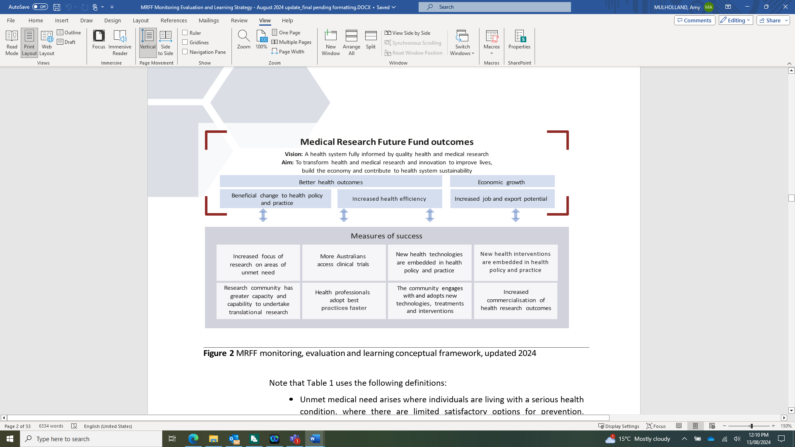

Figure 2. MRFF monitoring, evaluation and learning conceptual framework, updated 2024.

As part of the implementation of the MEL Strategy, a list of MRFF performance indicators, underpinned by measurable indicators, has been developed (refer to MEL Strategy and MRFF performance indicators, above). The performance indicators provide a framework for assessing the progress made towards the 8 MRFF Measures of Success and in the longer term the impact of the MRFF.

To measure impact across the MRFF program, the Department of Health and Aged Care (department) has undertaken the first of planned regular surveys to capture data on all MRFF performance indicators across all completed grants, and a subset of performance indicators for active grants. The department will continually refine and coordinate data captured from the survey and other sources.

The aim of the survey was to provide a high-level public overview of the success and impact of MRFF-funded research, as assessed by the MEL Strategy and MRFF performance indicators. The data collected will also form a baseline for future evaluations of longer-term impact. This survey complements information and data collected in applications and progress and final reports.

## 2.1 Approach

The survey was conducted using the Qualtrics platform and opened on 21 March 2024 for a 6-week period; survey questions can be found in Appendix 1. The survey was disseminated to all grantees with active or completed MRFF grants in March 2024 (n = 1,328). The lead investigator (Chief Investigator A) of each MRFF grant was invited to complete the survey or delegate to a member of their project team. Once the survey closed, data cleaning and validation was undertaken, and responses within free-text or ‘other’ fields analysed and coded. The dataset was then uploaded to the Microsoft Power BI platform for full analysis. Case studies were identified through information provided in the impact stories question of the survey. A subset of responses that demonstrated performance in one or more of the MRFF Measures of Success were selected and the lead investigator contacted to seek permission and refine the case study for presentation in this report. In some cases, data or information provided through the survey has been updated to provide contemporary figures.

## 2.2 Limitations

It is recognised that indicators of health and healthcare change and commercialisation are often complex and long-term in nature and cannot always be captured via routine approaches or connected back to a single project. The relatively early stage of most MRFF-funded projects also creates difficulty in measuring the impact of individual projects, and the collective impact of the MRFF program (all funded grants). This survey was designed to capture granular information on projects at all stages in their life cycle, with subsequent monitoring of progress at regular intervals planned. To reduce survey burden, questions about health and healthcare change and commercialisation were only available to completed grants, which limits full impact analysis to a smaller pool of projects.

The cohort of MRFF grants is mainly comprised of individual projects, with a small subset of larger programs delivered by organisations on behalf of the MRFF. These programs are not always easy to identify based on the information recorded at the time of grant award. Program and project grants were treated equally for the purposes of this survey and the analysis, but it should be noted that some of the outliers in the data may relate to answers provided by organisations that manage the program, and some indicators and measures may be underestimated as they are not captured across all the projects awarded under the program.

There were additional limitations due to restrictions in the number of fields available for responses:

* clinical trials data is limited to the largest trial funded by the MRFF grant
* data on co-funding and new funding is limited to 3 sources of each per grant
* data on publications is limited to 5 per grant.

# Survey Results

## 3.1 Characteristics of survey respondents and key areas of research focus

### 3.1.1 Response Rate

The MRFF Performance Indicator Survey had a high overall response rate, with 1,002 out of 1,328 grantees completing the survey (75.5%). This includes response rates of at least 73% in every state and territory (Figure 3). Profiling the responses by organisation type and MRFF theme showed that the cohort of projects for which responses were recorded were representative of the overall MRFF program. Most respondents indicated their MRFF-funded projects were ongoing (85.6%) with 14.4% indicating that their projects were complete.

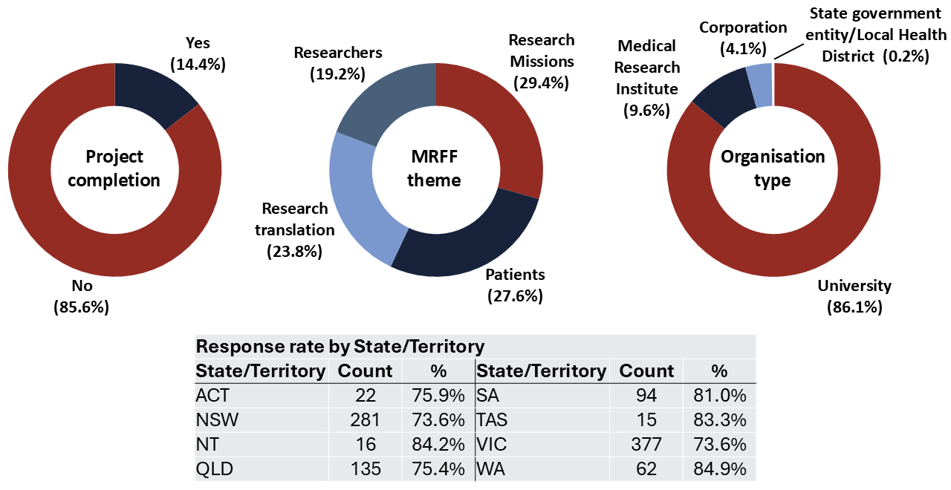

Figure 3. Profile of the survey respondents (n = 1,002).

### 3.1.2 Priority populations and emerging issues

| Performance indicator | Rationale | Measurable outputs |
| --- | --- | --- |
| Projects targeting priority populations | To capture how much of MRFF-funded research is prioritising populations where current interventions or technologies may not be suitable or accessible, or where those populations may be under-represented for other reasons | Number, value and proportion of projects on:   * Aboriginal and Torres Strait Islander health * older people experiencing diseases of ageing * people with rare or currently untreatable diseases/conditions * people in remote/rural communities * people with a disability (including people with intellectual disability) * individuals from culturally and linguistically diverse communities * LGBTIQ+ people * youth |
| Projects targeting emerging issues | To capture how much of MRFF-funded research is addressing unmet need0F[1], in terms of new and emerging issues | Number, value and proportion of projects on:   * COVID-19 or other emerging health challenges * Priorities arising from Senate Inquiries, emergencies, and other consumer-led mechanisms |

Table 1. Performance indicators relevant to priority populations and emerging issues.

|  |
| --- |
| As measured by this section of the survey:  839 MRFF projects (83.7%, total value $2.1 billion) are targeting one or more priority population(s) listed in Table 1.  674 MRFF projects (67.3%, total value $1.8 billion) are targeting emerging issues listed in Table 1.  The figures and summary below include additional priority populations and emerging issues that were identified by MRFF grantees. Results are not additive and there can be some overlap for projects that report more than one priority population or emerging issue. |

The majority of MRFF-funded projects relate to the priority populations (Figure 4) that were identified in the MRFF performance indicators publication, with the top 3 priority populations being people with rare or currently untreatable diseases or conditions (30.8% of projects), older people experiencing diseases of ageing (24.2%), and people in remote/rural communities (22.8%). Analysis of the ‘other’ responses (see Appendix 2) revealed a focus on people with chronic conditions, children and infants, and people who are pregnant. These populations have been a focus of many of the MRFF Initiatives such as the MRFF Cardiovascular Health Mission and the Preventive and Public Health Initiative.

The top 4 emerging issues (apart from ‘none’ (30.8%) or ‘other’ (21.7%)) addressed by MRFF grants were (Figure 5): mental illness (14.6%), cancers with low survival rates (12.8%), aged care (11.2%) and COVID-19 and obesity (6.7%). A very wide range of emerging issues (86) were identified through this section of the survey, reflecting the MRFF’s response to new health challenges that arise within the Australian population.

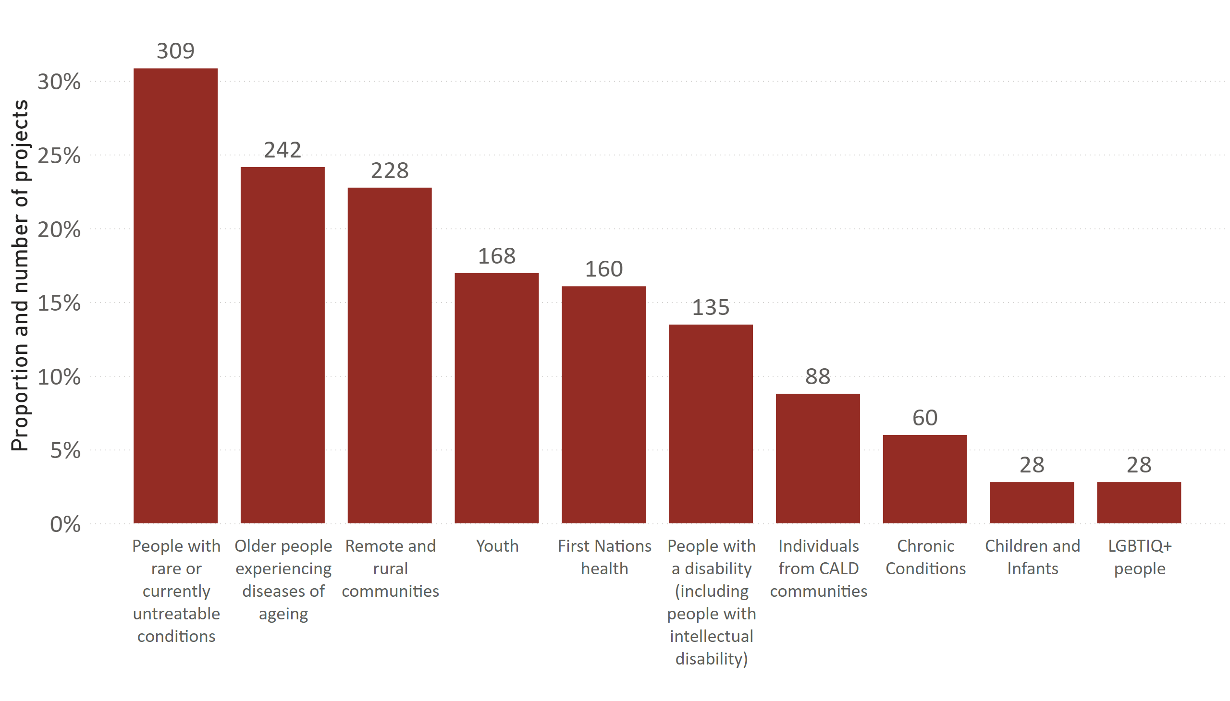

Figure 4. Reported alignment with the priority populations. Survey respondents were able to select more than one answer, and 995 unique respondents made 1,670 selections (n = 1,002). Only the top 10 responses are presented, with the full list available in Appendix 2. ‘Other’ responses (n = 158) have been coded and included in the figure above. One hundred and fifty-six (156) respondents selected ‘None of the above’.

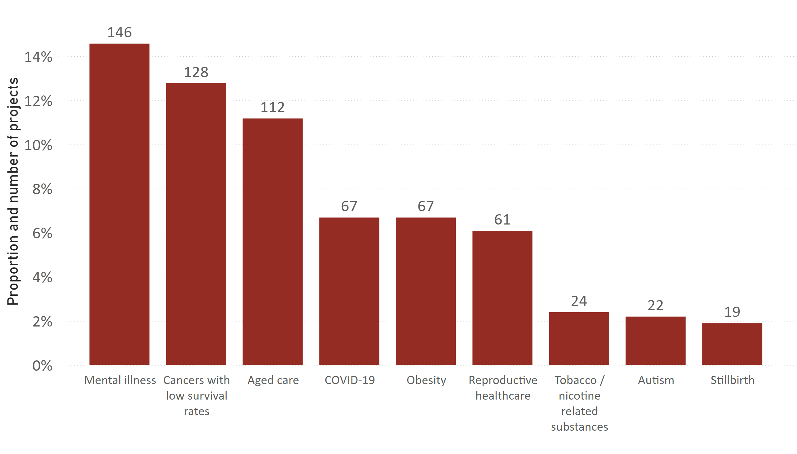

Figure 5. Reported alignment with unmet needs, emerging challenges or topics arising from parliamentary inquiries, emergencies or consumer-led mechanisms. Only the top 10 responses are presented, with the full list available in Appendix 2. Survey respondents were able to select more than one answer, and 983 unique respondents made 1,285 selections (n = 1,002). ‘Other’ responses (n = 217) have been coded and included in the figure above. Three hundred and nine (309) respondents selected ‘None of the above’.

|  |
| --- |
| **Case study**: A new nurse-led intervention to re-engage childhood brain cancer survivors  Led by Professor Claire Wakefield and Doctor Jordana McLoone, University of New South Wales  Funded by the 2019 Brain Cancer Survivorship grant opportunity  **An example of success in ‘the community engages with and adopts new health technologies, treatments and interventions’ and ‘increased focus of research on areas of unmet need’**  This project addressed an unmet need in childhood brain cancer survivorship care. The Engage program was designed to improve the quality of life and confidence of childhood brain cancer survivors in managing their health. This project gathered evidence to support the full translation of a childhood cancer survivorship care intervention, which is now part of usual care at Sydney Children’s Hospital and is about to be applied at Queensland Children’s Hospital. To support the ongoing sustainability of this intervention, the project team has used evidence from this trial to secure funding for additional hospital staff, and they have converted the program to a manualised, user-friendly, usual care-style system that can be used by nurses once research staff cease involvement. |

## 3.2 Clinical trials

| Performance indicator | Rationale | Measurable outputs |
| --- | --- | --- |
| Projects involving clinical trials | To capture multiple facets relating to clinical trials supported by MRFF funding | * number, value and proportion of projects by conditions, location * patients recruited (projected vs actual) * number of trials completed * number of trials with published outcomes |

Table 2. Performance indicator relevant to clinical trials.

|  |
| --- |
| As measured by this section of the survey:  506 MRFF projects (50.5%, total value $1.4 billion) include at least 744 clinical trials.  297 MRFF projects (29.6%, total value $779.5 million) include clinical trials in rural, regional and remote areas. |

Over half of MRFF projects included a clinical trial (506, 50.5%), 492 MRFF projects do not involve a clinical trial, and 4 respondents did not provide a response. Project leaders were asked how many clinical trials their MRFF grant supports, with 504 respondents indicating a total of 744 clinical trials funded by the MRFF (Table 3). Of these a majority (417, 82.4% of the clinical trials subset) reported that their MRFF grant supported one clinical trial. Respondents who indicated that their MRFF grant supports more than one clinical trial were advised to use the largest clinical trial when answering subsequent questions about trial characteristics.

Tracking trial registration is an important component of MRFF monitoring and evaluation activities. Of the registered trials, the most common clinical trial registries were ANZCTR and Clinicaltrials.gov (Figure 6). Almost one quarter of respondents advised that their trial was not yet registered (112, 22.1%), but 20 of this subset indicated intention to register their trial(s).

Clinical trial type was categorized into four different interventional categories (Figure 7: drug, device, health service change and other). There was also scope to indicate other categories via the free-text field. The top category selected was Interventional – health service change (156 responses) closely followed by Interventional – other (155), and Interventional – drug (144). The top three health conditions addressed by MRFF-funded clinical trials were cardiovascular disease, cancer and mental health (Figure 8). A very wide range of conditions are addressed through clinical trials, shown in Table 4. Although most clinical trials had urban and/or metropolitan sites (reflecting the concentration of research organisations and health services in capital cities), over half (297, 58.7%) of clinical trials had regional, rural or remote sites (Figure 9). The most common phase of clinical trial was Phase 3, with 176 responses and a combined 45.7% of all trials are in phase 3 or 4 (Figure 10).

A large number (214) have had no enrolments in their clinical trials, most likely due to many projects having not yet commenced (Figure 11). The majority of MRFF-funded trials plan to recruit up to 400 participants, with a sizeable number (68 projects) planning to recruit over 1,000. The highest response was 205,000 planned enrolments, which may reflect the grant being used to support a larger program that includes multiple projects and/or clinical trials. Eleven projects indicated a target recruitment of zero; one possible explanation is the use of the term “patient” instead of “participant” in the survey, which may have excluded public or preventive health trials. Looking at recruitment rates, 80 projects (16.0%) indicated they had met or exceeded their recruitment targets (Figure 12).

|  |  |  |
| --- | --- | --- |
| Number of Clinical Trials | Count | % |
| 0 | 4 | 0.8% |
| 1 | 417 | 82.4% |
| 2-4 | 60 | 11.9% |
| 5-9 | 17 | 3.4% |
| 10-14 | 5 | 1.0% |
| 15 | 1 | 0.2% |

Table 3. Reported number of clinical trials supported by the MRFF grant (n = 504).

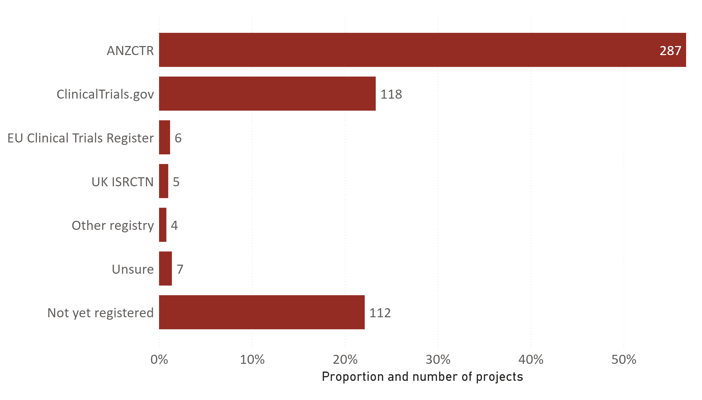

Figure 6. Breakdown of responses to the question on clinical trial registration. Survey respondents were able to select more than one answer, and 505 unique respondents made 544 selections (n = 506). ‘Other’ responses (n = 29) have been coded and included in the figure above.

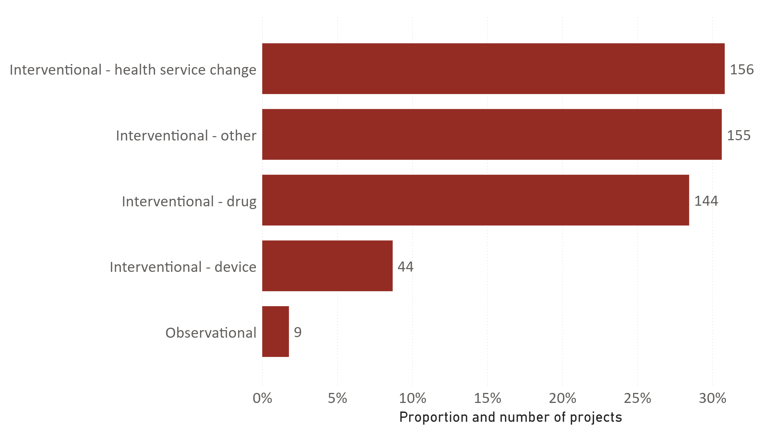

Figure 7. Reported types of clinical trials supported by MRFF grants. Survey respondents were able to select more than one answer, and 493 unique respondents made 566 selections (n = 506). ‘Other’ responses (n = 66) have been coded and included in the figure above. Sixteen (16) responses indicated another clinical trial type, while 5 indicated that their trials did not fit into the categories above.

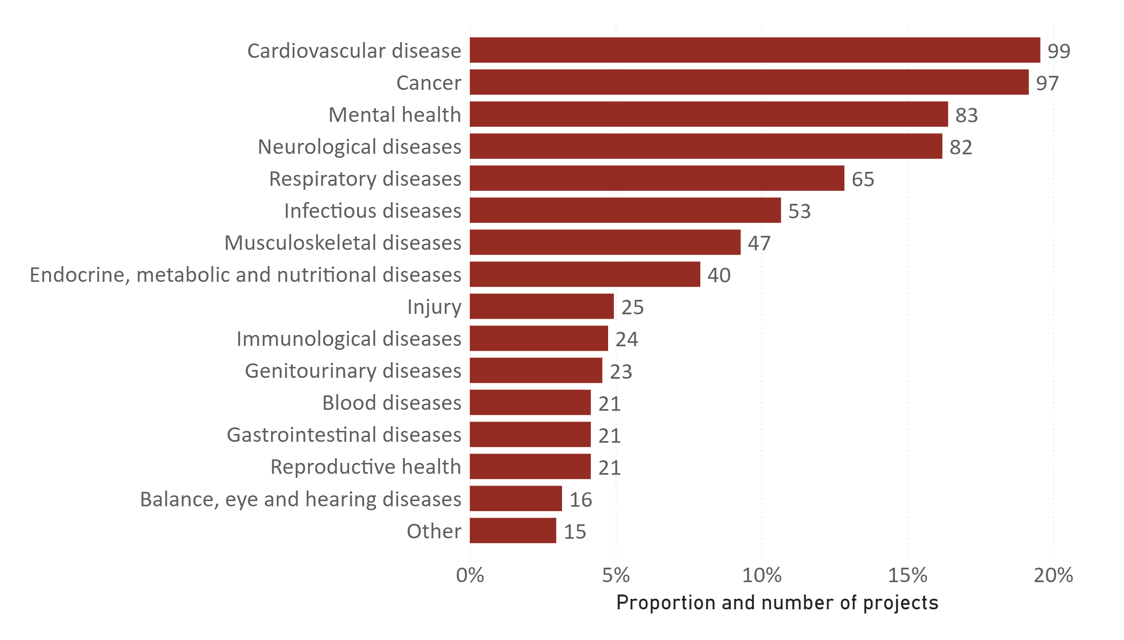

Figure 8. Health conditions addressed through MRFF-funded clinical trials. Survey respondents were able to select more than one answer, and 503 unique respondents made 828 selections (n = 506). ‘Other’ responses (n = 87) have been coded and included in the figure above.

| Health condition or area of focus | Count |
| --- | --- |
| Congenital and genetic diseases | 13 |
| Skin diseases | 9 |
| Conditions that affect pregnant people and infants | 8 |
| Environmental and occupational health | 8 |
| Health conditions that can be addressed through physical activity, lifestyle | 6 |
| Chronic conditions | 4 |
| Conditions that affect older people | 4 |
| Pain | 4 |
| Conditions requiring emergency and/or critical care | 3 |
| Developmental conditions | 3 |
| Kidney disease | 3 |
| Medication | 2 |
| Orofacial diseases | 2 |
| Stroke | 2 |
| Transplantation | 2 |
| Liver disease | 1 |
| Lymphoedema | 1 |
| Medication safety | 1 |
| Multiple conditions | 1 |
| Sleep conditions | 1 |
| Tobacco/Vaping dependence | 1 |
| None of the above | 6 |

Table 4. Breakdown of other responses to health conditions addressed through MRFF-funded clinical trials. ‘Other’ responses (n = 76) have been coded and included in the table above.

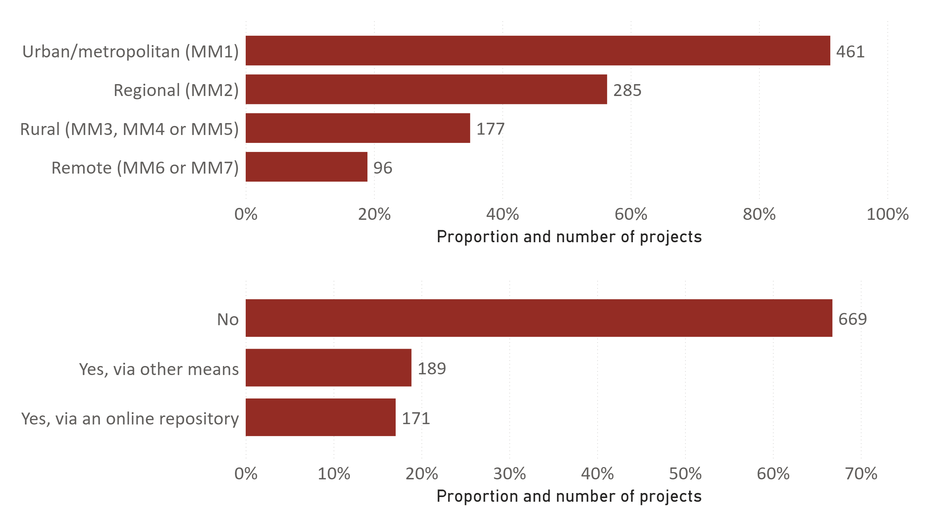

Figure 9. Reported trial site location, categorized using the Modified Monash Model 2019. Survey respondents were able to select more than one answer, and 495 unique respondents made 1,019 selections (n = 506).

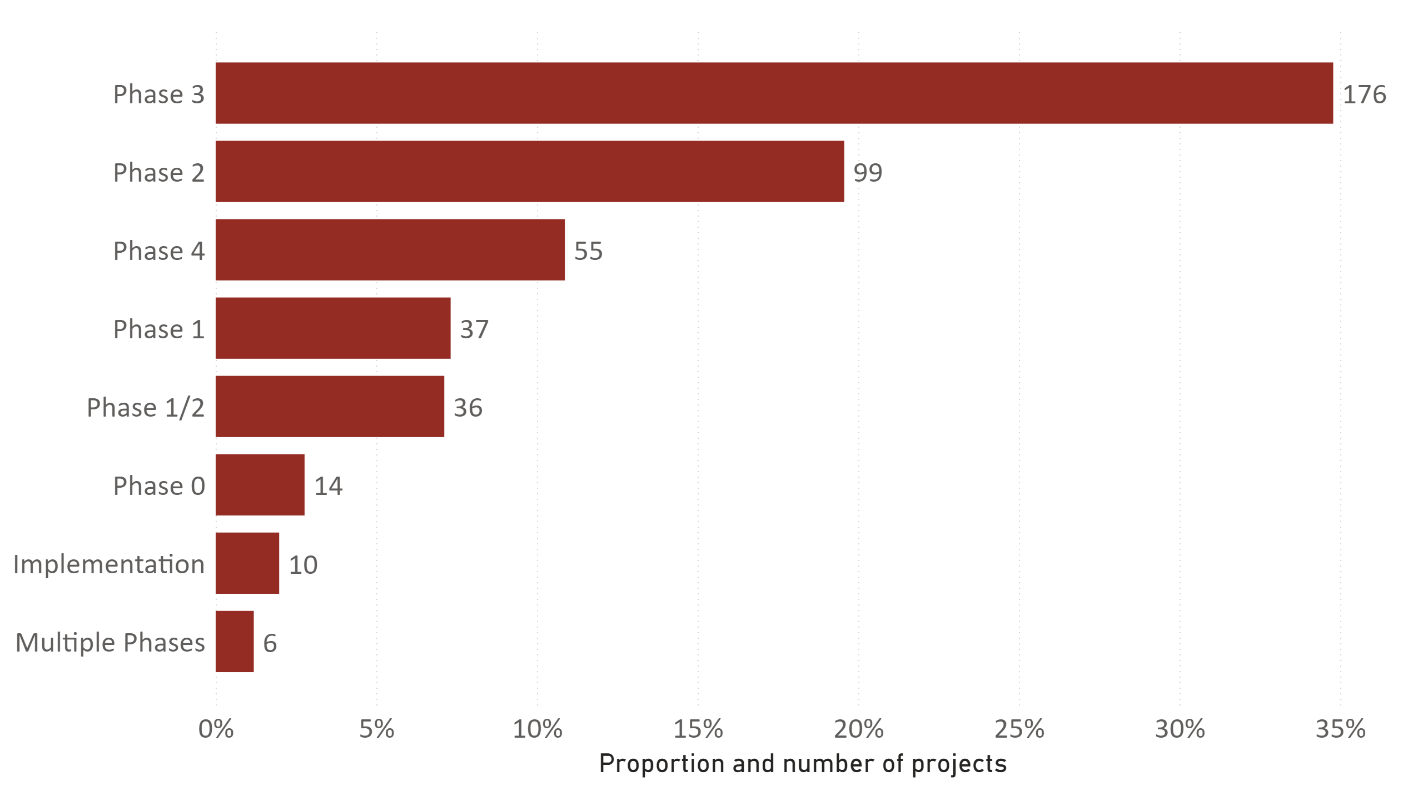

Figure 10. Reported alignment with the traditional clinical trial phases, from 503 responses (3 did not respond) (n = 506). ’Other’ responses (n = 79) have been coded and included in the figure above. Fifty-six (56) responses indicated that their clinical trial did not align with any traditional clinical trial phase.

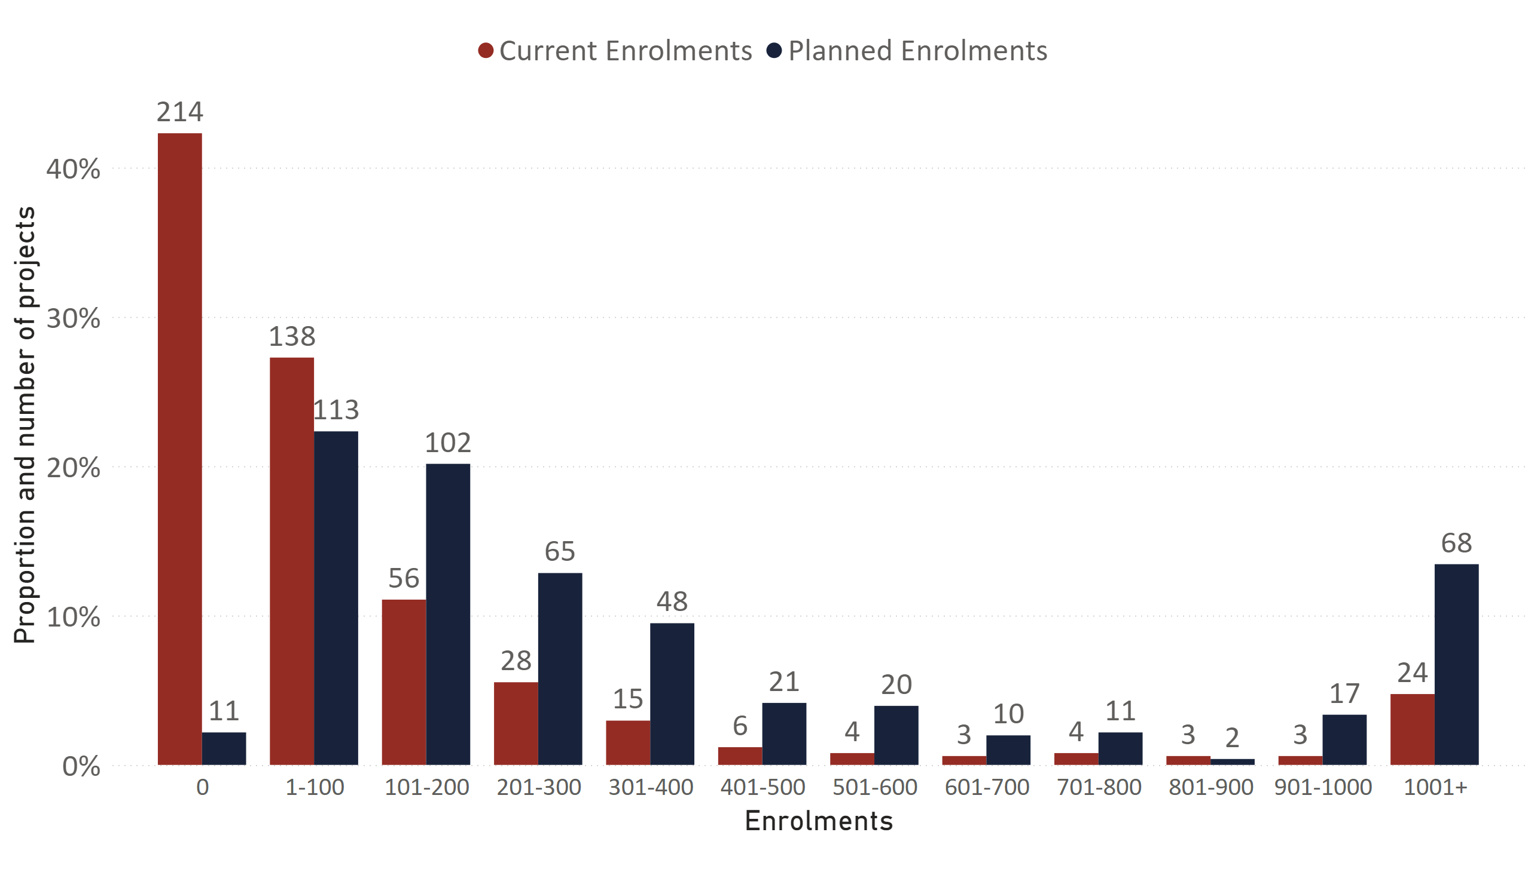

Figure 11. Reported number of patients enrolled versus recruitment targets in MRFF-funded clinical trials as of 21 March 2024, from 498 responses with current enrolments, and 488 responses with planned enrolments (n = 506).

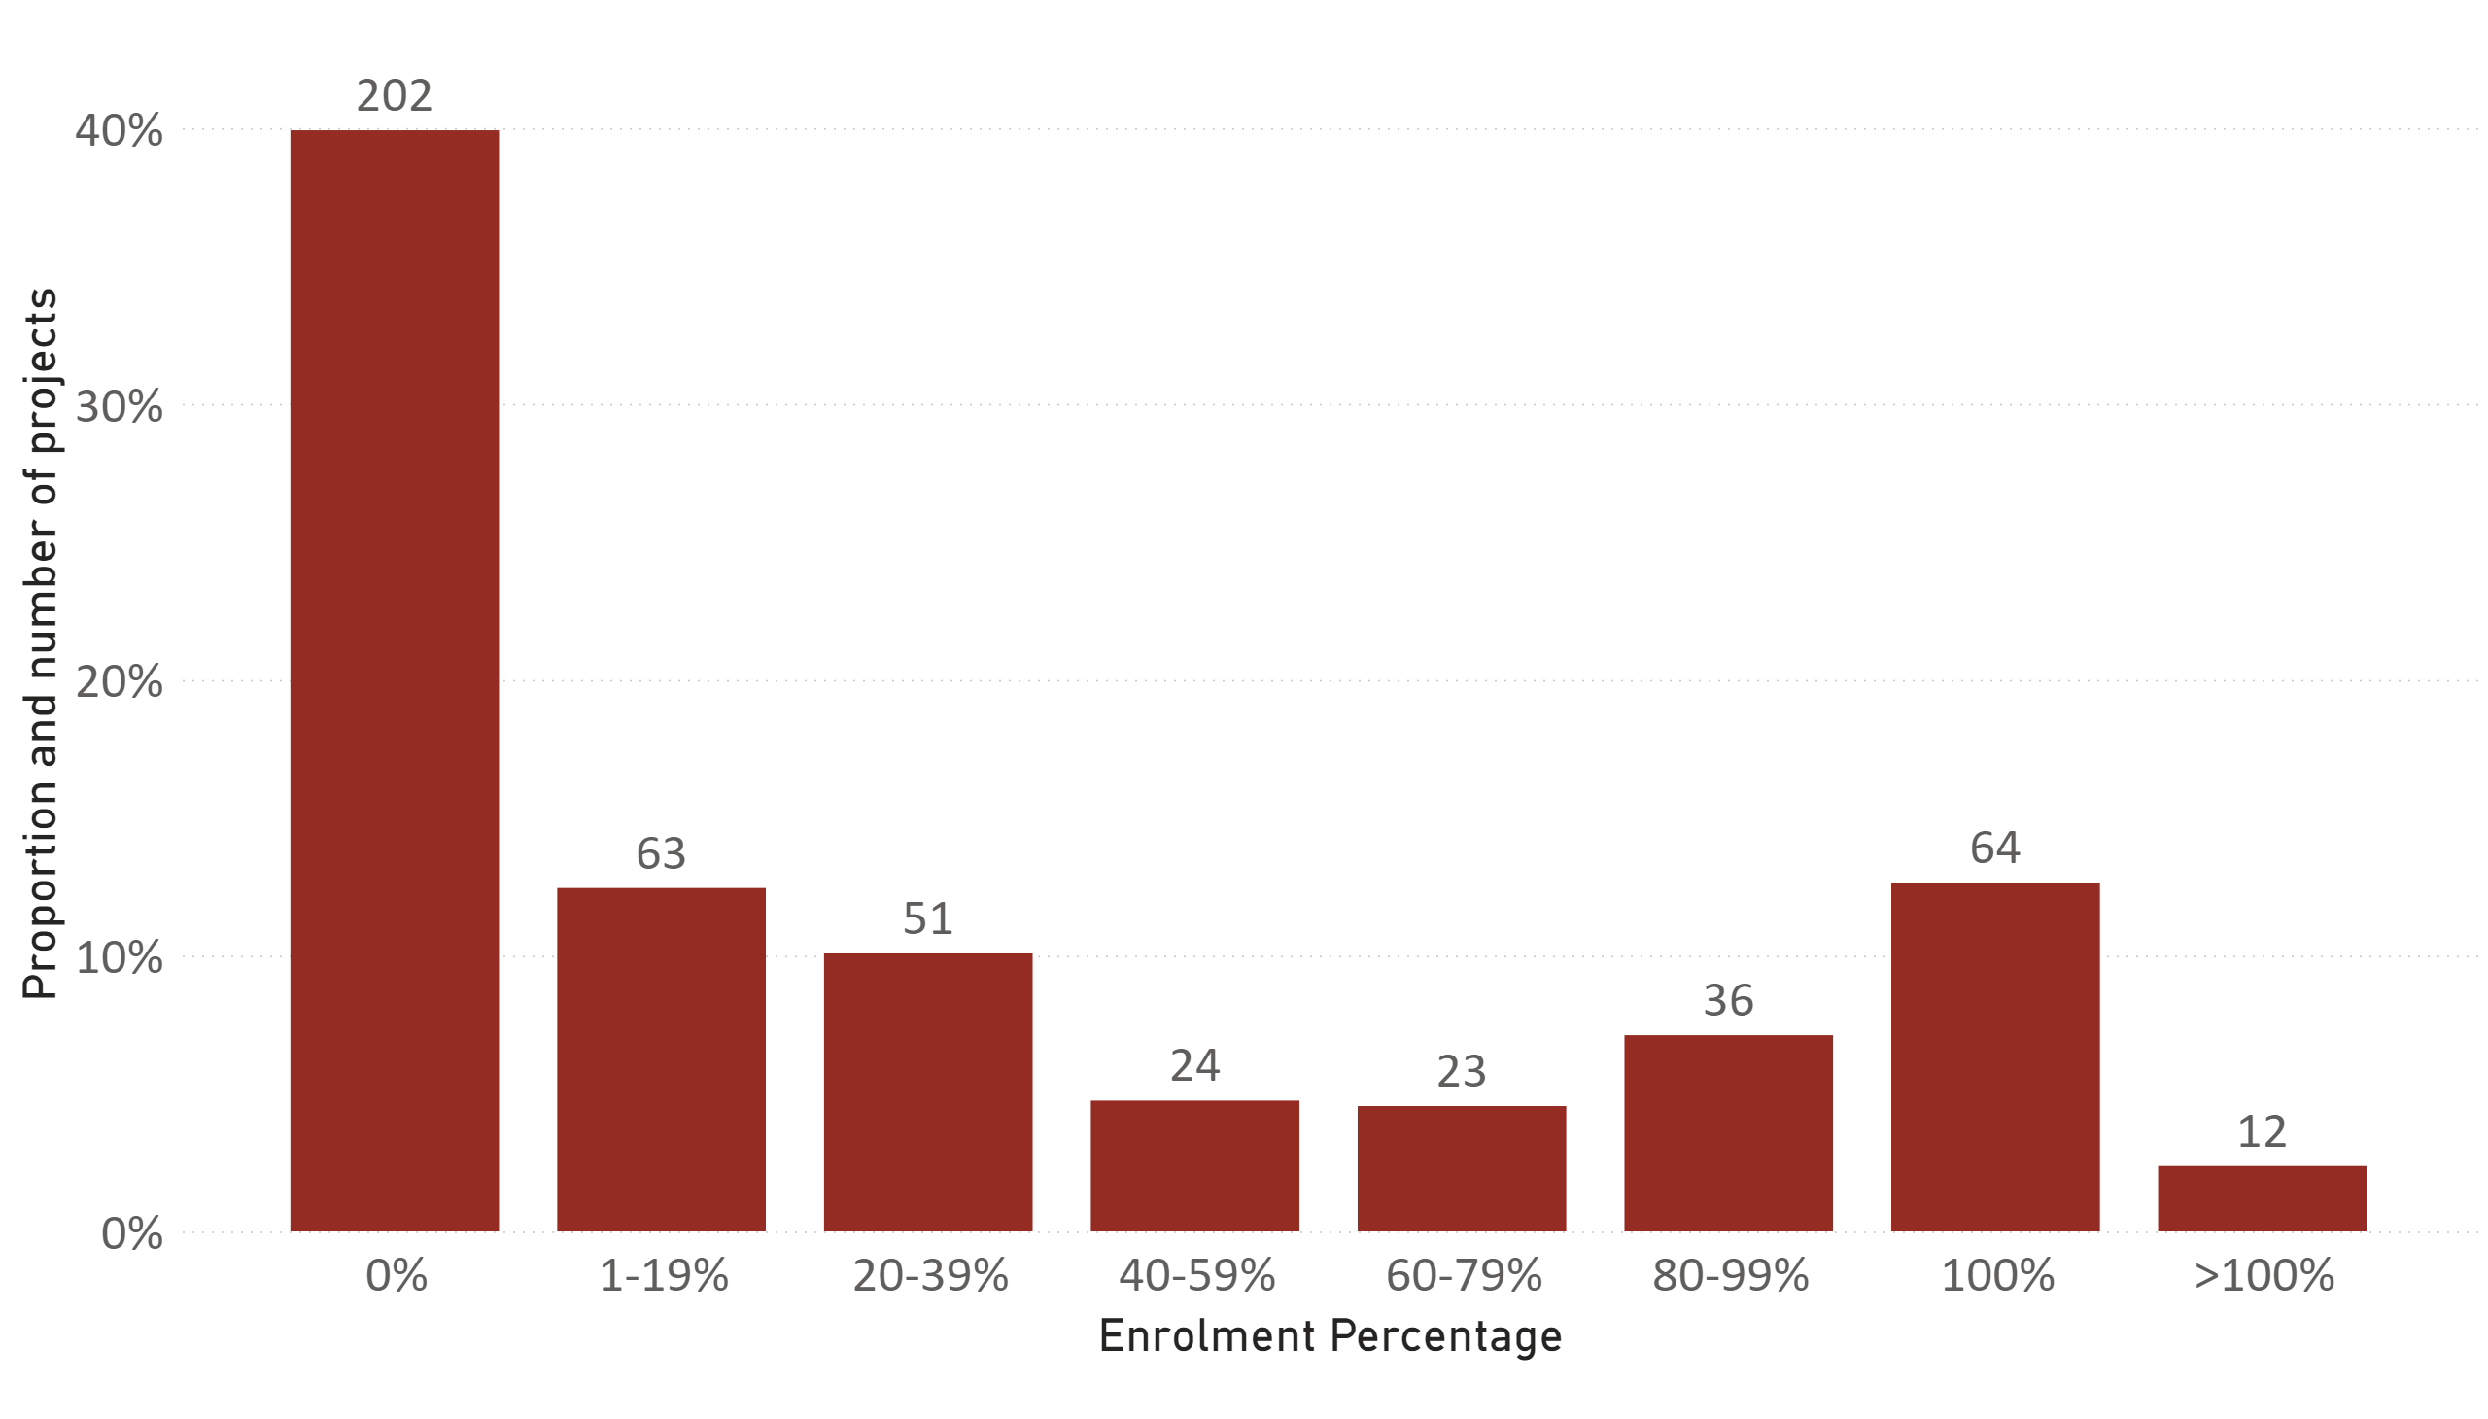

Figure 12. Recruitment percentages of 475 responses who provided both enrolled patients and recruitment targets (n = 506).

|  |
| --- |
| **Case study**: Melatonin supplementation to reduce the induction of labour rates in first time mothers: The MyTIME Trial  Led by Associate Professor Zoe Bradfield, Curtin University  Funded by the 2022 Clinician Researcher: Nurses, Midwives and Allied Health grant opportunity  **An example of success in ‘more Australians access clinical trials’ and ‘research community has greater capacity and capability to undertake translational research’**  The rate of first-time mothers having their labour induced is increasing. Induced labour can be associated with harm for mother and baby and contributes to rising health costs. This project will examine whether melatonin supplementation may help in starting labour normally. This trial aims to recruit 530 participants and is already ahead of targets.  On commencement the research team discovered there were no clinical trial midwives available in Western Australia to be employed on the trial. They have since trained 20 clinical trial midwives who are now working on the trial and good clinical practice (GCP) certified. Some have also completed benchtop lab training to enable them to undertake blood sample processing. These skills will serve the completion of this clinical trial and resource further clinical trials in Western Australia in the future. |

## 3.3 Research capacity and capability building

|  |  |  |
| --- | --- | --- |
| Performance indicator | Rationale | Measurable outputs |
| Research workforce indicators | To describe the research workforce supported by MRFF funding, in terms of capacity (e.g. is the MRFF supporting more early-to-mid career, diverse, rural/regional/remote researchers), and capability (e.g. increased training, mentorship, collaboration and access to further funding) | Number and type of research staff employed/supported:   * clinicians, allied health professionals, early-to-mid career, students, women, First Nations, rural/remote   Number of projects that:   * involve staff in research translation/knowledge mobilisation training * involve staff in industry exchange programs * involve international collaborators * involve interdisciplinary collaborators * result in new research collaborations/partnerships * have generated new funding (source and amount) |

Table 5. Performance indicator relevant to research capacity and capability building.

|  |
| --- |
| As measured by this section of the survey:  986 MRFF projects are supporting/have supported 7,527 research staff, total FTE 9,959 years.  962 MRFF projects are supporting staff involvement in workforce capacity or capability building activities. |

The results of this section of the survey showed that the MRFF has made a sizeable contribution to the health and medical research sector by funding over 7,527 research-related roles (Figure 13), corresponding to total FTE of 9,959 years (Figure 14). Research staff come from a range of professional and demographic backgrounds (Table 6), including those that have historically been under-represented in research. MRFF project teams have engaged in workforce capacity and capability building (Table 7), particularly in forming collaborations across the country, internationally, and across research disciplines. Research translation training was also a notable feature of capability building activities.

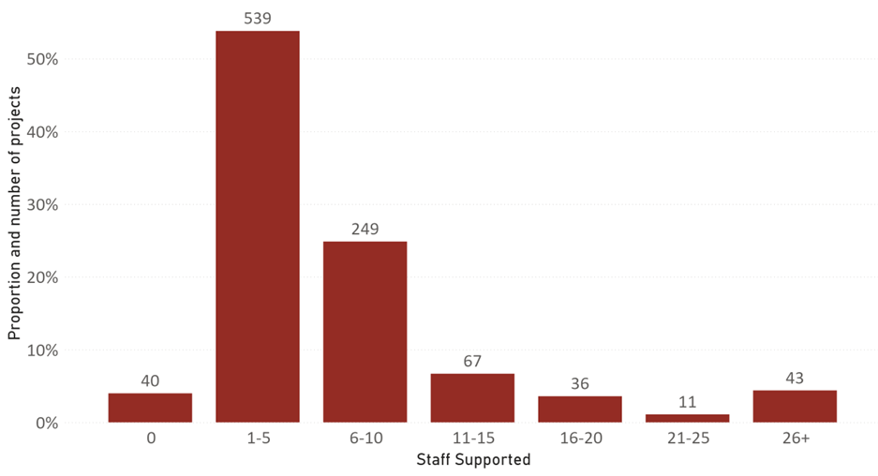

Figure 13. Reported number of people per grant who have/had their research roles paid for by the MRFF during the funding period, from 985 responses. (n = 1,002). Some respondents provided non-integer answers; these were rounded up for the analysis.

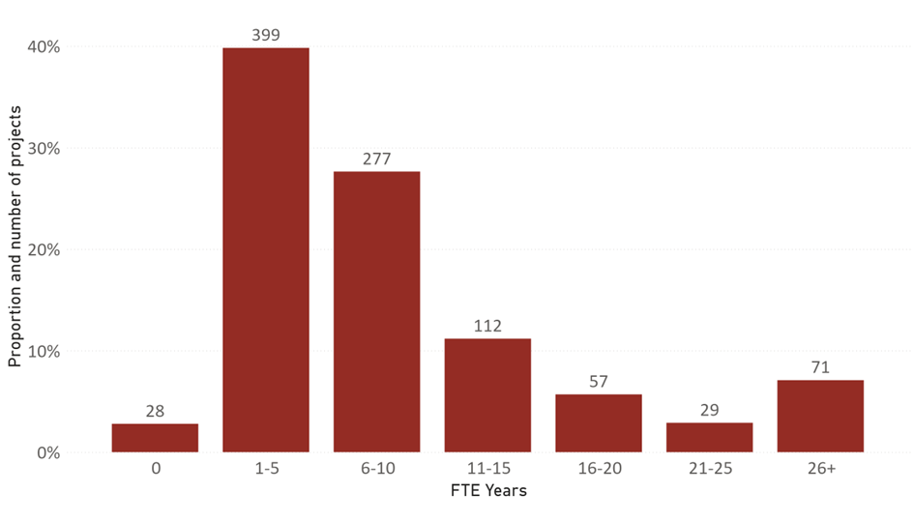

Figure 14. Reported number of FTE years per grant funded by the MRFF during the funding period, from 973 responses (n = 1,002).

| Category | Total people supported | Percentage of unique grants supporting staff in each category |
| --- | --- | --- |
| General Practitioners/Medical doctors in primary care | 101 | 5.3% |
| Medical doctors - specialists | 551 | 20.8% |
| Nurses or midwives | 931 | 26.5% |
| Dentists | 7 | 0.3% |
| Allied health professionals | 1,145 | 34.8% |
| Early career researchers | 2,141 | 70.3% |
| Mid career researchers | 972 | 47.5% |
| Higher degree research students (Masters, PhD) | 767 | 38.0% |
| Women | 4,699 | 77.8% |
| First Nations people | 436 | 13.8% |
| Located in a regional, rural or remote area | 902 | 21.2% |
| Cultural and linguistically diverse people | 1,096 | 34.8% |
| Researchers who are based in industry | 551 | 11.3% |

Table 6. Number of people supported by the MRFF, including categorisation into 13 groups captured in the survey. The percentage of projects that include a staff member with that characteristic/qualification is also shown (n = 1,002). Some respondents provided non-integer answers; these were rounded up for the analysis.

|  |  |  |
| --- | --- | --- |
| Workforce capacity building activities | Count | Percentage who responded ‘yes’ |
| Collaboration with Australian researchers outside of your institution | 857 | 85.5% |
| Interdisciplinary collaborations | 812 | 81.0% |
| New research collaborations/partnerships | 797 | 79.5% |
| Research translation training of research staff | 601 | 60.0% |
| Collaboration with international researchers | 577 | 57.6% |
| Establishing or expanding relationships and engagement with industry | 500 | 49.9% |
| Contract research or consultancies | 176 | 17.6% |
| Research staff involvement in exchange programs or placements with industry | 92 | 9.2% |
| Other activity not listed above | 72 | 7.2% |
| None of the above | 26 | 2.6% |

Table 7. Proportion of MRFF projects that have involved or led to workforce capacity or capability building activities, outputs or outcomes. Nine hundred and eighty-eight (988) unique respondents made 4,510 selections (n = 1,002).

|  |
| --- |
| **Case study**: Enabling Dads and Improving Indigenous Adolescent Mental Health  Led by Professor Susan Rees, Dr Lyndon Reilly and Uncle Professor Mick Adams, University of New South Wales  Funded by the 2019 Indigenous Health Research Fund  **An example of success in ‘research community has greater capacity and capability to undertake translational research’**  This project facilitated a substantive shift in the capacity of local First Nations people in remote communities to facilitate and evaluate a program that supports the mental health (social and emotional wellbeing) of adolescents and their dads. The funding was able to support a First Nations designed and led project to be empirically tested and now the communities are using that data and their knowledge to ensure it continues. They also plan to support the scaling up of the Enabling Dads project to other First Nations communities, and to ensure it is sustainable in their own communities. First Nations researchers who led this work are disseminating outcomes via publications and presentations and are now positioned to lead future funding proposals. This is evidence of building research capacity amongst First Nations health services researchers, particularly those in remote locations. |

## 3.4 Co-contributions to MRFF-funded projects

| Performance indicator | Rationale | Measurable outputs |
| --- | --- | --- |
| Research workforce indicators | To describe the research workforce supported by MRFF funding, in terms of capacity (e.g. is the MRFF supporting more early-to-mid career, diverse, rural/regional/remote researchers), and capability (e.g. increased training, mentorship, collaboration and access to further funding) | Number and type of research staff employed/supported:   * clinicians, allied health professionals, early-to-mid career, students, women, First Nations, rural/remote   Number of projects that:   * involve staff in research translation/knowledge mobilisation training * involve staff in industry exchange programs * involve international collaborators * involve interdisciplinary collaborators * result in new research collaborations/partnerships * have generated new funding (source and amount) |
| Commercialisation pathway indicators | To capture the level of progress towards the creation of healthcare products, treatments or interventions | Number, value and proportion of projects that:   * include co-funding (financial or in-kind) from industry partners (source and amount) * result in a patent application/approval * result in a product entering Phase 3/4 clinical trials * have led to creation of new start-ups/ companies * result in a product entering the market in Australia or overseas |

Table 8. Performance indicators relevant to co-contributions and new funding.

|  |
| --- |
| As measured by this section of the survey:  663 MRFF projects have attracted $787.4 million of co-funding to support the research.  312 MRFF projects have attracted $948.7 million of new funding to support the research. |

Universities, health services and research institutes were the top 3 sources of co-funding for MRFF projects. This result reflects the financial commitment that eligible organisations often make when hosting an MRFF project, as well as the involvement of health services that are often essential to the type of health and medical research funded by the MRFF.

Co-funding refers to funding provided by host and partner organisations to support a project, and the commitment is typically made as part of an application for MRFF funding. Six hundred and sixty-three projects reported a total of $787.4 million in co-funding (Table 9). The breakdown of co-funding was as follows: $245.9 million in cash, $313.3 million in both cash and in-kind, and $227.8 million in in-kind. For the projects that did report co-funding the median co-funding per grant was $200,000, the mean was $1.2 million and the range was <$1,000 to $51 million. One third (33.8%) of projects did not report any co-funding.

New funding refers to funding committed at some time after an MRFF grant has been secured and reflects success in leveraging the MRFF’s commitment to a project to attract further funding from other organisations. Three hundred and twelve projects reported a total of $948.7 million in new funding (Table 10), with $798.5 million in cash, $122.7 million in both cash and in-kind, and $7.5 million in in-kind. For the projects that reported new funding, the median new funding per grant was $700,000, the mean was $3 million and the range was <$1,000 to $67 million. Two thirds (68.9%) of projects did not report any new funding.

| Co-Funding Source | Number of Projects | Total Co-Funding |
| --- | --- | --- |
| Philanthropy/not-for-profit | 230 | $330,642,420 |
| Industry | 206 | $387,357,689 |
| State/territory government funding | 159 | $154,618,799 |
| University | 126 | $124,239,278 |
| Commonwealth Departments other than Health | 80 | $164,374,910 |
| Health service | 42 | $23,441,065 |
| Research Institute | 27 | $24,230,282 |
| Network or representative organisation | 21 | $17,942,857 |
| International government funding | 15 | $101,745,000 |
| Partner Organisation | 10 | $7,714,048 |
| Consumer/community organisation | 5 | $1,495,000 |
| Primary Health Network | 5 | $205,000 |
| International (non-government) | 4 | $1,002,546 |
| Local Government | 2 | $190,000 |
| Private investment funding | 2 | $21,474,305 |
| Department of Health and Aged Care | 1 | $2,000,000 |
| Other co-funding source not listed above | 18 | $27,650,000 |

Table 9. Distribution of the sources of co-funding for MRFF projects. Total Co-Funding includes all types of funding (cash, in-kind and both). Respondents were able to provide up to 3 sources of co-funding. Six hundred and fifty-nine (659) unique respondents made 936 selections (n = 663). ‘Other’ responses (n = 258) have been coded and included in the table above. Forty-eight (48) ‘Other’ responses were coded across multiple categories, causing the sum of the Total Co-Funding column to be above the total co-funding attracted.

| New Funding Source | Number of Projects | Total New Funding |
| --- | --- | --- |
| Commonwealth Departments other than Health (including NHMRC and ARC) | 121 | $473,145,857 |
| Philanthropy/not-for-profit | 106 | $112,028,583 |
| State/territory government funding | 69 | $95,522,307 |
| Industry | 68 | $123,269,461 |
| International government funding | 12 | $16,400,000 |
| University | 11 | $2,292,690 |
| Department of Health and Aged Care | 7 | $54,263,219 |
| Commonwealth government funding (other than Health) | 3 | $1,229,586 |
| International (non-government) | 2 | $3,150,000 |
| Research Institute | 2 | $100,006 |
| Consumer/community organisation | 1 | $50,000 |
| Health service | 1 | $50,000 |
| Network or representative organisation | 1 | $5,000 |
| Other new funding source not listed above | 10 | $62,690,106 |

Table 10. Distribution of the sources of new funding for MRFF projects. Total New Funding includes all types of funding (cash, in-kind and both). Respondents were able to provide up to 3 sources of new funding. Three hundred and eleven (311) unique respondents made 432 selections (n = 312). ‘Other’ responses (n = 58) have been coded and included in the table above. Three (3) ‘Other’ responses were coded across multiple categories, causing the sum of the Total New Funding column to be above the total new funding attracted.

|  |
| --- |
| **Case study**: Translating evidence to improve access to paediatric therapy  Led by Professor Katherine Harding, La Trobe University  Funded under the 2018 Next Generation Clinical Researchers grant opportunity  **An example of success in ‘health professionals adopt best practices faster’**  Children with disabilities often face very long waiting lists to access therapy services. Delayed care for these children can lead to missed windows of opportunity when treatment is most effective. This project tested the STAT model to reduce waiting times for paediatric services in community health settings and demonstrated 33% reductions in wait times and halving of waiting lists. Findings have been integrated into the new “Community Health Demand Management Toolkit” produced by the Victorian Department of Health, which has now significantly reduced the emphasis on triage systems (shown to be less effective) with greater emphasis on balancing supply and demand, reducing backlogs and managing patient flow through systems. The project team has now been funded by the Victorian Department of Health to support implementation of the new policy and toolkit to 78 community health services across Victoria. Further information on the STAT model is available at www.thestatmodel.com.au. |

## 3.5 Knowledge gain and dissemination

| Performance indicator | Rationale | Measurable outputs |
| --- | --- | --- |
| Knowledge gain indicators | To capture increased knowledge as a result of MRFF-funded research | * number of publications arising out of MRFF supported research * citation impact metrics |

Table 11. Performance indicator relevant to knowledge gain and dissemination.

|  |
| --- |
| As measured by this section of the survey:  A total of 1,070 digital object identifiers (DOIs) were reported (Table 12), though the number of MRFF-funded publications may be higher as respondents were limited to 5 per grant. Three hundred and forty-seven grantees reported that journal articles were one of the avenues by which they had disseminated their research findings. |

Grantees were asked if they had shared data with other researchers and stakeholders. Out of the 980 responses to this question, 164 indicated data sharing via an online repository and 189 indicate data sharing via other means (Figure 15). The free-text responses to ‘other means’ reflected a range of informal mechanisms such as sharing among collaborators, email, and internal dissemination (55 responses). The top two responses in the ‘other means’ field were publications (52) and presentations (46). Data sharing also occurred via databases (5), through government agencies (2) and other methods (29).

Out of 985 responses, 482 (48.9%) indicated they had disseminated research related to this MRFF grant. The top 3 most common avenues for dissemination were conference presentations, workshops, and journal articles (Figure 16). Many projects have actively disseminated research findings outside of academic settings with more than 1,000 communication activities reported to have taken place in consumer networks, industry, policy/practice, and via news and social media.

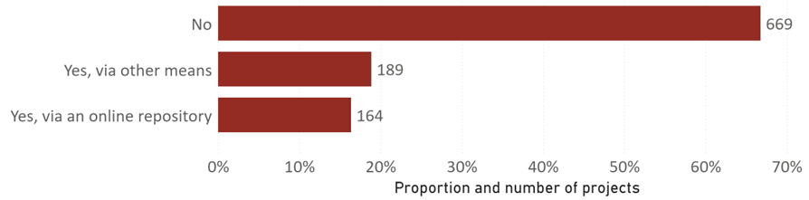

Figure 15. Number and proportion of grantees who report sharing data generated as part of this grant with other researchers, from 980 responses (n = 1,002).

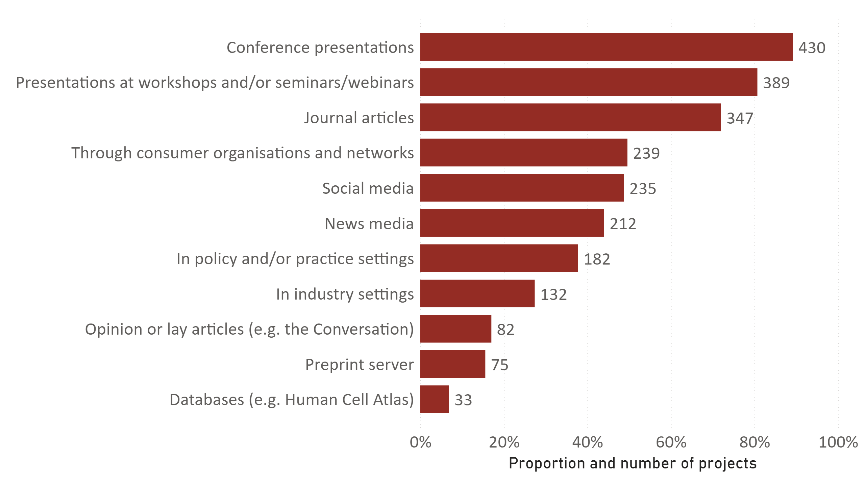

Figure 16. Avenues of research dissemination related to MRFF grants. Survey respondents were able to select more than one answer, and 480 unique respondents made 2,390 selections (2 did not respond) (n = 482). ‘Other’ responses (n = 24) have been coded and included in the figure above.

| Publications | Number of projects | Percentage |
| --- | --- | --- |
| 1 | 109 | 10.9% |
| 2 | 47 | 4.7% |
| 3 | 43 | 42.9% |
| 4 | 27 | 2.7% |
| 5 | 126 | 12.6% |

Table 12. Number of publications per grant, from 352 unique responses. Percentage denominator is total survey respondents (n = 1,002).

|  |
| --- |
| **Case study:** The role of particle size in the pathogenesis of engineered stone-associated accelerated silicosis  Led by Professor Graeme Zosky, University of Tasmania  Funded under the 2020 Silicosis Research grant opportunity  **An example of impactful knowledge dissemination leading to success in ‘new health interventions embedded in health policy and practice’**  This project examined the occupational hazards of working with engineered stone and aimed to identify the types of engineered stones that are most hazardous to lung health and why the dusts generated cause such severe disease. Findings from this project contributed directly to the legislation to ban engineered stone products in July 2024. The project team contributed to the policy setting document, national forums, and disseminated the findings widely through traditional scientific outputs, engagement with industry, and via the media. |

## 3.6 Consumer involvement

|  |  |  |
| --- | --- | --- |
| Performance indicator | Rationale | Measurable outputs |
| Consumer involvement indicators | To capture the level of involvement of relevant consumers throughout the research pipeline, from priority setting, co-design through to dissemination and translation | Number, value and proportion of projects that:   * include consumer organisations as project partners or advisory groups * involve consumers in priority and co-design of study * involve active consumer input in data gathering/analysis * involve active dissemination of results to consumers * deploy strategies to include traditionally underrepresented groups * involve consumers in project governance |

Table 13. Performance indicator relevant to consumer involvement.

|  |
| --- |
| As measured by this section of the survey:  830 MRFF projects (82.7%, total value $2.1 billion) involve consumers in the research. |

The data on consumer involvement shows a very high level of engagement with consumers to inform and progress MRFF-funded research and aligns with MRFF objectives to strengthen ties between research and the people who benefit. The top 4 types of consumer involvement in MRFF projects (Table 14) are consumer organisations as project partners or advisory groups (61.7%), consumers in priority setting and co-design of study (59.1%), consumers in project governance (46.7%) and active consumer input in data gathering and analysis (33%).

| Consumer involvement | Count | % |
| --- | --- | --- |
| Consumer organisations as project partners or advisory groups | 619 | 61.7% |
| Consumers in priority setting and co-design of study | 592 | 59.1% |
| Consumers in project governance | 469 | 46.7% |
| Active consumer input in data gathering/analysis | 331 | 33.0% |
| Active dissemination of results to consumers | 316 | 31.5% |
| Deployed strategies to include traditionally underrepresented groups | 224 | 22.3% |
| None of the above (too early in the project) | 109 | 10.9% |
| None of the above (not relevant/intended for this project) | 45 | 4.5% |
| Not yet applicable | 10 | 1.0% |
| Consumer involvement in project communications | 4 | 0.4% |
| Consumer reference group | 4 | 0.4% |
| Consumers as volunteers | 3 | 0.3% |
| Consumer Investigator | 2 | 0.2% |
| Consumer-led | 2 | 0.2% |
| Other activity not listed above | 8 | 0.8% |

Table 14. Number and proportion of MRFF projects that reported involvement in consumer activities. Nine hundred and eighty-four (984) unique respondents made 2,739 selections (19 did not answer/submitted invalid response) (n = 1,002). ‘Other’ responses (n = 38) have been coded and included in the table above.

## 3.7 Health and healthcare change

| Performance indicator | Rationale | Measurable outputs |
| --- | --- | --- |
| Healthcare change indicators | To capture the outcomes of research, the methods for dissemination, translation and the impacts of research on clinical practice and healthcare systems | Number, value and proportion of projects that:   * engage with partners who can change practice (medical colleges, health system managers) * result in TGA/FDA/EMA or PBAC/MSAC application/ approval * are cited in or change protocol/clinical guidelines * result in new treatments * result in withdrawal of ineffective treatments * result in repurposing of current treatments/technologies * result in better access to health interventions or technologies among priority populations |

Table 15. Performance indicator relevant to health and healthcare change.

|  |
| --- |
| As measured by this section of the survey:  116 completed MRFF projects (80.6% of completed projects, total value $233.1 million) were able to identify healthcare change output or outcome as a result of their research. |

To bring about health and healthcare change, project leaders have demonstrated engagement with clinicians and health system partners, as well as involvement in health professional education (Table 16). There was a lower extent of involvement in clinical quality registries and other avenues for promoting health and healthcare change.

Four fifths (80.6%) of completed MRFF projects have led to measurable health and/or healthcare change (Table 17), with a combined total of 46.5% of completed projects reporting contribution to healthcare policy or clinical guidelines and/or new or changed local standard healthcare procedures or service delivery1F[2]. There was strong indication that new or repurposed treatments, technologies and interventions are making their way to the clinic with a combined 38.9% reporting this as an outcome of their completed project2F[3]. A further 31.3% of completed projects reported that they had progressed their treatment of intervention along the pathway towards full translation, for example the next phase of development, or by gaining regulatory approval3F[4].

When considering population health changes that have occurred as a result of MRFF-funded projects, respondents reported a range of positive impacts on patient and family involvement in their health care, improved health literacy, and reduced mortality and morbidity (Table 18). Observations of reduced modifiable health risk factors and improvements in social determinants of health likely reflect the preventive and public health programs funded by the MRFF. The health and healthcare changes identified by respondents have primarily taken place within and beyond the study population (Figure 17), which is evidence of wider health system and community translation, but must also be treated with caution due to the small sample size.

| Activity | Count | % |
| --- | --- | --- |
| Engaged with relevant clinicians | 120 | 83.3% |
| Engaged with partners who can change practice (e.g. professional colleges or similar professional organisations, policy partners, health system managers) | 98 | 68.1% |
| Made changes to health professional education material to reflect new evidence | 51 | 35.4% |
| Established a Clinical Quality Registry or collaborated with an existing Clinical Quality Registry | 18 | 12.5% |
| None of the above | 8 | 5.6% |
| Developed new resources to inform health and healthcare change | 5 | 3.5% |
| Contributed to Parliamentary Inquiry/Royal commission | 1 | 0.7% |
| Engaged with industry | 1 | 0.7% |
| Not yet applicable | 1 | 0.7% |
| Other activity not listed above | 1 | 0.7% |

Table 16. Number and proportion of project leaders who reported engaging in activities to bring about health and healthcare change, as part of the MRFF project. One hundred and forty-one (141) unique respondents made 308 selections (n = 144, completed projects only. Three (3) did not respond). ‘Other’ responses (n = 14) have been coded and included in the table above.

| Outcome/Output | Count | % |
| --- | --- | --- |
| Contributed to healthcare policy or clinical guidelines | 61 | 42.4% |
| Progressed a new treatment or intervention to the next phase of development (e.g. to clinical trial) | 36 | 25.0% |
| New or changed local standard healthcare procedures or service delivery | 35 | 24.3% |
| Better access to treatments, health interventions or technologies | 32 | 22.2% |
| New treatments or interventions being adopted | 28 | 19.4% |
| Use of evidence by NGOs/end-users/stakeholders (other than those in the healthcare system) to guide patient care | 26 | 18.1% |
| None of the above | 23 | 16.0% |
| New or changed prevention program | 19 | 13.2% |
| Repurposing of current treatments and/or technologies | 16 | 11.1% |
| Completed a cost effectiveness analysis to support the use or discontinuation of an intervention | 13 | 9.0% |
| Improvements in clinical quality indicators (e.g. falls, pressure injuries) | 13 | 9.0% |
| Withdrawal of ineffective treatments or interventions | 12 | 8.3% |
| Improvements in healthcare sustainability (e.g. reduced wastage) | 9 | 6.3% |
| Regulatory (TGA/FDA/EMA) application/approval for determination about a new drug or device | 8 | 5.6% |
| Pharmaceutical Benefits Advisory Committee application/approval | 4 | 2.8% |
| Medical Services Advisory Committee application/approval | 3 | 2.1% |
| Other output or outcome not listed above | 10 | 6.9% |

Table 17. Number and proportion of projects that have led to health and healthcare change, categorised by the type of outcome or output. One hundred and thirty-nine (139) unique respondents made 352 selections (5 did not respond) (n = 144). ‘Other’ responses (n = 15) have been coded and included in the table above.

| Change | Count | % |
| --- | --- | --- |
| None of the above | 57 | 39.6% |
| Improved patient and family involvement in their health care | 35 | 24.3% |
| Health literacy improvements among the community | 29 | 20.1% |
| Patient/consumer-reported outcomes measures improvements | 27 | 18.8% |
| Reduction in modifiable health risk factors | 25 | 17.4% |
| Reduction in mortality and morbidity | 22 | 15.3% |
| Social determinants of health improvements | 14 | 9.7% |
| Improved productivity, such as ability to participate in paid or unpaid occupations | 9 | 6.3% |
| Too early | 4 | 2.8% |
| Improved diagnosis | 2 | 1.4% |
| Beneficial change to health systems | 1 | 0.7% |
| Change in efficacy of therapies | 1 | 0.7% |
| Improved access to care | 1 | 0.7% |
| Improved public awareness of genomic testing | 1 | 0.7% |
| Improved treatment of co-morbidities | 1 | 0.7% |
| Increased consumer and community involvement in research | 1 | 0.7% |
| New knowledge | 1 | 0.7% |
| Not applicable | 1 | 0.7% |
| Other change not listed above | 4 | 2.8% |

Table 18. Reported changes to population health. One hundred and thirty-seven (137) unique respondents made 236 selections (7 did not respond) (n = 144). ‘Other’ responses (n = 18) have been coded and included in the table above.

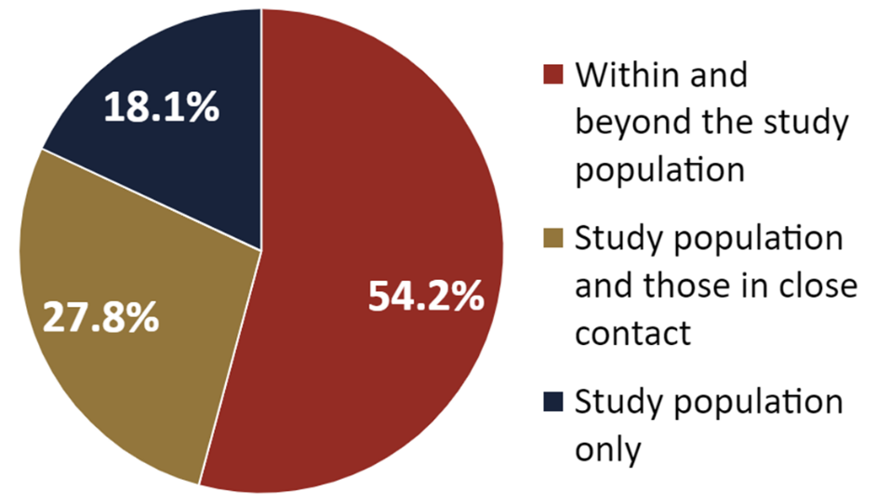

Figure **17**. Reach of the population health changes that have occurred as a result of MRFF-funded projects. The category ‘within and beyond the study population’ refers to changes that have also reached patients or community members who were not involved in the study. The category ‘Study population and those in close contact’ also includes family members who provide care. Note the number of unique respondents to this question was small (n = 72) and some respondents selected more than one option; the figure above considers only the widest population reach reported. The breakdown of all responses (n = 93) is as follows: 39 responses to ‘within and beyond the study population,’ 23 responses to ‘study population and those in close contact’ and 31 responses to ‘study population only.’

## 3.8 Commercialisation

| Performance indicator | Rationale | Measurable outputs |
| --- | --- | --- |
| Projects involving clinical trials | To capture multiple facets relating to clinical trials supported by MRFF funding | * number, value and proportion of projects by conditions, location * patients recruited (projected vs actual) * number of trials completed * number of trials with published outcomes |
| Research workforce indicators | To describe the research workforce supported by MRFF funding, in terms of capacity (e.g. is the MRFF supporting more early-to-mid career, diverse, rural/regional/remote researchers), and capability (e.g. increased training, mentorship, collaboration and access to further funding) | Number and type of research staff employed/supported:   * clinicians, allied health professionals, early-to-mid career, students, women, First Nations, rural/remote   Number of projects that:   * involve staff in research translation/knowledge mobilisation training * involve staff in industry exchange programs * involve international collaborators * involve interdisciplinary collaborators * result in new research collaborations/partnerships * have generated new funding (source and amount) |
| Healthcare change indicators | To capture the outcomes of research, the methods for dissemination, translation and the impacts of research on clinical practice and healthcare systems | Number, value and proportion of projects that:   * engage with partners who can change practice (medical colleges, health system managers) * result in TGA/FDA/EMA or PBAC/MSAC application/ approval * are cited in or change protocol/clinical guidelines * result in new treatments * result in withdrawal of ineffective treatments * result in repurposing of current treatments/technologies * result in better access to health interventions or technologies among priority populations |
| Commercialisation pathway indicators | To capture the level of progress towards the creation of healthcare products, treatments or interventions | Number, value and proportion of projects that:   * include co-funding (financial or in-kind) from industry partners (source and amount) * result in a patent application/approval * result in a product entering Phase 3/4 clinical trials * have led to creation of new start-ups/ companies * result in a product entering the market in Australia or overseas |

Table 19. Performance indicators relevant to commercialisation.

|  |
| --- |
| As measured by this section of the survey:  52 completed MRFF projects (36.1% of completed projects, total project value $166.3 million) achieved outputs and outcomes related to the commercialisation of the research. |

Relative to health and healthcare change, a lower proportion of completed projects reported that they had achieved measurable impacts in commercialisation. Of those reporting commercialisation outcomes (Table 20), most of these reflected earlier stage commercialisation activities such as improving the maturity of a technology or taking steps to disclose and protect intellectual property (IP). It was encouraging to see economic outcomes such as job and company creation and income generation from IP. Text responses under ‘Other’ were disparate (e.g. industry investment, creative commons licensing, open-source code libraries). It is well-recognised that the pathway to market is lengthy, and perhaps unsurprising to see limited evidence of full commercialisation of products funded by the MRFF, which only started disbursing funds in 2017.

| Outcome/Output | Count | % |
| --- | --- | --- |
| None of the above | 85 | 59.0% |
| Measurable improvement in the maturity of a technology, for example an improvement in technology readiness level | 27 | 18.8% |
| Intellectual property disclosure | 18 | 12.5% |
| Patent application/approval | 15 | 10.4% |
| Job creation in industry R&D and commercialisation | 11 | 7.6% |
| Commercialisation agreement with partners to commercialise Project Intellectual Property | 10 | 6.9% |
| Generated income from intellectual property | 7 | 4.9% |
| New start-ups/companies created | 7 | 4.9% |
| Product entering the market in Australia or overseas | 6 | 4.2% |
| Product entering Phase 3/4 clinical trials | 5 | 3.5% |
| Decision not to proceed with development of a product | 3 | 2.1% |
| Industry investment | 1 | 0.7% |
| Other output or outcome not listed above | 6 | 4.2% |

Table 20. Commercialisation-related outputs and outcomes. One hundred and thirty-seven (137) unique respondents made 201 selections (7 did not respond) (n = 144). ‘Other’ responses (n = 7) have been coded and included in the table above.

|  |
| --- |
| **Case study:** Delivering Research, Impact and Health Outcomes in Digital Health  Led by ANDHealth Limited  Funded by the 2020 Early Stage Translation and Commercialisation Support grant opportunity  **An example of success in ‘increased commercialisation of health research outcomes’ and ‘new health technologies are embedded in health policy and practice.’**  This program supported a cohort of Australian small to medium enterprises to commercialise their digital health technologies. Companies supported through the ANDHealth+ ESTAC program have demonstrated research and economic outcomes including: creating 108.8 new jobs, serving 1,382,276 patients, commencing 38 clinical studies and trials, 44 commercial pilots, and leveraging the MRFF investment through raising an additional $50.2 million of dilutive and non-dilutive funding since commencing involvement in the program.  In addition, a recent economic impact assessment of ANDHealth+ program determined that there is:   * $6.7 of revenue earnt for every $1 of ANDHealth+ Investment * $4.2 of gross economic value (driven by employment) for every $1 of ANDHealth+ Investment* * $19.7 of capital raised for every $1 of ANDHealth+ Investment * 87 patients impacted for every $1,000 of ANDHealth+ Investment * 56 new jobs created for every $1 million of ANDHealth+ Investment * 9 clinical trials commenced for every $1 million of ANDHealth+ Investment * 4.1 international market launches per $1 million of ANDHealth+ investment   *Calculated through applying average gross economic value produced by a Medtech job to the total number of ANDHealth+ jobs created.  Two examples of successful technology implementation delivered by companies supported by the ANDHealth+ program include:  **WeGuide** has developed a regulatory approved, flexible platform that quickly and securely creates digital health solutions for healthcare providers, clinical trial sponsors and medical research institutes to improve patient engagement and outcomes. Supporting patients on long waitlists with evidence-based support and supporting the clinical workforce is especially important in mental health. WeGuide has collaborated with the Centre for Clinical Interventions in WA (CCI) to support at-risk patients with eating disorders on long waitlists, introducing a self-guided app used by dozens of patients during the pilot phase. This initiative enhanced patient education and engagement with 50% of users reporting feeling more supported and better prepared for treatment and resulting in a 25% reduction in calls to clinicians. CCI also saved over $250,000 AUD in development costs. WeGuide is now used across Australia by over 20 clinical research ocase strganisations, hospitals and health organisations and has impacted over 250,000 patients through its platform.  **Perx Health** has developed a digital care management platform that increases adherence, improves health outcomes, and reduces health-related costs for Australians. Now deployed nationwide across health insurance, workers' compensation, and healthcare clinics, Perx has supported tens of thousands of individuals in managing treatment adherence. Perx supported medication adherence among patients with chronic conditions through the Sydney Local Health district and published the randomised control trial results in the British Medical Journal with the University of Sydney. The results showed a 0.7-point improvement in HbA1c, 30% better glycaemic control, and 16% improved cholesterol control, with over 90% adherence to tasks. Additionally, the platform has improved return-to-work outcomes by reducing claim durations by 57 days and delivering a positive return on investment of 8x. With usage across more than 27 different conditions and an average satisfaction score exceeding 90%, Perx delivers significant impact on patient engagement and health outcomes for over 13,000 Australians in public health, private health, and personal injury sectors. |

# Overall and relative indicators of performance

The distribution of performance indicator results (Figure 18) show that collectively, MRFF-funded projects are at a relatively early stage in their project life cycle. Indicators that emerge early on in a research project, such as those related to employing and training staff or involving consumers in advisory structures, were ubiquitous. The indicators relating to priority populations and emerging issues are also prominent, driven by the MRFF’s mission to direct research activity to areas of unmet need.

Over half of MRFF projects involve clinical trials, and 58.7% of this subset include trials in rural, regional and remote sites. A very wide range of health conditions are addressed through clinical trials, with the top three being cardiovascular disease, cancer and mental health. Notably, 45.7% of MRFF-funded trials are described as phase 3 or 4.

The indicators that depend on the availability of results – such as knowledge gain, healthcare change, and commercialisation pathway indicators – show proportionately less progress, as is expected given that 85.6% of the projects represented in these survey results have not yet concluded.

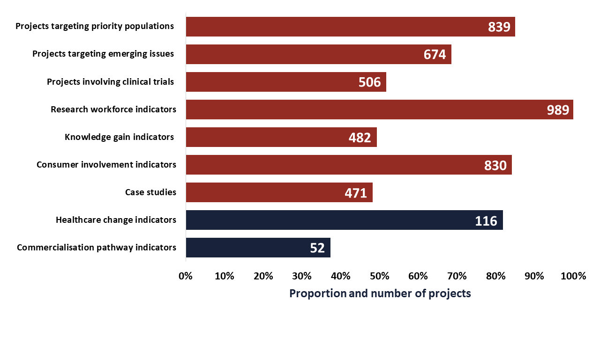

Figure 18. Number and proportion of MRFF-funded projects that have demonstrated progress against each of the performance indicators. For healthcare change indicators and commercialisation pathway indicators n = 144, for all others n = 1,002. Case studies have been included in the figure above to quantify and compare the full set of performance indicators, though this indicator is primarily for qualitative analysis.

When applying the performance indicator data to the MRFF measures of success, the results show comparatively more progress in measures associated with the characteristics or conduct of a project – for example, the focus of a project on an area of unmet need or the inclusion of a clinical trial is generally known on commencement of the project. There has been great progress in increasing the research community’s capacity for translational research. The longer-term measures of impact concerning the uptake of research into clinical practice or the commercialisation of new products have shown comparatively less progress, though it is encouraging to see that a reasonable proportion of completed projects demonstrate impact on health and health care.

# Conclusions

This is the first survey to capture data on the MRFF performance indicators. As many projects (85.6%) are yet to be completed, it will be some time before the impact of the MRFF program on health, health care and commercialisation will be fully realised. Nevertheless, significant progress was observed in performance indicators related to consumer involvement, the research workforce and addressing unmet needs.

Future surveys will consider the lessons learned from this survey, including refining of indicators and better ways to capture data from larger-scale research programs.

Appendix 1: Survey instrument

| Question(s) | Theme | Relevance to performance indicators |
| --- | --- | --- |
| **Question 0** – Chief Investigator A name  **Question 1** – What is your ORCID iD (if you have one)? | Chief Investigator information |  |
| **Question 2** – Is this project supported by the MRFF grant now complete? | Project completion | Only completed projects are asked questions relating to health and healthcare change indicators and commercialisation indicators |
| **Question 3** – Did/Does your MRFF grant focus on any of the following priority population topics? | Priority populations | Projects targeting priority populations |
| **Question 4** – Did/Does your MRFF grant address an unmet need, emerging challenge or topic arising from parliamentary inquiries, emergencies or consumer-led mechanisms? | Emerging issues | Projects targeting emerging issues |
| **Question 5** – Did/Does your MRFF grant include a clinical trial?  **Question 6** – How many clinical trials were/are supported by your MRFF grant?  **Question 7** – Please select registry/registries for your clinical trials.  **Question 8** – What kind of clinical trial?  **Question 9** – What health conditions did/does your clinical trial target?  **Question 10** – Did/Does your clinical trial involve sites in the following location categories as defined by the Modified Monash Model 2019?  **Question 11** – What phase was/is your clinical trial at?  **Question 12** – As at 21 March 2024 approximately how many people were formally enrolled in your clinical trial (if your trial is part of an international collaboration, indicate number of patients enrolled in the Australian arm(s) only)?  **Question 13** – In total, how many patients were/are planned for enrolment in your clinical trial (if your trial is part of an international collaboration, indicate number of patients planned for the Australian arm(s) only)? | Clinical trials | Projects involving clinical trials |
| **Question 14** – How many people, regardless of FTE, have/have had their research roles paid for by this MRFF grant during the funding period?  **Question 15** – What was/is the approximate total FTE years, funded by this MRFF grant during the funding period?  **Question 16** – Of the people funded by this MRFF grant within the funding period, regardless of FTE, how many are [categories listed]  **Question 17** – Since commencement of this MRFF grant, has your project involved or led to the following workforce capacity or capability building activities, outputs or outcomes [categories listed] | Research capacity and capability building | Research workforce indicators |
| **Question 18 and 19** – Has this MRFF grant involved co-funding (including in-kind funding)?  **Question 20 and 21** – Have the results of this MRFF grant generated NEW funding (including in-kind funding)? | Co-contributions to MRFF-funded projects | Research workforce indicators  Commercialisation pathway indicators |
| **Question 22** – Have you shared data generated as part of this MRFF grant with other researchers?  **Question 23** – Have you disseminated research related to this MRFF grant?  **Question 24** – Through what avenues have you disseminated research related to the MRFF grant?  **Question 25** – Please provide the Digital Object Identifier (DOI) of any publications supported by this MRFF grant. | Knowledge gain and dissemination | Knowledge gain indicators |
| **Question 26** – Has your MRFF project involved or included any of the following consumer activities? | Consumer involvement | Consumer involvement indicators |
| **Question 27** – Has your team done any of the following activities towards effecting health and healthcare change, as part of this project?  **Question 28** – Has this MRFF grant resulted in or contributed to any of the following outputs or outcomes towards effecting health and healthcare change?  **Question 29** – For the population of people whose health your MRFF grant aims to improve, have any of these changes occurred?  **Question 30** – Where have these changes been observed? | Health and healthcare change | Healthcare change indicators |
| **Question 31** – Has this MRFF grant resulted in the following outputs or outcomes related to commercialisation?  **Question 32** – If you have applied for any patents connected to work supported by this MRFF grant, please provide patent application number and details. | Commercialisation | Projects involving clinical trials  Research workforce indicators  Healthcare change indicators  Commercialisation pathway indicators |
| **Question 33 –** Have you done any of the following? | Engaging with the MRFF | Not applicable |
| **Question 34** – Are there any impact stories you would like to share about your research? | Case studies | Case studies |

Appendix 2: Additional figures and tables

**Priority populations (**section 3.1.2**)**

| Priority population | Count |
| --- | --- |
| People with rare or currently untreatable conditions | 309 |
| Older people experiencing diseases of ageing | 242 |
| Remote and rural communities | 228 |
| Youth | 168 |
| First Nations health | 160 |
| None of the above | 156 |
| People with a disability (including people with intellectual disability) | 135 |
| Individuals from CALD communities | 88 |
| Chronic conditions | 60 |
| Children and infants | 28 |
| LGBTIQ+ people | 28 |
| People who are pregnant | 19 |
| Cancer | 12 |
| Low SES | 11 |
| Mental Illness | 10 |
| Women | 10 |
| Neurological | 9 |
| Cardiovascular | 7 |
| Unspecified chronic conditions | 6 |
| Low- and Middle- Income Countries | 5 |
| Mothers | 5 |
| Multiple Priority Populations | 5 |
| Men | 3 |
| Respiratory | 3 |
| Endometriosis | 2 |
| Older people | 2 |
| Pain | 2 |
| Aged care residents | 1 |
| Carers | 1 |
| Chronic Kidney Disease | 1 |
| COVID-19 | 1 |
| Diabetes | 1 |
| Disability | 1 |
| Drug Users | 1 |
| Immunocompromised | 1 |
| Intellectual Disability | 1 |
| Musculoskeletal | 1 |
| Obesity | 1 |
| Other priority population not listed above | 18 |

Table 21. Reported alignment with the priority populations. Survey respondents were able to select more than one answer, and 995 unique respondents made 1,670 selections (n = 1,002). The top 10 responses are also found in Figure 4. ‘Other’ responses (n = 158) have been coded and included in the figure above.

**Emerging issues (**section 3.1.2**)**

| Emerging challenge | Count |
| --- | --- |
| None of the above | 309 |
| Mental illness | 146 |
| Cancers with low survival rates | 128 |
| Aged care | 112 |
| COVID-19 | 67 |
| Obesity | 67 |
| Reproductive healthcare | 61 |
| Tobacco / nicotine related substances (includes E-cigarettes and personal vaporises) | 24 |
| Autism | 22 |
| Stillbirth | 19 |
| Hearing health | 17 |
| Child and Infant Health | 16 |
| Poverty | 16 |
| Sleep disorders | 16 |
| Stroke and Cardiovascular Disease | 14 |
| Concussions and repeated head trauma | 13 |
| Antimicrobial Resistance | 12 |
| Dementia | 12 |
| Attention Deficit Hyperactivity Disorder | 11 |
| Bushfires | 10 |
| Cancer | 10 |
| Infectious Diseases | 10 |
| Genetics and Genomics | 9 |
| Allergy and anaphylaxis | 8 |
| Childhood rheumatic diseases | 8 |
| Dental health | 8 |
| First Nations Health | 8 |
| Health Services Research | 8 |
| Diabetes | 7 |
| Mental Health | 7 |
| Pain | 7 |
| Disability and NDIS | 6 |
| Medical cannabis | 6 |
| Musculoskeletal Conditions | 6 |
| Neurological Conditions | 5 |
| Vision Impairment | 5 |
| Age-related disease | 4 |
| Chronic Conditions | 4 |
| Climate and Health | 4 |
| Emergency Care | 4 |
| Health Equity | 4 |
| Intensive/critical care | 4 |
| Kidney Disease | 4 |
| Maternal health | 4 |
| Neurodegenerative disease | 4 |
| Rare Diseases | 4 |
| Silicosis | 4 |
| Alcohol and drug use | 3 |
| Artificial Intelligence | 3 |
| Childhood Dementia | 3 |
| ELSI | 3 |
| Endometriosis | 3 |
| Epilepsy | 3 |
| Liver Disease | 3 |
| N/A | 3 |
| Respiratory Conditions | 3 |
| Rural, Regional and Remote Health | 3 |
| Tuberculosis | 3 |
| Digital Health | 2 |
| Disability | 2 |
| Falls | 2 |
| Palliative Care | 2 |
| Physical Inactivity | 2 |
| Primary Care | 2 |
| Transplants | 2 |
| Biotoxin-related illnesses | 1 |
| Cardiovascular disease | 1 |
| Children and Infants | 1 |
| Consumer Involvement | 1 |
| Craniofacial Defects | 1 |
| Cultural Safety | 1 |
| Flood Recovery | 1 |
| Health Literacy | 1 |
| Healthcare quality | 1 |
| Healthcare-associated Injury | 1 |
| High Risk Surgical Patients | 1 |
| Hospital Admissions | 1 |
| Hypertension | 1 |
| Intellectual Disability | 1 |
| Maternal and Infant Health | 1 |
| Perioperative Assessment and Management | 1 |
| Pharmacogenomics | 1 |
| Plasma Treatment | 1 |
| Preventive Health | 1 |
| Speech, Language, Communication Disorders | 1 |
| Stem Cell Therapies | 1 |
| Surgery Complications | 1 |
| Other emerging challenge not listed above | 2 |

Table 22. Reported alignment with unmet needs, emerging challenges or topics arising from parliamentary inquiries, emergencies or consumer-led mechanisms. The top 10 responses are also found at Figure 5. Survey respondents were able to select more than one answer, and 983 unique respondents made 1,285 selections (n = 1,002). ‘Other’ responses (n = 217) have been coded and included in the table above.

Health.gov.au

All information in this publication is correct as of December 2024

1. From the 2022 MRFF 2022 National Critical Research Infrastructure Grant Opportunity:

   “Unmet medical need arises where individuals are living with a serious health condition where there are limited satisfactory options for prevention, diagnosis or treatment to support improved health outcomes.”
2. The number of unique respondents who reported ‘Contributed to healthcare policy or clinical guidelines’ or ‘New or changed local standard healthcare procedures or service delivery’ in Table 17.
3. The number of unique respondents who reported ‘Better access to treatments, health interventions or technologies’ or ‘New treatments or interventions being adopted’ or ‘Repurposing of current treatments and/or technologies’ in Table 17.
4. The number of unique respondents who reported ‘Progressed a new treatment or intervention to the next phase of development (e.g. to clinical trial)’ or ‘Regulatory (TGA/FDA/EMA) application/approval for determination about a new drug or device’ or ‘Pharmaceutical Benefits Advisory Committee application/approval’ or ‘Medical Services Advisory Committee application/approval’ in Table 17.