Service and Support Portal User Guide - Part 1: Administrator Functions
Contents
1 Background and overview of the Service and Support Portal 3
1.1 Purpose of the Guide 3
1.2 Introduction to using the Service and Support Portal 3
1.3 Service and Support Portal Access 3
1.4 Staff roles in the Service and Support Portal 4
1.4.1 Homepage views by role type 5
2 The Administrator Role 7
2.1 Creating service delivery outlets 8
2.1.1 Creating or adding a new outlet 8
2.1.2 Viewing outlets 11
2.1.3 Editing the Organisation philosophy and Specialised Services 12
2.1.4 Maximum Exit Amount and other prices 13
2.1.5 Adding Specialised Services 13
2.1.6 Diverse Needs Specialisations 14
2.2 Service Items 24
2.2.1 Adding a service item 25
2.2.2 Editing a service item 28
2.2.3 Home Care Package attributes 36
2.2.4 Adding pricing information to a Home Care Package service item or outlet 41
2.2.5 Additional home care pricing features 47
2.2.6 Editing service sub-types 48
2.2.7 Add a room type 55
2.2.8 Edit room details 59
2.2.9 Change room status 60
2.2.10 Delete a room 62
2.2.11 Transferring service items 62
2.2.12 Reviewing the Service Transfer Log 67
2.2.13 Transferring clients between service items 68
2.2.14 Reviewing the Client Transfer Log 71
2.2.15 Activating/deactivating a service item 73
2.3 Maintaining service delivery outlets 75
2.3.1 Activating an outlet 75
2.3.2 Deactivating an outlet 77
2.3.3 Removing an outlet 78
2.3.4 Editing outlet details 79
2.4 Tasks and notifications 81
2.4.1 Viewing tasks and notifications 81
2.4.2 Managing task and notification preferences 84
2.5 Creating and maintaining staff accounts 87
2.5.1 Viewing staff accounts 87
2.5.2 Adding new staff accounts, allocating roles and outlets 87
2.5.3 Editing a staff account 90
2.5.4 Deactivating staff accounts 92
2.5.5 Removing staff accounts 94
2.6 Infection Prevention Control (IPC) Lead Role 96
2.7 Entering Covid vaccination details 99
2.8 Generating reports and accessing forms 102
2.8.1 Generating reports 102
2.8.2 Viewing reports 104
2.8.3 Accessing forms 105

Background and overview of the Service and Support Portal

Purpose of the Guide
The My Aged Care Service and Support Portal User Guide – Part One (User Guide) outlines how Commonwealth-funded service providers (providers) set up and maintain the My Aged Care Service and Support Portal (Portal) for your organisation.
The User Guide is split into two parts as follows:
- Part One (this document) provides an overview of the Portal and describes the functions an Administrator can perform.
- Part Two provides an overview of the Portal and describes the functions that a Team Leader or Staff Member can perform.
This guide does not cover:
- Detailed instructions on how to set up organisations in the Relationship Authorisation Manager, which can be found on the RAM website.
- Detailed instructions on how portal users obtain a myID (which can be found in the user guide Logging in to the Aged Care Systems.
! This symbol is used to highlight important information.

Introduction to using the Service and Support Portal
The Service and Support Portal is used to:
- Manage information about the services you provide.
- Manage referrals for service(s) issued by My Aged Care contact centre staff or aged care needs assessors (assessors) by accepting, rejecting, or placing on a waitlist.
- Update client records with information about services being delivered.
- Request that an assessor undertakes a Support Plan Review for a client.
- Report Serious Incident Response Scheme (SIRS) Priority 1 and Priority 2 incidents in residential aged care.
- Generate reports.
- Report on COVID-19 outbreaks, order Personal Protective Equipment, and manage COVID-19 vaccination data.
- Manage residential client classifications, reassessments, reconsiderations, and palliative care administration.
- Apply to have claims to deliver specialised care to diverse needs groups verified.

Service and Support Portal Access
To access the Service and Support portal, each staff member must have a My Aged Care portal user account linked to a supported third-party authentication service.
For more information regarding setting up users and logging into the system please refer to Logging in to the Aged Care Systems.

Staff roles in the Service and Support Portal
The person nominated as the Organisation Administrator needs to be the first person from your organisation to log in to the Portal. Refer to Logging in to the Aged Care Systems for more information.
The Organisation Administrator will be responsible for assigning roles to other staff; this can include assigning other staff the administrator role to help set up and maintain information about your organisation in the Portal. Roles should be assigned in accordance with the duties the person performs within your organisation.
! If you are assigned more than one role, this access will apply across all outlets you have been granted access to in the Service and Support Portal.
The tables on the following page outline the functions for each role within the Portal.
It includes both client focused and organisation focused tasks.
Client Focussed Key Functions | Organisation Administrator | Outlet Administrator | Team Leader | Staff Member
Search for a client record  (for referred clients) |  |  | ü | ü
View client records  (for referred clients) |  |  | ü | ü
View referrals |  |  | ü | ü
Accept, reject and revoke referrals |  |  | ü
View tasks and notifications | ü | ü | ü | ü
Manage organisation preferences  for tasks and notifications | ü
Manage outlet preferences for  tasks and notifications | ü | ü
View My Aged Care interactions | ü | ü | ü | ü
Add client service information |  |  | ü | ü
Transfer clients between services | ü
Submit notifications under the  Serious Incident Response Scheme | ü | ü | ü | ü

Organisation Focussed Key Functions | Organisation Administrator | Outlet Administrator
Request change to contractual information | ü | ü
Add outlets | ü
Manage outlets: edit, activate, deactivate, remove | ü | ü
Manage services: add, edit, activate, transfer  (Organisation Administrators only) or deactivate | ü | ü
Manage staff (organisation level): add, edit, deactivate, remove | ü
Manage staff (outlet level): add, edit, deactivate, remove | ü | ü
Enter COVID-19 staff vaccination details | ü | ü
Add, edit and delete IPC Lead contacts | ü | ü

Homepage views by role type

Administrator homepage
Administrators at an Organisation level can view and manage information for the entire organisation in the Service and Support Portal. Administrators for one or more outlet(s) in the organisation (Outlet level) will only be able to view and manage information for the outlet(s) they have been assigned.
If you log in to the Service and Support Portal as an Administrator, you will see Tasks and notifications, My Aged Care interactions, Reports and Documents, Outlet administration, SIRS Notice, Government Provider Management System and Staff administration tiles on your homepage.
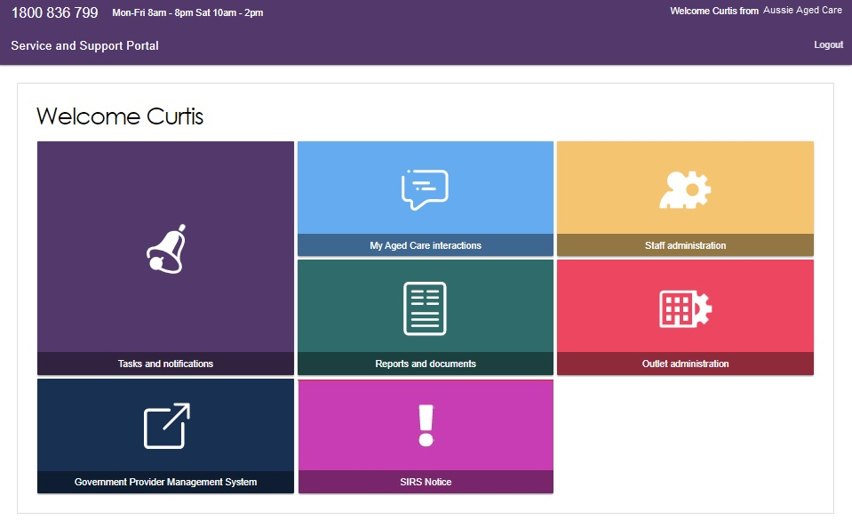

Team Leader homepage
People assigned the Team Leader role in the Service and Support Portal have the same functions as the Staff Member role but are also responsible for managing referrals for service(s).
If you log in to the Service and Support Portal as a Team Leader, you will see Service referrals, Find a client, Tasks and notifications, My Aged Care interactions, Reports and Documents, Retrieve a referral code, SIRS Notice, and Government Provider Management System tiles on your homepage.
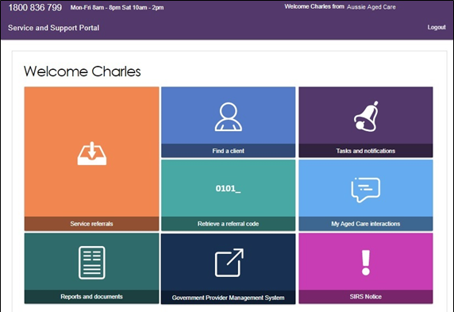
The Serious Incident Report tile will display on your homepage if you had access to the Service and Support Portal as of 1 April 2021 for Residential Aged Care. If you do not have access to the tile, your Administrator for Service and Support Portal will need to add the SIRS role to your staff profile.
For information on how to add the serious incident report tile for staff members please refer to the guide on How to use the Serious Incident Response Scheme Portal.

Staff Member homepage
People assigned the Staff Member role in the Service and Support Portal are responsible for adding and updating client service information in the client record.
If you log in to the Service and Support Portal as a Staff Member, you will see Service referrals, Find a client, Review requests, Tasks and notifications, My Aged Care interactions, Government Provider Management System and Reports and documents.
The Serious Incident Report tile will display on your homepage if you had access to the Service and Support Portal as of 1 April 2021 for residential aged care service providers. If you do not have access to the tile, your Administrator for the Portal will need to add the SIRS Notice role to your staff profile.
For information on how to add the SIRS Notice tile for staff members please refer to the guide on:
- How to access and use the Service and Support Portal for Serious Incident Response Scheme – Residential Aged Care services
- How to access and use the Service and Support Portal for Serious Incident Response Scheme (SIRS) - In-Home Care
If you have been assigned the SIRS role by your Organisation Administrator, you will then see a SIRS Notice tile.
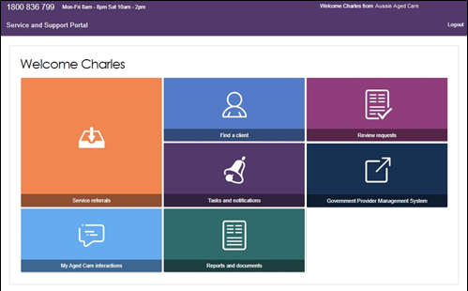

Homepage for users assigned multiple roles
If you log in to the Service and Support Portal as a user with Administrator, Team Leader and/or Staff Member roles, you will see the functions for all your roles on the homepage.
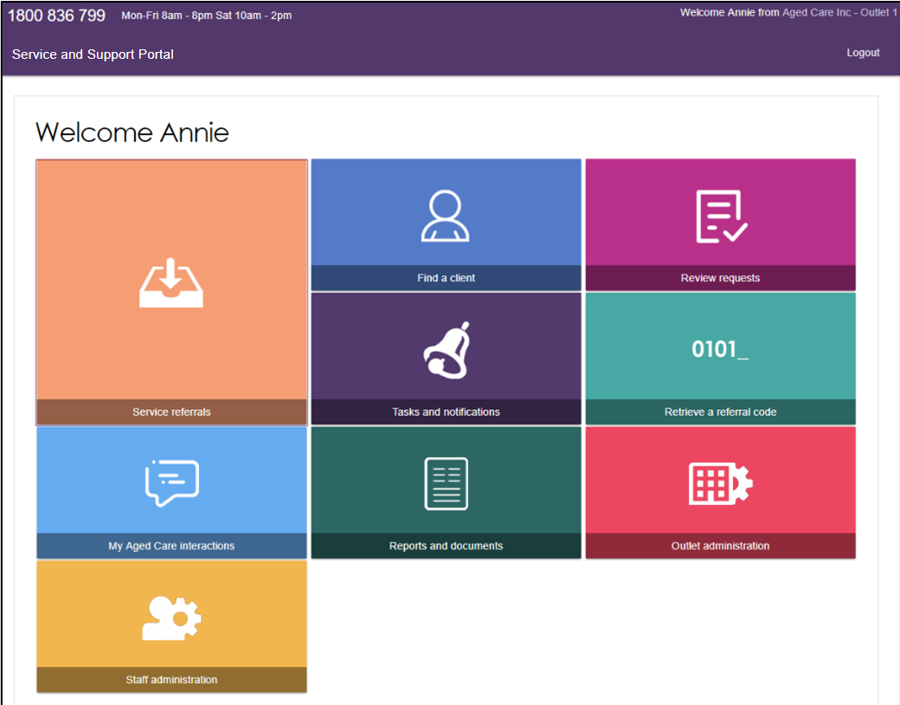

The Administrator Role
Service information is publicly displayed in the My Aged Care service finder (service finder) on the My Aged Care website.
My Aged Care contact centre staff and assessors use this service information to send referrals. Potential My Aged Care recipients and their support network use this service information to research and access services.
It is the Administrator’s responsibility to set up and maintain this information to ensure accurate referrals.

Creating service delivery outlets
Administrators will need to set up at least one outlet in the Service and Support Portal before they can add their organisations service information such as service items and service sub-types. Administrators can choose how to set up service(s) in the Portal: either all under one outlet or under multiple outlets
Each outlet that you set up can have a different staff, service information, locations and contact details recorded.
Refer to the user guide on Create service delivery outlets and add service information for further information about outlets.

Creating or adding a new outlet
Administrators need to set up outlets in the Portal before service information can be added. When you create an outlet, the status is set to Inactive by default. You must activate the outlet and create service items in an outlet before it can be made operational.
- From the Outlet administration page, select ADD NEW OUTLET.
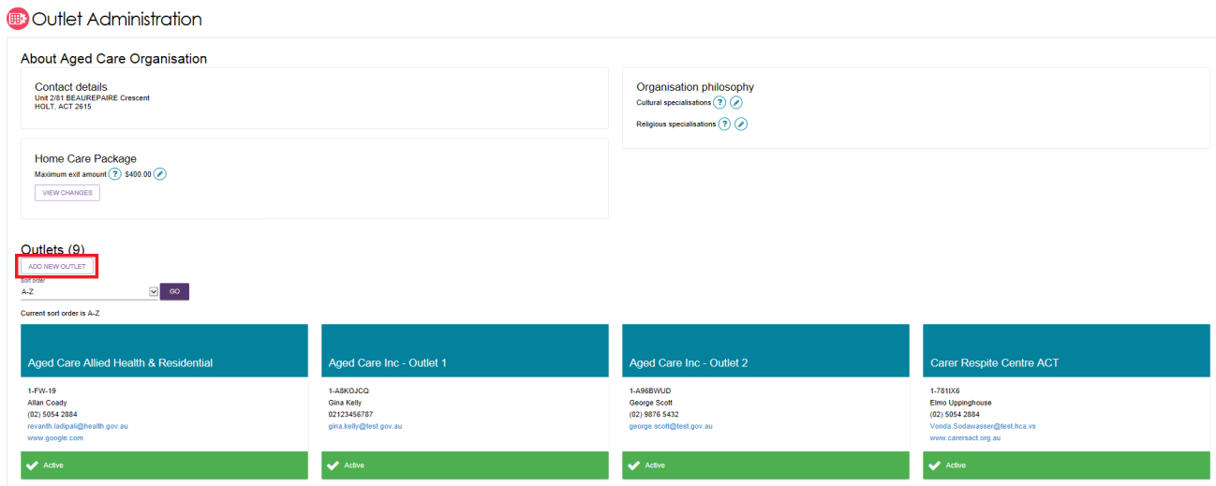
- Enter outlet details. To add an outlet address, select ADD OUTLET ADDRESS.
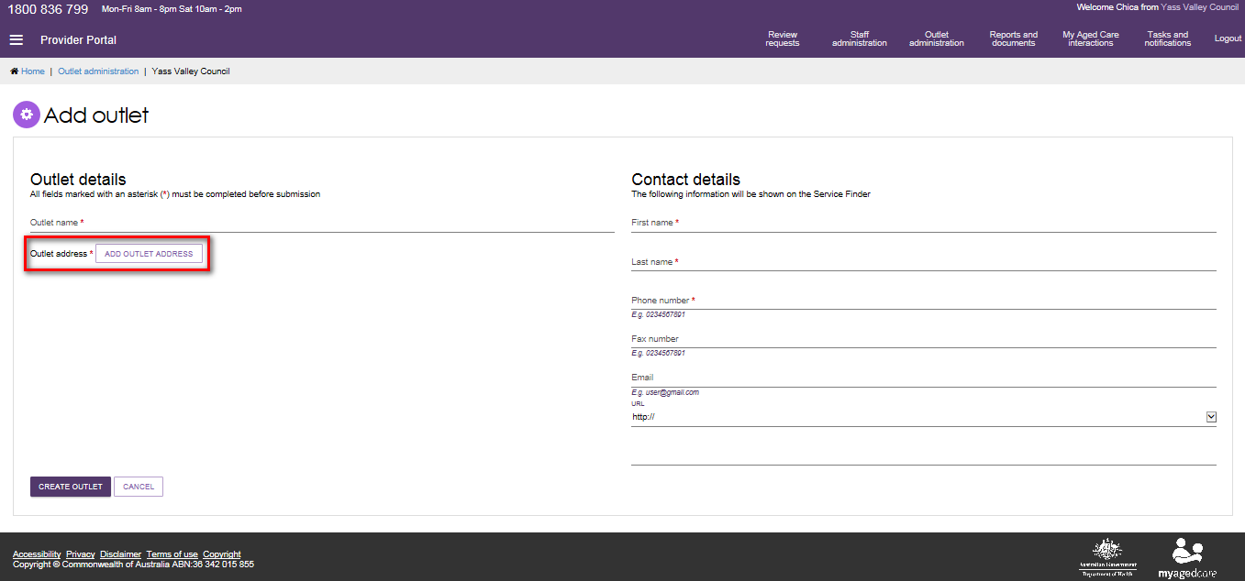
- Fill out your address details, select VALIDATE THIS ADDRESS.
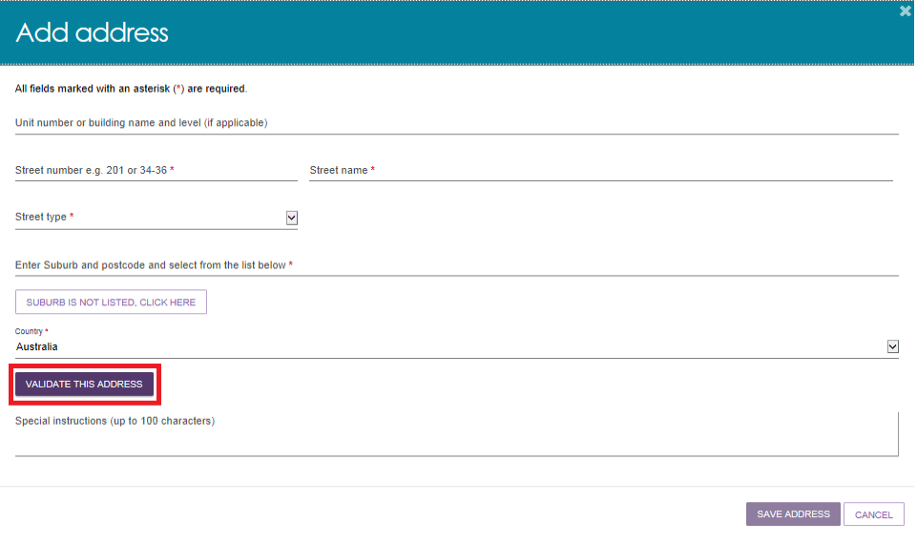
- Confirm that the address is displayed correctly, then select SAVE ADDRESS. If the address has been entered correctly but is not returned as a result, select Not found use entered address anyway.
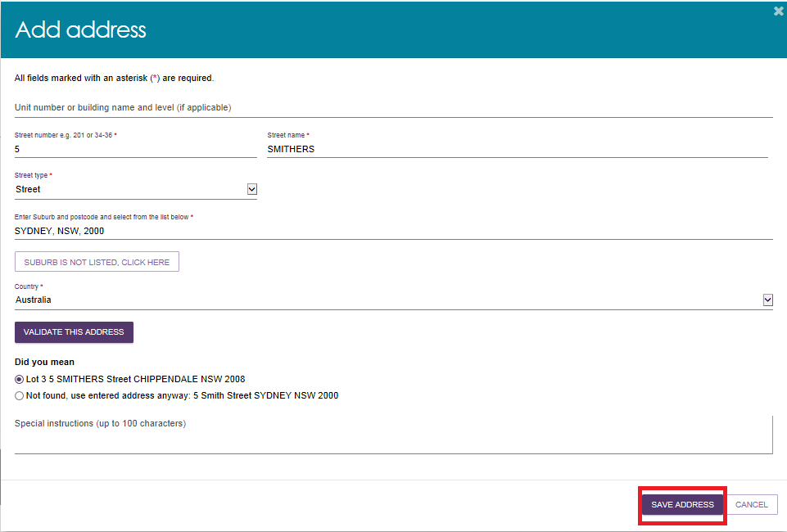
- Complete the remaining fields. Select CREATE OUTLET in order to save the record and create the outlet.
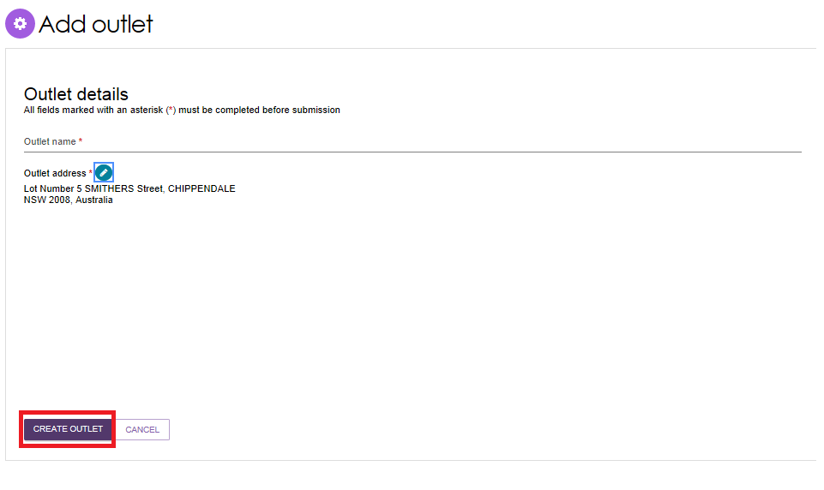
The outlet has now been created and the details for the outlet have been saved. Repeat this process for remaining outlets, if required.

Viewing outlets
To view outlets, follow the procedure below.
- Select Outlet administration from the homepage.
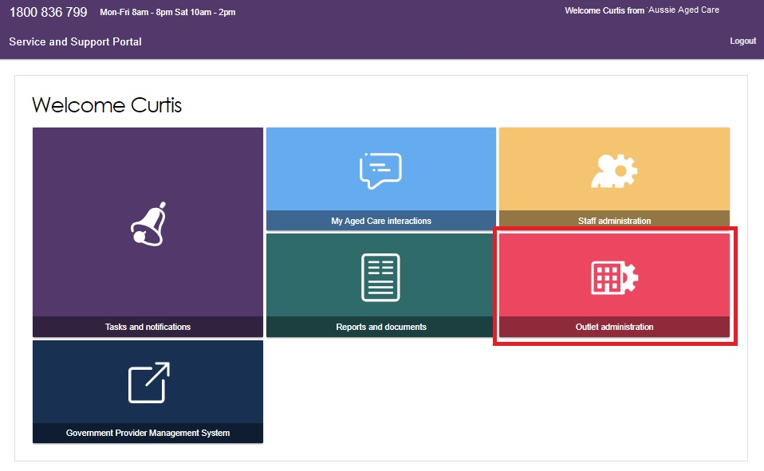
- You can view all of the outlets for your organisation.
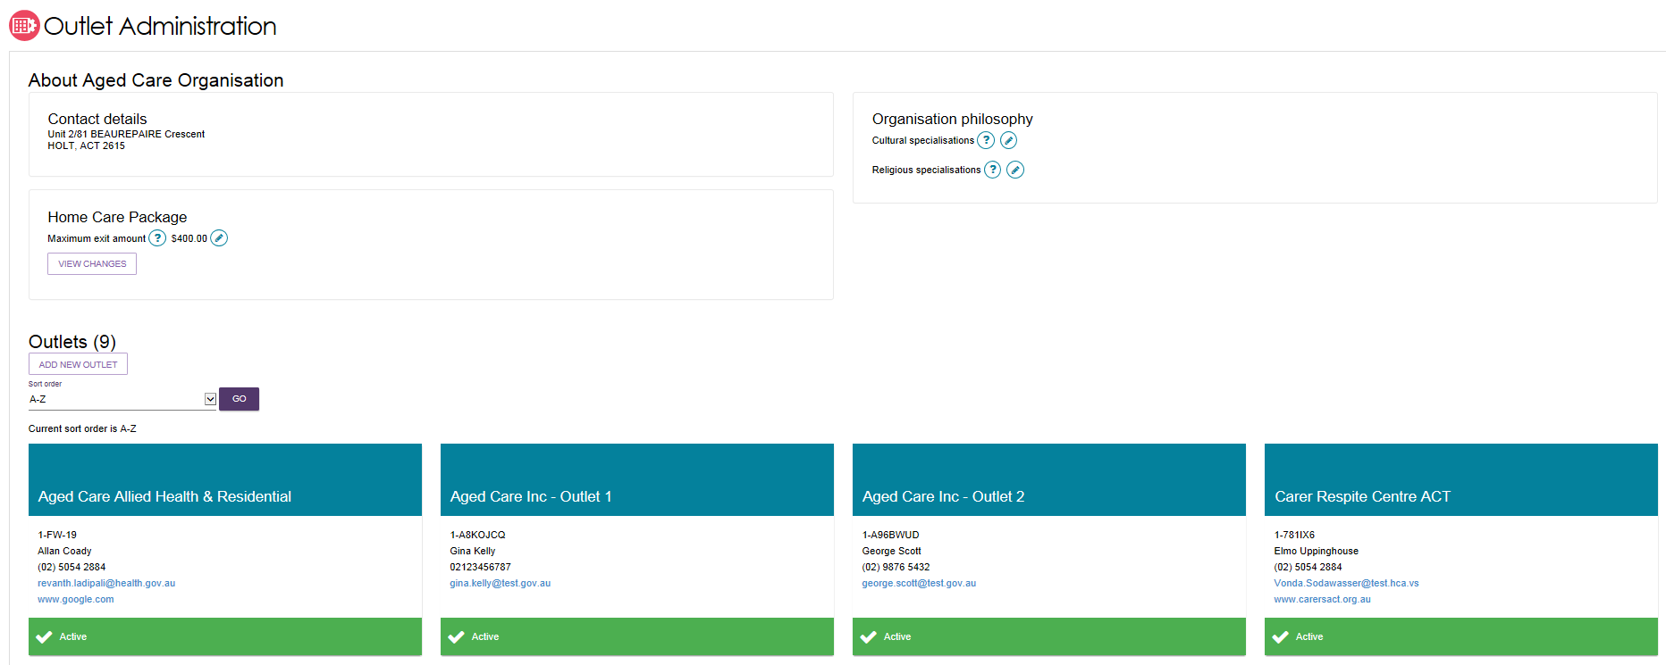

Editing the Organisation philosophy and Specialised Services
Organisation philosophy attributes and other specialisations will be shown in the service finder results and displayed as part of the detailed information for each of your services. These attributes and specialisations are not verified by the Department.
- Add/edit cultural specialisations.
Select the Edit icon  next to Cultural specialisations to select those groups that you have a focus on providing culturally specific care to.
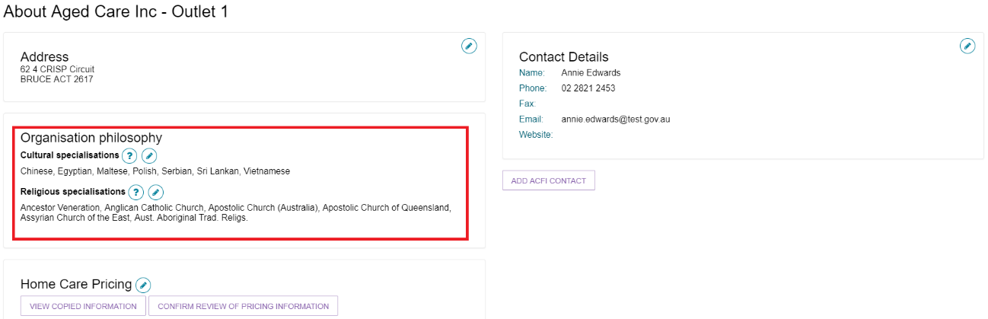
You can choose to apply this to all services in your organisation by using the SAVE AND APPLY TO ALL OUTLETS option or save as a default for all new services added by using the SAVE AND DONT APPLY TO ALL OUTLETS option.
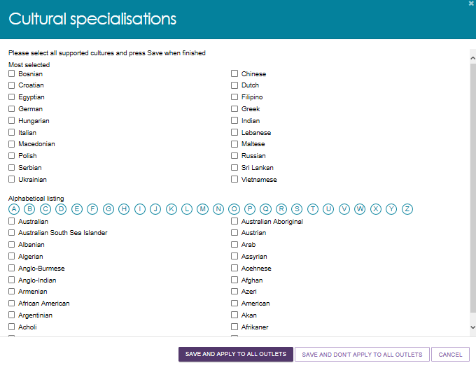
- Add/edit religious specialisations.
Select the edit icon next to Religious specialisations to indicate if you have a focus on delivering care that aligns with particular religious needs or values.
You can choose to apply this to all current services in your organisation by using the SAVE AND APPLY TO ALL OUTLETS option or save as a default for all new services added by using the SAVE AND DONT APPLY TO ALL OUTLETS option.
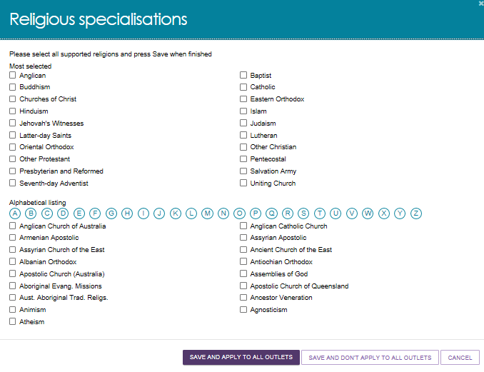

Maximum Exit Amount and other prices
From 1 January 2023, the Australian Government removed a provider’s ability to charge an exit amount, even if the care recipient previously agreed. Providers are also no longer able to charge a separate fee when engaging third party service; instead, service charges must now be all inclusive. These changes ensure that more funds are available to meet the direct care needs of My Aged Care recipients.
This means that:
- Exit amounts cannot be seen or edited in the My Aged Care Service and Support portal, and the Assessor Portal service finder.
- Providers cannot charge separately for third party services. Third-party related charges cannot be seen or edited in the My Aged Care Service and Support portal, and the Assessor Portal service finder.
- For newly generated Home Care Pricing Schedule Reports after March 2023, none of the capped prices (above) will appear. Old (historical) reports that are generated after March 2023 will continue to display the exit amount and the separate cost when you want to receive services from a different provider value.
For more information, visit the following Departmental websites:
- Pricing for Home Care Packages (HCPs)
- Third Party services for HCPs
- Exiting People from your Home Care Service.

Adding Specialised Services
You can indicate that a service or outlet offers the following Specialised Services. You should only select those with specific measures in place that demonstrate your specialised service offering, however they are not verified.
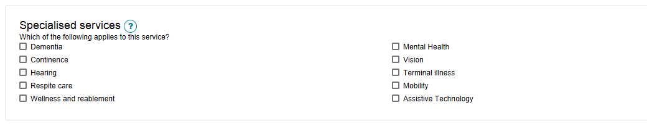

Diverse Needs Specialisations
All aged care services must provide care in which each consumer is treated with dignity and respect, with their identity, culture and diversity valued. While all service providers are required to deliver these inclusive care services, there are some that deliver specialised care for particular groups. Outlets with specific knowledge, expertise, and services, can apply to have their diverse needs specialisation verified. This helps older Australians with diverse aged care needs choose the care that best suits them.
Specialisations relating to a person’s community or background are verified under the My Aged Care Provider Specialisation Verification initiative. These specialisations are:
- Aboriginal and Torres Strait Islander peoples and communities
- people from culturally and linguistically diverse backgrounds
- people who are financially or socially disadvantaged
- veterans
- people who are homeless or at risk of becoming homeless
- care leavers
- parents separated from their children by forced adoption or removal
- lesbian, gay, bisexual, transgender and intersex people
- people who live in rural or remote areas.
Since 27 June 2022, no new diverse needs specialisation claims are being published on My Aged Care unless they have been verified by an independent assessor. Successful verification depends on the outlets ability to demonstrate they provide specialised care. The Specialisation Verification Framework sets out the criteria providers are required to meet and expected forms of evidence. Once the claims have been verified, the diverse needs specialisation/s will be shown on the service finder results with a tick icon and criteria to which the providers specialisation claims were verified against under the Specialisation Verification Framework.
For information on the verification process including how to apply, please refer to About Specialisation Verification.
For the specialisation criteria providers must meet to have their specialisation claims published to their MAC profile, please see the Specialisation Verification Framework.
! Upon transferring a service to a new outlet, any diverse needs specialisations recorded against the service will be removed.
The ability for outlet administrators to add/remove diverse needs specialisations against that service will be controlled by the current specialisation verifications in place at the new outlet.

Applying for and Adding Diverse Needs Specialisations
To indicate if your outlet or service has a focus on providing access to specific specialised services, submit a verification of specialisation application:
- Select Outlet administration from the home page.
- From the Outlet Administration page, select the outlet you wish to submit a verification of specialisation application for.
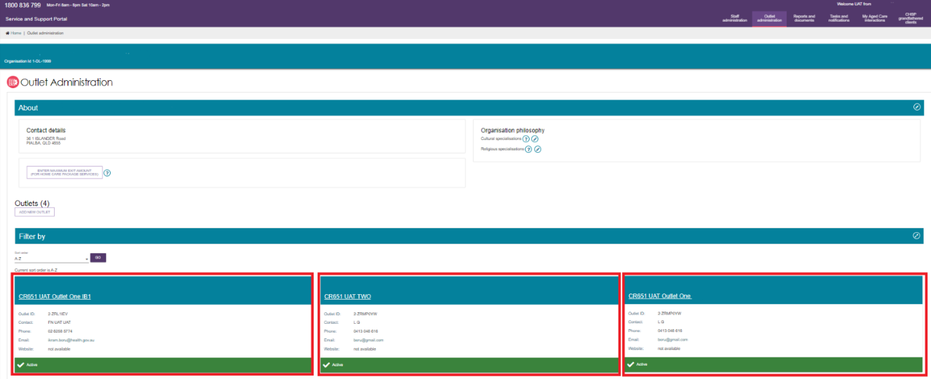
- Select MANAGE VERIFICATIONS.
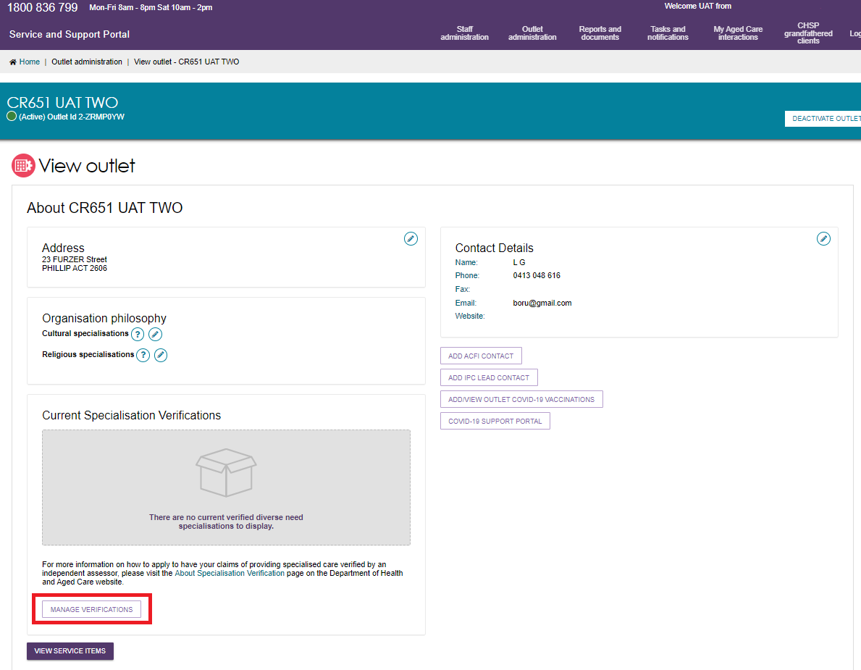
- Select LODGE A NEW APPLICATION.
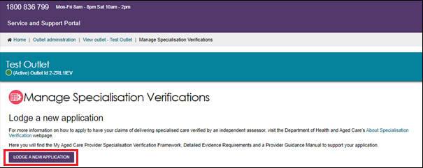
- After reading information about where to find additional resources to help you complete your application, click NEXT to move to the next step.
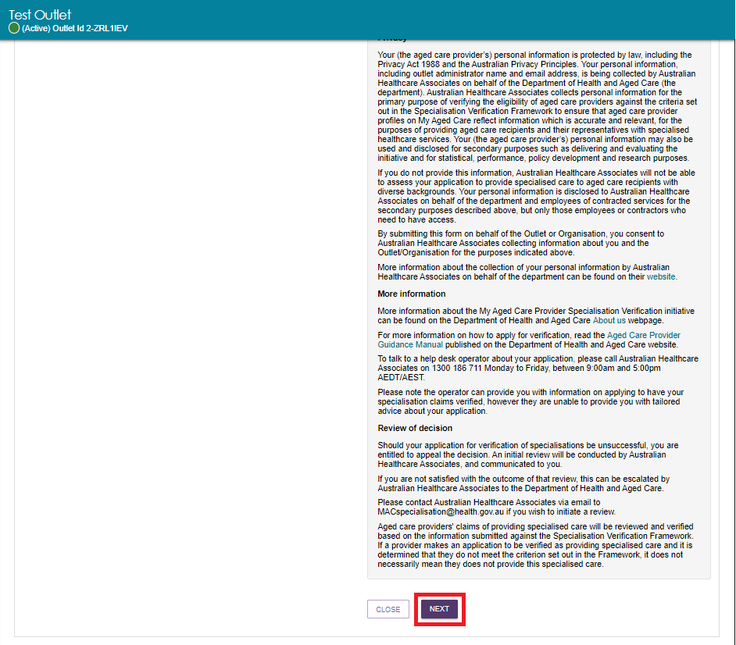
- Select the specialisation/s you wish to apply for verification by checking the relevant tick box, then select NEXT to progress.
You can also click Close to close the application screen without saving; click SAVE to save the status of the application and come back later; and click PREVIOUS to go to the previous application screen.
The current status of each specialisation for your outlet is displayed under the specialisation name. They are:
- Not verified
- Current (with a green dot)
- Expired on [Date] (with a red dot)
- Expiring on [Date] (with a yellow dot).
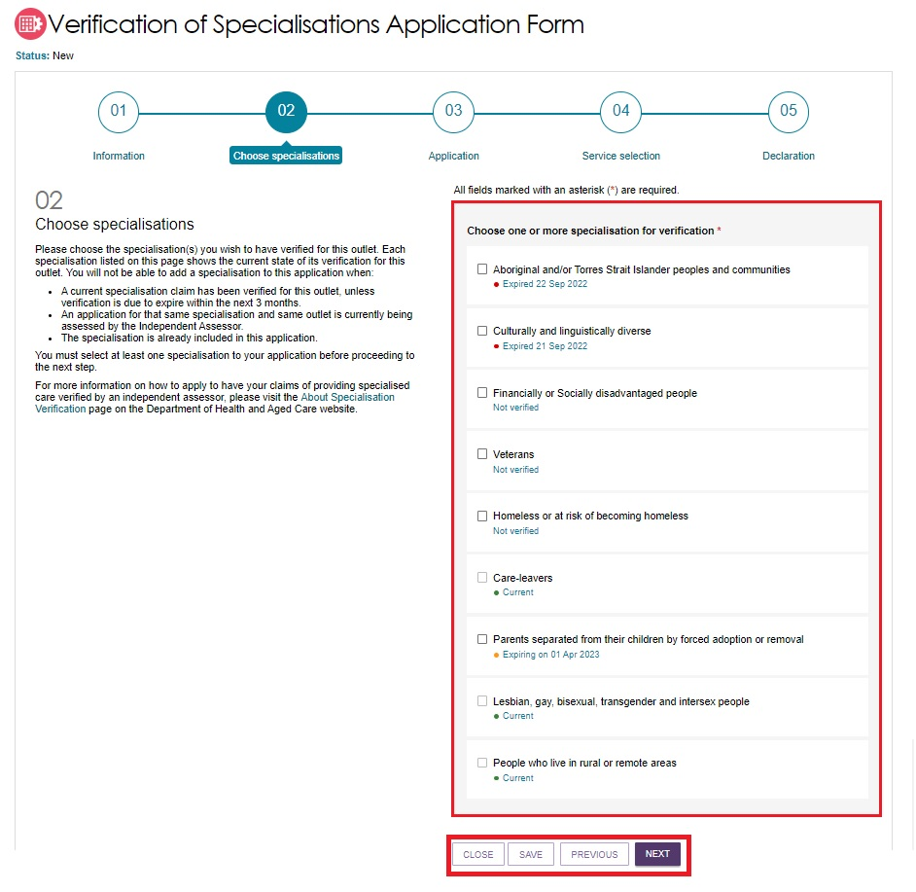
- Download the specialisation evidence form by clicking DOWNLOAD FORM. This will direct you to the form relevant to the specialisation claim you are applying to have verified, located on the Department’s website. Then, complete the form.
For each Diverse Needs specialisation that you are applying to have verified, there will be a separate section on this screen for you to download the form.
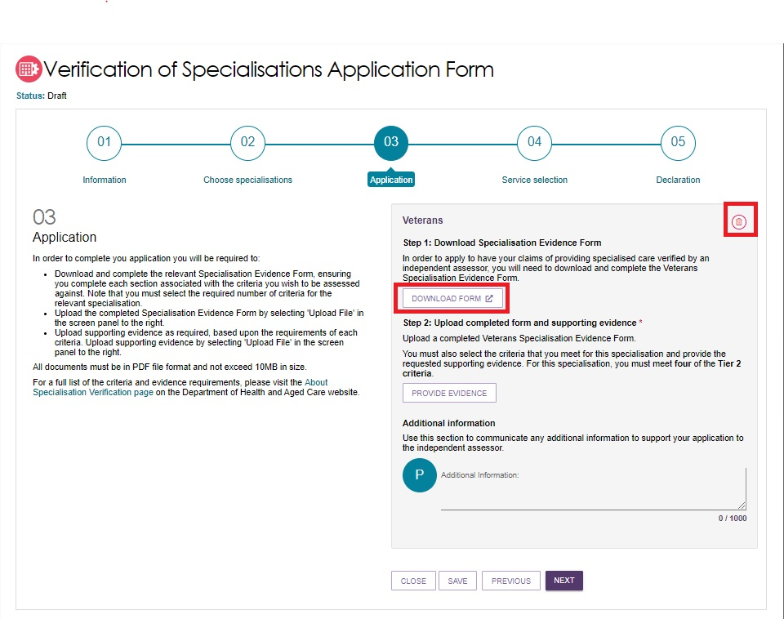
- To remove your application, select the delete (Rubbish bin) icon on the top right of the specialisation. Click YES REMOVE at the pop up that appears.
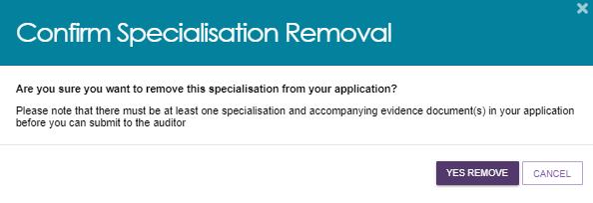
- Upload evidence that your outlet is eligible for a specialisation by clicking PROVIDE EVIDENCE.
To have diverse needs specialisations verified, you must meet one Tier 1 criterion OR 4 Tier 2 criteria. For some special need’s groups, fewer than 4 criteria are requirements for providers.
For each diverse needs specialisation that you are applying to have verified, there will be a separate section for you to upload the evidence specified. In these cases, all Tier 2 criteria for that specialisation must be met. For further information regarding the evidence requirements, please see the detailed evidence.
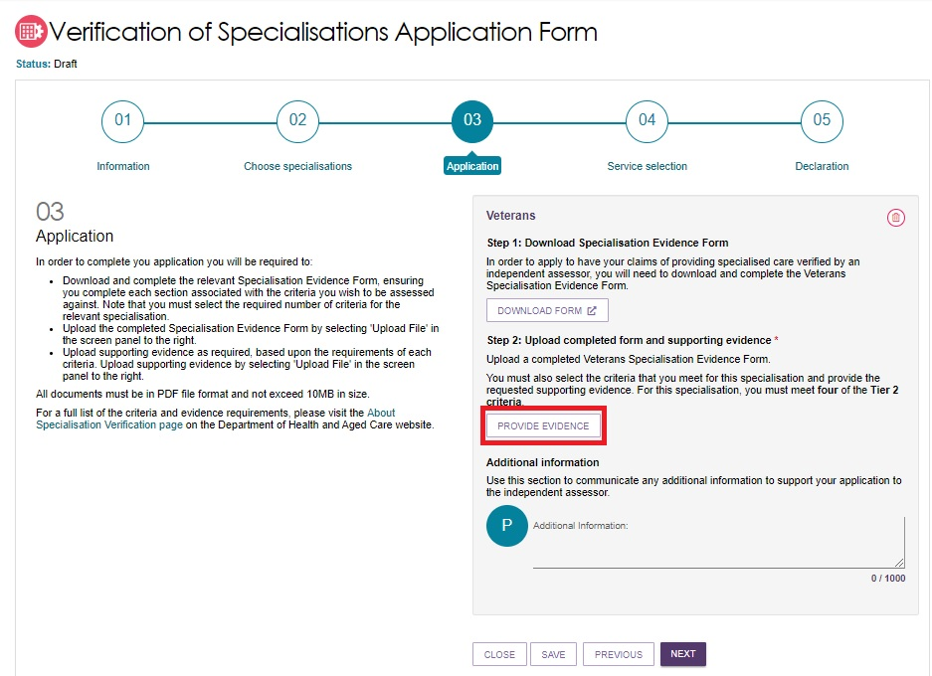
- A pop-up box will appear. Select which Tier and Criterion that you wish to upload evidence against in the drop-down menu, then select Choose Files to upload the PDF file. Click SUBMIT, then repeat for any additional evidence that is required for each specialisation application.
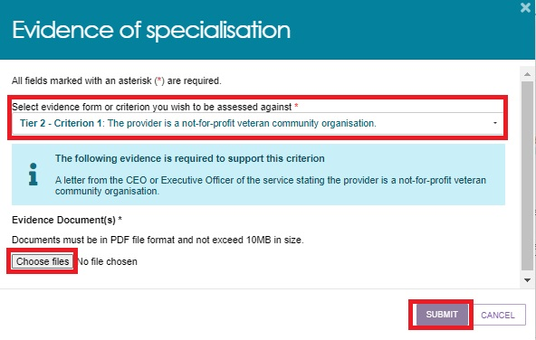
- Uploaded evidence will look like the below screenshot. At this stage, you can select:
- the double arrow (Expand) button to view the evidence required to support this criterion
- the delete/rubbish bin icon next to the file uploaded to delete the file
- The delete/rubbish bin icon on the top right of each document tier/criterion to delete the entire section.
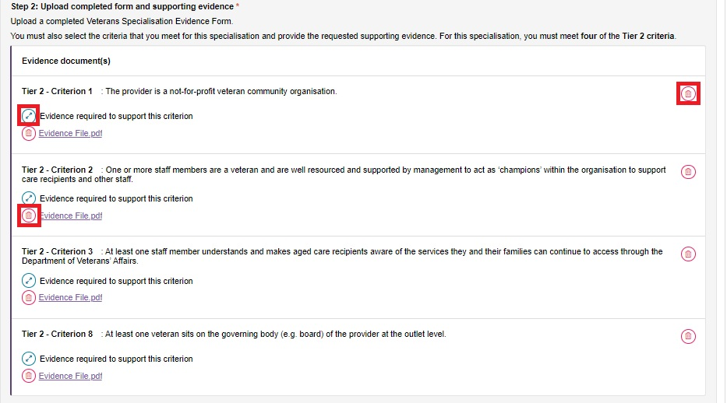
- If required, record any further information to support your application, then click NEXT.
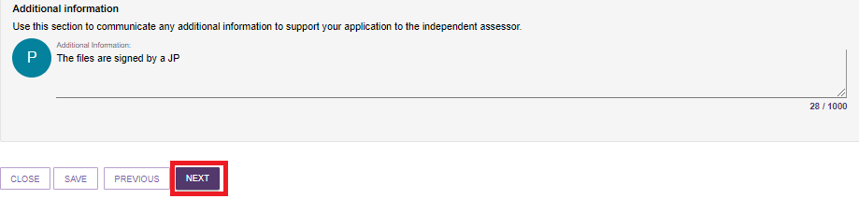
- Select the services associated with the outlet which cater for each diverse need’s specialisation being verified. Then click NEXT.
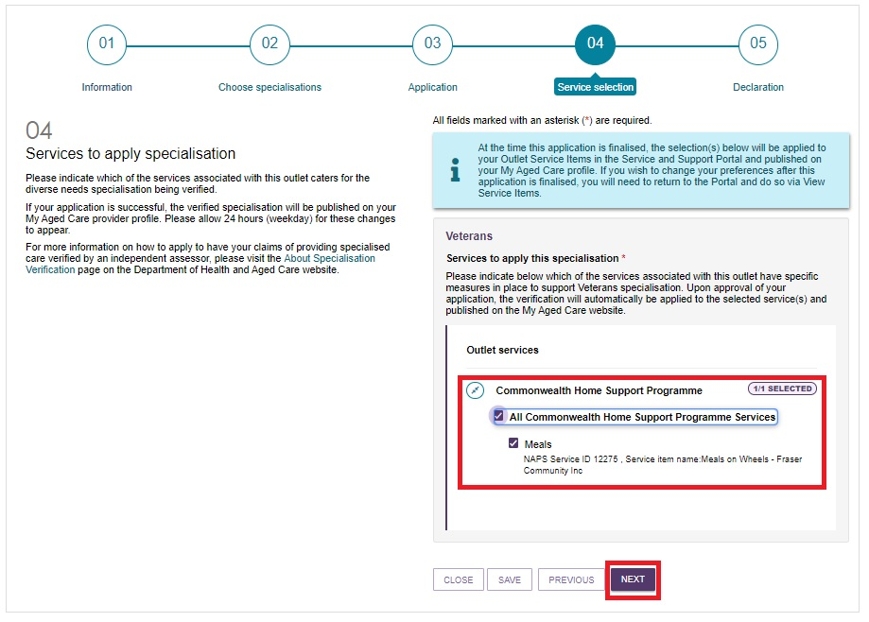
- To submit your application, you must agree with the declaration by ticking the checkbox, and then clicking SUBMIT.
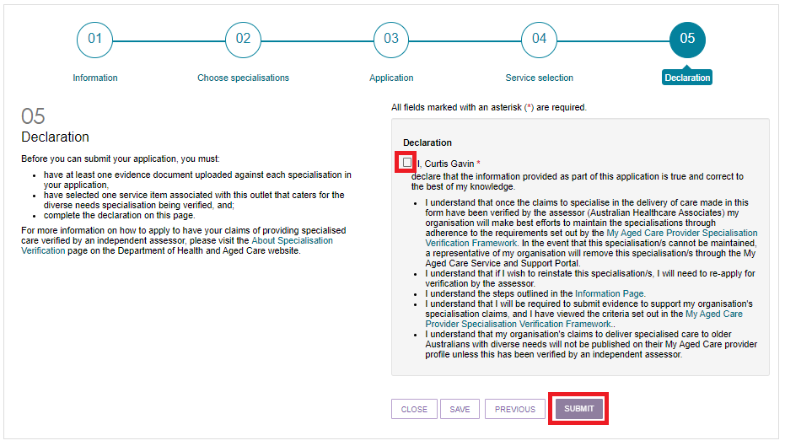
- You can view submitted applications by returning to the Manage Specialisation Verifications page which defaults to the Applications tab. In this tab you can also view any other applications in progress, and any finalised applications. In the Verifications tab, you can view a history of verifications for this outlet.
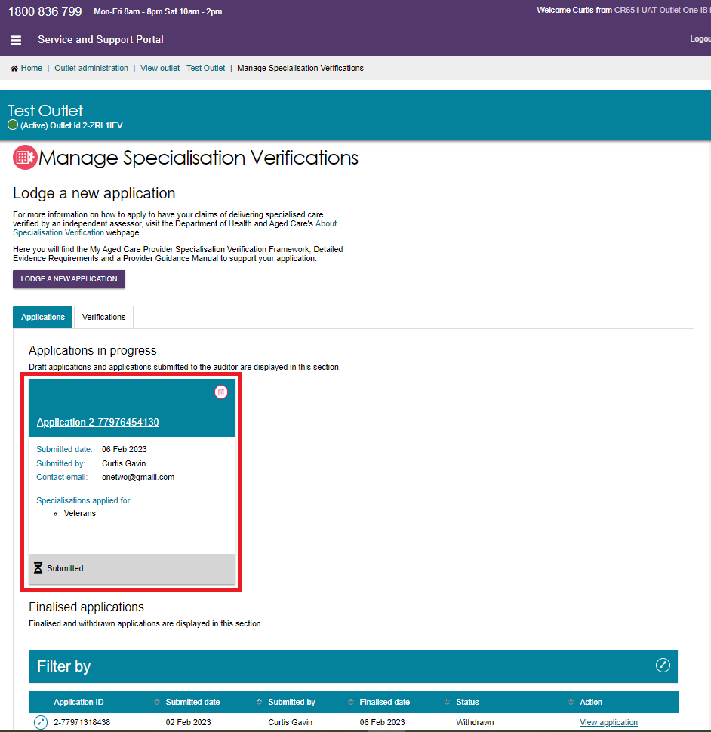

Editing Diverse Needs Specialisation Applications
- To edit an application that has been submitted, click on the application title. If an application requires additional information, you may be required to update and resubmit an application to the independent assessor.
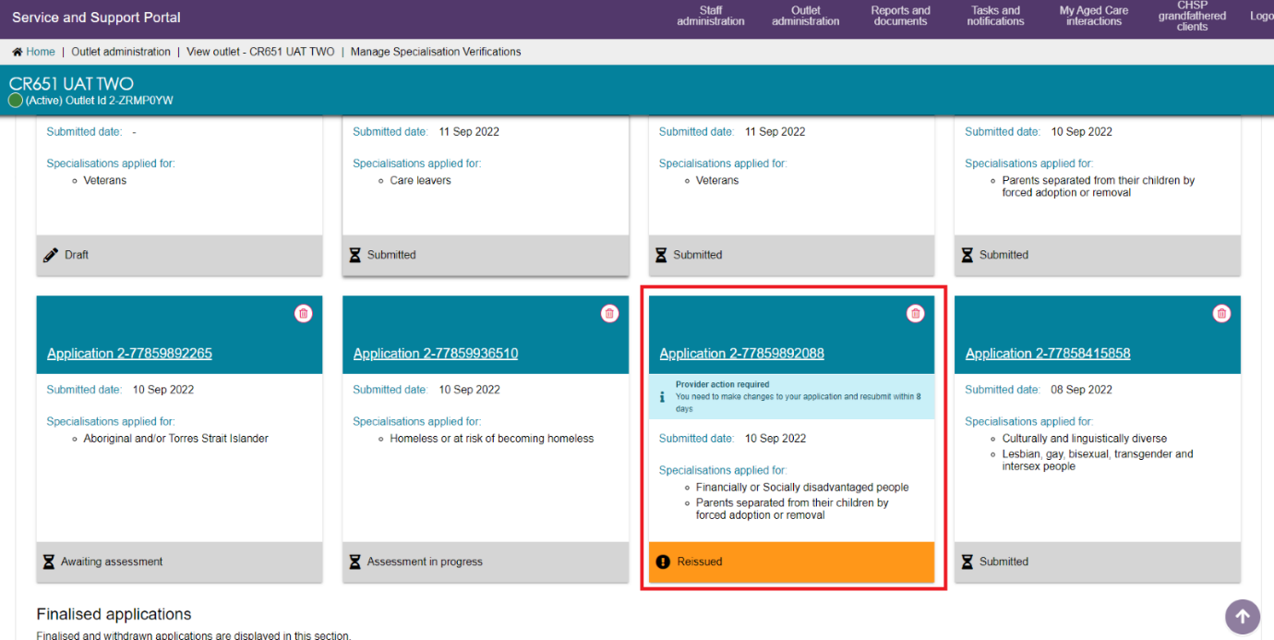
- To remove an application, select the delete (bin) symbol.
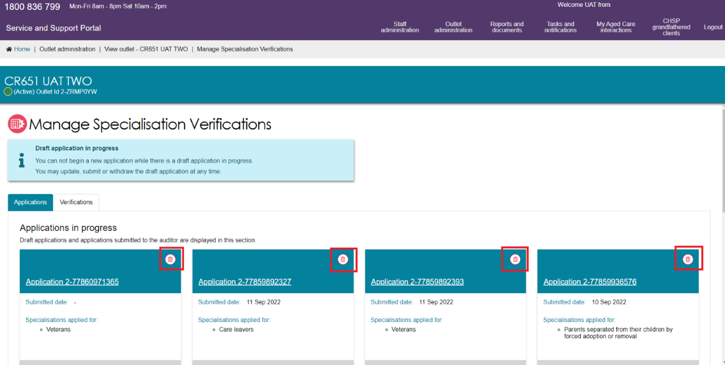

Service Items
You will need to create and maintain information about the aged care services that your organisation provides (known as service items) in the Service and Support Portal in order to receive referrals through My Aged Care.
It is important that information about the services you provide is kept up to date as the information is publicly displayed for prospective My Aged Care recipients and their support network on the service finder on the My Aged Care website (www.myagedcare.gov.au), and used by My Aged Care contact centre staff and assessors to refer clients to service(s).
! If you are adding or updating multi-purpose services or Short-Term Restorative Care (STRC) as a service type, please refer to the user guides available here: Service and Support Portal Resources.
Services need to be linked to one or more of your outlets. You can also add service sub-types under your service items.

Adding a service item
The steps to add a service item to an outlet are outlined below.
- Select Outlet administration from the homepage.
- From the Outlet administration page, select the name of the outlet on the outlet card that you want to add a service item to. The View Outlet page will be displayed.
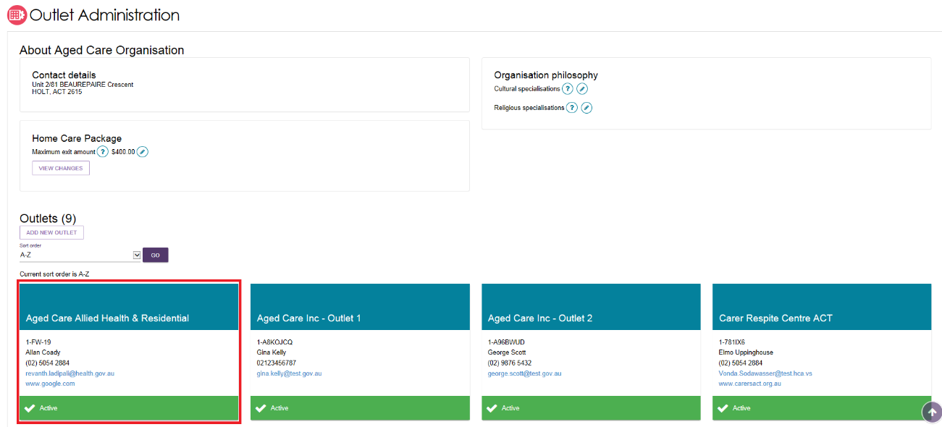
- From the View outlet page, select VIEW SERVICE ITEMS.
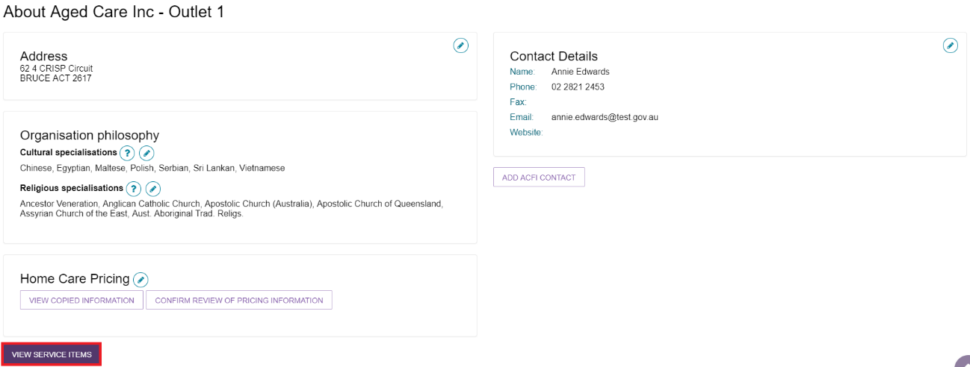
- From the View Service Items page, select ADD A SERVICE ITEM.
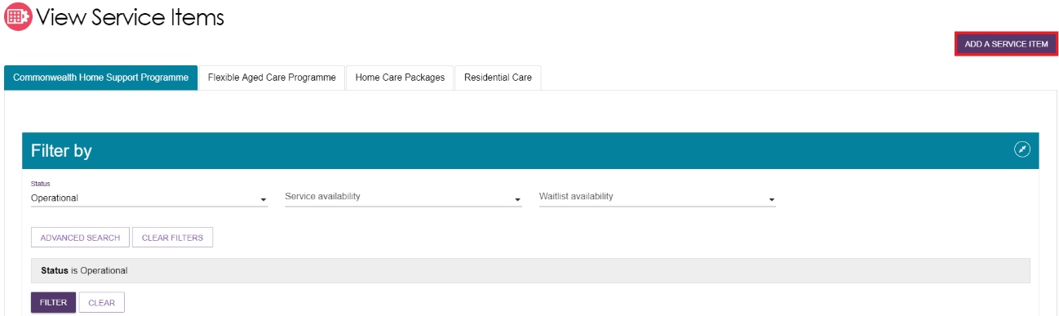
- Select the program for the service that you wish to add.
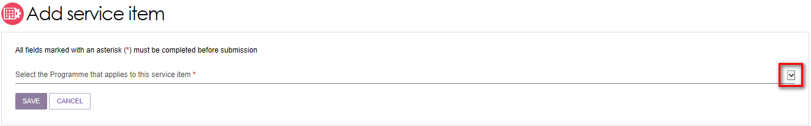
- Select Funded for the service item you are adding. Funded refers to government subsidised services that are funded and approved by the Australian Government under a Commonwealth aged care programme.
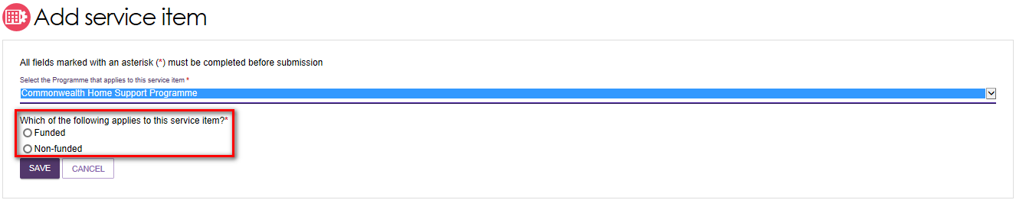
! For HCP services this option will not be available as all services must be Commonwealth government subsidised.
- For funded services, select the service you want to add to your outlet by selecting the relevant service item and then select SAVE. You can refine the list of service items by entering details and using the FILTER function.
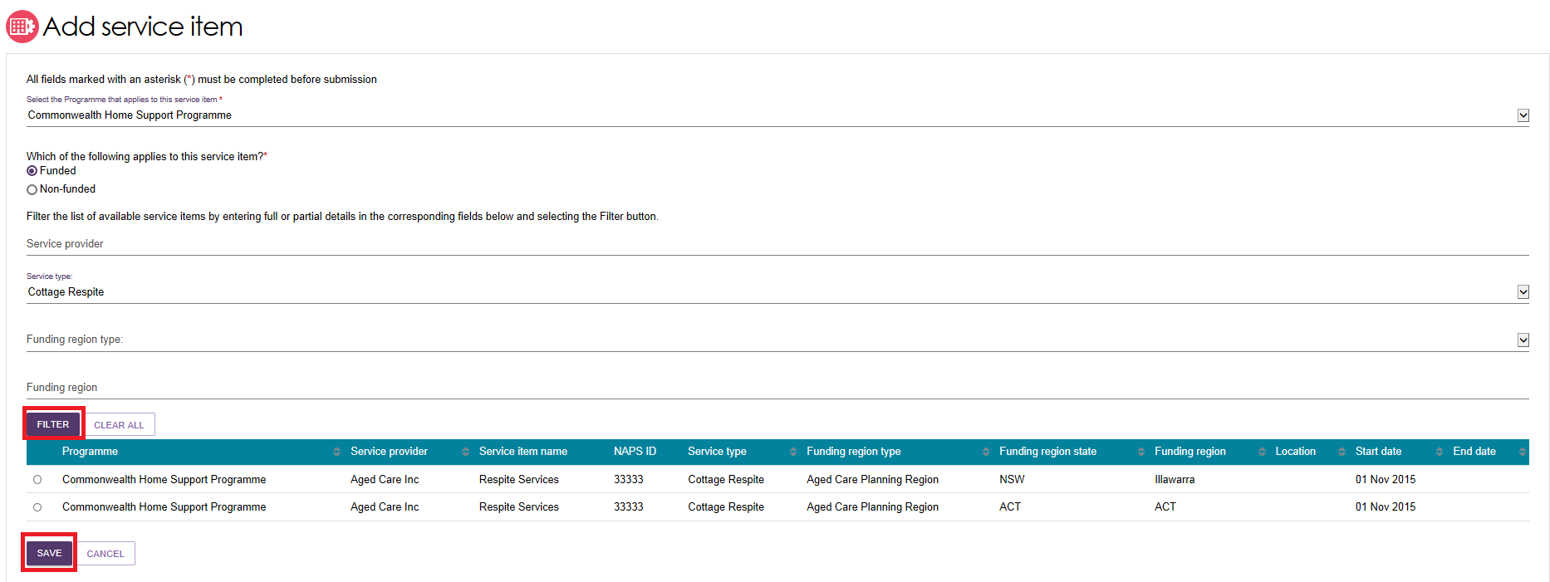
The service item will now display in the Outlet details page under Services.
! If you are adding a new HCP service, you will be required to enter a unique name for the service in the Service Item Name field that is displayed.
The service item will be defaulted to Offline, and the status will need to be changed to Operational before it is displayed on the public service finder. The process for activating a service item is described later in this guide.
! Once services have been added to an outlet, you can filter the list of services that are listed under a specific program by status, service availability and waitlist availability.
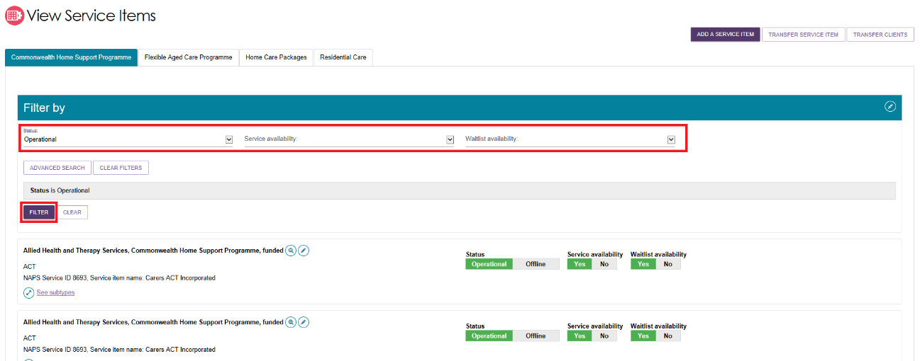

Editing a service item
You can edit service item details, including:
- Service item name
- Service delivery area
- If a service caters for diverse needs, you will only be able to select categories for which your outlet has been verified for providing specialised services to. See Adding and Editing Diverse Needs Specialisations for more information.
- If a service focuses on a specialised service (see Editing the Organisation Philosophy and Specialised Services)
- Upload promotional attachments (for residential facilities)
- Edit Home Care Package specific attributes
- Enter a detailed description for the service item.
The steps for editing service item information are outlined below.
! Only non-contractual information can be edited in the Service and Support Portal. The steps you need to take to request changes to contractual information are outlined in Section 2.3.5 of this guide.
- Select Outlet administration from the homepage.
- Select the outlet card you want to edit by selecting the outlet name.
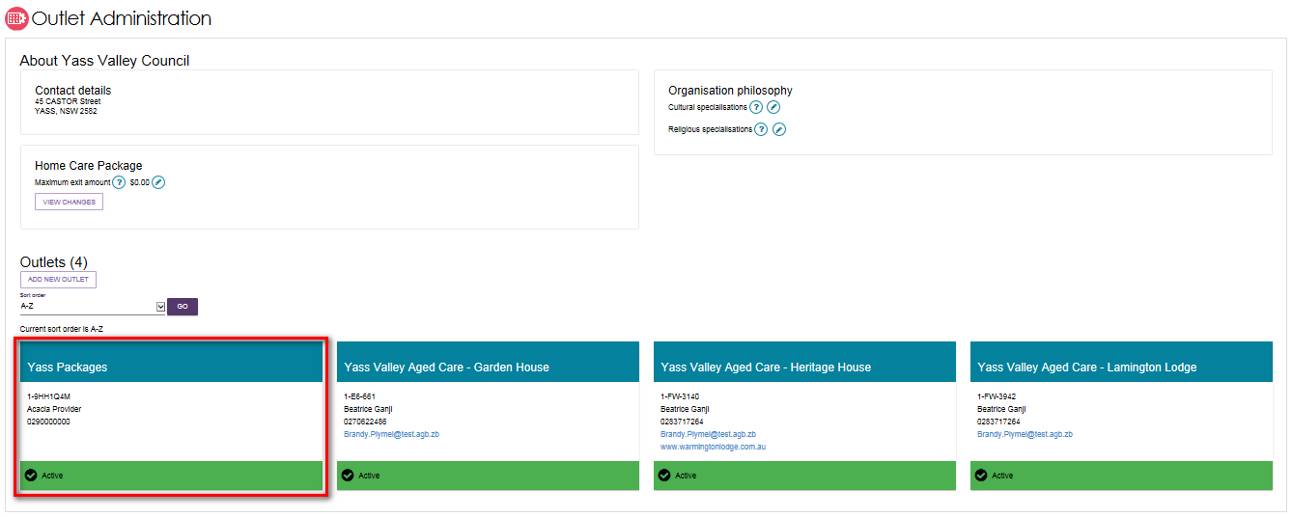
- On the View outlet page, select VIEW SERVICE items then select the Edit icon next to the relevant service item.
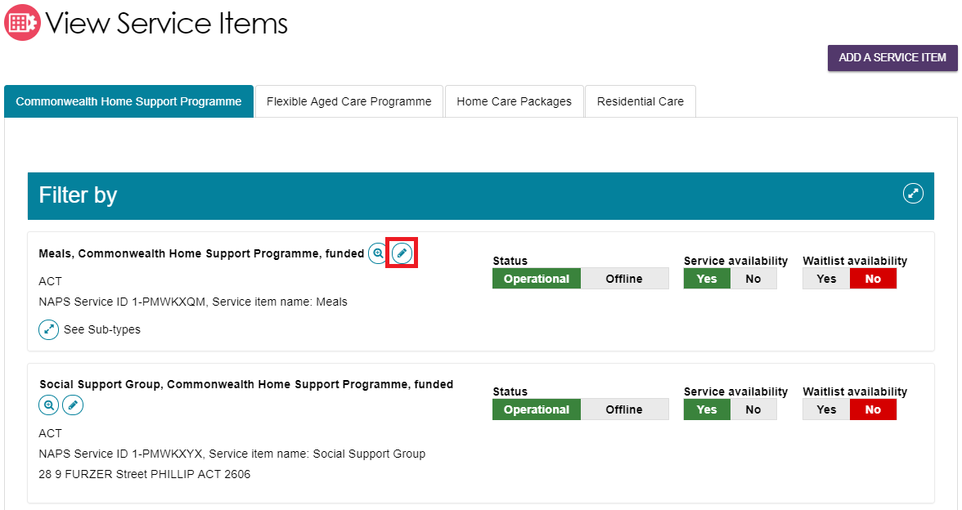
The Service details page will display.
- Make the required changes and select SAVE. Read-only information is contractual information and cannot be edited via the Service and Support Portal. Any additional service information can be added in the Service description free text field. This information will be displayed in the public service finder on the My Aged Care website to assist clients in selecting a provider.

Editing availability of services and waitlists for a service
You can maintain information about the availability of service items via the Portal. To maintain a waitlist via the Portal you must ensure that the waitlist availability status on the service item is set to Yes to turn on the waitlist, or No to turn off the waitlist.
! Service and waitlist availability information will be displayed on the Service Finder on the My Aged Care website. When you update availability information, the changes will appear on the Service Finder by the next day.
- Navigate to the View Outlet details from the Outlet administration page for the outlet that you want to edit service and waitlist information and select on VIEW SERVICE ITEMS.
- Select the relevant service/waitlist availability status (yes / no).
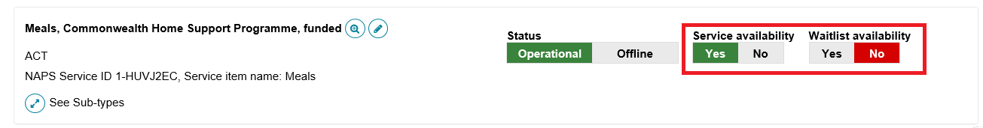
The waitlist functionality is explained in Assessor Portal User Guide 3 – Managing referrals for assessment and Support Plan Reviews.

Editing service delivery area
Information about the areas you deliver Commonwealth-funded services in (referred to as service delivery areas in the Service and Support Portal) are pre-populated, based on your contractual information. All providers (except residential care) must review their service delivery area information and edit if required.
It is important that you ensure the service delivery area(s) is accurate. This information is publicly displayed in the service finders, and impacts the referrals sent by contact centre staff and assessors.
You can select service delivery areas at either the client’s location or the service providers location. The steps to edit the service delivery area (if At client location is selected) are outlined below.
- Select Outlet administration from the homepage.
- Select the outlet card you want to edit by selecting the outlet name then select VIEW SERVICE ITEMS.
- On the View Service Items page, select the Edit icon next to the relevant service item.
The Service details page will display.
- Select Edit next to Service delivery area.
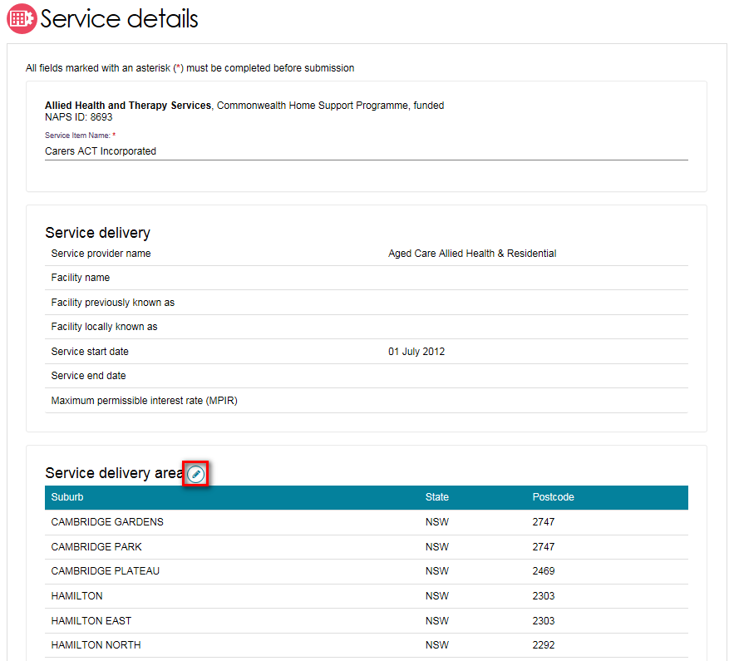
- Select the service delivery type (At provider location/at client location).
If you have selected at client location, you can choose the suburb(s) the service is delivered in. By default, the entire region, in which you are funded to provide service, is selected. You can choose to search for a specific suburb to add, add all the suburbs in the selected state, or add all the suburbs in the selected region.
The List of serviced suburbs is automatically saved upon adding new suburbs. Select CLOSE to go back to editing the service.
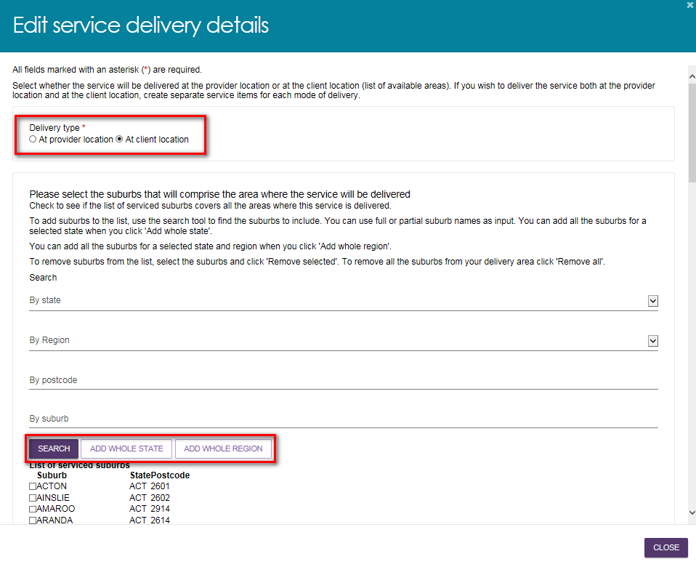
- To remove suburbs from the list, select the suburbs you wish to remove using the checkbox and select REMOVE SELECTED, or use REMOVE ALL to start configuring your list of suburbs from the beginning. These changes are automatically saved. Select CLOSE to go back to editing the service.
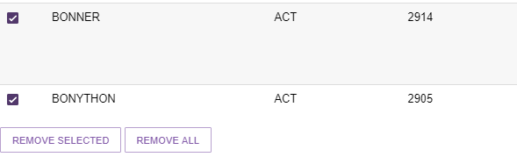

Attaching promotional material
Residential Care providers can add promotional material to be displayed in the service finder. Transition Care and Commonwealth Home Support Programme (CHSP) providers have the option to attach promotional material in the portal; however, this material will not be displayed on the service finder. Further information on attachments for HCP providers is shown in the next section of this guide.
Promotional material will not be visible on the Service Finder until it has been reviewed and approved by the Department. It is expected that it will take three business days. When approved, the promotional material will be displayed on the Service Finder on the My Aged Care website.
The steps to attach promotional material (for example, photos, brochures, menus) are outlined below.
- Select Outlet administration from the homepage.
- Select the Outlet Card you want to edit by selecting the outlet name.
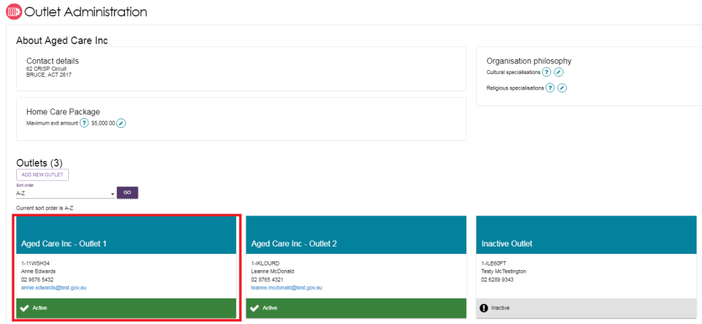
- On the View outlet page, select VIEW SERVICE ITEMS
- On the View Service Items page, select Residential Care and Edit the relevant service item.
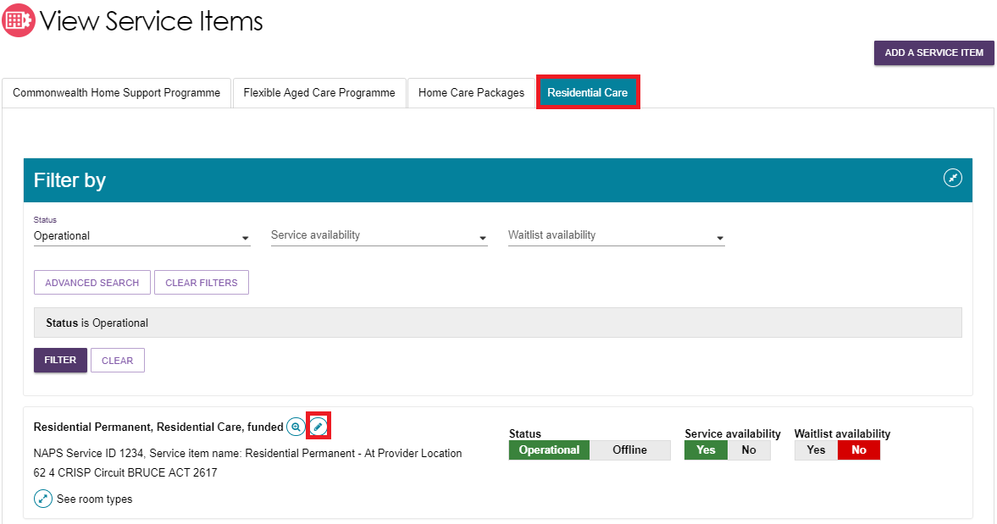
The Service details page will display.
- Scroll down to the Promotional section. Select Browse to find and attach your promotional material (file types supported include .jpg, .jpeg, .png, .pdf, .rtf, .doc and .docx) and select Save and Submit Requested Changes for Approval after entering information about the attachment. The Feature Photo option in the Type of the attachment dropdown will be the primary image displayed to users of the service finder.
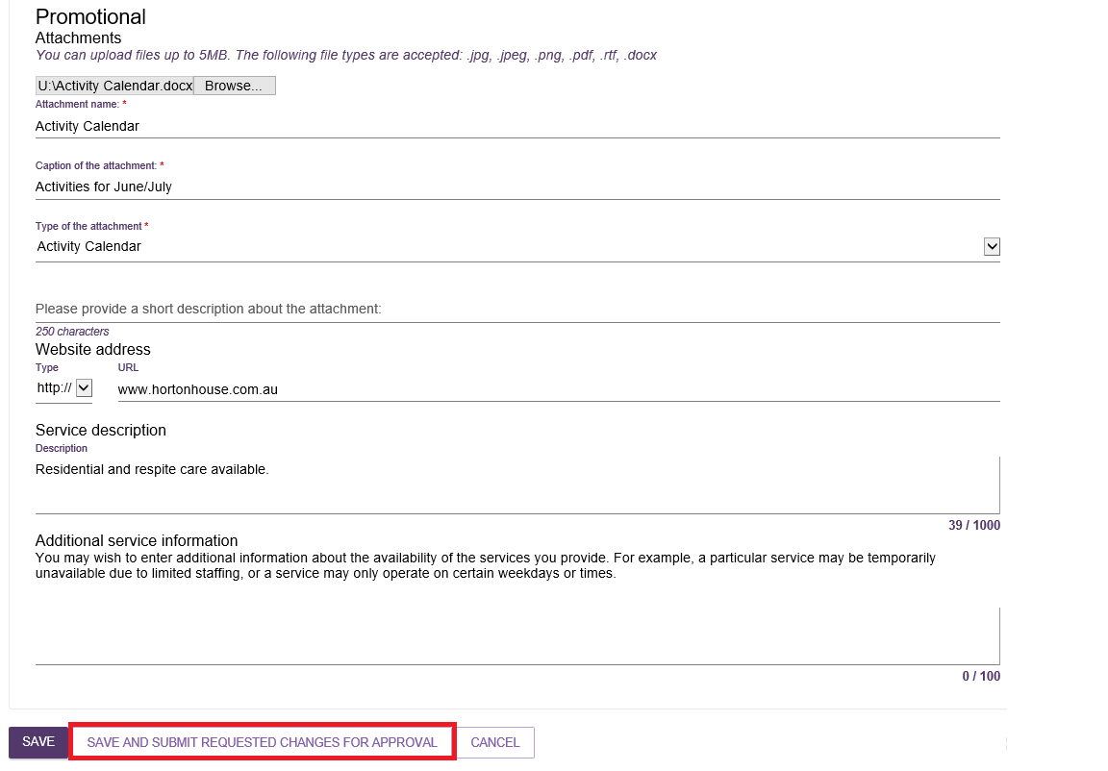
At the bottom of the screen, a confirmation will display, and a warning message will prompt you to submit the service item update to the Department for approval.
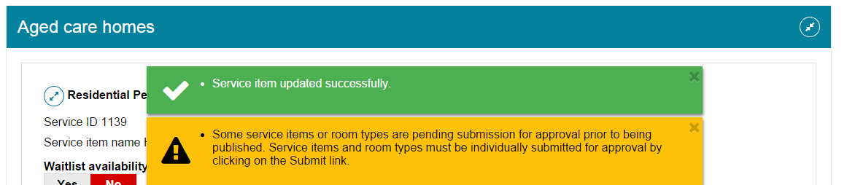

Home Care Package attributes
If you are configuring a Home Care Package service, a number of attributes specific to the delivery of this service type will become available to select and display on the service finder. These are shown as follows.
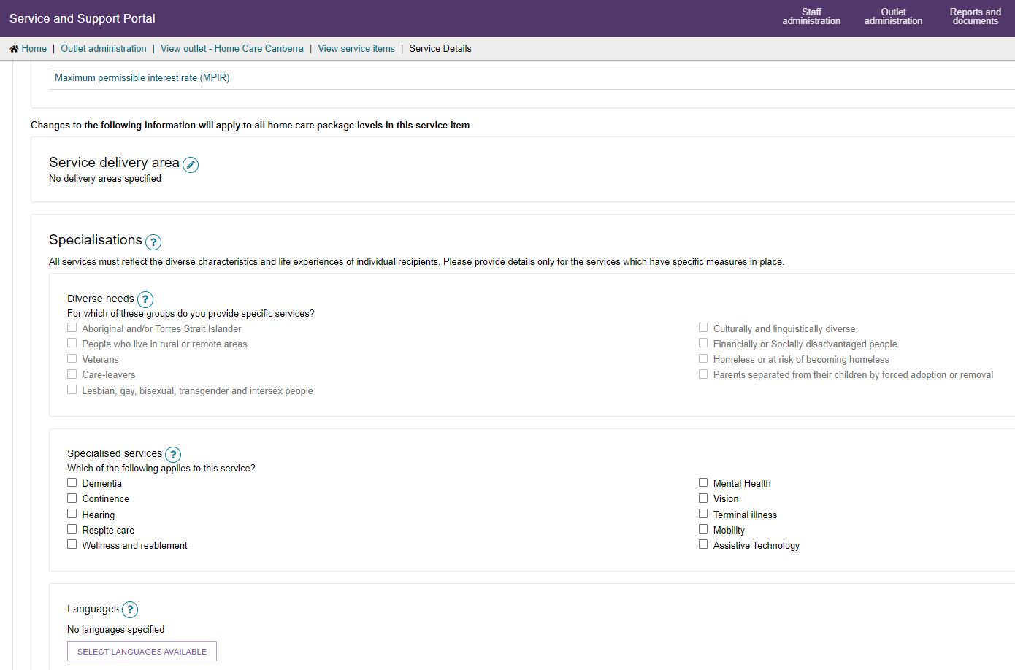

Specialisations
Specialisations is an umbrella term for 3 sub-groups: diverse needs, specialised services, and languages. Providers of all care types are able to identify their ability to provide services that cater to these specialisations. To declare any from Diverse needs, they must be verified by the independent assessor.
Specialised services will be displayed only for HCP service items.
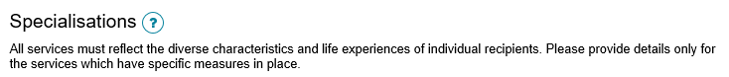

Diverse needs
Diverse Needs specialisations are a subset of Specialisations, involving providing specialised services for the groups identified as having special needs in the Aged Care Act 1997. These are:
- people from Aboriginal and Torres Strait Islander communities
- people from culturally and linguistically diverse backgrounds
- people who live in rural or remote areas
- people who are financially or socially disadvantaged
- veterans
- people who are homeless or at risk of becoming homeless
- care-leavers
- parents separated from their children by forced adoption or removal
- lesbian, gay, bisexual, transgender and intersex people.
Providers who wish to make claims that their outlet specialises in the care of people identifying with one or more of the diverse need’s groups will need to apply to have these claims verified by an independent assessor. While all providers must demonstrate that they meet the Aged Care Quality Standards, providing specialised services for the diverse needs groups is an optional and additional step.
Since 27 June 2022, no new unverified diverse needs specialisation claims will be published on My Aged Care. Successful verification is contingent on the outlets ability to demonstrate they provide specialised care. The criteria providers are required to meet, and expected forms of evidence, are set out in the Specialisation Verification Framework.
Only verified diverse needs specialisations are visible on My Aged Care provider profiles. Providers who have not had their diverse needs specialisation claim(s) verified will have had those claims removed from their My Aged Care Provider profile on 27 February 2023.
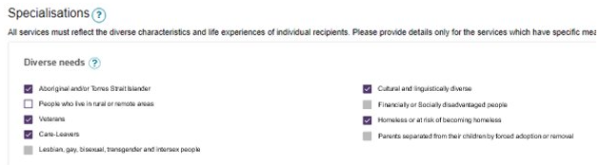
For more general information on the verification process and detailed evidence requirements, please refer to About Specialisation Verification and the Specialisation verification – final framework | Australian Government.
For specialisation criteria refer to Specialisation verification – final framework.

Specialised services
Although these services are not verified, please select only those with specific measures in place which demonstrate your specialised service offering.
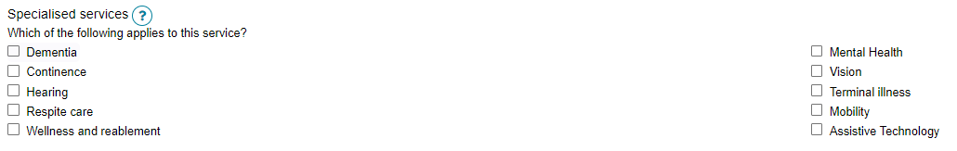

Languages
- To indicate that services are being delivered in a language other than English, select SELECT LANGUAGES AVAILABLE.
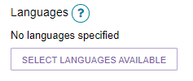
- Select one or more languages then select SAVE.
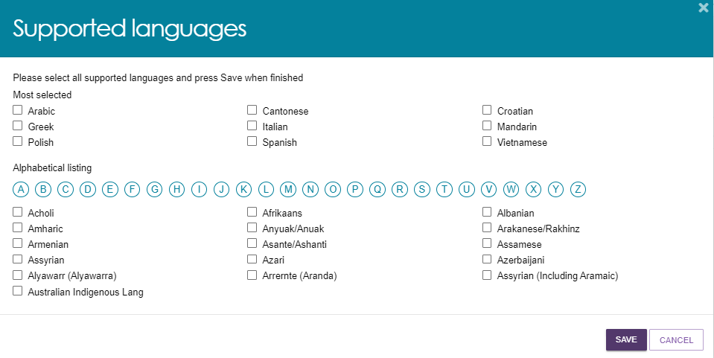
- The languages will be displayed. Select the Pencil (edit) icon to change languages.
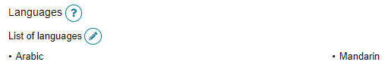

Hours of operation
You can outline standard hours of operation for this service. By default you can enter specific Monday to Friday, Saturday and Sunday hours. You can also specify individual working days by using the Customise option.
To edit your hours of operation:
- Select Outlet administration from the home page.
From the Outlet Administration page, select the outlet you wish to set the hours of operations.
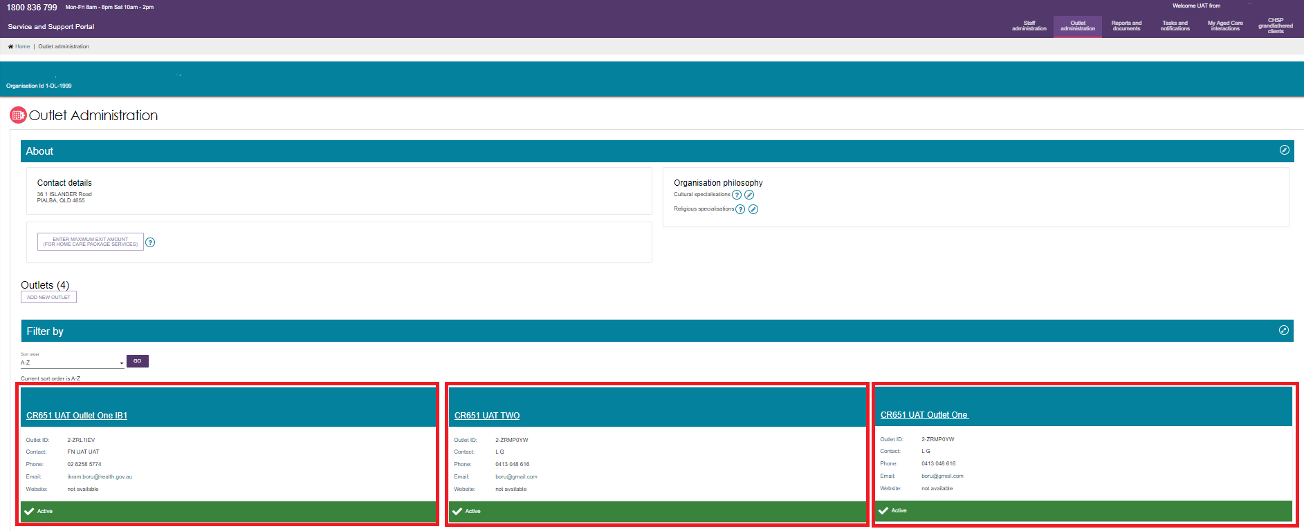
- Select VIEW SERVICE ITEMS.
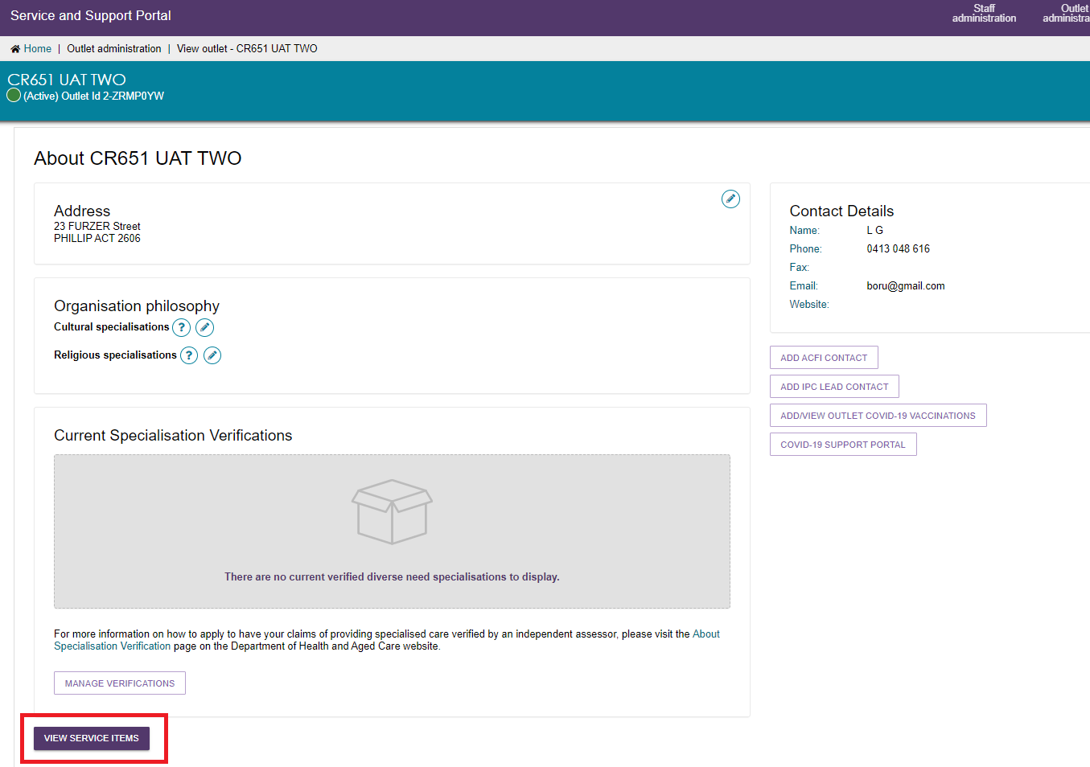
- Select the service you want to edit the hours of operation by selecting on the corresponding edit icon.
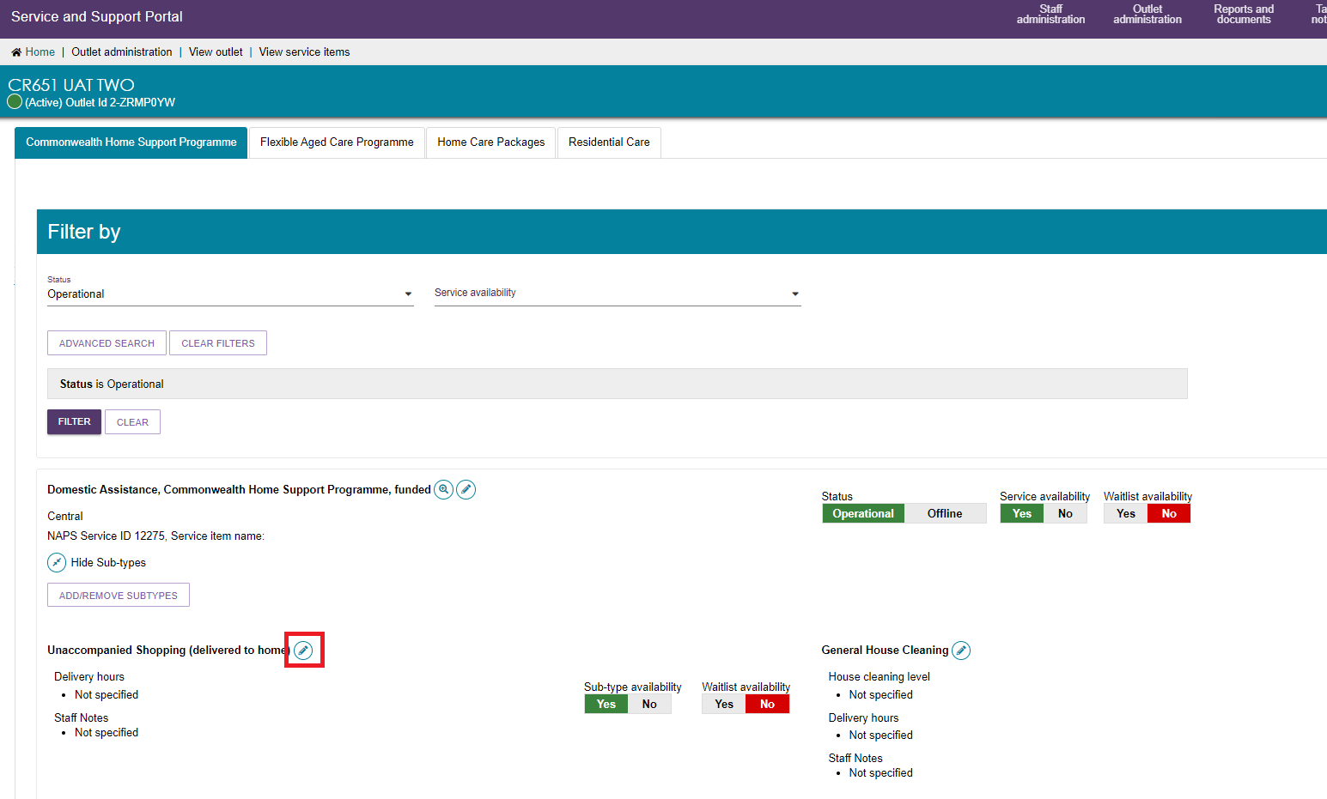
- Input the hours and save.
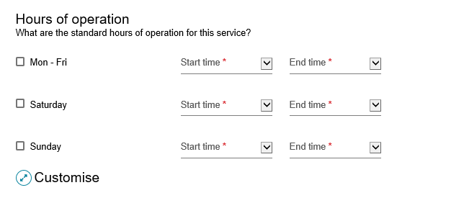
You can also indicate the average number of hours of service provision you provide each week per level of HCP.
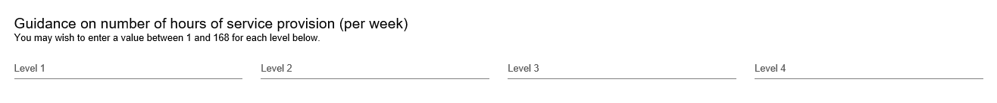

Service Description
You can enter any further information about your service here, and it will be displayed at the Service Finder.
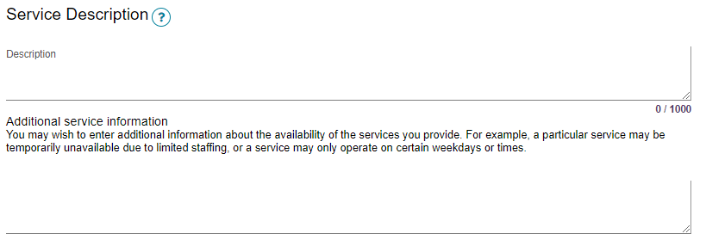

Adding pricing information to a Home Care Package service item or outlet
Publishing pricing information is mandatory for all HCP services and outlets.
If the service does not have the mandatory pricing information. You will not be able to:
- save a new service and make it Operational
- save changes to partially complete existing pricing information
- edit waitlist information
- confirm if you have reviewed pricing information.
! The help text against each pricing attribute provides further guidance on what specific information providers should be entering.
- From the Home Care Packages tab in the VIEW SERVICE ITEMS page, select the Edit icon next to the Home Care Package services that you wish to add pricing information.
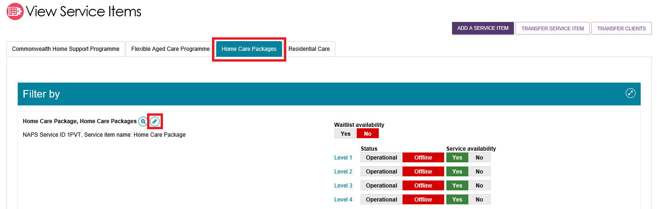
Alternatively, from the View Outlet page, select the Edit icon next to Home Care Pricing to edit the pricing information at the outlet level.
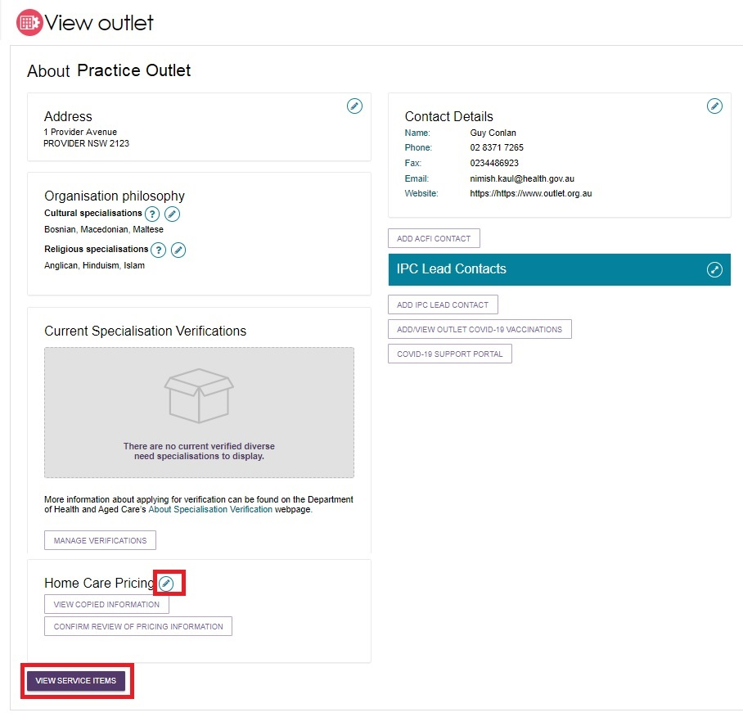
Please note that when you edit pricing information at the outlet level, this is a pricing template that you can save and apply to the services within a single outlet or all outlets in your organisation. This is best used when the pricing information for a number of your services is the same.
! Only information saved at the service item level will display on the service finder. If you select SAVE at the outlet level this will save the information locally and will not display in the My Aged Care service finder. Select SAVE AND APPLY TO ALL SERVICE ITEMS OF THIS OUTLET to display your changes in the My Aged Care Service Finder.
- The Home care pricing service details page will be displayed. Select Home Care Pricing to add or edit pricing information for that service.
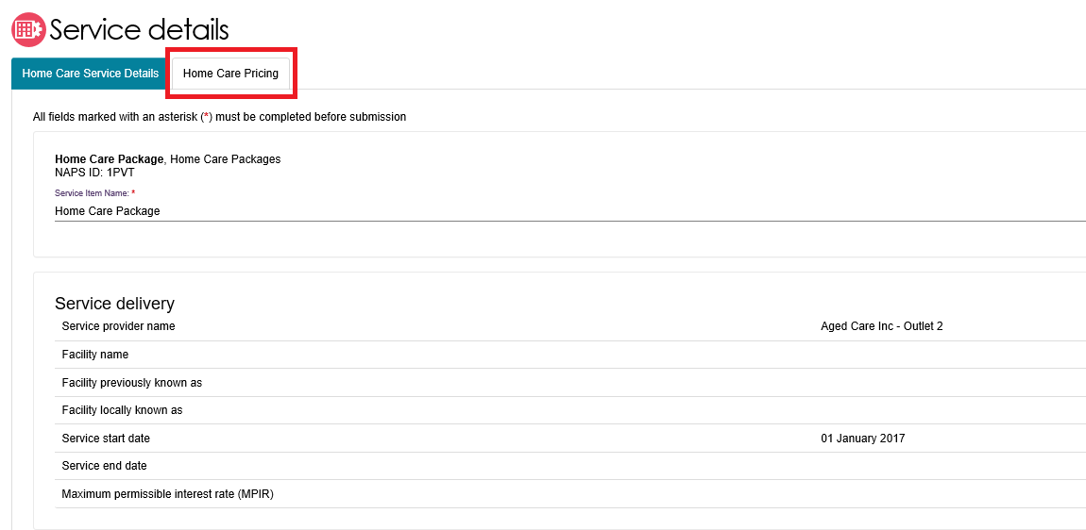
- From the Home Care Pricing tab, providers can enter detailed information for home care services about:
- Information about service offering and value statements
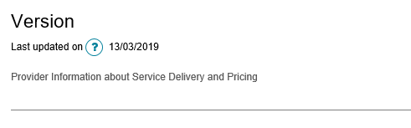

- Approximate Home Care Package Amounts
If you do not charge the maximum basic daily fee you will be required to indicate a price for each package level. If you do not charge any basic daily fee you will still be required to note a price, for example $0.
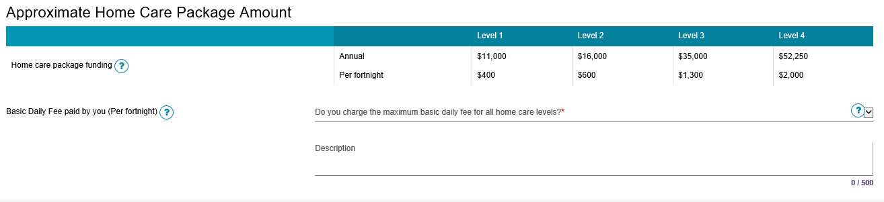
- Care Management, relevant prices, and number of hours of service.
Only select N/A where you do not provide for care management for that specific level of Home Care (e.g. Level 1).
Providers must publish a care management price in a clear dollar amount, so that care recipients can better understand and compare prices, and to understand what service they will receive for this charge.
If providers bundle the cost of care management with other costs, such as package management charges or in an all-inclusive service cost, this may mean that the provider is not providing the required care management services. It will also make understanding and comparing prices difficult for care recipients and the public. Providers that list $0 for a service that they intend to charge for (such as Care Management) may be breaking the Australian Consumer Law.
To ensure funds meet the direct care needs of older Australians, some prices are capped and there are new rules of charging for providers. For more information visit the Departments website.
Note: From January 2023, care management prices will be capped at 20% of the package level.
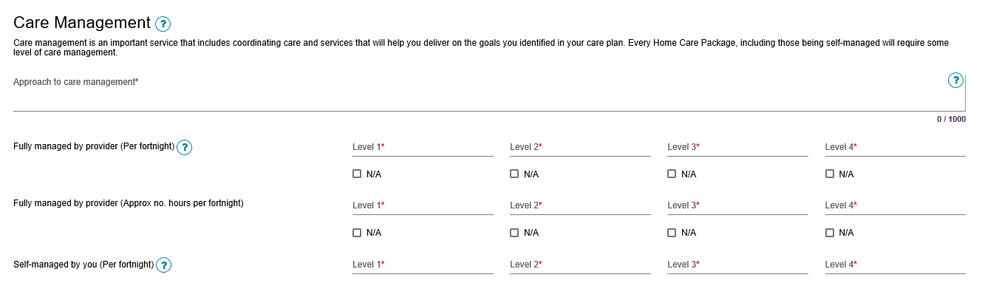

Details and prices for common services that are offered under each level of HCP. The five common services are: Personal care, Nursing, Cleaning and household tasks, Light gardening, and In-home respite.
An approved provider of home care must provide the price for each of the common types of care and services (standard hours). Only select N/A where you do not provide this particular service, for example on Public Holidays. If you provide the service but do not charge an extra amount, enter in the standard hours price.
Only select N/A where you do not provide this particular service, for example on Public Holidays. If you provide the service but do not charge an extra amount, enter in the price.
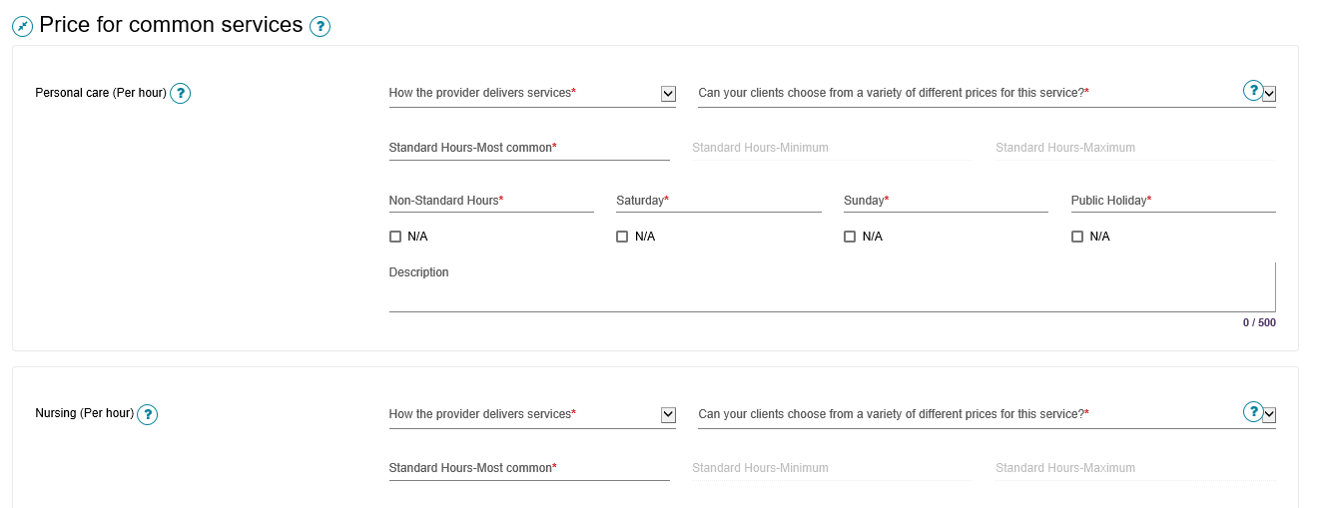
Other pricing information that may be charged by the provider – Package management. Only select N/A where you do not charge for package management for that specific level of home care (e.g. Level 1).
Similar to care management, you must publish a distinct package management price in a clear dollar amount so that care recipients can better understand and compare prices – see 3c above for further information.
Note: From 1 January 2023, package management prices will be capped at 15% of the package level.
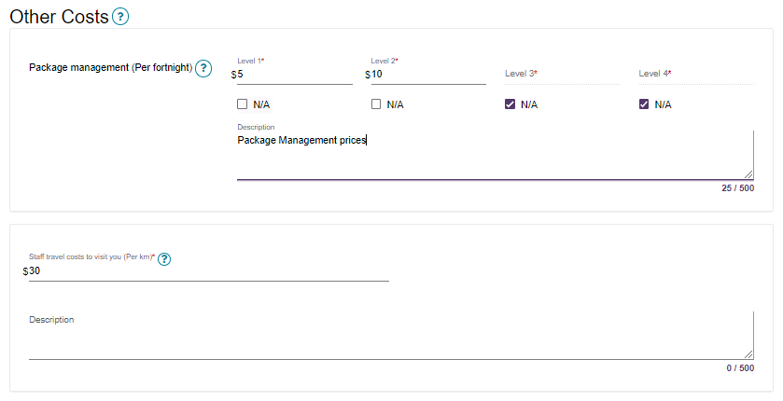
- Under the Full Price List section, a pricing schedule website link (URL) and/or a pricing schedule attachment can be added.
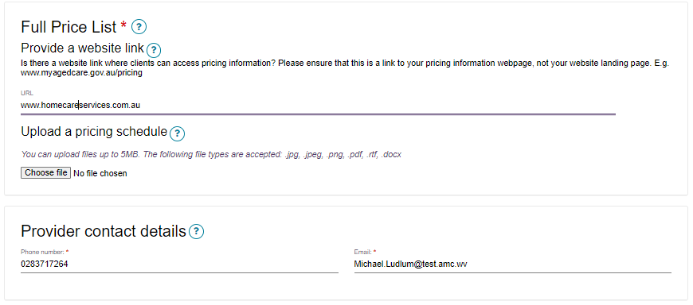
To add a pricing schedule website link type in the URL in the Provide a website link section. Ensure that the website URL you enter is a valid website address and includes www. at the beginning of the URL.
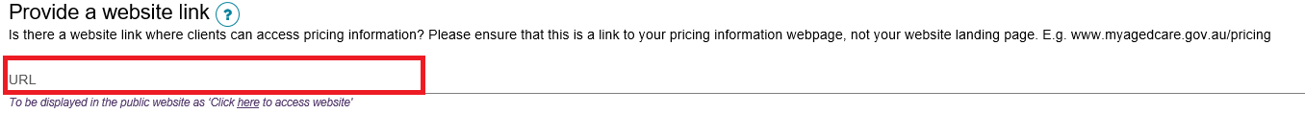
To upload the pricing schedule attachment, you must select Browse… and choose the document (e.g. PDF file) you wish to upload. Name the attachment and provide a caption or short description of the attachment.
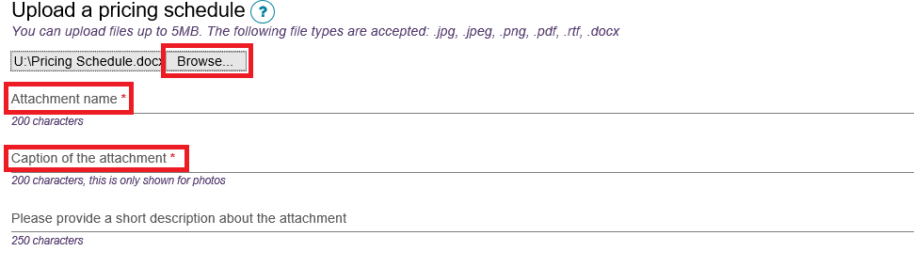
- If you are editing an individual service item, select SAVE to apply all pricing information you have added to the home care service.

Alternatively, if you are an Administrator and editing pricing information at the outlet level, you can choose to save and apply the pricing information to all Home care service items in that outlet, save locally (before applying to any services), apply these details to all of your outlets (if you are an Organisation Administrator) or Cancel to discard any changes made.
! All pricing information saved, including pricing schedule attachments, will appear by the next day on the new service finder on the My Aged Care website, and do not require approval from the Department.

Additional home care pricing features
Home care service providers are required to review and if required, update their pricing information annually. In the scenario where no changes need to be made to any of the pricing information, providers can confirm that they have reviewed their pricing.
- To do this select CONFIRM REVIEW OF PRICING INFORMATION.
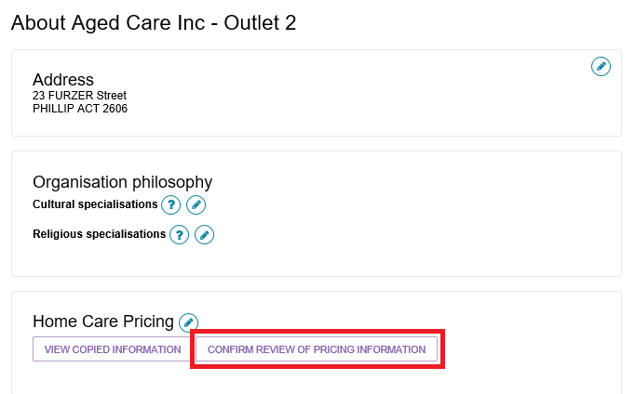
- Select the service(s) that you wish to confirm and select CONFIRM REVIEW.
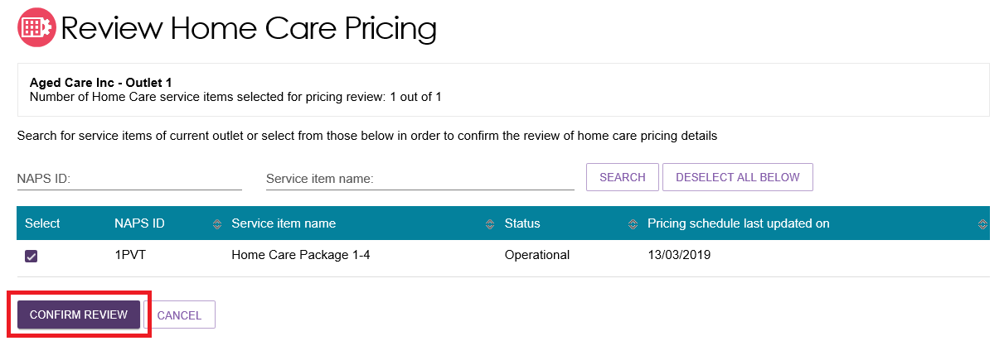
- Home care service providers can also view a history of copied pricing information that has been applied to services within an outlet. Select VIEW COPIED INFORMATION to view this history.
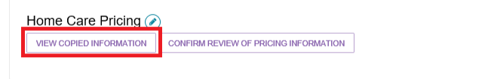
- Home care service providers can also view and print a copy of the pricing information they have added to individual services, which can then be attached to clients Home Care Agreements.
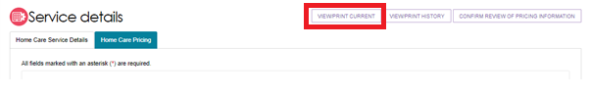
! Home care providers will be reminded to review or update home care pricing schedules for operational home care service items if they have not been reviewed or updated in the last 11 months.
Outlet and organisation administrators will receive a HCP annual pricing review task notifying them which services (in the outlet or organisation) are required to be reviewed. The task will close once all relevant services have been reviewed.
To assist providers in identifying all services requiring review, a Review pricing information – Home Care Service Items report is available from the Reports and documents tile. This report can be generated at the outlet or organisation level, respectively.
Please see Service and Support Portal User Guide - Tasks and Notifications for guidance on viewing and managing your tasks and notifications, including setting up email notifications.

Editing service sub-types
Service sub-types are individual services listed under a service item within an outlet in the Service and Support Portal.

Adding a service sub-type
The steps to add a service sub-type for a service item are outlined below.
Service sub-types are automatically populated when service items are added to your outlet; however, Administrators can edit service sub-types as needed.
- Select Outlet administration from the homepage.
Select the name of the outlet on the Outlet card you want to add a service sub-type to. The View outlet page will be displayed. Select VIEW SERVICE ITEMS
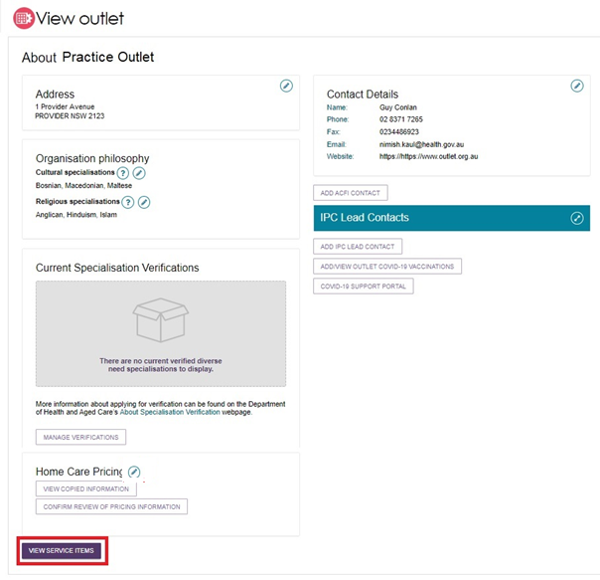
- To add a service sub-type, select the blue arrow next to See Sub-types under the service to see expanded service details.
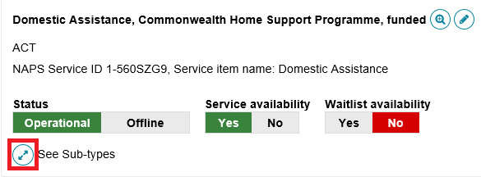
Then select ADD/REMOVE SUBTYPES.
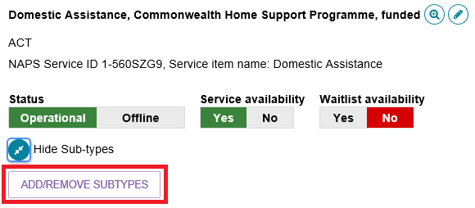
The Service Sub type page will be displayed.
- Select the sub-type you want to add to the service and then select SAVE.
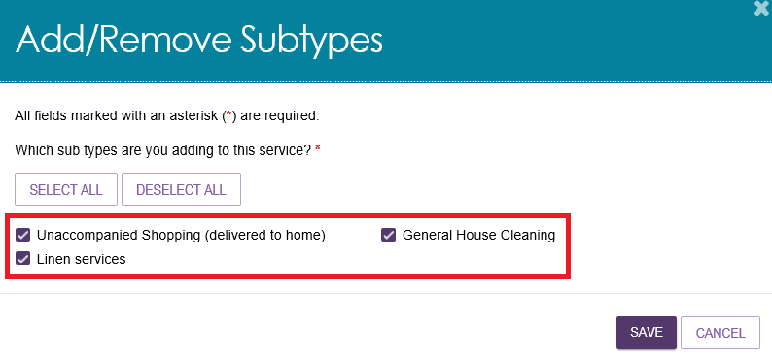
The service sub-type will be added to the service item. It will also be displayed in the service finder.

Removing a service sub-type
The steps to remove a service sub-type for a service item are outlined below.
- Select Outlet administration from the homepage.
- Select the name of the outlet on the Outlet card you want to remove a service sub-type from. The View outlet page will be displayed. Select VIEW SERVICE ITEMS.
- Select the blue arrow next to See Sub-types under the service to see expanded service details.
Then select ADD/REMOVE SUBTYPES.
- In the Add/Remove Subtypes box, deselect the subtypes you want to remove from the service item and select SAVE.
The service sub-type will be removed, and information about the service sub-type will not display in the service finder.

Maintaining service sub-types availabilities and waitlists
You can maintain detailed information about service sub-types for a service that you offer via the Service and Support Portal. You can edit details about:
- Service sub-type availability (and waitlist)
- Hours of operation for the service sub-type
- Notes of staffing for the service sub-type
- Whether transport is provided as part of that service.
Service sub-type information will be displayed on the Service Finder on the My Aged Care website. When you update this information, the changes will appear on the Service Finder by the next day.
- Navigate to the View Outlet details from the Outlet administration page for the outlet that you want to edit service and waitlist information for and select VIEW SERVICE ITEMS.
- To edit availability and waitlist information for service sub-types, select the arrows next to See Sub-types to display the sub-types that have been added to the service.
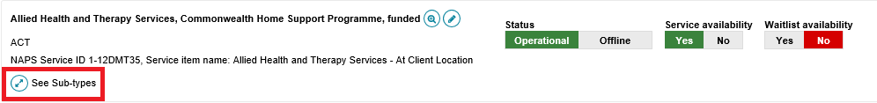
- Here you can edit the sub-type availability and sub-type waitlist availability by selecting the toggles and edit additional information about the service sub-type by selecting the Edit icon.
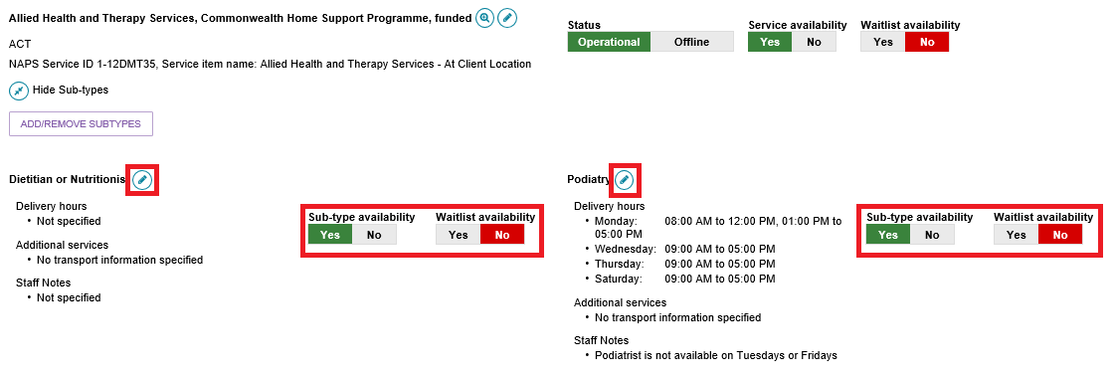
- Add any additional information about operating hours, staffing or transport for that service sub-type and select SAVE.
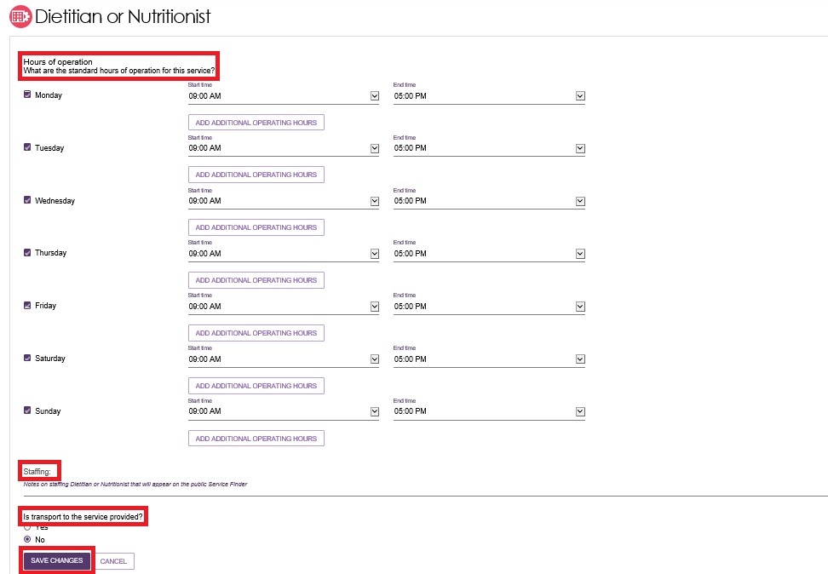
Your updated information will be saved.
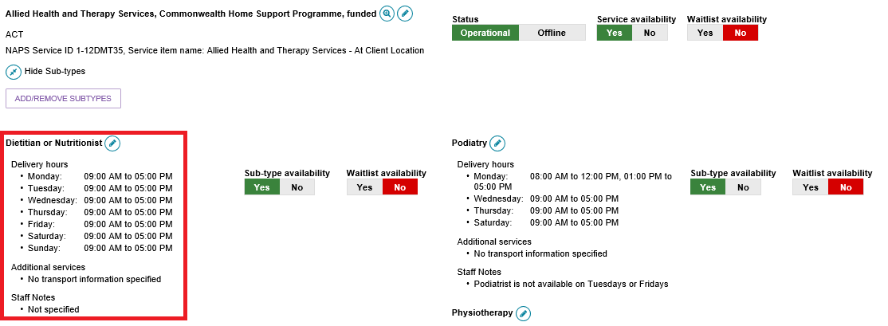

Add a room type
Residential Care providers can add information about the types of rooms their organisation offers.
The steps to add room information are outlined below.
Fields marked with an asterisk (*) are mandatory.
- Select Outlet administration from the homepage.
Select the name of the outlet on the Outlet Card you want to add room information to. The View outlet page will be displayed. Then click the VIEW SERVICE ITEMS button.
- From the View Service Items page, select Resident Care from the tab options. Select the blue arrow next to the service and select See room types.
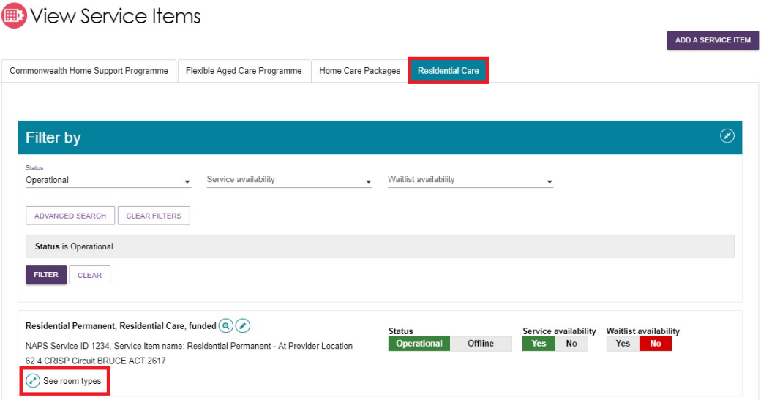
Then Select ADD ROOM TYPE.
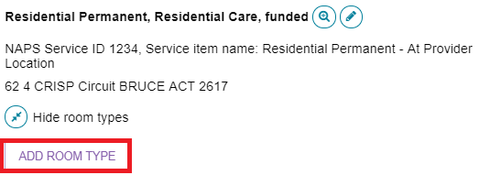
The Room Type page will be displayed.
Enter required information in the General room information and Pricing information sections.
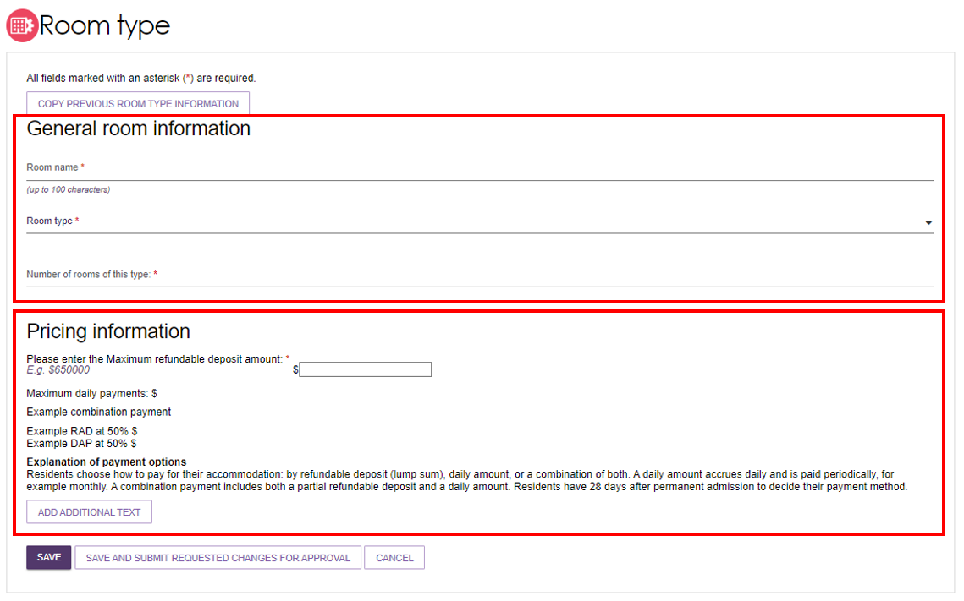
Ensure mandatory fields (red asterisk) are completed.
- If you enter a maximum refundable deposit (RAD) over $750,000, the following information banner will appear.
To publish and charge a room price above a RAD of $750,000 (or the equivalent daily payment), you must have a valid approval from the Independent Health and Aged Care Pricing Authority (IHACPA), or the former Aged Care Pricing Commissioner.
! If you do not have approval for this price for the room type, you cannot publish or charge this price. Conditional approval does not constitute approval until you have received a satisfaction of conditions letter from IHACPA.
- You must enter the date of IHACPA approval, enter the IHACPA approval reference number and attach the IHACPA approval letter for that room type.
The below fields will appear and need to be completed for rooms priced over $750,000.
- Approval or Conditional Approval
- Date of IHACPA approval (or Aged Care Pricing Commissioner approval) – IHACPA approvals are valid for 4 years. Once you enter the required approval details for a room, you will receive automatic notifications when your approval is nearing expiry. These will be sent at 6, 4 and 2 months before your Date of IHACPA approval indicates expiry. Rooms will be removed from My Aged Care if 4 years passes from your Date of IHACPA approval.
- IHACPA approval reference number – This is only required if your approval was granted on or after 1 July 2024. Approval letters issued prior to 1 July 2024 do not have an approval number.
- You will also need to attach and name the IHACPA approval letter for the room.
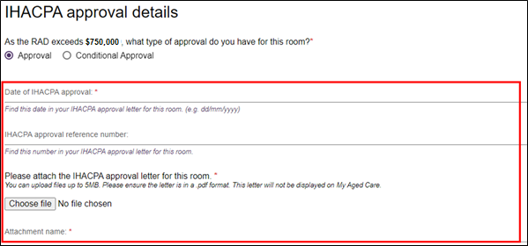

- Enter the required information under Key feature statement.
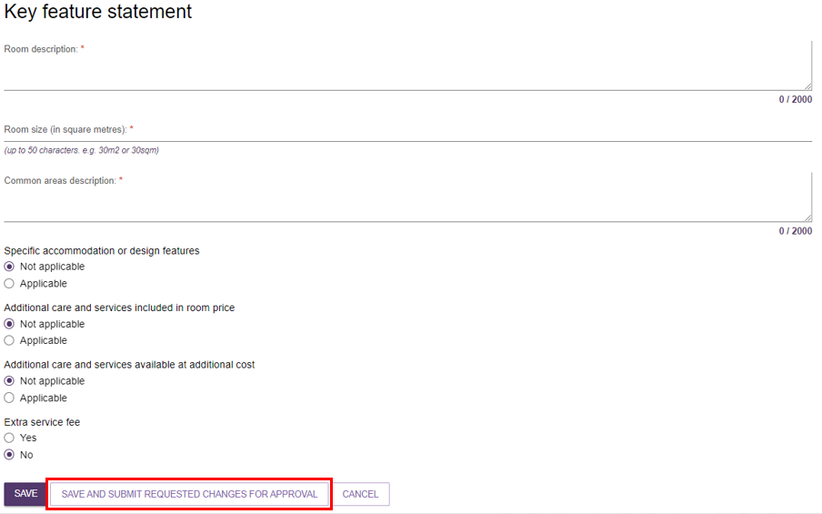
When entering room size (in square metres):
- if there is variation in room sizes, enter the size range of the room type from smallest to largest, e.g. 20sqm - 25sqm.
- indicate if the room size entered includes ensuite, e.g. 20sqm - 25sqm incl. ensuite.
- do not include private outdoor areas such as balconies or courtyards.
Please ensure that the room size entered aligns with information provided to IHACPA in your application for these rooms.
- Enter to submit this room information for publication select SAVE AND SUBMIT REQUESTED CHANGES FOR APPROVAL.
This room information will be displayed on the service finder once approved for publication by the Department (allow 3 business days).
If your room is not approved for publication, you will receive an email explaining the action you need to undertake before resubmitting. You can update your room request and submit again.
! If you select SAVE, this room information will be saved and not submitted for publication.

Edit room details
Residential Care providers can edit existing room information. The steps to edit room information are outlined below. Fields marked with an asterisk (*) are mandatory.
- To edit the details for a room, click on the edit icon (pencil).
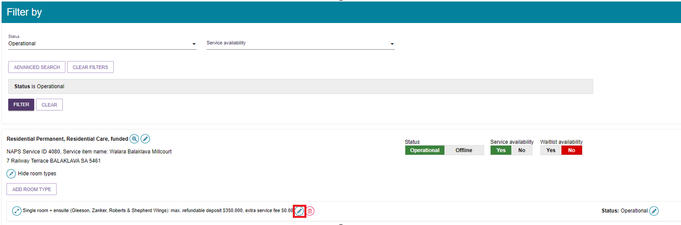
- Next, select the reason for resubmission from the drop-down menu and the continue to edit the details of the room.
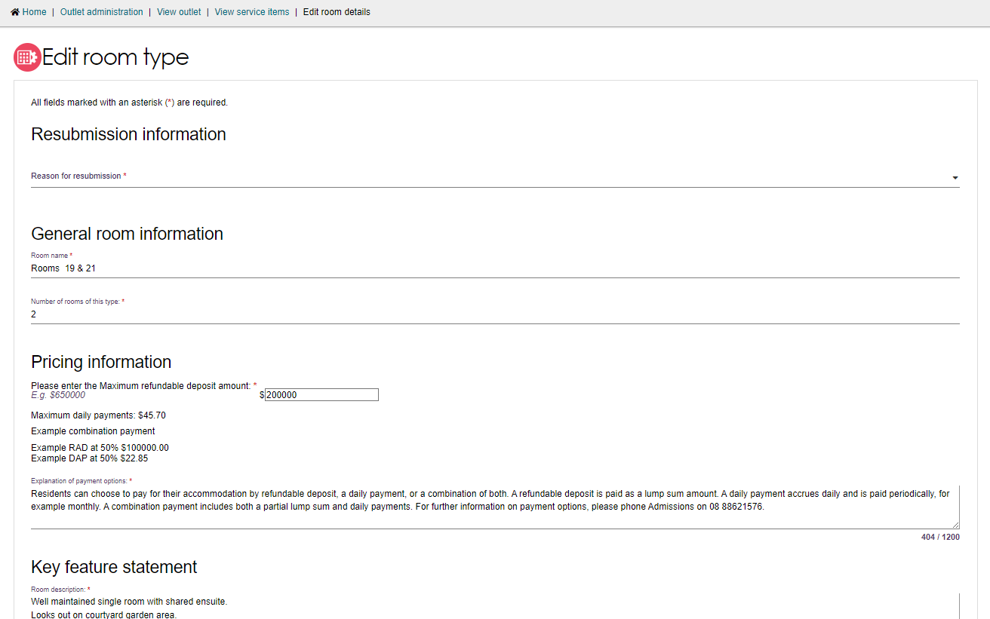
! Providers with an IHACPA approved maximum RAD over $750,000, can index the room price in line with legislation. For details on calculating the indexation of approved RADs visit www.ihacpa.gov.au.
NOTE: If you have selected Indexation of approved max RAD as the Reason for resubmission, you can only change the room price. If you wish to change other fields for the room, select a different resubmission reason.
- Scroll down to the bottom of the page. Select SAVE AND SUBMIT REQUESTED CHANGES FOR APPROVAL.
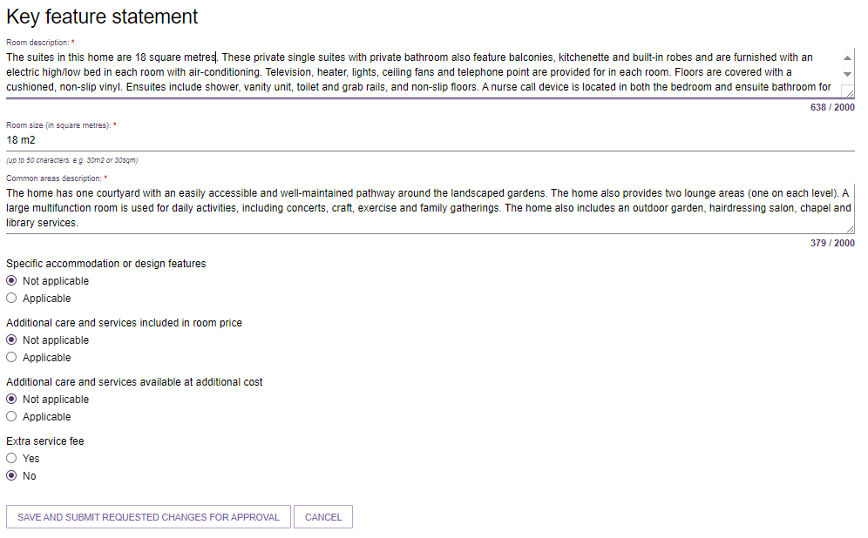
Once submitted, you will be redirected back to the View Service Items page and a green banner will display at the bottom of the screen confirming the edits were successfully submitted.

Change room status
- Click on the edit icon (pencil) next to the Status of the room you want to set as Offline or Operational.
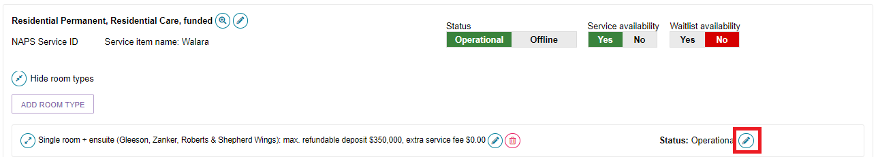
- From the pop-up select Offline (not displayed) from the change room status and select the reason for the change.
When you set the room to Offline a warning banner will appear advising that offline rooms are not displayed on My Aged Care.
Select SAVE.
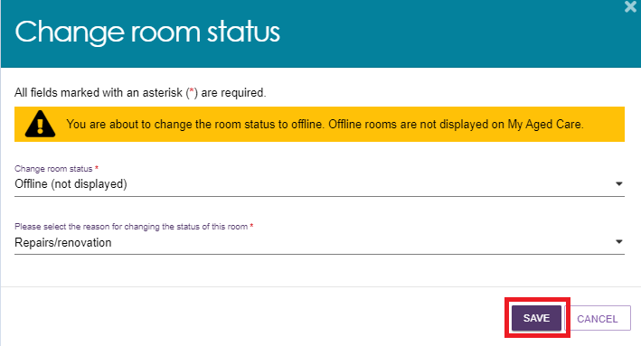
- A message will appear advising that you have successfully changed the status of the room. The status of the room will now display as Offline.
- If you wish to make an Offline room Operational, click on the edit icon (pencil) next to Status: Offline.
Select Operational (displayed) from the change status drop-down menu followed by the reason for the change. Then select SAVE.
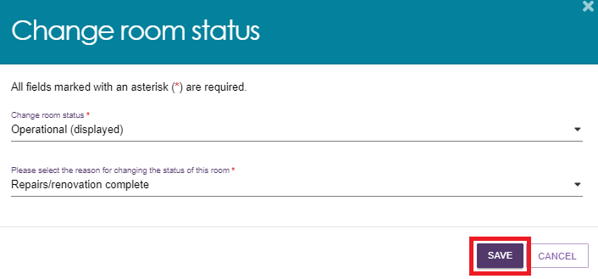
A green message will appear advising that you have successfully changed the status of the room and the room will show as Operational.
The room will be displayed on My Aged Care within 24 hours.

Delete a room
Residential Care providers can choose to permanently delete a room. Note that deletion of a room cannot be reversed.
- Click on the delete icon (bin) next to the room you wish to delete.
Ensure you select the correct room as the deletion of a room cannot be reversed.
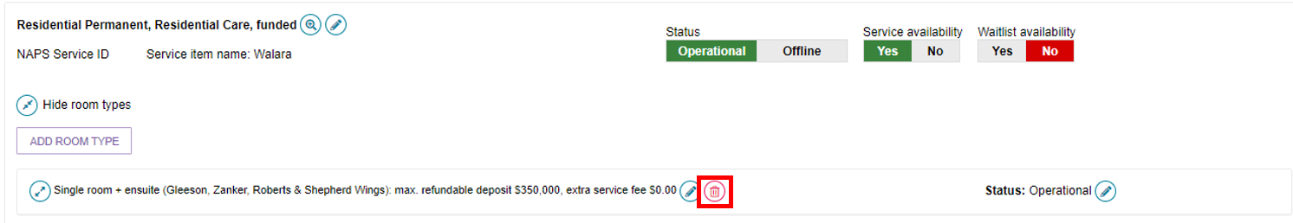
- From the pop-up, select the reason for deleting the room and click DELETE.
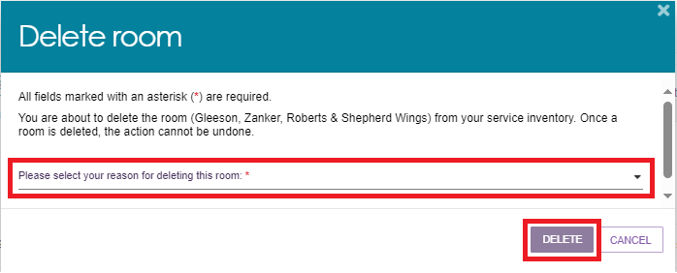
A green banner will display at the bottom of screen confirming the room has been successfully deleted.

Transferring service items
Organisation administrators may choose one or multiple service items to transfer between outlets of an organisation in the Service and Support Portal. Using this function, administrators can:
- Select and list the service item(s) to transfer
- Select an outlet to transfer service item(s)
- Generate and export a report listing service referrals linked to the service item(s)
This functionality does not apply to residential care (permanent and respite).
! If you are required to transfer clients between organisations, for example, as part of a merger or acquisition, contact the My Aged Care service provider and assessor helpline on 1800 836 799, who will be able to initiate the transfer of clients for you.
To transfer a service item between outlets, follow the steps below.
! Upon transferring a service to a new outlet, any diverse needs specialisations recorded against the service will be removed.
- From Outlet administration select the outlet that contains the service items you wish to transfer to a different outlet.
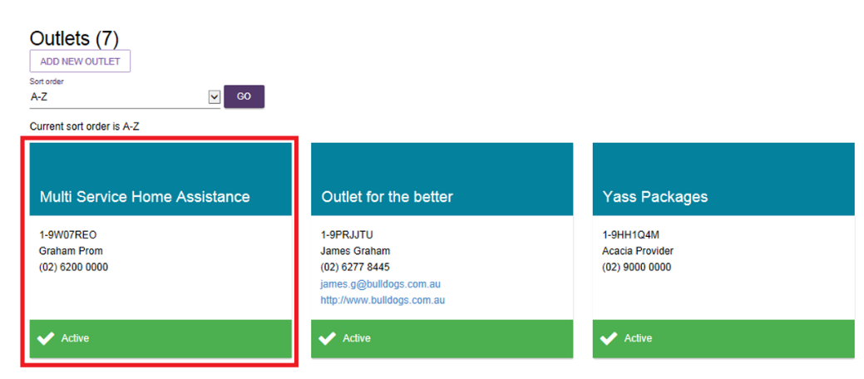
- Under View Service Items, select on the TRANSFER SERVICE ITEM button.
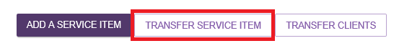
- Select the outlet you wish to transfer the service items to using the list provided. You can search for a specific outlet using the search function. Select NEXT to continue.
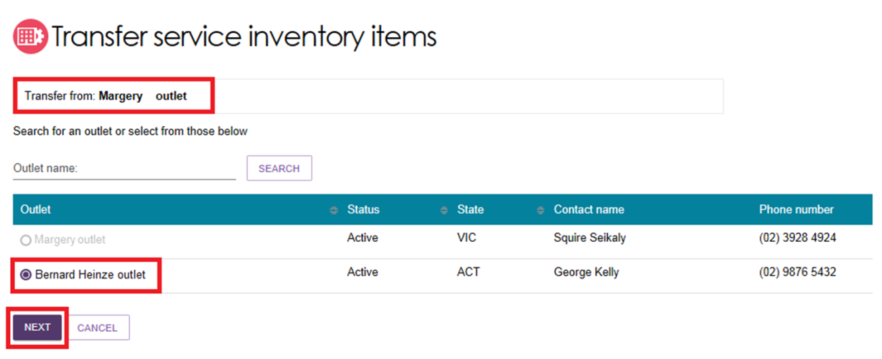
- Select the service item(s) that you want to transfer to another outlet. You can search for specific service items using the search functionality (by Programme or Service type). The following information is displayed to help identify each service item: the service type, NAPS service ID, service item name, funding state and funding region. You can transfer up to a maximum of 25 service items.
Select NEXT to proceed to the next screen. If you select CANCEL, you will exit the transfer process and be re-directed to the View Outlet screen.
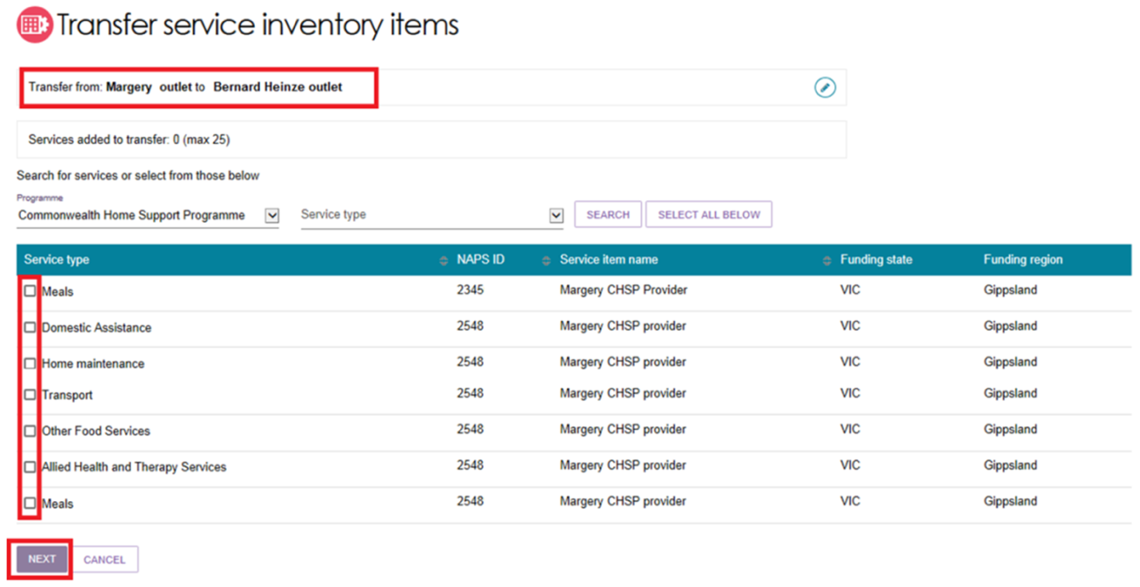
- Review the information to ensure that it is correct. To remove a service item, select the red bin icon. To cancel the transfer, select CANCEL.
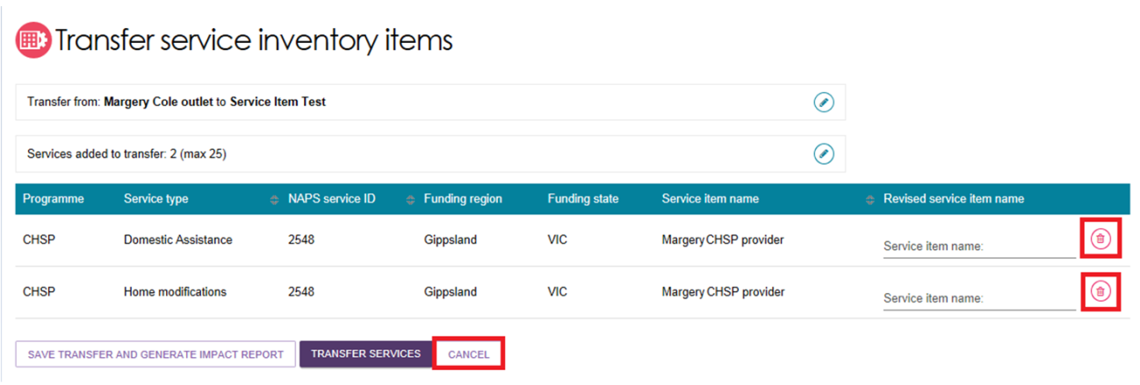
- To see the impact the service transfer will have on your organisation before you complete the transfer, select the SAVE TRANSFER AND GENERATE IMPACT REPORT button.
This report will appear in the Reports and documents tab. You can review the report and resume the transfer at a later stage.
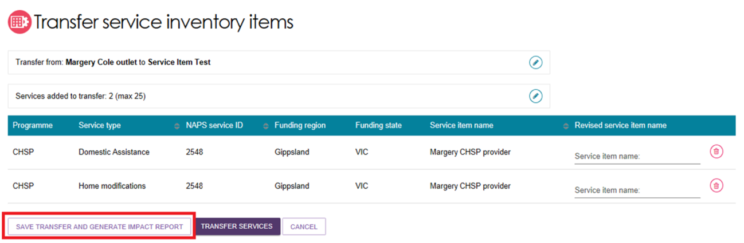
The following banner will display.
! The Transfer Impact Report may, on occasion, take some time to generate. If this happens, an alert message will prompt on screen. You can navigate away from the Transfer Service Inventory Items screen and be notified when the Transfer Impact Report completes. Alternatively, you may choose to transfer service inventory items without reviewing the report at any time.
- If you have reviewed the impact of the transfer and want to proceed, select TRANSFER SERVICES.
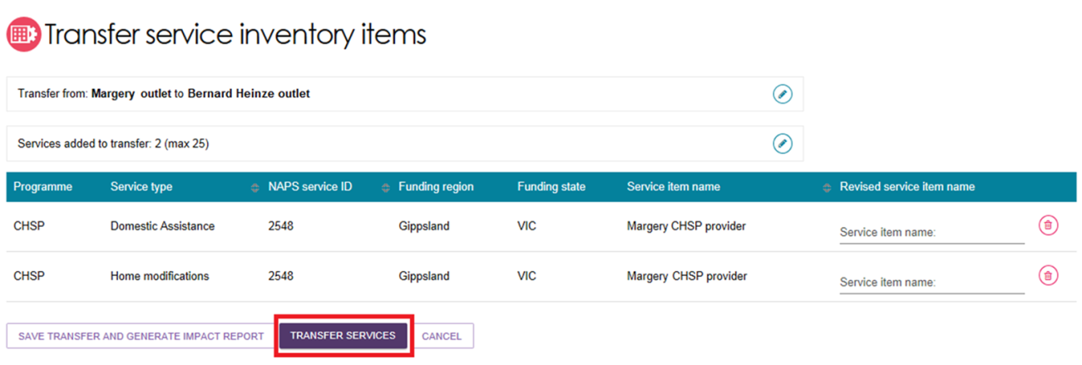
- To make any changes, select CANCEL. To finalise the transfer, select CONFIRM TRANSFER.
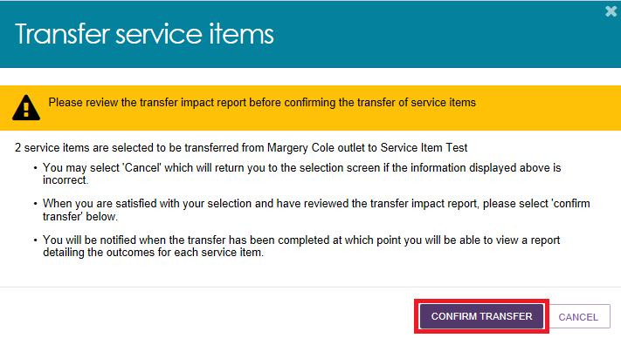
The transfer may take some time to complete. Review the status of the transfer by reviewing the service transfer log.
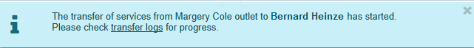
When the transfer action has started, the impacted records in the transfer process will be locked – the transfer process will run in the background.
Users will be able to view the records but cannot change the details until the transfer process has successfully completed.

Reviewing the Service Transfer Log
To review the status or details of previous and current service transfers, review the Transfer Log.
- Select Outlet administration from the homepage.
- Select an outlet to access the transfer log.
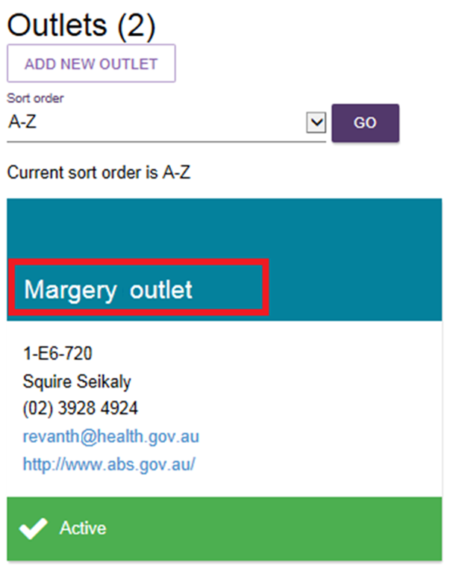
- Select the VIEW TRANSFER LOGS button.
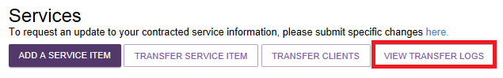
The transfer log will display information about past and current service and client transfers, including:
- Transfer type (service or person)
- Transfer date
- Status (In progress, completed, completed with errors)
For more detailed information about the transfer, select the magnifying glass icon.
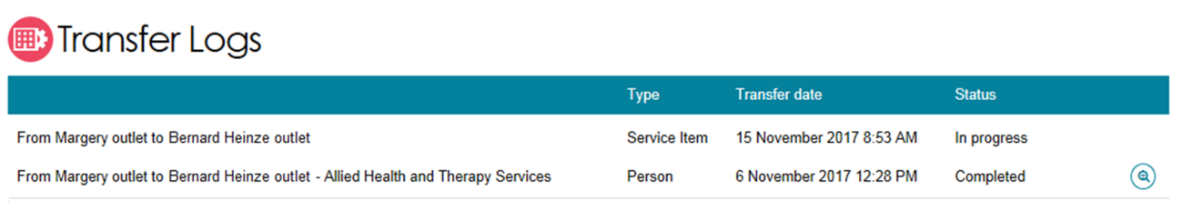
If a transfer has not been completed successfully, you can retry by selecting the magnifying glass icon, selecting the items you want to retry and selecting the RETRY SELECTED button.
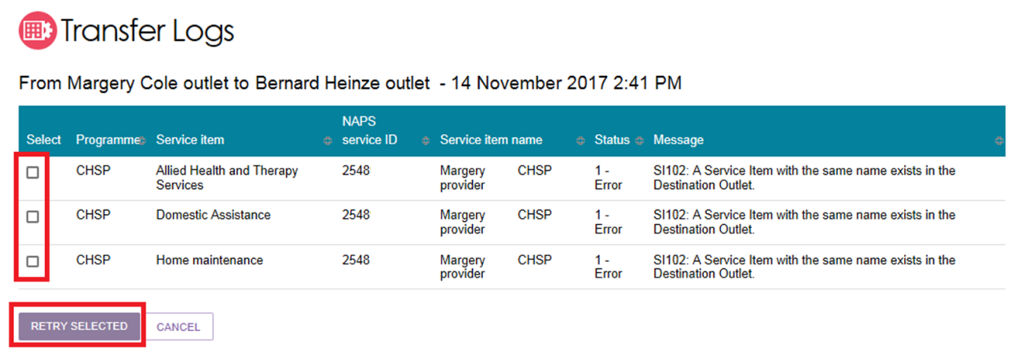

Transferring clients between service items
Organisation administrators may choose one or multiple clients to transfer between services (of the same service type) within an outlet or to another outlet within their organisation.
! This functionality does not apply to residential care (permanent and respite).
To transfer a client(s) to another service, follow the steps below.
- From Outlet administration select the outlet that contains the clients you wish to transfer to another service (the outlet you want to transfer clients from).
- Select on the TRANSFER CLIENTS button to start the process of transferring client(s) to another service.
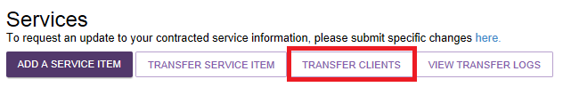
- Select the service that the client(s) is currently linked to. You can use the search functionality to find specific service types. Select NEXT to continue.
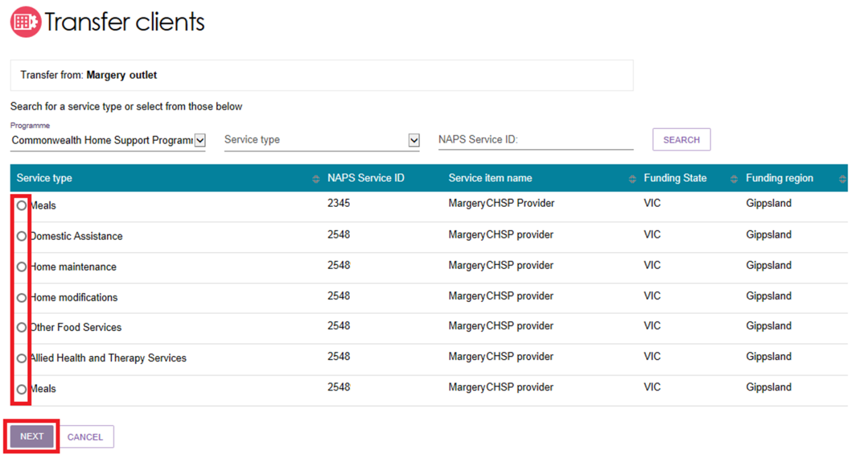
- You can choose to transfer clients to another service within the same outlet or transfer clients to another service under another outlet. Choose from one of these options and select NEXT.
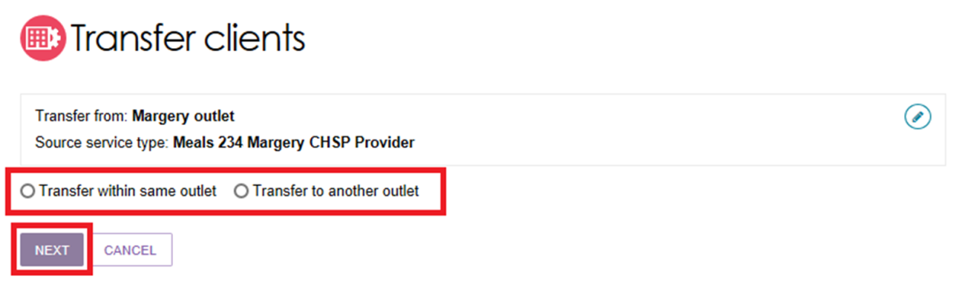
To transfer clients to another outlet, you must be an organisation administrator.
If you select Transfer to another outlet you will not be able to proceed unless you select an outlet.
- Select the service that you want to transfer clients to, from the list provided and select NEXT to continue.
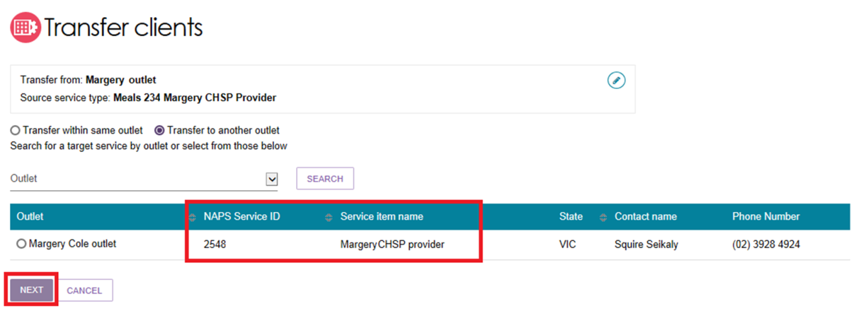
- Select the client(s) that you wish to transfer to the new service. You can transfer up to a maximum of 50 clients at one time. Select Transfer clients to continue.
You can also search for client to transfer by their last name, first name, or their Aged Care User ID.
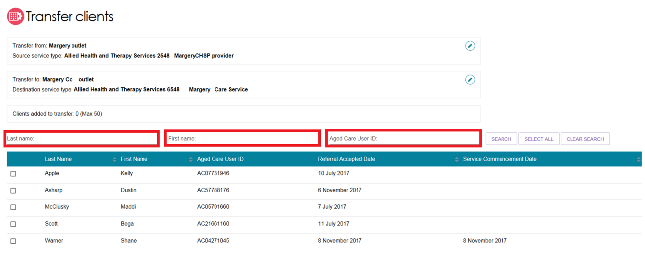
- Review the information about the transfer. If correct, select CONFIRM TRANSFER to complete the process.
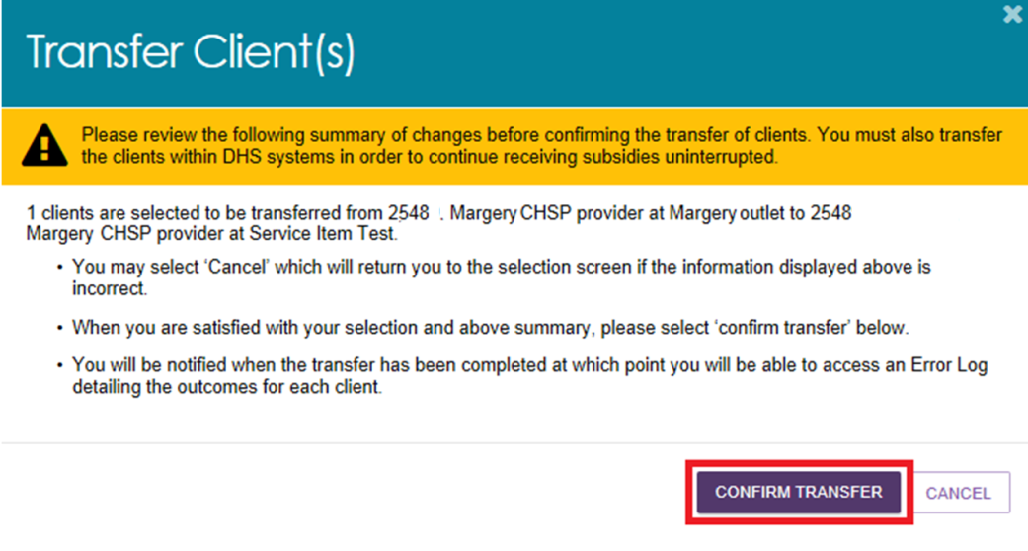

Reviewing the Client Transfer Log
To review the status or details of previous and current client transfers, review the Transfer Log.
- Select Outlet administration from the homepage.
- Select an outlet to access the transfer log.
- Select the VIEW TRANSFER LOGS button.
The transfer log will display information about past and current service and client transfers, including:
- Transfer type (service or person)
- Transfer date
- Status (In progress, completed, completed with errors)
For more detailed information about the transfer, select the magnifying glass icon.
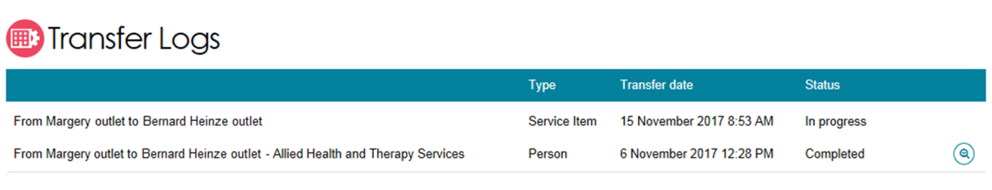
If a transfer has not been completed successfully, you can retry by selecting the magnifying glass icon, selecting the items you want to retry and selecting the RETRY SELECTED button.
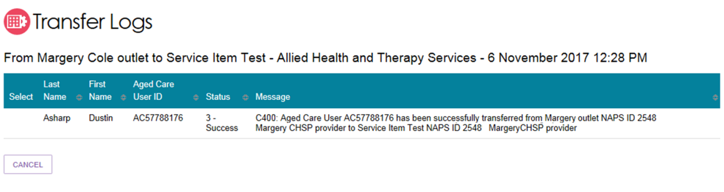
! If you continue to experience issues with transferring clients, please call the My Aged Care service provider and assessor helpline on 1800 836 799 for assistance.

Activating/deactivating a service item
The steps to activate/deactivate a service item are outlined below.
- Select Outlet administration from the homepage.
- Select the outlet that contains the service items that you want to activate/deactivate and then select VIEW SERVICE ITEMS.
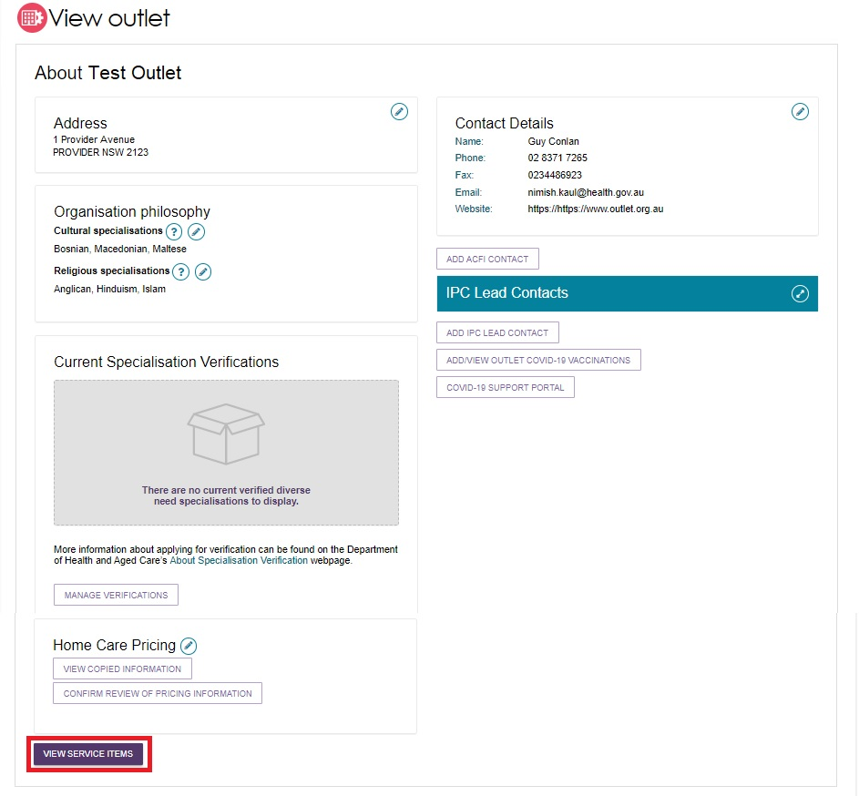
- Select the Residential Care tab.
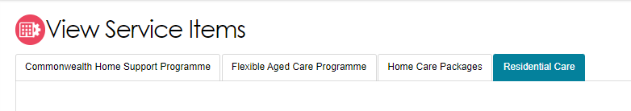
- For the services that have been added to the outlet, select Operational to activate the service item. Alternatively, select Offline to deactivate the service item under the Status heading.
Only Operational services will display in the service finders.
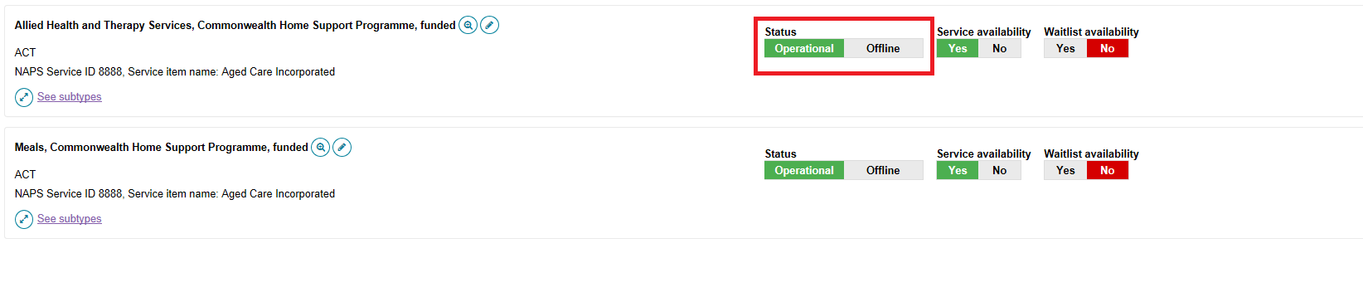
! The Offline status has replaced the Inactive status and should be used to indicate where a funded service is not currently offered by the provider. For example, the service is at capacity. Services that are Inactive are services that are no longer funded by the Department. Inactive services will not be visible in the My Aged Care Service and Support Portal. Please contact the My Aged Care service provider and assessor helpline on 1800 836 799 if you have questions about your Inactive services.

Maintaining service delivery outlets

Activating an outlet
After service items are added, outlet(s) need to be made active so that the following occurs:
- The service items display in the service finder.
- Contact centre staff and assessors can send electronic referrals to the appropriate outlet.
The steps to activate an outlet are outlined below.
- Navigate to the View Outlet details from the Outlet administration page for the outlet that you want to activate and select ACTIVATE OUTLET.
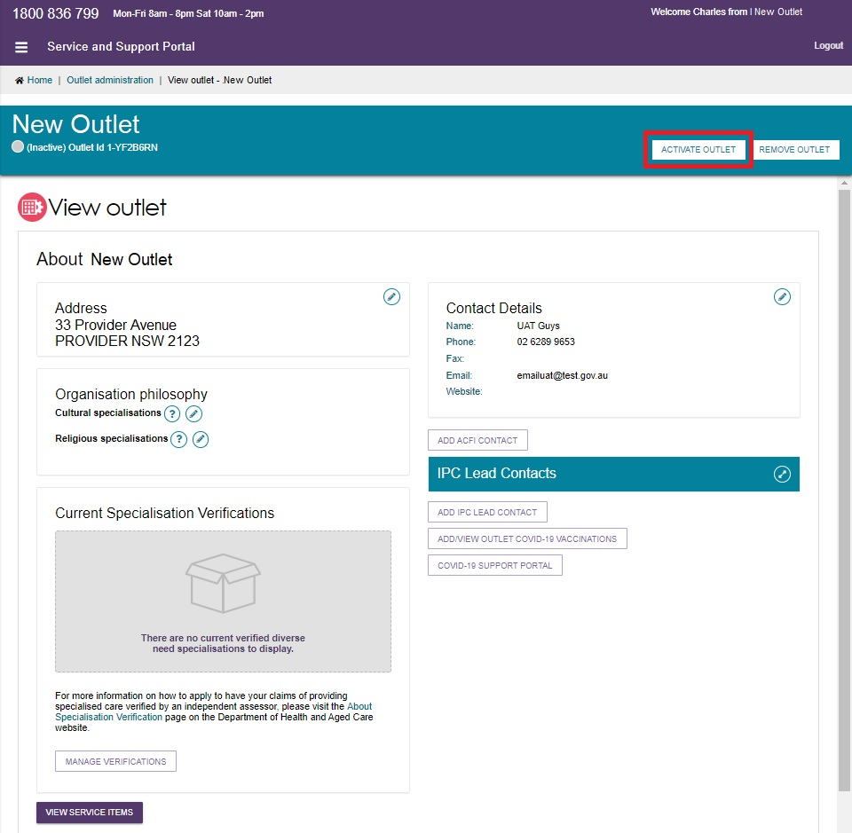
- Select ACTIVATE OUTLET to confirm that you wish for this information to be displayed in the service finder. A warning message will display:
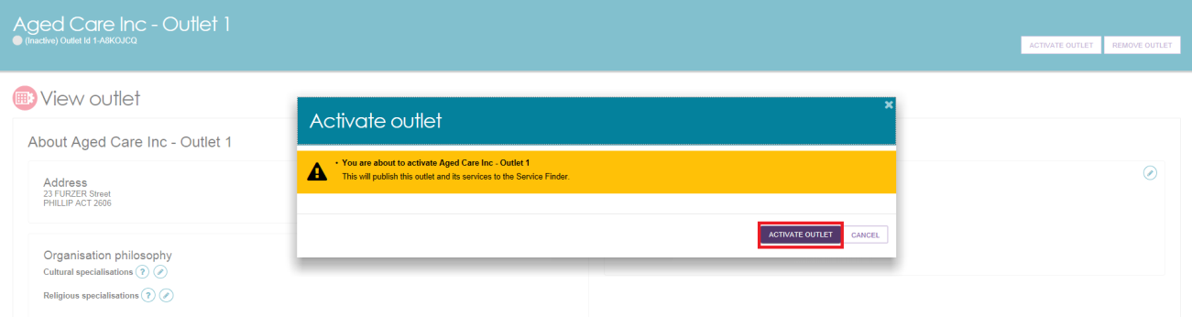
Your outlet is now active and operational service item information will display in the service finder, and will display as Active in the Service and Support Portal.
Assessors can only match and refer to active services.
Card View
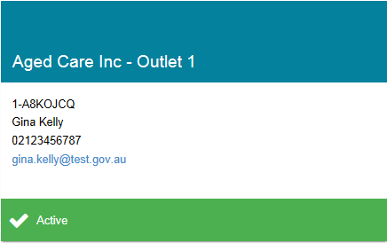
Outlet View
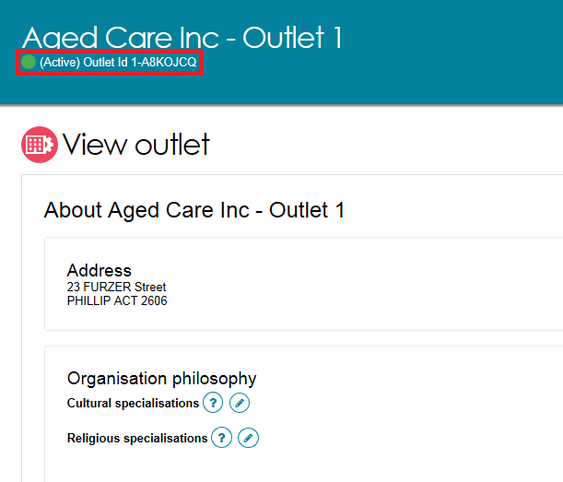

Deactivating an outlet
To remove an outlet from the service finder on the My Aged Care website, and stop referrals being sent to the outlet, it must be deactivated.
The steps to deactivate an outlet are outlined below.
- Select Outlet administration from the homepage.
- Navigate to the View Outlet details from the Outlet administration page for the outlet that you want to deactivate.
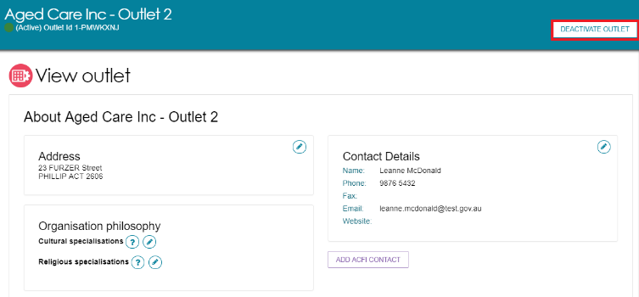
- Select DEACTIVATE OUTLET to confirm that you wish to deactivate the outlet.
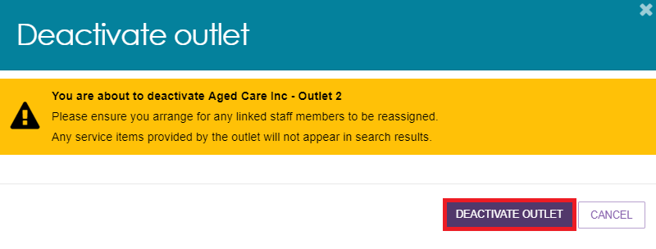
The outlet is now inactive, does not display on the relevant service finder or receive referrals, and displays as Inactive in the Service and Support Portal.
! An outlet cannot be made inactive if there are accepted and commenced services.

Removing an outlet
! If you want to create an outlet with the same name as the one you removed, you will need to call the My Aged Care service provider and assessor helpline on 1800 836 799.
To remove an outlet from the Portal, it must be in the status of Inactive.
The steps for removing an outlet are outlined below.
- Select Outlet administration from the homepage.
- Navigate to the View Outlet details from the Outlet administration page for the inactive outlet you wish to remove and select REMOVE OUTLET.
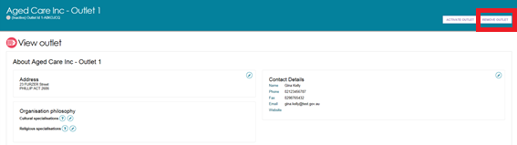
- Select REMOVE OUTLET to confirm you wish to remove the outlet.
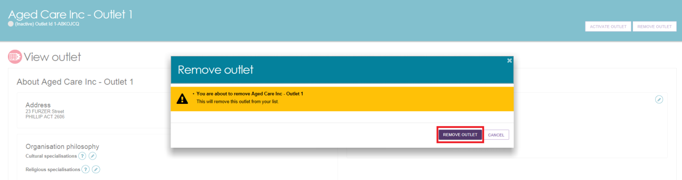
The outlet will no longer display in the Service and Support Portal.

Editing outlet details
The steps to edit an outlet are outlined below.
! Only Non-contractual information can be edited in the Service and Support Portal.
- Select Outlet administration from the homepage.
- Select the name of the outlet on the Outlet card you want to edit.
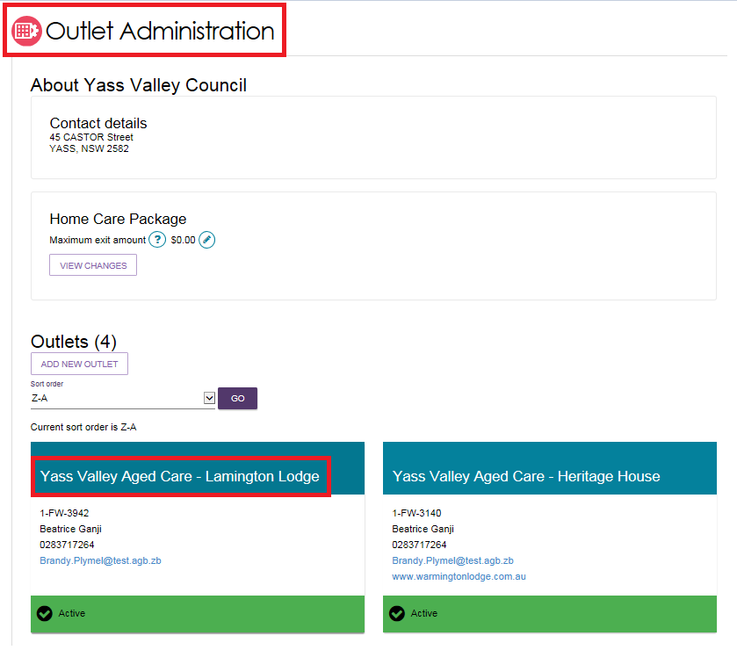
- On the View outlet page, select the area that you would like to edit, Address, Contact details or Organisation philosophy.
You can also change the Organisation philosophy when viewing your outlet information.
For more information on Organisation Philosophy refer to Editing the organisation philosophy and Specialised services.
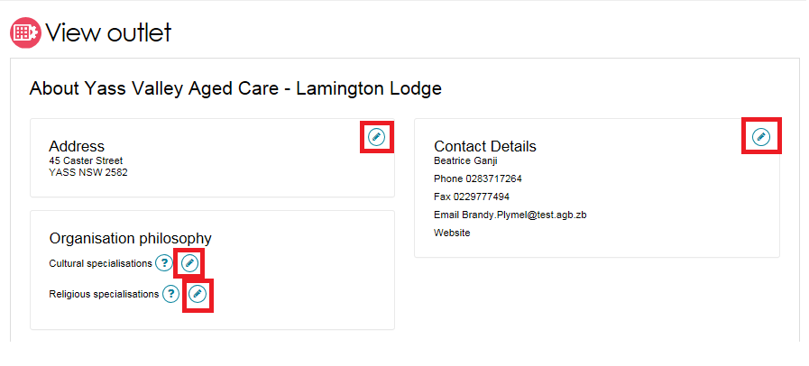
- Edit information and select SAVE CHANGES. To edit address details, select Edit next to the outlet address.
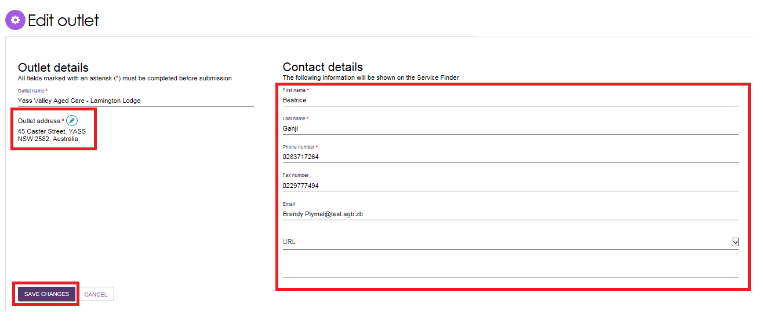

Tasks and notifications

Viewing tasks and notifications
You can view tasks and notifications in the Service and Support Portal. The steps to view tasks and notifications are outlined below.
! To view tasks for a particular outlet, you must be logged into the relevant outlet. You can do this by selecting the outlet you wish to log in to next to the Logout link at the top right of the portal.
- From the Service and Support Portal homepage select Tasks and notifications.
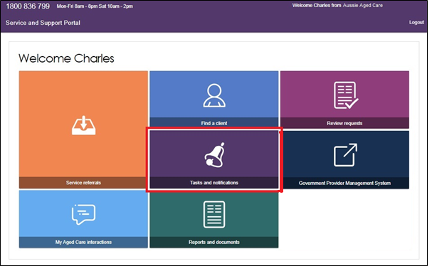
- To view tasks for your organisation, select Tasks. Select an outlet to view tasks related to that outlet.
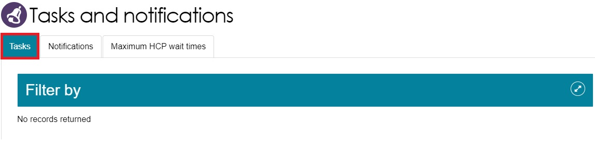
In the Tasks tab, you will be able to view all tasks that are relevant to your role. You can sort tasks by:
- Due date
- Category
- Title/Description
- Aged Care User ID
- Client name
- Activity ID
! Tasks that have been marked as important for your outlet by your outlet administrator will be displayed with a visual indicator. The managing preferences section in this guide explains how to set tasks as important.
- To view notifications for your organisation, select Notifications. Select an outlet to view tasks related to that outlet.
You will only be able to see tasks and notifications that are associated to your outlet and for clients you are providing services to. Assessors will be able to see all tasks and notifications for clients.
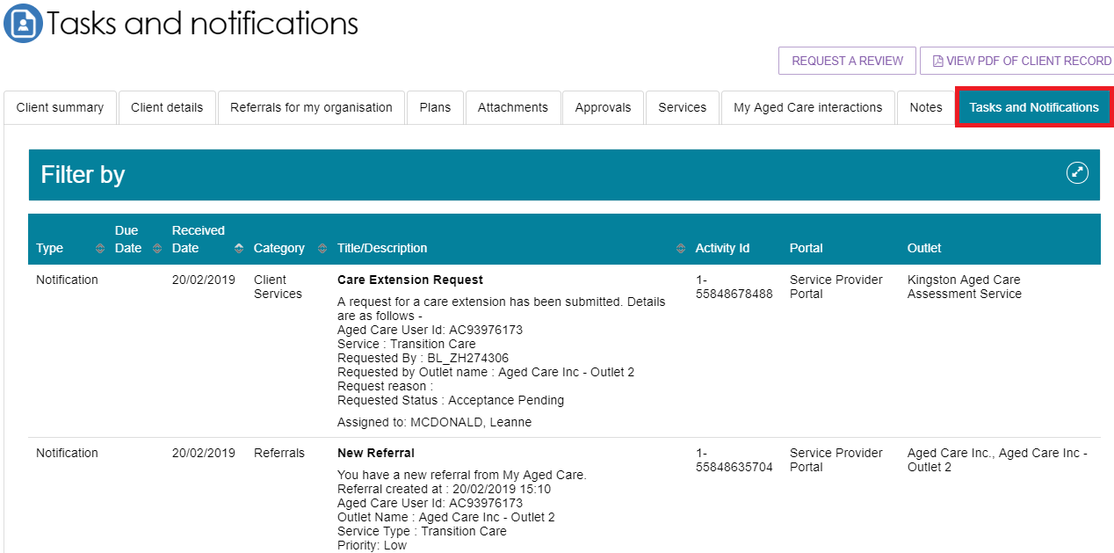
- You can search for specific tasks using the filter options or using custom filters in Advanced Search. Select the arrows to the right to expand or collapse the filter options.
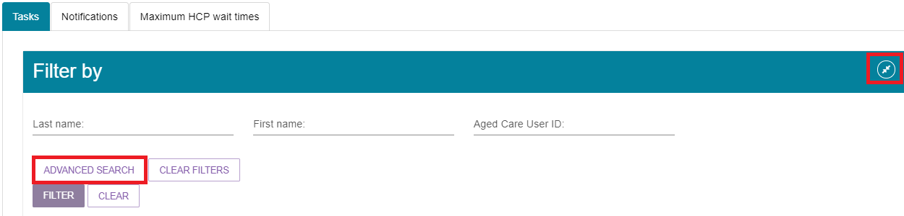
To apply custom filters, select ADVANCED SEARCH and choose filters from the drop-down menu and select ADD FILTER for each filter you want to apply.
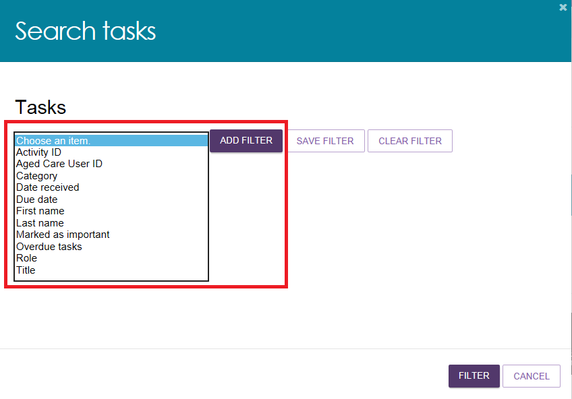
- The hyperlink under the task description will take you directly to the individual record and the section of the portal where you can action the task. Alternatively, you can navigate to the clients record by selecting the client’s Aged Care ID from the tasks list.
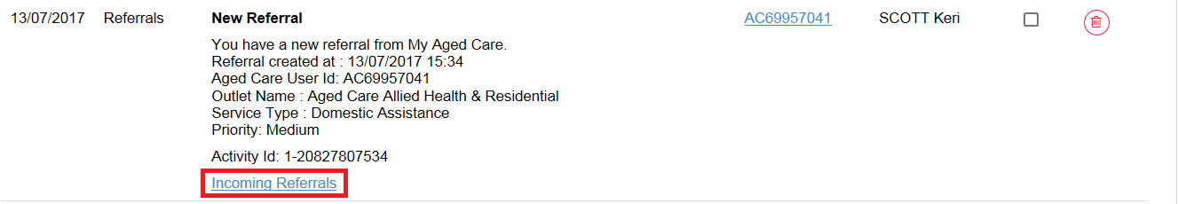
For example, selecting the link in an Overdue referral task will take you directly to the Incoming referrals tab where you can review the referral and determine whether to accept or reject the referral or place the client onto a waitlist, where appropriate.
Once the action required from the task has been completed, the task will automatically be removed from your task list.

Managing task and notification preferences
You must be an Administrator to manage task and notification preferences for your organisation or outlet. If you need to add this role to your user account, please see your organisation administrator.
As an Administrator, you will be able to:
- Edit email address and email frequency for new task and notifications
- Turn off visibility of notifications in the Portal
- View description of each task and notification, including which user types will be able to see them
- Edit individual task and notification preferences
- Mark a task or notification as important to your outlet.
These settings will affect all staff assigned to your outlet, so please ensure all staff are made aware of any changes you make.
- From the Service and Support Portal homepage select Tasks and notifications.
- Select the Manage Preferences tab.
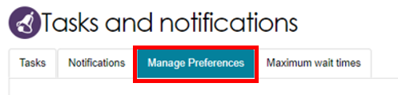
- If you are the Administrator for your organisation, you will be able to select which outlet you want to configure task and notification preferences for.
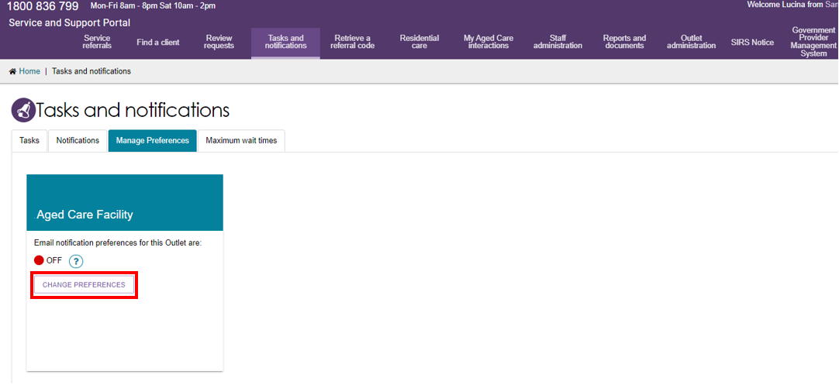
If you are the Administrator for your outlet, you will only be able to see your outlets preferences.
- The preferences page for the outlet will open. At the top of the page, you can configure the overall preferences for email preference, email address, email frequency and notification visibility in the portal.
You can choose to hide all notifications or hide individual notification types for the outlet. Selecting No to hide all means that no notifications for the outlet will be visible to staff associated with the outlet. Selecting No for an individual notification type means that only notifications of that type will be hidden for staff associated with the outlet.
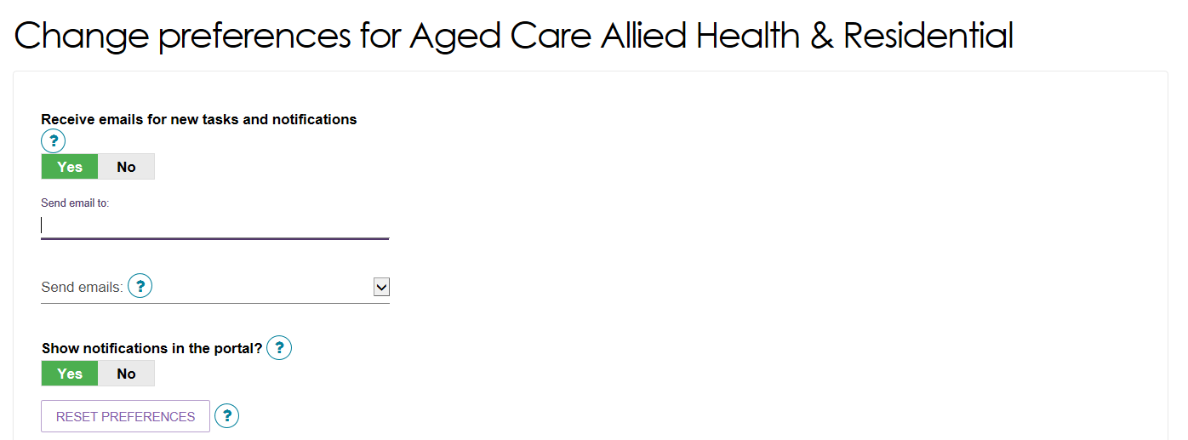

Tasks and notifications are sorted by category. Select the arrow icon to expand/collapse each category.
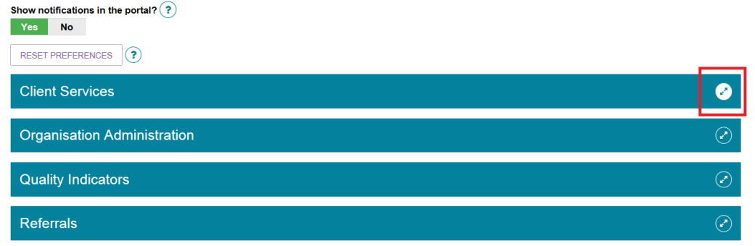
For each task or notification, you will be able to view:
- Type (e.g. task or notification)
- Title and brief description of the why the task or notification has triggered
- User type who can view or action the task or notification
For each task or notification, you will be able to individually configure:
- Whether to send an email when a task or notification generate
- Frequency of email notification, if enabled
- Whether to display a task or notification as important in the portal
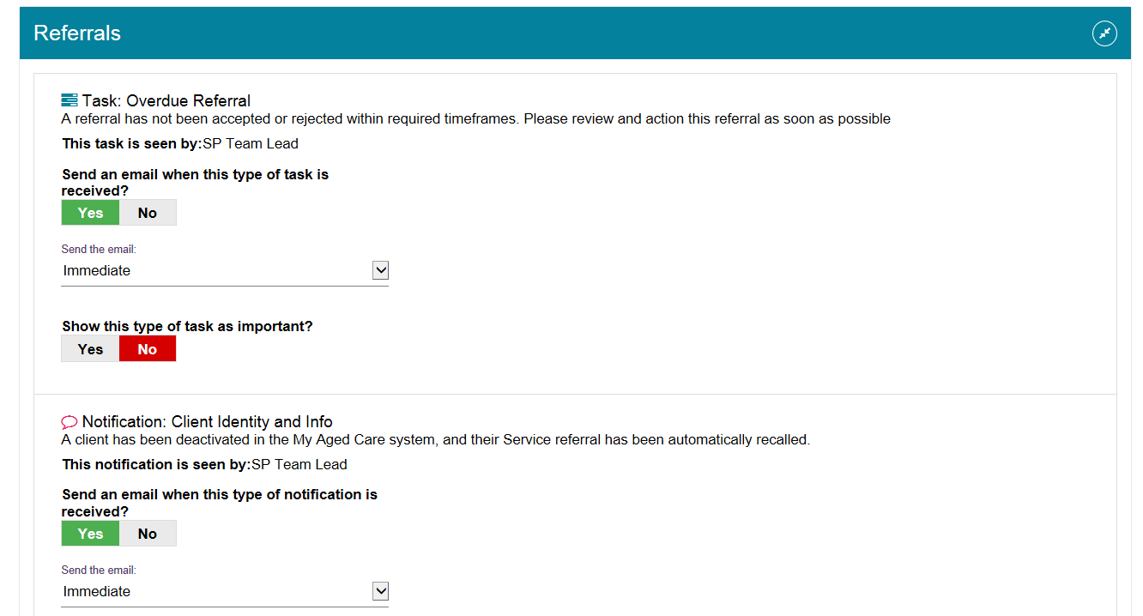
If you choose to mark a task or notification as important, staff within your outlet who can view that particular task/notification will see a visual indicator in their portal. For example, a notification of home care correspondence.
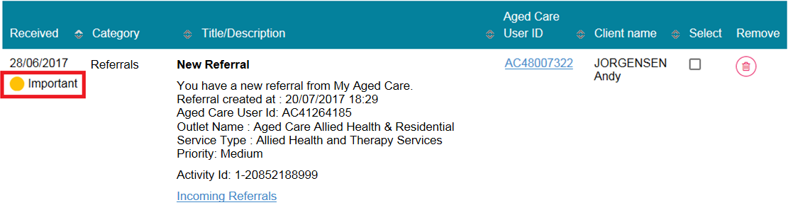
- Select SAVE when all changes have been made. You can reset the preferences by selecting RESET PREFERENCES at the top of the page.
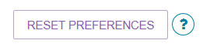

Creating and maintaining staff accounts
After you have created outlets for your organisation, you can create and maintain staff accounts. For more information about staff roles refer to Staff Roles in the Service and Support Portal.

Viewing staff accounts
By selecting Staff administration on the homepage, you can view all current staff that have access to the Service and Support Portal. You can sort staff alphabetically, or by the outlet(s) they are assigned to.
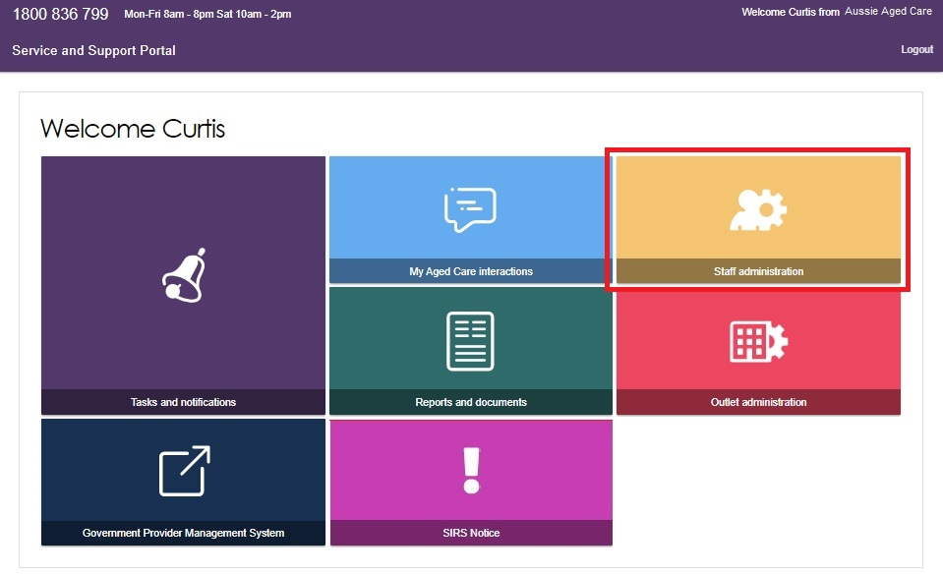

Adding new staff accounts, allocating roles and outlets
After you have created outlets for your organisation you can create staff accounts. You will need to assign roles to your staff and assign your staff to one or more outlets.
Staff can be assigned one or more roles (Administrator, Team Leader, Staff Member) at the same time within the Portal. The role(s) assigned to staff will apply across all outlets they are assigned to.
The steps to add a new staff account are outlined below.

! Staff assigned the Organisation Administrator role can manage all outlets for their organisation.
Staff assigned the Outlet Administrator role for one or more outlets will only be able to manage services and staff for the outlet(s) they have been assigned.
- Select Staff Administration from the homepage.
- Select ADD NEW STAFF from the staff administration page.
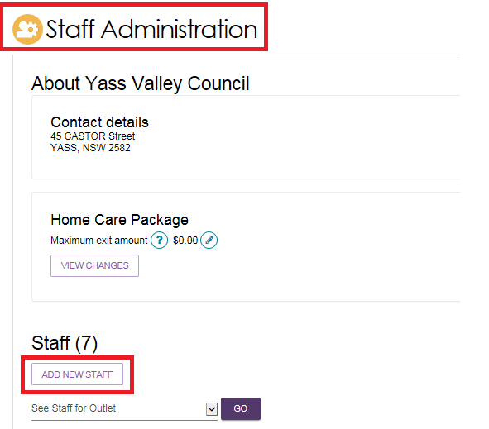
- You must enter staff details (First name, last name, unique email and a contact number), assign role(s) to staff, and assign staff to one or more outlets. Next, select SAVE.
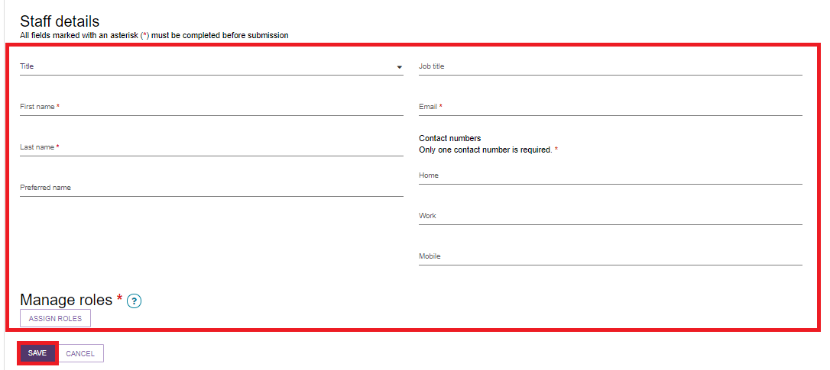
- You can assign staff to either the Organisation Level or Outlet Level. Organisation Level allows staff to access to the Organisation details, including all outlets for that organisation. Alternatively, you can choose to assign staff to access one, multiple, or all outlets under the Organisation.
Then, select SAVE and SAVE ROLES.
A person assigned the administrator role at the organisation level.
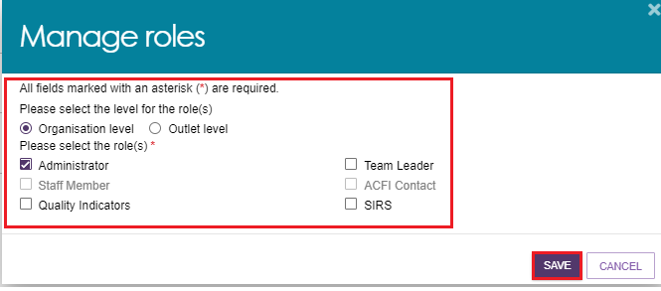
A person assigned the roles of administrator and team leader at the outlet level.
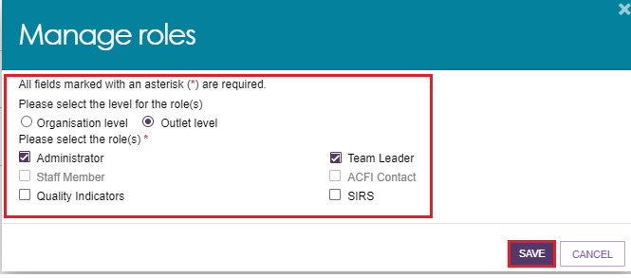
Choosing an outlet for the role.
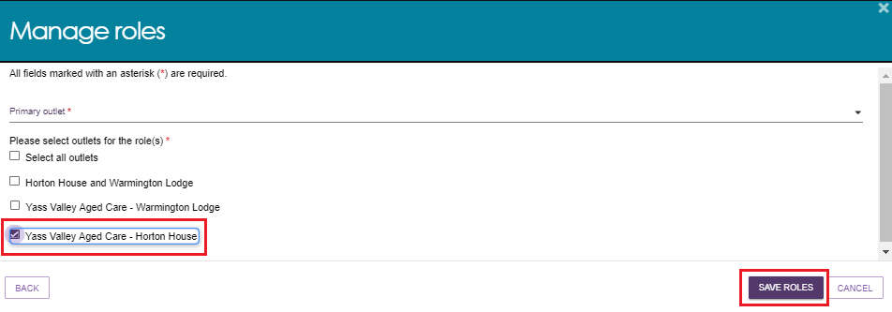
- Service Provider Administrators can add staff to additional roles in their outlet.
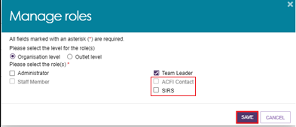
! The first time each staff member logs into the Service and Support Portal, they will need to follow the steps outlined in Logging in to the Aged Care Systems.

Editing a staff account
The steps to edit a staff account are outlined below.
- Select Staff administration from the homepage.
- Select the name on the Staff card that you want to edit.
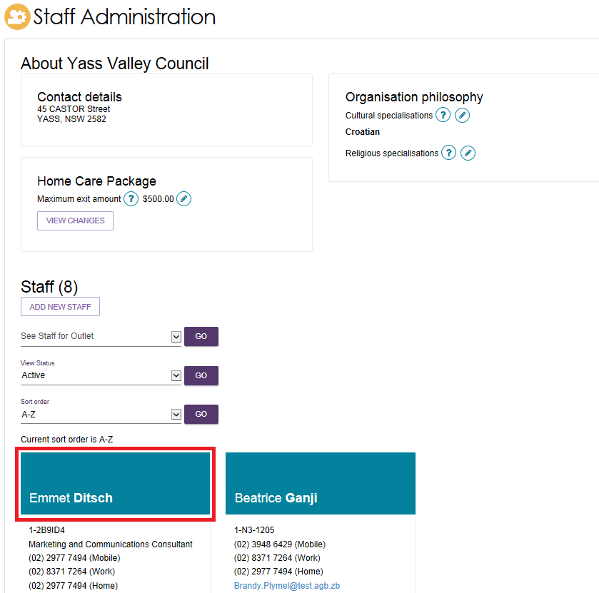
- Select EDIT STAFF DETAILS.
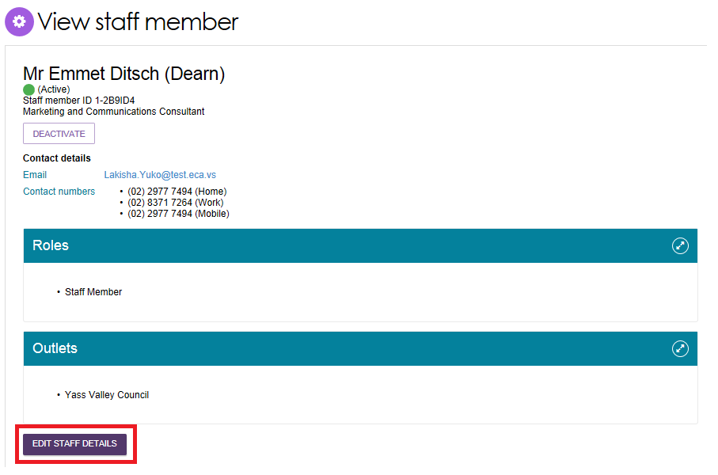
- Edit staff details and select SAVE.
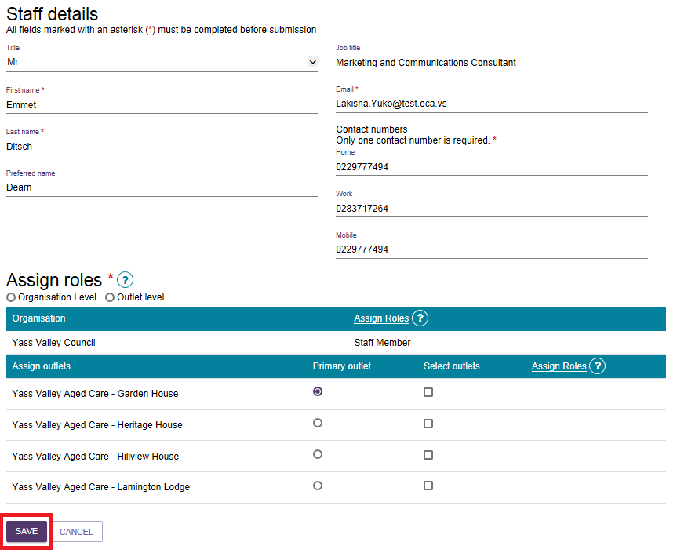

Deactivating staff accounts
Deactivating an account will permanently lock the account for the staff member and remove their access to the Service and Support Portal.
The steps to deactivate a staff account are outlined below.
- Select Staff administration from the homepage.
- From the Staff Administration page, select the name of the staff member on the Staff card that you want to deactivate.
- From the View staff member page, select DEACTIVATE.
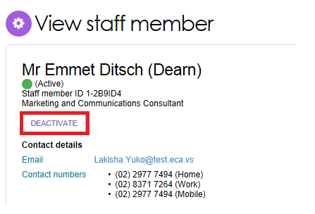
- Select DEACTIVATE ACCOUNT to confirm.
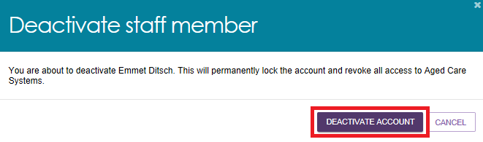
The staff member account will now appear as Inactive in the Service and Support Portal.

Removing staff accounts
Inactive staff members (that have previously been deactivated) can be removed from organisations and outlets and will no longer display in the Service and Support Portal.
! For information on removing a staff member’s authorisations in the Relationship Authorisation Manager (RAM), refer to Managing Authorisations.
If you need to restore access for a staff member who’s been removed, call the My Aged Care contact centre. You cannot re-create a portal user account using the same email address and myID.
The steps to remove a staff account are outlined below.
- Select Staff administration from the homepage.

- From the Staff Administration page, select Inactive from the View Status drop down menu to view inactive staff.
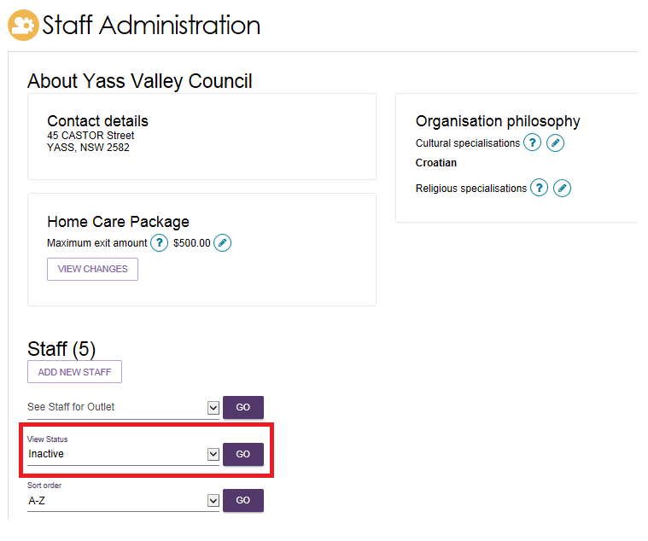
- Select the name of the staff member on the Staff card that you want to deactivate. The View staff member page will be displayed.
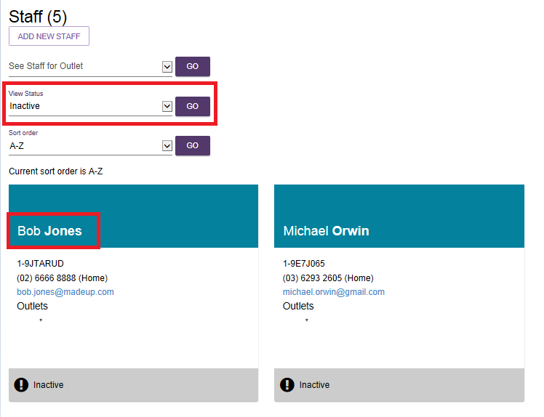
- From the View staff member page, select REMOVE.
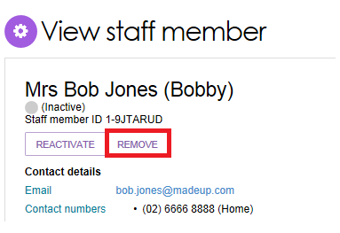
- Select REMOVE to remove the staff member from your staff list.
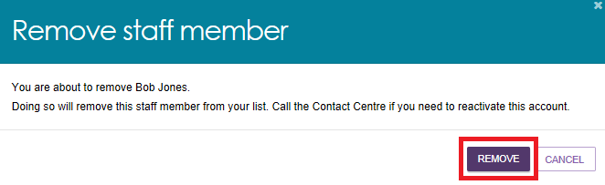

Infection Prevention Control (IPC) Lead Role
! Aged Care Organisations delivering residential aged care need to nominate an Infection Prevention Control (IPC) Lead under their outlet.
An IPC Lead is a registered or enrolled nurse who observes, assesses, and reports on IPC of the
service, and assists with developing procedures and providing advice within the services.
An Aged Care Organisation Administrator or an Outlet Administrator can assign, update, and view the IPC Lead Contact. Administrators must obtain and make a record of consent obtained from the IPC Lead to submit their details to the Department via the Service and Support Portal.
Details to report include the IPC Leads name, phone number, position/role, nurse registration
status and information about their IPC specific training.
IPC Lead information submitted to the Department via the Service and Support Portal will be
used to monitor expenditure of the Second COVID-19 supplement and related policy
development. The information will also be disclosed to the Aged Care Quality and Safety
Commission and may be used by this agency for compliance purposes.

To access the IPC Lead Role:
- Select Outlet administration from the homepage.
- In the Outlet Administration page click to select the outlet you want to edit.
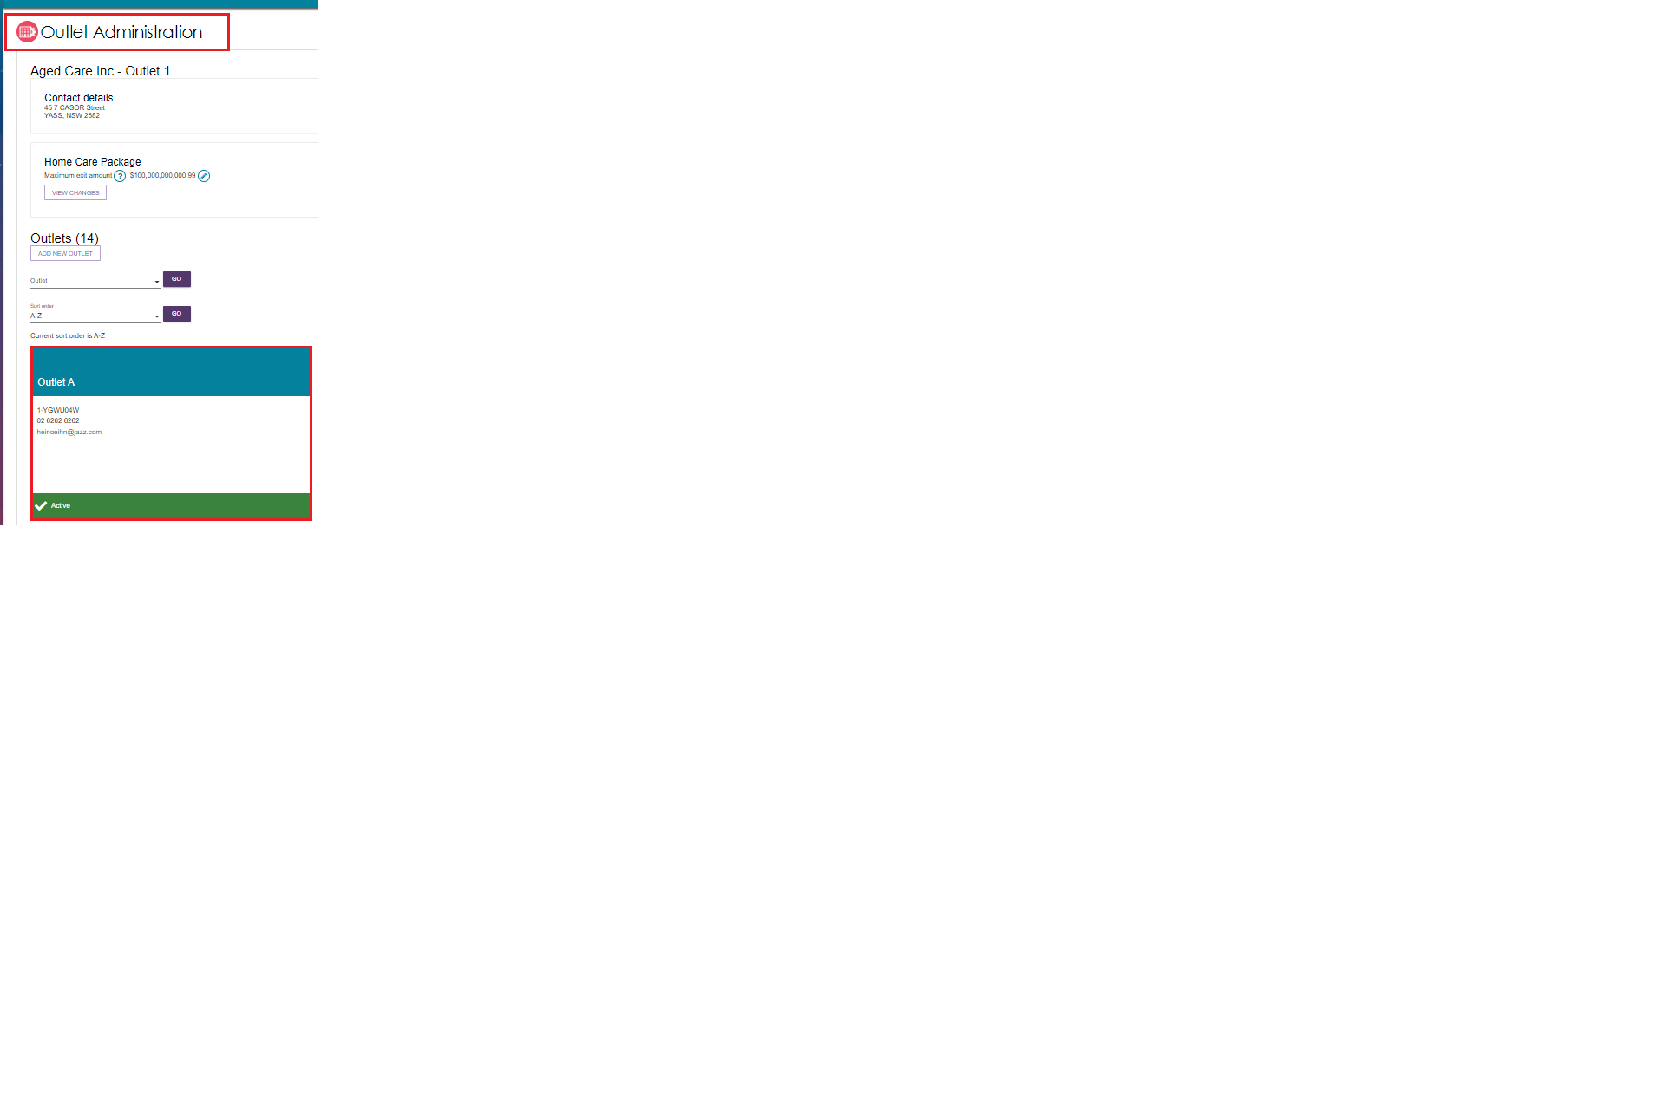
- To create a new IPC Lead Contact, in the View outlet page, select ADD IPC LEAD CONTACT. You can add IPC lead contact details at any stage. If a Primary Contact does not exist for the outlet, administrators will need to create one before creating an IPC Lead Contact. You can add IPC lead contact details at any stage after that.
! There can be up to 3 IPC Lead Contacts for each outlet.
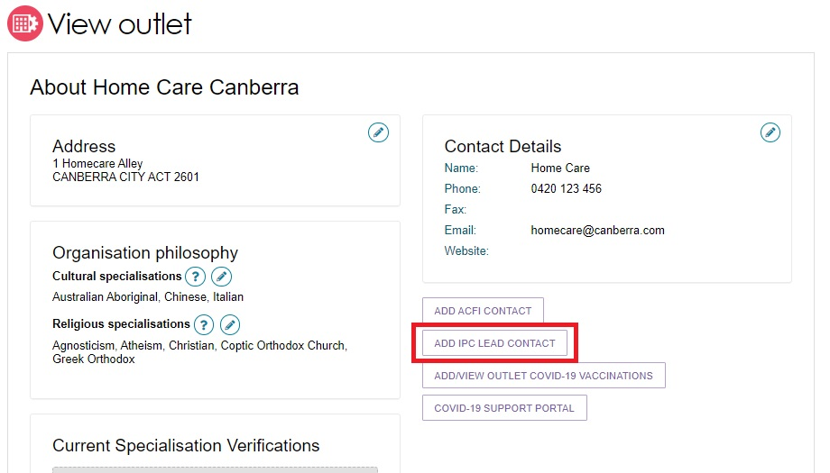
- You must enter the IPC Lead Contact details including their first name, last name, phone number, position/role, nurse registration status, and completion status for the online training modules. You must also select the completion status of their IPC Lead specialist training.
Once the status of specialist training is selected, further fields will appear to enable you to provide more details on this training. This includes the course name, education provider and completion date. Where the IPC lead is yet to enroll, a reason will be required. This information should be updated as circumstances change, including to reflect when training is completed.
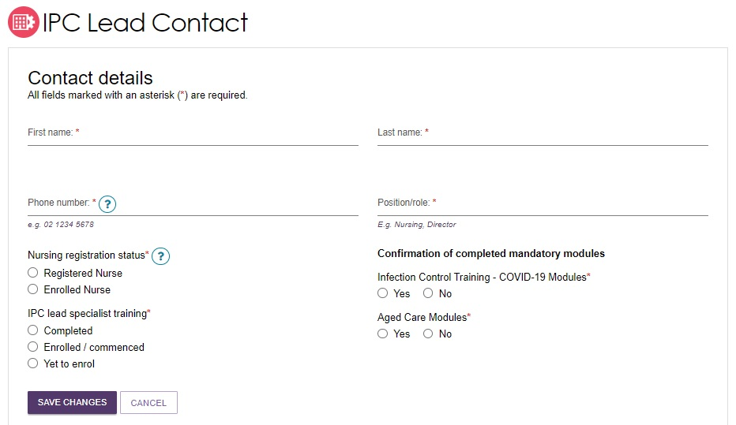
- You can edit and delete IPC Lead Contact details at any stage. In the View outlet page current IPC lead contacts will be listed. To edit a contact, select the pen icon and update incorrect. To delete a contact, select the rubbish bin icon. A pop-up screen will appear to confirm that you would like to delete the contact.
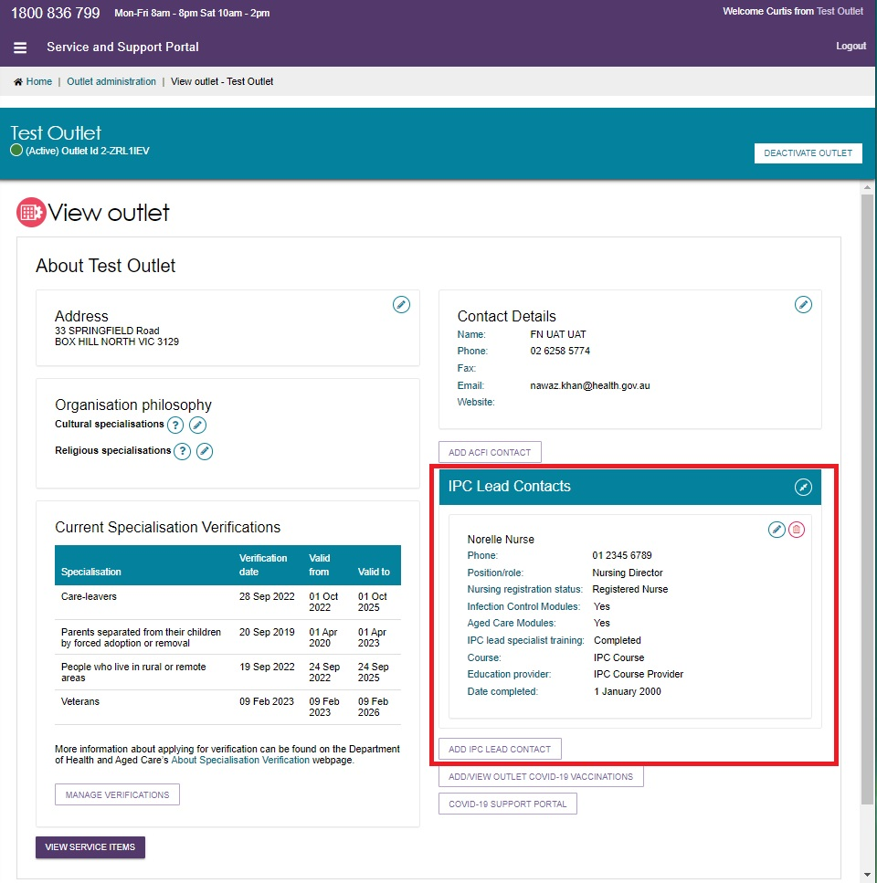

Entering Covid vaccination details
Providers with outlets on My Aged Care have the ability to enter the number of their staff and residents who are vaccinated against COVID-19. Weekly reporting of this data is mandatory for Residential aged care providers, including Multipurpose Services Program (MPS), National Aboriginal and Torres Strait Islander Flexible Aged Care Program (NATSIFACP), Short-term Restorative Care (STRC) and Transition Care Program (TCP). It is also mandatory for these providers to report on workers with approved exemptions to a COVID-19 vaccination.
HCP Providers and providers of STRC in a home and community setting are required to report on the COVID-19 vaccination status of their workers. Weekly reporting of worker vaccination data is mandatory for CHSP and NATSIFACP home care providers.
For more information refer to Mandatory COVID-19 vaccination reporting.
The steps to add vaccination details are below:
- Select the Outlet administration tile on the Portal home page.
- Scroll down and select the outlet for which you need to add vaccination details.
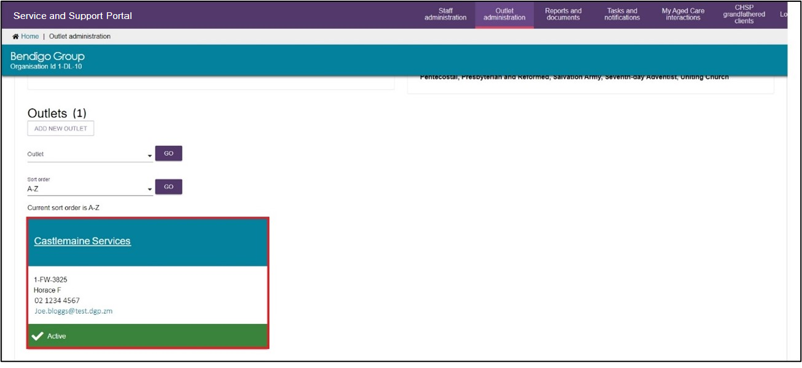
- Select ADD/VIEW COVID-19 VACCINATIONS
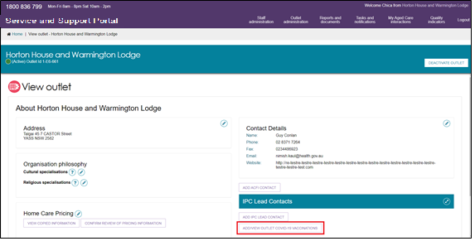
- Add in details that are requested for either/or staff and resident vaccinations. For detailed steps please see the user guide on How to view, add and update COVID-19 vaccination data.
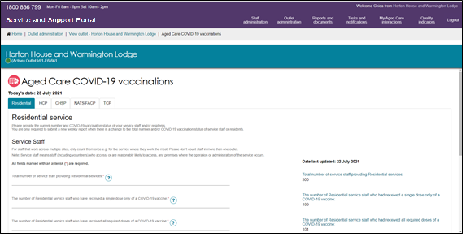
! Service Staff includes all people (including volunteers) working at a service who are responsible for care, support and services for clients, maintenance and administration – e.g. includes nursing and personal care staff, allied health professionals, administration staff, kitchen, cleaning, laundry and garden staff. Only include residents who receive accommodation services. Do not include those for whom you provide service at home or in the community. Please only include each resident once in your reporting.
- Select SAVE CHANGES on the data entry page.
- Confirm the data you have entered is correct and then select SUBMIT on the final screen.
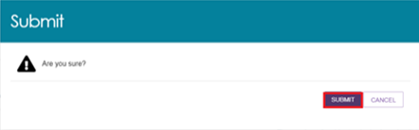
A green box will appear at the bottom of the screen to inform you the details have been saved.

Generating reports and accessing forms
Providers can generate and view reports and access forms via the Service and Support Portal. You will also be able to use the Reports feature to print documents.

Generating reports
Administrators, Team Leaders and Staff Members can generate reports. The steps to generate a report are outlined below.
- Select Reports and documents from the homepage. The Reports and forms page will be displayed.
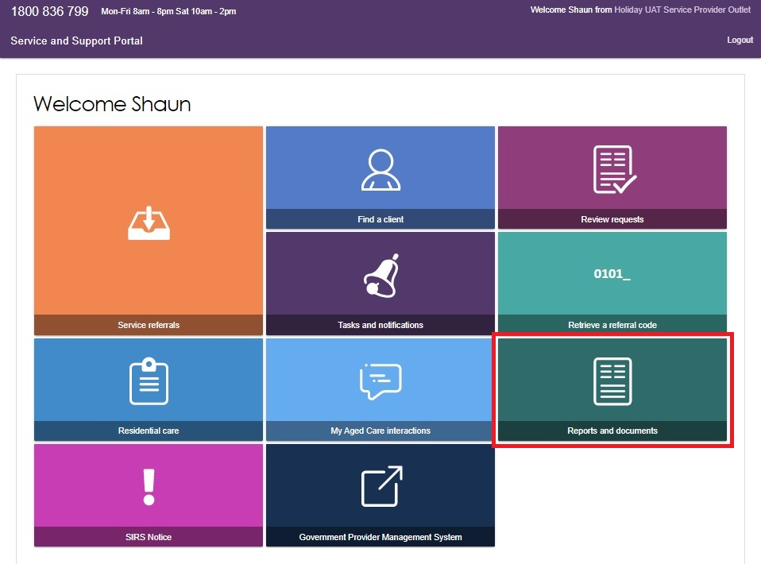
- The Reports and forms page features a Reports tab and a Forms tab. The reports tab displays a list of Recently Requested Reports and Reports.
The Recently Requested Reports will display client record PDFs that have been generated by the user.
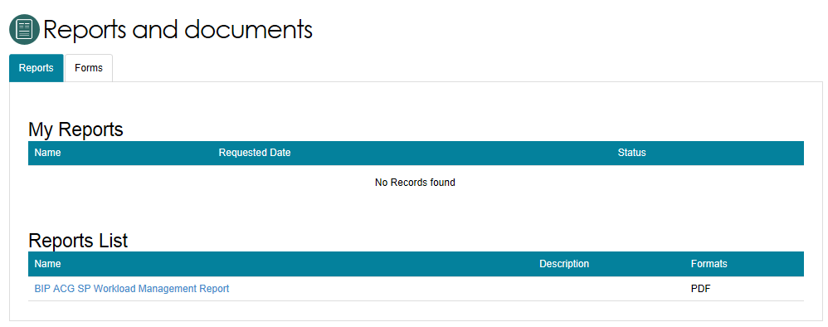
- To generate a report, select the name of the report in the Reports List.
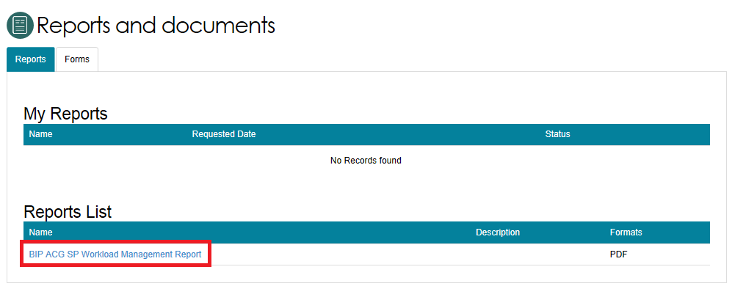
- Select the Outlet ID, enter a start and end date, and an output type (CSV or PDF), then select REQUEST REPORT. If you do not want to generate the report, select CANCEL.
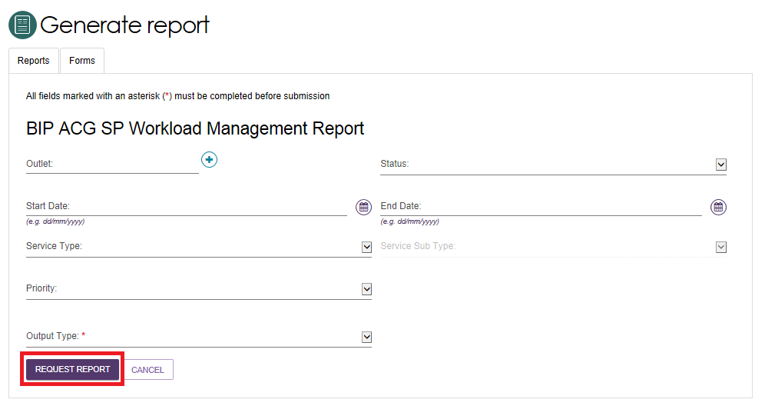

Viewing reports
The steps to view reports are outlined below.
- Select Reports and documents from the homepage. The Reports and forms page will be displayed.
- In the Recently Requested Reports list, select View beside the report you would like to view.
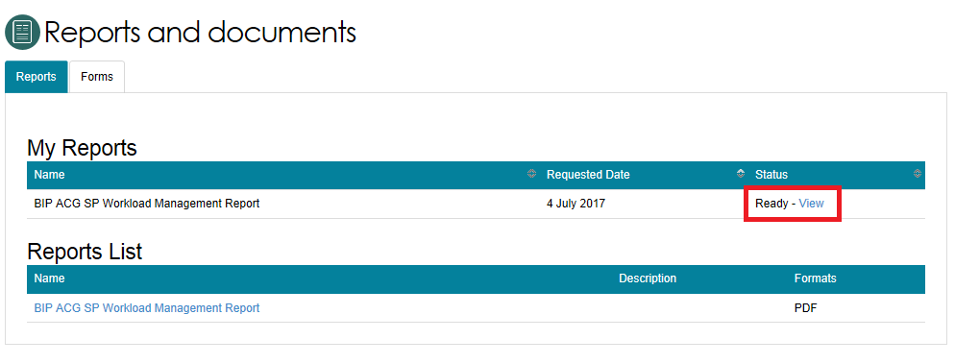
- Select the action you want to complete: Open, Save or Cancel the report.
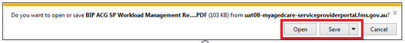

Accessing forms
The steps to access forms are outlined below.
- Select Reports and Documents from the homepage.
- Select the Forms tab. A list of all forms available will be displayed.
