Government Provider Management System

User Guide: Maintenance and Services

October 2024

Version 2.0

This Government Provider Management System (GPMS) User Guide aims to provide approved providers an overview of how to manage their organisational details held by the Department of Health and Aged Care in the GPMS portal.

Contents

1 Introduction 4

1.1 Purpose 4

1.2 Glossary 4

1.3 Login to the GPMS portal 4

1.4 Access Permission 5

1.5 Session time out 6

1.6 Further information and support 6

2 Manage your Organisation 6

2.1 Manage Your Organisation Details 7

3 Provider Details 9

3.1 View provider details 9

3.2 Edit provider details 11

3.2.1 Non-notifiable change 11

3.2.2 Changes that may materially affect suitability to be a provider of aged care 12

4 Services 13

4.1 View Services 13

4.1.1 Search and Filter 13

4.2 View Service details 14

4.3 View Service Combined 17

4.3.1 Service Combined – Closed Service 17

4.3.2 Service Combine in Progress 18

4.4 View Service Transferred 18

4.4.1 Recently Acquired Service 18

4.4.2 Recently Transferred to another provider (prior owner) 19

5 Key Personnel and Contacts 20

5.1 Accessing personnel information from the Manage Your Organisation page 20

5.2 Navigation to Services Key Personnel and Contacts 21

5.3 View Key Personnel and Contacts 23

5.4 View Key Personnel and Contacts Profile Page 25

5.4.1 Personnel Profile page 25

5.5 Add a new Point of Contact 28

5.5.1 What is a point of contact? 28

5.5.2 Point of Contact roles 29

5.5.3 Adding a new Point of Contact to an organisation 29

5.5.4 Adding a new Point of Contact to a service 30

5.5.5 For all users 31

5.6 Edit a Point of Contact 33

5.6.1 Personal Details 35

5.6.2 Contract and Employment Details 36

5.7 Cease a Point of Contact 38

6 Third Party Arrangements 40

6.1 View Third Party Arrangements 40

6.1.1 Search and Filter 40

6.2 View Third Party Arrangement details 41

# Introduction

The Government Provider Management System (GPMS) is a flexible IT (Information Technology) system which is a critical part of the Aged Care Digital Transformation Initiative underway to support aged care reform through better technology.

GPMS provides greater connectivity and data sharing between aged care providers and government.

## Purpose

This User Guide has been designed to support approved providers to view and manage your:

1. provider organisation details – including company information and approved care types.
2. services – details include Australian National Aged Care Classification (AN-ACC) and Accreditation (if applicable), addresses and care types delivered from the service.
3. personnel information – all personnel have a contact record in GPMS. Association records are created for specific roles such as a provider Key Personnel, service Key Personnel and Point of Contact role. A Key Personnel may also be identified as a governing person although this is not a separate contact record association.
4. third party arrangements associated with your organisation and/or your service/s.

## Glossary

A [glossary](https://www.health.gov.au/resources/publications/gpms-user-guide-glossary) is available on the departments website to help you to understand the terminology used in relation to GPMS functionality.

## Login to the GPMS portal

To login to the GPMS portal please visit [Log In to GPMS portal.](https://provider.health.gov.au/serviceproviderportal/login?ec=302&startURL=%2Fserviceproviderportal%2Fs%2F)

If you require assistance logging into the GPMS portal, please refer to the GPMS [Logging in to the Aged Care Systems](https://www.health.gov.au/resources/publications/logging-in-to-the-aged-care-systems).

Please be advised of the following:

The Department of Health and Aged Care will retain records of your access to GPMS. When prompted upon login to GPMS, you must accept the [GPMS Terms of Use](https://www.health.gov.au/resources/publications/government-provider-management-system-terms-of-use?language=en) to be able to access the system.

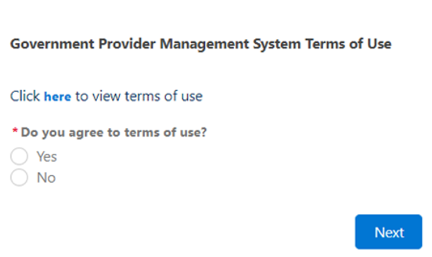

## Access Permission

Your organisation administrator can assign the following roles in the GPMS portal via the **Manage Your Organisation** landing page:

| **Role** | **Responsibility** |
| --- | --- |
| **Provider staff (Service)** | Users with this role can:   * view organisation details * view and edit service details for services they have been associated with |
| **Provider staff (Org)** | Users with this role can:   * view or edit organisation and service details * access, draft and submit Approved Provider Notifications or Governing Body Determination application forms to a Provider Governing Person |
| **Provider Governing Person** | Users with this role can:   * view or edit organisation details * access, draft, make a declaration and submission of notifications or application forms to the Aged Care Quality and Safety Commission.   A governing person is defined by the *Aged Care Quality and Safety Act 2018.* As a result of this, any person assigned this role **must also** be listed as key personnel for your organisation. |

In this document, the user role of Provider staff (Org) will be referred to as org-level user and Provider staff (Service) as service-level user.

## Session time out

Before starting work on an online form, the user should be aware of the “time-out” functions when a user is logged in to the GPMS portal.

GPMS has a time-out feature which automatically requires re-entry of username and password after 15 minutes of inactivity on the GPMS portal.

The Department strongly recommends users regularly save digital forms in progress in order to avoid loss of information which may occur given there is no “auto save” feature.

This also applies if you click on a notification that may pop up during the uploading of supporting evidence or if you refresh you page whilst editing a form.

Information which is lost due to “time-out” can not be recovered.

## Further information and support

Please refer to the [Government Provider Management System](https://www.health.gov.au/our-work/government-provider-management-system) webpage and the Manage Your Organisation webpage for more information.

If you require further assistance to login to GPMS please contact the My Aged Care service provider and assessor helpline on **1800 836 799**, Monday to Friday (8am to 8pm) and Saturday (10am to 2pm) local time across Australia.

For translating and interpreting services, call **131 450** and ask for My Aged Care on **1800 836 799**.

To use the National Relay Service, visit [About the National Relay Service (NRS) | Access Hub](https://www.accesshub.gov.au/about-the-nrs) or call **1800 555 660**.

To access sign language interpreting and captioning services through Deaf Connect, call [1300 773 803](tel:1300%20773%20803) or email [interpreting@deafconnect.org.au](mailto:interpreting@deafconnect.org.au).

# Manage your Organisation

The **Manage Your Organisation** page in the GPMS portal acts as a central hub for approved providers to manage their organisational details. This includes viewing or modifying details about their:

* Organisation
* Key Personnel and contacts
* Associated services, and
* Third-party organisations

## Manage Your Organisation Details

Once logged in, you can navigate through the **GPMS portal** by selecting the **Manage Your Organisation** tile to display the Manage Your Organisation landing page.

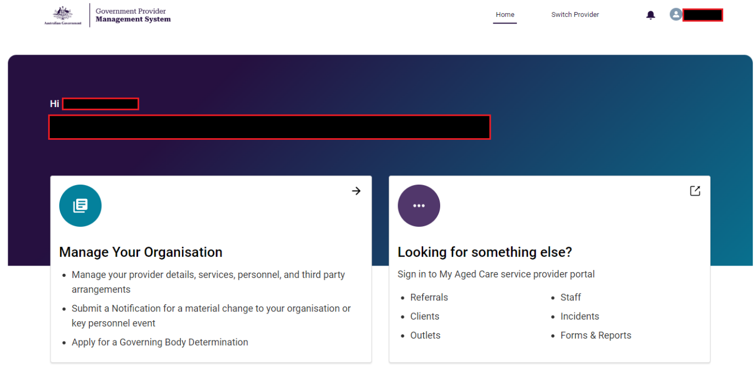

Your **approved provider Name** and **approved provider ID** will always be shownat the top of the page and throughout the GPMS portal.

Please note:

**If you have multiple user roles assigned to you within the GPMS portal, you may see additional tiles displayed on your homepage.** **For example, if you hold the Star ratings reviewer role then the Star Ratings tile will display.**

By selecting the Manage Your Organisation tile you can navigate to the Manage Your Organisation details landing page and Notify or Apply to the Commission.

| **Menu tile** | **Description** |
| --- | --- |
| **Provider details** | Manage your approved provider details, including any associated personnel and third party arrangements. |
| **Services** | Manage your service details, including any associated personnel and third party arrangements. |
| **Key Personnel and Contacts** | Manage your Key Personnel and contacts. |
| **Third Party Arrangements** | Manage your third party arrangements your organisation has in place. |
| **Notifying of certain matters** | An Approved Provider Notification is required to notify the Commission of certain changes or events that may affect their suitability to continue as an approved provider.  The GPMS portal allows approved providers to access and submit an online form to meet their notification obligations. |
| **Apply for a Determination that certain governing body responsibilities do not apply** | Approved providers are required to meet governing body membership requirements.  The GPMS portal contains an online form to apply for a determination from the Commission if approved providers are unable to meet the governing body membership requirements. |
| **Determination and Notification form tables** | Approved providers can track and manage Application for a Determination or Notification forms in the tables shown.  Additional information is available within the [GPMS User Guide: Governing Body Determinations.](https://www.health.gov.au/resources/publications/gpms-governing-body-determinations?language=en) |

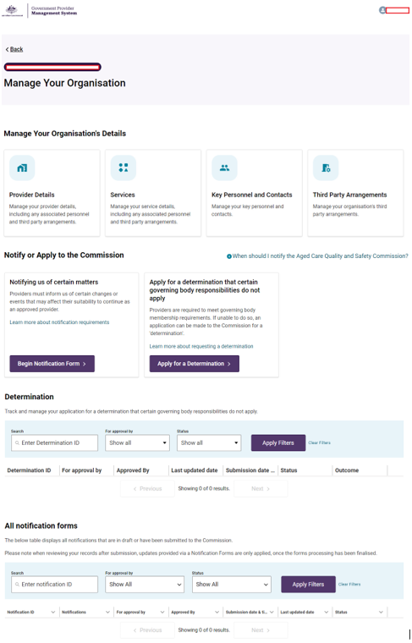

# Provider Details

1. From the **Manage Your Organisation** landing page, select the **Provider Details** tile.

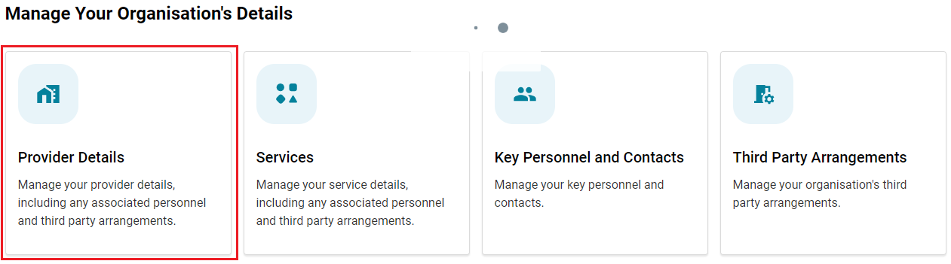

## View provider details

From the **Provider Details** page all org-level users will be able to view organisation details. This information includes:

* Approved provider details
* Care type details
* Incorporation details
* Australian Business Number (ABN) details
* Contact details
* Physical and Postal address
* Registered Business address

Please note:

Service-level users will only be able to view the ‘Your Provider Details section’ containing the approved provider Name, ID and ABN.

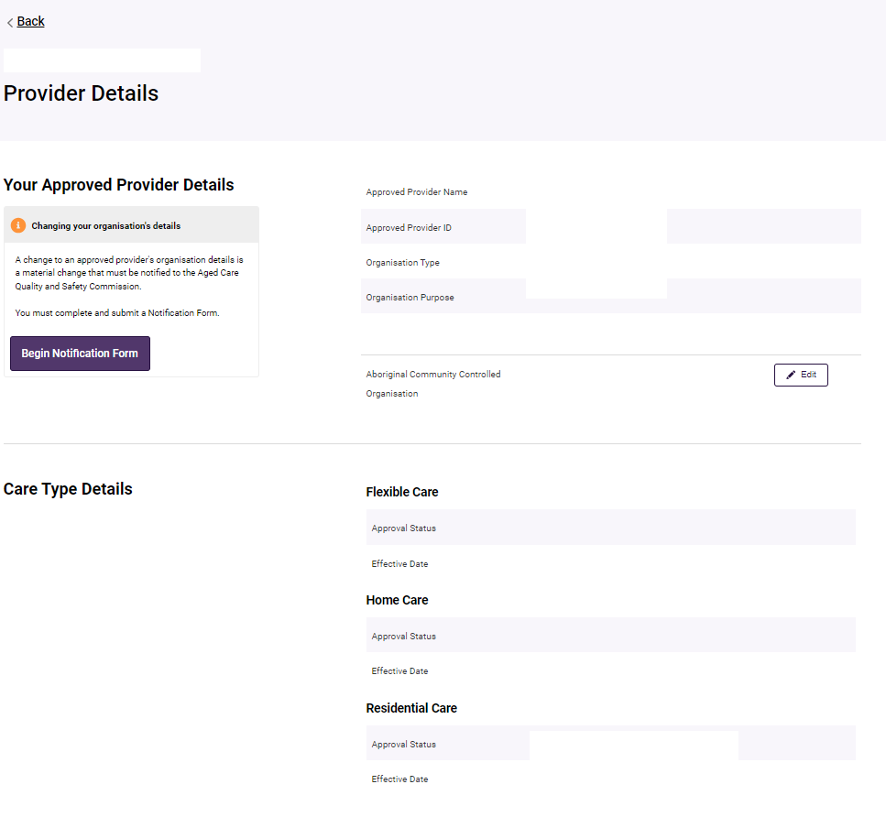

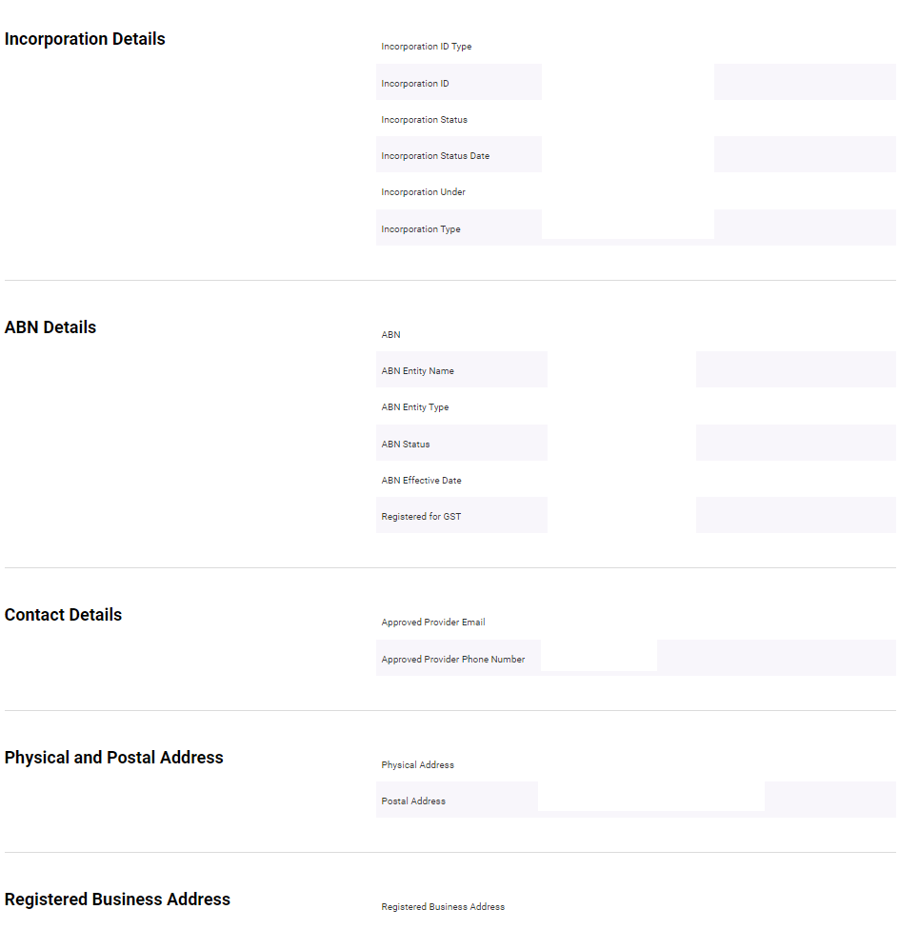

## Edit provider details

All org-level users can edit information held for their approved provider in real-time.

There are two types of changes as described in the sections below.

### Non-notifiable change

These are changes that you are not obligated under aged care legislation to notify the Aged Care Quality and Safety Commission about. Information that is not notifiable and can be modified will display an **Edit** option.

This information includes:

* Your approved provider Details – **Aboriginal Controlled Community Organisation**.This field may be blank upon initial review and the edit button will be visible to update if applicable:
  + Select **Edit**.

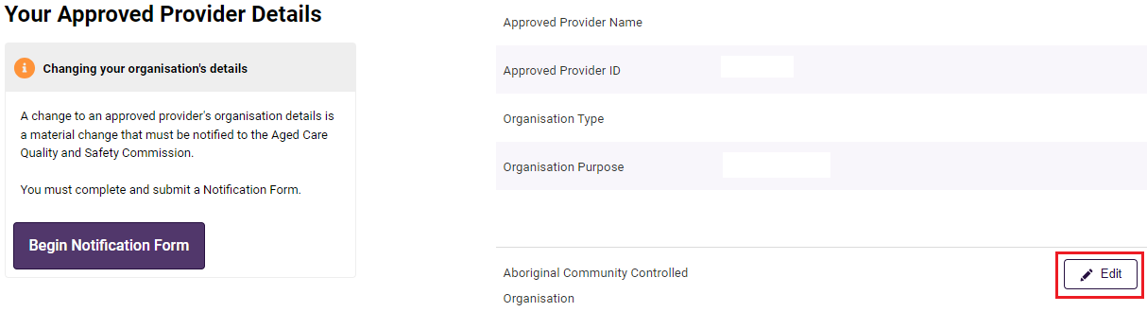

* + Select **Yes** or **No** from the dropdown menu.
  + Select **Save** to confirm, or alternatively, select the **Cancel** button to cancel the action and navigate back to the **Provider Details** page.

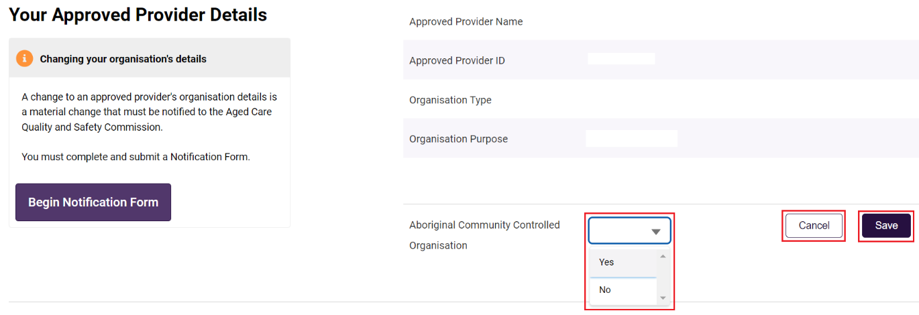

If the **Aboriginal Community Controlled Organisation field** contains a **Yes** or **No** then org-level users cannot edit the field and the **Edit** button will not be visible to the user.

This can only be changed using the Approved Provider Notification form.

### Changes that may materially affect suitability to be a provider of aged care

Making any other changes to the information held in **Your approved provider Details** can only be done by notification to the Aged Care Quality and Safety Commission.

This is because it is possible that a change to this information could materially affect your suitability.

1. Select **Begin Notification Form,** located on the top left-hand side of the page, to initiate this process.

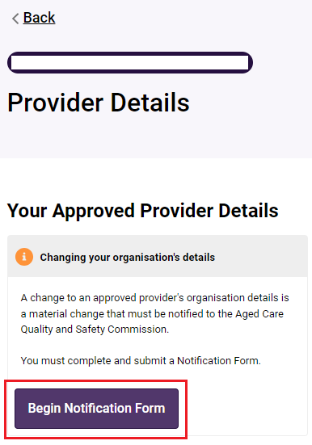

More information regarding how to use the new notification form can be found in the [GPMS User Guide: Approved Provider Notifications](https://www.health.gov.au/resources/publications/gpms-user-guide-approved-provider-notifications?language=en).

Please note:

Service-level users cannot initiate a notification form to notify of a material change or Key Personnel change or event, or a Governing Body Determination application form. Instead, they will see an information box which provides a link to further information about Approved Provider Notifications on the [Aged Care Quality and Safety Commissions website](https://www.agedcarequality.gov.au/providers/approval-accreditation/notifying-us-certain-matters).

# Services

1. From the **Manage Your Organisation** landing page, select the **Services** tile.

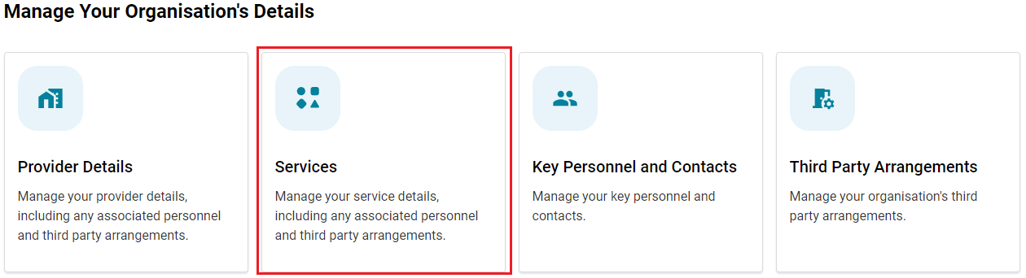

## View Services

All org-level and service-level users will be able to search and view the details of a Service they have access to.

* When an org-level user selects the **Services** tile, they are displayed a list of all services associated to their organisation.
* When a service-level user selects the **Services** tile, they are displayed a list of services they are associated with.
* Services that are **Inactive**, meaning they are not operational, will not be displayed in the Services table.

### Search and Filter

Users can search for their services by **Service Name** or **ID** orfilter by **State** or by **Status** from the dropdown menu and select the **Apply Filters** button.

Users can sort this table alphabetically. The sort order is displayed when a user hovers over the column headings.

Services in an Operational status and for all States are displayed by default.

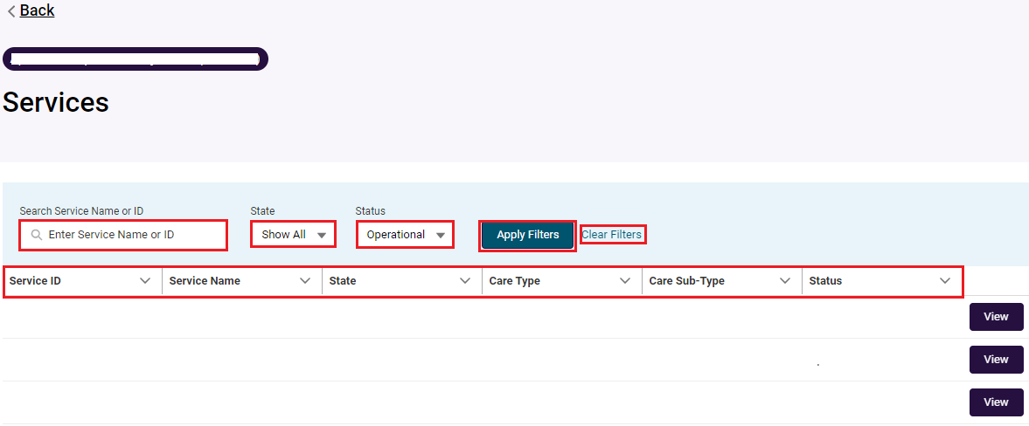

To view **Non-operational** Services

1. Click the **Status** dropdown menu.
2. Select Non-operational.
3. Click Apply Filter.

The user can view all Services in the following statuses:

| **Service Status** | **Description** |
| --- | --- |
| **Pre-operational (RESI/FLEXI)** | A Pre-Operational service is where the approved provider holds a provisional allocation of places for a service in which it intends to provide but has not yet commenced. |
| **Offline (RESI/FLEXI)** | A service which the approved provider has chosen to make offline. |
| **Offline – Temporary Closure of Facility (RESI/FLEXI)** | A service which the approved provider has made offline with the intention of reopening the service. An example is if the facility was being refurbished |
| **Offline – Permanent Closure of Facility (RESI/FLEXI)** | A service which the approved provider has made offline with the intention of closing. |
| **Service Record Closed (RESI/FLEXI)** | A service which the approved provider has closed with no intention of reopening. |
| **Closed – Combined (RESI)** | approved providers operating adjacent Residential services can apply to combine these services into a single ‘Continuing’ service. The ‘Discontinuing’ service(s) have a status of Closed – Combined. |
| **Closed (HC)** | A service which the approved provider has closed with no intention of reopening. |
| **Transferred** | A service that has been transferred to another approved provider within the last 7 years. |

1. To revert to the default view, select **Clear Filters**.

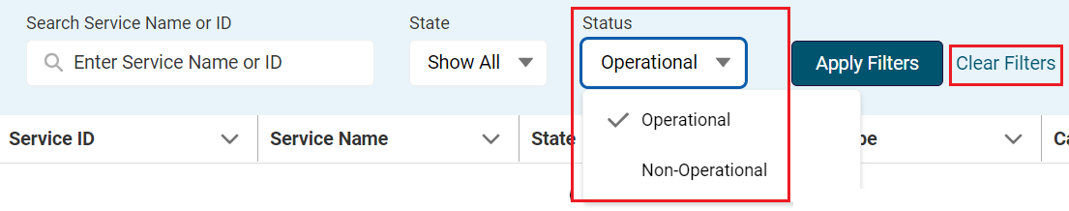

## View Service details

All org-level and service-level users will be able to view the **Service Details** page when selecting a service to **view**.

1. From the **Service** page navigate to the relevant service listing.
2. Select **View** and the **Service Details** page will be displayed containing service details of the selected service.

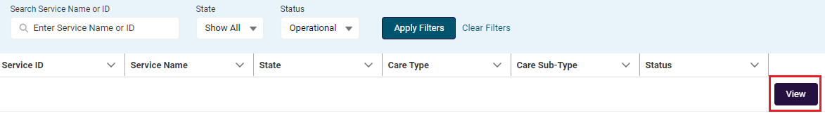

The **Service Details** page will display all information available for the service including:

* Basic details (service name, service name effective date, service ID, care type association start and end dates and service status)
* Australian National Aged Care Classification Base Care Tariff details (residential care service only)
* Accreditation details (residential care service only) – note: Accreditation details will not be visible for transferred services.
* Physical Address details
* Postal Address details
* Key Personnel and contacts

Please note:

The information box displays information on changing your service details.

Resi / Flexi Care changes, you will be directed to [State and territory offices](https://www.health.gov.au/about-us/contact-us/state-and-territory-offices) (STO).

Homes Care changes, you will be directed to the [Notification of changes for Home Care Packages](https://www.health.gov.au/our-work/home-care-packages-program/responsibilities/notification-of-changes#:%7E:text=Notification%20of%20changes%20for%20Home%20Care%20Packages%201,Person%20ends%20home%20care%20...%206%20Legislation%20).

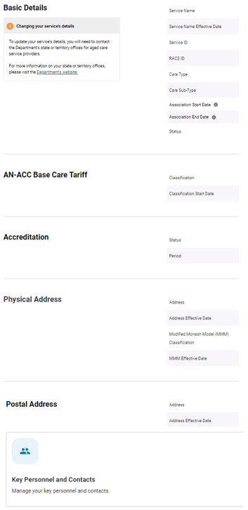

****Please note:****

To view places data, log into the My Aged Care Service and Support Portal or the Services Australia’s Aged Care Provider Portal.

When viewing the service details page in the GPMS Portal, if a field is not applicable for a care type, the field will be displayed as ‘blank’. For example, a Home Care service will display blank fields in the AN-ACC Base Care Tariff section of the page.

## View Service Combined

On the **Service Details** page, all org-level and service-level users (for services associated to them) can view information for a Service that has recently been combined or in progress of being combined.

Depending on the circumstances, a banner will display on the page containing information about the combining outcome.

**Service Combined – Retained Service**

Information for the retained / continuing residential service when the selected service is the ‘ongoing’ service which another Service(s) was combined with.

| **Event** | **Banner display** | **Changing your service’s details** |
| --- | --- | --- |
| **Retained / continuing**  **service** | * Date of combine * Continuing service * Discontinued service(s) | To update your service details, you will need to contact the departments state or territory offices for aged care service providers.  For more information on your state and territory offices, please visit the [Departments website](https://www.health.gov.au/about-us/contact-us/state-and-territory-offices). |

### ****Service Combined – Closed Service****

**Information for the discontinued residential service when the selected service has been closed because it was combined with another service(s).**

1. **To search for a closed service in the service details table, select the status of Non Operational and apply filters.**

| **Event** | **Banner display** | **Changing your service’s details** |
| --- | --- | --- |
| **Discontinued**  **service** | * Date of combine * Continuing service and service ID * Discontinued service(s) and service ID(s) | This service is no longer operational and has been combined with another one of your services. Details for this service can no longer be updated.  Any Key Personnel which are still associated with this service must be updated via a Notification Form.  For further information please visit the [Aged Care Quality and Safety Commission website](https://www.agedcarequality.gov.au/providers/approval-accreditation/notifying-us-certain-matters). |

### ****Service Combine in Progress****

**Information for a service which is currently in progress of being combined with another service(s).**

**When an approved provider has applied to the department to combine two or more of its residential services, the event of service combine in progress will display. All service details and associations will be visible for the service but are locked and will not be editable.**

No updates are permitted to the postal address or associated contacts for combine services.

| **Event** | **Banner display** | **Changing your service’s details** |
| --- | --- | --- |
| **Service combine in progress** | * Date of combine * Continuing service and service ID * Discontinued service(s) and service ID(s) | The combining of an approved providers service may constitute a material change or may result in changes to Key Personnel.  To ensure you meet your responsibilities please visit the [Aged Care Quality and Safety Commission website](https://www.agedcarequality.gov.au/providers/approval-accreditation/notifying-us-certain-matters). |

## View Service Transferred

On the **Service Details** page, all org-level and service-level users (for services associated to them) can view information for a service that has recently been transferred.

Information banners will display on the page to alert users to the transfer status of the service.

### Recently Acquired Service

Information for a service that has been recently acquired **in the past 60 days**.

| **Event** | **Banner display** | **Changing your service’s details** |
| --- | --- | --- |
| **Recently Acquired Service**  (RESI / FLEXI) | This service has been recently acquired by your organisation. Review your Key Personnel to ensure all information is up to date. | To update your service’s details, you will need to contact the departments state or territory offices for aged care service providers.  For more information on your state and territory offices, please visit the [Departments website](https://www.health.gov.au/about-us/contact-us/state-and-territory-offices). |
| **Recently Acquired Service**  (Home care Service) | This service has been recently acquired by your organisation. Review your Key Personnel to ensure all information is up to date. | Any changes to a home care service must be notified to the department via the Home Care Notification Form.  For more information please visit the [Departments website](https://www.health.gov.au/our-work/home-care-packages-program/responsibilities/notification-of-changes#:%7E:text=Notification%20of%20changes%20for%20Home%20Care%20Packages%201,Person%20ends%20home%20care%20...%206%20Legislation%20). |

### Recently Transferred to another provider (prior owner)

An approved provider that has transferred one of its services to another approved provider will see a status of **Transferred**.

Any updates to the service that occur after the transfer by the new approved provider, will not be visible to the previous approved provider. approved providers are only able to see information relevant to transferred services up until the date of service transfer.

The user will not be able to update anything on this page regarding the service as it is historical information. This includes no ability to update the:

1. postal address of the service; or
2. associated service contacts

**If searching for a transferred service in the service details table, select Non-Operational status and apply relevant filters.**

| **Event** | **Banner display** | **Changing your service’s details** |
| --- | --- | --- |
| **Transferred Service**  (Org-level view) | No banner visible | Your service has been transferred to another approved provider and can no longer be updated. Review your Key Personnel listing against this service and, if necessary, submit a Notification Form to update these details.  Read more about material changes on the [Aged Care Quality and Safety Commission’s website](https://www.agedcarequality.gov.au/providers/approval-accreditation/notifying-us-certain-matters). |
| **Transferred Service**  (Service-level view) | No banner visible | Your service has been transferred to another approved provider and can no longer be updated.  Review your Key Personnel listing against this service and, if necessary, get your organisation to submit a Notification form to update these details. |

# Key Personnel and Contacts

Using the Key Personnel and contacts tiles, accessed through the **Manage Your Organisation** page or from your **Service Details** page, org-level and service-level users can view all personnel associated with your organisation, including at your service/s.

The steps set out in this section are intended to cover all approved provider users with access to the GPMS portal. Users with limited access will not be able to perform all these steps:

**Org-level users** - will be able to view all personnel information and update Contact information

**Service-level users** – will only be able to view organisational level personnel but will be able to update contact personnel for the service/s they have been associated with by the organisation administrator.

This document may use the word ‘Contact’ as a way to describe or group together Key Personnel and points of contact as a single term.

## Accessing personnel information from the Manage Your Organisation page

Accessing personnel information associated with your organisation, **not** at your service/s, is achieved from the **Manage Your Organisation** landing page.

From there, select Key Personnel and Contacts.

Org-level user view

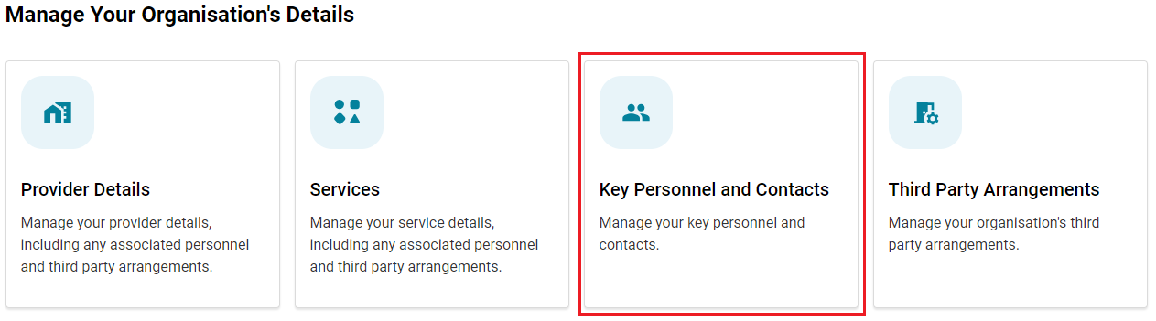

Service-level user view

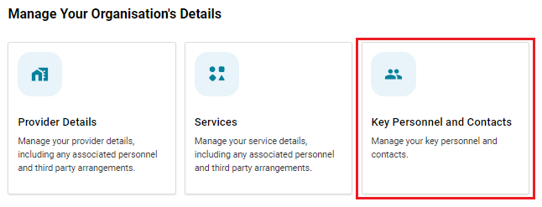

## Navigation to Services Key Personnel and Contacts

All **org-level users** and **service-level users** can view the Key Personnel and Contacts tile from the **Service Details** page.

1. From the **Manage Your Organisation** landing page, select **Services** tile to view the list of services associated with your organisation.

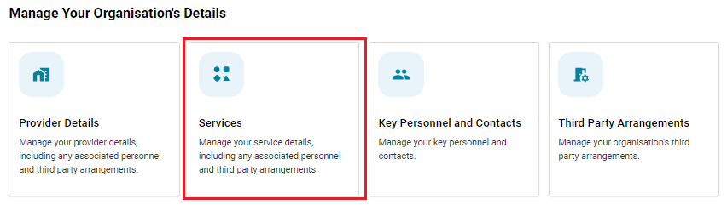

1. From the list of services displayed select **view** for the relevant service.

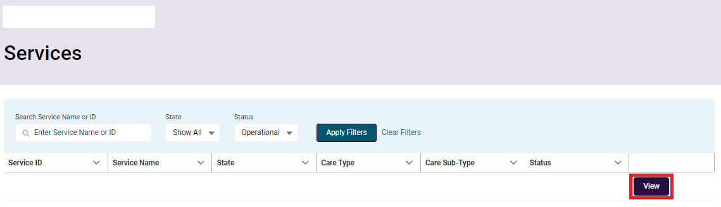

1. The **service details** page will display, and the **Key Personnel and Contacts** tile is located at the bottom of the page.

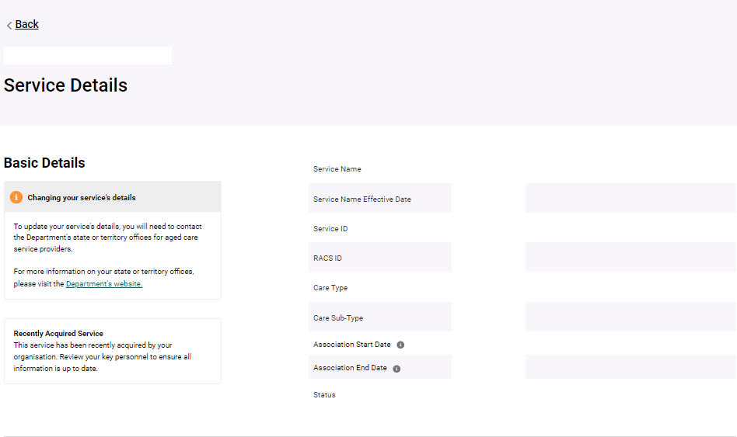

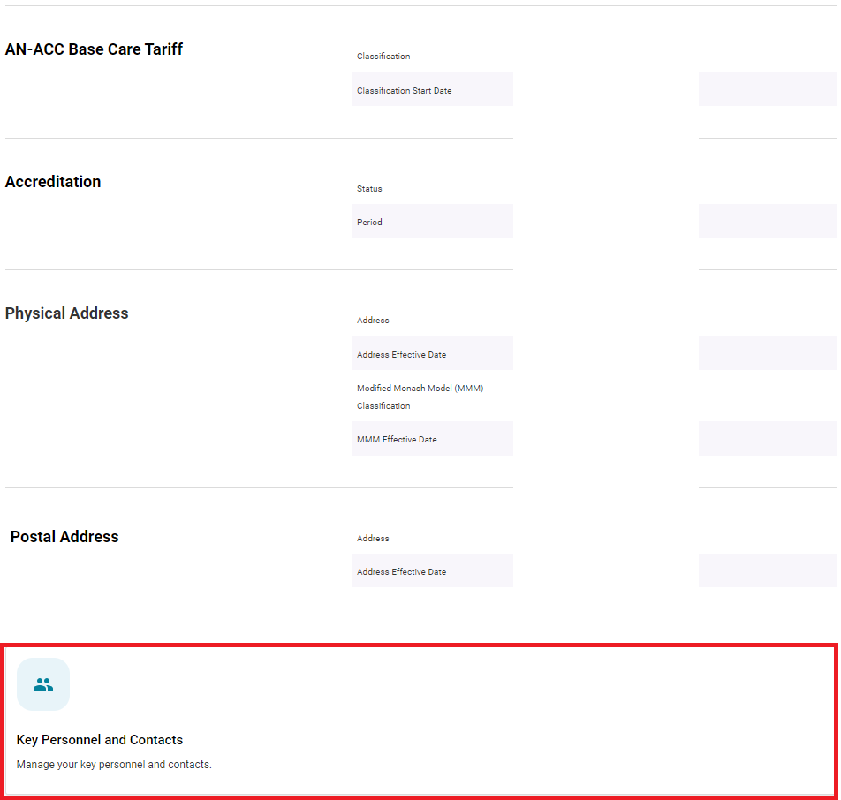

1. When an org-level or service-level user selects the **Service** **Key Personnel and Contacts** tile they are displayed a list of contacts associated to the selected Service.
2. The **Service Name** and **Service** **ID** is visible at the top of the page to confirm for the user which service information is displayed.

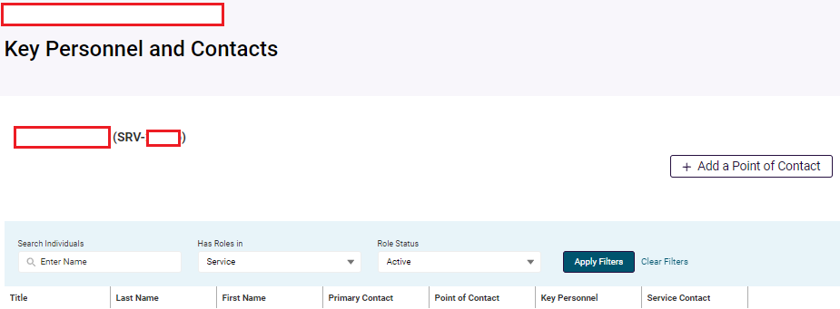

## View Key Personnel and Contacts

When selecting the **Key Personnel and Contacts** tile, a user will be presented with a table that displays the personnel permitted by their user access. It will also display different information depending on the user profile. Specifically:

an org-level user will see **all** Key Personnel and contacts associated with the whole organisation, including all services.

a service-level user will only see those associated with the services they have been given access to by the **Organisation Administrator**.

The table displays the following information:

* Title
* Last Name
* First Name
* Primary Contact – tick indicates the person is a primary contact
* Point of Contact – tick indicates the person is a point of contact
* Key Personnel – tick indicates the person is a Key Personnel
* Service Contact – tick indicates the person is a service contact

The table **will not**:

* identify personnel assigned as Governing Persons for their organisation.
* any personnel who are contacts (Key Personnel and point of contacts) for a Third Party Organisation engaged by your organisation

Please Note:

If the table displays duplicate records, meaning that the same individual is listed more than once, you are required to advise the Department. Please complete and submit the GPMS - Reporting a Duplicate Contact [Form](https://www.health.gov.au/resources/publications/government-provider-management-system-gpms-reporting-a-duplicate-contact) available on the Departments website. This will help to improve the information held about your organisation in GPMS.

There are several terms used for roles assigned to personnel which will display in the org-level view table. It is possible for one person to hold one or more of these roles:

| **Role** | **Description** |
| --- | --- |
| **Primary Contact** | Indicates that a person has been assigned as a primary contact for your organisation or for a service. |
| **Point of Contact** | Indicates that a person has been assigned as a point of contact. |
| **Key Personnel** | **Key Personnel** are defined by legislation. approved providers should be familiar with and apply this definition when notifying the Commission of its Key Personnel. |
| **Service contact** | Indicates that a person is associated with one or more of your services. |

Search and Filter *The process/steps below are user access dependent.*

* The table will display all active Key Personnel and/or contacts by default.
* The user can search by an **Individual** and select the **Apply Filters** button to display that person in the table.
* A user can select to filter the **Role Status** to display **Inactive** Contacts. On applying the filter, the user can view the Contacts which meet the following requirements:
* People with a Point of Contact role that ended within the last 7 years
* Key Personnel ceased within the last 7 years
* A user with org-level access will see the **Has Roles in** filter is defaulted to **Show All** and can filter by **Provider** or **Service**.
* A user with service-level access will see the Has **Roles in** filter is defaulted to **Service** and will not be editable by the user.
* When the user selects **Clear Filters**, the table is reverted to the default view based on their user access.
* When the user selects **View**, they are navigated to the **applicable Personnel Profile** page.
* The table can be sorted by last name or first name alphabetically. To sort, hover the mouse over the column headers and click to change the order of the displayed list.
* If you are an org-level user, you will see **+ Add a Key Personnel or Point of Contact** displayed above the table. Service-level users will see **+ Add a Point of Contact**.

Organisation view:

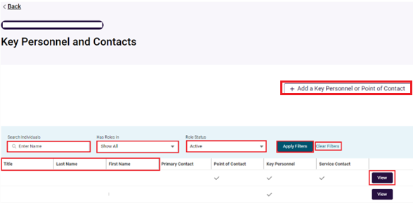

Service view:

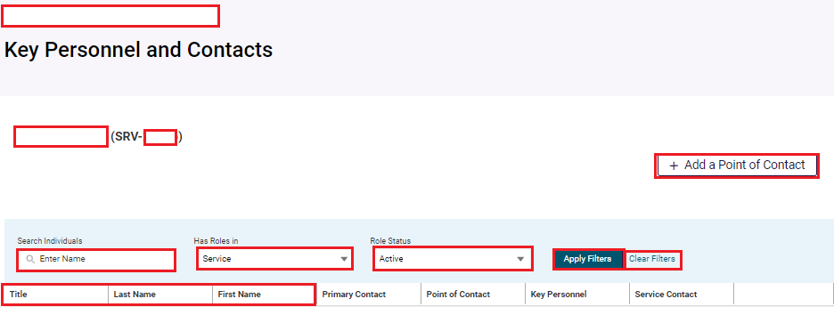

## View Key Personnel and Contacts Profile Page

Where access permits, a user can select **View** from the **Key Personnel and Contacts table** to navigate to the applicable **Personnel Profile** page.

### Personnel Profile page

The **Personnel Profile** Page will display different information depending on the role/s the personnel have with your organisation.

Personnel who are a point of contact with no active Key Personnel roles:

* Personal Details
* Contact and Employment Details

Personnel with **active Key Personnel role/s** will include additional information:

* Personal Details
* Contact and Employment Details
* **approved provider Key Personnel** and **Point of Contacts** (if applicable)
* **Service Key Personnel** and **Point of Contacts** (if applicable)
* An information box noting this contact is **Key Personnel**. It advises that you must complete and submit a **Notification Form** which can be used to update information held about your **Key Personnel**.
* **Service-level users** cannot access or submit an Approved Provider Notification

No active Key Personnel role*:*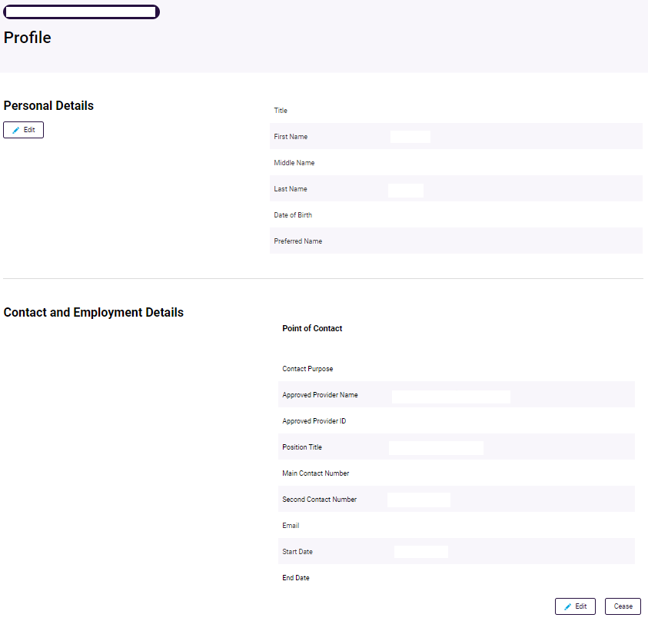

Active Key Personnel role:

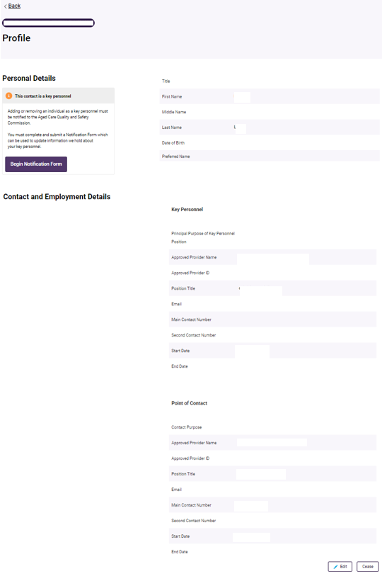

## Add a new Point of Contact

This sub-section describes how to add a point of contact for both your approved provider or associated service. The steps are the same, however accessing the relevant screen is achieved in a different manner.

1. Select **+ Add a Key Personnel or Point of Contact,** from the Key Personnel and Contacts table page to add a point of contact for the organisation.
2. Navigate to the **Key Personnel and Contacts** tile via the **Services** page – to add a point of contact for the service they are associated with.

The **+ Add a Point of Contact** button will only display if the Service is in the following statuses:

* Operational (RESI/FLEXI/HC)
* Offline (RESI/FLEXI)
* Offline – Temporary Closure of Facility (RESI/FLEXI)
* Offline – Permanent Closure of Facility (RESI/FLEXI)

A user cannot add a point of contact to a service with the following status:

* The Service is in progress of being combined with another Service(s)
* The Service has been transferred to another approved provider and the user is the old owner

In these circumstances, the **+ Add a point of contact button** will not be visible.

### What is a point of contact?

* A point of contact is a person you nominate as a contact for a specific purpose. For a service, this could be one or more people who have different point of contact roles.
* There must be at least one person nominated as a primary contact for your organisation and for each of your services. Meaning they will be the first point of contact for either the Department or the Commission.
* The nominated person must be able to engage with representatives of the Department or Commission in relation to that specific role.

### Point of Contact roles

An approved provider can select from the following list of roles:

* Primary contact
* Alternative contact – secondary to the Primary contact
* Care Manager contact
* Complaints Manager contact
* Compliance contact
* Compliance contact – home care
* Compliance contact – residential
* Emergency contact
* Financial Management contact
* Financial reporting contact
* Quality Assessment contact
* Quality Assessment Regional contact
* Service Monitoring and Reports contact

### Adding a new Point of Contact to an organisation

1. From the Key Personnel and Contacts table select **+Add a Key Personnel or Point of Contact** button to navigate to the **Add a New Key Personnel or Point of Contact** page.

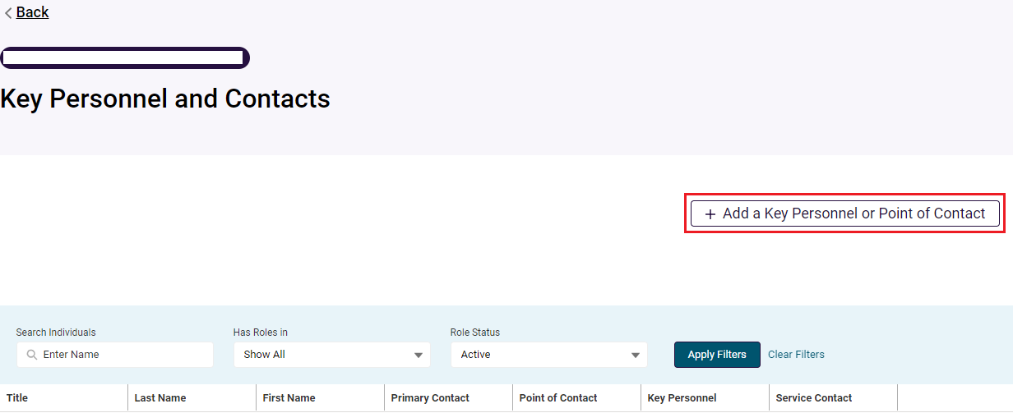

A popup screen will display and ask **What kind of individual** **do you want to add?** The options to select from are:

* **New Key Personnel** (this option will navigate to the Begin a **Notification Form**)

Adding or removing an individual as Key Personnel must be notified to the Aged Care Quality and Safety Commission. You must complete and submit a Notification Form which can be used to update information we hold about your Key Personnel.

* **New Organisation Point of Contact**

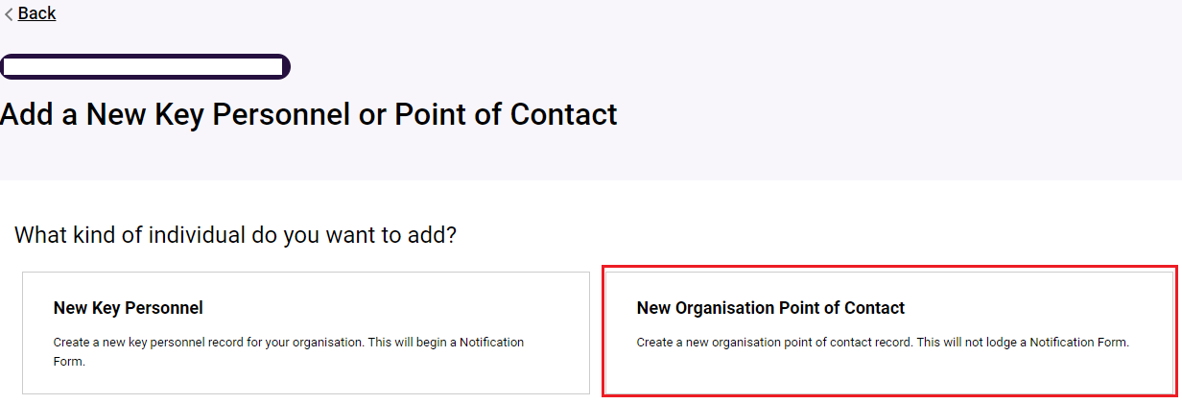

1. When you select **New Organisation Point of Contact** the **Add a New Point of Contact** page will appear
2. Continue process in section **5.5.5 For all users** below.

### Adding a new Point of Contact to a service

1. Follow the Navigation to Services Key Personnel and Contacts, then:
2. Select the + Add a Point of Contact button on the Service Key Personnel and Contact Table page.

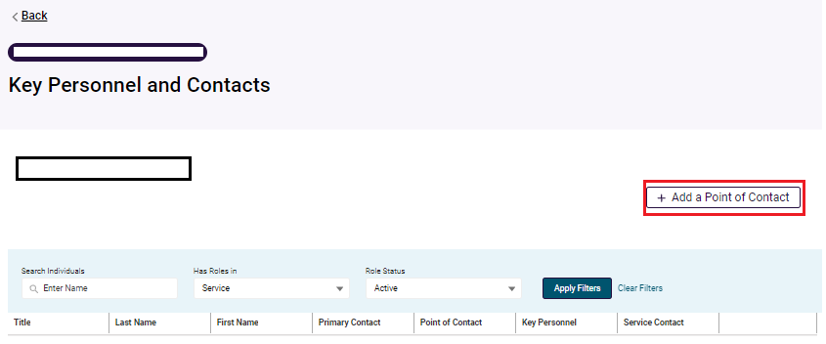

This will take you to the **Add a New Point of Contact page**.

1. Continue process in section **5.5.5 For all users** below.

### For all users

1. Before you can add a person as a contact, you must first check they do not already have a point of contact role. To do this, enter the name of the person you wish to add as a point of contact in the **Search and select an existing point of contact** field.

* If the person already has a record in GPMS their information will be will be pre-populated into the personal detail fields on the page.
* if the person is a Key Personnel, they will display so that you can select them, then move to the next step and add the new point of contact role association.
* you will not be able to change any of their personal information such as their name or position title, these fields cannot be edited.
* If the person does not have an existing record you will need to enter their details manually.

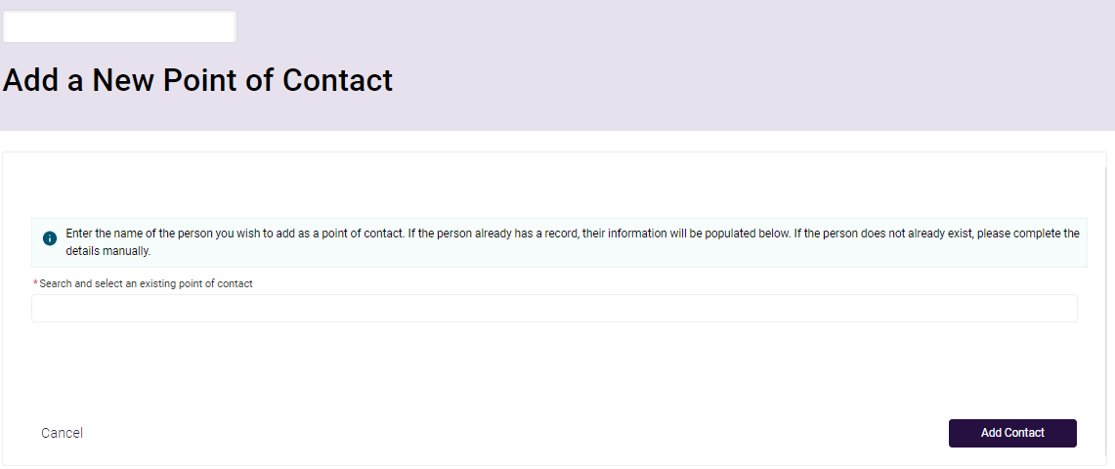

The following steps are for adding a person that does not have an existing record.

1. Enter the title, name and position title for the contact.
2. Select the **Contact Purpose** from the drop down list.

If you choose **Primary Contact** this means you are nominating this person as the first point of contact for the Service.

If another person has already been allocated as **Primary Contact**, GPMS will automatically end their primary contact’s role. This means that their **Primary Contact** role will be end dated with a date that is 1 day ***before*** the start date entered for the person you have nominated to be the new **Primary Contact**.

If the Service the user is adding a new Point of Contact to does not have an existing **Primary Contact**, an information text alert will be displayed advising that the Service currently does not have a primary contact assigned. The contact purpose will default to **Primary Contact** regardless of the option selected by the user.

1. Complete the remaining mandatory fields:

* **Start Date** – date they commenced as a point of contact for your organisation.
* **Main contact number** - this must be a number they can be readily contacted on.
* **Email** - the email address of the person, not the organisation’s general email address. For example, peter.smith@abcagedcare.com.au not reception@abcagedcare.com.au.

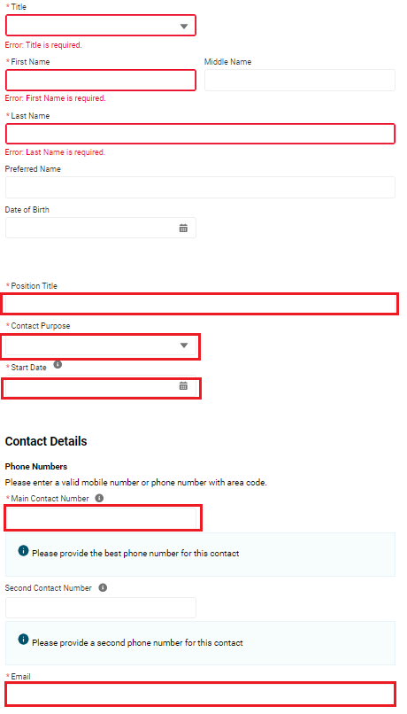

Fields marked with a red asterisk are mandatory. You may choose to include a **Preferred name, a Date of birth** and a **Second Contact Number**.

1. Once changes have been made, review the **Declaration** to confirm via a tick box that you have obtained the **personnel's consent for their details to be disclosed** to the Department. You cannot proceed if you do not tick ‘I agree’ in the **Declaration** box.
2. Select **Add Contact** to complete the change. Alternatively, select **Cancel** to return to the Profile page.

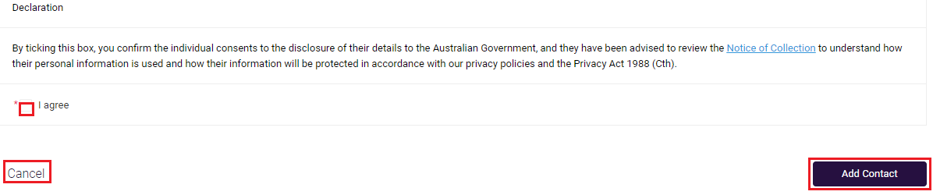

You will see a confirmation message displayed on screen confirming that the **record saved successfully**.

A screenshot of the 'Record saved successfully' message.

You will now be able to search for and view this new contact in the **Key Personnel and Contacts Table**.

## Edit a Point of Contact

All org-level and service-level users will be able to edit the **Personal Details** or **Contact and Employment Details** section for personnel as permitted by their user access level.

**This does not apply if the personnel is a Point of Contact and an active Key Personnel.**

Org-level users will be able to update all personnel with a Point of Contact role however in most cases, a service-level user will only have edit or update access for personnel associated with one or more services.

The following system **limitations** apply:

* Users can only update the Point of Contact Name fields (Title/First Name/Middle Name/Last Name) **once per day**. An update made on 1 July 2024 cannot be updated again until 2 July 2024.
* A Point of Contact associated with a service with the following status’ can be updated:
  + Operational (RESI/FLEXI/HC)
  + Offline (RESI/FLEXI)
  + Offline - Temporary closure of facility (RESI/FLEXI)
  + Offline - Permanent closure of facility (RESI/FLEXI)
* A Point of Contact cannot be edited, and the edit button will not display, if the personnel is associated with:
  + a Service that is in the process of being combined with another Service(s)
  + a Service that has been transferred to another approved provider and the user trying to update the Point of Contact is the prior owner.
  + the Point of Contact is historical, meaning they were ceased as a Point of Contact in the past.

1. Go to the **Key Personnel and contacts** table using one of the navigation steps set out in **5.3 View Key Personnel and Contacts**.
2. Select **View** on the contact to edit, this will navigate to the **Profile** page of the person you want to edit the details.

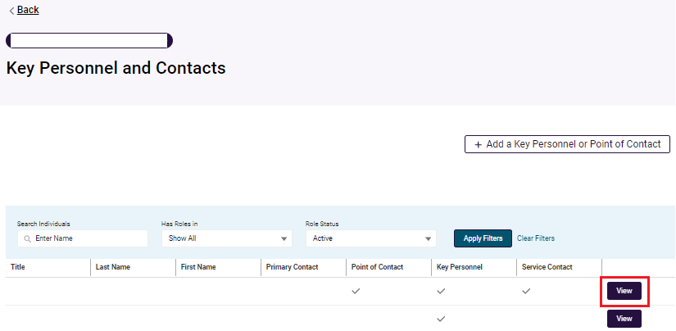

The table below contains information to guide you in making changes to existing contact information:

| **Contacts role type** | **Steps to follow** |
| --- | --- |
| **Primary Contact** | If you are updating or changing the **contact purpose** for a person nominated as the current primary contact, you must assign a new primary contact to another individual before you can update/change their contact purpose.  You can do this by updating an existing Point of Contact record, or adding a new Point of Contact |
| **Contact** | If you want to update the **contact purpose** of a Point of Contact, you must cease the Contact's role to assign a new role. |
| **Key Personnel** | Changes to Key Personnel details must be made via Notification form to the Aged Care Quality and Safety Commission. |

### Personal Details

1. Under the heading **Personal Details** select the **Edit** button to update the relevant fields:

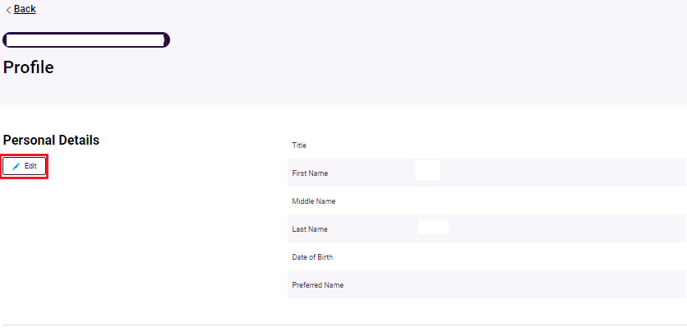

1. A **new window** will display on top of the page to allow you to update the required information.
2. Once changes have been made, review the **Declaration** to confirm via a tick box that you have obtained the personnel's consent for their details to be disclosed to the Department.
3. You cannot proceed if you do not tick ‘I agree’ in the **Declaration** box.
4. Select **Confirm** to complete the change. Alternatively, select **Cancel** to return to the **Profile** page.

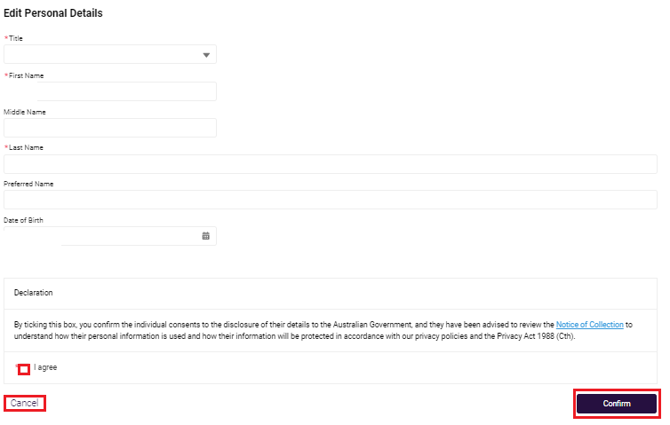

Fields marked with a red asterisk are mandatory. You may choose to include a **Preferred name** and **Date of birth**.

### Contract and Employment Details

1. Select the Edit button to update Contact and Employment Details.

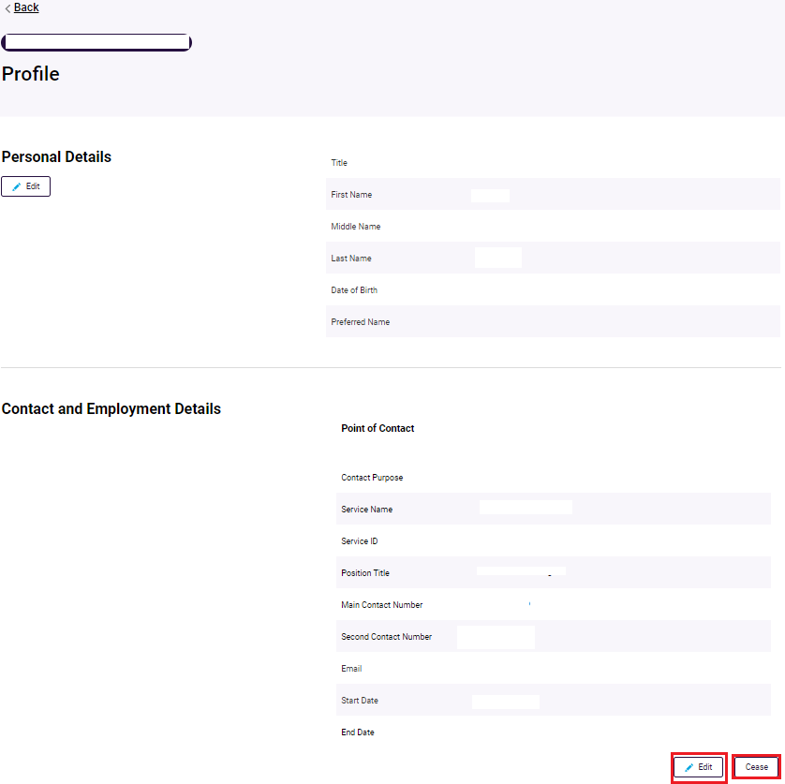

A **new window** will display on top of the page to allow you to update the required information.

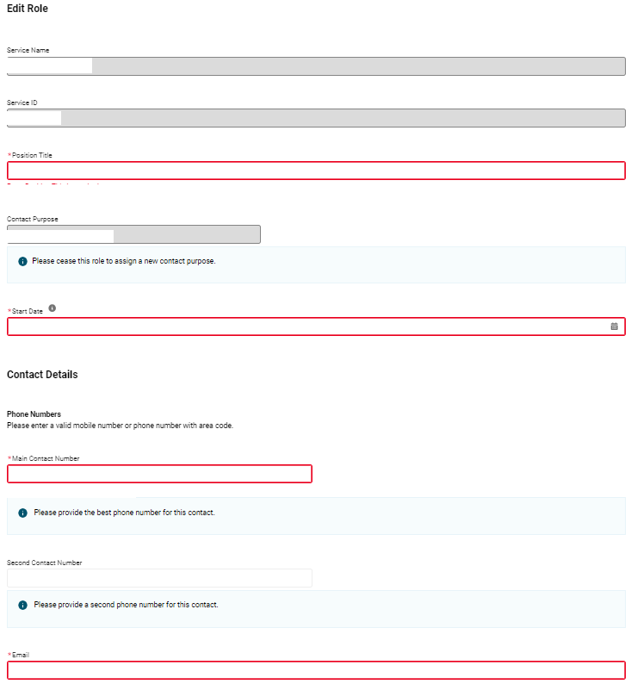

Fields marked with a red asterisk are mandatory a **Second Contact Number**.

1. Once changes have been made, review the Declaration to confirm via a tick box that you have obtained the personnel's consent for their details to be disclosed to the Department.
2. Select **Confirm** to complete the change. Alternatively, select **Cancel** to return to the Profile page.

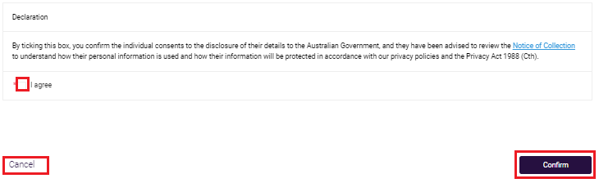

You will see a confirmation message displayed on screen confirming that the **Record saved successfully**.

A screenshot of the 'Record saved successfully' message.

You will now be able to search for and view this new contact in the **Key Personnel and Contacts Table**.

## Cease a Point of Contact

User access roles will determine what Point of Contact records a user can cease.

All org-level users can cease any organisational or service Point of Contact, however a service-level user can only cease a non-primary approved provider or Service Point of Contact

If the contact you want to cease is allocated as a Primary Contact, you must first follow the steps in the Point of Contact roles sub-section to add a new primary contact to the role. When a new Primary Contact is added the current primary contact relationship will be automatically end dated.

Where the Point of Contact is located in a service, the cease button will only be visible if the service has one of the following status:

* Operational (RESI/FLEXI/HC)
* Offline (RESI/FLEXI)
* Offline – Temporary Closure of Facility (RESI/FLEXI)
* Offline – Permanent Closure of Facility (RESI/FLEXI)
* Service Record Closed (RESI/FLEXI)
* Closed – Combined (RESI)
* Closed (HC)

1. Go to the **Key Personnel and contacts** table using one of the navigation steps set out in theView Key Personnel and Contacts section of this document.
2. Select **View** on the contact to cease this will navigate to the **Profile** page of the person you want to cease.



1. Under the **Contract and Employment Details** section of the person’s **Profile** page, select the **Cease** button.

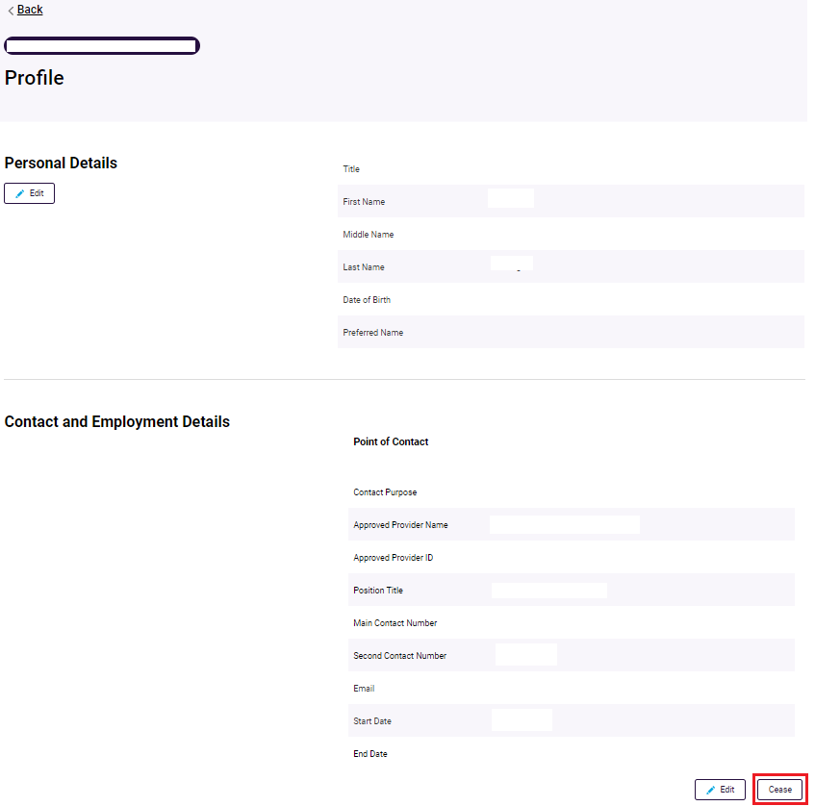

1. A **new window** will display on top of the page to allow you to select the date for the Contact’s role will conclude. The following system rules apply to this date field:

* The end date can be a past, present or future date
* The role end date cannot be prior to the role start date
* The role end date can be the same as the role start date
* The role end date is a required field

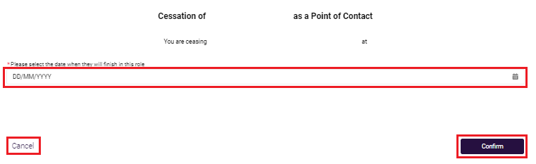

1. Select **Confirm** to complete the change. Alternatively, select cancel to return to the Profile page.

You will see a confirmation message displayed on screen confirming that the **Record saved successfully**.

A screenshot of the 'Record saved successfully' banner

You will now be able to search for and view this new contact in the **Key Personnel and Contacts Table**.

# Third Party Arrangements

All org-level users can view a list of all third party arrangements associated to their approved provider.

Users can also view the details held on each third party arrangement via the **Third Party Arrangement Details** page.

Service-level users will not see this tile on the **Manage Your Organisation’s Details** page.

## View Third Party Arrangements

1. From the **Manage Your Organisation** landing page, select **Third Party Arrangements** tile to view the third parties and services associated with your organisation.

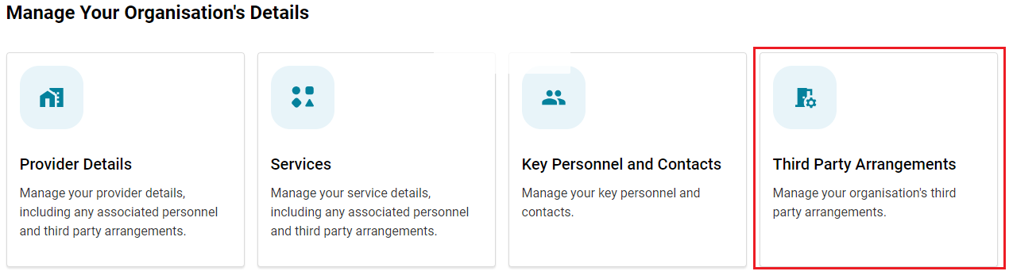

### Search and Filter

1. Users can search for a Third Party by **Third Party Name** orfilter by **Status** from the dropdown menu and select **Apply Filters** button.
2. The tables default view is **active** third party arrangements, however a user can select other status’ using the available table filters.
3. Users can sort this table alphabetically by hovering the mouse pointer over the column headers.
4. Select **Clear filters** to return to the default view.

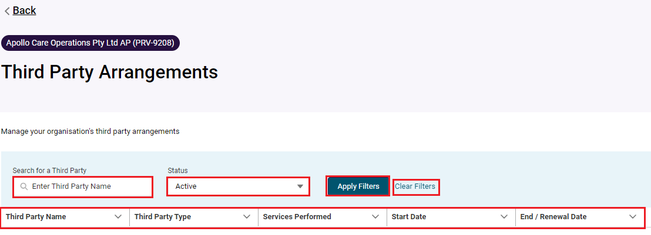

## View Third Party Arrangement details

An org-level user will be able to view the following information for an **active** Management Company or Service Delivery Organisation.

* A **management company** is a separate legal entity responsible for managing or running the day-to-day operations of your residential aged care service/s.
* A **service delivery organisation** is a separate legal entity that you have engaged under contract to deliver home care services specified under the contract to your consumers on your behalf.

Information held about a third party arrangement is provided by you when you notify the Commission about the arrangements you have put in place.

1. Basic details – this is information about the third party arrangement including:

* Third party name
* Third party ID - this is their record ID
* Third party type – whether they are a **management company** responsible for managing/running your residential aged care service/s or are a **service delivery** organisation delivering certain home care services to consumers on your behalf.
* ABN
* Incorporation ID – if applicable
* Incorporation type – if applicable
* Approved to provide aged care – if the organisation is an approved provider in their own right. This will be **Yes** or **No**.

1. Contract Details – the start and end date of their association with you.

* If the third party arrangement is a **Management Company**:
  + you will see their Association start and end dates. This is date they started managing your residential care service.
  + If the association is active the end date will be blank.
* If the third party arrangement is a **Service Delivery organisation**:
  + Services Performed – these are services will align with those provided under the Home Care Program
  + Roles and Responsibilities – any roles and responsibilities specified by you and as notified to the Commission.
  + Contract Start Date – the date the arrangement commenced.
  + Contract End / Renewal Date - the date that the contract/agreement is to cease or if your contact/agreement has a renewal date rather than an end date, this will be the date your contract/agreement is intended to be renewed.

1. Physical and Postal Address

To edit any of the details displayed on this page, you are required to notify the Commission formally through an Approved Provider Notification form.

You can navigate to the form by selecting **Begin Notification Form** located at the top of this page. Only org-level users can initiate this process.

More information can be found in the [GPMS User Guide: Approved Provider Notifications](https://www.health.gov.au/resources/publications/gpms-user-guide-approved-provider-notifications?language=en).