Government Provider Management System

User Guide:

Governing Body Determinations

September 2024

Version 1.1

This Government Provider Management System (GPMS) User Guide aims to support approved providers to begin, generate and complete a digital application for a Governing Body Determination from the Aged Care Quality and Safety Commission within GPMS.

Contents

1. Introduction 3

1.1 Purpose 3

1.2 Glossary 3

1.3 Login to the GPMS portal 3

1.4 Access Permission 4

1.5 Session time out 5

1.6 Further information and support 5

2. Accessing Determinations 5

3. Access, Draft and Submit Determination 7

3.1 Apply for a Determination whilst an application is in progress 7

3.2 Before you start 7

3.3 Add an Authorised Representative 9

3.4 Governing Body Determination Request 10

3.5 Reason for Determination 11

3.6 Care Recipients and Services 12

3.7 Key Personnel Cessation Details 14

3.8 Governing Body 16

3.9 Supporting Evidence 18

3.10 Review and Submit application to Governing Person 20

3.11 Confirmation of submitted determination application for review 22

3.12 Nominated governing person reviews the draft application form 23

3.13 Declaration and Submission 25

4. Determinations Table 29

4.1 View / Edit / Delete a form not yet submitted 29

4.2 View a Submitted Form 31

4.3 Status of an application 33

4.4 Save an application 33

5. Notifications 34

6. Paper based form submission 35

7. Withdrawal and updating a submitted application 35

# Introduction

The Government Provider Management System (GPMS) is a flexible IT (Information Technology) system which is a critical part of the Aged Care Digital Transformation Initiative underway to support aged care reform through better technology.

GPMS provides greater connectivity and data sharing between aged care providers and government.

## Purpose

This User Guide has been designed to support approved providers to complete, submit and view the status of the digital application form on the GPMS portal.

The assessment process, including communication with the approved provider will not be undertaken online. Instead, the Commission will engage directly with approved providers off system.

The ‘Apply for a determination’ feature on the GPMS portal allows approved providers to access, draft and submit a digital application for a determination that certain governing body responsibilities do not apply. Responsibility for these applications is owned by the Aged Care Quality and Safety Commission (the Commission).

Approved providers are encouraged to use this new online feature rather than relying on the downloadable governing body application form.

## Glossary

A [glossary](https://www.health.gov.au/resources/publications/gpms-user-guide-glossary?language=en) is available on the departments website to help you to understand the terminology used in relation to GPMS functionality.

## Login to the GPMS portal

To login to the GPMS portal please visit [Log In to GPMS portal.](https://provider.health.gov.au/serviceproviderportal/login?ec=302&startURL=%2Fserviceproviderportal%2Fs%2F)

If you require assistance logging into the GPMS portal, please refer to the GPMS [Logging in to the Aged Care Systems](https://www.health.gov.au/resources/publications/logging-in-to-the-aged-care-systems).

Please be advised of the following:

The Department of Health and Aged Care will retain records of your access to GPMS. When prompted upon login to GPMS, you must accept the [GPMS Terms of Use](https://www.health.gov.au/resources/publications/government-provider-management-system-terms-of-use?language=en) to be able to access the system.

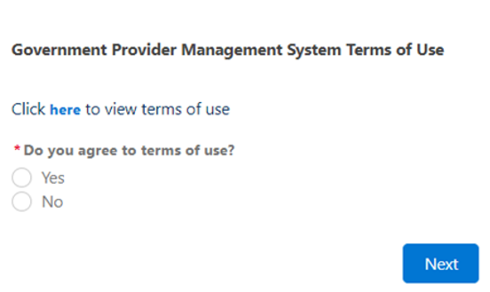

## Access Permission

Your organisation administrator can assign the following roles in the GPMS portal via the **Manage Your Organisation** landing page:

| **Role** | **Responsibility** |
| --- | --- |
| **Provider Staff (Org)** | Referred to in this document as **org-level user**.  Users with this role can:   * view or edit organisation and service details * access, draft and submit Approved Provider Notifications or Governing Body Determination application forms to a Provider Governing Person |
| **Provider Governing Person** | Users with this role can:   * view or edit organisation details * access, draft, make a declaration and submission of notifications or application forms to the Aged Care Quality and Safety Commission.   A governing person is defined by the *Aged Care Quality and Safety Act 2018.* As a result of this, any person assigned this role **must also** be listed as key personnel for your organisation. |

## Session time out

Before starting work on an online form, the user should be aware of the “time-out” functions when a user is logged in to the GPMS portal.

GPMS has a time-out feature which automatically requires re-entry of username and password after 15 minutes of inactivity on the GPMS portal.

The Department strongly recommends users regularly save digital forms in progress in order to avoid loss of information which may occur given there is no “auto save” feature.

This also applies if you click on a notification that may pop up during the uploading of supporting evidence or if you refresh you page whilst editing a form.

Information which is lost due to “time-out” can not be recovered.

## Further information and support

Please refer to the Government Provider Management System [webpage](https://www.health.gov.au/our-work/government-provider-management-system-gpms/government-provider-management-system-gpms-managing-your-organisation) and the Manage Your Organisation [webpage](https://www.health.gov.au/our-work/government-provider-management-system-gpms/government-provider-management-system-gpms-managing-your-organisation) for more information.

If you require further assistance to login to GPMS please contact the My Aged Care service provider and assessor helpline on **1800 836 799**, Monday to Friday (8am to 8pm) and Saturday (10am to 2pm) local time across Australia.

For translating and interpreting services, call **131 450** and ask for My Aged Care on **1800 836 799**.

To use the National Relay Service, visit [About the National Relay Service (NRS) | Access Hub](https://www.accesshub.gov.au/about-the-nrs) or call **1800 555 660**.

To access sign language interpreting and captioning services through Deaf Connect, call [1300 773 803](tel:1300%20773%20803) or email [interpreting@deafconnect.org.au](mailto:interpreting@deafconnect.org.au).

# Accessing Determinations

If, after considering your organisation’s governance arrangements against the governing body membership requirements under the *Aged Care Act 1997,* you require a time limited determination from the Commission, you can access the digital Governing Body Application Form through the GPMS portal.

Only certain users can access the digital application form. Your organisation administrator can assign one of the roles listed in section 1.4 of this guide in order to access to the GPMS Portal and **Manage Your Organisation** tile where the digital form is located:

Once logged in, you can navigate through the GPMS Portal to the digital application form by selecting the **Manage Your Organisation** tile to display the **Manage Your Organisation** landing page.

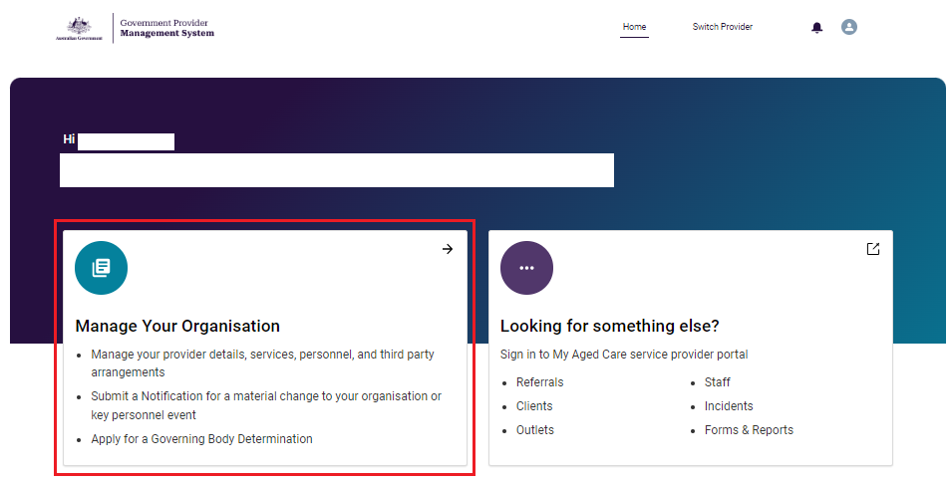

1. From the Manage Your Organisation page you will see two tiles under the heading **Notify or Apply to the Commission.**

* Notifying us of certain matters; and
* Apply for a determination that certain governing body responsibilities do not apply.

1. Within the tile you will see a link titled **Learn more about requesting a determination** which opens a new window in your browser and will display the govering body determination guideance held on the Commission’s website which will assist you to understand the responsibilities in order to better respond to the questions in the digital application form.
2. Select **Apply for a Determination** to apply for a Determination from the Aged Care Quality and Safety Commission.

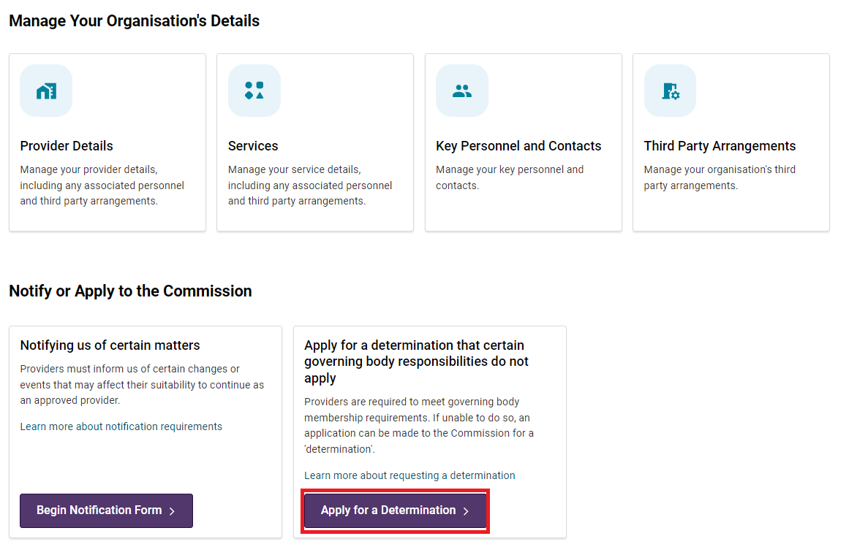

# Access, Draft and Submit Determination

This online feature replaces the previous Microsoft Word document based Governing Body Determination application form, providing a more streamlined application process for approved providers.

Follow the steps set out in this guide to help you to navigate the digital Governing Body Determination application form to enable the successful submission of your application.

From this point of the guide, the digital Governing Body Determination application form will be referred to as **the application form**.

## Apply for a Determination whilst an application is in progress

You will not be able to apply for a new determination whilst another has already been submitted or in draft status (as listed in the Determination table – see details later in this guide). This button will appear greyed out and you will not be able to launch another form.

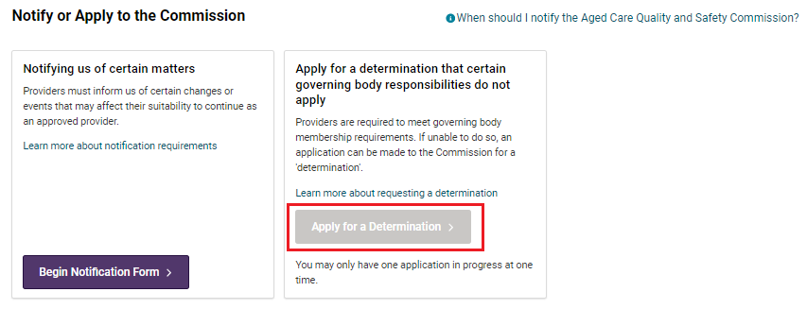

Determinations in a draft status can either be edited or deleted if the draft is no longer required.

## Before you start

1. The **Before You Start** page shows important information that may help users complete the application form with accuracy and efficiency.

| **Section** | **Description** |
| --- | --- |
| **About this form** | General guidance for approved providers about the application form |
| **Privacy and your personal information** | A statement about how personal information is protected. It also contains a link to the Commission’s Privacy Policy  It is expected that users have read and understood the Commissions Privacy Policy and the Notice of collection before progressing further. |
| **Notice of collection** | A link to the Commission’s Notice of collection held in its website. |
| **Who can approve and submit this form** | Applications for a Governing Body Determination need to be reviewed and signed by a governing person prior to submission to the Commission. A governing person is defined under the *Aged Care Quality and Safety Commission Act 2018*. |

1. You can view the application steps in the **progress bar** located on the left margin of each page of the application form. A green tick will appear when a section is complete. A blue circle will appear in the section currently being worked on. The steps include:

* Before You Start
* Authorised Representative
* Governing Body Determination Request
* Reason for Determination
* Care Recipients and Services
* Key Personnel
* Governing Body
* Supporting Evidence
* Review

1. The form contains mandatory fields that are marked with a red asterisk. You will not be able to proceed through the form if the fields are not completed.
2. Select **Next** to progress with the application..

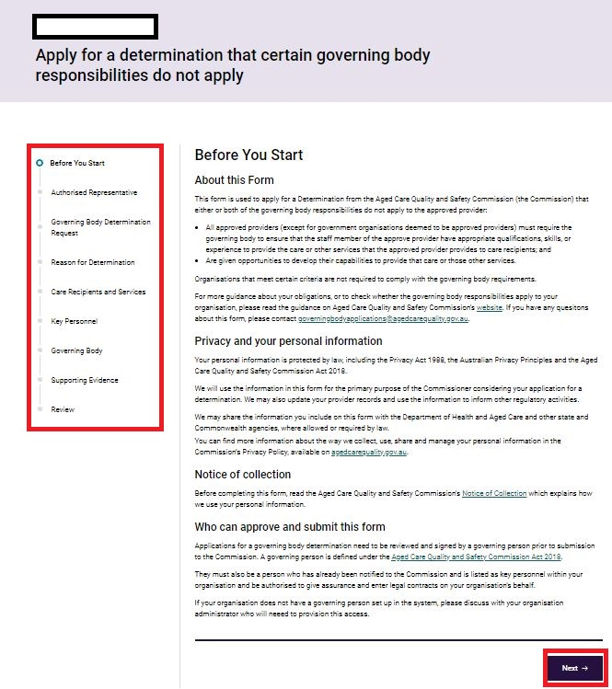

## Add an Authorised Representative

The Provider Staff (Org) user or Provider Governing Person may prefer to nominate another person as an authorised representative to manage enquiries or otherwise engage with the Commission in relation to the submitted application. If not another person, the Provider Staff (Org) user or Provider Governing Person’s details needs to be provided here.

Authorised Representative details must be provided to facilitate this liaison role. All fields are mandatory and must be completed:

* Full Name
* Role / Position
* Phone
* Email

1. Select the **Next** button to progress to the next page. Alternatively, you can select **Save for later** or **Back** to navigate to the **Before You Start** page.

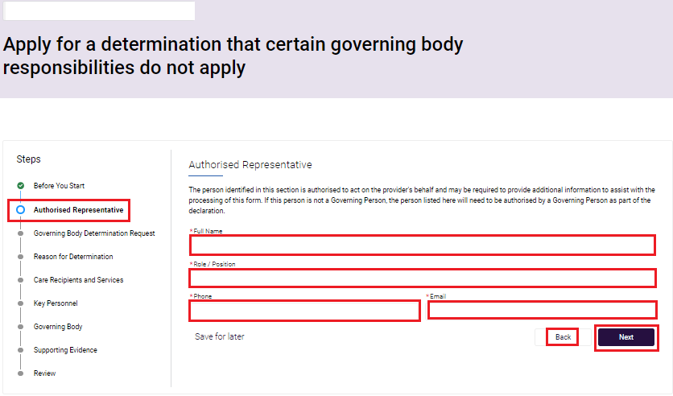

## Governing Body Determination Request

A user will be able to select which responsibility or responsibilities you are applying for a determination on. You must select either one or both responsibilities to proceed with the determination application.

You can visit the [Commission’s website](https://www.agedcarequality.gov.au/for-providers/strengthening-governance) for more information about these responsibilities and to help inform your application.

1. Select one or both of the responsibilities you are seeking a determination on:

* A majority of the members of the governing body being independent non-executive members
* At least one member of the governing body having experience in providing clinical care

1. Select the **Next** button to progress to the next page. Alternatively, you can select **Save** **for later** or **Back** to navigate to the **Authorised Representative** page.

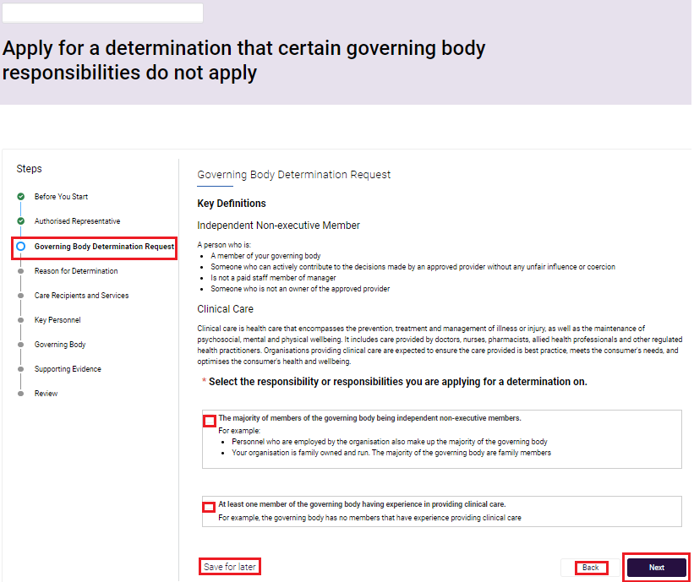

## Reason for Determination

You will need to provide reasons for the determination requested in the previous section, and why you cannot meet your responsibilities.

1. Click on the field titled **Enter the reasons below** to provide an explanation that outlines the reason for seeking a determination, including why you cannot meet the chosen responsibilities.

Ensure your response is no longer than 3000 characters. You may choose to type your response in an offline document, text only, and paste it into the response field.

1. Select the **Next** button to progress to the next page. Alternatively, you can select **Save** **for later** or **Back** to navigate to the **Governing Body Determination Request** page.

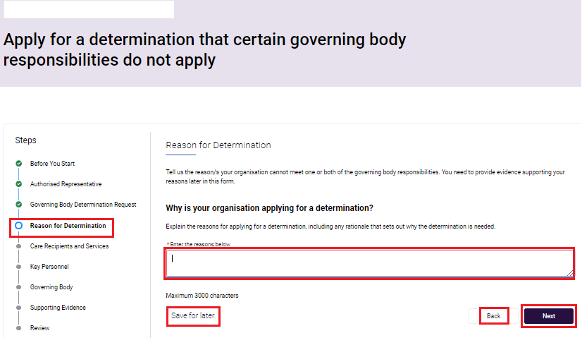

## Care Recipients and Services

When deciding a determination application, the Commissioner may consider several matters specified in section 63-1E(4) of the *Aged Care Act 1997*.

In this section of the form, provide information for the Commissioner to consider, specifically in relation to its care recipients and services.

On this page you will be shown the number of ‘Operational’ services associated with your organisation in a table format. You must enter the total number of consumers receiving aged care from each service to progress to the next page.

The total number of consumers will then show on the screen underneath the heading **Consumers you provide after care to across all of your services**. When landing on the page, the total will be zero until you enter information into the table.

This field is then automatically calculated based on the number of care recipients entered against each Service.

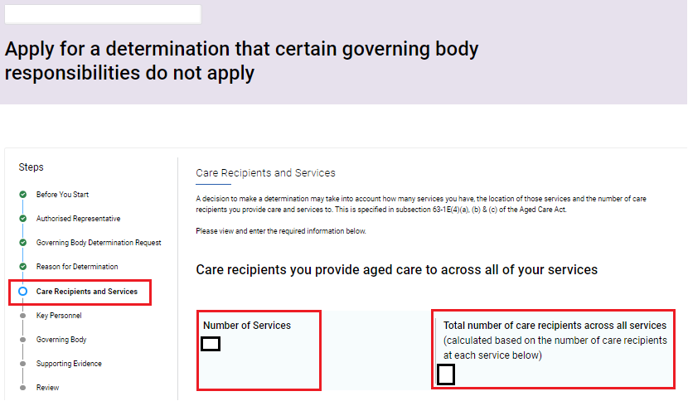

1. Enter the **number of care recipients** for each service listed in the **Services Location(s)** table.
2. If you have zero services you will see the below message under the **Service location(s)** table:

“Your organisation has no currently operational services, and therefore fewer than 40 care recipients. If you also have fewer than 5 governing persons, the Governing body requirements do not apply to you at this time.”

1. Select the **Next** button to progress to the next page. Alternatively, you can select **Save** **for later** or **Back** to navigate to the **Reason for Determination** page.

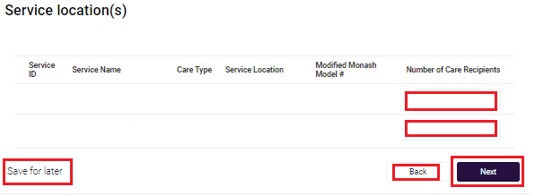

## Key Personnel Cessation Details

On this page of the application form, you will be able to see details about Key Personnel turnover. This is taken from your approved provider record in GPMS.

You will see the number of current Key Personnel listed as active and the number who have been ceased as Key Personnel, followed by the percentage.

Where applicable, these figures represent the 12 months period before you commence an application or, if you have operated as an approved provider for less than 12 months, these figures represent the date of approval to the date your application is completed.

It is recommended that you ensure that no Key Personnel changes are being processed before you commence this form.  If you have submitted a Key Personnel notification to the Commission and it is not yet finalised, contact the Commission for advice on progressing this application.

1. View the **Cessations Details** table to check that the information is correct.

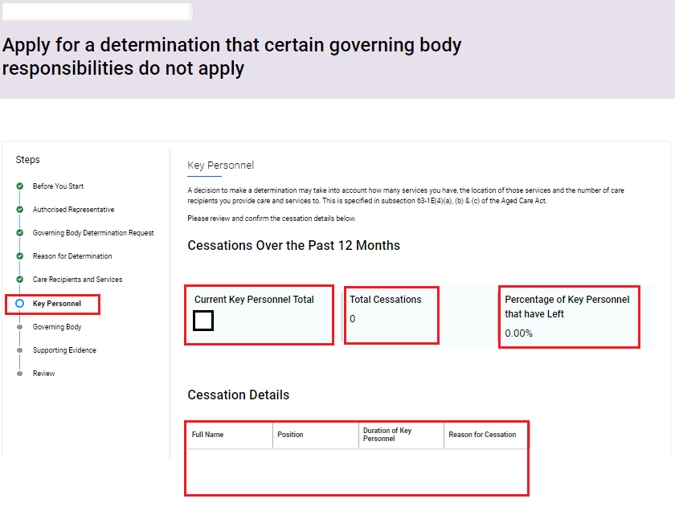

1. Confirm if the information displayed in the **Cessations Details** table is correct and complete by selecting:

* **Yes**; or
* **No, the information is incorrect or incomplete**

If you select **No**, you will be advised that before completing this form that you complete and submit a notification to the Commission to update your organisation’s key personnel records, because information about your key personnel turnover is part of the assessment of your application.

1. Select the **Next** button to progress to the next page. Alternatively, you can select **Save** **for later** or **Back** to navigate to the **Care Recipients and Services** page.

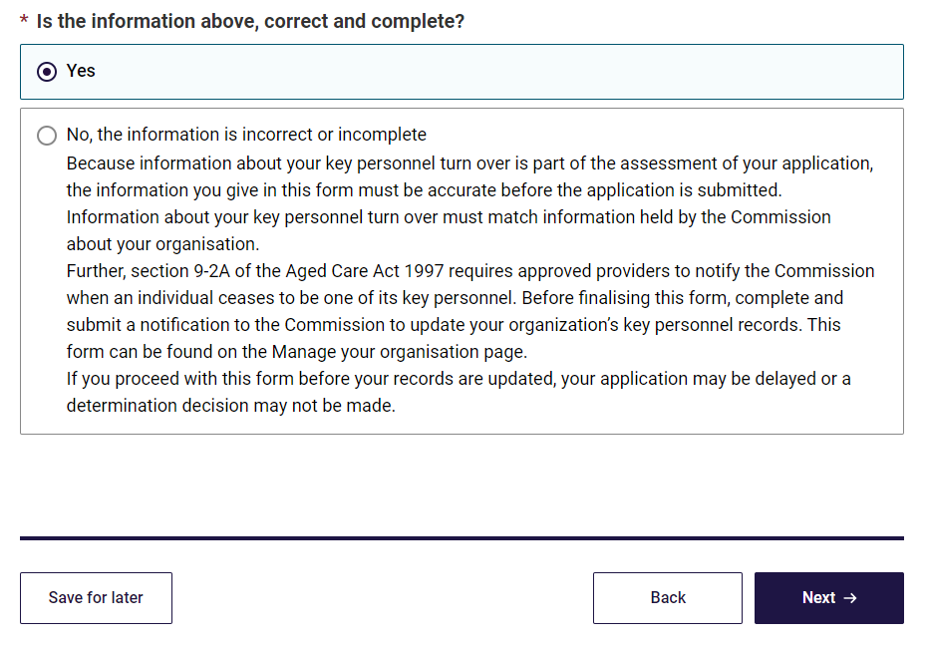

## Governing Body

This section of the application form requires details around the membership of your governing body, the arrangements of the governing body to act independently, and the arrangements of the governing body to seek advice to provide clinical care.

1. Enter a description about your organisation’s governing body in the free text fields. These fields are mandatory and have a maximum character limit of 3000 characters.

| **Section** | **Description** |
| --- | --- |
| **Describe the membership of your governing**  **body** | When describing the membership of your governing body, include the name, role/position and employment status of each individual member. |
| **Assisting your members to act objectively and independently** | Describe the arrangements you have made, or will make, to assist members of the governing body to act objectively and independently in the best interests of your organisation. |
| **Assisting your members to seek advice** | Describe the arrangements you have made, or will make, to assist members of the governing body to seek, when necessary, advice from a person with experience in the provision of clinical care. |

1. Select the **Next** button to progress to the next page. Alternatively, you can select **Save** **for later** or **Back** to navigate to the **Key Personnel and Cessation Details** page.

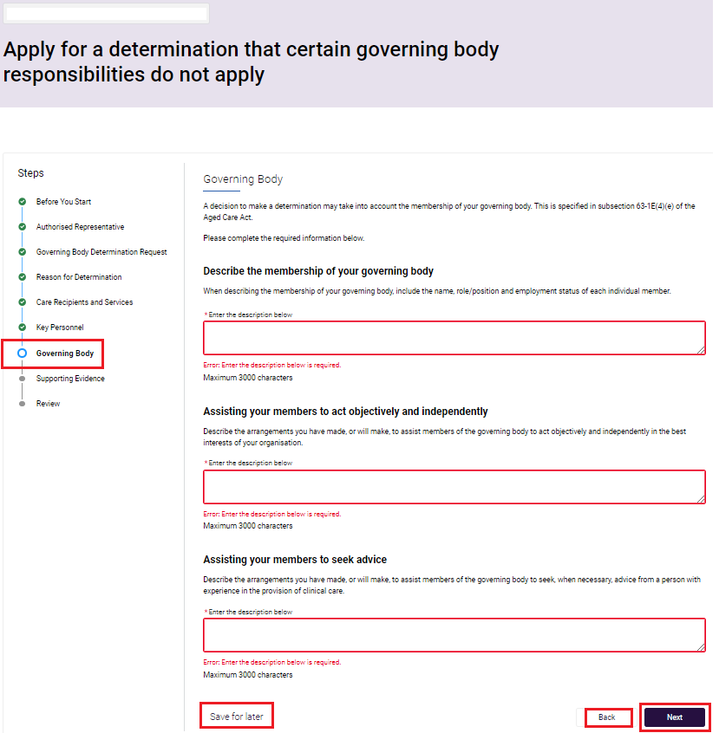

## Supporting Evidence

It is a requirement that you attach supporting documents to this application form for assessment. The information you upload should support the responses you have provided in the form.

You should ensure your supporting documents set out your plans for meeting the governing body responsibilities when the specified period expires.

You will not be able to progress this application form until at least one supporting document is uploaded.

For more information about the documents that may be applicable, visit the [Commission’s website](https://www.agedcarequality.gov.au/for-providers/strengthening-governance).

You can also email [governingbodyapplications@agedcarequality.gov.au](mailto:governingbodyapplications@agedcarequality.gov.au)

1. Tick the checkbox to select which document(s) you are uploading in support of your request for determination.

Before you upload your supporting documents, make sure they have an easily identifiable name. For example, name your company annual report ‘ABC Aged Care Pty Ltd_Annual Report_2023’.

Documents that can be uploaded include those listed in the application form as follows:

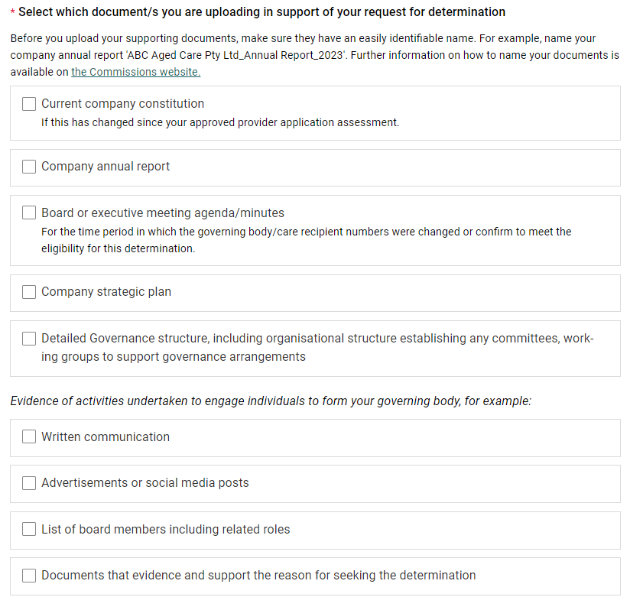

1. Attach the document by clicking on **Upload Files** button or **drag and drop files**.

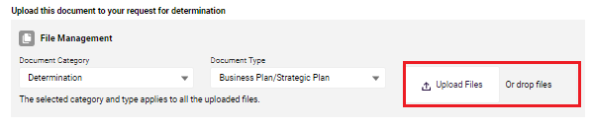

1. Once the file has uploaded, select **Done**.

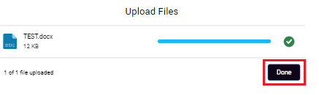

1. A green banner will then display confirming the file has been sent for scanning, then it will confirm the file has been uploaded.

A screenshot of the banner displayed confirming the file has been sent for scanning.

1. Once successfully scanned, you will also receive a notification that the file has been uploaded. (This may take a few minutes).

A screenshot of the banner displayed confirming the file has been uploaded.

1. You can preview or delete files that have been uploaded by clicking the icon next to the document uploaded.

**Delete file**

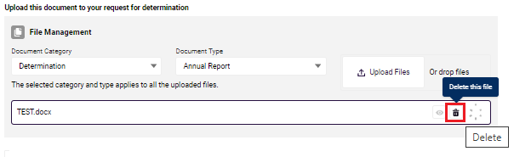

**Preview file**

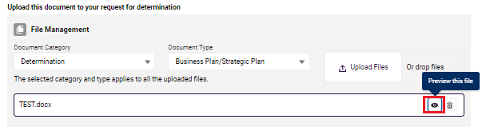

1. Select the **Next** button to progress. Alternatively, you can select **Save** **for later** or **Back** to navigate to the **Governing Body** page.

**Screenshot of 'Save for later' button, 'Back' button and 'Next' button highlighted.**

## Review and Submit application to Governing Person

An application cannot be submitted unless it is reviewed and then approved by a Provider Governing Person.

This means that a user with Provider Staff (Org) profile will be able to edit, review, assign, and reassign an application for their Provider Governing Person to review and approve.

1. It is expected that the information entered into the application form is reviewed to ensure accuracy and to ensure that all required documents uploaded support your responses.
2. To edit the information entered previously in the application form. Select **Edit,** located at the end of the review form . You will be navigated back to the first step of the form – **Step 1: Before You Start**. From here, navigate to the responses in the form you would like to to edit by clicking **Next**.
3. When you have finished editing, you can continue to the next step.

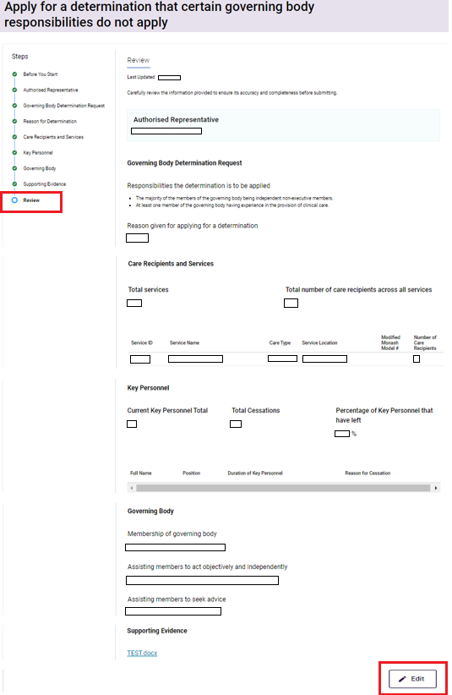

1. Select the governing person(s) that will be responsible for approving and submitting the application form:

* Depending on the provider’s requirements, more than one person in the list of governing persons can be selected

1. If you do not see a list of governing persons at the bottom of the page, this means that your organisation has not assigned a Provider Governing Person profile. You cannot proceed at this time. You must:

* select **save for later**
* contact your organisation administrator and inform them about the requirement to assign a Provider Governing Person to allow you to progress with your application
* return to this form when the Provider Governing Person has been assigned and go to the following step

1. Select the **Send for review** button. This will automatically generate an email to the selected governing person/s that an application form is available for them to review and approve. Alternatively, you can select **Save** **for later.**

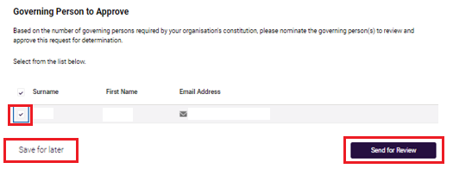

## Confirmation of submitted determination application for review

1. Once the **Send for Review** button has been selected, the Provider staff (Org) will be shown a completion message confirming the form has been sent to the nominated Provider Governing Person/s for review and submission.
2. The email address of the following users will be displayed to confirm where the notification email was sent:

* The nominated Provider Governing Person(s) selected to review and submit the declaration
* Authorised Representative for the approved provider

1. You will also be provided with a Determination ID for the application which can be used to track the progress of the application in the Determination Table.
2. Select **Return to Manage Your Organisation** to view the **Determination Table** on the **Manage Your Organisation** landingpage.

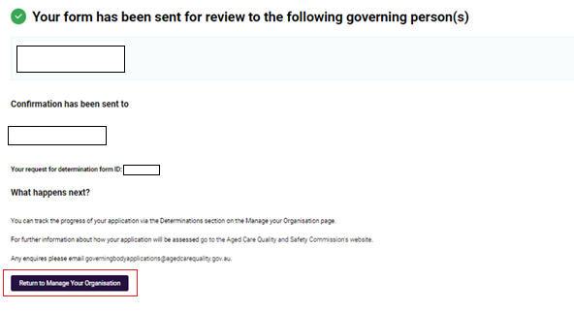

## Nominated governing person reviews the draft application form

1. Once the **Send for Review** button has been selected, all nominated Provider Governing Person(s) will receive an email and GPMS portal alert.
2. They will need to login to GPMS to view the message and application form.
3. To access the alert, click on the **bell icon** in the top menu on the GPMS portal landing page.
4. Select the Determination notification to navigate to the **Manage Your Organisation** landing page and view the **Determinations table**.

**Please note:**

If you are already on the Manage Your Organisation landing page, clicking on the notification will keep you on the page.

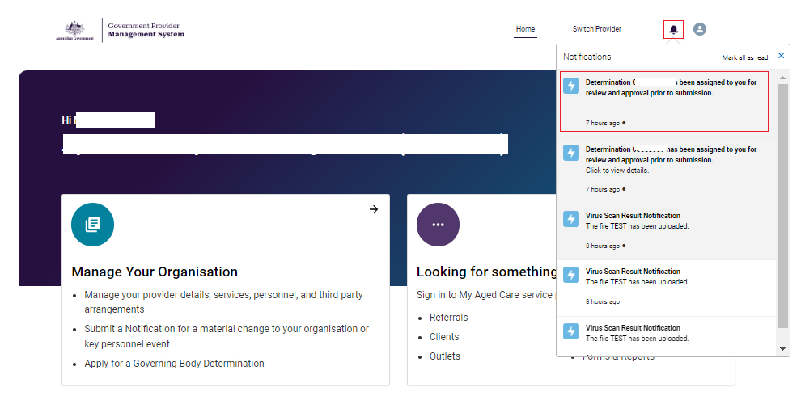

1. From the Determination table, select the **Edit** button to access the draft application.

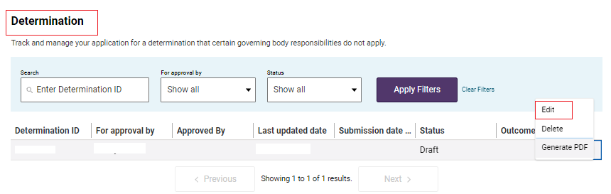

1. This will then open the review page and allow them to read the information that has been entered into the application form.
2. From here, options available are:
3. If they are satisfied with all of the content of the draft applications, meaning they can attest to it being true and accurate, select **Next** which will take them to to the Declaration and Submission page; or
4. If there is incorrect or missing information, they may click **Edit**. This will navigate them to the first step of the application form – Step 1: **Before You Start**. They will see the Declaration and Submission step visible in the progress bar to confirm that this is the current stage of the progress status;

**OR**

1. Click **Save for Later** which will save the form and allows them to return at a later stage to undertake the review and then submit when ready.

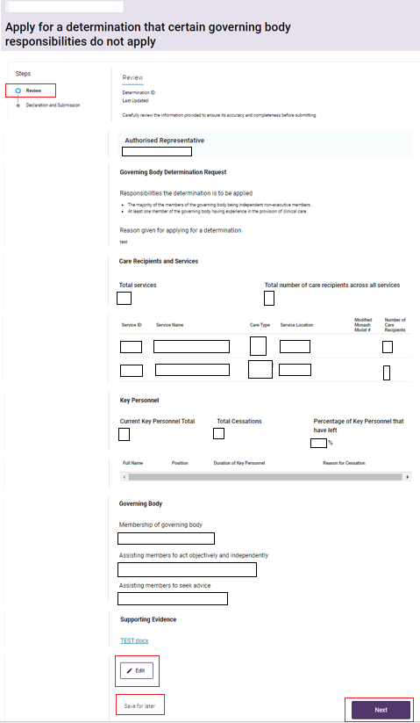

## Declaration and Submission

### Provider Governing Person Submits Determination application

If the Provider Governing Person is satisfied with the information presented in the digital determination application form, then they are required to confirm the declaration via a checkbox before submitting it.

1. Select from the first radio button:

* I, [Governing Person Name] agree to the statement presented above.

1. Click **Confirm** to submit orAlternatively, select **Back** to navigate to the **[confirm screen]**.

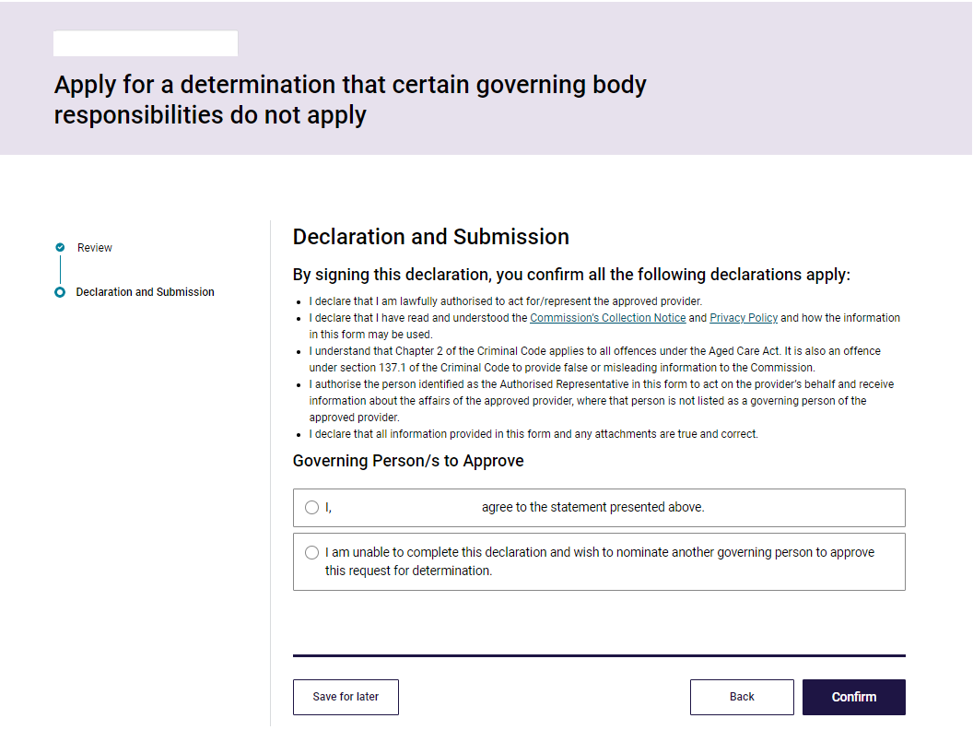

1. You will be shown a **Confirmation** screen after the form has been submitted. The following users will receive a confirmation email:

* The Provider Staff (Org) user who submitted the form to the Provider Governing Person to review and approve
* The Provider Governing Person who submitted the declaration
* Any additional nominated Provider Governing Persons who signed off the form
* Primary Contact for the Provider

1. The digital determination application form ID will also be included for reference.

**Please note:**

If there are no other Provider Governing Persons within the organisation to choose from, the second option to nominate another Governing Person will not be available to select and the user will see a checkbox instead.

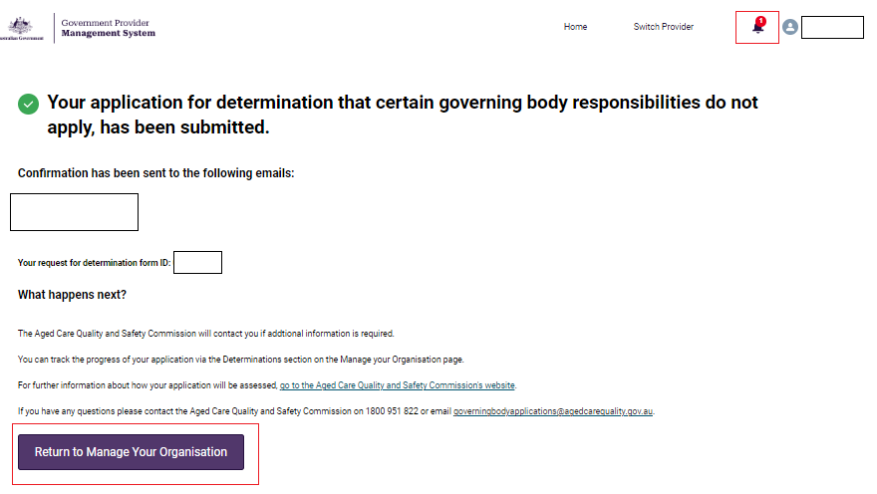

### Provider Governing Person nominates another Governing Person

If the Provider Governing Person is unable to complete the declaration:

1. Select from the second radio button:

* I am unable to complete this declaration and wish to nominate another governing person to approve this Determination

1. A list of other Governing Persons will display
2. Select from the **Nominate another Governing Person** list another governing person to complete the review and submit process.
3. Select **Confirm to send for review.** Alternatively, select **Back** to navigate to the **Review** page.

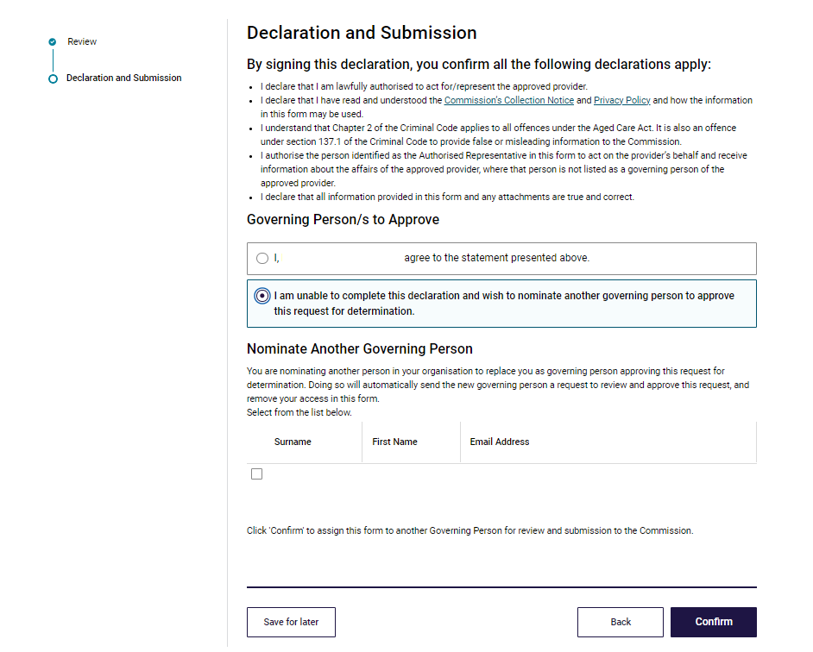

1. You will be shown a **Confirmation** screen after the digital determination application form has been sent to the nominated Provder Governing Person for review and submission. The following users will receive a confirmation email:

* The Provider Staff (Org) user who submitted the form to the Provider Governing Person to review and approve.
* The newly nominated Provider Governing Person who the form has been sent to for endorsement by the original nominated Provider Governing Person.
* Primary Contact to the Provider.

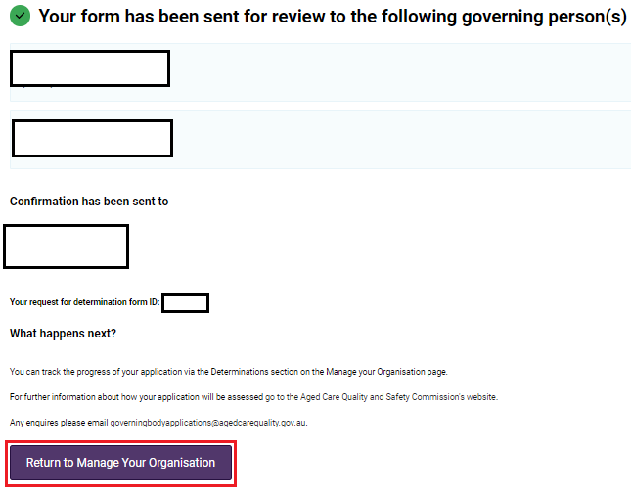

1. You can track your submission in the **Determinations Table** which you can access on the **Manage Your Organisation** page.

For further information about how your application will be assessed please visit the [Aged Care Quality and Safety Commission’s website](https://www.agedcarequality.gov.au/for-providers/strengthening-governance/request-determination).

Any enquiries please email [governingbodyapplications@agedcarequality.gov.au](mailto:governingbodyapplications@agedcarequality.gov.au).

# Determinations Table

This table allows you to track and manage your application for a determination that certain governing body responsibilities do not apply.

You will see a list of all determinations and can filter this list by status.

This table has two components:

1. Search criteria

You can search via the **Determination ID** or **for approval by** and apply filters, or alternatively search via the **Status** (Draft, Submitted, Processing, Finalised or show all)

The default view is **show all**. Select **Clear filters** to return to the default view.

1. Search via ascending or descending order from the table headers

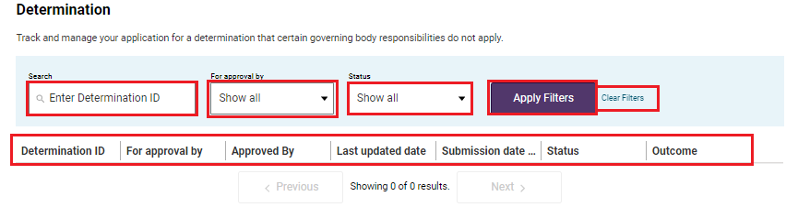

## View / Edit / Delete a form not yet submitted

The user can access the digital determination application form while waiting for the Provider Governing Person to review via the **Manage Your Organisation** page.

The status will show as **Draft** in the Determinations table and the user will be able to:

* Delete Draft
* Edit Draft

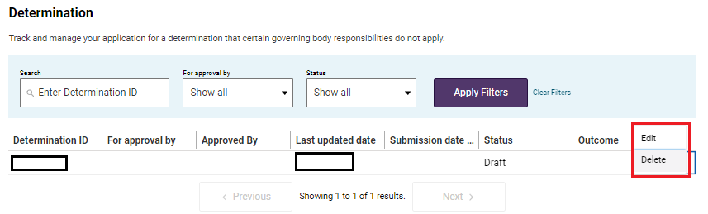

**Delete Draft**

1. To delete a draft, select **Delete.** A pop-up will then display to confirm selection, click **Cancel** to go back to the **Manage Your Organisation** landing page or **Proceed** to delete (This action will permanently delete the draft application).

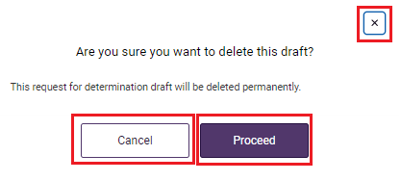

1. You will receive a confirmation message noting record has been successfully deleted.

A screenshot of the banner confirming the draft has been successfully deleted.

1. This change will also be updated in the **Determination** Table.

**Edit Draft**

1. If the user selects the **Edit** button they will navigate back to the form where they can perform the following actions:

* Edit the contents of the Governing Body Determination form



## View a Submitted Form

A form that has already been submitted by a nominated Provider Governing Person can be viewed via the **Determinations Table.**

The status will show as **Submitted** in the **Determinations Table** and the user will be able to:

* View Summary
* Generate PDF

When viewing the details of the digital determination application submission, the Submission date and name of the submitter will be displayed.

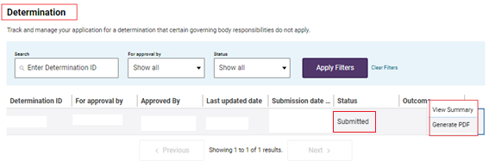

### View summary

1. From the Determination table, click on the **dropdown menu** in the **Outcome** column **View Summary**, this will open a summary page where the user will be able to view the details of digital determination application form.
2. Select **Return to Manage Your Organisation** to navigate back to the Manage your organisation landing page.

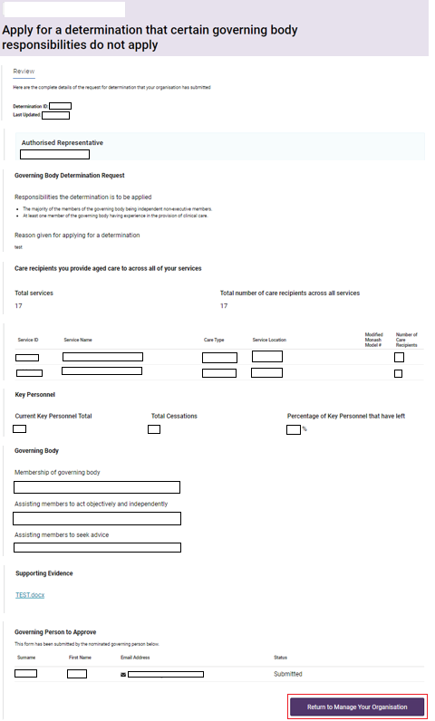

### Generate PDF

From the Determination table, click on dropdown menu in the outcome column and select **Generate PDF**, this will generate a PDF and the form is downloaded to your local drive.

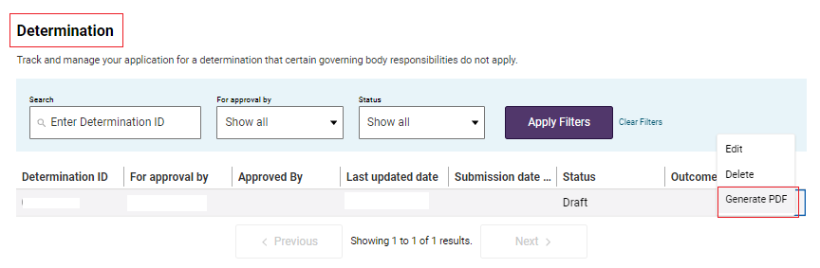

A screenshot of the 'PDF Generated' screen



## Status of an application

The user can see the following status in the Determination table. The assessment process, including communication with the approved provider will not be undertaken online. Instead, the Commission will engage directly with approved providers off system.

| **Status** | **Outcome** |
| --- | --- |
| **Draft** | A digital determination application form which has not been submitted by the Governing Person. |
| **Submitted** | The digital determination application form has been submitted by the Provider in GPMS and sent to the Commission |
| **Processing** | The Commission has commenced processing the digital determination application form. |
| **Finalised** | * Approved * Not Approved * Invalid * Withdrawn * Expired * Revoked |

## Save an application

You can select the **Save for later** button at any time throughout the form, this allows you to return at a later stage to complete the form and submit when ready.

1. Select **Save for later**.

Screenshot of the 'Save for later' button on the left side of screen highlighted.

1. A pop-up will appear with the option to **Cancel** to return to the form or click **OK** to proceed.



1. You will receive a conformation that your application has been saved, select **OK** to navigate to the Manage Your Organisation landing page.

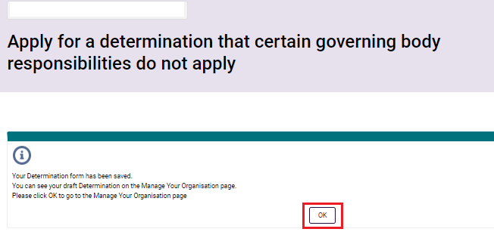

1. From the **Determinations table**, refresh the page to see the change made to the form.

# Notifications

A notification is an activity that informs the user of an event, for example when a form has been assigned to you for review and approval prior to submission or a file has been uploaded. The user may need to complete an action as a result of the notification.

All staff with access to the GPMS portal will have access to view notifications that apply to them.

To view these notifications, select the **Notifications** bell icon from the Manage Your Organisation landing page.

Screenshot of the GPMS Portal landing page with the 'Notifications' button highlighted.

# Paper based form submission

In exceptional circumstances or if technical difficulties exist, a word document-based application form can be requested. Contact the Commission on **1800 951 822** or email either [info@agedcarequality.gov.au](mailto:info@agedcarequality.gov.au) or [governingbodyapplications@agedcarequality.gov.au](mailto:governingbodyapplications@agedcarequality.gov.au).

# Withdrawal and updating a submitted application

Provider Staff (Org) user may choose to withdraw an application for a Governing Body Determination, in which case the assessment of the request and no determination decision is required to be made.

To request the withdrawal of an application or correction of any information provided contact the Commission on **1800 951 822** or email either [info@agedcarequality.gov.au](mailto:info@agedcarequality.gov.au) or [governingbodyapplications@agedcarequality.gov.au](mailto:governingbodyapplications@agedcarequality.gov.au).