A purple square with the heading text 'Expanding the National Aged Care Mandatory Quality Indicator Program: Staffing QIs Final Report '


Department of Health and Aged Care

Expanding the National Aged Care Mandatory Quality Indicator Program: Staffing QIs Final Report

28 June 2024 

About this report

The Department of Health and Aged Care (Department) worked with HealthConsult, the South Australian Health and Medical Research Institute (SAHMRI), and the University of Queensland (UQ) to develop new staffing quality indicators (QIs) for enrolled nurses, allied health professionals, and lifestyle officers. Together, we identified, assessed, developed, and piloted new evidence-based staffing QIs.

The new staffing QIs will be implemented as part of the National Aged Care Mandatory Quality Indicator Program (QI Program). We thank everyone who contributed to the sector consultation and all the residential aged care services that participated in the pilot.

Disclaimer

The Australian Government's Department of Health and Aged Care commissioned the HealthConsult, SAHMRI, UQ Consortium to develop new Quality Indicators (QIs) for enrolled nurses (ENs), allied health professionals, and lifestyle officers. These will be implemented as part of the National Aged Care Mandatory Quality Indicator Program (QI Program).

We (the Consortium) have prepared this final report for the benefit of the Department of Health and Aged Care. The report should not be used or relied upon for any purpose other than as an expression of the conclusions to the Client as to the matters within the scope of the report. Consortium organisations and staff expressly disclaim any liability to any person other than the Client who relies or purports to rely on the report for any other purpose.

We have prepared the report with care and diligence. The conclusions given by us in the report are given in good faith and in the reasonable belief that they are correct and not misleading. The report has been prepared by us based on information provided by the Client and by other persons. We have relied on that information and have not independently verified or audited that information.

Liability is limited by a scheme approved under Professional Standards legislation.

Executive summary

This Final Report presents the findings from the development and pilot testing of new staffing quality indicators (QIs) for enrolled nurses (ENs), allied health professionals, and lifestyle officers. These will be implemented as part of the QI Program in residential aged care services. The project was a collaborative effort involving the Department of Health and Aged Care, HealthConsult, SAHMRI, and the UQ.

The project aimed to expand the QI Program by developing evidence-based staffing QIs to monitor and improve the quality of care provided in residential aged care services. The development process included an evidence review, sector consultation, and a mixed-methods pilot study conducted with a diverse sample of residential aged care services.

Key Findings

* **Evidence review:** The review identified international evidence for staffing quality indicators based on total hours per resident per day and staff turnover (specifically for nursing and allied health). However, there are no additional staffing quality indicators that focus on enrolled nurses, allied health professionals, and lifestyle officers in the residential aged care setting.
* **Sector consultation:** The review gathered extensive feedback from aged care providers, care recipients, workforce organisations, unions, peak bodies, and technology providers. Key insights included the importance of multidisciplinary care, and the challenges of data collection and reporting.
* **QI development:** Eight QIs were developed, with four relying on information already reported through the Quarterly Financial Report (QFR) and four requiring additional data collection. During post-pilot data analysis, an additional QI was developed using pilot data collected for allied health professionals.
* **Pilot design and participation:** A six-week pilot was conducted with 69 residential aged care services, representing various states/territories, service sizes, and ownership models. Data collection tools, training, and support mechanisms were provided to assist accurate and consistent reporting.
* **Assessment of staffing QIs:** The assessment criteria for the QIs included importance, scientific acceptability, feasibility, and usability, using the US National Quality Forum evaluation criteria and the Endorsement and Maintenance Guidebook for quality measures.[1] The QIs were evaluated to determine their readiness for implementation, with some requiring further research and refinement in Table 1.

Table 1: Final assessment of the staffing QIs

| Proposed QIs | Importance | Scientific Acceptability | Feasibility | Usability | Summary |
| --- | --- | --- | --- | --- | --- |
| QI 1: EN care minutes per resident per day | Met | Met | Met | Met | Suitable for implementation |
| QI 2: Proportion of EN care minutes to total care minutes | Met | Met | Met | Met | Suitable for implementation |
| QI 3: Allied health care minutes per resident per day | Met | Met | Met | Met | Suitable for implementation |
| QI 4: Percentage of care recipients who received at least one instance of care from an allied health professional | Partially Met | Met | Not Met | Partially Met | Requires further research and evaluation prior to implementation |
| QI 5: Percentage of care recipients assessed as requiring allied health services who received at least one service instance | Partially Met | Not Met | Not Met | Partially Met | Requires further research and evaluation prior to implementation |
| QI 6 (New): Percentage of recommended allied health services received | Partially Met | Met | Not Met | Met | Suitable for near-term implementation |
| QI 7: Lifestyle officer care minutes per resident per day | Partially Met | Met | Met | Met | Suitable for implementation |
| QI 8: Percentage of care recipients who attended at least one lifestyle officer service | Partially Met | Not Met | Not Met | Partially Met | Requires further research and evaluation prior to implementation |
| QI 9: Percentage of care recipients with lifestyle recommendation in their care plan who attended at least one service delivered by a lifestyle officer | Partially Met | Not Met | Not Met | Partially Met | Requires further research and evaluation prior to implementation |

In summary:

1. **ENs:** Two QIs were piloted; EN care minutes per resident per day and the proportion of EN care minutes to total care minutes (Registered Nurses (RN), EN and Personal Care Workers (PCW)). Both QIs demonstrated suitability for implementation.
2. **Allied health professionals:** Four QIs were piloted, focusing on care minutes, services received, and services received when recommended. While the care minutes QI was suitable for implementation, the others required further research.
3. **Lifestyle officers:** Three QIs were piloted, focusing on care minutes and service attendance. The care minutes QI was found suitable for implementation, while the others needed refinement and further evaluation.

Conclusion

The pilot demonstrated importance, acceptability, feasibility, and usability of four QIs. These included EN care minutes, EN care minutes proportion, allied health care minutes, and lifestyle officer care minutes. One additional QI for recommended allied health services received is suitable for near-term implementation pending further feasibility assessments. More work is needed to refine the QIs related to allied health and lifestyle services received, to ensure they reflect service delivery and care recipient needs.

# Introduction

## Expansion of the QI program

The Department engaged a Consortium consisting of HealthConsult, the South Australian Health and Medical Research Institute (SAHMRI), and The University of Queensland (UQ) to develop and test three new staffing QIs for residential aged care. The new QIs will be included in the National Mandatory Aged Care Quality Indicator (QI) Program (Figure 1).

Figure 1: Background to the QI program, 2019-2025.

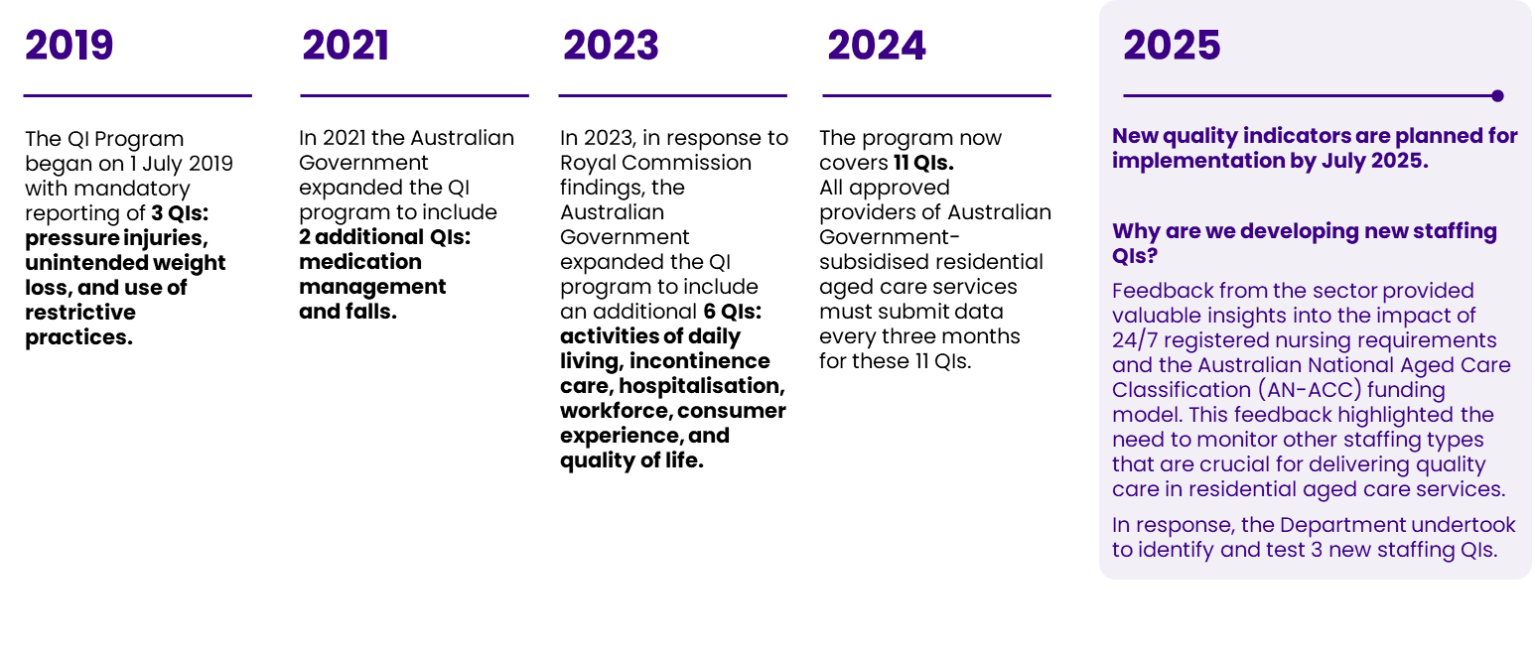

Source: New Aged Care Quality Indicators from October 2022 (agedcareessentials.com.au) and National Aged Care Mandatory Quality Indicator Program (QI Program) | Australian Government Department of Health and Aged Care

The QIs were to focus on:

* **Enrolled nurses (ENs):** nurses who have completed a Diploma of Nursing through a vocational education provider. ENs meet the EN standards for practice, work under the supervision of a registered nurse and cannot work independently.
* **Allied health professionals:** health professionals who are not doctors, dentists, or nurses. They are university-trained and have special skills in preventing, diagnosing, and treating various conditions and illnesses. The definition of allied health is consistent with that from the Quarterly Financial Report.
* **Lifestyle services:** lifestyle officers and assistants deliver activities to improve the psychological, spiritual, social, and physical well-being of residential aged care recipients. The definition of lifestyle services is consistent with that from the Quarterly Financial Report.

Improving the quality and safety of care for older people in residential aged care is a top priority for health and social care systems worldwide. QIs in monitoring programs are used in Australia and around the world to measure, evaluate, and monitor the quality and safety of care in both health care and aged care.

1. Project scope and progress to date

The Staffing QI project had 6 stages (Figure 2). First, we conducted a national and international evidence review to identify staffing QIs for ENs, allied health professionals, and lifestyle officers in residential aged care. Based on this review and extensive consultation with stakeholders, we identified 8 potential QIs for the 3 staffing types (ENs, allied health professionals and lifestyle officers). We tested these QIs, along with another QI developed post-pilot, for scientific acceptability, feasibility, and usability in a mixed-methods pilot study with a sample of residential aged care services.

Figure 2: Staffing QI Project – stages and key notes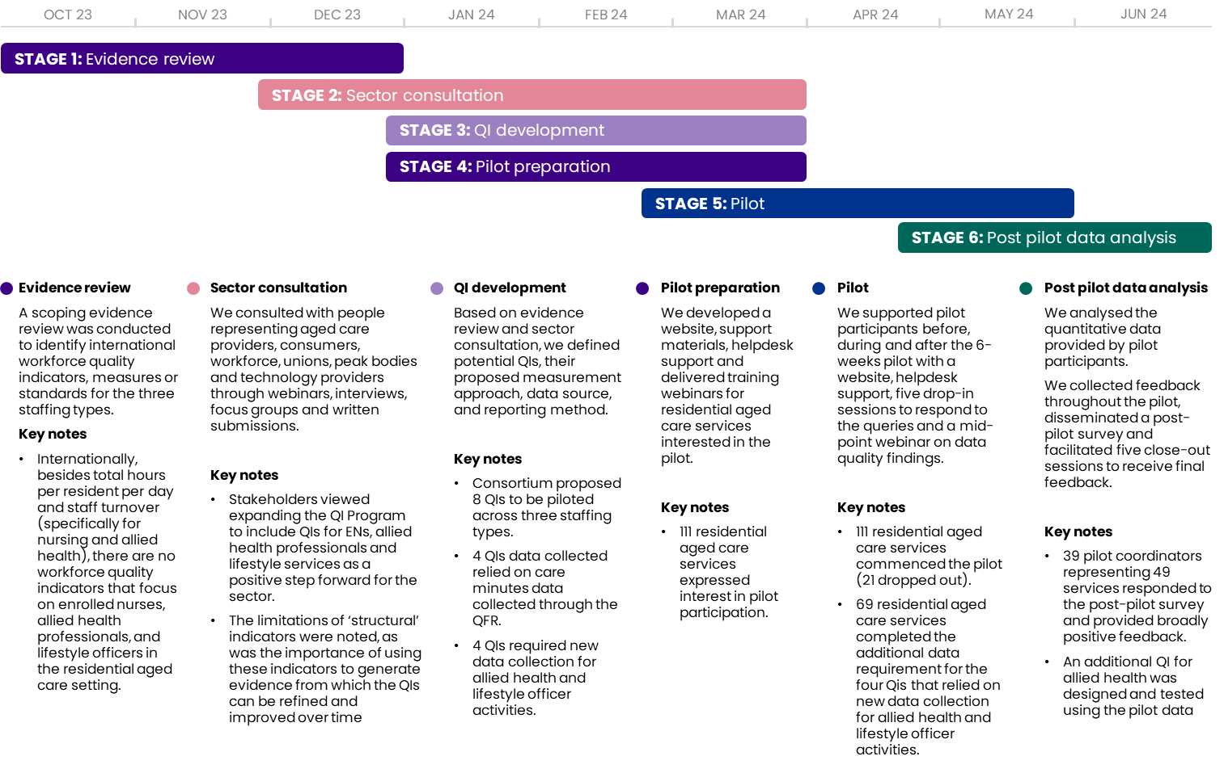

Source: Staffing QI Consortium

## Structure of this report

This Final Report brings together main findings from the evidence review, sector consultation, and lessons learned from the pilot.

The report is structured as follows:

* **Chapter 2:** **Evidence review.** Summary of national and international staffing QIs for ENs, allied health professionals and lifestyle officers.
* **Chapter 3:** **Sector feedback.** Summary of sector feedback on the proposed QIs. People representing aged care providers, consumers, workforce, unions, peak bodies and technology companies provided feedback through webinars, interviews, focus groups and written submissions.
* **Chapter 4:** **The staffing QI specifications and assessment criteria.** The QI specifications for each staffing domain and the criteria used to measure their importance, scientific acceptability, usability, ands feasibility.
* **Chapter 5: Pilot design and participation.** The pilot planned to enrol 130 residential aged care services (about 5% of the sector). A sample of 69 services from each state/territory of varying location, size, and ownership model was obtained. Pilot data includes allied health service and lifestyle officer activity data. Care minutes data was available for 2,518 residential care services from the Quarterly Financial Report (QFR) and was used for ENs, allied health professionals, and lifestyle officer care minutes QIs.
* **Chapter 6, 7, and 8:** **Evaluation of the QIs for ENs, allied health professions and lifestyle officers.** The prevalence, distribution, and variation of QIs for ENs, allied health professionals, and lifestyle officers in residential aged care services were compared to international standards. This helps decide if the quality is below international standards for the population. The distribution and variation of QIs will show if there is a gap in quality between services.

1. **Chapter 9:** **Conclusion.** Conclusions from the expansion of the QI Program project.
2. **Appendix A.** Summarises the process used for pre-pilot activities including pilot recruitment, pilot support activities including data collection processes and post-pilot activities including feedback collection process.

* **Appendix B.** Provides a quality assessment of the staffing QIs data submitted by the participating services. It evaluates the reliability of the measures and the validity of the submitted data by examining completeness, discrepancies, outliers, duplicates, and incorrect values.
* **Appendix C.** Displays how the variation across services is visualised using box plots.

# Evidence review

SAHMRI conducted **a** **scoping evidence review** to identify, synthesise and evaluate national and international staffing quality indicators (QIs). This included measures or standards for ENs, allied health professionals and lifestyle officers that are used to monitor and assess quality of care delivered to individuals in residential aged care.

Internationally, there are **few staffing QIs** that **focus specifically on ENs, allied health professionals and lifestyle officers** in residential aged care services.

Top 5 evidence review findings were summarised in Figure 3.

Figure 3: Key findings from the evidence review

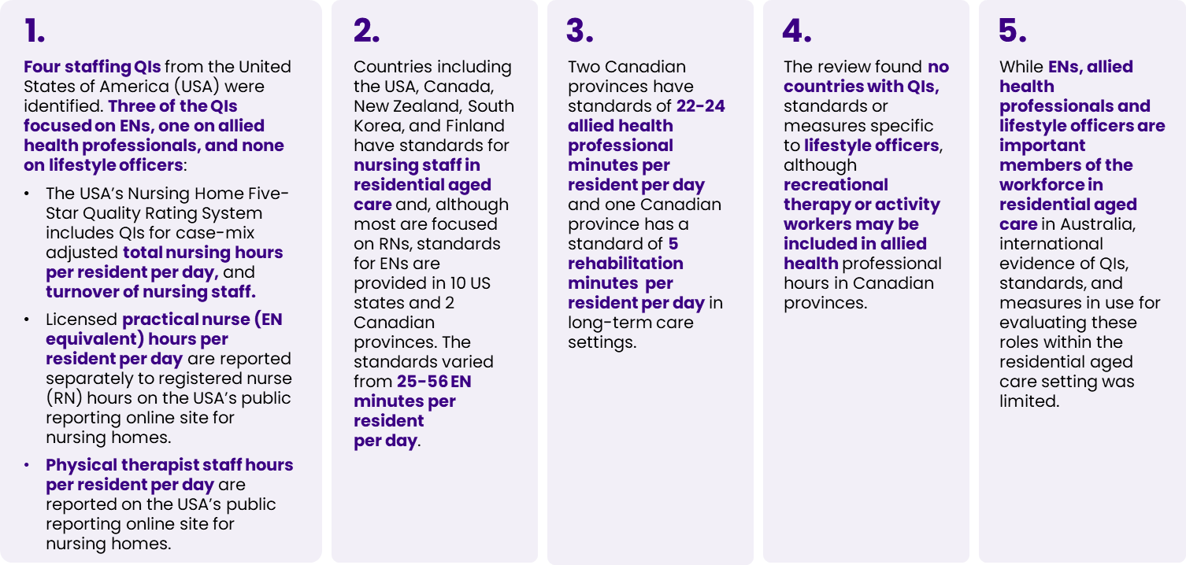

# Sector consultation

To prepare for the pilot of the three new staffing QIs, HealthConsult conducted sector consultations to gather feedback on the proposed indicators and understand their effectiveness, relevance, and potential impact.

We consulted with 110 individuals, including aged care providers, care recipients, workforce organisations/unions, peak bodies for nursing, allied health and lifestyle services, and technology providers. We also held two webinars, with over 900 people registered to attend, and received 24 written submissions in response to our public consultation paper. The findings from these consultations helped refine the specifications for the QIs described in Chapter 4.

QIs connect processes and outcomes and are designed around inputs (structural QIs), processes with service delivery (process QIs) and outputs (outcome QIs)[2]. Structural indicators are usually scored at a facility or provider level (e.g. staffing ratios). In contrast process and outcome indicators are scored at the care recipients’ level and aggregated to the service level (e.g. procedures are in place to ensure resident receives correct treatment – process; person has a pressure injury – outcome).

Top 5 sector consultation findings were summarised in Figure 4.

Figure 4: Key findings from the sector consultation

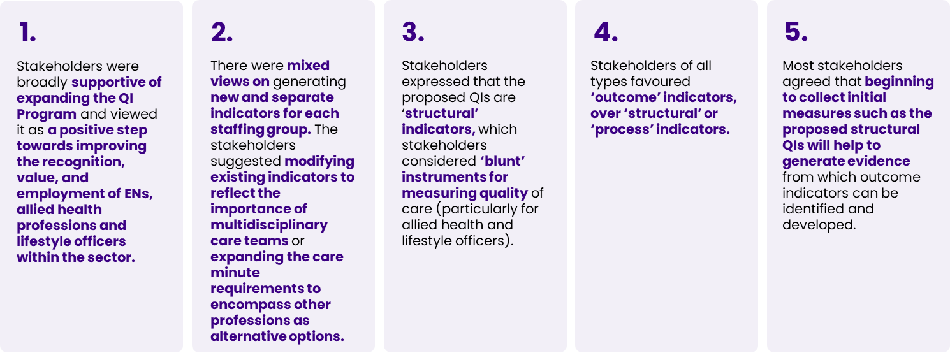

Specific feedback from stakeholders on the three staffing types included:

1. **ENs**: EN care minutes should be viewed individually and as a proportion of the total nursing staff to give a complete picture of a service’s staffing and skill mix.
2. **Allied health professionals:** Enhanced data collection is needed to develop evidence based QIs. Allied health care minutes as a single QI is considered a blunt measure because care minutes do not show the different services provided by various allied health disciplines or whether services are addressing the identified care needs of care recipients.
3. **Lifestyle officers:** Currently lifestyle officer minutes are collected and reported under QFR, but stakeholders questioned their relevance to quality. Enhanced data collection and research are needed to understand the relationship between lifestyle care minutes, other lifestyle measures, and care recipient outcomes.

# The Staffing QI specifications and assessment criteria

We identified 8 QIs for piloting based on the evidence review and sector consultation.

The 3 data sources used for the pilot QIs were:

1. **The QFR** for Quarter 4 of the 2022/2023 financial year (April to June 2023), collected quarterly by the Department of Health and Aged Care.
2. **Data collected by services** for the specific purpose of the pilot.
3. **December 2023 Star Ratings** to identify characteristics of services nationally (e.g. ownership, size, location) which is also used in the QI Program.

The reporting period for the pilot data collected by participating services was from 11 March 2024 to 21 April 2024. Allied health data was reported over the full 6 weeks. Lifestyle officer data was reported for one week (18-24 March 2024). During the post-pilot data analysis, the Consortium identified a new QI for allied health professionals that could be calculated using pilot data. The specifications of the 9 QIs are summarised in Table 2.

We assessed the 9 QIs using four well-accepted and defined QI assessment criteria[3]: importance, scientific acceptability, usability and feasibility. This assessment used information from the evidence review, sector feedback from key stakeholders and consumers, and analysis of the qualitative and quantitative data collected during and after the pilot. The results of this assessment are presented in Table 3.

The outcomes of the QI assessments determined whether the proposed QIs are ready for implementation, with 3 readiness categories identified:

* **Suitable for implementation:** These QIs are considered scientifically acceptable and important by the sector. They are highly usable and feasible for immediate implementation
* **Suitable for near-term implementation:** These QIs are considered scientifically acceptable and important by the sector. They are highly usable and feasible for implementation in near-future but may need extra resources for data collection before full-scale implementation.
* **Require further research and evaluation:** These QIs have potential future value but need further evidence or adjustments in their design or application. Further research and evaluation are needed to decide their suitability for future implementation.

Table 2: The staffing QI specifications

|  |  |  |  |  |  |  |
| --- | --- | --- | --- | --- | --- | --- |
| QI | Staffing type | Definition | Numerator | Denominator | Data source | Data collection period |
| 1 | Enrolled Nurse | EN care minutes | EN labour and agency minutes | Occupied bed days | QFR | 1 April – 30 June 2023 |
| 2 | Enrolled Nurse | Proportion of EN care minutes | EN care minutes per resident per day | EN, RN and PCW care minutes per resident per day | QFR | 1 April – 30 June 2023 |
| 3 | Allied Health | Allied health care minutes | Allied health labour and agency minutes | Occupied bed days | QFR | 1 April – 30 June 2023 |
| 4 | Allied Health | Percentage of care recipients who received at least one instance of care from an allied health professional | Number of care recipients who received at least one instance of care from an allied health professional | Total number of care recipients | Pilot | 11 March – 21 April 2024 |
| 5 | Allied Health | Percentage of care recipients assessed as requiring allied health services who received at least one service instance | Number of care recipients who were assessed as requiring allied health, and received at least one instance of care from an allied health professional | Number of care recipients with an allied health services recommendation in their care plan | Pilot | 11 March – 21 April 2024 |
| 6 (New) | Allied Health | Percentage of recommended allied health services received* | Number of recommended allied health services received | Number of allied health services recommended (in care plans) | Pilot | 11 March – 21 April 2024 |
| 7 | Lifestyle officer | Lifestyle officer care minutes | Lifestyle officer labour and agency minutes | Occupied bed days | QFR | 1 April – 30 June 2023 |
| 8 | Lifestyle officer | Percentage of care recipients who attended at least one lifestyle officer service | Number of care recipients who attended at least one lifestyle officer service | Total number of care recipients | Pilot | 18- 24 March 2024 |
| 9 | Lifestyle officer | Percentage of care recipients with lifestyle recommendation in their care plan who attended at least one service delivered by a lifestyle officer | Number of care recipients who attended at least one service delivered by a lifestyle officer and have lifestyle recommendation | Number of care recipients with lifestyle recommendation in their care plan | Pilot | 18- 24 March 2024 |

Note: QIs that were measured using the pilot data excluded care recipients who were absent from the service for the entire reporting period.

*QI 6 was developed after pilot data was collected. The QI 6 calculations relied on the existing pilot data

Table 3: QI assessment criteria

| Criteria1,2 | Importance | Scientific Acceptability | Feasibility | Usability |
| --- | --- | --- | --- | --- |
| Description | 1. Gap was identified in this area 2. Existing measures are insufficient to address this area 3. Literature supports that a benefit (e.g. improved outcomes) can be achieved from the implementation of this measure | 1. Is the measure precisely defined and reliable? 2. Does the measure demonstrate face validity, construct validity, and predictive validity? 3. Is there systematic bias and can that bias be addressed with adjustment? 4. Does it detect meaningful differences in performance? | 1. Is the data readily available? 2. Can the data be collected with minimal burden? 3. Is the implementation of the measure feasible? 4. Is the data reliable (i.e. complete, consistent, minimal errors and high quality)? | 1. Is the measure meaningful, understandable to a range of audiences? 2. Can the measure contribute to improvement in quality of care (i.e. inform practice change?) |
| Data source | * Sector consultation * Evidence review | * Quantitative data analysis | * Sector consultation * Pilot qualitative analysis * Quantitative data analysis | * Sector consultation |
| Assessment options | * Met * Partially met * Not met | * Met * Not met | * Met * Partially met * Not met | * Met * Partially met * Not met |

# Pilot design and participation

This Chapter presents the key features of the residential aged care services that participated in the pilot compared to the wider sector.

## Staffing QI pilot design and participation

We planned to involve a diverse sample of 130 residential aged care services (representing 5% of the sector) for a 6-week pilot. The pilot started on 11 March 2024, with the enrolment of 111 services that provided expression of interests.

We supported pilot sites with various resources including a dedicated [QI website](https://qi.healthconsult.com.au/), [helpdesk](mailto:QI@healthconsult.com.au), [guides](https://qi.healthconsult.com.au/ResourcePage), [FAQs](https://qi.healthconsult.com.au/FAQ), [training webinars](https://qi.healthconsult.com.au/Content/Docs/TrainingWebinarSession3_20240307_100526.mp4), and drop-in sessions (further details are in Appendix A). Participants provided their first data submission halfway through the pilot. They received individual reports outlining any data entry errors, missing fields, and illogical entries. A mid-point webinar was held to inform participants about common errors and to answer any questions. The final data submission deadline was extended from   
29 April to 15 May 2024 (3.5 weeks after the pilot ended).

In total, 69 services (53% of the planned sample) submitted their final data (Figure 5). 21 services dropped out before providing any pilot data, and another 21 did not submit final data. Main reasons for withdrawing included limited resources, high data requirements, time constraints, competing priorities, and unexpected events such as COVID outbreaks and staff leave (Figure 5). More details about the pre-pilot, pilot and post-pilot activities are in Appendix A.

Figure 5: Flow diagram of pilot participating residential aged care services

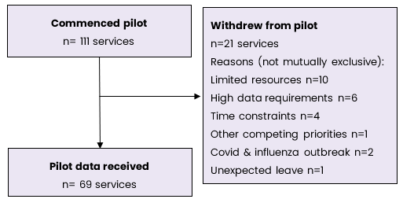

Figure 6 shows the number of services included in the analysis of the QFR data. A total of 2,658 services reported QFR data for the Quarter 4 FY 2022-23 reporting period. Out of these, 140 services were excluded for the following reasons: duplicate service names (35 services), no available service characteristics from the 2023 Star Ratings data (104 services), or having zero occupied bed days recorded in the QFR   
(1 service). Therefore, 2,518 services were included in the analysis of QIs derived from QFR data.

Figure 6: Flow diagram of national residential aged care services included in the QFR

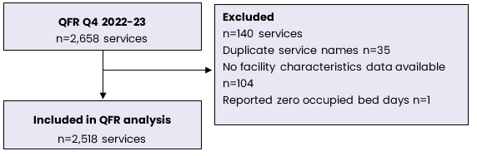

## Characteristics of pilot participants

The characteristics of the pilot participants were similar to those of residential aged care services nationwide (Figure 7).

Figure 7: Characteristics of services in the pilot (n = 69) and nationally (n=2,518)

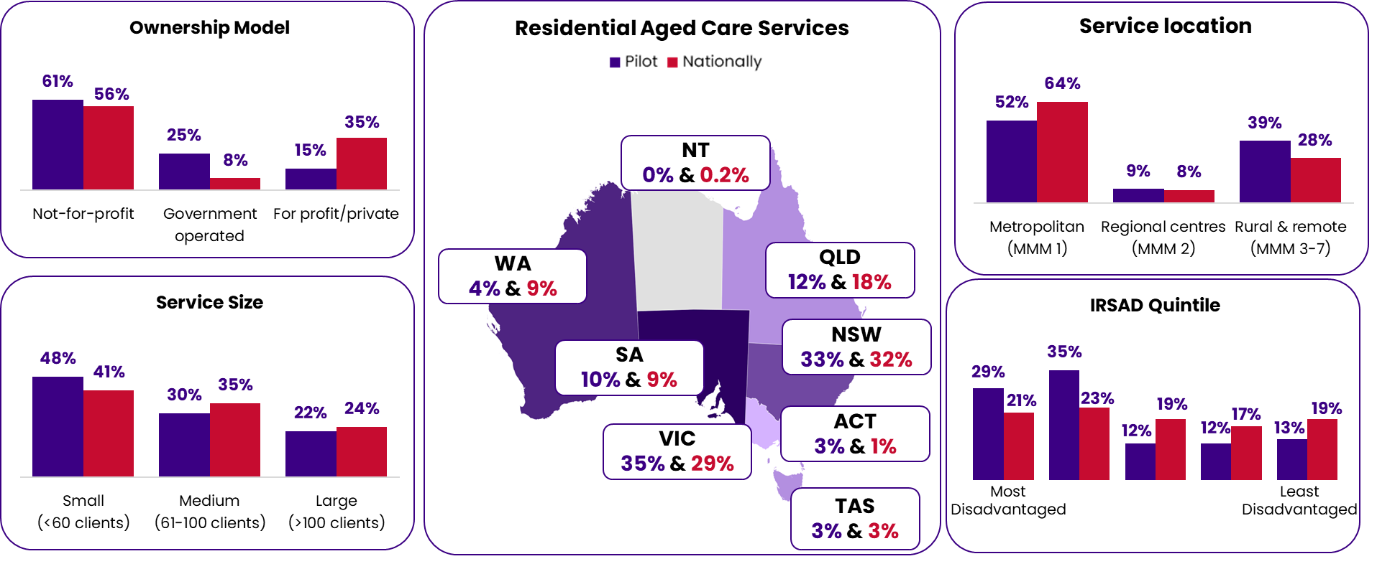

MMM = Modified Monash Model for remoteness; IRSAD = Index of Relative Socio-economic Advantage and Disadvantage. Data source: December 2023 star ratings data used for facility characteristics of services nationally

The characteristics of care recipients were similar between the pilot sites and the national averages (Table 4). Throughout the pilot period, we collected qualitative data from pilot participants in meetings and webinars. In addition, 38 pilot coordinators responsible for 49 residential aged care services responded to a post-pilot survey. Post pilot survey feedback is summarised in Appendix A. Data quality checks completed after the pilot are described in Appendix B. Variations across services in staffing QIs were observed using box plots in Chapter 6, 7 and 8. The interpretation of box plots is described in Appendix C.

Table 4: Characteristics of care recipients of residential aged care services in the pilot and nationally

|  | Care recipients in participating pilot services N=4,954 [% (n)] | Care recipients nationally  N=184,163 [% (n)] |
| --- | --- | --- |
| Gender* |  |  |
| Female | 65.4 (3,201) | 65.9 (121,353) |
| Male | 34.6 (1,692) | 34.1 (62,797) |
| Not specified | 0.0 (1) | 0.01 (13) |
| Dementia*# | 42.3 (2,055) | 54.2 (130,838) |
| AN-ACC classification |  | Not reported |
| 1 | 0.1 (4) |  |
| 2 | 3.5 (159) |  |
| 3 | 1.4 (63) |  |
| 4 | 6.9 (315) |  |
| 5 | 20.0 (921) |  |
| 6 | 8.8 (404) |  |
| 7 | 13.1 (604) |  |
| 8 | 7.3 (336) |  |
| 9 | 6.6 (302) |  |
| 10 | 5.7 (264) |  |
| 11 | 13.8 (636) |  |
| 12 | 2.9 (134) |  |
| 13 | 9.9 (455) |  |
| Not mobile± | 39.0 (1,791) | Not reported |
| QIs in previous quarter¥ |  |  |
| Falls | 27.9 (1,318) | 31.5 (61,947) |
| Falls with major injury | 1.7 (81) | 1.8 (3,629) |
| Hospitalisations | 11.4 (526) | 11.9 (23,237) |
| Significant weight loss | 7.3 (336) | 9.0 (14,001) |
| Decline in activities of daily living | 17.9 (764) | 18.2 (30,369) |

AN-ACC: Australian Aged Care Classification funding model; QI: quality indicator

*Based on 30 June 2023 data from the Australian Institute of Health and Welfare GEN data: People using aged care.

Available at: [GEN data: People using aged care - AIHW Gen (gen-agedcaredata.gov.au)](https://www.gen-agedcaredata.gov.au/resources/access-data/2024/april/gen-data-people-using-aged-care)

#Based on n=241,604 care recipients

±based on AN-ACC classification 9-13

¥ Based on previous quarter and as defined in the QI Program.

National QI Data for October-December 2023 quarter: 196,859 care recipients assessed for falls, 194,860 care recipients assessed for hospitalisations, 156,154 care recipients assessed for significant unplanned weight loss and 166,670 care recipients assessed for decline in activities of daily living. Available at: [Residential Aged Care Quality Indicators — October to December 2023 - AIHW Gen (gen-agedcaredata.gov.au)](https://www.gen-agedcaredata.gov.au/topics/quality-in-aged-care/residential-aged-care-quality-indicators-latest-release#accordion-collapse-d97f1b2722fa48b18cc809a2de32cd9a-10)

# Enrolled nurses

This Chapter outlines the key findings from the evidence review, stakeholder engagement activities, and lessons learned from the pilot on the proposed EN QIs. The 2 EN QIs piloted were:

* **QI 1:** EN care minutes per resident per day.
* **QI 2:** Proportion of EN care minutes to total care minutes (RNs, ENs and PCWs).

## Definition of enrolled nurses

The QFR defines ENs as those registered with the Nursing and Midwifery Board of Australia (NMBA) and employed in a direct care EN role, either directly or through a contract (including through an agency). ENs work under the supervision of a RN and cannot work independently. The Staffing QI pilot proposed to use the same definition as the QFR, which was supported by stakeholders.

## Evidence review

The evidence review identified international standards for ENs in residential aged care. The standards for ENs in 10 US states and 2 Canadian provinces ranged from 25-56 EN minutes per resident per day. The standards for the proportion of EN time from 2 Canadian provinces are 15-20%. The Australian Nursing and Midwifery Foundation (ANMF) supports a staffing mix of 30% RNs, 20% ENs, and 50% PCWs[4]. Based on evidence:

* The US’s Nursing Home Five-Star Quality Rating System includes 2 QIs: **case-mix adjusted total nursing hours per resident per day**, and **turnover of nursing staff**. Both these QIs include licensed practical nurses (the US equivalent to ENs).
* **Licensed practical nurse** (the US equivalent to ENs) **hours per resident per day** are reported separately to RN time on the US public reporting online site for nursing homes.

## Stakeholder and pilot participant feedback

Stakeholders recognised the importance of ENs in providing quality care and supported distinct QIs such as EN care minutes, reflecting the value of ENs’ contribution to care recipient outcomes. They noted that care minutes should be visible for all care staff (e.g. breakdown of care minutes for all care staff, including all nursing staff then individual nursing types) to give a picture of a service’s staffing and its skill mix.

The pilot participants added:

QI 1: EN care minutes is a useful snapshot for both service providers and the government. This QI leverages data that is already being collected, minimising the data gathering efforts. Utilising existing QFR data ensures that the indicator does not place an administrative burden on services.

QI2: Proportion of EN care minutes to total care minutes has the potential to provide valuable insights. The role of nurses, including ENs, is diverse and may encompass various activities including leisure and recreation. The minutes collected through this QI present a good opportunity to further explore and understand ENs' contributions to data collection, quality improvement, and care delivery in aged care settings. This indicator also relies on existing QFR data, maintaining efficiency in data collection and reporting.

There was broad consensus that the QIs for ENs provide useful information to services and the government. They offer insights into EN’s contributions to care quality and outcomes, without placing extra administrative burden on services.

## Pilot findings

### **QI 1:** EN care minutes per resident per day

The median [interquartile range (IQR)] EN care minutes per resident per day across the 2,518 services included in the QFR data nationally was 10 (1-22) minutes. At the pilot sites, the EN care minutes were slightly higher at 13 (0-40) minutes (Table 5). A total of 22.5% (n=566) of services reported zero EN care minutes. The median number of EN minutes was lower than international standards of 25-56 minutes per resident per day identified in the evidence review. This was based on standards in 10 US states and two Canadian provinces.

The median (IQR) EN care minutes was **higher for government operated services** nationally [91 (42-146)] compared to not-for-profit [8 (0-21)] and for-profit [8 (2-17)] services (Table 5).

The distribution of EN care minutes was **positively skewed** with only 21.4% (n=539) of services reporting ≥25 minutes per resident per day (Figure 8A). **Variation in EN care minutes was observed in all three ownership models**. Variation in EN care minutes was largest for government-operated services (Figure 9A). Three outliers were identified among the government-operated services, which also reported high RN minutes (95th percentile). Two of these services reported low personal care worker (PCW) minutes (1st percentile). Overall, QI 1 performed well based on its importance, scientific acceptability, feasibility, and usability (Table 6).

### **QI 2:** Proportion of EN care minutes to overall care minutes

The median (IQR) **proportion of EN care minutes to total care minutes** was **5% (1%-11%)** across the 2,518 services included in the QFR data nationally (Table 5).At the pilot sites, the **proportion of EN care minutes to total care minutes** was slightly higher at **7% (0%-21%).** A total of 22.5% (n=566) of services had zero proportion of EN care minutes. The median proportion of EN care minutes (5%) was lower than standards identified in the evidence review in two Canadian provinces (15-20%).

The median (IQR) proportion EN care minutes was **higher for government-operated** services [37 (17-59)] compared to not-for-profit [4 (0-10)] and for-profit [5 (1-9)] services (Table 5). The distribution of EN care minutes was **positively skewed** with only 14.7% (n=370) of services reporting the proportion of EN minutes ≥15% (Figure 8B). **Variation in the proportion of EN care minutes was observed in all three ownership models.** Variation in the proportion of EN care minutes was largest for government-operated services (Figure 9B). No outliers were identified, but the highest 25% of government services also had high RN minutes (median 65 minutes vs. 37 minutes for other government services) and low PCW minutes (median 11 minutes vs. 140 for other government services). Overall, QI 2 performed well based on its importance, scientific acceptability, feasibility, and usability (Table 6).

Table 5: Pilot results compared across the sector and compared to evidence

|  |  |  |  |  |
| --- | --- | --- | --- | --- |
| Service characteristics | QI 1: EN care minutes per resident per day, National​ | QI 1: EN care minutes per resident per day, Pilot​ | QI 2: Proportion of EN care minutes to total care minutes, National​ | QI 2: Proportion of EN care minutes to total care minutes, Pilot​ |
| Whole of sample | 2,518 | 69 | 2,518 | 69 |
| Services | 10 (1-22)​ | 13 (0-40)​ | 5 (1-11)​ | 7 (0-21)​ |
| Service ownership model |  |  |  |  |
| Government | 91 (42-146)​ | 98 (56-154)​ | 37 (17-59)​ | 41 (26-58)​ |
| Not-for-profit | 8 (0-21)​ | 4 (0-20)​ | 4 (0-10)​ | 2 (0-10)​ |
| For-profit | 8 (2-17)​ | 9 (0-13)​ | 5 (1-9)​ | 5 (0-7)​ |
| Service size |  |  |  |  |
| Small (≤60 clients) | 11 (0-27)​ | 40 (6-98)​ | 6 (0-13)​ | 17 (4-41)​ |
| Medium (61 to <100 clients) | 9 (2-21)​ | 6 (0-20)​ | 5 (1-11)​ | 3 (0-9)​ |
| Large (≥100 clients) | 8 (2-18)​ | 0 (0-17)​ | 4 (1-9)​ | 0 (0-8)​ |
| MMM region |  |  |  |  |
| Metropolitan (MMM1) | 7 (0-18)​ | 6 (0-18)​ | 4 (0-9)​ | 3 (0-8)​ |
| Regional (MMM2) | 15 (7-24)​ | 18 (8-90)​ | 8 (4-12)​ | 10 (5-33)​ |
| Rural or remote (MMM3-7) | 16 (5-35)​ | 40 (4-81)​ | 8 (2-17)​ | 17 (2-40)​ |
| International standards | 25 - 561 | 25 - 561 | 15%2 | 15%2 |
| ANMF suggestion | n/a | n/a | 20%2 | 20%2 |

Table data [Median (IQR)].

1Australian Government Department of Health and Aged Care, Expansion of the National Aged Care Mandatory Quality Indicator Program <https://www.health.gov.au/sites/default/files/2024-01/expansion-of-the-national-aged-care-mandatory-quality-indicator-program-consultation-paper.pdf>

2Willis, E., Price, K., Bonner, R., Henderson, J., Gibson, T., Hurley, J., Blackman, I., Toffoli, L and Currie, T. (2016) Meeting residents’ care needs: A study of the requirement for nursing and personal care staff. Australian Nursing and Midwifery Federation

Figure 8: Distribution of (A) QI 1: Enrolled nurse care minutes and (B) QI 2: Proportion of enrolled nurse care minutes to total care minutes, nationally.

|  |  |
| --- | --- |
| A) Figure 8 A is a distribution chart showing enrolled care nurse minutes nationally. | B) Figure 8 B is a distribution chart showing proportion of enrolled nurse care minutes to total care minutes nationally. |

Figure 9: Variation in QI 1: Enrolled nurse care minutes (A) nationally (B) pilot sites

|  |  |
| --- | --- |
| A) Figure 9 A is a box plot showing the variation in enrolled nurse care minutes nationally. | B) Figure 9 B is a box plot showing the variation in enrolled nurse care minutes in pilot sites. |

Figure 10: Variation in QI 2: EN care minutes to total care minutes (A) nationally (B) pilot sites

|  |  |
| --- | --- |
| A) Figure 10 A is a box plot showing the variation in enrolled nurse care minutes to total care minutes nationally. | B) Figure 10 B is a box plot showing the variation in enrolled nurse care minutes to total care minutes at pilot sites. |

## Quality indicator assessment

The evidence review, sector and pilot feedback, and pilot findings were used to assess the 2 QIs for ENs based on their importance, scientific acceptability, feasibility, and usability (Table 6). Overall, both QIs were found suitable for current implementation.

Table 6: Final assessment of QIs for ENs

| Assessment criteria | QI 1: EN care minutes | QI 2: Proportion of EN care minutes |
| --- | --- | --- |
| Importance | Met  Addresses a gap  Supported with evidence from 2 countries and by the sector | Met  Addresses a gap  Supported with evidence from one country and by the sector |
| Scientific Acceptability | Met  Well-defined and reliable  Demonstrates validity  Visualisations identified no systematic bias  There are meaningful differences across services | Met  Well-defined and reliable  Demonstrates validity  Visualisations identified no systematic bias  There are meaningful differences across services |
| Feasibility | Met  Data readily available and reliable  Minimal data collection burden  Implementation is feasible | Met  Data readily available and reliable  Minimal data collection burden  Implementation is feasible |
| Usability | Met  Meaningful and well-understood by a range of stakeholders  Potential to inform practice change | Met  Meaningful and well-understood by a range of stakeholders  Potential to inform practice change |
| Summary | Suitable for implementation | Suitable for implementation |

# Allied health professionals

This chapter outlines the key findings from the evidence review, stakeholder engagement activities, and lessons learned from the pilot on the proposed QIs for allied health professionals. Three QIs piloted were:

* **QI 3:** Allied health care minutes per resident per day.
* **QI 4:** Percentage of care recipients who received at least one instance of care from an allied health professional
* **QI 5:** Percentage of care recipients assessed as requiring allied health services who received at least one service instance
* A fourth potential QI for allied health professionals was identified and tested during post-pilot analysis:
* **QI 6 (New):** Percentage of recommended allied health services received.

## Definition of allied health

There are 7 allied health categories in the QFR: **1)** Physiotherapists, **2)** Occupational therapists, **3)** Speech pathologists, **4)** Podiatrists, **5)** Dietitians, **6)** Other allied health (includes art therapists, audiologists, chiropractors, counsellors, diabetes educators, exercise physiologists, music therapists, osteopaths, psychologists, and social workers), and **7)** Allied health assistants. The Staffing QI pilot proposed to use the same definition as the QFR, which was supported by stakeholders.

## Evidence review

The evidence review highlighted the importance of allied health professionals in residential aged care for enhancing the quality of care and care recipient wellbeing. In Canada, two provinces have set standards requiring 22-24 minutes of allied health professional time per resident per day. Another Canadian province has a lower standard of 5 minutes of rehabilitation per resident per day in long-term care settings[5].

A previous scoping review and stakeholder consultations in Australia concluded that allied health can meaningfully impact function, wellbeing, and quality of life for older people in residential aged care. Regular access to allied health is challenging due to funding constraints, workforce issues and limited understanding of the value of allied health in residential aged care[6]. Integrating allied health professionals, social workers, and recreation therapists into care teams is considered essential for improving care recipient outcomes[7].

## Stakeholder and pilot participant feedback

Stakeholders generally supported introducing QIs for allied health professionals in residential aged care, recognising their contribution to quality. However, they raised concerns about using a single measure of allied health care minutes. They believed this may not adequately reflect the quality and type of care delivered by different allied health professions or promote multidisciplinary care. They emphasised the need for a broad approach that considers the diversity of care recipients’ needs and the diversity of allied health care.

To address these concerns, the pilot collected a range of data about each allied health profession QFR category, including care settings and service delivery modes, alongside allied health care minutes. We collected data on care recipients’ assessed needs for allied health services to establish a link between their needs and the care delivered. Selected QI data such as falls with major injury, significant weight loss, hospitalisation, and activities of daily living were collected to give a complete picture of the potential relationship between the delivery of allied health care and the broader outcomes of residential care.

Stakeholders highlighted the importance of refining the definitions of allied health professionals within the QIs. Suggestions were made to reclassify degree-qualified recreational/diversional therapists as allied health professionals rather than lifestyle officers. Stakeholders also highlighted the importance of distinguishing between direct and indirect care minutes to accurately reflect the range of services offered, including non-clinical roles. They raised concerns about the potential administrative burden of collecting activity-level data about allied health service delivery.

Stakeholders supported allied health care minutes QI but expressed a preference for reporting at the category level, rather than total allied health care minutes, to ensure the indicator reflects the type of care delivered by different allied health professionals in each service. Stakeholders also noted that structural indicators like care minutes should be linked to the nature of care delivered by allied health professionals, e.g. their involvement in falls prevention and reablement.

Pilot participants found the allied health QIs useful, particularly QI 3 (care minutes per resident per day by allied health professionals), emphasising its re-use of data already collected and reported, minimising extra burden on staff. However, they encountered challenges with QI 4 (Percentage of care recipients who received at least one instance of care from an allied health professional) and QI 5 (Percentage of care recipients assessed as requiring allied health services who received at least one service instance). These challenges included unclear definitions and a data template that was difficult to use, requiring manual data entry.

Only one third of the pilot participants reported having a reliable, automated process to report QI 4 and QI 5. Some participants reported that relevant data for QI 5 is captured in clinical notes, so reporting requires manual auditing of care recipient records. This led to inconsistencies in pilot data due to varying practices in collection and categorisation of allied health services. Some sites benefited from data collection software, while others struggled without standardised documentation. Participants valued the training sessions provided and suggested their continuation for future implementation.

## Pilot findings

### QI 3: Allied health care minutes per resident per day

The median (IQR) **allied health care minutes per resident per day** was **4 (2-6) minutes** across the 2,518 residential aged care services **nationally** (excluding allied health assistant care minutes). This was the **same as the pilot sites**, which also delivered a median (IQR) of **4 (3-6) minutes** **of care** (Table 7). The median number of allied health care minutes was lower than international standards of 22-24 minutes per resident per day, standards identified in two Canadian provinces in the evidence review. However, the international definition for allied health may include services/professions not included in the Australian definition of allied health (e.g. recreational therapy). The median allied health care minutes was **consistent across ownership models, service sizes and MMM regions** (Table 7).

The distribution of allied health care minutes was **positively skewed** with only 0.4% (n=9) of services reporting ≥22 minutes per resident per day (Figure 11A). **Variation in allied health care minutes was observed in all three ownership models** (Figure 12A and B). One outlier was identified among the government-operated services, with this service also reporting the highest RN minutes and zero PCW, EN and lifestyle officer minutes. Overall, QI 3 performed well based on its scientific acceptability, feasibility, and usability (Table 6).

### QI 4: Percentage of care recipients who received at least one instance of care from an allied health professional

Of the 4,928 care recipients with allied health data provided by pilot participants, 18 were absent from the residential aged care services for the entire reporting period and were excluded from analysis. The median (IQR) **proportion of care recipients that received at least one allied health service** across the 69-pilot residential aged care services was **92% (76%-98%)** (Table 8). The distribution of allied health services received was **negatively skewed** (Figure 11B). Some variation in allied health services received was observed in all three ownership models (Figure 12C).

Most of the services reported that a high proportion of their **care recipients received at least one allied health service** during the pilot reporting period. Therefore, **this QI does not detect meaningful differences between services.** Overall, QI 4 performed well based on its scientific acceptability and usability (Table 6).

### QI 5: Percentage of care recipients assessed as requiring allied health services who received at least one service instance

Of the 4,910 care recipients with allied health recommendation data provided by pilot participants, **96.2% (n=4,721) had at least one allied health service recommended** in their care plan. The median (IQR) **proportion of** **care recipients with allied health services recommended that** received **at least one allied health service** across the 69-pilot residential aged care services was **95% (82%-100%)**. This was **similar across ownership models, service sizes, MMM regions and by care recipient characteristics** (Table 8). The distribution of allied health services received was **negatively skewed** (Figure 11C). **Some variation in allied health services received was observed in all three ownership models** (Figure 12D).

Most of the services reported that a high proportion of their care recipients **with allied health services recommended received at least one allied health service** during the pilot reporting period. Therefore, **this QI does not detect meaningful differences between services.**

Overall, QI 5 performed well based on its scientific acceptability and usability (Table 6).

### QI 6 (New): Percentage of recommended allied health services received

Allied health peak bodies advocated that a QI for allied health should consider care recipients’ diverse and fluctuating allied health care needs (i.e. different categories, types and delivery modes). Stakeholders agreed on the critical importance of monitoring allied health services against care recipient needs.

Consequently, following the pilot and utilising the pilot data collected, a new QI was developed to test if meaningful differences may be found by analysing the data by allied health services category, rather than all allied health services. In this QI, instances of each allied health service recommended in a care plan were counted. For example, a care recipient with both physiotherapy and occupational therapy recommended in their care plan would count once for physiotherapy and once for occupational therapy (a total of two). If only physiotherapy was received during the reporting period, they would contribute one to the numerator and two to the denominator.

The median (IQR) **percentage of** **allied health services received** **when recommended** in a care recipient’s care plan was **59% (37%-79%)** (Table 7). When analysed by allied health service type, **79% (56%-100%) of recommended physiotherapy** services were delivered, **40% (0%-100%) of recommended occupational therapy** services were delivered, **30% (12%-100%) of recommended speech pathology** services were delivered, **73% (35%-97%) of recommended podiatry** services were delivered, **32% (14%-100%) of recommended dietetics** services were delivered, and **95% (11%-100%) of other recommended allied health services** were delivered (Table 9). The new QI highlighted that **speech pathology, dietetics and occupational therapy recommendations were the least met** (Table 9). However, it is unclear whether the other allied health services recommended corresponded to the other allied health services received due to a lack of specificity in the definitions and/or number of categories. The median (IQR) **number of** **allied health services identified in care plans per care recipient** **was** **2.1 (1.5-3.1)** across pilot services. The median (IQR) number of **allied health sessions delivered to care recipients** **during the reporting period was** **3.4 (1.6-5.5)**. The distribution of allied health services received was **multimodal with multiple peaks** (Figure 11D). **Variation in recommended allied health services received was observed in all three ownership models** (Figure 12E). Variation in recommended allied health services received, by type of allied health service are shown in Figure 13.

There were 22,458 instances of allied health care reported by the services during the pilot. Of these, the **largest number of allied health sessions reported** were for **physiotherapy (73.5%)**, followed by **podiatry (11.3%)**, other allied health (6.0%), occupational therapy (5.7%), dietetics (2.4%) and speech pathology (1.2%) (Figure 14). The service provision reported during the pilot (see Figure 14) aligned with care minutes by allied health professionals shown in Table 8.

Table 7: Pilot results compared across the sector and against evidence (allied health)

| Service characteristics | QI 3: Allied health care minutes | QI 3: Allied health care minutes | QI 4: Received one instance of care from an allied health professional (%) | QI 5: Care recipients assessed as requiring allied health services who received at least one service instance (%) | QI 6 (New): Recommended allied health services received (%) |
| --- | --- | --- | --- | --- | --- |
| Sample size | 2,518 | 69 | 69 | 67 | 69 |
| Services | 4 (2-6) | 4 (3-6) | 92 (76-98) | 95 (82-100) | 59 (37-79) |
| Service ownership |  |  |  |  |  |
| Government | 4 (2-9) | 4 (3-6) | 93 (70-100) | 96 (88-100) | 54 (37-69) |
| Not-for-profit | 4 (3-6) | 4 (3-6) | 91 (76-98) | 91 (79-99) | 59 (36-82) |
| For-profit | 4 (3-5) | 4 (3-6) | 92 (88-100) | 96 (88-100) | 63 (52-74) |
| Service size |  |  |  |  |  |
| Small | 4 (2-6) | 4 (3-5) | 93 (73-100) | 96 (82-100) | 55 (37-87) |
| Medium | 4 (3-6) | 4 (3-7) | 91 (70, 96) | 93 (71-98) | 47 (34-66) |
| Large | 4 (3-5) | 5 (3-6) | 92 (88-98) | 98 (90-100) | 70 (56-94) |
| MMM region |  |  |  |  |  |
| Metropolitan | 4 (3-6) | 4 (3-6) | 92 (85-98) | 95 (88-100) | 60 (40-88) |
| Regional | 4 (3-6) | 9 (6-13) | 90 (83-98) | 92 (83-99) | 60 (54-65) |
| Rural or remote | 4 (2-6) | 3 (1-5) | 88 (72-99) | 95 (79-100) | 51 (36-76) |
| International standards | 22-241 | 22-241 | n/a | n/a | n/a |

QI 4 and QI 5 demonstrated that most care recipients in pilot sites received at least one allied health service during the pilot reporting period (6 weeks). All care recipients who received allied health services had at least one allied health service recommended in their care plan. This provided limited scope to identify meaningful differences between services, resulting in the QIs only partially meeting the ‘usability’ assessment criteria. On the other hand, the new QI 6 for allied health measured whether the recommended allied health service was provided during the reporting period (i.e. if services were received when recommended in the care plan). The specificity of this QI enabled meaningful differences to be detected across the pilot sites, better satisfying the ‘usability’ assessment criteria. Future work may be required to assess appropriate reporting period.

Table 8: Allied health care minutes by allied health professional subcategories

| Allied health service type | Allied health minutes per care recipient per day  [median (IQR)] |
| --- | --- |
| Physiotherapy | 2.9 (1.3-4.3) |
| Occupational therapy | 0.0 (0.0-0.0) |
| Speech pathology | 0.1 (0.0-0.1) |
| Podiatry | 0.2 (0.0-0.5) |
| Dietetics | 0.1 (0.0-0.2) |
| Other allied health | 0.0 (0.0-0.0) |

Figure 11: Distribution Of (A) QI 3: Allied health care minutes (nationally), (B) QI 4: Percentage of care recipients who received at least one instance of care from an allied health professional (pilot), (C) QI 5: Percentage of care recipients assessed as requiring allied health services who received at least one service instance (pilot), and (D) QI 6 (New): Percentage of recommended allied health services received (pilot)

|  |  |
| --- | --- |
| A)Figure 11 A is a distribution chart showing allied health care minutes nationally. | B) Figure 11 B is a distribution chart showing the percentage of care recipients at pilot sites who received at least one instance of care from an allied health professional. |
| C) Figure 11 C is a distribution chart showing the percentage of care recipients at pilot sites assessed as requiring allied health services who received at least one service instance. | D) Figure 11 D is a distribution chart showing percentage of recommended allied health services received at pilot sites. |

Table 9: QI 6 (New) - Recommended allied health services received by allied health service type

| Allied health service | N residential aged care services where at least one care recipient was recommended an allied health service± | Median (IQR) percentage of allied health services received when recommended in care plans* |
| --- | --- | --- |
| Physiotherapy | 67 | 79 (56, 100) |
| Occupational therapy | 25 | 40 (0, 100) |
| Speech pathology | 56 | 30 (12, 100) |
| Podiatry | 66 | 73 (35, 97) |
| Dietetics | 58 | 32 (14, 100) |
| Other allied health | 27 | 95 (11, 100) |
| All allied health (proposed QI) | 69 | 59 (37, 79) |

± identified in their care plan

*Care recipients that had multiple types of allied health

service recommendations in their care plans were counted once for each service.

Figure 12: Variation In (A) QI 3: Allied health care minutes (nationally) (B) QI 3: Allied health care minutes (pilot), (C) QI 4: Percentage of care recipients who received at least one instance of care from an allied health professional (pilot), (D) QI 5: Percentage of care recipients assessed as requiring allied health services who received at least one service instance (pilot), and (E) QI 6 (New): Percentage of recommended allied health services received (pilot)

|  |  |
| --- | --- |
| A) Figure 12 A is a box plot showing the variation in allied health care minutes nationally. | B) Figure 12 B is a box plot showing the variation in allied health care minutes at pilot sites. |
| C) Figure 12 C is a box plot showing the variation in the percentage of care recipients at pilot sites who received at least one instance of care from an allied health professional. | D) Figure 12 D is a box plot showing the variation in the percentage of care recipients at pilot sites assessed as requiring allied health services who received at least one service instance. |
| E) Figure 12 E is a box plot showing the variation in the percentage of recommended allied health services received at pilot sites. |  |

Figure 13: Variation in recommended allied health services received, by type of allied health service 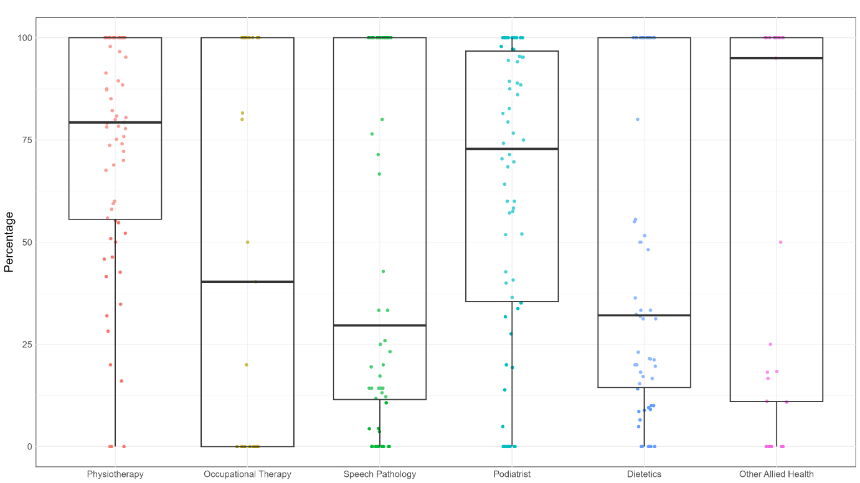

Figure 14: Proportion of allied health sessions by allied health service type

Note: Total number of allied health sessions by 69 pilot sites during reporting period: 22,458.

## Quality indicator assessment

We used the evidence review, sector and pilot feedback, and pilot findings to assess the 4 QIs for allied health professionals based on their importance, scientific acceptability, feasibility, and usability (Table 10). QI 3 and the new QI 6 were found suitable for current and near-future implementation, respectively.

Table 10: Final assessment of QIs for allied health professionals

| Assessment criteria | QI 3: Allied health care minutes | QI 4: Percentage of care recipients who received at least one instance of care from an allied health professional | QI 5: Percentage of care recipients assessed as requiring allied health services who received at least one service instance | QI 6 (New): Percentage of recommended allied health services received |
| --- | --- | --- | --- | --- |
| Importance | Partially Met   * Addresses a gap * Supported with evidence from one country and by the sector | Partially Met   * Addresses a gap * Published evidence not available but supported by stakeholders | Partially Met   * Addresses a gap * Published evidence not available but supported by stakeholders | Partially Met   * Addresses a gap * Published evidence not available but supported by stakeholders |
| Scientific Acceptability | Met   * Well-defined and reliable * Demonstrates validity * Visualisations identified no systematic bias * There were meaningful differences across services | Met   * Well-defined and reliable * Demonstrates validity * Visualisations identified no systematic bias * There were meaningful differences across services | Met   * Well-defined and reliable * Demonstrates validity * Visualisations identified no systematic bias * There were meaningful differences across services | Met   * Well-defined and reliable * Demonstrates validity * Visualisations identified no systematic bias * There were meaningful differences across services |
| Feasibility | Met   * Data readily available and reliable * Minimal data collection burden   Implementation is feasible | Not Met   * Data not readily available * Data is reliable at a service level not at a care recipient level * Required additional data collection * Implementation is not equally feasible across all services | Not Met   * Data not readily available * Data is not reliable, and some sites conducted manual audits of the care plans * Required additional data collection * Implementation is not equally feasible across all services | Not Met   * Data not readily available * Data is not reliable, and some sites conducted manual audits of the care plans * Required additional data collection * Implementation is not equally feasible across all services |
| Usability | Met   * Meaningful and well-understood by a range of stakeholders * Potential to inform practice change | Partially Met   * Meaningful * Some pilot sites did not understand the data parameters * Potential to inform practice change | Partially Met   * Meaningful * Some pilot sites did not understand the data parameters   Potential to inform practice change | Met   * Meaningful and well-understood by a range of stakeholders * Potential to inform practice change |
| Summary | Suitable for implementation | Requires further research and evaluation | Requires further research and evaluation | Suitable for near-term implementation |

## Lessons learned from the pilot

Pilot participants appreciated the regular webinars and support sessions, which offered opportunities to ask questions, address challenges, and exchange effective strategies for accurate data collection and reporting.

Based on the input from these interactions and the post-pilot survey, we proposed the following recommendations for allied health QIs, if QI 4, QI 5 and/or the new QI 6 are implemented.

1. Define all terms and occupational categories used in the data collection template clearly to ensure consistent interpretation and accurate collection of data across all residential aged care services. This will improve the clarity of the data requested and improve users' ability to gather reliable data.
2. Provide support sessions and training to address common questions, share effective strategies for accurate data collection and reporting. Ensure participants have the necessary support to meet reporting requirements.
3. Improve the data collection template by adding user-friendly features such as colour coding, freezing columns/rows, and providing clear instructions.
4. Develop minimum standards for allied health assessments to support consistent reporting and definition of allied health recommendations. Offer training to staff to improve their ability to identify, document and report allied health care needs consistently across all services
5. Encourage services to adopt data collection software that captures allied health recommendations and instances of allied health care across all sites to simplify the data collection and reporting process. Sites without software with searchable care plans found data collection for QI 4 and QI 5 challenging, with data collection requiring manual checks of care recipients records and allied health referrals.
6. Offer more support to sites (i.e. guides and data reporting and tracking sheets) that do not have electronic data collection tools or standardised documentation. Sites without these tools found the process more challenging, indicating a need for further support.

# Lifestyle officers

This chapter outlines the key findings from the evidence review, stakeholder engagements, and lessons learned from the pilot on the proposed QIs for lifestyle officers. Three QIs piloted were:

* **QI 7:** Lifestyle officer care minutes per resident per day.
* **QI 8:** Percentage of care recipients who attended at least one lifestyle officer service
* **QI 9:** Percentage of care recipients with lifestyle recommendation in their care plan who attended at least one service delivered by a lifestyle officer

## Definition of lifestyle officers

The QFR defines lifestyle officers as any staff member/s included in the diversional / lifestyle / recreation / activities officer role, without reference to training or qualifications.

The Staffing QI Pilot proposed to adopt the same definitions as the QFR, which was partially supported by stakeholders. Professional membership organisations strongly advocated for restricting the definition of lifestyle staff to qualified or certified staff (or reporting separately for qualified / unqualified staff).

## Evidence review

The evidence review found that no countries have QIs, standards, or measures specifically for lifestyle officers in residential aged care. However, some Canadian provinces include recreational therapy or activity workers within their allied health staffing standards.[8],[9] For example, British Columbia's standards include activity workers, while Alberta's incorporate recreational therapy.

There is limited evidence supporting the impact of lifestyle officers on care recipient outcomes in aged care services. Recreational therapy programs may offer benefits in improving mobility and reducing depression, but their effectiveness varies widely. These benefits are more pronounced when activities are individualised based on the interests and abilities of care recipients. Despite the lack of international standards, expanding the QI Program to include QIs for lifestyle officers could improve the monitoring and understanding of how lifestyle services are delivered across the sector. Including a lifestyle officer QI would recognise the importance of lifestyle officers in delivering holistic care and ensure their contributions are adequately measured and valued.

## Stakeholder and pilot participant feedback

Stakeholders recognised how lifestyle services contribute to care recipient wellbeing but were apprehensive about the evidential basis and data collection challenges for reporting on lifestyle activities. They raised concerns about reporting on: 1) Lifestyle services offered, 2) Care recipients who were assessed as requiring lifestyle services in their care plans and 3) Care recipients who attended lifestyle services.

Firstly, stakeholders pointed out the difficulty in accurately capturing and reporting the range of lifestyle services offered in residential aged care. The diversity of activities and the varying preferences of care recipients make it challenging to standardise data collection. They raised concerns about the extra administrative burden this may place on staff, particularly in smaller services where resources are already stretched.

Secondly, stakeholders expressed concerns about assessing care recipients’ needs for lifestyle services in their care plans. They noted that the process for determining which care recipients need lifestyle activities lacks a consistent framework. This inconsistency can lead to discrepancies in care plans and complicate the data collection process. Stakeholders highlighted the need for clear guidelines and assessment tools to ensure that care recipients' needs are accurately identified and documented.

Thirdly, there is apprehension about tracking care recipients’ attendance at lifestyle services. Stakeholders stressed the importance of monitoring participation to evaluate the effectiveness of lifestyle programs. However, they also noted that collecting this data can be resource-intensive and may detract from direct care time. The variability in care recipients' participation, influenced by their health status and personal preferences, adds another layer of complexity to the data collection process.

In summary, while stakeholders support including lifestyle officers in a Staffing QI, they stress the importance of refining the indicators and improving data collection methods. This is to accurately measure the impact of lifestyle services on care recipient wellbeing.

Pilot participants also noted that lifestyle service attendance is related to care recipients’ care goals and attitudes and there are no standard tools for assessing lifestyle service need. Most sites correlated allied health recommendations with lifestyle service needs when reviewing care plans, i.e. if a care recipient had an allied health service recommendation in their care plan, they were considered to have a lifestyle service need. This approach is not suitable for different services that may be focused on cognitive skills.

Only one third of the pilot participants reported having a reliable, automated process to report QI 8 and QI 9 (Appendix A). Some pilot participants used a cohort of volunteers and allied health assistants to deliver lifestyle activities. This meant that these activities were not reported in the QI as they did not meet the QFR definition of lifestyle officer. Several stakeholders also highlighted that QI descriptions should not stifle innovation and responsiveness to residents’ wants and needs.

## Pilot findings

### QI 7: Lifestyle officer minutes per resident per day

The median (IQR) **lifestyle officer minutes per resident per day** across the 2,518 residential aged care services nationally was **7 (3-10) minutes**. This was **same as the pilot sites**, which also provided a median (IQR) of **7 (5-11)** **minutes** **of lifestyle officer care** (Table 11).

In total, 12.5% (n=315) of services reported **zero** lifestyle officer minutes. No international standards were identified in the evidence review for lifestyle officer minutes. The median lifestyle officer minutes ranged from 6 (3-10) for not-for-profit services to 10 (5-15) for government-operated services (Table 11). The distribution of lifestyle officer minutes was **positively skewed** (Figure 12A).

Variation in lifestyle officer care minutes was observed in all three ownership models (Figure 16A and B). One outlier was identified among the not-for-profit services, but no other care minute indicators were outliers for this service.

### QI 8: Percentage of care recipients who attended at least one lifestyle officer service

Of the 4,825 care recipients with lifestyle officer data reported by pilot sites, 85 were absent from the service during the reporting period, 61 had missing data for the overall lifestyle variable, and 4,679 care recipients were included in the analysis. The median (IQR) proportion of care recipients that attended at least one lifestyle officer service across the 69-pilot residential aged care services was 89% (74%-99%). This remained similar across ownership model, service size, MMM region and by care recipient characteristics (Table 11). The distribution of attendance at lifestyle officer services was **negatively skewed** (Figure 12B).

Variation in attendance at lifestyle officer services was observed in all three ownership models (Figure 13B). Figure 14 shows the proportion of care recipients who received each lifestyle service type. The majority (78%) of care recipients attended “Other” lifestyle services. Based on the pilot participant feedback, the ‘other’ classification included services conducted with family members. These findings highlighted a need to use a different lifestyle service categorisation. Further **research and evaluation are required to categorise the lifestyle services consistently.** Any future work that involves designing measures for lifestyle officer services should consider collecting lifestyle services by the seven dimensions of wellness and/or by physical, cognitive, spiritual, emotional, cultural, creative, social or occupational domains. This was recommended by stakeholders at the start of the pilot.

### QI 9: **P**ercentage of care recipients with lifestyle recommendation in their care plan who attended at least one service delivered by a lifestyle officer

Of the 4,654 care recipients with care plan data reported by pilot sites, 96.2% (n=4,475) had lifestyle services recommended in their care plan. The median (IQR) proportion of care recipients with lifestyle services recommended that attended at least one lifestyle service across the 69-pilot residential aged care services was 89% (74%-99%). This was similar across ownership model, service size, MMM region and by care recipient characteristics (Table 11).

The distribution of lifestyle officer services attended for care recipients with lifestyle services recommended was **negatively skewed** (Figure 12C). Variation in attendance at lifestyle officer services for care recipients with lifestyle services recommended was observed in all three ownership models (Figure 13C).

Table 11: Lifestyle officer QIs for pilot sites, for all services and by service and care recipient characteristics.

| Service characteristics | QI 7: Lifestyle officer care minutes per resident per day, National  [median (IQR)] | QI 7: Lifestyle officer care minutes per resident per day, pilot  [median (IQR)] | QI 8: Percentage of care recipients who attended at least one lifestyle officer service  [median (IQR)] | QI 9: Percentage of care recipients with lifestyle recommendation in care plan who attended ≥1 service delivered by a lifestyle officer [median (IQR)] |
| --- | --- | --- | --- | --- |
| 1. Sample size | 1. 2,518 | 1. 69 | 1. 67 | 1. 65 |
| 1. All services | 1. 7 (3-10) | 1. 7 (5-11) | 1. 89 (74-99) | 1. 89 (74-99) |
| 1. Service ownership |  |  |  |  |
| 1. Government | 1. 10 (5-15) | 1. 11 (7-17) | 1. 92 (83-100) | 1. 92 (84-100) |
| 1. Not for profit | 1. 6 (3-10) | 1. 6 (1-9) | 1. 86 (68-98) | 1. 86 (63-98) |
| 1. For profit | 1. 7 (3-9) | 1. 6 (4-7) | 1. 89 (82-100) | 1. 95 (82-100) |
| 1. Service size |  |  |  |  |
| 1. Small | 1. 8 (3-11) | 1. 9 (6-12) | 1. 91 (79-97) | 1. 92 (81-99) |
| 1. Medium | 1. 6 (3-9) | 1. 6 (3-9) | 1. 83 (65-98) | 1. 84 (58-98) |
| 1. Large | 1. 6 (3-9) | 1. 5 (2-8) | 1. 93 (72-99) | 1. 93 (72-99) |
| 1. MMM region |  |  |  |  |
| 1. Metropolitan | 1. 6 (2-9) | 1. 7 (5-10) | 1. 91 (75-99) | 1. 95 (74-99) |
| 1. Regional | 1. 7 (4-10) | 1. 3 (1-5) | 1. 93 (71-98) | 1. 94 (72-98) |
| 1. Rural or remote | 1. 8 (4-12) | 1. 9 (5-11) | 1. 86 (75-95) | 1. 86 (76-94) |

Figure 15: Distribution of (A) QI 7: Lifestyle officer care minutes (nationally) (B) QI 8: Percentage of care recipients who attended at least one lifestyle officer service (pilot), and (C) QI 9: Percentage of care recipients with lifestyle recommendation in their care plan who attended at least one service delivered by a lifestyle officer (pilot)

|  |  |
| --- | --- |
| A)Figure 15 A is a distribution chart showing lifestyle officer care minutes nationally. | B)Figure 15 B is a distribution chart showing the percentage of care recipients at pilot sites who attended at least one lifestyle officer service. |
| C)Figure 15 C is a distribution chart showing the percentage of care recipients at pilot sites with lifestyle recommendations in their care plan who attended at least one service delivered by a lifestyle officer. |  |

Figure 16: Variation in (A) QI 7: Lifestyle officer care minutes (nationally) (B) QI 7: Lifestyle officer care minutes (pilot), (C) QI 8: Percentage of care recipients who attended at least one lifestyle officer service (pilot) and (D) QI 9: Percentage of care recipients with lifestyle recommendation in their care plan who attended at least one service delivered by a lifestyle officer (pilot)

|  |  |
| --- | --- |
| A) Figure 16 A is a box plot showing the variation in lifestyle officer care minutes nationally. | B) Figure 16 B is a box plot showing the variation in lifestyle officer care minutes at pilot sites. |
| C) Figure 16 C is a box plot showing the variation in the percentage of care recipients at pilot sites who attended at least one lifestyle officer service. | D) Figure 16 D is a box plot showing the variation in the percentage of care recipients at pilot sites with lifestyle recommendations in their care plan who attended at least one service delivered by a lifestyle officer. |

Figure 17: Lifestyle services delivered to care recipients

Excludes N=85 care recipients who were absent from the service for the entire reporting period. N=235 care recipients with no exclusion status recorded are included in the analysis.

## Quality indicator assessment

We used the evidence review, sector and pilot feedback, and pilot findings to assess the 3 QIs for lifestyle officers based on their importance, scientific acceptability, feasibility, and usability (Table 12). Overall, QI 7 was found suitable for current implementation.

Table 12: Final assessment of QIs for lifestyle officers

| Assessment criteria | QI 7: Lifestyle officer minutes | QI 8: Percentage of care recipients who attended at least one lifestyle officer service | QI 9: Percentage of care recipients with lifestyle recommendation in their care plan who attended at least one service delivered by a lifestyle officer |
| --- | --- | --- | --- |
| Importance | Partially Met   * Addresses a gap * Published evidence not available but supported by stakeholders | Partially Met   * Addresses a gap * Published evidence not available but supported by stakeholders | Partially Met   * Addresses a gap * Published evidence not available but supported by stakeholders |
| Scientific acceptability | Met   * Well-defined and reliable * Demonstrates validity * Visualisations identified no systematic bias * There are meaningful differences across services | Not Met   * QI is well-defined however not reliable due to lifestyle activity categories and lifestyle officer definition are not well defined * Demonstrates validity * Visualisations identified no systematic bias * There were no meaningful differences across services | Not Met   * QI is well-defined however not reliable due to lifestyle activity categories and lifestyle officer definition are not well defined * Demonstrates validity * Visualisations identified no systematic bias * There were no meaningful differences across services |
| Feasibility | Met   * Data readily available and reliable * Minimal data collection burden   Implementation is feasible | Not Met   * Data not readily available for reporting * Required additional data collection * Implementation is not equally feasible across all services | Not Met   * Data not readily available for reporting * Required additional data collection * Implementation is not equally feasible across all services |
| Usability | Met   * Meaningful and well-understood by a range of stakeholders * Potential to inform practice change | Partially Met   * Meaningful * Some pilot sites did not understand the data parameters * Potential to inform practice change | Partially Met   * Meaningful * Some pilot sites did not understand the data parameters   Potential to inform practice change |
| Summary | Suitable for implementation | Requires further research and evaluation | Requires further research and evaluation |

## Lessons learned from the pilot

Feedback received from pilot participants provided valuable insights related to QIs for lifestyle officers. Participants acknowledged that QI 7 addressed an important gap in measuring the level of care provided by lifestyle officers, with data readily available from existing reports. This QI was found to be meaningful and well-understood by a range of stakeholders. This shows its potential to inform practice change and improve the understanding of care delivered by lifestyle officers.

However, for QI 8 and 9, participants highlighted the need for standardised definitions of lifestyle officer roles and activity categories to ensure consistent data collection practices. The lack of clear definitions led to varying interpretations and impacted the users’ ability to consistently collect and report data for these QIs. Feedback also indicated that the provided data template was not user-friendly, requiring manual interpretation and data entry. Participants suggested improvements such as colour coding, freezing columns/rows, and providing clearer instructions to improve usability.

Furthermore, some participants relied on volunteers and allied health assistants to deliver lifestyle activities, but these roles were not specified in the data collection template. This highlighted the need for more comprehensive assessment tools and inclusive data collection methods to capture the full scope of lifestyle activities.

Participants valued regular webinars and support sessions, as they provided opportunities to seek clarification, discuss common issues, and share best practices. Based on the feedback received, we made the following recommendations, particularly if QI 8 and 9 are to be implemented in the future:

1. Develop standardised definitions for lifestyle officer roles and activity categories to ensure consistent data collection practices across all sites.
2. Provide support sessions and training to address common questions, share best practices, and ensure participants are well-informed and supported.
3. Refine the data collection template to improve usability, incorporating feedback such as colour coding, freezing columns/rows, and providing clear instructions.
4. Develop clear guidelines for determining what meets the definition of ‘lifestyle service recommendation’. This should reflect the range of roles involved in delivering lifestyle activities, such as volunteers and allied health assistants.

# Conclusion

The Consortium was asked to develop and test Staffing QIs for ENs, allied health professionals and lifestyle officers. In total we tested 9 QIs. Four QIs that rely on care minutes data collected through QFR were found suitable for current implementation (Table 13). Additionally, a new QI for allied health professionals was found suitable for near-future implementation (Table 14). The remaining four QIs have potential value but currently lack sufficient evidence or need substantial adjustments in their design or application. Further research and evaluation are needed to determine their suitability for broader implementation (Table 15).

**Table 13: Staffing QIs suitable for current implementation**

| QI | Staffing domain | Definition | Numerator | Denominator | Exclusions | Data source |
| --- | --- | --- | --- | --- | --- | --- |
| 1 | Enrolled Nurses | EN care minutes | EN labour and agency minutes* | Occupied bed days | None | QFR |
| 2 | Enrolled Nurses | Proportion of EN care minutes | EN care minutes per resident per day* | EN, RN and PCW care minutes per resident per day | None | QFR |
| 3 | Allied Health professionals | Allied health care minutes | Allied health labour and agency minutes* | Occupied bed days | Allied health assistant minutes& | QFR |
| 7 | Lifestyle officers | Lifestyle officer minutes | Lifestyle officer labour and agency minutes* | Occupied bed days | None | QFR |

*Direct care minutes as defined in the QFR.

& Allied health assistant care minutes and services delivered should be recorded and reported separately.

**Table 14: QI for allied health professionals suitable for near-future implementation**

| QI | Staffing domain | Definition | Numerator | Denominator | Exclusions | Data source |
| --- | --- | --- | --- | --- | --- | --- |
| 6  (New) | Allied Health professionals | Recommended allied health services received | Number of recommended allied health services received | Number of allied health services recommended in care plans | Care recipients who were absent from the service for the entire reporting period.  Allied health services funded privately by the care recipient or by other organisations.  Services received from allied health assistants | Additional data collection by residential aged care services |

*Direct care minutes as defined in the QFR.

Table 15**: Staffing QIs requiring further research and evaluation**

| QI​ | Staffing domain | Definition ​ | Numerator | Denominator | Exclusions | Data source |
| --- | --- | --- | --- | --- | --- | --- |
| 4 | Allied Health professionals | Percentage of care recipients who received at least one instance of care from an allied health professional | Number of care recipients who received at least one instance of care from an allied health professional | Total number of care recipients | Care recipients who were absent from the service for the entire reporting period.  Allied health services funded privately by the care recipient or by other organisations.  Services received from allied health assistants | Additional data collection by residential aged care services |
| 5 | Allied Health professionals | Percentage of care recipients assessed as requiring allied health services who received at least one service instance | Number of care recipients who were assessed as requiring allied health, and received at least one instance of care from an allied health professional | Number of care recipients with an allied health services recommendation in their care plan | Care recipients who were absent from the service for the entire reporting period.  Allied health services funded privately by the care recipient or by other organisations.  Services received from allied health assistants | Additional data collection by residential aged care services |
| 8 | Lifestyle officers | Percentage of care recipients who attended at least one lifestyle officer service | Number of care recipients who attended at least one lifestyle officer service | Total number of care recipients | Care recipients who were absent from the service for the entire reporting period. | Additional data collection by residential aged care services |
| 9 | Lifestyle officers | Percentage of care recipients with lifestyle recommendation in their care plan who attended at least one service delivered by a lifestyle officer | Number of care recipients who attended at least one service delivered by a lifestyle officer and have lifestyle recommendation | Number of care recipients with lifestyle recommendation in their care plan | Care recipients who were absent from the service for the entire reporting period. | Additional data collection by residential aged care services |

1. Pilot overview

This Appendix outlines the activities that were undertaken before during and after the pilot.

1. Pre-pilot preparation phase focused on developing and preparing the resources and support mechanisms required to help participants throughout the pilot. This included developing a dedicated website; establishing a helpdesk support function; and developing materials and resources accessible for all participants, including guidance on how to complete the pilot data submissions and FAQS. We conducted four training webinars for pilot participants.
2. A 6-week pilot was undertaken that commenced on 11 March 2024 and concluded on 21 April 2024. Participants were required to submit data at 2 timepoints during the 6-week period. A feedback report was provided to each participating site after review of their first data submission. During the 6-week period there were multiple points of contact with participants that included 5 drop-in sessions, circulation of key questions and answers, and a mid-point webinar. Helpdesk support was maintained throughout the data collection process.
3. Post-pilot phase included analysing data to produce the QIs derived from pilot and QFR data and seeking feedback and insight on the pilot process. Four closed session consultations and a survey were used as mechanisms to allow pilot participants to share their experiences and insights into the pilot process. This included the ease, accessibility and time burden of data collection and reporting. Benchmarking reports were generated for each participating site showing their QIs in comparison to other services and pilot sites.

Figure 18 illustrates the three main stages of the Staffing QI pilot: pre-pilot, pilot phase, and post-pilot evaluation. It also captures participant dropout at different points for reasons such as lack of resources, staffing issues, or changing priorities.

Figure 18: Pilot activities

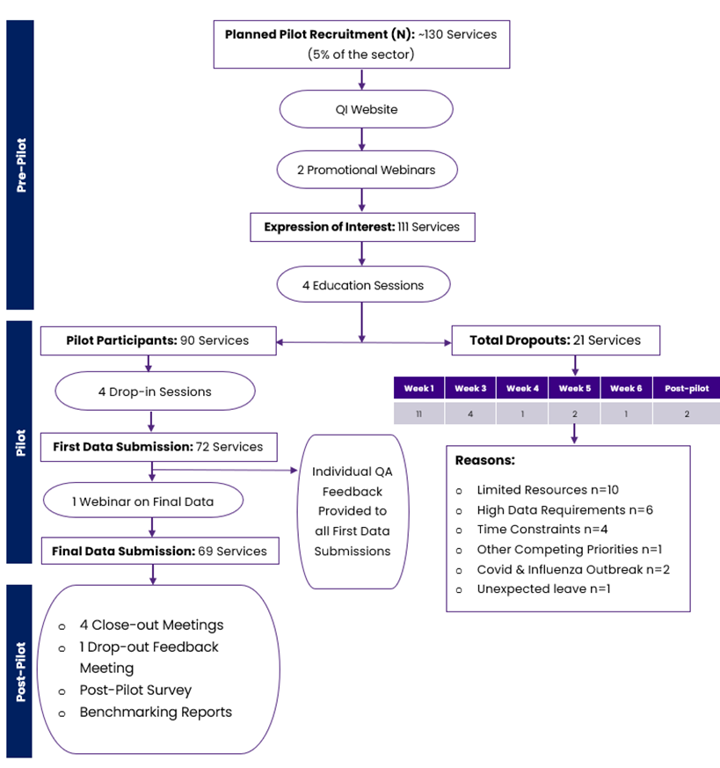

* 1. Pre-pilot

In the pre-pilot phase, two promotional webinars were conducted to explain the pilot's objectives, advantages, and expectations of participating sites. The QI website was developed as a central information repository accessible to all pilot participants. Additionally, four education sessions were held for participants who registered for the pilot with a focus on pilot materials, calculations supporting the QIs for the pilot, how to use the data collection tools, timelines, and how to submit data. Expressions of Interest were received from 111 services.

* 1. Pilot

During the pilot, four drop-in sessions were facilitated to allow participants to raise any queries and challenges that were present with collecting and preparing their data submissions. The drop-in sessions also provided the opportunity to give clarity on issues of scope. The main questions arising from these sessions were circulated to all pilot participants. Additionally, there was a webinar before the final data submission. Ninety services participated in the pilot, of which 72 services completed the first data submission and 69 services completed the final data submission, with 21 services dropped out during the pilot.

Email communication was regularly used to help participants with issues, send reminders, and to give feedback during the pilot. Table 16 summarises the reasons for dropout pilot participants, including dates and service characteristics.

Table 16: Reason for dropouts

| MMM Category​ | Service size | Ownership model​ | State​ | Date of withdrawal​ | Exit interview notes​ |
| --- | --- | --- | --- | --- | --- |
| MMM 5​ | <= 60​ | Not-for-profit​ | NSW​ | 28/02/2024​ | No capacity​ |
| MMM 2​ | <= 60​ | Not-for-profit​ | QLD​ | 4/03/2024​ | Other competing priorities​ |
| MMM 1​ | => 101​ | Not-for-profit​ | VIC​ | 7/03/2024​ | Limited resources​ |
| MMM 1​ | >61 and <=100​ | For-profit​ | VIC​ | 7/03/2024​ | N/A​ |
| MMM 1​ | >61 and <=100​ | Not-for-profit​ | SA​ | 7/03/2024​ | Excessive data requirements/limited resources​ |
| MMM 1​ | >61 and <=100​ | Not-for-profit​ | SA​ | 7/03/2024​ | Excessive data requirements/limited resources​ |
| MMM 5​ | >61 and <=100​ | Not-for-profit​ | SA​ | 7/03/2024​ | Excessive data requirements/limited resources​ |
| MMM 3​ | <= 60​ | Not-for-profit​ | NSW​ | 14/03/2024​ | Limited time resource​ |
| MMM 1​ | => 101​ | Not-for-profit​ | WA​ | 15/03/2024​ | Excessive data requirements/limited resources; uncertainty of how data will be used​ |
| MMM 1​ | <= 60​ | Not-for-profit​ | WA​ | 15/03/2024​ | Excessive data requirements/limited resources; uncertainty of how data will be used​ |
| MMM 7​ | <= 60​ | Government-operated​ | SA​ | 15/03/2024​ | N/A​ |
| MMM 1​ | >61 and <=100​ | Not-for-profit​ | ACT​ | 25/03/2024​ | Limited time resources​ |
| MMM 1​ | <= 60​ | Not-for-profit​ | NSW​ | 25/03/2024​ | Time constraints​ |
| MMM 1​ | => 101​ | Not-for-profit​ | NSW​ | 25/03/2024​ | Time constraints​ |
| MMM 4​ | <= 60​ | Government-operated​ | VIC​ | 25/03/2024​ | No capacity​ |
| MMM 5​ | <= 60​ | Government-operated​ | SA​ | 5/04/2024​ | Advised that service is unable to complete trial​ |
| MMM 1​ | => 101​ | Not-for-profit​ | QLD​ | 8/04/2024​ | Covid and influenza outbreak​ |
| MMM 5​ | >61 and <=100​ | Not-for-profit​ | QLD​ | 8/04/2024​ | Covid and influenza outbreak​ |
| MMM 1 | <= 60​ | Government-operated​ | VIC | 22/04/2024 | Staff absence |
| MMM 1 | >61 and <=100​ | For-profit | VIC | 10/05/2024 | Other competing priorities​ |
| MMM 1 | => 101​ | Not-for-profit​ | VIC | 13/05/2024 | Limited resources​ |

Pilot sites were required to submit data in two stages:

First data submission: This included services provided by allied health professionals over the first part of the pilot (up to three weeks of data) and one week of lifestyle officer activities.

Final data submission: This included services provided by allied health professionals over six weeks, one week of lifestyle officers’ activities. It included information about care recipients, including gender, dementia status, AN-ACC classification and whether they triggered specific QIs.

As of April 11, 2024, 72 services had submitted first data and 19 services had withdrawn from the pilot. Data that was submitted underwent a series of quality checks including a completeness check, validity check, and range check. Table 17 outlines the quality checks that were undertaken to review the first data submissions. Appendix B outlines the final data submission quality checks.

Table 17: List of quality checks and data assurances

|  |  |
| --- | --- |
| Data Assurances | Quality Checks |
| **Unique IDs consistency** | Ensuring consistency of Unique IDs across all tabs |
| **Provider basic details** | Validating NAPS ID, start and end dates of data collection period |
| **Paid lifestyle services in Service Information Tab** | Verifying completion of all relevant fields for services delivered by paid lifestyle officers (YES or NO) |
| **QI triggers in care recipient tab** | Confirming completion of QI triggers fields for each care recipient (YES or NO) |
| **Absence status of care recipients in allied health and lifestyle officers tabs** | Ensuring completion of the absence field for all care recipients (YES or NO) |
| **End-of-life status in allied health and lifestyle officers tabs** | Confirming completion of end-of life care field for each care recipient (YES or NO) |
| **Services confirmation** | Ensuring fields were completed and logic checks were done i.e. are the services delivered by subcategories greater than the whole (YES or NO; Number of Instances) |

* 1. Post-pilot

In the post-pilot phase, four close-out meetings and one drop-out meeting were carried out to gather participant feedback and allow them to share their experiences and insights into the pilot process. Additionally, a survey was circulated to capture insights into the pilot process, including the ease, accessibility and time burden of data collection and reporting. QIs were calculated from both pilot and QFR data. Benchmarking reports were generated and provided to each participating service that included their QIs in comparison to the average indicators for services of similar size, location, remoteness, and ownership model.

* + 1. Post pilot survey

The post pilot survey was sent to 75 pilot sites. This included 69 that submitted final data, five that indicated they would submit data later and one that provided data for first data submission. In total 38 pilot coordinators responsible for 49 residential aged care services responded to the survey (Figure 19).

Figure 19: Post pilot survey participant characteristics

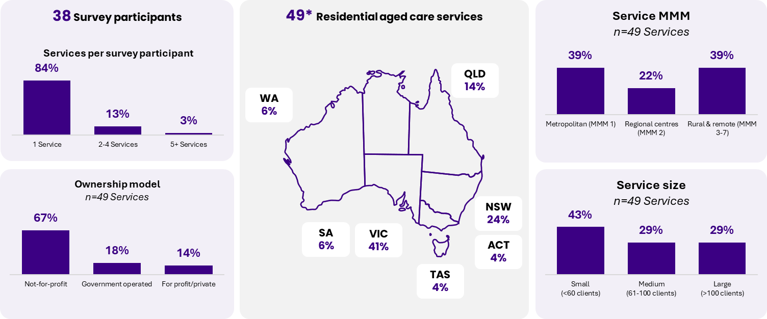

Pilot participants generally provided positive feedback about the pilot (Figure 20). They noted it took roughly two hours to collect six weeks of data about allied health professionals and one week of data about lifestyle officers. One third of the services were unable to extract all pilot data from reporting software.

Figure 20: Feedback from the pilot participants

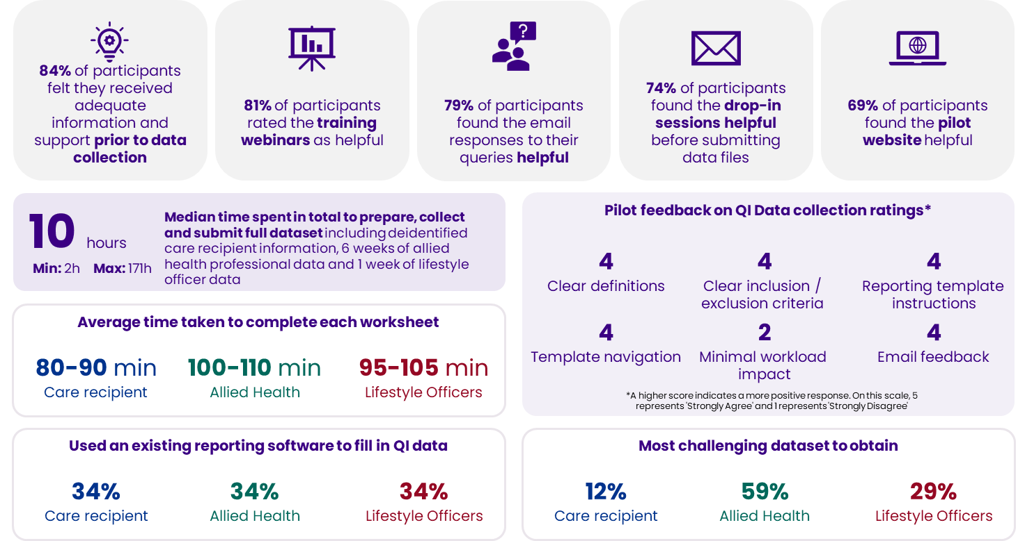

Pilot data collection included care recipient data which will not be required if the staffing QIs are implemented nationally.

1. Pilot data quality assessment
   1. Data collection period

Of the 69 services which participated in the pilot, 14.5% (n=10) of the services collected allied health data for <6 weeks (n=8 services) or >6 weeks (n=2 services). 11.6% (n=8 services) of services collected lifestyle officer data for <1 week (n=1 service) or >1 week (n=7 services). Analyses in this report are based on the study start and end dates that may not reflect the actual data collection period.

* 1. Care recipient characteristics

Data were reported for 5,111 unique care recipient IDs across three datasets for care recipient characteristics (n=4,954), allied health services (n=4,928) and lifestyle officer services (n=4,825).

Using the unique IDs provided, there were 120 records in the care recipient data that could not be linked to allied health or lifestyle data. There were 157 records in the allied health or lifestyle data that could not be linked to care recipient data. Some discrepancies can be attributed to care recipients arriving at or leaving the service during the reporting period. Others appear to be the result of errors in ID generation during data collection.

In total 4,954 care recipients were recorded in the care recipient dataset. Of these, 0.5% (n=26) of care recipients had none (n=9) or >1 gender selected (n=17) and were set to missing. 0.9% (n=45) of care recipients had an AN-ACC value which was not between 1-13 (expected range) and were set to missing in our analysis. Care recipients without an AN-ACC value may have been receiving respite care. For the allied health and lifestyle officer services received/attended QIs, care recipients were excluded from the QI estimation if they were absent for the entire reporting period. Of the 4,954 care recipients,   
4.8% (n=235) had no recorded status on whether they were absent for the entire reporting period and remained included in the analysis. Out of the 3.1% (n=155) of care recipients reported to be receiving end-of-life care, there were 78 discrepancies between the reporting periods for lifestyle officer and allied health data in whether the care recipients were reported as receiving end-of-life care. Therefore, planned stratifications by whether the care recipients were receiving end-of-life care were not included in this report.

* 1. Allied health professionals’ data

For the allied health services data, the use of 7,100 allied health services was reported across the 4,910 care recipients during the reporting period. There were 459 discrepancies in the number of allied health services recorded. These included instances where the service was recorded as accessed but the number of services for the care recipient was zero, the service was recorded as not accessed but the number of services was greater than zero, or the number of external, group or telehealth sessions was greater than the number of overall sessions (Table 18).

The data provided and feedback recorded from residential aged care services suggest there were inconsistencies in how the need for allied health in care recipients’ care plans was recorded. For example, at one residential aged care service, all care recipients had all allied health services recorded in their care plans. As a result, they scored poorly on QIs involving the care plan numbers in the denominator.

Table 18: Summary of discrepancies in allied health data

|  |  |  |  |  |
| --- | --- | --- | --- | --- |
| Service | Number of care recipients that used service | Service used but number of services 0 | Service not used but number of services >0 | Number of external, group or telehealth sessions greater than number of overall sessions |
| Physiotherapy | 3,069 | 26 | 28 | 226 |
| Occupational therapy | 355 | 0 | 1 | 0 |
| Speech pathology | 265 | 7 | 1 | 0 |
| Podiatry | 2,522 | 71 | 8 | 1 |
| Dietetics | 532 | 45 | 2 | 1 |
| Other allied health | 316 | 41 | 1 | 0 |

No changes have been made to the data in response to these inconsistencies - the allied health services received QIs were derived using each allied health service variable (“Care recipient received at least one instance of care from allied health staff”) as given, regardless of the number of sessions indicated.

* 1. Lifestyle officers’ data

Of the 4,825 care recipients with lifestyle officer data, 3.3% (n=157) had recorded that the recipient participated in at least one lifestyle officer service, but no individual lifestyle services were selected. For 1.8% (n=85) of care recipients, the overall lifestyle variable recorded that the recipient did not participate in any services, but individual lifestyle services were selected. No changes have been made to the original data in response to these inconsistencies. The lifestyle officer service attendance QIs were derived using the overall lifestyle variable as given, regardless of the individual lifestyle services selected. 61 care recipients with missing data for the overall lifestyle variable were excluded from the analysis.

* 1. Data quality notes

The data and feedback provided by the pilot coordinators suggested there were inconsistencies in how the need for allied health in care recipients’ care plans was recorded. For example, at one aged care service all care recipients had all allied health services recorded in their care plans, and as a result scored poorly on QIs involving the care plan numbers in the denominator.

Comments from pilot coordinators on recording allied health requirements in care plan:

|  |
| --- |
| “All residents have physiotherapy reviews as a minimum requested 3 monthly in their care plans and as additionally when mobility changes occur, following falls or on request by the resident, staff or GP. Residents who were not reviewed during the pilot study did not meet the above criteria”. |
| “All permanent residents in the service, are routinely reviewed by a physiotherapist 3 monthly and as required. Therefore, we have indicated for the permanent residents that a review or treatment is recorded in their care plan; however, the timing of the review did not coincide with the dates of the pilot. Regarding respite residents their care plan identifies physiotherapy is as required based on their assessed need, given there is no specific timeframe, we have indicated this was not recorded in their care plan. This is also a similar situation for podiatry. For the other allied health services, if there was a specific timeframe for a review to take place, we indicated this was recorded in their care plan. If the review was only when required and no specific timeframe for the review to take place, we responded no to the question”. |
| “For dietetics and speech pathology, the residents do not have the intervention recorded as a need in a care plan, rather the residents are treated on a referral basis. Therefore, all residents would be “NO” for these columns.; For podiatry, residents are typically seen on an 8-weekly basis”. |
| “The marked residents on the dietitian/speech pathologist are the only residents who were seen during this pilot period, no other residents were seen. The allied health only come on monthly basis and residents are seen on referral basis”. |

1. Visualising variation

Visualising variation using box plots for each QI provides an opportunity to understand each service’s performance relative to others in the pilot. Box plots show the variation between the services. Each dot in the figures represents a residential aged care service in the pilot.

The box plot shows the minimum value (bottom of the vertical line), 25th percentile (lowest point of the box), the 50th percentile (or median; middle of the box), 75th percentile (highest point of the box) and the maximum value (top of the vertical line). Thus, the middle 50% of services fall into the box for each QI. The values above the box are the highest 25%, and the values below the box are the lowest 25%.

A diagram of a box plot



1. US National Quality Forum. Measure Evaluation Criteria and Guidance for Evaluating Measures for Endorsement. (<https://www.qualityforum.org/WorkArea/linkit.aspx?LinkIdentifier=id&ItemID=88439>) and Partnership for Quality Measurement. Endorsement and Maintenance (E&M) Guidebook. (<https://p4qm.org/sites/default/files/2023-12/Del-3-6-Endorsement-and-Maintenance-Guidebook-Final_0_0.pdf>)
2. Donabedian A. The Quality of Care: How Can It Be Assessed? JAMA [Internet]. 1988 Sep 23 [cited 2018 Sep 20];260(12):1743–8. Available from: <http://jamanetwork.com/journals/jama/fullarticle/374139>
3. US National Quality Forum. Measure Evaluation Criteria and Guidance for Evaluating Measures for Endorsement. (<https://www.qualityforum.org/WorkArea/linkit.aspx?LinkIdentifier=id&ItemID=88439>) and Partnership for Quality Measurement. Endorsement and Maintenance (E&M) Guidebook. (<https://p4qm.org/sites/default/files/2023-12/Del-3-6-Endorsement-and-Maintenance-Guidebook-Final_0_0.pdf>)
4. Willis, E., Price, K., Bonner, R., Henderson, J., Gibson, T., Hurley, J., Blackman, I., Toffoli, L and Currie, T. (2016) Meeting residents’ care needs: A study of the requirement for nursing and personal care staff. Australian Nursing and Midwifery Federation
5. Report of the Auditor General of Alberta. Health and Alberta Health Services – Seniors Care in Long-term Care Facilities Follow-up. 2014..
6. [Scoping study on multidisciplinary models of care in residential aged care homes – Summary | Australian Government Department of Health and Aged Care](https://www.health.gov.au/resources/publications/scoping-study-on-multidisciplinary-models-of-care-in-residential-aged-care-homes-summary?language=en)
7. Meulenbroeks I, Raban MZ, Seaman K, Westbrook J. Therapy-based allied health delivery in residential aged care, trends, factors, and outcomes: a systematic review. Systematic Review
8. British Columbia Ministry of Health. *Residential Care Staffing Review*. 2017.
9. Report of the Auditor General of Alberta. *Health and Alberta Health Services – Seniors Care in Long-term Care Facilities Follow-up*. 2014.