Council of Elders 2024 – Year in review

The Council of Elders was established in December 2021 in response to recommendation 9 of the Royal Commission into Aged Care Quality and Safety Final Report. Council provides high-level, strategic advice to the Commonwealth Ministers responsible for aged care, and to senior executives in the Australian Department of Health and Aged Care.

Members have provided a direct voice to the Australian government from older people, informed by a diverse range of backgrounds, characteristics, life experiences, personal journeys and perspectives. Council has provided trusted, expert advice to the Government on aged care reform, focusing on the needs of vulnerable and disadvantaged individuals. Council insights are shaped by the voices of older people, families, carers, providers, and workers.

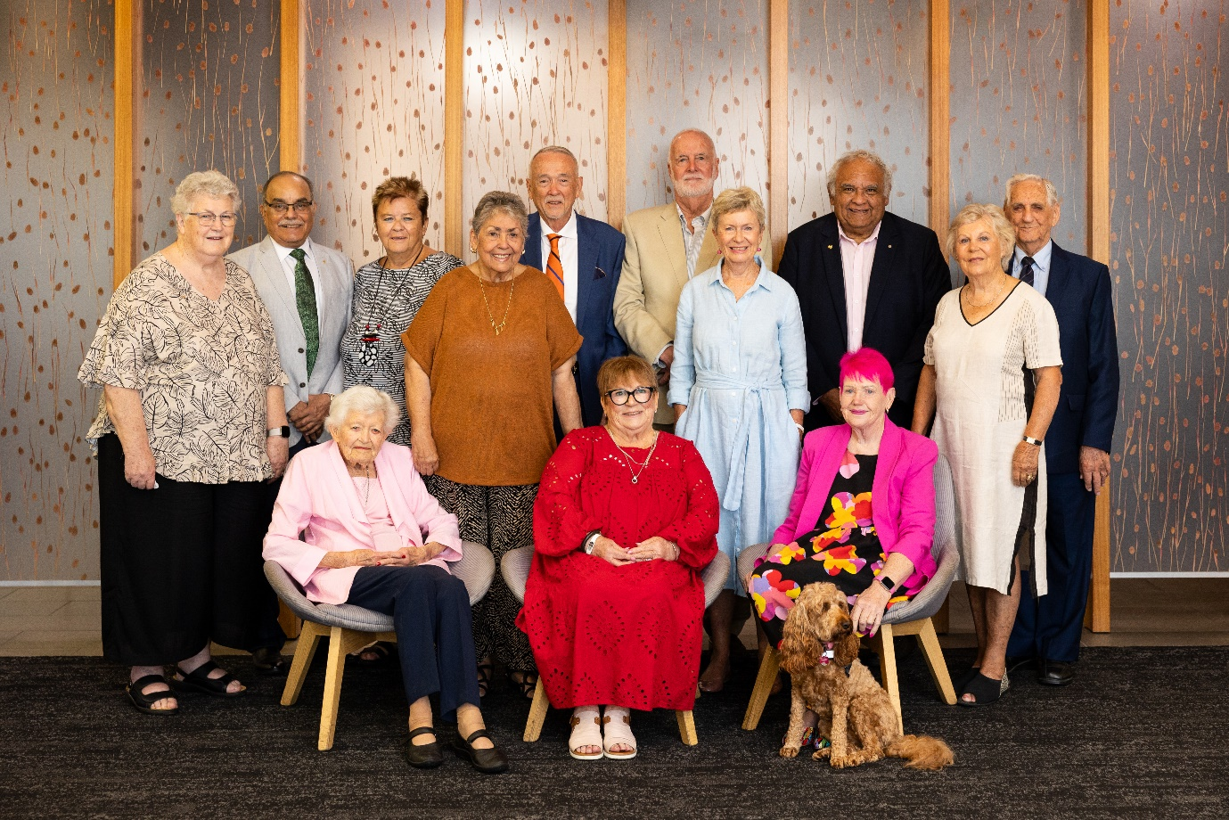

Council of Elders has worked with the National Aged Care Advisory Council, notably in addressing dementia care, the Acting Inspector General of Aged Care to strengthen accountability within the sector, and the Interim First Nations Commissioner, Andrea Kelly, to discuss issues relevant to indigenous communities including preserving ties to country, addressing cultural and language barriers, and educating on aged care accessibility.

This year, with refreshed membership and key priorities for the Minister for Aged Care, the Hon Anika Wells MP, Council has supported pivotal reforms, culminating in the introduction of the Aged Care Bill 2024 to Parliament in September.

Council met with the Hon Anika Wells MP, Minister for Aged Care, in March and underscored the importance of advancing the new Act at the earliest opportunity, while allowing time to integrate the Government’s response to the Taskforce Report into legislation. Council met with the Minister in October and reaffirmed support for the timely passage of the Aged Care Bill 2024, and shared feedback on the Bill’s current provisions and welcomed updates on potential amendments.

In addition, Council welcomed the appointment of the Hon Kate Thwaites MP as Assistant Minister for Ageing. In their first meeting held in September, Council expressed enthusiasm for a holistic approach to ageing issues and discussed topics encouraging active and healthy ageing and supporting at-home living arrangements and emphasising cross-departmental collaboration to achieve these outcomes.

Council of Elders has a wide remit to engage and consult with older people about changes being made to aged care and listen to their experiences. Council members are in a unique position to engage with the Australian public on aged care reforms and ageing well and this engagement is critical in ensuring the diverse views and perspectives of older people are heard by government. Each member has participated in open consultation activities by promoting discussion and consultation within their networks, facilitating focus groups and individual interviews targeted at specific issues or regions and engaging in online consultations, including webinars.

From January 2024, Council members have represented the Council at 33 events, both in person and online. This has included speaking opportunities at consumer and provider events, representation on panels, networking from departmental booths, participation in forums, webinars consultation hubs and podcasts.

(This figure includes events up to an including the 27 - 28 November meeting).

**Event pictures:**

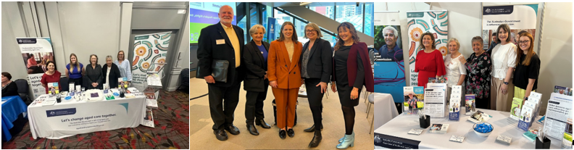

Since June 2024, Council members have visited 20 Residential Aged Care Facilities across all states and territories. These visits have been invaluable to understand the aspirations and concerns of resident and provide them with a voice to Council.

**Residential Aged Care Facility Visits:**

The Council met 8 times in 2024. The following summary highlights Council’s most significant impacts across whole-of-system and foundational matters, key reforms within the aged care roadmap, and current and emerging issues summarising key themes and advice of the council.

# Key Focus Areas and Policy Input

**Aged Care Reform** – Council advised balancing improved access with financial sustainability, reduced hospital admissions, financial pressures, and family caregiving burdens, will profoundly impact older Australians. They advised the government about the importance of regular, clear and concise communication with older people about the aged care reforms advising the department about the best ways to communicate with older people and their families about important aged care initiatives, like the passing of the Aged Care Bill 2024.

Members acknowledge that passing the Bill as soon as possible is essential to give timely information to participants and providers and support them being ready for implementation and noted the importance of consultation. Council has a keen interest in the draft Rules (subordinate legislation), particularly those Rules relating to fees, charges, caps, and means testing, and looks forward to their release.

**Taskforce and Financial Clarity** – Council noted that recent increases in public aged care investment need careful allocation and advised of concern among older people about changes to fees and charges and the user pays approach.

They advised clarity on consumer contributions is essential, especially amidst rising living costs and advocated for clear fact sheets to demystify provisions like “grandfathering” and “no worse off” assurances for home care, particularly for CHSP recipients. Council noted the feedback members are hearing is that it’s vital for older people to know the actual prices they will pay.

**Support at Home** – Council reviewed early drafts of the Support at Home service list, recommending refinements. Members strongly supported the importance of effective early interventions, a new restorative care pathway, comprehensive home assessments and priority support for those at risk due to falls or mobility issues. They highlighted participants need to receive assistance for a range of tasks they cannot complete themselves in order to continue living in their own home. Council members also emphasised the need for a strong awareness campaign and suggested there be greater attention to the provision of simple information in the form of fact sheets and advised communication materials and a central source of information is crucial.

**First Nations Pathways** – Council supported partnership – driven models for First Nations pathways, recommending CHSP’s grant-based structure to support culturally relevant and flexible services. Council advised place-based approaches and maintaining community ties were invaluable, with ongoing input from First Nations Council members.

**Star Ratings and Quality Standards** – Council welcomed the opportunity to discuss star ratings and quality standards with the department. Council advised of the value of transparent ratings and the importance of ongoing consumer confidence. Council continues to encourage clear explanations and communication to help older Australians understand and trust these ratings.

**Quality Indicators Program Expans**ion – Council was encouraged by the expansion of quality indicators, advocating for inclusive data collection to understand program uptake and better meet the diverse needs of older Australians, including First Nations and culturally diverse residents.

**Care Evaluation Framework** – Council provided input on evaluating 24/7 nursing measures, advising of the importance of a person-centred approach to measure quality at individual levels. They emphasised the importance of quality of life over mere survival, calling for continuous improvement driven by regular assessments.

# Networking Opportunities

Council members participated in range of networking opportunities during 2024 including but not limited to:

* + Australian Library and Information Association (ALIA) partnerships
  + Departmental Sponsored Events
  + Aged & Community Care Providers Association (ACCPA) International Conference
  + Australian Association of Gerontology Conference
  + Residential Aged Care Facilities

Members attended 20 aged care homes across all states and territories since June 2024, expanding the growth of consultations with older Australians and listening to firsthand experiences within the Aged Care sector.

# Other Notable Engagements

**Complaints Handling** – Council welcomed insights from the Aged Care Quality and Safety Commission on recent improvements in complaints management following advice from Council to help find the right balance between taking an educative, capacity building approach towards providers, with the need for older people to feel empowered and have their complaints taken seriously. Members commended the Commission’s approach to staff training, prioritising empathy and active listening in customer interactions. Council advice was used to place emphasis on prompt resolution and accountability, noting concerns in home care complaints.

**After-Hours Primary Care** – Council raised the challenges of accessing after-hours primary care, especially in rural areas. They stressed the importance of providing timely GP or nurse practitioner visits, which would require appropriate incentives. Council also provided feedback surrounding technological solutions, noting the need to build IT literacy for effective implementation.

## Special Acknowledgements

**Purple House Recognition** – Council invited the CEO of Purple House to share their pioneering approach to culturally safe, Indigenous-led health services in Alice Springs. Purple House’s model, supporting aged care, palliative care, and primary health, has inspired Council members as a benchmark for high-quality, culturally safe aged care in remote communities.

**In Memory of Major-General (Ret’d) Vikram Madan OAM** – Council respectfully acknowledges the passing of valued member Major-General Madan, whose contribution to the Council of Elders is deeply appreciated and whose presence will be greatly missed.

Through its work and collaborations, the Council remains dedicated to promoting the rights, dignity, and well-being of older Australians. Looking ahead, Council will continue to provide insight on aged care reform while advocating for respectful, responsive, and sustainable systems for all older Australians.