60-day prescriptions
Community Information Kit
January 2025 update
Contents
Introduction 2
Medicines available for 60-day prescriptions 3
Frequently asked questions 4
Communication resources 6
Newsletter article 8
Social posts 10

Introduction

About 60-day prescriptions
There are now almost 300 Pharmaceutical Benefits Scheme (PBS) medicines available for 60-day prescriptions. This will give many Australians twice the amount of their medication on a single prescription.
To qualify, patients must:
- live with a stable, ongoing health condition
- have discussed their medication with their prescriber and be assessed as suitable
- have received a new 60-day prescription.
Patients buying PBS medicines will save more than $1.6 billion over the next 4 years from 60-day prescriptions.
Patients taking only 60-day prescription medicines may halve their doctor and pharmacy trips to renew and fill their scripts, freeing up millions of GP visits.
The changes follow advice from the independent Pharmaceutical Benefits Advisory Committee (PBAC). The PBAC recommended it was clinically safe and suitable to allow 60-day prescriptions for eligible patients.

About this information kit
This kit includes information and communication resources you can share with your community to learn more about 60-day prescriptions.
It includes a newsletter/website article and social media posts as well as links to:
- a downloadable poster
- case study videos
- information and fact sheets.

How to use this kit
You can share information about 60-day prescriptions with your community by:
- including an article in your newsletters and/or websites
- publishing social media posts
- displaying resources such as the poster.

Further information
For more information visit health.gov.au/cheapermedicines
If you have questions or require further information, email the department at enquiries@health.gov.au

Medicines available for 60-day prescriptions
The list of medicines available for 60-day prescriptions supports patients who are living with stable ongoing health conditions including:
- acne
- androgen deficiency
- anxiety disorders
- arthritis
- breast cancer
- bipolar disorder
- chronic obstructive pulmonary disease (COPD)
- constipation
- Crohn’s disease
- depression
- diabetes
- epilepsy
- gastro-oesophageal reflux disease (GORD)
- glaucoma and dry eyes
- gout
- heart disease
- high cholesterol
- hypothyroidism
- incontinence
- menopause
- migraine
- osteoporosis
- Parkinson disease
- prostate cancer
- prostate enlargement
- ulcerative colitis.

How to check if a medicine is included
- For a searchable list of available medicines, visit https://www.health.gov.au/cheaper-medicines/60-day-dispensing-pbs-medicines-and-current-item-codes
- Browse the list or type the name of a specific medicine into the search box to see if it’s on the list.

Frequently asked questions
Will a patient need a new prescription to obtain a 60-day supply of their current medication?
Yes, to qualify, patients must:
- live with a stable, ongoing health condition
- have discussed their medication with their prescriber and be assessed as suitable
- have received a new 60-day prescription.

Patients with a stable, ongoing health condition should talk to their prescriber to find out if they are eligible for a 60-day prescription. Prescribers will use their best professional judgement to prescribe medicines for either 30 or 60-days.

How are patients saving with 60-day prescriptions?
Patients will receive twice the medication on a single prescription for almost 300 medicines. When a PBS medicine can be prescribed for 60-days patients may save:
- up to $189.60 a year, per medicine for Medicare card holders (non-concessional)
- up to $46.20 a year, per medicine for concession card holders.
A patient taking only medicines that have a 60-day prescription may halve their number of trips to the pharmacy to fill a script for those medicines. This may also free up appointments with prescribers to focus on other aspects of patient care.
How does this work with the PBS Safety Net?
The PBS Safety Net helps you pay less for medicines after you’ve reached a certain amount in a calendar year. This qualifying amount is called the Safety Net threshold.
The threshold is lower for concession card holders. Both the general and concessional thresholds will increase each year in line with the consumer price index.
You and/or your family only need to reach the threshold once in a calendar year. If you qualify for the Safety Net you pay a lower amount for PBS medicines, and concession card holders receive PBS medicines for free, for the rest of that year (plus any applicable premiums). For more information see the Pharmaceutical Benefits Scheme (PBS) | The Safety Net Scheme.
With 60-day prescriptions, some patients won’t reach the PBS Safety Net due to the savings on their medicines throughout the year. Others will reach the Safety Net later in the year, having spread their medicine costs over a longer period.
The benefit for patients is that their total annual medicines cost will be spread out over a greater period of time, resulting in a lower monthly medicines cost. If patients don’t reach, or hit the threshold later in the year, it means they have saved money throughout the year.
Do patients require a concession card to be eligible for a 60-day prescription?
No, patients do not need a concession card to access a 60-day prescription. Doctors retain full clinical discretion over what quantity of medicine is prescribed for their patients based on their assessment of their patient’s condition at the time.

Will 60-day prescriptions negatively impact the supply of medicine?
Moving to 60-day prescriptions has not affected the supply of medicine. Consumers still purchase the same amount of medicine each year. While eligible people can now get twice the medication on a single prescription, this will last them for a longer period of time. This means overall demand for medicines will stay the same.
Most medicines recommended by PBAC for 60-day prescriptions are not in short supply in Australia. If shortages do occur, alternative brands and/or strengths of the same medicine are usually available. The Department of Health and Aged Care monitored the list of recommended medicines for inclusion in each stage to reduce the risk of shortage.
More medicines can continue to become available for 60-day prescriptions after they have been deemed suitable and recommended by the Pharmaceutical Benefits Advisory Committee (PBAC), as part of routine monthly changes to the PBS.
Pharmaceutical companies must tell the Therapeutic Goods Administration (TGA) of expected medicine shortages. The Medicines Supply Security Guarantee changes commenced on 1July 2023. Medicine manufacturers must have more stock onshore for some brands of PBS medicine, helping ensure any temporary rise in demand for those brands is met.
Wholesalers must deliver to any pharmacy in 24 hours (excluding weekends or public holidays) if they are running low on medicine. This applies for most medicines.

Communication resources
The table below outlines the resources available to support communication and engagement.
Resource | Preview | Suggested use
Poster – less travel | 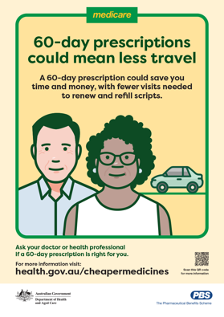 | Print and display poster in community waiting areas or on community noticeboards.
Poster – more medicines | 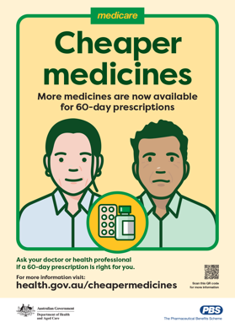 | Print and display poster in community waiting areas or on community noticeboards.
Frequently Asked Questions (FAQs) | 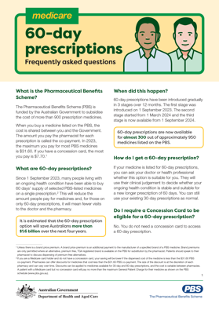 | Refer people to the FAQs on the Department of Health and Aged Care website or print and hand out hard copies.
Consumers Health Forum of Australia website and fact sheets | 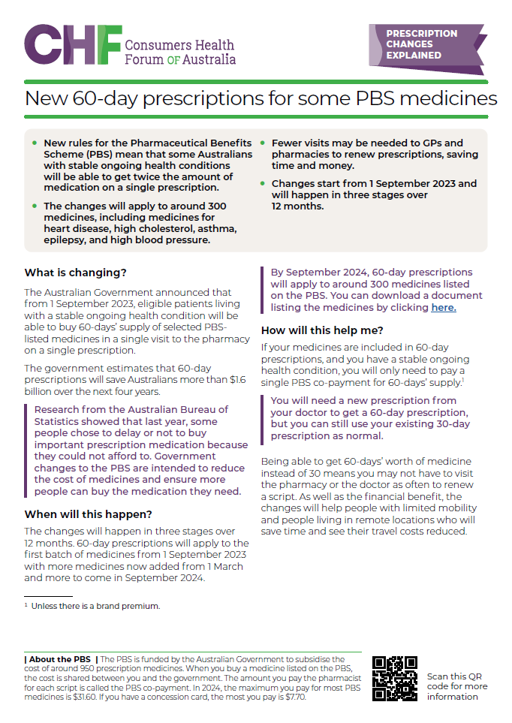  60dayscripts.com.au | Refer people to the information available on the Consumers Health Forum of Australia website or print and hand out hard copies.
Campaign website | 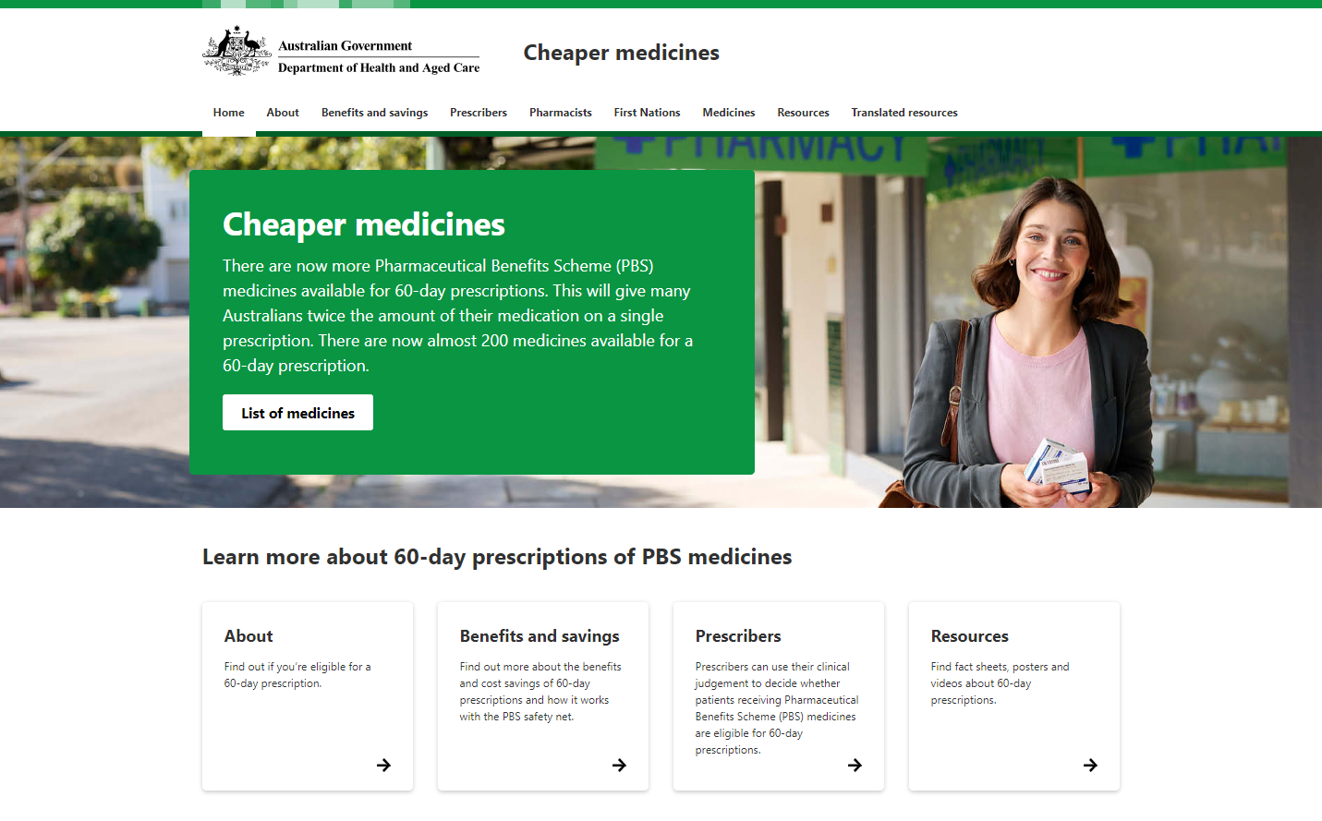  health.gov.au/cheapermedicines | Refer people to the website for more information.
Video case study: Jeanette |   After years of joint pain, Jeanette was diagnosed with rheumatoid arthritis. The introduction of 60-day prescriptions for selected PBS medicines will save her money and time so she can focus on enjoying life. | Refer people, or share links to the case study videos on social channels or in newsletters.
Video case study: Hermine |   At 18, Hermine was diagnosed with ulcerative colitis, a lifelong autoimmune disease. She can now get 60-day prescriptions for her PBS medicine, reducing her medical costs and saving time. | Refer people, or share links to the case study videos on social channels or in newsletters.
Video case study: Jonathan |   Jonathan takes medication to reduce his blood pressure and cholesterol. With his doctor’s approval, Jonathan can now get 2 months’ worth of medicine at once, and he won’t need to visit the pharmacy as often. | Refer people, or share links to the case study videos on social channels or in newsletters.
Explainer animation  What are 60-day prescriptions? | 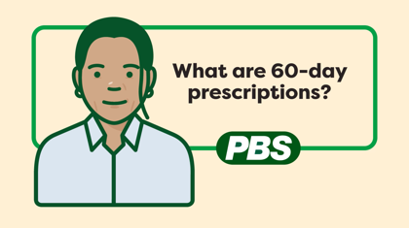 | Refer people, or share links to the explainer animation on social channels or in newsletters.
Explainer animation  Are my medicines suitable for 60-day prescriptions? | 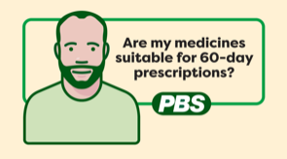 | Refer people, or share links to the explainer animation on social channels or in newsletters.
Patient FAQ with Dr Nicole Higgins – Episode 1 | 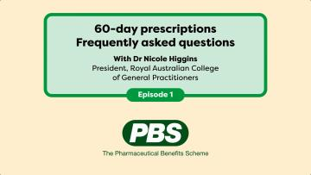 | Refer people, or share links to the Patient FAQ on social channels or in newsletters.
Patient FAQ with Dr Nicole Higgins – Episode 2 | 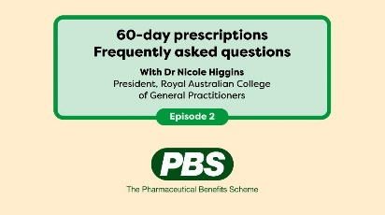 | Refer people, or share links to the Patient FAQ on social channels or in newsletters.

Newsletter article
Here is an article that can be used on your website news or in an electronic newsletter.

60-day prescriptions are available for many Australians
There are now almost 300 Pharmaceutical Benefits Scheme (PBS) medicines available for 60-day prescriptions. This will give many Australians twice the amount of their medication on a single prescription.
Patients with a 60-day prescription for a PBS medicine may save:
- up to $189.60 a year, per medicine for Medicare card holders (non-concessional)
- up to $46.20 a year, per medicine for concession card holders.
This also means many patients with stable, ongoing health conditions may halve their trips to their doctor or pharmacy to renew and fill their prescriptions.
Patients buying PBS medicines will save more than $1.6 billion over the next 4 years due to 60-day prescriptions.
To qualify, patients must:
- live with a stable ongoing health condition
- have discussed their medication with their prescriber and be assessed as suitable
- have received a new 60-day prescription.
Patients living with stable ongoing health conditions should chat to their doctor or healthcare professional to see if they are eligible for a 60-day prescription. Doctors will use their best professional judgement to prescribe medicines for either 30 or 60 days.
For more information, including medicines available for 60-day prescriptions and stable ongoing health conditions, visit health.gov.au/cheapermedicines
<ends>

Social posts
The posts and image tiles below can be published on your preferred social channels.
Post 1 – What are 60-day prescriptions? |  | Image
Long | 60-day prescriptions are available for almost 300 medicines listed on the Pharmaceutical Benefits Scheme.  This means many people can get twice the amount of medication on a single prescription.  Ask your doctor or prescriber if 60-day prescriptions are suitable for you.  For more information visit health.gov.au/cheapermedicines | 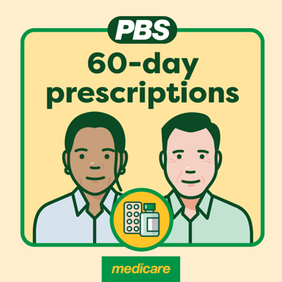  1080x1080
Short | 60-day prescriptions are available for almost 300 medicines listed on the Pharmaceutical Benefits Scheme.  Ask your doctor or prescriber if a 60-day prescription is right for you.  For more information visit health.gov.au/cheapermedicines | 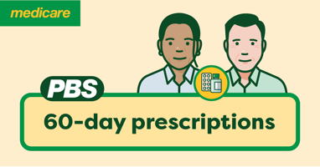  1200x627
Post 2 – Who can access 60-day prescriptions? |  | Image
Long | A 60-day prescription means you can get twice the amount of medication on a single prescription.  You can access this option if:  ✅ you have a Medicare card  ✅ your medicine is listed as available for 60-day prescriptions  ✅ your GP or prescriber considers it suitable for you.  To find out more visit health.gov.au/cheapermedicines  #60DayPrescriptions | 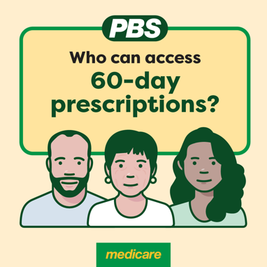  1080x1080
Short | 60-day prescriptions mean you can get twice the medication on a single prescription.  To find out more visit health.gov.au/cheapermedicines  #60DayPrescriptions | 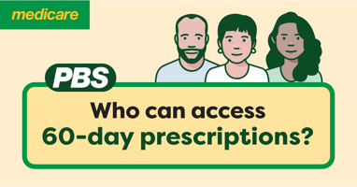  1200x627
Post 3 – What medicines are available for 60-day prescriptions? |  | Image
Long | Almost 300 medicines listed on the Pharmaceutical Benefits Scheme are available for 60-day prescriptions for eligible patients.  For a list of medicines assessed as safe for 60-day prescriptions, visit health.gov.au/cheapermedicines | 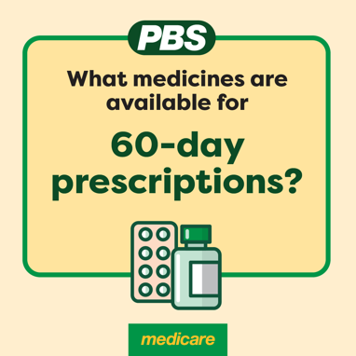  1080x1080
Short | Almost 300 medicines on the Pharmaceutical Benefits Scheme are available for 60-day prescriptions.  For a current list of medicines available for 60-day prescriptions, visit health.gov.au/cheapermedicines | 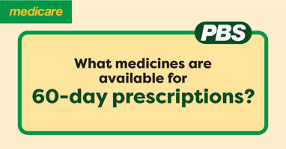  1200x627
Post 4 – Patient case study – Jeanette |  | Image
Long | After years of joint pain that was gradually getting worse, Jeanette was diagnosed with rheumatoid arthritis.  The introduction of 60-day prescriptions for selected medicines on the Pharmaceutical Benefits Scheme will save Jeanette money and time so she can focus more on enjoying life.  To watch Jeanette's story, visit health.gov.au/cheaper-medicines/resources/videos/jeanettes-60-day-prescriptions-story?language=en | 
Short | After years of joint pain, Jeanette was diagnosed with rheumatoid arthritis.  The introduction of 60-day prescriptions for selected medicines saves her money and time so she can focus on enjoying life.  To watch Jeanette's story, visit health.gov.au/cheaper-medicines/resources/videos/jeanettes-60-day-prescriptions-story?language=en
Post 5 – Patient case study – Hermine |  | Image
Long | At 18, university student Hermine was diagnosed with ulcerative colitis, a lifelong autoimmune disease that affects the digestive tract.  One of the medicines she takes every day to control her symptoms is now available for 60-day prescriptions. This means fewer appointments with her specialist, fewer visits to the pharmacy and savings on her medication costs.  To watch Hermine's story, visit health.gov.au/cheaper-medicines/resources/videos/hermines-60-day-prescriptions-story?language=en> | 
Short | At 18, Hermine was diagnosed with ulcerative colitis, a lifelong autoimmune disease.  She can now get 60-day prescriptions for some of her medicine, reducing her medical costs and saving time.  To watch Hermine's story, visit health.gov.au/cheaper-medicines/resources/videos/hermines-60-day-prescriptions-story?language=en>
Post 6 – Patient case study – Jonathan |  | Image
Long | Jonathan takes medication to reduce his blood pressure and cholesterol.  With his doctor’s approval, Jonathan can now get 60-days worth of medicine on a single prescription, and he won’t need to visit the pharmacy as often.  This means Jonathan will save time and lower the cost of his medicine.  To watch Jonathan’s story, visit:  https://www.health.gov.au/cheaper-medicines/resources/videos/jonathans-60-day-prescriptions-story?language=en
Short | Jonathan takes medication to reduce his blood pressure and cholesterol.  With his doctor’s approval, Jonathan can now get 60-days worth of medicine on a single prescription, and he won’t need to visit the pharmacy as often.  To watch Jonathan’s story, visit:  https://www.health.gov.au/cheaper-medicines/resources/videos/jonathans-60-day-prescriptions-story?language=en

