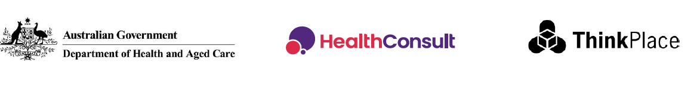

Building the evidence base for the next

National Oral Health Plan

29 January 2025

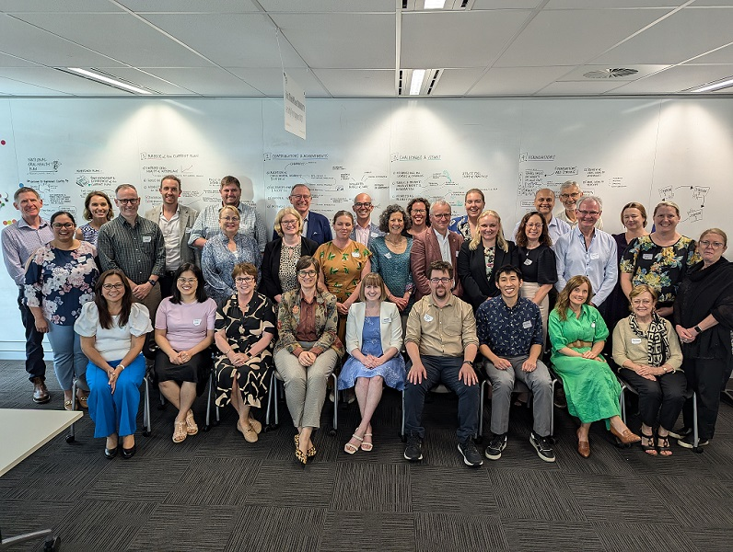

We facilitated a two-day co-design workshop in Canberra on the 3 and 4 December 2024 to review progress against the current Plan and discuss a vision for the next Plan.

The [Department of Health and Aged Care](https://www.health.gov.au/) has engaged [HealthConsult](https://www.healthconsult.com.au/) to provide expert analysis, facilitate stakeholder engagement, and ensure the next Plan is grounded in a solid evidence base. During November and December 2024, we (along with the team at [ThinkPlace](https://www.thinkplace.com.au/)) engaged with the oral health sector through one-on-one interviews, a co-design workshop and written submissions. In total we have spoken with more than 50 people representing 30 organisations, including state and territory health departments, government agencies, peak bodies, universities, consumer advocacy groups, and specialist organisations.

# This is what we’ve heard

* The current Plan remains **appropriate** and **gives a strong base to build on**.
* Participants supported keeping the six foundations in the current Plan with some discussion on modifying them to align with the [WHO Global oral health action plan (GOHAP)](https://www.who.int/publications/m/item/draft-global-oral-health-action-plan-(2023-2030)) and/or responding to emerging priorities including **data, technology, leadership and collaboration**.
* Participants acknowledged that, while the current Plan provides a strong foundation, it still faces challenges in securing sufficient **funding**, strengthening **leadership**, improving **monitoring**, and increasing **private sector** involvement.
* In voting for the next vision, 33% of workshop participants chose “**Affordable and accessible oral health care for all Australians**”.
* Participants agreed on two aims for the next Plan: 1) **improve oral health for all Australians** and 2) **make oral health an essential component of overall health**. **One-quarter of the participants felt** that the current Plan’s name, "**Healthy mouths and healthy lives for all**" already **reflects these aims**.
* Participants described the aspirational state as everyone in Australia to have **easy, timely and affordable access to oral health services. Whilst improving accessibility will address inequalities**, they emphasised that the next Plan must **keep working to remove barriers and reduce oral health problems faced by priority populations.**
* Participants agreed that the next Plan should **recognise the four priority populations in the** [current Plan](https://www.health.gov.au/sites/default/files/documents/2022/04/healthy-mouths-healthy-lives-australia-s-national-oral-health-plan-2015-2024.pdf). They identified at least **four additional groups** that need special focus in the next Plan: 1) people over 65 years old, 2) people living with disability, 3) people who experienced domestic violence, and 5) people with mental health or complex medical conditions. Participants recognised many people belong to multiple priority groups, highlighting the importance of providing care that meets each person's individual needs.
* Participants want the next Plan to be **simple**, **action oriented** and **inspiring**, while giving local communities and governments the freedom to adapt it to their population needs and **monitor progress** overtime.
* Four areas identified to mobilise the next Plan are: 1) **engage the private sector**, 2) **strengthen leadership and recognition of shared responsibilities** (e.g. appoint a Chief Dental Officer), 3) **improve data availability and reporting**, and 4) **better use of technology**.
* Participants identified the **Child Dental Benefits Scheme (CDBS)** as a major success. Increasing its use by eligible people may support building better partnerships with **private dental practices**. They suggested analysing CDBS data could show us who is using the scheme, where services are being provided, and what types of dental care people are receiving.
* Participants shared **37 success stories** during the workshops, demonstrating how local collaboration and targeted programs have **improved oral health outcomes across diverse communities**.

# This is what we’re doing next

* **We will continue with our one-on-one interviews.**
* We are preparing for a codesign workshop on 6 March 2025 (likely Canberra) where we will review and get feedback on the draft framework for the National Oral Health Plan 2025–2034.
* **We will publish an online survey** seeking feedback on the draft framework for the National Oral Health Plan 2025–2034 which will be open to everyone on the mail list.

### Share your thoughts or sign up to the mailing list

Send us an email [NOHP@healthconsult.com.au](mailto:NOHP@healthconsult.com.au).