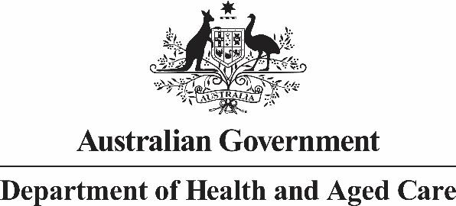

Allied Health Industry Reference Group

Meeting 12: 3 December 2024 – Summary of Outcomes

The Australian Government Chief Allied Health Office convened the 12th Allied Health Industry Reference Group (AHIRG) meeting on 3 December 2024. This meeting was open to allied health professional associations and was held in Melbourne. Members and professional association representatives could attend in person or online.

Topics discussed:

* Update on work of the Chief Allied Health Officer (CAHO)
  + Department of Health & Aged Care definition of ‘allied health’ to be considered and developed in 2025.
  + CAHO engaging with sector stakeholders and welcomes opportunities for organisations to showcase exemplar work that is addressing workforce issues or demonstrates models of care that work well.
  + CAHO is working on increasing awareness of allied health within the department.
  + A newsletter from the CAHO is in development and will be released later in the month.
* Mark Roddam, First Assistant Secretary, Primary Care Division, Department of Health and Aged Care, presented on intersecting health reforms that are relevant to allied health. This included key workforce reviews and major reforms occurring through the Strengthening Medicare budget measure. Reviews included Unleashing the Potential of our Health Workforce (Scope of Practice) Review; Review of General Practice Incentives; Working Better for Medicare Review; and A better after-hours system – Review of After-hours Primary Care Programs and Policy.
* Update and facilitated sessions in small groups on the National Allied Health Workforce Strategy:
  + The draft Strategy is progressing well.
  + Following consultations via a survey and online forums, themes have been identified to inform development of the draft Strategy.
  + The Draft Strategy will progress to Health Workforce Taskforce for approval to release it for public consultation. Consultation is planned for mid-December 2024 to mid-February 2025. The next phase is finalising Strategy and considering implementation planning.
  + Attendees worked in small groups to discuss the different themes in the draft Strategy and suggested actions to address them. These will be considered as part of implementation planning.
* Clae Hyde from the Department of Education presented on the Australian Universities Accord.

# Actions Register

| Meeting | Action | Action Officer | Status |
| --- | --- | --- | --- |
| M10, 05/03/24 | The Department of Health & Aged Care will look to bring an agenda item on intersecting health reforms to the next Allied Health Industry Reference Group meeting, to provide greater transparency on reforms influencing the National Allied Health Workforce Strategy. | Commonwealth CAHO | Completed at M12. |
| M12, 03/12/24 | The Department of Health & Aged Care will summarise and send attendees the list of top 2 actions for each emerging theme from the facilitated sessions on the National Allied Health Workforce Strategy. | Commonwealth CAHO |  |
| M12, 03/12/24 | The Department of Health & Aged Care will respond to any questions taken on notice regarding the presentation on intersecting reforms. | Commonwealth CAHO |  |
| M12, 03/12/24 | Attendees to provide case histories and videos to showcase allied health professions on the Department of Health and Aged Care’s intranet. | Members and professional association representatives |  |