Youth Vaping Education Campaign
Supporter communication kit
November 2024
Contents
Introduction 2
Frequently asked questions 4
Communication resources 8
Newsletter articles 15
Social media posts 18

Introduction

Support for young Australians to quit vaping
Vaping has rapidly increased in Australia, especially among 14 to 24 year olds. They are the first generation to be exposed to nicotine mainly through vaping instead of cigarettes.

Campaign to encourage young people not to vape
The Australian Government has launched a public health campaign to encourage young people to give up vaping – or not take it up in the first place.
The campaign asks young people ‘why are we still vaping’ and highlights the harms of vaping to their physical and mental health.
It aims to reach young people aged 14 to 24 and focuses on the social benefits of quitting together, to increase young people’s confidence in their ability to quit and empower them to take control of their health.
Vaping is dangerous in both the short and long-term.
Those who vape may experience:
- lung inflammation and throat irritation
- persistent coughing
- breathing problems
- shortness of breath
- permanent lung damage
- nausea
- nicotine poisoning
- nicotine dependence.
The nicotine in vapes is highly addictive. Those who are quitting may experience nicotine withdrawal symptoms that include:
- nicotine cravings
- mood changes
- difficultly concentrating
- feeling nervous, restless, irritable and/or anxious
- finding it hard to sleep.

About this information kit
This kit has information and communication resources you can share with young people in your community. Resources available to help raise awareness of the harms of vaping and help young people quit include:
- downloadable posters
- frequently asked questions
- a conversation guide for parents or carers
- fact sheet
- newsletter articles
- social media posts.

How to use this kit
You can share information about vaping with young people in your community by:
- including an article in your newsletters and/or websites
- publishing social media posts
- displaying resources such as a poster
- encouraging people to access the resources online.

Further information
For more information and resources visit: health.gov.au/vaping.
If you have questions or require further information, email giveupforgood@fenton.com.au

Frequently asked questions
The following frequently asked questions and answers are provided as background and can be used in your communications.

What is vaping?
Vaping is the use of an e-cigarette, or ‘vape’, a battery-operated device that can look like a cigarette, cigar, pipe, or a common item like a highlighter or USB device. The aerosol (mist or vapour) from vapes is made by heating up liquid chemicals that are breathed in.
Vapes deliver nicotine to those using them and mimic the action and sensation of smoking. This is commonly referred to as ‘vaping’.
Vapes, mods, tank systems, e-cigs and vape pens are all forms of e-cigarettes.

What’s in e-liquid?
The e-liquid in illegal vapes, also known as ‘vape juice’, can contain over 200 unique chemicals, including harmful substances like formaldehyde, nicotine and heavy metals.
Most vapes sold illegally in Australia contain nicotine – even when the packaging says they don’t.
Illegal vapes can contain high levels of nicotine and are unlikely to state how much nicotine they contain.
Illegal vapes can have dangerous substances in the liquids and vapour. Some chemicals found in vapes are known to cause cancer, such as:
- formaldehyde (used in industrial glues and for preserving corpses in hospitals and funeral homes)
- acetone (generally found in nail polish remover)
- acetaldehyde (used in chemicals, perfumes, and plastics)
- acrolein (commonly found in weedkiller)
- heavy metals like nickel, tin, and lead.
For more information about e-liquids and therapeutic vapes, visit the Therapeutic Goods Administration’s vaping hub.

Is the vapour created by e-cigarettes safe?
No. Calling the emissions from e-cigarettes ‘vapour’ gives the impression that it is just steam. This is not the case. The ‘cloud’ or aerosol that is exhaled while vaping is a mix of gases and tiny droplets of chemicals. When people vape, this fine spray of chemicals enters the body via the lungs and can cause many health impacts.

What do vapes smell like?
Only 3 flavours are now permitted in vapes available in pharmacies for therapeutic purposes, these are tobacco, mint and menthol.
Other vapes, sold illegally, often have flavours added to the e-liquid and this can make them smell and taste sweet. Flavours designed to appeal to young people can include fairy floss, fruit punch and cola (but the list of flavours is extensive!).

Why do young people vape?
Illegal vapes often have sweet flavours that may appeal to young people. They also come in youth-friendly packaging that might include bright colours, cartoons or be made to look like lollies.
Some of the reasons young people may try vaping include:
- curiosity
- a desire to fit in with their friends
- attractive flavours
- to imitate actors, models or influencers in movies, video games or social media
- a desire to appear grown up and assert independence
- copying adults or older siblings who smoke or vape
- a misguided view that vaping is safer than smoking.

Can vaping lead to nicotine dependance?
Yes. Most vapes in Australia contain nicotine, which is highly addictive because it triggers the release of dopamine in the brain, which makes you feel good.
As the nicotine levels in the body fade, the brain craves more dopamine. The longer someone has been using nicotine, the more dopamine they need to feel good. People become dependent on nicotine to create this feeling.
When someone stops vaping, the nicotine level in their bloodstream drops. Their dependency on nicotine may make it hard to concentrate, they may experience changes in their mood and might even feel irritable, frustrated, angry or anxious.

Can vaping impact mental health?
Yes. The nicotine in vapes is highly addictive and can negatively impact mental health.
Nicotine withdrawal symptoms can include:
- mood changes
- difficulty concentrating
- feeling nervous, restless, irritable and/or anxious.
Vaping during adolescence can cause nicotine dependence and harm parts of the brain that control attention, learning, memory and can increase the likelihood of using other addictive substances.

Are people who use vapes more likely to take up tobacco cigarettes?
Yes. Research shows that young people aged 12 to 17 who vape are 5 times more likely to start smoking in the future than those who have not.

What do the Australian Government reforms to vaping mean?
In Australia, vapes and vaping products, regardless of whether they contain nicotine or not, can only be sold in pharmacies. Non-pharmacy retailers that sell any type of vape are doing so illegally.
From 1 October 2024, people 18 years and older can buy vapes from a participating pharmacy with a nicotine concentration of 20 mg/mL or less without a prescription, where state and territory laws allow, but they must talk with the pharmacist before purchasing.
People under 18 years need a prescription to purchase vapes, where state and territory laws allow, to ensure they get appropriate medical advice and supervision.
Read more about the new regulations for vapes at health.gov.au/vaping/new-laws or at tga.gov.au.

How to support a young person to quit vaping
Talking to young people about the health risks of vaping is important.
The Escape the vape: a conversation guide for parents and carers can help start the conversation about quitting with young people. You can share this with parents and carers you engage with.
It includes advice to consider how adult behaviour may impact a young person and how environment can influence young people’s behaviour. For example, research has shown children whose parents vape are 64 per cent more likely to vape and if a parent currently smokes, their child’s likelihood of smoking increases by 193 per cent.
It also includes tips when talking to young people about vaping, including trying to:
- listen and talk without judgement
- be curious and interested in their thoughts and feelings
- provide a safe environment for two-way conversation – the safer they feel, the better the conversation will go and the more helpful it can be.

What’s the best way to support young people to quit?
There are lots of options to support young people to quit vaping.
- Quitline is a confidential phone service that offers support to young people, and parents and carers. Young people can talk to a professional counsellor about ways to quit and in some states and territories, they can chat to a counsellor online. Quitline can also help guide parents and carers through conversations about quitting and provide advice on what you can do.
To contact Quitline:
- call 13 7848
- start a webchat
- request a callback.
- A GP or a trusted health professional can give them helpful advice on how to quit.
- Encourage them to share their quitting journey with friends who support their decision.
- Download the My QuitBuddy app. The My QuitBuddy app includes great features to help people plan and quit successfully. Age restrictions may apply – check the app store for details.
There are also a range of mental health supports for young people such as:
- Kids Helpline (1800 551 800) offers a free, private and confidential phone and online counselling service for young people aged from 5 to 25.
- Beyond Blue (1300 224 636) offers information and support to help everyone in Australia achieve their best possible mental health, whatever their age and wherever they live.
- headspace (03 9027 0100) is a mental health support service for young people and their families with a focus on early intervention.
Remember that lots of young people have found it takes a few tries before they are completely vape-free. It’s important to encourage them to keep trying, even if it takes them a few goes before they quit completely.
For more information and resources visit health.gov.au/vaping.

Communication resources
The table below outlines the resources available to support communication and engagement.
Resource | Preview | Link | Suggested use
‘Escape the vape: a conversation guide’ is designed to help parents and carers start a conversation about vaping with a young person that they care about. | 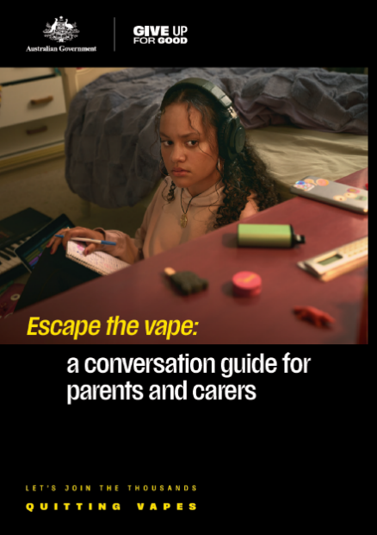 | Download here | Refer parents or carers to the conversation guide on the website or print and hand out hard copies.
‘What you need to know about vaping’ is a fact sheet for parents and carers to provide the facts about vaping. | 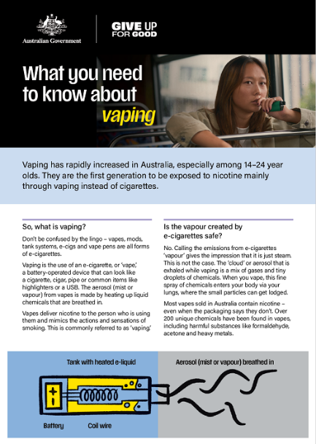 | Download here | Refer parents or carers to the fact sheet on the website or print and hand out hard copies.
Frequently asked questions (FAQs) for parents and carers is designed to help answer some common questions about vaping. | 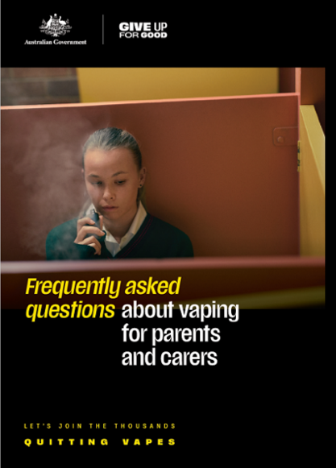 | Download here | Refer people to the FAQs on the website or print and hand out hard copies.
‘Escape the vape: a conversation guide for parents and carers’ in an animated video to help parents and carers start a conversation about vaping with young people. | 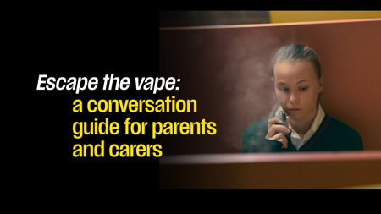  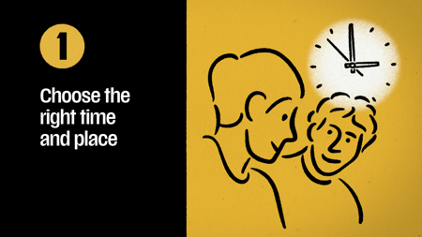 | Watch here | Refer parents or carers to the animated conversation guide on the website or use on your own channels.
‘Escape the vape: Let’s get the facts about vaping’ is a short animation that focuses on the facts about vaping. | 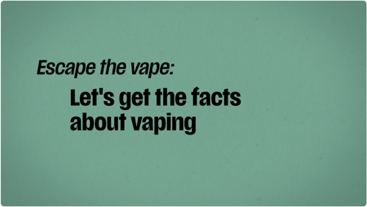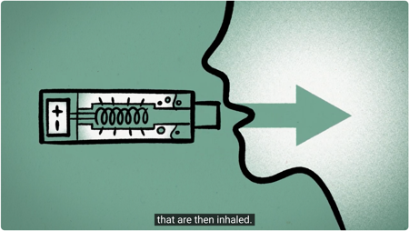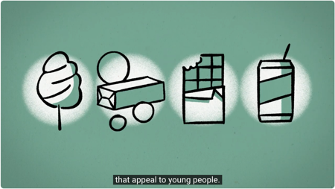 | Watch here | Refer parents or carers to the animated video on the website or use on your own channels.
‘Escape the vape: Support to quit vaping’ is a short animation about the support available to help young people quit vaping. | 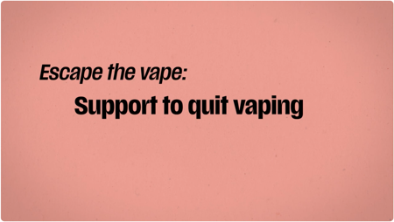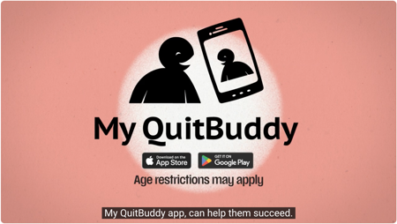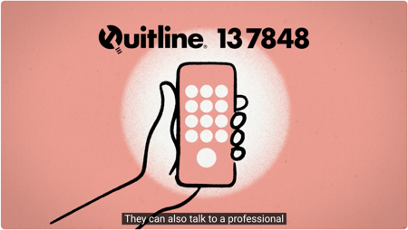 | Watch here | Refer parents or carers to the animated video on the website or use on your own channels.
‘Escape the vape: Four tips for talking about vaping’ is a short animation that provides useful tips for talking to young people about vaping. | 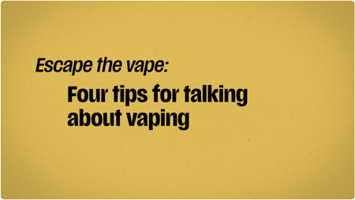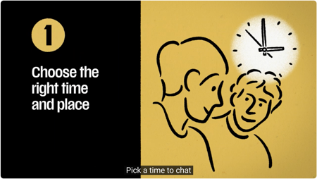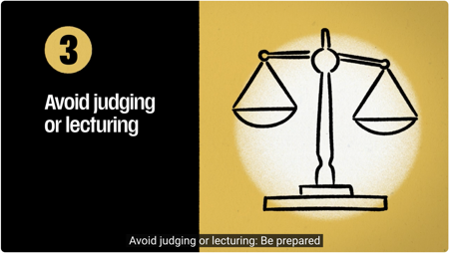 | Watch here | Refer parents or carers to the animated video on the website or use on your own channels.
‘Escape the vape: Having the conversation about vaping’ is a short animation to help parents and carers start a conversation about vaping. | 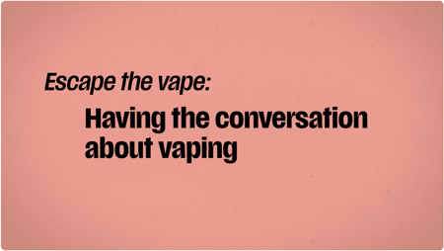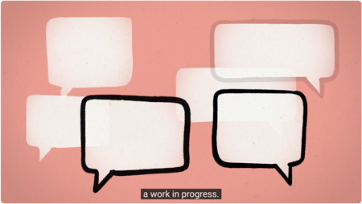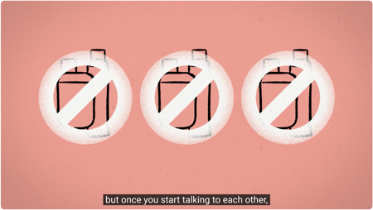 | Watch here | Refer parents or carers to the animated video on the website or use on your own channels.
‘Dr Anthea Rhodes on the harms of vaping’ video | 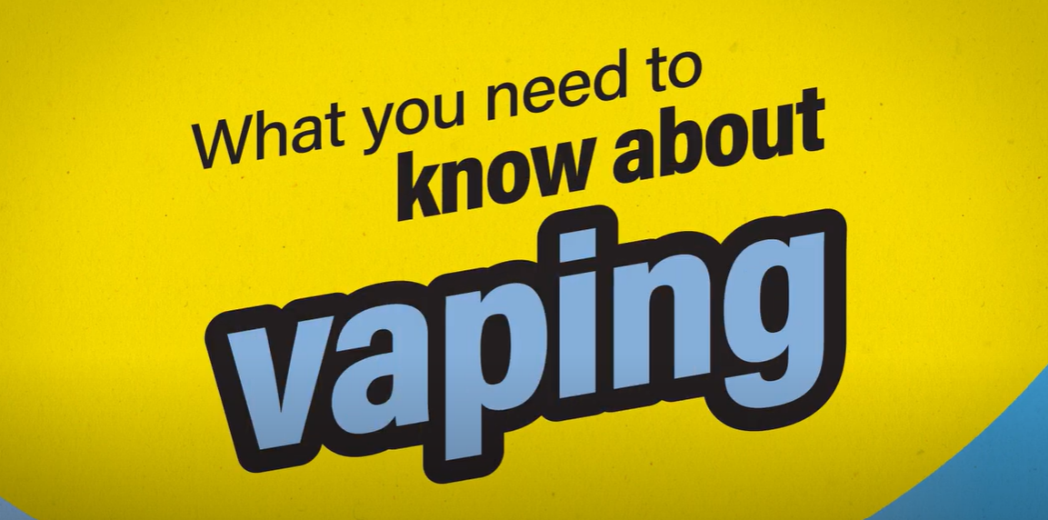 | Watch here | Refer young people, parents and carers to the video or use on your own channels.
‘Dr Anthea Rhodes on nicotine addiction and withdrawal’ video | 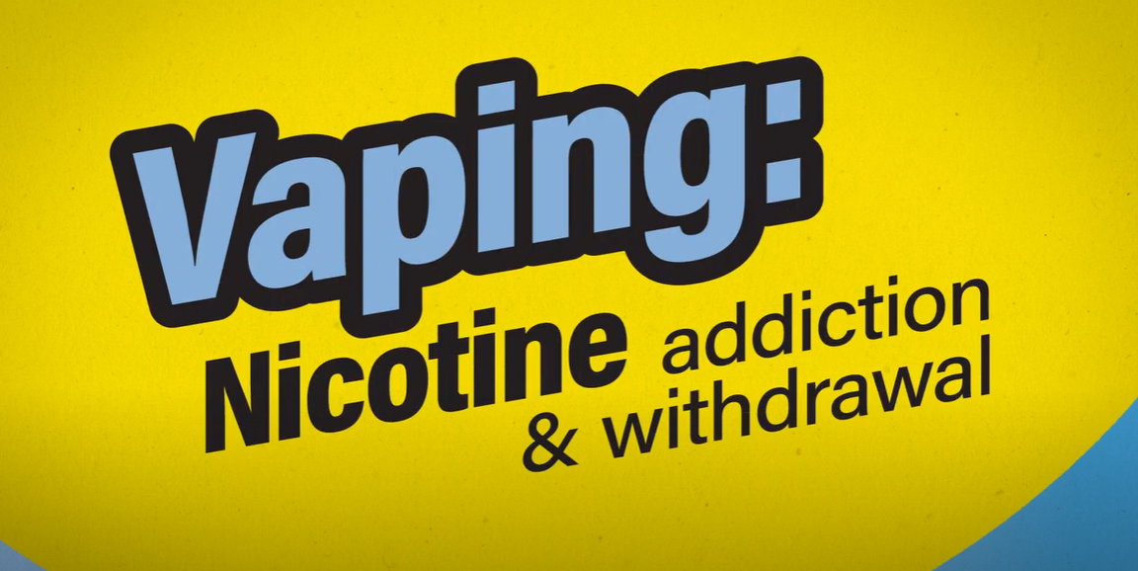 | Watch here | Refer young people, parents and carers to the video or use on your own channels.
‘Dr Anthea Rhodes shares advice for finding support to quit vaping’ video | 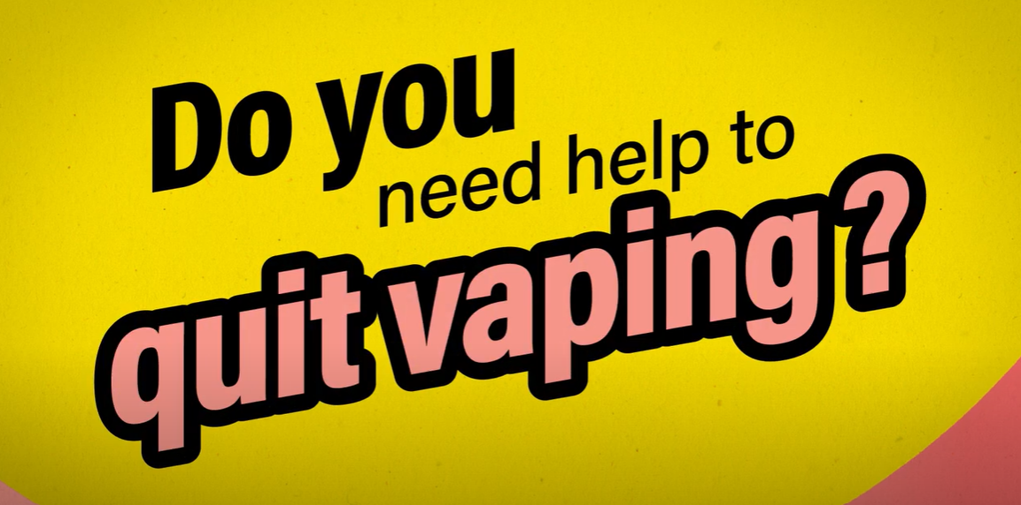 | Watch here | Refer young people, parents and carers to the video or use on your own channels.
Poster 1 | 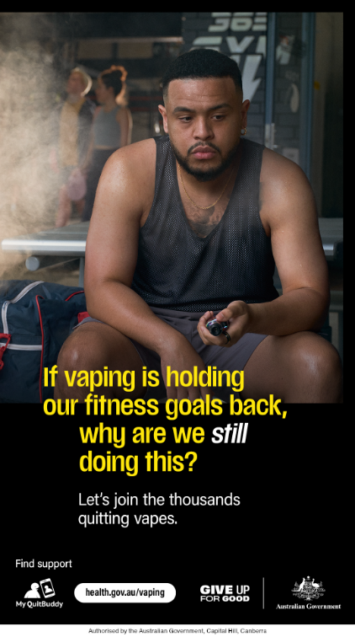 | Download here | Print and display posters for young people in community waiting areas or on community noticeboards.
Poster 2 | 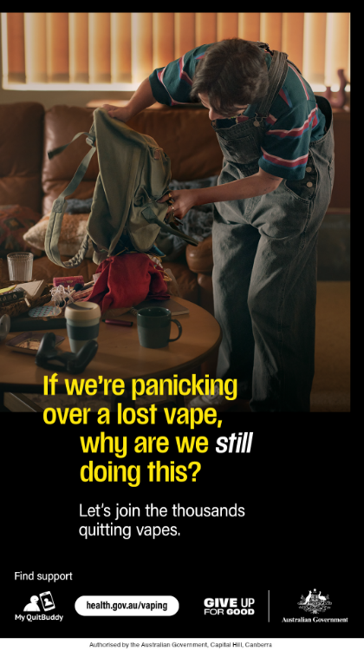 | Download here | Print and display posters for young people in community waiting areas or on community noticeboards.
Poster 3 | 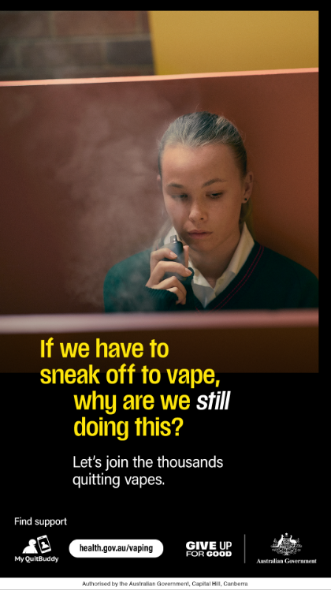 | Download here | Print and display posters for young people in community waiting areas or on community noticeboards.
Poster 4 | 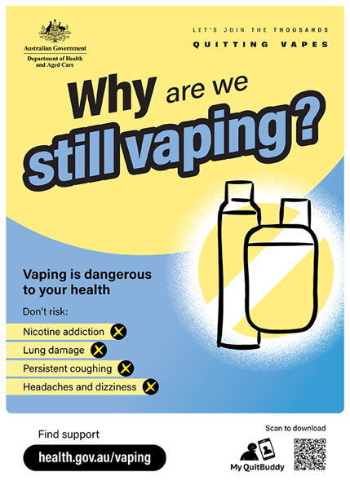 | Download here | Print and display poster for young people in community waiting areas or on community noticeboards.
Poster 5 | 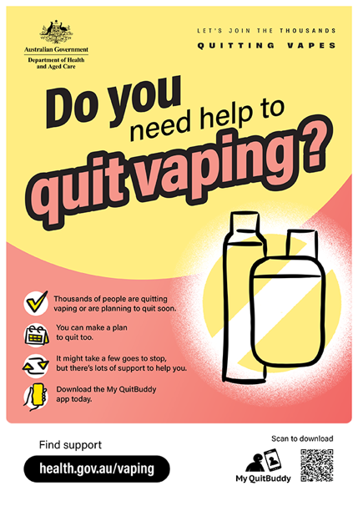 | Download here | Print and display poster for young people in community waiting areas or on community noticeboards.
All materials can be downloaded from health.gov.au/vaping.
Resources for First Nations audiences can be downloaded from health.gov.au/vaping/first-nations.
The youth vaping conversation guide, fact sheet, FAQ and animated videos have been translated into the following languages:
- العربية (Arabic)
- 简体中文 (Chinese Simplified)
- 繁體中文 (Chinese Traditional)
- Ελληνικά (Greek)
- 한국어 (Korean)
- ภาษาไทย (Thai)
- Tiếng Việt (Vietnamese).
Translated resources can be downloaded from health.gov.au/vaping/translated.

Newsletter articles
Two articles have been provided below that can be used on your website news or in an electronic newsletter. One is written for parents and carers and one is written for young people.
[For a parent and carer audience]

Vaping and young people – what you need to know
Don’t be confused by the lingo – vapes, mods, tank systems, e-cigs, and vape pens are all forms of e-cigarettes.
Most vapes contain nicotine – even when the packaging says they don’t. Over 200 unique chemicals have been found in illegal vapes, including harmful substances like formaldehyde, acetone and heavy metals.
When a person vapes, a fine spray of chemicals enters their body via the lungs, where small particles can get lodged.
Short and long-term vaping is dangerous to a young person’s health.
Those who vape may experience:
- lung inflammation and throat irritation
- persistent coughing
- breathing problems
- shortness of breath
- permanent lung damage
- nausea
- nicotine poisoning
- nicotine dependence.
Nicotine is highly addictive and may also affect mental health. People may experience nicotine withdrawal symptoms that include:
- nicotine cravings
- mood changes
- difficultly concentrating
- feeling nervous, restless, irritable and/or anxious
- finding it hard to sleep.
There are lots of options to support young people to quit vaping:
- The My QuitBuddy app includes great features to help them plan and quit successfully. Age restrictions may apply – check the app store for details.
- Quitline (13 7848) is a confidential phone service. They can talk to a professional counsellor about ways to quit. In some states and territories, they can also chat to a counsellor online.
- A GP or a trusted health professional can give them helpful advice on how to quit.
- Encourage them to share their quitting journey with friends who support their decision.
Remember lots of people have found it takes a few tries before they are completely vape-free. It’s important that they keep trying, even if it takes a few goes before they quit completely.
For more information and resources visit health.gov.au/vaping.
[For a young person audience]

Join the thousands quitting vapes
Thinking about quitting vapes? You’re not alone. Thousands of young people are making the choice to live vape-free, and you can too.
When you vape, you’re inhaling a fine spray of chemicals directly into your lungs, where tiny particles can get stuck and cause serious damage. Whether you’ve just started or have been vaping for a while, it’s important to know the risks.
Here’s what vaping can do to your health:
- lung inflammation and throat irritation
- persistent coughing
- breathing problems and shortness of breath
- permanent lung damage
- nausea
- nicotine poisoning
- nicotine dependence.
Nicotine is addictive and can also impact your mental health.
If you try to quit, you might notice:
- cravings for nicotine
- mood swings
- trouble concentrating
- feeling nervous, restless, or irritable
- difficulty sleeping.
But here’s the good news – you don’t have to do it alone. There are plenty of ways to get support:
- My QuitBuddy app: This app has everything you need to plan your quit journey and stay on track. Just be sure to check the app store for age restrictions.
- Quitline (13 7848): Want to talk? Quitline is a confidential phone service where you can chat with a professional counsellor about how to quit. In some places, you can even chat online.
- GP or trusted health professional: Your doctor or a health expert can give you solid advice on quitting.
- Lean on friends: Sharing your quitting journey with friends who support your decision can make a big difference.
Quitting isn’t easy, and it might take a few tries before you’re completely vape-free. But don’t give up – each attempt gets you closer to a healthier, vape-free life.
For more information and support, visit health.gov.au/vaping.

Social media posts
The posts and image tiles below can be published on your preferred social channels.
When sharing youth vaping resources across your social media channels, we’d recommend using the #JoinTheThousandsQuittingVapes hashtag.
Post | Image or video
Targeted at youth audiences
If you’re thinking about quitting vaping, there is support available to help you quit.  The free My QuitBuddy app provides personalised information and advice to help you on your quit journey.  Remember it’s okay if it takes a few tries to be completely vape-free and you’re not alone on the journey.  To find out more about the My QuitBuddy app visit https://www.health.gov.au/resources/apps-and-tools/my-quitbuddy-app  #JoinTheThousandsQuittingVapes | Social media tile ‘My QuitBuddy’  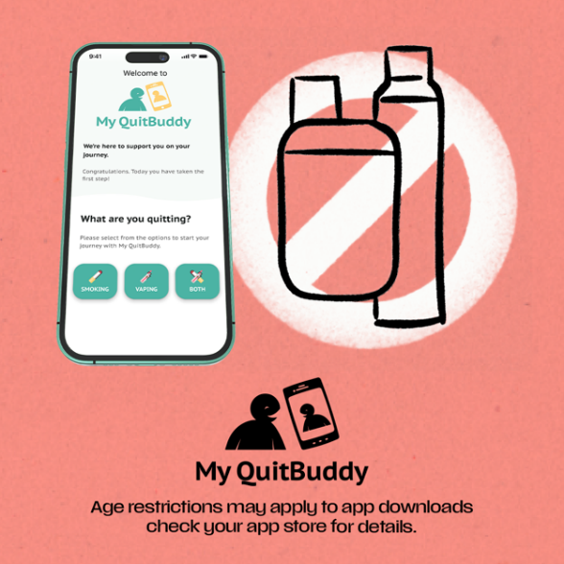
Are you vaping? Nicotine is highly addictive.  You may experience nicotine withdrawal symptoms that include mood changes, difficulty concentrating and feeling nervous, restless, irritable and/or anxious.  For more information and help to quit visit health.gov.au/vaping, download the My QuitBuddy app or talk to a health professional.  #JoinTheThousandsQuittingVapes | Social media tile ‘Most vapes contain nicotine’  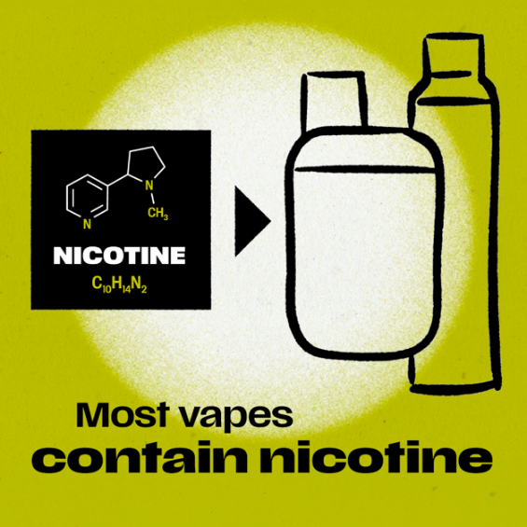
Did you know our brains are still developing until we reach our late 20s?  Vaping can harm parts of the brain that control attention, learning, memory and mood.  For more information and help to quit visit health.gov.au/vaping, download the My QuitBuddy app or talk to a health professional.  #JoinTheThousandsQuittingVapes | Social media tile ‘Vaping impacts’  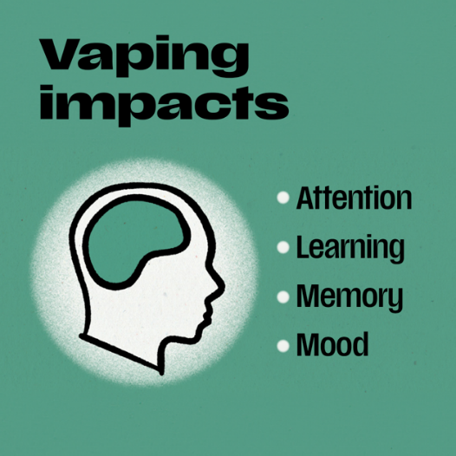
Quitting vaping is a major step towards improving your physical and mental wellbeing 🚫  Join the thousands quitting vapes.  For more information and help to quit visit health.gov.au/vaping, download the My QuitBuddy app or talk to a health professional.  #JoinTheThousandsQuittingVapes | Social media video ‘Fitness goals’  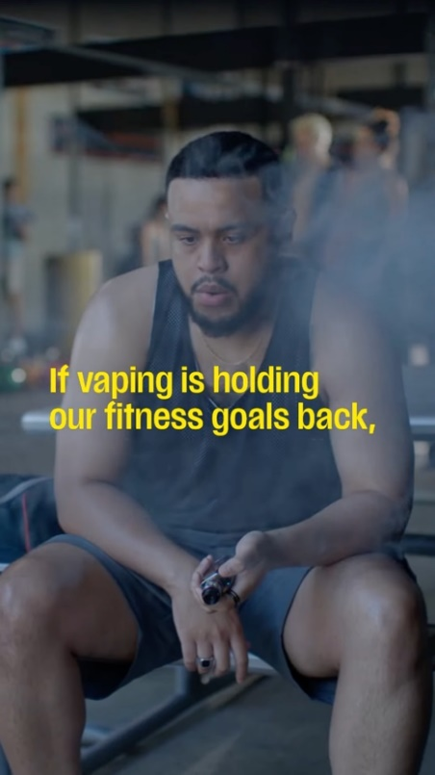
The nicotine in vapes means you may find vaping hard to resist but the harmful chemicals may affect your health.  Thousands of Australians have quit vaping or are planning on quitting vaping soon. You can too.  For more information and help to quit visit health.gov.au/vaping, download the My QuitBuddy app or talk to a health professional.  #JoinTheThousandsQuittingVapes | Social media video ‘Vaping in the bedroom’  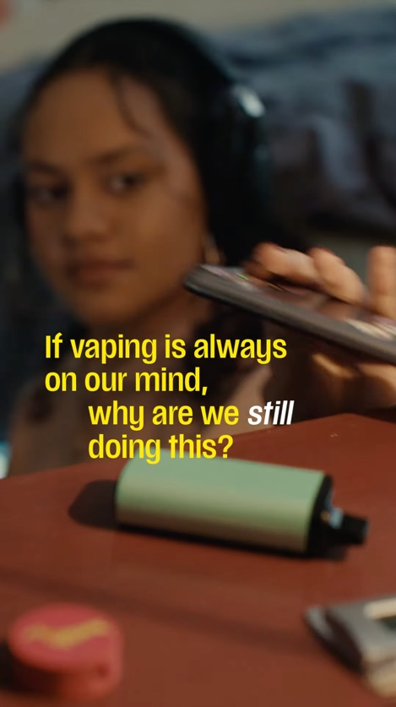
There is no such thing as safe vaping.  Thinking about giving up vaping?  Join the thousands of Australians quitting vapes and find help and support at health.gov.au/vaping, via the My QuitBuddy app or by speaking to a health professional.  #JoinTheThousandsQuittingVapes | Social media video ‘Vaping in the bathroom’  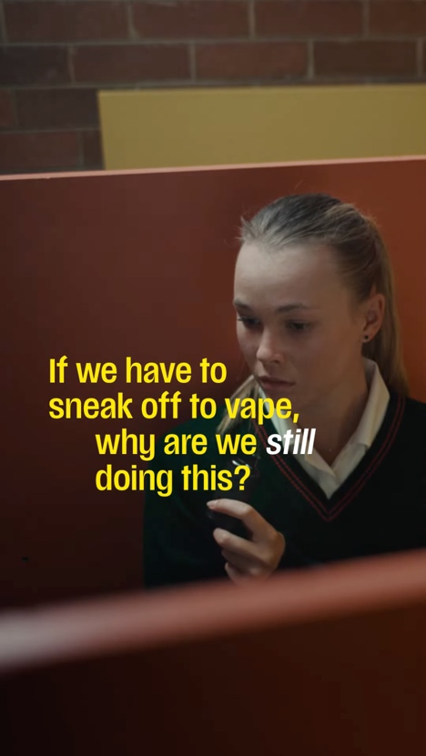
When you quit vaping, you’ll break your body’s dependence on nicotine. You’ll feel more in control and have more freedom to make choices about your life that don’t revolve around vaping.  For more information and help to quit visit health.gov.au/vaping, download the My QuitBuddy app or talk to a health professional.  #JoinTheThousandsQuittingVapes | Social media video ‘Wake and vape’  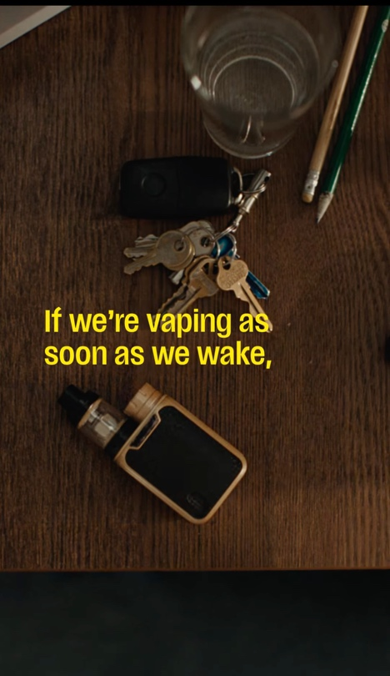
Targeted at parent and carer audiences
Did you know today’s 14 to 24 year olds are the first generation to be exposed to nicotine mainly through vaping instead of cigarettes?  There are helpful resources available that provide guidance to parents and carers wanting to talk to their young person about vaping at health.gov.au/vaping  #JoinTheThousandsQuittingVapes | Social media tile ‘Talking to a young person about vaping’  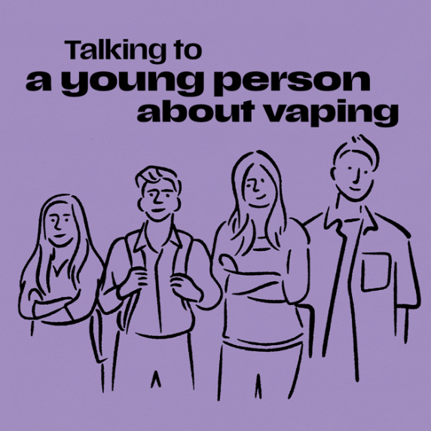
Having a conversation about vaping might feel tricky but it’s important to do. Here are 4 tips to help you start talking about vaping with a young person you care about.  There are helpful resources available that provide guidance to parents and carers wanting to talk to their young person about vaping at health.gov.au/vaping  #JoinTheThousandsQuittingVapes | Escape the vape: tips for talking about vaping  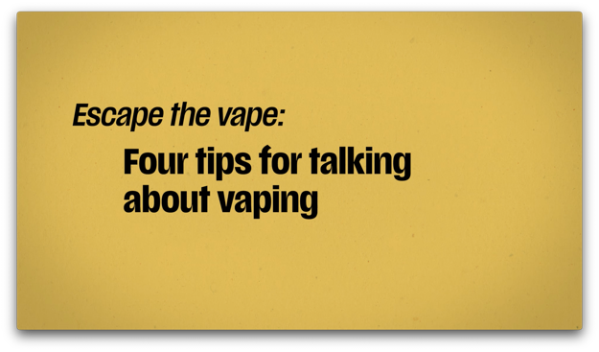  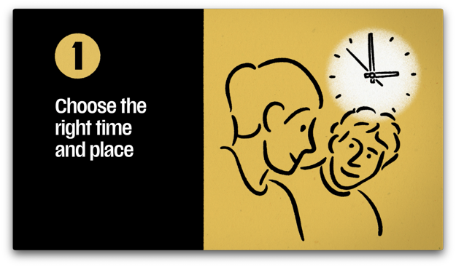
If a young person wants to quit vaping, accessing support can help them succeed.  Resources like the My QuitBuddy app provide personalised information and advice. Age restrictions may apply.  They can also talk to a Quitline counselor about vaping and how to quit.  There are helpful resources available that provide guidance to parents and carers wanting to talk to their young person about vaping at health.gov.au/vaping  #JoinTheThousandsQuittingVapes | Escape the vape: support to quit vaping  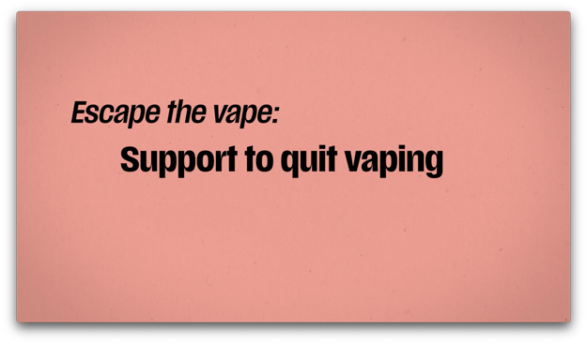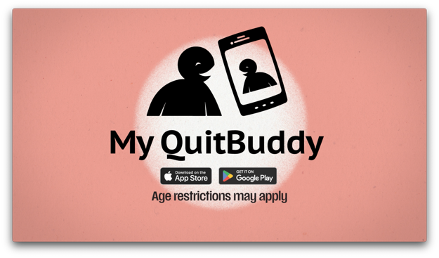
Let’s get the facts about vaping ⬇️  💨 Illegal vapes can look like a cigarette, cigar, pipe or common items like a highlighter or USB.  🧪 Over 200 unique chemicals have been found in illegal vapes, including formaldehyde, nicotine and heavy metals.  ⚠️ Most illegal vapes in Australia contain nicotine – even when the packaging says they don’t.  To find out more about vaping, visit health.gov.au/vaping  #JoinTheThousandsQuittingVapes | Escape the vape: get the facts about vaping  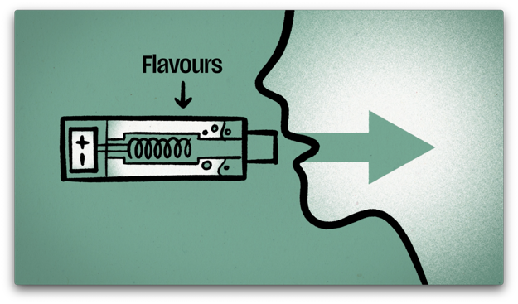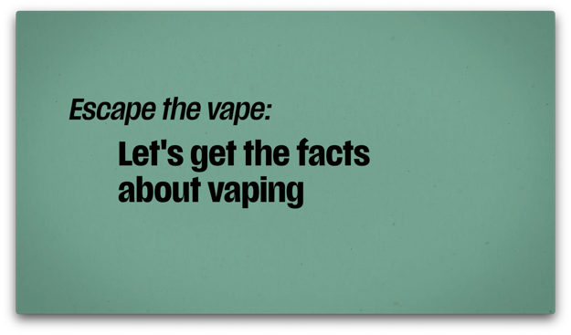
Talking to a young person about vaping? Think of your conversations as a work in progress – like quitting vaping, it might take a few tries, but it gets easier.  There are helpful resources available that provide guidance to parents and carers wanting to talk to their young person about vaping at health.gov.au/vaping  #JoinTheThousandsQuittingVapes | Escape the vape: having the conversation about vaping  