# Support at Home program

A guide for older Aboriginal and Torres Strait Islander people, families and carers

# Changes to aged care

The Australian Government is making positive changes to aged care.

These changes – known as the aged care reforms - will improve aged care in Australia now and into the future.

Many of these changes are in response to the Royal Commission into Aged Care Quality and Safety. Our vision is to give the highest quality care for older people, where and when they need it.

Together we can make positive changes to aged care that provides:

* high-quality care for older people
* better conditions for workers
* a modern sector.

The changes to aged care in Australia aim to achieve six main outcomes:

* respect, care and dignity
* real choice and control
* safe and high-quality care
* independence through care at home
* easy, consistent and fair access
* skilled care.

[health.gov.au/our-work/aged-care-reforms/priorities](https://www.health.gov.au/our-work/aged-care-reforms/priorities)

# About the Support at Home program

The Australian Government is improving in-home aged care to help older people live at home for longer.

A new program called Support at Home will bring together some in-home aged care programs from 1 July 2025.

Support at Home will help eligible Aboriginal and Torres Strait Islander people 50 years and over get culturally safe, trauma-aware and healing-informed aged care in or near your community.

Under Support at Home, there will be better access to services, products, equipment and home adjustments. This will help older Aboriginal and Torres Strait Islander people remain healthy, active and socially connected to their community.

**This includes:**

* A Restorative Care Pathway, which can help you keep and improve your independence through access to other health services.
* The Assistive Technology and Home Modifications (AT-HM) Scheme, to help you get products, equipment and/or home adjustments to meet your assessed needs.
* An End-of-Life Pathway, which can provide funding to get services and remain at home in your last 3 months of life.

**[health.gov.au/support-at-home](https://www.health.gov.au/our-work/support-at-home)**

# Support at Home start date

The Support at Home program will replace the Home Care Packages (HCP) Program and Short-Term Restorative Care (STRC) Programme from 1 July 2025.

The Commonwealth Home Support Programme (CHSP) will be part of the Support at Home program from 1 July 2027.

CHSP will continue running as normal until it moves to Support at Home. The National Aboriginal and Torres Strait Islander Flexible Aged Care (NATSIFAC) Program will continue, and will not be replaced by Support at Home.

[**health.gov.au/support-at-home**](https://www.health.gov.au/our-work/support-at-home/features)

[health.gov.au/our-work/hcp](https://www.health.gov.au/our-work/hcp)

[health.gov.au/our-work/short-term-restorative-care-strc-programme](https://www.health.gov.au/our-work/short-term-restorative-care-strc-programme)



# Support at Home program inclusions

## Services to help you to live at home for longer

Support at Home offers a lot of help so you can continue to live well at home. Based on your aged care assessment and eligibility, you will have access to an approved list of services. You will be helped to choose the mix of services you can get within your budget.

This includes services that support culturally safe care, such as:

* help to join in cultural activities
* access to Aboriginal and Torres Strait Islander health practitioners and health workers.

**You can get support for:**

* **Clinical care** – such as nursing care, occupational therapy and podiatry.
* **Independence** – such as help with showering, getting dressed, taking medications, transport or respite care.
* **Everyday living** – such as cleaning, gardening, shopping or preparing meals.

1. You can ask to change the mix of services you get from the approved list at any time with your provider. They will support you to make sure the services you get meet your needs.

Support at Home will have 8 ongoing service classifications, each with a budget for you to get services. You can ask for a reassessment if your needs change.

[health.gov.au/support-at-home-ongoing-services](https://www.health.gov.au/our-work/support-at-home/features#ongoing-services)

## Restorative Care Pathway

The Restorative Care Pathway will help you stay independent, lower the need for more services and help you in doing the activities you enjoy.

Under the Restorative Care Pathway, you may:

* get up to 12 weeks of restorative care
* get restorative care services, on top of any Support at Home services you already receive
* get an extra budget of about $6,000 (or up to $12,000 if needed) for other health services. This includes access to Aboriginal and Torres Strait Islander health practitioners and health workers
* have access to helpful equipment and home adjustments through the Assistive Technology and Home Modifications (AT-HM) scheme if needed.

[health.gov.au/support-at-home-short-term-supports](https://www.health.gov.au/our-work/support-at-home/features#shortterm-supports)

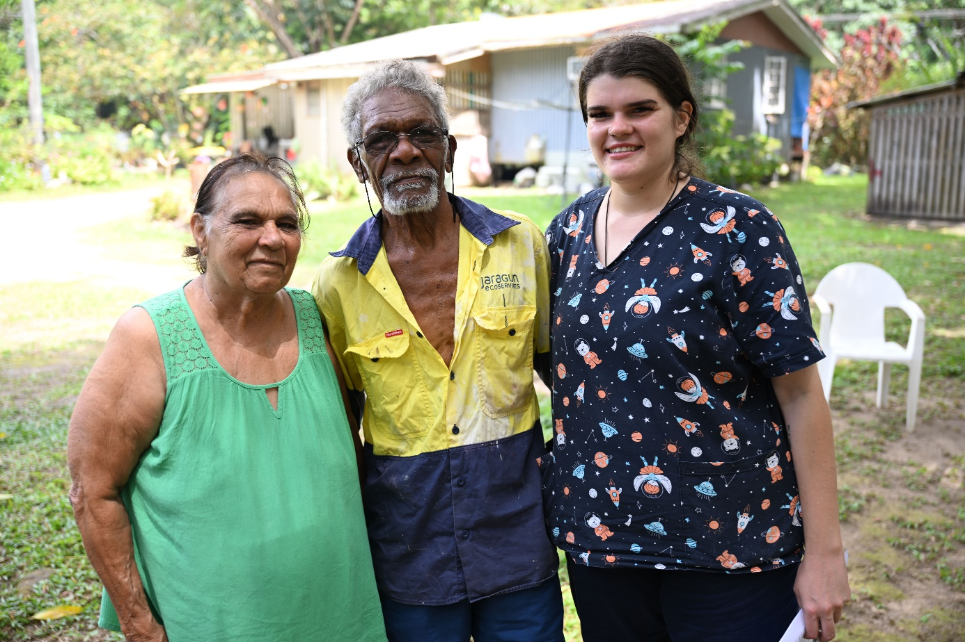

## End-of-Life Pathway

The End-of-Life Pathway will support you to remain at home in your last 3 months of life. You can be referred for a high-priority assessment to get the End-of-Life Pathway, even if you’re not already part of the Support at Home program.

Under the End-of-Life Pathway, you will:

* have quick access to a higher level of in-home aged care services if you have 3 months or less to live. This includes access to Aboriginal and Torres Strait Islander health practitioners and health workers
* have access to helpful equipment through the Assistive Technology and Home Modifications (AT-HM) Scheme if needed
* get funding of up to $25,000 over a 3-month period, with 16 weeks to use the money to give you more flexibility.

[health.gov.au/support-at-home-short-term-supports](https://www.health.gov.au/our-work/support-at-home/features#shortterm-supports)

## Assistive Technology and Home Modifications (AT-HM) Scheme

**The Assistive Technology and Home Modifications (AT-HM) Scheme will give you access to products, equipment and/or home adjustments to meet your assessed needs.**

If you are eligible for the AT-HM Scheme, after your aged care assessment, you can get up to $15,000 for home adjustments and $15,000 (or more with proof) for helpful equipment.

Some helpful equipment will be available from your provider and some will need a form or letter from a health worker, which your provider will help you organise. The AT-HM Scheme has a wide range of health workers that can help you to work out the right helpful equipment for you.

**The 3 funding levels for assistive technology and/or home adjustments include:**

|  |  |
| --- | --- |
| Low | $500 |
| **Medium** | **$2,000** |
| **High** | **$15,000** |

If you have specific needs, such as really bad incontinence, you may be eligible for more funding over a longer time.

An AT-HM list will tell you the products, equipment and home adjustments available under the AT-HM Scheme.

[health.gov.au/support-at-home-short-term-supports](https://www.health.gov.au/our-work/support-at-home/features#shortterm-supports)

## Care management

You will have access to care management, which helps you to get the best results from your aged care services.

Your provider will be responsible for providing the Support at Home program and giving care management as needed.

If you get ongoing services, you will have 10% of your quarterly (3-monthly) budget set aside with your provider to give care management. This amount will be the same even if you have a self-management arrangement in place with your provider.

Your provider will get more funding for care management, equal to an extra 12 hours per year. This is for each older Aboriginal and/or Torres Strait Islander person who gets ongoing Support at Home services.

[health.gov.au/support-at-home-features](https://www.health.gov.au/our-work/support-at-home/features)

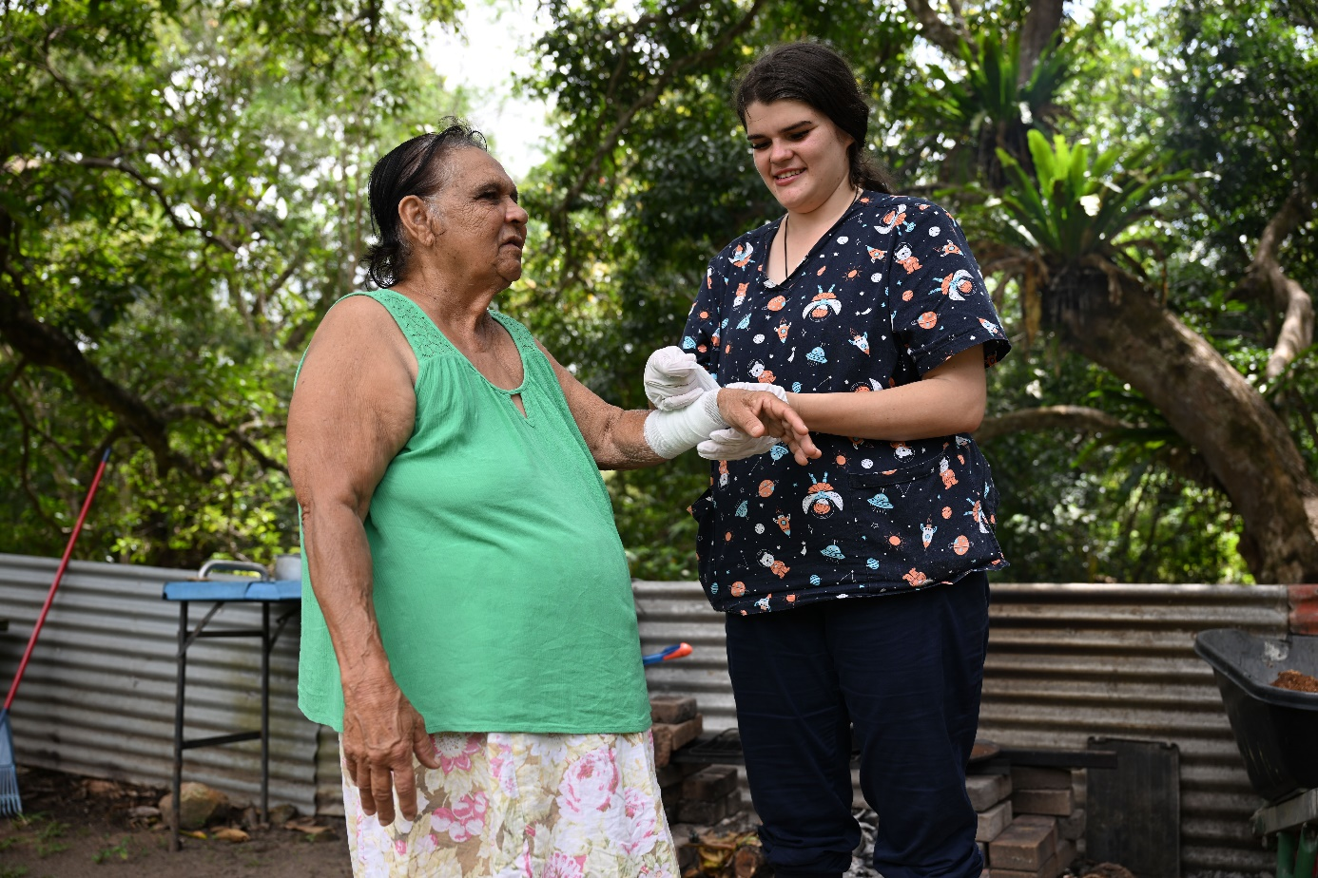

## Budgets and payments

Your Support at Home classification for ongoing services and approval for short-term pathways, assistive technology and/or home adjustments is worked out during your aged care assessment.

You will then get a quarterly (3-monthly) budget, based on your needs, that you and your provider manage.

If you don’t spend your budget every 3 months, you can carry over unspent funds of $1,000 or 10% of your 3-monthly budget (whichever is greater).

Assistive technology and/or home adjustments through the AT-HM Scheme are not budgeted every 3 months. They give a funding level which you can get for a longer time period.

Under Support at Home, you will only pay for the services you have received.

Payment rates will vary by the type of service you get and how much money you have and things you own. The Age Pension means test will be used to work out the means tested percentage payment. Commonwealth Seniors Health Cardholders will have lower payments than other self-funded retirees.

You will make no payment for clinical support services (such as nursing and physiotherapy).

You will make a small payment for independence services (such as personal care), and products and equipment under the AT-HM Scheme. These services will help keep people out of hospital and residential aged care.

You will make a higher payment for everyday living services (such as domestic help and gardening) – the government does not usually fund these services.

[health.gov.au/support-at-home-participant-contributions](https://www.health.gov.au/our-work/support-at-home/features#participant-contributions)

## No worse off principle for older people in the aged care system

If you were already receiving a Home Care Package, on the National Priority System or assessed as eligible for a package on 12 September 2024, you will be no worse off under Support at Home.

This means you will make the same financial payment, or lower, than you would have under the Home Care Packages Program.

You will also be able to enter residential care under the current fee system, regardless of when you need to enter residential care.

[health.gov.au/support-at-home-case-studies](https://www.health.gov.au/resources/publications/case-studies-support-at-home)



# How to enter the Support at Home program

We have created the Single Assessment System to make it easier for older people to get aged care services as their needs change.

## Check your eligibility

The first step to get government-funded aged care services is to check your eligibility for an aged care assessment.

You can do this:

* online at My Aged Care, or by calling My Aged Care **1800 200 422**
* through Elder Care Support. A list of Aboriginal Community Controlled Organisations delivering these services can be found on the National Aboriginal Community Controlled Health Organisation (NACCHO) website.

[myagedcare.gov.au/assessment](https://www.myagedcare.gov.au/assessment)

[naccho.org.au/elder-care-support-program](https://www.naccho.org.au/elder-care-support-program)

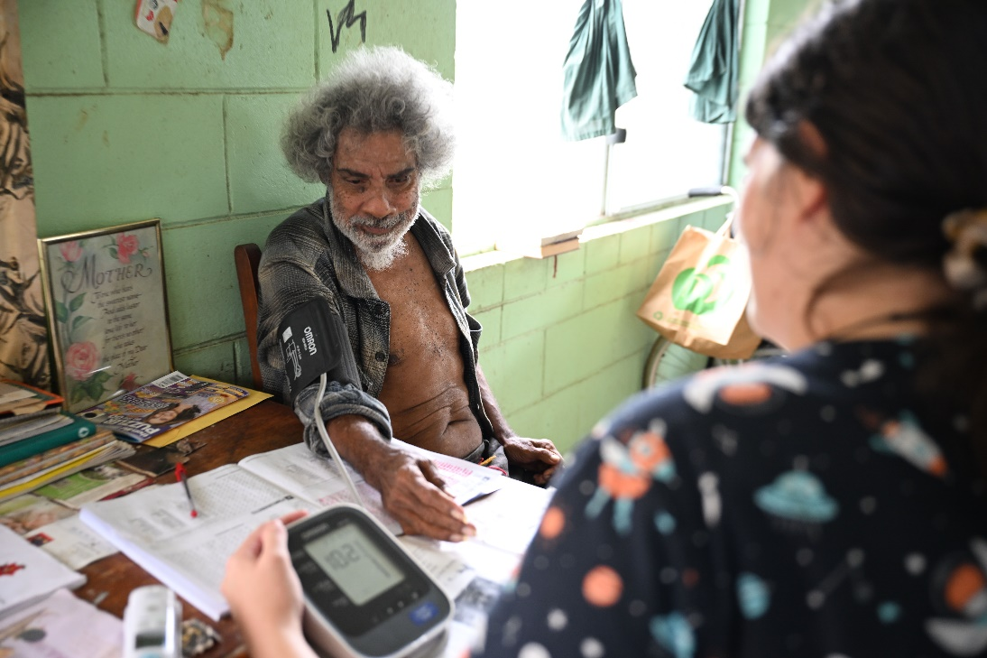

## Assessment process

If your request is successful, you will be referred for an assessment. Assessments are usually done in person, at your own home.

If you are assessed as eligible for the Support at Home program, you will receive a notice of decision and an individual support plan to share with your provider. This will contain:

* a summary of your aged care needs and goals
* a classification with an ongoing 3-monthly budget and a list of your approved services; and/or
* an approval for short-term supports, which may include a budget for:
  + assistive technology
  + home adjustments
  + Restorative Care Pathway (for example, in-depth other health services)
  + End-of-Life Pathway.

If you already get the Home Care Packages (HCP) Program, you will move to Support at Home and keep the same level of funding. You will be able to get services from the service list.

If you are on the National Priority System waiting for a Home Care Package, you will automatically get a Support at Home classification when a place is available. You won’t need a new assessment unless your needs change.

[health.gov.au/accessing-support-at-home](https://www.health.gov.au/our-work/support-at-home/features#accessing-services)

We are also working on an aged care assessment model specifically for Aboriginal and Torres Strait Islander people.

This model will ensure wherever possible that aged care assessments are conducted by assessors who are Aboriginal and Torres Strait Islander people, or others who have undertaken training in cultural safety and trauma informed approaches.

The Aboriginal and Torres Strait Islander assessment model is being designed with key stakeholders, and is expected to commence from July 2025.

# Changes for older people getting in-home aged care

If you get your home support through a Home Care Package, you will move to Support at Home on 1 July 2025 and receive care through the same provider. This includes services given by Aboriginal and/or Torres Strait Islander community-controlled providers.

You can be re-assessed to a higher classification level in the Support at Home program if your needs change.

If you need another round of restorative care after 1 July 2025, you will need to be re-assessed to get this under Support at Home.

If you get your home support through the Commonwealth Home Support Programme, you will move to Support at Home no earlier than 1 July 2027. That is unless you are re-assessed for a higher level of services.

The Department of Health and Aged Care is working with providers so they are well prepared to move to Support at Home and lower any impacts to your care.

Your provider will speak with you about any changes to your in-home care arrangements before they happen.

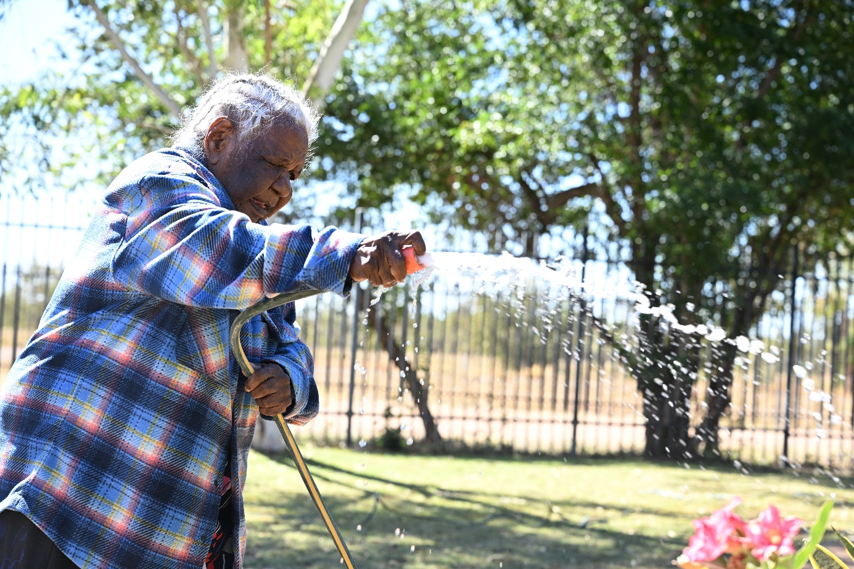

# Getting started with aged care

We’re working to make the aged care system easier to access and navigate.

## My Aged Care

If you need help around the house or are thinking about aged care homes, contacting My Aged Care is the first step. My Aged Care provides:

* information on the different types of aged care services available
* an assessment of needs to identify eligibility and the right type of care
* referrals and support to find service providers that can meet your needs
* information on what you might need to pay towards the cost of your care.

Contact My Aged Care:

* **1800 200 422**
* [MyAgedCare.gov.au](https://www.myagedcare.gov.au/)
* **Face-to-face** by speaking with an Aged Care Specialist Officer (to book an appointment call **1800 227 475** or visit any Services Australia Service Centre).

[health.gov.au/our-work/elder-care-support](https://www.health.gov.au/our-work/elder-care-support)

## Help from a care finder

Care finders can help older people who need intensive help to access aged care services and other supports in the community. It is a free service for vulnerable people who have no one else who can support them.

Visit the My Aged Care website to see a list of care finders in your area.

[MyAgedCare.gov.au/help-care-finder](https://www.myagedcare.gov.au/help-care-finder)

# Let’s change aged care together

**Thousands of people have been involved in shaping the reforms so far through surveys, webinars, online workshops, consultation papers and face-to-face events.**

There are plenty of opportunities for you to have your say about the changes to aged care:

* Sign up to receive *EngAged*, our monthly newsletter for older people: [health.gov.au/aged-care-newsletter-subscribe](https://www.health.gov.au/using-our-websites/subscriptions/subscribe-to-aged-care-newsletters-and-alerts?language=und)
* Visit the Aged Care Engagement Hub to find out about the latest consultation opportunities and outcomes: [AgedCareEngagement.health.gov.au/get-involved](https://agedcareengagement.health.gov.au/get-involved/)

‘The most impact is going to be coming from the people on the ground that need it.’

– Aunty Lyn Cullinane, member of the Council of Elders

