**Strengthening Medicare – General Practice Grants Program Evaluation: Final Report**

Australian Department of Health and Aged Care

28 November 2024

**Nous Group** acknowledges Aboriginal and Torres Strait Islander peoples as the First Australians and the Traditional Custodians of country throughout Australia. We pay our respect to Elders past, present and emerging, who maintain their culture, country and spiritual connection to the land, sea and community.

This artwork was developed by Marcus Lee Design to reflect Nous Group’s Reconciliation Action Plan and our aspirations for respectful and productive engagement with Aboriginal and Torres Strait Islander peoples and communities

Disclaimer:

Nous Group (**Nous**) has prepared this report for the benefit of the Australian Government Department of Health and Aged Care (the **Client**).

The report should not be used or relied upon for any purpose other than as an expression of the conclusions and recommendations of Nous to the Client as to the matters within the scope of the report. Nous and its officers and employees expressly disclaim any liability to any person other than the Client who relies or purports to rely on the report for any other purpose.

Nous has prepared the report with care and diligence. The conclusions and recommendations given by Nous in the report are given in good faith and in the reasonable belief that they are correct and not misleading. The report has been prepared by Nous based on information provided by the Client and by other persons. Nous has relied on that information and has not independently verified or audited that information.

Contents

1 Executive summary 1

2 Background and policy context 5

2.1 Primary care policy context: Strengthening Medicare 5

2.2 Overview of program 7

3 Evaluation approach and methodology 12

3.1 Evalution scope and objectives 12

3.2 Evaluation approach and program logic 12

3.3 Key evaluation questions 17

3.4 Methodology 19

4 Findings 21

4.1 Program design 21

4.2 Program delivery 42

4.3 Program outcomes 60

5 Lessons Learnt 70

Appendix A Data collection approach and responses 74

Appendix B PHN and practice consultation log 77

Appendix C Data collection tools 80

Appendix D NACCHO summary report 85

Appendix E Practice survey results by jurisdiction and remoteness 86

Appendix F Alignment of lessons learnt to policy documents 114

# Executive summary

The Strengthening Medicare – General Practice Grants Program (the Program) was introduced by the Australian Government in 2023 as part of its commitment to support primary care and implement Strengthening Medicare reforms over the next five years.[1] Nous Group (Nous) was engaged by the Department of Health and Aged Care (the Department) to conduct an independent evaluation of the Program.

Overview of the Program

The aim of the Program was to provide funding to general practices (practices) and Aboriginal and Community Controlled Health Organisations (ACCHOs) to expand patient access and support safe, and accessible, quality primary care. The grants were non-competitive and made available to eligible practices and ACCHOs to invest in one or more of three defined investment streams: digital capability uplift, infection prevention and control, and accreditation. The grants were administered through Primary Health Networks (PHNs) for practices and the National Aboriginal Controlled Community Health Organisation (NACCHO) for ACCHOs.

The Program required expenditure to be complete by 31 July 2024 (some grant recipients had an extension approved to 30 August 2024), with any unspent funds to be returned to the Department.

Overview of the evaluation

The evaluation assessed the appropriateness of the Program design, effectiveness and efficiency of implementation and effectiveness of the grant distribution mechanism. Four key evaluation questions (KEQs) guided data collection and analysis.

* KEQ 1: Implementation | What was intended to be delivered under the Program, and how well the Program was designed and administered to meet the intended outcomes.
* KEQ 2: Effectiveness | How effective the design and management of the Program, and the assessment and delivery of grants, was in achieving the intended outcomes.
* KEQ 3: Appropriateness | Whether and to what extent the delivery of grants within three distinct streams was appropriate to achieve the intended outcomes and contribute to the broader reform agenda.

KEQ 4: Efficiency | Whether what was delivered through the Program represented good value for money for the Department, and whether alternative mechanisms could have been considered to deliver the same (or better) outcomes.

The evaluation used mixed methods to analyse qualitative and quantitative data gathered from interviews with representatives from practices, PHNs, government and peak bodies, surveys completed by practices and PHNs, a review of operational data and policy documents.

Key findings

|  |
| --- |
| Overall, the evaluation found the Program was:   1. successfully implemented at a national level 2. valued by grant recipients, and 3. effective in enabling early outcomes – supporting practices and ACCHOs to improve and expand access to high-quality, safe primary care. 4. There were several lessons learnt to improve and enhance program design and implementation processes in future. |

Nearly all eligible practices (n=7,047, 93 per cent) and 126 ACCHOs[2] (100 per cent) participated in the Program, with a total of $189.3M[3] distributed to practices and $3.8M distributed to ACCHOs nationally. Of those practices receiving a grant, 75 per cent completed a self-evaluation survey and, 97 per cent (n=5,152) of survey respondents reported they had spent all their grant funds. Practices and ACCHOs spent their grant funding across the three investment streams on a range of priorities, with equipment and systems the most common spend in each of the investment streams. The number of practices and ACCHOs who spent in each stream is captured in Table 1.

Table 1 | Number of practices and ACCHOs who spent in each investment stream

|  | Practices* | ACCHOs |
| --- | --- | --- |
| Stream 1: Digital capability | 4,844 | 72 |
| Stream 2: Infection prevention and control | 3,327 | 28 |
| Stream 3: Accreditation | 3,950 | 71 |

*Note that practices and ACCHOs could spend across more than one stream

Grant recipients (both practices and ACCHOs) highly valued the Program and provided consistently positive feedback about the initiative itself, and the ease of the implementation processes and delivery from their perspective. Appreciation for the Program co-existed with concerns for broader system challenges (for example, workforce pressures), ongoing sustainability issues for general practice, and the importance of tailoring for the ACCHO sector.

The below dot points highlight some of the feedback from practice managers interviewed for the evaluation:

* “I would like to say thank you to the Department. You feel like GP clinics are getting a bit appreciated now and we have been doing it very tough for a long time… so just by giving a bit helps a lot”
* “The results speak for themselves – great improvement, feedback from patients is positive, they know we’re looking to improve.”
* “This money has made us feel like we are back in the 21st century… it’s really been such a help.”
* “The ease of it, the guidelines and communications of it, flexibility of it where we didn’t have to copious amounts of time on the budgeting, and freedom within it was amazing – that’s what we appreciated”.
* “I think the three streams hit the nail on the head.”
* “The grant has been amazing; we are so grateful to have got it. There are no other streams of funding we can get” [unaccredited practice]
* “The timing was really good from a broad perspective given the challenges of the general practice sector, during covid we were focused on getting by day by day… [the grant] meant we could take a step back and think about what we needed to move forward and get out of the chaos”.

Grant recipients reported the Program had enabled them to broadly improve their healthcare delivery. The evaluation has analysed these early outcomes against the Quintuple Aim Framework[4], an important driver of the Strengthening Medicare reforms.

Detailed findings across the design, delivery, and outcomes for the Program are set out in Section 4 of this report and summarised below in Table 2.

Table 2 | Summary of evaluation insights

| Insight grouping | Evaluation insights |
| --- | --- |
| Program design | 1. Consultation with the sector supported the design of the Program and delivery process but could have been strengthened by earlier and broader engagement. 2. Structuring the Program in five stages supported smooth delivery. 3. PHNs, NACCHO, practices and ACCHOs reported the three funding streams were appropriate for meeting the objectives of the Program. 4. Engaging NACCHO in the early co-design of the Program would have helped create investment streams that better served ACCHO’s needs. 5. The one-off, non-competitive and flexible nature of the grants supported delivery of the Program objectives. |
| Program delivery | 1. There was high uptake across practices and ACCHOs. 2. Most practices found the Program process simple and easy to engage with. 3. The Department provided the right information to PHNs and practices, and more timely communications could have strengthened rollout. 4. PHNs took different approaches to the Program administration and delivery. 5. Many PHNs found it difficult to meet initial project deadlines for applications and contract distribution. |
| Program outcomes | 1. The Program had broad overall benefits for primary care. 2. The Program had direct benefits in individual investment streams. 3. The Program has had unintended benefits for PHNs and practices. |

**Lessons learnt**

To ensure the success of other programs of a similar scale and nature, several lessons learnt that build on the strengths of the Program have been highlighted. While it is understood that this was a one-off program, the lessons learnt can be considered for other comparable programs, whether they be related to non-competitive grant programs in health or primary care, programs involving multiple stakeholders such as PHNs or NACCHO, or programs related to the investment streams.

The lessons learnt include:

1. Comprehensive and inclusive engagement with all stakeholders for large scale, national programs will optimise design and implementation.
2. Program design can incentivise behaviours that align to program objectives, including equity and accessibility.
3. Involving NACCHO early in the design of all programs related to First Nations primary care is critical and there are opportunities to translate good practice within the ACCHO sector to future national program design.
4. Programs that leverage those who have trusted relationships and understanding of the target recipients, such as NACCHO and PHNs have foundations for success.
5. When multiple partners are involved in program delivery, graduated support for varying levels of operational maturity may assist effective implementation.
6. Communications for large programs involving multiple stakeholders need to be timely, tested and well-thought through for end users.
7. Additional benefits for broader policy outcomes, beyond the immediate program objectives, can be achieved through program delivery.
8. Reporting and acquittal, ongoing monitoring and evaluation should be part of early design, and be proportional to the level of funding, administrative effort, and long-term impact.

The rationale and context for these are explored further in Section 5. including alignment to relevant government policy.

# Background and policy context

## Primary care policy context: Strengthening Medicare

There are over 7,000 practices and over 120 ACCHOs across the country, and most practices are small businesses.[5] Practices and ACCHOs often lack the time and resources that are needed to invest in the systems, processes, and staff to enhance safe, accessible, and high-quality care. At the same time, they are intended to be the first point of contact for Australians seeking healthcare. In 2021-22, 90 per cent of Australians accessed at least one Medicare-subsidised general practitioner service, leading to 189 million general practitioner attendances.[6] Despite this high usage of general practice services, the 2022 General Practice: Health of the Nation report highlights there has been a historic under-investment in primary care.[7]

The Program sits within broader reform and investment into the Australian primary care sector. The 2023-24 Federal Budget included a commitment of $5.7 billion over 5 years to strengthen Medicare, aligning with the directions of Australia’s Primary Health Care 10 Year Plan 2022-2032.[8] The Strengthening Medicare Taskforce was formed in July 2020 to pinpoint the most pressing investment needs in primary care to improve access and quality. Their report (The Strengthening Medicare Taskforce Report), released in December 2022, identified four priority areas for investment into the Australian primary care sector (Table 3).[9] The Program primarily contributes to two of these four priorities; increasing access to primary care and modernising primary care.

Table 3 | Strengthening Medicare Taskforce priority areas for investment

|  |  |
| --- | --- |
| Increasing access to primary care | * Support better continuity of care, a strengthened relationship between the patient and their care team, and more integrated, person-centred care through the introduction of voluntary patient registration. * Grow and invest in ACCHOs to commission primary care services for their communities. |
| Encouraging multidisciplinary team-based care | * Support local health system integration and person-centred care through facilitating integration of specialist and hospital services with primary care, and integrate primary care with mental health, aged care, community, and disability services. |
| Modernising primary care | * Better connect health data across all parts of the health system. * Provide and uplift in primary care IT infrastructure, education, and support to primary care practices so they can maximise the benefits of data and digital reforms, mitigate risks and undertake continuous risk improvements. |
| Supporting change management and cultural change | * Work with providers to help them effectively manage change and transition to new ways of working. * Support the development of practice management as a profession. |

## Overview of program

The Program expended $189.3[10] million across three investment streams to improve patient access and support safe, quality primary care

The Program provided eligible practices and ACCHOs access to $220 million in grants over two years (2022-23 to 2023-24) to make improvements that expand patient access and support safe, quality primary care. In total, $189.3M[11] was expended to practices and ACCHOs for a range of investments, including in innovation, training, equipment, and minor capital works.

The Program objectives were defined for three investment streams for acceptable grant expenditure. Each is a key foundation for quality and safety in practices and ACCHOs. These were to:

* **Enhance digital health capability**: Improving practice digital health capability—including hardware, software, and training in their use—is a fundamental enabler of a connected health system. Digital health has become a vital part of a modern, accessible healthcare system designed to meet the needs of all Australians.
* **Upgrade infection and prevention control arrangements**: The ability for practices to effectively manage infection prevention is critical to keep patients and practice staff safe. For respiratory infections, such as COVID-19 and influenza, appropriate infrastructure (such as dedicated isolation areas), clear lines of accountability, systems for managing the risk of cross-infection, and education for staff are essential so that patients can safely be seen face-to-face, if this is their preference.
* **Maintain or achieve accreditation**: Practice accreditation provides quality assurance in addition to individual clinician registration. Compliance against 17 Royal Australian College of General Practice (RACGP) standards provides assurance to patients and the government that general practitioners provide safe, and quality care based on best available evidence, with appropriate governance and record keeping that supports continuous quality improvement. There are financial and recruitment benefits to accreditation - it is a requirement for practices to access the Practice Incentives Program and Workforce Incentive Program and support the recruitment pipeline for general practitioners (trainees need to do two years of placement in accredited practices for their own vocational registration). Despite considerable investments in supporting general practitioner accreditation, barriers and challenges to accreditation remain. As of 2020, only 84 per cent of practices were accredited.[12]

The Department partnered with PHNs and NACCHO to manage and administer the Program to practices and ACCHOs respectively.[13] Practices and ACCHOs were eligible for single, one-off grants of either $25,000, $35,000 or $50,000, based on practice size, accreditation status and total client volume for ACCHOs. At the end of the Program, 7,047 practices and 126 ACCHOs had received a grant. The vast majority of these received grants worth $25,000.[14]

An overview of the context and design of the Program is provided in Table 4.

Table 4 | Strengthening Medicare - General Practice Grants programs

|  |  |
| --- | --- |
| Background and purpose of the program. | The Australian Government invested $220 million in grants, over two years from 2022-23 to 2023-24, through the Strengthening Medicare – General Practice Grants Program (the Program), to support general practices. A one-off grant of either $25,000, $35,000, or $50,000 will be available to each participating general practice. The purpose of this program was to provide funding to general practices to expand patient access and support safe, and accessible, quality primary care.  A single one-off grant was made available to each general practice or eligible ACCHO in any one or more of the three investment streams:   * Enhancing digital health capability: To fast-track the benefits of a more connected healthcare system in readiness to meet future standards. * Upgrading infection prevention and control arrangements: To support the safe, face to face assessment of patients with symptoms of potentially infections respiratory diseases (e.g. COVID, influenza). * Maintaining or achieving accreditation: Against the Royal Australian College of General Practitioners (RACGP) Standards for General Practice (5th edition), under the General Practice Accreditation Scheme- to promote quality and safety in general practice. |
| Who is eligible? | An open and operating general practice as per the RACGP definition for the purposes of practice accreditation against the Standards for General Practice, that meets:  Thre core criteria for practices:   * The practice operates within the model of general practice described in the RACGP’s definition of general practice. * General practitioner services are predominately of a general practice nature. * The practice is capable of meeting all mandatory indicators in the RACGP Standards for General Practice (5th Edition).   Criteria for ACCHOs:   * All ACCHOs are eligible for this funding |
| What are the medium-term outcomes of the program? | * Expanded patient access to and improved general practice services. * General practices supported to increase quality of primary health care services in local regions. * Improved, secure access and sharing of patient information across health systems. * Improved quality and safety in health service through increased proportions of practices accredited against  RACGP Standards. |

**The Program was designed in late 2022 and planned for delivery from April 2023 to July 2024**

Table 5 and Table 6 shows a high-level timeline of the Program from conception in 2022 to conclusion in 2024. The timeline was developed drawing on key dates from Program documentation and with input from key stakeholders.

The timeline shows the key dates and activities along the Program’s lifespan as well as key stakeholders and their roles and responsibilities across the Program stages.

The grant agreement between PHNs and practices had an activity end date of 31 July 2024. Extensions were provided to some practices with a 30 August 2024 deadline for expenditure, and submission of Financial Acquittal Reports (FARs) by 1 September 2024. Self-evaluation surveys were open until 23 September 2024.

Table 5 | The Program timeline

| Date | Activity | Relevant stakeholder |
| --- | --- | --- |
| 25 October 2022 | Program approved | The Department of Health and Aged Care |
| November 2022 | External sector consultation on program design with peak bodies including RACGP | The Department of Health and Aged Care |
| November 2022 | Small group of PHN CEOs engaged by the Department to discuss implementation | PHNs |
| 22 December 2022 | Program guidelines approved | The Department of Health and Aged Care |
| 18 January 2023 | Program for PHNs opens | PHNs |
| February to March 2023 | Six Working Group sessions held with Department to discuss implementation | PHNs |
| 21 April 2023 | PHNs send application packs to eligible practices 21-26 April 2023 | PHNs |
| 5 May 2023 | NACCHO sends grant packs to ACCHOs | NACCHO |
| 5 May 2023 | Program is opened to ACCHOs | ACCHOs |
| 6 June 2023 | Q&A Webinar for PHNs to clarify practice eligibility | The Department of Health and Aged Care |
| 15 June 2023 | Practices must return application packs to their local PHN | Practices |
| 15 June 2023 | ACCHOs must return application packs to their local PHN | ACCHOs |
| 28 September 2023 | Minister approves opening remaining funding to previously ineligible practices, grant amounts remain the same.* | The Department of Health and Aged Care |
| 30 September 2023 | NACCHO submits financial report and acquittal report to NT PHN | NACCHO |
| Mid-November 2023 | Remaining funding opens to State and Territory practices, new practices and late applicants | Practices |
| 31 July 2024 | Practices must spend their grant funds by end of program. | Practices |
| 30 August 2024 | Some practices provided extensions to spend their grant funds | Practices |
| 1 September 2024 | Practices to complete financial acquittal report | Practices |
| 30 September 2024 | NACCHO submits financial report and acquittal to NT PHN and final summary report to the Department | NACCHO |
| 30 September 2024 | Deadline for practices to provide self-evaluation and financial acquittal report to their PHN | Practices |
| 31 December 2024 | Grant agreement between the Department and PHNs ends | The Department of Health and Aged Care and PHNs |

Table 6 | The program timeline - by stage

| Key stage | Date |
| --- | --- |
| Planning | October 2022 to March 2023 |
| Standard grant application period | 21 April 2023 to 15 June 2023 |
| Late grant application period  The late grant application period applies to Practices that became eligible in September 2023. This included state/territory/local government owned/managed practices, and newly opened eligible practices. | Mid-November 2023 to mid-December 2023 |
| Grand spending period | June 2023 to September 2024 |
| Self-evaluation survey | February 2024 to September 2024 |
| Monitoring and compliance | July 2024 to September 2024 |
| Financial acquittal | July 2024 to September 2024 |

# Evaluation approach and methodology

|  |
| --- |
| This section details the approach and framework that structures the evaluation. It includes the:   * evaluation scope and objectives * evaluation approach and program logic * key evaluation questions * methodology |

## Evalution scope and objectives

Nous was engaged by the Department to independently evaluate the Program. The evaluation was conducted between December 2023 and October 2024. The evaluation assessed the extent to which the aims and objectives of the Program have been achieved. The findings will contribute to the national evidence base and informing policy decisions about primary care grant programs, including the mechanism by which grants are administered going forward.

The objectives of the evaluation were to assess the:

* Appropriateness and design of the Program for achieving its objectives.
* Effectiveness and efficiency of the implementation process of the Program.
* Effectiveness of the grant distribution mechanism of the Program, and any barriers and enablers to achieving its intended outcomes.

## Evaluation approach and program logic

The evaluation used a program logic approach with a realist lens, combining both formative and summative elements. A realist lens is appropriate for this evaluation because it ensures analysis is undertaken from the perspective that outcomes are context dependent, and that even though an action may have one specific intention, the outcome may change depending on the context. The formative (or process) elements provide the Department with feedback about effectiveness of the design and delivery of the Program, including assessing the suitability of the Program’s design for achieving the intended outcomes, and whether and how initial implementation resulted in changes to the design and delivery of the Program. Summative (or outcome) elements provide the Department with feedback about the outcomes the Program achieved.

Table 7 shows the Program logic refined through the evaluation, which sets out the intended relationships between inputs, activities and outcomes. This program logic guided the development of the KEQs in Table 8.

Table 7 | Program logic

| Need | Inputs | Activities | Outputs | Outcomes | Impact |
| --- | --- | --- | --- | --- | --- |
| What need is being assessed? | What is being invested? | What is the program designed to do? | What is the program intented to do? | What will the program achieve/ | What will the broader reform agenda contribute? |
| Priority investment is needed to strengthen general practices and ACCHOs to expand patient access and improve quality, safe and affordable primary health care. | * Australian Government health policy (Strengthening Medicare). * General Practice Grants Program funding- $220 million in grants and $4.59 for PHNs to administer and manage. * General Practice Grants policy and support. * Funding agreements with 31 PHNs and a subcontract with National Aboriginal Community Controlled Health Organisation. * RACGP and peak bodies. * General practices and Aboriginal Community Controlled Health Services. * Data, including Practice Incentives Program (PIP), general practitioner full time equivalent, ACCHO, and PHN verification. | * Grant policy and program design and governance * Amendment to existing PHN Schedules (Grant agreements). * Grant communication and promotion. * Stakeholder engagement with PHNs and NACCHO. * Administration of the Program by PHNs and NACCHO for each region, including letters of offer, assessment, funding, monitoring/reporting and data capture. * Practices / ACCHOs invest in innovation, training, equipment, and/or minor capital works across three investment streams. * Targeted grant compliance and monitoring activities. * General practices/ACCHOs financial acquittals. | Department obtains more complete Practice / ACCHO practice data set. | **Short term outcomes (1-2 years)**   * National list of practices / ACCHOs for future policy development. * Improved relationships between practices and PHNs/ACCHOs and NACCO | **Medium-term outcomes (2-4 years)**   * Expanded patient access to and improved general practice services. * Improved, secure access and sharing of patient information across the health system. * Supporting general practices to increase quality of primary health care services in local regions, particularly for people at risk of poorer health outcomes. * Supporting the delivery of health information, advice and services to help people care for themselves and their families. * Improved quality and safety in health services and ensuring a high standard of national general practice services through increased proportion of practices accredited against RACGP Standards. |
|  |  | * Investment in clinical software and equipment. * Staff training on digital capability. * Capital works to secure or upgrade IT infrastructure. | Practices / ACCHOs will enhance digital health capability (e.g. IT hardware and software upgrade). | Increased uptake of contemporary digital health solutions. |  |
|  |  | * Professional assessment of existing infection prevention control arrangements. * Investment in infrastructure and equipment to improve infection and prevention. * Staff training on practice controls. | Practices / ACCHOs will upgrade infection prevention and control arrangements to improve capacity for patients to be safely seen face to face. | Increased proportion of COVID positive and other respiratory patients treated in a general practice setting (by increasing practices’ capacity to treat more of these patients). |  |
|  |  | * Investment in equipment or procedures to improve accessibility. * Capital works and/or training to improve patient safety and quality of care. * Investment in initiatives to support staff health, wellbeing and safety. * Professional development or equipment purchase to maintain/gain accreditation. * Consultant services to undertake practice improvements to gain/maintain accreditation. | Practices / ACCHOs to maintain and/or achieve accreditation against the RACGP Standards for General Practice under the General Practice Accreditation Scheme. | Increased proportion of accreditation general practices/ ACCHOs supporting patient safety and assuring a high level of care, effective risk management, and building a culture of quality and continuous improvement in general practice services. |  |

## Key evaluation questions

Four KEQs were used to structure the evaluation, and guided data collection and analysis. These are set out in Table 8, which includes mapping to where the relevant findings can be found in this report.

Table 8 | Key Evaluation Questions and research questions

| KEQ research questions |
| --- |
| **Implementation:**   * Design stage: Was the Program’s design appropriate to deliver the intended outcomes? * Design and delivery stages: What were the implementation issues, barriers to uptake, and lessons learnt? * Design stage: What were the reasons why some eligible practices did not apply for grants? * Design and delivery stages: Lessons learnt for future rollout/application. * Design stage: Sustainability of interventions in each stream, does this investment set them up for long term success? |
| **Effectiveness:**   * Outcomes stage: Has the Program increased the take up and use of contemporary digital health solutions for improved and secure communication of patient information? * Outcomes stage: Have the infection prevention and control measures funded under the grants enabled your practice to see more patients face to face? * Outcomes stage: Has the Program increased the proportion of practices maintaining and gaining General Practice accreditation overall, and in under-serviced locations? * Delivery and outcomes stages: Has the Program, through support to ACCHOs, benefitted First Nations Peoples in accessing primary healthcare? * Design and delivery stages: What are the key features of the Program that have assisted or hindered its success? * Delivery stage: How have the investment streams of the Program leveraged or interacted with other programs, including state/territory funded programs? E.g. state and territory/local government funded clinics. * Outcomes stage: Has the Program produced any unintended outcomes or impacts? If so, what are the key features of the Program that contributed to most of these? |
| **Appropriateness:**   * Design and delivery stages: Was providing one off grants, administered by PHNs/NACCHO the most appropriate way to achieve the Program objectives? * Design and outcomes stages: To what extent were the investment streams included in the current Program appropriate in meeting the aims and objectives of the Program? * Design and delivery stages: What are the key factors influencing the Program design (including eligibility to receive funding under the Program) and implementation? Have these changed since the Program implementation, if so, why? * Outcomes stage: What are the insights and other unintended benefits from the Program implementation that could be applied to other broader health policy program reforms in the future? |
| **Efficiency:**   * Design and outcomes stages: Does the Program provide value for money/investment? * Delivery: How efficiently have the Program resources been used? |

## Methodology

The evaluation used mixed methods, triangulating quantitative and qualitative data from surveys, interviews, case studies, and program documentation. This approach enabled a robust and comprehensive assessment of the Program’s design, delivery and outcomes. A detailed engagement and analysis approach was developed as part of the Evaluation Plan, which set out the quantum, format, and purpose of engagement with each group.

Evaluation engagement and data collection activities conducted included:

* 31 PHN interviews and surveys and an interview with NACCHO to understand the process of implementing the Program and to seek feedback on the design of the Program.
* 32 practice consultations, covering more than 100 clinics or practices, to understand the experience of applying for the grant and to understand any early outcomes from the Program. Practices were selected from a combination of a random sample, targeted sample, and practices put forward by PHNs.
* Interviews with 9 Department stakeholders to understand the policy context and implementation decisions of the Program.
* 5 peak body interviews to understand the policy context of the Program, and any consultation undertaken during design and implementation.
* Analysis of the grants master dataset to understand the types of practices who were and were not eligible for the grant. The master dataset was also used to select the random sample of practices invited for consults.
* Review of key program documents including grant guidelines, ministerial submissions, and communications to PHNs to understand the strategic intent and rollout of the Program.
* Qualitative and quantitative analysis of the practice and ACCHO self-evaluation survey.

The detailed data collection and analysis methodology can be found in Appendix A (data collection and analysis approach), Appendix B (consultation log), and Appendix C (data collection tools).

**A small number of changes were made to the planned evaluation methodology to respond to emerging implementation issues and progress**

The evaluation plan evolved to respond to the dynamic nature of the ongoing Program implementation.

Each PHN implemented their own process to administer and manage the grants. In order to best understand the national implementation of the Program, PHNs were individually consulted rather than conducting a series of combined focus groups. This yielded substantial insight into the variability of grant delivery processes, enablers and barriers.

Initially, the majority of stakeholder engagement time was planned with practice managers, however this stakeholder group is time poor, difficult to reach. A revised sampling approach was implemented which included pooling together a list of over 200 practices using three different approaches to reduce bias and assure representation of practices from priority regions. A random sample of 60 were then invited to participate in an interview. The three approaches to developing the initial sample included:

* **Targeted selection** of practices in priority areas including regional, rural and remote geographies and low Socio-Economic Indexes for Areas (SEIFA).
* **Randomised selection** of practices that participated in the Program.
* **Selected sample** from individual PHNs. Each PHN was invited to nominate up to 10 practices that could be randomly selected from to participate in interviews.

**Note**: Practices that were selected for compliance checks by the Department were omitted from the sampling pool to reduce administrative burden.

# Findings

|  |
| --- |
| This section provides a summary of interim report findings against the KEQs, structured by:   * program design * program delivery * program outcomes |

The evaluation findings reflect the views of PHNs and practices that participated in the evaluation and shared their insights either through interviews and/or a survey. The evaluation also collected insights from NACCHO through an interview and ACCHOs through a survey at the end of the Program. The evaluation team has consolidated insights to reflect the chronology of the Program’s implementation across program design, delivery and outcomes.

## Program design

### Consultation with the sector supported the design of the Program and delivery process, but could have been strengthened by earlier and broader engagement

**A small number of peak bodies were involved in the initial design of the investment streams**

There was some consultation on the design of the Program investment streams and grant mechanisms with peak body representatives, including RACGP and the Australian Medical Association (AMA). Peak bodies who were involved in this process provided positive feedback on how they were involved, noting that engagement in the early design phase allowed discussion on appropriate investment streams to best meet the needs of general practice.

Peak bodies interviewed largely felt that the investment streams were appropriate in meeting the needs of general practice, although some felt that infection prevention and control was less relevant given recent COVID-19 pandemic related funding at the time. Interviews with peak bodies consulted during the design phase suggests that the investment streams were not changed through consultation despite feedback being provided.

Peak bodies who were not involved in the design process provided feedback that if they had been involved earlier, they could have contributed to spreading accurate and timely information about the Program to the general practice sector. They also noted that they received questions directly from practices about the grant which they were ill informed to answer suggesting that it would be valuable where possible for the Department to provide information to all relevant peak bodies to provide accurate and consistent advice across the primary care sector. Whilst NACCHO was not involved in the design of the investment streams, they had some later input into changes made to the delivery of the Program for ACCHOs (for example, changing the grant allocation amounts) as outlined in section 4.1.4.

**PHNs, including a PHN working group, were engaged in the Program delivery process**

PHNs were engaged in the design process at two points; all PHN CEOs were provided with high-level information on the Program in November 2022 and from this meeting with CEOs, 10 PHN representatives were selected to participate in a working group to test Program delivery documents and processes in early 2023. The role of this group was to inform the design and rollout process, and not to provide input into the three investment streams or the grant mechanism i.e. one-off, non-competitive grants. The working group was responsible for providing review and feedback on key grant documents and communication material, the approach to distributing FARs and the approach to distributing the self-evaluation survey to practices.

PHN representatives involved reflected positively about their involvement in the PHN working group and being consulted through the design phase. A PHN representative commented that they “can’t speak highly enough” of the working group and that, in future programs, all PHNs should have the opportunity to be involved. Other PHN representatives engaged through the evaluation stated they would have liked to be involved to communicate the needs of their region and inform processes that would have saved later work such as ongoing refinements to the process.

The Department’s engagement with PHNs was primarily at a very senior level, engaging with PHN CEOs or executives. This may have had benefits for building relationships between the Department and PHNs, however it meant that some of the knowledge and feedback that more operational PHN staff could have fed into the process was not available. For example, PHN representatives responsible for administering the program who were interviewed as part of the evaluation, provided constructive feedback on how they would have designed documents or processes differently if they had been involved in the design process (for example quick reference guides, and clarity on the guidelines), despite their senior colleagues being involved in the working group.

**More consultation with PHNs, practices and consumer reference groups could have improved the Program’s design**

Many PHN representatives suggested engagement on the Program design could have also included consultation with general practitioners, especially to confirm the investment streams, and consumer reference groups to take a more patient-led approach to program design. However, whilst many practices reported there were other areas they would have liked to see investment in, beyond the three streams, almost all practices interviewed found the investment streams appropriate and did not provide feedback that they would have liked to be directly involved in the design process. This may reflect practice staff being time poor, or not being aware early engagement was possible. Given the scale of practices across the country, engagement through peak bodies would be appropriate, complemented by a targeted sample of practices.

Stakeholders suggested that more inclusive or in-depth consultation could have:

* Improved the appropriateness of the grant’s timing. As above, this largely relates to the infection prevention and control stream, which following COVID-19 was less appropriate for many practices that had already made many necessary upgrades.
* Informed a more robust set of guidance documents. Common themes emerged from consultations regarding areas of confusion in the application process for practices. This included aspects of the application form and eligible spending under each stream. Greater consultation could have highlighted these issues for inclusion in initial guidance documents s and made implementation more efficient.
* Highlighted areas of need for additional investment streams. Practices raised additional areas of need that could have been called out either within or in addition to the three investment streams as listed in Table 12.

|  |
| --- |
| “Government needs a mechanism for continuously engaging with the Australian community. They should think about engagement like the census, so there is always a baseline understanding of community needs. Then when rolling out programs quickly, consultation can be bespoke and rapid to test whether assumptions are still correct.” – Peak body representative |

### Structuring the Program in five stages supported smooth delivery

The Program design was divided into five stages of delivery, as shown in the roadmap in C.1.2 including:

1. Planning: The Department provided PHNs and NACCHO with guidance documentation and grant agreement packs. PHNs planned and designed processes for managing and implementing the Program and liaising with the Department to update practice data where required. NACCHO tailored the materials for their established processes, and provided collated reports as contracted to NTPHN and the Department.
2. Go – live: The Program was launched and PHNs dispatched application packs to practices. NACCHO managed the distribution of ACCHO grants.
3. Grant implementation: Practices applied for grants which were assessed and administered by PHNs. Practices then spent the grant funding across the three investment streams. ACCHOs were required to express their interest in the grant, and funds were administered through existing processes by NACCHO.
4. Monitoring and compliance: Practices selected for audit submitted information on investment activities. The Department also provided self-evaluation reporting templates and financial acquittal reports for PHNs to distribute to practices for completion.
5. Financial acquittal: Practices completed their self-evaluation and financial acquittal reports. Any unspent funding will be returned to the Department via PHNs or NACCHO at the end of the grant period. Final financial acquittal.

The process aligns to best practice grant delivery (with reference to the Commonwealth Grant Rules and Guidelines, Administration of Government Grants in the ACT: A framework and best practice policy, and Treasury’s Best Practice Guide for the Administration of Grants).[15] In practice, this supported PHNs to plan internal delivery processes and forecast workload and assist in timely and informative communications to practices. PHN representatives felt the Program adhered to the proposed five stages in delivery.

NACCHO note that direct contractual arrangements between the Department and NACCHO (rather than through NTPHN) could streamline processes and optimise opportunities for co-design, appropriate tailoring, and reporting that is aligned nationally across practices and ACCHOs.

HN representatives identified three changes that could have reduced pressure:

1. A longer planning phase would have provided PHNs with more of an opportunity to plan how they would deliver the grant. However, many PHN representatives did acknowledge that the Department also faced time pressures to deliver the Program.
2. Involving PHNs more in the design process to establish more realistic timelines and provide prior notice of what to expect. It would have also provided the opportunity for PHNs from a range of operational maturities to provide feedback to the Department on potential implementation challenges to mitigate (see Section 4.1.1).
3. Centralising some administrative tasks to reduce and streamline PHN workload. For example, many PHNs established individual processes to execute grant agreements and distribute grant packs. Some PHNs took manual processes and others implemented a digital solution. PHN representatives suggested the Department could have provided pre-filled templates or provided guidance on approaches to adopting a digital solution to reduce pressure on PHNs.

|  |
| --- |
| "We missed the opportunity to work with the practices to plan - we just had to go." – PHN representatives. |

Table 9 provides a high-level process map of the Program and key stakeholders’ roles and responsibilities at different stages. It has been adapted using the 16 steps and five stages listed in the ‘Guidance for Primary Health Networks’ document (Appendix C.1.2) and highlights that PHNs and NACCHO were responsible for a large proportion of the Program activity

Table 9 | Project process steps

|  | Planning | Go-live | Program implementation | Monitoring and compliance | Financial acquittal |
| --- | --- | --- | --- | --- | --- |
| Department of Health and Aged Care | * Allocates funding to PHNs based on confirmed practice lists for PHNs + a small buffer * Provides practice grant agreement packs and practice grant data to PHNs | * Promotes the Program to practices | * Oversees the national data reporting spreadsheet | * Conducts audits of a random sample of 5% of practices. * Distributes self-evaluation reporting template and financial acquittal report to PHNs. * Oversees the national data reporting spreadsheet | * Receives total unspent grant funding from PHNs. |
| PHNs and ACCHOs | * Review practice  grant data and notify the Department of key changes and review and collate invitation packs. * Design, plan and develop processes for managing and implementing the program. * NACCHO contracted to deliver the grant for ACCHOs through NTPHN. | * Open grant round and dispatch application pack to practices. * Promote the Program to their practices or ACCHOs. * PHNs and NACCHO manage enquiries from practices and ACCHOs. | * Update the national data reporting spreadsheet on the PHN Sharepoint. * Receive and assess completed application / grant agreement form, and determine grant amount applicable. * Prepare and dispatch letter of grant application outcome and grant agreement for each applicant. * Execute and pay grant funding. * PHNs and NACCHO manage enquiries from practices and ACCHOs | * Liaise with grant recipients for information requested. * Circulate evaluation reporting template and financial acquittal report to practices * PHNs and NACCHO manage enquiries from practices and ACCHOs | * Identify total unspent grant funds. * Review financial acquittal reports and evaluation forms. * Submit final financial acquittal report to the Department. * Update the national data reporting spreadsheet on the PHN Sharepoint upon receiving end of program declarations, self-evaluations and unspent funding. |
| Practices and ACCHOs |  |  | * Practices apply for grants by completing funding agreements and returning to PHNs. * ACCHOs respond  to grant EOI by responding to NACCHO they wanted to participate. * Spend grant funding * Keep records and proof of investments on how their practice has used the grant. | * During program: Practices selected for compliance activities submit information on investment activities. * End of program: Complete self-evaluation form and financial acquittal report. ACCHOs completed a separate survey driven by NACCHO. | * Return:   + Unspent grant funding   + Completed evaluation form   + Completed financial acquittal report |

### PHNs, NACCHO, practices and ACCHOs reported the three funding streams were appropriate for meeting the objectives of the Program

The Program was a 2022 Australian Labor Party election promise, forming part of a broader Government commitment to supporting and uplifting primary care. The initial commitment was for $220M ‘in practice infrastructure grants for improvements like upgrading IT systems to support telehealth consultations, upskilling staff, better ventilation and infection control, and purchasing new equipment’.[16] This provided direction for the Department to design the Program. The specific nature of the three investment streams was guided by this election commitment and the recommendations of the Strengthening Medicare Review, and were intentionally broad to meet a range of diverse needs for practices and ACCHOs. As noted above, the three investment streams were defined as expenditure to:

* Enhance digital health capability.
* Upgrade infection and prevention control arrangements.
* Maintain and/or achieve accreditation.

Early in the implementation process, application packs were distributed to eligible practices and ACCHOs to participate in the Program. These packs required practices and ACCHOs to select the investment stream that they intended to allocate funds to. The initial intent from practices and ACCHOs is shown in Figure 1.

Figure 1 | Investment streams selected by practices and ACCHOs

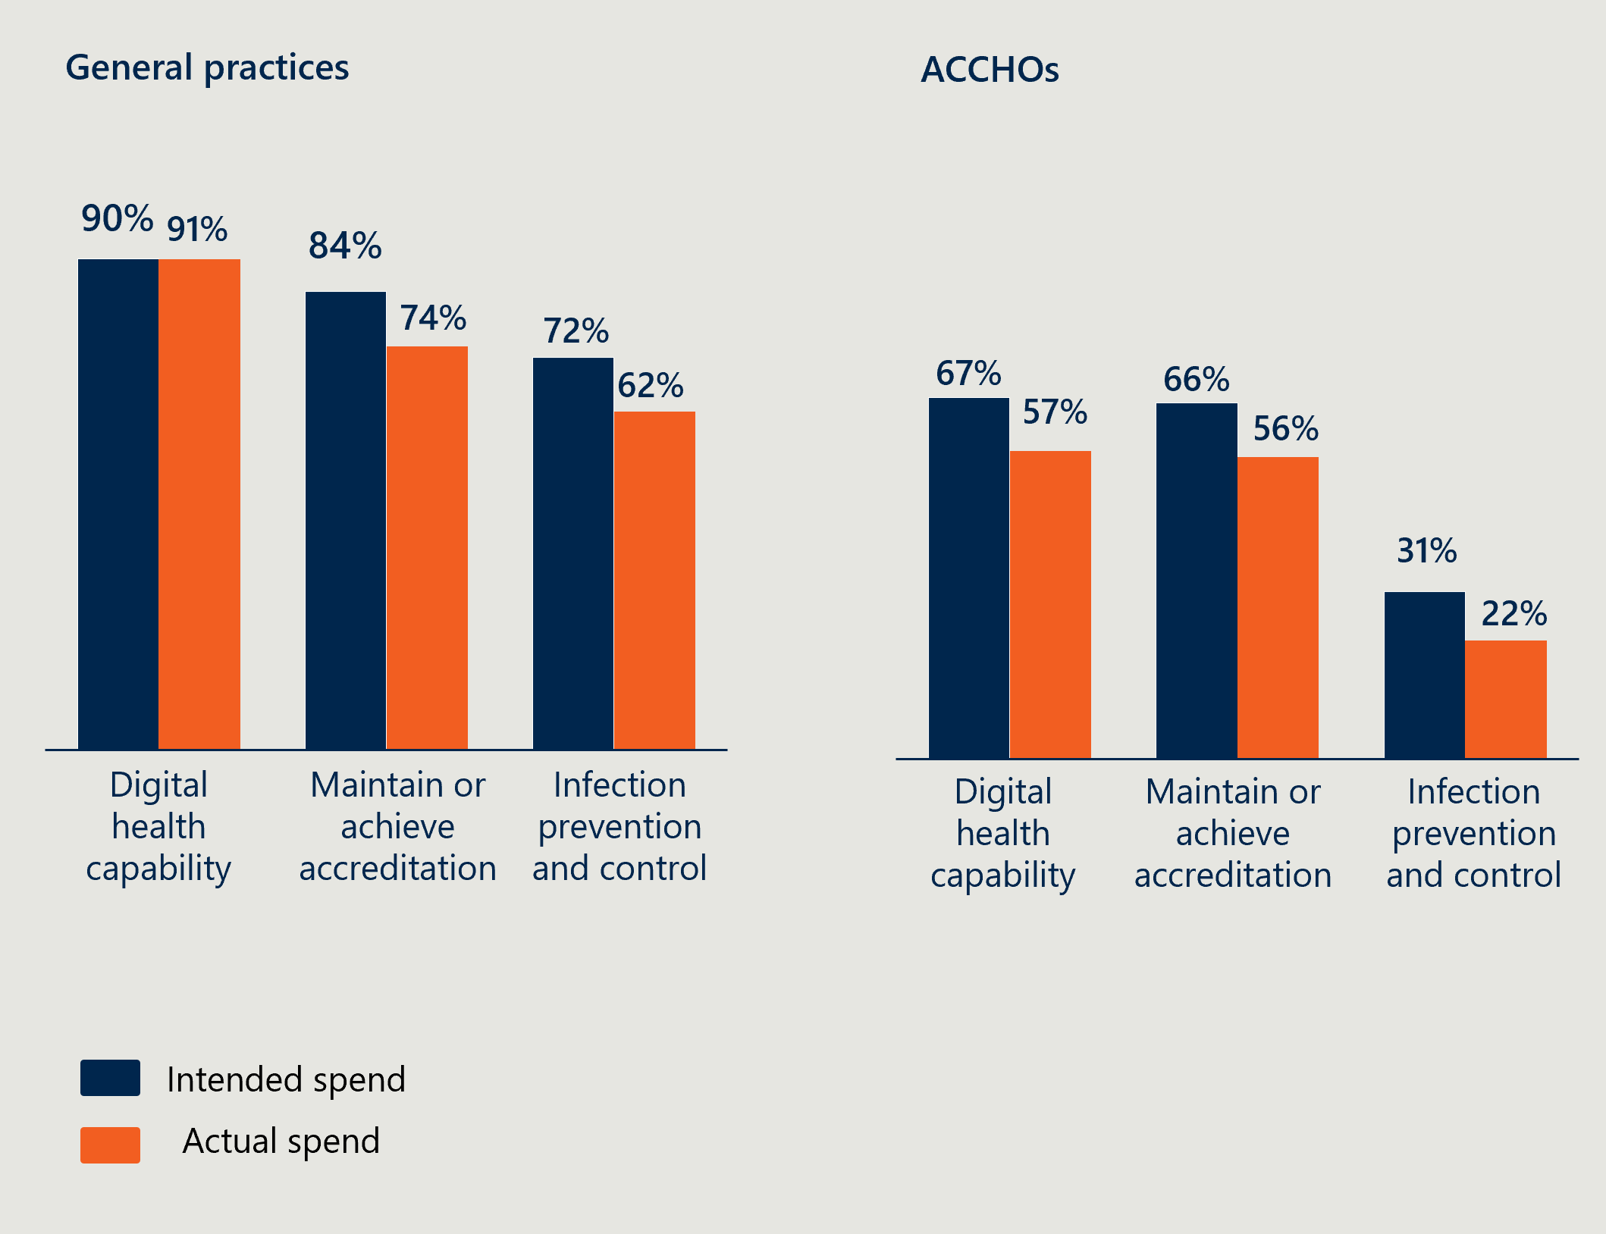

The percentage noted for each investment stream represents the proportion of initial grant agreements that indicated an intent to allocate the grant funds to that investment stream, noting that grant applicants were able to select more than one stream. Despite nominating their preferences in the initial stages of the Program, grant applicants were able to allocate funds to any stream during implementation. This data demonstrates that the percentage of practices spending some of their funding on each stream was relatively consistent from planned to actual, and that most practices spent across more than one investment stream.

Across both practices and ACCHOs, digital health capability was most likely to be selected, while infection prevention and control was least likely to be selected. ACCHOs were notably less likely to choose to spend grant funds on infection prevention and control compared to practices (22 per cent versus 62 per cent). Consultation with NACCHO suggests this is likely because ACCHOs had already received additional funding for infection prevention and control during the COVID-19 pandemic.

While most PHNs agreed that the investment streams targeted areas of need for practices, digital health capability and accreditation streams were noted through consultations to be most critical. Infection prevention and control initiatives were thought to have been addressed by many practices during the COVID-19 pandemic. One PHN representative noted a focus on accreditation and digital health was consistent with identified areas of need from an annual survey the PHN runs for their practices.

High interest in digital health capability investment saw many practices and ACCHOs taking the opportunity to upgrade outdated IT systems and improve telehealth capacity

|  |
| --- |
| “Digital health is the cornerstone of our new strategic plan, so it aligned very well. It’s the only way we will be able to address the primary care access issues.” – Rural PHN. |

Digital health is widely accepted as a foundation to quality primary care. Digital health improvements are often directly beneficial to patients by increasing access and quality, two of the key objectives of the Program. They can allow practices to increase the access to primary care through the provision of telehealth and video consults, and digital upgrades can streamline processes and support information and data quality and management. These improvements can allow practices to operate with greater efficiency, increase their capacity and better target patient needs.

Practices noted that establishing the right digital infrastructure and skills is a priority for many practices. They were supportive of this investment stream, suggesting that practices can fall behind if they lack technical skills and resources and that it can be difficult to find the funding to acquire them. Many practices saw this as an important opportunity to make significant IT investments, such as on new servers, computers, or workstations, which they otherwise would have struggled to afford. They reported that these investments have had immediate benefits for their practices in terms of improved efficiency and data security.

Digital infrastructure requires significant upfront investment, which many practices noted they struggled to prioritise under current economic conditions until a piece of equipment or system stopped working. Insights from practice managers suggest that digital equipment and software are often out of date in clinics, and the grant was timely and helped to upgrade hardware and systems. The value of the grant in investing in this infrastructure is reflected by more than 90 per cent of practices spending some of their funding on the digital capability investment stream. Around 75 per cent (n=4,000) of practices purchased IT systems and/or equipment.

Digital healthcare, especially telehealth, was expressed to be even more important in rural areas where primary care access can be constrained by distance. However, connectivity and infrastructure challenges can inhibit the use of technology. While many regional PHN representatives agreed enhancing practices’ capacity to provide digital care is needed, the grant was unable to address broader connectivity challenges. For example, the benefits of a new computer and software are minimised without stable internet connection. Interestingly the level of significant improvement seen in video telehealth capacity noted by MMM 6 & 7 practices at 48.3 per cent was much higher than MMM 1 & 2 practices at 25.8 per cent (see Table 11). This is despite per cent spending on purchase of equipment in the digital capability stream being similar across MMM groups at 82.9 per cent, 79.4 per cent and 85.5 per cent in MMM 1 & 2, MMM 3, 4 & 5 and MMM 6 & 7 respectively (see Table 10). It was hypothesised by PHN stakeholders that this could be due to a combination of these practices having less existing technology infrastructure and telehealth capability.

Table 10 | Number and percentage of practices spending on digital capability stream by MMM

| Response | MMM group 1 and 2 | MMM group 3, 4, and 5 | MMM group 6 and 7 |
| --- | --- | --- | --- |
| General Practice IT systems | 3,377 (87.4 per cent) | 720 (86.1 per cent) | 80 (55.2 per cent) |
| Internet connectivity improvements | 1,873 (48.5 per cent) | 368 (44.0 per cent) | 52 (35.9 per cent) |
| Upskilling staff in digital capability | 1,354 (35.1 per cent) | 242 (28.9 per cent) | 70 (48.3 per cent) |
| Purchase of equipment | 3,203 (82.9 per cent) | 664 (79.4 per cent) | 124 (85.5 per cent) |
| Upgrade of equipment | 2,988 (77.3 per cent) | 575 (68.8 per cent) | 99 (68.3 per cent) |
| Training courses | 791 (20.5 per cent) | 162 (19.4 per cent) | 20 (13.8 per cent) |
| Professional assessment of existing digital / cyber security capability and arrangements | 1,206 (31.2 per cent) | 218 (26.1 per cent) | 40 (27.6 per cent) |
| Other digital health capability enhancement (please provide a brief description) | 812 (21.0 per cent) | 141 (16.9 per cent) | 19 (13.1 per cent) |

Table 11 | Self-evaluation survey responses by MMM to level of improvement seen in video telehealth capacity

| Response | MMM group 1 and 2 | MMM group 3, 4, and 5 | MMM group 6 and 7 |
| --- | --- | --- | --- |
| Did not use grant for this purpose | 1,224 (31.7 per cent) | 246 (29.4 per cent) | 18 (12.4 per cent) |
| No change | 481 (12.5 per cent) | 94 (11.2 per cent) | 9 (6.2 per cent) |
| Minor improvement | 444 (11.5 per cent) | 110 (13.2 per cent) | 24 (16.6 per cent) |
| Moderate improvement | 636 (16.5 per cent) | 156 (18.7 per cent) | 22 (15.2 per cent) |
| Significant improvement | 997 (25.8 per cent) | 210 (25.1 per cent) | 70 (48.3 per cent) |
| No response | 81 (2.1 per cent) | 20 (2.4 per cent) | 2 (1.4 per cent) |

**A one-time $25K grant may not provide a sustainable solution for practices to maintain or achieve accreditation**

The accreditation process prompts practices to enhance and maintain their safety and quality standards to achieve compliance. Additionally, accreditation enables practices to access additional payments, such as the Practice Incentives Program Quality Improvement Incentive (PiP QI), that supports continuous quality improvement activities and provides confidence to practices and their communities that they are delivering safe and quality primary care.

PHNs and practices were mostly supportive of the accreditation stream, emphasising that accreditation is a major priority and expense for practices. Several practices expressed gratitude for the accreditation support, stating that the grant was pivotal in enabling them to attain or maintain accreditation. Practices expressed that they valued support to maintain or achieve accreditation not only to retain access to funding which requires accreditation but also because it provided assurance and helped their confidence that they were delivering care with a high degree of clinical safety. One PHN also noted that the timing of the grant in conjunction with the introduction of MyMedicare support (which practices need to be accredited to access) was especially effective, as they could pool funding from both programs.[17] Despite universal acceptance that accreditation is a priority for practices, there were some mixed views across stakeholders on its suitability for a grant program, including:

* The relevance of the stream was dependent on the timing of a practice’s accreditation cycle. This meant some practices reported this stream was very useful for them, whilst others who had just been through the accreditation process could not use it within the Program’s timeline.
* Practices who found this stream most useful tended to use it on a combination of clinical equipment and workforce support to help cover the additional workload from the accreditation process.
* Whilst most practices interviewed noted that they would have made the accreditation investments anyway, they valued that it took some of the financial and time pressure off the process. Similarly, PHN representatives felt that many practices already budget for spending required to maintain accreditation.
* For those not yet accredited, a one-off grant of this size is not likely to support them to achieve accreditation, and very few practices used the grant to achieve accreditation for the first time.
* A one-off grant may not prepare clinics for the ongoing costs of maintaining accreditation.
* Practices who found this stream most useful tended to use it on a combination of clinical equipment and workforce support to help cover the additional workload from the accreditation process.

**There was uptake of the infection prevention and control stream, despite feedback this need had already been funded recently, during the pandemic**

Infection prevention and control is critical to maintaining the safety of patients and clinicians. This grant provided an opportunity to make structural improvements to practices, such as upgrading ventilation or waiting rooms, which practices may not have otherwise been able to afford.

Several PHN representatives, some practices and peak bodies felt that the infection prevention and control stream had become less relevant, as practices upgraded their equipment and implemented quality improvement during the pandemic. Whilst many practices did still spend some of their grant on this investment stream, it tended to be on smaller ad hoc purchases or renovations rather than strategic investments seen in the other two streams. One PHN representative suggested that this stream was less relevant because of the parallel Vulnerable Populations COVID-19 Vaccinations Program funded by the Department which provided grants to support the vaccination of at-risk cohorts. Another noted that they received more questions from practices on what constituted eligible spending under this stream than the other two streams. As noted above, there was a much lower uptake of this investment stream by ACCHOs, with feedback provided by NACCHO that this need had already been met through previous grants during the COVID-19 pandemic response.

**Program stakeholders identified additional challenges sitting outside the three investment streams**

During consultations, peak bodies, general practitioners and practice managers reflected on challenges faced in primary care and general practice, beyond the three investment streams. Three key areas of need were identified by practices in interviews: workforce, MBS reform, and investment in preventative health. This reflects the broader financial challenges in the primary care landscape, and the need for ongoing and structural supports to maintain financial viability in the future.

The areas of focus consistently highlighted by PHN representatives were similar to those raised by grant recipients Including workforce, staff training and education, innovative models of care, targeted support for priority population communities and integrated care (as summarised in Table 12). PHN representatives recognised the alignment of some of these identified areas to existing investment streams but noted the value of specifically identifying them in recognition of their importance.

Table 12 | Identified priorities of practice need (n= number of PHNs identifying the area of need)

| Workforce  (n=20) | Staff training and education  (n=15) | Business viability and sustainability  (n=14) | Priority populations  (n=10) | Innovative models of care  (n=9) | Integrated and continuous care  (n=9) |
| --- | --- | --- | --- | --- | --- |
| Workforce shortages especially in regional, rural and remote areas present a threat to the long-term sustainability of general practice. PHNs and practices suggested that support in this area could include resources to:   * Support practices to employ medical assistants or improve retention rates. * Bring specialist resources to regional, rural and remote areas. | Training and education for staff can address the evolving demands of primary care and support with retention of staff. Suggestions for future focus areas included training for:   * Professional development for clinical staff, including specialist training closely related to patient outcomes, e.g. wound specialists, pharmacists etc. * Digital capability uplift, including for practice staff to learn how to use newly implemented systems. * Business skills such as business planning, workforce modelling, clinical governance and change management support. * Cultural competency and general communication skills.   Some practices spent their grants on staff training for digital capability uplift or accreditation; others weren’t aware they could spend it on training. | Business viability and sustainability emerged as a key challenge for clinics, including:   * Business continuity planning and capability building for business viability * innovative and efficient workforce models.   Top-up to MBS items to increase business viability without additional financial pressures on patients. | Improving access for priority populations, including rural and remote communities. Support could enable practices to meet local community needs and enhance their support of priority populations. One PHN also proposed further support for the transition of health services to ACCHOs. | Opportunity to pilot new, best practice or innovative models of care, including:   * Multidisciplinary teams and team-based models of care including nurse practitioner models. * Alternative, more efficient workforce structures.   Technological innovation, including within the scope available to nurses. | Opportunity to collaboratively support integrated and more continuous care, including:   * Collaboration between practices and hospital and health services (HHS) in local regions to support particular areas of health, e.g. promoting shared care for obstetrics. * Integrated Indigenous healthcare. * Integration of digital systems.   Collaboration across practices for large digital solutions. |

PHN representatives felt that the Program was well aligned to the Strengthening Medicare reform, including the focus of the Program on supporting practices to uplift primary care specifically around digital capability. Despite this, some felt links could have been more clearly drawn to help practices use the money effectively. For example, guidelines could have highlighted that the funding could be used to buy key pieces of equipment to meet changes in RACGP standards. Some PHNs felt that the $220M committed to the Program could have been used more effectively to support MBS reform.

One PHN suggested that the government could have provided larger grants for bigger, shared solutions such as subscriptions to digital platforms that could be shared by multiple practice and give them access to upgrades, they would otherwise be unable to afford. One group of practices pooled the money across multiple clinics to implement large IT upgrades, noting that the upgrades would have been significantly more expensive individually.

### Engaging NACCHO in the early co-design of the Program would have helped create investment streams that better served ACCHO’s needs

NACCHO did not have a role in the early design of the Program’s investment streams, delivery or communication material. As a result, several aspects of the Program could have been more tailored to suit the needs of ACCHOs. NACCHO’s feedback was that although the investment streams were broadly appropriate, there was an opportunity for a more tailored and targeted approach, including:

* Enhancing digital health capability | Digital health was a key area of need, but there was missed potential for targeted investment around cyber security and interoperability.
* Upgrading infection prevention and control arrangements | Similar to practices, ACCHOs had already received funding for improving infection prevention control measures during COVID-19. As a result, this stream was less relevant for ACCHOs.
* Maintaining or achieving accreditation | ACCHOs’ accreditation obligations are markedly different to practices’; NACCHO reported many ACCHOs need to manage up to seven distinct accreditations to meet the requirements of their funders which significantly adds to the burden and complexity of their accreditation processes. By keeping the investment stream confined to RACGP accreditation, the grant missed the opportunity to support ACCHOs’ to manage this complex process (for example, through software that could decrease accreditation burden and duplication across accreditation requirements). Despite this, NACCHO representatives reported that ACCHOs appreciated the funding to support their many requirements.

Outside of the three investment streams, NACCHO representatives reported that funding for staff and infrastructure are also key needs of ACCHOs and would have liked to be able to use the grant to fund these areas.

Early co-design with NACCHO for this stream of the Program would have saved the additional work required for later amendments to tailor and enable the Program to be more fit for purpose for the needs of ACCHOs. As per the NACCHO summary report (see Appendix D), NACCHO was able to work closely with the Department to adapt the Program process to better suit ACCHOs including (page 2):

* “ensuring all eligible ACCHOs were captured in the final list of organisations to receive funding;
* providing feedback on eligible activities under each investment stream;
* negotiating a top-up payment for ACCHOs with the inclusion of OSR data due to the ACCHO model of care and Medicare throughput compared to mainstream practices;
* co-designing the ACCHO grant agreement template and supporting documentation; and
* offering the grant to ACCHOs rather than having them apply.”

Further detail on the appropriateness of the Program design and design process is captured below in Table | Case study 1 - Appropriateness of the Program design for ACCHOs,this should be read in conjunction with the summary report NACCHO delivered on the Program (see Appendix D)

Table | Case study 1 - Appropriateness of the Program design for ACCHOs

| Case study 1 – National  Appropriateness of the Program design for ACCHOs |
| --- |
| Context  The Strengthening Medicare - General Practice Grants Program was distributed to practices and ACCHOs through separate funding mechanisms. Funding for ACCHOs was administered by NACCHO under an agreement with NTPHN, who were engaged by the Department. Features of the ACCHO program that differed to the general practice and PHN process included; a shorter administration process through an expression of interest (without a formal application), different reporting timeframes, and tailored formula to allocate funding amounts. After negotiation between the Department and NACCHO, the general practitioner FTE formula to determine grant size was adjusted to recognise the team-based care model |
| Improving the Department’s working relationship with NACCHO and ACCHOs  More detailed lessons learnt have been captured directly by NACCHO in their Summary report (see Appendix D). The observations presented here are drawn from all evaluation consultation, analysis and document review.  Increased involvement of NACCHO in the design phase for a fit-for-purpose grant   * Direct or streamlined contracting between the Department and NACCHO may have contributed to more efficient processes and alignment in timelines and reporting for the national program (practices and ACCHOs). * Early consultation with NACCHO would have supported:   + - earlier tailoring of communication, appropriate for ACCHO engagement     - earlier advice, solutions and adjustment on the grant size allocation formula.   ACCHOs take an integrated, holistic and multidisciplinary care approach, reflecting the aspirations of the Strengthening Medicare reforms  Several of the Strengthening Medicare reforms are standard ways of working in ACCHOs. This includes multidisciplinary care which is central to the way that ACCHOs support their communities and patients. There are opportunities for ACCHOs to play a thought leadership role in the design of future programs that are driving reform in Australian primary health care more broadly or be used as demonstrations or desired models of care.  Working with NACCHO and ACCHOs effectively requires cultural awareness  The Department’s obligations under the National Agreement on Closing the Gap, and specific recommendations of Strengthening Medicare, require working in partnership with First Nations organisations for shared decision making. Ongoing efforts to enhance cultural awareness and competency within the Department, including on issues of Indigenous data sovereignty, will be important to continue a collaborative partnership with NACCHO and ACCHOs.  The high uptake and complete expenditure of the grant amongst ACCHOs suggests that they were able to use the grant to meet their needs. Consultation with NACCHO also suggested these streams were largely appropriate but could have been tailored to better suit the needs of ACCHOs. |
| **Fit for purpose investment streams** |
| **Digital capability** There was a high uptake of this investment stream, and many ACCHOs used the funding for significant and/or strategic investments. Compared to general practice there was a greater focus on improving internet or cloud connectivity, and data security. ACCHOs using this stream often chose investments in new IT infrastructure/ software that included training for staff.  **Infection prevention and control:** There was a very low uptake of this stream by ACCHOs, which NACCHO attributed to overlapping funding during COVID-19. The 28 ACCHOs that did spend some of their funding in this stream, focused on a combination of infrastructure improvements, improving patient flows through space to improve safety, and other process improvements.  **Accreditation:** ACCHOs accreditation needs are more complex than those of general practices, as they have several accreditation standards they need to meet in addition to RACGP standards. Compared to general practices, ACCHOs were more likely to use the accreditation stream on people costs. This included training, but also temporary external support to help meet accreditation standards or covering additional wages for staff working overtime on activities to meet accreditation standards. |

### The one-off, non-competitive and flexible nature of the grants supported delivery of the Program objectives

|  |
| --- |
| “When the government funds initiatives this sends a price signal that those expenses are not part of core best practice, and the government should continue to pay for it.” – Peak body representative. |

The Program was defined by three design mechanisms: (1) one-off (2) non-competitive and open to unaccredited practices, and (3) highly flexible in what constituted eligible spend.

The one-off nature of the grants supported financially pressured practices to make critical investments to support quality and efficient patient care

Practice and PHN representatives agreed that one-off nature of the grants supported practices to make critical and intensive purchases or upgrades, and they came at the right time following the additional financial strain imposed by the COVID-19 pandemic. Many felt the grants were able to fund high-cost equipment and much-needed upgrades. Others raised concerns that maintaining accreditation and digital upgrades paid for by the grant will typically require ongoing funding and practices may struggle to sustain this (e.g. software with ongoing subscription fees).

Some PHN representatives and peak bodies suggested that despite clear communications that the grants were one-off, there may be an expectation from the sector that the government will continue funding similar grants in future.

The non-competitive nature of the grant allowed NACCHO to take a streamlined approach, where they leant into their active, existing relationships and processes (for example, using up to date contact lists) to administer quickly to all ACCHOs.

Practices found receiving up-front lump funding very useful

Many practices noted that a key strength of the grant design was that they received the full grant amount in a lump sum upfront. Many practices interviewed noted they were surprised how quickly they received the funds and valued that this allowed them to start spending quickly. This is reflected in the self-evaluation survey data where 95 per cent of practices reported that it ‘was easy for our practice to receive the grant funds’ (see Figure 3). This enabled them to invest in more expensive capital purchases, such as servers, that they would have struggled to afford otherwise or that would have created cash flow issues even if they knew the rest of the funding was coming.

Figure 3 | Practice self-evaluation survey responses to ‘It was easy for our practice to receive the grant funds’

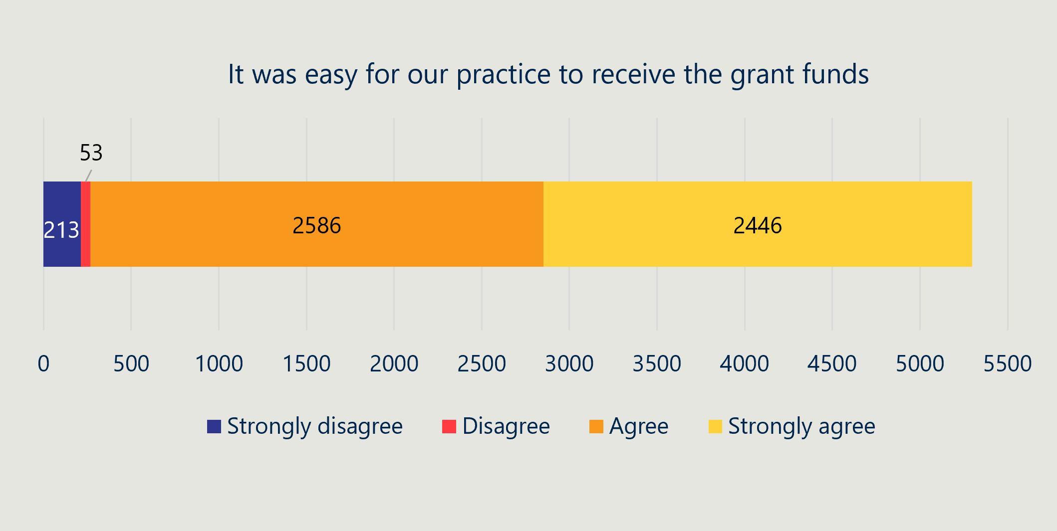This aspect of the Program design may have influenced what practices spent the grant on. Across the three investment streams, purchase and upgrade of equipment (and/or purchase of IT systems) was the most common thing that funding was spent on (see Figure 4, Figure 5, Figure 6, Figure 7, Figure 8 and Figure 9) for a breakdown of spending in each investment stream). In the digital capability and infection prevention control streams more than 90 per cent of practices spent at least some of their funding on equipment. While this may partly be because equipment was what practices needed most, it also fit most neatly into a one-off lump sum grant that did not support an ongoing investment.

**The non-competitive mechanism ensured the Program was equitable and reached more practices**

|  |
| --- |
| “It was good to provide funds to all practices – not just those that are good at writing grant applications.” - PHN Representative |

The non-competitive nature was central to the equity and accessibility of the Program, and most stakeholders appreciated this. Some PHN representatives noted that competitive grants often involve arduous processes and benefit those experienced in writing compelling applications over need.

Additionally, PHN representatives reported that this was the first grant many practices had applied for, either because of limited capacity or limited grants available to unaccredited practices. Several stakeholders felt the grant design was helpful for supporting smaller practices who needed the funds to improve their practice or gain accreditation for the first time. Almost all stakeholders interviewed noted the dramatically smaller administrative burden compared to other grant programs.

Not all PHN representatives and practices felt the non-competitive nature of the grant was a strength. A small number felt that fewer competitive grants could have allowed practices who could demonstrate a clear business case to receive more funding, and that those practices may have used the funding more effectively.

**The flexibility of the grant was generally well received. It caused confusion for some practices. ACCHOs required no additional support or clarification**

PHN representatives and practices appreciated the flexibility of eligible spends across the three investment streams. It enabled practices to tailor the funds to their highest areas of need and that it was a welcome contrast to other grant programs.

With this came some confusion regarding what constituted eligible spend. The breadth of eligible spend meant that some inclusions, such as training and education as it related to accreditation or digital skills uplift were not immediately clear to participants. This meant many PHNs had to respond to additional questions relating to what constituted eligible spend, placing a time burden on PHNs (see Section 4.2.5).

NACCHO reported that they did not have a similar problem, with almost no ACCHOs needing assistance to understand what was eligible under each of the investment streams, and no ACCHOs needing clarification about the Program or processes (see further discussion at Section 4.2.1)

Some stakeholders suggested that additional streams or more examples could have provided more clarity without any detriment to the grant’s flexibility. One practice suggested that having a list of ineligible spending areas (e.g. capital works) could have been clearer. The implications of the grant’s flexibility on delivery are discussed further in Program Delivery, Section 4.2.5.

**General practitioner FTE was a largely appropriate mechanism to determine grant amount allocation, however it disadvantaged practices and ACCHOs using multidisciplinary models of care**

Most practices and PHNs interviewed reported that the FTE of general practitioners within a practice or ACCHO was a fair mechanism to allocate funding amounts noting accreditation status was also considered and total client volume for ACCHOs.[18] This made it easy to justify respective amounts and practices generally were comfortable with this approach. Some PHNs reflected that sharing the formula directly with practices or ACCHOS could have addressed most questions regarding allocation amounts. Some practices raised questions about the data used to determine general practitioner FTE. For example, the formula relied on 2019 FTE data, which no longer reflected the current situation for some practices. The Department responded to queries or updates from practices and ACCHOs and adjusted their allocation as appropriate.

Importantly, ACCHOs provide healthcare through multidisciplinary teams, with general practitioners making up a small portion of the diverse ACCHO workforce. As such, general practitioner FTE does not accurately reflect the size and resource requirements of an ACCHO and may not have been an appropriate determinant for the allocation of grant amounts. This concern was raised and addressed through liaison between the Department and NACCHO which resulted in patient cohort size as a determinant of grant allocations, meaning that most ACCHOs received $5000 - $10,000 more than they otherwise would have.

A small number of practices also suggested that using general practitioner FTE for calculations disadvantaged practices with nurse practitioners and/or allied health staff – despite this workforce mix reflecting the multidisciplinary model of care Strengthening Medicare is aiming to create.

Suggestions on alternate mechanisms to determine grant allocation amounts were most often in addition to FTE, rather than in replacement of FTE. Some practices believed regionality by Modified Monash Model of practices and ACCHOs should have been considered, as well as whether the practice or ACCHO targeted priority populations, such as a high proportion of First Nations, Culturally and Linguistically Diverse individuals, or those experiencing socioeconomic disadvantage. However, it was noted by participants that there is no ‘perfect’ formula.

## Program delivery

### There was high uptake across practices and ACCHOs

Nearly all eligible practices (93 per cent), and all ACCHOs chose to participate in the Program. Table 13, Table 14, and Table 15 summarise the total Program uptake. As shown in Table 16, uptake amongst practices was relatively consistent across states and territories Distribution of spending across the three investment streams was largely consistent for practices across states and territories, with a small number of larger variations (for example lower uptake of stream two and three in the Northern Territory). More detail on this can be found in Appendix E (ACCHO breakdown by geography is not available). The Department’s FAR process will confirm the total final spend per investment stream. A more detailed breakdown of how practices and ACCHOs spent the grant within each investment stream is captured in Figure 4, Figure 5, Figure 6, Figure 7, Figure 8 and Figure 9.

Table 13 | Summary of program uptake

| Grant information | Practices | ACCHOs |
| --- | --- | --- |
| Number eligible | 7,607 | 126 |
| % uptake | 7,047 (93%) | 126 (100%)[19] |
| Total $ allocated | $189.3M | $3.8M |

Table 14 | Summary of program uptake by grant size

| Grant size | Practices | ACCHOs |
| --- | --- | --- |
| $25,000 | 6,466 (91.7%) | 27 (21.4%) |
| $30,000 | 0 | 57 (45.2%) |
| $35,000 | 1,081 (15.3%) | 22 (17.5%) |
| $45,000 | 0 | 3 (2.4%) |
| $50,000 | 107 (1.5%) | 1 (0.8%) |

Table 15 | Summary of program uptake by investment stream

| Investment stream | Practices | ACCHOs |
| --- | --- | --- |
| 1: Digital capability | 4,844 (91%) | 72 (57.1%) |
| 2: Infection prevention and control | 3,327 (62%) | 28 (22.2%) |
| 3: Accreditation | 3,950 (74%) | 71 (56.3%) |

Table 16 | | Uptake of the grant and investment streams by state and territory (practice only)

| State | Uptake of the grant | Stream 1 – Enhancing digital health capability | Stream 2 – Upgrading infection prevention and control arrangements | Stream 3 – Maintaining or achieving accreditation |
| --- | --- | --- | --- | --- |
| ACT | 99 (100.0%) | 88 (88.9%) | 57 (57.6%) | 68 (68.7%) |
| NSW | 1,718 (71.7%) | 1,557 (90.6%) | 1,118 (65.1%) | 1,254 (73.0%) |
| NT | 1,718 (71.7%) | 69 (100.0%) | 16 (23.2%) | 22 (31.9%) |
| Qld | 968 (67.4%) | 876 (90.5%) | 599 (61.9%) | 745 (77.0%) |
| SA | 318 (69.4%) | 286 (89.9%) | 153 (48.1%) | 208 (65.4%) |
| Tas | 122 (93.8%) | 111 (91.0%) | 66 (54.1%) | 96 (78.7%) |
| Vic | 1,456 (81.8%) | 1,309 (89.9%) | 950 (65.2%) | 1,119 (76.9%) |
| WA | 577 (86.9%) | 548 (95.0%) | 368 (63.8%) | 438 (75.9%) |
| **Total** | **5,327 (75.6%)** | **4,844 (90.9%)** | **3,327 (62.5%)** | **3,950 (74.2%)** |

Figure 4 | Summary of grant expenditure by across digital capability

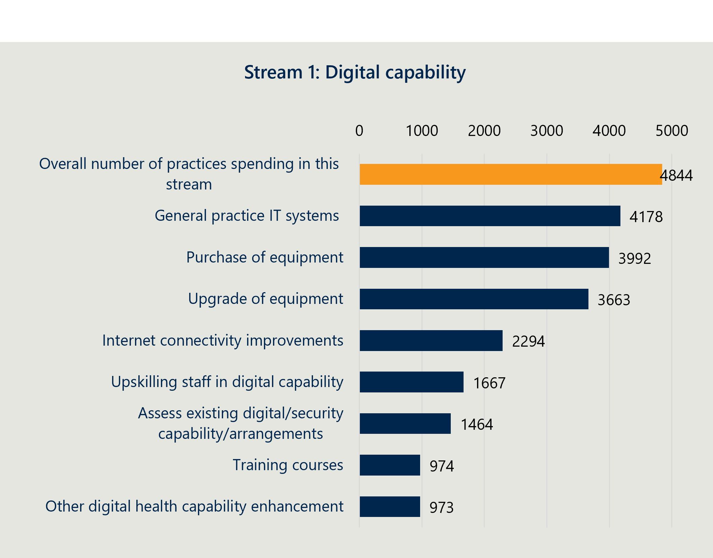

Figure 5 | Summary of grant expenditure across infection prevention and control

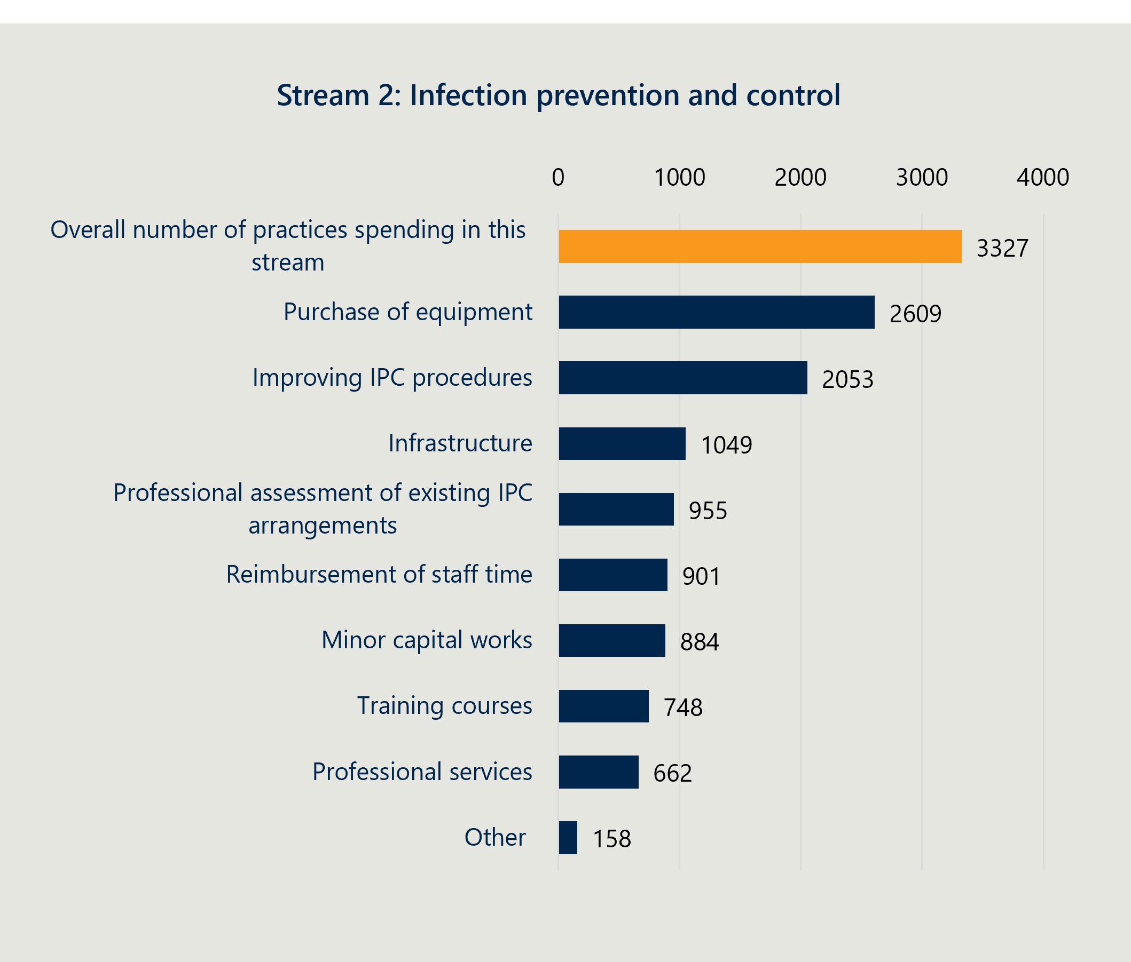

Figure 6 | Summary of grant expenditure across accreditation

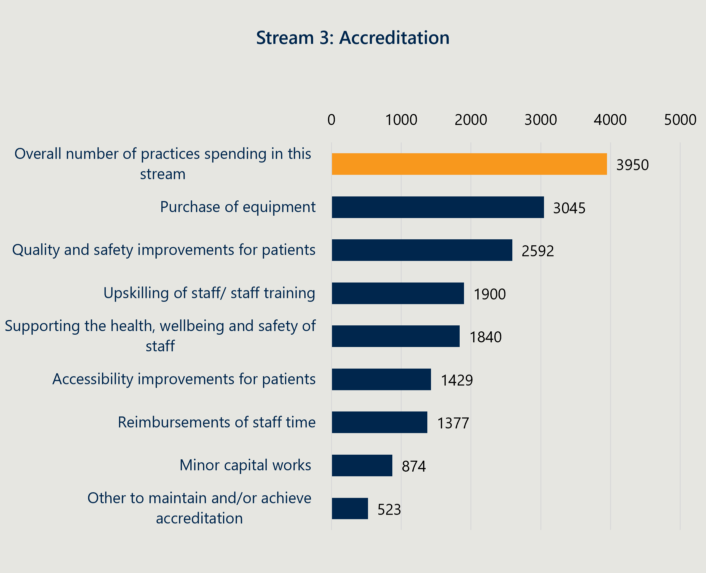

Figure 7 | Summary of ACCHO grant expenditure by number of ACCHOs across digital capability

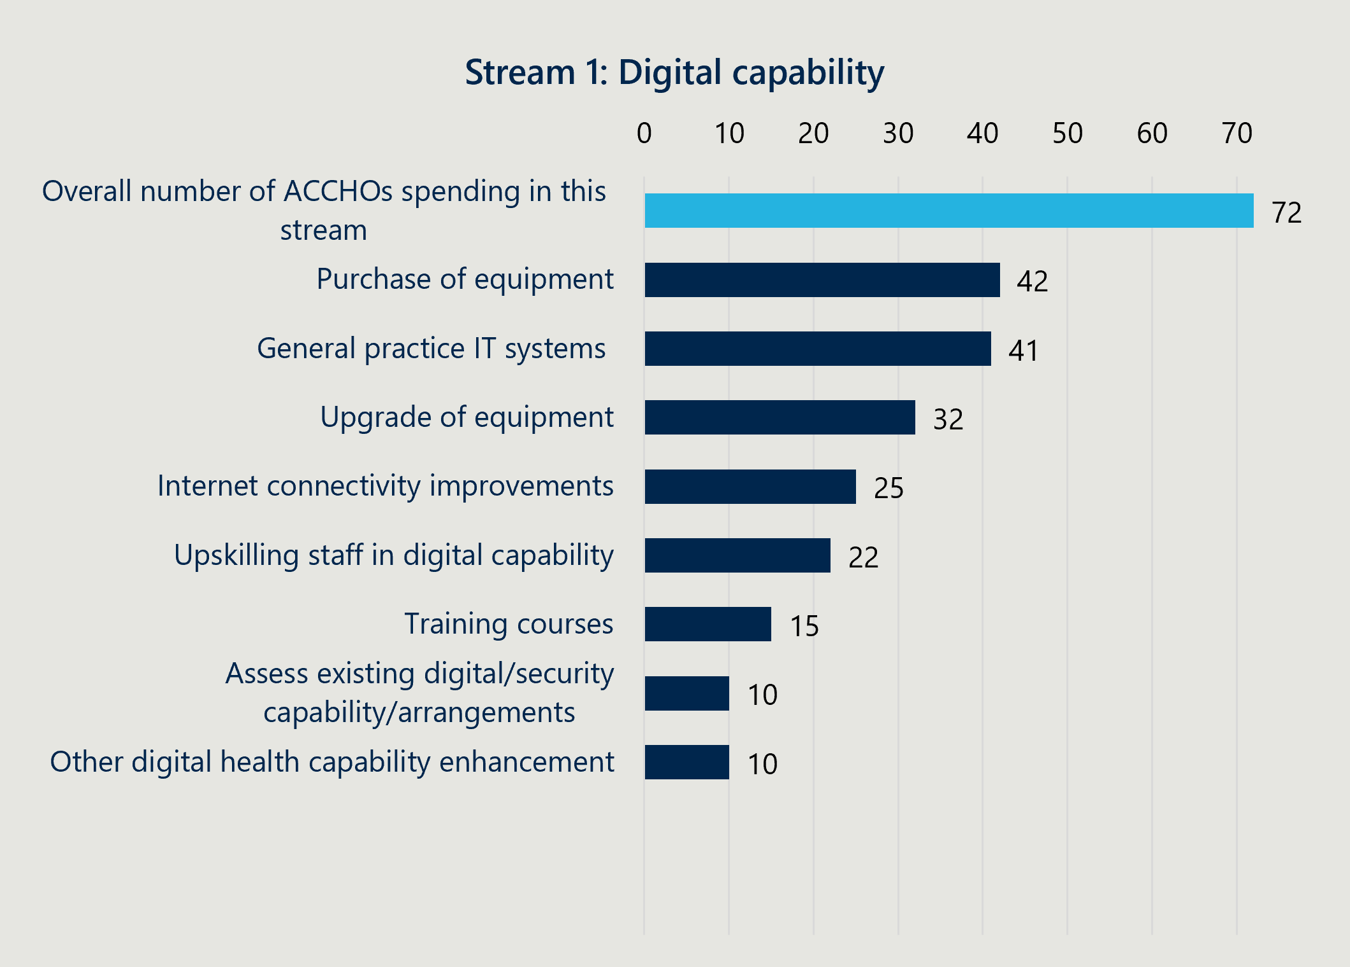

Figure 8 | Summary of ACCHO grant expenditure by number of ACCHOs across infection prevention and control

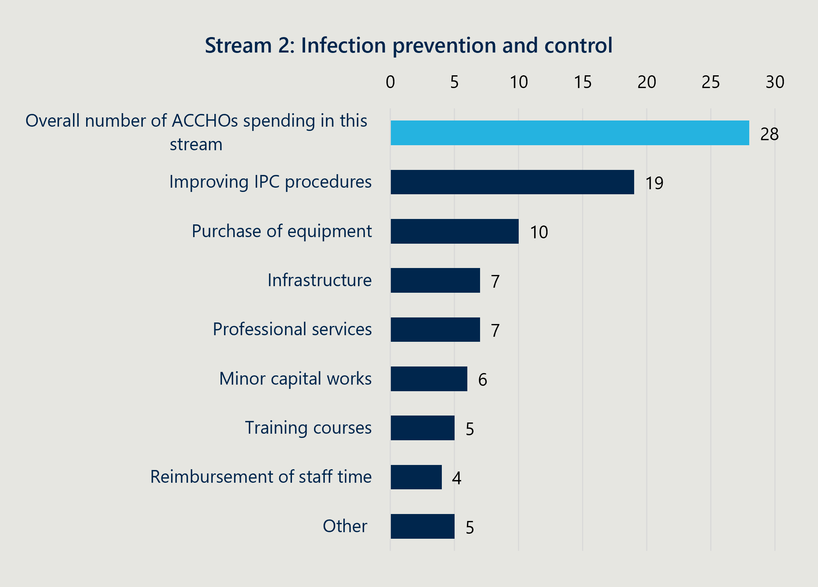

Figure 9 | Summary of ACCHO grant expenditure by number of ACCHOs across accreditation

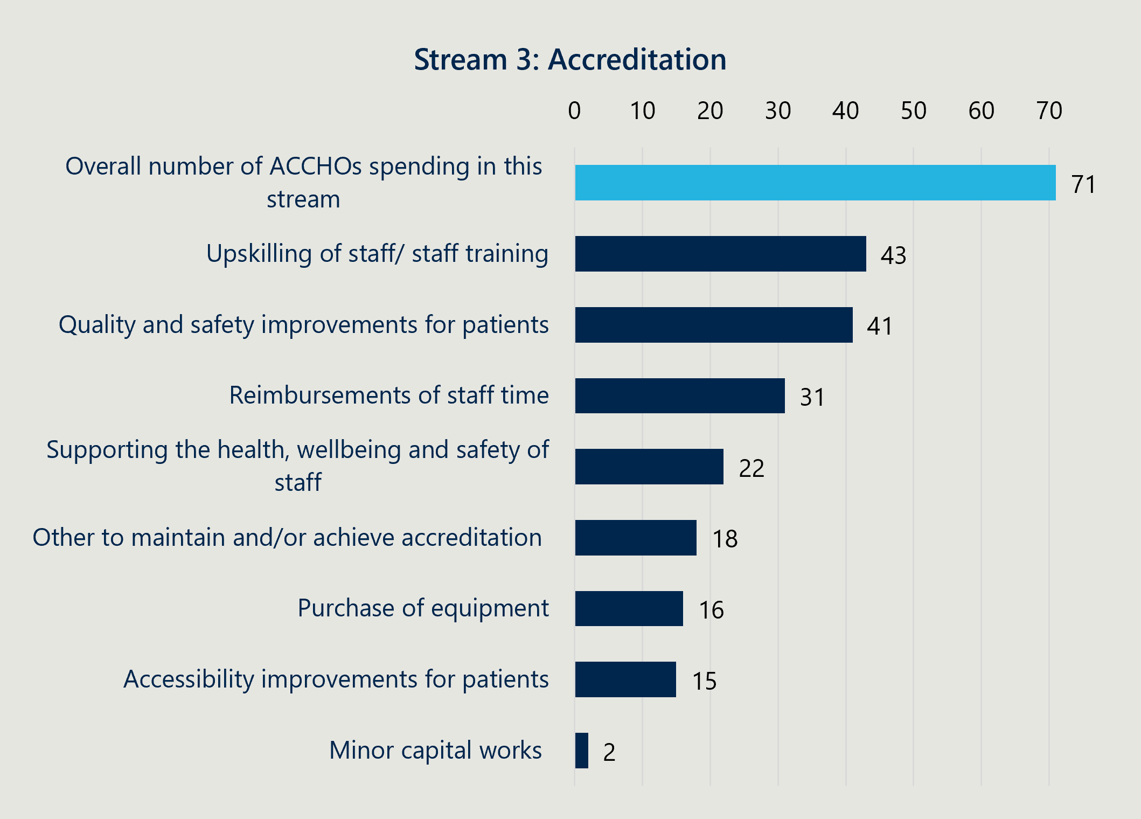

### Most practices found the Program process simple and easy to engage with

Almost all practices found the grant processes straightforward

Practices who received the grant consistently reported that they found the grant application process simple and easy to navigate. As shown below in Figure 10 ninety-four per cent of practices (n=5,017) who completed the self-evaluation survey agreed or strongly agreed that ‘it was easy to complete the application and grant agreement form’ suggesting almost all practices found the process simple.

Figure 10 | Practice self-evaluation survey responses to 'It was easy to complete the Application and Grant Application Form

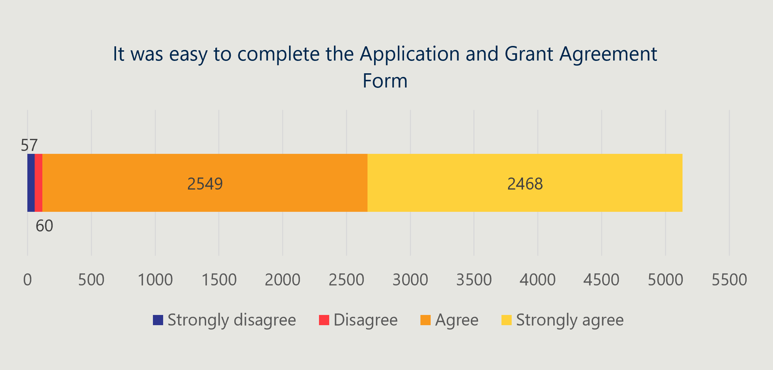Feedback from many practices interviewed indicated that compared to other grants they had applied for, this process was much more streamlined, and the steps they needed to take were clear. This suggests that PHNs, at least in most cases, successfully absorbed the workload and any complexity to create a process that practices could easily engage with, and not flow-on to practices. Practices interviewed also reported that they received the funds from the grant much quicker than expected.

Most practices understood what was eligible within each investment stream, and their PHN was able to assist when they had questions

Almost all practices reported the guidance documents were clear on what was eligible. Nearly every practice interviewed thought the criteria was clear, especially for the digital capability and infection prevention and control streams. Less than 20 per cent (n = 949) of practices who completed the self-evaluation survey reported that they needed to ask their PHN questions about the grant process or what was eligible. Practice self-evaluation survey results shown in Figure 11 demonstrate that while some more clarity could have been provided, the majority of practices (97 per cent, n=5039) had a clear understanding of what spend was eligible. Variation of comfort with the application was broadly similar across each state and territory. A more detailed breakdown of survey responses by state/territory can be found in Appendix E.

Figure 11 | Self-evaluation survey responses to 'the program guidance document clearly outlined the eligibility

Figure 11 is a vertical bar chart showing responses to the statement “The program guidance documentation clearly outlined the eligibility criteria”. Of the Responses 53 strongly disagree, 60 disagree, 2731 agree, and 2308 strongly agree.


### The Department provided the right information to PHNs and practices. More timely communications could have strengthened rollout

|  |
| --- |
| “Ninety per cent of PHNs agreed or strongly agreed that the Grant Opportunities Guidelines and Application Pack were clear and easily understandable for our PHN to effectively communicate to our practices.” – PHN representative survey |

PHNs reported thequality of communications and materials when provided was sufficient and better than other programs, with some areas for improvement identified by stakeholders

Most PHN representatives felt communications and materials provided by the Department were useful and high quality. When surveyed, all PHNs that responded (30 out of 31) agreed or strongly agreed that the national program guidance documentation clearly outlined the eligibility requirements for practices. Many PHN representatives found that the Program guidance was better designed than previous Department programs and that the series of webinars created a useful forum to receive information and seek clarification. This extended to the information packs sent out to PHNs as well as guidance documents on practice eligibility and the spending guidelines.

PHN representative feedback on communications includes:

* PHNs valued the flexibility and practical decisions the Department made to help practices get funding for what they needed to improve access. When multiple PHNs were unsure whether funding fell within the guidelines, they had a positive experience working with the Department to get proposed spending approved under the Program guidelines. This was especially the case for regional and rural practices where it can be more difficult to provide and/or increase access than in metropolitan practices.
* PHNs would have liked a consistent point of contact in the Department, including a phone number. Many PHN representatives sought a specific contact person in the Department rather than a generic mailbox. They felt this would get decisions quicker and that it could increase the consistency of information if from an individual rather than from a broader, changing team. Many PHN representatives also preferred a phone contact over an email.
* It took an extended period of time to get decisions on practice eligibility. Many PHN representatives experienced delays on questions related to practice eligibility. Some noted this may have been unavoidable given the pace of the Program rollout and the number of practices involved, while others found it strained their relationship with practices who were left unsure of their eligibility for a period (some reported weeks, others, months).
* A better system could be used to inform PHN representatives of updates made to the Master and PHN spreadsheets. Many PHN representatives noted that their process would benefit from receiving notifications from the Department if changes were made to the live spreadsheets. Throughout the Program, they were required to regularly check whether decisions or updates have been made in the spreadsheet.
* Providing guidance and materials earlier would have supported PHNs to develop their approach. While the guidance and materials were noted as useful by PHN representatives, many felt if they were provided earlier, they would have supported better planning and reduced delivery pressure. One PHN representative stated, ‘we were able to react to administering the grant, but if we had more notice and information upfront then we could have implemented more effectively’. It also meant that those without existing grants management or contract management software had to manage the grants manually.
* The speed by which the program was delivered was difficult in the early stages. Most PHN representatives noted the speed with which stages 1-3 of the process needed to be executed (from planning to implementation) was difficult to achieve and required them to pause on other projects to focus on the Program. This time pressure was almost absorbed by PHNs and not passed through to practices - nearly all practices reported they found it easy to apply for and receive the grant. NACCHO’s feedback, provided in their summary report (see Appendix D), on the early stages of the grant process, indicated they did not have the same challenges with time pressure in the initial distribution. NACCHO noted the importance of ensuring their involvement from the beginning in the design phase, including shared decision-making in line with Priority Reform 1 of the National Agreement on Closing the Gap.

PHNs noted that many practices required a high degree of their support which placed a disproportionate burden on PHNs with high numbers of practices

|  |
| --- |
| "It was low burden, especially compared to other grants." – Practice Manager |

Practices are varied in operational maturity and practice type with some as small solo practices and others as large corporates comprising multiple clinics. In the application phase, practices primarily required support on finding business information (ABN, trading name etc), and as noted earlier in this report, to confirm what they could spend the funding on in each investment stream. For some PHNs, especially those with manual grant management processes, this added unexpected workload burden including multiple back and forth communications with sometimes hundreds of practices.

The PHN self-evaluation survey reflects that processes were easier for practices because PHNs absorbed the burden. Ninety per cent of PHN representatives surveyed agreed or strongly agreed that ‘it was easy for practices to complete the application and Grant Agreement Form’. This contrasts with feedback from some PHN representatives that the guidelines were unclear and that many practices needed help to understand what was eligible. This is likely a reflection of the volume of practices applying for the grant. Figure 15Figure 12 below illustrates that even though most practices did not need support, the nearly 1,000 practices who did have questions required time and attention from their PHN.

Figure 12 | Practice self-evaluation survey responses to 'Our practice did not need assistance from our Primary Health Network to complete the grant application'

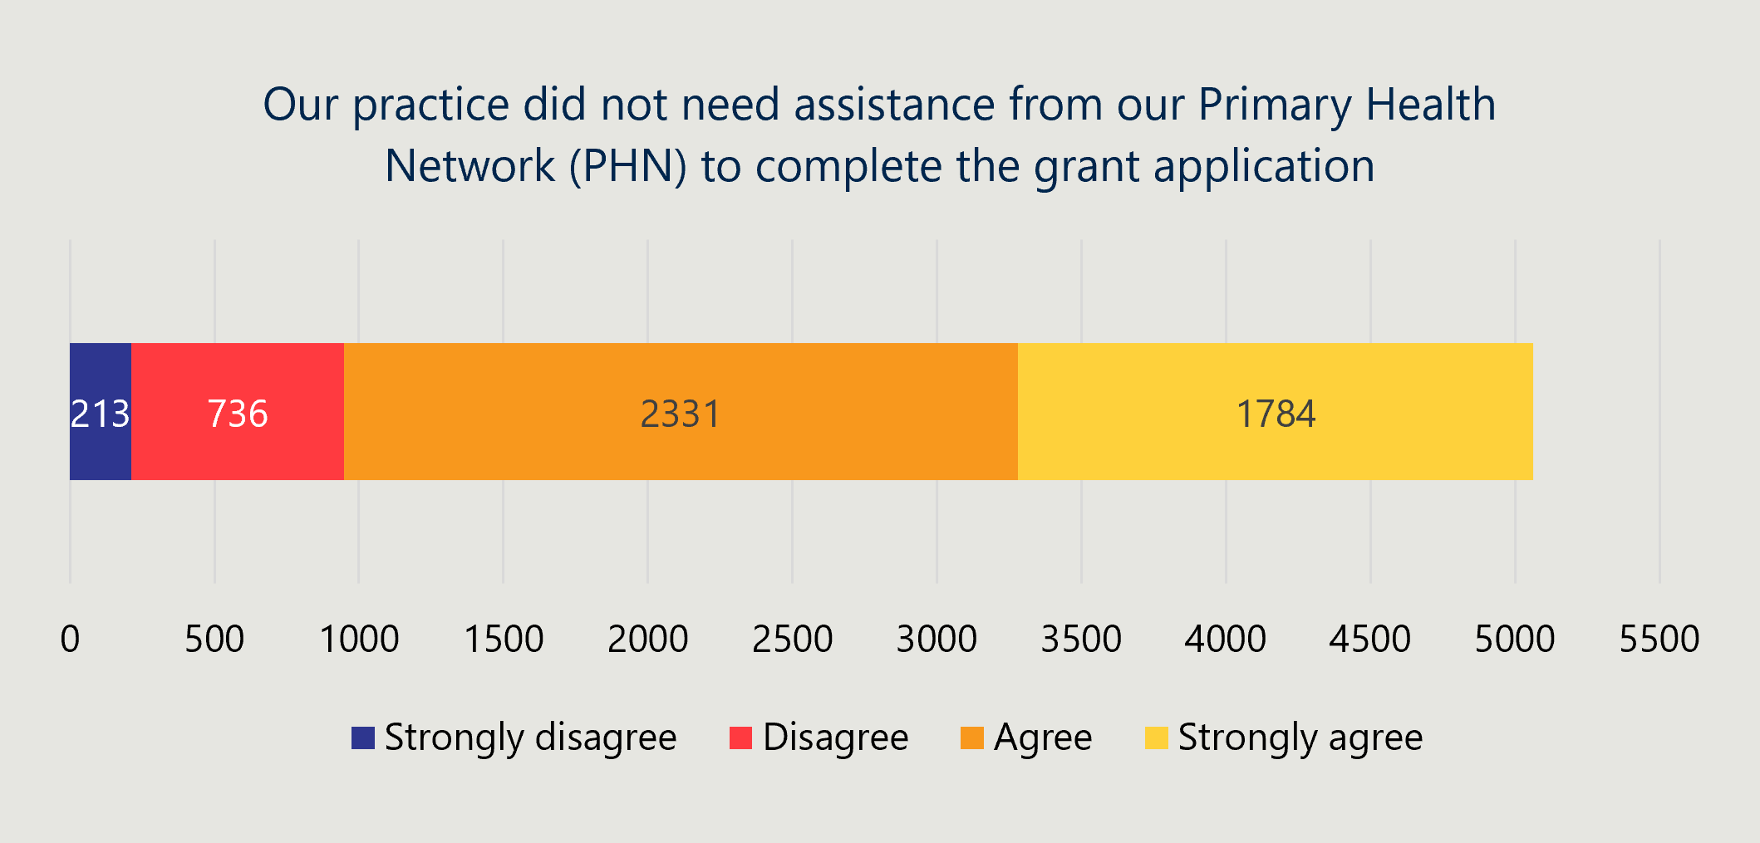

**The Department mostly provided timely responses to PHN and practice queries**

Especially in the early stages of the Program, many practices were unsure what was eligible under each of the investment streams. The initial guidance released to PHNs when the grant was released included ‘Guidance for PHNs and Guidance for NACCHO’. It included information related to program delivery and the roles PHNs and NACCHO would play. Practices received a grant agreement pack with a 2-page fact sheet on the Program and a placemat providing an overview of the Program.

Following several requests for clarification, the Department released an additional guidance document in June 2023, three months after implementation began, including examples for each stream. While this was useful, PHNs would have appreciated it at the beginning of the Program. Practices had already taken different approaches to how they intended to spend funds as set out in Case Study 2 (Figure 13).

The implications of confusion or lack of clarity on eligible spend included:

* PHN resources were largely spent providing operational support and clarifying basic program information, which was not viewed as an effective use of PHN time.
* It added to decision fatigue for practices as the areas were so broad it was hard to think about and prioritise what fit into it.
* Some practices did not apply or didn’t fully spend funds out of concern that they would need to return funds for ineligible or non-compliant spends.

Figure 13 | Case study 2 - How practices navigated expenditure decisions

| Case study 2 – Multiple Practices  How practices navigated expenditure decisions |
| --- |
| Guidance on what constituted eligible spending was released gradually over the course of the Program   * April 2023: Initial guidelines released * April – June 2023: PHNs and Department receive a substantial number of clarification questions on spend eligibility * June 2023: Department released updated guidance document with additional examples * Early 2024: Advice released that practices can switch investment streams |
| The design of the grant created both benefits and challenges for PHNs and practices  Benefits:   * Flexibility | Capacity to spend the funding on what was needed was appreciated by practices and important given the financial pressure most practices are under. * Lump sum funding up front allowed larger capital purchases | For practices under financial pressure the grant enabled them to make necessary system upgrades or purchases they could not otherwise afford under usual revenue and budgets.   Challenges:   * Uncertainty over what constitutes an eligible spend | Because the three streams were so broad, and initially not many examples were provided, some practices were unsure on what was eligible (especially whether staff training and small capital works were included). * Decision fatigue | A broad range of compliant categories of spend within each stream meant time poor practice managers/owners were fatigued by thinking through options. * Cold call approaches | The Program was heavily publicised, especially in rural and remote locations and some IT providers were cold calling practices trying to sell equipment/systems for the grant amount. * Time and resource burden for PHNs | Practices wanted assurances their spending fit compliance/eligibility requirements, and some PHNs did not want to take on this risk so logged all queries with the Department. |
| Practices took different approaches to spend grant funding* | examples:  QLD  Targeted investment:   * Some practices used funding for one or two big ticket purchases, often ones they had prioritised before the Program. Often these aligned to requirements from the updated RACGP accreditation guidelines. * For example, a combination of: * Equipment purchases such as a sterilisation machine. * IT purchases including servers and telehealth equipment. * Investment in key renovations, often to improve infection control and increase the number of patients seen.   NSW / ACT  For overall quality uplift:   * Some practices used funding for a range of smaller purchases, focused on helping the practice improve its efficiency and quality long term. * For example, a combination of: * A mix of capital, software, and training. * Data consultant or system (such as Cubico) to improve data quality and efficiency (often created significant benefits from practices).   WA / SA / NT  To support BAU operations   * Some practices used funding for a range of purchases, primarily to supplement their BAU operations and take pressure off their operating costs in the shorter term. * For example, a combination of:   + BAU infection prevention and control purchases such as PPE, disinfectant, sterilisation equipment.   + Training to meet accreditation requirements including CPR training for staff.   *There is no evidence to suggest there was a difference by PHN or jurisdiction, these are selected examples from consultations to date. |

NACCHO’s streamlined and simplified communications resulted in high uptake in ACCHOs and minimal clarification questions

The direct distribution of funds to ACCHOs responding to an EOI without an application process resulted in greater uptake of the Program – only one ACCHO chose not to participate compared to 511 practices (6 per cent of eligible practices) who chose not to participate.

Alongside changes to the grant agreement and reporting itself, NACCHO streamlined the messaging that sat around the grant to support ease of participation by ACCHOs. The purpose of these changes was to simplify and clarify messaging so that ACCHOs had a clear understanding of what they could spend the funding on and what was expected of them. These adjustments were aligned to established processes between NACCHO and ACCHOs. Potentially as a result of these changes and adjustments, NACCHO received almost no questions from ACCHOs on eligibility or how funding could be spent, in contrast to the experience of many PHNs.

Changes to the grant process once implementation was underway added burden to PHNs and put pressure on their relationships with practices

While many found that program delivery aligned to the grant guidelines process map (see Appendix C.1.1, PHN representatives highlighted three changes that impacted delivery:

* Updates to the practice eligibility | As the Program was delivered, remaining funds meant the Department expanded practice eligibility criteria to include state and territory practices. The soft close application deadline guidance was also shifted to a hard close with minimal warning. PHN representatives were mostly comfortable with these changes, but it disrupted their communications and engagement with practices and would have preferred more notice or involvement in the decision making. No PHN representatives raised concerns around the quality of the Department’s decisions about practice eligibility. However, the evaluation team noted there was inconsistent reports in decisions made across PHNs, particularly in the case of specialist clinics with some being found eligible and others not.
* Changes to communications that PHNs were asked to distribute to practices | Aside from changes to eligibility and the FAR process, some PHN representatives noted that the Department changed its mind on some messaging after it had already sent communications to the PHNs to distribute to practices. This meant PHNs needed to re-contact practices with the updated communication. At times this strained PHN and practice relationships. Some felt the Department’s desire to communicate fast meant that information was inaccurate or later updated and PHNs that had communicated quickly needed to update their own guidance to practices.
* Change to the acquittal process | Twenty per cent of PHN representatives felt the Program’s compliance and reporting requirements hindered their ability to implement the Program.[20] The Department initially sent out a digital static (Word document) financial acquittal report to be submitted via email for PHNs to distribute to practices. On November 6, two months following release of the manual static report and after some responses had been received, the Department changed the process to a digital online form submission. Notably, this change was in response to PHN representative feedback, however this meant that some PHNs needed to manually complete the required digital re-submission for hard copy acquittals already received.

### PHNs took different approaches to the Program administration and delivery

|  |
| --- |
| "The PHN information was all the same which was helpful. They all had different processes though; some were a survey form, some used a survey and Docusign and some just used Docusign with blanks, others have manual forms." – National Corporate Practice Manager (with 69 practices across 4 PHNs) |

While the Department provided overarching guidelines on what needed to be delivered, PHNs could choose how they would administer the Program. This included variances in approach that depended on a range of reasons, including:

* PHN maturity – including if the PHN had existing and established grant distribution mechanisms or digital tools.
* PHN practice numbers – influencing the capacity required of PHNs to provide hands on support, and
* PHN relationships with practices in their region – including how well PHNs understood the communication preferences of their practices.
* PHN collaboration – including whether PHNs collaborated closely with neighbouring PHNs to capture learnings to inform best approach.

The ways in which the Program administration delivery and administration and delivery varied are described below.

Program setup | PHNs brought internal various teams together to set up the Program. Some delivered with a core team drawing input from others (such as finance, and marketing) as needed, some had one person owning delivery, and others started up a working group at the beginning to identify what was needed and allocated tasks to those best placed to deliver across the stages of the Program. Practice engagement leads were deployed in almost all PHNs to plan and coordinate practice communications. Those that took the time to consider carefully their resourcing and project management approach reported more efficient or streamlined processes and less burden.

Contract distribution and management | There were two main types of approaches PHNs took to this process: a manual process or using grants management software.

* Manual approach: Some PHNs, often smaller or those with lower operational maturity, used a manual process of contract distribution and management, which included forms that needed to be printed off, signed and scanned and individually emailed. This meant that if practices made mistakes or the wrong details were used, there was repetition and double handling of forms with the back and forth. These PHNs reflected if they were running a similar process again, they would explore a digitised approach, such as with fillable PDFs.
* Grants management software: Some larger PHNs used existing contracts management software (including Folio, Bang the Table, Aspire Oracle) to manage the grants. Several sent out a survey to practices requesting required information then prepopulated forms for the practices to sign. This process still involved elements of burden on PHNs, including in ensuring they had the right information from practices. The benefits included reducing double handling, improved knowledge of digital tools, and a smoother experience for practices.

An added layer of complexity for corporates with practices across multiple PHNs.

Delivering the grants through location-specific organisations, such as PHNs, suited practices well. They were able to engage directly with a familiar organisation and contact. However, the different processes across PHNs presented a challenge to some corporate entities with practices across multiple PHNs. These organisations needed to work through multiple types of PHN processes to receive the grant in each of their practices, adding complexity to their experience. One organisation administered four different PHN processes across 69 practices nationally (see quote above).

Whilst all PHNs took different delivery approaches, there were several attributes that the most effective PHNs shared. Case Study 3 (Figure 14) sets out these key factors.

Figure 14 | Case study 3 - Key success factors for PHN delivery

| Case study 3 – Multiple PHNs  Key success factors for PHN delivery |
| --- |
| Context:  PHNs reported significantly different experiences in how easy it was for them to deliver the grant. Generally, whether the PHN had a smooth delivery experience was primarily reliant on processes and relationships built prior to the delivery of the grant, rather than decisions made over the course of the grant delivery process. The PHNs who were most effective and efficient in their delivery tended to have at least two out of three of the key success factors below. |
| Key success factors: |
| High operational maturity:  The operational maturity of the PHN had a significant impact on how smoothly and efficiently they rolled out the Program. The key relevant areas of operational maturity were:  Grants and contract management software   * PHNs that already used grants management software were better prepared to run an automated process, which significantly reduced the manual workload over the Program. * Where PHNs were able to build the process into their existing software, practices found it easier to engage with as they were already used to using that software.   Example 1: A Victorian PHN automated their system, and it is set up to be used in future. Using an existing system meant that their practices were already familiar with it which created a sense of ease. While it took a lot of work they saw significant benefits.  Project management approach  Capacity to project manage large collaborative pieces of work including approval processes, and incorporation of automation and digitalisation into their workflows significantly supported streamlined experiences. The PHNs that were most effective:   * Brought together all the relevant stakeholders in the PHN (primary care, finance, marketing, IT etc) to develop their overall approach to delivering the program. * Assigned clear responsibility for different components and streamlined their governance and approvals processes. * Developed a project plan and communications in advance which supported consistent and timely communications.   Example 2: Another Victorian PHN used a structured project management approach, including developing a full project plan at the beginning which included pre-approved messaging so that communications were consistent across the organisation and every individual understood their role in delivery. |
| Strong existing relationships with practices:  The relationship that PHNs had with their practices appeared to have a significant influence on the  uptake and speed of uptake of the grant by practices, and the level of support PHNs were able to provide practices in how to spend the funding. They did this by:   * Tailoring their communications to their practices (or different types of practices within their PHN). * Reaching out directly to practice managers either in person or over the phone to offer support. Additionally, because of the close relationship practice managers felt comfortable reaching out to the PHN when they had questions. * Advocating for their practices to try and get them recognised as eligible or to get approval of specific spending.   Example 1: One NSW/ACT PHN had strong existing relationships with their practices and consider it their core business to know how to best engage with each individual practice. Some practices respond without question, some never engage and some with inconsistent engagement. This knowledge was used to tailor and segment the communications approach with a 99% return rate very quickly. |
| Lower reliance on operational funding:  Some PHNs noted that the operational funding for the PHNs was not sufficient to deliver this program, and that they had needed to divert resources from delivering other programs to be able to deliver the Program on time (especially in the first stage of delivery to get the contracts out on time).  In general, the larger PHNs tended to have a greater pool of resources they could draw on at short notice and so were better placed to deliver the grant. Several of these PHNs reported the operational funding was adequate.  **Example 1:** Another NSW/ACT PHN had an established grants system set up for other programs and used the operational funding to streamline and automate processes. Although they worked across nearly every part of the business to deliver the program, they felt the operational funding was sufficient. |

### Many PHNs found it difficult to meet initial project deadlines for applications and grant agreement distribution

All PHNs felt that it was difficult to meet the Department’s initial timelines from grant announcement to grant agreement distribution. To meet these timelines, some needed to deprioritise other work. There were three main reasons that PHNs struggled to meet deadlines as outlined below.

PHNs struggled to forecast the amount of work required to deliver the grant

The short window between grant announcement and early deadlines (including applications and distributions of contracts) put a significant resourcing burden on PHNs with limited warning. It meant most PHNs reprioritised to deliver on time. Some PHN representatives did not have a good reference point to determine how much effort it would take to implement the Program. PHN representatives that were more familiar with programs of this size and nature were able to more effectively establish their processes.

Longer lead time between announcement and rollout would have allowed PHNs to better prepare for the Program administration and delivery, including providing them the opportunity to invest in grants management software or build internal processes. Additionally, because information was released gradually the operational load for PHNs ebbed and flowed but was difficult to plan for, especially when Department-communicated timelines shifted.

NACCHO’s method of grant distribution exemplifies good practice grant management

NACCHO has historically focused on advocacy but has recently expanded its mandate to include program delivery, now managing a significant number of contracts for ACCHOs. NACCHO now has a wealth of experience in distributing grant funding to ACCHOs, managing 70 to 80 grant programs per year. This shift was partly driven by the Closing the Gap agreement, indicating a proactive approach in direct funding management for ACCHOs, circumventing the variable and sometimes complex liaison between ACCHOs and local PHNs. NACCHO’s workforce is experienced in running grant programs and described it as their “bread and butter”. They have standard and streamlined procedures for tracking their processes but noted that they were still evolving and improving this newer function. Despite the growth of their remit, there were no reported internal barriers to implementation of the Program for NACCHO or ACCHOs.

There is an opportunity to learn from NACCHO’s experience for the implementation and delivery of future grant programs.

## Program outcomes

|  |
| --- |
| “Sixty-six per cent of PHN representatives agreed that the grants were either highly or moderately effective in achieving the Program objectives.” - PHN representative survey |

This section captures outcomes conveyed through interviews and surveys with PHN representatives, interviews with practices, as well as insights from the self-evaluation survey. All outcomes captured below are self-reported.

The evaluation team considered outcomes in three ways:

1. Broad benefits for general practice.
2. Investment stream-specific benefits for general practice.
3. Unintended benefits to PHN and general practice relationships.

### The Program had broad overall benefits for primary care

The broad benefits for general practice have been categorised against the Quintuple Aim Framework, for assessing health outcomes[21] – an important driver for Strengthening Medicare reforms. This is an extension of the Quadruple Aim, that Department’s primary health 10-year plan draws on.[22] The Quintuple Aim is shown in Figure 15.

Figure 15 | The Quintuple Aim Framework

Figure 15 is an infographic of 5 overlapping circles in a horizontal line with the text:
1. Improve people's experiences of care
2. Improve the health of populations
3. Improve the cost-efficiency of the health system
4. Improve the work life of health care staff
5. Advance health equity

Thematic analysis of responses captured in the self-evaluation survey and practice interviews showed several outcomes against the Quintuple Aim, as detailed below.

|  |
| --- |
| "Our GPs don't have to beg and plead for things they should have now. It's done wonders for staff morale." – Practice Manager |

**Quintuple Aim 1: Improve people’s experience of care**

* Quicker, easy to navigate administration through investment in digital health technology to streamline patient registration and appointment scheduling.
* Increased provision of telehealth, enhancing the accessibility of services.
* Engaging, safe and comfortable refurbished facilities positively impacting patient and community morale, and feedback received.
* Improved security of patient data from upgrades of IT systems and implementation of enhanced data security systems and protocols. ACCHOs particularly valued the opportunity to improve their digital security and patient confidentiality (n=17).

Quintuple Aim 2: Improve the health of populations

* Increased capacity and access, including renovations to create more spaces where patients could be seen, increasing accessibility, and improvements in efficiency and consult methods (such as telehealth) that allowed doctors to see more patients in the same amount of time. More than 50 per cent (n=2,901) of practice survey respondents reported the grant had enhanced their capacity to handle face-to-face appointments for people with respiratory conditions.
* Increased quality of care, including the use of data and systems to flag health concerns which may need to be followed up, and investment across the accreditation cycle in quality improvement. Many practices also noted the grant helped them afford the cost of re-accreditation, which helps maintain quality care for patients.

**Quintuple Aim 3: Improve the cost-efficiency of the health system**

* Increased access and efficiency through data or finance management software, and reductions in IT systems dropouts and delays. One practice interviewed reported they were now able to see 25 per cent more patients with the same FTE.
* Streamlined access to patient data through allocation of funds to sophisticated patient portals that offer easy access to personal health records, test results, and educational resources, enhancing engagement and satisfaction.

Quintuple Aim 4: Improve the work experience of health care providers

* Skilled workforce, including to support the training and professional development of staff or training as part of their accreditation process, such as First Aid training.
* Improved staff morale through improvements in day to day working conditions by higher quality technology, up-to date equipment and new nurses’ stations. Or simply in receiving funds as a recognition of the pressure staff have faced over the pandemic.
* Safer working environment for staff, such as for those who allocated funding towards infection prevention and control through improved infrastructure, including ventilation or changes to waiting rooms.

Quintuple Aim 5: Improve health equity

* Equity in access and outcomes across regions, socioeconomic status and patient demographics through non-competitive and equitable distribution of funds, compared to competitive grants which tend to be won by practices with higher capacity and capability in grant applications.
* Increased equity in patient access to services through enabling high-quality telehealth services, increasing access to healthcare for rural and remote patients, and increasing the number of available appointments within practices. This was frequently noted in practice interviews and in the ACCHO self-evaluation survey where ACCHOs reported using the grant to support internet and/or cloud connectivity (n=17) and to increase access through telehealth (n=27).

### The Program had direct benefits in individual investment streams

The direct benefits by investment stream have been captured in Case Study 3 (Figure 14), Case Study 4 (Figure 16) and Case Study 5 (Figure 17) overleaf. The considerations from a regional, rural and remote perspective are captured in Case Study 6 (Figure 18).

Figure 16 | Case study 4 - Digital capability

| Case study 4 – Multiple PHNs  Digital capability |
| --- |
| Alignment to Strengthening Medicare:  The digital capability stream was considered by peak bodies, PHNs and practices consulted to be strongly aligned to the Strengthening Medicare agenda because it supported an increase in access through telehealth, and uplifts quality and efficiency through systems and data upgrades.  Key insights:  Digital health is a cornerstone of modern health care delivery and is constantly evolving, requiring ongoing investment  The Program provided many practices with an important opportunity to invest in technological upgrades enabling them to increase their efficiency, capacity and reach |
| What stakeholders reported:  Strengths and opportunities:   * Block sum funding was well suited for digital capability uplift, financing large infrastructure upgrades. * Significant efficiency and effectiveness gains came from using this stream well, from computers working faster, to investment in data management systems improving efficiency and quality of care and patient satisfaction. * Capacity to include training for using systems was considered a strength of the Program.   Increased the reach and access of practices, especially for ACCHOs and regional and remote practices, who can offer more telehealth services and remote access for practices.  Challenges and limitations:   * One-off funding was less appropriate for ongoing subscriptions to important services - this meant some practices could only do trials or may be unable to continue services when their subscription runs out, so benefits may be temporary. * Digital support is critically important in rural and remote areas but grant funding were not sufficient to overcome the lack of baseline digital infrastructure (i.e. connectivity). |
| Examples | Practices used the funding in this investment stream for… |
| Hardware upgrades: New servers computers, printers and scanners enabled improvements in efficiency from faster working computers and machinery, and an increase in staff morale from less time spent being frustrated with slow equipment computers.  Internet and cloud connectivity: Significant number of practices (n=2240) and ACCHOs (n=17) used the grant for internet and cloud connectivity, which increased their productivity and capacity to provide high quality and accessible care.  Training: Practices that used training most effectively in this stream combined it with their new software purchase/upgrade so that staff were able to maximise the benefit they got from the system.  Software investment or upgrades: System upgrades that improved processes for their staff, helping them to organise and store information reliably and more easily accessed when needed. Some practices and ACCHOs used new software to better capture and analyse data.  Cyber security: Several practices improved their digital security systems and clinical software to enhance protection of patient information. This included software for practices to securely send patient data to specialists and cyber security training for staff.  Telehealth services: Many practices bought equipment such as new monitors, video cameras, phones, headsets and other equipment to support their telehealth services. Others used funding to increase their connectivity through broadband improvements. |

Figure 17 | Case study 5 - Infection prevention and control

| Case study 5 – Multiple PHNs  Infection prevention and control |
| --- |
| Key Insights  There was a broad spectrum of opinions as to whether this stream was appropriate or well targeted to meeting the needs of general practices, and most expenditure items that fell within it could also be categorised under accreditation. Many PHNs, practices and ACCHOs felt that this was an area most practices/ACCHOs had already invested in sufficiently over COVID, however many practices did spend at least some of their funding on this investment stream. While some ACCHOs did spend in this stream it was a much lower proportion, and NACCHO flagged that other funding streams had been available during covid that largely addressed these needs.  Alignment to Strengthening Medicare  Consultation with PHNs and peak bodies indicated this stream may have less strategic alignment with the broader aims of Strengthening Medicare. With the exception of practices who set up separate treatment rooms, spending under this stream did not largely contribute to increased access to primary care or large quality improvements which fall outside of usual quality care delivery or business as usual (BAU).  Stakeholders reported the strengths and opportunities as:   * When used well, spending in this stream greatly increased practices’ capacity to see patients, as often they built or set up separate treatment rooms which enabled them to see more patients at once. * Some practices/ACCHOs used this stream to fund infection control purchases they required under BAU including personal protective equipment (PPE) and disinfectant. * Good opportunity to replace critical equipment as required.   Stakeholders reported the challenges and limitations as:   * Many practices, PHN representatives and ACCHOs felt the critical issues in this stream had already been addressed during the COVID-19 pandemic. * Most purchases under this stream could also be allocated into the accreditation stream and this caused minor confusion for some practices in how to classify their spending.   Examples of how practices used the funding in this investment stream include:   * Minor renovations. This includes walls, carpets, chairs, and building new entrances or waiting rooms. * Sterilisation equipment. This includes washers/disinfectors, isolation rooms and cleaning products. * Separate treatment rooms. Additional treatment rooms isolated from the rest of the practice were a common use of this stream. This included separate entrances and waiting areas to reduce the likelihood of spreading infectious diseases. * Air conditioning and air filtration. Many practices, PHN representatives and ACCHOs felt the critical issues in this stream had already been addressed during the COVID-19 pandemic. * Most purchases under this stream could also be allocated into the accreditation stream and this caused minor confusion for some practices in how to classify their spending. * PPE. Some practices did use this stream to purchase additional PPE for example bulk orders of masks, or cleaning materials and equipment. * Peak body recommendation: staff training in infection control. Many practices, PHN representatives and ACCHOs felt the critical issues in this stream had already been addressed during the COVID-19 pandemic. Most purchases under this stream could also be allocated into the accreditation stream and this caused minor confusion for some practices in how to classify their spending. |

Figure 18 | Case study 6 - Accreditation

| Case study 6 – Multiple PHNs  Accreditation |
| --- |
| Key Insights:  Views on the usefulness/appropriateness of this stream varied based on where practices were in their accreditation cycle, while accreditation standards should be always adhered to, some practices who were not coming up for reaccreditation had limited use for this investment stream. Most practices (n=3188, 80% of survey respondents) used this stream to support reaccreditation rather than gaining accreditation for the first time, reflecting the fact that the vast majority of practices are already accredited.  Alignment to Strengthening Medicare:  All stakeholders viewed this stream as very aligned to the broader Strengthening Medicare agenda. Increases in accreditation rates is a primary care priority, and this stream allowed practices to be accredited for the first time or retain their accreditation. Achieving accreditation also enabled access to other funding – i.e. PiP QI.  What stakeholders reported as the strengths and opportunities:   * Accreditation can be expensive and time consuming; the grant was helpful in minimising this pressure. * Updated RACGP accreditation guidelines require new equipment such as reprocessing sterilisation machines. This is a significant one-off purchase, and the grant was timely to help make the purchase. * The breadth and flexibility of this stream enabled many practices to spend in areas they felt were of highest need. * Ability to use the grant to fund temporary additional support or hours took some workload off practices.   What stakeholders reported as the challenges and limitations:   * Accreditation has a high ongoing cost. If practices do not have the funds to maintain accreditation, there is a much lower ongoing value of this stream for the practice and its patients. * The use and value of the stream seemed to be dependent on where a practice was in its accreditation cycle. * Practices that used the grant to achieve accreditation for the first time will need to factor ongoing costs. * ACCHOs need to meet multiple accreditation requirements, and this grant only applied to RACGP accreditation.   Examples of how practices used the funding in this investment stream:   * Equipment. Equipment purchased to meet accreditation standards included defibrillators, derma scopes, Doppler machines. * Facility upgrades. Many practices spent some of their grant to keep their facilities fit-for-purpose, clean, safe and comfortable for patients. This includes upgrading waiting room chairs for elderly patient cohorts. * Clinical governance. Included development of clinical governance frameworks, policy and procedure templates, a policy development process and document management system. * Training. Included CPR training for all staff (maintaining accreditation requires staff to complete CPR training at least once every three years), some training for nurses and practice managers, and attendance at conferences and other professional development. * The accreditation fee and associated administrative costs. The grant was often used to cover the cost of the accreditation fee. Some practices also used it to cover the costs of gap analysis being done to understand what clinicial improvements the practice needed to make. * Time commitment for accreditation requirements. Some practices employed an external consultant to assist with accreditation requirements. Some practices used the grant to cover the overtime wages of existing staff to help complete accreditation requirements. |

Figure 19 | Case study 7 - Regional and rural practices

| Case study 7 – National  Regional and rural practices |
| --- |
| Summary:  General practices in rural and remote locations are under even greater workforce and financial pressure than many practices in metro areas, and their needs are slightly different. Interviews with general practices in rural and remote locations suggests that the grant was still largely appropriate to their needs, as the flexibility allowed them to spend on the areas of highest need within the investment streams. Some practices interviewed noted that everything is more expensive in regional and remote areas, and that this could have been reflected in the grant allocation formula.  Survey data from ACCHOs was not provided at a disaggregated regional/rural level, and so analysis of the ACCHO experience has not been included in this case study.  Investment streams:  Digital capability:   * Improving internet and cloud connectivity was flagged as a key benefit of the grant which was highly valued by regional and remote practices serving a large geographic area (and often with satellite clinics). However, because the fundamental infrastructure was sometimes not there (such as proper capacity to connect to the internet) the grant was not able to deliver those benefits for practices in areas with significant underlying connectivity issues. * Due to publicity about the grant, some rural practices reported receiving cold calls from IT and other providers trying to sell them $25k worth of their service. If practices were unsure how they wanted to spend the funds or did not do enough research, this created a risk of being taken advantage of. While this may have also occurred in metro practices it was only reported in interviews with regional practices.   Infection prevention and control   * Regional and remote practices tended to place a greater focus on critical infrastructure and back up capacity when spending within this investment stream. For example, installing back-up generators so that if power failed, vaccines and other medicines remain safe to use.   Accreditation:   * Many practices in rural and remote locations have high levels of staff shortages, and so ability to use the grant to get extra support to complete the accreditation process was highly valued (or used to pay their staff for overtime). * Some practices used the grant to get accreditation for small satellite clinics. * When practices are very busy and it is difficult to get additional support due to location, even with the grant support some practices do not have the time or money to proceed with the full accreditation process.   Additional areas where support and investment would be valued:  Regional and remote practices interviewed reported there were a small number of additional areas where support would have been valuable. These include:   * Additional workforce support. Practices interviewed provided the feedback that additional workforce support is critical to practice sustainability. Support is needed at both a practice level to help fund an increase in their workforce, and at a national level to increase the number of general practitioners being trained. * Broader funding for infrastructure or major capital expenditure to support upgrading out of date facilities. |

### The Program has had unintended benefits for PHNs and practices

|  |
| --- |
| "The relationships PHNs have with GPs was the reason to go with them for the grants - it was a natural fit." – Department  "The process of collating the practice list and data for all GPs has enduring value for us." – Department |

PHNs were widely agreed as the suitable entities to manage the Program administration given their existing contact and relationships with practices. This Program also helped PHNs to foster better relationships with practices, by creating an opportunity for positive engagement with their practices. The Program enabled PHNs to connect with previously unengaged practices, strengthening their network. Post-grant, many PHNs have leveraged these newfound links to involve practices in further programs and activities within the PHN structure. The benefits of PHNs building better relationships with their practices for program delivery and for the future, are set out in more detail in Case Study 6 (Figure 18).

The other advantage of updated practice lists is that it will make delivery of future programs significantly easier. Many PHNs noted that while there was a significant administrative burden setting up systems and processes to administer the Program, the administration burden for PHNs of running any future similar programs will be much lower now they are in place – with some PHNs experiencing this benefit already.

The Department now has a centrally stored practice list, which has been turned into a data asset that can be used across the Department, noting it will require maintenance for currency given the rapid changes in the sector. A centrally managed national list of practices has not previously been available. This data has already been invaluable in delivering other work in the primary care space, as it has helped map the current landscape to understand what is available and where.

The benefits of PHN relationships with practices are captured in Case Study 8 (Figure 20) overleaf.

Figure 20 | Case study 8 - PHN relationships with practices

| Case study 8 – Multiple PHNs  PHN relationships with practices |
| --- |
| Both PHNs and practices emphasised the importance of effective relationships for running the Program effectively. Practices who already had a strong relationship with their PHN benefited from the targeted advice and support they got throughout the application and delivery process.  An unanticipated benefit for PHNs was that the grant gave them an opportunity to build relationships with practices they had not previously/recently engaged with who were incentivised by the grant opportunity. Many PHNs reported that they have been able to maintain their engagement with these practices and have started engaging them through other programs and areas of the PHN.  **PHNs build strong relationships with their practices through:**   * Assigning owners for specific relationships.An individual in the PHN is responsible for owning the relationship with a practice or area, so they can build knowledge and trust over time. * Actively listening to understand the needs of their practices. Invest the time with practices to understand their specific needs and challenges, building a detailed understanding and relationship with the practices over time. * Regularly reach out to practices. Regularly pass on information to practices from the Department and other key sources, drawing on their knowledge of what will be most relevant to the practice.   **The benefits of strong relationships for this Program were:**  QLD:  Practices feel comfortable reaching out to PHNs: Practices with a good relationship with their PHN felt much more comfortable reaching out when they had questions or needed support and tended to get quicker and more targeted responses. A very small number of practices who did not have a good relationship with their PHN, noted this continued through this program.  “We called the PHN a couple of times for clarification when needed. We have a good relationship with them and contact them often for other things.”  NSW / ACT:  PHNs are better placed to give good advice to practices: PHNs already understand what their practices need, and so are were well placed to provide advice or suggestions to specific practices about how they could use the funding most effectively.  “I thought the customer service of the PHN was exceptional – and I have very high standards and expectations – there is always someone who will get back to you and help you.”  VIC / TAS:  Practices trust the advice that PHNs give them: When the PHN has demonstrated over time they will act in the practice’s best interest, practices are more likely to trust the advice PHNs give them and continue to engage with them in other areas and programs.  “The PHN were fantastic – they always are – they are always really personable and you know who you are talking to which makes it a hell of a lot easier.” |

# Lessons Learnt

The evaluation found that the Program:

* was successfully delivered at a national level
* valued by recipients, and
* effective in enabling early outcomes – supporting practices and ACCHOs to improve and expand access to high-quality, safe primary care.

There were several lessons learnt to improve and enhance program design and implementation processes in future.

To ensure the success of other programs of a similar scale and nature, several lessons learnt that build on the strengths of the Program have been highlighted. While it is understood that this was a one-off program, the lessons learnt can be considered for other comparable programs, whether they be related to non-competitive grant programs in health or primary care, programs involving multiple stakeholders such as PHNs or NACCHO, or programs related to the investment streams.

Eight overarching lessons for future programs are presented below, aligned to the Commonwealth Grants Rules and Principles (CGRP) 2024,[23] with a focus on the principles of robust planning and design, collaboration and partnership, proportionality, outcomes orientation, consistency with grant guidelines and established processes (including policy), and governance and accountability. Where relevant, lessons learnt also align to Australian Governments’ commitment to the National Agreement on Closing the Gap[24] and the Quintuple Aim.[25] The alignment has been mapped in Appendix F.

1. Comprehensive and inclusive engagement with all stakeholders for large scale, national programs will optimise design and implementation. While investment streams were established as part of an election commitment, the Department facilitated communication with PHN CEOs, a PHN working group and a short round of consultation with selected peak bodies to inform the processes and implementation of the Program. Including all stakeholders in co-design for a program of this scale could further optimise design and delivery.

* The PHN working group was valued by those involved, and future engagement with PHNs could encourage involvement from senior and operational representatives, leverage existing infrastructure (for example the PHN Collaborative), or involve an open expression of interest.
* The evaluation found that many stakeholders felt greater co-design could have occurred to ensure the process, eligibility criteria and investment streams were better aligned to the perspectives of practices and ACCHOs. A more robust co-design process to generate ideas and focus areas based in service delivery experience could have addressed many of the challenges that emerged through the Program. Involving all impacted stakeholders would be good practice. For the Program this included sector experts, peak bodies, general practitioners, practice managers, PHNs, NACCHO and government agencies as well as a sample of practices or ACCHOs as practical.

1. Program design can incentivise behaviours that align to program objectives, including equity and accessibility. In the case of the Program, the three design principles including the non-competitive, streamlined and flexible application process for practices or expression of interest process for ACCHOs, meant that it was mostly straightforward for all eligible recipients to access funds. The flexibility and choice for eligible spend across investment streams enabled optimal expenditure.

* Non-competitive grants are appropriate when the aim of the grant is to create equitable access for practices or ACCHOs and move funding into health services as quickly as possible – a highly appropriate design feature for this Program.
* A streamlined and flexible application process, or expression of interest process is appropriate for smaller grant sizes and non-competitive grants as it reduces the burden on recipients to access funding. It can also be appropriate when there is a high volume of grants as it minimises the administrative burden across the delivery process for the administering organisation (in this case PHNs and NACCHO). The expression of interest process was highly effective due to strong relationships between NACCHO and all ACCHOs. This approach was appropriate for the Program given the diversity across practices, ACCHOs and PHNs and the need for regional and local tailoring.
* Flexibility in spending is appropriate when a primary aim of the grant is to support financial sustainability, however the investment streams should be defined in collaboration with practices and ACCHOs to ensure they are focused on the areas of greatest need, as well as policy priorities.

Beyond the Program mechanisms, careful design of Program criteria means programs can contribute to shared benefits towards the broader policy objective and promote equity of access.

While the Program aligned well to the broader Strengthening Medicare agenda, the eligibility and criteria for how funds were allocated was noted to have potentially adverse impacts on some practices. Despite most stakeholders feeling that General Practitioner FTE was appropriate to determine grant size, some noted that because funding allocation was based on general practitioner FTE, those clinics adopting models in line with the Strengthening Medicare Agenda, including nurse-led and team-based models, were adversely ineligible for the larger grant amounts.

Equity should be considered in similar, future programs, as it was for the Program. This includes from both a service point of view in that all services, no matter their location, size or operating structure should have equitable access to the non-competitive opportunity. While there is no perfect formula to allocate funds across a diverse primary care service providers, consideration should be given to the demographics of the communities served, such as those services that provide care for communities at greater risk of exclusion or that face additional access barriers.

1. Involving NACCHO early in the design of all programs related to First Nations primary care is critical. There are opportunities to translate good practice within the ACCHO sector to future national program design. Late engagement with NACCHO meant that the design could have better reflected the primary care needs of ACCHOs and First Nations communities and avoided rushed and time-pressured program delivery. Doing this well will support the Department’s ongoing and critical relationship with NACCHO. In the case of the Program, there was much that could have been learnt early on from NACCHO about how to best administer the Program to ACCHOs, including streamlined agreements directly with NACCHO, tailored allocation criteria and communications. There may have been lessons or advice for PHNs from early engagement with NACCHO, given that NACCHO is familiar and well-practised in distributing large volumes of grants and the process for administering grant funds to ACCHOs was relatively challenge-free.
2. Programs that leverage those who have trusted relationships and understanding of the target recipients, such as NACCHO and PHNs, have foundations for success. Utilising PHNs and NACCHO as a delivery partner for the Program was highly appropriate and effective. The grants were distributed quickly and could involve those on the ground with trusted relationships. It also strengthened the relationships PHNs and NACCHO have with practices and ACCHOs respectively. It is essential that partners feel that their involvement and perspectives are valued in the process.
3. When multiple partners are involved in program delivery, graduated support for varying levels of operational maturity may assist effective implementation. PHNs and NACCHO were critical delivery partners to accessing practices and ACCHOs as part of the Program, and some were better equipped than others based on their existing digital, grants or administrative infrastructure. Those that did not have existing grants management software or infrastructure were unsure how to go about delivering a program like this and, in some cases, ended up taking a very manual, time-consuming approach to grant distribution. Understanding the delivery implications for partners may have allowed the Department to provide targeted advice or options to those PHNs without existing infrastructure or approaches to grants distribution. While variability across PHNs was observed, NACCHO were well equipped to administer the Program to ACCHOs given grant funding is a core existing funding stream for ACCHOs and established processes were in place.
4. Communications for large programs involving multiple stakeholders need to be timely, tested and well-thought through for end users. Overall, the materials prepared for the Program were valued and effective. The Department was quick to adjust communications approaches both in the type of communications and the materials that were distributed based on feedback from PHNs, NACCHO and eligible practices, which was highly valued by stakeholders. Earlier considerations, testing or involvement of communications experts (within the Department or PHNs and NACCHO) could have meant fewer adjustments and changes during implementation.
5. Additional benefits for broader policy outcomes, beyond the immediate program objectives, can be achieved through program delivery. An unintended benefit of the Program implementation was the strengthening of PHN to practice relationships and the improvement of local contact details and a national, system-level practice database to support future work. Producing a full list of all practices required a significant amount of work from the Department and PHNs. Maintaining this list will reduce the upfront time required for any future programs.
6. Reporting and acquittal, ongoing monitoring and evaluation should be part of early design, and be proportional to the level of funding, administrative effort, and long-term impact. The governance arrangements for the Program enabled appropriate transparency and were broadly proportionate for grant recipients. The change to digital financial acquittal reporting impacted a small portion of grant recipients who spend their funds early and were required to duplicate their reporting – in some cases the PHNs took on this repeated activity. The early case studies and compliance/audit process for those practices that were invited or required to participate, in addition to the financial acquittal report and self-evaluation survey, increased burden disproportionately for that small cohort. Efforts to exclude practices who were part of the audit/compliance activity from the interview sampling were appropriate. Incorporation of reporting, acquittal, monitoring and evaluation processes in the design phase to allow early planning and tool development would have prevented duplicative effort and streamlined processes. Being clear on realistic completion dates for programs will allow time to develop these mechanisms thoughtfully.

The Department should continue to evaluate and monitor for outcomes on programs where the intended outcomes may eventuate in the medium to long term. The evaluation was able to explore early and anecdotal outcomes of the Program, drawing largely on the perspectives of stakeholders and to reduce quantitative data collection burdens on participating practices. In order to continue to capture learnings from a program of such significant government investment, the Department should consider ongoing, proportionate monitoring and evaluation of the Program to continue to understand the sustainability of Program impact for target communities.

All lessons learnt should be considered within the context of the data that were collected as part of this evaluation and should be applied, contextually, to future programs only where relevant.

1. Data collection approach and responses

This section details the data collection methods and analysis plans.

The evaluation used qualitative and quantitative methods, as shown in Table 18 and Table 18. This mixed methods approach enabled triangulation of data sources. The below shows the data collection approach aligned to the final program timelines, and response rates by PHN for the practice self-evaluation survey is shown in Table 17.

Table 17 | Stakeholder engagement approach

| Stakeholder engagement type | Stakeholder | Response rate | Time period engaged |
| --- | --- | --- | --- |
| Surveys | Grant recipient | 5327 out of approximately 8000 | February 2024 to September 2024 |
| Surveys | ACCHOs | 126 | February 2024 to September 2024 |
| Surveys | PHNs and NACCHO | 30 out of 31 | March 2024 to July 2024 |
| Consultations | Peak bodies | 6 | February 2024 to March 2024 |
| Consultations | PHNs and NACCHO | 31 | February 2024 to July 2024 |
| Consultations | Practices | 32 interviews with coverage of over 100 practices | March 2024 to September 2024 |

Table 18 | Data collection approach

| Data type | Collection period |
| --- | --- |
| Funding data | March 2024 to September 2024 |
| Grant recipient information | March 2024 to September 2024 |
| Financial acquittal data | March 2024 to September 2024 |

Table 19 | General practice self-evaluation response rate by PHN

| PHN | Didn’t respond | Responded |
| --- | --- | --- |
| Central and Eastern Sydney | 196 (39.9 per cent) | 295 (60.1 per cent) |
| Northern Sydney | 8 (3.3 per cent) | 231 (96.7 per cent) |
| Western Sydney | 142 (46.7 per cent) | 162 (53.3 per cent) |
| Nepean Blue Mountains | 6 (5.1 per cent) | 112 (94.9 per cent) |
| South Western Sydney | 76 (21.6 per cent) | 276 (78.4 per cent) |
| South Eastern NSW | 44 (23.7 per cent) | 142 (76.3 per cent) |
| Western NSW | 18 (20.0 per cent) | 72 (80.0 per cent) |
| Hunter New England and Central Coast | 68 (18.6 per cent) | 298 (81.4 per cent) |
| North Coast | 76 (46.9 per cent) | 86 (53.1 per cent) |
| Murrumbidgee | 43 (50.6 per cent) | 42 (49.4 per cent) |
| North Western Melbourne | 89 (19.3 per cent) | 372 (80.7 per cent) |
| Eastern Melbourne | 69 (16.4 per cent) | 352 (83.6 per cent) |
| South Eastern Melbourne | 33 (7.4 per cent) | 412 (92.6 per cent) |
| Gippsland | 11 (13.4 per cent) | 71 (86.6 per cent) |
| Murray | 21 (12.1 per cent) | 152 (87.9 per cent) |
| Western Victoria | 97 (50.0 per cent) | 97 (50.0 per cent) |
| Brisbane North | 105 (35.7 per cent) | 189 (64.3 per cent) |
| Brisbane South | 88 (27.2 per cent) | 236 (72.8 per cent) |
| Gold Coast | 4 (2.2 per cent) | 182 (97.8 per cent) |
| Darling Downs and West Moreton | 17 (11.6 per cent) | 129 (88.4 per cent) |
| Western Queensland | 0 (0 per cent) | 29 (100.0 per cent) |
| Central Queensland, Wide Bay, Sunshine Coast | 155 (60.3 per cent) | 102 (39.7 per cent) |
| Northern Queensland | 99 (49.5 per cent) | 101 (50.5 per cent) |
| Adelaide | 138 (44.2 per cent) | 174 (55.8 per cent) |
| Country SA | 0 (0 per cent) | 144 (100.0 per cent) |
| Perth North | 41 (16.5 per cent) | 208 (83.5 per cent) |
| Perth South | 24 (9.8 per cent) | 221 (90.2 per cent) |
| Country WA | 21 (12.4 per cent) | 148 (87.6 per cent) |
| Tasmania | 8 (6.2 per cent) | 122 (93.8 per cent) |
| Northern Territory | 15 (17.9 per cent) | 69 (82.1 per cent) |
| Australian Capital Territory | 0 (0 per cent) | 99 (100.0 per cent) |
| Total | 1,712 (24.3 per cent) | 5,325 (75.7 per cent) |

1. PHN and practice consultation log

Table 20 summarises the consultation undertaken. To maintain the anonymity of practices who have taken part in a consult, practice interviews have been categorised against their PHN. The 32 interviews conducted provided coverage of over 100 practices. No ACCHOs were able to be interviewed for the evaluation. Their insights have been collected directly through the ACCHO self-evaluation survey data and indirectly through an interview with NACCHO.

Table 20 | Stakeholder engagement by PNH as on June 14

| PHN | PHN completed the survey | PHN completed an interview | Practices interviewed (coverage of 100 practices) |
| --- | --- | --- | --- |
| Adelaide | Yes | Yes | 1 |
| Australian Capital Territory | Yes | Yes | 1 |
| Brisbane North | Yes | Yes | 1 |
| Brisbane South | Yes | Yes | 1 |
| Central and Eastern Sydney | Yes | Yes | 1 |
| Central Queensland, Wide Bay & Sunshine Coast | Yes | Yes | 2 |
| Country SA | Yes | Yes | 2 |
| Darling Downs and West Moreton | Yes | Yes |  |
| Eastern Melbourne | Yes | Yes | 3 |
| Gippsland | Yes | Yes | 1 |
| Gold Coast | Yes | Yes |  |
| Hunter New England and Central Coast | Yes | Yes | 3 |
| Murray | Yes | Yes | 1 |
| Murrumbidgee | Yes | Yes | 3 |
| Nepean Blue Mountains | Yes | Yes |  |
| North Coast | Yes | Yes | 2 |
| North Western Melbourne | Yes | Yes | 2 |
| Northern Sydney | Yes | Yes | 1 |
| Northern Territory | Yes | Yes | 1 |
| South Eastern Melbourne | Yes | Yes | 1 |
| South Eastern NSW | Yes | Yes | 2 |
| South Western Sydney | Yes | Yes |  |
| Tasmania | Yes | Yes |  |
| Western NSW | Yes | Yes | 1 |
| Western Queensland | Yes | Yes |  |
| Western Sydney | Yes | Yes | 1 |
| Western Victoria | Yes | Yes |  |
| Northern Queensland | No | Yes |  |
| Perth North PHN | Yes | Yes |  |
| Perth South | Yes | Yes |  |
| Country WA | Yes | Yes | 1 |
| Total | 30 | 31 | 32 |

Table 21 | Stakeholder engagement by PHN as on June 14

| Peak bodies interviewed: |
| --- |
| Royal Australian College of General Practitioners (RACGP) |
| Australian Medical Association (AMA) |
| Consumer’s Health Forum of Australia (CHF) |
| Australian Primary Health Care Nurses Association (APNA) |
| Australian Association of Practice Management (AAPM) |

| Department of Health and Aged Care Stakeholders interviewed: |
| --- |
| 9 x Department representatives across the Primary Care Access Branch and the PHN Operations Branch |

1. Data collection tools

The below includes the survey and interview instruments used with stakeholders.

* 1. PHN Survey

1. Please select your PHN.
2. Please provide details of a person to contact within the PHN for any follow-up questions arising from this survey.

**Program application**

1. To what extend do you agree with the following statements about the grant’s application process:
   1. The national program guidance documentation clearly outlined the eligibility criteria and application requirements for practices.
   2. It was easy for practices to complete the Application and Grant Agreement Form.
   3. The level of assistance required from our PHN during the application process was appropriate for a program of this nature.
2. From your perspective, how could the Program's application processes be enhanced for similar programs in the future?
3. How can PHN support to practices be improved for future programs of a similar nature?

**Program implementation**

1. In your understanding, to what extent did practices within your PHN face challenges in effectively using the grant funding? Note: Acknowledging that practices’ experiences may vary, please select the option that most accurately represents the most common experience amongst practices within your PHN.
   1. [If answer to PI.1 = Moderate challenges or Significant challenges] What do you believe were the main challenges (up to 3) practices faced in effectively using the grant funding?
2. What solutions or enhanced support mechanisms do you understand could address these challenges for similar programs in the future?
3. For those practices that effectively used the grant funding, what do you believe were the main factors or enablers (up to 3) that contributed to this?

**Achievement of program objectives**

Digital health capabilities

1. To what extent do you believe the Program contributes to enhancing digital health capabilities amongst practices that invested in this stream?
2. Please provide any supporting comments here:

**Upgrading infection prevention and control arrangements**

1. To what extent do you believe the Program contributes to improving infection prevention and control arrangements amongst practices that invested in this stream?
2. Please provide any supporting comments here:

Maintaining or achieving accreditation

1. To what extent do you believe the Program contributed to practices that invested in this stream prepare for accreditation and/or become accredited?
2. Please provide any supporting comments here:

**Overall**

1. Overall, how effective were the grants in achieving the Program objectives? Note: The Program aimed to increase patient access and ensure the delivery of safe, accessible, and high-quality primary care. It targeted three key areas: digital health improvements, infection prevention and control measures, and support for maintaining or achieving accreditation.
2. Please provide any supporting comments here:
3. From your understanding, what were the main reasons that practices either did not apply for grant funding or returned it unused? Select the top 3 that apply. (administrative challenges, mismatch with organisational needs, resource constraints, financial sustainability concerns, additional cost impost, lack of suitable projects, technical or capacity limitations, competing priorities/programs, practice business factors, external factors, other).

**Unintended outcomes and impacts**

1. Were there any unintended outcomes or impacts from the Program? Note: Unintended outcomes can be positive, such as unexpected benefits or efficiencies gained, or negative, such as challenges or obstacles not initially anticipated.
   1. [If Yes to UO.1] List the top (up to 3) main unintended outcomes or impacts:

**Future focus areas**

1. What alternative strategies or approaches, if any, would you recommend that could more effectively fulfill the stated objectives of the GP Program? That is, to increase patient access and ensure the delivery of safe, accessible, and high-quality primary care.
2. For future GP grant programs, what specific areas should be targeted to improve the capability or capacity of practices?

**General feedback**

1. Please provide any additional comments about the current GP Program or suggestions for future programs.
   1. PHN Interview Guide

**Grant program delivery:**

Does your experience of delivering the Program align with the process map of the grants process? If not, where does it differ?

1. How did you go about administering the Program? Do you have any lessons learnt from that approach, what advice would you give to other PHNs administering this program or similar future programs?

**Grant program design:**

1. From your perspective, were the Program investment streams the right focus for practices areas given the amount of money available?
2. Was providing one-off grants, administered by PHNs the most appropriate way to achieve the Program objectives?

**Lessons learnt for future delivery:**

1. What has been your experience liaising with the Department to coordinate the delivery of the Program? What worked well, what could be done differently?
2. Do you have any other comments?
   1. General Practice Survey
3. Name, agreement ID, postcode of practice location.
4. Please select when investment stream(s) your practice spent funding on.
5. Has your practice spent all grant funding?

**Stream 1 – Enhance digital health and**

1. What did you spent grant funds on (select all that apply)?
2. To what extent has the grant assisted improvements in digital health capabilities for your practice?
3. What is the main benefit your practice gained from funded activities to improve its digital health capabilities? Please share your thoughts in a brief response.

**Stream 2 – Infection prevention and control**

1. What did you spend grant funds on relating to infection prevention and control (select all that apply)?
2. Has the grant enhanced your practice’s capacity to handle face-to-face appointments for patients with respiratory infection symptoms?
3. What prevented your practice from increasing its capacity to handle face-to-face appointments for patients with respiratory infection symptoms?
4. What is the main benefit your practice gained from the funded initiatives for upgrading infection prevention and control? Please share your thoughts in a brief response.

**Stream 3 – Maintain or achieve accreditation against RACGP Standards for General Practices**

1. What was your aim in using this grant?
2. What did you spend grant funds on to maintain or achieve accreditation (select all that apply)?
3. What is the current accreditation status of your practice (after completing grant funding)?
4. What has prevented your practice from achieving accreditation?
5. What is the main benefit your practice gained from the grant-supported activities for accreditation? Please share your thoughts in a brief response.

**About the process.**

To what extent do you agree with the following statements?

1. The Program guidance documentation clearly outlined the eligibility criteria and application requirements.
2. It was easy to complete the Application and Grant Agreement Form.
3. Our practice did not need assistance from our Primary Health Network (PHN) to complete the grant application.
4. It was easy for our practice to receive the grant funds.
5. If you have any other comments about the grant funding and the Program, please provide them here.
   1. ACCHO survey
6. Name, jurisdiction, funding amount, number of clinics receiving the funds.
7. Which investment stream did your ACCHO spend grant funding on? (select all options which apply).

**Stream 1 – Enhance digital health and**

1. What did your ACCHO spent all grant funding?
2. If other was selected, please describe here.
3. How has the grant improved digital health capability for your ACCHO?

**Stream 2 – Infection prevention and control**

1. What did you spend grant funds on (select all that apply)?
2. If other was selected, please describe here.
3. How has the grant improved infection prevention and control for your ACCHO?

**Stream 3 – Maintain or achieve accreditation against RACGP Standards for General Practices**

1. What did you spend grant funds on to maintain or achieve accreditation?
2. If other was selected, please describe here.
3. How has the grant improved the accreditation status of your ACCHO?

**Other comments**

1. Any other comments you would like to provide in relation to the grant and/or activities undertaken, including success stories or challenges.
   1. Practice Interview Guides

**Your involvement**

1. What motivated you to apply for the Program and how have you used the grant funding in your practice?
2. What have you spent grant funds on and across which of the three investment streams?

**Program experience**

1. What was your experience in applying for the grant? i.e. was the process easy to follow, accessible and timely? What worked well and what could have been improved?
2. What has been your experience (so far) in spending and reporting on the grant funds? i.e. was it clear how and where you can spend funds? Have the reporting activities been easy to complete? What could have been improved?
3. What has been your experience working with your PHN to participate in the Program? What worked well and what could have been improved?

Early outcomes

1. Have you observed any early outcomes as a result of the use of the grant funding? To what extent does this align with your original aims for the funding?
2. Has the use of the grant funding led to any changes to your processes or the way your practice operates?
3. Do you think that any alternative mechanisms could have delivered the same (or better) outcomes?
4. What is your perspective on the chosen three investment streams? And how could these have been better aligned to your needs?
   1. Peak Body Interview Guide
5. What is your involvement or familiarity with the Program?
6. To what extent do you believe the three investment streams of the Program were appropriate in contributing to the broader strengthening Medicare/ primary care reform agenda?
7. In your view, was the Program design and delivery appropriate for meeting the needs of the primary care ecosystem given the level of funding available? E.g. small, once-off, non-competitive grants.
8. How have the investment streams of the Program leveraged or interacted with other programs?
9. What worked well in the design and delivery of this program? What could be improved in the future?
10. Are there insights or other unintended benefits or challenges from the Program implementation that could be applied to other broader health policy program reforms in the future?
11. Any other comments?
12. NACCHO summary report

Provided as an attachment.

2. Practice survey results by jurisdiction and remoteness
   1. Survey results by jurisdiction

The evaluation agreed to maintain anonymity across PHNs. To maintain this, survey results are presented by state or territory below.

Table 22 | General practice grant uptake (self-evaluation survey response)

| State | Responded  No | Responded  Yes* |
| --- | --- | --- |
| NSW | 679 (28.4 per cent) | 1,716 (71.6 per cent) |
| VIC | 324 (18.2 per cent) | 1,456 (81.8 per cent) |
| QLD | 468 (32.6 per cent) | 968 (67.4 per cent) |
| WA | 87 (13.1 per cent) | 577 (86.9 per cent) |
| SA | 140 (30.6 per cent) | 318 (69.4 per cent) |
| TAS | 8 (6.2 per cent) | 122 (93.8 per cent) |
| ACT | 0 (0 per cent) | 99 (100.0 per cent) |
| NT | 15 (17.9 per cent) | 69 (82.1 per cent) |
| Total | 1,721 (24.4 per cent) | 5,325 (75.6 per cent) |

*Yes responses include those who had unspent funds (n = 49) and those who did not complete the survey (n = 108)

Table 23 | Percentage of practices who indicated they had spent part of their funding on an investment stream

|  |  |  |  |
| --- | --- | --- | --- |
| State | Stream 1 – Enhancing digital health capability | Stream 2 – Upgrading infection prevention and control arrangements | Stream 3 – Maintaining or achieving accreditation |
| ACT | 88 (88.9 per cent) | 57 (57.6 per cent) | 68 (68.7 per cent) |
| NSW | 1,555 (90.6 per cent) | 1,116 (65.0 per cent) | 1,252 (73.0 per cent) |
| NT | 69 (100.0 per cent) | 16 (23.2 per cent) | 22 (31.9 per cent) |
| QLD | 876 (90.5 per cent) | 599 (61.9 per cent) | 745 (77.0 per cent) |
| SA | 286 (89.9 per cent) | 153 (48.1 per cent) | 208 (65.4 per cent) |
| TAS | 111 (91.0 per cent) | 66 (54.1 per cent) | 96 (78.7 per cent) |
| VIC | 1,309 (89.9 per cent) | 950 (65.2 per cent) | 1,119 (76.9 per cent) |
| WA | 548 (95.0 per cent) | 368 (63.8 per cent) | 438 (75.9 per cent) |
| **Total** | **4,842 (90.9 per cent)** | **3,325 (62.4 per cent)** | **3,948 (74.1 per cent)** |

Table 24 | Stream 1 (Digital): What did you spend grant funds on? (by State)

| Response | NSW | Vic | Qld | WA | SA | Tas | ACT | NT |
| --- | --- | --- | --- | --- | --- | --- | --- | --- |
| General Practice IT systems | 1,376 (88.5 per cent) | 1,139 (87.0 per cent) | 770 (87.9 per cent) | 460 (83.9 per cent) | 235 (82.2 per cent) | 98 (88.3 per cent) | 79 (89.8 per cent) | 19 (27.5 per cent) |
| Internet connectivity improvements | 781 (50.2 per cent) | 645 (49.3 per cent) | 415 (47.4 per cent) | 246 (44.9 per cent) | 132 (46.2 per cent) | 36 (32.4 per cent) | 29 (33.0 per cent) | 8 (11.6 per cent) |
| Upskilling staff in digital capability | 521 (33.5 per cent) | 467 (35.7 per cent) | 278 (31.7 per cent) | 183 (33.4 per cent) | 90 (31.5 per cent) | 49 (44.1 per cent) | 30 (34.1 per cent) | 47 (68.1 per cent) |
| Purchase of equipment | 1,287 (82.8 per cent) | 1,049 (80.1 per cent) | 733 (83.7 per cent) | 455 (83.0 per cent) | 236 (82.5 per cent) | 93 (83.8 per cent) | 71 (80.7 per cent) | 66 (95.7 per cent) |
| Upgrade of equipment | 1,245 (80.1 per cent) | 993 (75.9 per cent) | 649 (74.1 per cent) | 398 (72.6 per cent) | 190 (66.4 per cent) | 70 (63.1 per cent) | 54 (61.4 per cent) | 62 (89.9 per cent) |
| Training courses | 339 (21.8 per cent) | 279 (21.3 per cent) | 147 (16.8 per cent) | 122 (22.3 per cent) | 55 (19.2 per cent) | 15 (13.5 per cent) | 10 (11.4 per cent) | 5 (7.2 per cent) |
| Professional assessment of existing digital / cyber security capability and arrangements | 514 (33.1 per cent) | 382 (29.2 per cent) | 289 (33.0 per cent) | 143 (26.1 per cent) | 77 (26.9 per cent) | 34 (30.6 per cent) | 20 (22.7 per cent) | 4 (5.8 per cent) |
| Other digital health capability enhancement (please provide a brief description) | 305 (19.6 per cent) | 254 (19.4 per cent) | 185 (21.1 per cent) | 123 (22.4 per cent) | 62 (21.7 per cent) | 22 (19.8 per cent) | 16 (18.2 per cent) | 5 (7.2 per cent) |

Table 25 | Stream 1: To what extent has the grant assisted improvements in digital health capabilities for your practice? (by State)

| Question | Response | NSW | Vic | Qld | WA | SA | Tas | ACT | NT |
| --- | --- | --- | --- | --- | --- | --- | --- | --- | --- |
| Video telehealth | Did not use grant for this purpose | 458 (29.5 per cent) | 328 (25.1 per cent) | 291 (33.2 per cent) | 238 (43.4 per cent) | 96 (33.6 per cent) | 38 (34.2 per cent) | 27 (30.7 per cent) | 12 (17.4 per cent) |
| Video telehealth | No change | 175 (11.3 per cent) | 195 (14.9 per cent)) | 96 (11.0 per cent) | 58 (10.6 per cent) | 40 (14.0 per cent) | 12 (10.8 per cent) | 6 (6.8 per cent) | 1 (1.4 per cent) |
| Video telehealth | Minor improvement | 177 (11.4 per cent) | 158 (12.1 per cent) | 126 (14.4 per cent) | 61 (11.1 per cent) | 23 (8.0 per cent) | 19 (17.1 per cent) | 11 (12.5 per cent) | 3 (4.3 per cent) |
| Video telehealth | Moderate improvement | 287 (18.5 per cent) | 231 (17.6 per cent) | 146 (16.7 per cent) | 68 (12.4 per cent) | 42 (14.7 per cent) | 27 (24.3 per cent) | 11 (12.5 per cent) | 2 (2.9 per cent) |
| Video telehealth | Significant improvement | 414 (26.6 per cent) | 375 (28.6 per cent) | 204 (23.3 per cent) | 111 (20.3 per cent) | 77 (26.9 per cent) | 13 (11.7 per cent) | 33 (37.5 per cent) | 50 (72.5 per cent) |
| Video telehealth | No response | 44 (2.8 per cent) | 22 (1.7 per cent) | 13 (1.5 per cent) | 12 (2.2 per cent) | 8 (2.8 per cent) | 2 (1.8 per cent) |  | 1 (1.4 per cent) |
| Secure data storage | Did not use grant for this purpose | 180 (11.6 per cent) | 155 (11.8 per cent) | 88 (10.0 per cent) | 101 (18.4 per cent) | 43 (15.0 per cent) | 15 (13.5 per cent) | 13 (14.8 per cent) | 50 (72.5 per cent) |
| Secure data storage | No change | 76 (4.9 per cent) | 79 (6.0 per cent) | 51 (5.8 per cent) | 34 (6.2 per cent) | 11 (3.8 per cent) | 9 (8.1 per cent) | 9 (10.2 per cent) |  |
| Secure data storage | Minor improvement | 117 (7.5 per cent) | 74 (5.7 per cent) | 86 (9.8 per cent) | 32 (5.8 per cent) | 17 (5.9 per cent) | 8 (7.2 per cent) | 18 (20.5 per cent) | 4 (5.8 per cent) |
| Secure data storage | Moderate improvement | 330 (21.2 per cent) | 281 (21.5 per cent) | 182 (20.8 per cent) | 99 (18.1 per cent) | 45 (15.7 per cent) | 23 (20.7 per cent) | 13 (14.8 per cent) | 5 (7.2 per cent) |
| Secure data storage | Significant improvement | 808 (52.0 per cent) | 698 (53.3 per cent) | 456 (52.1 per cent) | 270 (49.3 per cent) | 162 (56.6 per cent) | 54 (48.6 per cent) | 35 (39.8 per cent) | 9 (13.0 per cent) |
| Secure data storage | No response | 44 (2.8 per cent) | 22 (1.7 per cent) | 13 (1.5 per cent) | 12 (2.2 per cent) | 8 (2.8 per cent) | 2 (1.8 per cent) |  | 1 (1.4 per cent) |
| Interoperable software | Did not use grant for this purpose | 202 (13.0 per cent) | 179 (13.7 per cent) | 118 (13.5 per cent) | 104 (19.0 per cent) | 51 (17.8 per cent) | 15 (13.5 per cent) | 18 (20.5 per cent) | 10 (14.5 per cent) |
| Interoperable software | No change | 104 (6.7 per cent) | 94 (7.2 per cent) | 79 (9.0 per cent) | 31 (5.7 per cent) | 19 (6.6 per cent) | 10 (9.0 per cent) | 11 (12.5 per cent) | 1 (1.4 per cent) |
| Interoperable software | Minor improvement | 148 (9.5 per cent) | 139 (10.6 per cent) | 129 (14.7 per cent) | 26 (4.7 per cent) | 34 (11.9 per cent) | 17 (15.3 per cent) | 6 (6.8 per cent) | 3 (4.3 per cent) |
| Interoperable software | Moderate improvement | 436 (28.0 per cent) | 326 (24.9 per cent) | 219 (25.0 per cent) | 126 (23.0 per cent) | 55 (19.2 per cent) | 29 (26.1 per cent) | 26 (29.5 per cent) | 7 (10.1 per cent) |
| Interoperable software | Significant improvement | 621 (39.9 per cent) | 549 (41.9 per cent) | 318 (36.3 per cent) | 249 (45.4 per cent) | 119 (41.6 per cent) | 38 (34.2 per cent) | 27 (30.7 per cent) | 47 (68.1 per cent) |
| Interoperable software | No response | 44 (2.8 per cent) | 22 (1.7 per cent) | 13 (1.5 per cent) | 12 (2.2 per cent) | 8 (2.8 per cent) | 2 (1.8 per cent) |  | 1 (1.4 per cent) |
| Other | Did not use grant for this purpose | 392 (25.2 per cent) | 313 (23.9 per cent) | 234 (26.7 per cent) | 130 (23.7 per cent) | 58 (20.3 per cent) | 51 (45.9 per cent) | 28 (31.8 per cent) | 6 (8.7 per cent) |
| Other | No change | 82 (5.3 per cent) | 64 (4.9 per cent) | 38 (4.3 per cent) | 25 (4.6 per cent) | 20 (7.0 per cent) | 4 (3.6 per cent) | 5 (5.7 per cent) | 2 (2.9 per cent) |
| Other | Minor improvement | 41 (2.6 per cent) | 37 (2.8 per cent) | 24 (2.7 per cent) | 30 (5.5 per cent) | 9 (3.1 per cent) | 4 (3.6 per cent) | 1 (1.1 per cent) | 1 (1.4 per cent) |
| Other | Moderate improvement | 218 (14.0 per cent) | 194 (14.8 per cent) | 120 (13.7 per cent) | 63 (11.5 per cent) | 28 (9.8 per cent) | 7 (6.3 per cent) | 15 (17.0 per cent) | 5 (7.2 per cent) |
| Other | Significant improvement | 778 (50.0 per cent) | 679 (51.9 per cent) | 447 (51.0 per cent) | 288 (52.6 per cent) | 163 (57.0 per cent) | 43 (38.7 per cent) | 39 (44.3 per cent) | 54 (78.3 per cent) |
| Other | No response | 44 (2.8 per cent) | 22 (1.7 per cent) | 13 (1.5 per cent) | 12 (2.2 per cent) | 8 (2.8 per cent) | 2 (1.8 per cent) |  | 1 (1.4 per cent) |

Table 26 | Stream 2: What did you spend grant funds on relating to infection prevention and control? (by State)

| Reponse | NSW | Vic | Qld | WA | SA | Tas | ACT | NT |
| --- | --- | --- | --- | --- | --- | --- | --- | --- |
| Professional assessment of existing infection prevention and control arrangements | 354 (31.7 per cent) | 268 (28.2 per cent) | 166 (27.7 per cent) | 101 (27.4 per cent) | 48 (31.4 per cent) | 7 (10.6 per cent) | 9 (15.8 per cent) | 1 (6.2 per cent) |
| Infrastructure | 387 (34.7 per cent) | 310 (32.6 per cent) | 160 (26.7 per cent) | 101 (27.4 per cent) | 50 (32.7 per cent) | 13 (19.7 per cent) | 23 (40.4 per cent) | 4 (25.0 per cent) |
| Purchase of equipment | 887 (79.5 per cent) | 712 (74.9 per cent) | 471 (78.6 per cent) | 312 (84.8 per cent) | 114 (74.5 per cent) | 58 (87.9 per cent) | 45 (78.9 per cent) | 9 (56.2 per cent) |
| Improving infection prevention and control procedures | 725 (65.0 per cent) | 582 (61.3 per cent) | 352 (58.8 per cent) | 241 (65.5 per cent) | 93 (60.8 per cent) | 31 (47.0 per cent) | 23 (40.4 per cent) | 5 (31.2 per cent) |
| Training courses | 244 (21.9 per cent) | 216 (22.7 per cent) | 104 (17.4 per cent) | 118 (32.1 per cent) | 46 (30.1 per cent) | 9 (13.6 per cent) | 6 (10.5 per cent) | 4 (25.0 per cent) |
| Reimbursement of staff time | 293 (26.3 per cent) | 253 (26.6 per cent) | 161 (26.9 per cent) | 122 (33.2 per cent) | 52 (34.0 per cent) | 13 (19.7 per cent) | 4 (7.0 per cent) | 2 (12.5 per cent) |
| Minor capital works | 327 (29.3 per cent) | 292 (30.7 per cent) | 117 (19.5 per cent) | 78 (21.2 per cent) | 39 (25.5 per cent) | 12 (18.2 per cent) | 16 (28.1 per cent) | 2 (12.5 per cent) |
| Professional services | 223 (20.0 per cent) | 189 (19.9 per cent) | 118 (19.7 per cent) | 94 (25.5 per cent) | 21 (13.7 per cent) | 7 (10.6 per cent) | 8 (14.0 per cent) | 1 (6.2 per cent) |

Table 27 | Stream 2: Has the grant enhanced your practice's capacity to handle face-to-face appointments for patients with respiratory infection symptoms? (by State)

| NSW | Vic | Qld | WA | SA | Tas | ACT | NT |
| --- | --- | --- | --- | --- | --- | --- | --- |
| 982 (88.0 per cent) | 842 (88.6 per cent) | 518 (86.5 per cent) | 330 (89.7 per cent) | 121 (79.1 per cent) | 49 (74.2 per cent) | 46 (80.7 per cent) | 13 (81.2 per cent) |

Table 28 | Stream 3: What was your aim in using this grant? (by State)

| Response | NSW | Vic | Qld | WA | SA | Tas | ACT | NT |
| --- | --- | --- | --- | --- | --- | --- | --- | --- |
| Maintain accreditation | 972 (77.6 per cent) | 892 (79.7 per cent) | 631 (84.7 per cent) | 367 (83.8 per cent) | 169 (81.2 per cent) | 83 (86.5 per cent) | 56 (82.4 per cent) | 17 (77.3 per cent) |
| Achieve accreditation | 188 (15.0 per cent) | 158 (14.1 per cent) | 76 (10.2 per cent) | 42 (9.6 per cent) | 24 (11.5 per cent) | 11 (11.5 per cent) | 9 (13.2 per cent) | 4 (18.2 per cent) |
| Register for accreditation | 54 (4.3 per cent) | 48 (4.3 per cent) | 25 (3.4 per cent) | 19 (4.3 per cent) | 6 (2.9 per cent) |  | 3 (4.4 per cent) |  |
| No response | 38 (3.0 per cent) | 21 (1.9 per cent) | 13 (1.7 per cent) | 10 (2.3 per cent) | 9 (4.3 per cent) | 2 (2.1 per cent) |  | 1 (4.5 per cent) |

Table 29 | Stream 3: What did you spend grant funds on to maintain or achieve accreditation? (by State)

| Response | NSW | Vic | Qld | WA | SA | Tas | ACT | NT |
| --- | --- | --- | --- | --- | --- | --- | --- | --- |
| Accessibility improvements for patients | 464 (37.1 per cent) | 393 (35.1 per cent) | 252 (33.8 per cent) | 175 (40.0 per cent) | 94 (45.2 per cent) | 27 (28.1 per cent) | 16 (23.5 per cent) | 5 (22.7 per cent) |
| Quality and safety improvements for patients | 833 (66.5 per cent) | 726 (64.9 per cent) | 472 (63.4 per cent) | 296 (67.6 per cent) | 137 (65.9 per cent) | 70 (72.9 per cent) | 45 (66.2 per cent) | 10 (45.5 per cent) |
| Supporting the health, wellbeing and safety of staff | 604 (48.2 per cent) | 545 (48.7 per cent) | 321 (43.1 per cent) | 193 (44.1 per cent) | 100 (48.1 per cent) | 42 (43.8 per cent) | 23 (33.8 per cent) | 9 (40.9 per cent) |
| Purchase of equipment | 973 (77.7 per cent) | 846 (75.6 per cent) | 589 (79.1 per cent) | 339 (77.4 per cent) | 143 (68.8 per cent) | 80 (83.3 per cent) | 55 (80.9 per cent) | 17 (77.3 per cent) |
| Reimbursement of staff time | 442 (35.3 per cent) | 396 (35.4 per cent) | 267 (35.8 per cent) | 150 (34.2 per cent) | 76 (36.5 per cent) | 27 (28.1 per cent) | 15 (22.1 per cent) | 2 (9.1 per cent) |
| Minor capital works | 310 (24.8 per cent) | 292 (26.1 per cent) | 119 (16.0 per cent) | 82 (18.7 per cent) | 37 (17.8 per cent) | 9 (9.4 per cent) | 17 (25.0 per cent) | 5 (22.7 per cent) |
| Upskilling of staff / staff training | 602 (48.1 per cent) | 547 (48.9 per cent) | 349 (46.8 per cent) | 233 (53.2 per cent) | 102 (49.0 per cent) | 37 (38.5 per cent) | 20 (29.4 per cent) | 8 (36.4 per cent) |
| Other investment/s to maintain and/or achieve accreditation (please provide a brief description) | 157 (12.5 per cent) | 137 (12.2 per cent) | 105 (14.1 per cent) | 61 (13.9 per cent) | 38 (18.3 per cent) | 11 (11.5 per cent) | 11 (16.2 per cent) | 3 (13.6 per cent) |

Table 30 | Stream 3: What is the current accreditation status for your practice? (by State)

| Response | NSW | Vic | Qld | WA | SA | Tas | ACT | NT |
| --- | --- | --- | --- | --- | --- | --- | --- | --- |
| Accredited | 1,070 (85.5 per cent) | 984 (87.9 per cent) | 683 (91.7 per cent) | 395 (90.2 per cent) | 185 (88.9 per cent) | 90 (93.8 per cent) | 66 (97.1 per cent) | 19 (86.4 per cent) |
| Registered, and working towards accreditation | 77 (6.2 per cent) | 64 (5.7 per cent) | 34 (4.6 per cent) | 23 (5.3 per cent) | 7 (3.4 per cent) | 4 (4.2 per cent) |  | 1 (4.5 per cent) |
| Not registered for accreditation: We ARE planning to register for accreditation in the next 12 months | 44 (3.5 per cent) | 39 (3.5 per cent) | 11 (1.5 per cent) | 4 (0.9 per cent) | 5 (2.4 per cent) |  | 1 (1.5 per cent) | 1 (4.5 per cent) |
| Not registered for accreditation: We are NOT planning to register for accreditation in the next 12 months | 23 (1.8 per cent) | 11 (1.0 per cent) | 4 (0.5 per cent) | 6 (1.4 per cent) | 2 (1.0 per cent) |  | 1 (1.5 per cent) |  |
| No response | 38 (3.0 per cent) | 21 (1.9 per cent) | 13 (1.7 per cent) | 10 (2.3 per cent) | 9 (4.3 per cent) | 2 (2.1 per cent) |  | 1 (4.5 per cent) |

Table 31 | Responses to questions about the grant process across States

| Variable | Response | NSW | Vic | Qld | WA | SA | Tas | ACT | NT |
| --- | --- | --- | --- | --- | --- | --- | --- | --- | --- |
| The Program guidance documentation clearly outlined the eligibility criteria and application requirements. | Strongly agree | 724 (42.2 per cent) | 717 (49.2 per cent) | 410 (42.4 per cent) | 225 (39.0 per cent) | 125 (39.3 per cent) | 43 (35.2 per cent) | 51 (51.5 per cent) | 13 (18.8 per cent) |
| The Program guidance documentation clearly outlined the eligibility criteria and application requirements. | Agree | 880 (51.3 per cent) | 675 (46.4 per cent) | 504 (52.1 per cent) | 321 (55.6 per cent) | 173 (54.4 per cent) | 77 (63.1 per cent) | 46 (46.5 per cent) | 54 (78.3 per cent) |
| The Program guidance documentation clearly outlined the eligibility criteria and application requirements. | Disagree | 23 (1.3 per cent) | 9 (0.6 per cent) | 15 (1.5 per cent) | 8 (1.4 per cent) | 3 (0.9 per cent) |  | 1 (1.0 per cent) | 1 (1.4 per cent) |
| The Program guidance documentation clearly outlined the eligibility criteria and application requirements. | Strongly disagree | 21 (1.2 per cent) | 12 (0.8 per cent) | 13 (1.3 per cent) | 3 (0.5 per cent) | 4 (1.3 per cent) |  |  |  |
| The Program guidance documentation clearly outlined the eligibility criteria and application requirements. | No response | 68 (4.0 per cent) | 43 (3.0 per cent) | 26 (2.7 per cent) | 20 (3.5 per cent) | 13 (4.1 per cent) | 2 (1.6 per cent) | 1 (1.0 per cent) | 1 (1.4 per cent) |
| It was easy to complete the Application and Grant Agreement Form. | Strongly agree | 798 (46.5 per cent) | 765 (52.5 per cent) | 445 (46.0 per cent) | 173 (30.0 per cent) | 147 (46.2 per cent) | 62 (50.8 per cent) | 66 (66.7 per cent) | 12 (17.4 per cent) |
| It was easy to complete the Application and Grant Agreement Form. | Agree | 803 (46.8 per cent) | 625 (42.9 per cent) | 478 (49.4 per cent) | 348 (60.3 per cent) | 153 (48.1 per cent) | 56 (45.9 per cent) | 31 (31.3 per cent) | 55 (79.7 per cent) |
| It was easy to complete the Application and Grant Agreement Form. | Disagree | 21 (1.2 per cent) | 3 (0.2 per cent) | 5 (0.5 per cent) | 27 (4.7 per cent) | 2 (0.6 per cent) |  | 1 (1.0 per cent) |  |
| It was easy to complete the Application and Grant Agreement Form. | Strongly disagree | 20 (1.2 per cent) | 13 (0.9 per cent) | 14 (1.4 per cent) | 7 (1.2 per cent) | 3 (0.9 per cent) |  |  |  |
| It was easy to complete the Application and Grant Agreement Form. | No response | 74 (4.3 per cent) | 50 (3.4 per cent) | 26 (2.7 per cent) | 22 (3.8 per cent) | 13 (4.1 per cent) | 4 (3.3 per cent) | 1 (1.0 per cent) | 2 (2.9 per cent) |
| Our practice did not need assistance from our Primary Health Network (PHN) to complete the grant application. | Strongly agree | 545 (31.8 per cent) | 524 (36.0 per cent) | 332 (34.3 per cent) | 158 (27.4 per cent) | 114 (35.8 per cent) | 50 (41.0 per cent) | 55 (55.6 per cent) | 6 (8.7 per cent) |
| Our practice did not need assistance from our Primary Health Network (PHN) to complete the grant application. | Agree | 711 (41.4 per cent) | 627 (43.1 per cent) | 452 (46.7 per cent) | 273 (47.3 per cent) | 122 (38.4 per cent) | 54 (44.3 per cent) | 38 (38.4 per cent) | 54 (78.3 per cent) |
| Our practice did not need assistance from our Primary Health Network (PHN) to complete the grant application. | Disagree | 283 (16.5 per cent) | 190 (13.0 per cent) | 104 (10.7 per cent) | 92 (15.9 per cent) | 52 (16.4 per cent) | 10 (8.2 per cent) | 3 (3.0 per cent) | 2 (2.9 per cent) |
| Our practice did not need assistance from our Primary Health Network (PHN) to complete the grant application. | Strongly disagree | 80 (4.7 per cent) | 49 (3.4 per cent) | 43 (4.4 per cent) | 22 (3.8 per cent) | 12 (3.8 per cent) | 3 (2.5 per cent) | 1 (1.0 per cent) | 2 (2.9 per cent) |
| Our practice did not need assistance from our Primary Health Network (PHN) to complete the grant application. | No response | 97 (5.7 per cent) | 66 (4.5 per cent) | 37 (3.8 per cent) | 32 (5.5 per cent) | 18 (5.7 per cent) | 5 (4.1 per cent) | 2 (2.0 per cent) | 5 (7.2 per cent) |
| It was easy for our practice to receive the grant funds. | Strongly agree | 758 (44.2 per cent) | 747 (51.3 per cent) | 449 (46.4 per cent) | 217 (37.6 per cent) | 143 (45.0 per cent) | 60 (49.2 per cent) | 62 (62.6 per cent) | 10 (14.5 per cent) |
| It was easy for our practice to receive the grant funds. | Agree | 847 (49.4 per cent) | 639 (43.9 per cent) | 473 (48.9 per cent) | 320 (55.5 per cent) | 158 (49.7 per cent) | 59 (48.4 per cent) | 36 (36.4 per cent) | 54 (78.3 per cent) |
| It was easy for our practice to receive the grant funds. | Disagree | 22 (1.3 per cent) | 9 (0.6 per cent) | 10 (1.0 per cent) | 9 (1.6 per cent) | 1 (0.3 per cent) | 1 (0.8 per cent) |  |  |
| It was easy for our practice to receive the grant funds. | Strongly disagree | 17 (1.0 per cent) | 10 (0.7 per cent) | 8 (0.8 per cent) | 4 (0.7 per cent) | 2 (0.6 per cent) |  |  |  |
| It was easy for our practice to receive the grant funds. | No response | 72 (4.2 per cent) | 51 (3.5 per cent) | 28 (2.9 per cent) | 27 (4.7 per cent) | 14 (4.4 per cent) | 2 (1.6 per cent) | 1 (1.0 per cent) | 5 (7.2 per cent) |

* 1. Survey results by remoteness (MMM)

The evaluation agreed to maintain anonymity across PHNs. To maintain this, survey results are presented by Modified Monash Model (MMM) [26] below.

Table 32 | Positive responses to each of the streams

| MMM group | Stream 1 – Enhancing digital health capability | Stream 2 – Upgrading infection prevention and control arrangements | Stream 3 – Maintaining or achieving accreditation |
| --- | --- | --- | --- |
| MMM 1 & 2 | 3,861 (91.7 per cent) | 2,763 (65.6 per cent) | 3,204 (76.1 per cent) |
| MMM 3,4 & 5 | 836 (87.3 per cent) | 490 (51.1 per cent) | 659 (68.8 per cent) |
| MMM 6 & 7 | 145 (92.9 per cent) | 72 (46.2 per cent) | 85 (54.5 per cent) |
| **Total** | **4,842 (90.9** **per cent)** | **3,325 (62.4** **per cent)** | **3,948 (74.1** **per cent)** |

Table 33 | Stream 1: What did you spend grant funds on? (by MMM group)

| Response | MMM 1 & 2 | MMM 3,4 & 5 | MMM 6 & 7 |
| --- | --- | --- | --- |
| General Practice IT systems | 3,376 (87.4 per cent) | 720 (86.1 per cent) | 80 (55.2 per cent) |
| Internet connectivity improvements | 1,872 (48.5 per cent) | 368 (44.0 per cent) | 52 (35.9 per cent) |
| Upskilling staff in digital capability | 1,353 (35.0 per cent) | 242 (28.9 per cent) | 70 (48.3 per cent) |
| Purchase of equipment | 3,202 (82.9 per cent) | 664 (79.4 per cent) | 124 (85.5 per cent) |
| Upgrade of equipment | 2,987 (77.4 per cent) | 575 (68.8 per cent) | 99 (68.3 per cent) |
| Training courses | 790 (20.5 per cent) | 162 (19.4 per cent) | 20 (13.8 per cent) |
| Professional assessment of existing digital / cyber security capability and arrangements | 1,205 (31.2 per cent) | 218 (26.1 per cent) | 40 (27.6 per cent) |
| Other digital health capability enhancement (please provide a brief description) | 812 (21.0 per cent) | 141 (16.9 per cent) | 19 (13.1 per cent) |

Table 34 | Stream 1: : To what extent has the grant assisted improvements in digital health capabilities for your practice? (by MMM group)

| Question | Response | MMM 1 & 2 | MMM 3,4 & 5 | MMM 6 & 7 |
| --- | --- | --- | --- | --- |
| Video telehealth | Did not use grant for this purpose | 1,224 (31.7 per cent) | 246 (29.4 per cent) | 18 (12.4 per cent) |
| Video telehealth | No change | 480 (12.4 per cent) | 94 (11.2 per cent) | 9 (6.2 per cent) |
| Video telehealth | Minor improvement | 444 (11.5 per cent) | 110 (13.2 per cent) | 24 (16.6 per cent) |
| Video telehealth | Moderate improvement | 636 (16.5 per cent) | 156 (18.7 per cent) | 22 (15.2 per cent) |
| Video telehealth | Significant improvement | 997 (25.8 per cent) | 210 (25.1 per cent) | 70 (48.3 per cent) |
| Video telehealth | No response | 80 (2.1 per cent) | 20 (2.4 per cent) | 2 (1.4 per cent) |
| Secure data storage | Did not use grant for this purpose | 449 (11.6 per cent) | 145 (17.3 per cent) | 51 (35.2 per cent) |
| Secure data storage | No change | 192 (5.0 per cent) | 63 (7.5 per cent) | 14 (9.7 per cent) |
| Secure data storage | Minor improvement | 286 (7.4 per cent) | 58 (6.9 per cent) | 12 (8.3 per cent) |
| Secure data storage | Moderate improvement | 786 (20.4 per cent) | 172 (20.6 per cent) | 20 (13.8 per cent) |
| Secure data storage | Significant improvement | 2,068 (53.6 per cent) | 378 (45.2 per cent) | 46 (31.7 per cent) |
| Secure data storage | No response | 80 (2.1 per cent) | 20 (2.4 per cent) | 2 (1.4 per cent) |
| Interoperable software | Did not use grant for this purpose | 520 (13.5 per cent) | 163 (19.5 per cent) | 14 (9.7 per cent) |
| Interoperable software | No change | 277 (7.2 per cent) | 59 (7.1 per cent) | 13 (9.0 per cent) |
| Interoperable software | Minor improvement | 399 (10.3 per cent) | 87 (10.4 per cent) | 16 (11.0 per cent) |
| Interoperable software | Moderate improvement | 995 (25.8 per cent) | 205 (24.5 per cent) | 24 (16.6 per cent) |
| Interoperable software | Significant improvement | 1,590 (41.2 per cent) | 302 (36.1 per cent) | 76 (52.4 per cent) |
| Interoperable software | No response | 80 (2.1 per cent) | 20 (2.4 per cent) | 2 (1.4 per cent) |
| Other | Did not use grant for this purpose | 942 (24.4 per cent) | 241 (28.8 per cent) | 29 (20.0 per cent) |
| Other | No change | 175 (4.5 per cent) | 50 (6.0 per cent) | 15 (10.3 per cent) |
| Other | Minor improvement | 133 (3.4 per cent) | 12 (1.4 per cent) | 2 (1.4 per cent) |
| Other | Moderate improvement | 534 (13.8 per cent) | 101 (12.1 per cent) | 15 (10.3 per cent) |
| Other | Significant improvement | 1,997 (51.7 per cent) | 412 (49.3 per cent) | 82 (56.6 per cent) |
| Other | No response | 80 (2.1 per cent) | 20 (2.4 per cent) | 2 (1.4 per cent) |

Table 35 | Stream 2: What did you spend grant funds on relating to infection prevention and control? (by MMM group)

| Response | MMM 1 & 2 | MMM 3,4 & 5 | MMM 6 & 7 |
| --- | --- | --- | --- |
| Professional assessment of existing infection prevention and control arrangements | 792 (28.7 per cent) | 134 (27.3 per cent) | 28 (38.9 per cent) |
| Infrastructure | 891 (32.2 per cent) | 140 (28.6 per cent) | 17 (23.6 per cent) |
| Purchase of equipment | 2,171 (78.6 per cent) | 374 (76.3 per cent) | 63 (87.5 per cent) |
| Improving infection prevention and control procedures | 1,735 (62.8 per cent) | 275 (56.1 per cent) | 42 (58.3 per cent) |
| Training courses | 602 (21.8 per cent) | 126 (25.7 per cent) | 19 (26.4 per cent) |
| Reimbursement of staff time | 744 (26.9 per cent) | 122 (24.9 per cent) | 34 (47.2 per cent) |
| Minor capital works | 759 (27.5 per cent) | 113 (23.1 per cent) | 11 (15.3 per cent) |
| Professional services | 562 (20.3 per cent) | 79 (16.1 per cent) | 20 (27.8 per cent) |

Table 36 | Stream 2: Has the grant enhanced your practice's capacity to handle face-to-face appointments for patients with respiratory infection symptoms? (by MMM group)

| MMM 1 & 2 | MMM 3,4 & 5 | MMM 6 & 7 |
| --- | --- | --- |
| 2,443 (88.4 per cent) | 403 (82.2 per cent) | 55 (76.4 per cent) |

Table 37 | Stream 3: What was your aim in using this grant? (by MMM group)

| Response | MMM 1 & 2 | MMM 3,4 & 5 | MMM 6 & 7 |
| --- | --- | --- | --- |
| Maintain accreditation | 2,550 (79.6 per cent) | 563 (85.4 per cent) | 74 (87.1 per cent) |
| Achieve accreditation | 437 (13.6 per cent) | 68 (10.3 per cent) | 7 (8.2 per cent) |
| Register for accreditation | 139 (4.3 per cent) | 13 (2.0 per cent) | 3 (3.5 per cent) |
| No response | 78 (2.4 per cent) | 15 (2.3 per cent) | 1 (1.2 per cent) |

Table 38 | Stream 3: What did you spend grant funds on to maintain or achieve accreditation? (by MMM group)

| Response | MMM 1 & 2 | MMM 3,4 & 5 | MMM 6 & 7 |
| --- | --- | --- | --- |
| Accessibility improvements for patients | 1,173 (36.6 per cent) | 221 (33.5 per cent) | 32 (37.6 per cent) |
| Quality and safety improvements for patients | 2,110 (65.9 per cent) | 417 (63.3 per cent) | 62 (72.9 per cent) |
| Supporting the health, wellbeing and safety of staff | 1,560 (48.7 per cent) | 248 (37.6 per cent) | 29 (34.1 per cent) |
| Purchase of equipment | 2,497 (77.9 per cent) | 492 (74.7 per cent) | 53 (62.4 per cent) |
| Reimbursement of staff time | 1,138 (35.5 per cent) | 194 (29.4 per cent) | 43 (50.6 per cent) |
| Minor capital works | 742 (23.2 per cent) | 121 (18.4 per cent) | 8 (9.4 per cent) |
| Upskilling of staff / staff training | 1,568 (48.9 per cent) | 277 (42.0 per cent) | 53 (62.4 per cent) |
| Other investment/s to maintain and/or achieve accreditation (please provide a brief description) | 413 (12.9 per cent) | 95 (14.4 per cent) | 15 (17.6 per cent) |

Table 39 | Stream 3: What is the current accreditation status for your practice? (by MMM group)

| Response | MMM 1 & 2 | MMM 3,4 & 5 | MMM 6 & 7 |
| --- | --- | --- | --- |
| Accredited | 2,805 (87.5 per cent) | 608 (92.3 per cent) | 79 (92.9 per cent) |
| Registered, and working towards accreditation | 177 (5.5 per cent) | 28 (4.2 per cent) | 5 (5.9 per cent) |
| Not registered for accreditation: We ARE planning to register for accreditation in the next 12 months | 98 (3.1 per cent) | 7 (1.1 per cent) |  |
| Not registered for accreditation: We are NOT planning to register for accreditation in the next 12 months | 46 (1.4 per cent) | 1 (0.2 per cent) |  |
| No response | 78 (2.4 per cent) | 15 (2.3 per cent) | 1 (1.2 per cent) |

Table 40 | Responses to questions about the grant process (by MMM group)

| Variable | Response | MMM 1 & 2 | MMM 3,4 & 5 | MMM 6 & 7 |
| --- | --- | --- | --- | --- |
| The Program guidance documentation clearly outlined the eligibility criteria and application requirements. | Strongly agree | 1,860 (44.2 per cent) | 385 (40.2 per cent) | 63 (40.4 per cent) |
| The Program guidance documentation clearly outlined the eligibility criteria and application requirements. | Agree | 2,128 (50.5 per cent) | 518 (54.1 per cent) | 84 (53.8 per cent) |
| The Program guidance documentation clearly outlined the eligibility criteria and application requirements. | Disagree | 52 (1.2 per cent) | 7 (0.7 per cent) | 1 (0.6 per cent) |
| The Program guidance documentation clearly outlined the eligibility criteria and application requirements. | Strongly disagree | 33 (0.8 per cent) | 14 (1.5 per cent) | 6 (3.8 per cent) |
| The Program guidance documentation clearly outlined the eligibility criteria and application requirements. | No response | 138 (3.3 per cent) | 34 (3.5 per cent) | 2 (1.3 per cent) |
| It was easy to complete the Application and Grant Agreement Form. | Strongly agree | 1,950 (46.3 per cent) | 448 (46.8 per cent) | 70 (44.9 per cent) |
| It was easy to complete the Application and Grant Agreement Form. | Agree | 2,028 (48.2 per cent) | 447 (46.7 per cent) | 74 (47.4 per cent) |
| It was easy to complete the Application and Grant Agreement Form. | Disagree | 45 (1.1 per cent) | 11 (1.1 per cent) | 3 (1.9 per cent) |
| It was easy to complete the Application and Grant Agreement Form. | Strongly disagree | 38 (0.9 per cent) | 13 (1.4 per cent) | 6 (3.8 per cent) |
| It was easy to complete the Application and Grant Agreement Form. | No response | 150 (3.6 per cent) | 39 (4.1 per cent) | 3 (1.9 per cent) |
| Our practice did not need assistance from our Primary Health Network (PHN) to complete the grant application. | Strongly agree | 1,431 (34.0 per cent) | 310 (32.4 per cent) | 43 (27.6 per cent) |
| Our practice did not need assistance from our Primary Health Network (PHN) to complete the grant application. | Agree | 1,828 (43.4 per cent) | 433 (45.2 per cent) | 70 (44.9 per cent) |
| Our practice did not need assistance from our Primary Health Network (PHN) to complete the grant application. | Disagree | 581 (13.8 per cent) | 133 (13.9 per cent) | 22 (14.1 per cent) |
| Our practice did not need assistance from our Primary Health Network (PHN) to complete the grant application. | Strongly disagree | 164 (3.9 per cent) | 32 (3.3 per cent) | 16 (10.3 per cent) |
| Our practice did not need assistance from our Primary Health Network (PHN) to complete the grant application. | No response | 207 (4.9 per cent) | 50 (5.2 per cent) | 5 (3.2 per cent) |
| It was easy for our practice to receive the grant funds. | Strongly agree | 1,916 (45.5 per cent) | 463 (48.3 per cent) | 67 (42.9 per cent) |
| It was easy for our practice to receive the grant funds | Agree | 2,075 (49.3 per cent) | 437 (45.6 per cent) | 74 (47.4 per cent) |
| It was easy for our practice to receive the grant funds | Disagree | 34 (0.8 per cent) | 13 (1.4 per cent) | 5 (3.2 per cent) |
| It was easy for our practice to receive the grant funds | Strongly disagree | 25 (0.6 per cent) | 10 (1.0 per cent) | 6 (3.8 per cent) |
| It was easy for our practice to receive the grant funds | No response | 161 (3.8 per cent) | 35 (3.7 per cent) | 4 (2.6 per cent) |

1. Alignment of lessons learnt to policy documents

The lessons learnt for future programs are presented in this report, aligned to the Commonwealth Grants Rules and Principles (CGRP) 2024 principles, [27] the Australian Governments’ commitment to the National Agreement on Closing the Gap[28] and the Quintuple Aim. [29] Table 41 maps each recommendation’s alignment to relevant policy.

Table 41 | Alignment of lessons learnt to relevant policy

|  | Recommendation | Alignment |
| --- | --- | --- |
| 1 | Comprehensive and inclusive engagement with all stakeholders for large scale, national programs will optimise design and implementation. | * Robust planning and design* * Collaboration and partnership* |
| 2 | Program design can incentivise behaviours that align to program objectives, including equity and accessibility. | * Consistency with established processes (including policy)* * Quintuple Aim * Robust planning and design* |
| 3 | Involving NACCHO early in the design of all programs related to First Nations primary care is critical. There are opportunities to translate good practice within the ACCHO sector to future national program design. | * Collaboration and partnership* * Closing the Gap |
| 4 | Programs that leverage those who have trusted relationships and understanding of the target recipients, such as NACCHO and PHNs, have foundations for success. | * Collaboration and partnership* |
| 5 | When multiple partners are involved in program delivery, graduated support for varying levels of operational maturity may assist effective implementation. | * Outcomes orientation* * Consistency with grant guidelines and established processes (including policy)* |
| 6 | Communications for large programs involving multiple stakeholders need to be timely, tested and well-thought through for end users. | * Robust planning and design* * Outcomes orientation* * Consistency with grant guidelines and established processes (including policy)* |
| 7 | Additional benefits for broader policy outcomes, beyond the immediate program objectives, can be achieved through program delivery. | * Robust planning and design* * Outcomes orientation* * Consistency with grant guidelines and established processes (including policy)* |
| 8 | Reporting and acquittal, ongoing monitoring and evaluation should be part of early design, and be proportional to the level of funding, administrative effort, and long-term impact. | * Governance and accountability* * Outcomes orientation* |

*Principles in the Commonwealth Grants Rules and Principles 2024.

1. Department of Health and Aged Care, Taskforce Report. <https://www.health.gov.au/sites/default/files/2023-02/strengthening-medicare-taskforce-report_0.pdf>
2. Of the 127 eligible ACCHOs, one withdrew from the Grant Program. For reporting purposes, the Department tracked uptake for 126 eligible ACCHOs.
3. As at 30 October 2024. This figure may change once the financial acquittal process has been completed
4. [On the Quintuple Aim: Why Expand Beyond the Triple Aim? | Institute for Healthcare Improvement (ihi.org)](https://www.ihi.org/insights/quintuple-aim-why-expand-beyond-triple-aim)
5. Gordon, J. et al. ‘General Practice Statistics in Australia: Pushing a Round Peg into a Square Hole’ (2022) International Journal of Environmental Research and Public Health 19(4) <https://www.ncbi.nlm.nih.gov/pmc/articles/PMC8872542/>
6. AIHW, ‘General practice, allied health and other primary care services’ <https://www.aihw.gov.au/reports/primary-health-care/general-practice-allied-health-and-other-primary-c> Last updated 21 April 2023.
7. Royal Australian College of GPs. General Practice: Health of the Nation 2022. <https://www.racgp.org.au/general-practice-health-of-the-nation-2022/#:~:text=The%202022%20General%20Practice%3A%20Health,the%20provision%20of%20patient%20care>
8. Department of Health and Aged Care, Australia’s Primary Health Care 10 Year Plan 2022-2032. https://www.health.gov.au/resources/publications/australias-primary-health-care-10-year-plan-2022-2032?language=en
9. Department of Health and Aged Care, Strengthening Medicare Taskforce Report. <https://www.health.gov.au/sites/default/files/2023-02/strengthening-medicare-taskforce-report_0.pdf>
10. As at 30 October 2024. This figure may change once the financial acquittal process has been completed
11. Ibid
12. https://consultations.health.gov.au/primary-health-networks-strategy-branch/review-of-general-practice-accreditation-arrangeme/user_uploads/review-of-the-ngpa-scheme---consultation-paper---final---110821--004-.pdf
13. Department of Health and Aged Care. (2023). Fact Sheet: Strengthening Medicare – General Practice Grants Program. https://www.health.gov.au/sites/default/files/2023-05/strengthening-medicare-general-practice-grants-program.pdf
14. Data supplied by the Department in Addendum Number 1 of the Request For Quote for the evaluation engagement
15. Commonwealth Grant Rules and Guidelines. <https://www.finance.gov.au/government/commonwealth-grants/commonwealth-grants-rules-and-guidelines>
16. Woodley, M (2022). Accessed via: <https://www1.racgp.org.au/newsgp/professional/labor-promises-nearly-1-billion-in-general-practic>
17. MyMedicare practices are able to access additional information about patients through a more formalised relationship, and are eligible for additional MBS items, including longer telehealth consults with additional billing incentives. Whilst there is currently an exemption until June 2025 for practices in some settings, practices will need to be accredited to access MyMedicare in the future. <https://www.health.gov.au/our-work/mymedicare/practices-and-providers#benefits>
18. $25k grants were awarded to practices and ACCHOs with <7FTE general practitioners (or any unaccredited practice), $35k grants were awarded to practices or ACCHOs with 7-14.9 FTE general practitioners, and $50k grants awarded to practices of ACCHOs with 15+ FTE general practitioners.
19. Of the 127 eligible ACCHOs, one withdrew from the Program. For reporting purposes, the Department tracked uptake for 126 eligible ACCHOs.
20. Ibid
21. [On the Quintuple Aim: Why Expand Beyond the Triple Aim? | Institute for Healthcare Improvement (ihi.org)](https://www.ihi.org/insights/quintuple-aim-why-expand-beyond-triple-aim)
22. <https://www.health.gov.au/resources/publications/australias-primary-health-care-10-year-plan-2022-2032?language=en>
23. Department of Finance, Commonwealth Grants Rules and Principles 2024. Accessed via: [Federal Register of Legislation](https://www.legislation.gov.au/F2024L00854/latest/downloads)
24. Commonwealth of Australia, Department of the Prime Minister and Cabinet. Accessed via: [Closing the Gap](https://www.closingthegap.gov.au/national-agreement)
25. [On the Quintuple Aim: Why Expand Beyond the Triple Aim? | Institute for Healthcare Improvement (ihi.org)](https://www.ihi.org/insights/quintuple-aim-why-expand-beyond-triple-aim)
26. MMM measures remoteness and population size on a scale of Modified Monash (MM) categories MM 1 to MM 7. MM 1 is a major city and MM 7 is very remote. [Modified Monash Model](https://www.health.gov.au/topics/rural-health-workforce/classifications/mmm)
27. Department of Finance, Commonwealth Grants Rules and Principles 2024. Accessed via: [Federal Register of Legislation](https://www.legislation.gov.au/F2024L00854/latest/downloads)
28. Commonwealth of Australia, Department of the Prime Minister and Cabinet. Accessed via: [Closing the Gap](https://www.closingthegap.gov.au/national-agreement)
29. [On the Quintuple Aim: Why Expand Beyond the Triple Aim? | Institute for Healthcare Improvement (ihi.org)](https://www.ihi.org/insights/quintuple-aim-why-expand-beyond-triple-aim)