Stakeholder Kit – health professionals Star Ratings for residential aged care
November 2024

About this toolkit
We know healthcare professionals have a trusted and influential relationship with their patients. Healthcare professionals can play a key role in encouraging older Australians to plan for and consider their transition to aged care, when remaining at home is no longer an option.
This toolkit is designed to support you to share information about Star Ratings with any patients who may currently be considering residential aged care, or who may need to in the near future.
Star Ratings helps older people, their families and carers to research and compare aged care homes across a range of areas, including quality of care, safety and services, plus feedback from residents themselves.
Star Ratings was a critical recommendation of the Royal Commission into Aged Care Quality and Safety. Nearly two years since its introduction, Star Ratings is providing transparency and accountability around the quality of aged care homes and is helping to uplift the sector, with more 4 and 5 star homes than ever before.
By sharing information about Star Ratings with your patients, you can help them prepare early for their transition into aged care.

What’s in this toolkit
- Patient talking points
- Patient Q&As
- Editorial content
- Social media posts
- Resources for the community
- Images.
We recommend including the following call to action in all communication materials:
- To access Star Ratings and helpful resources, visit www.health.gov.au/StarRatings.

Patient talking points
Below are some talking points that may help you to share information about Star Ratings with your patients.
- Star Ratings can help you research and compare the quality of care, safety and services of aged care homes nationally.
- Comparing aged care homes with Star Ratings can help you feel more informed about the options available.
- Aged care homes get an Overall Star Rating based on four sub-categories:
  - Residents’ Experience
  - Compliance
  - Staffing
  - Quality Measures.
- Aged care homes receive an Overall Star Rating of between 1 and 5 stars - the more stars, the better the quality and safety of care.
- Star Ratings is based on views from residents themselves, specific formal regulatory decisions made by the Aged Care Quality and Safety Commission and data collected from aged care providers.
- Star Ratings was a critical recommendation of the Royal Commission into Aged Care Quality and Safety, providing greater transparency on the performance of aged care homes and helping to uplift the sector.
- Across Australia, 69 per cent of all aged care homes are now rated as delivering good or excellent care.
- Resources are available to help you start searching and comparing aged care homes.
- Resources have been translated into six languages: Arabic, Cantonese, Greek, Italian, Mandarin and Vietnamese.
- For more information on Star Ratings and for access to helpful resources visit: health.gov.au/StarRatings.

Patient Q&As

What is Star Ratings?
Star Ratings is an online tool that helps you research and compare aged care homes. Star Ratings can help you understand the quality of care in aged care homes.
Aged care homes get an Overall Star Rating between 1 and 5 stars based on 4 sub-categories: Residents’ Experience, Compliance, Staffing and Quality Measures.
To access Star Ratings, visit health.gov.au/StarRatings and click through to the ‘Find a provider’ tool to search for homes by location.
If you need language support to navigate Star Ratings, you can use the Translating and Interpreting Service (TIS) by calling 131 450 and asking for My Aged Care on 1800 200 422.
Alternatively, you can reach out to your family or a friend to help you with your research.

What are the four sub-category ratings?
- Residents’ Experience: how people feel about the care they receive. Around 20% of all aged care home residents are surveyed every year about their overall experience, including how the staff treat them, the food standards and feelings of safety, independence and belonging.
- Compliance: based on specific formal regulatory decisions made by the Aged Care Quality and Safety Commission (‘the Commission’) on whether the aged care home is meeting its obligations to provide safe, quality care and services.
- Staffing: based on the amount of care provided to residents by nurses and care workers – this is compared with the minimum average care targets set by the Australian Government
- Quality measures: five crucial areas that are important indicators of care quality: falls and major injury, unplanned weight loss, pressure injuries, how medicines are used and the use of restrictive practices such as physical restraint.

What does the Overall Star Rating mean?
1 star: significant improvement needed
2 stars: improvement needed
3 stars: an acceptable quality of care
4 stars: a good quality of care
5 stars: an excellent quality of care.

My aged care home has a low rating. What should I do?
You can speak to your home to understand why it has a low rating and what it is doing to improve. These conversations can be difficult and if you would like support, please contact the Older Persons Advocacy Network (OPAN) at 1800 700 600 to connect with its free advocacy service. OPAN is available Monday to Friday (8am- 8pm) and Saturday (10am-4pm).
If you need a translator or interpreter, OPAN can arrange one for you or you can use Translating and Interpreting Support (TIS) by calling 131 450 and asking for OPAN at 1800 700 600.

How do I provide feedback on my/my loved one’s home?
There are multiple ways you can provide feedback to your home. You can talk to any member of your care team. You can also participate in the Quality of Care Experience – Aged Care Consumers tool as part of the National Aged Care Mandatory Quality Indicator Program
(QI Program).
Talking to your aged care home is often the fastest way to address any questions or concerns. If you are not able to resolve an issue with your home, the Commission can support you. To make a complaint, you can call 1800 951 822, lodge it online at agedcarequality.gov.au/making-complaint or write to the Aged Care Quality and Safety Commission, GPO Box 9819 in your capital city.
For translating and interpreting services, you can call 131 450 and ask for My Aged Care on 1800 200 422.

Editorial / website content
Below is suggested content for your printed newsletter, e-newsletter and/or website news section.

Star Ratings for aged care homes helps make your choice easier
Are you or a loved one considering an aged care home? Star Ratings can help you research and compare homes near you.
Starting the journey to aged care can be difficult and it’s important to find an aged care home that best meets your needs.
Star Ratings is a great place to start your research to help you make a more informed choice – you can compare the quality of care, safety and services of aged care homes across Australia.

How do Star Ratings work?
Each home receives an Overall Star Rating based on four sub-categories:
  - Residents’ Experience is based on how people feel about the care they receive. Around 20 per cent of all residents are surveyed every year about their overall experience at their home.
  - Compliance is how well the home is meeting its obligations to provide safe, quality care and services.
  - Staffing measures the amount of care provided to residents by nurses and care workers – this is compared with the minimum average care targets set by the Australian Government.
  - Quality Measures looks at five crucial areas that are important indicators of care quality: falls and major injury, unplanned weight loss, pressure injuries, how medicines are used and the use of restrictive practices such as physical restraint.
Based on performance, aged care homes receive an Overall Star Rating of between 1 and 5 stars - the more stars, the better the quality and safety of care.

Where you can find Star Ratings
You can find Star Ratings for aged care homes on the Find a provider tool.
Using the tool, you can filter homes by rating as well as the things that are important to you, like specialised care, health support, language and faith.
In addition to using Star Ratings for your research, you can also contact each home directly for more information on yours or your loved one’s specific needs and to check availability.
To find out more about Star Ratings and access information and resources to help you get started, visit www.health.gov.au/StarRatings.
For help deciding if it is time to consider residential aged care for yourself or a loved one, you can also reach out to your trusted doctor, nurses and healthcare provider at the [insert clinic name] for advice. Book an appointment by [insert booking / contact details].

Social media posts
Below are suggested posts to share about Star Ratings on your social media channels.
Channel | Copy | Social media tile
Facebook / Instagram | Star Ratings makes it easy to compare the quality, safety and services of aged care homes across Australia.  The higher the Star Rating, the better quality and safety of care.  To learn more about Star Ratings and how it can help you to make more informed choices about aged care homes for you or a loved one, visit health.gov.au/StarRatings.  For help on deciding if it is time to consider residential aged care, you can reach out to your trusted doctor, nurses and healthcare provider at the [insert clinic name] for advice. Book an appointment by [insert booking / contact details]. | Share the video from YouTube: https://youtu.be/zUy3uNL-14A  Or download the below image:  1200x1200 (FB)
Facebook / Instagram | Watch this ‘How to use Star Ratings’ 🌟 animation for tips on how to start comparing the quality of aged care homes in your area today.  To learn more about Star Ratings visit health.gov.au/StarRatings.  For help on deciding if it is time to consider residential aged care, you can reach out to your trusted doctor, nurses and healthcare provider at the [insert clinic name] for advice. Book an appointment by [insert booking / contact details]. | Share the video from YouTube: https://youtu.be/Ljip-GaPH5I

Resources
The table below outlines the resources available to help people find and use Star Ratings.
Resource | Preview | Link | Suggested use
30 second ad |  | Watch here. | Share on your website or social media channels from YouTube.
15 second ad |  | Watch here. | Share on your website or social media channels from YouTube.
Animation – “How to use Star Ratings” | 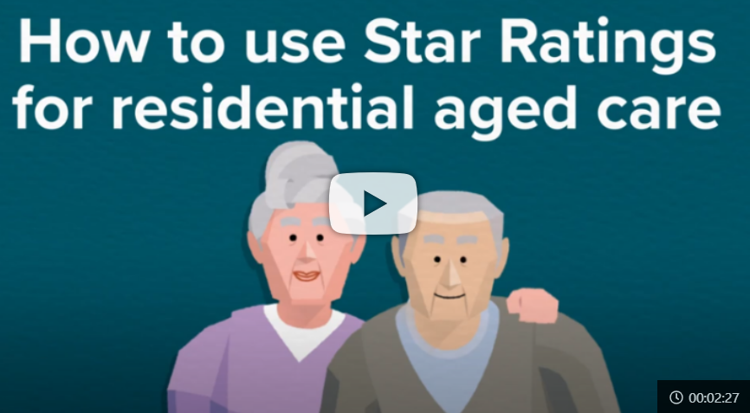 | Watch here.  Also available in:  Arabic  Cantonese  Greek  Italian  Mandarin  Vietnamese | Share on your website or social media channels from YouTube.
Poster | 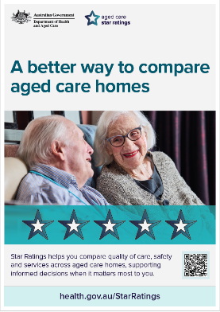 | Download here.  Also available in:  Arabic  Cantonese  Greek  Italian  Mandarin  Vietnamese | Print and display in reception or waiting areas.
Postcard | 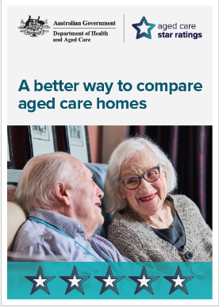 | Download here.  Also available in:  Arabic  Cantonese  Greek  Italian  Mandarin  Vietnamese | Print and display in reception or waiting areas.
Social Carousel Tiles | 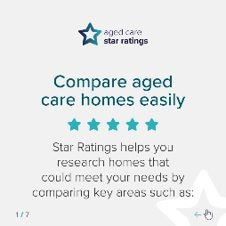 | Download here.  Also available in:  Arabic  Cantonese  Greek  Italian  Mandarin  Vietnamese | Share on your social media channels.
Factsheet for older people | 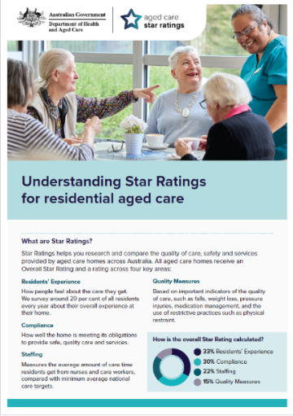 | Download here.  Also available in:  Arabic  Cantonese  Greek  Italian  Mandarin  Vietnamese | Share online, or print and hand out to your patients.
Factsheet for support people | 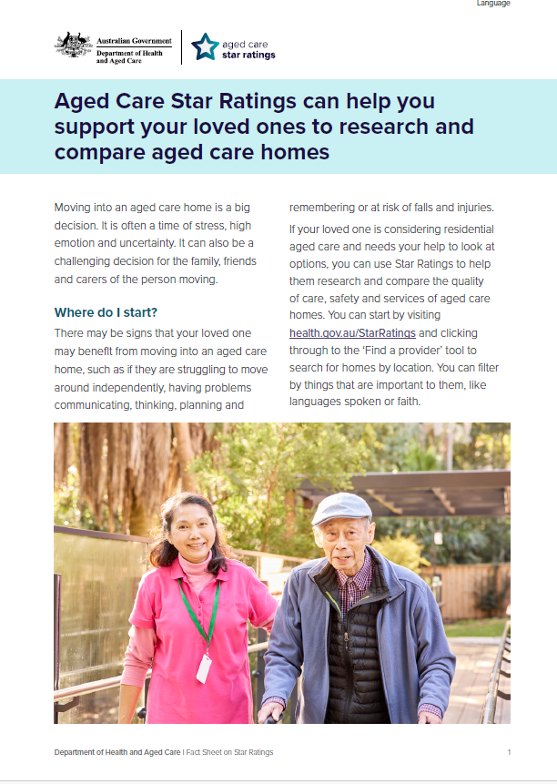 | Download here.  Also available in:  Arabic  Cantonese  Greek  Italian  Mandarin  Vietnamese | Share online, or print and hand out to your patients.
Frequently asked questions | 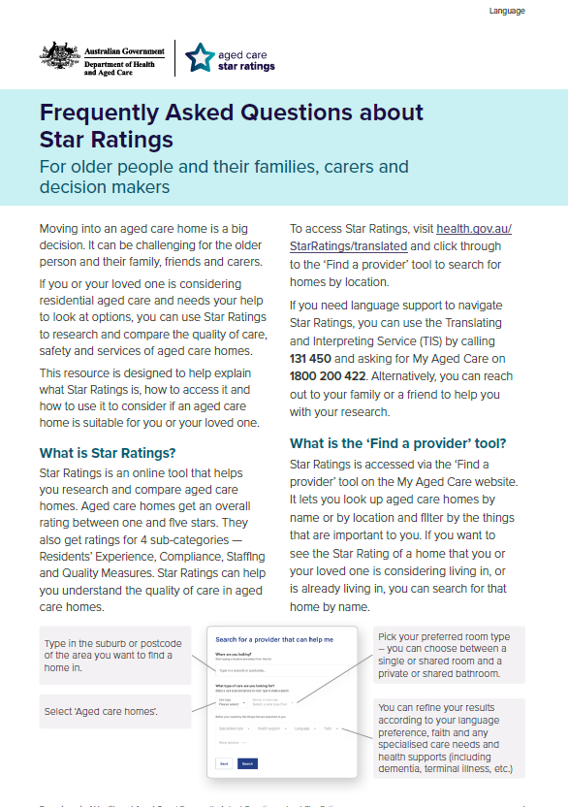 | Download here.  Also available in:  Arabic  Cantonese  Greek  Italian  Mandarin  Vietnamese | Hand out to older people considering aged care, their families and carers.
Brochure | 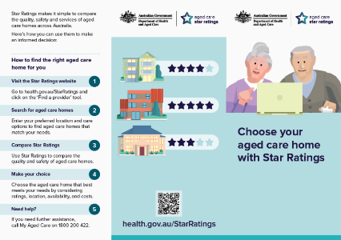 | Download here. | Print and display in reception or waiting areas. Hand out to older people, their families and carers.

More information
For more details about Star Ratings for residential aged care homes, visit health.gov.au/StarRatings
If you need further assistance, please contact The Department of Health and Aged Care at communication.agedcare@health.gov.au.

