Single Assessment System map

Welcome to the Single Assessment System online map instructions. These instructions support you to:

* move around the map
* search for an address or service area
* investigate the Single Assessment System service areas and Aged Care Planning Regions (ACPRs).

These instructions and associated images are primarily for use with a desktop web browser (e.g. Google Chrome, Firefox or Edge), however, the principles can also be applied to tablet and mobile views.

**How to navigate the map**

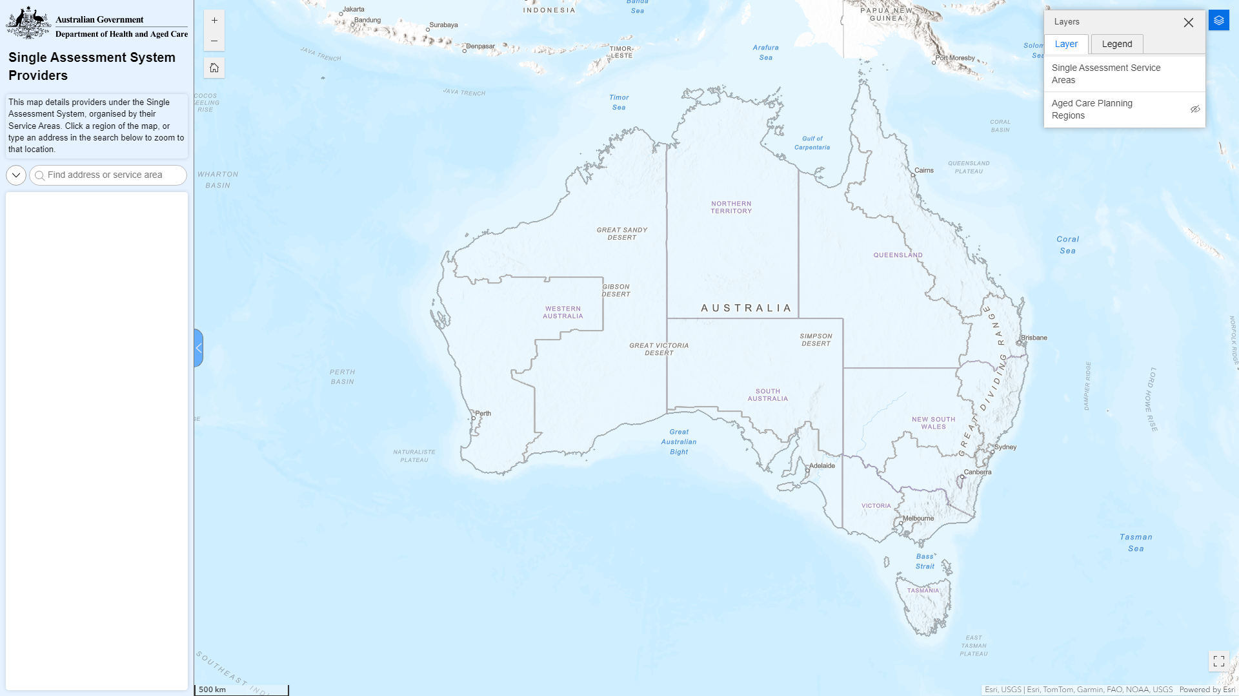

You can navigate the map by clicking and dragging your mouse around, zooming in and out with the scroll wheel, searching for a location or service area with the search bar, or a combination of different methods.

**How to view different layers in the map**

The information provided by the map is organised into "layers". Each layer is an interactive picture that you can turn on and off to see the visual information. You can see a full list of layers available by clicking on the layer button in the top right of the map. Only one layer is selected when the map is first opened, which is the "Single Assessment System service areas". There is one additional layer for "Aged Care Planning Regions" which you can turn on by clicking on the symbol of the eye in the layer menu, and you can also do this with the Single Assessment System service areas by clicking the eye symbol to turn them off.

When you are finished with the layer list, you can close it by clicking the x in the top right corner of the pop-up.

**How to use the tools**

|  |  |
| --- | --- |
| Function | Description |
| Home | * Zoom to the original Australia-wide view of the map. |
| Zoom in / out | * Zoom in and out of the map, alternatively you can use the scroll wheel on your mouse. * If you hold Shift and click and drag your mouse, you will create a box that you will zoom to when you release left click. |
| Search | * Search for an address, Single Assessment System service area or Aged Care Planning Region. * If you would only like to do one kind of search, you can click the down arrow next to the search bar and turn off "Single Assessment System Service Areas", "Aged Care Planning Regions" or "Address Search". |
| Clear search selection | * After searching for one location and wanting to search for a second location, click the x in the search bar and the trash can above the location details to fully clear your selection. |
| Layer list | * All the data layers in the map can be turned on or off. Click the eye symbol next to a layer to show or hide it. |
| Full screen | * Make the map take up the entire screen it is currently on. |
| Close sidebar | * Closes or reopens the sidebar at the left edge of the screen. |