# Service and Support Portal User Guide - Serious Incident Response Scheme: Residential Aged Care Services

This My Aged Care user guide is designed for administrators, team leaders and staff members. It explains how to access and use the Serious Incident Response Scheme (SIRS) functions for residential aged care services within the Service and Support Portal.

! The following services are considered residential aged care services:

* residential aged care facility (RACF)
* multi-purpose service (MPS) or
* National Aboriginal and Torres Strait Islander Flexible Aged Care Program (NATSIFACP) service.

This guide is spilt into the following sections:

SIRS functions and roles 2

Granting users access to the SIRS portal 2

Submitting a new SIRS notice 5

Viewing existing SIRS notices 8

Editing or deleting draft SIRS notices 11

Finding SIRS notices using the basic and advanced searches 13

Exporting a list of draft SIRS notices 17

Viewing SIRS follow-up notifications 19

Uploading multiple SIRS notices at once 21

Accessing SIRS help and further information 26

! Throughout this guide, additional useful instructions and information can be found by hovering over the help icons A common help icon, stylized as a blue question mark inside a white circle. Such icons indicate that more information can be provided by interacting with the icon. next to each question.

## SIRS functions and roles

| Role | Description of access |
| --- | --- |
| Administrator | Administrators have access at either an organisation or outlet level to:   * Provide staff access to the SIRS portal * Manage the roles within the SIRS portal * View all SIRS notifications * Edit and delete all draft SIRS notifications * Submit SIRS notifications * Upload multiple SIRS notices at once. |
| Team Leader | Team leaders have access at either an organisation or outlet level to:   * View all SIRS notifications * Edit or delete all draft SIRS notifications * Submit SIRS notifications. |
| Staff Member | Staff members have access at an outlet level to:   * View their created SIRS notifications * Edit or delete their draft SIRS notifications * Submit SIRS notifications. |

## Granting users access to the SIRS portal

If you are an administrator, you can provide staff access to the **SIRS Notice** dashboard tile and corresponding portal by following the steps below:

1. Log in to the My Aged Care Service and Support Portal.
2. From the home screen of the My Aged Care Service and Support Portal, select the **Staff administration** tile.

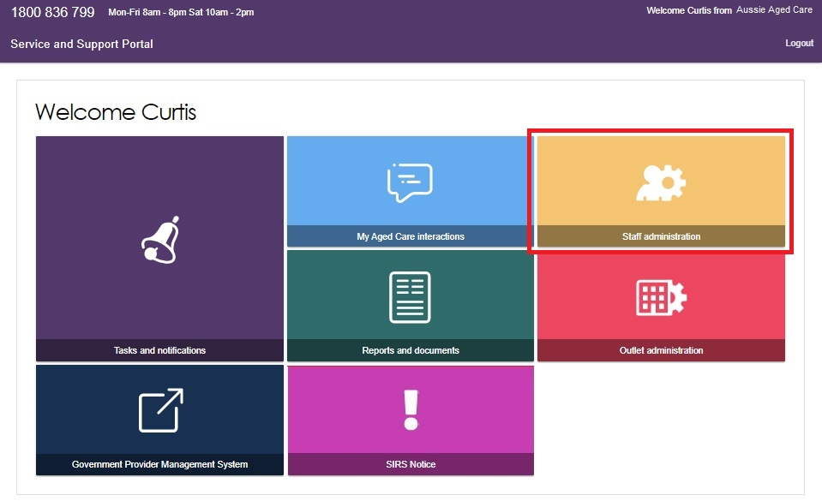

1. Scroll down to the staff section of the **Staff administration page**. Use the search fields to filter for the correct staff member. Then, select the name of the staff member who requires access to the SIRS portal.

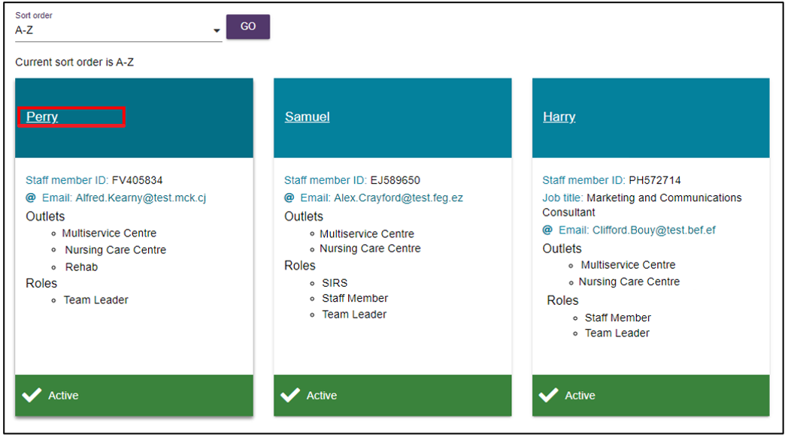

! For more information on how to add a staff member to your facility in the My Aged Care Service and Support Portal, please refer to the [My Aged Care Assessor Portal – Organisation Administrator User Guide](https://www.health.gov.au/resources/publications/my-aged-care-assessor-portal-organisation-administrator-user-guide?language=en).

1. Select the **EDIT STAFF DETAILS** button.

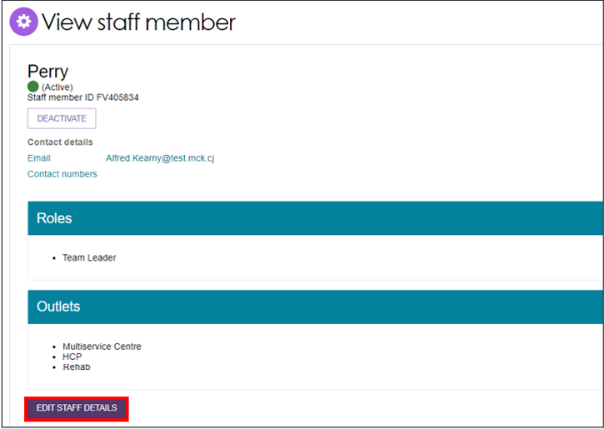

1. Select the **MANAGE ROLES** button.

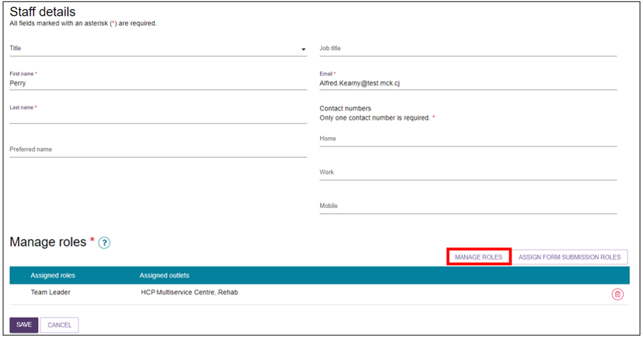

1. A pop-up box will appear displaying a series of checkboxes. If the staff member already has a role, the corresponding box will be checked. Check the corresponding **SIRS** checkbox by selecting it. Then, select the **SAVE** button.

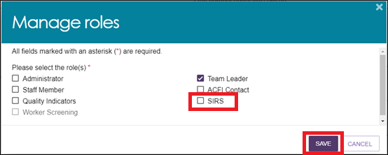

The staff member will now be able to view and select the new **SIRS Notice** tile on their dashboard, enabling them to access view, edit, and submit SIRS notices and associated information.

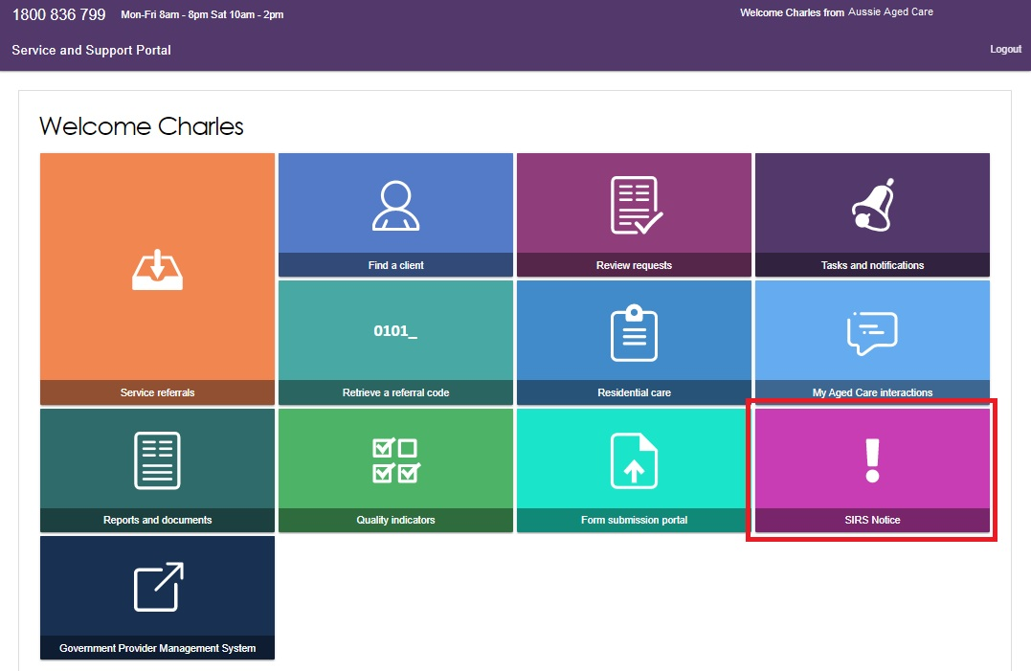

## Submitting a new SIRS notice

! For information on what incidents must be reported in a SIRS notice, visit the [Aged Care Quality and Safety Commission’s website](https://www.agedcarequality.gov.au/sirs).

1. Log in to the My Aged Care Service and Support Portal.
2. From the home screen of the My Aged Care Service and Support Portal, select the **SIRS Notice** tile.



Select the **Submit new notice** tile to begin filling out a new SIRS notice form.

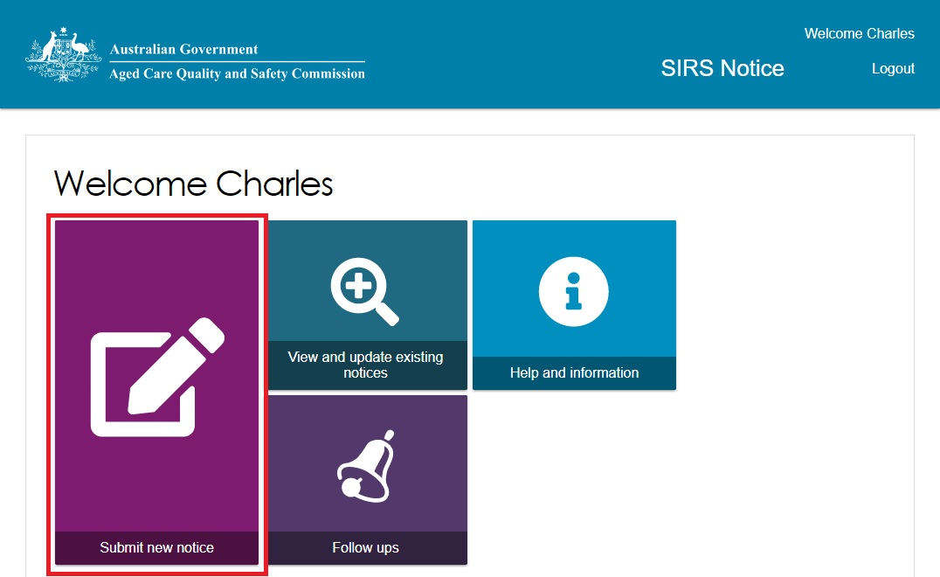

! Additional helpful information and examples can be found by following the link to the [Aged Care Quality and Safety Commission website](https://www.agedcarequality.gov.au/sirs/submit-notifications).

A new tab will open containing important information pertinent to the SIRS notice. Read the information carefully, then select the **Next** button to proceed.

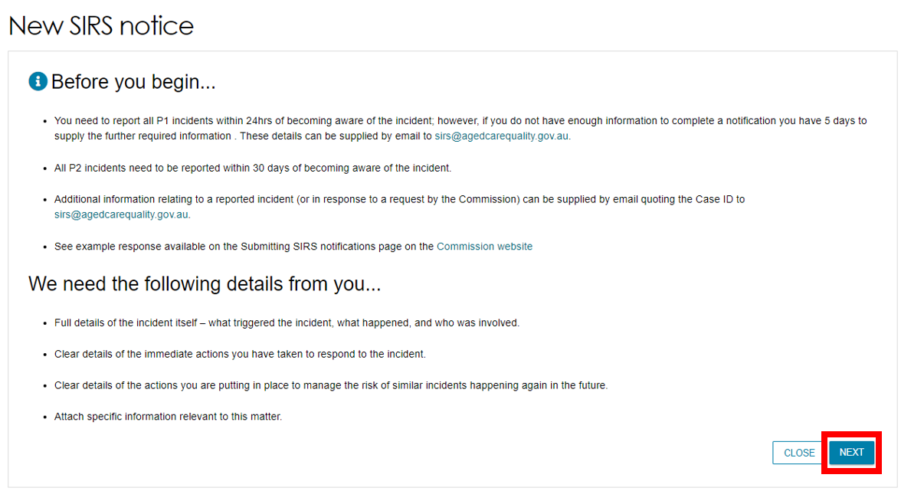

1. Complete the required information on the **Your details** page, including selecting the appropriate setting where the incident occurred in. Ensure you have entered information for each field marked with an asterisk (*). Once you have finished, navigate to the **Incident details** page by selecting the **Next** button.

To access help text detailing what information is required for each input field, select the question mark symbols A common help icon, stylized as a blue question mark inside a white circle. Such icons indicate that more information can be provided by interacting with the icon. next to each field.

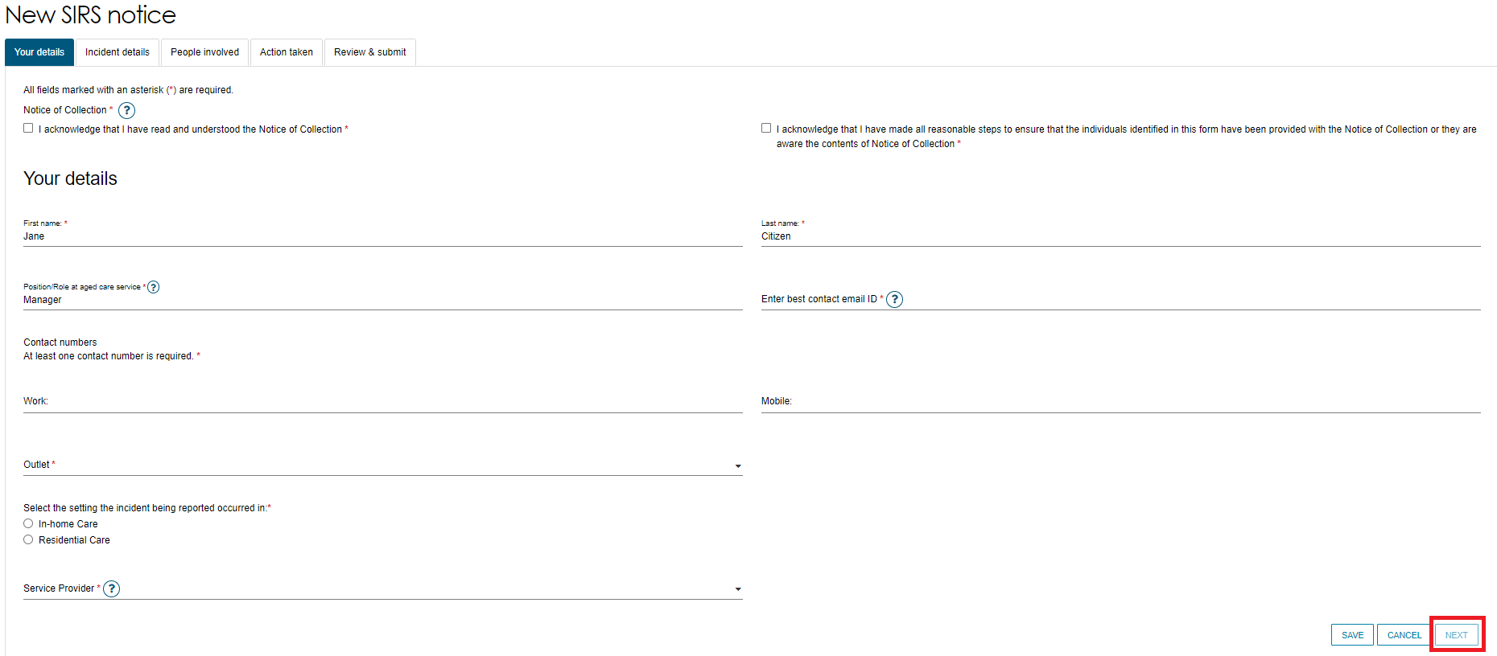

! The two (2) notices of collection acknowledgements located near the top of the **Your details** page of the SIRS form must be checked before proceeding.

1. Complete the required information on the **Incident details** page and the **People involved** page. The SIRS notification form allows you to capture details for up to a maximum of six (6) **Subjects of allegation** within a single notification on the **People involved** page.
2. Complete the required information on the **Action taken** page.

! Ensure you have entered information for each field marked with an asterisk (*) for every page.

1. After completing all four data collection pages of the SIRS form, you will be taken to the **Review & Submit** page. This page summarises the information you have provided, please review it carefully.

If mandatory information is missing, a large red **X** will appear next to the relevant page summary. To return to and edit a page, select the pencil symbol on the right-hand side of the page summary.

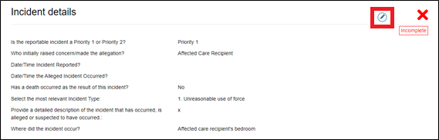

1. Select the acknowledgement checkbox, and then select the **SUBMIT** button to proceed.

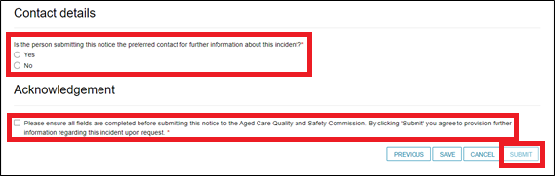

1. A pop-up box will appear, prompting you to confirm that the notice is ready for submission.

Select the **SUBMIT** button to submit your SIRS notice.

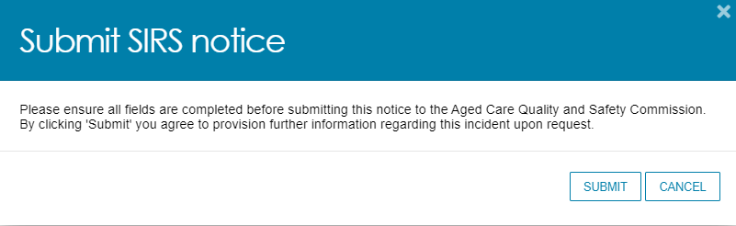

The submitted notice can now be viewed in the list of existing notices. Refer to the Viewing existing SIRS notices section of this guide for more information.

## Viewing existing SIRS notices

Administrators, team leaders, and staff members can view existing SIRS notices based on their permissions. Refer to the SIRS functions and roles section of this guide for more information.

1. Log in to the My Aged Care Service and Support Portal.
2. From the home screen of the My Aged Care Service and Support Portal, select the **SIRS Notice** tile.



1. Select the **View and update existing notices** tile.

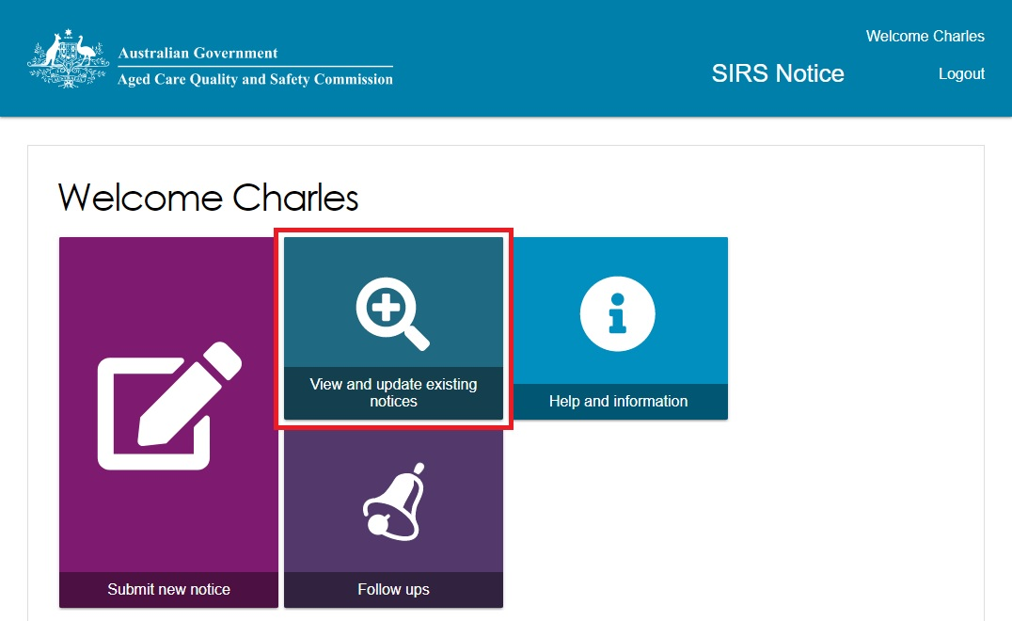

1. Use the search fields and the **FILTER** button near the top of the page to search for the appropriate SIRS notice. Once you have found the appropriate notice in the table, select the **Incident ID** to view the notice.

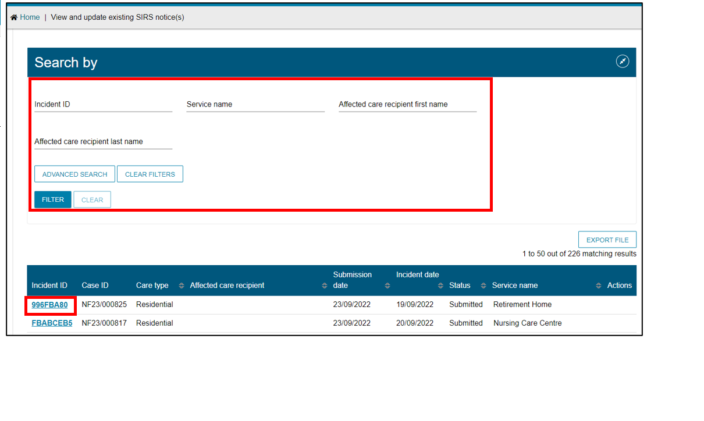

! If you are an administrator or team leader at the organisation level, you will see a list of all in-draft and completed notifications for your organisation. If you are an administrator or team leader for only your outlet, you will see a list of all draft and completed notifications for your outlet. Drafts will be deleted after 60 days.

1. You can now view and navigate through the draft or submitted notifications using the **NEXT** and **Previous** buttons.

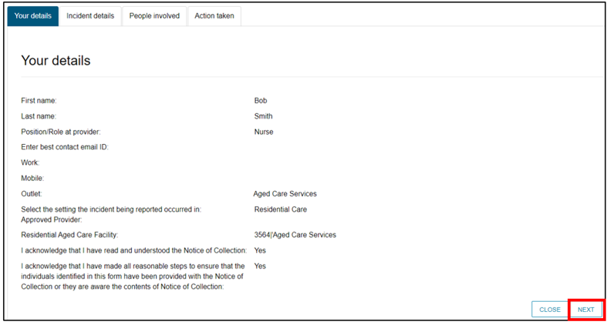

## Editing or deleting draft SIRS notices

Administrators, team leaders, and staff members can edit or delete draft SIRS notices based on their permissions. Refer to the SIRS functions and roles section of this guide for more information.

1. Log in to the My Aged Care Service and Support Portal.
2. From the home screen of the My Aged Care Service and Support Portal, select the **SIRS Notice** tile.



1. Select the **View and update existing notices** tile.



1. Use the search fields and the **FILTER** button near the top of the page to search for the appropriate SIRS notice. Once you have found the appropriate draft notice in the table, you can select the pencil symbol to edit the draft notice.

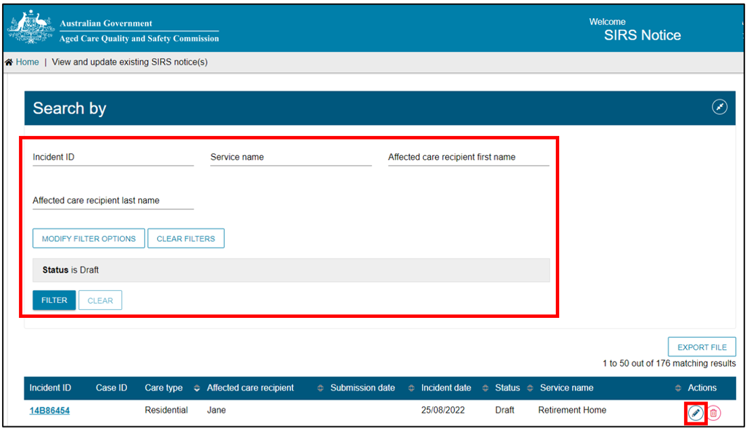

The process for editing a draft notice is similar to creating a new notice. Refer to the Submitting a new SIRS notice section of this guide for more information.

! If you are an administrator or team leader at the organisation level, you will see a list of all in-draft and completed notifications for your organisation. If you are an administrator or team leader for only your outlet, you will see a list of all draft and completed notifications for your outlet. Drafts will be deleted after 60 days.

1. Draft notices can also be deleted by selecting the bin symbol to the right of the notice.

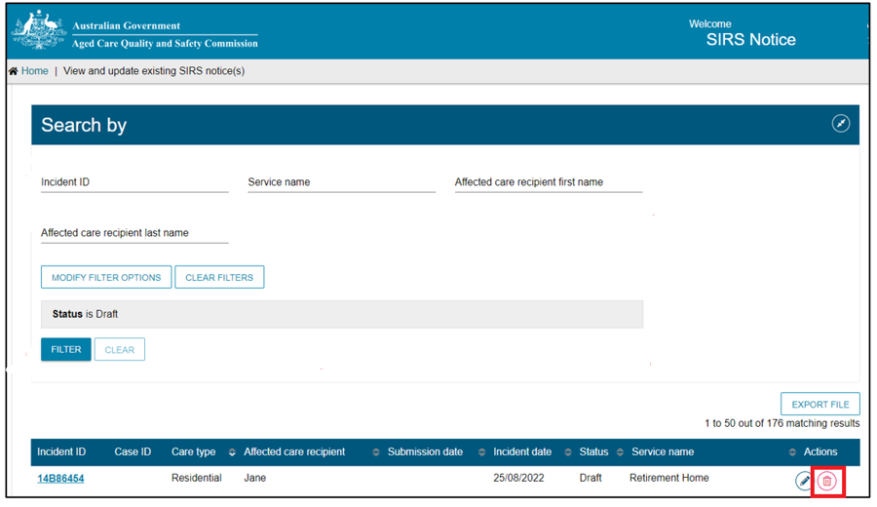

1. A pop-up will appear, prompting you to confirm your deletion. Select **OK** to delete the draft notice.

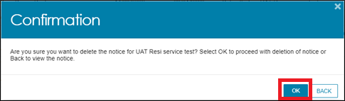

## Finding SIRS notices using the basic and advanced searches

1. Log in to the My Aged Care Service and Support Portal.
2. From the home screen of the My Aged Care Service and Support Portal, select the **SIRS Notice** tile.



1. Select the **View and update existing notices** tile.



1. To perform a **basic search**, type the appropriate terms into either of the **Incident ID**, **Service name**, **Affected care recipient first name**, or **Affected care recipient last name** input field(s).
2. Then select the **FILTER** button to filter the list of SIRS notices using your terms. The results of your basic search will appear in the table below.

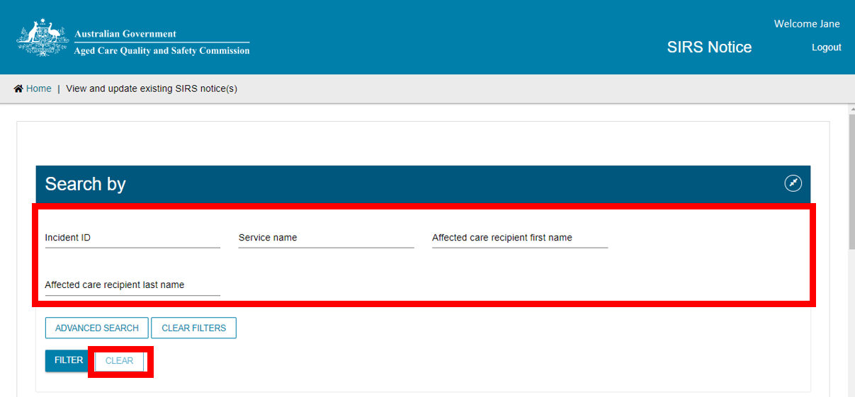Additionally, to clear a basic search, select the **CLEAR** button.

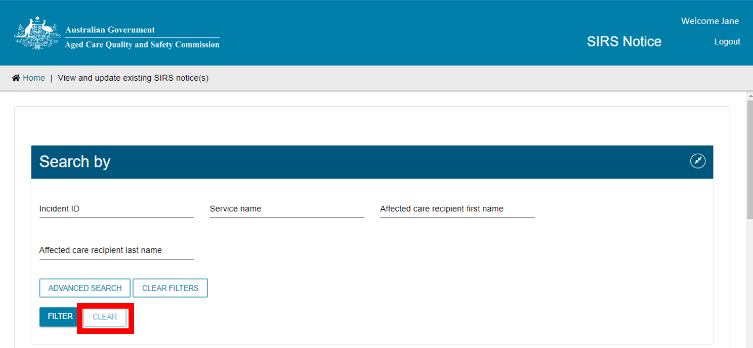

1. To perform an **advanced search**, select the **ADVANCED SEARCH** button.

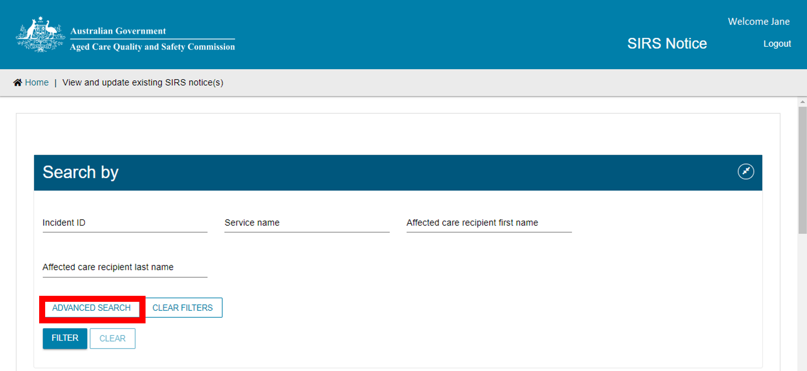

A pop-up window will appear. Use the drop-down menu to select the advanced filter you wish to use, then select the **ADD FILTER** button to reveal the input field for that filter.

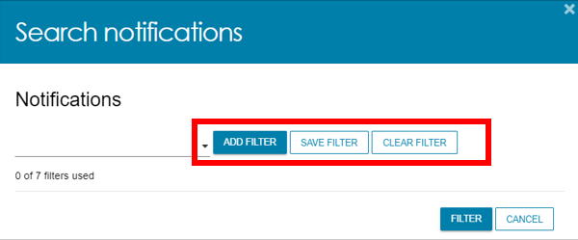

1. In the newly revealed input field for your chosen filter, input your chosen terms. For some filters, terms are selected from a drop-down menu. For other filters, terms are typed into the input field. Once you have inputted your terms, select the **FILTER** button to begin your advanced search using your chosen filters and terms.

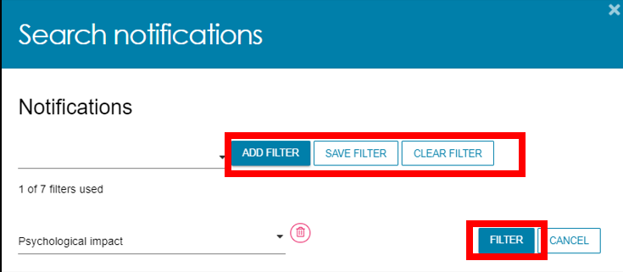

Up to seven filters can be added together by repeating steps seven and eight. Filters can also be deleted by selecting the bin icon on the right-hand side of the filer.

1. After selecting **FILTER** the popup will close, and your results will appear in the table below. To clear an advanced search, select the **CLEAR FILTERS** button.

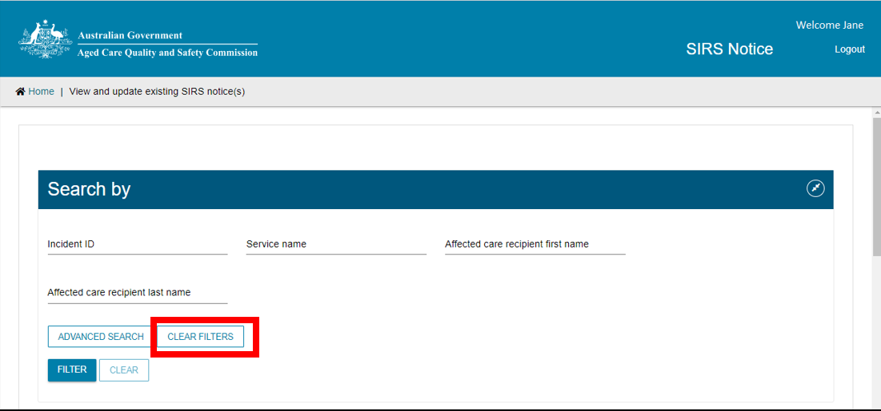

## Exporting a list of draft SIRS notices

If you are an Organisation Administrator, you will be able to export a list of draft SIRS notices. Outlet Administrators and staff, however, cannot export draft SIRS notices.

1. Log in to the My Aged Care Service and Support Portal.
2. From the home screen of the My Aged Care Service and Support Portal, select the **SIRS Notice** tile.



1. Select the **View and update existing notices** tile.



1. Select the **EXPORT FILE** button on the right-hand side of the page. If this button is not visible, check your permissions as it will only be visible for Organisation Administrators.

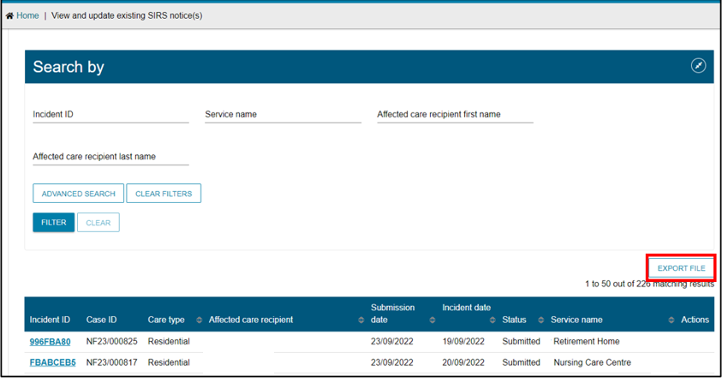

1. A .csv file will be automatically downloaded to your computer with the following name format:

“DraftNotices_” + “YYYY” + “MM” + “DD” + “hhmmss” + “#” + “.csv”.

For example, “DraftNotices_202206101504556.csv” (where “hh” is 24hr time).

The file contains the following information about each draft SIRS notice as a table:

1. Notification status
2. Care Type
3. Service name
4. Date/time incident reported
5. Date/time incident occurred
6. Incident type
7. Affected care recipient first name
8. Affected care recipient last name
9. Psychological impact
10. Physical impact
11. Provider determined priority level

Use Microsoft Excel or an equivalent spreadsheet editor to open the .csv file.

! Please note: .csv files cannot store anything beyond numbers and text. If you edit a .csv file in Excel, and then use any of Excel’s formatting or formula tools, you must **save as** an .xlsx file to keep your changes.

## Viewing SIRS follow-up notifications

1. Log in to the My Aged Care Service and Support Portal.
2. From the home screen of the My Aged Care Service and Support Portal, select the **SIRS Notice** tile.



1. Select the **Follow ups** tile.

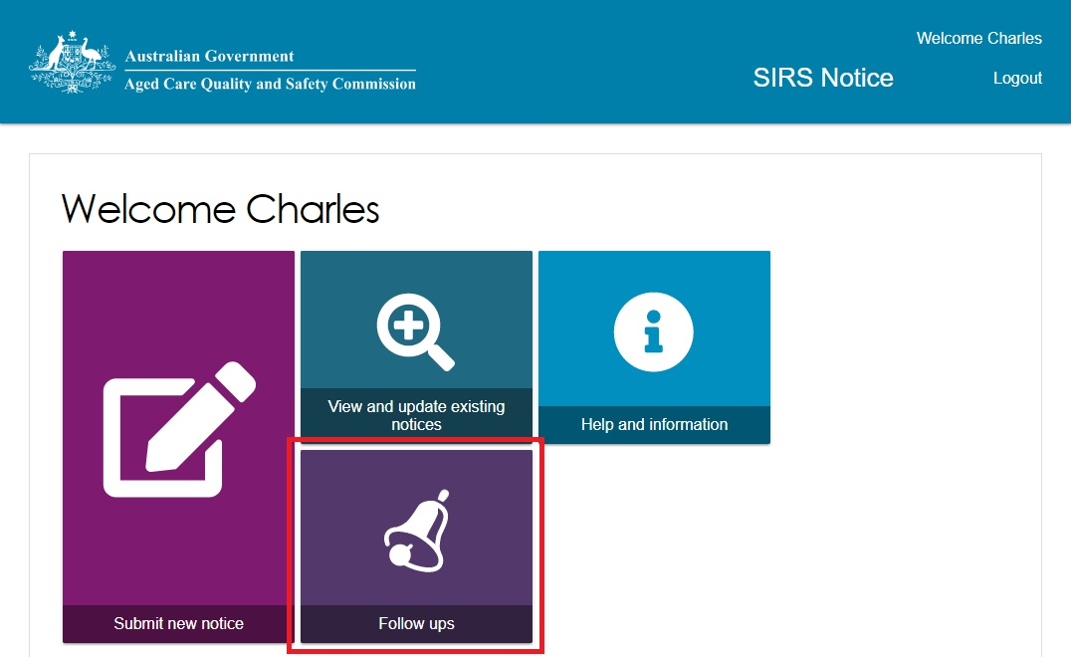

1. To search for a specified follow up, input search terms into the **Incident ID**, or **Service name** search fields, and select the **FILTER** button. The results will be listed in the table below.

Once you have found the appropriate follow-up in the table, select the name of the follow-up under the **Category** column to view it.

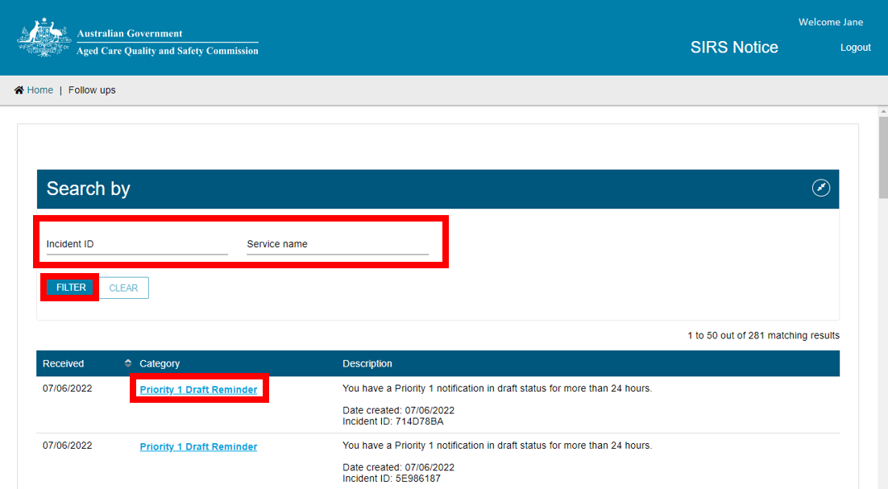

! If you are an administrator or team leader you will be able to view all follow up emails concerning cases relevant to your organisation and outlet respectively. Staff members can only view follow ups concerning draft notifications created by themselves.

1. A pop-up window will appear, detailing the chosen follow-up. When you have finished reading the follow-up, select the **CLOSE** button.

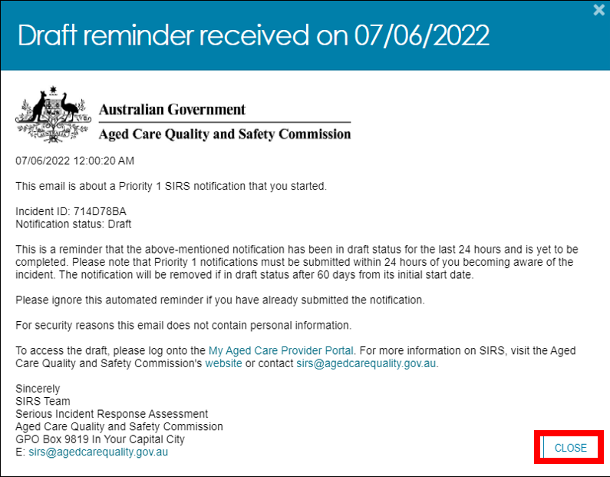

1. You can also use the **Follow ups** page to easily create a new SIRS notice. Select the **NEW SIRS NOTICE** button at the bottom of the page to begin creating a new notice.

For more information, please refer to the Submitting a new SIRS notice section of this guide.

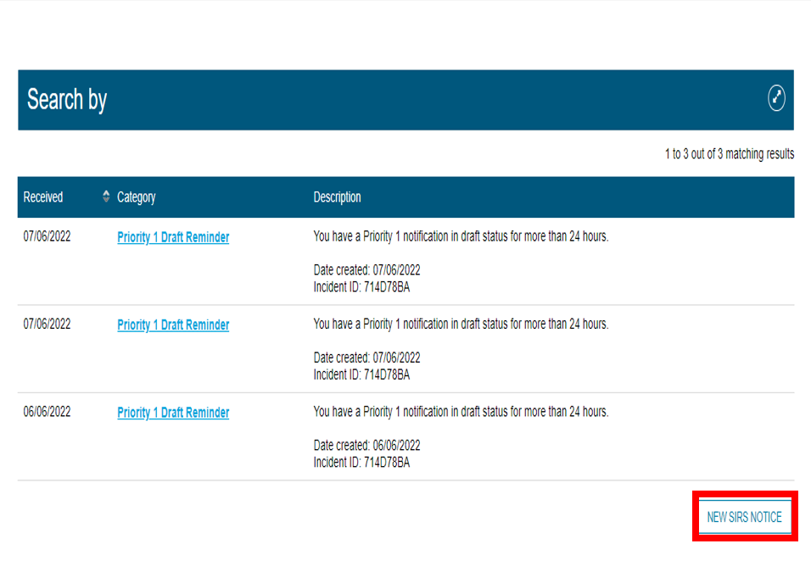

! Follow-ups concerning drafts will remain in your list for 60 days, after which they will be deleted.

## Uploading multiple SIRS notices at once

Organisation and outlet administrators can **bulk upload** multiple Priority 2 SIRS notices at once. The bulk upload function does not support SIRS notices that contain multiple offenders or Priority 1 incidents.

1. Log in to the My Aged Care Service and Support Portal.
2. From the home screen of the My Aged Care Service and Support Portal, select the **SIRS Notice** tile.



1. Select the **Bulk Upload** tile. The bulk upload page lists previous bulk uploads in the table below.

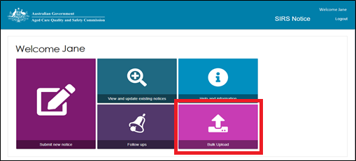

1. Bulk uploads need to be validated before they can be inputted into the system. To view the validation status of previously performed bulk upload, select the magnifying glass symbol to the right of an upload.

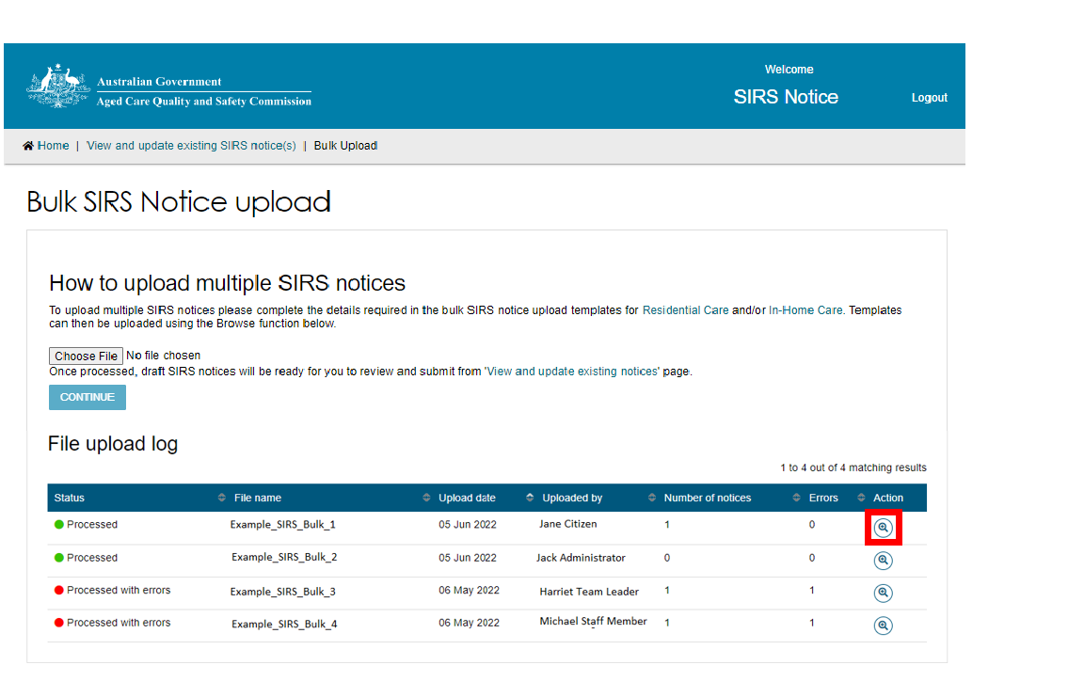

1. Bulk uploads need to adhere to the provided template to be successfully processed. Before starting any bulk upload, you must first download the SIRS notice upload template. For residential aged care services, click the **Residential Care** link to download the corresponding template.

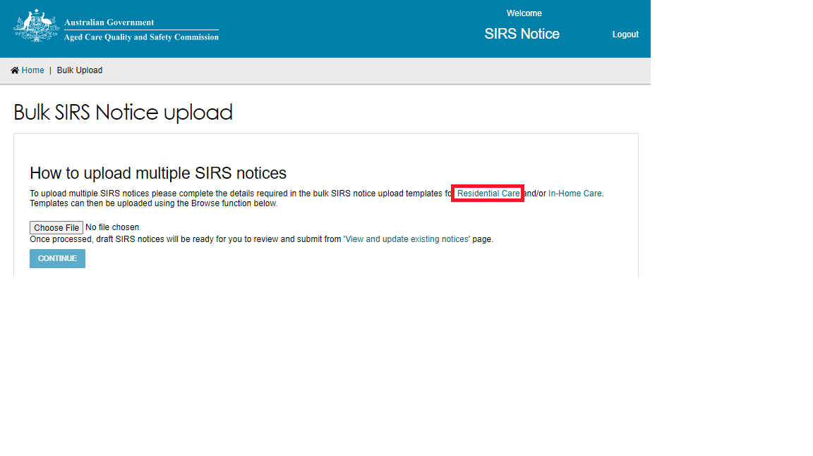

1. An .xlsx file will be downloaded to your computer called **SIRS_template_resi**. Open the file and begin inputting the details of your SIRS notice(s). Each row within the file will produce a unique single SIRS notice and contains 87 columns which need to be considered.

Some of the columns contain data validation, prompting you to pick an option from a drop-down menu. In such cases, typing in invalid information will prevent you from saving the file.

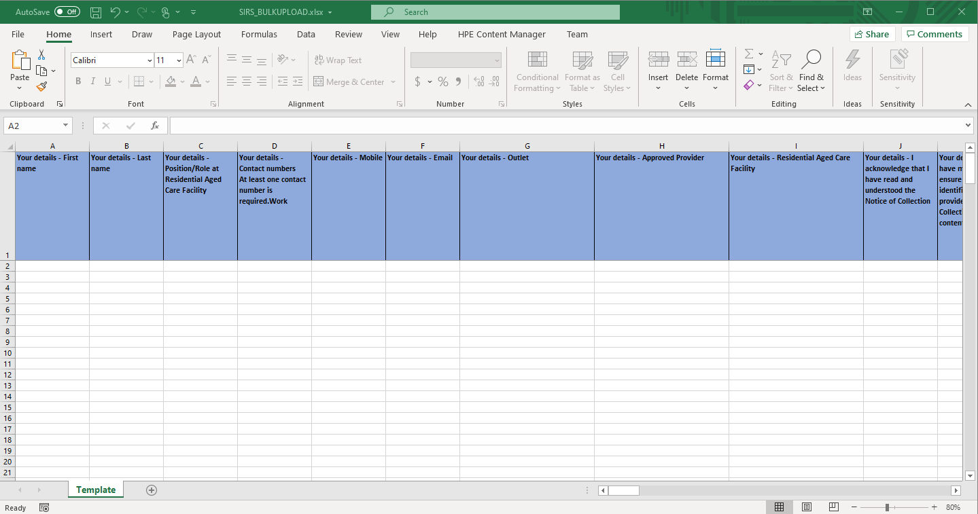

! The maximum file size is 5mb (roughly 500 filled rows).

Please note: when filling out the .xlsx file, you must NOT copy / paste any rows or columns. Doing so may break the data validation rules, causing your bulk upload file to be invalid.

1. Once you have filled out the .xlsx. file save the file with a unique name, this will help you find the file later. Then select the **Choose File** button on the bulk upload page.

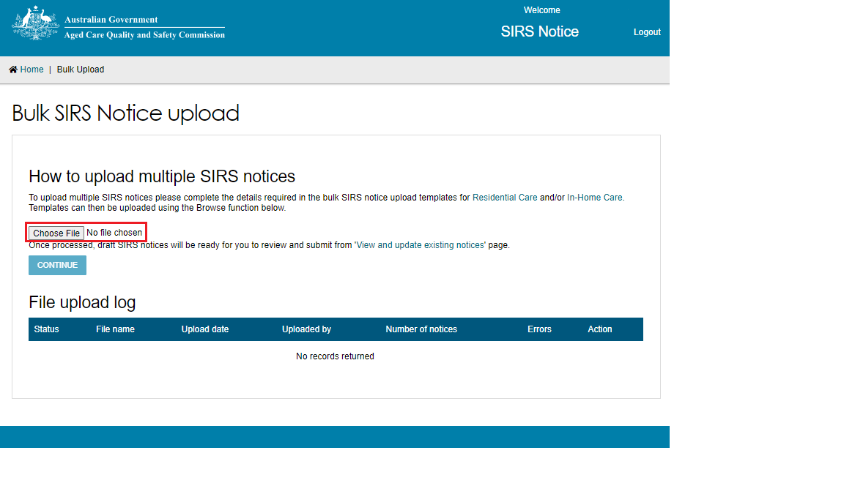

1. A file explorer pop-up box will open, prompting you to search for and select the .xlsx file you just filled out. Find and open the file using the popup box. Your selected file will be uploaded. After uploading the file, select the **CONTINUE** button to proceed.

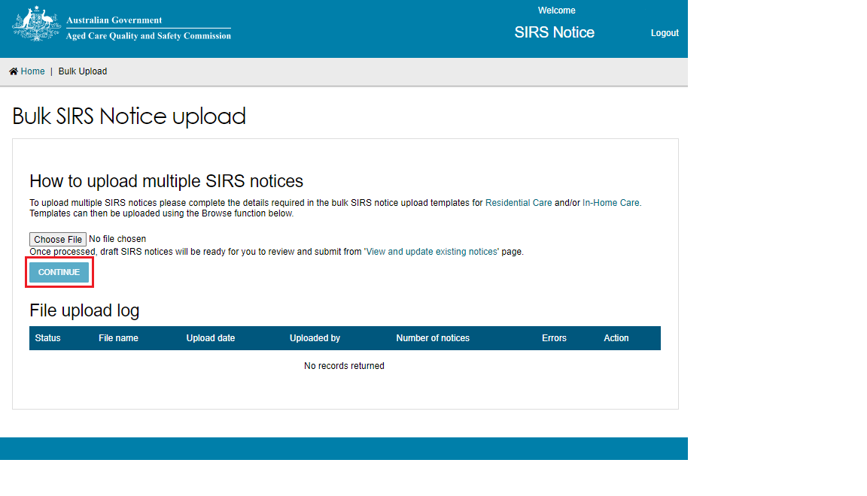

1. Processing of the file will begin, as indicated by the **Processing** status in the table. Reload the web page after a few minutes to view the results of the processing.

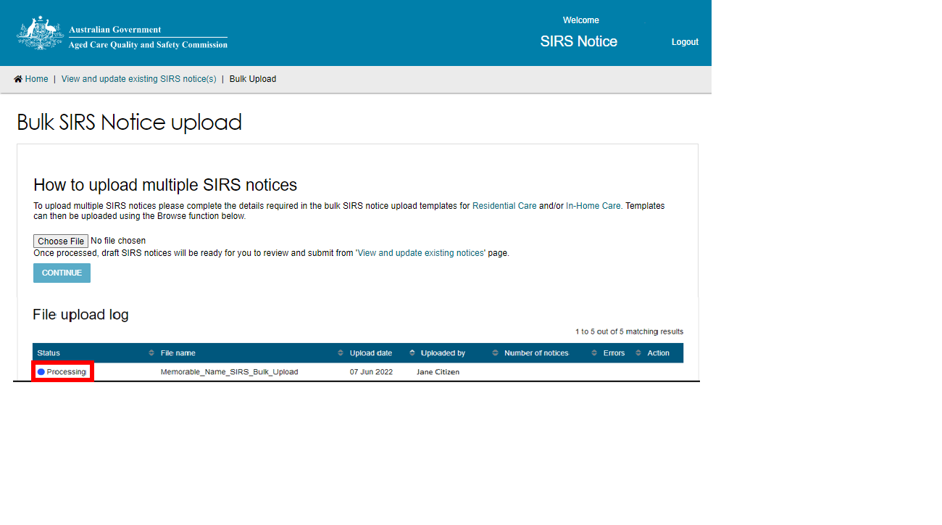

1. Once the status changes to **Processed** or **Processed with errors**, select the magnifying glass symbol to view the upload details.

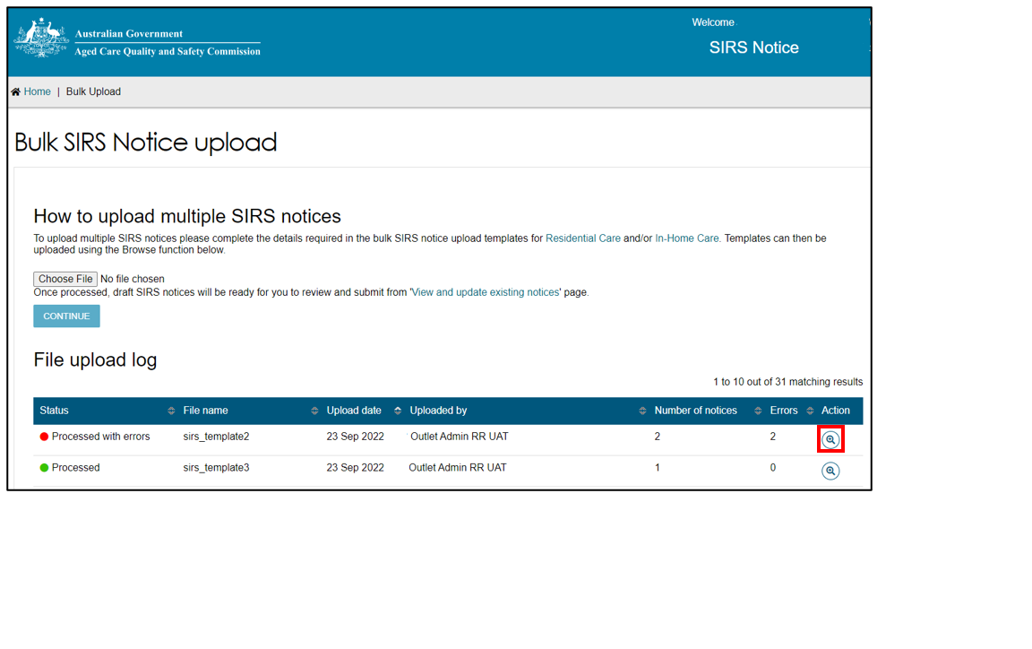

1. Each notice contained within the bulk upload will be listed in a separate row.

Notices with a **Ready for Submission** status possess no errors and can be submitted immediately by selecting the paper airplane symbol on the right-hand side of the notice.

You can also submit all notices which are **Ready for Submission** by selecting the **SUBMIT ALL VALID REPORTS** button.

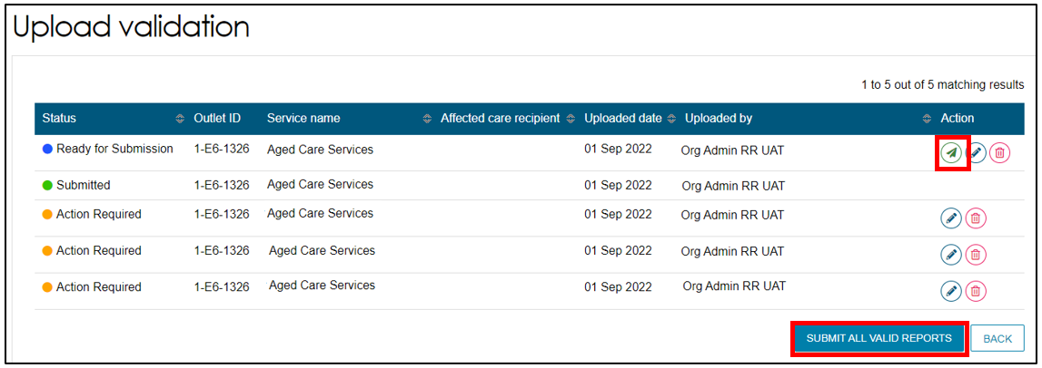

1. Notices with an **Action Required** status possess errors and must be edited before submission. To edit a draft notice, select the pencil symbol on the right-hand side of the notice.

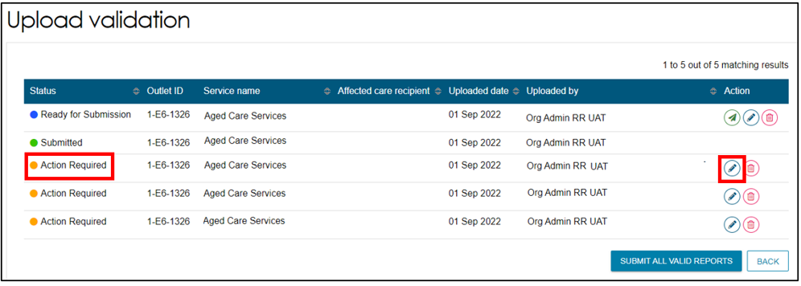

1. After selecting the pencil symbol, you will be taken to the **Review & Submit** page of the SIRS form, allowing you to review the incomplete or erroneous segments of the notice and submit them individually.

Please refer to Submitting a new SIRS notice for more information regarding this step.

1. Duplicates or other erroneous notices can also be removed by selecting the bin symbol on the right-hand side of the notice.

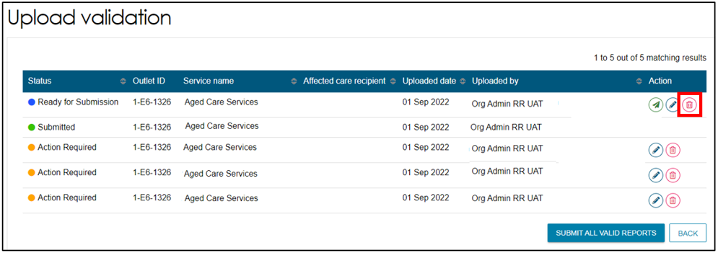

! Unsubmitted draft notices, such as those within a bulk upload, will be removed after 60 days.

## Accessing SIRS help and further information

1. Log in to the My Aged Care Service and Support Portal.
2. From the home screen of the My Aged Care Service and Support Portal, select the **SIRS Notice** tile.



1. Select the **Help and information** tile.

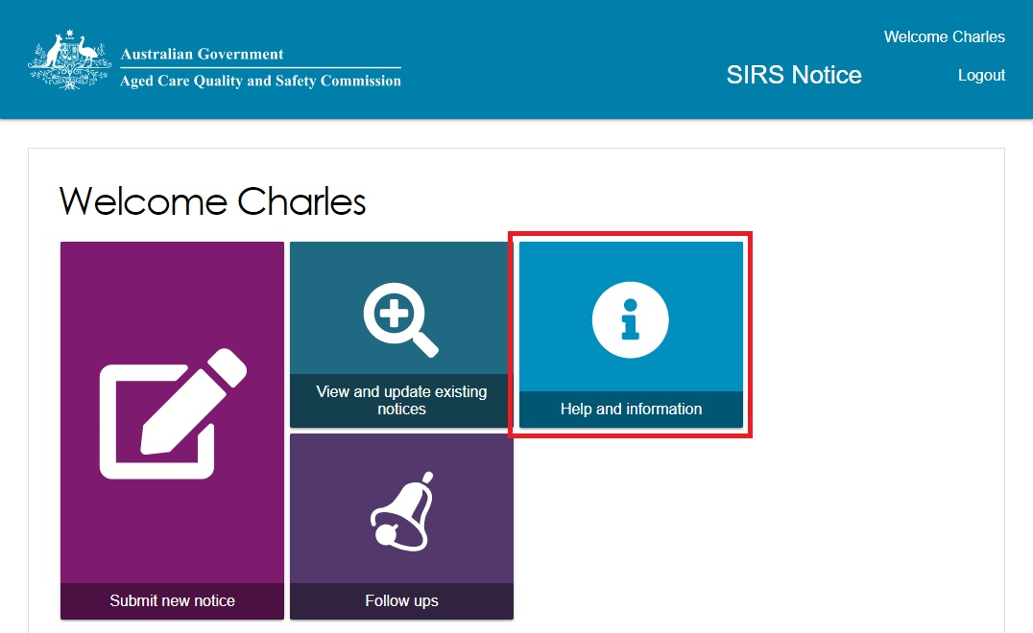

1. The various channels for additional help and information will be displayed. Select the links within each information column to navigate to the corresponding information or help resource.

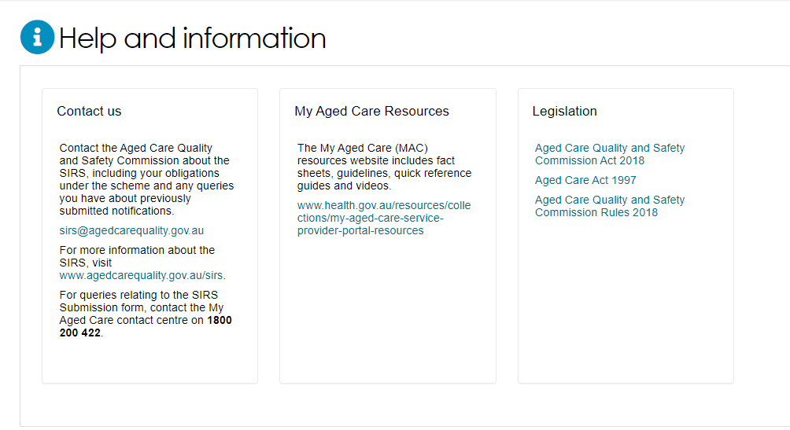

! You can also call the My Aged Care Service Provider and Assessor Helpline on 1800 836 799. If you have a technical issue you can ask the Call Centre staff to escalate your query to the tier 2 team for resolution.