Childhood immunisation - health professionals’ kit
November 2024

About the health professionals’ kit
Research has shown that a consistent recommendation from a healthcare professional plays an important role in parents’ decisions about childhood vaccination. Health professionals are vital for communicating the benefits and safety of childhood immunisation and providing reassurance that vaccinating their children is the right thing to do.
The resources in this kit are designed to support you in conversations with parents and carers about childhood immunisation.
Resources included in this kit:
- key messages
- answers to common questions from parents and carers
- support for conversation approaches to childhood immunisation
- following up on children who have missed scheduled vaccines
- immunisation clinical support
- communication resources
- newsletter article.

Further information
For more information, visit health.gov.au/childhoodimmunisation.
For any queries about the resources in this kit, please contact immunisationcomms@health.gov.au
Information for parents, resources and campaign materials can be found at health.gov.au/childhoodimmunisaion
Easy read information for accessibility purposes can be found here.
Disease specific information can be found at:
- Childhood immunisation video hub
- skai.org.au
Table of contents
Key messages 1
Common questions from parents and carers 2
Conversation approaches to childhood immunisation 2
Following up on children who have missed scheduled vaccines 2
Immunisation clinical support 3
Posters, brochures, videos, stickers 4
Resources for Aboriginal and Torres Strait Islander people 8
Easy Read resources 12
Newsletter article 14
Social posts 15

Key messages
Topic | Message
Routine childhood immunisation | - Childhood immunisation is a safe and effective way to protect your kids from serious diseases. Immunisation helps children stay healthy by preventing serious infections.  - The National Immunisation Program provides free vaccines at scheduled times to infants and children between birth and the age of 4 to protect them against serious diseases.
The National Immunisation Program Schedule | - The timing of each dose of every vaccine in the childhood immunisation schedule is carefully planned to safely protect babies and children from as young as possible and when they need it most.  - All diseases we vaccinate against on the schedule can be serious for children and the community. We still vaccinate against rare diseases like polio and diphtheria to prevent the diseases re-emerging in Australia.  - Aboriginal and Torres Strait Islander children and children with certain medical conditions are recommended to receive extra vaccines for free under the National Immunisation Program.
Timing and catch up | - Vaccinating on time and in line with the National Immunisation Program schedule gives the best protection. Delaying vaccines means your child is unprotected for longer.  - It’s easy to catch up on missed vaccinations. There is no need to repeat the doses already received and there is no need to get extra doses.
Side effects and safety | - Almost all reactions are minor and usually go away within a few days. These are mostly injection site reactions and show the immune system is responding to the vaccine. Serious side effects from immunisation are very rare.  - All childhood vaccines have been carefully tested and continue to be monitored to ensure the highest safety standards are maintained.
Common questions and more information | - For more information, including how to check if your child’s vaccinations are up to date, visit health.gov.au/childhoodimmunisation. You can also talk to your trusted doctor, nurse or other health professional.  - Visit the Your Questions Answered page on our website for further frequently asked questions and answers.  - When looking online for vaccine information, be sure to use reliable sources based on scientific evidence, such as the Childhood vaccinations page on the Sharing Knowledge About Immunisation website.  - Video resources have been developed to help parents and carers understand the diseases we vaccinate against and the NIP schedule here.

Common questions from parents and carers
Although most Australian parents and carers choose to vaccinate their children, it’s natural to have questions about vaccination. Visit the Your Questions Answered page on our website for further frequently asked questions and answers covering:
- How vaccines work
- Vaccine safety
- Side effects
- Vaccine-preventable diseases
- Vaccination schedule
- Disease specific information (video hub)
- Easy read information for accessibility purposes

Conversation approaches to childhood immunisation
There is a range of evidence-based resources available to support health professionals with the conversations they have with parents and carers about childhood immunisations.
The Sharing Knowledge About Immunisation (SKAI) communication support tools are designed to aid and inspire conversations about vaccinating for pregnant women, parents of young children, and families. They were developed by the National Centre for Immunisation Research and Surveillance (NCIRS), in partnership with the University of Sydney and other collaborators.
- The health professional tools (www.skai.org.au/healthcare-professionals) are designed to help you meet the needs of all parents, whether they are ready to vaccinate, have questions, or intend to decline vaccination altogether.
- The parents page (www.skai.org.au/childhood) provides information and resources to support parents in making vaccination decisions for their family.

Following up on children who have missed scheduled vaccines
Reports from the Australian Immunisation Register (AIR) can be accessed to assist in identifying children at your practice who have missed scheduled vaccines at a certain age (AIR010A report). Reports covering due and overdue children by locality and by vaccination provider (AIR011A and AIR011B) are also available.
Health professionals can use these reports to track the vaccination status of children, implement reminder and recall systems, and consider opportunities to deliver more accessible and flexible vaccination services for harder-to-reach children.
Further information about AIR reports can be accessed from the Services Australia website: www.servicesaustralia.gov.au/view-vaccination-provider-reports.

Immunisation clinical support
There is a range of information, resources and tools available on the Department of Health and Aged Care website to support clinical practice and the delivery of immunisation services. This includes:
- The Australian Immunisation Handbook
- The National Immunisation Program schedule
- Catch-up vaccination resources
- Reports from the Australian Immunisation Register
- Program advice for providers
- Influenza vaccination resources
- National Centre for Immunisation Research and Surveillance tools, resources and services
For more information visit Immunisation clinical support.
Contacts for state and territory immunisation health services can be found here.

Posters, brochures, videos, stickers
The table below outlines the resources available to support childhood immunisation communication and engagement.
Resource | Preview | Link | Suggested use
Poster | 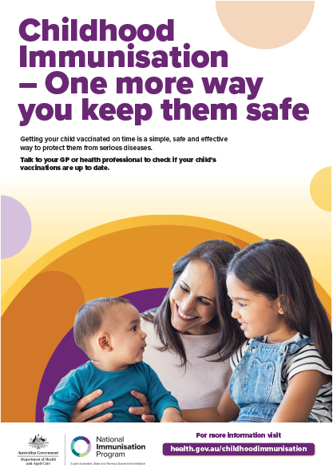 | Download here. | Print and display poster in reception or waiting areas.
Brochure | 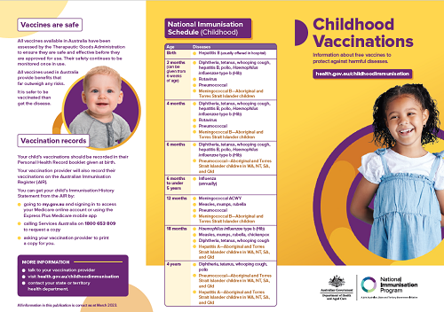 | Download here.  Order free hard copies of this resource by contacting National Mailing and Marketing:  Email: health@nationalmailing.com.au  Phone: 02 6269 1080  Quote the order ID IT0329, the quantity of the resource you wish to order and provide your delivery address.  A factsheet version is also available in 10 languages for download and print from the Department’s webpage Translated resources.  The translated languages are: Arabic, Assyrian, Simplified Chinese, Traditional Chinese, Karen, Korean, Persian/Farsi, Thai, Vietnamese | Display brochures in reception or waiting areas. Hand out to parents and carers.
Magnet | 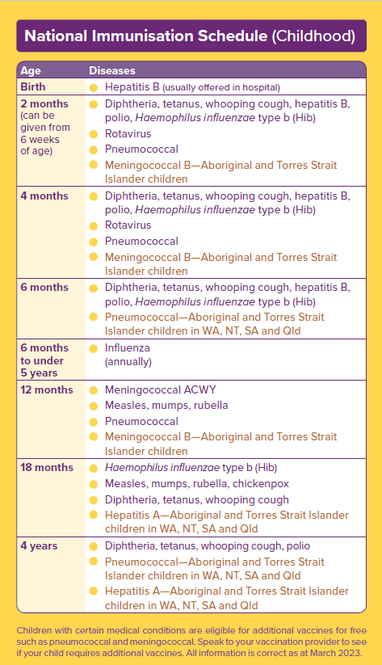 | Download here.  Order free copies of this resource by contacting National Mailing and Marketing:  Email: health@nationalmailing.com.au  Phone: 02 6269 1080  Quote the order ID IT0302, the quantity of the resource you wish to order and provide your delivery address. | Hand out to parents and carers.
Animation 1 | Why timing is important  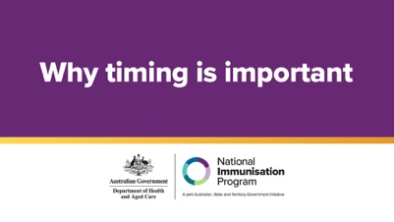 | View on the website.  Share on your social media channels from YouTube.
Animation 2 | How vaccines work  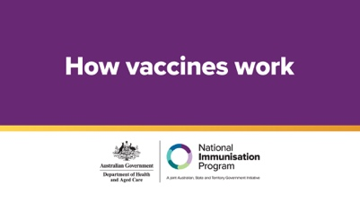 | View on the website.  Share on your social media channels from YouTube.
Animation 3 | Simple and safe  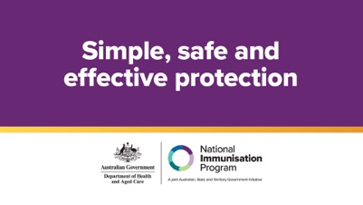 | View on the website.  Share on your social media channels from YouTube.
Animation 4 | How vaccines work for pregnancy and newborns  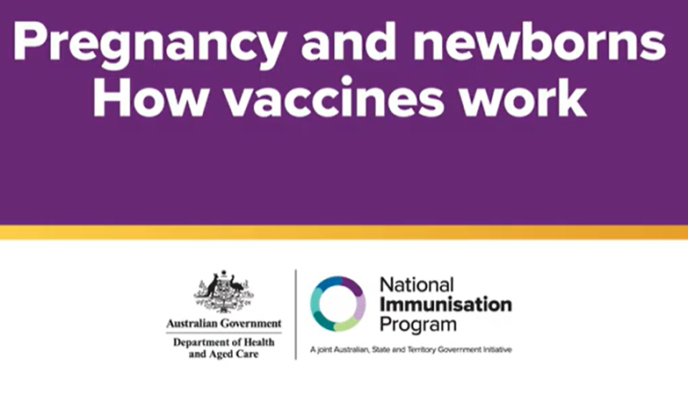 | View on the website.  Share on your social media channels from YouTube.
Video | Health professionals on the importance of routine childhood vaccination  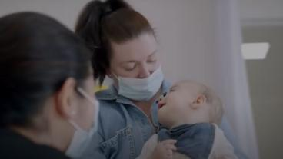 | View on the website.  Share on your social media channels from YouTube.
Video | Health professionals on the safety of routine childhood vaccination  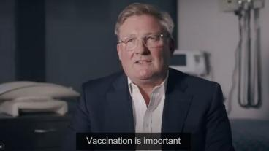 | View on the website.  Share on your social media channels from YouTube.
Case study | Parents speak about routine childhood vaccination  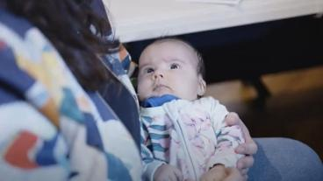 | View on the website.  Share on your social media channels from YouTube.
Case study | Rhiannon shares Lucy’s story, to warn other parents about the serious risks of flu  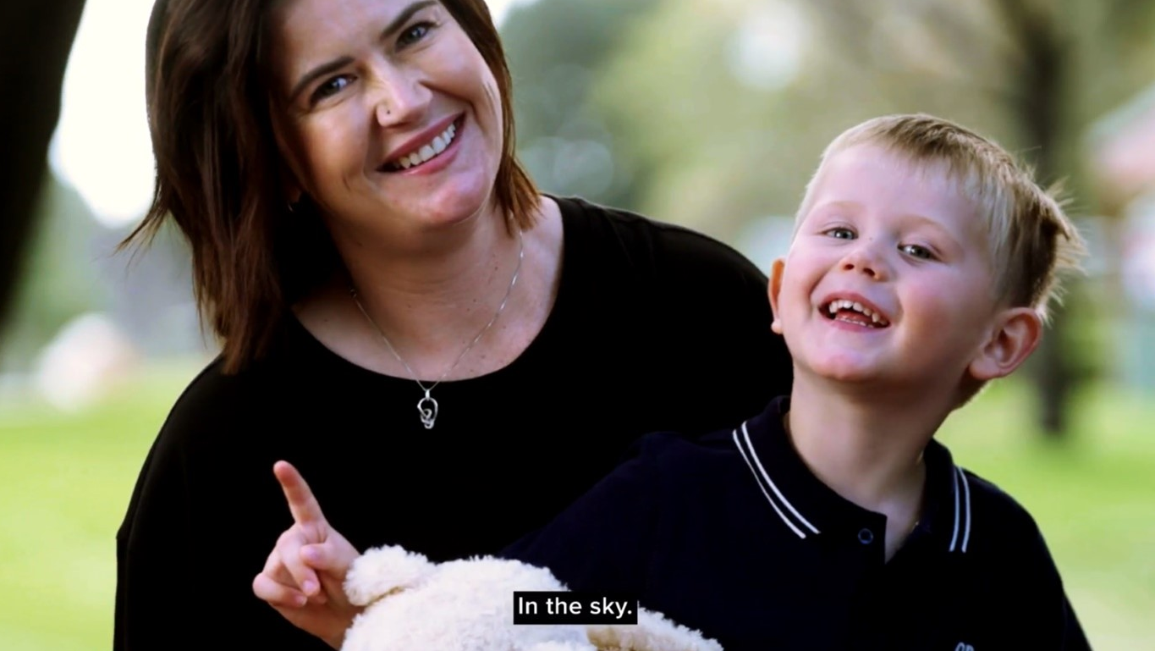 | View on the website.  Share on your social media channels from YouTube.
Frequently Asked Questions | www.health.gov.au/childhood-immunisation/your-questions-answered | A factsheet version is also available in 10 languages for download and print from the Department’s webpage Translated resources.  The translated languages are: Arabic, Assyrian, Simplified Chinese, Traditional Chinese, Karen, Korean, Persian/Farsi, Thai, Vietnamese. | Refer parents to the FAQS available on the website.
Milestone stickers | 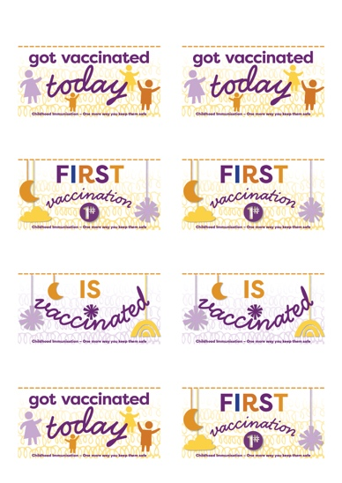 | Download here. | Print these on sticky labels using your office printer and peel off to give to parents/children when they receive their vaccination.
Milestone cards | 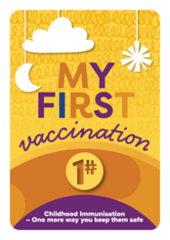  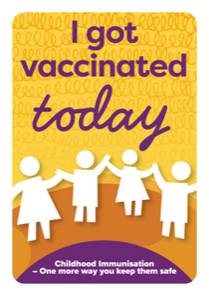  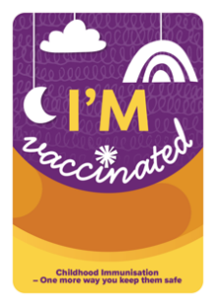 | Download here. | Print these on cards to provide to parents to take a photo with their child after their vaccination appointment.

Resources for Aboriginal and Torres Strait Islander people
Resource | Preview | Link | Suggested use
Poster 1 | 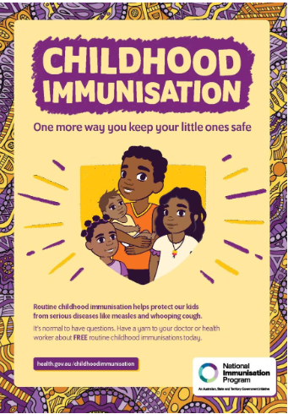 | Download here. | Print and display poster in reception or waiting areas.
Poster 2 | 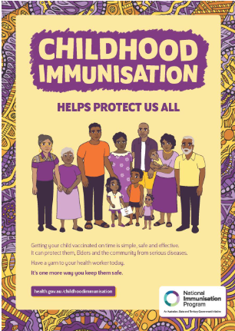 | Download here. | Print and display poster in reception or waiting areas.
Adaptable poster | 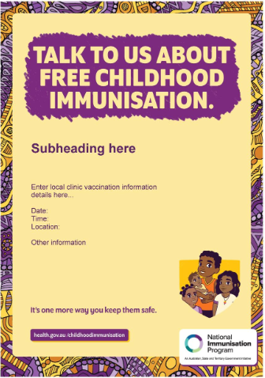 | Download here. | This poster for Aboriginal and Torres Strait Islander Health services and clinics can be adapted to promote local clinic vaccination information
Height chart | 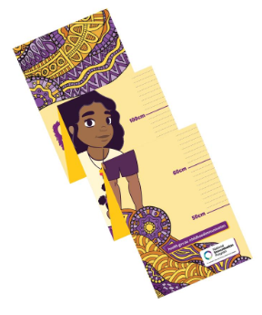 | Download here.  Order free copies of this resource by contacting National Mailing and Marketing:  Email: health@nationalmailing.com.au  Phone: 02 6269 1080  Quote the order ID IT0331, the quantity of the resource you wish to order and provide your delivery address. | This height chart is for display in Aboriginal and Torres Strait Islander Health services and clinics to promote local vaccinations
Advertisement | 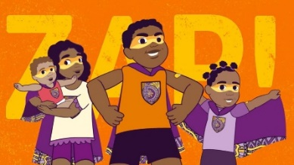 | View on the website.  Share on your social media channels from YouTube. | Super Kids ad can be shown throughout social media and Medical Centres.
Animation 1 | This animation for Aboriginal and Torres Strait Islander families explains all you need to know about childhood vaccinations.  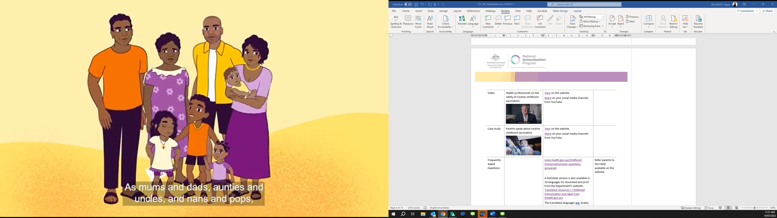 | View on the website.  Share on your social media channels from YouTube.
Animation 2 | This short animation for Aboriginal and Torres Strait Islander families explains that vaccines have been carefully tested, to protect us from diseases.  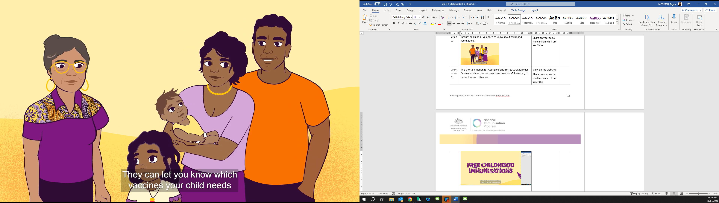 | View on the website.  Share on your social media channels from YouTube.
Animation 3 | This short animation explains how vaccination provides protection against diseases that can make little ones very sick.  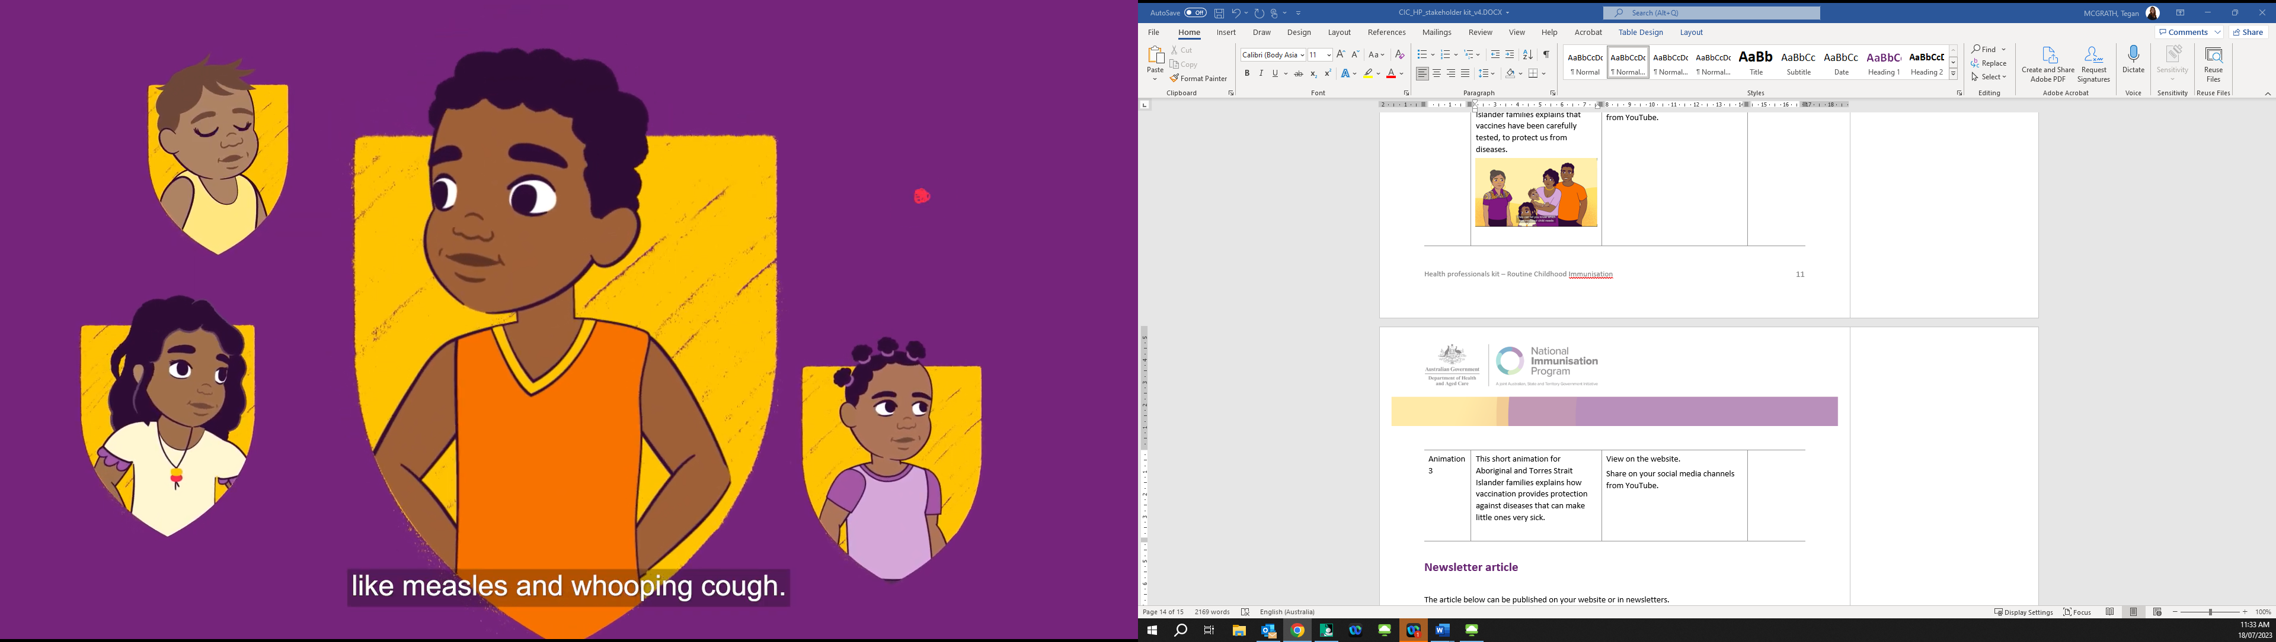 | View on the website.  Share on your social media channels from YouTube.
Video | Health worker Irene talks about how getting immunised can protect your children.  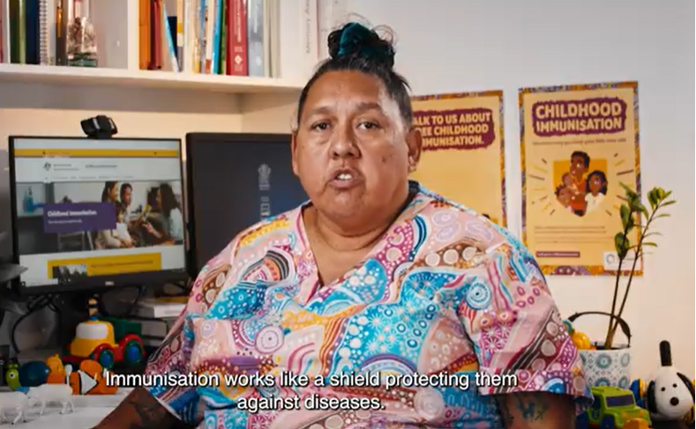 | View on the website.  Share on your social media channels from YouTube.
Video | Health worker Florianna talks about why children need to be immunised.  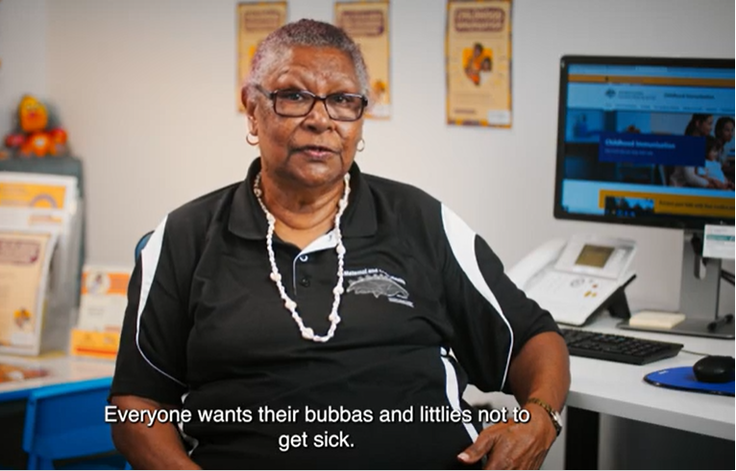 | View on the website.  Share on your social media channels from YouTube.
Video | Nurse Kristy addresses common questions from parents.  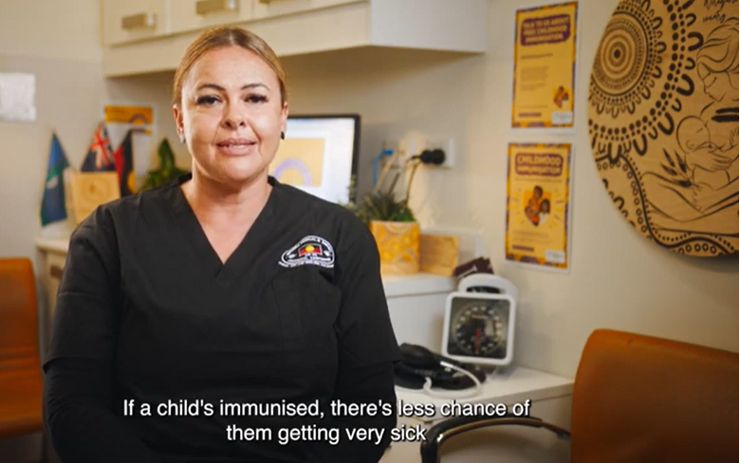 | View on the website.  Share on your social media channels from YouTube.
Video | Nurse Tisha explains why childhood immunisations are so important.  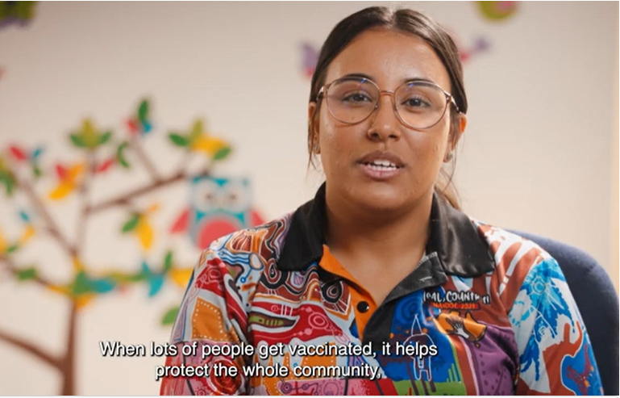 | View on the website.  Share on your social media channels from YouTube.

Easy Read resources
An Easy Read combines text and imagery to simplify and explain information to work as a handout. Easy Read is a way to present information for people who are not familiar with English, or who have low literacy or a learning disability.
What are vaccines for children | 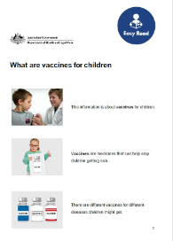 | View on website. | Print, share and display resources in waiting areas
Why it is important for children to get vaccines | 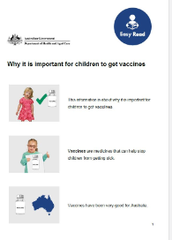 | View on website. | Print, share and display resources in waiting areas
How to get a vaccine for your child | 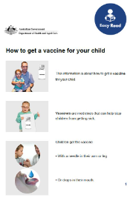 | View on website. | Print, share and display resources in waiting areas
Side effects from vaccines | 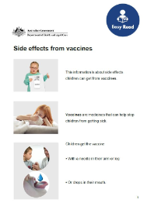 | View on website. | Print, share and display resources in waiting areas
What vaccines children should have | 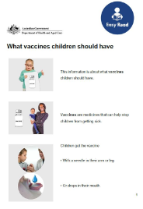 | View on website. | Print, share and display resources in waiting areas
Vaccines are safe for children | 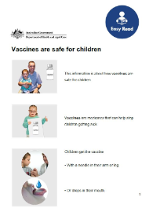 | View on website. | Print, share and display resources in waiting areas
Getting more than 1 vaccine at a time | 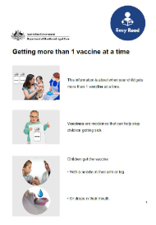 | View on website. | Print, share and display resources in waiting areas

Newsletter article
The article below can be published on your website or in newsletters.

Are your child’s vaccinations up to date?
From the moment they’re born, most babies can fight the germs they encounter every day, but there are some serious and life-threatening diseases they are not protected from. Vaccines under the National Immunisation Program (NIP) are a free, safe, and effective way to protect children from preventable diseases, such as measles and whooping cough.
The childhood immunisation schedule is carefully planned to protect babies and children from as young as possible and when they need it most. Vaccinating on time with the schedule gives the best protection from preventable diseases. Delaying a vaccine appointment means your child is unprotected for longer than they need to be.
You can see if your child is up to date by:
- viewing the NIP schedule to see which immunisations are recommended at specific times.
- checking your child’s immunisation history through the Medicare Express app,
- or via myGov Medicare online account.
For more information, talk to your trusted health professional, or visit health.gov.au/childhoodimmunisation.

Social posts
The posts and image tiles below can be published on your preferred social channels.
Post | Image
Australia’s National Immunisation Program provides free vaccines to protect children against serious diseases.  The program’s schedule has recommended vaccines for your child from birth to 4 years to help protect against diseases such as:  - whooping cough  - meningococcal (ACWY)  - pneumococcal.  Find out more about the childhood immunisation schedule at health.gov.au/childhoodimmunisation. | 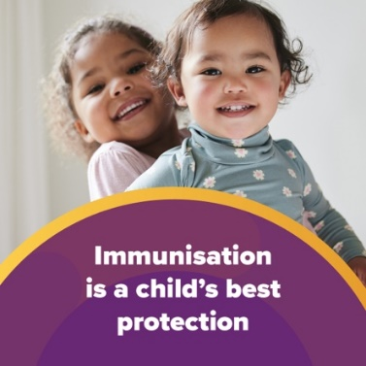
Are your child’s vaccinations up to date?  For the best protection, babies and children need to get their vaccinations on time.  The National Immunisation Program provides free vaccines to babies and children at scheduled times from birth to 4 years.  For more information, including how to check if your child’s vaccinations are up to date, visit health.gov.au/childhoodimmunisation. | 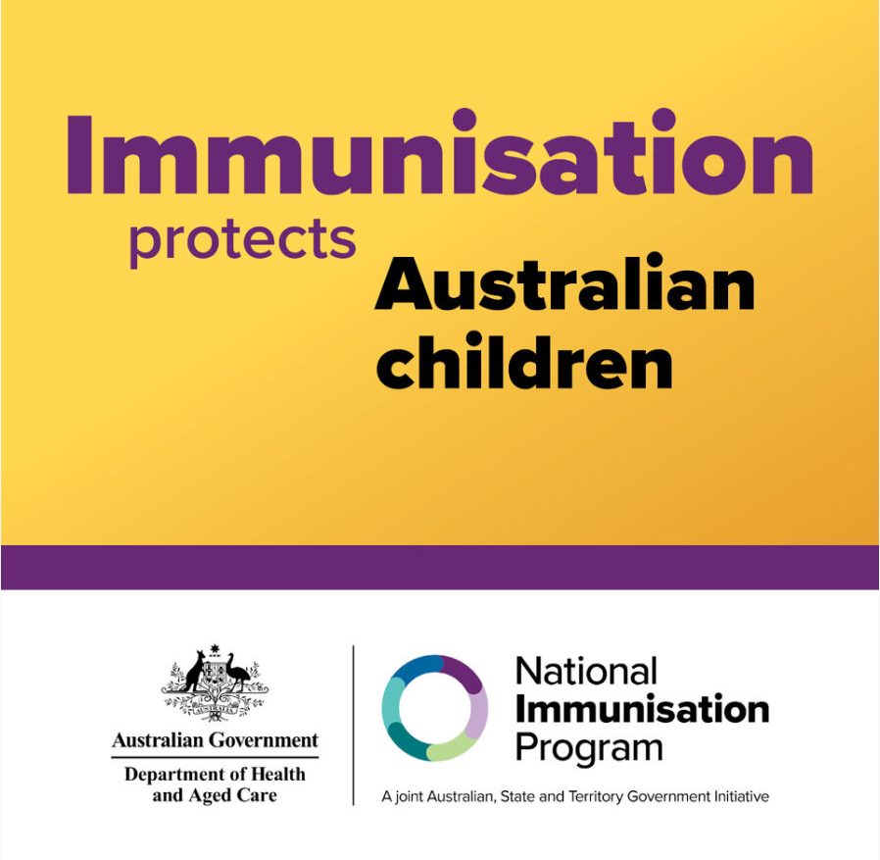
The National Immunisation Program schedule 🗓️ outlines the childhood vaccinations recommended for all children in Australia.  On time vaccination means children are protected from serious disease with stronger immune systems. Skipping and delaying vaccines means children are unprotected for longer than they need to be.  To learn more, visit health.gov.au/childhoodimmunisation. | 