**Overview of client support relationships in the   
Service and Support Portal**

# Purpose

Before June 2022, clients could only be supported in My Aged Care by individual representatives, who can make decisions for and act on behalf of a client. There was no system role that reflected supported decision-making (such as by an advocate), and no capability for organisations to support clients in the system.

This fact sheet provides an overview of the changes that have been made to expand the current My Aged Care representative model since June 2022:

* A new support relationship type of **Agent** (in addition to Regular and Authorised Representatives), a role for organisations and professional individuals who provide support and assistance to a client but cannot make decisions on their behalf.
* A **support person** or **support organisation** can be appointed as an agent or representative for a client.
* Support Organisations approved by the Department of Health and Aged Care (the Department) can establish **organisation relationships** with clients in the system. Currently, support organisations can only be appointed as agents.
* Service and Support Portal users can view organisation and agent relationships through the updated **Support network tab** in a client’s record.

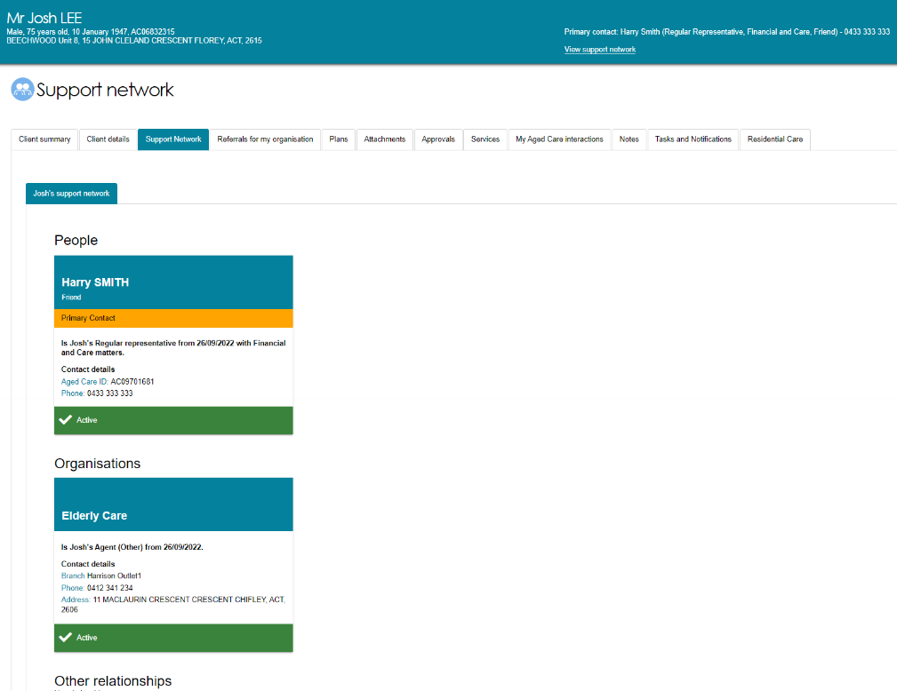

# Agent Relationships

An Agent can provide support and assistance to a My Aged Care client, access and update a limited amount of client information and be involved in discussions with the client and   
My Aged Care but cannot make or convey decisions on behalf the client (as a representative can).

* An ***organisation agent*** is an employee of an organisation approved by the Department to support clients in My Aged Care, such as advocates and care finders. They will access My Aged Care through the Service and Support portal.
* An ***individual agent*** may be a professional support person who provides support to aged care consumers within a community setting, such as language or cultural support, but is not connected with an organisation approved by the Department. They will access My Aged Care through the Online Account (via myGov).

|  |  |  |  |
| --- | --- | --- | --- |
| **Difference between the types of My Aged Care support relationships** | | | |
| **A nominated person or support organisation can:** | **Agent** | **Regular Representative** | **Authorised Representative** |
| Give information to My Aged Care including talking to assessors, the My Aged Care contact centre and service providers |  |  |  |
| Request information about the client’s progress in My Aged Care |  |  |  |
| Submit an ‘Apply for Assessment Online’ on behalf of a client and create a pending relationship |  |  |  |
| Register the client in My Aged Care and create a pending relationship **(organisation relationships only)** |  |  |  |
| Access **client record information except assessment detail\*** through the contact centre or in the My Aged Care Online Account |  |  |  |
| Only able to update the client’s **contact and service preference information^** through the My Aged Care contact centre or the  My Aged Care Online Account |  |  |  |
| Access **all client record information including assessment detail** through the contact centre or in the My Aged Care Online Account |  |  |  |
| **Update all of the client’s information** through the contact centre or in the My Aged Care Online Account |  |  |  |
| Be nominated as the client’s first contact point for My Aged Care phone calls (Primary Contact) |  |  |  |
| Receive email notifications and copies of correspondence, for example, Home Care Package letters |  |  |  |
| Upload documents on behalf of the client within My Aged Care systems |  |  |  |
| Provide consent and convey decisions to My Aged Care on the client’s behalf, with their consent, e.g. to commence screening, generate a referral code, request a support plan review |  |  |  |
| Make decisions on the client’s behalf and provide consent to commence an aged care assessment (and complete the My Aged Care assessment consent form), support plan review and send referrals for aged care services |  |  |  |

*Agents can view most information in a client’s record (current care approvals, current services and service recommendations, people associated with the care plan, review history, and reablement and linking support history), but cannot view the client’s assessment history or view/print the Integrated Assessment Tool (IAT) form.

^Agents can edit client contact details (phone, address, primary contact), generate a referral code, and set the seeking services preference to ‘Yes’. They cannot set the seeking services preference to ‘No’ or decline a home care package.

# Organisation relationships

Support Organisations in My Aged Care are limited to those organisations approved by the Department and who support ‘hard to reach’ vulnerable older Australians needing more intensive or specific assistance to access and engage with the aged care system.

A relationship with a Support Organisation will either be with an Outlet (also referred to as Branch) of an approved organisation, or with a named staff member at an outlet.

This is a picture of a note, representing some information that will be important to the reader, following this picture The initial cohort of support organisations in My Aged Care will be Advocacy organisations, and will be Agent organisations. This cohort has been gradually transitioned onto the system from November 2022. Further support organisation cohorts (such as care finders and Indigenous facilitators) will be rolled out with future system updates, and communications will be provided by the Department.

# Service and Support Portal Changes

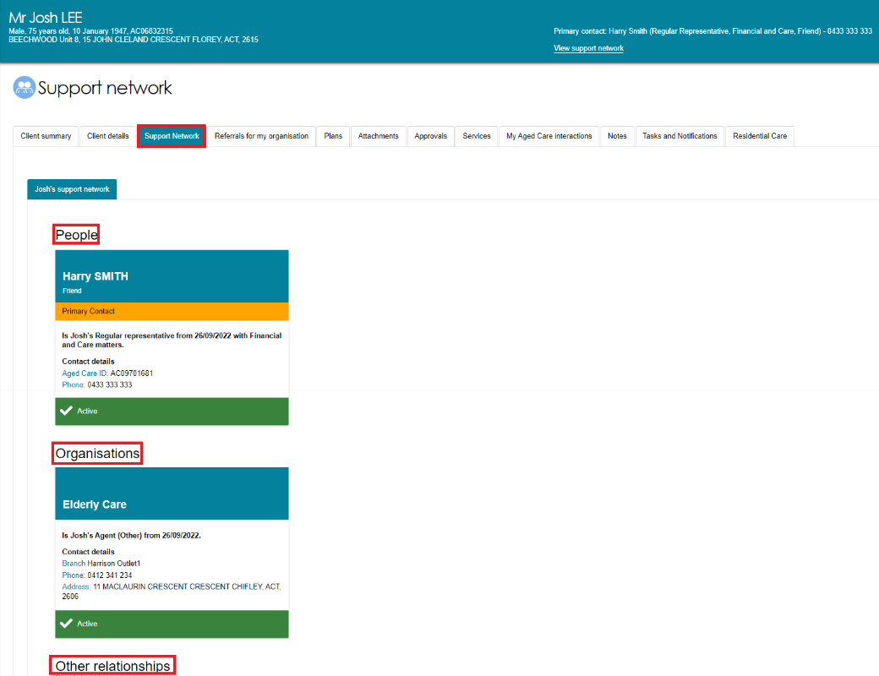Client support relationships are displayed in the **Support Network** tab in the client record. Portal users will be able to differentiate between individual (People), organisation relationships and other relationships (such as a carer).

There are three sections in a client’s ‘Support Network’:

* *‘People*’ displays the individual(s) supporting the Aged Care Client as an agent or representative
* *‘Organisations’* displays the Outlets/Branches supporting the Aged Care Client as an agent or representative
* *‘Other relationships’* displays the other relationship types, such as Carer, Emergency contact, and GP.

Details of the support being provided to the client, the date the relationship commenced, and contact details of the supporting party are displayed on each relationship card.

# For further information

Call the My Aged Care assessor and provider helpline on **1800 836 799** for support and technical assistance. The helpline is available 8am to 8pm Monday to Friday and 10am to 2pm Saturdays, local time across Australia.