National Women’s Health Advisory Council

**Annual Report**

2023–24

2024

# Acknowledgement of Country

The National Women’s Health Advisory Council acknowledges the Traditional Owners and Custodians of Country throughout Australia, and their continuing connection to land, sea, and community. We pay our respects to them and their cultures, and to Elders both past and present.

Contents

Acknowledgement of Country 2

Minister’s foreword 4

About the National Women’s Health Advisory Council 6

Role and remit 6

Membership 6

Acknowledging intersectionality 7

Impact so far 8

Council focus areas 8

Subcommittees 8

#EndGenderBias survey on lived experiences 12

Key findings 12

Literature review to identify strategies to reduce sex and gender bias in healthcare 15

Key findings 15

Connecting leaders at the National Women’s Health Summit 17

A framework to monitor and report on the National Women’s Health Strategy 19

Results 19

Opportunities and next steps 22

Acknowledgements 22

# Minister’s foreword

It is with great pride that I present the inaugural Annual Report for the National Women’s Health Advisory Council (Council). I established the Council in 2023 to improve health outcomes for women and girls, drawing on the expertise of members to identify and address barriers to accessing care and ensuring equity in the health system. I am proud to Chair a Council that is genuinely and profoundly committed to tackling the complex and systemic issue of gender bias in our health system.

The Albanese Labor Government has an ambitious reform agenda when it comes to women’s health. While health outcomes have improved significantly for women and girls over the last few decades, they still face unique challenges navigating the health system, from delayed diagnosis to dismissal of pain; every woman has a story. We know this is particularly true for those who are part of diverse communities including the LGBTIQA+ community, First Nations women, migrant and refugee women, women with disability, and women living in rural and remote communities.

It's not good enough, and it never has been.

Women deserve better. We owe it to every woman to take meaningful, material action. This is why I established the Council - to improve women’s health and end medical misogyny.

Over the past 18 months, the Council has made significant strides in this crucial mission. We established four dedicated subcommittees, focusing on critical areas of women’s health: Access, Care, and Outcomes; Empowerment; Research; and Safety.

For the first time, we invited Australian women to share their experiences of the health system through the #EndGenderBias survey. We heard an outpouring from women who all had a story to tell; of discrimination, dismissal and gender bias. We convened the 2024 National Women’s Health Summit, bringing together experts, policy makers and community advocates to tackle how we can fundamentally transform the health system to better serve women and improve health outcomes.

Beyond the #EndGenderBias survey, I’ve had countless women write, call, and approach me at events, all to share their unique yet harrowingly similar stories of gender bias. It’s heartbreaking.

Intersectionality has also played a compounding role in most of these stories. The report of the survey found that people from intersectional backgrounds have an 80% chance of experiencing gender bias in the health system.

We have also developed a robust Monitoring and Reporting Framework to measure implementation of the National Women’s Health Strategy 2020-2030. This will be critical if the Government is to drive progress under the Strategy.

The 2024-25 Budget also saw the Government commit more than $160 million in women’s health to tailor services, tackle bias and improve access to care in alignment with the Strategy. Whether it be supporting women who have experienced a miscarriage, creating better care for women with endometriosis, or ensuring health professionals can support women with menopause, this package will go a long way.

These investments align with our broader initiatives, like the Strengthening Medicare reforms which will further bolster primary healthcare and support our health professionals – the foundation for any strong health system.

Each of these initiatives has brought us closer to our goal, however none of this would have been possible without the contributions of many dedicated individuals. I would like to extend my heartfelt thanks to all the Council members and special advisers for their time, expertise, and unwavering commitment.

I would also like to express my deepest gratitude to all the women and girls who have shared their stories of gender bias and contributed to the work of the Council. Your voices have provided invaluable insights into the barriers and biases in our healthcare system. Thank you for your courage and generosity in speaking up and may your stories stay in mind, as the Council works towards a fair, responsive health system that all women and girls deserve.

As we look ahead, we remain committed to our mission. We will continue to advise on the implementation of the National Women’s Health Strategy and build off the extraordinary work untaken over the past 18 months. With the support of the Albanese Labor Government, we will continue to make progress towards a healthier future for all women and girls in Australia.

We will continue to shine a light on women’s health.

To talk about topics shrouded in shame, stigma, and discrimination.

To listen, support, and respect women.

To learn from the lived experiences of women, and experts.

And to drive ambitious, necessary, and long overdue reform.

Our work has only just begun.

Let us continue our journey toward equitable healthcare for all.

A portrait of Hon Ged Kearney in front of the RANZCOG banners
 

The Hon. Ged Kearney MP, Assistant Minister for Health and Aged Care and Indigenous Health

Chair, National Women’s Health Advisory Council

# About the National Women’s Health Advisory Council

## Role and remit

The [National Women’s Health Advisory Council](https://www.health.gov.au/committees-and-groups/national-womens-health-advisory-council?language=en) (Council) is an Australian first, bringing together a diverse group of experts to examine gender bias in the health system. The Council was formed in response to a significant body of research emphasising the health disparities between men and women, as well as poor health outcomes for women-specific conditions. Women, girls and gender diverse people are at greater risk of poorer health outcomes related to their treatment, management and diagnosis of health conditions across a range of conditions and diseases, including but not limited to, endometriosis, attention deficit hyperactivity disorder (ADHD) and cardiovascular disease.

Across Australia’s health and medical ecosystem, there is significant momentum to understand and address sex and gender bias. The National Health and Medical Research Council (NHMRC) recently published its first *Statement on Sex, Gender, Variations of Sex Characteristics and Sexual Orientation in Health and Medical Research* aimed at ensuring research comprehensively includes gender and other characteristics.

The Council will accelerate this momentum by providing advice to the Australian Government to improve the health system for women, girls and gender diverse people. The Council also provides advice on the implementation of the [National Women’s Health Strategy 2020-2030](https://www.health.gov.au/resources/publications/national-womens-health-strategy-2020-2030?language=en) (Strategy) and supports Government action under the health and wellbeing pillar of the [Working for Women: A Strategy for Gender Equality](https://genderequality.gov.au/).

The Council aims to reduce inequities in healthcare access and outcomes for all women, girls and gender diverse people in Australia. It carefully considers the unique and diverse health needs of women, girls and gender diverse people, with a special focus on marginalised populations outlined as priority groups in the Strategy.

The Council complements existing Commonwealth initiatives to address sex and gender bias in the health system and more broadly to promote the health and wellbeing of Australian women, girls and gender diverse people. Together the Council is shaping the nation’s future direction and investment in women’s health.

## Membership

[The Council](https://www.health.gov.au/committees-and-groups/national-womens-health-advisory-council#members) is made up of 18 distinguished leaders from peak stakeholder organisations, consumer groups, academia and medical and professional bodies. Members contribute a wide breadth of knowledge, expertise, and experience to inform all aspects of women's health. To complement members, a range of special advisers provide subject matter expertise to the Council on a needs-to basis.

Council members and special advisers were invited to participate for a 3-year period (2022-2023 to 2024-2025). The Assistant Minister for Health and Aged Care and Indigenous Health, the Hon. Ged Kearney is the Chair of the Council.

## 

## Acknowledging intersectionality

The Council applies a gender-sensitive and intersectional lens across their work.

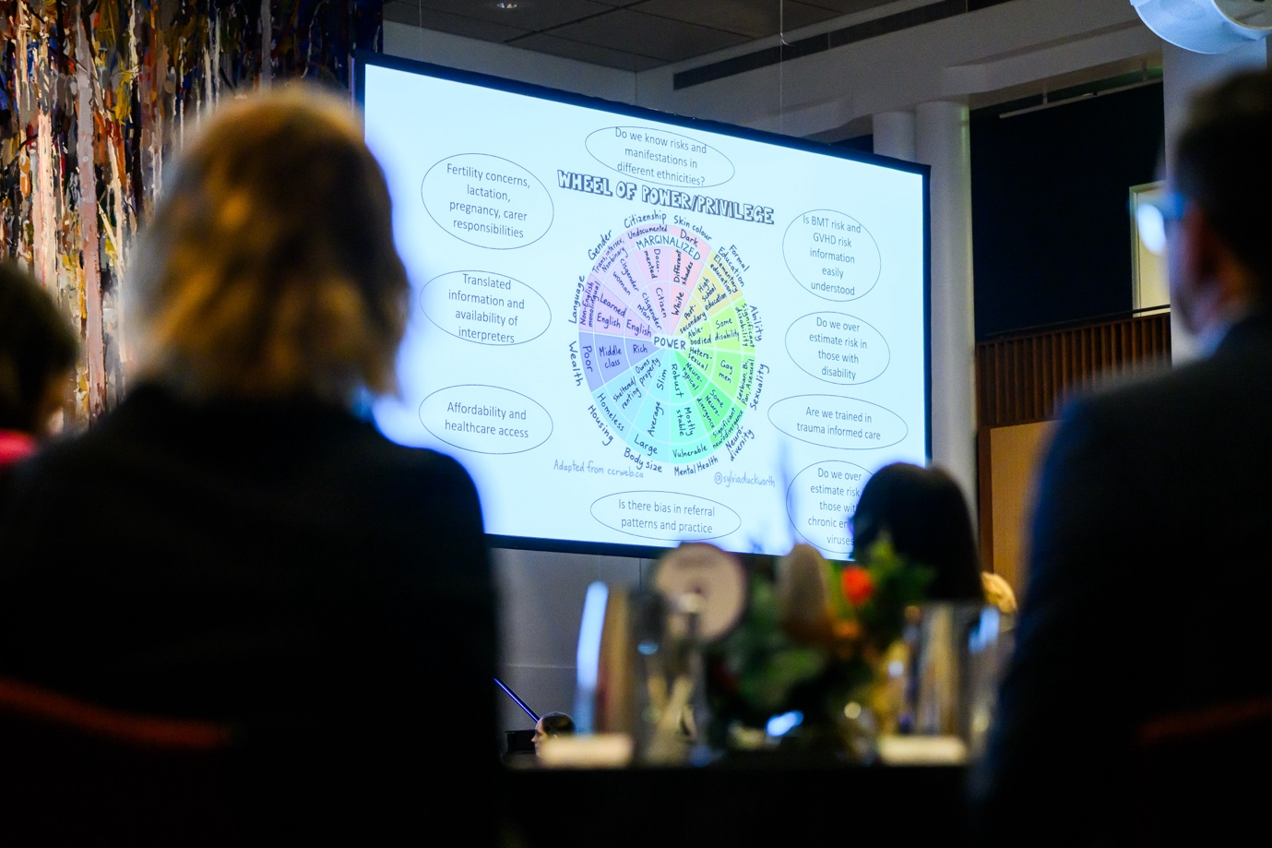

Figure 1: Associate Professor Nada Hamad’s presentation at the National Women’s Health Summit on considering power and privilege in healthcare

An intersectional approach recognises how different aspects of an individual’s identity such as sexuality, race or ethnicity as well as life experience such as social class, remoteness, age, disability and language create overlapping marginalisation. Gender bias in healthcare manifests differently as social inequities and biases intersect with and amplify disparities in health outcomes and healthcare experiences for women.

The Council understands gender is a diverse social identifier including norms, behaviours, attitudes and appearance. For the purposes of the Council Annual Report, the Council use “woman”, “women”, “girl/s”, and “gender diverse people” throughout. The language choice is designed to include all people assigned female at birth and transgender people. It includes intersex people and people with diverse genders and sexualities. Any references to particular groups and experiences will be specified. The Strategy and related work refer to “women and girls”.

# 

# Impact so far

In its first 18 months, the Council set out to improve the community and health sectors’ understanding and evidence base of gender bias in the healthcare system.

The Council successfully oversaw the delivery of 5 key initiatives:

1. Four **subcommittees** to explore gender bias across varied focus areas.
2. The **#EndGenderBias survey** to better understand lived experiences.
3. **A literature review** to identify strategies to reduce sex and gender bias in healthcare.
4. Connecting leaders at the **National Women’s Health Summit.**
5. A framework to **monitor and report** on the National Women’s Health Strategy.

These activities will help the Council and Government to understand the impact of gender bias on the women’s health landscape, women’s experiences navigating healthcare, and how to deliver better health services that meet the needs of Australian women. Information gathered through these activities will help inform the Council’s work for the remainder of its term.

The Council was officially announced 8 December 2022. Between 20 February 2023 and June 2024, the Council has delivered 5 key initiatives, 7 council meetings and 16 subcommittee workshops.

# Council focus areas

## Subcommittees

The Council established 4 subcommittees to investigate gender bias across varied focus areas. Each subcommittee was tasked with exploring their focus area and developing advice on how to address identified issues.

A collage of four photos of people at the National Women's Health Summit. In the first three photos, people are speaking at a podium. In the fourth photo, attendees are posing in front of the RANZCOG banners.


Figure 2: *From left to right:* Associate Professor Fei Sim (Pharmaceutical Society of Australia) and Professor Danielle Mazza AM FAHMS (SPHERE NHMRC Centre of Research Excellence in Women's Sexual and Reproductive Health in Primary Care) for the Access, Care and Outcomes; Dr Sarah White (Jean Hailes for Women’s Health) presented on behalf of the Empowerment subcommittee; Ms Prue Torrance (NHMRC) on behalf of the Research subcommittee; Dr Nisha Khot (RANZCOG), Ms Eman Al-Dasuqi, Dr Adele Murdolo and Ms Nadia Akbar (Multicultural Centre for Women’s Health). The Safety Subcommittee was led by Dr Adele Murdolo

Subcommittees were made up of a mix of Council members and special advisers, tackling areas aligned to their expertise.

* The **Access, Care and Outcomes Subcommittee** explored factors of the health system that influence women, girls’ and gender diverse people’s choice and quality of health services.
* The **Empowerment Subcommittee** explored barriers and enablers to women, girls and gender diverse people being active agents for their health, and options to empower them in the workforce.
* The **Research Subcommittee** looked at ways to reduce gender bias in research, its methods, who does it and how to better translate it into practice.
* The **Safety Subcommittee** focussed on ensuring women can work in and receive physically, culturally and socially safe healthcare.

Each subcommittee developed specific advice on how to address their respective issues.

To support the subcommittees, the Council commissioned ThinkPlacex to facilitate workshops with each subcommittee to distil their discussions into detailed reports. Subcommittee discussions found key areas for improvement, and system levers to resolve them, including how Government, training institutions, community services, health organisations and healthcare providers can create change. Opportunities for improvement were shared and discussed at the National Women’s Health Summit 2024.

### Key themes

Subcommittees identified and discussed issues that span the healthcare lifecycle and touch on all factors across the health system, stemming from gender bias relevant to their focus area.

Subcommittee discussions included topics such as:

* Health service design.
* Funding models and guidelines.
* Provider behaviour.
* Women’s health literacy.
* Health and medical research.
* Healthcare policy.

While each subcommittee focused on a different area, overarching and common themes emerged from the discussions, as summarised below.

#### Women-centric holistic healthcare to improve accessibility and quality

To deliver consistently safe, timely, and accessible healthcare to women and gender diverse people, services must embed their needs by default. Holistic gender-responsive care needs a comprehensive suite of services which reflect women’s health needs across the life course and are available through affordable pathways. Currently, many health services deliver best practice evidence-based and person-centred services. However, some women and gender diverse people struggle to access health services, or may face long wait times, high costs, long distance travel and/or discrimination. An example is persistent workforce shortages in sexual and reproductive healthcare across regional and remote areas of Australia creating a ‘postcode lottery’. Even when delivered well, states and territories may not collect data about services consistently, if at all, increasing challenges in tracking and reporting health outcomes.

A better understanding of how health providers are supported and funded could help to highlight service access and equity disparities for chronic and mental health conditions that uniquely or disproportionately affect women.

#### Support a capable, well-resourced and representative service delivery workforce

Proper training and consistent use of best practice ensures healthcare workers provide safe, timely and appropriate care for women and gender diverse people. Improved knowledge dissemination, ongoing skills development and more sustainable resourcing models will create a more inclusive, skilled, and gender-responsive healthcare workforce.

Capacity building opportunities include:

* **Incorporate research and lived experiences to tailor services to the needs of women, girls and gender diverse people**:It is important to wholly understand women, girls and gender diverse people’s health needs, such as their lived experiences of family domestic and/or sexual violence, and gender and sexuality diversity. This understanding can be combined with research to help tailor more effective services to improve health outcomes for women and gender diverse people.
* **Use evidence-based strategies to build and retain a skilled and diverse workforce:** Using a strategic effort to attract, recruit and retain a skilled healthcare workforce can improve women’s experiences and representation, challenge gender norms and improve workplace culture. Bolstering a skilled and diverse workforce may help address issues such as pay equity, representation in leadership and end bullying and harassment in the workplace, especially where there is gender imbalance in the sector.
* **Provide cultural safety training***:* Equipping the workforce to cater for the needs of First Nations women and culturally and linguistically diverse women requires setting foundational social and cultural skills and practicing anti-discrimination within the workplace. All health professionals including allied health professionals, pharmacists and interpreters, should receive training in cultural safety.
* **Provide training in family, domestic and sexual violence:** Health professionals should be aware, skilled and equipped to deliver safe, trauma-informed and shame-sensitive care. Co-designing workforce training with victim-survivors from marginalised backgrounds may help practitioners identify signs of abuse to better support women, girls and gender diverse people experiencing violence when accessing care. The workforce should be supported to respond to disclosures of violence, including having appropriate training in providing healthcare to victim-survivors and access to referral pathways.
* **Recognise the role of interpreters in the health workforce:** Interpreters are crucial in making the health system safer for women by facilitating access to healthcare and informed decision-making for culturally and linguistically diverse women, girls and gender diverse people. Investing in the interpreter workforce, including specialised training in gender-aware healthcare and domestic and/or sexual violence, can ensure women’s health needs are met. Specific consideration should be given to the safety of interpreters. This may include training about family, domestic and sexual violence, debriefing, and access to counselling, to minimise harm and vicarious trauma, particularly for interpreters from refugee backgrounds.

#### Empowerment is underpinned by comprehensive health literacy

Women, girls and gender diverse people can be empowered to improve their health and wellbeing through increasing choice, strengthening voice and transforming power relations. There is no current shared understanding among researchers, policymakers and the community of what empowerment is and how it is impacted by gender bias in health.

Investing in health literacy, both for health professionals as well as women, girls and gender diverse people, supports women to be empowered to make informed choices about their bodies. Information needs to be up-to-date, evidence based and accessible. Improving women, girls and gender diverse people’s health outcomes relies on building health literacy that instils an understanding of their bodies, rights, and service options, enabling greater agency and autonomy.

Prioritising women, girls and gender diverse people’s empowerment in meaningful, action-oriented, and systemic ways is integral to enabling them to take full advantage of increased access, services and better healthcare outcomes.

#### Entrenched and far-reaching gender bias needs intersectional gender-aware structural change and policy reform

Women, girls and gender diverse people have a right to a healthcare system free from discrimination. Health services should aim to protect women’s health rights by upholding organisational policies and structures that create a safe, respectful and dignified healthcare experience for all women.

Gender bias and discrimination can also exist in rules and policies in healthcare organisations. Gender bias can play out in different ways such as interpersonal interactions between patients and providers and/or women working in healthcare environments. Finding a trusted healthcare provider can be a turning point for women, girls and gender diverse people's healthcare journey. Healthcare providers deliver effective care to women, girls and gender diverse people when they listen, take patient concerns seriously and offer a range of suitable options to empower women to make independent and informed health decisions. Delivering patient-centred, culturally safe, trauma-informed and shame-sensitive care requires providers to treat women, girls and gender diverse people as individuals, staying aware of harmful social norms or stereotypes.

Importantly, structural change and policy reform must recognise the complex and interconnected nature of gender bias in healthcare and include the needs of marginalised women. Better incorporating a gender-sensitive and rights-based approach into policy, guidelines and national frameworks could help bolster health and wellbeing services. For structural and policy transformation to be effective, there needs to be more comprehensive and meaningful collaboration across sectors.

#### Increase representation of women, girls and gender diverse people in research and improve translation of research into practice

There is a long history in Australia and internationally of sex and gender bias in health research, where data is collected from men and extrapolated to women, with adverse effects on women’s health and wellbeing. The majority of research either does not collect data on sex and gender, or assumes sex is binary, ignoring gender entirely. The sector needs to strengthen requirements for researchers to collect and report studies by sex and gender and foster greater consideration of intersectional factors (such as ethnicity, socio-economic status, age) in health and medical research. Many policy and funding guidelines encourage the inclusion of sex and gender variables in health and medical research, and research institutions are increasingly implementing these data collection and reporting practices.

Increasing participation of women, girls and gender diverse people in research and clinical trials is also necessary to address historic gaps. Encouraging researchers to collaboratively design research and engagement strategies with women and gender diverse people will help to produce an evidence base that is representative of all people in Australia.

# #EndGenderBias survey on lived experiences

For the first time, Australian women, girls and their carers were invited to share their experiences of gender bias in the healthcare system. The survey aimed to understand barriers and bias women face in the health system.

Priority populations views were specifically sought including First Nations women, LGBTIQA+, those with culturally and linguistically diverse backgrounds, lower socioeconomic households, regional and remote communities, and people with a lived experience of a disability.

The survey heard about barriers and bias from 3 different perspectives:

* 2,570 women shared their personal lived experiences.
* 86 shared an experience of someone they care for.
* 497 health professionals, researchers and representative groups discussed the systemic challenges driving gender bias in healthcare.

## Key findings

The Australian Women and Girls Research Centre at the University of Queensland analysed the survey results.

Two thirds of participants reported experiencing gender bias or discrimination in their own healthcare within the last ten years, and 80% reported such an experience on behalf of someone else. These percentages were even higher for some priority groups such as participants with a disability (84%), those who identified as LGBTIQA+ (84%) or who had experienced violence or abuse. More than 50% of participants felt they were treated very or extremely differently in healthcare settings due to their gender. More than 70% felt their opinions were not heard or considered.

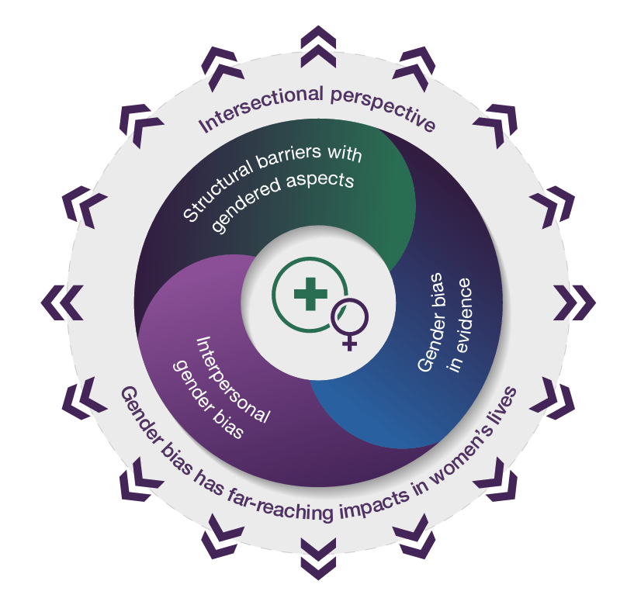

Figure 3: Impact of gender bias model

Participants reported experiences of gender bias in healthcare that were layered and overlapping, including:

* **Interpersonal experiences** - consultations between individuals and their healthcare providers.
* **Structural barriers** affecting the accessibility and affordability of healthcare.
* **Evidence base** underpinning healthcare and medical innovation.
* **Intersectional experiences of gender bias** - related to other aspects of women’s identities such as age and rurality.

Gender bias in healthcare has far reaching impacts on respondent’s lives, including:

* Feelings of abandonment, shame, blame and self-doubt.
* Significant financial burden, lost educational and career opportunities.
* Delayed diagnosis and treatment led to disease progression, fewer treatment options and worse health outcomes.
* ‘Near misses’ where dismissed health concerns turned out to be immediately life threatening.
* Giving up.

More than half of the health professionals, researchers, and consumer advocates who responded to the survey did not believe Australian research guidelines fostered inclusion of sex and gender in the design of health research or that research in relation to women’s health was incorporated into guidelines or implemented into clinical practice or public health and policy settings.

Respondents shared a range of harrowing testimonies.

“*I have seen multiple doctors over the last 15 years, noting how exhausted I was. I was given the assurance - you are a teenage girl, girls are always tired....then I became a mum at 20 and I was assured it was because I had children and all mothers were exhausted … I was finally referred to a sleep clinic and I was diagnosed with Type 1 Narcolepsy.”* - Woman, 25-34 years old, metropolitan.

*“Without preamble or discussing risks/benefits, [doctor] presented two choices … like it was a McDonald’s drive through option. How can you decide without context, facts, risks, long term impacts?”* - Woman, 55-64 years old, regional.

*“[The doctor] was very rough with his internal examination and when I told him he was hurting me, he replied with a comment along the lines of ‘well, you got yourself into this mess, you’ll just have to deal with it.”* – Woman, 55-64 years old, migrant background, experienced violence.

Nevertheless, respondents also recounted positive healthcare experiences that stemmed from strong interpersonal interactions and relationships. Finding a doctor who listened and took their concerns seriously was often a turning point in women’s healthcare. Women felt listened to when healthcare professionals had an openness to learn and treated the patient as an expert about their own experience.

*“Once I finally found specialists who diagnosed me, they created a network to continue the search for answers because they knew more was wrong. One also suggested I apply for disability pension due to the nature of my conditions (and expenses), and I was approved first go due to his thorough report.”* -Woman, 18-24 years old, regional.

Many healthcare professionals shared that they prefer a longer, more relational approach. However, this standard of care is difficult due to workforce shortages and short consultations.

*“Many women describe not feeling heard as they are rushed through consultations and that consultations are more about ticking the box and meeting institutional needs vs individualising care. As a clinician I find the time pressures mean that I am not providing the care that the woman will benefit from*.” - Health professional.

The survey’s insights help provide a rich understanding of the barriers and biases experienced by Australian women and gender diverse people when navigating the healthcare systems and highlight opportunities for improvement.

# 

# Literature review to identify strategies to reduce sex and gender bias in healthcare

Women and men have different experiences of health and illness because of variations in both sex and gender. It is crucial to understand these differences and how they can improve health outcomes, quality of life, and wellbeing for all people.

With this knowledge the Department of Health and Aged Care commissioned Monash University on behalf of the Council to undertake a literature review. The literature review aimed to identify gender equity issues in the Australian context and inform strategies to reduce sex and gender bias in the health system.

The findings of the review were presented to the Council and serve as further evidence to support their decision making moving forward.

## Key findings

* While some differences in health outcomes can be attributed to biological factors between women and men, many arise from the explicit and implicit biases of healthcare professionals, who inevitably reflect the rigid sex and gender norms of the general population of which they are a part. The findings highlight the need for the healthcare professions to recognise and address the adverse effects of implicit biases and disparities in healthcare.
* The review found variations in the extent to which evidence on sex and gender is incorporated in Australian clinical practice guidelines. The terms “sex” and “gender” tended to be used interchangeably or conflated and were rarely defined.
* There was limited evidence of interventions to reduce gender bias and inequity in healthcare globally. Women who are First Nations, immigrants, or refugees and those from low-income or marginalised backgrounds are more likely to experience compounded health inequities. This disparity is due to the lack of accessible and culturally safe healthcare services, entrenched institutional discrimination and language barriers.
* Despite recognition of the importance of sex inclusiveness in clinical research or randomised controlled trials, sex and gender data are poorly reported in many leading medical journals. These findings cast doubt on the validity of applying research results to the treatment of women and sex and gender diverse people.
* Women’s health and women’s bodies are over-medicalised. Sociocultural influences on women’s health and their experiences of care are too often missing from research and practice. Even when “gender” is the term applied, the reference tends to be “sex”.

The review outlined several opportunities to address sex and gender bias in healthcare:

1. Ensure that the terms and concepts of “sex” and “gender” are clearly defined and used accurately in relation to healthcare.
2. Introduce and continue culturally sensitive training for healthcare professionals that includes an intersectional and multilingual approach.
3. Introduce undergraduate, postgraduate, and continuing professional education that ensures sex and gender awareness in quality of care for all health professions.
4. Ensure sex and gender discrimination in healthcare such as health status and health outcomes are addressed in research, to enable understanding and intervene for change.
5. Support journal editors and editorial board members (or voluntary editors) to enforce and implement existing criteria and recommendations for sex and gender aware publication practices.
6. Encourage sex and gender awareness in all clinical guidelines, to assess existing evidence of its treatment of sex and gender, and to enable strategies to end inequity and discrimination.
7. Develop a central database of clinical guidelines and consider sex and gender in all NHMRC-endorsed activities.
8. Continue research to understand how sex and gender contribute to major differences in the nature, prevalence and burden of health problems.
9. Encourage moving beyond simple binaries of sex and gender in medical research and practice.
10. Practise inclusive healthcare for gender diverse people.
11. Widely distribute the findings of the literature review for maximum influence.

# 

# Connecting leaders at the National Women’s Health Summit

On 14 March 2024, the National Women’s Health Summit (Summit) was held at Parliament House on behalf of the Council and in partnership with the Royal Australian and New Zealand College of Obstetricians and Gynaecologists (RANZCOG).

The Summit was an opportunity to bring together experts, policy makers, community advocates, and women with lived experience to discuss how Australia can fundamentally transform the health system to improve access to healthcare, services and outcomes for women.

The Summit included diverse panels of health professionals, community advocates, policy makers, academia and women with lived experience who spoke to the importance of addressing complex and systemic bias against women and gender diverse people.

Council subcommittee leads shared their initial findings with the sector.

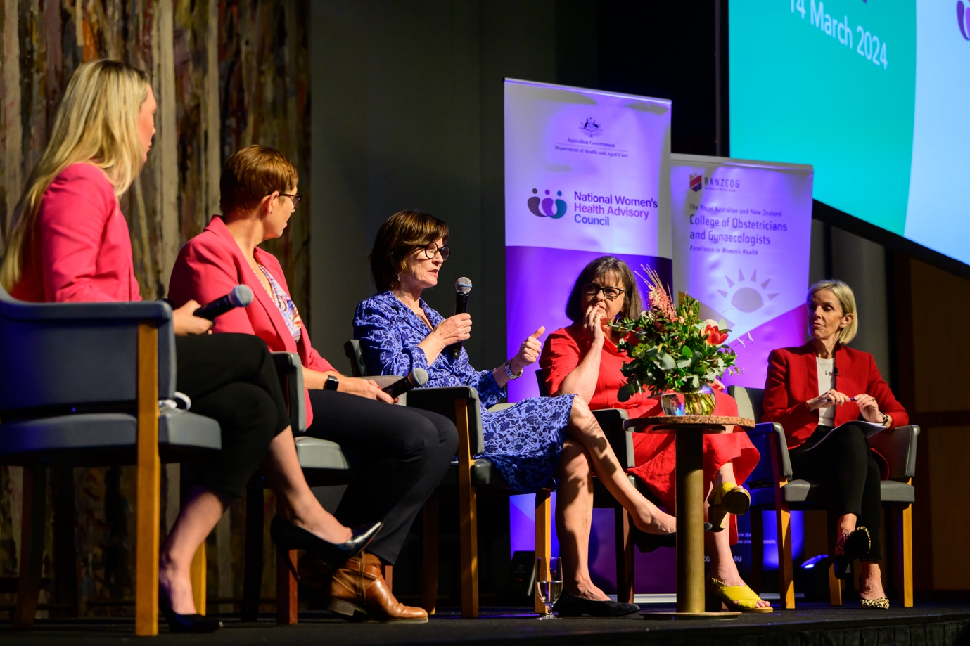

Figure 4: The Health Ministers panel (Jonty Bush MP, Rachel Stephen-Smith MLA, The Hon. Mary-Anne Thomas, and The Hon. Ged Kearney moderated by Sophie Scott OAM) at the National Women’s Health Summit 2024 shared perspectives as political leaders about the opportunities ahead to make change in women’s health

Based on discussions, presentations and online engagement, the following themes were identified:

* Importance of the health system addressing and considering intersectionality rather than a ‘one size fits all’ approach.
* Practitioners need time with patients to build relationships and trust and deliver best care.
* Greater community led interventions to increase availability of tailored support and services, including culturally safe services.
* Improve health education for women, girls and gender diverse people through all stages of their life cycle, including resources for LGBTIQA+ community members.
* Foster inclusion of sex and gender in the design of health research to ensure women’s health needs are investigated.
* Address harmful misinformation and gendered social norms.
* Ensure greater representation in the health workforce, research and clinical trials for migrant, refugee, First Nations and gender diverse populations.

# 

# A framework to monitor and report on the National Women’s Health Strategy

From its establishment, the Council was tasked with providing advice on the implementation of the National Women's Health Strategy 2020-2030 (Strategy). The Strategy outlines a national approach to reducing inequalities and improving health outcomes for all women and girls, particularly those at greatest risk of poor health.

Measuring progress on the Strategy provides critical information on the effectiveness of the healthcare system for women and gender diverse people. To enable the Council to understand the baseline of activities against the Strategy and track future progress, the Council engaged Deloitte Access Economics to assess progress since 2020 until the Council’s establishment in January of 2023.

This engagement resulted in:

* A monitoring and reporting framework for the Strategy that outlines how to track progress.
* A baseline report and scorecard which measures progress on the Strategy’s:
  + Implementation at the priority area level.
  + Outcomes at the population level using key data indicators.

Analysing progress against the Strategy since its release in 2019 is crucial due to the significant changes to Australia’s health landscape. The COVID-19 pandemic, in particular, impacted the personal lives, health and wellbeing of all women and gender diverse people. Not only did the emergence of COVID-19 pull attention from the Strategy, but it also aggravated the challenges identified in the Strategy, including workforce shortages and inequitable access to services across priority groups.

## Results

The Council worked to identify Government and non-Government contributors for the Strategy’s priorities and actions. The monitoring and reporting framework enabled assessment of the extent that stakeholders had delivered on the Strategy by:

* Developing a rating system.
* Identifying contributors.
* Gathering evidence through stakeholder consultation, desktop review and data analysis.
* Summarising evidence by themes.

The baseline assessment included a survey and 115 consultations:

* 67 organisations
* 11 focus groups
* 8 states and territories
* 18 Council members
* 8 survey results.

Contributors provided information to enable assessment of how they have implemented activities in alignment with the Strategy and monitor changes in population health outcomes for women and girls over time. The results are below.

### Priority area actions:

The Strategy identifies 5 priority areas with an additional area on research. Each priority area outlines a series of sub-priorities and actions and are associated with a set of outcomes.

* 7 out of 20 sub-priorities (35%) rated as ‘requiring stronger focus’
* 10 out of 20 sub-priorities (50%) rated as having made ‘some progress’
* 3 out of 20 sub-priorities (15%) are rated as having ‘meaningful progress.’

**Priority Area 1 – Maternal, sexual & reproductive health:** Public awareness and understanding has improved due to a range of educational initiatives. Access to sexual and reproductive healthcare, including abortion and long-acting reversible contraception (LARC) has increased. The models of care of maternity services delivered to First Nations peoples have increased with the expansion of Birthing on County (BOC) centres. However, far more action is required to ensure equitable access across priority groups, particularly in regional and remote areas, and in response to the recent reduction in some maternal, sexual, and reproductive health services nationally.

**Priority Area 2 – Healthy ageing**: There is evidence that the health sector is increasingly adopting a life course approach to healthy ageing, and of growing awareness and action in specific areas (such as menopause and dementia). However, there is confusion among health providers around how a life course approach to healthy ageing differs for women relative to men and, as a result, limited evidence of a gender-specific approach being applied.

**Priority Area 3 – Chronic conditions and preventive health**: There is evidence of greater efforts to raise awareness and improve primary prevention of chronic diseases – for the general population, rather than specifically focusing on women (some exceptions exist, such as awareness campaigns on heart disease risk factors for women). Stakeholders noted clear implementation progress for endometriosis, without significant action on other chronic pain conditions. For most chronic conditions, health services and measures are rarely tailored to the unique needs of women.

**Priority Area 4 – Mental health**: Stakeholders noted increased awareness and reduced stigma related to mental health issues and supports – however, without a gender-specific lens. Similarly, progress was identified in eating disorder awareness and support, such as in schools, and other areas of service delivery, but often without a gender or priority population lens. Concerns were raised in consultation about the lack of focus on preventive mental healthcare, poor access to specialist mental health services (including psychiatrists), the fragmentation of care across providers and a lack of integration with other healthcare services.

**Priority Area 5 – Health impacts of violence against women**: Stakeholders noted that action against this priority area largely relates to violence against women, as compared to the associated health impacts. Regardless, positive examples were provided of training provided to health professionals to manage the health impacts of violence against women, and co-designed and trauma-informed models of care.

**Investing in Research**: While there have been improvements in the disaggregation of data by sex and gender, significant blackspots remain – including for chronic fatigue and incontinence. Further, there is very limited data disaggregated by priority group including by First Nations and culturally and linguistically diverse status. As such it is difficult to assess the healthcare needs, service use and outcomes of these groups. Researchers identified there is low awareness of existing datasets and insufficient investment in data analysis, leading to missed opportunities and duplication.

### Outcomes:

The Strategy identifies 24 key measures of success related to the 5 priority areas. These were assessed as outcome measures in the monitoring and reporting framework. Of these:

* 7 out of 24 were rated ‘Positive trend in outcome.’
* 11 out 24 were rated ‘No observable change.’
* 2 out of 24 were rated ‘Negative trend in outcome.’
* 4 out of 24 were rated ‘Insufficient data available.’

# 

# Opportunities and next steps

The Council is developing a future work plan building on the issues and opportunities identified through their work so far. These activities will include to engage with existing bodies, such as federal and jurisdictional Governments, health professional organisations (e.g. Medical Deans and Colleges) and other advisory bodies to ensure their activities align with best practice and the implementation of the Council’s findings.

The Council will also look to commission further research into remaining knowledge gaps.

The Council will continue providing strategic advice to Government including, but not limited to, monitoring the implementation of the Strategy.

# Acknowledgements

The success of the Council’s first 18 months was made possible by a vast network and the community who supported Council initiatives.

The Council would like to thank all women, girls and gender diverse people who participated in the #EndGenderBias survey and provided valuable insight into the barriers and biases in the health system. The Council thanks the various federal, state and territory Government departments and non-Government organisations who helped to inform the monitoring and reporting framework. The Council would like to thank all National Women’s Health Summit speakers, panellists, Government representatives and delegates who attended both in-person and online.

Thank you to Council members and special advisers for their time, expertise and commitment to this cause. A special thank you to subcommittee leads who undertook additional responsibilities and time to develop the subcommittee reports and to inform the National Women’s Health Summit.

The Council also thanks the Department of Health and Aged Care who supported its work as Secretariat.



Figure 5 The Summit was attended by distinguished delegates from across the sector