**National Dementia Action Plan**

Monitoring and Reporting Framework

# Contents

National Dementia Action Plan Monitoring and Reporting Framework 3

What is the Monitoring and Reporting Framework? 3

What are the components of this framework? 3

Dashboard on National Dementia Action Plan measures 5

How were the measures of progress chosen? 5

What are indicators? 5

How were indicators chosen? 6

Updating indicators over time 7

How will indicators be reported? 8

Annual activity reporting 9

Evaluation 9

# National Dementia Action Plan Monitoring and Reporting Framework

## What is the Monitoring and Reporting Framework?

The National Dementia Action Plan 2024-2034 (Action Plan) is a joint initiative between the Australian Government and state and territory governments. Its vision is:

*People living with dementia and their carers have the best possible quality of life, including their emotional and physical wellbeing. People living in Australia recognise and understand dementia.*

The Action Plan includes 8 broad actions that support and guide efforts to achieve this vision over 10 years. Each of the 8 actions include ways in which governments will aim to improve outcomes, as well as a broad objective (‘Where do we want to be in 10 years?’), an outcome statement from the perspective of people living with dementia, and measures of progress against each of the actions (‘How will we know if we have made a difference?’).

This framework lays out an approach agreed by the Australian and state and territory governments to monitor and report progress related to the 8 actions of the Action Plan. It aims to support public accountability on whether governments are on track to achieve the Action Plan’s vision. It does this by outlining principles for measuring impact and enabling evaluation, as well as describing reporting of activities delivered under actions in the Action Plan.

Further details about how the Action Plan will be implemented by the Australian and state and territory governments can be found in the implementation chapter of the Action Plan and on the [Department of Health and Aged Care’s website](https://www.health.gov.au/our-work/national-dementia-action-plan).

## What are the components of this framework?

The framework is made up of 4 components:

* **Dashboard on National Dementia Action Plan indicators:** produced annually by the National Centre for Monitoring Dementia at the Australian Institute of Health and Welfare (AIHW). The dashboard will report on the measures of progress set out in the ‘How will we know if the National Dementia Action Plan has made a difference?’ statements under each action in the Action Plan. This will provide a regular and consistent evidence base on how the Action Plan is tracking to meet its overall objective.
* **Annual activity reporting:** annual reporting of activities, such as new programs or changes to existing policies and programs, will be undertaken by the Australian and state and territory governments and published annually on the Department of Health and Aged Care website. This will support accountability by the Australian and state and territory governments and make it clear how activities align with the Action Plan’s actions.
* **Mid-point review:** will be undertaken to comprehensively assess progress against the Action Plan.
* **Final evaluation:** a final evaluation will be undertaken at the end of the Action Plan to consider how effective it was and measure the impact of actions undertaken.

Overarching governance for the implementation of the Action Plan will be driven by a group of Australian and state and territory government officials and people with lived experience of dementia, supported by the Dementia Expert Reference Group and community representatives as required. The Implementation Group will meet periodically through the duration of the Action Plan to assess progress and adjust future priorities under the Action Plan based on progress information generated by components of this framework.

Figure 1: Key components of the Action Plan’s Monitoring and Reporting Framework

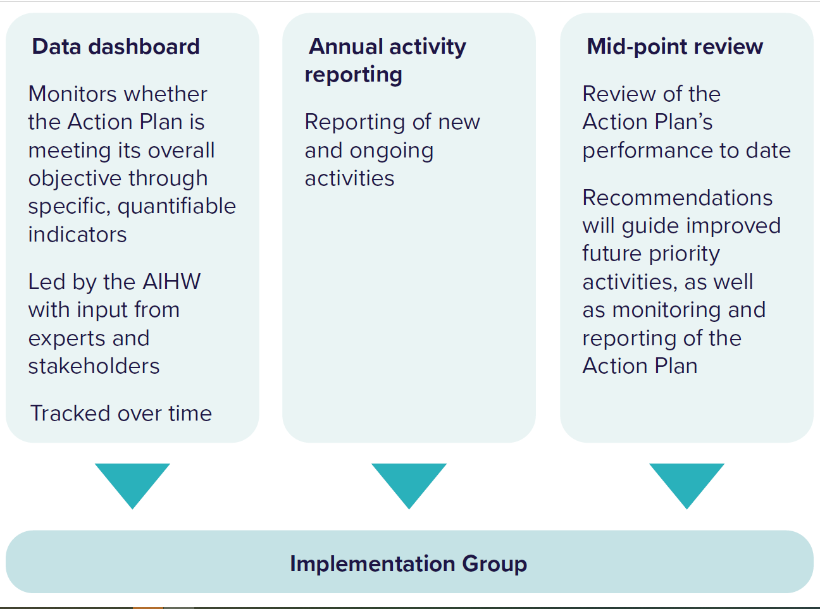

# Dashboard on National Dementia Action Plan measures

## How were the measures of progress chosen?

Under each action, the Action Plan lists broad measures of progress titled ‘How will we know if the National Dementia Action Plan has made a difference?’. These measures collectively indicate whether the Action Plan is meeting its objective to improve the lives of people with dementia, their carers and families. These measures were selected through an extensive consultation process including feedback on a public consultation paper that discussed how to monitor and report the Action Plan’s progress. Input was received from the general public, people living with dementia, their carers and families, dementia experts within and outside government, peak bodies such as Dementia Australia and the National Aboriginal Community Controlled Health Organisation, health and aged care providers and clinicians, and representatives from the Australian and state and territory governments.

## What are indicators?

The AIHW has been tasked with developing and reporting indicators related to the broad measures of progress under each action included in the Action Plan. Indicators are *quantifiable and specific metrics (like numbers or percentages) that use data to track whether the Action Plan is improving outcomes for people with dementia*.[1] See Figure 2 on opposite page.

Figure 2: How reporting on indicators relates to the Action Plan’s actions and measures of progress

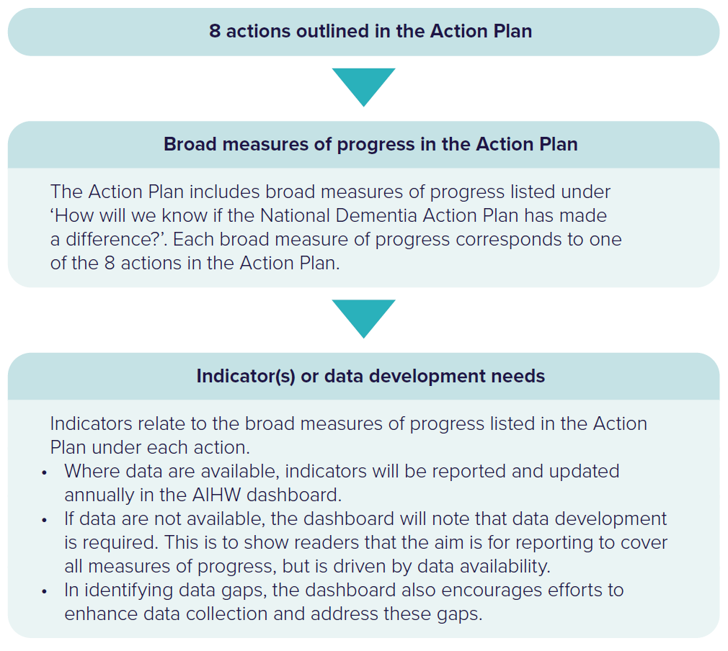

## How were indicators chosen?

Indicators were selected through: an initial review of existing indicators used in other work to monitor dementia quality of care; an assessment of national data available to monitor dementia and its impacts; consultation with dementia experts within and outside government, peak bodies such as Dementia Australia and the National Aboriginal Community Controlled Health Organisation, people with lived experience of dementia, key data providers and representatives from the Australian and state and territory governments.

Data to track indicators have been selected based on the following principles:

* must have information that closely relates to one or more of the Action Plan’s measures of progress and focus on improved outcomes
* must be readily available and regularly updated
* must have transparent and defensible data collection approaches.

For some indicators there are no comprehensive national data available as there are significant dementia data gaps in Australia. Where there are no comprehensive data available (referred to as primary data), there may be ‘proxy’ data that can be used; these are data that may not be as comprehensive or have other limitations, but which are still highly relevant to inform on measures of progress. The dashboard will outline whether data development is underway or needed to improve available data.

For some measures of progress, there will be no primary or proxy data available and so no indicators are reported. In these cases, data development activities will be required so that progress can be measured in the future. Appropriate indicators will be chosen as data development occurs over the life of the Action Plan.

## Updating indicators over time

As discussed above, some measures of progress in the Action Plan will require data development before they can be observed and tracked over time through indicators. Data development may entail a data source being created (such as a survey or a new data linkage) or expanding or making an existing data source available (such as government administrative data) to analyse for the purposes of reporting on the Action Plan’s progress. Work is underway towards closing key data gaps. For more information, see the [National Dementia Data Improvement Plan 2023–2034](https://www.aihw.gov.au/reports/dementia/national-dementia-data-improvement-plan-2023-2033/contents/about) which has been developed to guide priorities, including activities required to assess the performance of the Action Plan.

It is also worth noting that indicators do not currently incorporate targets—that is, a numeric goal to work towards. Targets require an understanding of the current situation (or baseline) to be relevant, which is currently limited by extensive data gaps related to key outcomes of interest for people with dementia, their carers and families. In the absence of targets, the dashboard will show whether indicators are improving, remaining the same, or getting worse.

As data availability changes over time, indicators may be modified and targets introduced. If primary data become available, proxy data sources may be retained if they add additional insights. The mid-point evaluation of the Action Plan will be a good opportunity to assess data over the first half of the Action Plan and potentially propose some targets for the second half of the Action Plan. Modifying indicators should only be undertaken if this improves on information previously captured by the original indicator or data source. Experts and key stakeholders will continue to be consulted regularly when the AIHW plan major modifications to existing indicators or the introduction of new ones.

The Australian and state and territory governments are committed to collecting and sharing relevant data to support effective monitoring and reporting of the Action Plan. Australian and state and territory government data will be essential for measuring performance and tracking progress. Governments will work together to ensure data needed to measure outcomes for people living with dementia are collected, shared and progressively improved over the life of the Action Plan. This will include identifying where data need to be linked between systems to improve our understanding of the impact of the Action Plan. Linked de-identified data will provide improved disaggregated information, support the development of new indicators and deliver deeper insights into how and why certain outcomes occur. Key activities and initiatives that governments fund under the course of the Action Plan will need to embed evaluation and high-quality data collection to inform progress.

## How will indicators be reported?

Indicators will be reported annually through an [online dashboard](https://www.aihw.gov.au/reports/dementia/ndap-indicators-dashboard/contents/about) hosted by the AIHW and will be organised under the relevant action and ‘measure of progress’ to which they relate. The dashboard will provide a comprehensive picture of progress where data are available to report indicators, but also of persistent data gaps and whether any data development activities are being undertaken to allow for reporting relevant indicators in the future.

Where data are available to report on an indicator, the dashboard will also present:

* whether there has been progress over time for a given indicator
* a description of the data available, guidance on how to interpret the results, and information on data limitations
* where appropriate, statistical breakdowns for priority groups
* any historical changes to the data sources or specifications for a given indicator.

For some indicators, updated data will not be available annually or available with a time lag (for example, latest data would be 2-3 years behind the current year), and for others, progress is only expected in the longer term. However, annual updates will be carried out with the aim of providing accountability to the public on progress as it occurs, as well as to help inform priorities considered by the Action Plan’s Implementation Group.

The first annual dashboard will provide a baseline of indicators with available data—that is, an indication of the state of play at the start of the Action Plan. Subsequent annual updates against these indicators would then show changes from the baseline and year-on-year. Assuming data availability improves over time, more indicators will become available, and it is expected that the annual dashboards would increasingly provide a better picture of the impacts of the Action Plan.

## Annual activity reporting

There will be annual activity reporting on the difference being made under the Action Plan from government-funded initiatives. Annual activity reporting will:

* enable governments to showcase and promote related activities
* provide stakeholders with an up-to-date view of activities undertaken against the Action Plan and their progress
* clearly describe how the activities are linked to the Action Plan and discuss their impact.

The Action Plan’s Implementation Group (consisting of Australian and state and territory government officials and people with lived experience of dementia) will determine the process and timing of annual reporting.

## Evaluation

A mid-point review will be undertaken to comprehensively assess progress against the Action Plan and consider:

* progress made on implementing the actions set out in the Action Plan and the impact of these actions in improving outcomes for people living with dementia, their carers and families
* any factors impacting implementation or limiting the ability of governments and others to make progress towards the 8 actions described in the Action Plan
* opportunities for improvement, including to better target actions to meet the needs of people living with dementia, their carers and families, to improve the effectiveness and efficiency of implementation or to improve governance, monitoring and reporting arrangements (such as the indicators captured in the annual dashboard)
* any new developments made in dementia research, technology or supports and how these could be incorporated into the Action Plan moving forward.

The review would be undertaken in close collaboration with people with lived experience of dementia and a report on the outcomes of the review would be made publicly available.

At the end of the Action Plan, a final evaluation will be undertaken which will consider how effective the Action Plan was and measure the impact of actions.

1. For a small number of indicators, it is not appropriate to report numerical data (for example, reporting on improved national data for measuring the number of people living with dementia). Instead, the state of progress will be described.