

National Aged Care Advocacy Program Evaluation

Final report

Australian Government Department of Health and Aged Care

11 July 2024



© Commonwealth of Australia as represented by the Australian Government Department of Health and Aged Care, 2024

Apart from uses permitted by the Copyright Act 1968 and this copyright notice, all other rights (including all commercial rights) are expressly reserved.

**Permitted uses**

You may download, display, print, and reproduce the whole or part of this publication in unaltered form for:

* your own personal use;
* use within your organisation; or
* distribution and sharing with third parties,

but only if:

* you or your organisation do not use or reproduce the publication for any commercial purpose; and
* if reproduced, this copyright notice and all disclaimer notices are included as part of any reproduction.

This licence does not cover, and there is no permission given for, use of the Commonwealth Coat of Arms or any logos and trademarks (including the logo of the Australian Government Department of Health and Aged Care).

**Disclaimer**

This publication has been produced independently by Australian Healthcare Associates at the request of the Australian Government Department of Health and Aged Care.

The Australian Government accepts no responsibility for material contained in the publication. The views or recommendations expressed in this publication may include the views or recommendations of third parties and do not necessarily reflect those of the Australian Government or indicate a commitment to a particular course of action.

Providing access to the publication does not constitute an endorsement, approval or recommendation by the Australian Government of any organisation, association, entity, service, program, products or research offered by virtue of any information, material or content within the publication.

The information in this publication is provided on the basis that all persons accessing it undertake responsibility for assessing the relevance and accuracy of its content.

**Suggested citation:** Australian Healthcare Associates, 2024, National Aged Care Advocacy Program Evaluation: Final report, Australian Government Department of Health and Aged Care, Canberra.

Australian Healthcare Associates: Australia's largest health and human services consulting firm

Level 6, 140 Bourke St, Melbourne Vic 3000

Locked Bag 32005, Collins Street East, Vic 8006

1300 242 111

aha@ahaconsulting.com.au

www.ahaconsulting.com.au

Acknowledgement of Country

In the spirit of respect and reconciliation, Australian Healthcare Associates acknowledges the traditional custodians of Country, the Aboriginal and Torres Strait Islander peoples, and their continuing connection to land, waters, sea, and community.

Australian Healthcare Associates is located on the lands of the Kulin Nation.   
We pay respect to Elders past and present.

Contents

1 Summary 1

Findings 2

Future opportunities 1

2 Introduction 2

2.1 NACAP expansion 2

2.2 Aged care system reform 3

2.3 About this evaluation 4

2.4 About this report 5

3 NACAP information and advocacy 6

3.1 Information and advocacy services are reaching more older Australians 7

3.2 Advocacy cases are becoming more complex 10

3.3 Promotion and outreach activities are establishing appropriate referral pathways 17

3.4 Information and advocacy services are broadly achieving their intended outcomes 24

Future opportunities for information and advocacy 31

4 Home Care Check‑In Project 32

4.1 HCCI service delivery is resource intensive 33

4.2 HCCI services are making a difference to the lives of vulnerable people 36

Future opportunities for the HCCI Project 39

5 Education 40

5.1 SDOs are delivering more education sessions to aged care staff and clients 41

5.2 Delivering education in residential aged care remains challenging 48

5.3 Aged care staff who receive NACAP education report positive outcomes 50

5.4 Early learnings have helped refine the design and implementation of diversity education 52

Future opportunities for education 55

6 Service delivery in context 56

6.1 The NACAP is an important part of a suite of programs supporting older people 56

6.2 The consortium model is key to effective and efficient program delivery 59

6.3 Advocate workforce needs support to carry out a rewarding yet challenging role 63

Future opportunities to support effective service delivery 67

7 Conclusion 68

7.1 Limitations 68

7.2 Final reflections 70

Abbreviations 94

References 95

Tables

Table 3‑1: Total cases by service type 8

Table 3‑2: Proportion of cases where the recipients identified with a NACAP target group 11

Table 3‑3: Proportion of cases where recipients reported membership of at least one NACAP target group, by target groups and service type, October 2023 to March 2024 11

Table 3‑4: In-scope issues managed by NACAP advocates, October 2023 to March 2024 14

Table 3‑5: Out-of-scope issues managed by NACAP advocates, October 2023 to March 2024 15

Table 3‑6: Proportion of cases by referral source, October 2023 to March 2024 17

Table 5‑1: Education sessions, 2021-22 42

Table 5‑2: Education sessions, 2022-23 42

Table 5‑3: Number of education sessions and attendees by education type, October 2023 to March 2024 43

Table 5‑4: Proportion of education sessions aimed at NACAP target groups, October 2023 to March 2024 43

Table 5‑5: Targeted education sessions by target group, October 2023 to March 2024 44

Table 5‑6: Education sessions and attendees, by type and target audience, January 2024 to March 2024 47

Table 5‑7: NACAP education activities completed by aged care staff survey respondents 50

Table A‑1: Appropriateness evaluation questions and their location in this report 71

Table B‑1: Overview of stakeholder consultations 73

Table B‑2: Participation in, and recency of, NACAP education among aged care staff survey respondents 76

Table B‑3: Number and proportion of aged care staff aware of NACAP information, advocacy and education services 76

Table B‑4: Survey respondents by who they sought NACAP support for 77

Table B‑5: Respondents’ self-reported membership of diverse groups 78

Table C‑1: Proportion of cases by referral source (full list), October 2023 to March 2024 80

Table D‑1: HCCI recipient referral source 83

Table D‑2: Proportion of HCCI clients by identified risk flags, July 2023 to March 2024 83

Table D‑3: Proportion of HCCI clients by NACAP target group, July 2023 to March 2024 84

Table E‑1: Information and advocacy cases, July 2020 to December 2023 85

Table E‑2: Responses to “the support I received improved my understanding of aged care services” 86

Table E‑3: Responses to “the support I received improved my understanding of accessing services” 86

Table E‑4: Responses to “the support I received improved my understanding of advocacy” 86

Table E‑5: Responses to “the support I received improved my understanding of aged care rights” 87

Table E‑6: Responses to “the support I received improved my confidence” 88

Table E‑7: Responses to “I felt empowered to self-advocate” 88

Table E‑8: Risk flags per HCCI recipient, July 2023 to March 2024 88

Table E‑9: Change in risk score from first to last assessment for 24 HCCI recipients 89

Table E‑10: Number of residential and home care education sessions delivered by SDOs to aged care staff and clients, 2020‑21 to 2022‑23 90

Table E‑11: Education session attendees, by education type, October 2023 to March 2024 90

Table E‑12: Aged care staff responses to “I feel better informed about …” 91

Table E‑13: Advocate workforce FTE, 2020-21 to 2023-24 91

Figures

Figure 3‑1: Information and advocacy cases, July 2020 to December 2023 7

Figure 3‑2: Proportion of advocacy cases that include an out-of-scope issue, by jurisdiction 16

Figure 3‑3: Screenshot of OPAN website’s translation feature 19

Figure 3‑4: Proportion of respondents agreeing that the support they received improved their understanding of aged care services, advocacy and aged care rights 24

Figure 3‑5: Proportion of respondents agreeing that the support they received improved their confidence 27

Figure 3‑6: Proportion of respondents agreeing that they were satisfied with the services they received 29

Figure 4‑1: Number of risk flags per HCCI recipient, July 2023 to March 2024 34

Figure 4‑2: Change in risk score from first to last assessment for 24 HCCI clients 37

Figure 5‑1: Number of residential and home care education sessions delivered by SDOs to aged care staff and clients, 2020‑21 to 2022‑23 41

Figure 5‑2: Education session attendees, by education type, October 2023 to March 2024 45

Figure 5‑3: Target and actual aged care staff registrations for online education sessions, 2021‑22 and 2022-23 46

Figure 5‑4: Aged care staff satisfaction with NACAP education 51

Figure 5‑5: Proportion of aged care staff agreeing that they feel better informed about 51

Figure 6‑1: Advocate workforce FTE, 2020-21 to 2023-24 63

Figure B‑1: Proportion of respondents to aged care staff survey by role 75

Figure B‑2: Proportion of respondents to aged care staff survey by work setting 75

Figure B‑3: Proportion of surveys completed, by jurisdiction 77

Figure B‑4: Proportion of survey respondents currently receiving aged care services 79

Figure C‑1: OPAN awareness-raising activities, January to June 2023 82

# Summary

Many older people need support to understand and exercise their aged care rights and to raise and address concerns with their aged care providers. The National Aged Care Advocacy Program (NACAP) provides free, confidential and independent information, education and advocacy support to older people and their representatives who are receiving, or seeking to receive, Australian Government‑funded aged care services. It also delivers education sessions to aged care providers to promote awareness of aged care rights and provider responsibilities.

The NACAP is managed by the Older Persons Advocacy Network (OPAN) and delivered by its 9 member service delivery organisations (SDOs) nationwide.

The Royal Commission into Aged Care Quality and Safety (the royal commission) recognised the importance of the NACAP in supporting older people through both individual and systemic advocacy and recommended additional funding to further develop and expand the program. In response, the Australian Government increased NACAP funding in the 2021‑22 Budget by $99.6 million to a total of $151 million over 4 years to expand the reach of advocacy services and introduce new service offerings, including a Home Care Check‑In (HCCI) pilot for vulnerable, at risk, and socially isolated older people.

In August 2023, the Australian Government Department of Health and Aged Care (the department) engaged Australian Healthcare Associates (AHA) to evaluate the NACAP’s implementation, effectiveness and efficiency.

We consulted with 743 stakeholders, comprising NACAP recipients, aged care staff, OPAN and SDO staff and government representatives, and synthesised the findings from these consultations with other program documentation and data including the NACAP minimum data set (MDS). We found that the NACAP is a highly valued program providing much-needed support and delivering positive outcomes for older people.

Findings

A brief overview of the findings is provided below.

The NACAP is providing high-quality information and advocacy services to people with diverse needs

Information and advocacy form part of NACAP’s core services, supporting older people who receive or are seeking to receive government-subsidised aged care (and their representatives). Since the NACAP’s funding increase, information and advocacy cases have grown from 6,990 cases in quarter 2 2021‑22 to 10,316 cases in quarter 2 2023‑24, an increase of almost 48%. Stakeholders noted the NACAP’s consistent focus on quality and equity. They told us that older people are presenting with increasingly complex issues that can be more time-consuming to resolve.

A total of 38% of information and advocacy recipients reported membership of at least one of the NACAP target groups. These target groups include people living with dementia, a mental health condition, a disability, cognitive decline and those who identify as being from special needs groups as defined in the Aged Care Act 1997.[1] This demonstrates that services are performing well in reaching those who may experience disadvantage and barriers to access.

Advocates support recipients with a range of issues. Mostly these are within the program’s scope. However, sometimes advocates deal with out-of-scope issues (for example, housing/tenancy issues), particularly where they impact on aged care rights and where other services are not available.

Both OPAN and SDOs use a range of strategies to promote the NACAP to referrers and older people, including strategies tailored to reach people with diverse needs. The introduction of the Advocacy Community Network Development (ACND) expansion project, while still in its early stages, has increased the reach of the NACAP and is helping to raise awareness of the program among older people and potential referrers.

We found that the NACAP is effective in increasing older people’s knowledge of services, advocacy and aged care rights. Recipients felt that advocates were making a considerable difference in their lives, and 90% of the surveyed 418 recipients responded that they were satisfied with the services they received. Satisfaction with the NACAP was high, due to the professionalism of advocates and the quality of the support they deliver, even when the recipient’s issue was unable to be resolved. In addition, around three‑quarters of NACAP recipients in our survey felt more confident and empowered to self-advocate.

The Home Care Check‑In pilot has achieved positive results and a broader rollout of the service would be beneficial

The HCCI service supports extremely vulnerable home care recipients with complex needs. Unlike general advocacy clients, the needs of HCCI clients extend beyond assistance with a particular aged care advocacy issue. HCCI clients have multiple vulnerabilities and community support advocates need to spend time building rapport and trust with HCCI clients before they can help them to understand and navigate the health and social support services available to them, referring them to these services where appropriate. The HCCI program offers preventative support and helps clients to build a scaffold of support around themselves before they are exited from the program. The HCCI Project is currently being piloted in 3 states (Western Australia, New South Wales and South Australia) and has supported 92 older people since it began in July 2023.

While the HCCI service is designed specifically to support extremely vulnerable clients, the pilot has revealed an even greater complexity and need for support than initially anticipated, and the service has been more resource intensive to deliver than planned.

Stakeholders reported positive outcomes for clients, including increased confidence, independence, social connection and linkages with health and support services. The pilot is also proving effective in reducing clients’ assessed risk and vulnerability, suggesting it provides a vital service for those most in need. Broader rollout is encouraged.

NACAP education is effective, but delivery in residential facilities is an ongoing challenge

NACAP’s core education activities provide information on a range of topics related to aged care advocacy, aged care rights, and elder abuse prevention (OPAN 2024c). SDOs are responsible for delivering education sessions to aged care clients and staff in residential and community care settings, while OPAN mainly delivers online education to older people and their representatives, aged care providers and staff, and members of the public. In addition, as part of NACAP’s expansion, a diversity education program was introduced to educate aged care providers about culturally safe and inclusive services to people from diverse and marginalised groups.

The number of education sessions delivered by SDOs has grown from 490 sessions in quarter 2 2021‑22 to 885 sessions in quarter 2 2023‑24, an increase of 80% since the NACAP’s funding was increased. Most sessions are delivered to people living in residential aged care, which is consistent with the emphasis placed on this activity through SDO KPIs. However, SDO representatives reported significant challenges with delivering education sessions in residential care settings. While most SDOs are making good progress towards their education session performance targets, they highlighted that doing so requires a concerted effort to build trust and rapport with aged care staff in their region.

The key impetus for all education activities, including educating aged care staff, is to increase awareness and referrals to NACAP services for older people. However, data was collected only from aged care staff for this evaluation. Most aged care staff who completed NACAP education activities reported that their knowledge of advocacy, aged care rights, and elder abuse had improved and, importantly, that they had implemented changes in their day-to-day work as a result.

We heard that the design and implementation of diversity education are going according to plan. While this expansion activity was not a focus of the evaluation and no outcome data was collected, we observed positive steps to establish the project, which aims to educate providers on the delivery of culturally safe and inclusive services to people from diverse and marginalised groups. OPAN is using available demographic data to gain insights into local population characteristics of different geographic regions, enabling the education to be tailored to local needs. This flexible approach to targeting need is seen as a key strength of the program.

**The NACAP exists in a complex environment, and the consortium model supports staff to deliver quality services**

The NACAP is one of several Australian Government‑funded programs aiming to improve older people’s access to, and outcomes of, aged care services. NACAP’s expansion comes at a time of significant reform in the aged care sector and coincides with the introduction of new measures to improve the quality, safety, accessibility and equity of aged care services. As these programs add to existing programs servicing the sector, it is important to consider how these programs work together. Overall, most stakeholders believed that the NACAP works well with services such as the care finder program, and the Aged Care Specialist Officers (ACSOs). While there are some areas of overlap between the programs, stakeholders believed that this was not a problem, provided there is a strong commitment to a “no wrong door” approach to help older people reach the service best suited to their needs.

The OPAN consortium model delivers a range of efficiencies and supports national consistency, while maintaining each SDO’s individual presence, identity and autonomy within their jurisdiction. Advocates valued the way the consortium approach elevates and amplifies the voices of the older people they work with through systemic advocacy. While some SDO representatives found it difficult to keep up with the pace set by OPAN (e.g. for responding to requests for information or changing data processes), the benefits were seen to vastly outweigh the drawbacks.

The NACAP is managed and delivered by experienced, skilled, and dedicated staff. The expansion has allowed SDOs to more than double their workforces. At the same time, OPAN has continued to strengthen and expand its suite of training and professional development for advocates, recognising that a professionalised advocacy workforce is key to ensuring consistent, high-quality service delivery for recipients. Advocates are supported by several OPAN initiatives including the Advocacy Academy, the Knowledge Hub, and communities of practice (CoPs). SDOs also provide additional training and support for advocates. The challenging nature of the advocate role is recognised across the consortium, and supports are in place to minimise burnout and vicarious trauma as advocates perform their roles.

In light of these findings, we identified 12 opportunities to support the future delivery of the NACAP.

Future opportunities

For information and advocacy:

1. Consider defining a prioritisation framework to help advocates determine when it is appropriate to address issues currently defined as out of scope (e.g. legal, housing) where these are crucial to aged care rights being upheld. Criteria may include the individual’s level of risk, the availability of other supports, and the urgency of the issue(s).
2. Develop reporting mechanisms to capture the time that advocates spend addressing out‑of‑scope issues to inform future resourcing. Use this information to focus efforts in working with other organisations to clarify and strengthen arrangements for supporting older people with complex issues that span sectors, and where appropriate, undertake coordinated, cross‑sectoral systemic advocacy.
3. Continue to increase the geographical reach of the NACAP, including through the ACND, while ensuring sufficient time is spent in communities for relationships to be established and embedded.
4. Repeat the demand study, using MDS data, to prioritise geographical areas and population groups for further expansion.
5. Leverage insights generated from the diversity education expansion activity regarding demographics and needs in different regions to target promotion of information and advocacy.

For the HCCI Project:

1. Fund all SDOs to establish or expand HCCI services in high-need areas, including funding to recruit, train and support appropriately qualified community support advocates.

For education:

1. Consider revising the KPI related to RACH resident education to capture efforts to arrange sessions rather than the number of sessions actually delivered, as the latter is not always within SDOs’ control.
2. Work with aged care staff to develop flexible options for NACAP education that meet their needs (content, format, duration).

To support effective service delivery

1. Ensure SDOs are adequately resourced to meet the administrative and service delivery requirements of the program. This includes being able to respond to OPAN’s requests for information and data in a timely manner.
2. Consider ways to make training delivered by individual SDOs available across the consortium where relevant.
3. Consider opportunities to ensure that all advocates have access to timely and appropriate peer, manager, and external support.
4. Consider creating additional CoPs to provide general advocates across the consortium with meaningful opportunities to connect with each other.

# Introduction

The National Aged Care Advocacy Program (NACAP) provides free, independent and confidential information, advocacy support, and education to older people (and their representatives) receiving, or seeking to receive, Australian Government‑funded aged care services. Additionally, the NACAP delivers education sessions to aged care providers and staff to promote awareness of aged care rights and provider responsibilities (Department of Health and Aged Care 2018).

The NACAP is delivered by 9 service delivery organisations (SDOs) – one in each state and the Australian Capital Territory, and 2 in the Northern Territory. After independently delivering NACAP services for over 20 years, they came together in 2017 to form the Older Persons’ Advocacy Network (OPAN), a consortium comprising the 9 SDOs and the OPAN national secretariat.[2] The establishment of the consortium formalised a commitment to improving national coordination, relationship building and knowledge sharing between the SDOs. It also provided the foundation for a national voice that could more effectively deliver systemic advocacy.

## NACAP expansion

The Royal Commission into Aged Care Quality and Safety (the royal commission) highlighted the essential role of individual and systemic advocacy in safeguarding the rights and interests of older people and recommended expanding the NACAP’s coverage and activities (Royal Commission into Aged Care Quality and Safety 2021a).

In response, the Australian Government increased the NACAP funding by $99.6 million over 4 years (announced in the 2021‑22 Budget) and expanded the NACAP activities to include:

* Advocacy Community Network Development (ACND), to increase awareness of and referral pathways into the NACAP and build older people’s capacity to self-advocate
* a Home Care Check‑In pilot, to provide preventative safety checks, referrals, and service linkages for home care consumers at risk of social isolation, neglect, or harm
* a Home Care and Aged Care Costs Education project, in which financial advocacy officers (FAOs) directly support older people in financially complex cases
* diversity education, to increase aged care providers’ capacity to meet the needs of people from diverse backgrounds
* support for aged care reform and emergencies, provided to aged care providers and older people in response to emerging or emergent issues.

## Aged care system reform

The NACAP operates in a complex system. The current *Aged Care Act 1997* is the primary legislation covering Australian Government‑funded aged care. Along with the associated aged care principles, the Act sets out rules for funding, regulation, approval of providers, subsidies and fees, standards, quality of care, the rights of people receiving aged care and non‑compliance.

The Act also requires a Charter of Aged Care Rights (the Charter) that protects the rights of people accessing government-funded care. The Charter sets out 14 consumer rights and is supported by 8 Aged Care Quality Standards that outline provider responsibilities.

The Aged Care Act and principles, the Charter, and the Aged Care Quality Standards are fundamental to the NACAP’s role, as advocates use their knowledge of these “tools” to resolve issues between aged care recipients and providers (and encourage recipients to use them in advocating for themselves).

However, the royal commission found that the current Aged Care Act – and related legislation – is no longer fit for purpose; in part because it centres on providers and their funding rather than aged care recipients and *their* needs. It recommended a new Aged Care Act to “enshrine the rights of older people who are seeking or receiving aged care … [leaving] no doubt to all involved in the system about the importance placed on these rights” (Royal Commission into Aged Care Quality and Safety 2021). The Australian Government has accepted the recommendation and is developing a new rights-based Aged Care Act, which will come into effect from 1 July 2025 (subject to parliamentary processes).

In addition, the Australian Government has announced a $17.7 billion aged care reform package to improve the quality, safety, accessibility, equity and sustainability of aged care services. The package includes funding to develop a new aged care regulatory model to support the new Act and ensure “a consistent way to provide feedback and promptly address complaints and concerns, with a focus on resolving issues respectfully and adequately”.

OPAN plays a key role in supporting the department in implementing these reforms and providing information and education to aged care recipients and providers. The inherent complexity of the aged care system and the current rate of reform (combined with other demographic, clinical and cultural trends) mean that demand for the NACAP is predicted to rise in coming years.

## About this evaluation

Australian Healthcare Associates (AHA) was commissioned to evaluate the NACAP by the Australian Government Department of Health and Aged Care (the department). The evaluation was undertaken between August 2023 and June 2024.

The evaluation was focused on the established core NACAP services (information, advocacy, and education) and the pilot Home Care Check-In Project. Other expansion activities were considered where relevant but were not a major focus; nor was systemic advocacy.

The evaluation was guided by 10 key evaluation questions (KEQs) that explore the NACAP’s implementation, effectiveness, efficiency, and opportunities for future improvement.

1. How well is the NACAP being delivered?
2. Do advocates have the capacity, skills and knowledge required to deliver the NACAP?
3. How is HCCI implementation progressing across states and territories?
4. How is the design and planning of the diversity education rollout progressing?
5. Are there appropriate referral pathways for older people?
6. Is the NACAP consortium model effective?
7. To what extent is NACAP information, advocacy, and education achieving the intended objectives?
8. To what extent is the HCCI Project achieving its intended objectives?
9. Have the NACAP resources been used efficiently to achieve the planned outputs?
10. Based on the key findings from the evaluation, what recommendations can be made to improve the implementation, effectiveness, and efficiency of the NACAP?

These KEQs are supplemented by detailed sub-questions. See Appendix A for the full list of evaluation questions, mapped to the relevant sections of this report.

### Data sources

To answer these evaluation questions, we drew on multiple data sources:

* program documents (including performance reports, service delivery guides, program logics, activity work plans, annual and financial reports)
* NACAP minimum data set (MDS) and OPAN data summaries
* interviews with representatives from government, OPAN and SDOs
* survey responses from aged care staff and NACAP recipients.

See Appendix B for further details about data sources and collection methods.

## About this report

This report brings together all aspects of the evaluation.

Section 3 presents findings about the nature and volume of information and advocacy services being delivered, the characteristics of people accessing these services, and the barriers that advocates are working to address. We also consider the appropriateness of promotional activities and referral pathways and how well services are achieving their intended outcomes.

Section 4 looks at implementation of the HCCI Project and the difference it is making to recipients’ lives.

Section 5 presents findings related to education activities. We consider the number and type of education sessions delivered by SDOs and the barriers to delivering education to residential aged care clients. We also look at the experiences and outcomes of aged care staff who completed NACAP education activities and discuss the rollout of the diversity education program.

Section 6 looks at the broader context of the NACAP, including how it fits into the aged care landscape. We also discuss the OPAN consortium model and the advocate workforce.

# NACAP information and advocacy

Information and advocacy are the NACAP’s core services to support older people and their representatives. As defined in the Service Delivery Framework (OPAN 2023a):

* **Information** is the provision of individualised information about advocacy, the aged care system, complaints processes, and rights and responsibilities. It can include referral to other services as relevant to the person’s needs.
* **Advocacy** occurs when support beyond initial information is required. It involves standing alongside an individual to ensure that their voice is heard in relation to a specific issue, assisting them to understand their rights and options, and representing their views and interests where required.

The NACAP provides 2 types of individual advocacy: general and financial.[3] General advocacy is delivered by a workforce of 189.3 FTE advocates and is intended to provide support for a broad range of issues related to the rights of older people. Financial advocacy provides support for complex financial issues and is delivered by specialist FAOs (14.2 FTE) through the Home Care and Aged Care Costs Education project, introduced as part of the expansion (see section 3.1.2).

This section explores the nature and volume of information and advocacy services being delivered, the characteristics of people accessing these services, and the issues that advocates are working to address. We also describe promotional activities and referral pathways. The section concludes with an analysis of whether NACAP information and advocacy services are achieving their intended outcomes – and why.

## Information and advocacy services are reaching more older Australians

There has been a clear increase in the number of information and advocacy cases since the expansion funding was introduced (Figure 3‑1). Cases increased slowly over the first year before jumping significantly in early 2023. This pattern highlights that expanding services takes time, including time to recruit and train an expanded workforce (OPAN 2023b). This is true even for long-running programs with well-established services, such as NACAP information and advocacy.

Figure 3‑1: Information and advocacy cases, July 2020 to December 2023

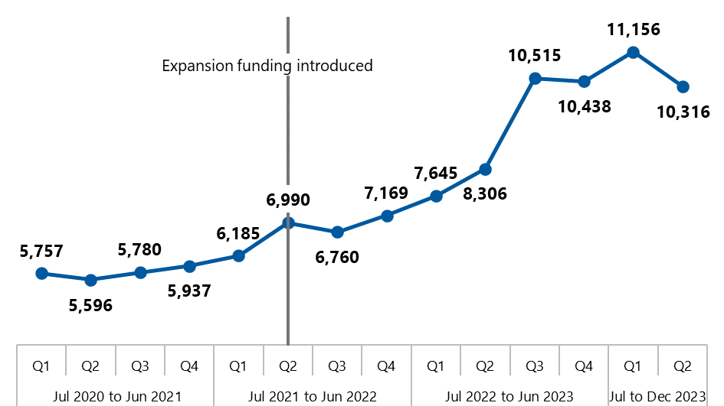

Source: OPAN data summary 1 (2024a).

Note: Jul 2023 to Dec 2023 data is still preliminary as minor adjustments can occur during the data quality checking process. Values include Abuse of Older Persons information provisions and advocacy cases.

Data is provided in Appendix E, section E.1.

Data sources

OPAN introduced a new NACAP MDS in 2023, meaning only 6 months of MDS data was available for this evaluation (October 2023 to March 2024). OPAN also provided us with summary data on services delivered prior to October 2023; however, we were unable to explore this data in the same depth as the MDS data.

The discussion of information and advocacy cases in the rest of this chapter is based on MDS data and includes all eligible clients between October 2023 and March 2024.

**Information** data reflects all types of information provision – both in scope and out of scope – to eligible clients. Information provision to “ineligible” clients is not included.

**Advocacy** data includes all advocacy and advocacy – abuse of older person cases. These cases may have involved consultation with, or partial management by, an FAO, but excludes financial advocacy cases.

**Financial advocacy** data includes advocacy and advocacy – abuse of older person cases fully managed by an FAO.

These definitions are aligned with OPAN reporting to maximise the integrity and comparability of the data over time.

We note that OPAN regards all MDS data as preliminary until it is reconciled at the end of the financial year, and this process may result in minor adjustments to the MDS data provided for this evaluation. In addition, some MDS data items are not recorded until a case is closed. Finally, we have rounded most figures to the nearest whole number for ease of reading. There may therefore be some slight differences between the figures presented in this report and future reporting from this dataset. However, these differences are likely to be extremely small and therefore do not affect the findings of this evaluation.[4]

### Demand for services is likely to increase

Between October 2023 and March 2024, SDOs opened a total of 21,714 new cases, the majority (68%) of which were information provision (Table 3‑1). General advocacy accounted for 30% of cases, while financial advocacy made up 2% of cases.

Table 3‑1: Total cases by service type

| Service type | Number of cases | Proportion |
| --- | --- | --- |
| Information | 14,664 | 68% |
| Advocacy | 6,592 | 30% |
| Financial advocacy | 458 | 2% |
| Overall | 21,714 | 100% |

Source: NACAP MDS.

In early 2022, the department commissioned a study to explore the current and future met and unmet demand for NACAP services. The study found that there is current unmet demand for aged care advocacy services and, while the expansion funding may alleviate that in the short term, unmet demand is likely to increase over the longer term (Deloitte 2022).

The authors noted certain limitations with the study, including “significant gaps” in the available data (the study was conducted before the MDS was introduced). Furthermore, the study was conducted shortly after the NACAP expansion funding came into effect but before the expansion activities had been fully implemented.

Since detailed mapping of met and unmet demand was out of scope for this evaluation, we suggest the department repeats the demand study using the more accurate and thorough data available since the introduction of the MDS. This would enable a better understanding of the impact of the expansion activities on NACAP reach, priority areas for further expansion, and the key drivers of demand – including the introduction of the new Aged Care Act and related reforms.

Overall, we heard from stakeholders that there is strong demand for NACAP and that it could be expanded further to meet the needs of people receiving aged care services. However, stakeholders noted that, as recruitment targets have now been met (see section ), expanding the reach of the NACAP will require additional funding to increase the advocate workforce.

SDO representatives felt strongly that it was important to provide high quality services to those in need, rather than simply increasing the quantity of services delivered.

### Financial advocacy officers offer expertise to older people and other advocates

Financial advocacy was introduced as a specialist offering through the Home Care and Aged Care Costs Education (HCACE) expansion project. It is delivered by 14.2 FTE financial advocacy officers (FAOs). Over the 6 months to March 2024, FAOs fully managed 458 cases – accounting for 2% of all information and advocacy cases over the period (Table 3‑1).

FAOs also provide considerable support and coaching to general advocates in addition to managing complex cases themselves. While the evaluation did not look at the HCACE project in detail, we heard that this support and capacity-building means that general advocates are more confident and skilled in supporting older people with financial issues, and only the most complex financial cases need to be fully managed by an FAO.

## Advocacy cases are becoming more complex

SDO representatives told us that both information provision and advocacy cases have become more complex and therefore more resource intensive. They identified a range of factors that may contribute to increasing case complexity, including the increasing complexity of the aged care system itself. We heard that each wave of system reform, while important, introduces new service changes, decisions, and confusion.

Stakeholders also pointed to the generational shift in the aged care population, from the Silent Generation (born between 1928 and 1945) to the Baby Boomers (born between 1946 and 1964). Stakeholders reported that this has led to changing cultural norms, with care recipients now more prepared to ask for help and more willing to discuss their mental health and other issues that affect their interaction with aged care services.

In addition, an increasing number of older people are seeking information and advocacy support for complicated financial issues associated with superannuation.

We also heard that many of the issues that contribute to case complexity are out of scope for the NACAP because they do not relate to accessing or interacting with Australian Government‑funded aged care services, but that advocates nonetheless feel obligated to assist – especially when out-of-scope issues impact on aged care (see section 3.2.2).

Whether in-scope or out-of-scope, SDOs highlighted that growing complexity means that cases are taking longer to resolve, thus making service delivery appear less efficient.

### Services are reaching NACAP target groups

One of the key principles of the NACAP is access and equity, particularly for older people with diverse needs (Department of Health and Aged Care 2018).

Overall, in 38% of information and advocacy cases, recipients reported membership of at least one of the NACAP target groups (Table 3‑2). Of the cases where recipients reported membership of at least one of the NACAP target groups (Table 3‑3), the most commonly reported groups were people living in a rural or remote area (27%) or coming from a CALD background (25%). Membership of any target group was more common among recipients of both general advocacy (58%) and financial advocacy (57%) than information (28%).

The NACAP is expected to deliver 20% of advocacy services to a subset of 7 target groups (OPAN 2024b). Available MDS data shows this target is being met: between October 2023 and March 2024, 20% of advocacy recipients identified with one of these 7 groups.

Table 3‑2: Proportion of cases where the recipients identified with a NACAP target group

| NACAP target group | Information | Advocacy | Financial advocacy | Overall |
| --- | --- | --- | --- | --- |
| **Total number of cases** | **14,664** | **6,592** | **458** | ****21,714**** |
| At least one NACAP target group | 28% | 58% | 57% | 38% |
| KPI 2: Special needs reach* | n/a | 20% | 17% | 20% |
| Not applicable | 5% | 10% | 13% | 7% |
| Unknown | 67% | 32% | 31% | 55% |
| Total | 100% | 100% | 100% | 100% |

Source: NACAP MDS.

Note: NACAP target groups marked with an asterisk (*) in Table 3‑3 count towards the special needs reach KPI.

Table 3‑3: Proportion of cases where recipients reported membership of at least one NACAP target group, by target groups and service type, October 2023 to March 2024

| NACAP target group | Information | Advocacy | Financial advocacy | Overall |
| --- | --- | --- | --- | --- |
| **Number of cases where recipients reported membership of at least one NACAP target group** | **4,149** | **3,823** | **259** | ****8,231**** |
| People who live in a rural or remote area | 25% | 31% | 17% | 27% |
| People from CALD backgrounds* | 24% | 26% | 19% | 25% |
| People living with dementia | 23% | 16% | 19% | 19% |
| People living with a disability | 16% | 21% | 24% | 18% |
| People living with cognitive decline | 9% | 11% | 12% | 10% |
| People who are financially or socially disadvantaged | 6% | 9% | 22% | 8% |
| People living with a mental health condition | 6% | 7% | 3% | 6% |
| People from Aboriginal and Torres Strait Islander communities* | 4% | 7% | 6% | 5% |
| People who are homeless or at risk of being homeless* | 2% | 2% | <1% | 2% |
| Veterans* | 2% | 1% | 4% | 2% |
| Care leavers* | <1% | <1% | <1% | <1% |
| LGBTI people* | <1% | <1% | 0% | <1% |
| Parents separated from their children by forced adoption or removal* | <1% | <1% | <1% | <1% |

Source: NACAP MDS.

Notes: Total proportions may exceed 100% as multiple target groups can be identified. Target groups marked with an asterisk (*) count toward the special needs reach KPI.

We heard that the consortium is implementing a range of approaches to expand the geographic reach of the NACAP and its ability to support people from diverse or marginalised population groups, including through the ACND expansion (section 3.3.2).

A key enabler of the delivery of the NACAP in rural and regional areas is the increased physical presence of advocates. In 2018-19, prior to the expansion, there were 28 points of access across Australia (OPAN 2017). As of April 2024, there are 63 points of access[5], 26 of which are physical offices and 37 are advocates who work from home and travel to see recipients.

All SDOs provide services to regional and remote regions, although they have differing approaches to servicing recipients. Several SDOs described travelling out of a major centre to regional or remote areas (for example, fly-in or fly-out). Another approach adopted by SDOs is to recruit advocates in regional towns (place-based advocates) to service the local surrounding areas. Most SDO staff spoke about the strength of place-based approaches for broadening points of access as well as creating awareness and establishing trust within local communities, including developing relationships with RACH. However, given the challenges of recruiting and retaining advocates in some jurisdictions, many SDO representatives stressed the importance and appropriateness of continuing fly-in and fly‑out models of advocacy.

In addition, as some regions require 2 advocates to visit recipients for safety concerns, there are further challenges with the need to recruit multiple place-based advocates in already thin workforce markets.

* We have a range of place-based services as well as more flexible services, which are fly-in fly-out (or drive-in drive‑out). And that is the product of a number of iterations of testing a model that works for this kind of distance with real challenges like workforce and accommodation in far-flung regions. You cannot find advocates to go out there, there is no available housing and there's no sources of workforce. So there are lots of things we’re grappling with there. – SDO representative

Future demand analyses could provide meaningful additional data on the overall costs and benefits of broadening the point of access for NACAP services into rural and remote areas to address unmet need.

### Advocates go beyond the NACAP’s scope to support older people when required

According to the National Aged Care Advocacy Framework (Department of Health and Aged Care 2018), issues that are in scope for information and advocacy services relate to support that enables people to:

* interact effectively with the aged care system
* transition between aged care services
* have the means and power to make informed decisions about the care they receive
* exercise their right to choose when accessing and receiving aged care services
* have their aged care rights better understood or upheld
* have their aged care needs better met
* increase their capacity to self-advocate (related to their aged care services)
* receive help to resolve problems or complaints with aged care providers in relation to the aged care services they receive
* know their care rights and responsibilities
* not be subjected to elder abuse within the aged care system
* address issues that impact their ability to live in their own homes, with the aim of preventing premature admission to aged care facilities and focusing on wellness and reablement.

Below we consider both the in-scope and out-of-scope issues that older people and their representatives most frequently request advocacy support for and the reasons why advocates go beyond their remit to address the out-of-scope issues.

#### Most issues are in scope

In the 21,714 cases opened between October 2023 and March 2024, advocates recorded a total of 23,204 issues. Of these, 83% (n = 19,287) were in-scope (Table 3‑4).

The majority of advocacy – and to a lesser extent – information cases relate to issues to do with care or service delivery and access. Issues related to elder abuse and enduring power of attorney are comparatively more common among information than advocacy cases. Not surprisingly, financial advocacy cases centre on financial issues. They more frequently relate to home care and residential aged care, where funding and fees tend to be more complex compared with CHSP services.

Table 3‑4: In-scope issues managed by NACAP advocates, October 2023 to March 2024

| Issue type | Information | Advocacy | Financial advocacy | Overall |
| --- | --- | --- | --- | --- |
| **Total number of in-scope issues** | **12,325** | **6,474** | **488** | 19,287 |
| Care or service delivery (provision, quality) | 32% | 48% | 4% | 37% |
| Care or service access (navigation, suitability, change) | 36% | 33% | 4% | 34% |
| Abuse of older person | 10% | 4% | 1% | 8% |
| Financial – home care | 4% | 7% | 48% | 6% |
| Enduring power of attorney/‌guardian general information | 8% | 2% | <1% | 6% |
| Financial – residential aged care | 5% | 3% | 40% | 5% |
| Financial – CHSP | <1% | <1% | 3% | <1% |
| COVID-related | <1% | <1% | 0% | <1% |
| Other | 5% | 2% | <1% | 4% |
| Total | 100% | 100% | 100% | 100% |

Source: NACAP MDS.

SDO representatives recounted the difficulty of trying to help an older person with an in‑scope issue when the person also has several other – often more urgent – ”out‑of‑scope” concerns, as discussed below.

#### The full extent of out-of-scope work is unknown

Out-of-scope issues accounted for 17% (n = 3,917) of all issues recorded in cases opened between October 2023 and March 2024. The vast majority of these (n = 3,653; 93%) were addressed in information cases. This is consistent with feedback from SDOs that recipients make initial contact with the NACAP for information on a wide range of issues; many are subsequently directed elsewhere, meaning that advocacy cases are naturally narrower in scope.

However, it is important to note that the numbers above only reflect issues captured in the MDS and therefore do not include advocacy cases with no in-scope issues. Advocates indicated that, in some cases, they provide out-of-scope advocacy to ensure clients are not left vulnerable and unsupported. This may include bridging support until other services can be found or may involve standalone case work to resolve issues. Given this work is not captured in the MDS, its nature, volume, and impact on workforce capacity is unknown.

For out-of-scope issues captured in the MDS, legal and fair-trading related issues (for example, deceased estate issues, wills and other legal document advice) were most common overall and within information and advocacy cases (Table 3‑5), supporting feedback from SDOs that these (along with housing) are a prominent concern for their recipient cohort.

Table 3‑5: Out-of-scope issues managed by NACAP advocates, October 2023 to March 2024

| Issue type | Information | Advocacy | Financial advocacy | Overall |
| --- | --- | --- | --- | --- |
| Total number of out-of-scope issues | **3,653** | **238** | **26** | 3,917 |
| Legal/fair trading | 21% | 15% | 15% | 21% |
| Housing/tenancy | 15% | 17% | 4% | 15% |
| Health/medical services | 12% | 15% | 0% | 12% |
| Financial (non-aged care) | 10% | 12% | 46% | 11% |
| Centrelink | 7% | 6% | 12% | 7% |
| Abuse (non NACAP eligible) | 4% | 5% | 4% | 4% |
| Retirement village | 3% | <1% | 0% | 2% |
| Mental health | 2% | 3% | 4% | 2% |
| Transport | 2% | 2% | 4% | 2% |
| Disability | 1% | 4% | 0% | 2% |
| Community participation | 1% | <1% | 0% | 1% |
| Discrimination | <1% | <1% | 0% | <1% |
| Drug and alcohol | <1% | 0% | 0% | <1% |
| Other | 22% | 20% | 12% | 21% |
| Total | 100% | 100% | 100% | 100% |

Source: NACAP MDS.

There are marked regional differences in the prevalence of out-of-scope issues. Specifically, advocates in the Northern Territory face a substantially higher proportion of advocacy cases (including financial advocacy) that include an out-of-scope issue than their counterparts in other jurisdictions (Figure 3‑2). This is likely a consequence of a lack of available services in the Northern Territory (for example, non-aged care financial services, housing, transport or Centrelink).

Figure 3‑2: Proportion of advocacy cases that include an out-of-scope issue, by jurisdiction

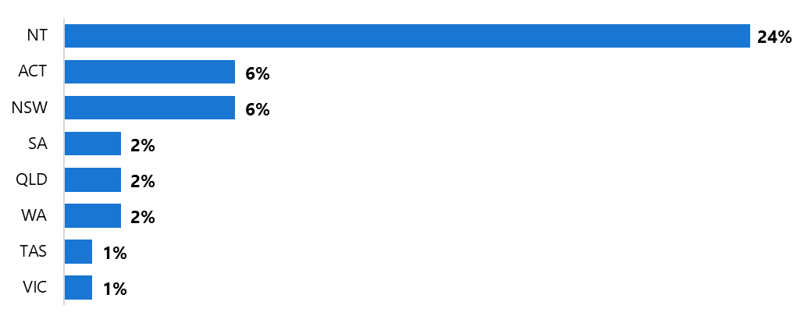

Source: NACAP MDS.

Note: Advocacy and financial advocacy cases have been combined in this figure. Values have been rounded to the nearest whole percent.

SDO representatives reported that they refer people with out-of-scope issues to other services where possible. However, they noted that a lack of appropriate or available services means that, at times, such referrals are not possible. In these cases, they prefer to assist with out-of-scope issues rather than leaving vulnerable older people, who often present with complex issues, without support.

Thus, while out-of-scope advocacy cases may not be common, SDO representatives highlighted the importance of the work they do to address them (which is not recognised in current reporting mechanisms).

We understand that OPAN continues to monitor the issues for which NACAP recipients need support and to consider whether and how these would be served by revising the program’s scope. It is worth noting that any change to scope can introduce a new suite of challenges and possible unintended consequences such as

* the potential for further blurring of the line between the NACAP and other aged care programs (see section 6.1) or programs offered by other sectors
* the potential risk that the NACAP’s reputation for possessing specialist expertise in the aged care sector is diminished
* the additional recruitment and training required to ensure the advocacy workforce has the skills and capacity to respond to a broader range of issues.

## Promotion and outreach activities are establishing appropriate referral pathways

Both OPAN and the SDOs invest significant effort in promoting the NACAP to potential recipients and referrers.[6] Promotional activities include social and traditional media campaigns targeting a range of audiences, including older people and their representatives, aged care providers, healthcare providers, and others.

OPAN promotes the program at a national level, ensuring consistent branding and messaging, while SDOs tailor promotion to their region.

### Promotional efforts are reaching older people and their supporters

While referral sources do not provide insight into how many people are aware of the NACAP, they do provide an indication of how those who use the program found out about it. MDS data shows that, between October 2023 and March 2024, referral sources were similar for both information and advocacy (Table 3‑6).

Table 3‑6: Proportion of cases by referral source, October 2023 to March 2024

| Referral source | Information | Advocacy | Financial advocacy | Overall |
| --- | --- | --- | --- | --- |
| **Total number of cases** | **14,664** | **6,592** | **458** | 21,714 |
| Self | 18% | 23% | 32% | 20% |
| Previous client | 14% | 16% | 9% | 15% |
| Family member or carer | 10% | 10% | 18% | 10% |
| Other | 8% | 7% | 8% | 8% |
| My Aged Care | 6% | 8% | 5% | 7% |
| Unknown | 8% | 4% | 5% | 7% |
| Aged care provider | 6% | 4% | 5% | 5% |
| Event (ACND) | 6% | 1% | <1% | 4% |
| OPAN referral | 4% | 3% | 5% | 4% |
| Education session | 4% | 5% | 2% | 4% |
| Friend or other supporter | 4% | 3% | 3% | 4% |
| Other service provider | 3% | 3% | 1% | 3% |
| Healthcare provider | 3% | 4% | <1% | 3% |

Source: NACAP MDS.

Note: Referral sources accounting for less than 3% of overall referrals have not been included in the table.   
A full list can be found in Appendix C.

The top 3 referral sources were self (20%), previous client (15%), and family member or carer (10%), suggesting that efforts to raise awareness of the NACAP are reaching older people and their representatives.

Despite this success, both recipients and advocates told us that older people often only “stumble across” the NACAP when they need help, suggesting there may be others who need advocacy support but are not aware it is available. While the extent of unmet need is unknown, stakeholders emphasised the importance of proactively raising awareness of the NACAP among older people and their supporters – for example, as people enter the aged care system, so that they know where to turn if issues arise.

The department has worked closely with OPAN since the expansion to improve recipient awareness of the program. For instance, OPAN contact details are now included in the After you’ve registered with My Aged Care brochure (Commonwealth of Australia 2024).[7]

Referrals from aged care providers (5%) and healthcare providers (3%) were relatively low given the central role that they play in the lives and care of many older people. However, it is possible that information from these providers may have subsequently led to self‑referrals, meaning the providers themselves are under-represented in the referral source data.

#### Tailored promotional strategies are important to reach people with diverse needs

SDO representatives told us that while national activities are important, tailored promotional activities and strategies are necessary to increase reach among members of NACAP target groups (who are likely to be the most vulnerable and most in need of advocacy support). Activities to expand the reach of promotional activities appear to most frequently consider 2 groups in particular: people from CALD backgrounds and Aboriginal and Torres Strait Islander communities.

We note that work is being undertaken through the diversity education project (section 5.4) to understand the population characteristics of different regions. There may be opportunities to leverage the insights gained through that project to develop regional‑specific promotional strategies for NACAP target groups.

CALD communities

SDOs undertook a range of efforts to engage with and promote the NACAP to CALD communities. Many advocates are from CALD backgrounds themselves and are well-placed to foster relationships with members of specific communities through promotion at cultural events and education of CALD seniors’ groups. The relationship building and networking activities conducted with CALD communities (and other groups) as part of the Advocacy Community Network Development (ACND) expansion project are discussed in section 3.3.2.

Both OPAN and several SDOs are tailoring promotions to CALD communities by translating resources into multiple languages. For example, the OPAN website is available in 13 languages other than English (Figure 3‑3), and 3 SDOs have also translated their website content into different languages. Some SDOs have also translated brochures and other hard-copy resources into community languages.

While this work is important, translation alone is not sufficient to address cultural differences that may impact people’s understanding of what advocacy is (see section 3.4.1).

Figure 3‑3: Screenshot of OPAN website’s translation feature

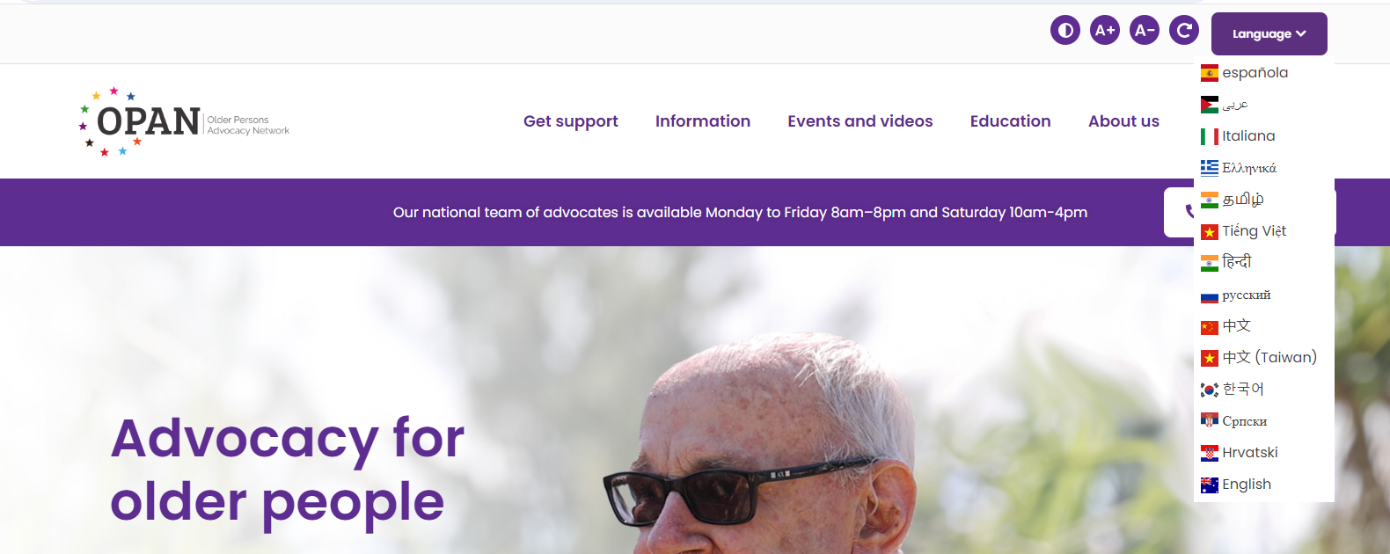

Aboriginal and Torres Strait Islander communities

We heard that some SDOs have created specific, culturally appropriate resources promoting the NACAP to Aboriginal and Torres Strait Islander people. For example:

Darwin Community Legal Service and Catholic Care NT jointly commissioned animated advertisements featuring Aboriginal and Torres Strait Islander characters facing different aged care issues (including service provision and financial issues) and encouraging them to “stop the worry – call advocacy”. The advertisement ran on Channel 9 and was shared via social media.

* ARAS developed promotional materials that use culturally relevant terms to improve understanding of the issues that advocates can help with (e.g. “humbugging” rather than “financial abuse”).
* DCLS will launch a “community champions” pilot in mid‑2024 (described below).

Promoting the NACAP with the help of community champions

In mid‑2024, DCLS will pilot a project to better understand the cultures and needs of the First Nations communities they work with in order to improve their approach to community outreach, information and advocacy.

In preparation, they have partnered with local councils and other organisations to find community champions. These community champions will be instrumental in supporting advocates by:

* promoting the NACAP in their communities
* helping create and translate easy-to-read resources
* assisting with delivery of education sessions
* providing guidance to build advocates’ cultural competence.

By sharing learnings from this pilot across the consortium, DCLS hopes to support the continuous improvement in the way the NACAP is promoted and delivered to First Nations communities.

### Advocacy Community Network Development Officers are building awareness and trust

The Advocacy Community Network Development (ACND) expansion project aims to increase awareness of and referrals to NACAP information and advocacy services. The project is currently delivered by 11.2 FTE ACND officers (ACNDOs), who delivered 1,840 awareness‑raising events across Australia in the 2022‑23 financial year (OPAN 2023b). The total funding amount for ACND events in 2022‑23 was $1714,759.

ACNDOs have succeeded in building strong connections with stakeholders that SDOs had previously struggled to reach, such as:

* local government representatives and members of parliament
* health professionals, including GPs and hospital staff
* local branches of organisations such as the State Emergency Service, Lions Club, and Country Women’s Association
* neighbourhood houses, men’s sheds, and CALD community groups.

We heard that advocates attend a range of community events to try to promote NACAP; they attend public spaces (like shopping centres or multicultural festivals); and develop relationships with community leaders and other representatives. ACNDOs worked with local community representatives, particularly in CALD communities (for example, community support officers), to create culturally appropriate resources to distribute at these events.

* Whenever we create any resources, we do have consultations with them around whether it’ll be appropriate, culturally appropriate to deliver this sort of educational resource in their community, which they highly value. – SDO representative

The expansion funding has been key to this success by enabling ACNDOs to have a regular presence in the communities they serve, so that the NACAP has become associated with a familiar, trusted face. We heard that this trust has resulted in more referrals to NACAP information and advocacy services:

* We’ve definitely seen a lot of growth … the ACNDO being able to go out into the community and build relationships, and be seen at shops and community events, and be able to have that reach to stakeholders, has definitely built our portfolio. – SDO representative

While SDO representatives were positive about the impact of the ACND, they told us that working in multiple communities across large geographic areas can create a substantial travel burden for ACNDOs. This can potentially lead to burnout, impacting staff retention.

In addition, the travel and time invested in building networks across multiple diverse areas must be weighed against the opportunity costs of having a more regular presence in a small number of communities. Some SDO representatives highlighted that the time that ACNDOs require to develop trust and plan events in consultation with local communities is not well reflected in current reporting.

* There should be a separate measurement. It might take 6 days and 16 meetings to organise that thing, and yet it’s not recorded in Salesforce. – SDO representative

Some representatives felt that there was some ambiguity with the ACNDO role, leading to potential duplication of effort with advocates and inconsistencies in how the project is implemented across jurisdictions.

It is worth noting that some variation in how a new role is implemented is to be expected and appropriately allows SDOs the flexibility to trial different approaches in delivering this newly funded project. Some ongoing differences may also be appropriate as ACNDOs tailor their activities to best meet community needs. Nonetheless, as the ACND is a new initiative, there may be an opportunity to consider whether refinement is required as the project enters its second funding cycle.

### Referral pathways are based on a “no wrong door” approach

The NACAP is a long-term program with well-established referral pathways. However, SDO representatives told us that this means the NACAP is sometimes seen as a go-to service to support older people, regardless of whether they have issues related to aged care or not. As a result, SDOs sometimes receive referrals that are not appropriate (see section 3.2.2).[8]

The NACAP intake assessment process plays an important role in identifying “inappropriate” referrals and, where possible, providing information or connecting the person to a more appropriate service. While this increases advocates’ workload, SDO representatives emphasised the importance of maintaining a “no wrong door” approach for older people seeking support.

However, advocates did express frustration about receiving referrals when they could not support the recipient, especially where they felt the referrer was “passing the buck” rather than genuinely engaging with the person.

* We need to better understand what we mean by ‘no wrong door’ and consider what this means for scope … I think that, systemically, providers need to be really clear about who they’re referring a person on to, not just let’s get them off the phone. – SDO representative

While some SDO representatives suggested that improving referring organisations’ understanding of the NACAP – and other support services – might help to reduce out‑of‑scope referrals, others suggested that this may not have a significant impact, given the complexity of the system and the high staff turnover within the sector.

In addition, the increasing complexity of cases discussed in section 3.2 means that older people who are referred to the NACAP may need support for both in-scope and out‑of‑scope issues. Furthermore, it may be appropriate for some clients to receive support from multiple services – for example, care finders and advocates may both provide support, either as separate services or through a key worker model (see section 6.1 for further discussion).

## Information and advocacy services are broadly achieving their intended outcomes

The intended outcomes of information and advocacy support include that recipients are:

* aware of and knowledgeable about available aged care services, the role of advocacy and their aged care rights
* confident about self-advocating and exercising their aged care rights.

Overall, we found that the NACAP is achieving these outcomes in most cases and, importantly, providing recipients with a positive experience despite systemic issues that often limit the extent to which their issue can be resolved.

### The NACAP is increasing older people’s knowledge of services, advocacy and aged care rights

As shown in Figure 3‑4, most respondents to our NACAP recipient survey reported that the NACAP improved their understanding of what aged care services are available and how to access them, what aged care advocacy is, and their aged care rights. Below the figure we explore some of the reasons why knowledge did – or did not – improve.

Figure 3‑4: Proportion of respondents agreeing that the support they received improved their understanding of aged care services, advocacy and aged care rights

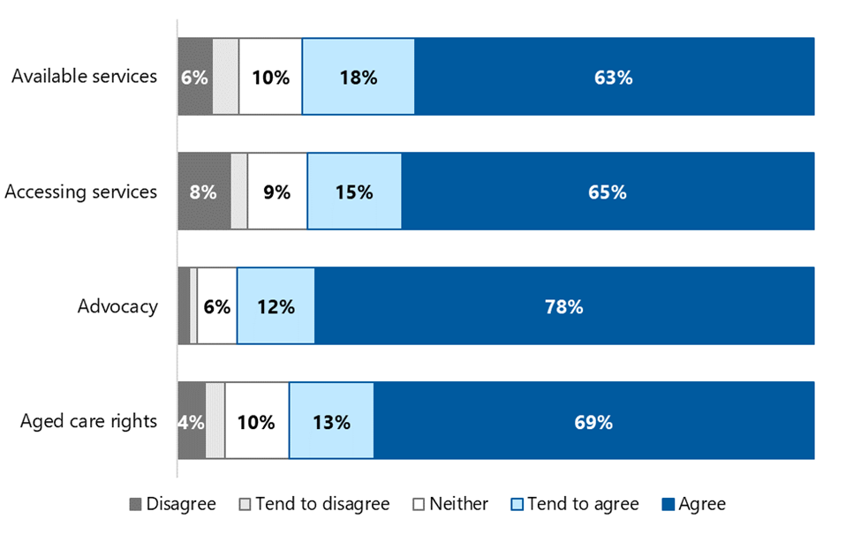

Data is provided in Appendix E, section E.2.

#### Services

Respondents told us that the information provided by advocates was “enlightening”, as they previously had very little knowledge of what services were available or how to access them. They expressed gratitude that advocates took the time to explain the available services and their appropriateness to their personal circumstances.

* They helped us to work out what the providers were able to give us because the provider was not clear at all. Made all of us feel calmer, gave us direction … – NACAP recipient

Advocates and recipients reflected that the complexities of the aged care system and recipients’ needs and characteristics (e.g. lack of digital literacy) are key reasons why information and advocacy may not improve understanding of where and how to access aged care services. Recipients discussed that, at times, the information they received served to highlight the lack of available services (whether due to a shortage of services per se or a lack of services for which the client is eligible).

* I became more aware of the lack of services available to me, they didn’t help me to be aware of any more services. It made me feel more helpless. – NACAP recipient

#### Advocacy

Although most respondents indicated an improved understanding of the role of advocacy after their engagement with the NACAP, some misunderstandings were still evident and several respondents expressed confusion about why their issue could not be resolved.

* It is very confusing because it’s still not clear to me how much power [the advocate] has and what they can do on your behalf. – NACAP recipient

Some recipients appeared to misinterpret the advocate’s role as being equivalent to a lawyer or mediator. This was reiterated by advocates who felt that many older people initially see them in this light and noted that in many languages the word “advocate” is similar to – or interchangeable with – the term for lawyer. This confusion may be heightened for recipients serviced by SDOs that also offer legal services.

* I felt that they were like legal people who had a better understanding of what is available and what isn’t, on what’s right and what’s wrong. – NACAP recipient

#### Aged care rights

Advocates’ ability to provide concrete explanations of how aged care rights are relevant to an older person’s specific issue appeared to be a key driver of recipients’ improved understanding of their rights. Respondents found this knowledge to be eye-opening.

* I am more informed now … I have a better understanding   
  of my aged care rights. – NACAP recipient

NACAP recipients appreciated when their advocate pointed them to the Charter of Aged Care Rights (the Charter) and felt that providers could do more to promote it. This suggestion is somewhat concerning given that aged care providers do have a responsibility to provide the Charter to people under their care and assist them to understand it.

Respondents who indicated that the information or advocacy they received did not improve their understanding of their rights tended to suggest that this was because they understood them prior to engaging with the NACAP.

Ingrid’s story*

Ingrid, who was from a CALD background, needed advocacy help when her mother, Renate, had been asked by management to leave her RACH because of her behaviour.

Renate had been a prisoner of war and had PTSD from witnessing men committing acts of torture and violence in war camps. There had been several incidents in the RACH where Renate was abusive towards male staff who reminded her of people she had witnessed committing atrocities.

Ingrid approached her local SDO to better understand Renate’s situation and options. The advocate explained Renate’s rights and told Ingrid that there were steps that the RACH needed to take before evicting Renate. Ingrid appreciated that the advocate understood her concerns and explained that the RACH should be better equipped to provide quality care for clients with histories of complex trauma.

With Renate’s consent, Ingrid and the advocate met with RACH management to explain Renate’s history of trauma. The advocate gave the RACH resources to help staff more appropriately provide care for residents with PTSD such as Renate. The advocate was able to help Ingrid and Renate achieve a positive outcome. Ingrid reported that the quality of Renate’s care improved, her distress lessened, and she did not need to move out of the RACH. Ingrid was grateful for the advocate’s empathy for her mother. She appreciated having someone in her corner while she worked through this issue.

*Names changed to protect anonymity

### Most recipients feel more confident and empowered to self‑advocate

In addition to the gains in knowledge discussed above, around three‑quarters of survey respondents reported that the NACAP improved their confidence to discuss their aged care needs with providers and advocate for themselves (Figure 3‑5).

Figure 3‑5: Proportion of respondents agreeing that the support they received improved their confidence

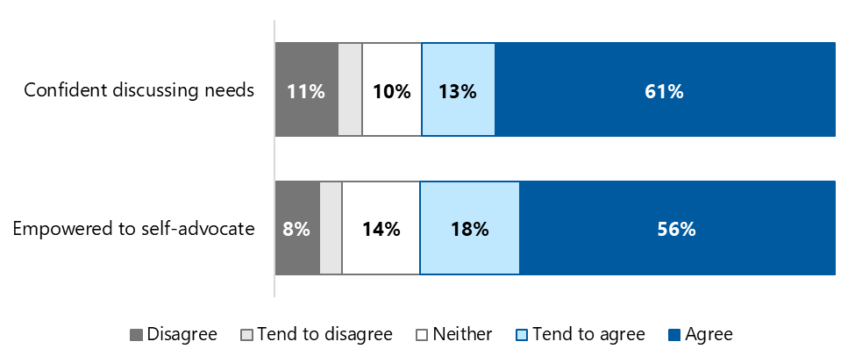

Data is provided in Appendix E, section E.3.

#### Confidence to discuss needs

Survey respondents reflected that the sense of validation they received from advocates was crucial in building their confidence to talk to providers about their needs. They explained how advocates empathised with them, helped them workshop their issues and reinforced the idea that both they – and their concerns – matter.

* She treated me like a real person, and not a silly old fool. Some people think us older people are senile, but she treated me with respect, she knew what I was saying and agreed with me. – NACAP recipient

However, some older people reported that their confidence to discuss their aged care needs had not improved. While there are a range of reasons for this, a frequent concern is that older people fear being seen as a ”troublemaker” and worry about how this may impact their future care.

#### Empowered to self-advocate

Recipients valued the patience of advocates and the time they took to explain how their issues fit within the complexities of the aged care system. This knowledge improved their understanding and empowered older people to self-advocate.

* I don’t believe we would be in the situation we are now without our advocate. The advocate made a process that was very complicated, very simplistic for us. She put it in layman’s terms and guided us through it so we could do it ourselves. I now feel more confident to do a lot more myself because the aged care system is very complicated with all the abbreviations, and I didn’t know what these abbreviations were without the [advocate]. – NACAP recipient

Advocates also derived a sense of satisfaction when recipients were able to self-advocate or advocate for their peers.

* We can give them support so they can then become their own advocates, which is really important … once we’ve shown them a way of working through [an issue], they take it up and think, ‘I’m going to do it like that’. They’ve got the confidence. I helped one client and empowered her to do it – now she’s going around advocating for everyone. – SDO representative

However, not all recipients felt they could self-advocate. Some older people described their age, other special needs, and the perceived power differential between themselves and their aged care provider as barriers to resolving issues without support.

### Advocates are making a meaningful difference in a challenging system

In line with the positive impact of information and advocacy support on their knowledge and confidence, most survey respondents were satisfied with the services they received (Figure 3‑6).

Figure 3‑6: Proportion of respondents agreeing that they were satisfied with the services they received

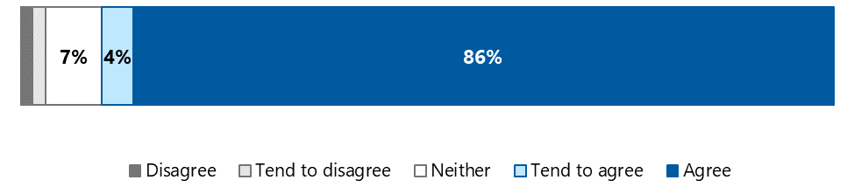

Recipients’ satisfaction with information or advocacy provision was largely due to the attributes of the advocates themselves. Recipients valued advocates’ experience in and knowledge of the aged care industry and their professionalism, approachability, communication skills, compassion, respect, trustworthiness and determination to help them. Most recipients were glowing in their praise for advocates and expressed deep appreciation not only for the support they provided but also how they provided it. A large contributing factor to recipient satisfaction is that advocates actively listened to older people.

* I felt that was I represented fairly and professionally. She [the advocate] took all my issues into account. These days people don’t listen much, but I felt that I was listened to. She had to have listened or I wouldn’t have the outcome that I received. – NACAP recipient

Where dissatisfaction was reported, this generally related to the fact that the advocate was unable to resolve the recipient’s issue. Respondents indicated that, despite the advocate’s best efforts, they were still experiencing issues with their aged care provider and were left with no option but to wait for a response from the Aged Care Quality and Safety Commission. It is worth noting that unresolved issues are the minority, accounting for 9% of all defined presenting issues for advocacy cases within the MDS. This figure is likely to decrease as issues are resolved in future.[9]

Importantly, advocates’ ability to provide a positive experience meant that recipients were generally satisfied with the service they received even when the advocate was unable to resolve their issue.

* I hope that they have more power, that they can have more clout in the future. They said all the right things, and they were well aware of their limitations. They were honest and supportive, but a toothless tiger. – NACAP recipient

Betty’s story*

Betty, a First Nations woman, lived in a RACH. She felt that she was not being treated with respect, and described her care as “cold, harsh and inhumane”. However, she was concerned she would face retribution from her service provider if she made a complaint. She felt helpless as she had very limited mobility and was fully reliant on care, and she feared even worse treatment if she spoke up.

Betty’s daughter, Linda, encouraged her to get in touch with her local SDO. Over the phone, the advocate reassured Betty that how she was being treated was unacceptable and offered to support her.

Betty and Linda planned to meet with the advocate at the RACH. However, when Betty arrived at the meeting, she became anxious and fearful and denied that there was a problem, due to intense fear of her situation worsening. With Linda’s help, Betty eventually managed to explain to the advocate the full extent of her mistreatment.

The advocate spoke to Betty and Linda about Betty’s rights, and the quality of care she should expect. Both Betty and Linda felt the advocate tried their best to empower Betty, including offering to support her to raise her concerns. Despite these efforts, Betty did not feel confident to speak up.

Linda was frustrated that more could not be done to improve Betty’s situation, and wished she could make a complaint about the RACH on Betty’s behalf, but she also knew it was important to respect Betty’s wish to not air her grievances.

While Betty and Linda did not achieve the outcome they had hoped for through advocacy, they valued the information, care and support provided by the advocate.

*Names changed to protect anonymity

Future opportunities for information and advocacy

1. Consider defining a prioritisation framework to help advocates determine when it is appropriate to address issues currently defined as out of scope (e.g. legal, housing) where these are crucial to aged care rights being upheld. Criteria may include the individual’s level of risk, the availability of other supports, and the urgency of the issue(s).
2. Develop reporting mechanisms to capture the time that advocates spend addressing out-of-scope issues to inform future resourcing. Use this information to focus efforts when working with other organisations to clarify and strengthen arrangements for supporting older people with complex issues that span sectors and, where appropriate, undertake coordinated, cross-sectoral systemic advocacy.
3. Continue to increase the geographical reach of the NACAP, including through the ACND, while ensuring sufficient time is spent in communities for relationships to be established and embedded.
4. Consider repeating the demand study using MDS data to enable a better understanding of the impact of the expansion activities on NACAP reach, priority areas for further expansion, and the key drivers of demand.
5. Leverage insights generated from the diversity education expansion activity regarding demographics and needs in different regions to target promotion of information and advocacy.

# Home Care Check‑In Project

The Home Care Check‑In (HCCI) Project is currently being piloted in selected Aged Care Planning Regions (ACPRs) by 3 SDOs. Advocare (Western Australia) was the first to roll out the pilot in July 2022, followed by Aras (South Australia) in October 2022 and SRS (New South Wales) in January 2023. The pilot will run until 30 June 2025 in all 3 states.

The HCCI supports older people who live at home and receive (or are registered for) government-funded aged care services.[10] It is targeted at people who live alone and are socially isolated, reliant on a single carer or service provider, or otherwise at risk of harm. The project aims to reduce risk and isolation by providing regular check-ins and monitoring; developing a trusting relationship over time; and building a scaffold of supports by helping the recipient to connect with other services in the community.

Importantly, the HCCI also supports recipients to stay connected to the services they already receive by helping them to articulate their needs and wishes and providing information and advocacy if the need arises. The HCCI can also complement the service provider’s case coordination or case management role by offering ”an extra pair of eyes”.)

The HCCI also complements other national programs designed to support older people with additional vulnerabilities. For example, the care finder program provides intensive support to help people connect with the aged care system, while the HCCI supports people who are already connected with the system. The relationship between the NACAP, HCCI and the care finder program is discussed further in section 6.1.1. However, it is important to note that both programs provide vital support for vulnerable people who are otherwise likely to “fall through the cracks”.

In this section we discuss the implementation of the HCCI Project and the difference it is making to recipients’ lives.

HCCI data

As a pilot project, HCCI data is not currently part of the NACAP MDS. Figures in this section are based on summary data provided by OPAN.

## HCCI service delivery is resource intensive

The HCCI Project is delivered by a newly established workforce of 5.6 FTE community support advocates. Between July and December 2023, a total of 66 new recipients entered the program, and 1,028 check‑ins were completed. HCCI funding for this period was $535,900. We heard that the HCCI is being implemented in line with the service delivery guidance, making it relatively consistent across each of the pilot sites. Community of practice meetings also support consistency by providing advocates with a forum to discuss ideas and troubleshoot challenges based on a shared understanding of the program.

SDO representatives told us that both the recipient-facing and non-recipient-facing aspects of the pilot are resource intensive. For instance, they discussed the time required to build referral pathways (section 4.1.1), address recipients’ complex needs (section 4.1.2) and train and support advocates delivering HCCI services (section 4.1.3).

### Time invested in building referral pathways is paying off

Initial scoping of the project assumed that the primary referral pathway would be Aged Care Assessment Team (ACAT) assessments identifying clients with complex vulnerability, with a defined or automatic pathway through My Aged Care. OPAN has worked closely with the department to develop this pathway, including establishing a priority phone line and referral process.

To increase referrals while these pathways develop, SDO representatives reported that they have undertaken significant work to promote the HCCI and establish relationships with external referrers. The referral process is flexible and informal: referrals are accepted via email or phone, and anyone can make a referral, as long as the older person has consented. SDO representatives indicated that referrers valued this simplicity and compared it favourably to the more complex referral processes for many services.

Referral patterns for the HCCI are noticeably different to information and advocacy (see section 3.2). The top sources of HCCI referrals were internal referrals of advocacy and information clients (24%), aged care providers (22%) and healthcare providers (12%). See Appendix D for more detail on referral sources and recipient characteristics.

### The complexity of the cohort was initially underestimated

While the HCCI service is designed specifically for vulnerable people, SDO and OPAN representatives told us they did not fully anticipate the breadth and depth of recipients’ support needs before service delivery commenced.

To be eligible for HCCI services, older people must be identified by an ACAT, Case Coordination Team (CCT) or Regional Assessment Service (RAS) or have one or more of the following risk flags:

* be living alone
* be experiencing grief or loss
* be socially isolated or lacking close relationships
* have few friends or family that regularly check in
* have a cognitive impairment and are unable to problem-solve or speak up
* have difficulty communicating or being understood
* have issues with mobility
* be unable to drive.

It is therefore unsurprising that more than three‑quarters of HCCI recipients are socially isolated, almost two‑thirds have limited mobility, are unable to drive or are reliant on one carer, one‑third have difficulty communicating and one‑quarter live with a cognitive impairment. Significantly, however, half of all HCCI recipients enter the program with 5 or more identified risk flags (Figure 4‑1).

Figure 4‑1: Number of risk flags per HCCI recipient, July 2023 to March 2024

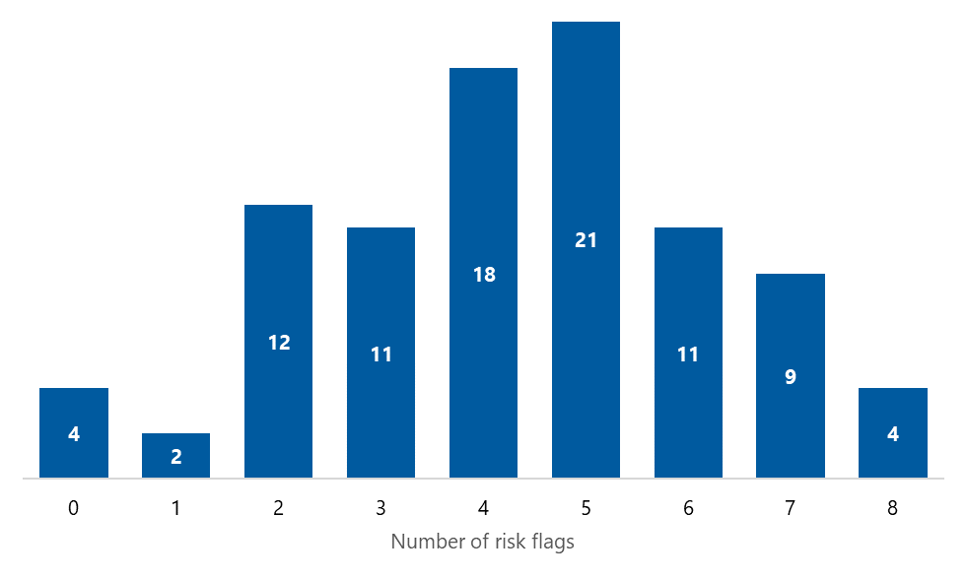

Source: HCCI dataset

Data is provided in Appendix E, section E.4.

In addition, 79% of HCCI recipients belong to at least one NACAP target group, compared to 28% for information and advocacy services overall.

We also heard that HCCI recipients commonly experience a range of other complex issues not captured in the data, including trauma, abuse, hoarding and squalor, and technological barriers that contribute to isolation.

* One of the most unexpected things was the volume of clients that had experienced trauma. – OPAN representative

Each of these factors not only add to but compound the vulnerability of HCCI recipients and the complexity of their support needs. Advocates highlighted that this complexity means they need more time to build trust and rapport with clients as well as to find and engage them with appropriate supports. Documentation provided by OPAN indicates that each check‑in can take anywhere from 20 minutes to 2 hours (OPAN 2023c).

### Providing HCCI services requires specialised training and ongoing support

The current workforce of community support advocates is composed of health professionals (predominantly nurses and social workers) with experience in the aged care sector. Community support advocates felt that this professional background and experience was essential in providing them with an understanding of trauma-informed care and enabling them to meet their clients’ complex health, aged care and social needs. Their experience also helped them to “read” situations and understand risk. We heard that some clients’ living environments were unsafe (e.g. due to hoarding and squalor or risks posed by other members of the household), and the community support advocates had strategies in place, including carrying duress alarms and working in pairs where necessary, to ensure their safety.

At the same time, the community support advocates reflected on the importance of ongoing training and support to fulfil what can be an extremely challenging role. In addition to the support available to all NACAP advocates (see section 6.3), we heard that SDOs and OPAN have been responsive to emerging training needs as the pilot has rolled out and community support advocates have developed an understanding of what the role requires.

* If something came up that we felt like we needed training in, say for example hoarding and squalor, we could do some specific training on that.   
  So it was very much just identifying a need and we would access the training. – SDO representative

In addition to ongoing training, we heard that access to professional and peer support is critical for community support advocates. Both regular professional supervision and the HCCI Community of Practice (CoP) were highly regarded by advocates, providing them with an opportunity to problem-solve complex issues, discuss professional boundaries and build their own resilience. Alongside the CoP, a shared Teams channel was seen to be enhancing consistency across pilot sites through easy access to shared resources and ad hoc peer-to-peer discussions.

## HCCI services are making a difference to the lives of vulnerable people

* The service makes me feel human again, like someone actually cares about what happens to me. I just want to get back to ‘being me’ and this is helping. – HCCI recipient

Over the course of the pilot, community support advocates appear to have provided support as diverse as the clients they work with. Sometimes, this entailed directly addressing clients’ need for aged care, health or social services by:

* assisting clients to voice their needs and wishes with aged care providers
* liaising with housing departments and Services Australia
* organising home medicine reviews
* arranging access to assistive technology
* filling out paperwork.

We also heard numerous examples of community support advocates “thinking outside the box” to meet clients’ needs – for example:

* researching community groups that provide computer classes, to help a client meet people with similar interests
* making a hairdressing appointment for a client who lacked confidence in their appearance
* sourcing a second-hand typewriter to help a client write stories – an activity they enjoyed.

SDO and OPAN representatives told us that the HCCI target population requires intensive, holistic support that is not possible in core advocacy services. They, and recipients themselves, reflected on the difference that this support is making for vulnerable older people who would otherwise “fall through the cracks” in a fragmented system.

* She helped me get information. She organised the pharmacy to sort out my tablets, she helped me to get my disability parking, she helped me to get a chair to sleep in, an electric chair that folds out and stands up, and she’s helping me get a mobility scooter. The system confuses me, I don’t know what I can do, she’s just given me so much education. – HCCI recipient

OPAN and SDO representatives also reported that satisfaction among service providers, ACATs, RAS, community health services, care finder organisations, and social workers who refer into the program is high and that they see huge value in the broad support offered by the program.

### Receipt of HCCI services is associated with reduced risk scores in most cases

Stakeholders told us that most HCCI recipients saw improvements in a range of domains, including increased confidence and self‑determination, enhanced independence and self‑advocacy skills, increased social connection, and increased linkages with essential health and support services.

SDO representatives also highlighted the impact of the HCCI on recipients’ quantitative outcome measures such as the Personal Wellbeing Index (Capic et al. 2024) and a bespoke HCCI risk assessment tool.

Risk assessments are conducted as part of the HCCI intake process and repeated at the advocate’s discretion. We were able to assess change in risk for 24 recipients, who represented all 3 pilot sites. Figure 4‑2 shows that 18 of these recipients had lower risk scores on repeat assessment, while 6 were identified as being at higher risk. On average, risk scores reduced by 2.8 points (from 14.5 to 11.6) from first to last assessment.

Figure 4‑2: Change in risk score from first to last assessment for 24 HCCI clients

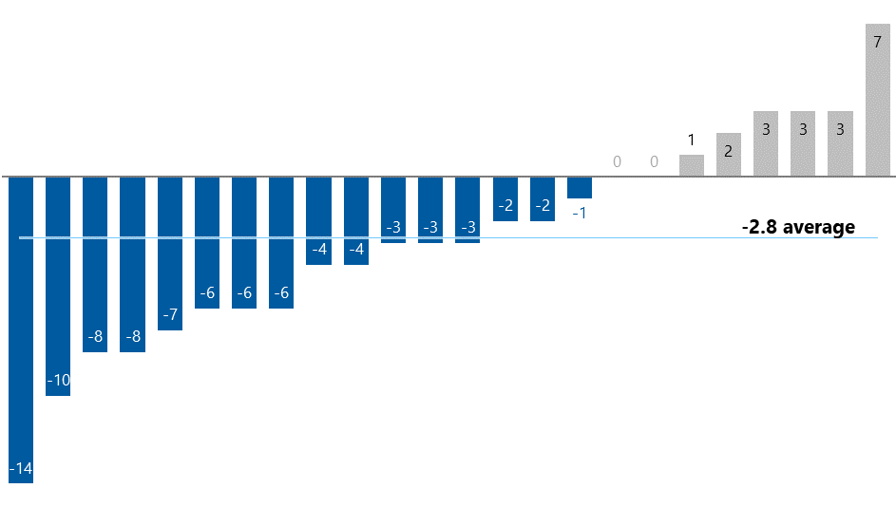

Note: Risk scores ranged from 0 to 27. The time between first and last assessment ranged from 0 to 376 days, with an average of 135 days.

Data is provided in Appendix E, section E.5.

Most stakeholders considered a reduction in risk to be an appropriate way of measuring the HCCI’s success, although some noted that it may not always be a realistic goal given the multiple, complex, and longstanding difficulties that HCCI recipients often live with.

Bill’s story*

Initial risk assessment score: 22/27 | Subsequent risk assessment score: 6/27

Bill is a veteran with PTSD and a history of substance use problems. He lives with cognitive impairment and has difficulty communicating. Bill is unable to drive, lives alone and has no social or family connections. He is at risk of homelessness as the manager of his retirement village is asking him to move out.

Bill was referred to the community support advocate by a care finder after he was refused service by several aged care providers due to his behaviour towards care staff. An ACAT assessment had been arranged but was cancelled when Bill’s My Aged Care representative – his retirement village manager – did not answer or return calls.

The community support advocate conducted a total of 14 home care check-ins with Bill, 13 of which were in person. Through these visits the advocate saw that Bill was malnourished and was having increasing difficulty with his mobility and vision. The advocate also noticed that Bill’s cognition was deteriorating from one visit to the next. Bill reported that he had not seen his GP or any other health professional for almost 10 years.

With Bill’s consent, the advocate:

* made an appointment for Bill to see his GP, accompanied him to the appointment, and subsequently followed up on the GP’s referrals to a geriatrician, social worker, and podiatrist.
* contacted the Department of Veterans’ Affairs community nursing and transport programs, requesting a review of Bill’s eligibility for assistance and providing supporting evidence from the GP regarding Bill’s deteriorating condition.
* explained the Charter of Aged Care Rights and conflict of interest in relation to his current My Aged Care representative.
* arranged an ACAT assessment and supported Bill during the assessment and continued to advocate when Bill’s representative did not appropriately assist him to take up his approved package.

Bill ultimately received a formal diagnosis of dementia. He was later admitted to hospital, where the social worker lodged a guardianship application and listed the community support advocate as a person of importance. The community support advocate continues to visit Bill in hospital while he waits for a place in a residential aged care home. Bill is now well-fed, clothed, and supported.

*Name changed to protect anonymity

Future opportunities for the HCCI Project

1. Fund all SDOs to establish or expand HCCI services in high-need areas, including funding to recruit, train and support appropriately qualified community support advocates.

# Education

NACAP education activities are designed to provide information on a range of topics related to aged care advocacy, aged care rights, and elder abuse prevention (OPAN 2024c). SDOs and OPAN both have a role in delivering education activities.

SDOs are responsible for delivering education sessions to aged care clients and staff in residential and community care settings. The key impetus for all education activities, including education for aged care staff, is to increase awareness of and referrals to NACAP services for older people.

OPAN leads a new diversity education program for aged care staff (as part of the NACAP expansion), hosts regular webinars and roundtables, and offers online training modules for a range of audiences.

This section begins by quantifying the number and type of education sessions delivered by SDOs. We then explore the challenges they encounter in delivering education to aged care clients, before considering the experiences and outcomes of aged care staff who complete education activities. Finally, we briefly discuss the rollout of the new diversity education program.

## SDOs are delivering more education sessions to aged care staff and clients

The number of education sessions delivered by SDOs has increased substantially since the NACAP expansion funding was introduced in Q2 2022. Figure 5‑1 shows the number of residential and home care education sessions delivered each quarter.

Figure 5‑1: Number of residential and home care education sessions delivered by SDOs to aged care staff and clients, 2020‑21 to 2022‑23

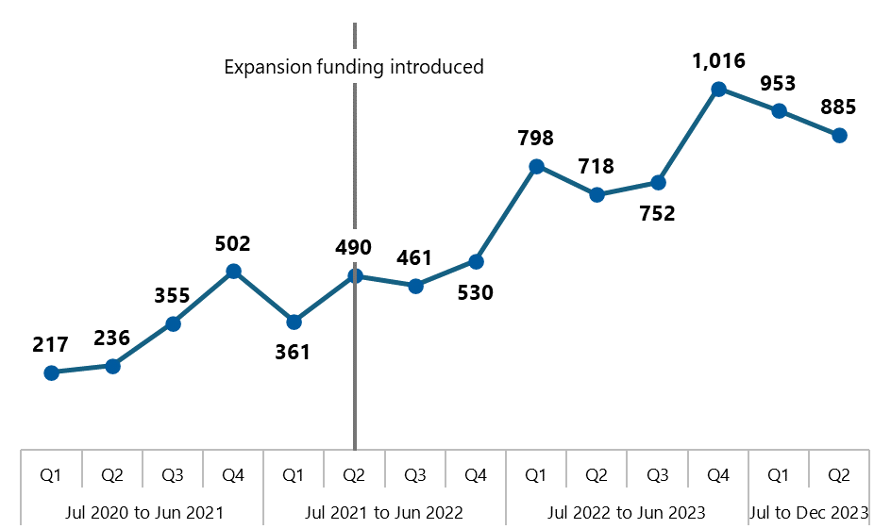

Source: OPAN data summary 1 (2024a)

Note: Jul 2023 to Dec 2023 data is still preliminary as minor adjustments can occur during the data quality checking process. Data includes residential aged care and home care education sessions but not abuse prevention, meaning the figure under-represents the total number of education sessions delivered by SDOs.

Data is provided in Appendix E, section E.6.

While we do not have an equivalent breakdown of the number of abuse prevention education sessions by quarter, the number of sessions almost doubled after expansion funding, from 515 sessions in 2021-22 (Table 5‑1) to 1,077 sessions in 2022-23 (Table 5‑2).

Table 5‑1: Education sessions, 2021-22

| KPI | Session type | Target | Actual | % of target |
| --- | --- | --- | --- | --- |
| 5 | Advocacy (residential) | 3,044 | 1,268 | 42% |
| 6 | Advocacy (community) | 686 | 574 | 84% |
| 7 | Elder abuse (all settings) | 540 | 515 | 95% |

Source: OPAN data summary 6 (OPAN 2024c)

Table 5‑2: Education sessions, 2022-23

| KPI | Session type | Target | Actual | % of target |
| --- | --- | --- | --- | --- |
| 5 | Advocacy (residential) | 3,044 | 2,147 | 71% |
| 6 | Advocacy (community) | 910 | 1,137 | 125% |
| 7 | Elder abuse (all settings) | 714 | 1,077 | 151% |

Source: OPAN data summary 6 (OPAN 2024c)

Education data

Below, we use MDS data to look more closely at the volume and nature of education sessions delivered between October 2023 and March 2024. As discussed in section 3, there may be some slight differences between the figures presented in this report and future reporting from this dataset (e.g. due to minor adjustments or rounding differences). This does not affect the findings of this evaluation.

### Education is predominantly delivered in residential settings, as intended

Between October 2023 and March 2024, SDOs delivered a total of 2,533 education sessions to 41,025 attendees (Table 5‑3). Education sessions in residential aged care accounted for three‑quarters of sessions delivered (which aligns with KPI targets).

Table 5‑3: Number of education sessions and attendees by education type, October 2023 to March 2024

| Education session type | Sessions: number | Sessions: proportion | Attendees: number | Attendees: proportion |
| --- | --- | --- | --- | --- |
| Advocacy (residential) | 1,217 | 48% | 19,492 | 48% |
| Advocacy (community) | 416 | 16% | 7,033 | 17% |
| Abuse of Older People (residential) | 613 | 24% | 9,651 | 24% |
| Abuse of Older People (community) | 287 | 11% | 4,849 | 12% |
| Total | 2,533 | 100% | 41,025 | 100% |

As noted in section 3.2, the “special needs reach KPI” specifies that at least 20% of education sessions be delivered to 7 special needs groups. Table 5‑4 shows that, between October 2023 and March 2024, 18% of education sessions were targeted to at least one of these groups, just falling short of the KPI. However, 43% of sessions targeted at least one of the NACAP’s complete list of target groups.

Table 5‑4: Proportion of education sessions aimed at NACAP target groups, October 2023 to March 2024

| Education session target | Advocacy (residential) | Advocacy (community) | Abuse of Older People (residential) | Abuse of Older People (community) | Overall |
| --- | --- | --- | --- | --- | --- |
| **Total number of education sessions** | **1,217** | **416** | **613** | **287** | 2,533 |
| Targeted towards at least one target group | 41% | 50% | 39% | 51% | 43% |
| KPI 2: Special needs reach | 14% | 28% | 14% | 28% | 18% |
| Not specifically targeted | 59% | 50% | 61% | 49% | 57% |
| Total sessions | 100% | 100% | 100% | 100% | 100% |

Source: NACAP MDS.

Note: NACAP target groups marked with an asterisk (*) in Table 5‑5.

As shown in Table 5‑5, the most common target group was people living in rural and remote areas (66%), followed by people from CALD backgrounds (32%).

Table 5‑5: Targeted education sessions by target group, October 2023 to March 2024

| NACAP target group | Advocacy (residential) | Advocacy (community) | Abuse of Older People (residential) | Abuse of Older People (community) | Overall |
| --- | --- | --- | --- | --- | --- |
| **Total number of targeted sessions** | **503** | **210** | **237** | **147** | 1,097 |
| People who live in rural or remote areas | 67% | 61% | 63% | 73% | 66% |
| People from CALD backgrounds* | 27% | 40% | 30% | 41% | 32% |
| People from Aboriginal and Torres Strait Islander communities* | 12% | 24% | 11% | 41% | 18% |
| People who are financially or socially disadvantaged | 11% | 17% | 8% | 33% | 15% |
| People living with cognitive decline | 11% | 2% | 6% | <1% | 7% |
| People living with dementia | 8% | 1% | 6% | 5% | 6% |
| Veterans* | 4% | 4% | 3% | 9% | 5% |
| People who are homeless or at risk of being homeless* | 2% | 7% | 1% | 12% | 4% |
| LGBTI people* | 2% | 3% | 2% | 14% | 4% |
| Parents separated from their children by forced adoption or removal* | 1% | 4% | 2% | 11% | 3% |
| Care leavers* | <1% | 5% | 1% | 10% | 3% |
| People living with a disability | 4% | 2% | <1% | 2% | 3% |
| People living with a mental health condition | 1% | <1% | <1% | 0% | <1% |

Source: NACAP MDS.

Note: Proportions sum to more than 100% as SDOs could record more than one target group for each education session. Target groups marked with an asterisk (*) count toward the special needs reach KPI.

### Education is predominantly delivered to aged care clients, as intended

Aged care clients account for the largest proportion of attendees across all education types (Figure 5‑2). While they are slightly less well represented at Abuse of Older People sessions in the community, this is consistent with the fact that a lower proportion of these sessions are specifically targeted towards aged care clients (e.g. 24% compared to 40% of advocacy sessions in residential care).

Figure 5‑2: Education session attendees, by education type, October 2023 to March 2024

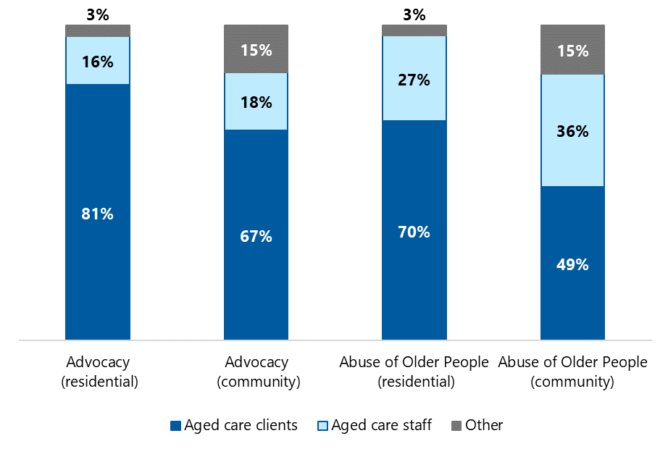

Source: NACAP MDS.

Note: Proportions are calculated based on total attendees as follows: Advocacy (residential) = 19,492; advocacy (community) = 7,033; Abuse of Older People (residential) = 9,651; Abuse of Older People (community) = 4,849.

Data is provided in Appendix E, section E.7.

As shown in Table 5‑6, sessions targeting residential care staff had the lowest average attendance, perhaps highlighting the time pressure that is frequently cited as a barrier to education in this population (see section 5.4.1). As such, online education for aged care staff allows greater flexibility given these time pressures and, accordingly, we can observe attendance at online education sessions (KPI 11) more than doubled the attendance target in both 2021-22 and 2022-23 (see Figure 5‑3).

Figure 5‑3: Target and actual aged care staff registrations for online education sessions, 2021‑22 and 2022-23

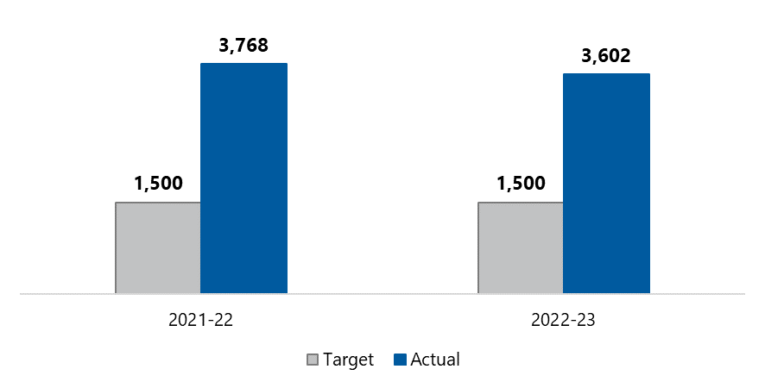

Source: OPAN data summary 6 (OPAN 2024c)

Table 5‑6: Education sessions and attendees, by type and target audience, January 2024 to March 2024

| Education type | Target audience | Number of education sessions | Attendees: clients | Attendees: staff and other stakeholders | Attendees: other | Attendee total | Average attendees per session |
| --- | --- | --- | --- | --- | --- | --- | --- |
| Advocacy (residential) | **Total** | **562** | **7,204** | **1,407** | **210** | **8,821** | **15.7** |
| Advocacy (residential) | Clients | 494 | 7,199 | 717 | 188 | 8,104 | 16.4 |
| Advocacy (residential) | Staff and stakeholders | 68 | 5 | 690 | 22 | 717 | 10.5 |
| Advocacy (community) | **Total** | **174** | **2,101** | **611** | **393** | **3,105** | **17.8** |
| Advocacy (community) | Clients | 128 | 2,094 | 219 | 51 | 2,364 | 18.5 |
| Advocacy (community) | Staff and stakeholders | 46 | 7 | 392 | 342 | 741 | 16.1 |
| Abuse of Older People (residential) | **Total** | **244** | **2,648** | **1,003** | **72** | **3,723** | **15.3** |
| Abuse of Older People (residential) | Clients | 176 | 2,648 | 306 | 51 | 3,005 | 17.1 |
| Abuse of Older People (residential) | Staff and stakeholders | 68 | 0 | 697 | 21 | 718 | 10.6 |
| Abuse of Older People (community) | **Total** | **131** | **928** | **854** | **273** | **2,055** | **15.7** |
| Abuse of Older People (community) | Clients | 68 | 928 | 89 | 58 | 1,075 | 15.8 |
| Abuse of Older People (community) | Staff and stakeholders | 63 | 0 | 765 | 215 | 980 | 15.6 |
| Total | **All** | ****1,111**** | ****12,881**** | ****3,875**** | ****948**** | 17,704 | 15.9 |

Source: NACAP MDS.

Note: This table includes education sessions from 1 January to 31 March 2024 only as the target audience data item is a recent introduction to the MDS.

## 

## Delivering education in residential aged care remains challenging

While the number of education sessions is increasing, and sessions appear to be reaching their intended audience, SDO representatives highlighted the challenges they encounter in achieving these outputs, particularly in residential care settings. This is reflected in performance against KPIs, as shown in Table 5‑1 and Table 5‑2.

Advocates expressed frustration that, while they are required to deliver education sessions in residential care facilities, aged care providers currently have no reciprocal obligation to allow them to do so. As a result, the time that SDOs invest in trying to set up education sessions does not always translate into achievements against KPI 5 (and additional efforts to achieve the KPI target may divert advocates’ time and attention away from other activities).

* That is one of the longstanding barriers to the program, that it’s not mandated [for aged care providers] to have education sessions. And so what that actually means is that there’s a lot of time invested in advocates actually trying to engage with providers and set those education [sessions] up, which they can accept or refuse. – OPAN representative

Advocates told us that their requests to deliver education sessions were sometimes ignored and that scheduled sessions were sometimes cancelled at short notice. OPAN reporting shows that, between January and June 2023, 219 providers did not respond to SDO requests to schedule advocacy education sessions and 22 refused, while 194 sessions were cancelled prior to the scheduled time (OPAN 2024c). In addition, MDS data shows that, between October 2023 and March 2024, around 5% (84 of 1,830) of scheduled RACH education sessions were cancelled or refused with no notice (i.e. when the advocate arrived at the facility to deliver the session).[11]

Advocates also told us that, in some cases, education sessions are not promoted or the target audience is not properly supported to attend or improve their understanding of advocacy and aged care rights.

* One of the other challenges that we often face is that we’re getting into residential facilities to do the education sessions, but they’re giving us an audience that’s got dementia and they really have no idea what’s going on. Last week I went to do a session in a 120‑bed residential home. I go in through the locked doors, to a room where they said, yep, we’ve got all these people here for you. There were 12 residents sitting there, who had no idea who we were, what we were doing. They were a really, really inappropriate audience. – SDO representative

It is important to note that these challenges should not be taken to mean that aged care providers are hostile towards the NACAP or suspicious of advocates. Rather, such challenges may partially reflect the many challenges within the aged care sector, including the competing priorities that aged care staff must manage; helping clients to attend a NACAP education session – or attending a session themselves – may be one in a long list of tasks for a busy shift. This is supported by the success highlighted in the next section.

### Relationship building is key to securing aged care staff support for education

SDO representatives highlighted their ongoing efforts to build relationships with residential aged care services in their area. Some SDOs have introduced roles that focus solely on arranging and delivering education, while other advocates provide education alongside their information and advocacy case load. Regardless of the model, we heard that having a single point of contact for all aged care services in a given geographic region helped to build relationships and ensure consistent messaging about the purpose of the education sessions. Some place-based advocates in regional areas reported more success than their metropolitan counterparts because providers saw them as a familiar face and a member of the community.

* So, part of my job is engaging with providers to book education sessions. There’s a lot of that [relationship building], as well as actually going to the sessions. There is a lot of benefit in forming relationships with the providers. I think it’s fantastic going out and seeing staff who we’ve seen before, like coordinators, managers, and forming those relationships, those ongoing ones. – SDO representative

We also heard that the high rates of staff turnover within the aged care sector means that relationship building is a never-ending task. However, formalising relationships with aged care providers can reduce the impact of personnel changes; SDO representatives reported that memoranda of understanding (MOUs) were helpful to document agreements such as the frequency of education sessions, the space and logistical support to be provided, and how the education sessions will be promoted (e.g. a poster with their photo and the dates and times of their upcoming visits to a RACH).

SDO representatives were cautiously optimistic that the new Aged Care Act, with its explicit object to “provide and support education and advocacy”, may, over time, improve buy-in to the idea of NACAP education among aged care staff. However, they also noted that this cultural change will take time and, indeed, additional work to build providers’ understanding of their responsibility to support their clients to access education.

## Aged care staff who receive NACAP education report positive outcomes

This section relates specifically to the outcomes of NACAP education for aged care staff. Outcomes for older people and their representatives who participate in education sessions are not routinely collected, and education session attendees were not eligible for our NACAP recipient survey following advice from OPAN.

Of the 204 aged care staff we surveyed, 156 (76%) reported having completed at least one NACAP education activity, most commonly an OPAN webinar or roundtable (Table 5‑7).[12] They were generally positive about the education they received and were able to put learnings into practice, as discussed below.

Table 5‑7: NACAP education activities completed by aged care staff survey respondents

| Activity | Number | Proportion |
| --- | --- | --- |
| Webinars or roundtables | 115 | 49% |
| Talk To Us First e‑learning | 72 | 31% |
| **Abuse of the Older Person e‑learning** | 26 | 11% |
| Other | 21 | 9% |
| Total activities | 234 | 100% |

Note: Respondents’ description of “other” activities most commonly referred to in‑person presentations. Two people referenced the diversity education program (section 5.4).

Satisfaction with NACAP education was high among aged care staff who completed it (Figure 5‑4) and several survey respondents reported that they had recommended the education to colleagues.

Figure 5‑4: Aged care staff satisfaction with NACAP education

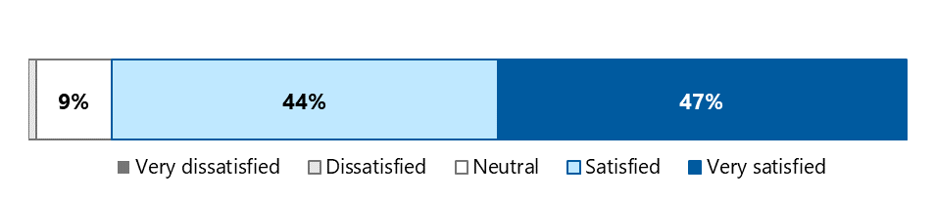

Respondents commented that the education was well structured and provided clear and concise information and practical advice. Many appreciated having an opportunity to ask questions and reflected that presenters were knowledgeable but also followed up in a timely fashion when they were unsure of the answer to a question. Webinar participants also highlighted the value of hearing from older people themselves.

### Education improves knowledge and results in practice change

The majority of survey respondents indicated that the education they received improved their knowledge of aged care rights, the meaning of advocacy, their responsibilities in supporting older people to raise concerns, and how to identify, prevent, and respond to elder abuse (Figure 5‑5).

Figure 5‑5: Proportion of aged care staff agreeing that they feel better informed about

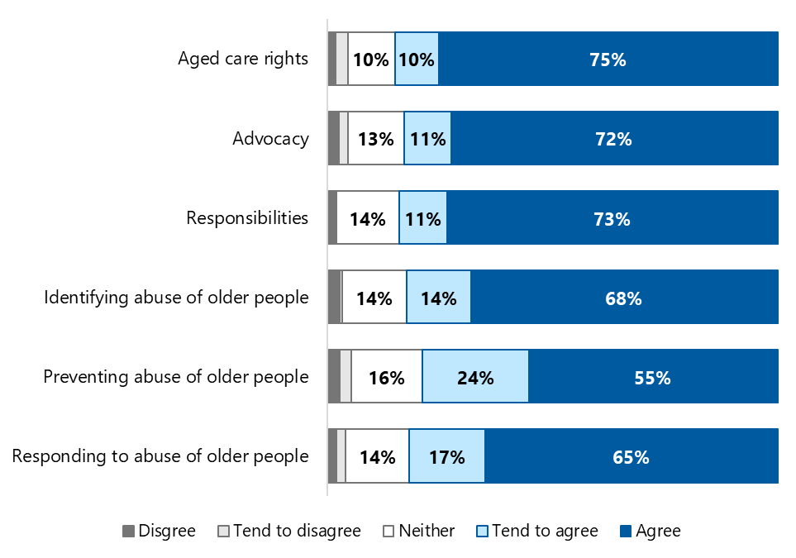

Data is provided in Appendix E, section E.8.

Staff who disagreed that the education improved their knowledge reflected that this was because they already had a good understanding of the issues covered. Others noted that while they did have a good understanding of these issues previously, the education was a good refresher.

While some staff indicated that they had not yet put their learnings into practice or had been unable to do so because “our facility dictates how they want things done”, feedback from others highlighted the ways that NACAP education has enabled them to better support older people. For example, one respondent reported that their RACH has introduced regular resident group meetings to discuss the Charter of Aged Care Rights, so that this is not something that is introduced on admission and forgotten. Another shared how NACAP education had helped them respond to elder abuse:

* I have recently been advised by a family member that she believes her mother is the victim of elder abuse. I have been able to have this sensitive conversation with my client and was able to encourage her to reach out to OPAN. The client has not yet done so, so this is something I will continue to monitor and report in my documentation. – Aged care staff member

## Early learnings have helped refine the design and implementation of diversity education

The diversity education program aims to educate aged care providers on the delivery of culturally safe and inclusive services to people from diverse and marginalised groups. This includes assisting aged care providers to understand:

* the demographics of their ACPR
* the service delivery barriers that prevent members of diverse groups from accessing their services
* how to meet their obligations to deliver inclusive services, as set out in the Aged Care Quality Standards
* how to integrate inclusive service delivery into their quality improvement processes and organisational plans.

Below we briefly explore the program’s design and early implementation. Note that assessing the outcomes of diversity education is out of scope for this evaluation.

### Aged care staff want more options for education that are tailored to their needs

When asked how NACAP education could be improved, many aged care staff responded that the activities “are excellent as they are” or suggested only that they be more widely promoted and more frequently available. However, there was a desire from others for greater tailoring of education to the needs of different audiences (e.g. themed sessions, different formats including face-to-face education and podcasts, information relevant to specific populations). One respondent suggested an annual call-out for topic suggestions.

* I'm Aboriginal, so to be more engaging to my mob, [a suggestion] would be to engage within the community. Put stories in, as they can draw the attention and link it back to something we can relate to. – Aged care staff member

Time constraints were also a key issue for aged care staff. Several survey respondents who had completed NACAP education suggested a need for briefer activities that can fit into their schedules, and one‑third of those who had not completed any education indicated that this was because they had not had time. It is worth noting that some advocates reported that engagement in their face-to-face education sessions improved after they offered shorter sessions and tailored the content to the needs of individual aged care providers.

### Content is tailored to ensure local relevance

OPAN has led the diversity education program’s design and implementation, with input from ADA Australia, SRS, and an external expert training consultant. A reference group of the diversity peak bodies also contributed, ensuring the education content is accurate and contemporary.

We heard that the program is intentionally flexible and data-driven; it begins with OPAN using available demographic data to gain insights into the population characteristics of different geographic regions. This enables education in a given region to be tailored to local needs, and this flexibility was seen as one of the program’s key strengths.

* [OPAN] really focused on what the participants needed within [different] areas. And it cut across resi-care and the community space. So it was looking at what people need to do in terms of developing a plan to support their potential or current clients from diverse backgrounds. – SDO representative

As noted in section 3.3.1, there may be efficiencies to be gained by using the regional insights developed through this work to inform future promotional activities. Identifying areas with high concentrations of NACAP target groups may not only inform the education delivered to aged care providers but also suggest areas that may benefit from tailored promotional strategies or ACND activities.

### The format has been adjusted to meet participants’ needs

The education itself is delivered over 2 full‑day face-to-face workshops, in capital cities and regional locations. It comprises 4 modules:

1. Understanding your community: Using stakeholders/​data to understand your community, collecting information from older people about their identity.
2. Promoting service accessibility: Individual, organisational and cultural/​social influences, barriers to service access and their impact on older people.
3. Opportunities to act: Eight areas to target in relation to Aged Care Quality Standards.
4. The diversity planning process: Setting goals, monitoring progress, example templates for policy and procedures.

The diversity education program was initially rolled out in Queensland and Tasmania, with the 2 workshops delivered 2 weeks apart. Feedback indicated that this model was challenging for both aged care providers and workshop facilitators. For aged care providers, particularly those that were smaller and more remote, the cost of 2 separate instances of travel and releasing staff from regular duties was prohibitive. For facilitators, it meant a punishing schedule and raised concerns about the risk of burnout and turnover.

* There’s a lot of travel required to deliver those face-to-face workshops. Take the example of a trainer who is flying from Sydney to Queensland on Monday, delivering training on the Tuesday, flying to a separate location in Queensland to deliver another workshop series on Wednesday, doing the training on the Thursday, and then trying to come back to Sydney on the Friday. Because of the large number of workshops that we are delivering, it was extremely difficult to be able to justify having that 2 week break in between. – OPAN representative

Given this feedback, the model was revised and workshops were delivered over 2 consecutive days as the education was rolled out in other states and territories. SDO representatives felt that this has helped to alleviate the issues above.

### Perceived overlap with other education may hinder uptake

While SDO representatives felt that the diversity program is unique, we heard that aged care providers are not always clear on how it differs to education offered by other providers. Stakeholders in one jurisdiction suggested that this confusion hindered the program’s uptake, as aged care providers believed they had already completed the education and so declined the offer to participate.

They suggested opportunities to improve implementation by liaising with other education providers to identify underserviced regions and refine promotional materials and approaches to clearly delineate NACAP diversity education from similar programs in the market.

Future opportunities for education

1. Consider revising the KPI related to education sessions in residential care settings to capture work to arrange sessions rather than the number of sessions delivered, as the latter is not always within SDOs’ control.
2. Work with aged care staff to develop flexible options for NACAP education that meet their needs (content, format, duration).

# Service delivery in context

In preceding sections of this report we explored specific issues in relation to NACAP information, advocacy, and education activities. Below we discuss 3 factors that influence the implementation and outcomes of the program in general, namely its intersection with other aged care supports, the OPAN consortium, and the workforce that delivers NACAP services.

## The NACAP is an important part of a suite of programs supporting older people

The NACAP is a well-established program that plays an essential and clearly defined role within the service system. The new expansion activities complement the longstanding core services of education, information, and advocacy.

While the NACAP is unique, it does share some similarities with other programs and services. Below, we discuss its intersection with 2 of these: the care finder program and the Aged Care Specialist Officers (ACSOs).

### The distinction between the care finder program and the NACAP is unclear to some stakeholders

The care finder program provides intensive support to help vulnerable older people understand and access the aged care system and/or other relevant supports in the community (e.g. housing or mental health services). Care finder services are commissioned by Primary Health Networks (PHNs) and delivered by 172 organisations across Australia (Australian Healthcare Associates 2024). Four of these (ADA Australia, ADACAS, Advocare and ARAS) are NACAP SDOs.

In SDOs that provide both advocacy and care finder services, a central intake function is useful in efficiently directing clients to the most appropriate service. However, while advocates were consistently clear on the boundaries of their role, and the distinction between the NACAP and the care finder program, we heard that for some referrers and older people, the distinction is less clear.

This is perhaps not surprising given similarities in the target cohorts, the issues that can be addressed, and the intensity of support provided across the 2 programs. For example, while the care finder program targets people who are vulnerable and unable to access services without intensive support, the NACAP is also available to such individuals. Further, both programs support clients with aged care concerns (noting that care finders do not provide advocacy except in limited instances[13]). The care finder program has a broader remit than the NACAP advocacy offering and can address other issues such as housing or concerns about health services. It also generally offers a higher intensity of support than the NACAP provides. In that way, the care finder program is similar to the HCCI – although HCCI is reserved for people already approved for or receiving home care services rather than those seeking to access them and at this stage is only available in a limited number of ACPRs (see section 4).

SDO representatives told us that the overlap between the care finder program and the NACAP can mean that very vulnerable people with complex needs, who would be more appropriate for the care finder program, are often referred to the NACAP. This may be partially explained by the fact that the care finder program is relatively new and may not be fully understood by referrers, while the NACAP has a long-established reputation for supporting older people to get the help they need through its “no wrong door” policy. It may be further exacerbated by a lack of available care finder services in some regions, as well as a broader lack of aged care services which makes it difficult for care finders to close cases and take on new clients (Australian Healthcare Associates 2024). As discussed in section 3.2.2, we heard that advocates sometimes work outside the scope of the NACAP to support older people when the service they require is unavailable.

* Advocates are receiving a higher number of calls coming through for potential people that should be with care finders and needing that sort of assistance there. But care finders in some areas are saying that they’re all at capacity. – SDO representative

We note the collaborative work undertaken by the department and OPAN to define how the NACAP (including HCCI) and the care finder program can best work together. This includes outlining which program is most suitable for which circumstances, how care finders can engage NACAP support if they have clients whose issues include concerns related to aged care rights (e.g. through consultation liaison or joint management arrangements), and when referral from one program to the other may be justified. Further efforts to communicate the delineation between the programs to potential referrers would be beneficial.

### Financial advocates value the role of ACSOs and saw opportunities to strengthen connections

SDO representatives also discussed the intersection between the FAOs and ACSOs. Introduced in 2021, ACSOs are part of My Aged Care face-to-face services. They are based in Services Australia centres[14] and give older people information on the different types of aged care services, check if they are eligible, provide financial information about aged care services and make referrals for assessment. FAOs told us that a key difference between ACSOs and FAOs is that while ACSOs can look at an older person’s fees or charges, they are not able to contact providers and have no ongoing contact with the clients. In contrast, FAOs provide ongoing support to clients until their issue is resolved, and in some instances have repeat contact with providers and Services Australia to address concerns about fees and charges.

* ACSOs have been a really great help for us in the sense that they will sit down and do some calculations for clients but the tricky thing with them is they’re based in one spot. They don’t go see people at their home, they expect the client to come with the information. Clients don’t know what they don’t know, so they don’t know what to bring. Whereas we would visit the client and say ‘okay, we need this, we need that’. – SDO representative

We heard mixed feedback about the relationship between FAOs and ACSOs. Some SDO representatives felt that FAOs are now working well with ACSOs and referring to them where appropriate. However, others reported that the relationship is a work in progress. They indicated that they initially knew little about the ACSO role and that ACSOs know little about what FAOs do. This is somewhat surprising given that the department communicated with OPAN about the ACSO rollout, and with Services Australia about NACAP, and may suggest room to improve communications within SDOs to ensure that information is disseminated effectively to advocates on the ground.

In the context of these discussions, one FAO highlighted that understanding of their role is variable within Services Australia more broadly and suggested that a dedicated point of contact would be helpful. They noted that financial advocacy cases are “always urgent” and that streamlined communication is critical to ensuring timely and effective resolution for older people and their representatives.

### The NACAP complements other aged care programs

Overall, most stakeholders believed that the NACAP works well with the care finder program, ACSOs and other services to support older people when interacting with the aged care system. While some areas of overlap between the programs were identified, stakeholders believed that this was not a problem, provided there is a strong commitment to a “no wrong door” approach to help older people reach the service best suited to their needs. That said, some felt that developing a shared understanding of referral protocols across programs would be useful to ensure each program is working to its strengths and minimise out-of-scope work.

* There’s definitely overlap in the roles. Is that a problem? Possibly not. There are many older people that need support and probably not enough support for them. So I suspect people are going to agencies that they’re familiar with. All of those roles provide a level of education about the aged care system. – Government representative

## The consortium model is key to effective and efficient program delivery

The OPAN consortium was established in March 2017, following a 2015 review of Australian Government‑funded aged care advocacy services (Australian Healthcare Associates 2015). The formation of the consortium was seen as an opportunity to increase consistency in the way advocacy was delivered, while retaining and building on each SDO’s existing expertise and networks.

### The consortium model offers a range of benefits, and few drawbacks

Stakeholders noted that the consortium has matured considerably over the past 7 years and identified a range of benefits arising from the consortium approach:

* OPAN has helped formalise and standardise a range of processes including data governance, a revised service delivery framework and practice and education guidelines. In addition, they have established an MOU with the Aged Care Quality and Safety Commission to escalate complaints and share information on emerging aged care issues (see box below). These processes, along with information and resource sharing across the SDO network, have reduced duplication and promoted efficiency and consistency.
* A robust governance structure promotes a democratic and collegiate approach to decision-making. The representation of SDOs on the OPAN board, and the introduction of an independent chairperson, were seen as positive developments.
* OPAN has supported the professionalisation of the advocacy workforce by developing a national advocate professional development strategy, a suite of training opportunities (see section 6.3.3) and a code of conduct for advocates. This has reduced (but does not eliminate) the need for SDOs to develop or source their own professional development and training.
* Collaboration between SDOs has improved through structured processes (e.g. regular meetings for staff at all levels, from CEOs to business managers to advocates) as well as more informal collaboration between SDOs, which occurs independently of OPAN. This collaboration was exemplified by the support provided to ERA in Victoria by other SDOs during the height of the COVID-19 lockdowns when demand for advocacy skyrocketed.
* Bulk purchasing discounts enabled SDOs to save on the transition to the Salesforce CRM platform. This platform was seen to enhance professionalism and efficiency of both data management and service delivery (e.g. shared case notes within an SDO mean that recipients do not need to retell their story).
* OPAN has developed an effective mechanism, informed by robust data, for raising the voices of older people, and the issues identified through individual advocacy, to the national policy level (see section 6.2.2).

NACAP and the ACQSC

The Aged Care Quality and Safety Commission (ACQSC) is the national regulator of Australian Government‑funded aged care services. NACAP advocates can assist clients to raise complaints about aged care providers with the ACQSC and support the client’s voice to be heard throughout the complaints resolution process. The ACQSC has several channels for people wishing to make complaints, including a national phone number, online form, and email. In addition, OPAN and ACQSC have an agreed pathway for SDOs to escalate aged care issues with their local ACQSC representative. Situations that might trigger escalation include where the SDO:

* has concerns about an immediate risk to the safety of a consumer
* has identified a pattern of concerns relating to a particular service or provider that warrant consideration by the regulator
* has been denied access to a consumer seeking advocacy support.

At the national level an MOU between OPAN (including SDOs) and the ACQSC has been established to share information about quality-of-care concerns and discuss solutions, informing the broader quality and compliance work of the ACQSC. For example, information about systemic issues may be used to prioritise or plan a site audit. Likewise, this relationship informs NACAP strategies such as approaches to accessing residential aged care.

We heard from advocates that they value the relationship OPAN has established with the ACQSC and the development of a clear and consistent approach to addressing quality-of-care issues that arise in advocacy cases. Although advocates have experienced delays when contacting the ACQSC national phone line on behalf of clients, a new priority phone line and email contact for advocates is expected to improve this process.

Stakeholders generally felt that while national consistency has improved, this has been achieved without compromising each SDO’s individual presence, identity and autonomy within their jurisdiction.

Alongside these benefits, some SDO staff did raise concerns about the consortium model. These included challenges keeping up with OPAN’s requirements, such as frequent meetings, extensive reporting and short timeframes for providing additional information or data or implementing process changes, including for data collection. This appears to have been more challenging for smaller SDOs with less administrative capacity. Some SDO representatives suggested that OPAN should spend more time discussing their decision‑making process with them and asking for feedback. SDO staff (including managers as well as advocates) reported they sometimes feel under pressure to shift priorities quickly, with little context or warning.

* There might be an off-the-cuff question from somebody in government. Then [OPAN] will go, ‘Well, how do we know that? Is there data on that?’ And then the next thing you know, [OPAN says], ‘In this quarter, we want you to tell us all the people who have refused education’. But we’re 2 months into the quarter, and so you’re sending out emails saying, ‘Can you remember?’ instead of going, ‘For the next quarter, we will record this and we’ll put it in your system for next quarter’. – SDO representative

SDO representatives did, however, acknowledge that much of this additional work was due to the pace of the expansion, the extent of change in the aged care system, and the need for OPAN to respond quickly to emerging issues and requests from the department, rather than limitations of the consortium model per se. The vast majority perceive the short-and-longer term benefits of the consortium model as outweighing any concerns.

### OPAN provides clear pathways for systemic advocacy

A major benefit of the consortium model is OPAN’s ability to drive improvements in legislation, policy and practice through systemic advocacy. While SDOs have long been working to achieve systemic change at a state/territory and national level (and indeed, continue to do so), the introduction of OPAN has provided a mechanism for amplifying the voices of older people and the issues identified through individual advocacy at the national level. OPAN uses data on common issues identified through advocacy case work, along with more detailed case studies, to develop presenting issues reports which include recommendations for policy change that OPAN actively pursues through a range of systemic advocacy activities. These include direct reporting of issues and provision of advice to the department, participation in a range of external aged care advisory processes, and development of position statements and submissions – often in collaboration with other organisations.

Advocates reported that the processes to achieve systemic change are more efficient and effective because of the consortium approach. The opportunity to feed their experiences into systemic advocacy endeavours (through quarterly reports) helps them feel supported and heard. Advocates told us that having opportunities to influence improvements to the way aged care is delivered can alleviate the burnout that can result from repeatedly supporting clients through similar issues.

The potential of systemic advocacy to drive down demand for individual advocacy by improving the system (by, for example, pushing for greater transparency of aged care costs and fees) was recognised.

* We have greater reach because of OPAN … and we know that our concerns and systemic issues are being taken up to the top. So that’s really good to know. – SDO representative

While strongly supportive of OPAN’s national systemic advocacy efforts, some SDO representatives requested that OPAN provide more financial support for, and recognition of, the systemic advocacy they undertake at a state/territory level. For example, staff in one jurisdiction reported spending considerable time on systemic advocacy to address widespread issues with a large aged care provider. They were ultimately successful, with their efforts resulting in an overhaul of provider management; however, they noted that they do not have dedicated funding for such work, nor is it recognised through KPIs.

## Advocate workforce needs support to carry out a rewarding yet challenging role

Advocates are the foundation of the NACAP and are passionate about empowering older people to understand and exercise their rights. This section assesses the growth in the advocate workforce since the expansion funding was introduced and the training and supports that enable the delivery of consistently high-quality services across Australia.

### Expansion funding has been directed primarily to growing the advocate workforce

Prior to the introduction of expansion funding, NACAP services were delivered by a FTE workforce of 105.9 general advocates. By 2023-24, the total workforce had more than doubled to 220.3 FTE (Figure 6‑1). This increase is primarily due to an increase in advocates but also reflects the introduction of the new ACNDOs and FAOs and, to a lesser extent, community support advocates.

Figure 6‑1: Advocate workforce FTE, 2020-21 to 2023-24

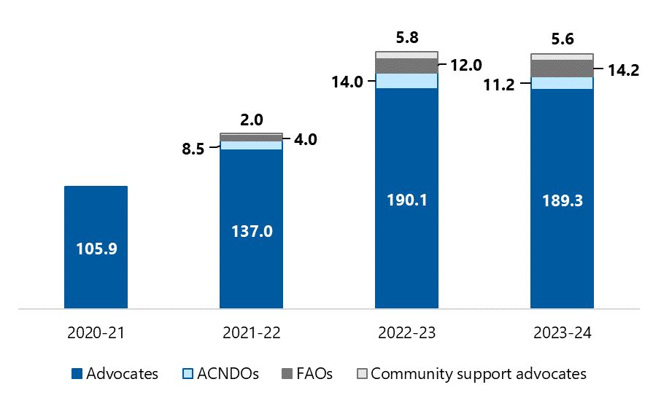

Source: OPAN data summary 1 (2024a)

Note: FTE is from one point in time (quarter 2) each financial year, except in 2023-24 when it is calculated on the average of quarter 1 and quarter 2.

Data is provided in Appendix E, section E.9.

Program reporting shows that the growth in the advocate workforce is in line with the increase in funding, and salaries account for approximately 80% of NACAP expenditure in both 2021-22 and 2022-23. Some SDO representatives, however, suggested that the remaining funds were insufficient to provide the additional administrative support and infrastructure (e.g. additional office space, fleet cars and parking space) required to support the expanded advocate workforce.

### SDOs work hard to recruit the right people

SDO managers discussed the importance of recruiting the right people for the advocate role. They worked hard to ensure they selected individuals who are resilient, resourceful and whose values align with the role (in particular, working alongside rather than “for” the older person). They also look to recruit advocates from diverse backgrounds.

SDOs did not generally have a shortage of applicants, although a smaller pool of candidates did make recruitment more difficult in regional locations.

SDO managers also reported that once advocates had settled into the role, turnover was generally relatively low. They recognised that the role was both challenging and rewarding and provided a range of support to advocates (see section 6.3.3). We heard that having a larger advocate workforce aided retention because advocates had more opportunities for formal and informal peer support, both in person and online. In smaller SDOs, such as in the Northern Territory, advocates were more likely to feel isolated, and this, coupled with high levels of community need and a lack of aged care or other support services, created additional pressure.

### Advocates benefit from ready access to training and support

In November 2021, OPAN established the Advocacy Academy, which provides a range of online learning opportunities. It aims to create nationally consistent practices and build (and maintain) a professional and skilled workforce. A core set of orientation modules is mandatory for all new advocates as part of this onboarding process. These modules were seen as particularly beneficial for advocates who do not have a background in aged care, although advocates pointed out that are they no replacement for on-the-job practical training such as “shadowing” or mentoring with other advocates.

While some advocates commented that the volume of training offered through the Advocacy Academy could be time-consuming to complete, they consistently reported that the training was high quality and comprehensive and set them up well to perform their roles.

* I cannot praise it enough. It’s just absolutely excellent. Standardising the training across all the SDOs is fabulous. – SDO representative

The Advocate Knowledge Hub is an online library of resources, hosted on the Advocacy Academy, that provides advocates with accessible information to help their casework. Advocates appreciated this resource – particularly because it was reviewed regularly to provide up-to-date information in a constantly changing landscape.

* Before, I’d have a folder for residential aged care, I’d have folder for this, and I’d try and keep all the relevant information, it became a real mess. But with the Academy, I can just click on it, and all of the information’s there. I don’t need to worry about downloading. It’s all updated, it’s all fresh, it’s all new. So yeah, from my perspective, it saved me a lot of time. – SDO representative.

In addition to the training offered through the Advocacy Academy and the resources on the Advocate Knowledge Hub, some SDOs have arrangements in place where advocates keep up to date with emerging issues or policy changes across different “portfolios” (e.g. guardianship, home care packages) and share this information with their team. In particular, we heard that a key benefit of the FAO role is the expertise they can share with general advocates regarding financial issues. This helps the general advocates provide a quality service to older people with more straightforward financial issues, without the need to refer the case to a FAO.

SDOs also offered their advocates additional, more formal professional development opportunities based on identified needs. These included:

mental health first aid

* strategies for responding to people with suicidal ideation or at risk of self-harm
* self-care strategies, to reduce stress and avoid burnout
* managing vicarious trauma arising from their roles.

Advocates suggested that OPAN could, where possible, offer this training to all advocates nationally, noting that some may be best delivered in a face-to-face format (e.g. managing vicarious trauma). They also suggested other topics for consideration, including:

* building skills in conflict resolution and de-escalating tense situations
* public speaking to help less experienced advocates become more confident to deliver education sessions
* understanding the changes likely to arise from the new Aged Care Act.

In addition to the importance of training for advocates, we also heard about the need for timely and appropriate support – both to manage complex cases and to maintain their own wellbeing when dealing with complex cases. Advocates valued the opportunity for formal and informal briefing with managers and peers, and some felt that it would be helpful to have greater access to external professional supervision and support when needed.

Overall, the combination of OPAN’s Advocacy Academy, the Advocate Knowledge Hub and additional training and support offered by SDOs appears to be effective in preparing and supporting advocates to carry out their role.

### CoPs foster a network of engaged advocates

OPAN has established communities of practice (CoPs) for community support advocates, FAOs and Aboriginal and Torres Strait Islander advocates. We heard consistently positive feedback about them. The CoP for community support advocates was particularly helpful in clarifying interpretations of the guidelines and definitions in the early days of the HCCI Project. Similarly, FAOs found their CoP useful for workshopping difficult cases and working through the implications of changes to aged care fees and charges.

The Aboriginal and Torres Strait Islander CoP was seen to be particularly effective. Participants suggested that it ensures that Aboriginal and Torres Strait Islander recipients are provided with culturally safe and appropriate supports across Australia and enables its members to:

* Share cultural experience, discuss cases and opportunities for professional development, and really just support each other as a network. – SDO representative

It is clear that the 3 existing CoPs create meaningful program benefits such as improved knowledge sharing, collaborative troubleshooting and service consistency across regions. In addition, they were seen to be helpful in identifying whether common presenting issues were specific to a particular jurisdiction or were occurring more broadly and warranted escalation to OPAN for a systemic response.

* To be able to connect into other organisations across Australia and hear about the challenges they’re facing; seeing trends within the different states; being able to come together as a group and identify challenges and the barriers; put forward some solutions; share resources across our organisations … I think is a great resource to have. – SDO representative

Currently, there are no formal CoPs for general advocates, who expressed a desire for more opportunities to connect with peers in other SDOs.[15] Several interview participants highlighted the value of CoPs in supporting and reducing isolation for advocates working in niche areas, suggesting that future CoPs could be structured around NACAP target groups (e.g. CALD, LGBTI or rural populations).

Future opportunities to support effective service delivery

1. Ensure SDOs are adequately resourced to meet the administrative and service delivery requirements of the program. This includes being able to respond to OPAN’s requests for information and data in a timely manner.
2. Consider ways to make training delivered by individual SDOs available across the consortium where relevant.
3. Consider opportunities to ensure that all advocates have access to timely and appropriate peer, manager, and external support.
4. Consider creating additional CoPs to provide general advocates across the consortium with meaningful opportunities to connect with each other.

# Conclusion

This evaluation assessed the appropriateness, effectiveness and efficiency of the NACAP since its expansion in 2021. Below we outline some of the limitations of the evaluation and reflect on its findings and the future direction of the NACAP.

## Limitations

A key strength of this evaluation is the high levels of stakeholder engagement we achieved, including representation of NACAP recipients from every state and territory and all NACAP target groups. The rich feedback we received from stakeholders was augmented by a high volume of quantitative data. Nonetheless, readers should keep several limitations in mind when considering our findings and recommendations.

### Data, reporting and documentation

To the extent possible, we drew on existing data and documentation so as not to burden stakeholders with additional, evaluation-specific reporting requirements. This data comes with the gaps and inconsistencies that are inherent in real-world, ever-evolving program reporting.

For example, the MDS does not collect data on waiting times for information and advocacy services, mode of delivery (e.g. in person or over the phone), recipient gender, or standalone out-of-scope advocacy work. As such we were unable to consider these factors in our analysis of how well the NACAP is being delivered and to whom (and who may be missing out).

In addition:

* Data on target and actual education session participants was only reliably collected from 1 January 2024, meaning findings in section 5.1 may not accurately represent alignment between planned and actual delivery.
* Delays in the introduction of outcome measures to the MDS meant that we were not able to explore whether outcomes are associated with different recipient and service characteristics.

### Stakeholder consultations

In relation to the **NACAP recipient survey**:

* We relied on SDOs to invite NACAP recipients to participate in the evaluation, as their existing rapport and understanding of recipients’ needs enabled them to do so in a way that was appropriate to each individual. While SDOs were encouraged to invite all recipients to participate, advocates could decline if they determined that the client was unsuitable (e.g. due to imminent end of life, cognitive impairment or mental health issues). Overall, 696 recipients were deemed unsuitable, and we cannot validate the appropriateness of these exclusions.
* The survey was not distributed to education session attendees, following advice from OPAN that doing so would not be feasible for SDO staff.
* We received only 3 responses from HCCI recipients, preventing us from drawing any conclusions about their experiences or outcomes specifically from the responses received.
* Survey data was self-reported and may be subject to recall bias; we were not able to validate responses (including the type of NACAP support that respondents received).
* Satisfaction ratings may reflect respondents’ satisfaction with the outcome of the information or advocacy received (i.e. whether or not the issue was resolved) rather than the experience of the NACAP itself.

A little over half of our **aged care staff survey** respondents were in a management role, meaning that the perspectives of those providing day-to-day care for older people may be under‑represented. Further, 83% of survey respondents most recently completed a NACAP education activity more than 6 months ago. Consequently, their recall of the education itself and its impact on their practice may be limited.

A lower-than-expected number of **government representatives** participated in consultations. This limited our ability to gather rich insights regarding the broader policy context and the intersection between the NACAP and other Australian Government‑funded programs.

Finally, our **interviews with advocates** were coordinated by SDO managers, which may have impacted who attended. In addition, management staff were present at 5 out of 9 advocate interviews, which may have curtailed advocates’ willingness to discuss issues or provide feedback that could be seen as critical or negative.

## Final reflections

The NACAP expansion was introduced in response to the royal commission’s recognition of the vital role advocacy services play in ensuring that the aged care rights of older people are upheld.

The findings of this evaluation highlight the achievements of the OPAN consortium since the expansion funding was introduced. The expansion has facilitated rapid growth of, and increased professionalisation of, the advocate workforce, including the introduction of specialised roles to deliver new awareness-raising and needs-focused initiatives. As a result, the program’s reach is growing.

However, the complexity of advocacy work means that the potential for further growth is limited within current funding.

In addition, effective advocacy requires an aged care system with sufficient capacity to provide high-quality services to older Australians. Without an appropriate supply of aged care services and supports, it is hard to envision how the NACAP will be able to support older people to truly exercise their aged care rights.

Despite these limitations, NACAP services are making a meaningful difference to the lives of those who receive them – many of whom experience multiple and intersecting forms of vulnerability. In addition, the consortium model means advocates are better placed than ever to share their first-hand knowledge of the issues and challenges their clients face and contribute to improving the aged care system. It will therefore be important to maintain the NACAP’s momentum as the aged care sector transitions to the new rights-based Aged Care Act, to ensure older people’s rights are upheld and their wishes are met, whether they are living independently at home or in residential care.

##### Evaluation questions mapped to report sections

Table A‑1: Appropriateness evaluation questions and their location in this report

| Question | Report section |
| --- | --- |
| 1. How well is the NACAP being delivered? | 3, 4, 5 and 6 |
| * 1. What are the demographic characteristics of people who use NACAP services? | 3.2, 4.1.2 |
| * 1. Are there any barriers to delivering NACAP core and expansion activities? | 3.2, 4.1, 5.2, 5.4.4 |
| * 1. Are HCCI recipients satisfied with this service (including differences in satisfaction according to recipient characteristics)? | 4.2 |
| 1. Do advocates have the capacity, skills and knowledge required to deliver the NACAP? | 6.3 |
| 1. How is HCCI implementation progressing across states and territories? | 4 |
| 1. How is the design and planning of the diversity education rollout progressing? | 5.4 |
| 1. Are there appropriate referral pathways for older people? | 3.3.3 and 4.1.1 |
| 1. Is the NACAP consortium model effective? | 6.2 |
| 1. To what extent is NACAP information, advocacy, and education achieving the intended objectives? | 3.4 and 5.3 |
| * 1. Are older people and staff aware of NACAP services? | 3.3.1 |
| * 1. Are aged care staff who participate in education sessions knowledgeable about the role of advocacy, aged care rights and empowering older people to address aged care issues? | 5.3.1 |
| * 1. Are NACAP recipients more knowledgeable about the role of advocacy and their aged care rights, following their engagement with the NACAP? | 3.4.1 |
| * 1. Are NACAP recipients confident about exercising their aged care rights? | 3.4.2 |
| * 1. Are there any barriers to achieving the expected outcomes (knowledge of advocacy, aged care rights and confidence exercising rights), including barriers for specific population groups? | 3 |
| * 1. Has the NACAP resulted in any unintended consequences? | 6.1 |
| 1. To what extent is the HCCI Project achieving its intended objectives? | 4.2 |
| 1. Have the NACAP resources been used efficiently to achieve the planned outputs? | 6.3.1 |
| * 1. What key factors have impacted the efficiency of the NACAP? | 3.2, 4.1, 5.2.1 and 6.2.1 |
| * 1. Is any aspect of the program duplicative of other aged care programs/​services? | 6.1 |
| 1. Based on the key findings from the evaluation, what recommendations can be made to improve the implementation, effectiveness, and efficiency of the NACAP? | 3, 4, 5 and 6 |

##### Evaluation data sources

This evaluation drew on 3 categories of data, namely program reporting and background documentation, MDS data, and stakeholder consultations. Each of these is described in turn below.

###### Program reporting and documentation

The department provided initial program documentation including:

* NACAP Monitoring and Evaluation Framework
* program logics for information and advocacy, education and other projects.

OPAN also provided a wealth of reports and documentation, including:

* activity work plans, which detail the activities required to meet program objectives and outcomes
* NACAP performance reports, which provide 6-monthly updates on activities undertaken (and progress against agreed milestones), performance against agreed targets, collaborations, and risks and mitigation strategies
* OPAN and SDO annual and financial reports, which highlight key achievements, provide case studies, and outline income and expenditure for each financial year
* responses to AHA requests for data (e.g. service delivery data dating back to 2020‑21, performance targets, HCCI and financial data)
* other documentation (including governance information and OPAN’s presenting issues reports).

###### MDS data

The MDS collects the number of information and advocacy cases and education and event sessions provided by SDOs. Self-reported outcome measures are not yet collected by the MDS, meaning that this data was not available for our evaluation.

On 30 April 2024, OPAN provided us with MDS data **on information, advocacy, education, and ACND events. This d**ata related to the period from 1 October 2023 to 31 March 2024.

We received data from the HCCI dataset on 20 May 2024, relating to HCCI services delivered between 1 July 2023 and 31 March 2024. Note that while this dataset is currently separate to the MDS, it will be integrated if the pilot is rolled out nationally.

We note that OPAN regards all MDS data as preliminary until a reconciliation process is completed at the end of each financial year and thus the findings presented in this report may differ from future reporting from this dataset.

We used the MDS data dictionary version 1.4.2 and HCCI data dictionary version 1.4 to interpret the data items.

###### Stakeholder consultations

Between October 2023 and April 2024 we consulted with a total of 743 individuals representing 5 stakeholder groups (Table B‑1).

Table B‑1: Overview of stakeholder consultations

| Stakeholder group | Method | Consultation period | Participants |
| --- | --- | --- | --- |
| Government | Interview | Jan – Feb 2024 | 8 |
| OPAN representatives | Interview | Nov 2023 – Jan 2024 | 15 |
| SDO representatives | Interview | Jan – Mar 2024 | 98 |
| NACAP recipients | Survey | Jan – Apr 2024 | 418 |
| Aged care staff | Survey | Nov – Dec 2023 | 204 |
| All stakeholders | All | Oct 2023 – Apr 2024 | 743 |

Government representatives

We conducted 2 online interviews with representatives of:

* the department’s Navigation and Access Branch, Aged Care Communication and Change Branch Aged Care Volunteer Visitors Scheme, and Consumer Support Section
* the department’s state and territory branches and the Aged Care Quality Safety Commission.

Consultations explored the NACAP’s benefits, challenges, and degree of alignment or duplication with other government-funded programs and services.

OPAN representatives

We held 3 separate meetings with different groups of OPAN representatives.

**Operations leads included senior leaders and expansion project managers (excluding HCCI). We met with this group in person and explored h**ow the consortium works together and collaborates with external stakeholders, the progress and outcomes of the NACAP’s implementation overall and of the expansion activities specifically, and gaps, alignment, or duplication between the NACAP and related services.

**HCCI leads** attended an online interview and shared their perspectives on the project’s implementation, outcomes, and future directions.

**Governance leads were m**embers of the OPAN Board of Directors. We met with them online and asked about the consortium’s governance structure and decision-making process, relationships with other stakeholders, the successes and challenges of the NACAP.

SDO representatives

Our total sample of 98 SDO representatives comprised:

* 49 advocates: 32 general, 8 FAOs, 3 ACDNOs, 6 community support advocates
* 6 team leaders
* 43 managers.

We conducted up to 3 meetings at each SDO, one each for managers, advocates and, if relevant, community support advocates. However, as noted in section 7.1.2, managers and team leaders were often present during advocate interviews.

We asked managers about program implementation and demand, the consortium model and other strategic partnerships that relate to the NACAP, and program gaps and duplication.

In interviews with advocates, we explored the highlights and challenges of the role, views on the training and support provided by SDOs and OPAN, and outcomes of advocacy among recipients.

Community support advocates and HCCI managers were asked about the pilot’s implementation, success and challenges, staff training and support, recipient characteristics, and suggestions for the future direction of the service.

Aged care staff

Residential aged care and home care provider staff were invited to take part in an anonymous online survey. The survey was promoted by:

* OPAN, through its e-learning system, webinar mailing list, and website
* SDOs, through their routine channels of communication with aged care providers in their region
* the department, through its Bulk Information Distribution System (BIDS) notices.

In total, we received 204 completed surveys. Just over half of survey respondents were in management or coordination roles, with no responses received from medical staff (Figure B‑1).

Figure B‑1: Proportion of respondents to aged care staff survey by role

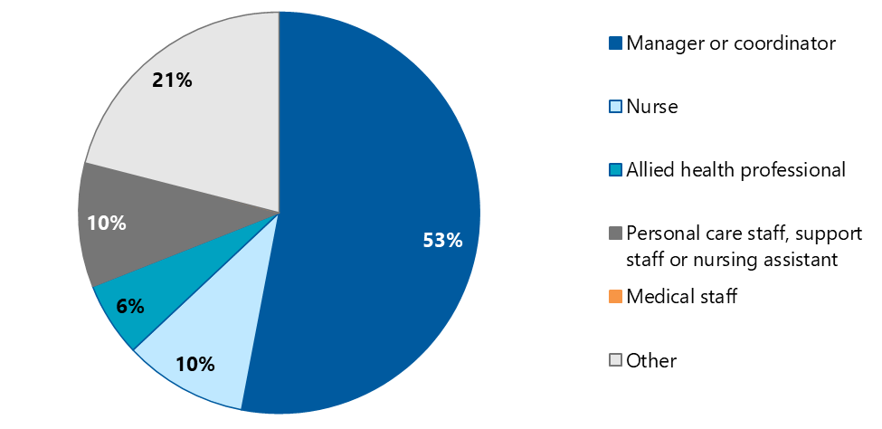

Respondents most commonly indicated that they work in Australian Government‑funded home care services (Figure B‑2). Common “other” settings described by respondents included hospital, community and not‑for‑profit organisations.

Figure B‑2: Proportion of respondents to aged care staff survey by work setting

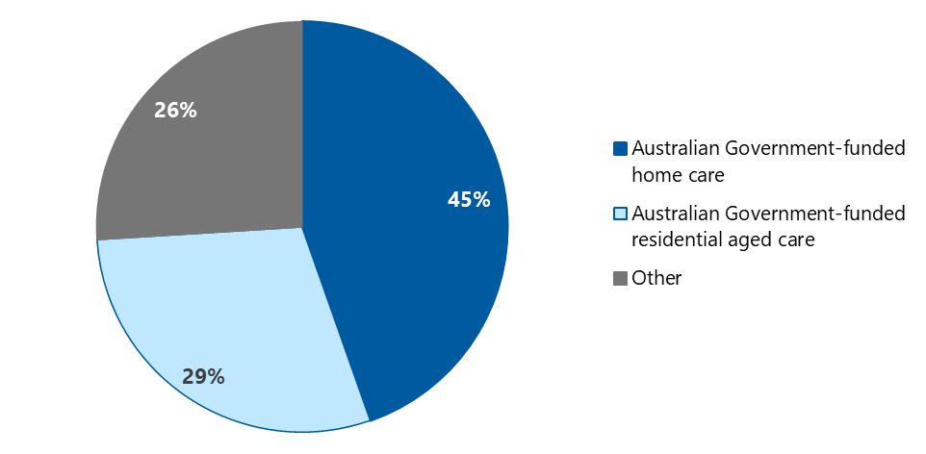

One hundred and fifteen respondents had attended an OPAN webinar or roundtable, 20% of whom had done so in the last 6 weeks (Table B‑2). Respondents who had completed the Talk To Us First e-learning tended to have done so more than 6 months ago.

Table B‑2: Participation in, and recency of, NACAP education among aged care staff survey respondents

| Education type | Less than 6 weeks | Between 7 weeks and 6 months | More than 6 months | Participants |
| --- | --- | --- | --- | --- |
| OPAN webinars or roundtables | 20% | 57% | 23% | 115 |
| Talk To Us First e-learning | 4% | 38% | 58% | 72 |
| **Abuse of the Older Person e-learning** | 17% | 47% | 36% | 26 |
| Other education | 19% | 24% | 57% | 21 |

Most respondents were aware of different types of NACAP services available prior to completing the survey (Table B‑3).

Table B‑3: Number and proportion of aged care staff aware of NACAP information, advocacy and education services

| Education type | Number | Proportion |
| --- | --- | --- |
| Information and advocacy for older people or their representatives | 176 | 86% |
| OPAN webinars or roundtables | 162 | 79% |
| OPAN e-learning modules | 139 | 68% |
| Group education sessions for older people or their representatives, delivered by SDO | 134 | 66% |

NACAP recipients

Bellberry Human Research Ethics Committee (HREC) approved our survey of NACAP recipients.

The survey was open to NACAP recipients who had their information or advocacy case closed between 2 January and 31 March 2024. They were invited by their advocate to learn more about the evaluation and complete a short survey online, in hard copy, or over the telephone. SDOs collated contact details for eligible and consenting recipients and shared these securely with us on a weekly basis. We then followed up with these recipients by phone and/or email.[16]

In total, 418 recipients completed the survey, most of whom had sought NACAP support for themselves (Table B‑4).

Table B‑4: Survey respondents by who they sought NACAP support for

| Sought support for | Number | Proportion |
| --- | --- | --- |
| Self | 315 | 63% |
| A friend or family member | 118 | 24% |
| A person I legally represent | 66 | 13% |
| Other | 3 | <1% |
| Total | 502 | 100% |

Note: The total number (502) is greater than the total number of respondents (418) because respondents could select more than one option

We received survey responses from all jurisdictions and SDOs (Figure B‑3).

Figure B‑3: Proportion of surveys completed, by jurisdiction

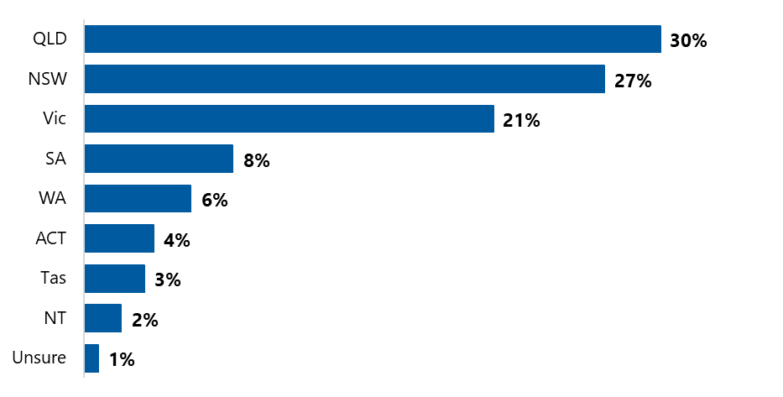

N = 418.

The majority of respondents identified with at least one diverse group, as shown in Table B‑5. This is substantially higher than representation of these groups among the broader population of information and advocacy recipients (see section 3.2). It may be that members of these groups were more likely to take up the invitation to contribute to the evaluation or that recipient characteristics can be validated by advocates before entry into the MDS, whereas survey data is based purely on self-reporting.

Table B‑5: Respondents’ self-reported membership of diverse groups[17]

| Group | Number | Proportion |
| --- | --- | --- |
| People living with a disability | 215 | 64% |
| People who are socially isolated | 152 | 46% |
| People who are financially or socially disadvantaged | 125 | 37% |
| Has a mental health condition | 117 | 35% |
| People who live in a rural or remote area | 91 | 27% |
| People from CALD backgrounds | 72 | 22% |
| Has cognitive impairment (including dementia) | 60 | 18% |
| People from Aboriginal and Torres Strait Islander communities | 26 | 8% |
| Parents separated from their children by forced adoption or removal | 16 | 5% |
| Veterans | 15 | 4% |
| People who are homeless or at risk of being homeless | 9 | 3% |
| Is a care leaver | 7 | 2% |
| LGBTI people | 6 | 2% |
| At least one diverse group | 334 | 82% |

Note: N = 418. Proportions sum to more than 100% as survey respondents could select more than option.

Respondents were most commonly receiving aged care services in a community setting (Figure B‑4). One in 10 indicated that they were not currently receiving any aged care services, which, when combined with the data in Table B‑4, suggests that many of the people who seek support for a friend or family member are also aged care clients themselves. The information and support they receive may have flow on benefits for their interactions with their own aged care providers in future.

Figure B‑4: Proportion of survey respondents currently receiving aged care services

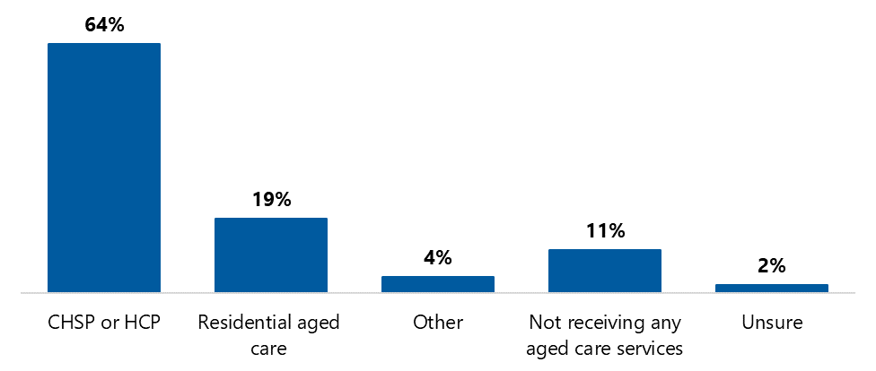

Note: Other includes respite and transitional care.

##### Referrals and promotion

Table C‑1 shows the full list of referral sources for information and advocacy cases.

Table C‑1: Proportion of cases by referral source (full list), October 2023 to March 2024

| Referral source | Information | Advocacy | Financial advocacy | Overall |
| --- | --- | --- | --- | --- |
| **Total number of cases** | **14,664** | **6,592** | **458** | 21,714 |
| Self | 18% | 23% | 32% | 20% |
| Previous client | 14% | 16% | 9% | 15% |
| Family member or carer | 10% | 10% | 18% | 10% |
| Other | 8% | 7% | 8% | 8% |
| My Aged Care | 6% | 8% | 5% | 7% |
| Unknown | 8% | 4% | 5% | 7% |
| Aged care provider | 6% | 4% | 5% | 5% |
| Event (ACND) | 6% | 1% | <1% | 4% |
| OPAN referral | 4% | 3% | 5% | 4% |
| Education session | 4% | 5% | 2% | 4% |
| Friend or other supporter | 4% | 3% | 3% | 4% |
| Other service provider | 3% | 3% | 1% | 3% |
| Healthcare provider | 3% | 4% | <1% | 3% |
| Website | 2% | 1% | <1% | 1% |
| OPAN advertising | <1% | 1% | <1% | <1% |
| SDO advertising | <1% | <1% | <1% | <1% |
| Local Government Authority | <1% | <1% | <1% | <1% |
| Police | <1% | <1% | 0% | <1% |
| Aged Care Quality and Safety Commission | <1% | <1% | 0% | <1% |
| Aged Care System Navigator | <1% | <1% | <1% | <1% |
| Community Legal Service | <1% | <1% | <1% | <1% |
| Peak body | <1% | <1% | <1% | <1% |
| Other OPAN organisation | <1% | <1% | <1% | <1% |
| Office of the Public Advocate (or equivalent) | <1% | <1% | 0% | <1% |
| Health services | <1% | <1% | <1% | <1% |
| Emergency referral | <1% | <1% | 0% | <1% |
| Family/self | <1% | <1% | 0% | <1% |
| Post case follow-up survey | <1% | <1% | 0% | <1% |
| Aged care services | <1% | <1% | 0% | <1% |
| Community organisation | <1% | 0% | 0% | <1% |
| Non-QDAP provider | 0% | <1% | 0% | <1% |
| Previous contact | 0% | <1% | 0% | <1% |
| Justice/legal | <1% | 0% | 0% | <1% |
| Queensland Health | <1% | 0% | 0% | <1% |
| Total | 100% | 100% | 100% | 100% |

Source: NACAP MDS.

Note: OPAN and SDO advertising include brochures, newsletters, and radio.

An indication of OPAN’s awareness‑raising activities, and their reach, is provided in Figure C‑1.

Figure C‑1: OPAN awareness-raising activities, January to June 2023

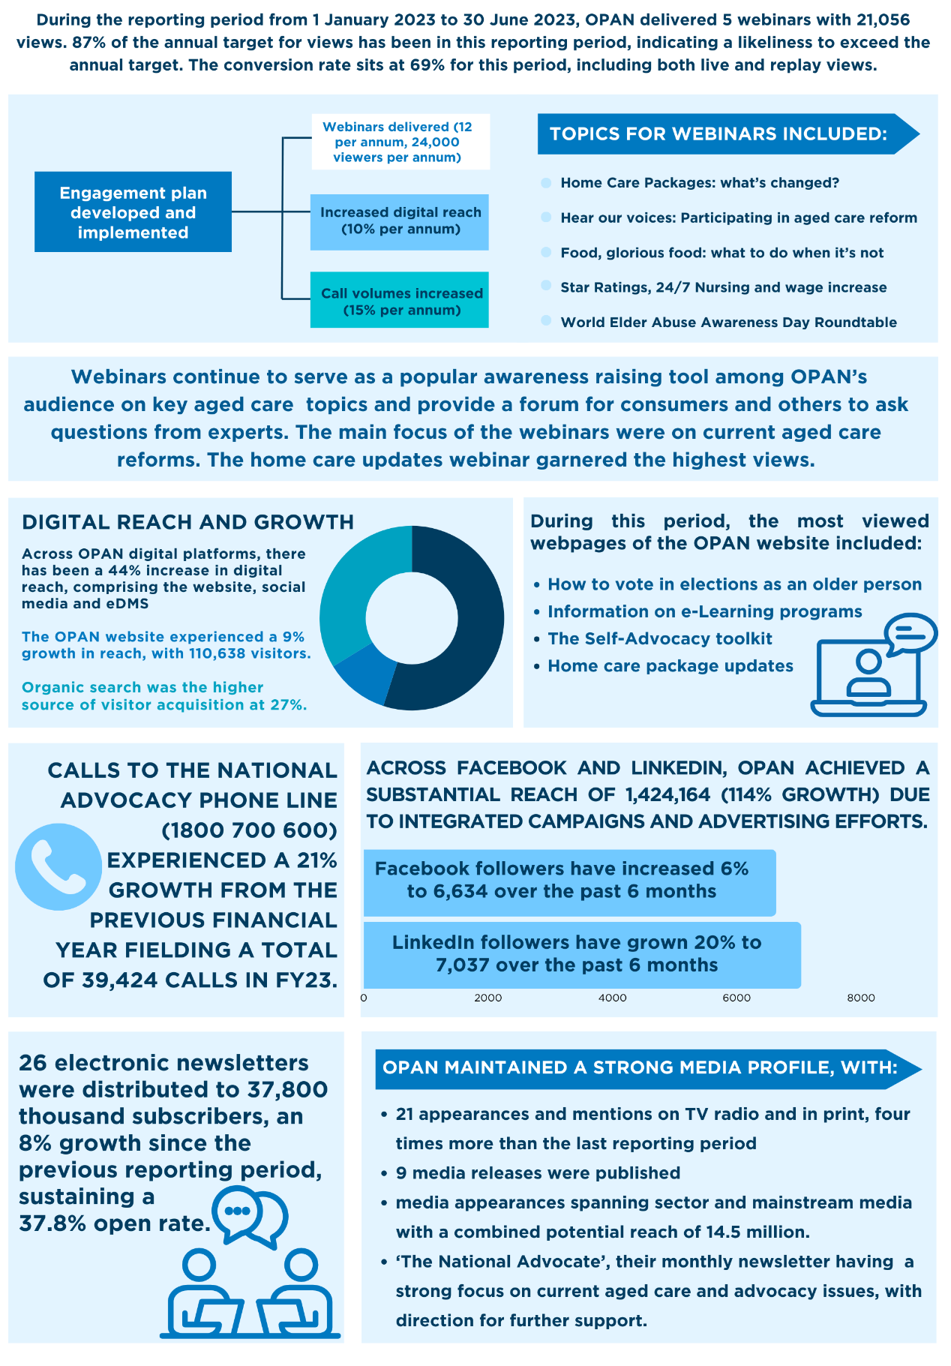

Source: (OPAN 2023b)

Long text description provided in Appendix E, section E.10.

##### HCCI referrals and recipient characteristics

Table D‑1: HCCI recipient referral source

| Referral source | Number | Proportion |
| --- | --- | --- |
| SDO internal referral | 22 | 24% |
| Aged care provider | 20 | 22% |
| Healthcare provider | 11 | 12% |
| ACAT | 8 | 9% |
| Social worker | 5 | 5% |
| Other | 5 | 5% |
| Care finder or Trusted Indigenous Facilitator | 4 | 4% |
| Other service provider | 4 | 4% |
| Local Government Authority | 3 | 3% |
| Aged Care System Navigator | 2 | 2% |
| RAS | 2 | 2% |
| My Aged Care | 2 | 2% |
| Aged Care Specialist Officer | 1 | 1% |
| Friend or other supporter | 1 | 1% |
| Mental health support service | 1 | 1% |
| Other OPAN organisation | 1 | 1% |
| Total | 92 | 100% |

Table D‑2: Proportion of HCCI clients by identified risk flags, July 2023 to March 2024

| HCCI risk flags | Total clients | Advocare | ARAS | SRS | Overall |
| --- | --- | --- | --- | --- | --- |
| Socially isolated | 71 | 88% | 84% | 63% | 77% |
| Living alone | 67 | 73% | 77% | 69% | 73% |
| Limited mobility | 60 | 54% | 68% | 71% | 65% |
| Unable to drive independently | 59 | 58% | 61% | 71% | 64% |
| Heavily reliant on one carer | 55 | 77% | 45% | 60% | 60% |
| Experiencing grief or loss | 34 | 65% | 26% | 26% | 37% |
| Difficulty communicating or being understood | 29 | 42% | 16% | 37% | 32% |
| Living with a cognitive impairment | 22 | 27% | 13% | 31% | 24% |
| None | 4 | 0% | 6% | 6% | 4% |

Note: n = 92. Flags are not mutually exclusive and proportions therefore do not sum to 100%.

Table D‑3: Proportion of HCCI clients by NACAP target group, July 2023 to March 2024

| NACAP target group | Advocare | ARAS | SRS | Overall |
| --- | --- | --- | --- | --- |
| People who are financially or socially disadvantaged | 83% | 52% | 76% | 71% |
| People living with a disability | 39% | 24% | 59% | 42% |
| People living with a mental health condition | 48% | 24% | 45% | 40% |
| People living with cognitive decline | 35% | 14% | 34% | 29% |
| People who live in rural or remote areas | 9% | 0% | 48% | 22% |
| People from CALD backgrounds | 13% | 29% | 3% | 14% |
| People from Aboriginal and Torres Strait Islander communities | 9% | 5% | 17% | 11% |
| People living with dementia | 4% | 10% | 14% | 10% |
| People who are homeless or at risk of being homeless | 9% | 0% | 7% | 5% |
| Veterans | 4% | 0% | 3% | 3% |
| Care leavers | 4% | 0% | 0% | 1% |
| Parents separated from their children by forced adoption or removal | 4% | 0% | 0% | 1% |
| At least one NACAP target group | 88% | 68% | 83% | 79% |

Note: n = 92. Groups are not mutually exclusive and proportions therefore do not sum to 100%.

##### Alt text and data tables

This appendix contains text alternatives (including data tables) to the figures in this report, with the aim of increasing document accessibility.

###### Data table for Figure 3‑1

Table E‑1: Information and advocacy cases, July 2020 to December 2023

| Financial year | Quarter 1 | Quarter 2 | Quarter 3 | Quarter 4 | Total |
| --- | --- | --- | --- | --- | --- |
| 2020-21 | 5,757 | 5,596 | 5,780 | 5,937 | 23,070 |
| 2021-22 | 6,185 | 6,990 | 6,760 | 7,169 | 27,104 |
| 2022-23 | 7,645 | 8,306 | 10,515 | 10,438 | 36,904 |
| 2023-24 | 11,156 | 10,316 | No data | No data | 21,472 |

Return to Figure 3‑1

###### Data tables for Figure 3‑4

Table E‑2: Responses to “the support I received improved my understanding of aged care services”

| Response | Number | Proportion |
| --- | --- | --- |
| Disagree | 21 | 6% |
| Tend to disagree | 16 | 4% |
| Neither | 38 | 10% |
| Tend to agree | 67 | 18% |
| Agree | 238 | 63% |
| Total | 380 | 100% |

Table E‑3: Responses to “the support I received improved my understanding of accessing services”

| Response | Number | Proportion |
| --- | --- | --- |
| Disagree | 31 | 8% |
| Tend to disagree | 10 | 3% |
| Neither | 35 | 9% |
| Tend to agree | 55 | 15% |
| Agree | 240 | 65% |
| Total | 371 | 100% |

Table E‑4: Responses to “the support I received improved my understanding of advocacy”

| Response | Number | Proportion |
| --- | --- | --- |
| Disagree | 8 | 2% |
| Tend to disagree | 5 | 1% |
| Neither | 25 | 6% |
| Tend to agree | 50 | 12% |
| Agree | 316 | 78% |
| Total | 404 | 100% |

Table E‑5: Responses to “the support I received improved my understanding of aged care rights”

| Response | Number | Proportion |
| --- | --- | --- |
| Disagree | 17 | 4% |
| Tend to disagree | 12 | 3% |
| Neither | 39 | 10% |
| Tend to agree | 52 | 13% |
| Agree | 267 | 69% |
| Total | 387 | 100% |

Return to Figure 3‑4

###### Data tables for Figure 3‑5

Table E‑6: Responses to “the support I received improved my confidence”

| Response | Number | Proportion |
| --- | --- | --- |
| Disagree | 43 | 11% |
| Tend to disagree | 17 | 4% |
| Neither | 40 | 10% |
| Tend to agree | 50 | 13% |
| Agree | 231 | 61% |
| Total | 381 | 100% |

Table E‑7: Responses to “I felt empowered to self-advocate”

| Response | Number | Proportion |
| --- | --- | --- |
| Disagree | 31 | 8% |
| Tend to disagree | 16 | 4% |
| Neither | 54 | 14% |
| Tend to agree | 69 | 18% |
| Agree | 218 | 56% |
| Total | 388 | 100% |

Return to Figure 3‑5

###### Data table for Figure 4‑1

Table E‑8: Risk flags per HCCI recipient, July 2023 to March 2024

| Number of flags | Number of recipients |
| --- | --- |
| 0 | 4 |
| 1 | 2 |
| 2 | 12 |
| 3 | 11 |
| 4 | 18 |
| 5 | 21 |
| 6 | 11 |
| 7 | 9 |
| 8 | 4 |
| Total | 92 |

Return to Figure 4‑1

###### Data table for Figure 4‑2

Table E‑9: Change in risk score from first to last assessment for 24 HCCI recipients

| First | Last | Difference |
| --- | --- | --- |
| 23 | 9 | -14 |
| 22 | 12 | -10 |
| 14 | 6 | -8 |
| 20 | 12 | -8 |
| 20 | 13 | -7 |
| 14 | 8 | -6 |
| 16 | 10 | -6 |
| 19 | 13 | -6 |
| 15 | 11 | -4 |
| 17 | 13 | -4 |
| 13 | 10 | -3 |
| 16 | 13 | -3 |
| 20 | 17 | -3 |
| 14 | 12 | -2 |
| 16 | 14 | -2 |
| 9 | 8 | -1 |
| 7 | 7 | 0 |
| 11 | 11 | 0 |
| 9 | 10 | 1 |
| 7 | 9 | 2 |
| 9 | 12 | 3 |
| 10 | 13 | 3 |
| 11 | 14 | 3 |
| 15 | 22 | 7 |

Return to Figure 4‑2

###### Data table for Figure 5‑1

Table E‑10: Number of residential and home care education sessions delivered by SDOs to aged care staff and clients, 2020‑21 to 2022‑23

| Financial year | Quarter 1 | Quarter 2 | Quarter 3 | Quarter 4 | Total |
| --- | --- | --- | --- | --- | --- |
| 2020-21 | 217 | 236 | 355 | 502 | 1,310 |
| 2021-22 | 361 | 490 | 461 | 530 | 1,842 |
| 2022-23 | 798 | 718 | 752 | 1016 | 3,284 |
| 2023-24 | 953 | 885 | No data | No data | 1,838 |

Return to Figure 5‑1

###### Data table for Figure 5‑2

Table E‑11: Education session attendees, by education type, October 2023 to March 2024

| Education type | Aged care clients | Aged care staff | Other |
| --- | --- | --- | --- |
| Advocacy (residential) | 81% | 16% | 3% |
| Advocacy (community) | 67% | 18% | 15% |
| Abuse of Older People (residential) | 70% | 27% | 3% |
| Abuse of Older People (community) | 49% | 36% | 15% |

Return to Figure 5‑2

###### Data table for Figure 5‑5

Table E‑12: Aged care staff responses to “I feel better informed about …”

| Topic | Disagree | Tend to disagree | Neither | Tend to agree | Agree |
| --- | --- | --- | --- | --- | --- |
| Aged care rights | 2% | 3% | 10% | 10% | 75% |
| Advocacy | 3% | 2% | 13% | 11% | 72% |
| Responsibilities | 2% | 0% | 14% | 11% | 73% |
| Identifying abuse of older people | 3% | 1% | 14% | 14% | 68% |
| Preventing abuse of older people | 3% | 3% | 16% | 24% | 55% |
| Responding to abuse of older people | 2% | 2% | 14% | 17% | 65% |

Return to Figure 5‑5

###### Data table for Figure 6‑1

Table E‑13: Advocate workforce FTE, 2020-21 to 2023-24

| Financial year | Advocates | ACNDOs | FAOs | Community support advocates | Total |
| --- | --- | --- | --- | --- | --- |
| 2020-21 | 105.9 | No data | No data | No data | 105.9 |
| 2021-22 | 137.0 | 8.5 | 4.0 | 2.0 | 151.5 |
| 2022-23 | 190.1 | 14.0 | 12.0 | 5.8 | 221.9 |
| 2023-24 | 189.3 | 11.2 | 14.2 | 5.6 | 220.3 |

Return to Figure 6‑1

###### Long description for Figure C‑1: OPAN awareness-raising activities, January to June 2023

OPAN has developed and implemented an engagement plan with the following aims:

* deliver 12 webinars and reach 24,000 viewers per annum
* increase digital reach by 10% per annum
* increase call volumes by 15% per annum.

Webinars

Between 1 January 2023 and 30 June 2023, OPAN delivered 5 webinars, which received a total of 21,056 views. This is 87% of the annual target for views in this 6‑month reporting period, indicating a likeliness to exceed the annual target. The conversion rate was 69%, including both live and replay views.

The main focus of the webinars was current aged care reforms. Topics included:

* Home Care Packages: what’s changed?
* Hear our voices: Participating in aged care reform
* Food, glorious food: what to do when it’s not
* Star Ratings, 24/7 Nursing and wage increase
* World Elder Abuse Awareness Day Roundtable

The home care updates webinar garnered the highest views.

Webinars continue to serve as a popular awareness-raising tool for key aged care topics and provide a forum for consumers and others to ask questions of experts.

Digital reach and growth

Digital reach across all platforms (website, social media and eDMS) increased by 44% in this reporting period.

Website

Website reach grew by 9% to 110,638 visitors. Organic search was the highest source of visitor acquisition at 27%. The most viewed webpages were:

* How to vote in elections as an older person
* Information on e-Learning programs
* The Self-Advocacy toolkit
* Home care package updates.

Social media

Across Facebook and LinkedIn, OPAN achieved a substantial reach of 1,424,164 impressions (114% growth) due to integrated campaigns and advertising efforts.

* Facebook followers increased by 6%, to 6,634.
* LinkedIn followers increased by 20%, to 7,037.

Newsletter

OPAN distributed 26 electronic newsletters to 37,800 thousand subscribers, an 8% growth since the previous reporting period. The newsletters sustained a 37.8% open rate.

Call volumes

For the 2022‑23 financial year, there were 39,424 calls to the national advocacy phone line (1800 700 600) – a 21% increase from the previous financial year.

Media

OPAN also maintained a strong media profile, with:

* 21 appearances and mentions on TV radio and in print (4 times more than the last reporting period).
* Publication of 9 media releases.
* Media appearances spanning sector and mainstream media, with a combined potential reach of 14.5 million.
* Publication of “The National Advocate” monthly newsletter which has a strong focus on current aged care and advocacy issues, with direction for further support.

Return to Figure C‑1

Abbreviations

| Term | Definition |
| --- | --- |
| ACAT | Aged Care Assessment Team |
| ACND | Advocacy Community Network Development |
| ACNDO | Advocacy Community Network Development Officer |
| ACPR | Aged Care Planning Region |
| ACSO | Aged Care Specialist Officer |
| ADA Australia | Aged and Disability Advocacy Australia |
| ADACAS | ACT Disability, Aged and Carer Advocacy Service |
| AdvoTas | Advocacy Tasmania |
| AHA | Australian Healthcare Associates |
| AIHW | Australian Institute of Health and Welfare |
| ARAS | Aged Rights Advocacy Service |
| BIDS | Bulk Information Distribution System |
| CALD | culturally and linguistically diverse |
| CCNT | Catholic Care Northern Territory |
| CCT | Case Coordination Team |
| CHSP | Commonwealth Home Support Programme |
| CoP | Community of Practice |
| DCLS | Darwin Community Legal Service |
| ERA | Elder Rights Advocacy |
| FAO | financial advocacy officer |
| FTE | full-time equivalent |
| HCCI | Home Care Check-In |
| HCP | Home Care Package |
| KEQs | key evaluation questions |
| KPI | key performance indicator |
| LGBTI | lesbian, gay, bisexual, transgender, intersex |
| MDS | minimum data set |
| NACAP | National Aged Care Advocacy Program |
| OPAN | Older Persons Advocacy Network |
| PHN | Primary Health Network |
| RACH | residential aged care home |
| RAS | Regional Assessment Service |
| SDO | service delivery organisation |
| SRS | Seniors Rights Service |

References

AIHW (Australian Institute of Health and Welfare) (2023) [*Older Australians – Veterans,*](https://www.aihw.gov.au/reports/older-people/older-australians/contents/population-groups-of-interest/veterans) AIHW website*,* accessed 23 May 2024.

AIHW (2024) [*Rural and remote health*](https://www.aihw.gov.au/reports/rural-remote-australians/rural-and-remote-health), AIHW website*,* accessed 15 May 2024.

AHA (Australian Healthcare Associates) (2015) [*Department of Social Services Review of Commonwealth Aged Care Advocacy Services Final Report*](https://www.ahaconsulting.com.au/projects/national-aged-care-advocacy-review/), report to the Australian Government Department of Social Services, AHA Consulting, Melbourne, accessed 30 May 2024.

AHA (2024) [*First Report on the implementation of the care finder program*](https://www.health.gov.au/resources/publications/first-report-on-the-implementation-of-the-care-finder-program?language=en), report to the Australian Government Department of Health and Aged Care, AHA Consulting, Melbourne, accessed 31 May 2024.

Capic T, Cummins R, Emerson C, Hartanty N, Hutchinson D, Jona C, Khor S, Lau ALD, Mclean C, Au; E, Tunbridge L, Weinberg M, Cummins RA and Ps FAS (2024) [Personal Wellbeing Index Manual: 6th Edition, Version 1,](https://www.acqol.com.au/uploads/pwi-a/pwi-a-english.pdf) 6th edn, Cummins RA (ed) Geelong, accessed 31 May 2024.

Commonwealth of Australia (2024) [*After you’ve registered with My Aged Care*](https://www.myagedcare.gov.au/sites/default/files/2024-05/after-youve-registered-with-my-aged-care.pdf), My Aged Care website, accessed 18 June 2024.

Deloitte (2022) [*Demand Study of the National Aged Care Advocacy Program (NACAP) Final report*](https://www.health.gov.au/resources/publications/the-2022-demand-study-of-the-national-aged-care-advocacy-program-nacap?language=en), report to the Australian Government Department of Health, Deloitte, Sydney, accessed 18 June 2024.

Department of Health and Aged Care (2018) [*National Aged Care Advocacy Framework,*](https://www.health.gov.au/sites/default/files/documents/2019/12/national-aged-care-advocacy-framework.pdf) Commonwealth of Australia, Canberra, accessed 12 July 2023.

Department of Health and Aged Care (2021) [*Australian Government response to the final report of the Royal Commission Into Aged Care Quality and Safety,*](https://www.health.gov.au/resources/publications/australian-government-response-to-the-final-report-of-the-royal-commission-into-aged-care-quality-and-safety) Commonwealth of Australia, Canberra, accessed 30 May 2024.

Department of Health and Aged Care (2022) [*Care finder policy guidance,*](https://www.health.gov.au/resources/publications/care-finder-policy-guidance-for-phns?language=en) Commonwealth of Australia, Canberra, accessed 30 May 2024.

Department of Health and Aged Care (2023) [*Modified Monash Model*](https://www.health.gov.au/topics/rural-health-workforce/classifications/mmm), Department of Health and Aged Care website, accessed 25 June 2024.

Department of Health and Aged Care (2024) [*Aged care reform roadmap*](https://www.health.gov.au/our-work/aged-care-reforms/roadmap), Department of Health and Aged Care website, accessed 17 June 2024.

OPAN (The Older Persons Advocacy Network) (2017) *National Aged Care Advocacy Program Funding Round*, OPAN, accessed 25 June 2024.

OPAN (2023a) [*Media release: OPAN BACKS AGED CARE REFORM ROADMAP AND TASKFORCE*](https://opan.org.au/2023/06/07/opan-backs-aged-care-roadmap-and-taskforce/), OPAN website, accessed 20 June 2024.

OPAN (2023b) *Service Delivery Framework*, OPAN, accessed 31 May 2024.

OPAN (2023c) *OPAN Performance Report 1 January 2023 to 30 June 2023*, OPAN, accessed 15 May 2024.

OPAN (2023d) *Home Care Check-In Project: KPI Adjustment Background*, OPAN, accessed 31 May 2024.

OPAN (2023e) *Aged Care Quality and Safety Commission Practice Guidelines*, OPAN, accessed 19 June 2024.

OPAN (2024a) [*2024 Federal Budget – OPAN’s response*](https://opan.org.au/2024/05/15/federal-budget/#:~:text=%E2%80%9CWe%20are%20disappointed%20to%20see,advocated%20for%E2%80%9D%20said%20Mr%20Gear.), OPAN website, accessed 26 June 2024.

OPAN (2024b) *Evaluation Data Summary #1*, OPAN, accessed 30 May 2024.

OPAN (2024c) *Evaluation Data Summary #6*, OPAN, accessed 23 May 2024.

OPAN (2024d) *OPAN NACAP National Minimum Dataset Data Dictionary and Guidelines*, OPAN, accessed 15 May 2024.

Royal Commission into Aged Care Quality and Safety (2021a) [*Final report: care, dignity and respect Volume 1: summary and recommendations*](https://www.royalcommission.gov.au/aged-care/final-report), Commonwealth of Australia, Canberra, accessed 31 May 2024.

Royal Commission into Aged Care Quality and Safety (2021b) [*Aged Care Royal Commission Final Report: Summary*](https://www.royalcommission.gov.au/aged-care/final-report)*,* Commonwealth of Australia, Canberra, accessed 31 May 2024.

1. The 9 special needs groups defined in the Aged Care Act 1997 are: people from Aboriginal and Torres Strait Islander communities; people from CALD backgrounds; people who live in rural or remote areas; people who are financially disadvantaged; veterans; people who are homeless or at risk of becoming homeless; care-leavers (which includes Forgotten Australians, Former Child Migrants and Stolen Generations); parents separated from their children by forced adoption or removal; LGBTI people.
2. In this report, we use “OPAN” to refer to the OPAN national secretariat, and “OPAN consortium” or “consortium model” to refer to the way the OPAN national secretariat and the 9 SDOs work together.
3. The NACAP also delivers systemic advocacy, which OPAN defines as influencing and working towards long-term change to legislation, policies and practices impacting on the rights and interests of older people (OPAN 2023a). While not a focus of the evaluation, systemic advocacy activities are discussed in the context of the NACAP consortium model in section 6.2.2.
4. For example, in most instances, excluding open cases changed our figures by less than 1%.
5. Data provided by OPAN on 21 June 2024. The remoteness classifications of these points of access are as follows: 38% metropolitan, 21% regional centres, 14% large rural towns, 8% medium rural towns, 14% small rural towns, 3% remote communities, 2% very remote communities (Department of Health and Aged Care 2023)
6. Marketing and communications accounted for 5% of total NACAP-related SDO expenditure in 2022-23 (ranging from 2% to 11% across SDOs).
7. We note that information about OPAN is included in the Charter of Aged Care Rights, which is expected to be provided to all older people when they begin receiving care.
8. The MDS does not currently capture the number of inappropriate referrals, although out-of-scope information provision may give some indication.
9. Delayed resolution may explain why unresolved issues were reported by 25% of survey respondents, who were invited to complete the survey immediately following their case being closed.
10. This includes services through the CHSP, HCP and STRC. We note that these current programs will be replaced by the new Support at Home program (HCP and STRC in July 2025, and CHSP no earlier than July 2027). HCCI eligibility criteria will need to be updated accordingly.
11. Cancellations with no notice are recorded in the MDS with zero attendees but count toward KPIs.   
    Cancellations with notice are not recorded in the MDS and do not count toward KPIs.   
    MDS figures include both advocacy and elder abuse education, while summary figures include only advocacy education.
12. Of those who had not completed any NACAP education, 23 (48%) indicated that this was because they were unaware of its availability and that they would consider participating in future.
13. Care finder policy guidance outlines circumstances where care finders may provide discrete elements of individual advocacy but recommends that if advanced advocacy skills or intensive advocacy support is required, the client should be referred to OPAN (Department of Health n.d.)
14. ACSOs also offer video consultations.
15. While all advocates across the nation meet periodically, the large number of attendees can make it difficult to achieve the level of collaborative engagement possible with a smaller CoP.
16. OPAN and SDOs had the option to supplement this primary recruitment strategy by publishing information about the survey in newsletters, on their website, or in other relevant communication channels.
17. This list of groups does not align directly with the current MDS data extract (version 1.4.2). The survey was developed when MDS version 1.3 was available. As version 1.3 of the MDS does not include some diverse groups, such as cognitive impairment, additional categories were added to the survey.