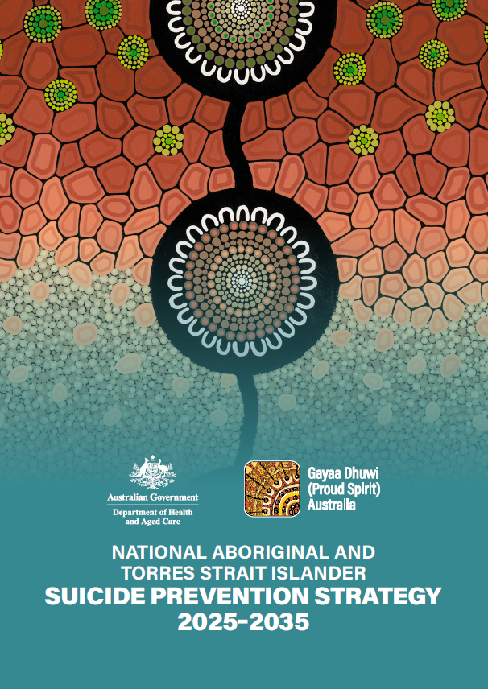

NATIONAL ABORIGINAL AND TORRES STRAIT ISLANDER SUICIDE PREVENTION STRATEGY 2025–2035

© Gayaa Dhuwi (Proud Spirit) Australia

Ground floor, 103 Northbourne Ave, Turner ACT 2612

PO Box 5379, Braddon ACT 2612

02 5134 2100

[info@gayaadhuwi.org.au](mailto:info@gayaadhuwi.org.au)

The contents of this Strategy may not, unless explicity stated otherwise, be reprinted, reproduced, or published in any form whatsoever without the permission of Gayaa Dhuwi (Proud Spirit) Australia.

To request rights to reproduce content from this document, which are copyright to Gayaa Dhuwi (Proud Spirit) Australia, email us [communications@gayaadhuwi.org.au](mailto:communications@gayaadhuwi.org.au)

ISBN 978-1-7638168-1-7

**Gayaa Dhuwi (Proud Spirit) Australia acknowledges Aboriginal and Torres Strait Islander peoples as the Traditional Custodians of the lands on which we live, work, and play. We pay respect to Elders past and present.**

**We also acknowledge the individual and collective contributions of those with lived or living experience of suicide and mental-ill health. Without the courage to share their stories we wouldn’t be able to write policy, develop frameworks, or deliver services as we all strive towards zero suicide.**

# Artist acknowledgement

Artwork created by Leah Brideson (Kamilaroi).

Leah is an Aboriginal woman born in Canberra, ACT. Leah’s mob are Kamilaroi from her Grandmother’s country in the Gunnedah region.

Leah’s art practice began in her early childhood. As a self-taught artist, Leah paved her own way in rediscovering and sharing her identity after constantly being told she was ‘too white to be Aboriginal.’ She created a visual way to say the words that were going unheard.

Leah refers to her arts practice as ‘visual yarns’; illustrated stories and conversations, connecting people with cultural practices and landscapes, gently hinting nuances of activism and a vehicle for voicing culture, Country, and connection.

# Artwork story

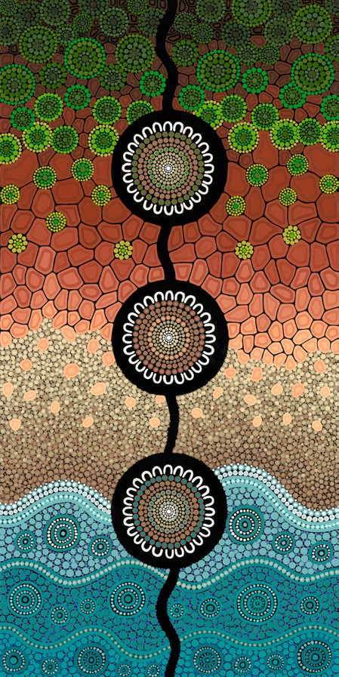This artwork, inspired from the Ocean Edge series, tells the story of our connection to the past, present, and the future.

There are three meeting places, all connected by journey lines, that acknowledge the Traditional Custodians and our ancestors that have paved the way and continue to guide us through this side of the Dreaming.

The ocean edge represents the flow and relationship between land and ocean from an aerial perspective. This also symbolises the continual connection to the past, present and future.

Looking out to the ocean reminds me to take a breath, take a step back, ground my feet in the Earth, focus on family and what is important right now, and find a better flow to the busyness of life, whilst looking back to the land, where my ancestors walked, gives perspective on the vastness of our Dreaming connection to Country.

Contents

Contents

Artist acknowledgement 3

Artwork story 3

Recognition statement 6

Foreword from the Minister for Health and Aged Care 8

Foreword from the Chair of Gayaa Dhuwi (Proud Spirit) Australia 9

Strategy snapshot 10

Purpose statement 11

Core principles 11

Enabling factors 14

Sustained, flexible, and targeted funding 14

Effective implementation 14

Governance, monitoring, and evaluation 14

Priorities and initiatives 15

Priority 1: Leadership and self-determination 16

Priority 2: Thriving communities 17

Priority 3: Informed and supportive communities 18

Priority 4: Culturally safe, accessible, targeted, and coordinated care 19

Priority 5: Responsive workforce 21

Priority 6: Evidence and data 22

Appendices 23

Appendix A: Glossary 23

Appendix B: Guiding principles 24

Appendix C: Governance 25

# Recognition statement



Gayaa Dhuwi (Proud Spirit) Australia acknowledges Aboriginal and Torres Strait Islander peoples as the Traditional Custodians of the lands and waters on which we live, work, and learn. We recognise and respect the strength and resilience of Aboriginal and Torres Strait Islander peoples, communities, and cultures.

Gayaa Dhuwi (Proud Spirit) Australia (Gayaa Dhuwi) also extends its thanks to the Aboriginal and Torres Strait Islander peoples who contributed to the development of the National Aboriginal and Torres Strait Islander Suicide Prevention Strategy (the Strategy). Gayaa Dhuwi also recognises the continued leadership, advocacy, and service delivery of Aboriginal and Torres Strait Islander peoples in preventing suicide and self-harm amongst our peoples.

Aboriginal and Torres Strait Islander peoples, communities, and cultures have continued to thrive for more than 65,000 years. This is despite the profound interpersonal and systemic effects of colonisation, discrimination, and intergenerational trauma on individual and collective health and wellbeing.

An extensive evidence base demonstrates that suicide and self-harm disproportionately impacts Aboriginal and Torres Strait Islander peoples compared to non-Indigenous people in Australia. In 2021, suicide accounted for 5.3% of all deaths amongst Aboriginal and Torres Strait Islander peoples, while the comparable proportion for non-Indigenous Australians was 1.8%. Young Aboriginal and Torres Strait Islander peoples are significantly affected, and experience rates of suicide more than double that of young non-Indigenous Australians.

In May 2013, the first National Aboriginal and Torres Strait Islander Suicide Prevention Strategy (2013 NATSISPS) was launched. In 2016, the Aboriginal and Torres Strait Islander Suicide Prevention Evaluation Project (ATSISPEP) was undertaken with the aim of providing greater clarity on the work required to achieve a meaningful and sustained reduction in the rates of suicide and self-harm amongst Aboriginal and Torres Strait Islander people.

A group of circular designs. This artwork, inspired from the Ocean Edge series, tells the story of our connection to the past, present, and the future.
There are three meeting places, all connected by journey lines, that acknowledge the Traditional Custodians and our ancestors that have paved the way and continue to guide us through this side of the Dreaming.The ATSISPEP remains the primary evidence base for what works in Aboriginal and Torres Strait Islander-led suicide and self-harm prevention. The central tenants of the ATSISPEP are the success factors relating to Aboriginal and Torres Strait Islander-led suicide and self-harm prevention. These

success factors are organised into three levels of intervention — population-level interventions, targeted interventions for groups at a higher risk of suicide and self-harm, and specific interventions for individuals at higher risk of suicide and self-harm, or who have attempted suicide. It is interventions across these levels, together with Aboriginal and Torres Strait Islander leadership and working in partnership with Aboriginal and Torres Strait Islander communities, that represent the key focus areas necessary to enhance the wellbeing of Aboriginal and Torres Strait Islander peoples and communities and, in turn, meaningfully reduce suicide and self-harm amongst Aboriginal and Torres Strait Islander peoples.

Many important developments have occurred since the creation of the 2013 NATSISPS and ATSISPEP. These have included the creation of the National Agreement on Closing the Gap (2020), which seeks to deliver a new era of partnership and decision-making between all Australian Governments and Aboriginal and Torres Strait Islander peoples, including a commitment to ensuring a “significant and sustained reduction in suicide of Aboriginal and Torres Strait Islander peoples towards zero”. The National Aboriginal and Torres Strait Islander Health Plan 2021–2031 similarly prioritises the importance of culturally safe and responsive mental health and suicide prevention services for Aboriginal and Torres Strait Islander peoples.

Drawing on the past work and led by the seminal work of ATSISPEP and the Thematic Analysis Report for the Submissions to the draft strategy, the National Aboriginal and Torres Strait Islander Suicide Prevention Strategy 2025–2035 (the Strategy) sets a path for all governments to work in genuine partnership with Aboriginal and Torres Strait Islander peoples, organisations and communities to reduce the rates of suicide and self-harm amongst Aboriginal and Torres Strait Islander peoples by driving culturally safe and responsive solutions.

# Foreword from the Minister for Health and Aged Care

Suicide and mental ill-health continue to impact Aboriginal and Torres Strait Islander individuals, families, communities, and kin disproportionately, with a suicide rate that is more than double that observed among non-Indigenous Australians.



Working in partnership with Aboriginal and Torres Strait Islander stakeholders and acknowledging their depth of experience and leadership strengthens our efforts to improve social and emotional wellbeing outcomes for Aboriginal and Torres Strait Islander peoples. Their voices are essential to ensure our approach moving forward includes the right actions and reforms that truly reflect the needs of Aboriginal and Torres Strait Islander peoples. This is critical if we are to close the gap.

The Australian Government is committed to ensuring Aboriginal and Torres Strait Islander peoples enjoy the highest possible standard of social and emotional wellbeing, mental health, and suicide prevention outcomes. We need coordinated action across all parts of the system of care so that all Aboriginal and Torres Strait Islander peoples can access evidence-based culturally-safe care and support.

The Australian Government is committed to reforming the mental health system and improving outcomes for Aboriginal and Torres Strait Islander peoples. The National Aboriginal and Torres Strait Islander Suicide Prevention Strategy 2025–2035 will provide an important framework to guide this reform.

The Strategy is the product of extensive consultation and nationwide Aboriginal and Torres Strait Islander expertise and lived experience. In line with the National Agreement on Closing the Gap (2020), the Strategy will assist us work towards the shared goal of ensuring that Aboriginal and Torres Strait Islander peoples experiencing or at risk of suicide can access a high-quality, connected system of care, wherever they live and whatever their circumstances.

I thank Gayaa Dhuwi (Proud Spirit) Australia for their leadership in delivering this Strategy and acknowledge those people with lived and living experience who have contributed to its development. It is your willingness to share personal and community experiences that will drive improvements in outcomes for Aboriginal and Torres Strait Islander peoples. I invite you to read and engage with the Strategy, and to support its activation and implementation.

The Hon Mark Butler MP

Minister for Health and Aged Care

# Foreword from the Chair of Gayaa Dhuwi (Proud Spirit) Australia

Our people deserve to enjoy high levels of social and emotional wellbeing. To achieve this, we need Aboriginal and Torres Strait Islander leadership across all parts of the Australian mental health system, and recognition of Aboriginal and Torres Strait Islander concepts of social and emotional wellbeing, mental health, and healing.



The National Aboriginal and Torres Strait Islander Suicide Prevention Strategy 2025–2035 (the Strategy) represents another crucial step forward in our drive towards a sustained reduction in suicide and self-harm in our communities. This evidence-based roadmap, crafted in partnership between Aboriginal and Torres Strait Islander peoples, government agencies, and key stakeholders, offers a comprehensive framework for achieving lasting and meaningful change.

This renewed NATSISPS preserves the best of the original strategy, developed in 2013, but now accounts for several changes within the Australian mental health system. It draws on key elements of the Gayaa Dhuwi (Proud Spirit) Declaration, endeavouring to incorporate Aboriginal and Torres Strait Islander cultural concepts with clinical approaches to achieve the highest attainable standard of mental health and suicide prevention outcomes for our people.

The development of this Strategy wouldn’t have been possible without the contributions of countless individuals and organisations. I extend my gratitude to the Aboriginal and Torres Strait Islander community leaders, Elders, survivors, researchers, and advocates who have generously shared their knowledge, experiences, and expertise. I also acknowledge the invaluable support of government agencies and non-government organisations, who have partnered with us in this endeavour.

Ultimately, the Strategy represents a vital investment in hope. We are confident that through collaborative efforts, culturally safe interventions, and a genuine commitment to addressing the underlying causes of disadvantage, we can move towards a significant and sustained reduction of suicide and self-harm in our communities.

Professor Helen Milroy AM

Chair, Gayaa Dhuwi (Proud Spirit) Australia

# Strategy snapshot

| Purpose statement | | | | | |
| --- | --- | --- | --- | --- | --- |
| To achieve a significant and sustained reduction in suicide and self-harm of Aboriginal and Torres Strait Islander people towards zero through Aboriginal and Torres Strait Islander community leadership and governance. | | | | | |
| Core principles | | | | | |
| Aboriginal and Torres Strait Islander-led | Underpinned by Culture | Lived experience informed | | Holistic and integrated systems and services | Place-based responses |
| Enabling factors | | | | | |
| Sustained and targeted funding | | | | | |
| Rigorous implementation | | | | | |
| Governance, monitoring, and evaluation | | | | | |
| Priorities | | | | | |
| Priority 1: Leadership and self- determination  Outcome: Aboriginal and Torres Strait Islander peoples and communities are empowered to lead responses to suicide and self-harm in Community. | Priority 2: Thriving communities  Outcome: Aboriginal and Torres Strait Islander communities are supported to thrive through culture and deep connection to family, community, and Country. | Priority 3: Informed and supportive communities  Outcome: Aboriginal and Torres Strait Islander communities are empowered with the knowledge, resources, and skills to identify and support groups and individuals experiencing or most at risk of suicide-related distress and self-harm. | Priority 4: Culturally safe, accessible, targeted, and coordinated care  Outcome: Aboriginal and Torres Strait Islander peoples are able to access culturally safe, and coordinated care, where and when needed. | Priority 5: Responsive workforce  Outcome: The suicide and self-harm prevention workforce is sustainable and culturally and clinically capable of responding effectively to the needs of Aboriginal and Torres Strait Islander peoples at risk of suicide and self-harm. | Priority 6: Evidence and data  Outcome: All activities aimed at preventing suicide and self- harm amongst Aboriginal and Torres Strait Islander communities are culturally informed and evidence-based, including in its research, design, implementation, and evaluation. |

# Purpose statement

To achieve a significant and sustained reduction in suicide and self-harm of Aboriginal and Torres Strait Islander people towards zero through Aboriginal and Torres Strait Islander community leadership and governance.

# Core principles

This Strategy identifies five core principles, which build on those identified in the ATSISPEP and the National Strategic Framework for Aboriginal and Torres Strait Islander Peoples’ Mental Health and Social and Emotional Wellbeing (see Appendix B). The core principles establish the foundations for the Strategy and its priorities and will be critical to the implementation of the Strategy.

| Principle | Description |
| --- | --- |
| Aboriginal and Torres Strait Islander-led | Self-determination forms the foundations of Aboriginal and Torres Strait Islander governance, guided by Aboriginal and Torres Strait Islander-led and Aboriginal and Torres Strait Islander-controlled systems.  Self-determination includes the active involvement, direction setting, and decision-making authority of local Aboriginal and Torres Strait Islander peoples to shape, manage, and govern social and emotional wellbeing, mental health, and suicide prevention systems, services, and programs that directly impact their communities[1].  Self-determination recognises the unique cultural and historical experiences of Aboriginal and Torres Strait Islander peoples and acknowledges the importance of community control and cultural safety in achieving improved suicide and self-harm prevention outcomes. |
| Underpinned by culture | Aboriginal and Torres Strait Islander culture is foundational to the identity, spirituality, and resilience of Aboriginal and Torres Strait Islander communities.  Culture is crucial to developing and implementing effective Aboriginal and Torres Strait Islander suicide and self-harm prevention responses.[2] Cultural ways of knowing, being, and doing, and relationships between self, Country, community, and spirituality, are all cultural determinants of Aboriginal and Torres Strait Islander health.[3] It is these factors that must be promoted to reduce the rates of suicide and self-harm amongst Aboriginal and Torres Strait Islander peoples. |
| Lived experience informed | The experience and contribution of Aboriginal and Torres Strait Islander peoples with a lived or living experience of suicide and self-harm is critical.  This lived experience must inform, in a meaningful way, all activities that emerge from the Strategy, and will be used throughout its implementation. The Aboriginal and Torres Strait Islander Lived Experience Centre defines lived or living experience of suicide as follows:  ‘People with lived or living experience of suicide are those who have experienced suicidal thoughts, survived a suicide attempt, cared for someone through a suicidal crisis, been bereaved by suicide, or having a loved one who has died by suicide, acknowledging that this experience is significantly different and accounts for Aboriginal and Torres Strait Islander peoples’ ways of understanding social and emotional wellbeing.’[4] |
| Holistic and integrated systems and services | For Aboriginal and Torres Strait Islander peoples, health is a holistic, integrated, and culturally informed concept. It connects the physical health and wellbeing of an individual with the health of their family, kin, community, and connection to Country, culture, spirituality, and ancestry.  It involves the whole community, throughout the life course of an individual, and requires an understanding and consideration of the whole person in the context of their family and community. Approaches to suicide and self-harm prevention must encompass a holistic and integrated understanding of health and must follow a systems-based approach to suicide prevention. They must be community-specific, community-led, and trauma-informed, improving the social determinants of health that can contribute to suicidal behaviours and self-harm.  In practice, this means that systems and services that respond to Aboriginal and Torres Strait Islander suicide and self-harm need to be responsive to the needs of individuals, family, and community. This includes being accessible and easy to navigate, placing the individual at the centre of responses to suicide and self-harm. This also includes prioritising integration and collaboration of all aspects of the system to meet the needs of Aboriginal and Torres Strait Islander peoples accessing suicide and self-harm support. |
| Place-based responses | Approaches to prevent suicide and self-harm must prioritise self-determination. They must be place-based, community-specific, and community led.  Responses to Aboriginal and Torres Strait Islander suicide and self-harm must be tailored to reflect the specific needs of individual and diverse communities. Differences in cultural practices, beliefs, geographic factors, and available and accessible services between communities highlight the need to empower communities and cultural leaders to lead integrated and collaborative responses in their community. This includes in design, implementation, and evaluation of responses to self-harm and suicide in community to meet their specific needs.  Aboriginal and Torres Strait Islander Community-Controlled Health Organisations (ACCHOs) play a central and critical role in community-led, owned, and governed suicide and self-harm prevention activity. This involves ACCHOs and (where appropriate) other Aboriginal and Torres Strait Islander Community-Controlled Organisations (ACCOs) leading place-based planning, design, implementation, and evaluation of suicide prevention activity. |

# Enabling factors

For the Strategy to deliver meaningful and sustainable outcomes, three enabling factors are required to create the appropriate environment for the priorities and initiatives to be implemented and sustained.

## Sustained, flexible, and targeted funding

Sustained, flexible, and targeted funding from all levels of government is critical to implement this Strategy. Such funding must support locally driven responses to Aboriginal and Torres Strait Islander

suicide and self-harm and must be flexible to support effective service delivery and service accessibility. Such funding must also enable systems-based responses.

To achieve this, funding models, arrangements, and evaluation mechanisms need to be established to ensure funding is invested optimally in effective community-driven suicide and self-harm prevention activities. This includes supporting flexible, improved, increased and, where appropriate, joint jurisdictional funding for existing and emerging suicide and self-harm prevention responses and supporting ongoing Aboriginal and Torres Strait Islander leadership, governance, workforce development, research, and evaluation of suicide and self-harm prevention activities.

## Effective implementation

A National Implementation Advisory Group (Advisory Group) will be established by Gayaa Dhuwi to facilitate and oversee the Strategy’s implementation, monitoring, and evaluation. The Advisory Group will support a whole-of-system response, collaboration, and coordination, supported by genuine partnerships and shared accountability.

An Implementation Plan for the Strategy must be developed in consultation with Aboriginal and Torres Strait Islander leaders and community members, Aboriginal community-controlled organisations, governments, and other stakeholders. The Implementation Plan must outline actions and initiatives to be undertaken to achieve the Strategy’s priorities and initiatives, including building and strengthening structures and capacity that empower Aboriginal and Torres Strait Islander peoples.

The Implementation Plan must identify the key implementation partners required to deliver the Strategy, including (but not limited to) governments of all levels, the Aboriginal and Torres Strait Islander community-controlled sector, Aboriginal and Torres Strait Islander peak bodies, non-Indigenous service providers, and other partners.

## Governance, monitoring, and evaluation

The Advisory Group will monitor and evaluate the delivery of the Strategy and collaborate and coordinate with the Social and Emotional Wellbeing Policy Partnership where required. It will ensure that Aboriginal and Torres Strait Islander peoples’ perspectives are prioritised through this process.

# Priorities and initiatives



**The Strategy is designed to achieve a significant and sustained reduction in suicide and self-harm of Aboriginal and Torres Strait Islander peoples towards zero through Aboriginal and Torres Strait Islander community leadership and governance.**

The Strategy contains six priorities that build on the evidence base contained in the ATSISPEP. The priorities and initiatives are designed to empower, support, and enable community-led responses to suicide and self-harm for Aboriginal and Torres Strait Islander peoples.

The priorities and initiatives are intended to deliver improved suicide and self-harm prevention outcomes for Aboriginal and Torres Strait Islander peoples, and are therefore applicable to ACCHOs, ACCOs, and non-Indigenous service providers.

Priority 1: Leadership and self-determination



Empowering Aboriginal and Torres Strait Islander peoples and communities to lead responses to suicide and self-harm.

The ATSISPEP identified that suicide and self-harm prevention activities that are self-determined and are Aboriginal and Torres Strait Islander-led are most effective in delivering positive and sustained outcomes. For this reason, Aboriginal and Torres Strait Islander leadership and self-determination, including the involvement of a diverse range of Elders and cultural healers, must be central to prevent suicide and self-harm amongst Aboriginal and Torres Strait Islander peoples.

The importance of self-determination as a critical success factor to achieving positive life outcomes is further reinforced by the National Agreement on Closing the Gap, in particular Priority Reform 1 (formal partnerships and shared decision-making).

### Outcome:

Aboriginal and Torres Strait Islander peoples and communities are empowered to lead responses to suicide and self-harm in community.

### Initiatives:

1. Establish and build on Aboriginal and Torres Strait Islander control, leadership, governance, and coordination of suicide and self-harm prevention activities.
2. Promote youth leadership and oversight of Aboriginal and Torres Strait Islander youth empowerment and suicide and self-harm prevention activities.
3. Increase and strengthen partnerships and shared decision-making arrangements and structures between ACCHOs, governments, Aboriginal and Torres Strait Islander communities, and people.
4. Continue to develop and refine approaches that support all suicide and self-harm prevention

approaches and services to be delivered in partnership with Aboriginal and Torres Strait Islander organisations, communities, and people in genuine and meaningful ways.

1. Support and promote the involvement of a diverse range of Elders and cultural healers in Aboriginal and Torres Strait Islander suicide and self-harm prevention activity design and implementation to ensure that all activity meets cultural governance and is delivered within a cultural framework.

Priority 2: Thriving communities



Supporting Aboriginal and Torres Strait Islander communities to thrive through culture, and deep connection to family, community, and Country.

Thriving Aboriginal and Torres Strait Islander communities require self-determination, culture, and

Aboriginal and Torres Strait Islander leadership to close the gap in Aboriginal and Torres Strait Islander suicide and self-harm. This requires investment in and prioritisation of activities that promote healing and strengthen social and emotional wellbeing, culture, and identity, while also addressing the social determinants of health, racism and discrimination, community challenges, poverty, and alcohol and other drug use.

Priority Reform 3 (transforming government organisations) of the National Agreement on Closing the Gap represents the primary commitment of the Commonwealth Government to address the social determinants that impact the lives of Aboriginal and Torres Strait Islander peoples. This includes strengthening the cultural safety and responsiveness of government departments, including government funded services. Giving effect to this commitment aims to address the cultural and social determinants of health to improve social and emotional wellbeing for Aboriginal and Torres Strait Islander peoples and reduce the risk of suicide and self-harm.

### Outcome:

Aboriginal and Torres Strait Islander communities are supported to thrive through culture and deep connection to family, community, and Country.

### Initiatives:

1. Strengthen collaboration with Aboriginal and Torres Strait Islander communities to address the historical, social, and cultural determinants of health that can improve social and emotional wellbeing for Aboriginal and Torres Strait Islander peoples and reduce the risk of suicide and self-harm.
2. Enhance efforts at local, regional, and national levels to promote healing and reconciliation between Aboriginal and Torres Strait Islander peoples and non-Indigenous Australians.
3. Empower local Aboriginal and Torres Strait Islander communities to mitigate risk factors and build protective factors of suicide and self-harm by promoting healing and strengthening the protective factors associated with social and emotional wellbeing.

Priority 3: Informed and supportive communities



Empowering Aboriginal and Torres Strait Islander communities with the knowledge, resources, and skills necessary to identify and support individuals experiencing or at risk of suicide-related distress and self-harm.

Aboriginal and Torres Strait Islander communities must be equipped with the knowledge, resources, and skills required to identify and support individuals experiencing or at risk of suicide-related distress and self-harm, and to respond effectively. This includes being able to identify groups who are at higher risk of suicide and self-harm and building the capacity of community members to support individuals and groups at higher risk. This will ensure that communities are better placed to prioritise and tailor selective suicide and self-harm prevention responses to individuals and groups most in need.

### Outcome:

Aboriginal and Torres Strait Islander communities are empowered with the knowledge, resources and skills to identify and support groups, and individuals experiencing or most at risk of suicide-related distress and self-harm.

### Initiatives:

1. Promote, build on, and, where necessary, develop Aboriginal and Torres Strait Islander-led regional planning to understand the extent of suicide-related distress and self-harm in communities. This should involve the identification of groups and individuals who are experiencing, or most at risk of, suicide-related distress and self-harm, and understanding how these groups and individuals can be best supported.
2. Enable and equip Aboriginal and Torres Strait Islander communities to identify and respond to individuals and groups who are at higher risk of suicide-related distress and self-harm.

Support the development and promotion of Aboriginal and Torres Strait Islander-led and community-based activities that are designed to reduce suicide-related distress and self-harm amongst individuals and groups most at risk of suicide-related distress and self-harm, including children, young people, Elders, and LGBTQIA+SB peoples.

Priority 4: Culturally safe, accessible, targeted, and coordinated care



Ensuring that culturally safe and coordinated care is readily accessible to Aboriginal and Torres Strait Islander peoples experiencing or at risk of suicide-related distress and self-harm.

Making sure that the right care is available at the right place and right time is crucial to supporting Aboriginal and Torres Strait Islander peoples who experience or are at risk of suicide-related distress and self-harm.

For Aboriginal and Torres Strait Islander peoples experiencing or at risk of suicide-related distress and self-harm, they need to be able to access therapeutic treatment — whether from an ACCHO, ACCO, or non-Indigenous health services — as soon as possible and in a way that is culturally safe, accessible, targeted, and coordinated.

### Outcome:

Aboriginal and Torres Strait Islander peoples are able to access culturally safe, and coordinated care, where and when needed.

### Initiatives:

1. Support and enable ACCHOs and ACCOs to deliver social and emotional wellbeing, healing, and community-based suicide prevention services in ways that are flexible and aligned with the needs of the local community. These services should be designed to enhance an individual’s protective factors, preventing the escalation of acute suicide-related distress and self-harm.
2. Improve access to social and emotional wellbeing, healing, and suicide and self-harm prevention services for Aboriginal and Torres Strait Islander peoples.
3. Ensure that supporters, family, carers, and kin are embedded in the delivery of social and emotional wellbeing, healing, and suicide prevention services for Aboriginal and Torres Strait Islander peoples.
4. Implement responsive and culturally safe clinical and non-clinical services for Aboriginal and Torres Strait Islander peoples experiencing acute suicide-related distress and self-harm, including children, young people, and Elders, and LGBTQIA+SB peoples. These services must ensure continuity of care, and operate across the continuum, from prevention, to aftercare, to postvention.
5. Promote and enhance the coordination of care for individuals receiving social and emotional wellbeing, healing, and suicide prevention services, including with other health, non-health, and social supports.

Priority 5: Responsive workforce



Enhance and enable the suicide prevention workforce to deliver effective suicide and self-harm prevention services and activities in, and in partnership with, Aboriginal and Torres Strait Islander communities.

Supporting the safety, wellbeing, development, and retention of Aboriginal and Torres Strait Islander peoples — including those with a lived and living experience of suicide and self-harm — to become and remain key members of the suicide and self-harm prevention workforce is critical to ensure that services and initiatives are culturally safe and accessible. It is also important that the broader suicide and self-harm prevention workforce, including the workforce operating in the non-Indigenous suicide and self-harm prevention service system, is equipped and held accountable to deliver culturally safe responses to Aboriginal and Torres Strait Islander suicide and self-harm.

### Outcome:

The suicide and self-harm prevention workforce is sustainable and culturally and clinically capable of responding effectively to the needs of Aboriginal and Torres Strait Islander peoples at risk of suicide and self-harm.

### Initiatives:

1. Promote Aboriginal and Torres Strait Islander representation, retention, and leadership across all disciplines, roles, and functions of the Aboriginal community-controlled and non-Indigenous mental health and suicide and self-harm prevention system.
2. Prioritise the development of a sustainable Aboriginal and Torres Strait Islander workforce, including individuals with a lived and living experience of suicide and self-harm, to deliver services within the Aboriginal Community-Controlled and non-Indigenous sectors.
3. Support the wellbeing of Aboriginal and Torres Strait Islander peoples working in the Aboriginal community-controlled and non-Indigenous suicide and self-harm prevention sectors.
4. Ensure that Aboriginal and Torres Strait Islander people working in the Aboriginal Community-Controlled and non-Indigenous suicide and self-harm prevention sectors are supported, including with the training, qualifications, skills, and development opportunities required.
5. Ensure that all staff working in and preparing to work in Aboriginal Community-Controlled and non-Indigenous suicide and self-harm prevention services are trained, supported, qualified, and capable of delivering culturally safe and trauma-informed care.

Priority 6: Evidence and data



Develop and use culturally informed evidence to inform the design and application of future responses to prevent Aboriginal and Torres Strait Islander suicide and self-harm.

Making data and resources more accessible to Aboriginal and Torres Strait Islander peoples and communities at a regional level supports communities to ensure that suicide and self-harm prevention responses are evidence-based. It also supports monitoring and evaluation of interventions, to ensure they are working to respond to suicide and self-harm in community.

This priority is aligned to Priority Reform 4 (shared access to data and information at a regional level) in the National Agreement on Closing the Gap.

### Outcome:

All activities aimed at preventing suicide and self-harm amongst Aboriginal and Torres Strait Islander communities are culturally informed and evidence-based, including in their research, design, implementation, and evaluation.

### Initiatives:

1. Develop and establish Aboriginal and Torres Strait Islander governance and accountability frameworks to ensure effective Aboriginal and Torres Strait Islander data ownership and sovereignty in the evaluation and publication of resources related to suicide and self-harm prevention activities.
2. Develop a suicide and self-harm prevention research, evaluation, and accountability framework that enables Aboriginal and Torres Strait Islander governance over evaluations of suicide and self-harm prevention activities.
3. Establish cross-system and cross-jurisdictional partnerships and data-sharing processes to support workforce planning, policy development, monitoring and evaluation, and continuous quality improvement at the national, jurisdictional, regional, and community levels.

# Appendices

## Appendix A: Glossary

| TERM | MEANING |
| --- | --- |
| ACCHO | Aboriginal and Torres Strait Islander Community Controlled Health Organisation |
| ACCO | Aboriginal and Torres Strait Islander Community Controlled Organisation |
| Advisory Group | National Implementation Advisory Group |
| LGBQTI+SB | Lesbian, Gay, Bisexual, Queer, Transgender, Intersex, Asexual, Sistergirl and Brotherboy |
| National Agreement | National Agreement on Closing the Gap (2020) |
| The Strategy | National Aboriginal and Torres Strait Islander Suicide Prevention Strategy 2025–2035 |
| SEWB | Social and emotional wellbeing |
| Social determinants of health | The conditions in which people are born, grow, work, live, and age, and the wider set of forces and systems shaping the conditions of daily life (World Health Organisation) |

## Appendix B: Guiding principles

From the [National Strategic Framework for Aboriginal and Torres Strait Islander Peoples’ Mental Health and Social and Emotional Wellbeing 2017–2023](https://www.niaa.gov.au/resource-centre/national-strategic-framework-aboriginal-and-torres-strait-islander-peoples-mental)

|  |  |
| --- | --- |
| A black number in a circle | Aboriginal and Torres Strait Islander health is viewed in a holistic context, that encompasses mental health and physical, cultural, and spiritual health. Land and sea are central to wellbeing. Crucially, it must be understood that when the harmony of these interrelations is disrupted, Aboriginal and Torres Strait Islander ill-health will persist. |
| A black number in a circle | Self-determination is central to the provision of Aboriginal and Torres Strait Islander health services. |
| A black number in a circle | Culturally valid understandings must shape the provision of services and must guide assessment, care and management of Aboriginal and Torres Strait Islander peoples’ health problems generally, and mental health problems, in particular. |
| A black number in a circle | It must be recognised that the experiences of trauma and loss, present since European invasion, are a direct outcome of the disruption to cultural wellbeing. Trauma and loss of this magnitude continues to have intergenerational effects. |
| A black number in a circle | The human rights of Aboriginal and Torres Strait Islander peoples must be recognised and respected. Failure to respect these human rights constitutes continuous disruption to mental health (versus mental ill-health). Human rights relevant to mental illness must be specifically addressed. |
| A black number in a circle | Racism, stigma, environmental adversity, and social disadvantage constitute ongoing stressors and have negative impacts on Aboriginal and Torres Strait Islander peoples’ mental health and wellbeing. |
| A black number in a circle | The centrality of Aboriginal and Torres Strait Islander family and kinship must be recognised as well as the broader concepts of family and the bonds of reciprocal affection, responsibility, and sharing. |
| A black number in a circle | There is no single Aboriginal or Torres Strait Islander culture or group, but numerous groupings, languages, kinships, and tribes, as well as ways of living. Furthermore, Aboriginal and Torres Strait Islander peoples may currently live in urban, rural, or remote settings, in traditional or other lifestyles, and frequently move between these ways of living. |
|  | It must be recognised that Aboriginal and Torres Strait Islander peoples have great strengths, creativity, and endurance and a deep understanding of the relationships between human beings and their environment. |

## Appendix C: Governance

### Steering Committee

| Name | Role / position |
| --- | --- |
| Rob McPhee (Chair) | Deputy Chair, Gayaa Dhuwi |
| Professor Helen Milroy AM | Chair, Gayaa Dhuwi |
| Professor Pat Dudgeon AM | Board Director, Gayaa Dhuwi |
| Rachel Fishlock | Chief Executive Officer, Gayaa Dhuwi |
| Sarah Hawke | Representative from the Department of Health and Aged Care |
| Monica Barolits-McCabe and Anna-Louise Kimpton | Representatives from the National Aboriginal Community Controlled Health Organisation |

### Governance Committee

| Name | Role / position |
| --- | --- |
| Rob McPhee (Chair) | Deputy Chair, Gayaa Dhuwi |
| Professor Helen Milroy AM | Chair, Gayaa Dhuwi |
| Professor Pat Dudgeon AM | Board Director, Gayaa Dhuwi |
| Dr Mark Wenitong | Board Director, Gayaa Dhuwi |
| Dr Marshall Watson | Independent Member |
| Dr Gracelyn Smallwood AM | Independent Member |
| Leilani Darwin | Independent Member |
| Wayne Oldfield | Independent Member |
| Rachel Fishlock | Chief Executive Officer, Gayaa Dhuwi |

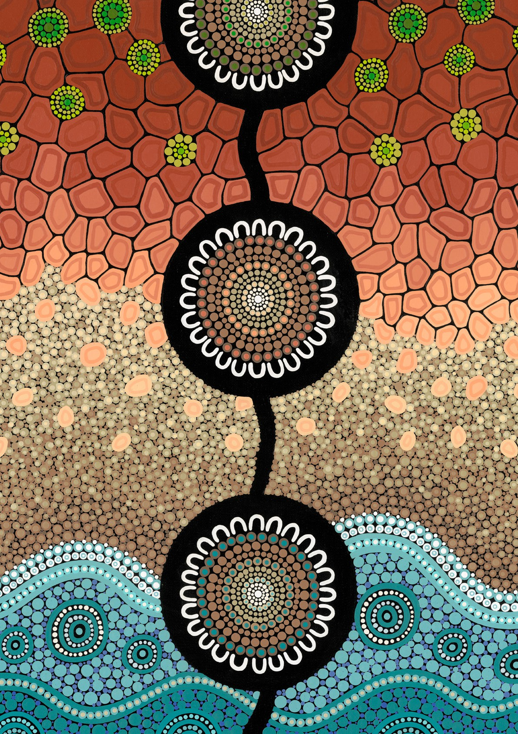

1. Swan P, and Raphael B ‘Ways forward: National Consultancy Report on Aboriginal and Torres Strait Islander Mental Health.’ Canberra: AGPS (1995).; Dudgeon et al (n2)
2. Dudgeon (n2)
3. Lowitja Institute ‘Culture is Key: Towards cultural determinants-driven health policy — Final Report,’ Lowitja Institute, Melbourne (2020)
4. Aboriginal and Torres Strait Islander Lived Experience Centre 2020. Correspondence with Gayaa Dhuwi (Proud Spirit) Australia.