# 

# Service and Support Portal User Guide – The client record

This user guide is for Staff Members or Team Leaders within the My Aged Care Service and Support Portal.

It explains how to search for and view information in the client record.

The client record contains client details, service referral details, assessment information, documents attached to the client record, care approval information, service delivery information, client interactions with My Aged Care and all notes created about the client.

A Team Leader can also perform all the functions of a Staff Member.

This guide contains the following topics:

Finding a client 2

Viewing client information 4

What information is in the client record? 5

Client Summary 6

Client Details 7

Support Network 8

Referrals for my organisation 9

Plans 9

Attachments 10

Approvals 11

Services 12

My Aged Care interactions 13

Notes 13

Viewing and adding client notes 14

Tasks and notifications 15

Residential Care 15

For more information or support 16

## Finding a client

To find a client who has been referred to or accepted to service by your organisation, follow the procedure below.

1. Select **Find a client** from the home page.

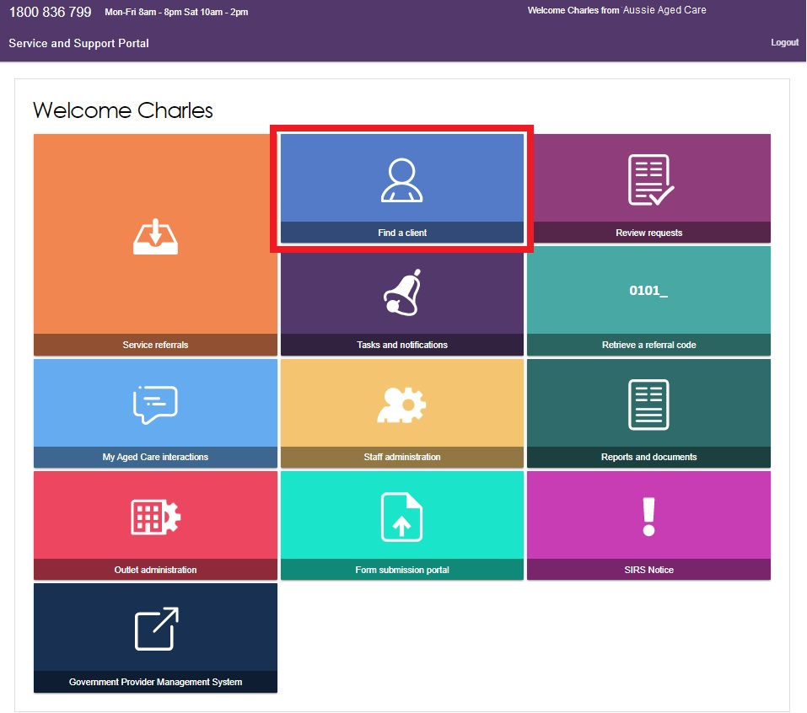

1. You can do a basic search by entering First Name, Last Name or Aged Care User ID and selecting **SEARCH**. To display more search fields, you can select **ADVANCED SEARCH**.

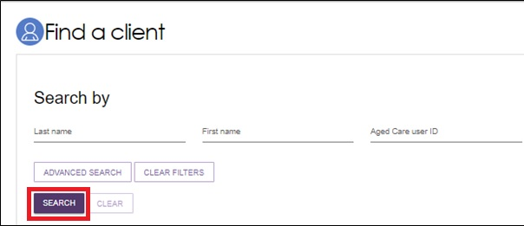

1. Any recently viewed clients will be displayed under the heading **Recently Viewed Persons** on the **Find a client** page. Selecting a client’s name will take you directly to the client record.

Any matching results will be displayed.

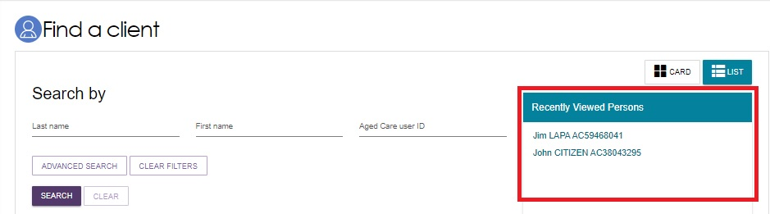

1. The Advanced Search allows you to search using more filters, and to combine filters.

The filters available include:

* Aged Care Management Payment System (ACMPS) number
* Centrelink Customer Reference Number (CRN)
* Client status
* Date of birth
* Department of Veterans’ Affairs (DVA) card number
* Home contact number
* Locality
* Medicare Card number
* Postcode
* Preferred name
* State
* Suburb
* System for the Payment of Aged Residential Care (SPARC) number.

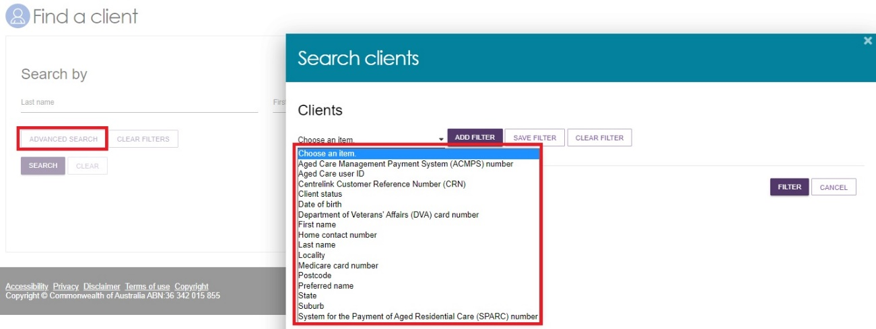

## Viewing client information

Once you have located the relevant client’s details, you can view information contained in the client record.

You can view all information about a client, except their contact details, prior to accepting a referral.

1. Select the client record using one of three ways.
2. Select the client’s name from the list of search results.

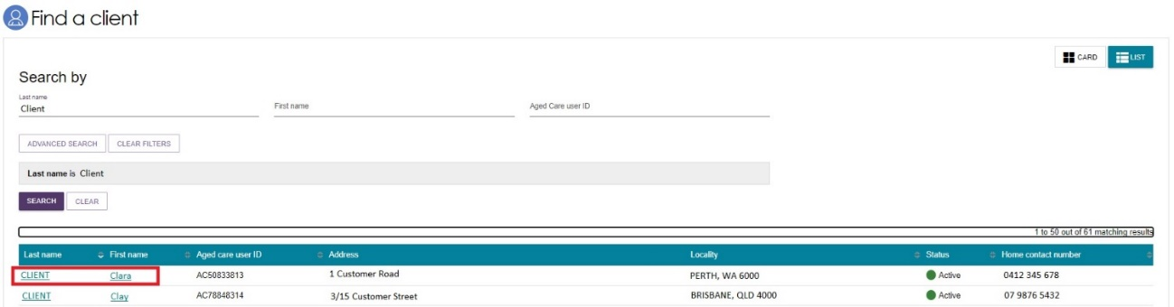

1. In the **Find a client** section by selecting the client’s name when in card view.

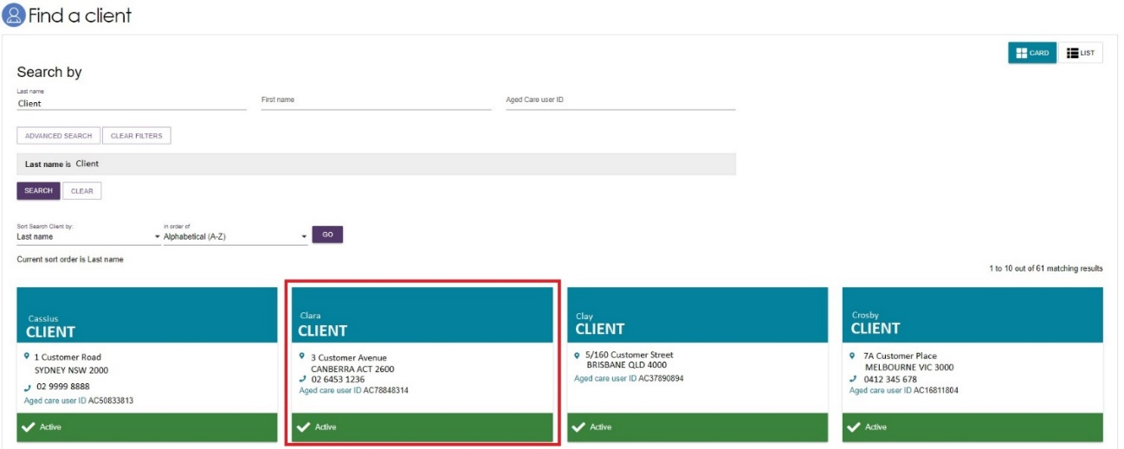

1. By selecting **Service referrals**, selecting the expansion arrow on the client card in card view, or to the left of the expanded record in list view, and selecting **VIEW CLIENT RECORD**.

Card view

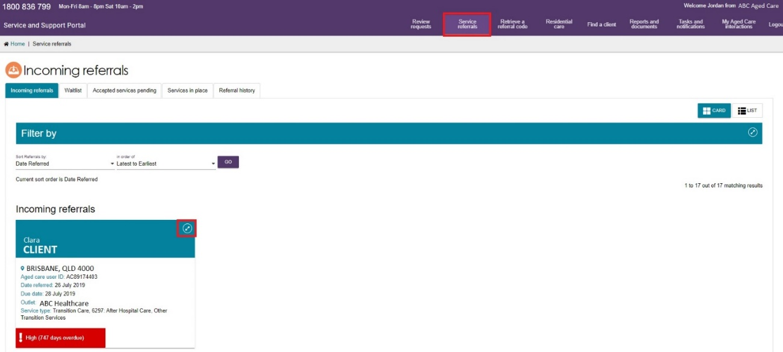

List view

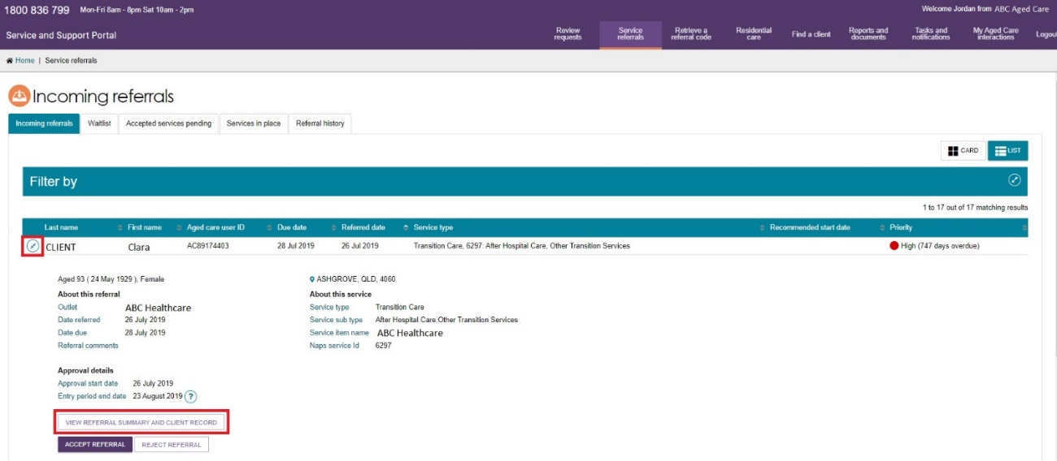

1. The **Referrals for my organisation** page will be displayed.

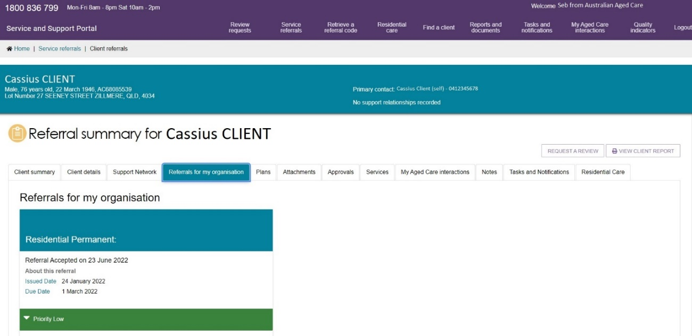

## What information is in the client record?

The client record contains client information displayed across 11 tabs, which are described in more detail below.

The client record contains tabs with the following information:

* Client Summary
* Client Details
* Support network
* Referrals for my Organisation
* Plans
* Attachments
* Approvals
* Services
* My Aged Care interactions
* Notes
* Tasks and Notifications
* Residential Care.

## 

## Client Summary

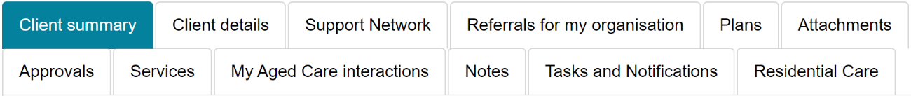

The Client summary tab contains a real-time client journey tracker (Client tracker) and a dashboard of key information (Client summary) about the client’s interactions with My Aged Care.

The Client tracker is a visual display of what stage a client is at in their My Aged Care journey, including the client’s current position and any next steps that need to be taken by the client.

The stages of the tracker are:

1. Registered (client has been registered with My Aged Care).
2. Assessment (client has had an assessment or are having an assessment to determine their care needs).
3. Waiting for services (client has had an assessment and has been recommended for services).
4. Receiving services (a provider has accepted the client’s service referral and commenced services).
5. Support Plan Review (client is undergoing review by an aged care needs assessor (assessor).

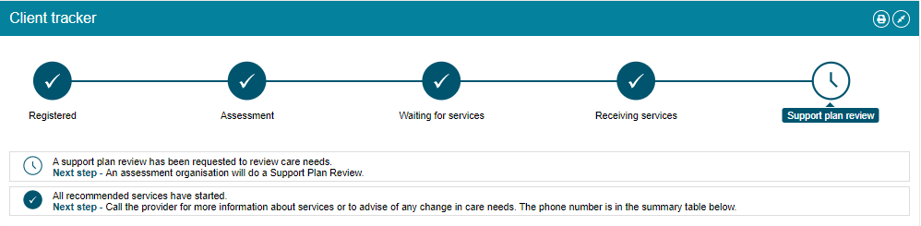

The Client summary provides information about the client’s interactions with My Aged Care, including:

* Assessments.
* Approvals.
* Service recommendations.
* Service delivery status.
* Client goals.
* Reablement and linking support periods (where available).

The Client summary provides information about the client’s interactions with My Aged Care, including: 
• Assessments 
• Approvals 
• Service recommendations 
• Service delivery status 
• Client goals 
• Reablement and linking support periods (where available) 
 


The Client tracker and Client summary information can be printed in a similar format as it is displayed within the portal by using the print page button on the right-hand side of each heading.

The Client Tracker will be collapsed by default and can be expanded using the double arrow icon to the right of the heading.

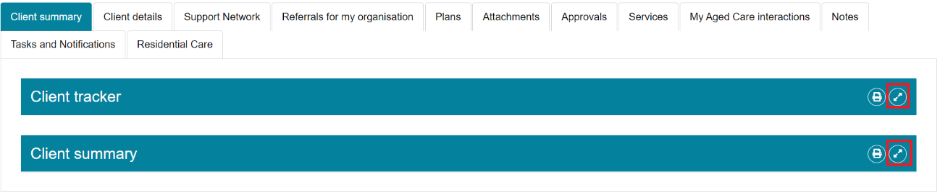

## Client Details

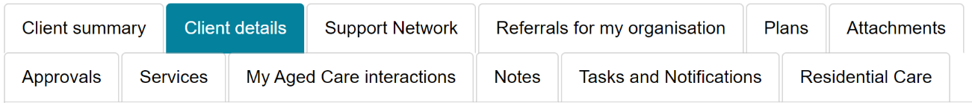

The Client details page contains basic demographic and contact information about the client. It is where you can view high-level details about any active support plans, services, current notes and the client’s primary contact details.

The page also contains an option to notify My Aged Care when the client is deceased.

The ‘Primary contact’ is by default the client, but can also be nominated by the client or their agent or representative. This information allows assessors, My Aged Care contact centre staff and service providers to identify the key contact details for a client. This field does not have a bearing on system generated mail correspondence the client may receive in relation to their care.

To update the Primary Contact, or any other client details, select the pencil icon

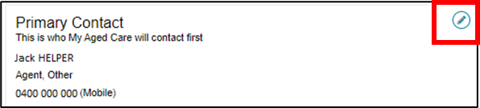

My Aged Care clients and their support network can also receive email and/or SMS notifications when a client reaches the following key stages of their My Aged Care journey.

1. Client registration is complete.
2. The client’s assessment is finalised.
3. The client is approved for care after a comprehensive assessment.
4. A client is assigned a Home Care Package, and at all stages where a HCP letter would be generated for a client, such as an assignment letter or withdrawal letter. Clients, their representatives, and relevant support people are automatically opted in to receive copies of Home Care Package letters. Regular representatives can opt out of receiving these letters by calling My Aged Care. When a Home Care Package letter is generated, a notification will be sent to the affected client, representative and/or agent.
5. A Support Plan Review request has been submitted.
6. A support relationship is activated, declined, inactivated or expiring, and the submission or action of documents relating to support relationships.

! If a client’s status is **Deceased**, the client’s record will be read-only, and you will not be able to edit any client information. Additional notes and attachments can be attached to the client record and assessments can be finalised after the status is changed.

A banner will be displayed on all tabs of the client record indicating the client’s new deceased status If the client’s status is incorrect, please contact the Service Provider and Assessor Helpline on 1800 836 799.

Error message "The department has been notified that this client is deceased. Please contact us on 1800 836 799 is this is incorrect"

## Support Network

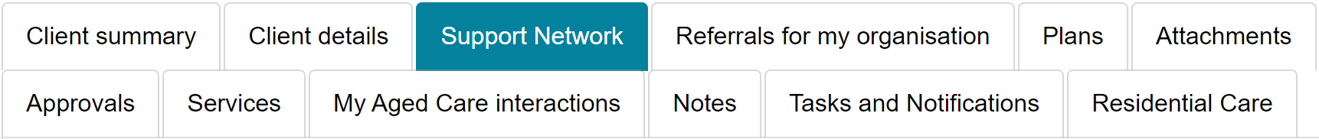

The **Support Network** tab contains information about current relationships between the client and people who assist them in their aged care journey.

The relationships that could be considered part of a client’s **Support Network** are as follows:

1. Representatives (individuals and organisations)
2. Agents (individuals and organisations)
3. Carers
4. Emergency Contacts
5. GPs
6. Support Persons

Authorised representatives are able to opt the client out from receiving letters but they themselves cannot opt out.

The **Support Network** tab also allows providers to notify My Aged Care of the death of a person with a listed relationship with the client.

Any carer relationships made in the Support Network tab are able to request call backs from the [Carer Gateway](https://www.carergateway.gov.au/) and the [Dementia Australia - National Dementia Helpline](https://www.dementia.org.au/helpline).

## Referrals for my organisation

The **Referrals for my organisation** tab displays service referrals that have been issued to or accepted by your organisation.

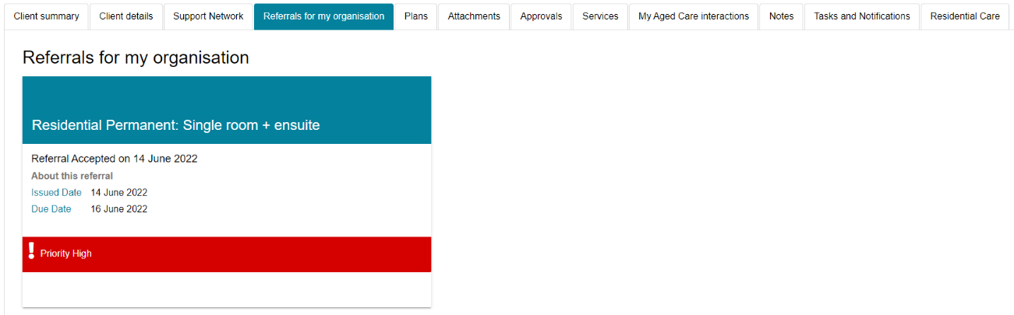

## Plans

The **Plans** tab contains detailed information about current and previous screening and assessments the client may have had, including client goals, recommendations and motivations, as well as the support plan.

Select the double arrow icon next to each heading to display detailed information captured during the assessment.

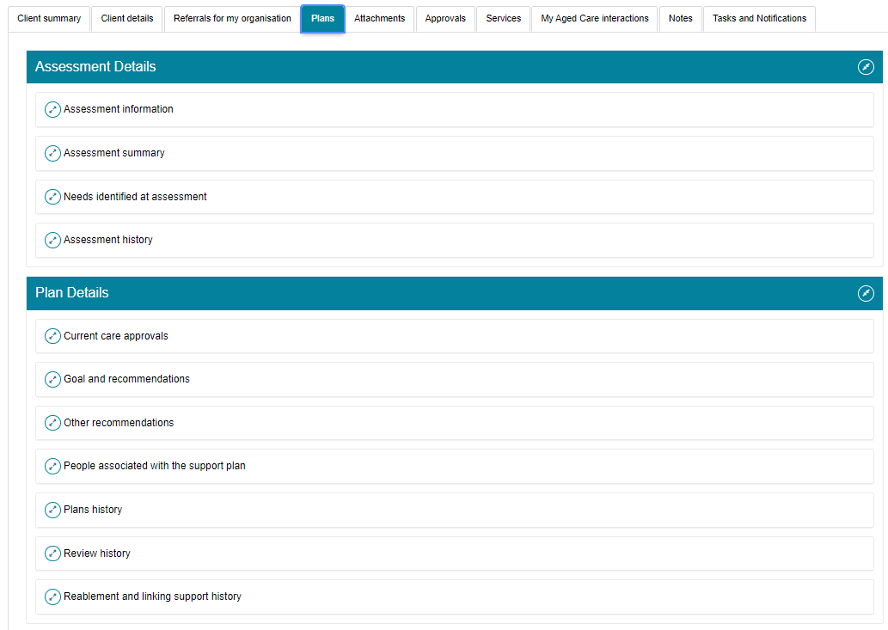

Providers will be able to access read-only versions of a client’s support plan and previous screening and assessments. This information can be printed, if required.

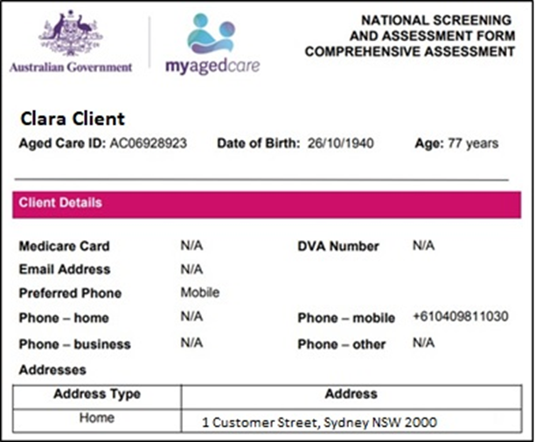

## Attachments

The **Attachments** tab contains documents that have been attached to the client record. This is also where service providers can add an attachment to the client record.

To upload an attachment to the client record, select **ADD AN ATTACHMENT** from this tab.

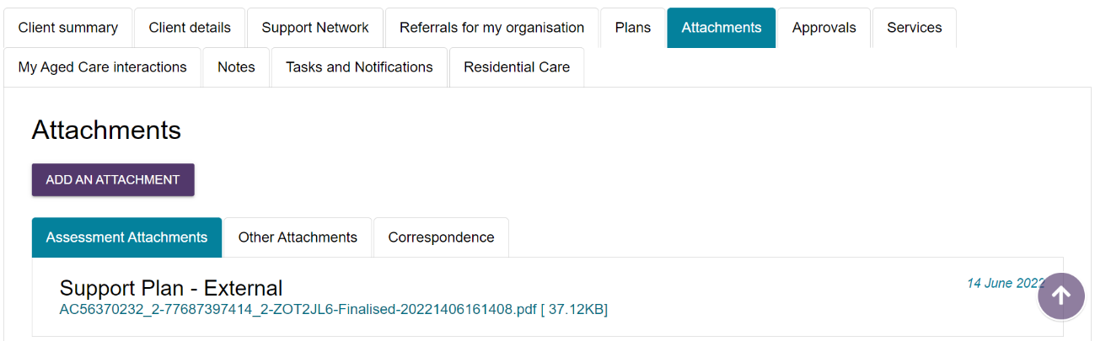

Add the attachment by selecting **Browse**. Enter the required information, including name of the attachment and the type of document. Select **UPLOAD** to add it to the client record.

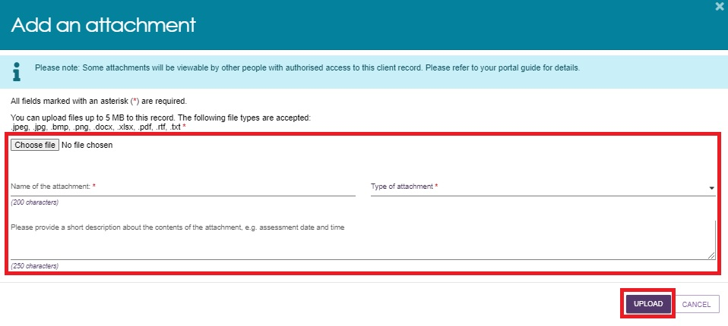

There are many types of attachments available from the Type of attachment drop down menu:

**Assessment Attachments** are any documents that are relevant to the client’s assessment, for example, clinical notes or a discharge summary.

**Other Attachments** are documents that relate to the client’s general circumstances, for instance, documents related to the establishment of a support relationship (including legal documentation and the Appointment of Support Person Form, Appointment of Support Organisation Form); Occupational Therapist drawings used in home modifications, etc.

**Correspondence** are documents/letters that are generated in My Aged Care, related to Home Care Packages. There are a number of letters sent to clients related to their Home Care Package at different stages. Copies of these letters will also be sent to their representative/s.

**Sensitive Attachments** are documents that contain client information of a sensitive nature. For example, documents about a client’s financial situation, safety concerns and legal issues that may impact provision of services.

! Where a client record has a **Sensitive Attachment**, provider(s) who have received a referral for or are providing services to a client will be notified that a SensitiveAttachment exists for the client.

Contact the assessor, or the My Aged Care provider and assessor helpline to obtain further information about the Sensitive Attachment.

If an attachment has been uploaded in error, please contact the My Aged Care service provider and assessor helpline on 1800 836 799 for deletion.

## Approvals

The **Approvals** tab contains a view of a client’s approvals for aged care services under the Aged Care Act 1997. This includes a client’s current approvals and also previous approvals that existed prior to the start of My Aged Care where the record has been linked with Services Australia systems (such as Centrelink and Medicare).

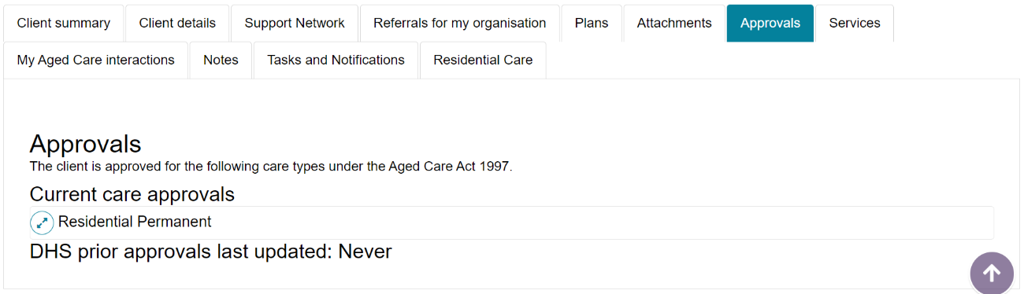

! If a client has a Home Care Package approval, the details of pending packages and assigned packages will be displayed from underneath Current care approvals. Further details of the changes to Home Care Packages can be found on the [Home Care Packages Program reforms](https://www.health.gov.au/health-topics/aged-care/aged-care-reforms-and-reviews/home-care-packages-program-reforms) page on the Department’s website.

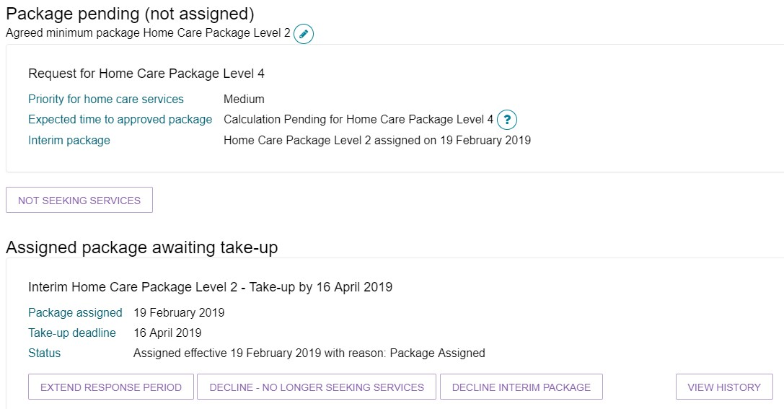

## Services

The **Services** tab contains a record of:

* Services the client is currently receiving
* Services that are pending (Not yet in place)
* Service referrals yet to be accepted
* Previous services the client has received
* Services from other systems (not managed by My Aged Care).

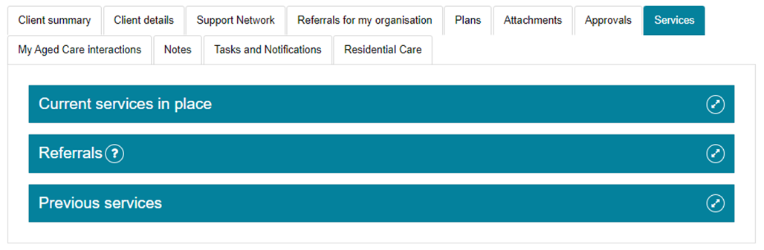

The following screenshot shows an example of a client’s current services in place.

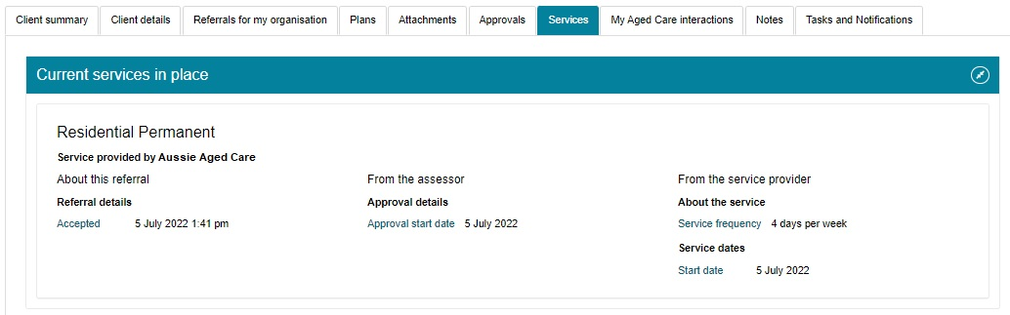

## My Aged Care interactions

The **My Aged Care Interactions** tab will show the client’s history of interactions with My Aged Care, for example, a phone call to the My Aged Care contact centre.

For clients and carers, it may also show the history of interactions with the Carer Gateway and the National Dementia Helpline.



## Notes

The **Notes** tab contains notes that have been created about the client.

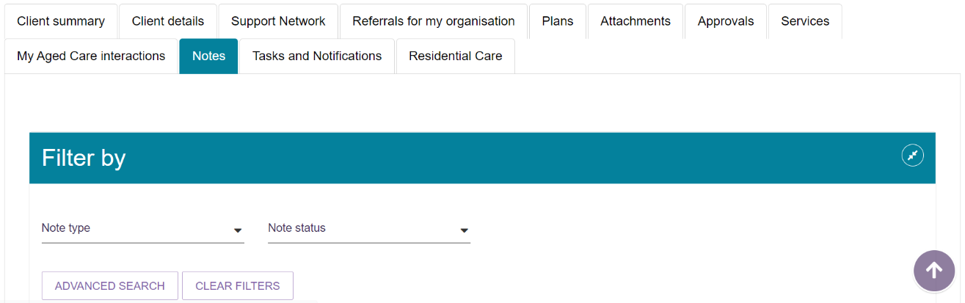

There are different types of notes, listed in the table below.

| Note type | Who can add? | Who can view? | Description | Examples |
| --- | --- | --- | --- | --- |
| Client story | Assessor | Client Assessor Provider | A summary of the client’s current circumstances. | Mrs Jones has just been discharged from hospital and is seeking help at home.  Lives with her husband and has early onset dementia. |
| Observations | Provider Assessor | Provider Assessor | Observations from service provider and/or assessors’ interactions with the client. | There is a dog on the property.  Mrs Smith seems more energetic than she did during my last visit. |
| Other | Client Provider Assessor | Client Provider Assessor | Additional information about the client. | Jennifer has planned respite on 01/08/2017. |

## 

! When the My Aged Care contact centre staff or assessors add a Sensitive note about a client from their respective portals, all service providers who are sent a referral will see a flag informing them that there is a sensitive note about the client and instructing them to call the My Aged Care contact centre for more information.

a flag of a sensitive note. "This client has a sensitive note on their record. Please call My Aged Care on 1800 836 799 for further information"

## Viewing and adding client notes

To add client notes, follow the steps below.

1. To add and view Client notes, navigate to the **Notes** tab from the client record.



1. From the **Notes** tabs, you can view notes about the client, and select **ADD A NOTE**.

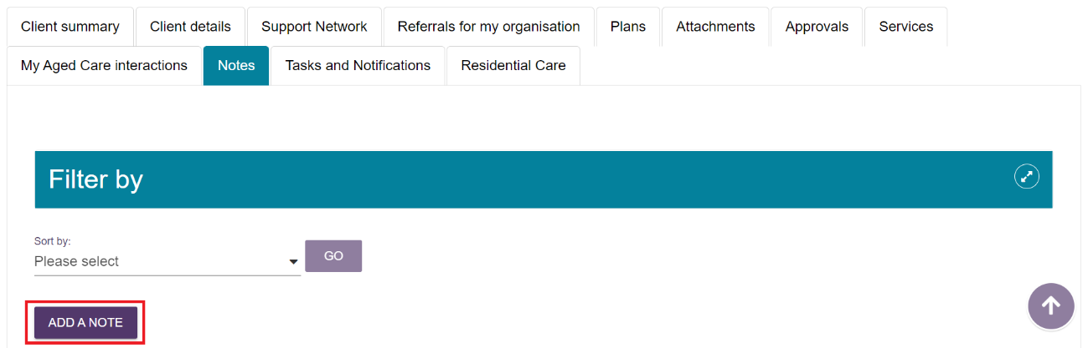

1. From the pop-up box, select a note type, and add a description of the note. Select **SAVE** once complete.

A help icon Help icon - question mark in the pop-up box provides information about the different types of notes to help assessors and service providers select the appropriate category.

Providers, staff members and team leaders using the Service and Support Portal cannot edit, delete or inactivate notes.

Step Three: From the pop-up box, select a note type, and add a description of the note. Select ‘Save’ once complete. 

## Tasks and notifications

The **Tasks and Notifications** tab will display all tasks and notifications for a single client.

You will only be able to see tasks and notifications that are associated to your outlet and for clients you are providing services to.

Assessors will be able to see all tasks and notifications for clients.

An example of a notification is of a New Referral between a client and their Service and Support outlet.

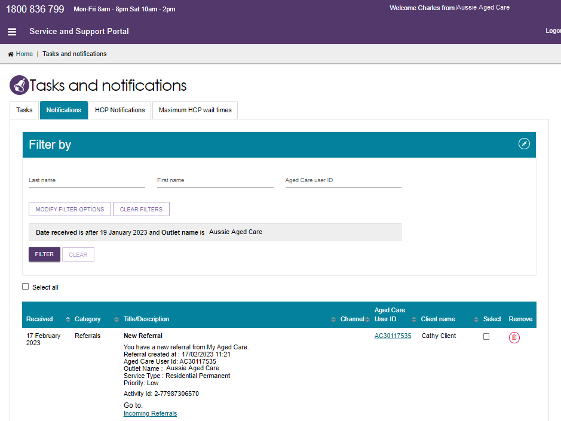

## Residential Care

This section shows information for clients who are in Residential Permanent Care or Residential Respite Care and has received an Australian National Aged Care Classification (AN-ACC) assessment or is currently undergoing an AN-ACC assessment.

For more information refer to the [Residential aged care funding reform](https://www.health.gov.au/health-topics/aged-care/aged-care-reforms-and-reviews/residential-aged-care-funding-reform) page.

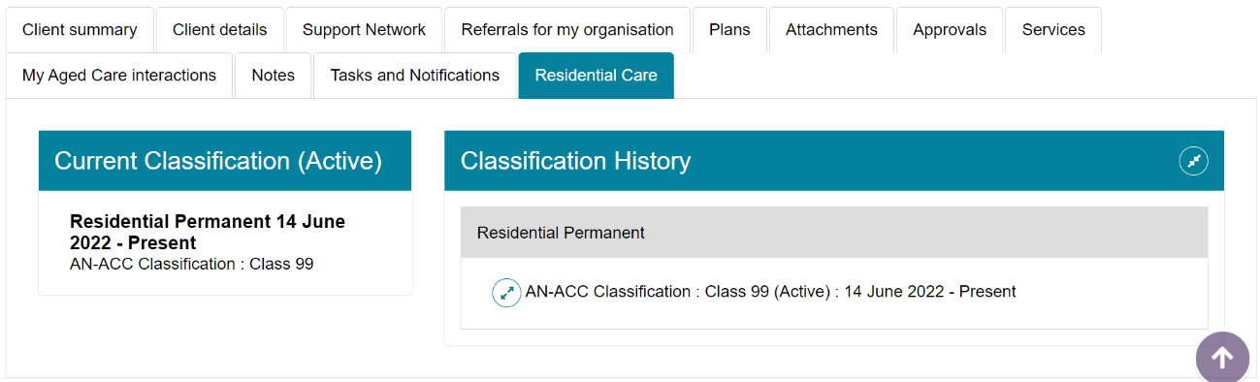

## For more information or support

Further information is available from the [My Aged Care for service providers](https://www.health.gov.au/initiatives-and-programs/my-aged-care/using-my-aged-care/my-aged-care-for-service-providers) page on the Department’s website.

The My Aged Care service provider and assessor helpline is available by calling 1800 836 799 from 8 am to 8 pm Monday to Friday or 10 am to 2 pm on Saturday.