# Service and Support Portal User Guide – Recording and updating client service delivery information

This User Guide is designed for Staff Members and Team Leaders within the My Aged Care Service and Support Portal. It explains the procedures for recording and updating service delivery information in the client record. A Team Leader can manage referrals, as well as all the functions of a Staff Member.

Service delivery information should be recorded on the My Aged Care client record for all clients accepted for service. This includes service commencement date, service frequency, and service end date where a service has ceased. This information should be recorded within 14 calendar days of acceptance, and providers will receive notification reminders prompting them to enter this information if it is not completed within this timeframe.

For Home Care Packages and Residential Care Permanent services, the service commencement date will be automatically filled in from the Services Australia records and will be read-only. Other information such as service frequency will still need to be maintained by the provider.

For further detail regarding the procedures for updating service delivery information, please refer to the [My Aged Care for service providers](https://www.health.gov.au/our-work/my-aged-care/using-my-aged-care/my-aged-care-for-service-providers) section on the Department’s website.

This guide is spilt into sections as follows:

Adding service delivery information 2

Updating service delivery information 5

Recording note of changes made to client service information 7

Requesting an extension to the client’s care 8

Requesting a review of a client’s support plan 10

For more information and support 15

## Adding service delivery information

1. Go to the Service Referrals tile from the Service and Support Portal home page, then select the **Accepted Services Pending** tab.

Alternatively, if you know the client’s name you can use the **Find a client** function.

This tab displays accepted referrals that do not have service delivery information recorded against them.

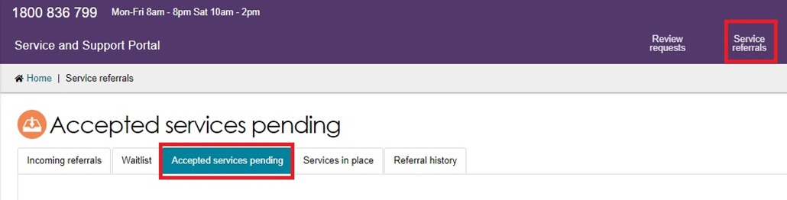

1. Select the relevant client’s service referral, then you can add service delivery information for the service.

To do this, select the expand icon (double arrow) on the Client card or in List View to view the client information. Select **Add service information**.

Card View

Once you have located the relevant client’s service referral in the ‘Accepted service pending’ tab, you can add service delivery information for the service.
1. Select the arrow on the 'Client card' to view the expanded client card view and select ‘Add service information’


List View

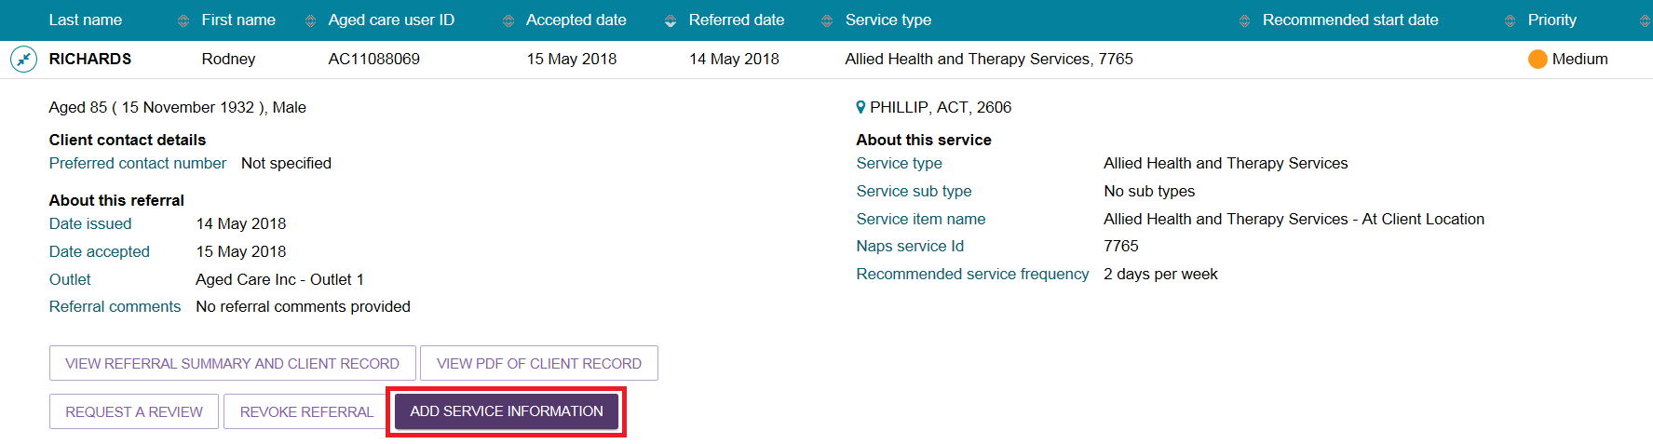

1. The **Add service information** screen will be displayed.

When adding service information for **residential care including respite, transition care, short term restorative care, and Commonwealth home support programme services**, you must enter the **Service start date**, input a **Frequency**, and select an **Intensity** from the drop-down list.

Enter any additional information in the remaining fields and select **Save changes**.

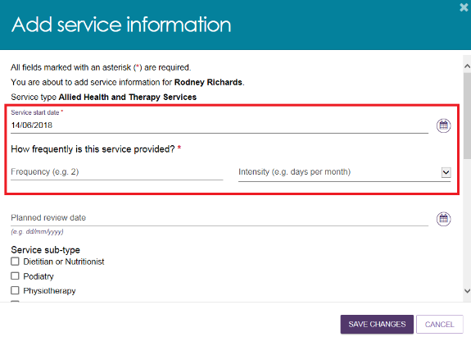

When updating **Home Care Package information** you must enter a **Frequency** and select an **Intensity** from the drop-down list.

The **Service start date** will update once the commencement date has been received from Service Australia.

Enter any additional information in the remaining fields and select **SAVE CHANGES**.

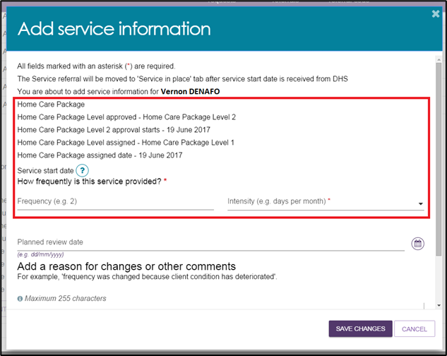

1. To supply specific service delivery information select **Other – Specify** and enter additional service delivery information in the free text field.

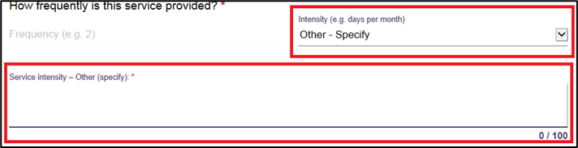

1. Once saved, the client information will move to the **Services in place** tab:

* Immediately for **residential care including respite, transition care, short term restorative care, and Commonwealth home support programme services.**
* once a **Service start date** is present, for **Home Care Packages.**

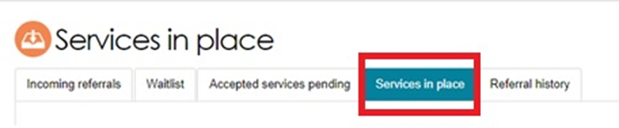

1. Once this has occurred, the filled-in service information will display under the **Services** section within the client record.

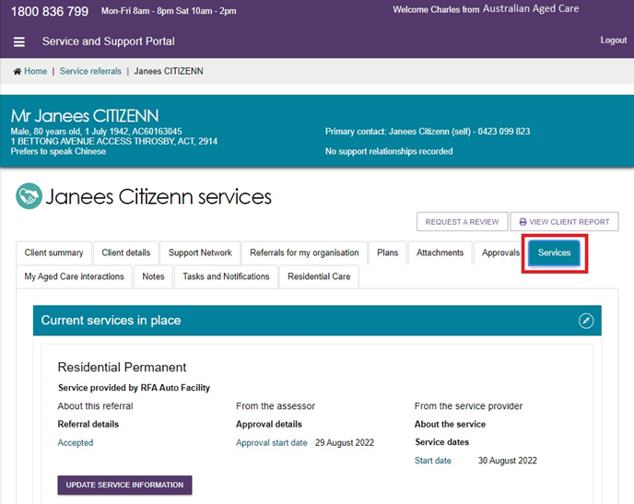

**!** Service information for a Home Care Package will contain further information about the package, such as if the approval is for a higher level than the assigned package. This then mean that the client has accepted an interim package and may remain on the national Home Care queue to receive a package at their approved level.

## Updating service delivery information

The **Services in place** tab in the **Service referrals** section of the Service and Support portal displays accepted services that have service delivery information recorded.

1. Navigate to the **Services in place** tab by selecting **Service referrals** from the home page or the **Service Referrals** link at the top of the screen from any page within the portal.

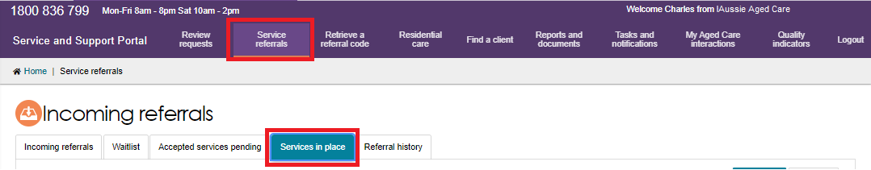

1. For the service you are updating, expand the **Client list** to view the expanded client list view and select **Update Service Information**. Alternatively, you can select **Update Service Information** in the expanded card view.

Card View

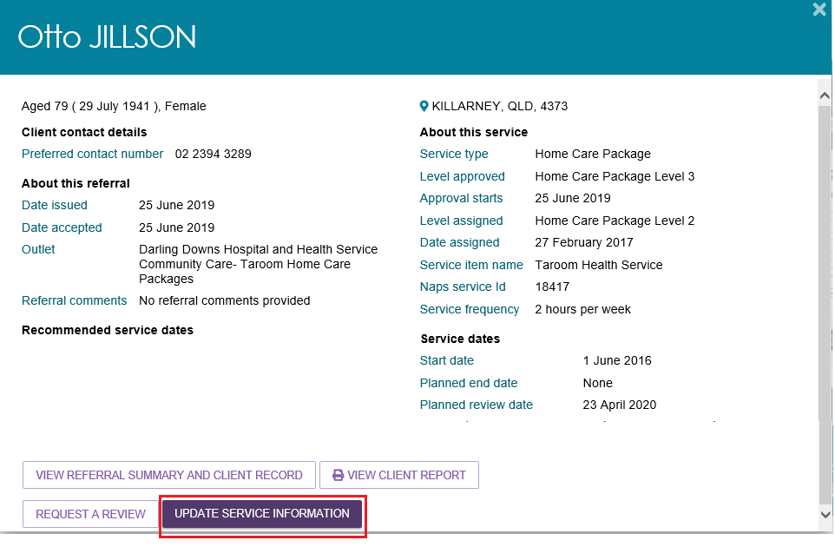

List View

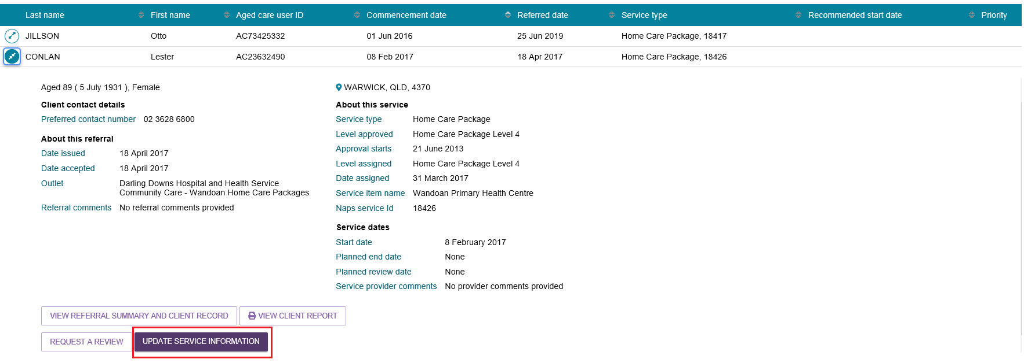

1. Update service information and select **Save changes**. This information will now be updated on the **Services in place** tab and the **Services** tab in the client record.

3. Update service information and select 'Save changes'. This information will now be updated on the ‘Services in place’ tab and the ‘Services’ tab in the client record.

Service delivery information can also be updated from the ‘Services’ tab in the client record by selecting ‘Update service information’ for the relevant service.

Service delivery information can also be updated from the **Services** tab in the client record by selecting **Update service information** for the relevant service.

**!** Ceasing a client’s service with the reason of **Client deceased** will change the client’s status to **Deceased** and make the client record read-only. Any unaccepted service referrals will be recalled, services in place will be ceased, assessments will be cancelled, and the client’s access to the My Aged Care Online Services will be revoked.

My Aged Care will not send correspondence to the client or their support network after the status is changed to **Deceased**.

Additional notes and attachments can be attached to the client record for 14 days after ceasing services.

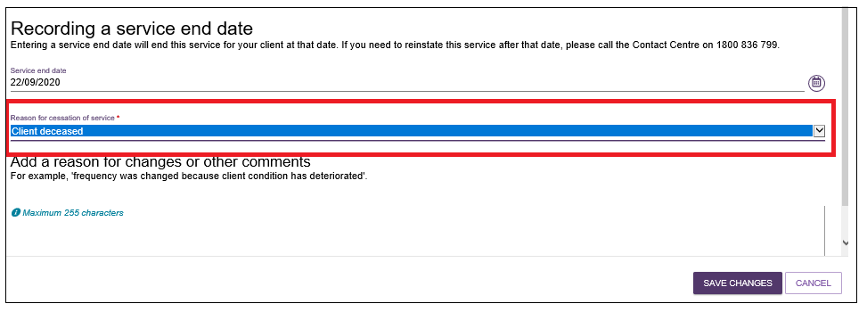

## Recording note of changes made to client service information

My Aged Care contact centre staff, assessors and service providers (providers) can view and add different types of notes about clients in the My Aged Care portals.

If there is significant change to a client’s service delivery information, it is recommended that providers update the service information and add a note to the client record.

**!** If a client’s needs or circumstances have changed significantly since their last assessment, a review of the client’s support plan may be required.

Providers can add the following notes to the client record:

* **Observations:** Observations from provider and/or assessors’ interactions with the client. Assessors and providers can view these notes.
* **Other:** Additional information about the client. Assessors, providers and clients can view these notes.

Providers can view the following notes:

* Client Story
* Other
* Observations.

**!** When My Aged Care contact centre staff or assessors add a **Sensitive note** about a client, a flag will appear on the client record advising the provider to call the My Aged Care contact centre for more information.

Information on the content of the sensitive note will only be provided where relevant to the provider.



To add a note to the client record, follow the steps below.

1. Navigate to the client record and select **Notes**.


To add a note to the client record, follow the steps below. 
1.Navigate to the client record (refer to QRG: Navigating and viewing information in the client record) and select ‘Notes’. 


1. Notes already present on the client record will be displayed.

Select **Add a Note** and choose the note type and a description. Once this information is filled in, select **Save**. Alternatively, from the **Client details** tab, select **Add a note** from the **Current notes** section.

You can add Notes of type **Other** and **Observations** to the client record of any clients that have been referred to your outlet. For example, clients in your **Incoming referrals** tab.

The blue screenshot of a question mark is a help hint which explains the various note types and who gets to see them, as there is a different audience per note type.

Notes already present on the client record will be displayed.
Select ‘Add a Note’, and choose the note type and a description. Once this information is populated, you add the note to the client’s record by selecting ‘Save’



1. These notes will be visible to My Aged Care contact centre staff, assessors, and other providers delivering services to that client.

For further information about note types and who can view them, refer to information contained in the [Service and Support Portal User Guide - *The client record*](https://www.health.gov.au/resources/publications/my-aged-care-service-and-support-portal-user-guide-the-client-record) located on the Department’s website.

## Requesting an extension to the client’s care

Providers can request a care extension via the Service and Support Portal. This request will be sent to the Assessment Delegate for approval.

Periods of Transition Care can be extended to a maximum of 42 consecutive days.

Periods of Residential Respite care can be extended for a maximum of 21 day non-consecutive periods.

All respite care approvals from non-My Aged Care systems can be extended in the Service and Support Portal. The use of the offline residential respite extension form will no longer be supported.

**!** A care extension may only be granted for the approved level of care. If a client needs a higher level of respite, they will require a new Respite Classification. This can be facilitated by requesting a Residential Respite Assessment in the MyAssessor App.

Care extensions are effective from the commencement date within the request pending the Assessment Delegate’s approval. Extension requests cannot be backdated.

To request a care extension, follow the steps below.

1. Find the client you wish to request a care extension for, by navigating to the **Services in Place** tab and expanding the card or list view for the client and select **request <care type> extension** (care type referenced will vary depending on relevant extension type).

This button is only visible if the client is eligible for care extension.

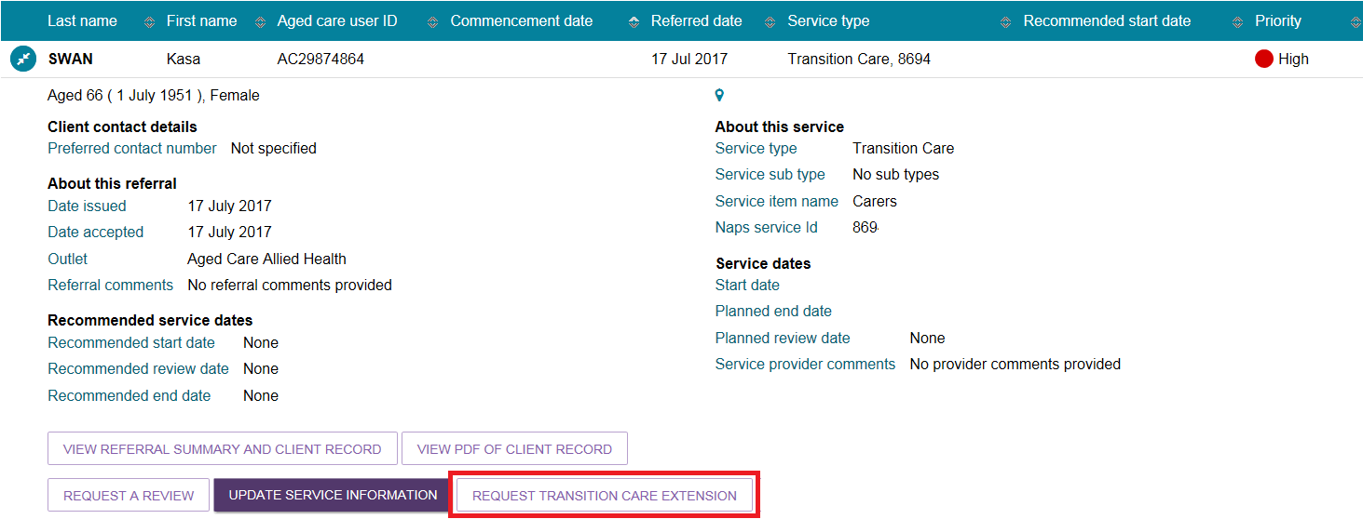

Alternatively, locate the client through the **Find a client** functionality, and navigate to either the **Services** or **Approvals** tab of the client record and select **Request <care type> extension**.

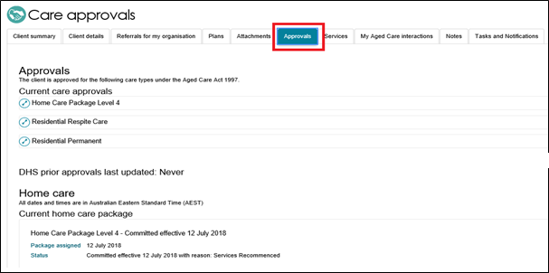

1. Complete all mandatory information indicated in the extension request pop up. The heading of the pop up and the mandatory information will depend on the care type the extension relates to. Once completed, selected **Submit request**.

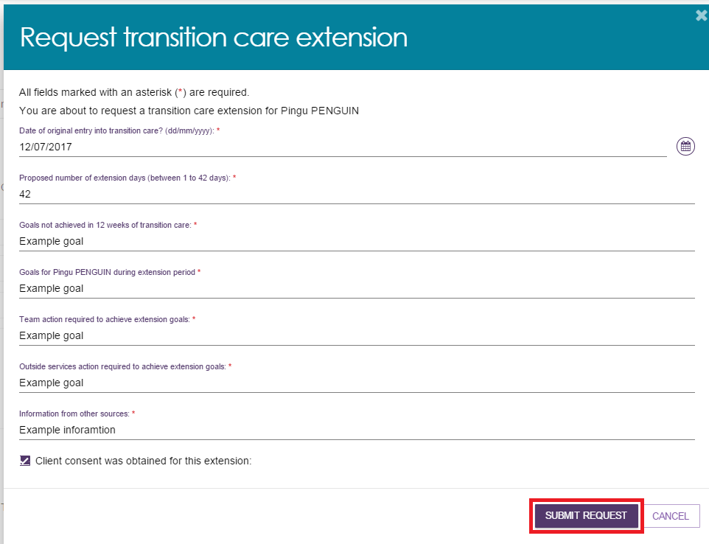

1. You will receive confirmation that the care extension request has been submitted to the Assessment Delegate.



1. You will also receive a notification that the request has been submitted, located in the Tasks and Notifications section of the client record, or the Tasks and Notifications tile of the portal. You will also receive a notification when the Assessment Delegate has made a decision on the care extension request.

You will receive confirmation that the care extension request has been submitted to the Delegate.
 
You will also receive a notification that the request has been submitted:


## Requesting a review of a client’s support plan

If a client’s needs or circumstances have changed significantly since their last assessment and their support plan no longer reflects their current situation, you can request a review of the client’s support plan. The assessor will conduct a review of the client’s situation which may lead to a new assessment of the client’s needs.

Providers are encouraged to contact the assessment organisation prior to submitting the request and to provide as much information as possible to explain the client’s need for, and urgency of, a support plan review or new assessment. This information is available in the detailed assessment history information in the client’s support plan in the **Plans** tab of the client record.

If a client has not previously had an assessment through My Aged Care, a request for review will be sent to the My Aged Care contact centre.

**!** You cannot submit a request for review if there is already an existing assigned review for the client in the assessor portal or an assessment is currently being undertaken. You should discuss the request with the assessor who conducted the client’s most current assessment.

This information can be found in the client’s **assessment information**, with more detailed information available in the **assessment history** in the support plan in the **Plans** tab of the client record.

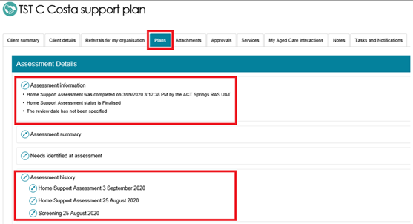

To request a review of a client’s support plan, follow the steps below.

1. Select **Service referrals** from the homepage.

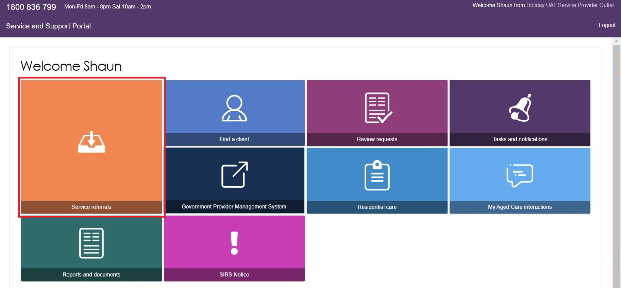

1. Select **Services in place**, locate the client for whom you wish to request a review and select **Request a review**.

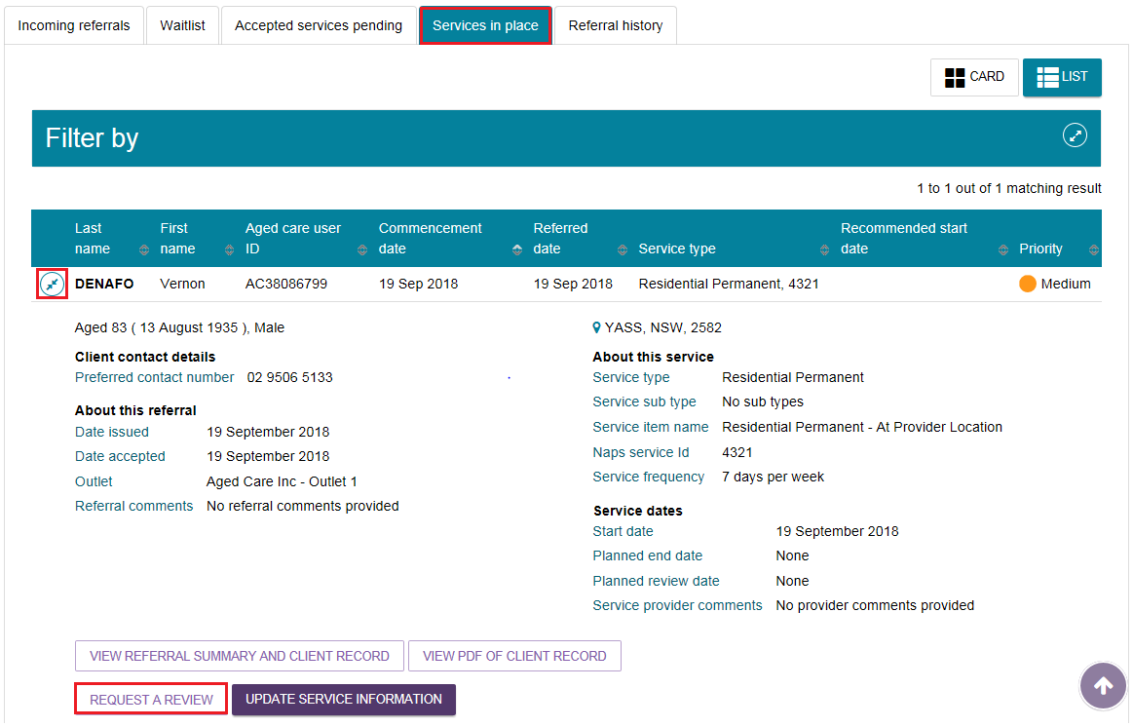

Alternatively, a link to request a review will display at the top of any page in the client’s record.

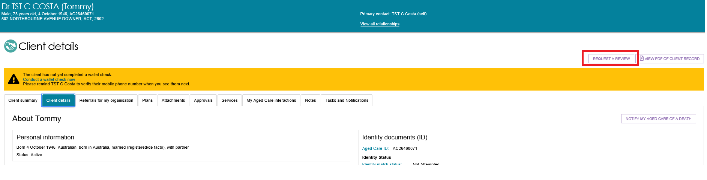

1. Complete all mandatory fields within the review request.
2. What circumstances have changed for the client?

If the client has a **Change in care needs** or **Change in caring arrangements**, or the client **Needs Transition Care**, **Needs Residential Care**, or **Needs Residential Respite** and you believe the client requires a **direct comprehensive assessment** rather than a Support Plan Review, there is a checkbox you can select that will explain the eligibility criteria.

If the client is eligible, you will be prompted to call the provider and assessor helpline to request a direct comprehensive assessment.

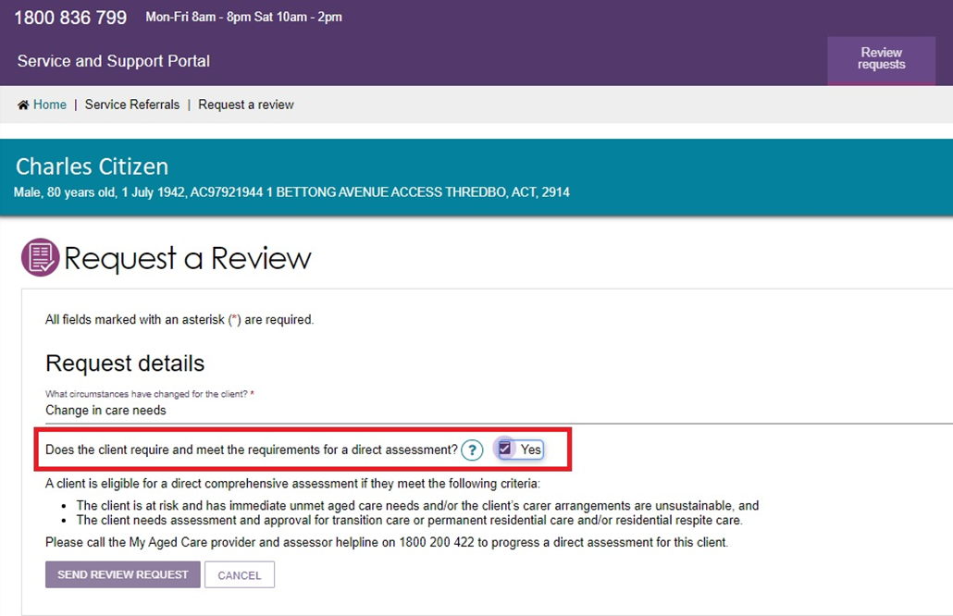

1. Does this request need to be actioned urgently?

If the client needs require urgent review, tick the **Yes** box and provide information in the reason field.

This will help the assessor or contact centre to prioritise the client’s support plan review request.

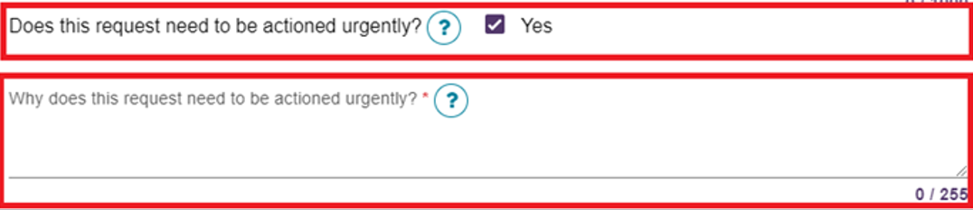

1. What type of subsidised aged care is the client receiving?

Primary reason for Support Plan Review Request

Depending on the answers, different questions will need to be completed at this step.

the Request Details of Request a review section of the portal.
Questions include: what circumstances have changed for the client? how does this affect the client's need? what type of subsidised aged care is the client receiving? Primary reason for support plan review request?

1. If the client is receiving a **home care package or combination of home care package and Commonwealth Home Support Programme (CHSP),** it will be mandatory for a care plan and budget to be attached to the review request.

The request will not be able to be submitted without this information.

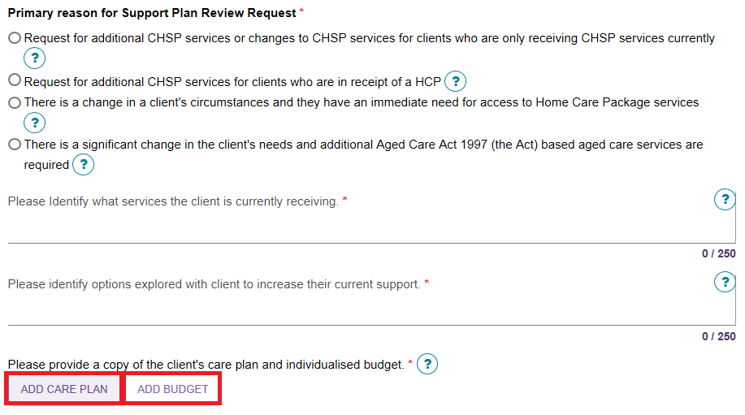

1. Select browse to choose a document for upload.

Complete all mandatory fields and click **upload** to complete.

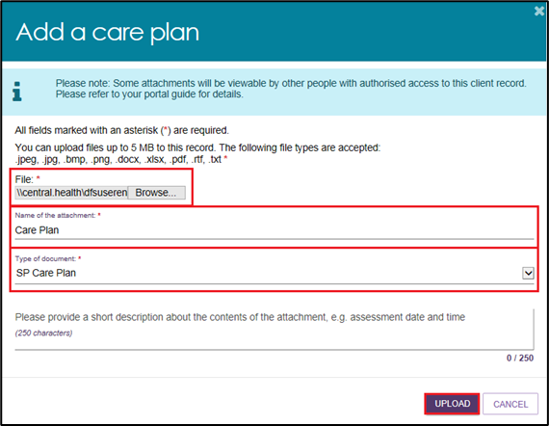

1. Once the documents are successfully uploaded, they will display in the review request.

Clicking the **bin** icon next to the attachment name will remove the attachment from the review request. A confirmation message will not display.

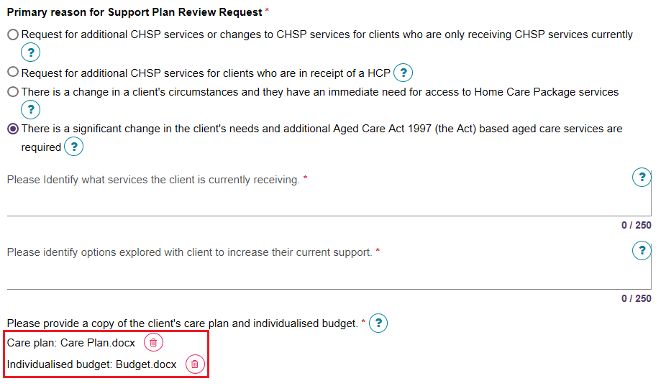

1. Once all mandatory fields have been completed, select **I have reviewed the information on this page and I confirm that it is correct** then select **SEND REVIEW REQUEST** to submit the review request to the most recent assessment organisation.

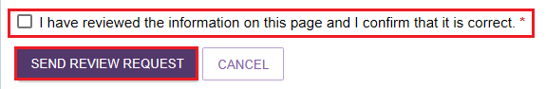

1. A confirmation will display if the request is submitted successfully.

## For more information and support

Further information is available from [Service and Support Portal User Guide: Part 2 Team Leader and Staff Member Functions](https://www.health.gov.au/resources/publications/my-aged-care-service-and-support-portal-user-guide-part-2-team-leader-and-staff-member?language=en) on the Department’s website.

For further information about a client’s support plan review, refer to [When to request a Support Plan Review from an Assessorfact sheet](https://www.health.gov.au/resources/publications/when-to-request-a-support-plan-review-from-an-assessor-fact-sheet)*,* available on the Department’s website.

The My Aged Care service provider and assessor helpline is available on 1800 836 799.