# Presentation slide: Medical Research Future Fund RAO Webinar 29 August 2024 Presenters: Pru Glasson, Director - Translation and Commercialisation, Misha Hutchings, Director - Grants Management Office, and Cindy Thamrin, Director - Performance and EvaluationContents

1. **Webinar overview**
2. **Commercialisation-related grant opportunities**
3. **Post-award updates on media embargoes and project reporting**
4. **Monitoring, evaluation and learning strategy**
5. **Q&A**
6. **Keep connected**

# MRFF Research Administration Officer Webinars

Aim to:

provide practical information to the sector and Research Administration Officers (RAOs) in particular about MRFF administrative arrangements

assist RAOs and potential grantees in better supporting MRFF funded research and researchers

aid the implementation of any changes to MRFF grant administration

seek feedback from RAOs, with a view toward continuous improvement of MRFF grant administration.

## Commercialisation- related grant opportunities

**Pru Glasson  
Director – Translation and Commercialisation**

Medical Research Commercialisation Initiative

Upcoming funding opportunities for small-to-medium enterprises

# MRFF Medical Research Commercialisation Initiative

$450 million over 10 years from 2024-2025

The Initiative is seeking to support projects that:

Help build a more mature, vibrant and thriving ecosystem that drives health and medical research and its translation into commercial outcomes and clinical practice, improving health and generating jobs and economic growth

Grow the number of research outputs and improve Australia’s performance in key commercialisation benchmarks, such as increasing the number of intellectual property applications so innovations can be capitalised and returns on investment are attained, as well as increasing the number of tangible products derived from research for patient benefits.

# Key features of medical research commercialisation grant opportunities

* Large quantum of funding available to select few organisations
* 1-4 grants awarded each GO depending on objectives
* $20 million - $50 million per grant

An **organisation** will be funded to identify and select a number of Australian small and medium enterprises (SMEs) undertaking early-stage medical research and medical innovation projects that have commercial potential

Not just capital – organisations are expected to create an **ecosystem,** providing access to industry knowledge

The GOs do **not** fund organisations to progress their own research

The grant funds are **non-dilutive** i.e. organisations cannot take equity stakes in the SMEs funded

Successful organisation provides up to $5 million in funding over five years to partnered SMEs, **allocated incrementally** as projects seek and then demonstrate proof-of-concept and transition towards implementation.

# Medical research commercialisation grant opportunities

* Since 2017-18, $345.3 million of MRFF funding has been allocated through the Medical Research Commercialisation Initiative
* $45 million through **BioMedTech Horizons** which supported the development of **49 biomedical and medical technologies** from proof-of-concept to commercial development – single grant awarded
* $22.3 million through **Biomedical Translation Bridge** which nurtured the translation of **21 projects through to the proof-of-concept stage** with expert industry support and mentoring – single grant awarded
* $79 million through **Early Stage Translation and Commercialisation Support** which has **to date supported 74 Australian SMEs** undertaking early-stage medical research and innovation projects with commercial potential – **4 grants** awarded, across 4 streams: Early Stage Digital Health, Early Clinical Medical Devices, Early Clinical Drugs, Pre-Clinical research or medical innovation
* **BioMedTech Incubator**
  + Intended to increase the number of **innovations, novel drugs, novel uses for existing drugs, innovative medical devices and/or digital health technologies** that have progressed through the early stages of research and development to the point where they are **‘de-risked’** and attractive to private investment or commercialisation
  + **$50 million** over 2 years from 2022-23 – single grant – **Generalised – First Cohort applications under review**
  + **$50 million** over 2 years from 2023-34 – single grant – **Dementia and Cognitive Decline – EoIs closed July 2024. Second round opens 2025**
  + **$99 million** over 3 years from 2024-25 - grants up to $33m - **Organisation can specialise in their area of commercialisation expertise** - **Funding Organisation Applications closed 31 July 2024**.

# Upcoming funding opportunities for SME

**CUREator+**

Accelerating the research translation and commercialisation of preclinical and clinical early-stage medical research and medical innovations with commercial potential.

Funding up to a maximum of $5 million per project in two funding stages.

**Second EoI round to open mid-late 2024**

**CUREator+ Dementia and Cognitive Decline**

Funding innovations that support early diagnosis, prevent severity of progression and/or management of the cognitive, neuropsychiatric, and motor symptoms of dementia and/or promote enabling environments to increase safety and quality of life of those living with dementia and cognitive decline.

Funding up to a maximum of $5 million per project in two funding stages.

First EOIs closed July. **A second round for First Stage applications will open in 2025.**

**2024 BioMedTech Incubator**

Grants of $33 million to funding organisations to deliver programs. Closed for applications 31 July 2024.

Successful organisations can specialise in their area of expertise.

Anticipate funded organisations will open for funding applications from SMEs mid - late 2025

# What impact can these programs have?

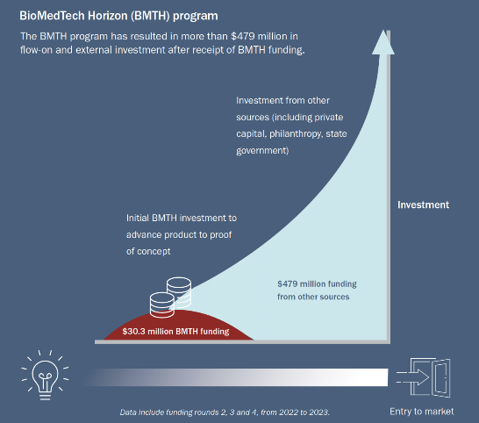

# Managing MRFF grants

**Misha Hutchings  
Director – Grants Management Office (GMO)**

* Media embargo
* Updated project reporting templates
* Upcoming developments

# Funding outcomes under media embargo

A media embargo is a restriction on publicising information about the outcomes of a grant opportunity until the embargo has been lifted. A media embargo applies regardless of the application outcome.

**What can you do during a media embargo?**

* + Share outcomes through private/internal communications with your collaborators (including potential investors), family, friends, colleagues, and staff who assisted with the application process, as long as they also do not promote the outcomes publicly
  + Begin preparation for grant start (seeking approvals, progressing agreements, advertising positions without mention of the funder or grant opportunity)
  + Submit any necessary variation requests or other communications with the department (via grant hubs)
  + Commence the grant if the start date occurs during the embargo period
* **What you must not do during a media embargo**
  + Applicants, administering institutions and administering organisations cannot engage directly with media outlets, issue media releases or other communications (including on social media), or otherwise actively seek to publicise the funded research.

We will release a policy soon with these and further details.

# Revised project reporting templates

Key updates include:

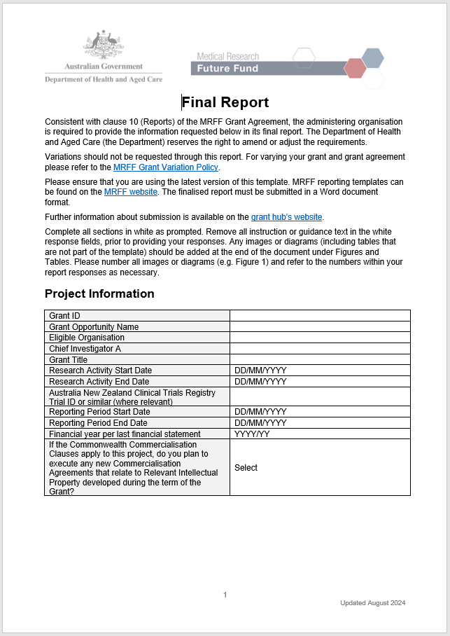streamlined some questions to seek details where crucial –use more space to explain what isn’t going well and what you’re doing or will do about it

updated formatting to tables to make it easier to digitise the information you’ve provided

removed duplication of financial reporting *(only MRFF grants administered by NHMRC)*

*forthcoming -* guidance to be published shortly.

# Revised project reporting templates

When reviewing the draft reports ensure:

correct template has been used

the entire template is filled out, with accurate responses provided to all questions

(e.g. all project milestones listed, selected dropdown responses, entered N/A where applicable, added responses within the provided field (table))

responses are relatively lengthier to describe issues and solutions

Lastly, submit reports as MS Word documents according to the respective grant hub’s processes.

# Revised project reporting templates

For financial details be aware:

The Total Budget should equal the total in the grant agreement or schedule

* for MRFF grants previously managed by the Department or another grant hub, the total is the amount of the original MRFF grant received

Where allowable without a variation, indicate changes to expenditure items/budget categories and explain in the comments (e.g. underspend for one item/category used to cover increased costs to existing approved expenditure).

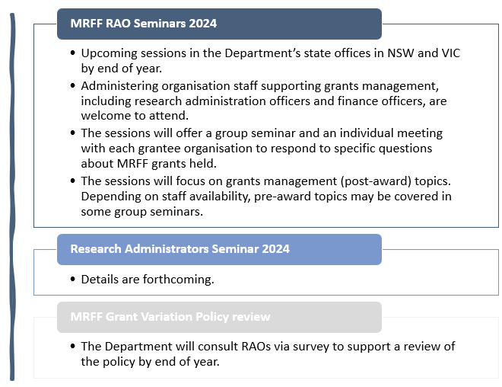

Upcoming post-award developments

# Monitoring, evaluation and learning strategy

**Assoc. Prof. Cindy Thamrin  
Director – Performance and Evaluation**

* Updated measures of success and impact measures
* Performance indicators survey update

# MRFF Monitoring, evaluation and learning strategy

The MRFF Monitoring, evaluation and learning strategy 2020-21 to 2023-24 (MEL Strategy) provides an overarching framework for assessing the performance of the MRFF.

Updated in August 2024

# MRFF impact measures and measures of success

# **Diagram outlining the MRFF's vision, aim, and measures of success**

# Refreshed impact measures and measures of success

* Impact measure

Beneficial change to health *policy and* practice

* Measures of success

New health interventions are embedded in health *policy and* practice

New health interventions are embedded in health *policy and* practice

The community engages with and adopts new technologies, treatments *and interventions*

Incorporation of the performance indicators published in 2023

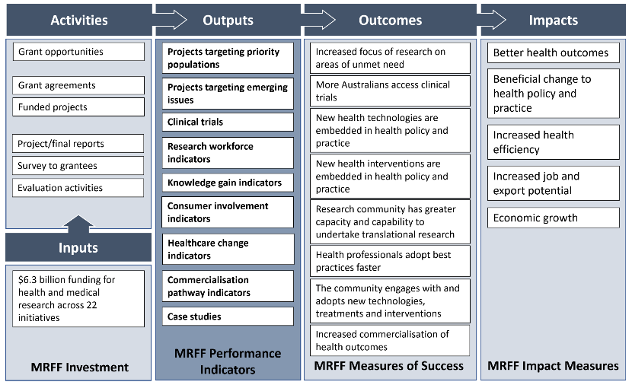

# Summary of changes

Minor changes to the wording of one impact measure and 3 measures of success

Incorporation of the performance indicators published in 2023

Better articulation of performance monitoring data sources, including performance indicators survey

Inclusion of completed evaluation/review of MRFF initiatives

Other minor editorial changes

# What does this mean for researchers?

Helps researchers strategise their own research impact in grant proposals, progress and final reports

Implications for public and preventive health research with the refreshed measures of success

Understanding how the impact of the MRFF and research funded by the MRFF are evaluated, to support policy and program development

Transparency of data collection for evaluation purposes, and the outcomes of these evaluation activities

# MRFF Performance indicators survey

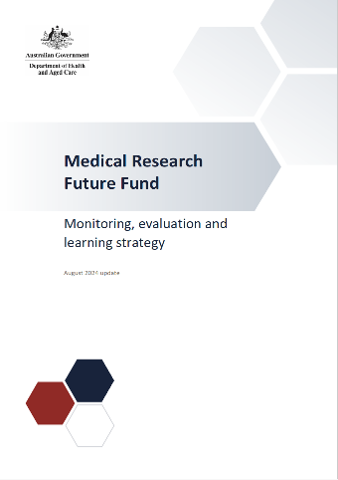Survey went out in March 2024, and closed in April 2024.

One of the key methods of data capture to track research impact over time.

We thank all Research Administration Officers for their assistance in ensuring grantees are aware of and complete the survey.

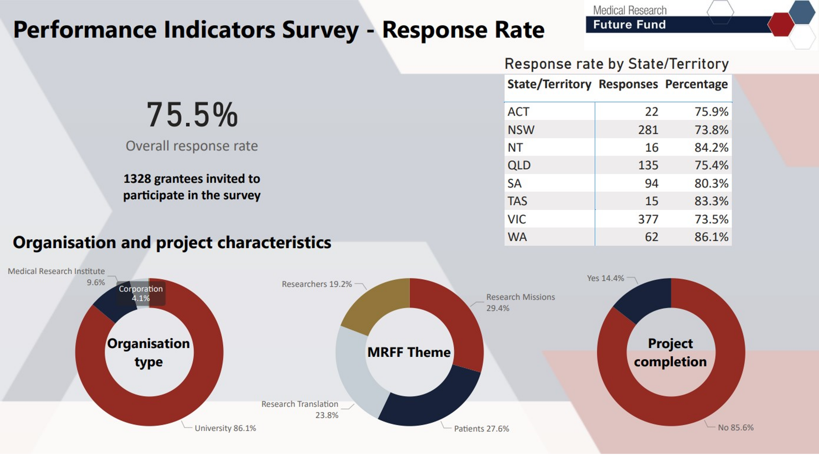

# Q&A

# Keep Connected



**Access MRFF post-award resources**

[health.gov.au/mrff](https://www.health.gov.au/our-work/mrff/grants-management-resources)

**Register for notifications for new  
MRFF grant opportunities**

www.grants.gov.au

**Send any questions to**

mrff@industry.gov.au

mrff.postaward@nhmrc.gov.au

MRFF@health.gov.au

**Subscribe to MRFF News**

[health.gov.au/our-work/mrff/news](https://www.health.gov.au/our-work/mrff/news)



Thank you for your time!