Medical Research Future Fund Report on gender data for grant opportunities
December 2024

Contents

Introduction 5

Reporting on gender data for MRFF grant opportunities 5

Report overview 6

Approach 8

Limitations 8

Funding insights 10

General trends 10

Grant hubs 13

MRFF themes 18

MRFF initiatives 25

Broad research area 30

Application budgets 35

Grant team size 41

Lead Chief Investigator characteristics 41

Grant assessors 51

Opportunities for learning 52

Conclusions 53

Appendices 54

Funding snapshot

The 2024 Medical Research Future Fund (MRFF) gender data report is the third from the Australian Government to provide an overview of gender data for MRFF grant opportunities, in line with the [MRFF Monitoring, Evaluation and Learning Strategy](https://www.health.gov.au/resources/publications/mrff-monitoring-evaluation-and-learning-strategy-2020-21-to-2023-24). This report is based on data from competitive grant opportunities that opened between 2017 (when MRFF competitive grant opportunities became available) and 30 June 2024 and had outcomes data available as of 7 May 2024.

Since 2017, the MRFF has received slightly more applications from women than from men, for both Chief Investigators and lead Chief Investigators. This is a shift from what was reported in [2022](https://www.health.gov.au/resources/publications/medical-research-future-fund-grant-opportunity-gender-data-report-22-march-2022?language=en) and [2023](https://www.health.gov.au/resources/publications/mrff-report-on-gender-data-for-grant-opportunities-august-2023?language=en). Overall funded rates remain similar for men and women. Chief Investigators who identified as non-binary had higher overall funded rates (33.8%) than men (24.7%) or women (25.7%), although this is based on small numbers.

In the 2022–23 financial year, women Chief Investigators and lead Chief Investigators submitted a higher number of applications and had higher funded rates than men. This reflects the findings from the 2021–22 financial year, which was the first year in which women submitted more applications than did men. Compared to men (23.6%) and women (26.9%), non-binary Chief Investigators had a higher funded rate (51.6%) in 2022–23, but again, this is based on small numbers.

Grant hubs

For MRFF grant opportunities administered by the National Health and Medical Research Council (NHMRC), overall funded rates were 22.3% for women lead Chief Investigators and 23.0% for men lead Chief Investigators. For MRFF grants administered by the Business Grants Hub (BGH), overall funded rates were 12.2% for women lead Chief Investigators and 10.6% for men lead Chief Investigators. There was a slight increase in relative funded rates for women in NHMRC-administered grant opportunities in this year’s report, which was counterbalanced by a decrease in relative funded rates for women in BGH-administered grant opportunities. This resulted in funded rates being more balanced across genders than those in the 2023 report.

Application area of research

Women lead Chief Investigators submitted more applications than did men under the broad research areas of ‘Health services’ and ‘Public health’, whereas more men than women submitted applications under the broad research areas of ‘Basic science’ and ‘Clinical medicine and science’. Women lead Chief Investigators had higher funded rates than men under the broad research area of ‘Public health’, while men had higher funded rates for all other broad research areas. These findings are similar to those of the 2023 report.

Application budgets

As was reported in 2023, women Chief Investigators and lead Chief Investigators tended to apply for smaller grant budgets than men, but women had higher funded rates for applications with larger budgets. Men Chief Investigators and lead Chief Investigators continued to receive a higher proportion of funding than did women for applications with larger budgets – likely because they submitted a higher number of high-budget applications.

Investigator characteristics

More women lead Chief Investigators applied for funding at a younger age and at an earlier career stage than men. Women at these earlier time points also received a higher proportion of funding than did men. Compared with men, women at older ages and later career stages submitted fewer applications but tended to have higher funded rates. Men received a higher overall proportion of funding than did women.

Also similar to observations reported in 2023, funded applications tended to have larger team sizes than unfunded applications. Women-led teams continued to be larger and have a higher proportion of women team members than men-led teams. However, the difference between the average sizes of women-led and men-led teams has decreased slightly since the 2023 report. Given the similar funded rates for women-led and men-led teams, this suggests that MRFF funding may be associated more with team size rather than the gender of the lead Chief Investigator.

Primary institution characteristics

Based on the primary institution of the lead Chief Investigator, for institutions in New South Wales, Tasmania and the Northern Territory, women lead Chief Investigators submitted more applications than did men. Women and men lead Chief Investigators from Victorian institutions submitted a similar number of applications. For other locations, men submitted more applications than did women. Non-binary lead Chief Investigators from Victorian institutions had a funded rate of 44.4%.

Grant assessors

As was reported in 2023, more women than men volunteered to serve on MRFF Grant Assessment Committees (55.8% women compared with 44.2% men). The average number of women assessors per committee (11.3) was also higher than the average number of men (9.0). Not enough data were available to report on the numbers of non-binary grant assessors.

**The findings of this report show a continued trend towards better parity between men and women researchers across the MRFF. There has also been an overall increase in the proportion of non-binary researchers applying for and receiving MRFF funding.** The department will continue to monitor gender data to support better representation of diverse genders among health and medical researchers. Diversity in representation has known positive impacts on health outcomes, as recognised in the joint MRFF/NHMRC [Statement on Sex, Gender, Variations of Sex Characteristics and Sexual Orientation in Health and Medical Research](https://www.nhmrc.gov.au/research-policy/gender-equity/statement-sex-and-gender-health-and-medical-research).

# Introduction

The Australian Government invests in Australian research and its translation into practice to ensure that Australia’s health system remains prepared for current and future health challenges.

The government provides direct support for health and medical research through the Medical Research Future Fund (MRFF) and the National Health and Medical Research Council (NHMRC) Medical Research Endowment Account. These funds are complementary: the MRFF funds priority-driven research with a focus on research translation, whereas the NHMRC focuses on investigator-led research. They work together to support a diversity of Australian health and medical research and researchers. The NHMRC is also one of 2 grant hubs that administers the MRFF program, the other being the Business Grants Hub (BGH) at the Department of Industry, Science and Resources.

The MRFF is a $22 billion (as at December 2023) long-term investment supporting Australian health and medical research. It was established in 2015 and, at present, is approved by government to provide up to $650 million in annual health and medical research funding. The MRFF aims to support Australian research and innovation to improve health outcomes, build the economy and contribute to health system sustainability.

## Reporting on gender data for MRFF grant opportunities

This report is the third from the Australian Government to provide an overview of gender data for MRFF grant opportunities. Annual reporting of this type is in line with the [MRFF Monitoring, Evaluation and Learning Strategy](https://www.health.gov.au/resources/publications/mrff-monitoring-evaluation-and-learning-strategy-2020-21-to-2023-24).

Data analysis, reporting and data-informed decision-making are critical for the MRFF to achieve its strategic objectives, namely:

equitable health outcomes through research-informed preventive health and health care, from primary to tertiary care

health and economic benefits from transformative and innovative research through the translation of outcomes into policy and practice, and the commercialisation of new diagnostics, therapeutics and preventive health interventions

a skilled and sustainable health and medical research workforce with expertise in research translation, innovation and commercialisation

a health and medical research sector and health system that are ready to respond to emerging and future challenges.

### 2023 gender data report

The previous [MRFF grant opportunity gender data report](https://www.health.gov.au/resources/publications/mrff-report-on-gender-data-for-grant-opportunities-august-2023?language=en) was published on 11 August 2023. It assessed MRFF grant opportunity data available up to 30 May 2023, covering approximately 74.2% of the MRFF’s completed competitive grant opportunities at that time. It was the first gender data report from the Department of Health and Aged Care to report findings for each financial year, providing a basis for future analyses of changes over time.

The key findings listed in the 2023 report were as follows:

Overall, more men than women had applied for MRFF grants to date, both as lead Chief Investigator and for all Chief Investigators.

The 2021–22 financial year was the first in which more women than men applied for funding, both as lead Chief Investigator and for all Chief Investigators.

More women than men lead Chief Investigators applied for funding at a younger age and at an earlier career stage.

Funded rates for women and men Chief Investigators were similar across the range of areas assessed in the report.

### Current report

The current report, which is based on data available up to 7 May 2024, covers the same topics as the previous reports (published in [2022](https://www.health.gov.au/resources/publications/medical-research-future-fund-grant-opportunity-gender-data-report-22-march-2022?language=en) and [2023](https://www.health.gov.au/resources/publications/mrff-report-on-gender-data-for-grant-opportunities-august-2023?language=en)) and continues to report on annual trends. However, this report introduces the following key additions and changes:

For some analyses, data for Chief Investigators who identify as non-binary are now available for reporting (in previous years, there were too few non-binary researchers to include their data in analyses).

Due to improved Chief Investigator data, the analysis of organisation characteristics is now based on the Chief Investigator’s primary institution rather than the lead or administering organisation listed on the application.

The analysis of Fields of Research has been removed because of complexities introduced by a change in the Australian and New Zealand Standard Research Classification in 2020. This change was applied differently across the 2 grant hubs administering MRFF grant opportunities, meaning that the data are no longer comparable.

Funded rates for MRFF grant opportunities that are new to this report can be found in Appendix A (for lead Chief Investigators) and Appendix B (for all Chief Investigators).

## Report overview

This report provides an overview of gender data for applicants, grantees and grant assessors for MRFF competitive grant opportunities that opened between 2017 and 30 June 2023 and had applications and outcomes data available as of 7 May 2024.

The aim of this report is to:

build on the previous reports

help monitor trends over time for gender equity in MRFF funding

inform opportunities for improvement and policy changes.

This report acknowledges the following understandings of sex and gender, as outlined in the joint MRFF/NHMRC [Statement on Sex, Gender, Variations of Sex Characteristics and Sexual Orientation in Health and Medical Research](https://www.nhmrc.gov.au/research-policy/gender-equity/statement-sex-and-gender-health-and-medical-research):

A person’s sex is based upon their sex characteristics, such as their chromosomes, hormones, and reproductive organs. While typically based upon the sex characteristics observed and recorded at birth or infancy, a person’s reported sex can change over the course of their lifetime and may differ from their sex recorded at birth.

Gender is a social and cultural concept. It is about social and cultural differences in identity, expression and experience as a man, woman, or non-binary person. Non-binary is an umbrella term describing gender identities that are not exclusively male or female.

This report also acknowledges that First Nations Australians are often called Aboriginal and Torres Strait Islander peoples, but that there is significant diversity within these 2 groups.

# Approach

Grant opportunity, application, grant and researcher data were sourced from the 2 grant hubs involved in administering MRFF grants:

NHMRC – Chief Investigator data were captured through NHMRC grants management platforms

BGH – Chief Investigator data for grant opportunities that closed after November 2021 were captured through the Excel spreadsheets submitted by applicants; gender data were captured inconsistently before November 2021.

The gender of Chief Investigators was based on self-identification or cross-identification as ‘man’, ‘woman’, ‘non-binary’ or ‘not stated’ (see Limitations). Where gaps in gender data were found, data were cross-checked between NHMRC and BGH data sources.

The analysis for the current report was based on the subset of data from competitive grant opportunities that opened between 2017 (when MRFF competitive grant opportunities became available) and 30 June 2023, had outcomes data available as of 7 May 2024, and for which Chief Investigator gender data were available. This comprised:

**112 competitive grant opportunities** (74.2% of all competitive grant opportunities)

**5,176 applications** that were received through competitive grant opportunities (96.3% of the applications received for all grant opportunities)

**43,801 Chief Investigator applicants** (not distinct; see Limitations regarding distinct applicants) (99.9% of all Chief Investigator applicants for all grant opportunities)

**1,097 awarded grants** (98.2% of all awarded grants as of 7 May 2024).

This report includes findings for grant opportunities that opened in 2021–22 and that had their outcomes announced after publication of the 2023 report. Therefore, in some instances, the numbers shown for 2021–22 may be higher than those in the 2023 report.

Comparisons between the funded rates for men and women were made using the chi-square test. Only statistically significant comparisons (P < 0.05) are reported; otherwise, descriptions refer to numerical comparisons only.

The following steps have been taken to preserve applicants’ anonymity:

All data are de-identified and no names of people or institutions are published in this report.

Subcategory values with fewer than 10 identified applicants are generally not reported. This includes cases in which low numbers of applicants declared their gender as non-binary and those in which gender was not stated by the applicant.

## Limitations

Although the analysis presented in this report is comprehensive, the following limitations should be noted:

Reportable data are only available from 2017 onwards, corresponding to the earliest MRFF investments.

An individual may be named on more than one application; these instances are treated as distinct applicants for the purpose of this analysis.

All non-competitive, demand-driven and one-off or ad hoc grant opportunity types are excluded from the analysis. Competitive grant opportunity types with fewer than 10 applications are also excluded.

On 28 October 2022, gender categorisation changed within the NHMRC’s grant system. Accordingly, this report uses the updated categories of ‘men’, ‘women’, ‘non-binary’ and ‘not stated’.

The 2022 MRFF gender data report included 4 BGH-administered grant opportunities for which gender data were manually added by cross-matching names with NHMRC data and desktop research. These data are included in the analysis for the 2023 and current reports.

The analysis is specific to data available at the time of award. It excludes post-award changes such as variations, relinquishments and withdrawals.

# Funding insights

Note that, in this section, ‘overall rates’ refers to data that cover grant opportunities that opened within the 6 financial years from 2017–18 to 2022–23 and for which outcomes were available up to 7 May 2024.

## General trends

Note that the lead Chief Investigator data reported in this section are for women and men only, as there were not enough data to maintain the anonymity of non-binary lead Chief Investigators (see Approach).

### Overall rates

Overall, women and men lead Chief Investigators submitted similar numbers of applications (2,597 for women and 2,572 for men) and had similar funded rates (21.3% for women and 21.2% for men). Men lead Chief Investigators received a larger proportion of funding than did women (51.0% for men and 42.6% for women). This was likely due to the higher amounts of funding applied for and received by men, and the large gender disparity in the earliest years of the MRFF.

When considering all Chief Investigators, there were similar numbers of women (21,999) and men (21,737) applicants. There were 65 non-binary Chief Investigator applicants. Funded rates were similar for women (25.7%) and men (24.7%), and higher for non-binary applicants (33.8%; based on small numbers).

### Annual trends

The 2022–23 financial year had fewer available grant opportunities than the 2021–22 financial year. This resulted in 2022–23 having a lower overall number of applications and applicants than the previous financial year.

#### Lead Chief Investigator

In the 2022–23 financial year, there were more applications from women lead Chief Investigators than from men. This was similar to the 2021–22 financial year, when this outcome was first seen. Women lead Chief Investigators also had a higher funded rate than men in 2022–23 (Figure 1). Although men lead Chief Investigators continued to receive a higher proportion of funding than did women in 2022–23, the gap between men and women was the smallest it has ever been (Figure 2). Funding data are shown in Table 1.

Figure 1 Number of applications and funded rates for women and men lead Chief Investigators, by financial year

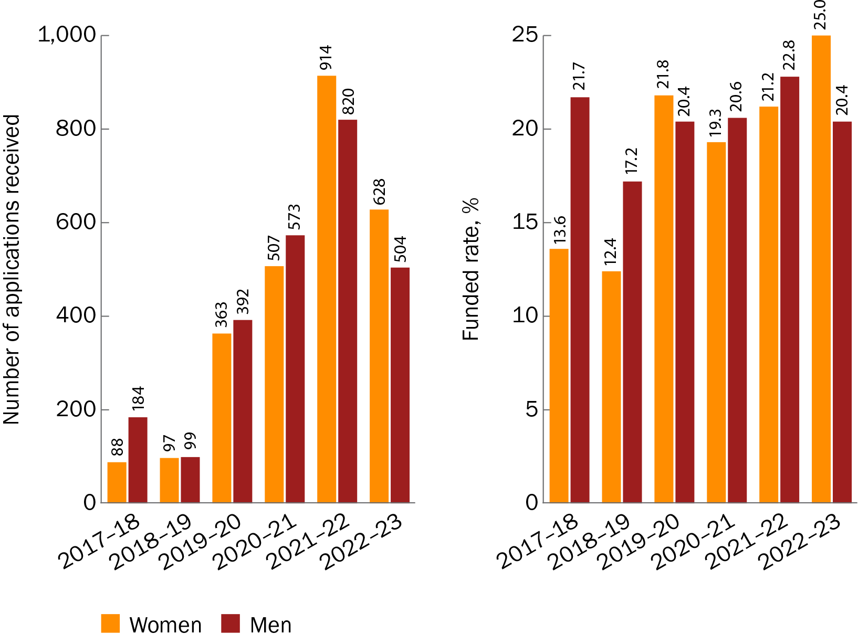

Figure 2 Proportion of funding received each year by women and men lead Chief Investigators

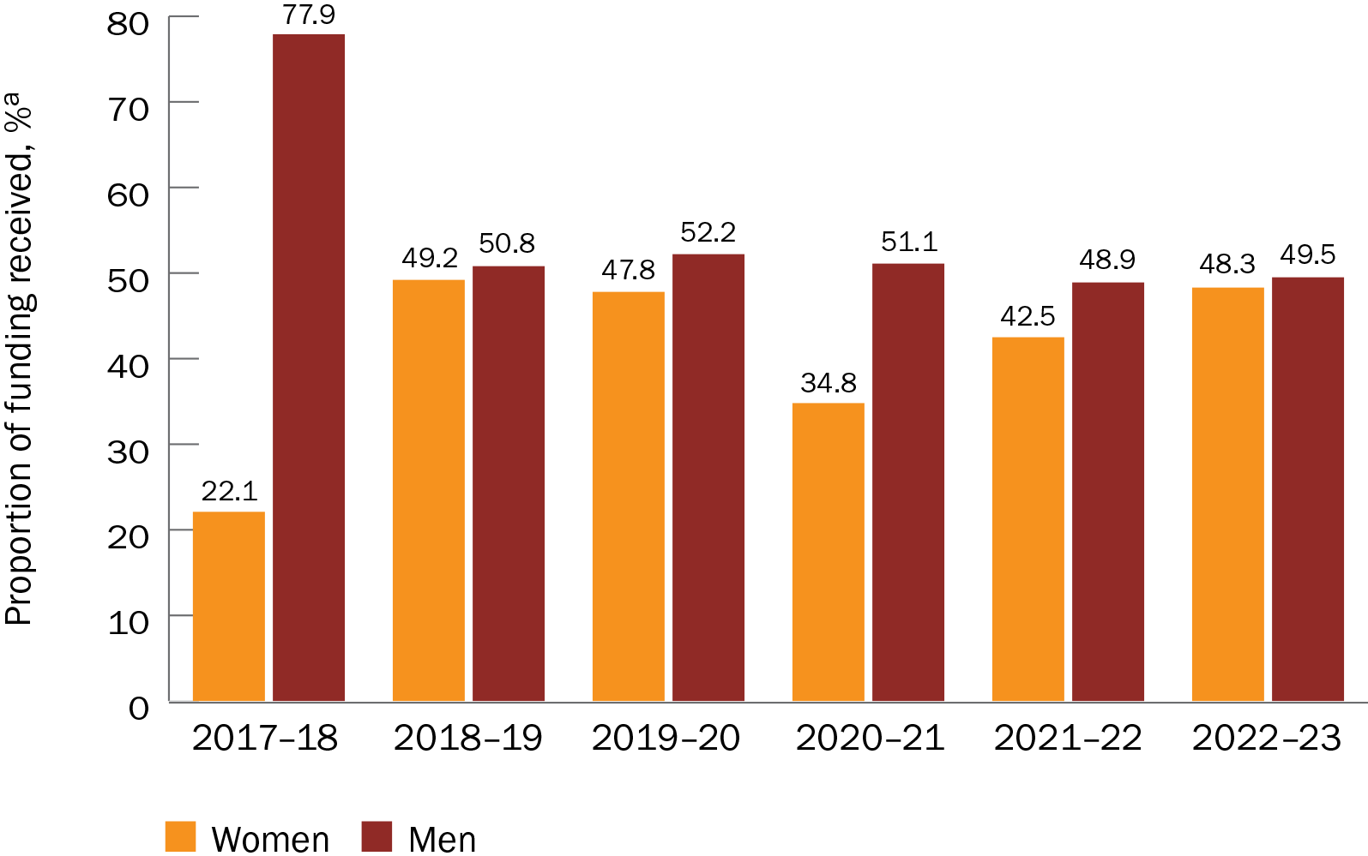

a The proportion of funding received is a percentage of the total funded amount each year for grant opportunities included in this analysis.

Table 1 Annual funding for women and men lead Chief Investigators

| Financial year | Funded amount for women lead Chief Investigators ($)a | Funded amount for men lead Chief Investigators ($)a | Total funded amount ($)b |
| --- | --- | --- | --- |
| 2017–18 | 17,824,267.31 | 62,778,797.06 | 80,603,064.37 |
| 2018–19 | 28,801,994.85 | 29,688,109.46 | 58,490,104.31 |
| 2019–20 | 117,645,910.84 | 128,392,263.81 | 246,038,174.65 |
| 2020–21 | 163,578,019.48 | 240,311,174.90 | 469,918,937.48 |
| 2021–22 | 330,100,260.69 | 379,560,906.11 | 776,047,126.59 |
| 2022–23 | 315,156,256.91 | 322,713,855.81 | 651,985,872.02 |

a Funded amounts are for grant opportunities included in this report (see Approach) for which data were available.

b Includes applications in which the gender was not stated or not provided.

#### All Chief Investigators

The 2022–23 financial year had more women than men Chief Investigator applicants (continuing the outcome first seen in 2021–22), and there were 31 non-binary Chief Investigator applicants. Women also had a higher funded rate than men – this has been more equal in previous years. Non-binary Chief Investigators had a funded rate of 51.6%, although this was based on a small number of applicants (Figure 3).

Figure 3 Number of applicants and funded rates for women, men and non-binary Chief Investigators, by financial year

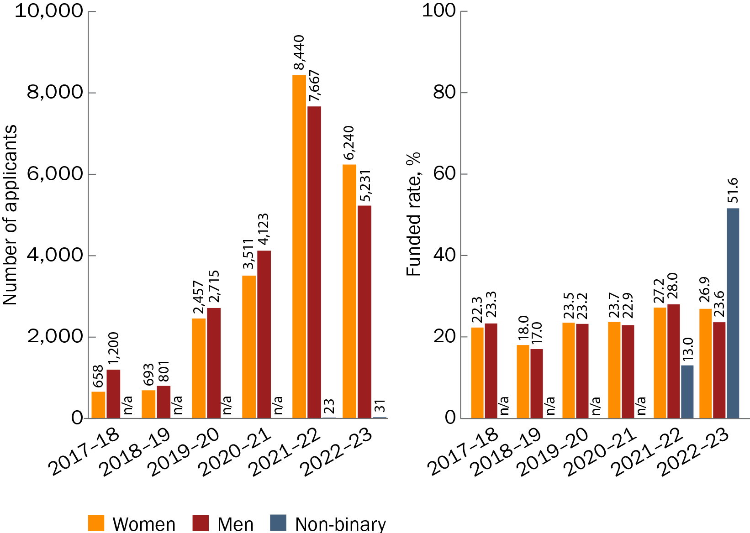

n/a = not applicable because there were <10 applicants

## Grant hubs

Note that comparisons of funded rates and funded amounts between grant hubs should be made with caution because of the small number of BGH-administered grant opportunities – and, therefore, applications – included in this analysis.

When comparing the grant hubs, funded rates tended to be similar for women and men for NHMRC-administered grant opportunities but higher for women for BGH-administered grant opportunities. However, the difference in the funded rates between women and men for BGH-administered MRFF grants has decreased since the previous report, meaning that women and men now seem to have a more equal chance of being funded, regardless of the grant hub.

### NHMRC-administered grant opportunities

#### Overall rates

The overall funded rate was slightly lower for women lead Chief Investigators (22.3% funded from 2,327 applications) than for men (23.0% funded from 2,196 applications), although the gap was smaller than that reported in 2023. Women lead Chief Investigators also received a smaller proportion of the total funding than did men (for grant opportunities that had data available, from all grant hubs) (Figure 4), but again, the difference was smaller than that reported previously.

For all Chief Investigators, overall funded rates were almost the same for women (26.8% funded from 19,148 applicants) and men (26.7% funded from 18,465 applicants). Non-binary Chief Investigators had a higher funded rate (40.0%) than women or men, but this was based on data from only 55 applicants.

Figure 4 Proportion of total funding received by women and men lead Chief Investigators, by grant hub

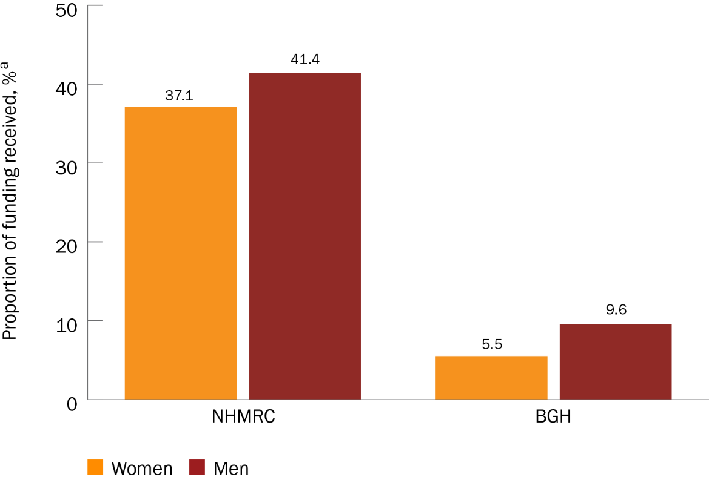

a The proportion of funding received is a percentage of the total funded amount across both grant hubs ($2,283,083,279.42) for grant opportunities included in this analysis.

#### Annual trends

In the 2022–23 financial year, there were more applications from women lead Chief Investigators than from men, continuing the outcome first seen in the 2021–22 financial year. However, unlike the previous year, women had a higher funded rate than men in 2022–23 (Figure 5). Women lead Chief Investigators also received a higher proportion of the total funding than did men in 2022–23, the first time this has happened since MRFF competitive grant opportunities became available in 2017 (Figure 6). Funding data are shown in Table 2.

Figure 5 Number of applications and funded rates for women and men lead Chief Investigators for NHMRC-administered grant opportunities, by financial year

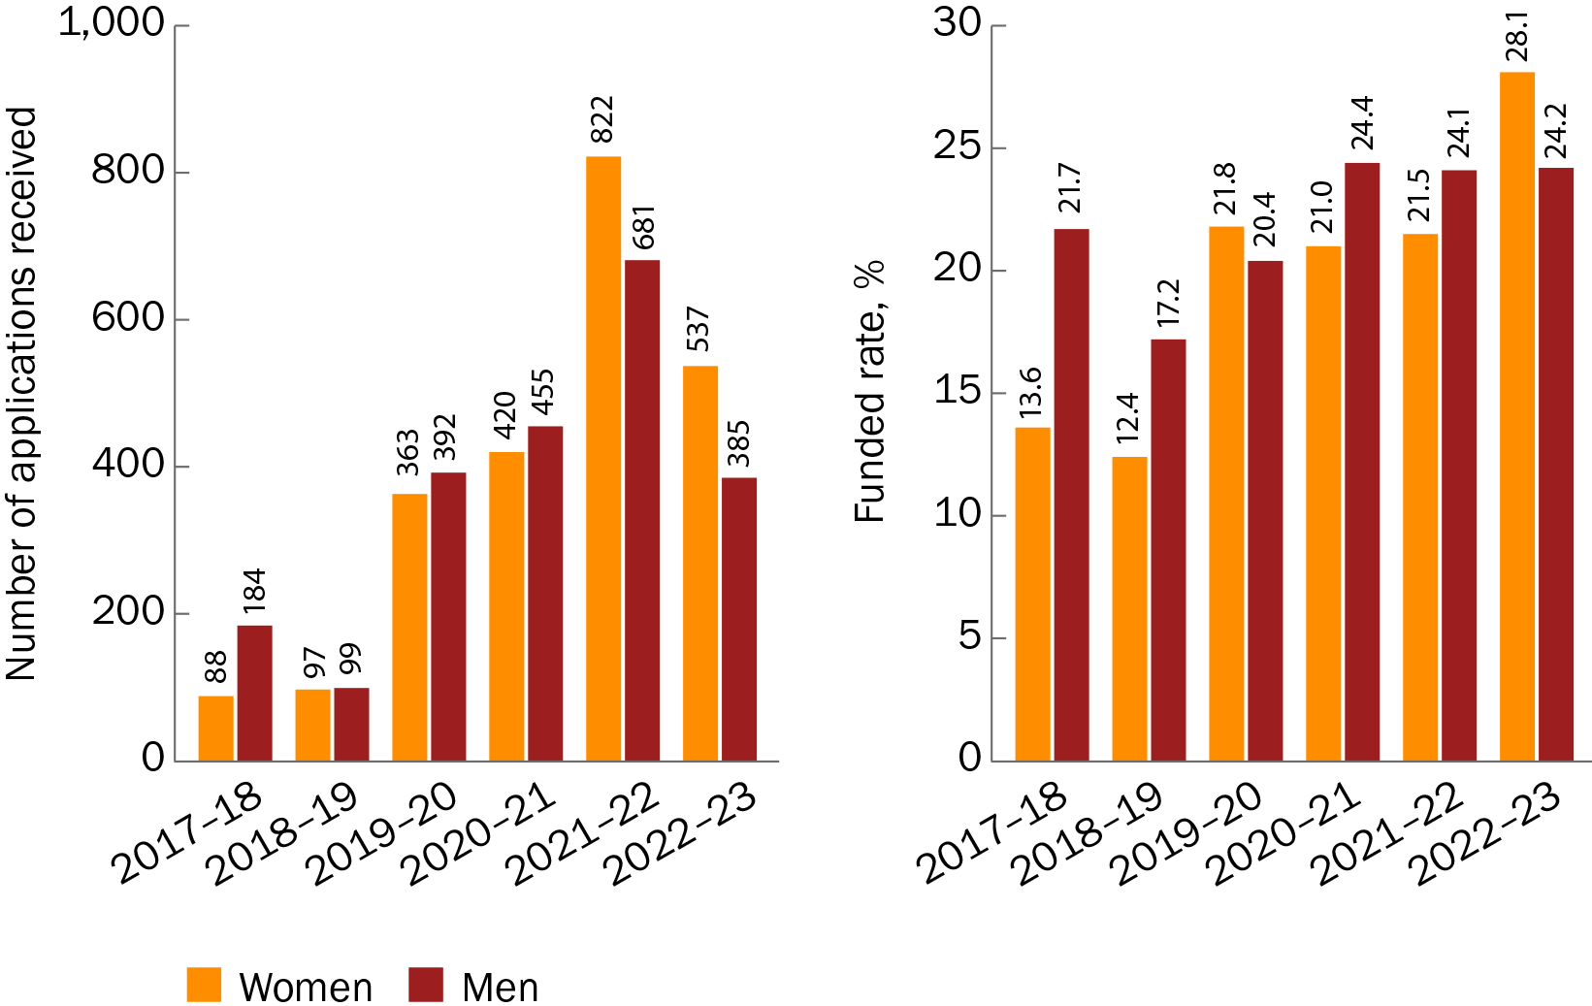

Figure 6 Proportion of funding received each year by women and men lead Chief Investigators for NHMRC-administered grant opportunities

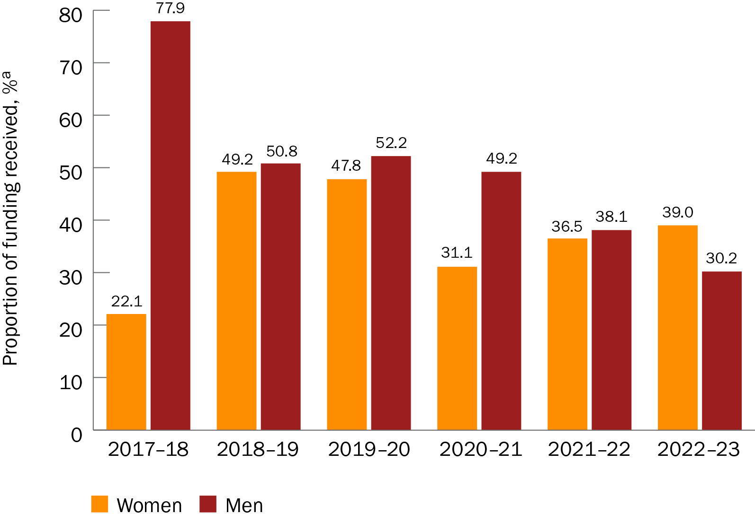

a The proportion of funding received is a percentage of the total funded amount each year for grant opportunities included in this analysis.

Table 2 Annual funding for women and men lead Chief Investigators for NHMRC-administered grant opportunities

| Financial year | Funded amount for women lead Chief Investigators ($)a | Funded amount for men lead Chief Investigators ($)a | Total funded amount ($)b |
| --- | --- | --- | --- |
| 2017–18 | 17,824,267.31 | 62,778,797.06 | 80,603,064.37 |
| 2018–19 | 28,801,994.85 | 29,688,109.46 | 58,490,104.31 |
| 2019–20 | 117,645,910.84 | 128,392,263.81 | 246,038,174.65 |
| 2020–21 | 146,075,906.48 | 231,194,278.90 | 469,918,937.48 |
| 2021–22 | 283,175,877.69 | 295,543,417.11 | 776,047,126.59 |
| 2022–23 | 254,342,400.91 | 196,743,270.81 | 651,985,872.02 |

a Funded amounts are for grant opportunities included in this report (see Approach) for which data were available.

b Includes applications in which the gender was not stated or not provided.

For all Chief Investigators, the 2022–23 financial year was similar to the previous year in that there were more women than men applicants. However, women Chief Investigators had a higher funded rate than men in 2022–23, a reversal of the funded rates for 2021–22. The number of, and funded rates for, non-binary Chief Investigator applicants were higher in 2022–23 than in 2021–22 (Figure 7).

Figure 7 Number of applicants and funded rates for women, men and non-binary Chief Investigators for NHMRC-administered grant opportunities, by financial year

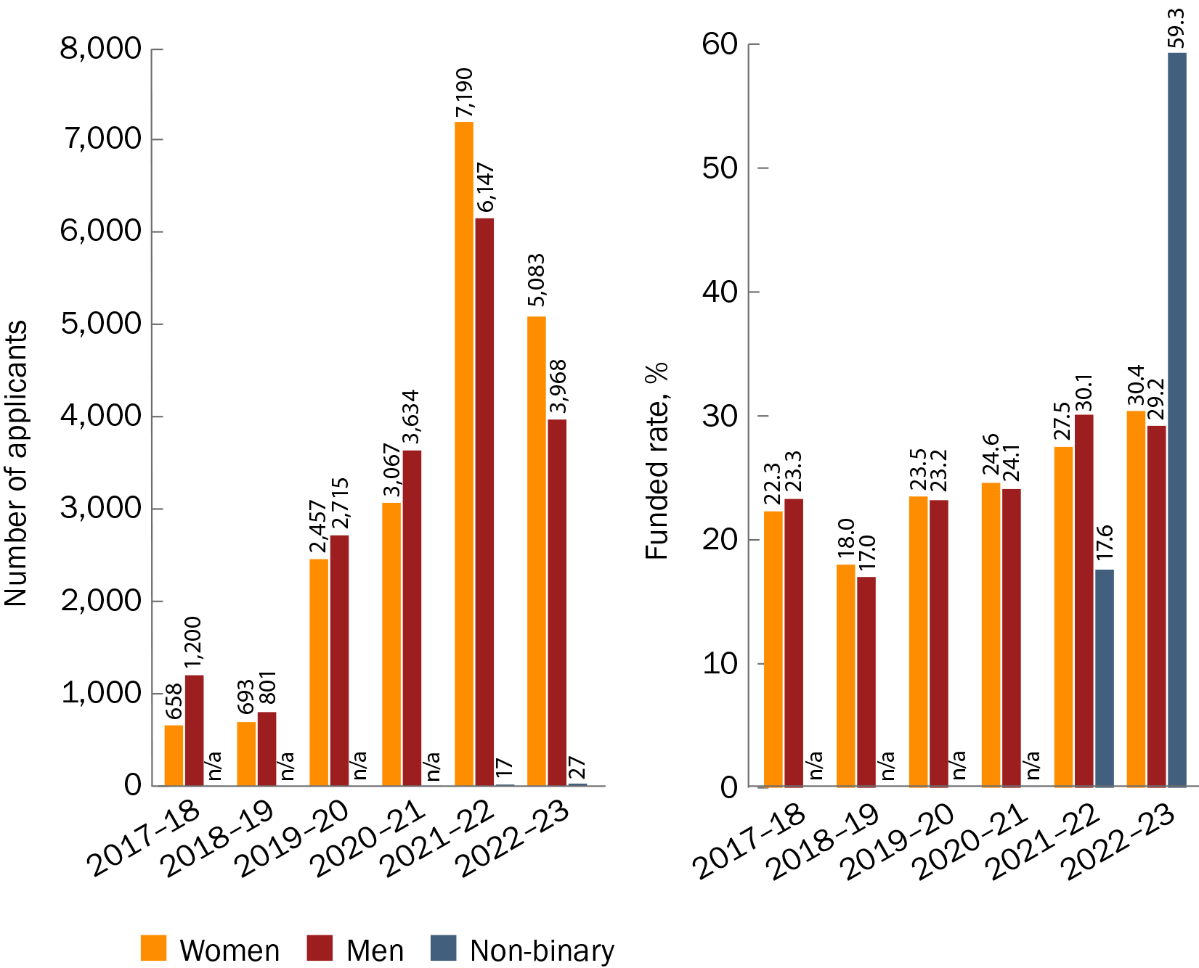

n/a = not applicable because there were <10 applicants

### BGH-administered grant opportunities

#### Overall rates

As was reported in 2023, there were fewer overall applications from women (270) than men (376) lead Chief Investigators. Women lead Chief Investigators still had a higher overall funded rate than men (12.2% funded compared with 10.6% funded), but the difference was smaller than that reported in 2023. Men received a higher proportion of the total funding than did women (for grant opportunities that had data available, from all grant hubs).

Results were similar for all Chief Investigators; there were fewer women applicants than men (2,851 and 3,272 applicants, respectively), but women had a higher overall funded rate than men (18.4% funded compared with 13.4% funded). There were 10 non-binary Chief Investigator applicants, none of whom received funding.

#### Annual trends

Continuing the outcomes seen in previous years, there were fewer applications from women than men lead Chief Investigators in 2022–23. However, unlike in earlier years, women lead Chief Investigators had a lower funded rate than men in 2022–23 (Figure 8). Women also received a much lower proportion of funding than did men (Figure 9). Funding data are shown in Table 3.

Figure 8 Number of applications and funded rates for women and men lead Chief Investigators for BGH-administered grant opportunities, by financial year

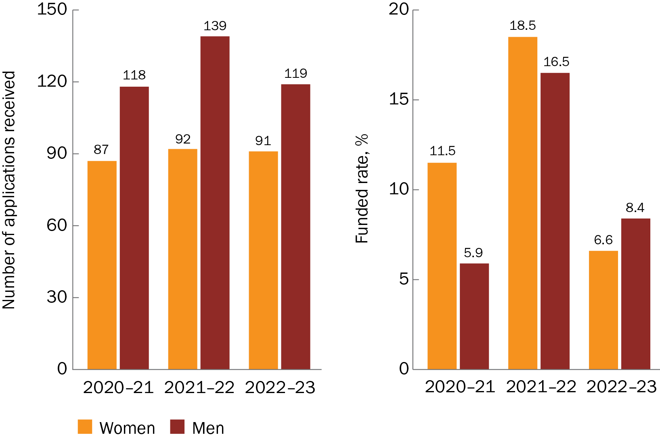

Figure 9 Proportion of funding received each year by women and men lead Chief Investigators for BGH-administered grant opportunities

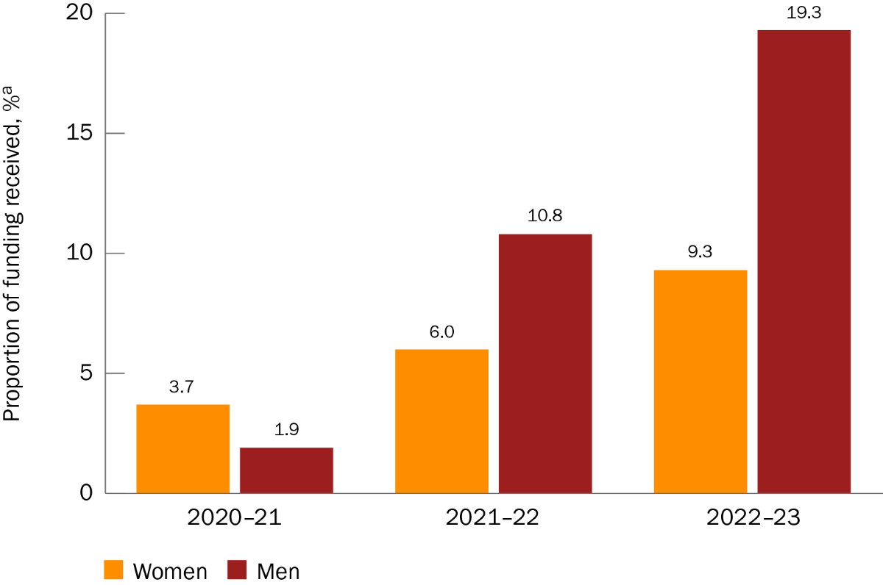

a The proportion of funding received is a percentage of the total funded amount each year for grant opportunities included in this analysis.

Table 3 Annual funding for women and men lead Chief Investigators for BGH-administered grant opportunities

| Financial year | Funded amount for women lead Chief Investigators ($)a | Funded amount for men lead Chief Investigators ($)a | Total funded amount ($)b |
| --- | --- | --- | --- |
| 2020–21 | 17,502,113.00 | 9,116,896.00 | 469,918,937.48 |
| 2021–22 | 46,924,383.00 | 84,017,489.00 | 776,047,126.59 |
| 2022–23 | 60,813,856.00 | 125,970,585.00 | 651,985,872.02 |

a Funded amounts are for grant opportunities included in this report (see Approach) for which data were available.

b Includes applications in which the gender was not stated or not provided.

For all Chief Investigators, the observations reported in 2023 continued. There were more men than women applicants in 2022–23, but women had a higher funded rate than men (Figure 10). No financial years had 10 or more non-binary Chief Investigator applicants.

Figure 10 Number of applicants and funded rates for women and men Chief Investigators for BGH-administered grant opportunities, by financial year

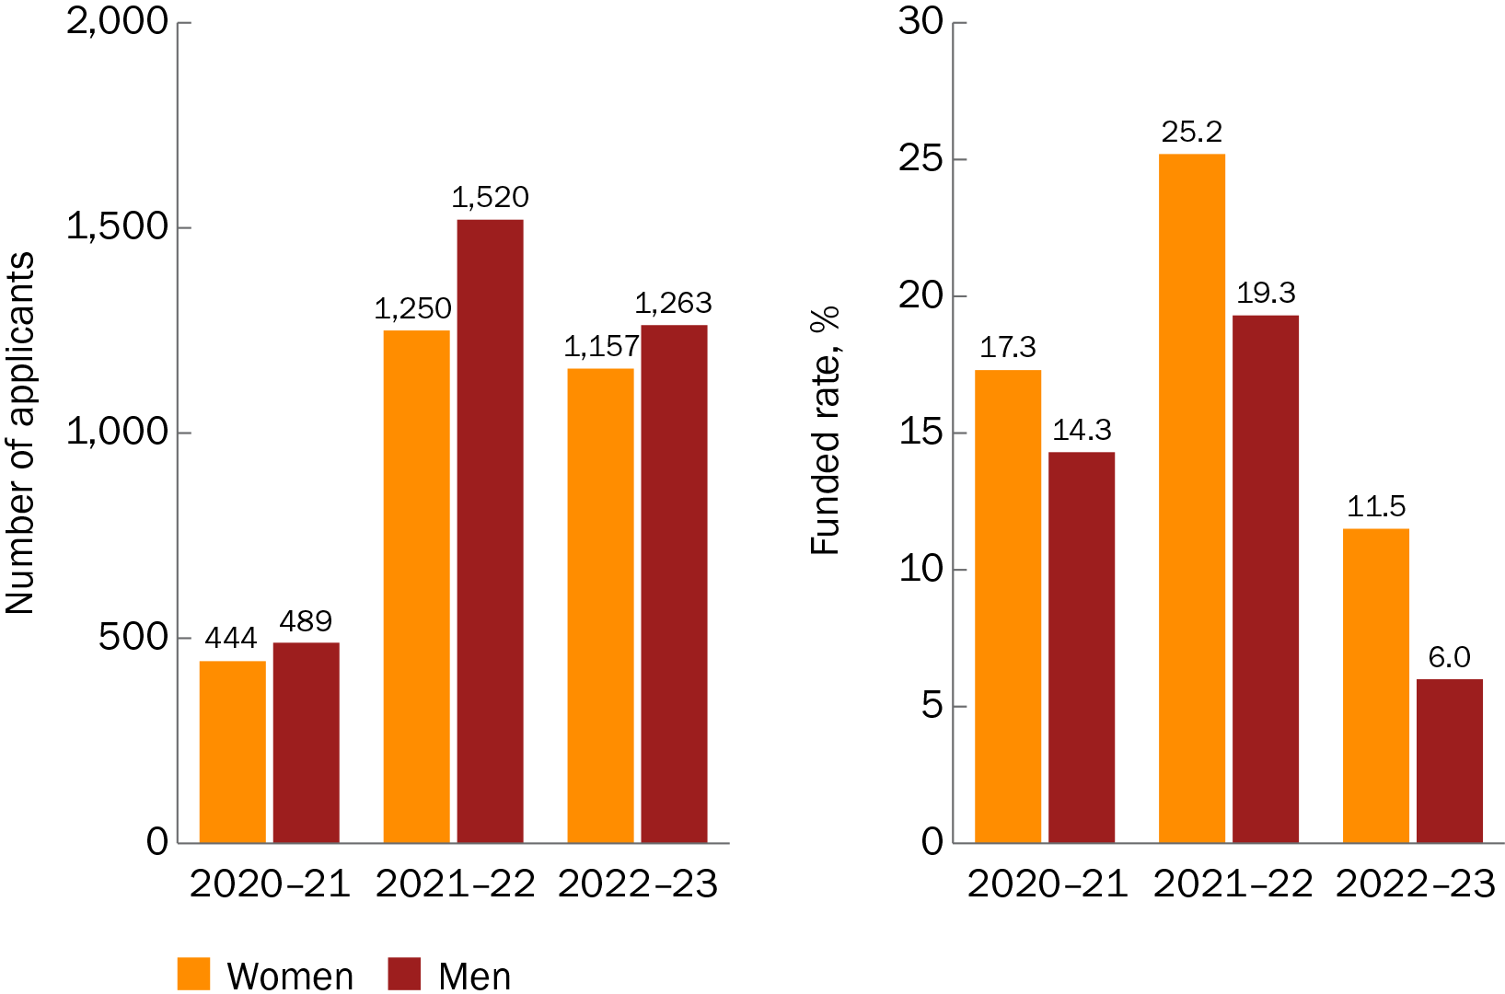

## MRFF themes

### Overall rates

As was reported in 2023, there were more applications from women than men lead Chief Investigators under the MRFF themes ‘Research Translation’ and ‘Researchers’, and women had higher funded rates than men under the themes ‘Research Translation’ and ‘Research Missions’ (Figure 11). However, unlike in the 2023 report, women lead Chief Investigators received a higher proportion of funding than did men under the themes ‘Research Translation’ and ‘Researchers’ (Figure 12). Only the finding for ‘Research Translation’ was statistically significant (P = 0.010).

Figure 11 Number of applications and funded rates for women and men lead Chief Investigators, by MRFF theme

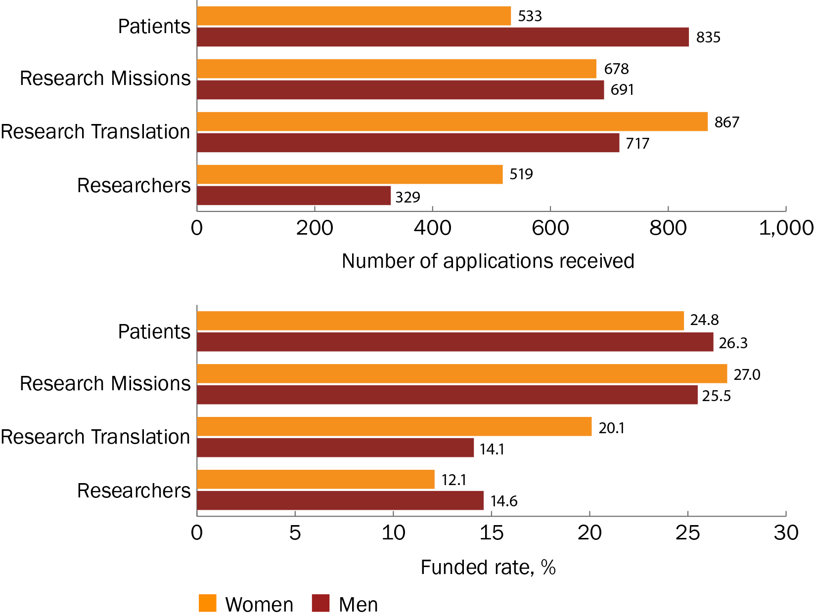

Figure 12 Proportion of funding received by women and men lead Chief Investigators, by MRFF theme

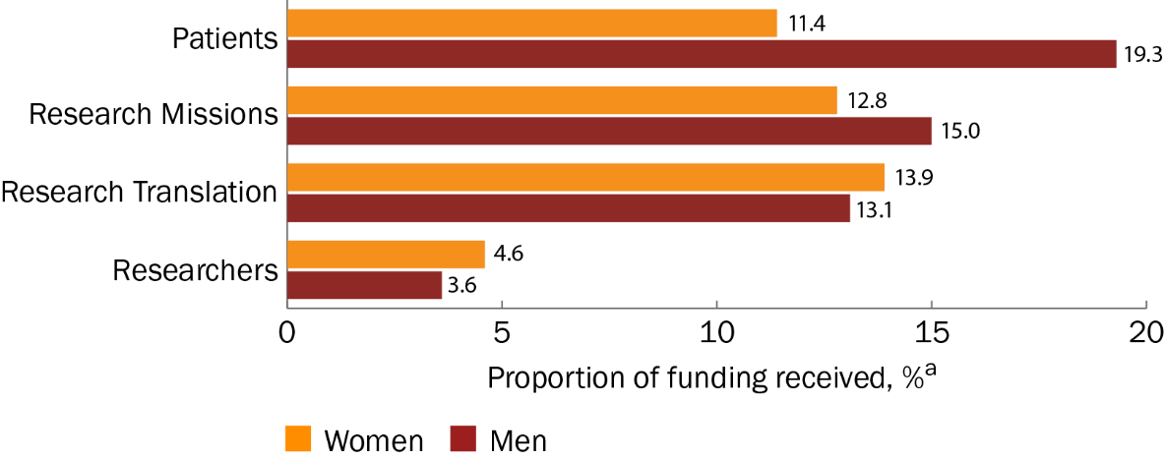

a The proportion of funding received is a percentage of the total funded amount across all MRFF themes ($2,283,083,279.42) for grant opportunities included in this analysis.

For all Chief Investigators, the observations reported in 2023 continued. There were more women than men applicants under the themes ‘Research Translation’ and ‘Researchers’, but women Chief Investigators had a higher funded rate than men under all themes except ‘Researchers’. Of the 3 themes with 10 or more non-binary Chief Investigator applicants, non-binary Chief Investigators had the highest funded rate under the theme ‘Patients’ (Figure 13).

Figure 13 Number of applicants and funded rates for women, men and non-binary Chief Investigators, by MRFF theme

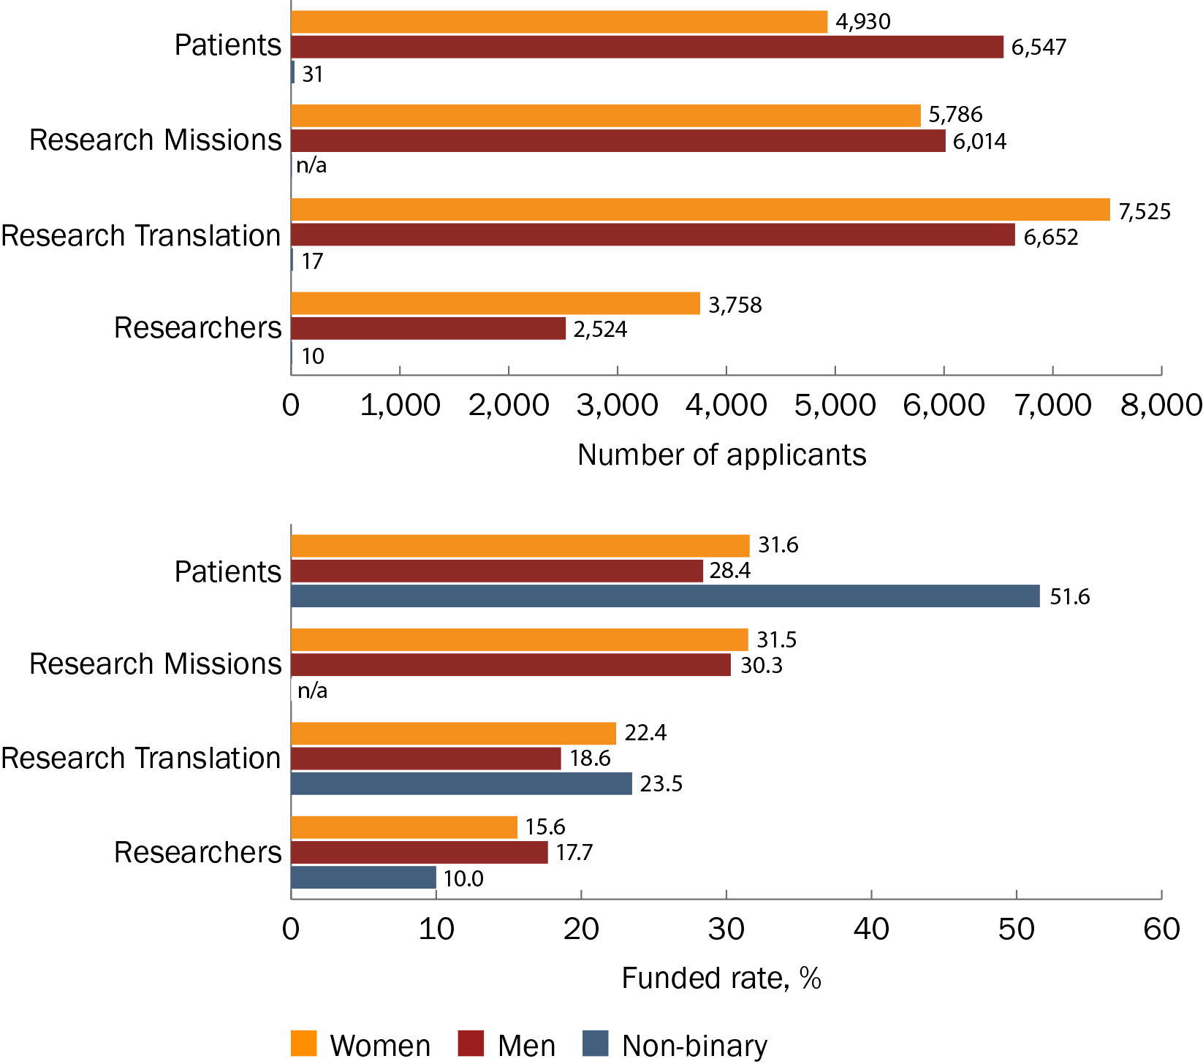

n/a = not applicable because there were <10 applicants

### Annual trends

As identified in the 2023 report, funded rates have generally increased over time for all themes, most notably for the ‘Researchers’ theme. This is likely driven by the Early to Mid-Career Researchers initiative, which is outlined in the [2023 Medical Research Future Fund Early to Mid-Career Researcher grant opportunity outcomes data](https://www.health.gov.au/resources/publications/medical-research-future-fund-early-to-mid-career-researchers-grant-opportunity-outcomes-data?language=en) report.

In the 2022–23 financial year, there were more applications from women than men lead Chief Investigators under all themes except ‘Patients’. Women lead Chief Investigators also had higher funded rates than men under all themes except ‘Research Missions’. However, in 2022–23, men lead Chief Investigators received a higher proportion of funding than did women under all themes except ‘Researchers’ (Table 4).

Results were similar for all Chief Investigators in 2022–23. There were more women than men applicants under all themes except ‘Patients’, for which the numbers of men and women applicants were similar. Women Chief Investigators had funded rates that were similar to or higher than those for men under all themes. Only the themes ‘Patients’ and ‘Research Translation’ had 10 or more non-binary Chief Investigator applicants. Notably, all non-binary Chief Investigators who applied under the theme ‘Patients’ received funding (Table 5).

In the 2022–23 financial year, the 2023 MRFF Models of Care for Sexuality and Gender Diverse People and People with Innate Variations of Sex Characteristics grant opportunity opened. This could be one reason for the increase in non-binary Chief Investigator applicants in the most recent reporting round. Other potential factors include improved reporting and increased self-reporting by non-binary applicants.

Table 4 Number of applications and funded rates for women and men lead Chief Investigators each year, by MRFF theme

| MRFF theme | Financial year | Gender of lead Chief Investigator | Number of applications submitted | Proportion of applications funded | Proportion of funding receiveda |
| --- | --- | --- | --- | --- | --- |
| Patients | 2017–18 | Women | 88 | 13.6% | 22.1% |
| Men | 184 | 21.7% | 77.9% |
| 2018–19 | Women | 16 | 12.5% | 7.3% |
| Men | 39 | 20.5% | 22.1% |
| 2019–20 | Women | 107 | 23.4% | 16.4% |
| Men | 143 | 28.7% | 30.4% |
| 2020–21 | Women | 133 | 24.1% | 15.1% |
| Men | 225 | 27.1% | 26.1% |
| 2021–22 | Women | 126 | 31.7% | 10.7% |
| Men | 151 | 28.5% | 13.5% |
| 2022–23 | Women | 63 | 33.3% | 6.5% |
| Men | 93 | 29.0% | 9.5% |
| Research Missions | 2018–19 | Women | 34 | 11.8% | 31.9% |
| Men | 16 | 18.8% | 15.0% |
| 2019–20 | Women | 142 | 19.0% | 15.2% |
| Men | 177 | 13.6% | 11.2% |
| 2020–21 | Women | 144 | 26.4% | 9.8% |
| Men | 137 | 28.5% | 19.1% |
| 2021–22 | Women | 173 | 39.9% | 13.1% |
| Men | 227 | 33.0% | 15.7% |
| 2022–23 | Women | 185 | 24.3% | 13.6% |
| Men | 134 | 26.1% | 14.6% |
| Research Translation | 2018–19 | Women | 47 | 12.8% | 10.0% |
| Men | 44 | 13.6% | 13.6% |
| 2019–20 | Women | 103 | 25.2% | 15.8% |
| Men | 48 | 14.6% | 3.1% |
| 2020–21 | Women | 220 | 11.8% | 9.0% |
| Men | 196 | 7.7% | 3.7% |
| 2021–22 | Women | 257 | 24.5% | 13.7% |
| Men | 250 | 21.2% | 16.5% |
| 2022–23 | Women | 240 | 22.1% | 18.9% |
| Men | 179 | 11.2% | 21.2% |
| Researchers | 2019–20 | Women | 11 | 9.1% | 0.4% |
| Men | 24 | 33.3% | 7.5% |
| 2020–21 | Women | 10 | 20.0% | 1.0% |
| Men | 15 | 20.0% | 2.2% |
| 2021–22 | Women | 358 | 6.1% | 4.9% |
| Men | 192 | 8.3% | 3.2% |
| 2022–23 | Women | 140 | 27.1% | 9.3% |
| Men | 98 | 21.4% | 4.3% |

a The proportion of funding received is a percentage of the total funded amount each year for grant opportunities included in this analysis.

Table 5 Number of applicants and funded rates for women, men and non-binary Chief Investigators each year, by MRFF theme

|  |  |  |  |  |  |  |  |  |
| --- | --- | --- | --- | --- | --- | --- | --- | --- |
| MRFF theme | Financial year | | Number of women Chief Investigator applicants | Funded rate for women Chief Investigators | Number of men Chief Investigator applicants | Funded rate for men Chief Investigators | Number of non-binary Chief Investigator applicants | Funded rate for non-binary Chief Investigators |
| Patients | | 2017–18 | 658 | 22.3% | 1,200 | 23.3% | n/a | n/a |
| 2018–19 | 137 | 21.9% | 298 | 21.5% | n/a | n/a |
| 2019–20 | 779 | 29.9% | 942 | 28.3% | n/a | n/a |
| 2020–21 | 1,081 | 28.5% | 1,706 | 26.3% | n/a | n/a |
| 2021–22 | 1,432 | 37.2% | 1,508 | 34.0% | 11 | 18.2%a |
| 2022–23 | 843 | 36.4% | 893 | 32.4% | 12 | 100.0%a |
| Research Missions | | 2018–19 | 228 | 18.0% | 196 | 14.3% | n/a | n/a |
| 2019–20 | 927 | 17.2% | 1,216 | 18.9% | n/a | n/a |
| 2020–21 | 952 | 30.7% | 1,101 | 30.0% | n/a | n/a |
| 2021–22 | 1,839 | 44.2% | 2,047 | 41.8% | n/a | n/a |
| 2022–23 | 1,840 | 28.2% | 1,454 | 26.1% | n/a | n/a |
| Research Translation | | 2018–19 | 328 | 16.5% | 307 | 14.3% | n/a | n/a |
| 2019–20 | 674 | 24.2% | 404 | 21.0% | n/a | n/a |
| 2020–21 | 1,377 | 15.3% | 1,193 | 12.2% | n/a | n/a |
| 2021–22 | 2,670 | 27.5% | 2,686 | 24.0% | n/a | n/a |
| 2022–23 | 2,476 | 21.1% | 2,062 | 15.5% | 10 | 20.0%a |
| Researchers | | 2019–20 | 77 | 28.6% | 153 | 30.7% | n/a | n/a |
| 2020–21 | 101 | 20.8% | 123 | 17.1% | n/a | n/a |
| 2021–22 | 2,499 | 8.5% | 1,426 | 9.5% | n/a | n/a |
| 2022–23 | 1,081 | 30.5% | 822 | 29.8% | n/a | n/a |

n/a = not applicable because there were <10 applicants

a Funded rates should be interpreted with caution because of the low number of applicants.

## MRFF initiatives

This analysis included 19 MRFF initiatives (see Table 7 for the full list). The initiatives ‘Researcher Exchange and Development within Industry’ and ‘Medical Research Commercialisation’ were excluded due to a lack of Chief Investigator gender data and because the latter initiative funds organisations rather than individuals or teams. The initiative ‘Rapid Applied Research Translation’ was included in analyses of all Chief Investigators but excluded from lead Chief Investigator analyses because of a lack of gender data in the early years.

As reported in 2023, 8 (44.4%) of the 18 MRFF initiatives considered in the lead Chief Investigator analyses received more applications from women than men. There were 11 initiatives (61.1%) in which the funded rate for women lead Chief Investigators was similar to or higher than that for men. As was also reported in 2023, the initiatives ‘Dementia, Ageing and Aged Care Mission’, ‘Indigenous Health Research Fund’, ‘Traumatic Brain Injury Mission’ and ‘Research Data Infrastructure’ were of note because funded rates for women lead Chief Investigators were almost or more than double those for men; only the findings for ‘Dementia, Ageing and Aged Care Mission’ were statistically significant (P = 0.022) (Table 6).

For all Chief Investigators, there were 9 MRFF initiatives (out of 19; 47.4%) with more women than men Chief Investigator applicants. However, there were 14 initiatives (73.3%) in which women Chief Investigators had a higher funded rate than men. Three initiatives had 10 or more non-binary Chief Investigator applicants. Of these, ‘Emerging Priorities and Consumer Driven Research’ had both the highest number of non-binary applicants and the highest funded rate for non-binary Chief Investigators (Table 7).

Table 6 Number of applications, funded rates and funding received for women and men lead Chief Investigators, by MRFF initiative

| MRFF initiative | Gender of lead Chief Investigator | Number of applications submitted | Proportion of applications funded | Amount funded | Proportion of total funded amounta |
| --- | --- | --- | --- | --- | --- |
| Australian Brain Cancer Mission | Women | 4 | 25.0% | $5,991,219.44 | 0.3% |
| Men | 12 | 25.0% | $5,462,646.70 | 0.2% |
| Cardiovascular Health Mission | Women | 135 | 28.1% | $48,633,733.21 | 2.1% |
| Men | 195 | 25.1% | $62,181,409.62 | 2.7% |
| Clinical Trials Activity | Women | 383 | 21.9% | $178,863,581.37 | 7.8% |
| Men | 633 | 24.8% | $302,940,027.30 | 13.3% |
| Clinician Researchers | Women | 155 | 20.0% | $42,201,259.24 | 1.8% |
| Men | 66 | 25.8% | $23,578,810.00 | 1.0% |
| Dementia, Ageing and Aged Care Mission | Women | 152 | 25.0% | $70,916,579.24 | 3.1% |
| Men | 92 | 14.1% | $18,033,977.42 | 0.8% |
| Early to Mid-Career Researchers | Women | 343 | 8.5% | $57,110,958.42 | 2.5% |
| Men | 224 | 8.9% | $29,019,606.65 | 1.3% |
| Emerging Priorities and Consumer Driven Research | Women | 144 | 32.6% | $81,305,984.46 | 3.6% |
| Men | 178 | 30.9% | $119,943,706.76 | 5.3% |
| Frontier Health and Medical Research | Women | 34 | 20.6% | $8,533,084.33 | 0.4% |
| Men | 72 | 22.2% | $33,282,514.67 | 1.5% |
| Genomics Health Futures Mission | Women | 43 | 41.9% | $46,751,664.87 | 2.0% |
| Men | 90 | 47.8% | $120,279,962.94 | 5.3% |
| Global Health | Women | 12 | 16.7% | $1,965,306.90 | 0.1% |
| Men | 29 | 31.0% | $18,142,046.09 | 0.8% |
| Indigenous Health Research Fund | Women | 73 | 53.4% | $48,688,594.74 | 2.1% |
| Men | 37 | 37.8% | $15,527,732.02 | 0.7% |
| Million Minds Mental Health Research Mission | Women | 158 | 12.7% | $37,972,299.31 | 1.7% |
| Men | 82 | 9.8% | $34,837,160.35 | 1.5% |
| National Critical Research Infrastructure | Women | 100 | 6.0% | $59,426,446.00 | 2.6% |
| Men | 190 | 9.5% | $122,085,749.00 | 5.3% |
| Preventive and Public Health Research | Women | 563 | 23.8% | $179,839,845.58 | 7.9% |
| Men | 331 | 18.7% | $85,813,316.35 | 3.8% |
| Primary Health Care Research | Women | 115 | 17.4% | $36,894,731.25 | 1.6% |
| Men | 72 | 15.3% | $16,897,946.34 | 0.7% |
| Research Data Infrastructure | Women | 68 | 14.7% | $23,490,386.00 | 1.0% |
| Men | 98 | 5.1% | $8,677,450.00 | 0.4% |
| Stem Cell Therapies Mission | Women | 66 | 21.2% | $13,583,405.07 | 0.6% |
| Men | 124 | 29.8% | $80,015,107.24 | 3.5% |
| Traumatic Brain Injury Mission | Women | 28 | 35.7% | $13,902,506.65 | 0.6% |
| Men | 21 | 14.3% | $1,365,177.70 | 0.1% |

a Expressed as a percentage of the total funded amount across all initiatives ($2,283,083,279.42) for grant opportunities included in this analysis. Percentages do not equal 100% because only data for men and women are reported.

Table 7 Number of applicants and funded rates for women, men and non-binary Chief Investigators, by MRFF initiative

| MRFF initiative | Number of women Chief Investigator applicants | Funded rate for women Chief Investigators | Number of men Chief Investigator applicants | Funded rate for men Chief Investigators | Number of non-binary Chief Investigator applicants | Funded rate for non-binary Chief Investigators |
| --- | --- | --- | --- | --- | --- | --- |
| Australian Brain Cancer Mission | 73 | 47.9% | 119 | 37.0% | n/a | n/a |
| Cardiovascular Health Mission | 1,134 | 31.9% | 1,630 | 29.9% | n/a | n/a |
| Clinical Trials Activity | 3,416 | 27.8% | 5,058 | 26.5% | 13 | 38.5%a |
| Clinician Researchers | 1,378 | 22.1% | 821 | 26.7% | n/a | n/a |
| Dementia, Ageing and Aged Care Mission | 1,412 | 23.6% | 1,003 | 21.7% | n/a | n/a |
| Early to Mid-Career Researchers | 2,202 | 10.8% | 1,427 | 11.3% | n/a | n/a |
| Emerging Priorities and Consumer Driven Research | 1,404 | 41.7% | 1,369 | 36.3% | 18 | 61.1%a |
| Frontier Health and Medical Research | 261 | 21.1% | 480 | 24.4% | n/a | n/a |
| Genomics Health Futures Mission | 659 | 55.7% | 818 | 51.0% | n/a | n/a |
| Global Health | 173 | 28.3% | 214 | 27.6% | n/a | n/a |
| Indigenous Health Research Fund | 601 | 53.2% | 350 | 49.1% | n/a | n/a |
| Million Minds Mental Health Research Mission | 1,053 | 14.7% | 761 | 11.4% | n/a | n/a |
| National Critical Research Infrastructure | 937 | 10.7% | 1,377 | 11.4% | n/a | n/a |
| Preventive and Public Health Research | 4,420 | 26.7% | 3,167 | 25.3% | 10 | 40.0%a |
| Primary Health Care Research | 933 | 22.1% | 711 | 19.3% | n/a | n/a |
| Rapid Applied Research Translation | 305 | 24.6% | 195 | 13.3% | n/a | n/a |
| Research Data Infrastructure | 894 | 11.1% | 1,162 | 8.3% | n/a | n/a |
| Stem Cell Therapies Mission | 494 | 31.0% | 773 | 33.4% | n/a | n/a |
| Traumatic Brain Injury Mission | 214 | 28.0% | 262 | 21.8% | n/a | n/a |

n/a = not applicable because there were <10 applicants

a Funded rates should be interpreted with caution because of the low number of applicants.

## Broad research area

Note that broad research area data were only available for NHMRC-administered grant opportunities. Also, several funded rates for the 2017–18 and 2018–19 financial years – especially for the broad research area ‘Basic science’ – should be interpreted with caution because of low numbers of applications.

### Overall rates

As was reported in 2023, more women than men lead Chief Investigators applied under the broad research areas ‘Health services’ and ‘Public health’, whereas more men applied under ‘Basic science’ and ‘Clinical medicine and science’. ‘Public health’ remained the only broad research area in which women lead Chief Investigators had a higher funded rate than men (Figure 14).

Similar findings were seen for all Chief Investigators. There were more women than men Chief Investigator applicants under the broad research areas ‘Health services’ and ‘Public health’. Women Chief Investigators had a higher funded rate than men under the broad research areas ‘Public health’ and ‘Clinical medicine and science’. There were 2 broad research areas with 10 or more non-binary Chief Investigator applicants: ‘Clinical medicine and science’ and ‘Health services’. Almost half of the non-binary Chief Investigator applicants under the research area ‘Clinical medicine and science’ received funding (Figure 15).

Figure 14 Number of applications and funded rates for women and men lead Chief Investigators, by broad research area

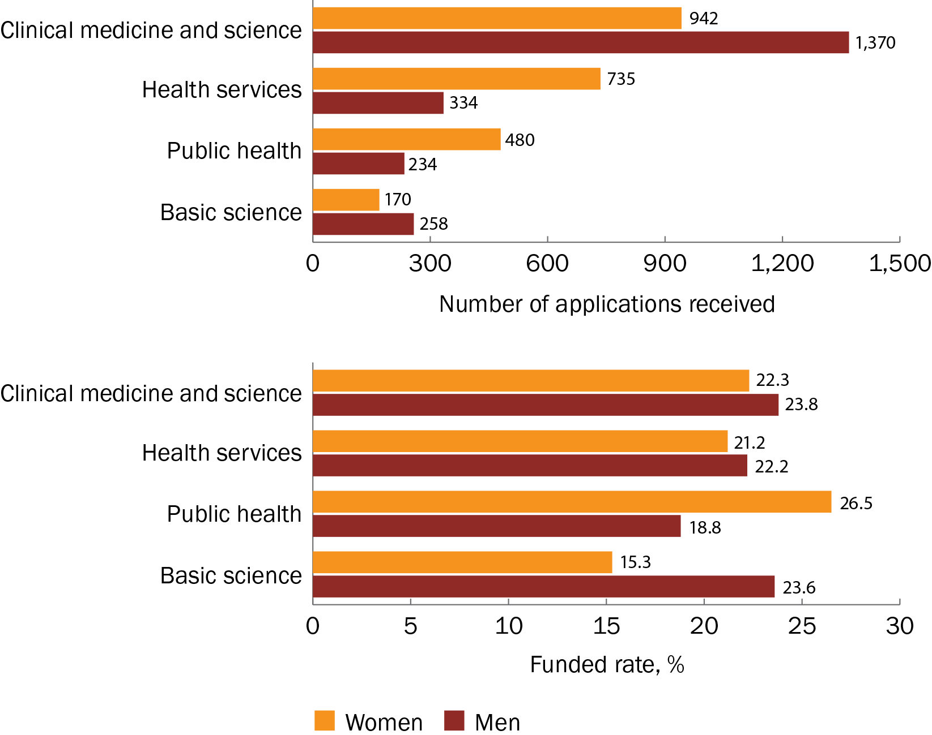

Figure 15 Number of applicants and funded rates for women, men and non-binary Chief Investigators, by broad research area

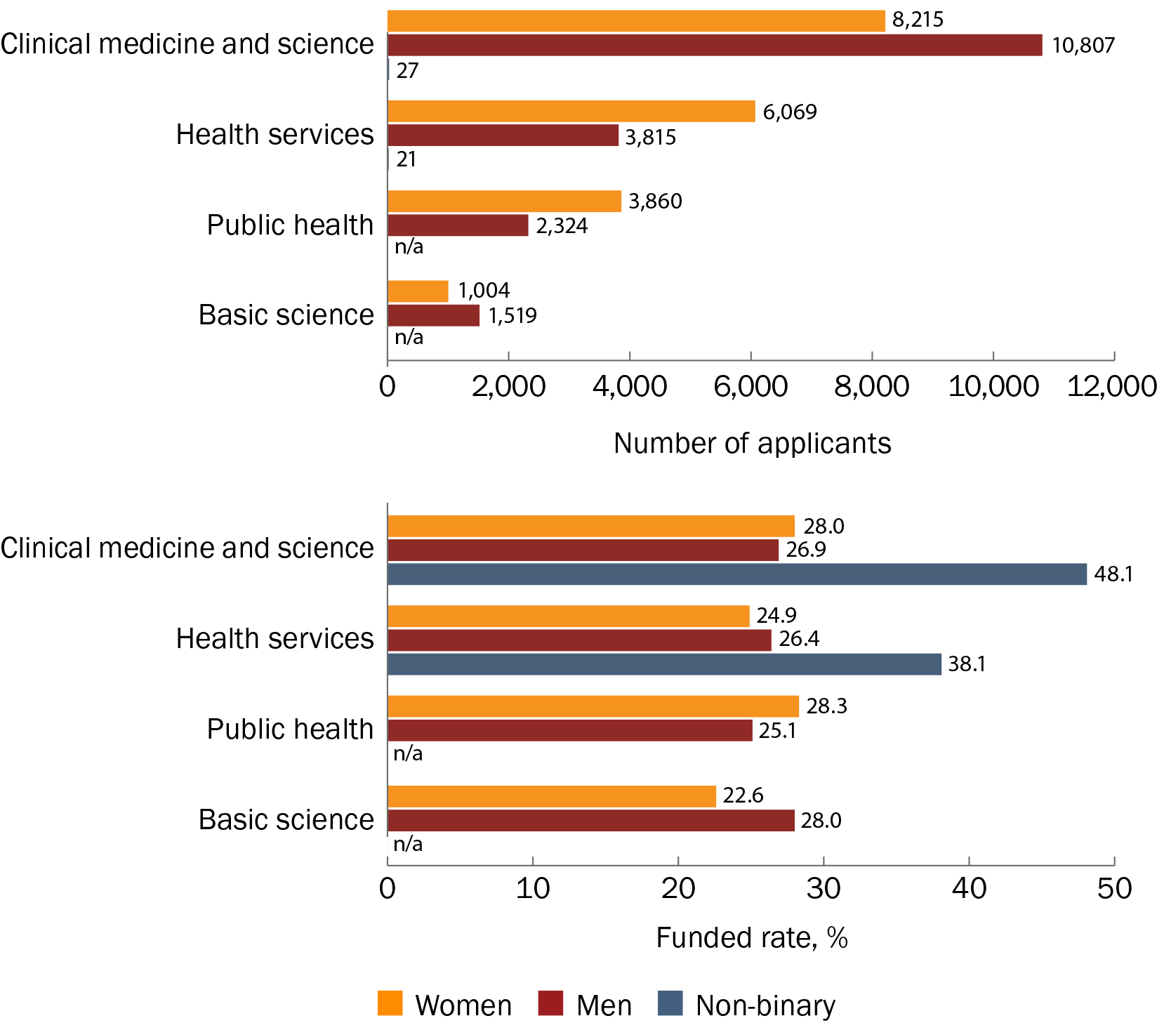

n/a = not applicable because there were <10 applicants

### Annual trends

In the 2022–23 financial year, all broad research areas had fewer applications from both women and men lead Chief Investigators than in the previous financial year. There were more applications from women than men lead Chief Investigators under all broad research areas except ‘Clinical medicine and science’. Women lead Chief Investigators also had a higher funded rate than men in 3 of the 4 broad research areas, with the exception being ‘Basic science’ (Table 8).

As with lead Chief Investigators, the 2022–23 financial year saw fewer women and men Chief Investigator applicants than the previous financial year in all broad research areas. More women than men Chief Investigators applied under the research areas ‘Health services’ and ‘Public health’, but the funded rates for women were similar to or higher than those for men under all research areas except ‘Basic science’. Only ‘Clinical medicine and science’ and ‘Health services’ had 10 or more non-binary Chief Investigator applicants in 2022–23. In both of these research areas, the funded rates for non-binary applicants exceeded 60% (Table 9).

Table 8 Number of applications and funded rates for women and men lead Chief Investigators each year, by broad research area

| Broad research area | Financial year | Number of applications – women lead Chief Investigators | Proportion of applications funded – women lead Chief Investigators | Number of applications – men lead Chief Investigators | Proportion of applications funded – men lead Chief Investigators |
| --- | --- | --- | --- | --- | --- |
| Clinical medicine and science | 2017–18 | 70 | 12.9% | 171 | 22.8% |
| 2018–19 | 40 | 7.5% | 61 | 18.0% |
| 2019–20 | 132 | 21.2% | 225 | 25.3% |
| 2020–21 | 211 | 21.3% | 327 | 23.9% |
| 2021–22 | 313 | 22.4% | 369 | 24.7% |
| 2022–23 | 176 | 31.3% | 217 | 23.0% |
| Health services | 2017–18 | 8 | 0.0%a | 1 | 0.0%a |
| 2018–19 | 37 | 18.9% | 31 | 19.4% |
| 2019–20 | 101 | 19.8% | 56 | 7.1% |
| 2020–21 | 112 | 19.6% | 48 | 25.0% |
| 2021–22 | 288 | 18.8% | 108 | 26.9% |
| 2022–23 | 189 | 28.0% | 90 | 25.6% |
| Public health | 2017–18 | 8 | 25.0%a | 10 | 10.0%a |
| 2018–19 | 19 | 10.5%a | 7 | 0.0%a |
| 2019–20 | 103 | 24.3% | 64 | 17.2% |
| 2020–21 | 67 | 22.4% | 24 | 25.0% |
| 2021–22 | 142 | 30.3% | 78 | 17.9% |
| 2022–23 | 141 | 28.4% | 51 | 23.5% |
| Basic science | 2017–18 | 2 | 50.0%a | 2 | 0.0%a |
| 2018–19 | 1 | 0.0%a | 0 | n/a |
| 2019–20 | 27 | 22.2% | 47 | 17.0% |
| 2020–21 | 30 | 20.0% | 56 | 26.8% |
| 2021–22 | 79 | 12.7% | 126 | 23.8% |
| 2022–23 | 31 | 9.7% | 27 | 29.6% |

n/a = not applicable

a Funded rates should be interpreted with caution because of the low number of applications.

Table 9 Number of applicants and funded rates for women, men and non-binary Chief Investigators each year, by broad research area

| Broad research area | Financial year | Number of women Chief Investigator applicants | Proportion of women Chief Investigators funded | Number of men Chief Investigator applicants | Proportion of men Chief Investigators funded | Number of non-binary Chief Investigator applicants | Proportion of non-binary Chief Investigators funded |
| --- | --- | --- | --- | --- | --- | --- | --- |
| Clinical medicine and science | 2017–18 | 551 | 23.8% | 1,090 | 23.8% | n/a | n/a |
| 2018–19 | 290 | 16.9% | 482 | 17.0% | n/a | n/a |
| 2019–20 | 988 | 27.0% | 1,530 | 25.4% | n/a | n/a |
| 2020–21 | 1,614 | 25.6% | 2,538 | 23.8% | n/a | n/a |
| 2021–22 | 2,868 | 28.9% | 3,164 | 31.2% | n/a | n/a |
| 2022–23 | 1,904 | 32.0% | 2,003 | 29.6% | 11 | 72.7%a |
| Health services | 2017–18 | 38 | 0.0% | 30 | 0.0% | n/a | n/a |
| 2018–19 | 289 | 22.1% | 230 | 21.7% | n/a | n/a |
| 2019–20 | 673 | 18.9% | 493 | 15.4% | n/a | n/a |
| 2020–21 | 801 | 23.0% | 515 | 22.9% | n/a | n/a |
| 2021–22 | 2,478 | 24.1% | 1,413 | 29.2% | n/a | n/a |
| 2022–23 | 1,790 | 30.0% | 1,134 | 30.9% | 11 | 63.6%a |
| Public health | 2017–18 | 60 | 21.7% | 68 | 22.1% | n/a | n/a |
| 2018–19 | 111 | 10.8% | 83 | 4.8% | n/a | n/a |
| 2019–20 | 673 | 22.6% | 472 | 22.7% | n/a | n/a |
| 2020–21 | 474 | 24.5% | 272 | 24.3% | n/a | n/a |
| 2021–22 | 1,335 | 32.4% | 796 | 28.3% | n/a | n/a |
| 2022–23 | 1,207 | 30.4% | 633 | 26.2% | n/a | n/a |
| Basic science | 2017–18 | n/a | n/a | 12 | 41.7%a | n/a | n/a |
| 2018–19 | n/a | n/a | n/a | n/a | n/a | n/a |
| 2019–20 | 123 | 25.2% | 220 | 26.4% | n/a | n/a |
| 2020–21 | 178 | 23.0% | 309 | 28.2% | n/a | n/a |
| 2021–22 | 509 | 23.6% | 774 | 29.5% | n/a | n/a |
| 2022–23 | 182 | 17.6% | 198 | 24.2% | n/a | n/a |

n/a = not applicable because there were <10 applicants

a Funded rates should be interpreted with caution because of the low number of applicants.

## Application budgets

### Overall rates

As was reported in 2023, women lead Chief Investigators applied for smaller grant budgets (<$1 million) more often than men but had higher funded rates than men for budgets of $1 million and greater (Figure 16). Despite women’s higher funded rates, however, men lead Chief Investigators continued to receive a proportion of funding that was similar to or higher than that received by women for most budget bands, especially for budgets of $2 million and over (Figure 17).

Similar findings for applications and funded rates were seen for women and men Chief Investigators. There were only 2 budget bands with 10 or more non-binary Chief Investigator applicants: $0.5 million to <$1 million and $2 million to <$5 million (Figure 18).

Figure 16 Number of applications and funded rates for women and men lead Chief Investigators, by application budget

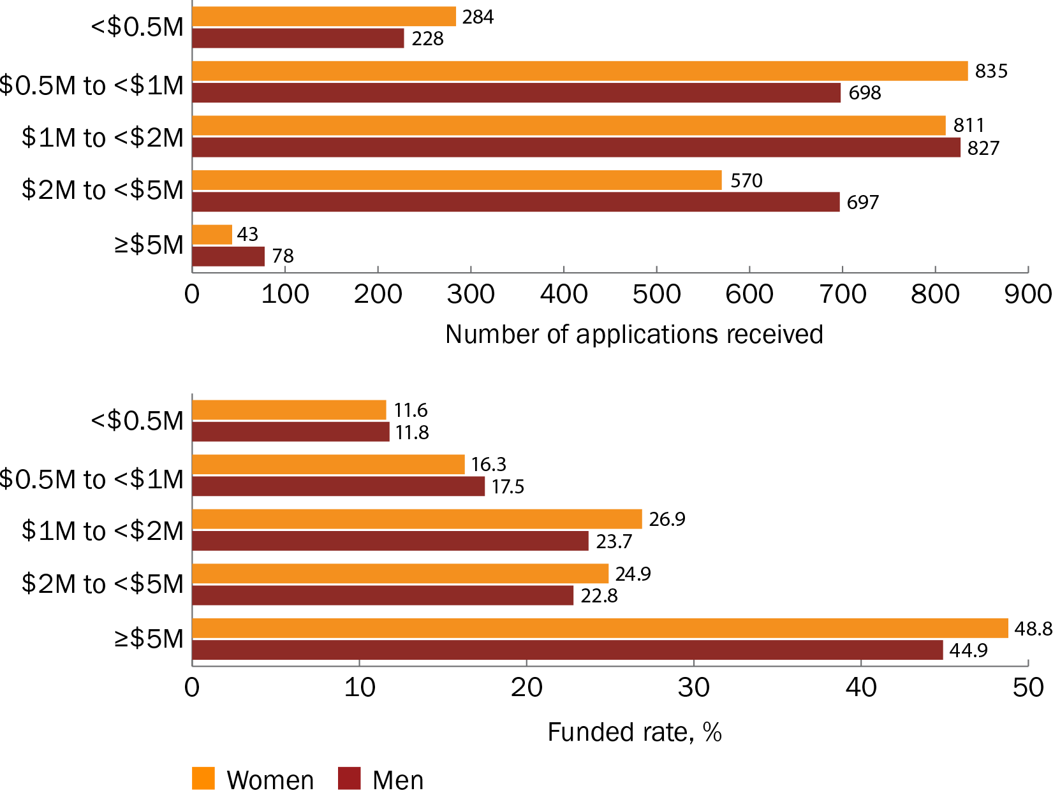

Figure 17 Proportion of funding received by women and men lead Chief Investigators, by application budget

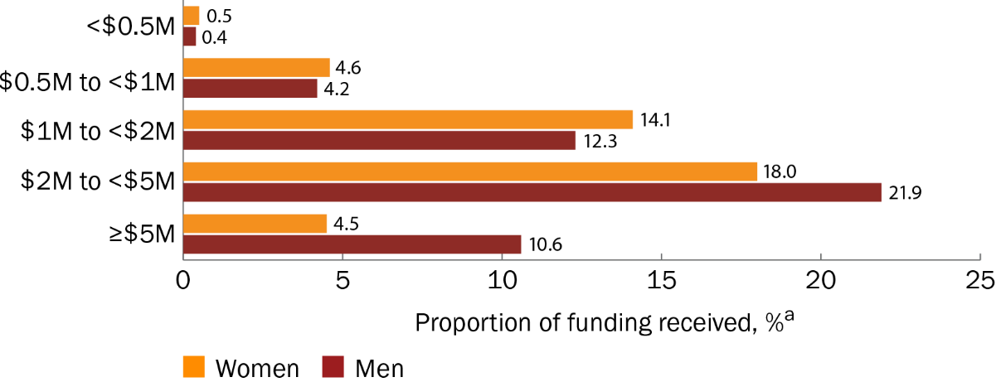

a The proportion of funding received is a percentage of the total funded amount across all application budgets ($2,283,083,279.42) for grant opportunities included in this analysis.

Figure 18 Number of applicants and funded rates for women, men and non-binary Chief Investigators, by application budget

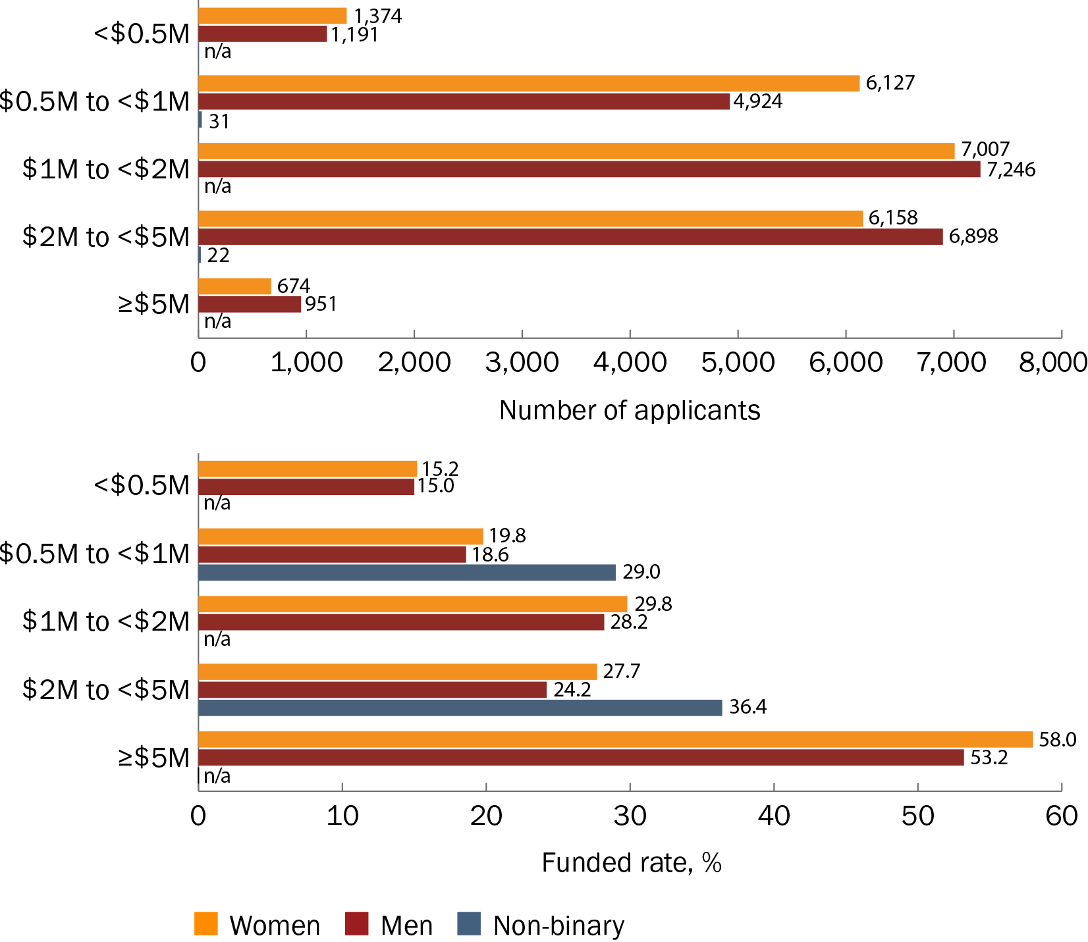

n/a = not applicable because there were <10 applicants

### Annual trends

The 2022–23 financial year had fewer applications and fewer applicants overall than the 2021–22 financial year. This was especially notable for the number of applications received from lead Chief Investigators for the highest budget band (≥$5 million).

For lead Chief Investigators, the 2022–23 financial year had generally the same outcomes seen in previous years – that more women than men submitted applications for grant budgets of less than $2 million, while more men than women submitted applications for grant budgets of $2 million and greater. However, unlike the previous financial year, women lead Chief Investigators in 2022–23 had higher funded rates than men for all budget bands (Table 10).

Similar findings were seen for all Chief Investigators in the 2022–23 financial year. There were more women than men Chief Investigator applicants for application budgets of less than $2 million, and there were more men than women applicants for budgets of $2 million and greater. However, women Chief Investigators had a higher annual funded rate than men for all budget bands. The only budget band with 10 or more non-binary Chief Investigator applicants (for both 2021–22 and 2022–23) was $0.5 million to <$1 million (Table 11).

Table 10 Number of applications and funded rates for women and men lead Chief Investigators each year, by application budget

| Application budget | Financial year | Number of applications – women lead Chief Investigators | Proportion of applications funded – women lead Chief Investigators | Number of applications – men lead Chief Investigators | Proportion of applications funded – men lead Chief Investigators |
| --- | --- | --- | --- | --- | --- |
| <$0.5 million | 2017–18 | 8 | 0.0%a | 12 | 33.3%a |
| 2018–19 | 7 | 14.3%a | 1 | 0.0%a |
| 2019–20 | 79 | 15.2% | 77 | 10.4% |
| 2020–21 | 62 | 12.9% | 51 | 13.7% |
| 2021–22 | 73 | 2.7% | 57 | 7.0% |
| 2022–23 | 55 | 18.2% | 30 | 13.3% |
| $0.5 million–<$1 million | 2017–18 | 18 | 11.1% | 33 | 6.1% |
| 2018–19 | 23 | 4.3% | 19 | 26.3% |
| 2019–20 | 119 | 17.6% | 125 | 17.6% |
| 2020–21 | 126 | 19.0% | 127 | 23.6% |
| 2021–22 | 342 | 10.2% | 266 | 13.5% |
| 2022–23 | 207 | 25.6% | 128 | 21.1% |
| $1 million–<$2 million | 2017–18 | 41 | 17.1% | 103 | 24.3% |
| 2018–19 | 34 | 14.7% | 52 | 11.5% |
| 2019–20 | 119 | 24.4% | 108 | 25.9% |
| 2020–21 | 214 | 17.8% | 238 | 14.7% |
| 2021–22 | 251 | 34.7% | 205 | 34.1% |
| 2022–23 | 152 | 34.2% | 121 | 26.4% |
| $2 million–<$5 million | 2017–18 | 19 | 15.8% | 32 | 28.1% |
| 2018–19 | 31 | 12.9% | 27 | 22.2% |
| 2019–20 | 45 | 35.6% | 75 | 29.3% |
| 2020–21 | 101 | 25.7% | 147 | 28.6% |
| 2021–22 | 221 | 24.4% | 246 | 19.1% |
| 2022–23 | 153 | 25.5% | 170 | 19.4% |
| ≥$5 million | 2017–18 | 2 | 0.0%a | 4 | 0.0%a |
| 2018–19 | 2 | 50.0%a | 0 | n/a |
| 2019–20 | 1 | 100.0%a | 7 | 0.0%a |
| 2020–21 | 4 | 50.0%a | 10 | 40.0%a |
| 2021–22 | 27 | 59.3% | 46 | 65.2% |
| 2022–23 | 7 | 14.3%a | 11 | 9.1%a |

n/a = not applicable

a Funded rates should be interpreted with caution because of the low number of applications.

Table 11 Number of applicants and funded rates for women, men and non-binary Chief Investigators each year, by application budget

| Applicant budget | Financial year | Number of women Chief Investigator applicants | Funded rate for women Chief Investigators | Number of men Chief Investigator applicants | Funded rate for men Chief Investigators | Number of non-binary Chief Investigator applicants | Funded rate for non-binary Chief Investigators |
| --- | --- | --- | --- | --- | --- | --- | --- |
| <$0.5 million | 2017–18 | 32 | 15.6% | 56 | 30.4% | n/a | n/a |
| 2018–19 | 30 | 13.3% | 16 | 12.5% | n/a | n/a |
| 2019–20 | 371 | 14.0% | 435 | 16.3% | n/a | n/a |
| 2020–21 | 236 | 20.8% | 228 | 18.4% | n/a | n/a |
| 2021–22 | 391 | 6.9% | 276 | 6.5% | n/a | n/a |
| 2022–23 | 314 | 22.9% | 180 | 16.1% | n/a | n/a |
| $0.5 million–<$1 million | 2017–18 | 129 | 10.9% | 167 | 11.4% | n/a | n/a |
| 2018–19 | 133 | 12.0% | 153 | 23.5% | n/a | n/a |
| 2019–20 | 813 | 19.2% | 773 | 15.8% | n/a | n/a |
| 2020–21 | 733 | 25.2% | 769 | 26.1% | n/a | n/a |
| 2021–22 | 2,557 | 13.5% | 1,941 | 13.5% | 11 | 0.0%a |
| 2022–23 | 1,762 | 28.1% | 1,121 | 24.7% | 16 | 56.3%a |
| $1 million–<$2 million | 2017–18 | 334 | 27.5% | 681 | 25.7% | n/a | n/a |
| 2018–19 | 287 | 18.8% | 351 | 13.7% | n/a | n/a |
| 2019–20 | 810 | 26.8% | 885 | 28.2% | n/a | n/a |
| 2020–21 | 1,627 | 19.2% | 1,803 | 17.7% | n/a | n/a |
| 2021–22 | 2,445 | 36.8% | 2,177 | 37.2% | n/a | n/a |
| 2022–23 | 1,504 | 34.2% | 1,349 | 32.7% | n/a | n/a |
| $2 million–<$5 million | 2017–18 | 148 | 24.3% | 266 | 25.6% | n/a | n/a |
| 2018–19 | 232 | 19.4% | 272 | 16.9% | n/a | n/a |
| 2019–20 | 430 | 34.4% | 576 | 31.3% | n/a | n/a |
| 2020–21 | 878 | 30.5% | 1,260 | 29.0% | n/a | n/a |
| 2021–22 | 2,572 | 26.3% | 2,608 | 22.6% | n/a | n/a |
| 2022–23 | 1,898 | 28.0% | 1,916 | 21.9% | n/a | n/a |
| ≥$5 million | 2017–18 | 15 | 0.0%a | 30 | 0.0% | n/a | n/a |
| 2018–19 | 11 | 54.5%a | n/a | n/a | n/a | n/a |
| 2019–20 | 33 | 12.1% | 46 | 13.0% | n/a | n/a |
| 2020–21 | 37 | 43.2% | 63 | 27.0% | n/a | n/a |
| 2021–22 | 475 | 72.8% | 665 | 70.5% | n/a | n/a |
| 2022–23 | 103 | 18.4% | 138 | 7.2% | n/a | n/a |

n/a = not applicable because there were <10 applicants

a Funded rates should be interpreted with caution because of the low number of applicants.

## Grant team size

Grant team size findings should be interpreted bearing in mind that grant funding rules and system limitations have changed over time and several grant opportunities have a cap of 10 or 15 Chief Investigators.

As was reported in 2023, funded applications tended to have larger team sizes than unfunded applications, and investigator teams were marginally larger on average when led by women than by men. However, the difference between the average sizes of women-led and men-led teams has decreased slightly since the 2023 report. Given the similar funded rates for women-led and men-led teams (21.3% and 21.2%, respectively), this suggests that receiving MRFF funding is likely associated more with team size than with the gender of the lead Chief Investigator.

Women-led teams continued to have more women than men team members, while men-led teams had more men than women team members (Table 12). Funded teams tended to have a more balanced gender composition than unfunded teams.

Table 12 Gender proportion and size of teams led by women and men Chief Investigators for funded and unfunded applications

| Gender of lead Chief Investigator | Outcome of application | Number of applications | Proportion of women Chief Investigators on team | Proportion of men Chief Investigators on team | Average team sizea |
| --- | --- | --- | --- | --- | --- |
| Women | Funded | 549 | 59.8% | 37.4% | 10.62 |
| Unfunded | 2,029 | 61.7% | 34.9% | 8.54 |
| Men | Funded | 542 | 36.5% | 60.3% | 9.97 |
| Unfunded | 2,012 | 32.0% | 64.6% | 7.92 |

Note: The proportion of men and women members on a team does not equal 100% as other genders are not reported.

a Grant funding rules and system limitations have changed over time and may impose restrictions on the number of people who can be entered as a Chief Investigator on grant applications.

## Lead Chief Investigator characteristics

### Age

As was reported in 2023, more women than men lead Chief Investigators applied for funding in younger age brackets (below 50 years of age), whereas more men than women applied in older age brackets (above 50 years of age). Men lead Chief Investigators aged 50–54 continued to submit more applications than men in other age brackets. Women aged 40–44 submitted the most applications of all lead Chief Investigators. Women lead Chief Investigators had higher funded rates than men for 4 age brackets, including the youngest (25–29 years) and the 2 oldest (60–64 years and over 65 years) (Figure 19).

However, unlike the observations reported in 2023, women lead Chief Investigators received a proportion of funding that was similar to or higher than that received by men for the age brackets spanning 25–54 years of age, while men received a higher proportion of funding than women for the older age brackets (Figure 20).

Figure 19 Number of applications and funded rates for women and men lead Chief Investigators, by age

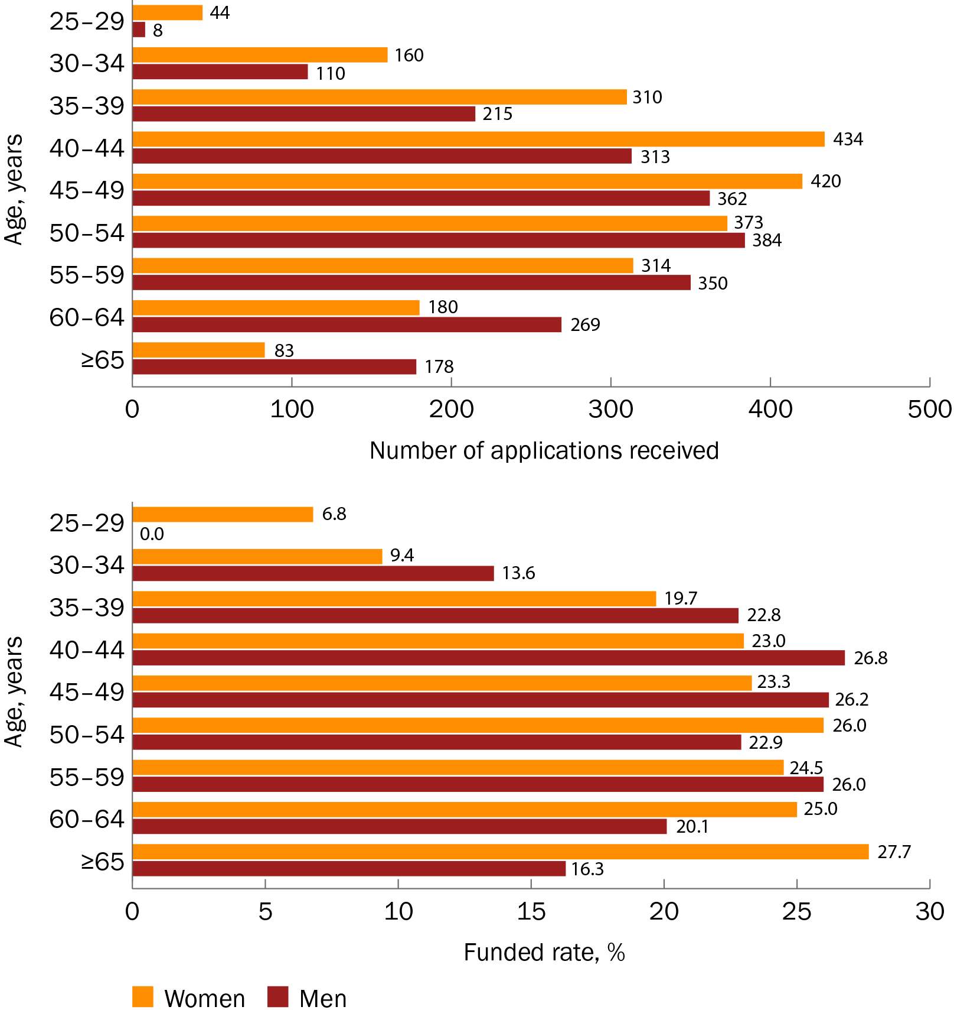

Figure 20 Proportion of funding received by women and men lead Chief Investigators, by age

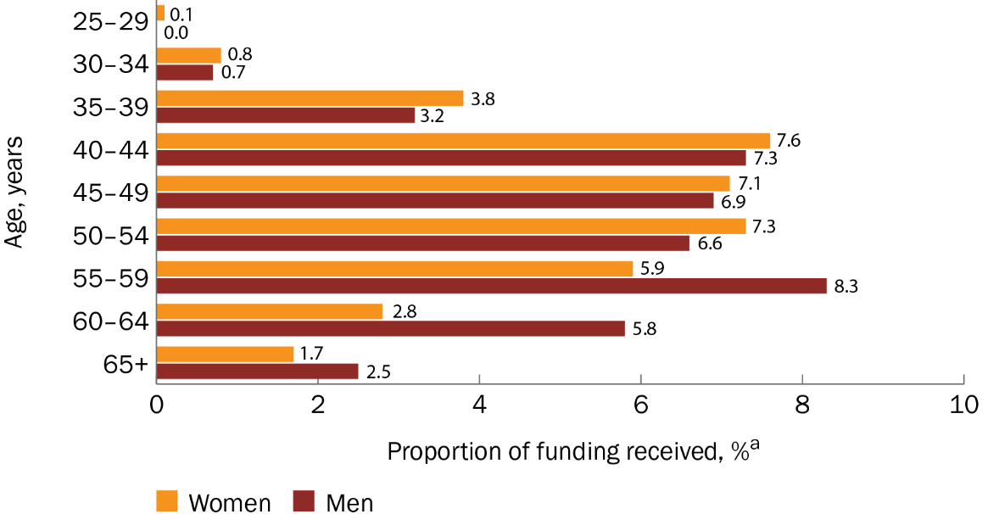

a The proportion of funding received is a percentage of the total funded amount across all ages ($2,283,083,279.42) for grant opportunities included in this analysis.

### Years post-PhD

Note that years post-PhD were calculated based on the year of application and were not adjusted for career disruptions or relative to opportunity considerations.

More women than men lead Chief Investigators submitted applications early in their careers (up to 20 years post-PhD), whereas more men than women submitted applications later in their careers (from 21 years post-PhD onwards). The highest number of applications of any career stage and for any gender came from women at the earliest stage of their careers (0–5 years post-PhD). Women lead Chief Investigators had their highest funded rate 11–15 years post-PhD, which was also the highest funded rate overall for any gender. The highest funded rates for men occurred 6–15 years post-PhD (Figure 21).

Women lead Chief Investigators received a proportion of funding that was similar to or higher than that received by men up to 20 years post-PhD. Men lead Chief Investigators who were at least 21 years post-PhD received a higher proportion of funding than women, with men who were 21–30 years post-PhD receiving the highest proportion of funding overall (for men and women across all post-PhD bands) (Figure 22).

Figure 21 Number of applications and funded rates for women and men lead Chief Investigators, by the number of years post-PhD

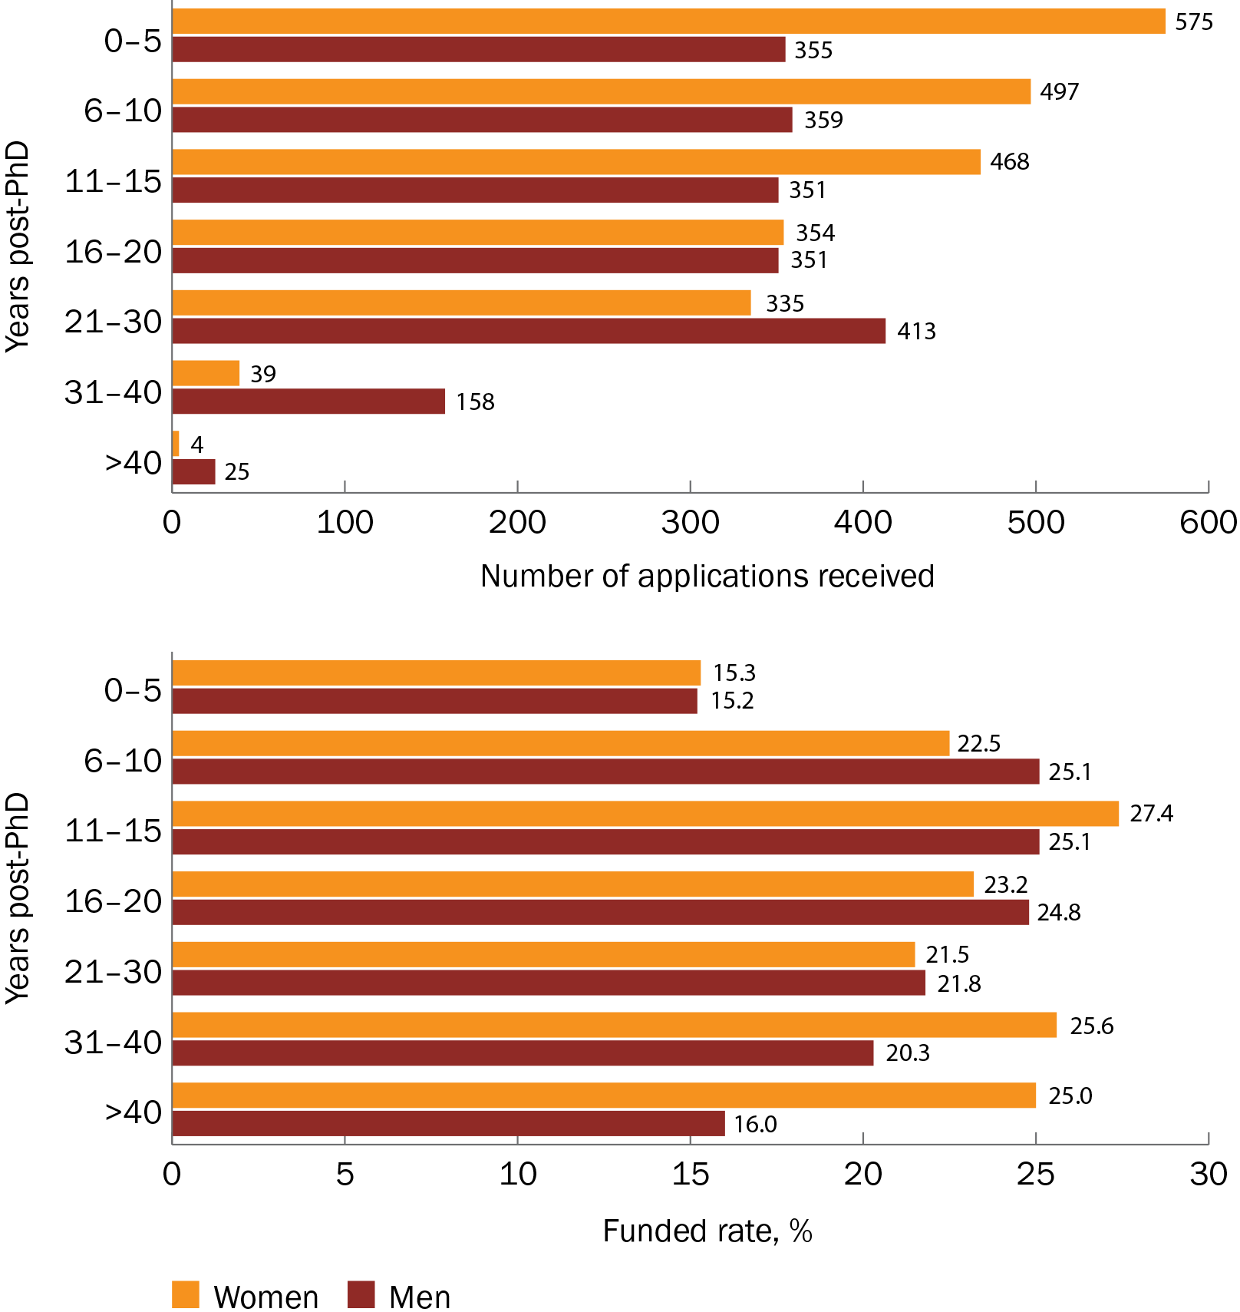

Figure 22 Proportion of funding received by women and men lead Chief Investigators, by the number of years post-PhD

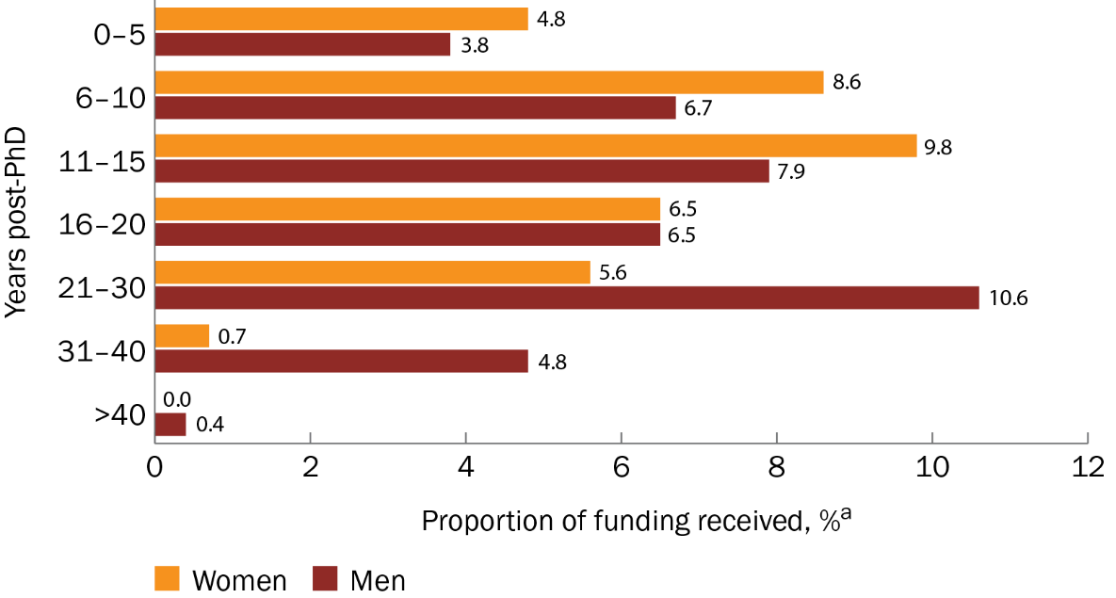

a The proportion of funding received is a percentage of the total funded amount across all years post-PhD ($2,283,083,279.42) for grant opportunities included in this analysis.

### Primary institution location

#### Overall rates

The following analyses are based on the primary institution of the lead Chief Investigator.

For institutions in New South Wales, Tasmania and the Northern Territory, women lead Chief Investigators continued to submit more applications than did men, whereas men lead Chief Investigators submitted more applications than did women in most other locations. The numbers of men and women applicants from Victoria were almost equal. Women lead Chief Investigators had slightly higher funded rates than men for primary institutions in South Australia, Tasmania, the Australian Capital Territory and the Northern Territory, whereas funded rates for men and women were similar for primary institutions in New South Wales, Queensland and Western Australia (Figure 23).

Because limited Chief Investigator profile data were available at the time, analysis in the 2023 report was based on the lead or administering organisation listed on the application rather than the primary institution of the lead Chief Investigator. Nevertheless, in line with the data reported in 2023, for primary institutions in New South Wales, South Australia, Western Australia, Tasmania and the Northern Territory, women lead Chief Investigators received a proportion of funding that was similar to or higher than that received by men (Figure 24).

Figure 23 Number of applications and funded rates for women and men lead Chief Investigators, by location of primary institution

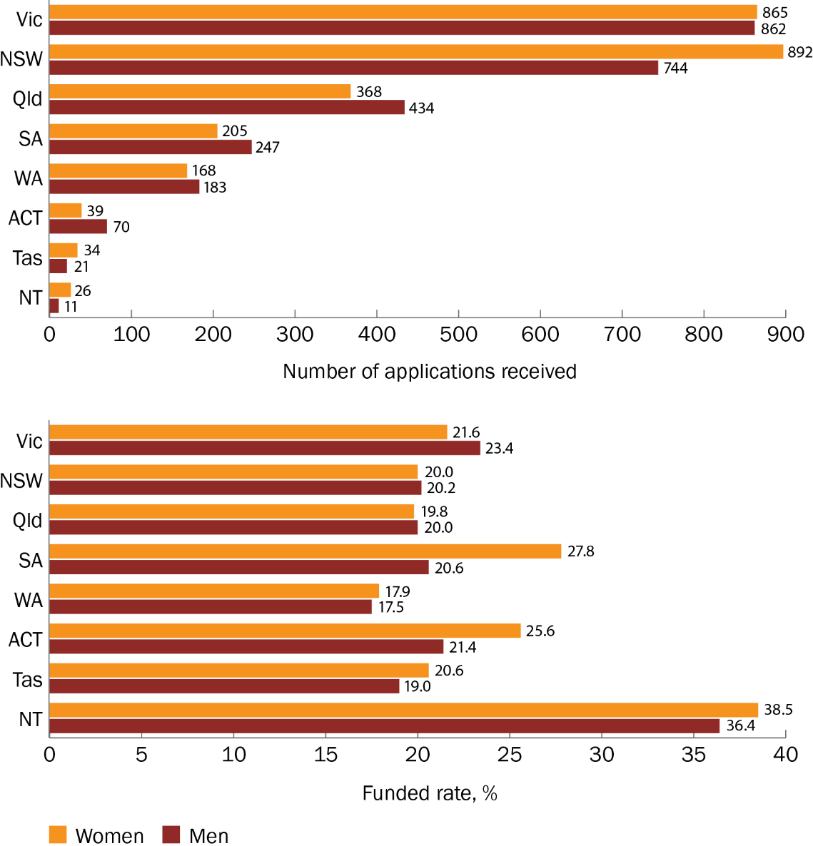

Figure 24 Proportion of funding received by women and men lead Chief Investigators, by location of primary institution

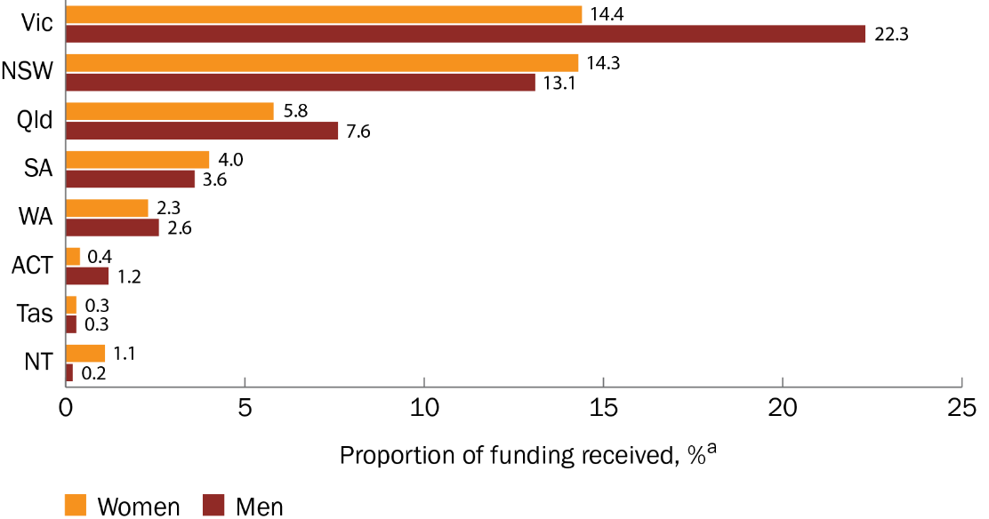

a The proportion of funding received is a percentage of the total funded amount across all states ($2,283,083,279.42) for grant opportunities included in this analysis.

For all Chief Investigators, there were more women than men applicants overall for primary institutions in Victoria, New South Wales, Queensland, Tasmania and the Northern Territory. Women Chief Investigators had a funded rate similar to or higher than that for men in all locations except Tasmania. There were 3 locations with 10 or more non-binary Chief Investigator applicants, with Victoria having the most (Figure 25).

Figure 25 Number of applicants and funded rates for women, men and non-binary Chief Investigators, by location of primary institution

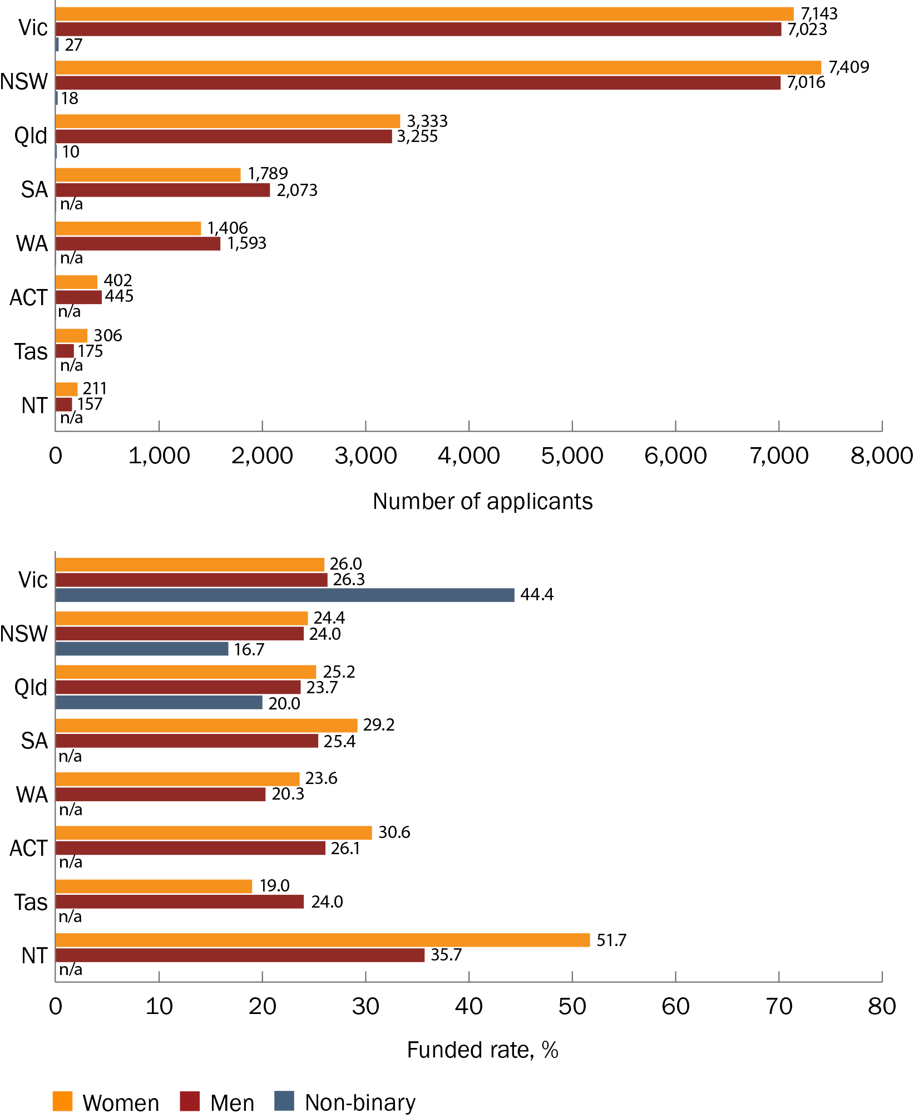

n/a = not applicable because there were <10 applicants

#### Annual trends (for all Chief Investigators)

In the 2022–23 financial year, all locations except the Northern Territory had fewer Chief Investigator applicants than the previous year. There were more women than men applicants for institutions in Victoria, New South Wales, Queensland, Tasmania and the Northern Territory, whereas applicant numbers for women and men were similar for institutions in South Australia, Western Australia and the Australian Capital Territory. Only Victorian institutions had 10 or more non-binary Chief Investigator applicants.

Also in 2022–23, women Chief Investigators had funded rates that were similar to or higher than those for men for all locations except Tasmania. The funded rate for non-binary Chief Investigators from Victorian institutions was more than double that for women or men in 2022–23, although this was based on a small number of applicants (Table 13).

Table 13 Number of applicants and funded rates for women, men and non-binary Chief Investigators each year, by location of primary institution

| Location of primary institution | Financial year | Number of women Chief Investigator applicants | Funded rate for women Chief Investigators | Number of men Chief Investigator applicants | Funded rate for men Chief Investigators | Number of non-binary Chief Investigator applicants | Funded rate for non-binary Chief Investigators |
| --- | --- | --- | --- | --- | --- | --- | --- |
| Victoria | 2017–18 | 244 | 24.2% | 451 | 27.3% | n/a | n/a |
| 2018–19 | 238 | 24.8% | 322 | 18.9% | n/a | n/a |
| 2019–20 | 825 | 25.8% | 962 | 26.2% | n/a | n/a |
| 2020–21 | 1,236 | 25.0% | 1,371 | 27.3% | n/a | n/a |
| 2021–22 | 2,613 | 27.1% | 2,373 | 28.4% | n/a | n/a |
| 2022–23 | 1,987 | 25.7% | 1,544 | 23.5% | 15 | 60.0% |
| New South Wales | 2017–18 | 222 | 18.0% | 404 | 17.6% | n/a | n/a |
| 2018–19 | 244 | 13.5% | 254 | 16.9% | n/a | n/a |
| 2019–20 | 784 | 22.7% | 826 | 20.8% | n/a | n/a |
| 2020–21 | 1,087 | 22.4% | 1,305 | 21.1% | n/a | n/a |
| 2021–22 | 2,874 | 25.5% | 2,495 | 26.7% | n/a | n/a |
| 2022–23 | 2,198 | 26.4% | 1,732 | 26.4% | n/a | n/a |
| Queensland | 2017–18 | 95 | 24.2% | 167 | 25.7% | n/a | n/a |
| 2018–19 | 79 | 21.5% | 81 | 11.1% | n/a | n/a |
| 2019–20 | 367 | 22.1% | 404 | 27.5% | n/a | n/a |
| 2020–21 | 576 | 22.9% | 648 | 17.9% | n/a | n/a |
| 2021–22 | 1,335 | 25.8% | 1,141 | 26.9% | n/a | n/a |
| 2022–23 | 881 | 27.4% | 814 | 22.6% | n/a | n/a |
| South Australia | 2017–18 | 35 | 31.4% | 85 | 20.0% | n/a | n/a |
| 2018–19 | 51 | 3.9% | 56 | 3.6% | n/a | n/a |
| 2019–20 | 176 | 29.5% | 224 | 23.7% | n/a | n/a |
| 2020–21 | 315 | 27.6% | 421 | 27.3% | n/a | n/a |
| 2021–22 | 662 | 27.6% | 741 | 26.9% | n/a | n/a |
| 2022–23 | 550 | 34.2% | 546 | 25.8% | n/a | n/a |
| Western Australia | 2017–18 | 20 | 10.0% | 46 | 17.4% | n/a | n/a |
| 2018–19 | 51 | 19.6% | 66 | 28.8% | n/a | n/a |
| 2019–20 | 154 | 7.8% | 179 | 12.8% | n/a | n/a |
| 2020–21 | 195 | 16.4% | 280 | 14.6% | n/a | n/a |
| 2021–22 | 598 | 30.6% | 629 | 28.1% | n/a | n/a |
| 2022–23 | 388 | 24.0% | 393 | 14.2% | n/a | n/a |
| Tasmania | 2017–18 | n/a | n/a | n/a | n/a | n/a | n/a |
| 2018–19 | 16 | 25.0% a | n/a | n/a | n/a | n/a |
| 2019–20 | 49 | 8.2% | 32 | 0.0% | n/a | n/a |
| 2020–21 | 42 | 35.7% | 31 | 22.6% | n/a | n/a |
| 2021–22 | 140 | 19.3% | 77 | 35.1% | n/a | n/a |
| 2022–23 | 50 | 16.0% | 24 | 25.0% | n/a | n/a |
| Australian Capital Territory | 2017–18 | 27 | 29.6% | 31 | 35.5% | n/a | n/a |
| 2018–19 | 12 | 0.0%a | n/a | n/a | n/a | n/a |
| 2019–20 | 73 | 30.1% | 81 | 16.0% | n/a | n/a |
| 2020–21 | 55 | 20.0% | 56 | 14.3% | n/a | n/a |
| 2021–22 | 131 | 47.3% | 152 | 46.1% | n/a | n/a |
| 2022–23 | 104 | 19.2% | 116 | 12.1% | n/a | n/a |
| Northern Territory | 2017–18 | n/a | n/a | 12 | 50.0%a | n/a | n/a |
| 2018–19 | n/a | n/a | n/a | n/a | n/a | n/a |
| 2019–20 | 29 | 51.7% | n/a | n/a | n/a | n/a |
| 2020–21 | n/a | n/a | 11 | 63.6%a | n/a | n/a |
| 2021–22 | 87 | 59.8% | 59 | 44.1% | n/a | n/a |
| 2022–23 | 82 | 43.9% | 62 | 19.4% | n/a | n/a |

n/a = not applicable because there were <10 applicants

a Funded rates should be interpreted with caution because of the low number of applicants.

## Grant assessors

Grant Assessment Committee member gender data were not available for all grant opportunities. The grant opportunities included in this report for which committee member gender data were available are listed in Appendix C.

As was reported in 2023, there were more women than men grant assessors (55.8% compared with 44.2%) (Figure 26). The average number of women assessors per committee (11.3) was also higher than the average number of men (9.0). There were not enough data available for non-binary grant assessors to include them in analyses.

Figure 26 Number of women and men appointed to Grant Assessment Committees

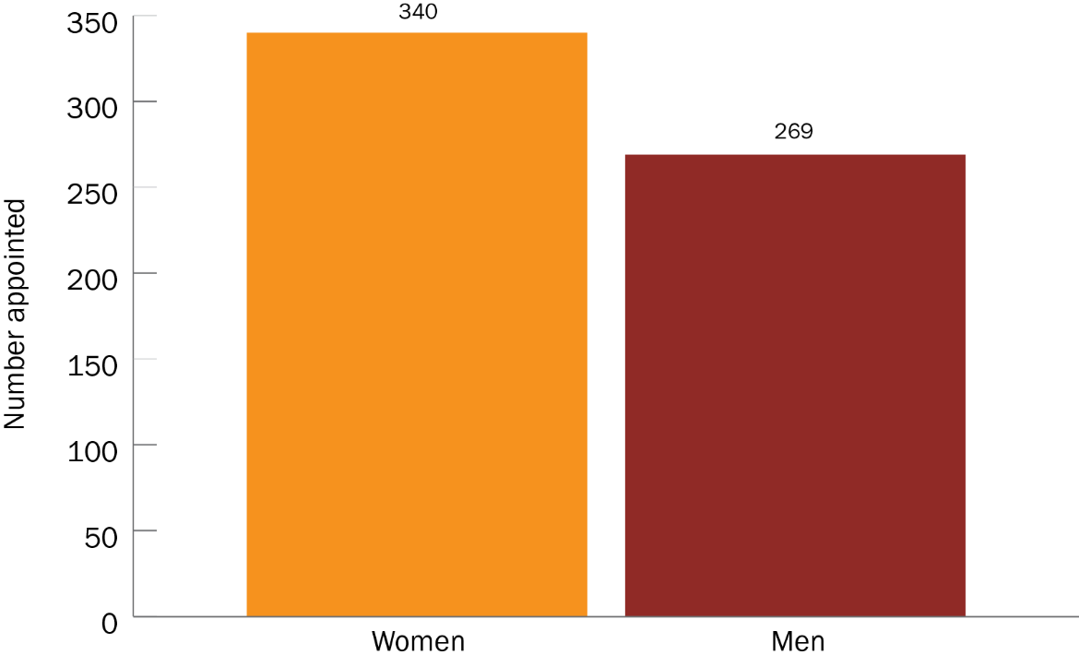

# Opportunities for learning

Many of the findings and gaps reported in the [2023 gender data report](https://www.health.gov.au/resources/publications/mrff-report-on-gender-data-for-grant-opportunities-august-2023?language=en) remain apparent with the added data from the 2022–23 financial year.

A high attrition rate among women researchers at the later stages of their careers is still observed in this report. This suggests that systemic barriers for women researchers persist within the health and medical research sector. There are policy interventions in place to try to reduce these barriers, such as [new special measures](https://www.nhmrc.gov.au/about-us/news-centre/working-towards-gender-equity-investigator-grants) under the Sex Discrimination Act 1984 to address systemic disadvantages faced by women and non-binary applicants to the NHMRC’s Investigator Grant scheme. These measures aim to award equal numbers of Investigator Grants to women and men in the 'Leadership' category and to include non-binary researchers with women in gender equity interventions. For the first time since the introduction of these measures in 2023, women received a higher proportion of NHMRC funding than did men. More women applied at Leadership Level 3 (L3), the highest category, in the Investigator Grant scheme than in previous years. Women also had higher funded rates than men across all schemes in the NHMRC 2023 grant program (more details are provided in the [NHMRC Annual Report 2023–24](https://www.nhmrc.gov.au/about-us/publications/annual-report-2023-24)). It will take time for these and other ongoing efforts to improve the longer-term retention of women researchers later in their careers.

The findings in the current report suggest that receiving MRFF funding may be attributed more to larger teams (those with a high number of members) rather than the gender of the lead Chief Investigator. Larger teams are likely to have more diverse members – in terms of both gender and expertise – than smaller teams, although the department will continue to monitor incoming data to determine the accuracy of these observations.

In terms of representation on Grant Assessment Committees, women researchers are present on these committees in higher numbers than men. This is a pattern that has persisted since the previous report.

This report was able to include some funding statistics on non-binary researchers, although data remain insufficient to give a thorough understanding of these researchers’ projects, their funded rates and the proportions of funding they received. The department will continue to monitor and report on broader, more diverse gender data as they become available.

# Conclusions

The findings of this report show a continued trend towards better parity between men and women researchers across the MRFF.

The 2022–23 financial year had fewer applications and applicants overall than 2021–22 – a result of fewer grant opportunities being available – but a high number of women researchers continue to apply for funding, and funded rates for women and men researchers are more equal than they were in the previous financial year. However, despite women’s higher funded rates when applying for larger budgets, men still received a higher proportion of funding than did women. This is likely because more men than women applied for and received grants with larger budgets.

The challenges identified in the 2023 gender data report and in other analyses of gender data among Australian researchers remain. These include the high attrition rate among women researchers at more senior levels and the gender imbalance in research teams and in Grant Assessment Committees.

The department now has sufficient gender data for MRFF grant opportunities to report on funded rates for non-binary researchers. Although some of the increase in the number of non-binary applicants can be attributed to the opening of grant opportunities especially relevant to non-binary people as a health priority population in 2022–23 (such as the 2023 Models of Care for Sexuality and Gender Diverse People and People with Innate Variations of Sex Characteristics grant opportunity), this is not the only driver and there has been an overall increase in the proportion of non-binary researchers applying for and receiving MRFF funding.

The better representation of diverse genders among health and medical researchers will have a positive impact on health outcomes, as recognised in the joint MRFF/NHMRC [Statement on Sex, Gender, Variations of Sex Characteristics and Sexual Orientation in Health and Medical Research](https://www.health.gov.au/resources/publications/statement-on-sex-gender-variations-of-sex-characteristics-and-sexual-orientation-in-health-and-medical-research?language=en) (published July 2024). Continuous monitoring of gender data will enable the department to track gender diversity among researchers and research teams, and evaluate any associations with MRFF impact measures and measures of success, as outlined in the [MRFF Monitoring, Evaluation and Learning Strategy](https://www.health.gov.au/resources/publications/mrff-monitoring-evaluation-and-learning-strategy-2020-21-to-2023-24).

# Appendices

Appendix A Funded rates for MRFF grant opportunities that are new to this report – for lead Chief Investigators

| Grant opportunity | Number of women lead Chief Investigator applicants | Funded rate for women lead Chief Investigators | Number of men lead Chief Investigator applicants | Funded rate for men lead Chief Investigators |
| --- | --- | --- | --- | --- |
| 2022 Assessment of High-Cost Gene Treatments and Digital Health Interventions | 12 | 75.0% | 8 | 37.5% |
| 2022 Clinical Trials Activity | 32 | 37.5% | 50 | 30.0% |
| 2022 Genomics Health Futures Mission | 17 | 47.1% | 35 | 48.6% |
| 2022 Indigenous Health Research | 35 | 57.1% | 11 | 54.5% |
| 2022 Joint Transnational Call | 0 | n/a | 2 | 50.0% |
| 2022 Mental Health Research | 57 | 14.0% | 28 | 7.1% |
| 2022 Multiple Sclerosis Research | 3 | 66.7% | 6 | 66.7% |
| 2022 National Critical Research Infrastructure | 46 | 13.0% | 67 | 16.4% |
| 2022 Rapid Applied Research Translation | 21 | 19.0% | 21 | 19.0% |
| 2022 Research Data Infrastructure | 29 | 6.9% | 28 | 7.1% |
| 2023 BioMedTech Incubator Dementia and Cognitive Decline | 0 | n/a | 2 | 50.0% |
| 2023 Cardiovascular Health Mission | 24 | 29.2% | 20 | 20.0% |
| 2023 Chronic Respiratory Conditions | 26 | 46.2% | 16 | 6.3% |
| 2023 Clinician Researchers: Applied Research in Health | 56 | 37.5% | 41 | 29.3% |
| 2023 Consumer-Led Research | 72 | 18.1% | 23 | 8.7% |
| 2023 Dementia Ageing and Aged Care Mission | 43 | 0.0% | 19 | 0.0% |
| 2023 Early to Mid-Career Researchers | 84 | 20.2% | 57 | 15.8% |
| 2023 Global Health | 7 | 0.0% | 8 | 37.5% |
| 2023 International Clinical Trial Collaborations – Round 1 | 7 | 42.9% | 13 | 0.0% |
| 2023 International Clinical Trial Collaborations – Round 2 | 8 | 12.5% | 10 | 10.0% |
| 2023 Maternal Health and Healthy Lifestyles | 35 | 20.0% | 15 | 20.0% |
| 2023 Models of Care for Sexuality and Gender Diverse People and People with Innate Variations of Sex Characteristics – Streams 1 and 2 | 6 | 83.3% | 8 | 62.5% |
| 2023 Models of Care for Sexuality and Gender Diverse People and People with Innate Variations of Sex Characteristics – Streams 3 and 4 | 3 | 0.0% | 2 | 100.0% |
| 2023 National Critical Research Infrastructure | 34 | 0.0% | 60 | 0.0% |
| 2023 Primary Health Care Research | 11 | 54.5% | 6 | 66.7% |
| 2023 Stem Cell Therapies Mission | 5 | 0.0% | 17 | 35.3% |
| 2023 Traumatic Brain Injury – Stream 1 | 1 | 0.0% | 1 | 0.0% |
| 2023 Traumatic Brain Injury – Stream 2 | 3 | 66.7% | 3 | 0.0% |

n/a = not applicable

Note: The total number of applicants for each grant opportunity may not equal the sum of women and men Chief Investigators reported in this table as gender data may not be available for all applicants.

Appendix B Funded rates for MRFF grant opportunities that are new to this report – for all Chief Investigators

| Grant opportunity | Number of women Chief Investigator applicants | Funded rate for women Chief Investigators | Number of men Chief Investigator applicants | Funded rate for men Chief Investigators |
| --- | --- | --- | --- | --- |
| 2022 Assessment of High-Cost Gene Treatments and Digital Health Interventions | 108 | 59.3% | 123 | 56.9% |
| 2022 Clinical Trials Activity | 408 | 37.0% | 495 | 35.6% |
| 2022 Genomics Health Futures Mission | 284 | 57.4% | 321 | 49.2% |
| 2022 Indigenous Health Research | 300 | 59.3% | 147 | 47.6% |
| 2022 Joint Transnational Call | 0 | n/a | 3 | 33.3% |
| 2022 Mental Health Research | 410 | 15.9% | 248 | 9.7% |
| 2022 Multiple Sclerosis Research | 40 | 65.0% | 62 | 64.5% |
| 2022 National Critical Research Infrastructure | 482 | 17.4% | 671 | 18.0% |
| 2022 Rapid Applied Research Translation | 305 | 24.6% | 195 | 13.3% |
| 2022 Research Data Infrastructure | 325 | 8.0% | 352 | 7.4% |
| 2023 BioMedTech Incubator Dementia and Cognitive Decline | 20 | 50.0% | 20 | 25.0% |
| 2023 Cardiovascular Health Mission | 216 | 31.0% | 246 | 29.3% |
| 2023 Chronic Respiratory Conditions | 214 | 34.1% | 198 | 33.3% |
| 2023 Clinician Researchers: Applied Research in Health | 507 | 37.7% | 447 | 36.5% |
| 2023 Consumer-Led Research | 639 | 18.0% | 308 | 14.9% |
| 2023 Dementia Ageing and Aged Care Mission | 437 | 0.0% | 262 | 0.0% |
| 2023 Early to Mid-Career Researchers | 574 | 24.2% | 375 | 21.9% |
| 2023 Global Health | 91 | 24.2% | 87 | 21.8% |
| 2023 International Clinical Trial Collaborations – Round 1 | 81 | 21.0% | 114 | 21.1% |
| 2023 International Clinical Trial Collaborations – Round 2 | 92 | 8.7% | 105 | 15.2% |
| 2023 Maternal Health and Healthy Lifestyles | 326 | 25.5% | 181 | 17.1% |
| 2023 Models of Care for Sexuality and Gender Diverse People and People with Innate Variations of Sex Characteristics – Streams 1 and 2 | 89 | 77.5% | 56 | 67.9% |
| 2023 Models of Care for Sexuality and Gender Diverse People and People with Innate Variations of Sex Characteristics – Streams 3 and 4 | 82 | 48.8% | 33 | 45.5% |
| 2023 National Critical Research Infrastructure | 416 | 0.0% | 609 | 0.0% |
| 2023 Primary Health Care Research | 123 | 62.6% | 76 | 64.5% |
| 2023 Stem Cell Therapies Mission | 115 | 25.2% | 140 | 30.7% |
| 2023 Traumatic Brain Injury – Stream 1 | 35 | 0.0% | 51 | 0.0% |
| 2023 Traumatic Brain Injury – Stream 2 | 43 | 37.2% | 39 | 33.3% |

n/a = not applicable

Appendix C Gender data for Grant Assessment Committee members, by grant opportunity

| Grant opportunity | Grant hub | Number of men assessors | Number of women assessors | Percentage of men assessors | Percentage of women assessors |
| --- | --- | --- | --- | --- | --- |
| 2021 BioMedTech Incubator | BGH | 6 | 4 | 60.0% | 40.0% |
| 2022 Assessment of High-Cost Gene Treatments and Digital Health Interventions | NHMRC | 8 | 7 | 53.3% | 46.7% |
| 2022 Clinical Trials Activity | NHMRC | 19 | 25 | 43.2% | 56.8% |
| 2022 Indigenous Health Research | NHMRC | 5 | 12 | 29.4% | 70.6% |
| 2022 Mental Health Research | NHMRC | 9 | 19 | 32.1% | 67.9% |
| 2022 Multiple Sclerosis Research | NHMRC | 6 | 4 | 46.2% | 30.8% |
| 2022 National Critical Research Infrastructure | BGH | 8 | 8 | 50.0% | 50.0% |
| 2023 Cardiovascular Health Mission | NHMRC | 10 | 9 | 52.6% | 47.4% |
| 2023 Chronic Respiratory Conditions | NHMRC | 6 | 12 | 33.3% | 66.7% |
| 2023 Clinician Researchers: Applied Research in Health | NHMRC | 18 | 18 | 50.0% | 50.0% |
| 2023 Consumer-Led Research | NHMRC | 16 | 13 | 57.1% | 46.4% |
| 2023 Early to Mid-Career Researchers | NHMRC | 31 | 48 | 38.3% | 59.3% |
| 2023 Genomics Health Futures | NHMRC | 10 | 13 | 43.5% | 56.5% |
| 2023 International Clinical Trial Collaborations (Round 23.1) | NHMRC | 7 | 9 | 43.8% | 56.3% |
| 2023 International Clinical Trial Collaborations (Round 23.2) | NHMRC | 7 | 7 | 50.0% | 50.0% |
| 2023 Maternal Health and Healthy Lifestyles | NHMRC | 8 | 16 | 33.3% | 66.7% |
| 2023 Models of Care for Sexuality and Gender Diverse People and People with Innate Variations of Sex Characteristics | NHMRC | 4 | 9 | 26.7% | 60.0% |
| 2023 Optimising Screening, Diagnosis and Management of Obstructive Sleep Apnoea | NHMRC | 8 | 6 | 57.1% | 42.9% |
| 2023 Primary Health Care Research | NHMRC | 5 | 7 | 41.7% | 58.3% |
| 2023 Stem Cell Therapies | NHMRC | 5 | 11 | 31.3% | 68.8% |
| 2023 Traumatic Brain Injury | NHMRC | 9 | 5 | 64.3% | 35.7% |